Integrated Assessment Tool (IAT) Live Trial

Final Report

1 September 2023

**Contents**

Acknowledgement of Country 4

Department acknowledgements 4

Glossary 5

Executive summary 7

Key Performance Indicator – outcomes 8

IAT Live Trial – assessor feedback 9

Lessons learned 11

PART A – IAT Live Trial delivery overview 24

Background, purpose, and scope 24

Purpose and scope of the IAT Live Trial 25

Delivering the IAT Live Trial 26

Ethics applications 26

Qualitative research data methodology 28

Key Performance Indicators deep dive 29

Note on data currency 29

Monitoring methodology of the key KPIs over the course of the IAT Live Trial 30

IAT snapshot 30

IAT Power BI dashboard reporting 31

Sprint planning and monitoring 32

KPI derivation and comparison 34

Evaluation and analysis of each KPI 34

Assessments completed over the IAT Live Trial period 35

IAT Cancelled 36

AMO breakdown 37

Rural and remote assessments 39

First Nations assessments 46

Hospital ACAT assessments 50

Supporting participating AMOs 52

Key themes 54

PART B – Feedback and insights 62

IAT design and functionality feedback 62

Suitability of IAT questions 75

CALD and First Nations assessments 77

Training and further guidance 81

Function 91

Medical and Medication 93

Goal setting 95

Assessor recommendations 99

Allied health referrals 102

Assistive Technology - Home Modification (AT-HM) 106

IAT Live Trial observations 112

Appendix A: Qualitative research questions 117

Appendix B: Monthly assessor survey outcomes 124

Service type recommendations 124

Listed services 125

Referral recommendations 127

Allied health 129

AT-HM 131

CALD and First Nations people 138

Goal setting 141

Improvements 143

Appendix C: Fortnight Check-In Call Responses 150

Sequencing workshop 150

Appendix D: Cost Breakdown 151

# Acknowledgement of Country

The Department of Health and Aged Care acknowledges the Traditional Owners of Country throughout Australia, and their continuing connection to land, sea and community. We pay our respects to them and their cultures, and to Elders both past and present.



# Department acknowledgements

The Department of Health and Aged Care (the department) also wish to acknowledge the significant contribution made by the Assessment Management Organisations (AMOs) who participated in the IAT Live Trial and thank each assessor for their professionalism, feedback and valuable insights across the IAT Live Trial. The department also wish to acknowledge Aboriginal Community Services (ACS), the Institute for Urban Indigenous Health (IUHI), the South West Aboriginal Medical Services Aboriginal Corporation (SWAM) and the Australian Unity Home Care Services (AUHCS).

# Glossary

Table 1 and 2 below sets out the acronyms referenced throughout this paper.

#### Table : Organisation name acronyms

|  |  |
| --- | --- |
| Acronym | Organisation name |
| ACNA | Access Care Network Australia Pty Ltd |
| ACT HD | Canberra Health Services |
| A4L | Aspire4Life |
| BCGL | Brightwater Care Group Limited |
| CHL | Catholic Healthcare Limited |
| COAL | Community Options Australia Limited |
| COI | Care Options Incorporated |
| CT | Care Tasmania Pty Ltd |
| HAC | Health Administration Corporation |
| ILA | Independent Living Assessment Incorporated |
| NSW MoH | New South Wales Ministry of Health |
| NT DoH | Northern Territory Department of Health |
| P4HL | Partners 4 Health Limited |
| QLD DoH | Department of Health Queensland |
| REST | Resthaven Incorporated |
| SA DoH | Department of Health and Wellbeing, South Australia |
| SCS | Suncare Community Services Ltd |
| SER | Serendipity (WA) Pty Ltd |
| TAS DoH | Tasmanian Department of Health |
| UCiA | Uniting Communities Incorporated |
| VIC DoH | Victorian Department of Health |
| WA DoH | Department of Health Western Australia |

#### Table 2: General acronyms

|  |  |
| --- | --- |
| **General acronyms** |  |
| ACAS | Aged Care Assessment Services |
| ACAT | Aged Care Assessment Team |
| AHCSA | Aboriginal Health Council of South Australia |
| AHREC | Aboriginal Human Research Ethics Committee |
| AIATSIS | Australian Institute of Aboriginal and Torres Strait Islander Studies |
| AMO | Assessment Management Organisation |
| AT-HM | Assistive Technology - Home Modification |
| Bellberry | Bellberry Limited |
| CALD | Culturally and Linguistically Diverse |
| CoP | Community of Practise |
| DSSI | Duke Social Support Index |
| GPCOG | General Practitioner Assessment of Cognition |
| HREC | Human Research Ethics Committee |
| IAT | Integrated Assessment Tool |
| ITD | Information Technology Division |
| KICA-COG | Kimberley Indigenous Cognitive Assessment |
| KPI | Key Performance Indicator |
| MAC | My Aged Care |
| MMM | Modified Monash Model |
| MMSE | Mini Mental State Examination |
| NSAF | National Screening and Assessment Form |
| PM | Project Management |
| RAS | Regional Assessment Service |
| RUDAS | Rowland Universal Dementia Assessment Scale |

# Executive summary

A new aged care assessment tool presently referred to as the **Integrated Assessment Tool (IAT)** prototype was trialled between 17 April to 28 July 2023 for assessing older people for aged care services.

The IAT has been developed using a range of verified assessment instruments building on the current National Aged Care Screening and Assessment Form (NSAF).



The IAT assesses functional needs across a range of domains including activities of daily living, cognition, psycho-social, frailty and medical conditions.

The purpose of the IAT Live Trial was to collect a large and representative sample of assessment data to further inform the classification system to align to the needs of the client population.

The scope of the department’s IAT Live Trial was:

1. Completion of 20,000 assessments conducted by AMOs (RAS ACAT) using the IAT
2. Coverage across diverse complex client demographics including First Nations, CALD, rural and remote and in-hospital settings
3. Individual client data collected and stored for further analysis to inform work on classification arrangements
4. Capture of feedback from the assessment workforce on the usability and effectiveness of the IAT
5. Operation of the IAT Live Trial in a manner that minimises the time burden on assessors and clients as much as possible.

A total of **22,002** assessments were completed by the 22 AMOs who participated in the IAT Live Trial. This is 10.0% above the target of 20,000 completed assessments for the trial.

At the conclusion of the IAT Live Trial, KPIs relating to the proportions of RAS versus Aged Care Assessment Team[1] (ACAT) assessments and rural and remoteness were met or exceeded. The proportions of assessments completed with CALD and First Nations older people were below target, as were the proportion of ACAT assessments completed in a hospital setting.

The voluntary nature of participation suggests that despite the large number of completed assessments, the outcomes may not be representative of the diverse population of older people, but particularly for these 3 cohorts.

Managing the risk of underlying sample biases will be an important consideration for future IAT Live Trial dataset analysis.

## Key Performance Indicator – outcomes

The IAT Live Trial has been managed, monitored, and evaluated in line with the following 6 Key Performance Indicators (KPIs):

1. Aim to complete 20,000 assessments
2. RAS versus ACAT split:
   1. RAS assessments: 60% of completed assessments (12,000)
   2. ACAT assessments: 40% of completed assessments (8,000)
3. Rural and remote: 30% of completed assessments (6,000)
4. CALD: 20% of completed assessments (4,000)
5. First Nations older people: 5% of completed assessments (1,000)
6. In-hospital assessments: 30% of completed ACAT assessments (2,400).

#### Figure : KPI summary at the conclusion of the IAT Live Trial

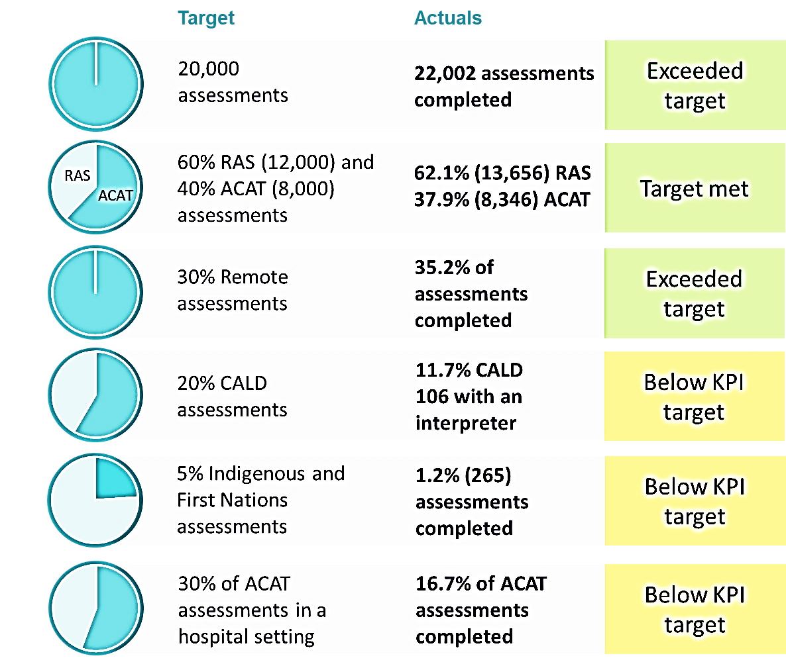

*The data analysed and presented in Figure 1 is current as of the final PM report data extract obtained on 20 August 2023, which includes assessment completion information as of

18 August 2023, which is beyond the end of the IAT Live Trial.

## IAT Live Trial – assessor feedback

Throughout the IAT Live Trial, the department experienced strong engagement from assessors which has provided valuable insights and feedback. Assessors also indicated an overall willingness to continue engaging with the department across future iterations of the IAT design by way of co-design activities, increased user acceptance testing opportunities and involvement in development of ongoing training material.

Assessor feedback was strong in relation to streamlining and refining specific IAT sections to keep clients engaged and build rapport.

#### Figure 2: Key IAT assessor feedback areas for improvement

Figure 2: displays in the 4 columns listed areas for improvement in the IAT based on the assessors' feedback.
The main areas listed are the IAT functionality and useability, assessment of the CALD and First Nations people using validated cognitive tools, IAT assessor training and technology.

*DSSI = Duke Social Support Index, GPCOG = General Practitioner Assessment of Cognition, KICA-COG = Kimberley Indigenous Cognitive Assessment, RUDAS = Rowland Universal Dementia Assessment Scale, MMSE = Mini Mental State Examination

#### Figure 3: IAT trial feedback channels

Figure 3: displays the IAT trial 5 feedback channels assessors used during the trial, which were monthly assessors surveys, MyAssesor Community of Practice online chat, emails to a designated email box, fortnightly online webex meetings referred to as fortnightly assessor check-in calls, and phone calls to the AMOs - check in consultations. 968 assessors registered on My Assessor online chat.
 

The IAT Live Trial dataset is now an asset held by the department to be used to support future aged care policy development. However, the monitoring and evaluation of IAT Live Trial KPIs has revealed under-representation of certain client demographics. This under representation is likely driven by the availability and willingness to complete the IAT for selected participants as represented in the feedback provided by assessors. The department may consider means to address this both in the IAT itself and in weighting future statistical analysis.

## Lessons learned

Throughout the IAT Live Trial, feedback from assessors was obtained to gain insights into both the design and functionality of the IAT, as well as their overall impressions of the IAT Live Trial. The majority of assessors indicated, through channels such as the monthly assessors’ surveys, that they had a positive experience using the IAT.

Assessors provided large amounts of qualitative and quantitative feedback, provided through the monthly assessor surveys, My Assessor chat (CoP) and email inbox, and assessor check-in calls, which can support guiding the department with future iterations of the IAT and full-scale implementation.

Set out below is a summary of findings, insights and next steps that can support the department to evolve the design, implementation, and user experience of the IAT. Further details and specific feedback instances for assessors can be found in Part B of this report. These points relate to the rights based, person-centred approach that is underpinning the aged care reform program following the *Royal Commission in the Aged Care Quality and Safety (*Royal Commission), and that will be central in the new Aged Care Act.

The volume of feedback is presented as the number of instances of feedback received. The instances of feedback, in Table 3, have been summarised from each of the following feedback channels: the monthly assessors surveys, My Assessor chat (CoP) and email inbox, and assessor check-in calls.

#### Table : Key learning considerations: assessor feedback

| # | Key feedback | Consideration | Feedback examples |
| --- | --- | --- | --- |
| **Functionality** | | | |
| 1 | Revision of hover help boxes guidance | Assessors suggested relevant and precise help text guidance to support accuracy of assessments | * 32 instances of feedback noted that hover help boxes did not provide specific enough information (e.g., 'without help' 'with some help' 'completely unable' 'who helps' 'is the need being met' in function section) * 14 instances of feedback noted that hover help boxes simply repeated the question (e.g., hover help boxes for light and moderate/heavy housework were the same). |
| 2 | Additional free text and ‘N/A’ response options | Assessors suggested the addition of ‘Not Applicable (N/A)’ and ‘free text’ options throughout the IAT to support accurately capturing their client’s narrative and circumstances. | * 28 instances of feedback requested the addition of ‘N/A’ response options throughout the IAT (e.g., questions about what kind of garden the client has) * 22 instances of feedback requested the addition of ‘N/A’ response options in the function section (e.g., if client is blind, they cannot fill out the clock, inaccurate reflection of function) * 36 instances of feedback requested the addition of more ‘free text’ response options in the IAT, 9 of which specified the function section example questions include:   + Bladder and bowel   + Weight, appetite, weight loss/gain. |
| 3 | Too many drop-down boxes | Assessors suggested the volume of drop-down response boxes be reviewed. | * 11 instances of feedback noted that the volume of drop-down boxes in the IAT extended assessment times as assessor experienced difficulties whilst navigating them   (e.g., ‘informal carer helps’ and "client does not require assistance")   * 4 instances of feedback noted that drop-down boxes should be replaced with free text boxes (Specific examples not provided). |
| 4 | Hard to read due to font size and colour | Assessors suggested the bigger font sizes and darker font colour. | * 8 instances of feedback shared that the current light grey font colour throughout the IAT is challenging to read, and that black was a better option * 6 instances of feedback shared that the font size was too small, consider font size 14 preferred font size * 1 instance of feedback noted that the   drop-down boxes are hard to see as they are grey in colour. |
| 5 | New ‘service type’ options | Assessors suggested the addition of alternative categories within the Assessor Recommendations section of the IAT. These categories could accommodate clients whose needs do not align with any of the currently listed service types. | * 37 instances of feedback noted that the current service type recommendations, reablement and restorative, are not applicable to all clients and that a maintenance referral category should be added. |
| **Sequencing and length of sections** | | | |
| 6 | Sequence re-ordering | Assessors suggested a reordering of the IAT sections sequence and reduction in the sections’ length. | * 45 instances of feedback suggested the Social section could be moved to later in the assessment (e.g., after the Function section) * A direct example provided by an assessor: Q.23.1 "Preferred structure for the IAT for improved flow of assessment 1. Assessment details 2. Reason for assessment.   4. Medications 5. Medical section 6. Physical/Personal Health 7. Frailty 8. Cognition 9. Behaviour 10. Psychological 11. Social section 12. Home & Personal 13. Financial 14. Function". |
| 7 | Relocation of the Medical and Medication section | Assessors suggested the Medical and Medication section may be more beneficial being placed towards the beginning of the assessment. | * 5 instances of feedback noted that the Medical and Medication sections could be located towards the start of the assessment, as information regarding a client’s medical background can help clients to understand the outcomes of other sections. (e.g., Care information could be after the social screen and Medical section could come after Frailty). |
| 8 | Placement of Psychological, Social, and Cognition sections | Assessors highlighted difficulties in building trust and rapport with clients when tasked with asking challenging questions, such as the Psychological, Social and Cognition sections. | * 45 instances of feedback noted that the social section of the IAT appears to early in the IAT (e.g., Social should be with the psychological section) * 29 instances noted that the social sections placement hinders rapport building (Example not provided) * 6 instances of assessor feedback noted that Duke Social Support Index (DSSI) current location question is not relevant. (e.g., Duke Social scale should be moved to psychological). |
| 9 | Combine Medical and Medication questions into one section | Assessors suggested combining all the Medical and Medication questions into one section due to their similarity and to help with the flow of the IAT. | * 17 instances of feedback noted that the consolidation of medical and medication sections would be beneficial, as the topics covered are often interrelated (e.g., takes medicine in Function section aligns with Medical and Medication) * 5 instances of feedback targeted towards sequence noted that a combination of these two sections would help with the flow of the IAT (e.g., frailty question could be part of either overall vulnerability or linked with pain/sleep/mobility/diet sections as they all relate to frailty). |
| 10 | Health conditions reference list refinement | Assessors suggested a review of the health conditions reference list and naming conventions. | * 2 instances of feedback noted that the list appeared incomplete, as numerous conditions were not included (specific examples not provided) * 2 instances of feedback noted the naming conventions of the list required review to make the list more comprehensive (e.g., respirator (different interpretation to many), Decubitus ulcer (as opposed to chronic ulcer) and urethral catheter (omission of suprapubic catheter). |
| 11 | Goal setting questions are repetitive | Assessors suggested a thorough review of the goal setting section’s content to eliminate any duplication and streamline questions. By focusing on creating a concise, relevant, and engaging experience, it may be possible to prevent fatigue and frustration among clients. | * 140 instances of feedback noted that the goal setting section featured repetition (e.g., 54 instances suggested ‘Client goal’ and ‘goal’ fields were repetitive.) * 2 instances of feedback commented clients wanted to express their goals without detailing how they planned to achieve them (examples not provided). |
| **Language and wording** | | | |
| 12 | Some questions need further explanation and guidance | Assessors suggested detailed explanations for questions prone to confusion and additional response options. | * 54 instances of feedback requested additional detail on ‘What is the difference between ‘Goal’ and ‘What is the client's goal’ * 22 instances of feedback requested additional response options for answers with only a ‘yes’ or ’no’ response (e.g., ‘do you drive?’ only has a yes or no response. No option for explain if a client is restricted by themselves or authority). |
| 13 | DSSI was confronting for some clients | Assessors suggested consideration be given to alternatives to the DSSI. | * 66 instances of feedback noted that the DSSI could be interpreted as confronting and difficult to ask in front of family members (e.g., do you feel you're being listened to". " Do you have a definite role in the family and friends" "Are there any financial concerns") * 8 instances of feedback noted clients can feel uncomfortable and confronted with reminders of past traumas or family issues. |
| 14 | Function section revised for hospital assessments | Assessors suggested the function section responses may not be relevant for in hospital assessments. | * 6 instances of feedback noted that the function section is too long (example not provided) * 5 instances of feedback noted that some of the IAT questions lack relevance for hospital assessments (e.g., ‘Is the need being met?’) |
| **CALD and First Nations assessments** | | | |
| 15 | Cultural sensitivity | Assessors stated the IAT could be more culturally sensitive to CALD and First Nations clients. | * 15 instances of feedback noted that the number of questions caused client fatigue or distraction during the assessment, especially among those with limited English fluency (example not provided) * 14 instances of feedback noted that assessors received feedback from First Nations clients that they would like to be e.g., ‘assessed the exact same as everyone else’” * 8 instances of feedback noted that the social section question e.g., ‘do you get to have a yarn with family or friends’ received negative responses and occasional stereotyping inclusions * 4 instances commented that First Nations specific questions can be inappropriate - e.g., assumes First Nations people are on pension and not self-funded ‘can she/he remember it is pension week’. |
| 16 | Translation challenges | Assessors mentioned when requiring an interpreter, the DSSI and GPCOG were challenging to translate, and the number of questions being translated caused client fatigue or distraction during the assessment. | * 16 instances of feedback indicated a preference for adopting one of the alternative cognitive tools. e.g., RUDAS or MMSE * 6 instances of feedback indicated that the DSSI was difficult to translate with clients with limited English fluency and extended assessment durations. |
| 17 | More training for cognitive assessments with CALD and First Nations clients | Assessors recognise the need for developing additional training materials for the GPCOG tool that are culturally sensitive and tailored to diverse client groups. | * 130 instances of feedback found cognitive assessment on CALD and First Nations clients to be more challenging. * Examples include:   + Difficulty translating name/address   + “do you get to have a yarn with family or friends” question received negative responses   + The use of words such as ‘yarn’ and ‘mob’ can be received negatively. |
| **Training and further guidance** | | | |
| 18 | Review of translation materials | Assessors have suggested a review of translated materials and IAT specific training for interpreters to bridge language barriers. | * 27 instances of feedback indicated that assessors felt the IAT was not translated correctly (e.g., ‘Name and Address’ difficult to translate equally to client’s language) * 5 instances of feedback suggested that interpreters should undergo basic IAT training. (example not provided) |
| 19 | Increased Training | Assessors suggested increased training sessions on select IAT sections such as Function, Cognition, Assessor recommendations, and  AT-HM. | * 13 instances of feedback mentioned that assessors would benefit from further training in a format conducted very similar to the pre-trial training sessions (e.g., Staff online training with videos and case studies) * 6 instances of feedback mentioned that assessors would benefit from specific training sessions relating to Assessor recommendations (e.g., frequency of service prescription). |
| 20 | Provide training specific to the Assessor Recommendations section | Assessors suggested more guidance material on the IAT, to upskill and train assessors in the correct way to complete the IAT. | * 40 instances of feedback mentioned that assessors would be interested in additional training materials related to allied health referral recommendations (e.g., clear instructions/rules about what assistive technology can be prescribed) * 15 instances of feedback mentioned that assessors would be interested in additional training relating to AT-HM (e.g., examples of what equipment/items are classified in each section of assistive technologies) * 8 instances of feedback mentioned that assessors would benefit from additional training materials related to low-risk item recommendations (no examples provided). |
| **Carer profile** | | | |
| 21 | Carer hours capture isn’t comprehensive | Assessor suggested the carer hour capture be revised to ensure assessors can showcase carer strain and client support more accurately within the IAT. | * 3 instances of feedback noted that there is no way of capturing the impact and stress levels on the carer, i.e., there is no quantifiable measure of stress (e.g., Caregiver Strain Index) * 16 instances of feedback requested additional detail on how to appropriately capture carer hours (e.g., difficult for carer to determine as appointments vary, live-in carers can differ from other carers. Breaking the day into time frames isn’t easy to work out.). |
| **Cognition and Psychological** | | | |
| 22 | The GPCOG tool can be intrusive and challenging for assessors to complete. | Assessors stated the GPCOG tool questions were intrusive and challenging when using the tool with clients in particular name and recall test. | * 18 instances of feedback specifically noted that the questions in GPCOG may not be suitable (e.g., only relates to dementia and at times may need to be utilised for someone with brain injury/memory loss from accident or other occurrence) * 4 instances of assessor feedback noted that due to the harsh wording of some questions, assessors rephrase each question, impeding the validity of the tool (no specific examples of questions provided). |
| 23 | Additional response options for GPCOG | Assessors suggested additional response options when they cannot complete the GPCOG. | * 6 instances of feedback noted that the GPCOG could include e.g., ‘no cognitive concerns' and 'client declined to complete’ as response options for situations where they cannot complete the GPCOG. |
| 24 | GPCOG is difficult to use with CALD clients | Assessor stated they find GPCOG difficult to use with CALD clients. | * 27 instances of feedback noted that the name and recall test was not appropriate for CALD clients * Assessor stated they find GPCOG difficult to use with CALD clients and interpreters find it difficult to translate, whereby GPCOG doesn’t provide enough in-depth information about the client’s cognition. |
| 25 | Alternate cognitive tools may be more suitable for CALD clients. | Assessors have expressed a preference for alternate tools. | * 16 instances of feedback noted that RUDAS and MMSE cognitive tests felt more fitting when assessing CALD clients. * 3 instances of feedback noted that assessors would feel more comfortable administering RUDAS or MMSE with CALD clients. |

#### Table 4: Key learning considerations: Project management

| # | Key feedback | Consideration |
| --- | --- | --- |
| **Communications** | | |
| 26 | Assessors and AMOs disseminate communications best when provided to nominated key stakeholders | Updates regarding the IAT Live Trial were more promptly received by all trial participants if targeted communications were directed to assessment team leaders and coordinators. This method allowed this key stakeholder group to monitor ongoing trial updates and disseminate information in regular BAU team activities (e.g., team meetings, regular newsletters) without relying on assessors to check other platforms. |
| 27 | Assessors preferred a multi-channelled communications approach | Assessors felt that having several options to engage with the IAT Live Trial helped them feel heard when providing feedback, increasing their engagement over the trial period. |
| 28 | The My Assessor chat CoP was difficult to navigate at times | Assessors seeking to access the latest updates from the IAT Live Trial stated that at points of high enquiry volume, the My Assessor chat CoP was difficult to navigate due to many repetitive posts across the platform. These posts could be archived in future use of the platform. |
| **Ethics** | | |
| 29 | Department to increase awareness on the purpose and need for ethics consideration and approval | Understand the general and specific responsibilities of researchers and institutions in undertaking research related activities with vulnerable demographics. Seeking approval from a registered ethics committee adds value to a project, protects the reputation of the department, and contributes to the safety and wellbeing of study participants and researchers. |
| 30 | Recognition that approval from an ethics committee takes time | Project start dates can be delayed if applications are not submitted well in advance. Know the meeting schedules and anticipated timeframes for each committee approached and make sure applications are submitted well in advance. |
| 31 | Each ethics committee has certain requirements that they expect to be met and/or complied with by each application | Know, understand, and accept the requirements of each ethics committee and comply with these to avoid unnecessary delays in the assessment of an application. |
| **Technology** | | |
| 32 | Review Service recommendations page | 106 incidents and enquiries spoke to the error that was occurring within the Service recommendations page of the IAT, whereby assessors experienced delays and issues in finalising an assessment, preventing assessors from completing the IAT in a timely manner. |
| 33 | Enhancing the My Aged Care portal | 53 incidents and enquiries spoke to My Aged Care portal crashes affecting assessors’ ability to conduct assessments seamlessly and efficiently. Assessors have expressed interest in sharing more detailed ideas for enhancing the My Aged Care portal. |
| 34 | Online technology support channel | 150 instances of technology specific assessor feedback was recorded through the My Assessor chat CoP and email inbox showing a preference for chat or web functions  3 instances of assessor feedback directly mentioned that assessors were not willing to spend “time on the phone” with the contact centre support team. |
| 35 | Data quality was impacted by missing data values in PM report extract | Several issues were raised over the duration of the IAT Live Trial relating to ACAT/RAS, location, and interpreter data fields. The issues were identified with the department’s ITD and resolutions were found for each issue. The impact was that the accuracy and quality of reporting assessment completion was influenced. |
| 36 | Data availability and reliability was impacted by missing or delayed PM report extracts | The regular three times weekly data extract process was intermittently disrupted throughout the IAT Live Trial. At times, PM report extracts were missed or arrived late resulting in delays to updating assessment completion numbers and communications to stakeholders. |
| 37 | Business reporting definitions changed during the IAT Live Trial | The business definitions for reporting and assessment completion definitions changed during the IAT Live Trial. NSAF finalised requirements for assessment completion changed during the IAT Live Trial. IAT assessment completed definition changed during the IAT Live Trial. The impact of these changes was that the number of completed assessments was modified, and the accuracy of data reporting was influenced. |

# PART A – IAT Live Trial delivery overview

This section of the report provides an overview of the delivery of the IAT Live Trial, documenting the background, purpose, and scope of the IAT Live Trial. The overview of the department’s delivery approach to the IAT Live Trial will include:

* Timeline of key milestones of the IAT Live Trial
* Ethics applications
* Monitoring of KPI performance
* KPI outcomes
* Communications approach to support AMOs.

## Background, purpose, and scope

### Background of the IAT Live Trial

To access Commonwealth aged care services in the home, older people are currently required to complete an assessment with an AMO to determine their eligibility and care needs. Information about the older person’s physical, psychological, and social care needs are captured through the current assessment form, called the National Screening and Assessment Form (NSAF). *The Royal Commission into Aged Care Quality and Safety* (Royal Commission) recommended the implementation of a new aged care program to replace existing in-home aged care programs, residential aged care, short-term care, and respite care.



The Royal Commission also recommended the Australian Government replace the Aged Care Assessment Program (ACAP) and the Regional Assessment Services (RAS) with one Single assessment process. In response to the Royal Commission, the Australian Government has proposed a new in-home aged care program to replace the Commonwealth Home Support Programme (CHSP),

Home Care Packages (HCP), Short Term Restorative Care (STRC) and referrals to residential respite. The new program is scheduled for commencement from 1 July 2025.

The IAT has been developed to assess older people accessing aged care support, in a similar way to the current NSAF, albeit with additional modules added to provide better insights and understanding about the individual being assessed. The IAT is intended to replace the NSAF used by RAS and ACAT workforces. The assessment will provide referrals to other aged care supports and programs such as Residential Aged Care (including residential respite and Transitional Care Program (TCP) in a similar way to how referrals occur now.

Validated assessment tools have been added to the IAT and will provide more consistency when assessing the care needs of older people. This new instrument covers the following domains: general and personal health; functional decline; cognition and behaviour; psychological condition; community engagement and support; medical conditions; home and personal safety; and carer support, as well as the standard components of the NSAF.

## Purpose and scope of the IAT Live Trial

The department launched the IAT Live Trial as a method of trialling the IAT and assessment process with older people.

The primary goal of the IAT Live Trial was to collect a large and representative sample of assessment data from older people, with the intention of analysing and refining the classification system to align to the needs of the client population.

A collection of qualitative research questions was formulated by the policy team at the department to determine the effectiveness of the IAT in administering the aged care assessment process (see Appendix A: Qualitative Research Questions).

Assessor training was a function of the IAT training team who prepared training materials and delivered IAT training sessions to assessors through a Train-the-Trainer format.

The scope of department’s IAT Live Trial was:

* Completion of 20,000 assessments conducted by AMO (RAS ACAT) using the IAT
* Coverage across diverse complex client demographics including First Nations, CALD, rural and remote and in-hospital settings
* Individual client data collected and stored for further analysis to inform work on classification arrangements
* Capture of feedback from the assessment workforce on the usability and effectiveness of the IAT
* Operation of the IAT Live Trial in a manner that minimises the time burden on assessors and clients as much as possible
* The IAT Live Trial should be run in a way that allows early identification of any problems or issues and prompt remediation during the IAT Live Trial.

## Delivering the IAT Live Trial

The IAT Live Trial was conducted between 17 April 2023 and 28 July 2023. The IAT Live Trial start date was planned for 3 April 2023, however it was delayed by two weeks due to delayed mainstream ethics approval. First Nations Ethics approval was granted on 26 May 2023, for assessments starting on or after 16 May 2023.

#### Figure 4: Key milestones timeline of the IAT Live Trial

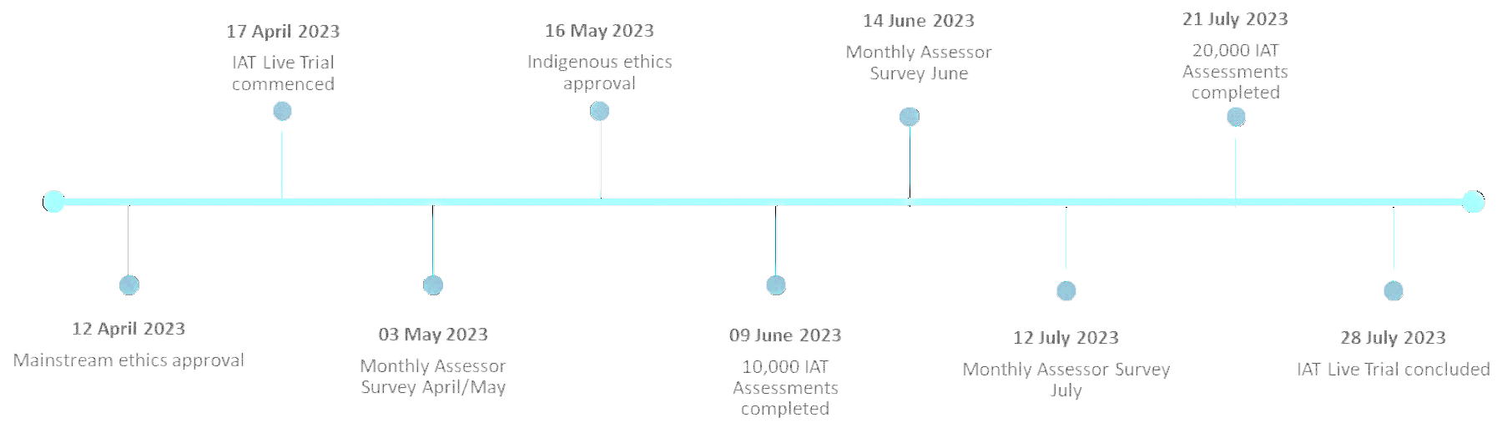

## Ethics applications

With the IAT Live Trial requiring the participation of a diverse demographic of older people, approval to conduct the project was sought from 3 registered human research ethics committees:

* Bellberry Limited (Bellberry)
* Australian Institute of Aboriginal and Torres Strait Islander Studies (AIATSIS)
* Aboriginal Health Council of South Australia (AHCSA).

The timelines associated with the application, approval, and notification process for each of the committees is outlined in the Table 5 below.

#### Table : Ethics timeline

| **Timeline of activities** | **Bellberry** | **AIATSIS** | **AHCSA** |
| --- | --- | --- | --- |
| Date of application | 07/03/23 | 21/02/23 | 05/04/23 |
| Date of resubmission | - | 18/03/23 | - |
| Date of approval |  |  |  |
| Conditional (no assessments with First Nations older people) | 12/04/23 | - | - |
| Unconditional | 20/06/23 | 12/07/23 | 26/05/23 |
| **\*Premature use of IAT with First Nations older people** |  |  |  |
| Date of notification | 02/05/23 | 30/06/23 | 01/06/23 |
| Date of acknowledgement by committee | 02/05/23 | 12/07/23 | 09/08/23 |
| **\*Extension of time 1 (end of July 2023)** |  |  |  |
| Date of notification | 08/06/23 | 12/07/23 | 01/06/23 |
| Date of acknowledgement by committee | 12/06/23 | 12/07/23 | 01/06/23 |
| **Extension of time 2 (end of September 2023)** |  |  |  |
| Date of notification | 27/07/23 | 27/07/23 | 27/07/23 |
| Date of acknowledgement by committee | 01/08/23 | 03/08/23 | 09/08/23 |

*It should be noted that no modifications can be made to an application until after a committee has made its determination. As such, the dates on which each of the ethics committees were notified of the premature use of the IAT with First Nations older people, as well as the initial time extension, differed because of the different stages the application assessment processes were at.

# Premature use refers to the 32 IAT assessments with older Aboriginal and Torres Strait Islander older people that were completed prior to approval being received from an Aboriginal Human Research Ethics Committee (AHREC). Data from these assessments was removed from the IAT Live Trial dataset.

To make sure older people participating in the IAT Live Trial were provided with psychologically and culturally safe environments during assessments, assessor followed the methodologies and approaches documented in each of the ethics applications, and as approved by each of the registered Human Research Ethics Committees (HREC). In addition to protocols specifically designed for the IAT Live Trial (e.g. Participant Information Forms and Consent Forms), the protocols used as part of the NSAF process were also followed, along with the specific directions and conditions of each of the HRECs.

In line with this, each committee were also advised that the IAT was used with First Nations clients prior to the attainment of the required ethics approval, and of the decision to extend the IAT Live Trial period.

Each of the committees acknowledged the premature use of the IAT and concurred that the remedial actions taken to address the use of the assessment tool prior to approval had been appropriate and that no further action was required other than to report the matter in the project completion reports. Final project completion reports will be submitted to each committee prior to the end of September 2023. A condition of ethical approval from Bellberry is that all IAT Live Trial electronic data is to be securely stored for 15 years after the IAT Live Trial has ended.

The IAT Live Trial data only reports on IAT assessments started on or after the 12 April 2023, the date on which ethics approval was received for non-First Nations clients, and on or after the 16 May 2023, the date on which approval was received for the inclusion of First Nations clients.

## Qualitative research data methodology

To capture feedback from the assessment workforce on the usability and effectiveness of the IAT, the department implemented 3 monthly assessor surveys sent over the months of May 2023, June 2023, and July 2023 that focused on:

* Service type recommendations
* IAT usability
* Allied health service referrals
* AT-HM recommendations
* IAT effectiveness for CALD older people and First Nations people
* Clarity of IAT questions for assessors
* Additional IAT training recommendations
* Additional feedback.

The contents of the monthly assessor surveys were designed by the department’s policy team to collect assessor feedback to analyse and refine the classification system to align to the needs of the client population post-IAT Live Trial. Monthly assessor surveys were provided as an anonymous and optional form of feedback for assessors to share their experiences of using the IAT in client assessments. The question set used in the monthly assessor surveys consisted of Likert scale, yes/no, and free-text questions. The question set was reviewed by the department’s policy team following the collection of responses from each survey. Minor updates were made to the question set in the June 2023 and July 2023 surveys to refine the collection of data. Appendix A: Qualitative Research Questions showcases these updates across the surveys.

Assessor feedback captured through the monthly assessor surveys, My Assessor Chat CoP, emails, and the Contact Centre has been themed into key feedback categories. Feedback themes and assessor responses are presented in Part B – Feedback and Insights.

As the feedback provided in the monthly assessor surveys was anonymous and the survey could be taken multiple times, feedback cannot be tied to the number of assessors who responded. We have referenced the number or times separate pieces of feedback was provided on one topic e.g., *10 Mentions or it was mentioned 10 times*. An assessor's response to a question can reference multiple feedback themes. Volume of feedback is presented as the number of instances of feedback received. Careful interpretation of volume as a measure of strength of response was required to distinguish between spontaneous feedback and feedback elicited by specific questions.

Quantitative and qualitative data presented in Part B – Feedback and Insights have different sources of information. Qualitative data is sourced from the free-text questions of the 3 monthly assessor surveys and other communication channels, whereas quantitative data is sourced from Likert scale and yes/no questions from the 3 monthly assessor surveys. Taking this into account, the number of mentions referenced in each section cannot be correlated to one another.

## Key Performance Indicators deep dive

As mentioned above, the IAT Live Trial has been managed, monitored, and evaluated in line with the following 6 KPIs:

1. Aim to complete 20,000 assessments
2. RAS versus ACAT split:
   1. RAS assessments: 60% of completed assessments (12,000)
   2. ACAT assessments: 40% of completed assessments (8,000)
3. Rural and Remote: 30% of completed assessments (6,000)
4. CALD: 20% of completed assessments (4,000)
5. First Nations older people: 5% of completed assessments (1,000)
6. In-hospital assessments: 30% of completed ACAT assessments (6,000).

KPIs were monitored throughout the IAT Live Trial period from 17 April 2023 to 28 July 2023. To support achieving representation of target demographics during the IAT Live Trial period, communication was tailored directly to AMOs to encourage increased representation of these demographics where possible. The results of the IAT Live Trial against the trial objectives are summarised in Figure 1.

Overall, the 22 participating AMOs exceeded the overall target of 20,000 completed assessments during the IAT Live Trial. KPIs relating to the proportions of RAS versus ACAT assessments and rural and remoteness were met or exceeded.

However, 3 demographic representations based KPIs were below target. The proportions of assessments completed with CALD, First Nations older people and ACAT assessments completed in a hospital setting were below target.

## Note on data currency

The data analysed and presented in this report is current as of the final PM report data extract obtained on **20 August 2023**, which includes assessment completion information as of **18 August** **2023,** which is beyond the end of the IAT Live Trial.

The PM report data is extracted from the Aged Care Data Warehouse for the purpose of the IAT Live Trial 3 times per week by the ITD.

A completed assessment is defined as having an IAT Status of Finalised and an NSAF Status of either Finalised / Undergoing Support / Support Plan Review.

For the purpose of monitoring the IAT Live Trial (and in this report) the following filters were applied to the PM report data:

* Filtered out any test records using the test names contained in the AMO field
* Filtered out any assessments started before 17 April 2023
* Filtered out any First Nations assessments started before 16 May 2023.

## Monitoring methodology of the key KPIs over the course of the IAT Live Trial

To support ongoing monitoring of KPIs during the IAT Live Trial the following methods were used:

* IAT snapshot report, 3 times weekly
* Power BI dashboard reporting, 3 times weekly
* Sprint planning and monitoring, approximately once per fortnight.

## IAT snapshot

The IAT snapshot was produced after each PM report was received from ITD. It is a high-level view of the overall progress of the IAT Live Trial for senior stakeholders within the department.

#### Table 6: Final IAT snapshot comparing PM reports received on 18 and 20 August 2023

|  |  |  |  |
| --- | --- | --- | --- |
| **IAT Status** | **NSAF Status** | **Count from previous report (18/08/2023)** | **Count from current report (20/08/2023)** |
| **Finalised** | **Finalised / Undergoing Support / Support Plan Review** | **21,999** | **22,002** |
| In Progress | 2 | 2 |
| Cancelled | 27 | 27 |
| Other | 30 | 27 |
| **In Progress** | Finalised / Undergoing Support / Support Plan Review | 21 | 21 |
| In Progress | 1 | 1 |
| Cancelled | 6 | 6 |
| **Cancelled** | Finalised / Undergoing Support / Support Plan Review | 349 | 352 |
| In Progress | 1 | 0 |
| Cancelled | 719 | 719 |
| Other | 3 | 1 |
| **Total** | | **23,158** | **23,158** |

Table 6 is taken from the most recent IAT snapshot distributed at the conclusion of IAT Live IAT Live Trial reporting. It compares assessment data from two consecutive PM reports, in this case, the current PM report was received on 20 August 2023 and previous PM report received on 18 August 2023. At this stage of the IAT Live Trial, IAT assessments were no longer available to assessors for updating[2], however, associated NSAF assessments could still be filled and modified.

Table 6 displays 21,999 completed assessments from the 18 August 2023 PM report and 22,002 completed assessments from the 20 August 2023 PM report. The 3 additional “completed” assessments observed were a result of updates in NSAF status to Finalised / Undergoing Support / Support Plan Review. Additionally, Table 6 also displays 349 IAT cancelled and NSAF status of Finalised / Undergoing Support / Support Plan Review from the 18 August 2023 PM report, this can be seen to increase by 3 to 352 in the 20 August 2023 PM report.

The data commentary provided in the IAT snapshots also included updates on data quality issues which were observed in the PM report and under investigation with ITD, for example, assessments missing location information.

## IAT Power BI dashboard reporting

The IAT Power BI dashboard is a bespoke interactive tool for monitoring the IAT Live Trial with a range of views detailing each KPI and filtering by date, jurisdiction, assessment status and AMO.

A non-interactive pdf version of the IAT Power BI dashboard was also included in each IAT snapshot.

#### Figure 5: IAT Power BI dashboard from the PM report received on the 20 August 2023

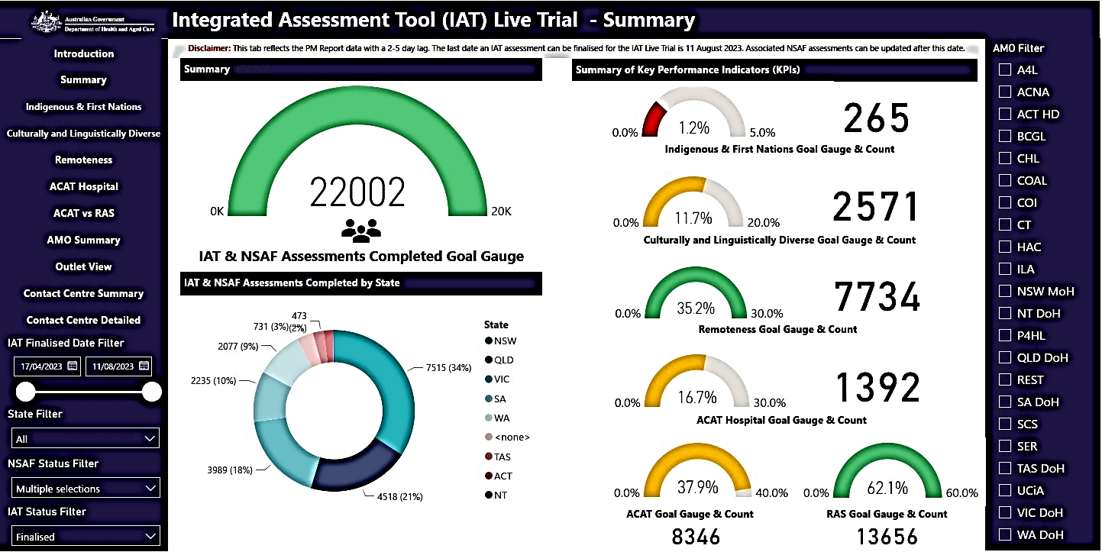

Figure 5 contains a screenshot of the summary page of the IAT Power BI dashboard (as of 18 August 2023) from the 20 August 2023 PM report and distributed with the final IAT snapshot) with gauge diagrams indicating progress toward the goal of 20,000 total assessments completed (top left) and each of the demographic representation KPIs (right).

## Sprint planning and monitoring

An agile, sprint-based project management methodology was used to support the IAT Live Trial. The IAT Live Trial was divided into 6 time periods known as “sprints” to monitor and communicate progress of the IAT Live Trial towards assessment completion KPI targets.

In each of these time periods a target for assessment completion was set by the department, informed by historical NSAF assessments. KPIs relating to First Nations and CALD were monitored, including with direct communications with specific AMOs. At the conclusion of each sprint, the IAT Live Trial project management team reflected on the success of the previous sprint in reaching those targets to distil learnings for planning and implementing subsequent sprints.

#### Table : Sprint - Assessment completion targets

|  |  |  |  |
| --- | --- | --- | --- |
| **Sprint number** | **Date start – Date end** | **Target % of contracted completed assessments** | **Actual % of contracted completed assessments** |
| Before | 17/04-25/04/2023 | 5% | 3.60% |
| Sprint 1 | 26/04-09/05/2023 | 10% | 9.69% |
| Sprint 2 | 10/05-24/05/2023 | 10% | 13.56% |
| Sprint 3 | 25/05-07/06/2023 | 15% | 12.68% |
| Sprint 4 | 08/06-21/06/2023 | 15% | 12.21% |
| Sprint 5 | 22/06-05/07/2023 | 15% | 13.25% |
| Sprint 6* | 06/07-28/07/2023 | 18,000 | 26.13% |
| After | 29/07-11/08/2023 | - | 0.31% |

*The goal for Sprint 6 was a total of 18,000 completed assessments rather than a percentage of contracted assessments. At the end of Sprint 6, the actual total number of a completed assessments was 21,928, with 6,291 completed assessments during Sprint 6.

Table 7 contains a summary of the timing of each sprint period, completed assessment target volumes and actual completed assessment volumes relative to the number of contracted assessments. This is also represented visually in Figure 6 below.

In sprints 3 to 5, the number of actual completed assessments was slightly below the 15% targets. Sprint 6 was extended to align with the revised end date of the IAT Live Trial (28 July 2023) and higher volumes of completed assessments were observed, exceeding the Sprint target of 18,000 total completed assessments. The Sprint “After” covers the period after which no new IATs could be initiated, but some were finalised, adding to the total.

#### Figure 6: Cumulative completed assessments by week with Sprint targets

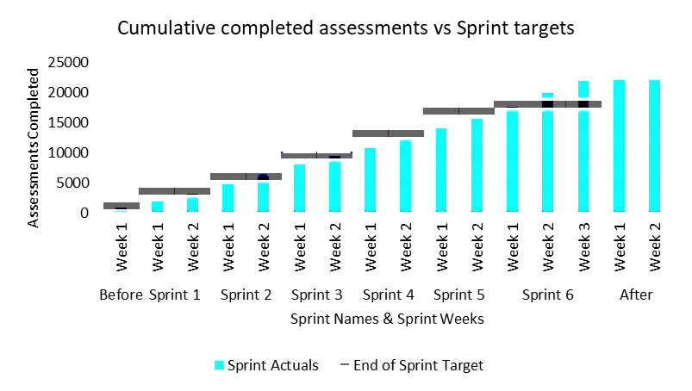

## KPI derivation and comparison

The KPI targets for the IAT Live Trial were selected by the department and mainly based on historical NSAF assessment representation. For example, the selection of 30% rural and remote assessments was based on typical representation of rural and remote clients in NSAF assessments. The same can be said for approximately 20% CALD clients and 30% of ACAT completed assessments in a hospital setting. The exception to this is the target of 5% First Nations assessments, which is approximately double the representation in NSAF assessments of 2.1% as shown in Table 17a.

The representation of each of these demographics in historical NSAF assessments varies for the AMOs participating in the IAT Live Trial due to their operational locations and specialisations. As such, it is important to compare performance against both the IAT Live Trial KPI targets and historical NSAF assessments for each AMO. For this comparison, NSAF data from April to June 2022 (aligning to approximately the same period as the IAT Live Trial in the previous year) is used as a reference point in the following sections of this report. In Tables and Figures it is referred to as “NSAF dataset”.

## Evaluation and analysis of each KPI

#### Figure 7: Total completed assessments

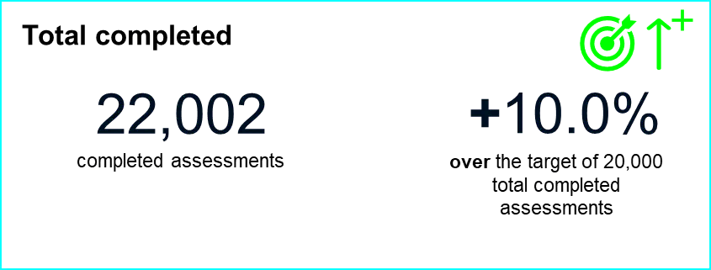

A total of **22,002 assessments were completed** during the IAT Live Trial. This is **10.0% more than the target of 20,000** total completed assessments throughout the IAT Live Trial.

## Assessments completed over the IAT Live Trial period

The IAT Live Trial was conducted over the period from 17 April 2023 to 28 July 2023 inclusive, with only IAT assessments in progress available to be completed until 11 August 2023. The end of the IAT Live Trial had no impact on assessor’s ability to complete NSAF assessments.

#### Figure 8: Assessments completed over the IAT Live Trial period

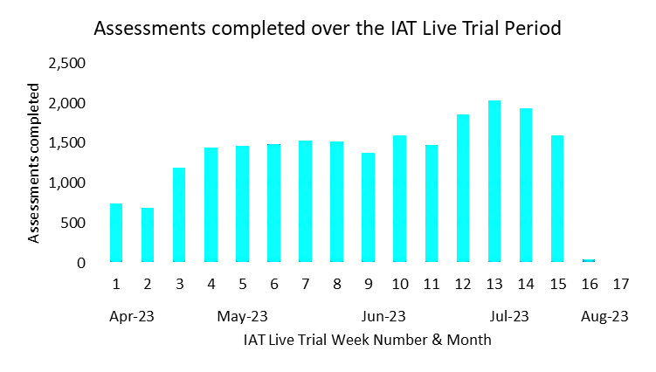

From Figure 8 above, there are some clear trends on a month to month basis.

* In April 2023, the first two weeks of the IAT Live Trial, assessment volumes were relatively low, with a number of technology issues impacting assessors
* In May 2023, assessments completed increased from April 2023 reaching a steady weekly number of assessments completed that continued into June 2023
* In July 2023, there was another increase in weekly assessments completed that coincided with the new financial year. It was communicated by several AMOs that pressure to complete allocated NSAF assessments outside the IAT Live Trial before 30 June 2023 was limiting their capacity to complete IAT assessments
* An increase in completed assessment volumes from July 2023 was observed most strongly for the following AMOs:
  + Aspire4Life (A4L)
  + Serendipity (WA) Pty Ltd (SER)
  + Community Options Australia Limited (COAL)
  + Department of Health QLD (QLD DoH)
* In August 2023, as expected, there was an immediate drop off in assessment completion, as no new IATs were started after 28 July 2023.

## IAT Cancelled

The absolute number of IAT assessments cancelled in each week of the IAT Live Trial was relatively consistent, typically around 60 to 80 assessments per week. However, the total number of assessments completed each week tended to increase over time, meaning the underlying “rate of cancellation” decreased through the duration of the IAT Live Trial. This is shown in Figure 9, where the proportion of IAT assessments cancelled is plotted for each week of the IAT Live Trial.

High cancellation rates at the beginning of the IAT Live Trial were also driven by data capture issues in the IAT assessment application, resulting in assessors abandoning their IAT assessments. This is supported by feedback from assessors using both the My Assessor chat CoP and IAT Live Trial contact centre to raise technology issues as discussed in the Technology Section (Part B – IAT Content Feedback – Technology). The main data capture issues included a data retention error that prevented assessment data from transferring from the IAT to the NSAF and an issue where the submit button for the IAT was not visible.

In total there were 1,072 IATs cancelled during the IAT Live Trial representing 4.6% of all IAT assessments started during the IAT Live Trial. No new IAT assessments were started after 28 July 2023, as such, no cancellations are observed in August 2023 in Figure 9.

#### Figure 9: Proportion of IAT assessments cancelled over IAT Live Trial period

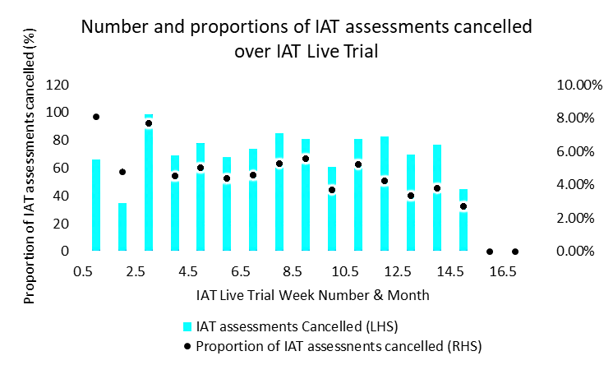

## AMO breakdown

Analysis in the following sections is broken down by AMO.

Table 8 and Figure 10 display the number of assessments completed by each AMO compared to the volume of assessments those AMOs were contracted to complete in the IAT Live Trial. The AMOs that participated in the IAT Live Trial vary in size, and therefore had contracted assessment volumes agreed with the department on a case-by-case basis to reflect their individual size and capacity to participate in the IAT Live Trial.

Those AMOs that completed more assessments have a greater effect on the overall KPIs measured throughout the IAT Live Trial. In particular, the two AMOs with most assessments completed, **Victorian Department of Health (VIC DoH)** and **NSW Ministry of Health (NSW MoH)**, represent 35.4% of total assessments completed.

Overall, as showcased in Table 8, 91.4% of total contracted assessments were completed. Out of the total 22 AMOs participating, 13 AMOs exceeded their contracted assessment volumes by the end of the IAT Live Trial.

#### Table : Percentage of completed contracted assessments

|  |  |  |  |
| --- | --- | --- | --- |
| **AMO** | **Assessments completed** | **Assessments contracted** | **% of contract completed** |
| VIC DoH | 4,086 | 5,308 | **77.0%** |
| NSW MoH | 3,705 | 3,411 | **108.6%** |
| ACNA | 2,156 | 2,119 | **101.7%** |
| HAC | 2,067 | 2,371 | **87.2%** |
| A4L | 1,876 | 1,671 | **112.3%** |
| SER | 1,483 | 1,460 | **101.6%** |
| QLD DoH | 1,242 | 2,098 | **59.2%** |
| SCS | 910 | 968 | **94.0%** |
| CHL | 812 | 506 | **160.5%** |
| SA DoH | 772 | 801 | **96.4%** |
| COAL | 593 | 795 | **74.6%** |
| REST | 524 | 519 | **101.0%** |
| WA DoH | 382 | 679 | **56.3%** |
| P4HL | 281 | 225 | **124.9%** |
| CT | 217 | 153 | **141.8%** |
| COI | 196 | 139 | **141.0%** |
| ILA | 159 | 155 | **102.6%** |
| UCiA | 149 | 223 | **66.8%** |
| TAS DoH | 145 | 207 | **70.0%** |
| ACT HD | 112 | 102 | **109.8%** |
| BCGL | 102 | 96 | **106.3%** |
| NT DoH | 33 | 56 | **58.9%** |
| **Total** | **22,002** | **24,062** | **91.4%** |

Figure 10: Completed assessments by AMO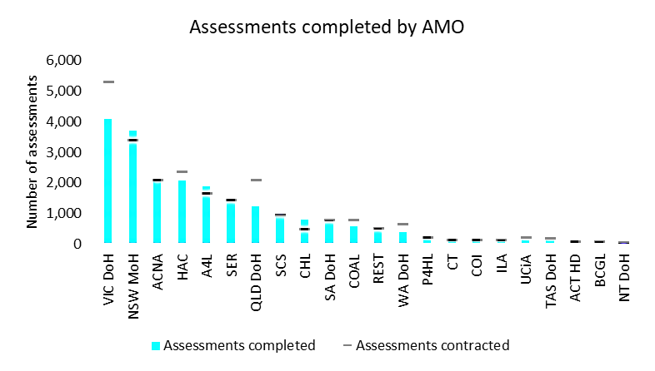

#### Figure 11: RAS versus ACAT assessments

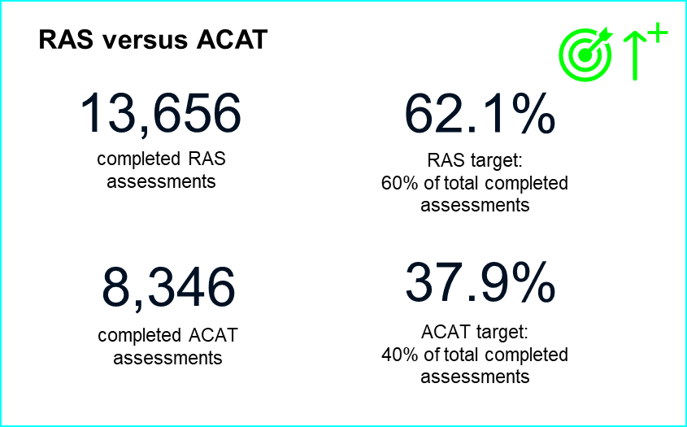

Of the 22,002 assessments completed during the IAT Live Trial, 13,656 were RAS assessments, while the remaining 8,346 were ACAT assessments. This equates to 62.1% RAS and 37.9% ACAT, which is consistent with the target ratio of 60% RAS and 40% ACAT.

### AMO Breakdown

Table 9 provides a breakdown of completed assessments grouped by AMOs which perform ACAT assessments, RAS assessments, or both.

#### Table 9: Completed RAS versus ACAT assessments

|  |  |  |  |
| --- | --- | --- | --- |
| **AMO type** | **AMO** | **ACAT assessments** | **RAS assessments** |
| ACAT | NSW MoH | 3,705 | 0 |
| QLD DoH | 1,242 | 0 |
| SA DoH | 772 | 0 |
| WA DoH | 382 | 0 |
| TAS DoH | 145 | 0 |
| ACT HD | 112 | 0 |
| NT DoH | 33 | 0 |
| RAS | HAC | 0 | 2,067 |
| A4L | 0 | 1,876 |
| SER | 0 | 1,483 |
| SCS | 0 | 910 |
| CHL | 0 | 812 |
| COAL | 0 | 593 |
| REST | 0 | 524 |
| P4HL | 0 | 281 |
| CT | 0 | 217 |
| COI | 0 | 196 |
| ILA | 0 | 159 |
| UCiA | 0 | 149 |
| BCGL | 0 | 102 |
| ACNA | 0 | 2,156 |
| ACAT & RAS | VIC DoH | 1,955 | 2,131 |
|  | **Total** | **8,346** | **13,656** |
|  | **Proportion** | **37.9%** | **62.1%** |

## Rural and remote assessments

For the purposes of monitoring IAT Live Trial assessments, rural and remote assessments are defined as those taking place in locations with MMM2-7 remoteness.

#### Figure 12: Rural and remote number and percentage of completed assessments

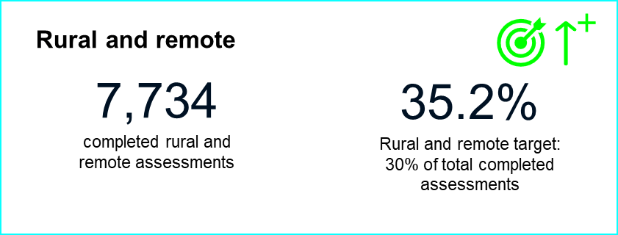

Of the 22,002 assessments completed during the IAT Live Trial, 7,734 have been identified as completed with clients located in MMM 2 to 7 areas. This equates to 35.2% of assessments which is above the KPI target of 30%.

Table 10 details the number of completed assessments by each individual MMM category. The 35.2% of assessments classified as rural and remote were spread primarily across MMM2-5 areas with a small number of assessments completed in very remote MMM6-7 areas.

Of the remaining 64.8% of assessments, 61.5% were completed in MMM1 areas. Incorrect location inputs or addresses not contained in the database have resulted in 734 (3.3%) of the completed assessments missing any meaningful location data, therefore the remoteness of those assessments cannot be identified.

#### Table 10: Completed assessments by MMM

|  |  |  |
| --- | --- | --- |
| **Modified Monash Model (MMM)** | **Completed assessments** | **Percentage** |
| 1 | 13,534 | 61.51% |
| 2 | 1,848 | 8.40% |
| 3 | 2,414 | 10.97% |
| 4 | 1,228 | 5.58% |
| 5 | 1,975 | 8.98% |
| 6 | 209 | 0.95% |
| 7 | 60 | 0.27% |
| Missing | 734 | 3.34% |
| **Total** | **22,002** | **100%** |

### AMO breakdown

The following table provides a breakdown of MMM 2-7 assessments by AMO. The representation of MMM 2-7 assessments by AMO is highly dependent on the areas (and populations) in which each AMO operates. For most of Northern Territory Department of Health (NT DoH), Tasmanian Department of Health (TAS DoH) and Care Tasmania (CT) assessments are in MMM 2-7.

#### Table 11: Completed rural and remote assessments

| **AMO** | **MMM2-7 completed assessments** | **All completed assessments** | **MMM2-7 (%) of completed assessments** | **Assessments missing location** |
| --- | --- | --- | --- | --- |
| VIC DoH | 1,153 | 4,086 | **28.2%** | 97 (2.4%) |
| NSW MoH | 1,604 | 3,705 | **43.3%** | 49 (1.3%) |
| ACNA | 504 | 2,156 | **23.4%** | 72 (3.3%) |
| HAC | 1,209 | 2,067 | **58.5%** | 63 (3.0%) |
| A4L | 730 | 1,876 | **38.9%** | 134 (7.1%) |
| SER | 681 | 1,483 | **45.9%** | 124 (8.4%) |
| QLD DoH | 686 | 1,242 | **55.2%** | 16 (1.3%) |
| SCS | 209 | 910 | **23.0%** | 35 (3.8%) |
| CHL | 15 | 812 | **1.8%** | 48 (5.9%) |
| SA DoH | 113 | 772 | **14.6%** | 10 (1.3%) |
| COAL | 121 | 593 | **20.4%** | 39 (6.6%) |
| REST | 82 | 524 | **15.6%** | 7 (1.3%) |
| WA DoH | 63 | 382 | **16.5%** | 5 (1.3%) |
| P4HL | 36 | 281 | **12.8%** | 2 (0.7%) |
| CT | 206 | 217 | **94.9%** | 11 (5.1%) |
| COI | 2 | 196 | **1.0%** | 3 (1.5%) |
| ILA | 0 | 159 | **0.0%** | 11 (6.9%) |
| UCiA | 142 | 149 | **95.3%** | 7 (4.7%) |
| TAS DoH | 145 | 145 | **100.0%** | 0 (0.0%) |
| ACT HD | 0 | 112 | **0.0%** | 0 (0.0%) |
| BCGL | 1 | 102 | **1.0%** | 0 (0.0%) |
| NT DoH | 32 | 33 | **97.0%** | 1 (3.0%) |
| **Total** | **7,734** | **22,002** | **35.2%** | **734 (3.3%)** |

#### Figure 13: CALD assessments

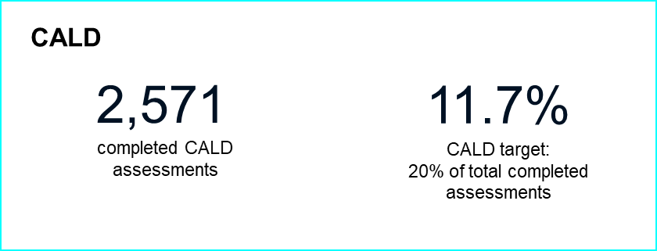

Of the 22,002 assessments completed during the IAT Live Trial, 2,571 were CALD older people. This equates to 11.7% of assessments, below the KPI target of 20%.

CALD older people are also under-represented with respect to historical NSAF assessments, indicating potential sample bias in the IAT Live Trial dataset which has resulted in fewer CALD older people participating or sub-demographics of CALD older people not participating in the IAT Live Trial.

This is also consistent with feedback provided by assessors and AMOs via the My Assessor chat CoP and in monthly assessor surveys. The key items highlighted through these channels likely to impact the CALD representation KPI included:

* Reluctance from CALD older people to participate in the IAT Live Trial, often due to the additional time required for an IAT assessment or difficulty understanding why they would take a longer assessment
* Concerns with the suitability of cognition assessment tools and the IAT more broadly for older people with CALD backgrounds, particularly those requiring translation using an interpreter.

A need for additional time considerations and booking for interpreter-led assessments, as assessors requiring translation support require longer assessment bookings. Further analysis of the demographic and clinical characteristics of CALD older people participating in the IAT Live Trial compared to historical NSAF data could be used to identify the extent and details of the underlying sample bias in the IAT Live Trial dataset with respect to CALD older people.

### AMO breakdown

Table 12 and Figure 14 provide a breakdown of completed assessments for CALD older people by AMO. This is compared to the representation of CALD older people in April to June 2022 NSAF assessments for each AMO.

The under-representation of CALD older people in comparison to the NSAF dataset is present in the assessments of every AMO except Community Options Australia Limited (COAL) and Uniting Communities Inc. (UCiA). This implies that the sample bias present in the IAT Live Trial dataset is consistent across assessments completed by all AMOs (i.e. not driven by particular AMOs) and is also consistent with feedback provided by assessors and AMOs.

#### Table 12: Completed CALD assessments

|  |  |  |  |  |  |
| --- | --- | --- | --- | --- | --- |
| **AMO** | **CALD completed assessments** | **Completed assessments** | **CALD (%) - Trial** | **CALD (%) - NSAF dataset** | **Difference** |
| VIC DoH | 610 | 4,086 | **14.9%** | **32.5%** | **-17.6%** |
| NSW MoH | 438 | 3,705 | **11.8%** | **24.0%** | **-12.2%** |
| ACNA | 232 | 2,156 | **10.8%** | **18.3%** | **-7.5%** |
| HAC | 215 | 2,067 | **10.4%** | **17.9%** | **-7.5%** |
| A4L | 189 | 1,876 | **10.1%** | **13.4%** | **-3.3%** |
| SER | 180 | 1,483 | **12.1%** | **14.8%** | **-2.7%** |
| QLD DoH | 57 | 1,242 | **4.6%** | **13.0%** | **-8.4%** |
| SCS | 31 | 910 | **3.4%** | **11.3%** | **-7.9%** |
| CHL | 218 | 812 | **26.8%** | **42.0%** | **-15.2%** |
| SA DoH | 102 | 772 | **13.2%** | **22.0%** | **-8.8%** |
| COAL | 149 | 593 | **25.1%** | **23.7%** | **1.4%** |
| REST | 42 | 524 | **8.0%** | **18.4%** | **-10.4%** |
| WA DoH | 24 | 382 | **6.3%** | **20.1%** | **-13.8%** |
| P4HL | 23 | 281 | **8.2%** | **18.9%** | **-10.7%** |
| CT | 1 | 217 | **0.5%** | **7.9%** | **-7.4%** |
| COI | 8 | 196 | **4.1%** | **16.7%** | **-12.6%** |
| ILA | 9 | 159 | **5.7%** | **20.3%** | **-14.7%** |
| UCiA | 20 | 149 | **13.4%** | **6.4%** | **7.0%** |
| TAS DoH | 3 | 145 | **2.1%** | **8.8%** | **-6.7%** |
| ACT HD | 6 | 112 | **5.4%** | **25.5%** | **-20.2%** |
| BCGL | 11 | 102 | **10.8%** | **25.9%** | **-15.1%** |
| NT DoH | 3 | 33 | **9.1%** | **13.5%** | **-4.4%** |
| **Total** | **2,571** | **22,002** | **11.7%** | **21.7%** | **-10.0%** |

Figure 14: CALD representation by AMO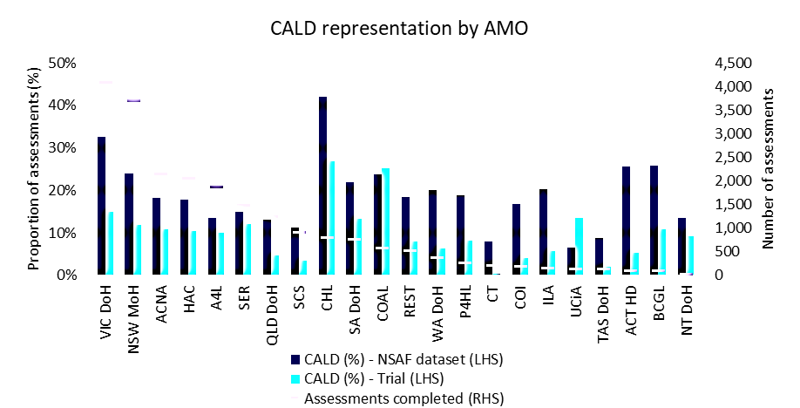

#### Figure 15: Interpreter breakdown

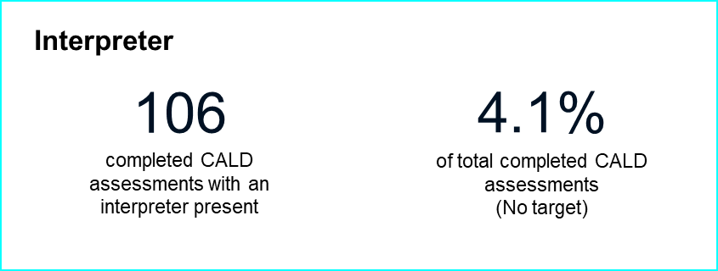

Of the 2,571 CALD assessments completed during the IAT Live Trial, 106 have been completed with an interpreter present. This represents 4.1% of completed CALD assessments, however there is no current KPI target and no identification of assessments with an interpreter present in the NSAF dataset.

As noted above, assessors and AMOs encountered issues relating to use of the IAT with CALD older people, specifically relating to the use of an interpreter. It is therefore likely that interpreter assessments are under-represented among the CALD demographic of IAT Live Trial assessments. Again, further analysis may be conducted on historical NSAF data to identify the extent of this likely under-representation.

### Interpreter AMO and AMO outlet breakdown

Table 13, Table 14 and Table 15 provide a breakdown of completed assessments for CALD older people with interpreter assistance by AMO and the main contributing AMO outlets.

#### Table : CALD with interpreter assistance by AMO

|  |  |
| --- | --- |
| **AMO** | **CALD with interpreter assistance** |
| NSW MoH | 50 |
| VIC DoH | 38 |
| HAC | 8 |
| SER | 3 |
| CHL | 2 |
| SA DoH | 2 |
| ACNA | 1 |
| COAL | 1 |
| P4HL | 1 |
| **Total** | **106** |

#### Table : CALD with interpreter assistance by VIC DoH outlets

|  |  |
| --- | --- |
| **VIC DOH Outlets** | **CALD with interpreter assistance** |
| North Eastern Metro-St Vincents ACAS | 9 |
| Kingston Aged Care Assessment Service | 7 |
| Bundoora ACAS | 6 |
| Caulfield ACAS | 3 |
| Central East ACAS | 3 |
| Greater Bendigo City Councils | 2 |
| The City of Greater Dandenong | 2 |
| Heidelberg ACAS | 1 |
| mecwacare Regional Assessment Services | 1 |
| Melbourne City Council | 1 |
| Monash City Council | 1 |
| Mt Eliza Aged Care Assessment Services | 1 |
| Wyndham City Council | 1 |
| **Total** | **38** |

#### Table : CALD with interpreter assistance by NSW MoH outlets

|  |  |
| --- | --- |
| **NSW MoH Outlets** | **CALD with interpreter assistance** |
| South Western Sydney LHD ACAT | 24 |
| Northern Sydney LHD ACAT | 11 |
| Sydney Inner West ACAT | 11 |
| Western Sydney LHD ACAT | 4 |
| **Total** | **50** |

#### Table : Interpreter breakdown by language

|  |  |
| --- | --- |
| **Interpreter Language** | **Number of assessments** |
| Mandarin | 18 |
| Greek | 17 |
| Arabic | 16 |
| Cantonese | 13 |
| Italian | 12 |
| Korean | 4 |
| Vietnamese | 4 |
| Karen | 3 |
| Macedonian | 3 |
| Polish | 3 |
| Farsi (Persian) | 2 |
| Russian | 2 |
| Croatian | 1 |
| Hungarian | 1 |
| Khmer | 1 |
| Maori | 1 |
| Portuguese | 1 |
| Serbian | 1 |
| Tamil | 1 |
| Other | 2 |
| **Total** | **106** |

## First Nations assessments

Of the 22,002 assessments completed during the IAT Live Trial, 265 were First Nations older people. This equates to 1.2% of assessments, below the KPI target of 5%.

#### Figure 16: Number of completed First Nations assessments

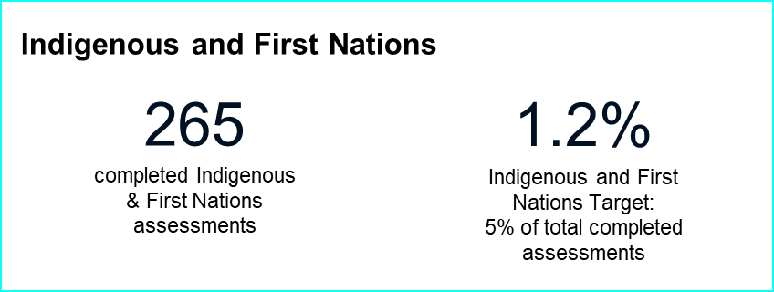

First Nations Ethics approval was granted on 26 May 2023 for assessments starting on or after 16 May 2023. This means that assessments started before this date have been excluded from the IAT Live Trial dataset. This can be seen in Figure 17, showing the number of First Nations assessments completed in each week of the IAT Live Trial.

#### Figure 17: First Nations assessments completed over the IAT Live Trial period

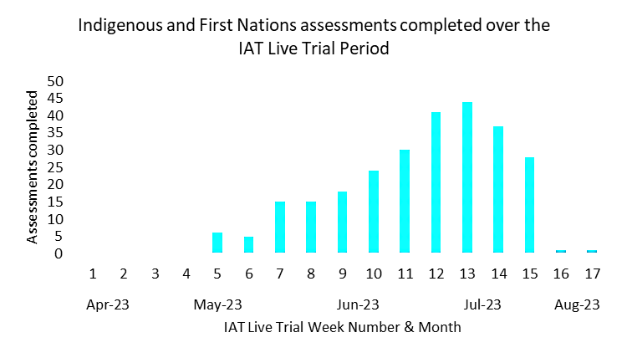

After ethics approval was granted for the inclusion of First Nations older people, the volume of assessments was initially low as the ethics outcome was communicated to AMOs and the AMOs gradually scheduled IAT assessments with First Nations older people. This approval was promptly communicated to AMOs through a targeted communications approach, providing ethics approval notification to all IAT Live Trial participants via the My Assessor chat CoP, target email notification and Fortnightly assessor check-in call reminders. This targeted communication approach aided in the increased representation of First Nations older people in the IAT Live Trial, encouraging AMOs to increase First Nations assessments. The effect of this is seen in the increasing assessment volumes through June and July 2023.

The largest volume of First Nations assessments completed in a single week was 44 in July 2023 where approximately 2.17% of completed assessments were with First Nations older people. Whilst this is below the KPI target of 5%, it is reasonably close to the representation in the NSAF dataset of 2.1%.

Feedback provided by assessors and AMOs via the My Assessor chat CoP and in monthly assessor surveys indicated additional challenges with performing First Nations assessments. The key items highlighted through these channels likely to have impacted the First Nations representation KPI included:

* Cultural and logistical barriers to IAT Live Trial participation, including the length of the IAT assessment and IAT consent processes
* Dissatisfaction from assessors on the effectiveness and appropriateness of the IAT tailoring to First Nations older people
* Certain sections, including the DSSI, of the IAT were not suitable for this demographic.

Table 17 and Table 18 contain a summary of First Nations assessments completed by State and MMM. Where no location was recorded in the PM report, the State and MMM for those assessments has been inferred based on other First Nations assessments performed by the same AMO outlet.

#### Table 17: Completed First Nations assessments by state[3]

|  |  |
| --- | --- |
| **State** | **First Nations completed assessments** |
| NSW | 106 |
| QLD | 72 |
| WA | 26 |
| VIC | 25 |
| SA | 18 |
| TAS | 7 |
| NT | 6 |
| ACT | 5 |
| **Total** | **265** |

#### Table 18: Completed First Nations assessments by MMM5

|  |  |
| --- | --- |
| **MMM** | **First Nations completed assessments** |
| 1 | 83 |
| 2 - 3 | 89 |
| 4 - 7 | 93 |
| **Total** | **265** |

### AMO breakdown

Table 17a and Figure 18 provide a breakdown of completed assessments for First Nations older people by AMO. This is compared to the representation of First Nations older people in April to June 2022 NSAF assessments for each AMO.

Similar to CALD assessments in the previous section, First Nations older people appear under-represented across the majority of AMOs. However, this is impacted by both the initial delay in ethics approval to conduct assessments with First Nations older people as well as the lag in AMOs starting to conduct assessments with First Nations older people after ethics approval was granted.

#### Table 17a: Completed First Nations assessments

|  |  |  |  |  |  |
| --- | --- | --- | --- | --- | --- |
| **AMO** | **First Nations completed assessments** | **Completed assessments** | **First Nations (%) - Trial** | **First Nations (%) - NSAF dataset** | **Difference** |
| VIC DoH | 25 | 4,086 | 0.6% | 0.6% | **0.0%** |
| NSW MoH | 40 | 3,705 | 1.1% | 2.2% | **-1.1%** |
| ACNA | 11 | 2,156 | 0.5% | 2.9% | **-2.4%** |
| HAC | 40 | 2,067 | 1.9% | 3.4% | **-1.4%** |
| A4L | 32 | 1,876 | 1.7% | 2.1% | **-0.4%** |
| SER | 23 | 1,483 | 1.6% | 3.5% | **-1.9%** |
| QLD DoH | 28 | 1,242 | 2.3% | 2.8% | **-0.5%** |
| SCS | 6 | 910 | 0.7% | 1.5% | **-0.8%** |
| CHL | 3 | 812 | 0.4% | 1.7% | **-1.4%** |
| SA DoH | 12 | 772 | 1.6% | 2.0% | **-0.5%** |
| COAL | 13 | 593 | 2.2% | 1.8% | **0.4%** |
| REST | 1 | 524 | 0.2% | 1.3% | **-1.1%** |
| WA DoH | 15 | 382 | 3.9% | 3.2% | **0.8%** |
| P4HL | 1 | 281 | 0.4% | 3.9% | **-3.5%** |
| CT | 4 | 217 | 1.8% | 2.4% | **-0.5%** |
| COI | 1 | 196 | 0.5% | 1.2% | **-0.7%** |
| ILA | 1 | 159 | 0.6% | 0.3% | **0.4%** |
| UCiA | 3 | 149 | 2.0% | 5.2% | **-3.2%** |
| TAS DoH | 2 | 145 | 1.4% | 2.8% | **-1.4%** |
| ACT HD | 1 | 112 | 0.9% | 0.8% | **0.1%** |
| BCGL | 0 | 102 | 0.0% | 1.7% | **-1.7%** |
| NT DoH | 3 | 33 | 9.1% | 33.3% | **-24.2%** |
| **Total** | **265** | **22,002** | **1.2%** | **2.1%** | **-0.9%** |

#### Figure 18: First Nations representation by AMOFigure 18 provides a breakdown of completed assessments for First Nations older Australians by AMO. This is compared to the representation of First Nations older Australians in April to June 2022 NSAF assessments for each AMO.

## Hospital ACAT assessments

Of the 8,344 ACAT assessments completed during the IAT Live Trial, 1,392 were conducted in a hospital setting. This equates to 16.7% of assessments which is below the KPI target of 30%.

#### Figure 19: Completed hospital ACAT assessments

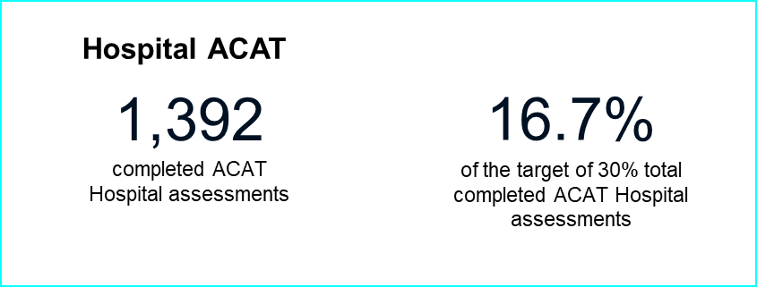

Hospital ACAT assessments are also under-represented with respect to historical NSAF assessments, suggesting some level of sample bias in the IAT Live Trial dataset which has resulted in fewer assessments being conducted in a hospital setting.

The key issues highlighted by assessors and AMOs via the My Assessor Chat CoP and in monthly assessor surveys likely to have impacted the hospital ACAT assessments KPI included:

* Some assessors could not complete all sections of the IAT, such as the Function section, when undertaking hospital assessments.
* Assessment length, client fatigue and disinterest in completing the IAT assessment.

Further analysis on the demographic and clinical characteristics of clients assessed in a hospital setting in the IAT Live Trial compared to historical NSAF data may be useful to identify the underlying reasons behind under-representation in the IAT Live Trial sample.

### AMO breakdown

Figure 20 and Table 18 provide a breakdown of ACAT assessments completed in a hospital setting by AMO. This is compared to the representation in April to June 2022 NSAF assessments.

Similar to CALD assessments in the previous section, assessments in a hospital setting appear under-represented across almost all ACAT AMOs compared to historical NSAF assessments, suggesting some systematic factors may be present. Note that while Northern Territory Department of Health (NT DoH) completed more that 30% of assessments in a hospital setting, this was with respect to a small number of total assessments completed.

#### Table 18: Completed hospital finalised assessments

|  |  |  |  |  |  |
| --- | --- | --- | --- | --- | --- |
| **AMO** | **ACAT in hospital assessments** | **ACAT assessments** | **ACAT in hospital %** | **ACAT in-hospital (%) – NSAF dataset** | **Difference** |
| NSW MoH | 648 | 3,705 | 17.5% | 28.0% | **-10.5%** |
| VIC DoH | 334 | 1,955 | 17.1% | 24.6% | **-7.5%** |
| QLD DoH | 130 | 1,242 | 10.5% | 24.7% | **-14.2%** |
| SA DoH | 156 | 772 | 20.2% | 28.7% | **-8.5%** |
| WA DoH | 69 | 382 | 18.1% | 25.7% | **-7.7%** |
| TAS DoH | 20 | 145 | 13.8% | 25.3% | **-11.5%** |
| ACT HD | 24 | 112 | 21.4% | **33.9%** | **-12.4%** |
| NT DoH | 11 | 33 | 33.3% | 30.9% | **2.4%** |
| **Total** | **1,392** | **8,346** | **16.7%** | **26.3%** | **-9.6%** |

#### Figure 20: ACAT in hospital representation by AMO

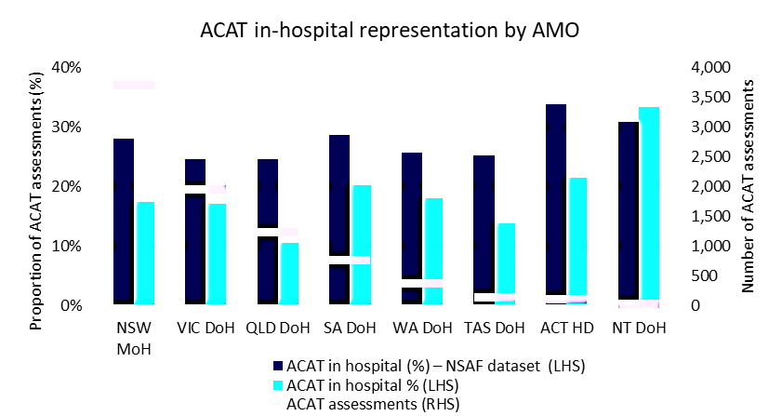

## Supporting participating AMOs

### IAT Live Trial communications

To support AMOs participating in the IAT Live Trial, several engagement channels were maintained with IAT Live Trial participants to support timely, clear, and consistent communications in relation to the IAT Live Trial. These channels included:

* The My Assessor chat CoP
* The IAT Live Trials email inbox
* Fortnightly assessor check-in calls
* Targeted AMO consultations

### My Assessor Chat CoP

The My Assessor Chat CoP was established to support assessors during the IAT Live Trial by providing a forum for sharing insights, accessing materials, and receiving regular updates on the IAT Live Trial. The Discourse platform was chosen to host the My Assessor chat CoP based on the department’s previous success using platform. The My Assessor chat CoP was introduced to facilitate engagement with the department by acting as a channel for the department to engage with assessors who offer different perspectives on relevant issues; provide feedback on the IAT Live Trial; and fostering an environment for assessors to ask questions and encourage relationship building, peer learning and knowledge sharing within and across the Aged Care sector and engagement and trust with the department.

### IAT Live Trial email

A shared IAT Live Trials Microsoft Outlook email account (IATLiveTrials@Health.gov.au) was also established for assessors to contact the department should they have any queries on the IAT Live Trial. The shared mailbox created an identity for the project and assisted the project team distributing critical work tasks.

### Fortnightly assessor check-in calls and consultations

Optional assessor Fortnightly check-in calls were established from June 2023 to increase engagement and support AMOs to achieve their contracted KPIs across the IAT Live Trial, including through targeted check-in consultations delivered by the IAT Live Trial project team. In the July 2023 period, 7 targeted check-in consultations were conducted. These AMOs were selected based upon criteria, including KPI completion rates (AMOs with lower and higher completion rates) and AMOs that were more likely to complete targeted assessments for key demographics such as First Nations and CALD older people.

### Communications metrics

During the IAT Live Trial, a total of 567 enquiries were received from IAT Live Trial participants. These enquiries were made up of 205 emails and 362 My Assessor chat CoP posts. At the commencement of the IAT Live Trial, assessors increasingly used communication channels to enquire about technology, ethics, and training enquiries. As assessor confidence grew throughout the IAT Live Trial, overall volumes of enquiries reduced, and assessors moved to providing further feedback and policy enquiries.

#### Figure 21: Communication metrics

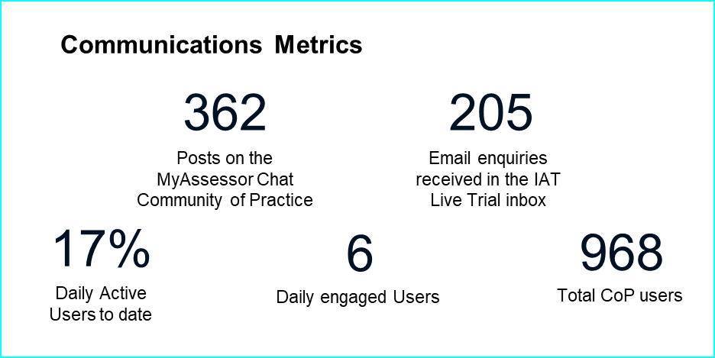

#### Figure 22: Total number of enquiries received during the IAT Live Trial

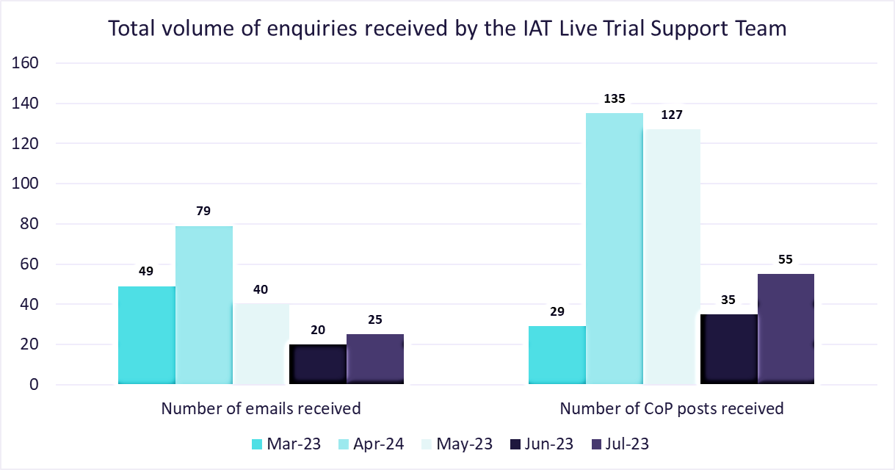

#### Figure 23: Breakdown by the type of enquiries

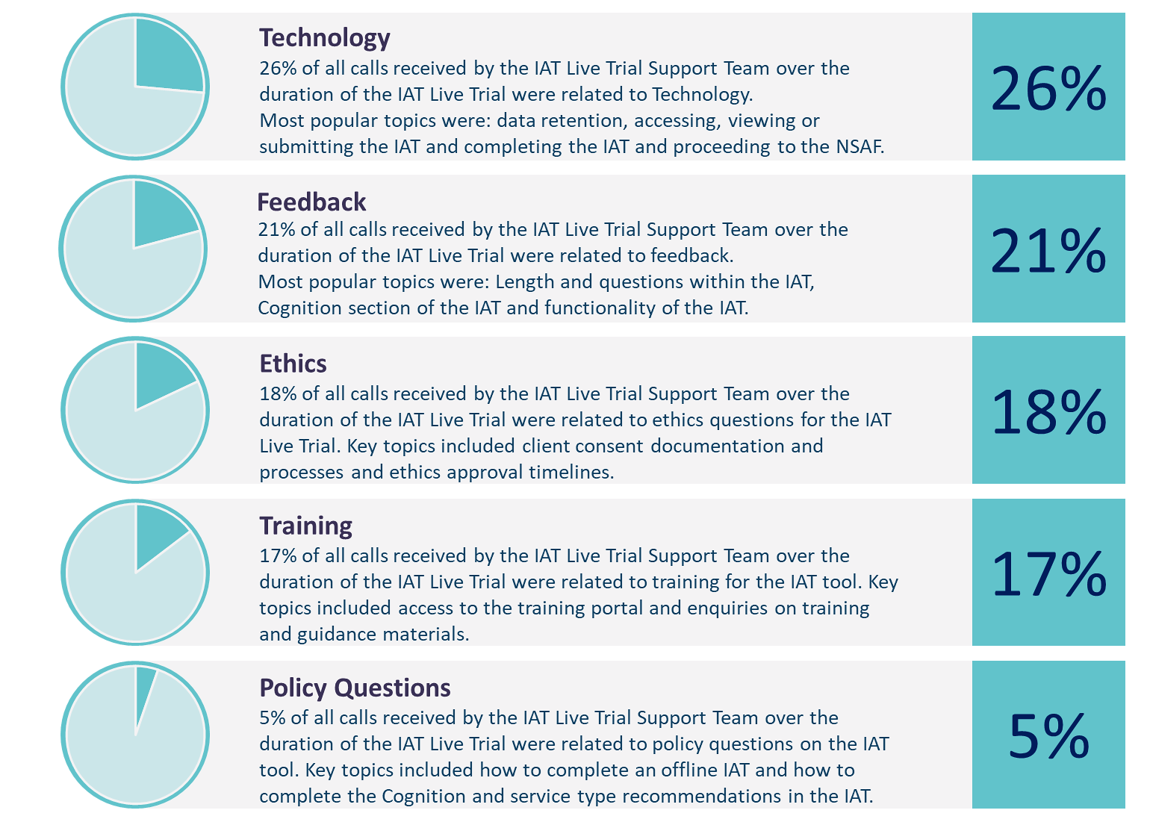

## Key themes

### Technology

Over the duration of the IAT Live Trial, enquiries relating to technology and technology errors were the most common topic received by the IAT Live Trial support team, totalling to 150 assessor enquiries. With large volume of enquiries relating to this topic, assessors were redirected towards the IAT Live Trial contact centre for designated technological support during the trial. When combined with IAT Live Trial contact centre efforts to resolve technology incidents, the volumes of enquiries relating to this topic declined towards the end of the trial.

#### Table : Volume of technology enquiries by month

|  | March 2023 | April 2023 | May 2023 | June 2023 | July  2023 | Total |
| --- | --- | --- | --- | --- | --- | --- |
| Data is not flowing from the IAT to NSAF correctly or data not saving correctly in the NSAF | 0 | 49 | 7 | 2 | 0 | 58 |
| Accessing, viewing, or submitting IAT | 2 | 11 | 3 | 1 | 9 | 26 |
| IT support enquiry | 1 | 1 | 1 | 0 | 6 | 9 |
| Assessor is experiencing general technology errors during the trial | 0 | 8 | 7 | 0 | 0 | 15 |
| Assessor unable to finalise the IAT questions and proceed to completing the NSAF | 0 | 5 | 15 | 2 | 1 | 23 |
| Assessor unable to connect to the My Assessor portal | 0 | 0 | 1 | 1 | 2 | 4 |
| IAT and NSAF timing out | 0 | 6 | 5 | 2 | 0 | 13 |
| Assessor is experiencing a red error message | 0 | 2 | 0 | 0 | 0 | 2 |
| **Total enquiries** | | | | | | **150** |

### Feedback

Assessors remained engaged over the duration of the IAT Live Trial, with 110 feedback related enquiries received across the trial period. Feedback raised over the email inbox and My Assessor chat CoP related to usability and features of the IAT and potential improvement areas. This feedback was redirected towards the monthly assessor surveys and saw significant decline in feedback enquiry volumes. This feedback was also captured as ad-hoc feedback and provided to the department for consideration in the further development of the IAT.

#### Table : Volume of feedback enquiries by month

|  | March 2023 | April 2023 | May 2023 | June 2023 | July 2023 | Total |
| --- | --- | --- | --- | --- | --- | --- |
| Offline capability and connectivity | 1 | 0 | 2 | 0 | 0 | 3 |
| Service type recommendation | 1 | 0 | 1 | 0 | 0 | 2 |
| Cognitive | 1 | 0 | 4 | 3 | 11 | 19 |
| Carer profile | 1 | 1 | 3 | 0 | 0 | 5 |
| Function | 0 | 1 | 0 | 0 | 0 | 1 |
| AY-HM | 0 | 1 | 0 | 0 | 0 | 1 |
| Financial or Legal section | 0 | 1 | 0 | 0 | 0 | 1 |
| IAT Functionality | 0 | 8 | 5 | 0 | 0 | 13 |
| IAT Sequencing | 0 | 3 | 3 | 0 | 0 | 6 |
| IAT questions and length | 0 | 4 | 14 | 9 | 18 | 45 |
| Social | 0 | 1 | 2 | 0 | 0 | 3 |
| Assessor referral recommendations | 0 | 0 | 2 | 0 | 1 | 3 |
| Goal setting | 0 | 0 | 1 | 0 | 0 | 1 |
| Physical and Personal Health | 0 | 0 | 1 | 0 | 0 | 1 |
| Low risk recommendations | 0 | 0 | 1 | 0 | 0 | 1 |
| Reason for assessment | 0 | 0 | 0 | 1 | 0 | 1 |
| Medical and Medical conditions | 0 | 1 | 2 | 0 | 1 | 4 |
| **Total enquiries** | | | | | | **110** |

### Ethics

104 enquiries were received in relation to ethics approval timelines and client consent for trial participation and consent documentation processes. This included how and where consent for older people is captured and provided to the department, and confirmation on when First Nations older Australian clients could participate in the trial.

#### Table : Volume of Ethics enquiries by month

|  | March 2023 | April  2023 | May  2023 | June  2023 | July  2023 | Total |
| --- | --- | --- | --- | --- | --- | --- |
| Ethics approval | 2 | 3 | 1 | 0 | 0 | 6 |
| Client consent documentation and processes | 14 | 41 | 29 | 8 | 6 | 98 |
| **Total enquiries** | | | | | | 104 |

### Training

In the lead-up to the commencement of the IAT Live Trial, most enquiries received by the IAT Live Trial Support Team related to assessors confirming access details for the IAT training portal and training materials and guidance. These requests declined significantly as the trial progressed and assessors became more familiar with the IAT.

Requests for further guidance and updates to training materials received throughout the duration of the IAT, noting areas such as GPCOG, function and service recommendations as areas in need of further training support and guidance off the back of the IAT Live Trial.

#### Table : Volume of training enquiries per month

|  | March 2023 | April 2023 | May 2023 | June 2023 | July 2023 | Total |
| --- | --- | --- | --- | --- | --- | --- |
| Training portal access | 20 | 23 | 1 | 1 | 0 | 45 |
| Training material and guidance | 12 | 9 | 3 | 6 | 8 | 38 |
| **Total enquiries** | | | | | | 83 |

### Policy questions

Policy questions were anticipated to receive the largest volume enquiries received by the IAT Live Trial support team as per the IAT Live Trial support model. Comparatively, this topic saw only 32 assessors reaching out over the IAT Live Trial email inbox and My Assessor chat seeking clarification on various sections and questions within the IAT during the trial.

#### Table 23: Volume of policy enquiries per month

|  | March 2023 | April 2023 | May 2023 | June 2023 | July 2023 | Total |
| --- | --- | --- | --- | --- | --- | --- |
| Cognition | 1 | 3 | 3 | 2 | 1 | 10 |
| Offline capability and connectivity | 3 | 8 | 0 | 0 | 0 | 11 |
| AT-HM | 1 | 0 | 0 | 0 | 0 | 1 |
| Service type recommendations | 2 | 0 | 0 | 1 | 1 | 4 |
| Language and wording clarification | 0 | 0 | 1 | 1 | 0 | 2 |
| Social | 0 | 0 | 1 | 0 | 0 | 1 |
| Low risk recommendations | 0 | 0 | 1 | 0 | 0 | 1 |
| IAT question clarification | 0 | 0 | 0 | 2 | 0 | 2 |
| **Total enquiries** | | | | | | 32 |

### Monthly assessor survey

The monthly assessor survey was established for assessors to provide detailed, structured feedback on the IAT. Survey participation was optional and anonymous. The survey featured a set of structured questions designed to anonymously capture more precise insights, in line with the qualitative research questions (see Appendix A: Qualitative research questions).

Throughout the IAT Live Trial, the survey was refined, with the primary objective of consistently capturing more timely and specific feedback at different stages of the trial. This included language modifications, addition and deletion of questions, and the inclusion of sub-questions to enhance the granularity of assessor responses.

Assessors were provided with two weeks to complete each survey and contribute their feedback. Notifications were disseminated via email and the CoP to raise awareness and provide clear instructions for completing the survey.

A total of 585 completed survey responses were collected over the 3 surveys. Please see Appendix B: Monthly assessor survey outcomes for the full outcomes.

### Contact centre

A dedicated IAT Live Trial Contact Centre was established to manage level one technical and operational support across the duration of IAT Live Trial. The IAT Live Trial contact centre commenced on 17 April 2023, including a dedicated 1300 899 140 phone number, call centre support, and a liaison officer. The contact centre remained open until the close of the IAT Live Trial on 28 July 2023.

The IAT Live Trial contact centre managed inbound calls from assessors relating to issues experiencing while accessing and completing the IAT with older people. Complex issues were escalated to the department’s Technology Business as Usual (BAU) team for triaging and directed policy-related questions through to the IAT project management team for resolution.

#### Figure 24: Contact centre metrics

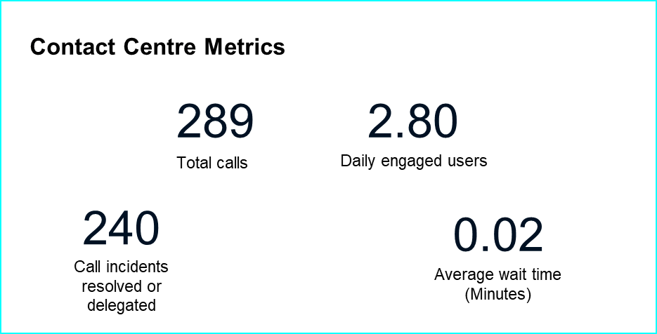

For clarity, an assessor call is labelled as a call. An incident is when the call relates to an IT issue and has either an incident script or is escalated to the IAT Live Trial contact centre liaison officer for resolution as the operator is unable to resolve the issue.

At the conclusion of the IAT Live Trial, 100% of incidents are at a resolved status. Resolved status and delegated to IT indicates that an incident has been captured by the contact centre, entered an assessment trouble-shooting stage and either been rectified with the contact centre, with the command centre, or with IT.

The total volume of calls received by the IAT Live Trial contact centre over the trial duration has been broken down into volume of calls per month in the following table:

#### Figure 25: Total volume of calls received by the IAT Live Trial contact centre

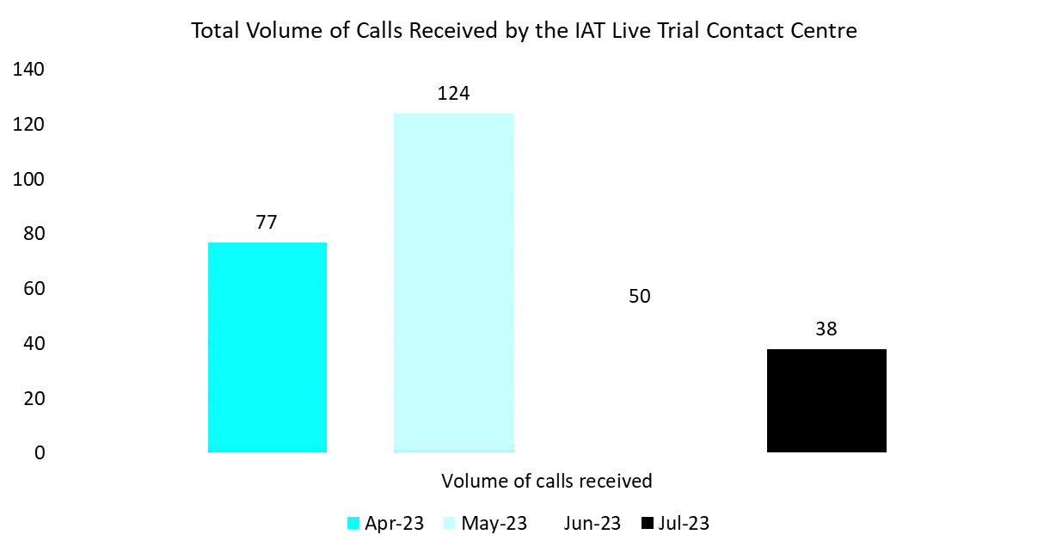

The pattern of the call volumes during the trial showed a higher volume of calls in the early stages of the trial, decreasing as assessor confidence in the IAT grew and IT issues were resolve. Key themes

assessor calls to the IAT Live Trial contact centre were categorised into: **IT Incidents, assessor advice**, and **Feedback on the IAT tool**. A breakdown of calls by theme has been conducted to provide insights into the common issues and trends in issues experienced by assessors and their feedback on the IAT tool.

Out of the 289 calls received by the contact centre over the duration of the IAT Live Trial, 240 calls were related to incidents, 29 calls were to request advice relating to the IAT Live Trial, and 20 calls were to provide feedback on the IAT tool. As the contact centre was initially established to managed IT related incidents, the higher proportion of IT related calls was expected.

### Incidents

The IAT Live Trial contact centre was established to manage incidents experienced by assessors participating exclusively in the IAT Live Trial. This support channel captured the majority of incidents experienced by assessors throughout the trial. Major incidents saw higher call volumes during the trial, decreasing as workarounds and solutions were deployed and communicated.

#### Table : Volume of incident-related calls received over IAT Live Trial duration

|  | April 2023 | May 2023 | June 2023 | July 2023 | Total |
| --- | --- | --- | --- | --- | --- |
| Accessing, viewing, or submitting IAT | 10 | 8 | 3 | 0 | 21 |
| Assessor cannot access finalised read-only version of IAT | 1 | 0 | 0 | 0 | 1 |
| Assessor has commenced the IAT but cannot re-enter to complete IAT assessment | 1 | 0 | 0 | 0 | 1 |
| Assessor is experiencing portal errors or crashes with the IAT | 2 | 14 | 11 | 10 | 37 |
| Assessor unable to finalise the IAT questions and proceed to completing the NSAF | 21 | 47 | 19 | 19 | 106 |
| Assessor unable to submit someone for delegation when the assessment was started in the IAT | 1 | 2 | 0 | 0 | 3 |
| Data is not flowing from the IAT to NSAF correctly or data not saving correctly in the NSAF | 21 | 12 | 5 | 2 | 40 |
| IAT and NSAF timing out | 0 | 1 | 2 | 0 | 3 |
| Information is not saving correctly on IAT | 2 | 0 | 0 | 0 | 2 |
| Other issues | 2 | 19 | 2 | 3 | 26 |

### Observed trends in incident logging

There were 4 major incidents over the IAT Live Trial each with different trending patterns of call volumes that is tied to their resolution status.

* **NSAF data retention** issues were prevalent over the months of April 2023 and May 2023 with 21 occurrences in April 2023 and 12 occurrences in May 2023. NSAF data retention incident logging decreased over the months of June 2023 and July 2023 with 5 occurrences logged in June 2023 and two occurrences in July 2023. The reasoning behind these decreases is likely due to IT hotfixes resolving NSAF data retention issues that had a large impact on NSAF finalisation over the months of April 2023 and May 2023.
* **My Aged Care portal** errors/crashes occurred due to server issues across the platform. My Aged Care portal errors/crashes were logged by assessors consistently over the duration of the IAT Live Trial. This is likely due to no known resolutions from the department’s IT support team to mitigate the impact on assessors.
* **Accessing, viewing, or submitting the IAT** was a prevalent incident at the start of the IAT Live Trial. Accessing, viewing, or submitting the IAT was logged as an incident 10 times in April 2023 and 8 times in May 2023. As assessors became more familiar with the use of the IAT tool, these incidents decreased to 3 occurrences in June 2023 and zero occurrences in July 2023.
* The most predominant incident affecting the IAT Live Trial was assessors being **unable to finalise the IAT questions** and proceed to completing the NSAF.

In April 2023, 21 occurrences were raised with the IAT Contact Centre. This increased to 47 occurrences in May 2023. A workaround was deployed for the incident, and as this workaround was communicated to assessors, the number of occurrences decreased to 19 in June 2023 and 19 in July 2023.

### Assessor advice

This category relates to calls received by the IAT Live Trial contact centre from assessors seeking advice around topics such as training, consent, policy and guidance with the IAT. The support model for the IAT Live Trial indicates that these forms of enquiries be directed to My Assessor chat CoP or the IAT Live Trial email inbox.

The IAT Live Trial contact centre received 29 calls in relation to advice and guidance for the IAT tool and the IAT Live Trial. These calls were redirected to the appropriate location on the My Assessor chat CoP to find further guidance.

#### Table : Volume of assessor advice-related calls received over IAT Live Trial duration

|  | April 2023 | May 2023 | June 2023 | July 2023 | Total |
| --- | --- | --- | --- | --- | --- |
| Request training materials/guidance on using IAT tool | 3 | 4 | 0 | 0 | 7 |
| Assessor is enquiring about IAT Live Trial Information | 5 | 5 | 5 | 1 | 16 |
| Assessor requesting assistance for client not participating in the IAT Live Trial | 3 | 2 | 1 | 0 | 6 |

#### 

### IAT feedback

Assessors made 20 calls to the IAT Live Trial contact centre providing feedback and advice for the future development of the IAT. These callers were reminded that the IAT project team had several other channels for capturing feedback for the IAT Live Trial including My Assessor chat CoP, email enquiries and monthly assessor surveys.

#### Table : Volume of IAT feedback-related calls received over IAT Live Trial duration

|  | April 2023 | May 2023 | June 2023 | July 2023 | Total |
| --- | --- | --- | --- | --- | --- |
| IAT offline capabilities & inability to access IAT on the  My Assessor App | 0 | 5 | 2 | 0 | 7 |
| IAT usability issues | 5 | 5 | 0 | 3 | 13 |

A small volume of calls was received by the IAT Live contract centre in relation to the offline capabilities of the IAT and whether the IAT can be used via the My Assessor app. As previously communicated in training materials, the IAT is unable to be accessed offline or via the My Assessor app over the duration of the trial. Any assessors calling to note issues with internet connectivity or availability to complete the IAT via the My Assessor online portal were redirected to complete the offline IAT form available on My Assessor chat CoP and notified that there was no functionality to complete the IAT via My Assessor app.

# PART B – Feedback and insights

This section of the report provides an analysis of feedback captured throughout the IAT Live Trial to identify potential improvement opportunities, refinements, and further supports required ahead of the deployment of the IAT from 1 July 2024. It includes:

* Feedback on the design and functionality of the IAT, including:
  + functionality, accessibility and useability of the IAT
  + suitability of IAT questions and language
  + training and further guidance, and
  + targeted IAT sections
* Feedback on the delivery of the IAT Live Trial, including communications:
  + technology
  + ethics and
  + KPI performance.

Over the duration of the IAT Live Trial assessors were invited to provide feedback about the design and functionality of the IAT. This feedback was provided through several channels, including:

* Monthly assessor surveys (overall 585 survey responses)
* The My Assessor chat CoP (overall 362 enquiries)
* The IAT Live Trials email inbox (overall 205 enquiries)
* Fortnightly assessor check-in calls (on average 100 assessors attended)
* AMO check-in consultations (7 targeted AMO’s).

As the monthly assessor survey and the survey questions were not mandatory, the number of responses received per question may vary.

## IAT design and functionality feedback

### Functionality

Assessors shared feedback on the design and layout of the IAT. Feedback was collected from monthly assessor surveys, My Assessor chat CoP, and the email inbox. There was a question dedicated to hover help box functionality in all three of the monthly assessor surveys. Without prompting, assessors also provided feedback on other functionality topics, such as font size and response box options by utilising free-text options within the survey and other feedback channels.

In the monthly assessor surveys, assessors were asked if they found the hover help text boxes in the IAT appropriate and useful. From the total of 498 responses to this question, across the 3 monthly assessors surveys, 95 did not find them appropriate and useful, and 403 did.

#### Figure 26: Hover help box quantitative feedback

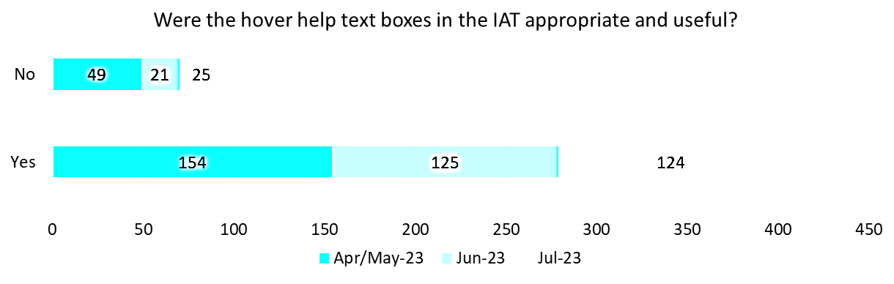

Key themes in relation to IAT sequence are presented in Table 27 below. These findings refer to qualitative data provided through free text within the monthly assessor surveys questions and other feedback channels.

#### Table : Functionality qualitative feedback

|  |  |  |  |  |
| --- | --- | --- | --- | --- |
| **Theme** | **Monthly assessor survey** | **My Assessor chat (CoP) and email inbox** | **Assessor check-in call** | **Total** |
| Hover help text boxes | 84 mentions | 32 enquiries | - | **116** |
| Adjust response options | 66 mentions | - | - | **66** |
| Free-text options | 36 mentions | - | - | **36** |
| Drop-down boxes | 15 mentions | 2 enquiries | 5 comments | **22** |
| Font colour and size | 8 mentions | 3 enquiries | - | **11** |
| **Total functionality feedback instances** | | | | **251** |

##### Hover help text boxes:

116 instances of assessor feedback noted that the hover help text boxes could be improved to help assessors complete the IAT.   
Out of the 116 feedback instances:

* 32 instances of feedback noted that hover help boxes did not provide specific enough information (e.g., 'without help' 'with some help' 'completely unable' 'who helps' 'is the need being met' in function section)
* 14 instances of feedback noted that hover help boxes simply repeated the question (e.g., hover help boxes for light and moderate/heavy housework were the same).
* One instance provided the following example: The personal health section question “does the client have any major skin conditions?” is accompanied by a hover help text box stating “whether the client has any major skin conditions”
* 3 instances requested the difference between monocular and binocular blindness.

**Guidance in hover help text boxes did not consistently offer insightful information.**

##### Adjust response options:

66 instances of assessor feedback noted that response options did not allow for the complete capture of client circumstances. Outline below are the assessors’ description of the response options.   
Out of the 66 feedback instances:

* 22 commented the option for ‘not applicable’ should be added to relevant questions (e.g. questions about what kind of garden the client has)
* 5 instances provided the example of: When assessing hospital patients, assessors are unable to view the home environment.
* One instance provided the example of: A ‘not applicable’ option should be added is if a client is not using online services or a communication device (examples not provided).

**Additional response options, including a ‘not applicable’ option for relevant questions.**

##### Free text options:

36 instances of assessor feedback indicated that there were limited response options in questions without free text. Assessors provided the following examples of potentially missing information includes.

Out of the 36 feedback instances:

* 3 instances mentioned, if an older Australian does not require assistance to walk, but uses a walking stick or frame
* One instance mentioned, a client might have the ability to drive, but due to medications they are taking during their recovery phase after surgery, so they are unable to do so
* One instance mentioned, assessors cannot record if significant weight gain/loss is intentional.

**Additional free text options would allow assessors to capture greater detail in their responses.**

##### Drop-down boxes:

22 instances of assessor feedback regarding the drop-down boxes in the IAT.

Out of the 22 feedback instances:

* 11 instances of feedback noted that the volume of drop-down boxes in the IAT extended assessment times as assessor experienced difficulties whilst navigating them (e.g., ‘informal carer helps’ and "client does not require assistance")
* 4 instances of feedback noted that drop-down boxes should be replaced with free text boxes (Examples not provided).
* 3 instances mentioned, drop-down boxes are cumbersome and time consuming to complete, contributing to longer assessment times and clients becoming fatigued and disinterested
* 5 mentioned, the drop-down boxes are difficult to navigate and interact poorly with older technology devices, particularly in instances where there were multiple options, requiring assessors to scroll.

**Drop-down boxes that have an abundance of options are difficult to navigate, impeding the fluidity of the assessment process.**

##### Font colour and size:

11 instances of assessor feedback indicated that assessors experienced difficulties viewing the IAT content due to small size and light colouring of the IAT font. Whilst this is a small number of feedback instances, there would be merit in considering the font size within the IAT to better support accessibility across the tool. There were 8 specific requests from assessors who suggested that replacing any grey or light grey coloured text to black would improve the usability of the IAT.

**The IAT font size is too small and grey font is difficult to see.**

##### Summary:

Key feedback to consider regarding the functionality of the IAT included:

**Hover help guidance can be improved**

* Add additional guidance in each box
* Add a hover help to each question

**Adjust response options**

* Add ‘not applicable’ response option where relevant
* Consider approaches to address requests to add more free-text options

### Sequence

Assessors shared feedback on the sequence, order, and flow of IAT. Feedback was initially provided unprompted from assessors, with no targeted monthly assessor survey questions included in the April/May and June 2023 monthly assessor surveys. As such, a targeted survey question was included in July 2023 monthly assessor survey and a specific sequence-related discussion was held on the 17July 2023 fortnightly assessor check-in call.

In the July 2023 monthly assessor survey, assessors were asked ‘do you find the current structure and sequence of questions and sections within the IAT adequate?’. From a total of 127 responses to this question, 88 responses (69%) indicated that the current structure and sequence was not adequate, 24 assessors neither agreed or disagreed, and 15 assessors found it adequate.

#### Figure 27: Quantitative survey feedback

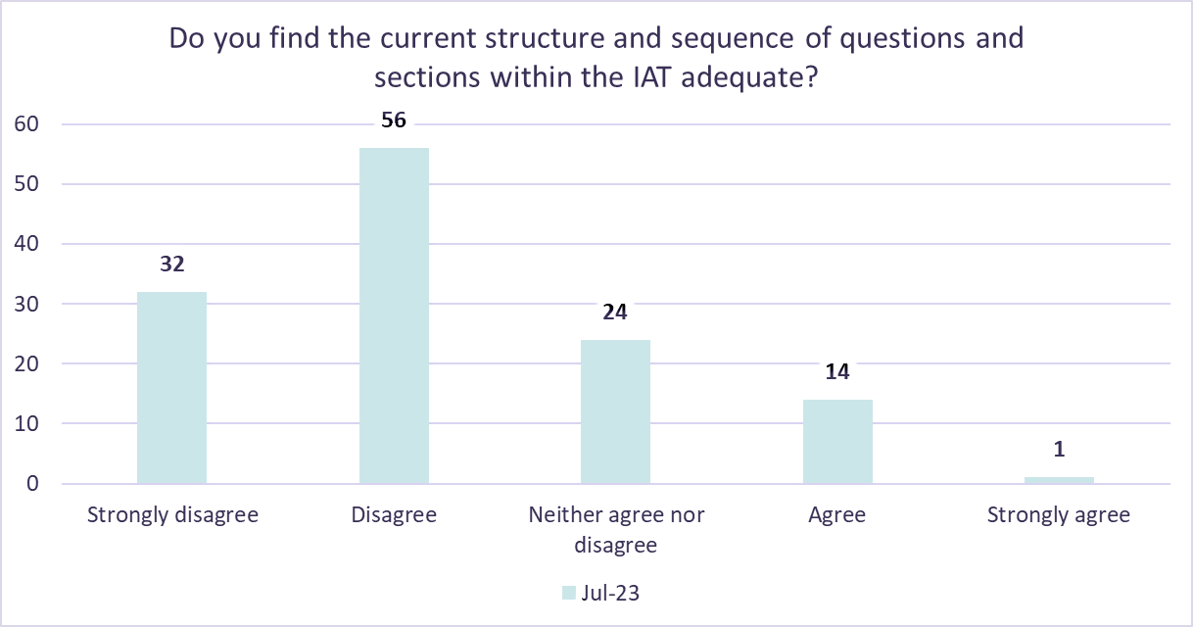

Within the July 2023 monthly assessor survey, assessors were asked *“Please provide information about your response in Q23, including suggestions to improve the sequencing of the IAT.”* A total of 106 assessors responded.

Key themes in relation to IAT sequence are presented in Table 28 below. These findings refer to qualitative data provided through free text within the monthly assessor surveys questions and other feedback channels.

#### Table : Sequence qualitative feedback

|  |  |  |  |  |
| --- | --- | --- | --- | --- |
| **Theme** | **Monthly assessor survey** | **My Assessor chat (CoP) and email inbox** | **Assessor check-in call** | **Total** |
| Assessor sequence suggestion | 59 mentions | - | 12 comments | **71** |
| IAT doesn’t flow | 57 mentions | - | 6 comments | **63** |
| Social section is too early | 33 mentions | 4 enquiries | 8 comments | ***45*** |
| Medical and Medications sections should be combined | 13 mentions | - | 4 comments | **17** |
| Carer profile is too early | 4 mentions | *-* | - | **4** |
| **Total functionality feedback instances** | | | | **200** |

##### Assessor sequence suggestion:

71 instances of assessor feedback suggested possible re-ordering of the IAT.

Out of the 71 feedback instances:

* 33 suggested relocating the Social section to later in the assessment
* 13 suggested combining the Medical and Medication section
* 4 suggested relocating the Carer profile to later in the assessment.

##### The flow of the IAT:

63 instances of assessor feedback noted that the flow and sequence of the IAT could be improved.

Out of the 63 feedback instances:

* 5 instances mentioned assessors found it difficult to navigate between sections during assessments
* 5 instances suggested assessors tend to ask the question in a similar format to the NSAF

##### Adjust Social section to be later:

45 instances of assessor feedback noted that the Social section appears too early in the IAT to build rapport with the client.

Out of the 45 feedback instances:

* 7 instances mentioned personal questions in the social section e.g. DSSI can be intrusive
* 6 instances of assessor feedback noted that DSSI’s current location question is not relevant. (e.g., DSSI scale should be moved to psychological)
* This can make older people reluctant to give complete or accurate answers before rapport is built.

**The early placement of the Social section hinders rapport building.**

##### Medical and Medications sections to be combined:

Out of the 17 feedback instances:

* 17 instances of assessor feedback noted that the consolidation of medical and medication sections would be beneficial, as the topics covered are often interrelated (e.g., takes medicine in Function section aligns with Medical and Medication)
* 5 instances of assessor feedback targeted towards sequence noted that a combination of these two sections would help with the flow of the IAT (e.g., frailty question could be part of either overall vulnerability or linked with pain/sleep/mobility/diet sections as they all relate to frailty).

**Medical and Medication sections could be combined due to their similarity.**

Summary**:**

Key feedback to consider regarding the sequence of the IAT included:

**IAT flow can be improved**

* Assessors found it challenging to navigate between sections
* Further training could improve assessor experience with the IAT

**Sequence could be improved**

* Moving Social section later in the assessment
* Combining the Medical and Medication sections

**Co-design workshop**

* Assessors are fully engaged and are willing to support the department through a co-design workshop of IAT sequencing and flow

### Length

Assessors shared feedback on the length of the IAT. Feedback was collected from monthly assessor surveys, My Assessor chat CoP, and the email inbox. Feedback was unprompted from assessors, as there were no targeted monthly assessor survey questions on this aspect of the IAT.

Key themes coming from assessors in relation to IAT length are presented in Table 29 below. These findings refer to qualitative data provided through free-text monthly assessor surveys questions and other feedback channels.

#### Table : Length qualitative feedback

|  |  |  |  |
| --- | --- | --- | --- |
| **Theme** | **Monthly assessor survey** | **My Assessor chat (CoP) and email inbox** | **Total** |
| IAT is too long | 55 mentions | 10 enquiries | **65** |
| Goal setting section is too long | 62 mentions | - | **62** |
| Carer profile is difficult to navigate, adding to IAT length | 4 mentions | 30 enquiries | **34** |
| Assessment is too complex for CALD and First Nations clients, adding to IAT length | 27 mentions | - | **27** |
| Function section is too long | 6 mentions | - | **6** |
| Social section is too detailed, adding to IAT length | 3 mentions | - | **3** |
| **Total length feedback instances** | | **197** | |

IAT length could be reduced:

65 instances of assessor feedback noted that the IAT was lengthy.

Out of the 65 feedback instances:

* 9 instances commented this presented as challenging for some older people as they may have mental, and cognitive limitations and may become distracted and fatigued during the later stages of the assessment, affecting the perceived quality of client responses.

**IAT assessments can take 2 – 3 hours to complete.**

##### Goal setting section is repetitive:

62 instances of assessor feedback noted that repetition is a key contributor to section length of the goal-setting section.

Out of the 62 feedback instances:

* 2 instances commented clients wanted to express their goals without detailing how they planned to achieve them
* 41 instances suggested ‘Client goal’ and ‘goal’ fields were repetitive.

**Recording the ‘goal’ and ‘client goal’ fields in the goal-setting section is repetitive as assessors input the same information.**

Carer profile is difficult to use:

34 instances of assessor feedback noted that questions relating to capturing of daily care hours was contributing to the overall longer IAT duration.

Out of the 34 feedback instances:

* 5 instances commented Carer hours sliding scale was difficult to use
* 7 instances commented the varying level of care week to week, and the difference in type of carer e.g. Live-in Carer contribute to the difficulty.

**The carer hours sliding scale takes longer to navigate than a textbox to record hours.**

##### IAT CALD and First Nations clients:

27 instances of assessor feedback revealed that these client cohorts encountered difficulties in fully comprehending the intent behind each question.

Out of the 27 feedback instances:

* One instance noted that in some cases, clients who had lower levels of education, were not proficient in English, or were being assessed in environments filled with distractions, required more time to ensure client comprehension
* 9 instances of assessor feedback noted clients appeared to tire more quickly, leading to challenges in completing the remainder of the assessment.

**Complex questions can take longer to explain for CALD and First Nations clients.**

### Summary:

Key feedback to consider regarding the length of the IAT included:

**IAT length could be reduced**

* Assessment complexity and larger question set led to a longer assessment duration
* longer length of assessment can lead to increased levels of distraction, disinterest, and fatigue for older Australians

**Goal setting section is repetitive**

* ‘Client goal’ and ‘goal’ fields could be combined

### Technology

Assessors shared feedback on technology issues during the trial. Feedback was collected from monthly assessor surveys, My Assessor chat CoP, contact centre, and email inbox. Feedback collated was unprompted from assessors, with no targeted technology-related questions surveyed.

Within the monthly assessor surveys, there was no questions targeted towards assessor feedback for technology. Despite this, assessors provided 314 instances of qualitative feedback relating to technology issues they were experiencing.



Key themes coming from assessors in relation to technology are presented in Table 30 below. These findings refer to qualitative data provided through free-text monthly assessor surveys questions and other feedback channels.

#### Table : Technology qualitative feedback

|  |  |  |  |  |
| --- | --- | --- | --- | --- |
| **Theme** | **Monthly assessor survey** | **My Assessor chat (CoP) and email inbox** | **Contact centre** | **Total** |
| Service recommendations error | 4 mentions | 2 enquiries | 106 incidents | 112 |
| Data is not flowing from IAT to NSAF correctly | 22 mentions | 43 enquiries | 40 incidents | 105 |
| Portal errors or crashes with the IAT | 10 mentions | 6 enquiries | 37 incidents | 53 |
| Accessing, viewing, or submitting IAT | 11 mentions | - | 21 incidents | 32 |
| Completing IAT on tablets/iPads | 5 mentions | 2 enquiries | - | 7 |
| Assessor unable to submit someone for delegation when assessment was started in the IAT | - | - | 3 incidents | 3 |
| IAT & NSAF timing out | - | - | 3 incidents | 3 |
| Assessor has commenced but cannot re-enter IAT | - | - | 1 incident | 1 |
| **Total length feedback instances** | | | | **316** |

Service recommendations error:

106 incidents were raised to the contact centre relating to an error experienced where page scaling was not responsive and hid the ‘Finalise IAT and proceed to NSAF’ button.

**Assessors could not always finalise the IAT despite completing mandatory fields.**

##### Data is not flowing from IAT to NSAF correctly:

83 incidents were raised to the Contact Centre and My Assessor Chat (CoP) and Email Inbox regarding a data retention incident that prevented assessment data flowing from the IAT to the NSAF.

**Data would not always accurately transfer from the IAT to NSAF.**

##### Portal errors or crashes with the IAT:

37 incidents were raised to the contact centre on My Aged Care portal server issues related to a high-volume of concurrent users.

**My Aged Care portal server errors caused delays for assessors.**

##### Accessing, viewing, or submitting IAT:

32 instances of assessor feedback were recorded where assessors experienced issues with the usability of the IAT.

Out of the 32 feedback instances:

* 10 instances suggest to isolated bugs or errors experienced by assessors, reporting lag within the IAT.
* 10 instances commented that the option to complete an IAT was not available in the My Aged Care portal
* 6 instances reported only being able to type a single character in each free-text box. This issue was occasionally occurred to assessors using Google Chrome with the Grammarly extension installed and could be resolved by removing the extension
* 6 instances noted that despite completing all mandatory fields, a red line indicating an incomplete section appeared, hindering them from finalising the IAT
* A single assessor provided commentary that the option to complete an IAT was not appearing for any of their clients.

**IAT lag causes assessment time delays.**

These errors extended the duration of assessments, causing frustration among assessors and impacted the timing of subsequent assessments with different clients.

##### Completing IAT on tablets/iPads:

7 instances of assessor feedback related to the usability of tablets and iPads for completing the IAT.

Out of the 7 feedback instances:

* 4 instances commented the IAT should be available on My Assessor app.

**IAT should be available on My Assessor app.**

##### Summary:

Key feedback to consider regarding technology included:

**IAT stability**

* Increased testing of the IAT platform prior to deployment

**My Assessor app for IAT**

* Consider the deployment of the IAT on My Assessor app to support remote assessors and mobile friendliness.

## Suitability of IAT questions

### Language and wording

Assessors shared feedback on language and wording of the IAT. Feedback was collected from monthly assessor surveys, My Assessor chat CoP, and email inbox. Feedback on IAT language and wording was captured in a dedicated monthly assessor survey question, which was consistent across the April/May 2023, June 2023 and July 2023 surveys. Assessors also furthered this feedback through providing free-text responses in the monthly assessor surveys and other feedback channels.

In the monthly assessor surveys, assessors were asked if there were any questions which were unclear or created interpretation issues. From a total of 445 responses to this question, 216 responses indicated there were unclear questions which created misinterpretation. 229 responses indicated there were not.

It's important to highlight that while the majority answered ‘No’ in the April/May 2023 monthly assessor survey, in the June and July 2023 monthly assessor survey the majority answered ‘Yes’.

#### Figure 28: Quantitative survey feedback

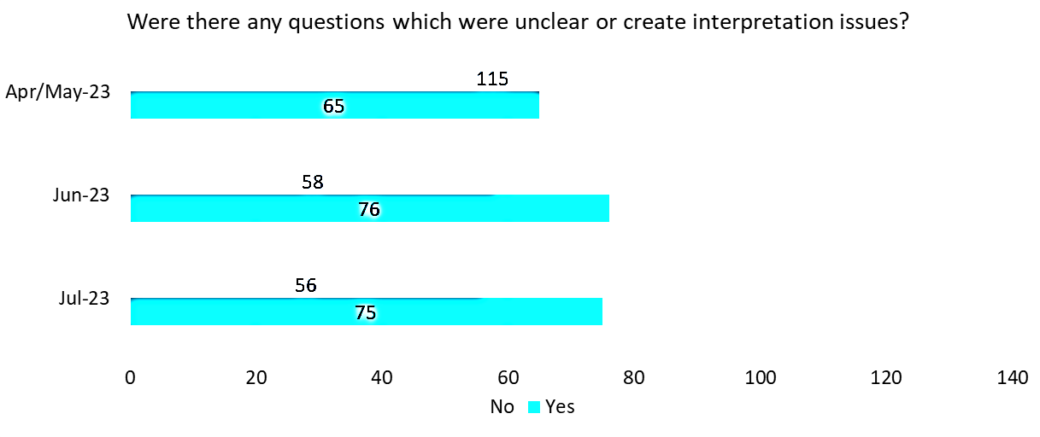

Key themes coming from assessors in relation to IAT language and wording are presented in Table 31 below. These findings refer to qualitative data provided through free-text monthly assessor surveys questions and other feedback channels.

#### Table : Language and wording qualitative feedback

|  |  |  |  |
| --- | --- | --- | --- |
| **Theme** | **Monthly assessor survey** | **My Assessor chat (CoP) and email inbox** | **Total** |
| Goals are repetitive or confusing | 184 mentions | 1 enquiry | **185** |
| Social questions and DSSI can be challenging for clients to complete | 54 mentions | 12 enquiries | **66** |
| Wording of questions limits rapport | 17 mentions | - | **17** |
| **Total language and wording feedback instances** | | | **268** |

##### Goals are repetitive or confusing:

185 instances of assessor feedback noted that the goal setting section was repetitive and confusing.

Out of the 185 feedback instances:

* Assessors struggled to distinguish between ‘goal’ and ‘client goal’, deeming it as unnecessary repetition (140 instances) or a source of confusion (45 instances)
* Clarifying the distinction between these two fields or the removal of one of them may address this assessor concern.

**There is not enough explanation on the differences between types of goals.**

##### Social questions in the DSSI can be challenging for clients to complete:

66 instances of assessor feedback noted that questions asked in the social section can make clients uncomfortable. Out of the 66 instances, 45 instances questioned the suitability of DSSI.

Example Include:

* 2 instances commented on the personal and intrusive nature of the question “do you feel valued to your friends and family,” made clients feel uncomfortable
* 2 instances commented that clients felt they were being confronted with reminders of past traumas or family issues
* 32 instances suggested the use of more general questions can yield similar outcomes without being as personal and sensitive.

**Clients are not comfortable answering deeply personal questions about their social life.**

##### Summary:

Key feedback to consider regarding the language and wording of the IAT included:

**Social questions in DSSI can be sensitive when client responding**

Assessors have proposed the use of more general questions that can yield similar outcomes without being as personal and sensitive.

**Wording of questions limits rapport**

Direct social and cognitive questions can create client barriers.

## CALD and First Nations assessments

Assessors shared feedback suitability of the IAT for CALD and First Nations clients. Feedback was collected from monthly assessor surveys, My Assessor chat CoP, and email inbox. There was a question dedicated to IAT suitability for CALD and First Nations clients in all 3 of the monthly assessor surveys. A ‘not-applicable’ option was added in June 2023 and July 2023. Assessors also used

free-text questions in the monthly assessor surveys and other feedback channels.

### CALD

In the monthly assessor surveys, assessors were asked if they found the IAT effective and appropriate in assessing the care and needs of CALD. From the total of 379 responses to this question, 190 found it appropriate in assessing the care and needs of CALD. 184 assessors indicated they did not.

##### Figure 29: CALD quantitative survey feedback

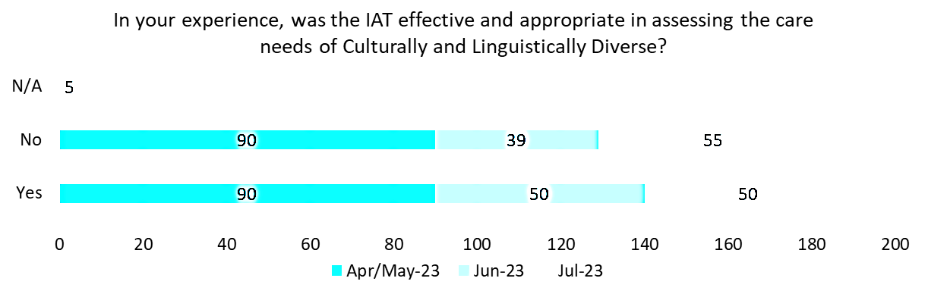

Although the survey questions were not mandatory, a not applicable (N/A) option was requested and provided to assessors in the June and July 2023 surveys as not all assessors had the opportunity to assess someone who identified as CALD.

### Interpreters

In the monthly assessor surveys, assessors were asked if they had experienced any challenges or barriers when using an Interpreter during an IAT assessment. From the total of 57 responses to this question, 34 experienced challenges or barriers. 23 indicated they did not.

#### Figure 30: Interpreters quantitative survey feedback

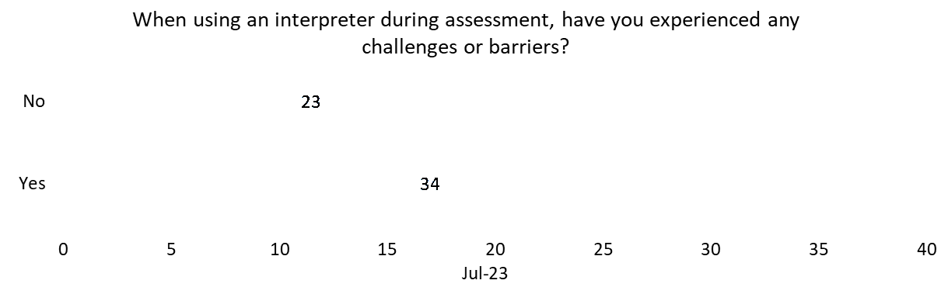

The addition of the question to the July 2023 survey was due to the low number of assessments using an interpreter in the IAT Live Trial throughout April/May 2023 and June 2023.

### First Nations people

In the monthly assessor surveys, assessors were asked if they found the IAT effective and appropriate in assessing the care and needs of First Nations people. From the total of 273 responses to this question, 150 did not find it appropriate in assessing the care and needs of First Nations people, 101 indicated they found it appropriate.

#### Figure 31: First Nations quantitative survey feedback

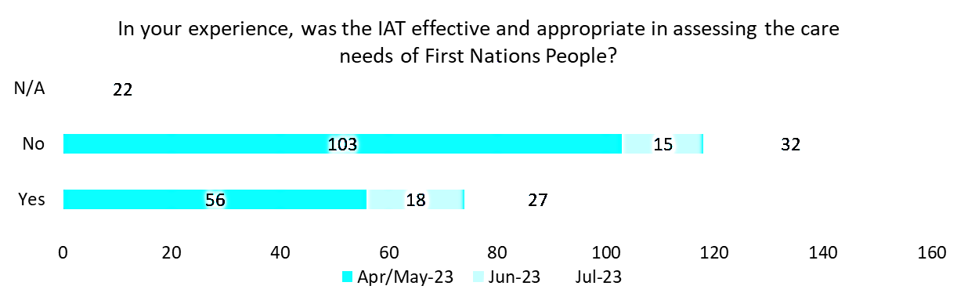

Although the questions were not mandatory, an N/A option was requested and provided to assessors in the June and July 2023 surveys as not all assessors had the opportunity to assess someone who identified as First Nations. Zero assessors selected N/A in June 2023 survey and 22 assessors selected N/A in July 2023 survey.

Key themes coming from assessors in relation to completing CALD and First Nations IAT assessments are presented in Table 32 below. These findings refer to qualitative data provided through free-text monthly assessor surveys questions and other feedback channels.

#### Table : CALD and First Nations assessments qualitative feedback

|  |  |  |  |
| --- | --- | --- | --- |
| **Theme** | **Monthly assessor survey** | **My Assessor chat (CoP) and email inbox** | **Total** |
| IAT may be culturally unsuitable | 50 mentions | 18 enquiries | **68** |
| Using GPCOG with CALD and First Nations people | 26 mentions | 9 enquiries | **35** |
| Translation issues | 27 mentions | - | **27** |
| Length of assessment | 26 mentions | - | **26** |
| DSSI | 6 mentions | - | **6** |
| **Total CALD and First Nations assessment feedback instances** | | **162** | |

##### IAT may be culturally unsuitable:

68 instances of assessor feedback noted that the IAT can be culturally insensitive to CALD and First Nations clients.

Out of the 68 feedback instances:

* 14 instances suggested there was occasional stereotyping inclusions and discomfort with certain questions
* 15 instances of feedback noted that the number of questions caused client fatigue or distraction during the assessment, especially among those with limited English fluency (example not provided)
* 7 instances commented “do you get to have a yarn with family or friends” question received negative responses
* 4 instances commented that First Nations specific questions can be inappropriate - assumes First Nations people are on pension and not self-funded "can she/he remember it is pension week”
* 3 instances commented that asking a client of Aboriginal or Torres Strait Islander descent if they feel connected to country and if they feel connected to their "mob" does not feel comfortable for an assessor.

**IAT delivery is challenging for assessors from different cultural backgrounds to their client.**

##### Using GPCOG with CALD and First Nations people:

Out of the 35 instances of assessor feedback noting that when administering GPCOG to CALD and First Nations clients:

* 6 instances commented that names and words like ‘John Brown’ and ‘Kensington’ are difficult for CALD client to remember and
* 16 instances commented that alternative cognitive tools may be more effective, such as RUDAS or the MMSE.

**GPCOG’s westernised nature was difficult for CALD & First Nations clients to understand.**

##### Translation issues:

27 instances of assessor feedback noted challenges when utilising translated materials with clients whose primary language is not English. No question specific examples were provided by assessors.

Out of the 27 feedback instances:

* 16 instances of feedback indicated a preference for adopting one of the alternative cognitive tools such as RUDAS or MMSE
* 6 instances of feedback indicated that the DSSI was difficult to translate with clients with limited English fluency and extended assessment durations (example not provided)
* 4 instances commented that reasonable translations of questions is not available which can be distressing to some clients.

**Assessors faced difficulties explaining questions to non-English speaking clients.**

##### Language may be inappropriate for CALD and First Nations people:

9 instances of assessor feedback noted that IAT language may be inappropriate for CALD and First Nations people.

Out of the 9 feedback instances:

* 8 instances of feedback noted that the social section question “do you get to have a yarn with family or friends” received negative responses and occasional stereotyping inclusions.

**CALD and First Nations people struggle with the westernised wording of the IAT.**

##### Summary:

Key feedback to consider regarding the CALD and First Nations assessments included:

**IAT can be culturally sensitive**

* Assessors highlighted that IAT delivery can be challenging with CALD and First Nations people due to occasional stereotyping and certain terms included.

**Use of an interpreter extends assessment times**

* Assessors mentioned when requiring an interpreter, the DSSI and GPCOG were often challenging to translate, and the number of questions being translated caused fatigue or distraction during the assessment.
* Assessors suggested that alternative cognitive tools may be more effective, such as RUDAS or the MMSE

## Training and further guidance

### Training

Assessors shared feedback regarding the effectiveness of train-the-trainer sessions through a dedicated training evaluation survey. Feedback regarding any further training and guidance material requested by assessors into the next stage of the IAT rollout was collected from several channels, including monthly assessor surveys, the My Assessor chat CoP and the email inbox, and was unprompted from assessors.

A training feedback survey was issued to participants of the IAT train the trainer sessions, and responses analysed to determine key lessons learned on the training initiatives that supported the IAT Live Trial.

The survey was issued from March 2023 until May 2023 and captured feedback on the outcomes of the train the trainer sessions, content, and delivery. The training feedback survey received 242responses from trainers and requested rating scales for the learning pack and training materials. The survey included a sentiment analysis of trainer experiences of the training environment and preparedness for conducting the training with assessors.

|  |  |
| --- | --- |
| A graph showing the Learning Pack Rating being 4 out of 5 stars | **Learning pack rating**  Trainers and learners were asked to the rate the quality and effectiveness of the IAT learning pack out of 5 stars. |
| A graph showing Training material rating being 4.1 out of 5 stars. | **Training material rating**  Trainers and learners were asked how satisfied they were with the IAT Trial training out of 5 stars. |
| A graph showing the percentage of the assessors' satisfaction with the training environment helpfulness (91%) | **Training environment helpfulness**  Trainers and learners were asked to indicate if accessing the training environment was helpful in their learning experience. 91% found the training environment valuable to their learning experiences. |
| A graph showing assessors' percentage of readiness to conduct an IAT assessment after training session (71%) | **‘Readiness’ after training session**  Trainers and learners were asked to indicate how ‘ready’ they feel after completing their facilitated training session. 77% felt ready to conduct IAT assessments after completing the training. |



### Further guidance

Assessors provided feedback on further guidance that would benefit their IAT experience. Feedback was collated from monthly assessor surveys, My Assessor chat CoP and the email inbox. Feedback was unprompted from assessors, as there were no targeted monthly assessor survey questions on further guidance.

Key themes coming from assessors in relation to IAT training and further guidance are presented in Table 33 below. These findings refer to qualitative data provided through free-text monthly assessor surveys questions and other feedback channels.

#### Table : Further guidance qualitative feedback

|  |  |  |  |
| --- | --- | --- | --- |
| **Theme** | **Monthly assessor survey** | **My Assessor chat (CoP) and email inbox** | **Total** |
| Additional training material request | 55 mentions | - | **55** |
| Allied health support | 40 mentions | - | **40** |
| Additional training | - | 38 enquiries | **38** |
| AT-HM | 15 mentions | - | **15** |
| Low risk items | 8 mentions | - | **8** |
| **Total training and further guidance feedback instances** | | | **156** |

##### Additional training material request:

55 instances of assessor feedback requesting supplementary training materials IAT.

Out of the 55 feedback instances:

* 55 instances emphasized a desire to have additional training videos, section-specific training materials, and sample answer responses
* 1 instance suggested that the Aged Care Assessment Manual should encompass the IAT process.

**Additional training materials for assessors would improve their assessment training skills.**

##### Allied health support:

Through the feedback channels, there were 40 instances where assessors requested further guidance when making referrals to allied health, allowing them to support these professionals more effectively. Predominantly focusing on the frequency and cost of allied health intervention would give assessors greater confidence when making allied health referrals.

**Assessors do not feel comfortable making allied health referrals.**

##### Additional training:

Through the My Assessor chat (CoP) and email inbox, there were 38 requests for additional training sessions. Additionally, 7 AMOs emphasized that appropriately trained staff was a key success factor in completing the IAT. As such, offering future training sessions, similar to the pre-trial sessions conducted, would contribute to enhancing assessor skills.

**Previous IAT training was received well by assessors and assessment organisations.**

##### Assistive Technology and Home Modifications:

Assessors noted on 15 occasions that further guidance on AT-HM would benefit their IAT experience. Assessors primarily requested further training on funding tiers, descriptions of available devices and clearer explanations of available categories.

**Assessors would benefit from greater access to training materials.**

##### Low risk items:

There were 8 instances of feedback from assessors requesting supplementary training on recommending low-risk items to clients. Assessors expressed they lacked the requisite experience to recommend low-risk items with confidence. As such, further guidance and training on available items has been requested.

**Assessors require upskilling to ensure low-risk items can be recommended with confidence.**

##### Summary:

When prompted, assessors provided key insights into the usefulness of training materials and potential inclusions for future guidance ahead of the 1 July 2024 Go-Live. Key feedback to consider regarding training and further guidance included:

**Additional training material request**

As assessors completed the IAT and grew more familiar with the tool, some indicated a desire to have further guidance materials, such as dedicated training sessions or example IAT question answers, for more complex areas of the IAT.

Targeted IAT sections

**Allied health support**

Assessors highlighted that without a specific background in certain allied health specialities that sections like the assessor recommendations section were difficult to complete for some allied health referrals.

This meant that some assessors felt they may be inaccurately recording a client’s needs.

### Carer profile

Assessors provided feedback on the Carer profile section of the IAT. Feedback was collected from monthly assessor surveys, My Assessor chat CoP and the email inbox. Feedback was unprompted from assessors, as there were no targeted monthly assessor survey questions on the Carer profile.

#### Table : Carer profile qualitative feedback

|  |  |  |  |
| --- | --- | --- | --- |
| **Theme** | **Monthly assessor survey** | **My Assessor chat (CoP) and email inbox** | **Total** |
| Section is too long | 4 mentions | 30 enquiries | **34** |
| Capturing carer hours is confusing | 16 mentions | 2 enquiries | **18** |
| Section appears too early | 4 mentions | - | **4** |
| Carer strain is not captured | 3 mentions | - | **3** |
| Type of carer support options are inadequate | 2 mentions | - | **2** |
| **Total Carer profile feedback instances** | | | **61** |

##### Carer profile is difficult to use:

Assessors noted 34 times that daily carer hour capture was contributing to the overall longer IAT duration.

Out of the 34 feedback instances:

* Carer profiles was expressed to be difficult to use (example not provided).

##### Capturing carer hours is confusing:

Assessors expressed 18 times that they found the process of capturing carer hours confusing. The reasons provided by assessors are listed below.

Out of the 18 feedback instances:

* 3 instances of assessor feedback noted that there is no way of capturing the impact and stress levels on the carer, i.e., there is no quantifiable measure of stress (e.g., Caregiver strain index)
* 16 instances of feedback requested additional detail on how to appropriately capture carer hours (e.g., difficult for carer to determine as appointments vary, live-in carers can differ from other carers. Breaking the day into time frames isn’t easy to work out.). This means the information recorded may be an inaccurate representation of the level of carer support the older Australian currently receives.

**Capturing weekly carer hours would be easier for clients and carers.**

##### Summary:

Key feedback to consider regarding the Carer Profile of the IAT included:

**Capturing carer hours is confusing**

* Carer hours are confusing to capture as daily care hours
* Capturing weekly carer hours would be easier for clients and carers

**Carer profile is difficult to use**

* Care hour sliding scales were difficult to navigate, adding to assessment length
* A simple textbox entry of care hours could be quicker and easier

### Social

Assessors provided insights on the Social section of the IAT. Feedback was collected from monthly assessor surveys, My Assessor chat CoP and the email inbox. Feedback captured from assessors was unprompted, with no questions regarding the Social section surveyed.

Key themes coming from assessors in relation to the Social section are presented in Table below. These findings refer to qualitative data provided through free-text monthly assessor survey questions and other feedback channels.

#### Table 35: Social qualitative feedback

|  |  |  |  |  |
| --- | --- | --- | --- | --- |
| **Theme** | **Monthly assessor survey** | **My Assessor Chat (CoP) and email inbox** | **Fortnightly Assessor Check-In** | **Total** |
| DSSI may be inappropriate | 39 mentions | 6 enquiries | - | 45 |
| Adjust Social section to be later | 33 mentions | 4 enquiries | 8 comments | 45 |
| Questions may be inappropriate to ask in front of family/carers | 7 mentions | - | - | 7 |
| Questions are too confronting | 7 mentions | - | - | 7 |
| Questions are not relevant | 3 mentions | - | - | 3 |
| **Total Social feedback instances** | | | | 107 |

##### DSSI may be inappropriate:

Assessors raised 45 concerns about the suitability of DSSI.

Out of the 45 feedback instances:

* 26 instances commented that the DSSI can be intrusive and inappropriate
* 7 instances noted that asking clients “do you feel valued to your friends and family,” and “do you feel listened to” made clients uncomfortable
* 8 instances noted clients felt confronted with reminders of past traumas or family issues
* 3 instances suggested that more generalised questions can get similar outcomes without intrusiveness.

**Clients can feel uncomfortable answering deeply personal questions about their social life.**

##### Adjust Social section to be later:

45 instances of assessor feedback noted that the Social section appears too early in the IAT.

Out of the 45 feedback instances:

* 11 instances suggested personal questions can make older people reluctant to give accurate answers
* 29 instances reported that reluctance in clients increases difficulty to build rapport

**The early placement of the social section hinders rapport building.**

**life**

**Summary**:

Key feedback to consider regarding the Social section of the IAT included:

**DSSI may be inappropriate**

* DSSI can be intrusive and inappropriate
* Consider removing confronting questions like “do you feel valued to your friends and family,” and “do you feel listened to”
* Consider alternative tools to the DSSI

**Adjust Social section to be later**

* Asking deeply personal questions early on limits rapport building
* Consider moving the Social section to later in the IAT

### Cognition and Psychological

Assessors shared feedback on the Cognition and Psychological sections of the IAT. Feedback was collected from monthly assessor surveys, My Assessor chat CoP and the email inbox. Feedback captured within the monthly assessor surveys regarding Cognition and Psychological sections was provided in a targeted KICA-COG survey question and through free-text qualitative questions. It was also captured through other feedback channels.

Key themes coming from assessors in relation to the Cognition and Psychological sections are presented in Table 36 below.

These findings refer to qualitative data provided through free-text monthly assessor survey questions, and other feedback channels.

#### Table 36: Cognition and Psychological qualitative feedback

|  |  |  |  |
| --- | --- | --- | --- |
| **Theme** | **Monthly assessor survey** | **My Assessor chat (CoP) and email inbox** | **Total** |
| GPCOG | 54 mentions | 20 enquiries | **74** |
| Using interpreters and GPCOG | 26 mentions | - | **26** |
| Alternative tools | 16 mentions |  | **16** |
| KICA-COG | 13 mentions | - | **13** |
| Language may be unsuitable for CALD and First Nations people | 9 mentions | - | **9** |
| **Total Cognition and Psychological feedback instances** | | | **138** |

##### GPCOG:

Assessors noted on 74 occasions feedback when using the GPCOG tool.

Out of the 54 feedback instances:

* 18 instances noted deeply personal GPCOG questions were confronting to clients
* 14 instances mentioned GPCOG sequence location in IAT made building rapport difficult
* 6 instances noted cognitive assessments may not be relevant to complete due reasons such as an older Australian refusing to complete, or there being no cognitive concerns. If cognitive assessment are being carried out when not relevant, this may contribute to the length of the IAT
* 6 instances suggested options to select ‘Not Applicable’, 'no cognitive concerns', or 'client declined to complete'.
* 6 instances expressed GPCOG tool may be inappropriate to use with CALD
* 26 instances reported that language may not be commonly understood by CALD, making name and recall tests more difficult to understand and remember

**The GPCOG may not be the most appropriate tool for assessing the cognitive needs of the general older Australian population.**

##### Using interpreters and GPCOG:

Assessors provided feedback 26 times on the experience using interpreters with the GPCOG.

Out of the 26 feedback instances:

* 18 instances reported that language used in GPCOG is too complex to interpret
* 11 instances expressed that interpreters struggle to accurately communicate question meaning
* There is a risk the meaning and intent of GPCOG is misrepresented.
* 6 instances provided examples of names and address that were difficult to interpret to other languages such as “John Brown” and "42 West Street, Kensington”
* Resulted in complicated and extended assessment experience for clients.

**The GPCOG is too complex to use with an interpreter present.**

##### Alternative tools:

Assessors provided suggestions 16 times for alternative cognitive tools.

Out of the 16 feedback instances:

* 11 instances suggested RUDAS as an alternative for CALD older people
* 4 instances commented that RUDAS is already validated for CALD older people and easier to translate
* 9 instances suggested MMSE as an alternative to GPCOG

**Assessors believe that other cognitive tools may be more effective than using GPCOG.**

##### KICA-COG:

Assessors spoke 13 times on the KICA-COG tool.

Out of the 13 feedback instances:

* 9 instances highlighted KICA-COG is not appropriate for all First Nations older people
* 4 instances suggested KICA-COG is more applicable for First Nations older people in remote areas

**The KICA-COG is best suited for clients living in rural and remote areas.**

##### Summary:

Whilst unprompted, assessors provided clear feedback regarding the Cognition and Psychological sections. Key feedback to consider regarding the Cognition and Psychological sections included:

**GPCOG**

* GPCOG doesn’t capture detailed older people cognition level and support needs
* GPCOG inhibits client rapport building
* GPCOG could be removed and replaced with an alternative tool

**KICA-COG**

* KICA-COG was not appropriate for all First Nations people, and was at times offensive
* KICA-COG could be targeted for use with First Nations older people or older people with basic schooling.

**Alternative tools**

* RUDAS is a suggested alternative for CALD older people rather than GPCOG
* MMSE is also a suggested alternative to GPCOG to capture further cognitive function and needs.

**Using interpreters and GPCOG**

* GPCOG language is complex and westernised, making it difficult to interpret for CALD older people
* RUDAS may be a better alternative to GPCOG for CALD older people.

## Function

Assessors shared feedback on function section of the IAT during the trial. Feedback was collected from the monthly assessor surveys, the My Assessor chat CoP and the email inbox. Feedback captured within the monthly assessor surveys in relation to the Function section was provided unprompted through free-text qualitative questions, as there was no dedicated survey question.

Within the monthly assessor surveys, there were no questions targeted towards assessor feedback for the Function section of the IAT. Despite this, assessors provided 20 instances qualitative feedback in relation to the Function section of the IAT.

Key themes coming from assessors in relation to the Function section are presented in Table 37 below. These findings refer to qualitative data provided through free-text monthly assessor surveys questions and other feedback channels.

#### Table 37: Function qualitative feedback

|  |  |  |  |
| --- | --- | --- | --- |
| **Theme** | **Monthly assessor survey** | **My Assessor chat (CoP) and email inbox** | **Total** |
| Additional free-text responses | 9 mentions | - | **9** |
| Questions require N/A response option | 6 mentions | - | **6** |
| Questions lack relevance for hospital assessments | 5 mentions | - | **5** |
| **Total Function feedback instances** | | | **20** |

##### Additional free-text responses:

9 instances of assessor feedback noted that additional free-text responses would improve recording client responses to function questions.

Out of the 9 feedback instances:

* Currently, not all IAT questions in the function section have a free-text box
* 4 instances commented “cannot capture intentional weight gain or weight loss”.

**Additional free text options would allow assessors to capture greater detail in their responses.**

##### Question require N/A response option:

6 instances of assessor feedback noted that function section could be improved by adding ‘not applicable’ or ‘N/A’ response options.

* Currently, assessors are required to complete all mandatory fields which may not be relevant to their client
* By ‘skipping’ these sections, assessors may be able to preserve data integrity and reduce completion time.

**Assessors would benefit from the ability to skip irrelevant yet mandatory fields with an N/A response.**

##### Questions lacks relevance for hospital assessments:

5 instances of assessor feedback noted that several questions in the function section are not relevant to clients in hospital.

Out of the 5 feedback instances:

* Hospital assessments mean that assessors are unable to observe a number of details
* 2 provided the example “Are your needs being met?”.

**The Function section requires adaptation for in-hospital assessments.**

##### Summary:

Assessors provided insights across the Function section across qualitative feedback channels. Key feedback to consider regarding the Function section included:

**Additional**

**free-text responses**

Assessors reported that the Function section sometimes required additional free-text box to allow for more accurate capture of some client circumstances. Response options sometimes did not allow for unique or uncommon client needs to be captured, potentially affecting assessment accuracy.

**Questions require N/A response option**

Assessors completing in-hospital assessments for older Australians were unable to accurately complete the Function section, as they were not able to view the client’s home. This led to requests for a ‘not-applicable’ response option to allow assessors to skip this section.

## Medical and Medication

Assessors shared feedback on the Medical and Medication sections of the IAT. Feedback was collected from several channels, including monthly assessor surveys, the My Assessor chat CoP and the email inbox. Feedback was provided unprompted through free-text qualitative questions, as there was no dedicated survey question.

Within the monthly assessor surveys, there were no questions targeted towards assessor feedback for the Medical and Medication sections of the IAT. Despite this, assessors regularly provided 28 instances qualitative feedback in relation to the Medical and Medication sections of the IAT.



Key themes coming from assessors in relation to the Medical and Medication sections are presented in Table 38 below. These findings refer to qualitative data provided through free-text monthly assessor surveys questions and other feedback channels.

#### Table 38: Medical and Medication qualitative feedback

|  |  |  |  |
| --- | --- | --- | --- |
| **Theme** | **Monthly assessor survey** | **My Assessor Chat (CoP) and email inbox** | **Total** |
| Medical and medication sections could be consolidated | 14 mentions | 4 enquiries | **18** |
| Listing all client medications is tedious | 5 mentions | - | **5** |
| Health conditions reference list requires refinement | 5 mentions | - | **5** |
| **Total Medical and Medication feedback instances** | | | **27** |

##### Medical and medication sections could be consolidated:

18 instances of assessor feedback noted that Medical and medication sections could be consolidated into one.

Out of the 18 feedback instances:

* 13 instances commented there are thematic similarities present within these sections
* 1 assessor provided the example “Information clients provide is interrelated and duplicative”
* Merging these components could enhance the flow of the assessment.

**Medical and Medication sections should be combined due to their similarity.**

##### Listing all client medications is tedious:

5 instances of assessor feedback noted that listing all client medications was an arduous task.

Out of the 5 feedback instances:

* 3 instances commented clients can struggle to recall the exact details of their prescriptions
* 2 instances commented “Some clients are prescribed 20 different medications”
* A focus on the purpose of the medication rather than the specific drug names may reduce the time it takes to complete this section.

**Capturing clients’ ‘Documenting medications’ by purpose, rather than drug name, may improve the efficiency of the assessment process.**

##### Health conditions reference list requires refinement:

5 instances of assessor feedback noted that the health conditions reference list requires refining.

Out of the 5 feedback instances:

* 2 instances noted that the list appeared incomplete as there were numerous common conditions not included
* 2 instances noted that the naming conventions required review to make the list more comprehensive
* An example provided by an assessors include some areas of confusion. These include respirator (different interpretation to many), decubitus ulcer (as opposed to chronic ulcer) and urethral catheter (omission of suprapubic catheter).

**The health conditions reference list is missing key values.**

##### Summary:

Whilst unprompted, assessors provided insights on the Medical and Medication sections. Key feedback to consider regarding the Medical and Medication sections included:

**Medical and Medication sections could be consolidated**

Assessors have commented on the thematic similarities present between the two sections and have found it counterintuitive for them to remain separate.

## Goal setting

Assessors shared feedback on goal setting section of the IAT during the trial. Feedback was collected from the monthly assessor surveys, the My Assessor chat CoP and the email inbox. Feedback regarding the IAT’s Goal setting section was captured in a dedicated monthly assessor survey question, which was consistent across the April/May 2023, June 2023 and July 2023 surveys.

Assessors were asked “*How easy was it to complete the goal setting questions?”.*

When asked about the ease goal setting questions, a total of 465 assessors answered this question. 156 responders found it difficult, 186 found it neither easy or difficult, and 123 found it easy.

#### Figure 32: Goal setting quantitative survey feedback

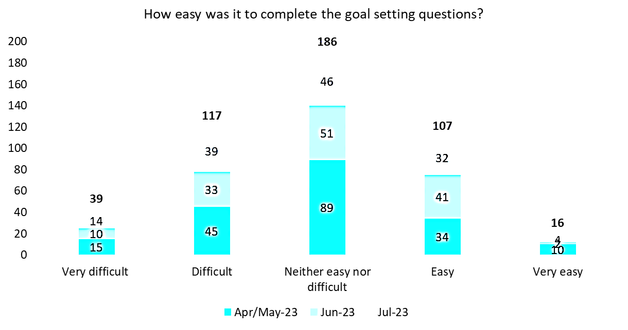

Assessor were asked “*were the categories used to capture the goal relevant?*”.

In the April/May 2023 monthly assessor survey, this question received a total of 180 responses. 134 found the categories relevant, whilst 46 did not.

#### Figure 33: Goal setting categories quantitative survey feedback

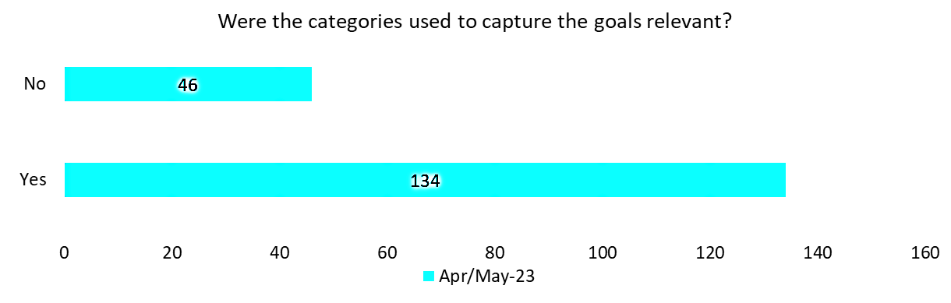

In the June and July 2023 monthly assessor surveys, this question received a total of 267 responses. 101 found the categories relevant, 136 were neutral, and 30 did not find them relevant.

#### Figure 34: Relevance of categories quantitative survey feedback

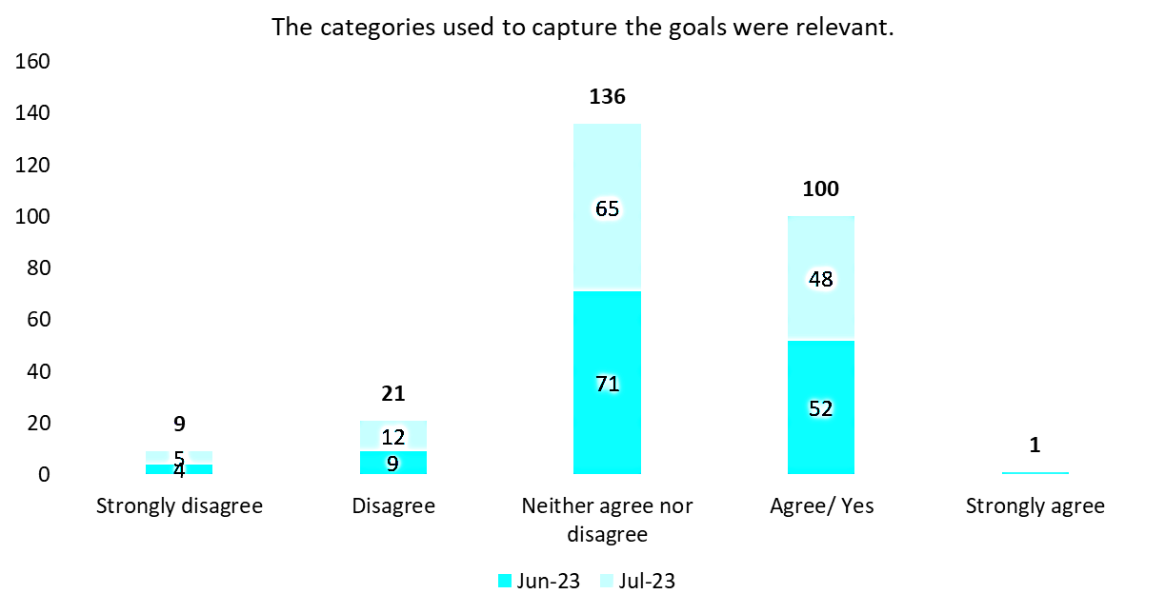

Key themes coming from assessors in relation to the Goal setting section are presented in Table 39 below. These findings refer to qualitative data provided through free-text monthly assessor surveys questions and other feedback channels.

#### Table 39: Goal setting qualitative feedback

|  |  |  |  |
| --- | --- | --- | --- |
| **Theme** | **Monthly assessor survey** | **My Assessor chat (CoP) and email inbox** | **Total** |
| Goals are repetitive or confusing | 184 mentions | 1 enquiry | **185** |
| Goal setting section is too long | 62 mentions | - | **62** |
| Adjustments to goal setting categories | 17 mentions | - | **17** |
| Character length is inadequate | 12 mentions | - | **12** |
| **Total Goal setting feedback instances** | | | **276** |

##### Goals are repetitive or confusing:

185 instances of assessor feedback noted that the goal setting section was repetitive and confusing.

Out of the 185 feedback instances:

* Assessors struggled to distinguish between ‘goal’ and ‘client goal’, deeming it as unnecessary repetition (140 instances) or a source of confusion (45 instances)
* Clarifying the distinction between these two fields or the removal of one of them may address this assessor concern.

**There is not enough explanation on the differences between types of goals.**

##### Goal setting section is too long:

62 instances of assessor feedback noted that the goal-setting section took too long to complete.

Out of the 62 feedback instances:

* 34 instances commented repetition was a key contributor to the section length
* 19 instances commented on the section’s question complexity and that lead to increased duration of assessment
* 6 instances noted clients were fatigued at this point of the assessment
* 2 instances commented assessors felt that clients simply wanted to list their goals without delving into the specific details required to ascertain them.

**Recording the ‘goal’ and ‘client goal’ fields in the goal-setting section is repetitive as assessors input the same information.**

##### Adjustments to goal setting categories:

17 instances of assessor feedback requested more goal categories and changes to the existing ones in the IAT.

Out of the 17 feedback instances:

* 9 instances noted clients’ goals often do not align with a single category
* 7 instances suggested selecting multiple goal categories for one client may allow for greater detail.

**Clients’ goals do not always align with a single goal setting category, limited the detail assessors can provide.**

##### Character length is inadequate:

12 instances of assessor feedback noted that the character length for goals is restrictive.

Out of the 12 feedback instances:

* 12 instances expressed the 100-character limit insufficient for capturing the necessary level of detail
* Increasing or removing the character limit would allow for assessors to include all necessary information pertaining to client goals.

**The existing character length restricts the detail assessors can provide on client goals.**

##### Summary:

When prompted, assessors highlighted key opportunities to refine the Goal setting section of the IAT. Key feedback to consider regarding the Goal setting section included:

**Goals are repetitive or confusing, adding to length**

Repetition in the Goal setting section questions, such as recording both a ‘goal’ and ‘client goal’, confused assessors, as they looked to confirm whether they understood the questions correctly. With assessors capturing the same information in both questions, assessors become confused if they are understanding the question ask correctly and may misinterpret the questions. This repetition also added to the section length.

## Assessor recommendations

Assessors shared feedback on the service recommendation type, frequency and other relevant aged care service recommendation supporting information. Feedback was collected from monthly assessor surveys, My Assessor chat CoP, and the email inbox. There were 8 quantitative questions and 5 qualitative questions dedicated to Assessor recommendations in all 3 of the monthly assessor surveys.

### Listed service type recommendations

Within the monthly assessor surveys, assessors were asked “*Did the listed services adequately capture what you wanted to recommend?*”

From a total of 533 responses to this question, 80 responses (15%) indicated they did not find the listed services adequate, 179 responses (34%) neither agreed nor disagreed, and 274 responses (51%) found the listed services adequate.

#### Figure 35: Assessor recommendations quantitative survey feedback

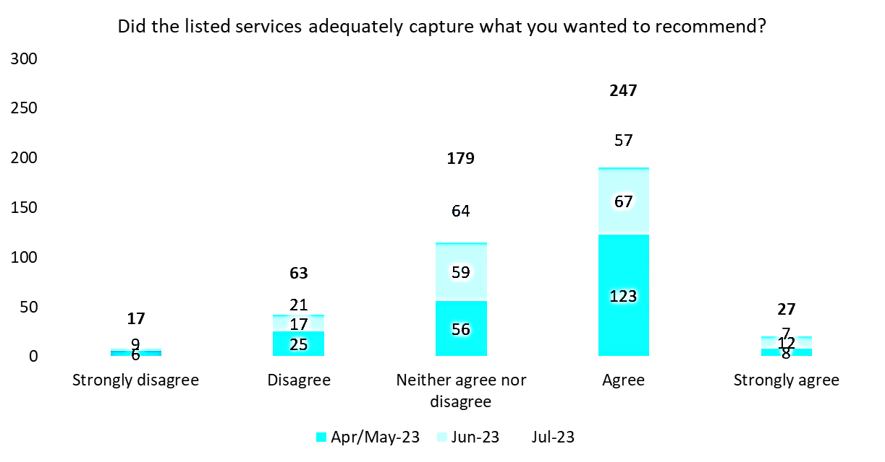

Assessors were asked “*When making service type recommendations (both short- and long-term services) did you find it easy to recommend the frequency and type of services?*

When asked about short-term recommendations, a total of 545 assessors answered this question. 287 responses (53%) indicated they found it difficult, and 258 responses (47%) indicated they found it easy.

#### Figure 36: Assessor recommendations quantitative survey feedback

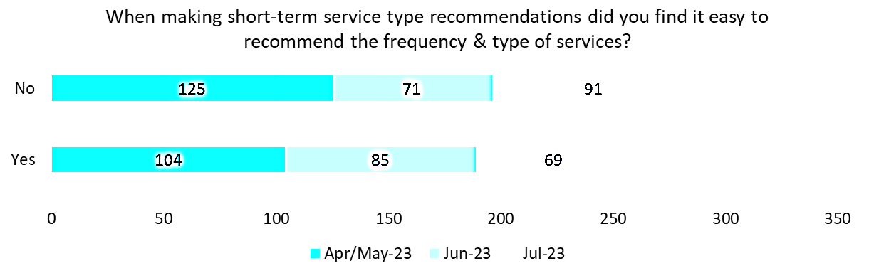

When asked about long-term recommendations, a total of 544 assessors answered this question. 262 responses (48%) indicated they found it difficult, and 282 responses (52%) indicated they found it easy.

#### Figure 37: Assessor recommendations quantitative survey feedback

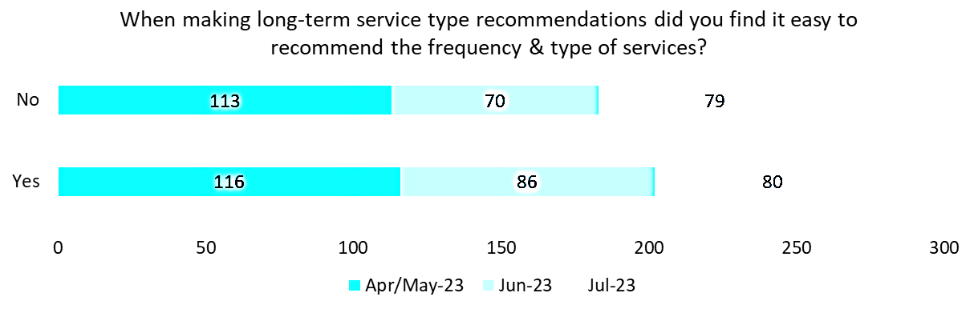

Assessors were asked “*Were the referral recommendations appropriate for: restorative services, reablement services, and short-term services?”*

When asked about restorative services, a total of 463 assessors answered this question. 132 responses (29%) indicated they found them inappropriate, and 331 responses (71%) indicated they found it appropriate.

#### Figure 38: Assessor recommendations quantitative survey feedback

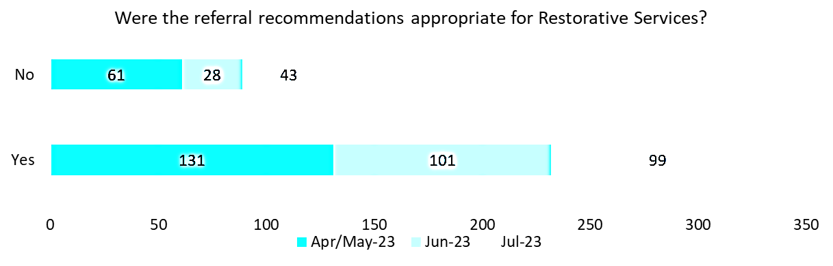

When asked about reablement Services, a total of 473 assessors answered this question. 116 responses (25%) indicated they found them inappropriate, and 357 responses (75%) indicated they found it appropriate.

#### Figure 39: Assessor recommendations quantitative survey feedback

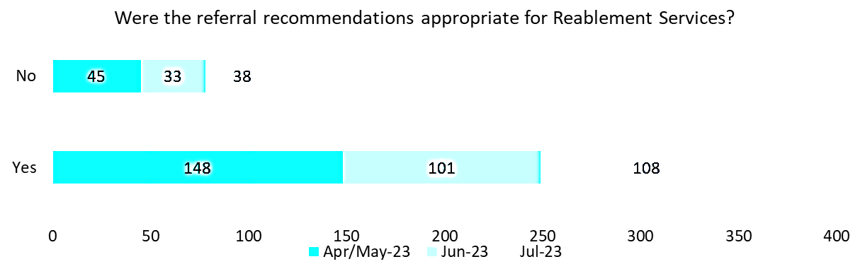

When asked about short-term services, a total of 475 assessors answered this question. 107 responses (23%) indicated they found them inappropriate, and 368 responses (77%) indicated they found it appropriate.

**Figure 40: Assessor recommendations quantitative survey feedback**

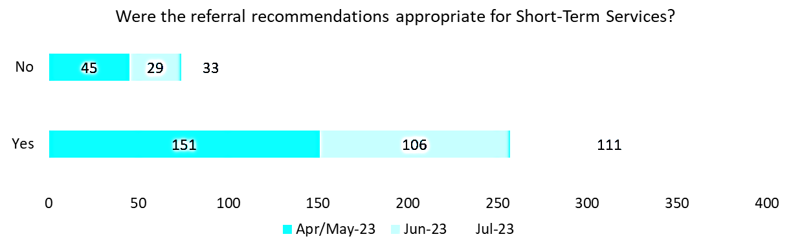

## Allied health referrals

Assessors were asked “Were you comfortable making referrals to allied health?”

From a total of 493 responses to this question, 83 responses (17%) indicated were not comfortable making referrals to allied health, 410 responses (83%) were comfortable.

#### Figure 41: Assessor recommendations quantitative survey feedback

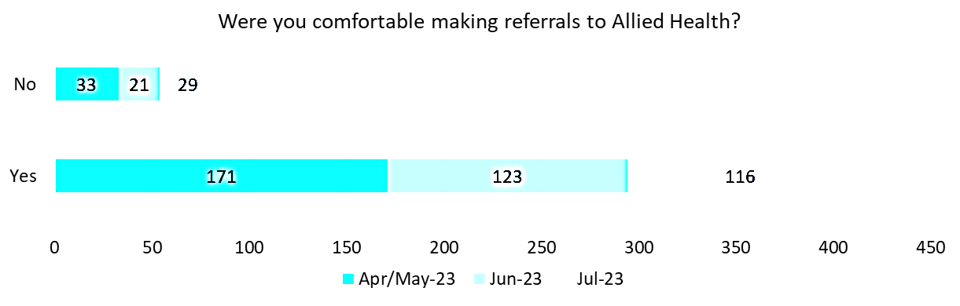

Assessors were asked “*When making referrals to allied health, were you comfortable with suggesting the frequency of allied health Input?”*

From a total of 494 responses to this question, 404 responses (82%) indicated were not comfortable suggesting the frequency of allied health Input, 90 responses (18%) were comfortable.

#### Figure 42: Assessor recommendations quantitative survey feedback

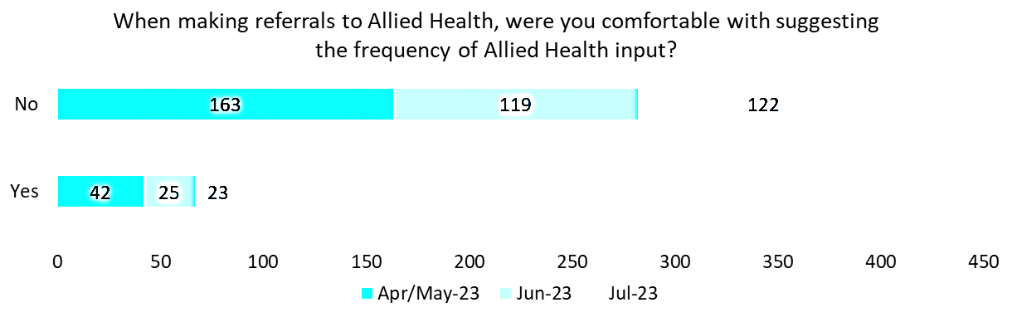

Within the monthly assessor surveys, assessors were asked the following qualitative questions:

### Listed service type recommendations

* A total of 86 individual responses were recorded to the question: *“If you disagree to the statement in Q2, what additional service types would you recommend be added?”*
* A total of 195 individual responses were recorded to the two questions: *“If no, why did you feel a Reablement referral / Reablement referral, was not appropriate?”.*

### Allied health

* Following the question asking if assessors were comfortable with suggesting the frequency of allied health input, assessor were asked “*If no, please provide reasoning?”* A total of 395 individual responses were recorded.
* “*If yes, please provide reasoning?”* A total of 84 individual responses were recorded.

Key themes in relation to the assessor recommendations section are presented in Table 40 below. These findings refer to qualitative data provided through free-text monthly assessor surveys questions and other feedback channels.

#### Table 40: Assessor recommendations qualitative feedback

|  |  |  |  |
| --- | --- | --- | --- |
| **Theme** | **Monthly assessor survey** | **My Assessor chat (CoP) and email inbox** | **Total** |
| Frequency should be completed by allied health | 185 mentions | - | **185** |
| Assessor struggled to predict frequency | 171 mentions | 6 enquiries | **177** |
| Reablement or restorative referrals may not be suitable for client | 37 mentions | - | **37** |
| Lack of guidance information | 22 mentions | - | **22** |
| Have an allied health or clinical background | 22 mentions |  | **22** |
| Comfortable making one-off recommendations | 18 mentions | - | **18** |
| **Total assessor recommendations feedback instances** | | | **461** |

#### Allied health referrals

Following the question “*When making referrals to allied health, were you comfortable with suggesting the frequency of allied health Input?”,* assessors who responded ‘No’ were asked to provide the reasoning for their response. A total of 395 responses were provided by assessors and their key reasoning were:

##### Frequency should be completed by allied health:

185 instances of feedback suggested frequency should be completed by allied health professional.

Out of the 185 feedback instances:

* In 98 instances, assessors expressed they feel they lack the experience/ qualifications to accurately suggest the frequency
* This increases the risk of incorrect frequencies being provided.

**Assessors would prefer trained allied health professionals to make judgements on the frequency of care a client requires.**

##### Assessors struggled to predict the frequency of allied health input:

177 instances of assessor feedback suggested it is difficult to predict the frequency of allied health Input.

* Frequency is normally completed by allied health professionals
* 62 instances suggested assessors have not been trained adequately or do not have access to the appropriate guidance material
* This increases the risk of incorrect frequencies being provided.

**Assessors lacked confidence when estimating the frequency of allied health input.**

##### Lack of guidance information:

22 instances of assessors commented they were not qualified to make Occupational Therapy and Physical Therapy recommendations.

* There is an opportunity to provide training sessions and guideline documentation
* This can help assessors understand and capture allied health frequency correctly.

**Assessors do not have access to adequate information to predict the cost and frequency of allied health input.**

### Listed service type recommendations

##### Reablement or Restorative referrals may not be suitable for client:

37 instances of assessor feedback raised Reablement, or Restorative referrals may not be suitable.

* 22 instances expressed it is a concern for clients who need ongoing support or have chronic conditions
* 14 instances suggested it was difficult to decide where to allocate their service recommendations for clients on a maintenance pathway.

**The service type recommendations do not account for clients who are on a maintenance pathway.**

Following the question “*When making referrals to allied health, were you comfortable with suggesting the frequency of allied health Input?”*, the assessors who responded ‘Yes’ were asked to provide the reasoning for their response. A total of 84 responses were provided by assessors and their key reasoning were:

##### Assessor has an allied health or clinical background:

22 instances of assessor feedback highlighted assessors that have backgrounds in allied health or clinical areas feel comfortable suggesting the frequency of allied health input.

##### Comfortable making one-off recommendations:

18 instances of assessor feedback commented assessors feel comfortable suggesting once off allied health frequencies.

**Assessors with an allied health or clinical background were more skilled in this area.**

##### Summary:

Key feedback to consider regarding the Assessor recommendations section included:

**Frequency should be completed by allied health**

* Assessors feel they lack the experience/ qualifications to accurately suggest the frequency
* This increases the risk of incorrect frequencies being provided.

**Difficult to predict the frequency of allied health input**

* Assessors find it difficult to accurately predict frequency
* This increases the risk of incorrect frequencies being provided.

## Assistive Technology - Home Modification (AT-HM)

Assessors shared feedback on the AT-HM recommendation within the IAT. Feedback was collected from monthly assessor surveys, My Assessor chat CoP, and the email inbox. There was 7quantitative and 4 qualitative questions dedicated to AT-HM in the monthly assessor surveys.

Within the monthly assessor surveys, assessors were presented the statement “*It would be beneficial for me to be able to prescribe AT-HM within the assessment, without the need to refer on to another allied health professional*”.

From a total of 276 responses to this question, 96 responses (35%) indicated they would not find it beneficial, 83 responses (30%) neither agreed nor disagreed, and 97 responses (35%) would find it beneficial.

#### Figure 43: AT-HM quantitative survey feedback

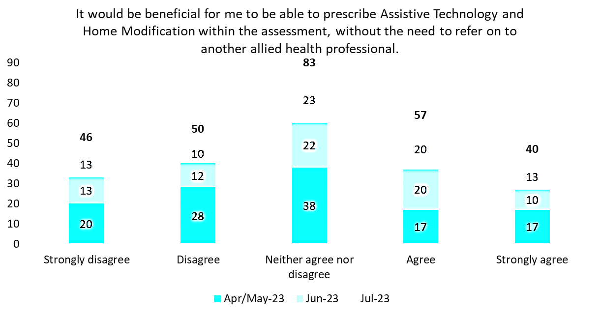

Assessor were presented the statement “*I was comfortable making the AT-HM recommendations.*”

From a total of 448 responses to this question, 140 responses (31%) indicated they were not comfortable making AT-HM recommendations, 149 responses (33%) neither agreed nor disagreed, and 159 responses (36%) were comfortable.

#### Figure 44: AT-HM quantitative survey feedback

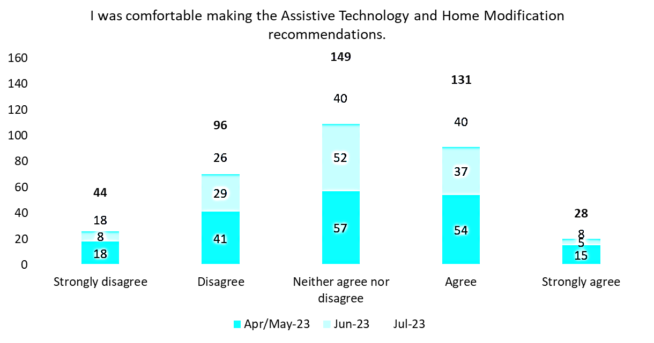

Assessor were presented the statement “*The AT-HM categories covered all the recommendations I wanted to make.*” From a total of 439 responses to this question, 80 responses (18%) indicated categories didn’t cover all the recommendations they wanted, 208 responses (47%) neither agreed nor disagreed, and 151 responses (35%) expressed they did.

#### Figure 45: AT-HM quantitative survey feedback

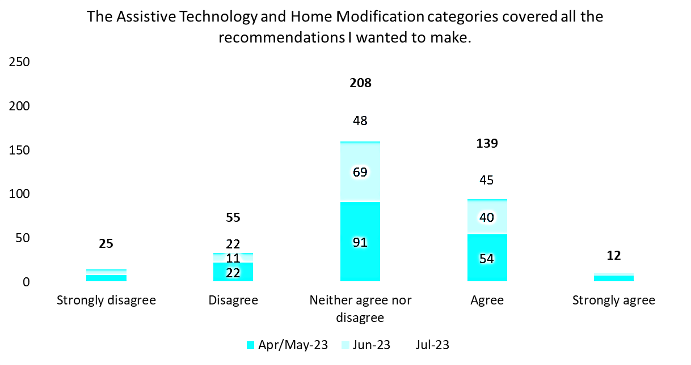

Assessor were presented the statement “*The assessment tool allowed me to gather enough information to make AT-HM recommendations.* “From a total of 438 responses to this question, 123 responses (28%) indicated the IAT didn’t allowed them to gather enough information to make AT-HM recommendations, 178 responses (41%) neither agreed nor disagreed, and 137 responses (31%) expressed that it did.

#### Figure 46: AT-HM quantitative survey feedback

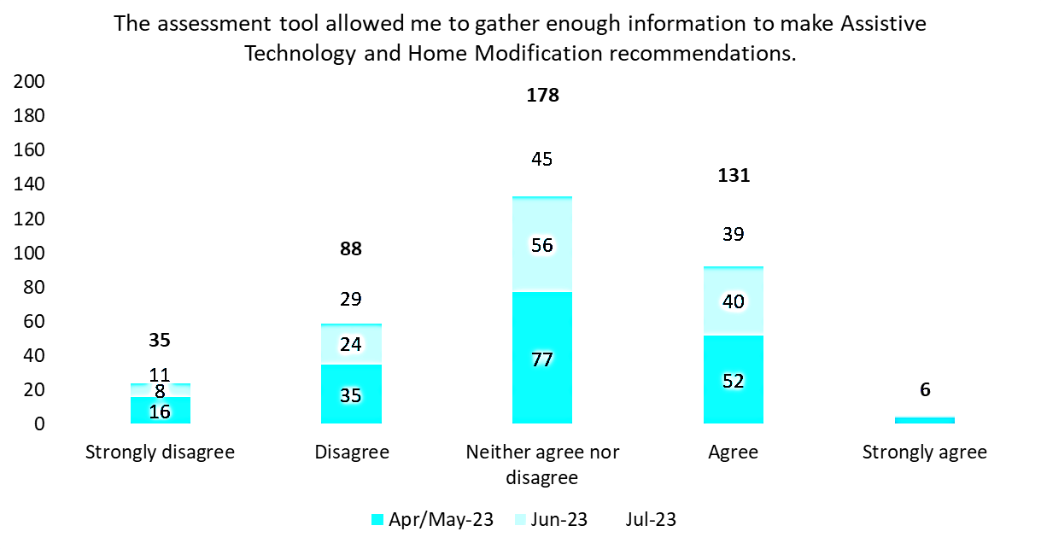

Assessor were presented the statement “*If items were grouped into categories (e.g., personal mobility aids) this would assist me when I am making AT-HM recommendations.*” From a total of 440 responses to this question, 53 responses (12%) indicated grouping items would not assist, 140 responses (32%) neither agreed nor disagreed, and 247 responses (56%) expressed it would help.

#### Figure 47: AT-HM quantitative survey feedback

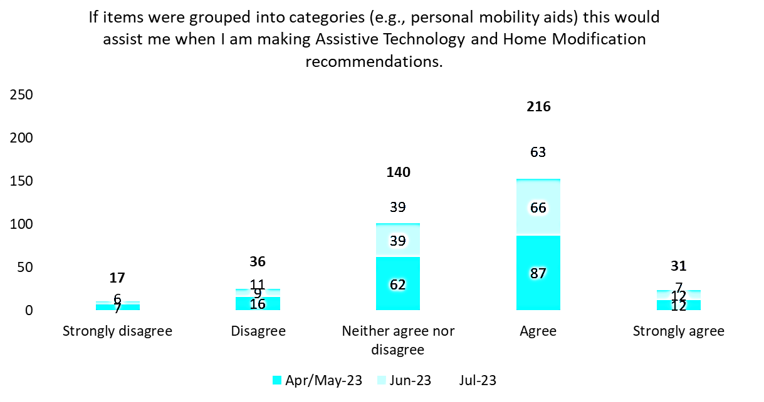

Assessor were presented the statement “*If individual items were classified according to risk levels (e.g. low, medium and high), this would assist me when I am making AT-HM recommendations.*

From a total of 438 responses to this question, 96 responses (22%) that classifying according to risk levels would not assist, 174 responses (40%) neither agreed nor disagreed, and 168 responses (38%) indicated it would assist.

#### Figure 48: AT-HM quantitative survey feedback

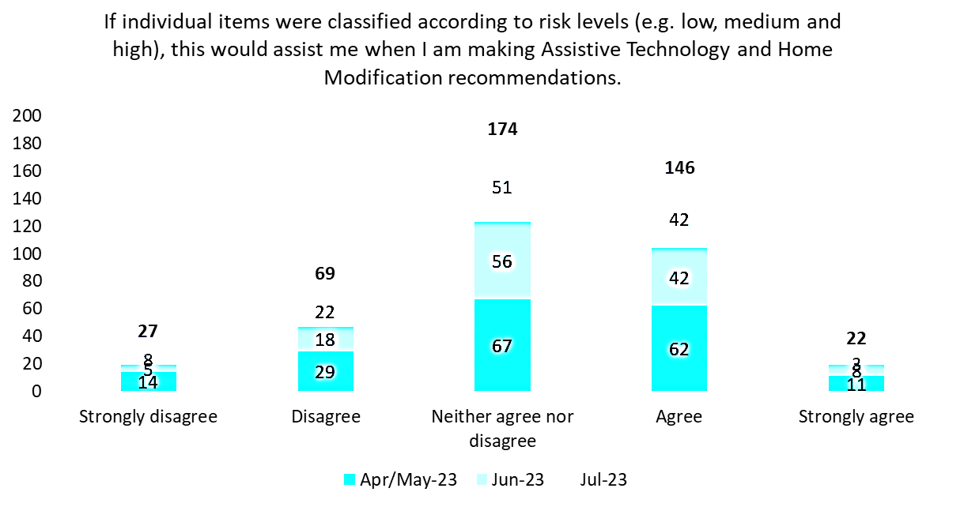

Assessor were presented the statement “*Are there any low-risk items you would feel comfortable recommending without referring for allied health assessment?”* From a total of 270 responses to this question, 67 responses (25%) that there are no low-risk items they feel comfortable recommending, and 203 responses (75%) indicated there are items assessors would feel comfortable recommending.

#### Figure 49: AT-HM quantitative survey feedback

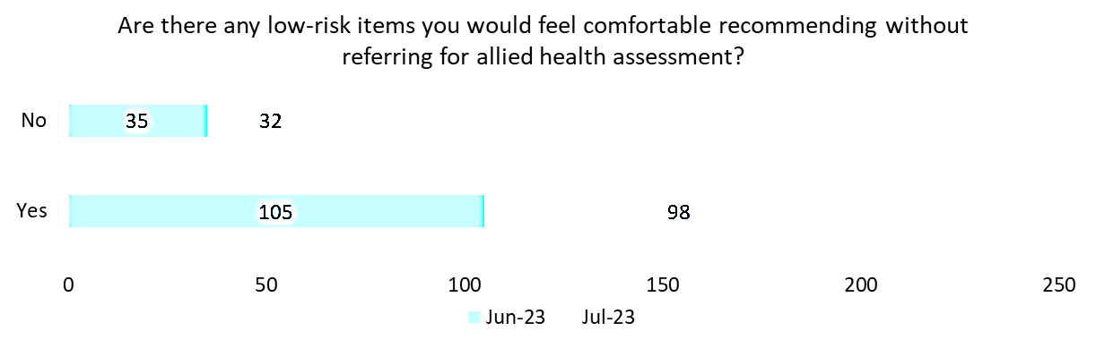

To understand the reasoning behind assessors’ responses to this question, it was changed from a free text question in the April/May 2023 monthly assessor survey, to a ‘Yes/No’ question with follow up enquires in the June and July 2023 monthly assessor surveys.

Within the monthly assessor survey, assessors were asked the following qualitative questions:

* “*What mechanisms could support assessors who are registered allied health professionals to do this [prescribe AT-HM within the assessment]?”* A total of 188 individual responses were recorded
* Following the question on AT-HM categories: “*What categories or items did you feel were not included*?”

A total of 152 individual responses were recorded

* Following the question on low-risk items **“***If yes, please list the items*.” A total of 192 individual responses were recorded
* Following the question on low-risk items“*If no, please provide reasons for this response.”* A total of 54 individual responses were recorded.

Key themes coming from assessors in relation to the AT-HM recommendations are presented in Table 41 below. These findings refer to qualitative data provided through free-text monthly assessor surveys questions and other feedback channels.

#### Table 41: AT-HM qualitative feedback

|  |  |  |  |
| --- | --- | --- | --- |
| **Theme** | **Monthly assessor survey** | **My Assessor chat (CoP) and email inbox** | **Total** |
| Categories are confusing | 31 mentions | - | **31** |
| Out of assessor’s scope | 29 mentions | - | **29** |
| Require additional training | 15 mentions | - | **15** |
| **Total AT-HM feedback instances** | | | **75** |

##### Categories are confusing:

31 instances of assessor feedback noted that the AT-HM categories were confusing.

Out of the 31 feedback instances:

* 21 instances commented that assessors struggled to distinguish what each category included and locate specific items
* 10 instances noted that more detailed category definitions, further breakdowns of categories and sub-categories, or the addition of a search bar would help to improve navigation.

**AT-HM categories were not clear enough for assessors.**

##### Out of assessors’ scope:

29 instances of assessor feedback noted that AT-HM should not be a part of the IAT.

Out of the 29 feedback instances:

* 16 instances expressed that making such recommendations was beyond the scope of their role
* 13 instances expressed that allied health professionals should be responsible for client recommendations
* Incorrect recommendations may result in a waste of resources, time, and money, and may not benefit the client as intended.

**AT-HM recommendations should not be part of the IAT.**

##### Assessors require additional training:

15 instances of assessor feedback noted that assessors would benefit further training related to AT-HM recommendations.

Out of the 15 feedback instances:

* 4 instances highlighted the challenge of dealing with a large number of items
* 7 instances suggested assessors lacked expertise in identifying items or their respective categories
* The potential benefit of more comprehensive training and guidance regarding category details and requested updates in the user guide to address this.

**Assessors would benefit from further training pertaining to**

**AT-HM recommendations.**

##### Summary:

Key feedback to consider regarding the AT-HM recommendations included:

**Categories are confusing**

* They struggled to distinguish what each category included and locate specific items
* More detailed category definitions, further breakdowns of categories and sub-categories, or the addition of a search bar would help to improve navigation.

**Out of assessor’s scope**

* Making such recommendations was beyond the scope of their role
* Incorrect recommendations may result in a waste of resources, time, and money, and may not benefit the client as intended.

## IAT Live Trial observations

### Technology

Monitoring of IAT Live Trial assessments was impacted by challenges in sourcing timely and accurate PM report data. Issues were raised during the IAT Live Trial relating to ACAT/RAS, location, and interpreter data fields. The issues were escalated and resolved with ITD. These issues impacted the accuracy and quality of reporting assessments.

Absent location data was improved over the duration of the IAT Live Trial; however, without a full resolution of absent location data, the identification of assessments conducted in MMM2-7 remoteness regions has been impacted resulting in understating reported assessments against the ‘rural and remote’ KPIs. The regular cadence of the data extract process (3 times per week) and subsequent availability of PM report data was intermittently disrupted throughout the IAT Live Trial. At times, PM report data extracts were missed or arrived late resulting in delayed updates of the assessment completion numbers and communication to stakeholders.



The business definitions for reporting and assessment completion definitions changed during the IAT Live Trial. NSAF finalised requirements for assessment completion and the ‘IAT assessment completed’ definition changed during the IAT Live Trial. The impact of these changes was that the number of completed assessments was updated to include additional NSAF assessment statuses, and the accuracy of data reporting was influenced.

### Communications

To support assessors throughout the IAT Live Trial several communications channels were established and maintained to provide prompt and clear trial updates to trial participants.

Initially, these communications were only provided via the My Assessor chat CoP. Joining instructions were provided to assessors, with direction to monitor the discussion forum for updates and key information. With increased volumes of enquiries relating to information already communicated, targeted emails with any communication information were provided to key stakeholders within each AMO assessment team e.g., co-ordinators, assessment team leaders. This saw a reduction of follow-up emails regarding previously communicated information as the IAT Live Trial progressed, as these key stakeholders ensured the dissemination of communications across their assessment teams in BAU team activities.

In the June 2023 period of the IAT Live Trial the fortnightly assessor check-in calls were established. These sessions providing IAT Live Trial participants with an opportunity for a face-to-face discussion regarding IAT Live Trial updates and feedback. With attendance averaging 80 assessors per session, assessors within these sessions reflected that the opportunity to engage across several channels meant assessors felt heard by the department when they provided feedback.

The My Assessor chat CoP was broadly successful in providing a platform for assessors to share lessons learned, feedback and ask questions regarding the IAT Live Trial. At instances of high enquiry volumes, such as when technology incidents occurred, assessors did reflect that the My Assessor chat CoP could be difficult to navigate due to a larger volume of posts across the platform. These post volumes often reflected the same, or similar topics as previously addressed on the platform.



### Ethics

There were several challenges, and in turn lessons to be learned, through the IAT Live Trial with respect to ethics. In particular:

* Determining whether vulnerable cohorts are intentionally or incidentally being included in a study. if intentionally, then ethics will be required (e.g., if First Nations older people are to be deliberately included, an application to a registered AHREC will be required. If their inclusion is only incidental, then a separate AHREC will not be required)
* Where an AHREC application is required, letters of support from relevant Indigenous organisations will be required. It is critical to liaise with Indigenous organisations to seek their involvement and support as early as possible, including where appropriate, seeking their input to and co-ownership of the design of a project
* Planning, preparing and submitting ethics applications as early as possible in a project
* Understanding the different timeframes and protocols for ethics committees
* Allowing sufficient time at the beginning of a project to obtain approvals prior to the planned commencement of fieldwork
* The importance of maintaining open communication with the ethics committees

The combination of the above challenges resulted in a slight delay in fieldwork with non- First Nations older people and a considerable delay in fieldwork with First Nations older people during the IAT Live Trial. While it is acknowledged that every project is different, being mindful of the above lessons will hopefully inform future projects where ethics is required.

It is also useful to fully understand a committee’s protocols, expectations, timelines, and minimum requirements before choosing to submit an application for consideration. This will help to streamline processes and possibly reduce frustration associated with the time it often takes for a committee to approve an application. Establishing and maintaining a positive working relationship with the “secretariate” can also be useful to help navigate processes and protocols.

Please refer to Lessons learned for additional insights.

### Feedback on KPI performance

Feedback provided by assessors and AMOs through the My Assessor chat CoP and in monthly assessor surveys likely to have impacted or driven these results include:

* Reluctance from CALD clients to participate in the Trial, often due to the additional time required for an IAT assessment or difficulty understanding why they would take a longer assessment
* Concerns with the suitability of cognition assessment tools and the IAT more broadly for clients with CALD backgrounds, particularly requiring translation using an interpreter
* A need for additional time considerations and booking for interpreter-led assessments, as assessors requiring translation support require longer assessment bookings. Cultural and logical barriers to IAT Live Trial participation including the length of the IAT and its consent and assessment process for First Nations people
* Dissatisfaction from assessors on the effectiveness and appropriateness of the IAT tailoring to First Nations older people
* Certain sections of the IAT assessment (including DSSI) of the IAT were not suitable for First Nations older people
* Assessors could not appropriately complete certain sections of the IAT for hospital assessments
* Assessment length, client fatigue and disinterest in completing the assessment.

### Limitations in the IAT Live Trial

The IAT Live Trial dataset is now an asset held by the department to be used to support future aged care policy development. However, the monitoring and evaluation of IAT Live Trial KPIs has revealed under-representation of certain client demographics. This under representation is likely driven by the availability and willingness to complete the IAT Live Trial for selected participants by AMOs and assessors. This is consistent with feedback from assessors and AMOs from the My Assessor chat CoP and monthly assessor surveys, where common themes of lack of tailoring, language and question unsuitability, and length of the IAT assessment were mentioned.

This introduces a limitation of the dataset and risk to the integrity of future analysis conducted on the dataset if not treated appropriately. To fully understand the extent and drivers of this potential sample bias further analysis is required.

This further analysis would consist of comparing the IAT Live Trial sample to historical NSAF data, identifying the characteristics of clients who are under-represented or not represented at all in the IAT Live Trial dataset. This analysis would be designed to focus on both demographics and the clinical condition of clients to identify client demographics at a more detailed level than the KPIs used in the monitoring the IAT Live Trial.



After conducting this analysis, it is then important for any findings to be appropriately communicated to future users of the IAT Live Trial dataset and considered in any future weightings of the data to achieve representativeness.

# Appendix A: Qualitative research questions

The IAT Live Trial project team conducted continuous refinement of the monthly assessor survey questions to ensure that the assessors were providing the most applicable feedback in line with the department’s initial qualitative research questions. The below features each month’s monthly assessor survey questions:

#### Table 42: Qualitative research questions

| Initial qualitative research questions | April/May 2023 survey questions | June 2023 survey questions | July 2023 survey questions |
| --- | --- | --- | --- |
| When making service type recommendations (both short- and long-term services) did assessors find it easy to recommend the type of services? | When making service type recommendations (both short- and long-term services) did you find it easy to recommend the frequency & type of services? | When making service type recommendations (both short- and long-term services) did you find it easy to recommend the frequency & type of services? | When making service type recommendations (both short- and long-term services) did you find it easy to recommend the frequency & type of services? |
| When making service type recommendations (both short- and long-term services) did assessors find it easy to recommend the frequency of services? | Short-term recommendations? | Short-term recommendations? | Short-term recommendations? |
|  | Long-term recommendations? | Long-term recommendations? | Long-term recommendations? |
| Did the listed services adequately capture what assessors wanted to recommend? | Did the listed services adequately capture what you wanted to recommend? | Did the listed services adequately capture what you wanted to recommend? | Did the listed services adequately capture what you wanted to recommend? |
| What was missing? | If no, what additional service types would you recommend be added? | If you disagree to the statement in Q2, what additional service types would you recommend be added? | If you disagree to the statement in Q2, what additional service types would you recommend be added? |
|  | Were the referral recommendations appropriate for:  Restorative services? | Were the referral recommendations appropriate for:  Restorative services? | Were the referral recommendations appropriate for:  Restorative services? |
|  | If no, what situations warranted an “opt out” for Restorative referrals? | If no, why did you feel a Restorative referral was not appropriate? | If no, why did you feel a Restorative referral was not appropriate? |
|  | Reablement services? | Reablement services? | Reablement services? |
|  | If no, what situations warranted an “opt out” for Reablement referrals? | If no, why did you feel a Reablement referral was not appropriate? | If no, why did you feel a Reablement referral was not appropriate? |
|  | Short-term services? | Short-term services? | Short-term services? |
| Were the decision support and hover help text boxes in the IAT appropriate? | Were the decision support and hover help text boxes in the IAT appropriate and useful?  If no, what wasn’t appropriate or useful? | Were the hover help text boxes in the IAT appropriate and useful?  If no, what wasn’t appropriate or useful? | Were the hover help text boxes in the IAT appropriate and useful?  If no, what wasn’t appropriate or useful? |
| Were the decision support and hover help text boxes in the IAT useful? |  |  |  |
| What was the breakdown of referrals to allied health services and recommended frequencies? | N/A – unable to access this information | N/A – unable to access this information | N/A – unable to access this information |
| Were assessors comfortable in  1. Making referrals to allied health and  2. When making the referrals to AH were they comfortable with suggesting the frequency of allied health input? | Were you comfortable making referrals to allied health? | Were you comfortable making referrals to allied health? | Were you comfortable making referrals to allied health? |
|  | When making referrals to allied health, were you comfortable with suggesting the frequency of allied health input? | When making referrals to allied health, were you comfortable with suggesting the frequency of allied health input? | When making referrals to allied health, were you comfortable with suggesting the frequency of allied health input? |
|  | If yes, please provide reasoning? | If yes, please provide reasoning? | If yes, please provide reasoning? |
|  | If no, please provide reasoning? | If no, please provide reasoning? | If no, please provide reasoning? |
|  | It would be beneficial for me to be able to prescribe AT-HM within the assessment, without the need to refer on to another allied health professional. | It would be beneficial for me to be able to prescribe AT-HM within the assessment, without the need to refer on to another allied health professional. | It would be beneficial for me to be able to prescribe AT-HM within the assessment, without the need to refer on to another allied health professional. |
|  | What mechanisms could support assessors who are registered allied health professionals to do this? | What mechanisms could support assessors who are registered allied health professionals to do this? | What mechanisms could support assessors who are registered allied health professionals to do this? |
| I was comfortable making the AT- HM recommendations (Strongly agree, agree, neutral, disagree, strongly disagree) | I was comfortable making the AT-HM recommendations. (Strongly agree, agree, neutral, disagree, strongly disagree) | I was comfortable making the AT-HM recommendations.  (Strongly agree, agree, neutral, disagree, strongly disagree) | I was comfortable making the AT-HM recommendations.  (Strongly agree, agree, neutral, disagree, strongly disagree) |
| The AT-HM categories covered all of the recommendations I wanted to make (Strongly agree, agree, neutral, disagree, strongly disagree & “what categories or items did you feel were not included?”) | The AT-HM categories covered all the recommendations I wanted to make. (Strongly agree, agree, neutral, disagree, strongly disagree) | The AT-HM categories covered all the recommendations I wanted to make. (Strongly agree, agree, neutral, disagree, strongly disagree) | The AT-HM categories covered all the recommendations I wanted to make. (Strongly agree, agree, neutral, disagree, strongly disagree) |
|  | What categories or items did you feel were not included? | What categories or items did you feel were not included? | What categories or items did you feel were not included? |
| The assessment tool allowed me to gather enough information to make AT-HM recommendations (Strongly agree, agree, neutral, disagree, strongly disagree and “what should be included to better support assessors?) | The assessment tool allowed me to gather enough information to make AT-HM recommendations.  (Strongly agree, agree, neutral, disagree, strongly disagree) | The assessment tool allowed me to gather enough information to make AT-HM recommendations.  (Strongly agree, agree, neutral, disagree, strongly disagree) | The assessment tool allowed me to gather enough information to make AT-HM recommendations.  (Strongly agree, agree, neutral, disagree, strongly disagree) |
|  | If items were grouped into categories (e.g., personal mobility aids) this would assist me when I am making AT-HM recommendations. | If items were grouped into categories (e.g., personal mobility aids) this would assist me when I am making AT-HM recommendations. | If items were grouped into categories (e.g., personal mobility aids) this would assist me when I am making AT-HM recommendations. |
|  | If individual items were classified according to risk levels (e.g. low, medium and high), this would assist me when I am making AT-HM recommendations. | If individual items were classified according to risk levels (e.g. low, medium and high), this would assist me when I am making AT-HM recommendations. | If individual items were classified according to risk levels (e.g. low, medium and high), this would assist me when I am making AT-HM recommendations. |
|  | Are there any low-risk items you would feel comfortable recommending or prescribing without referring for allied health assessment (e.g., jar openers, tipping kettle, non-slip mat)? | Are there any low-risk items you would feel comfortable recommending without referring for allied health assessment? | Are there any low-risk items you would feel comfortable recommending without referring for allied health assessment? |
|  |  | If yes, please list the items. | If yes, please list the items. |
|  |  | If no, please provide reasons for this response. | If no, please provide reasons for this response. |
| Was the IAT effective and appropriate in assessing the care needs of CALD and First Nations older people? | In your experience, was the IAT effective and appropriate in assessing the care needs of:  CALD? | In your experience, was the IAT effective and appropriate in assessing the care needs of:  CALD? | In your experience, was the IAT effective and appropriate in assessing the care needs of:  CALD? |
|  | First Nations older people? | First Nations older people? | First Nations older people? |
|  | If no, please explain why. | If no, please explain why. | If no, please explain why. |
|  |  |  | When using an interpreter during assessment, have you experienced any challenges or barriers? |
|  |  |  | If yes, please explain why. |
| How often were the KICA suite of tools used instead of the mainstream assessment tools? | N/A – unable to access this information | N/A – unable to access this information | N/A – unable to access this information |
| Which client groups were they used for (e.g. First Nations people, CALD). | N/A – unable to access this information | N/A – unable to access this information | N/A – unable to access this information |
| Why did the assessors choose to switch? | During assessment, if you decided to use the KICA suite of tools, why did you decided to select this tool? | During assessment, if you decided to use the KICA suite of tools, why did you decided to select this tool? | During assessment, if you decided to use the KICA suite of tools, why did you decided to select this tool? |
| Were older people from specific demographics assessed in a culturally safe manner? | N/A – unable to access this information | N/A – unable to access this information | N/A – unable to access this information |
|  | How easy was it to complete the goal setting questions? | How easy was it to complete the goal setting questions? | How easy was it to complete the goal setting questions? |
|  | Can you explain the reasons for your response to the previous question? | Can you explain the reasons for your response to the previous question? | Can you explain the reasons for your response to the previous question? |
|  | Were the categories used to capture the goals relevant? | The categories used to capture the goals were relevant.  (Strongly agree, agree, neutral, disagree, strongly disagree) | The categories used to capture the goals were relevant.  (Strongly agree, agree, neutral, disagree, strongly disagree) |
|  | Please provide suggestions for additional goal categories. | If you disagree to the statement in Q20, please provide suggestions for additional goal categories. | If you disagree to the statement in Q20, please provide suggestions for additional goal categories. |
| Were there any questions which were unclear or create interpretation issues? | Were there any questions which were unclear or create interpretation issues? | Were there any questions which were unclear or create interpretation issues? | Were there any questions which were unclear or create interpretation issues? |
|  | If yes, which questions? | If yes, which questions? | If yes, which questions? |
|  | In response to the previous question, please provide an example of how the question could be improved or differently worded? | In response to the previous question, please provide an example of how the question could be improved or differently worded? | In response to the previous question, please provide an example of how the question could be improved or differently worded? |
|  |  |  | Do you find the current structure and sequence of questions and sections within the IAT adequate?  (Strongly agree, agree, neutral, disagree, strongly disagree) |
|  |  |  | Please provide information about your response in Q23, including suggestions to improve the sequencing of the IAT. |
| What additional training and guidance is needed? | Can you recommend any additional training or guidance that would have improved your IAT experience? | From your experience using the IAT during the live trial, what do you think the department’s future assessment guidance material should cover (e.g. the Aged Care Assessment Manual and the My Aged Care Quality Assessment Framework)? | From your experience using the IAT during the live trial, what do you think the department’s future assessment guidance material should cover (e.g. the Aged Care Assessment Manual and the My Aged Care Quality Assessment Framework)? |
| How could the tool be improved? |  | Is there any other feedback you would like to provide about the IAT that was not captured in the above questions? | Is there any other feedback you would like to provide about the IAT that was not captured in the above questions? |

# Appendix B: Monthly assessor survey outcomes

#### Table 43: Monthly assessor survey response data

|  |  |  |
| --- | --- | --- |
| April/May 2023 Monthly assessor survey response data | June 2023 Monthly assessor survey response data | July 2023 Monthly assessor survey response data |
|  |  |  |

The April/May 2023 survey generated a total of 247 responses, followed by 165 responses in June 2023 and 173 responses in July 2023. A total of 585 completed survey responses were collected over the course of 3 months.

The results shown in Appendix B may vary compared to the data presented in Part B of the report. Appendix B provides the number of question specific responses. Part B of the report provides data on cross-question mentions which will result in a higher total.

The most prevalent responses have been documented in Appendix B Themes with lower response rates have not been included due to statistical relevance.

## Service type recommendations

Within the IAT, assessors can make AT-HM, service recommendations, Reablement (short-term), and Restorative (short-term) recommendations to the client. The following survey questions sought to understand the assessors’ experience using the IAT recommendation process.

### Short-term recommendations

Assessors were asked, when making short-term service type recommendations, did they find it easy to recommend the frequency and type of services.

#### Figure 50: Short-term recommendations



Over the 3 surveys, a total of 258 responses expressed they found it easy making these recommendations, while 287 did not find it easy. These findings may be attributable to training, experience and confidence when making short term recommendations. As such, there may be an opportunity to strengthen training in relation to supporting assessors with making short-term recommendations.

### Long-term recommendations

Assessors were asked, when making long-term service type recommendations, did they find it easy to recommend the frequency and type of services.

#### Figure 51: Long-term recommendations



Across the 3 surveys, a total of 262 responses expressed they did not find it easy making these recommendations whilst 282 found it easy. This may be attributable to training, experience and confidence when making long term recommendations. Similar to short-term recommendations, there may be an opportunity to strengthen training in relation to supporting assessors with making long-term recommendations.

## Listed services

Assessors were asked if they found the listed services were adequately capturing what they wanted to recommend.

Across the 3 surveys, 274 assessors agreed the listed services were adequately capturing what they wanted to recommend, 179 assessors neither agreed nor disagreed, and 80 assessors disagreed.

**Figure 52: Listed services capturing recommendations**



The 80 assessors that disagreed were asked to provide suggestions for additional listed services to be included within the service type recommendations. The suggestions have been listed below with the instances each was mentioned across the three surveys.

The most prevalent reasons and suggestions provided by assessors were:

* Specialised services (24)
  + These services include Dementia advisory, continence service, permanent disability, vision service
* Free text or 'other' option (10)
* Goods and equipment/GEAT2GO (9)
* Garden and outdoors e.g., garden maintenance (6)
* Transport (5)
* Shopping assistance (5)
* Cleaning and home maintenance support (5)
* Social e.g., group support (3)
* Medication and medical management (3)
* Advocacy (1).

Additionally, 2 responses suggested listing the listed service type recommendations in alphabetical order.

## Referral recommendations

### Restorative services

Assessors were asked about the suitability of the referral recommendations for restorative services. In the 3 surveys, 132 assessors expressed that they found the referral recommendation for restorative service were not appropriate, while 331 found them appropriate.

#### Figure 53: Recommendations for Restorative services

**

Those who did not find it appropriate were prompted to provide additional detail. The reasons have been listed below with the instances each was mentioned across the 3 surveys.

The most prevalent reasons provided by assessors were:

* Many clients need ongoing support (16)
* Client has chronic condition that can only be maintained, not restored (9)
* Confusing and time consuming (6)
* Not suitable for client (6)
* Unclear between restorative and reablement (5)
* Lack of restorative services in assessor’s region (4)
* Client had been in hospital (4)
* Client has existing Health Care Package (3).

### Reablement services

Assessors were asked to provide their views on the appropriateness of the referral recommendations for Reablement services. Across the 3 surveys, 116 Assessors did not find it appropriate, whilst 357 did, reflecting a very similar distribution of responses as the previous question.

#### Figure 54: Recommendations for Reablement services



Individuals who expressed discontent with the current referral recommendations for Reablement services were asked to elaborate further. The reasons have been listed below with the instances each was mentioned across the 3 surveys.

The most prevalent reasons provided by assessors were:

* Client has a chronic condition, whereby reablement is not an option (20)
* Reablement services not offered in assessors’ region (7)
* Confusing and time consuming (6)
* Not suitable for client (6)
* Unclear between restorative and reablement (5).

### Short-term services

Assessors provided feedback on the existing referral recommendations for short-term services and its appropriateness within the IAT. Over the 3 monthly assessor surveys, 107 responses indicated that the current short-term service referral recommendations are not appropriate, whilst 368 found that they were appropriate.

#### Figure 55: Short-term service recommendations



In each of the three surveys, assessors consistently exhibited a similar stance regarding the suitability of the current short-term service referral recommendations. Approximately 78% of assessors in each survey expressed that they found these options adequate.

### Hover help text boxes

Assessors were encouraged to provide their perspectives on the appropriateness and utility of the hover help text boxes within the IAT. Across the board, assessors generally expressed a high level of satisfaction, with 403 responses reporting they found the hover help text boxes were helpful, while 95 respondents disagreed.

**Figure 56: Hover help text boxes in the IAT**



Those who were not fully satisfied were asked for additional details, which have been recorded below. The reasons and suggestions have been listed below with the instances each was mentioned across the 3 surveys.

The most prevalent reasons and suggestions provided by assessors were:

* Instructions were unclear/ambiguous (12)
* Hover help text boxes did not provide extended information (12)
* Hover help text boxes repeated/rephrased question (11)
* Hover help text boxes should be prevalent for all questions (9)
* Hover help text boxes should feature example responses (5)

## Allied health

### Allied health referrals

Assessors were asked about their confidence in referring to allied health through the IAT. A total of 410 responses reported feeling comfortable with this process whilst 83 did not.

#### Figure 57: Referral to allied health



### Allied health referrals: frequency of allied health input

Assessors provided feedback on their comfort when suggesting the frequency of allied health input. A total of 404 responses indicated they do not feel comfortable providing frequency recommendations, while 90 respondents expressed, they do feel comfortable.

#### Figure 58: Frequency of allied health input



The most prevalent reasons provided by assessors were:

##### Challenges and concerns among assessors:

* **Preference for allied health input**: A substantial subset of assessors (183 mentions) believes that determining the frequency of allied health input should be the responsibility of allied health professionals themselves. This perspective suggests a clear division of roles in the assessment process.
* **Lack of experience**: A noteworthy proportion of assessors (91 mentions) acknowledges their lack of experience in suggesting the frequency of allied health input. This indicates a potential need for additional training or guidance in this specific aspect of assessment.
* **Difficulty in prediction**: A significant number of assessors (74 mentions) find it challenging to predict the necessary frequency of allied health involvement. This difficult might stem from the unique and diverse needs of individual clients, making a one-size-fits-all approach challenging.
* **Out of scope**: A smaller group (22 mentions) considers the frequency of allied health input to be outside the scope of their assessment responsibilities. This perspective suggests a need to clarify the extent of an assessor’s role in this regard.
* **Information gap**: Some assessors (18 mentions) express that they face challenges in providing frequency recommendations due to a lack of information available. Bridging this information gap could potentially improve their comfort levels.

##### Comfort factors among assessors:

* **One-off recommendations**: A subset of assessors (11 mentions) express comfort in providing one-off recommendations for allied health input frequency.
* **Allied health/clinical background**: Some assessors (10 mentions) who possess and allied health of clinical background feel confident in making frequency recommendations. Their specialised knowledge likely contributes to this confidence.
* **Adequate information access**: A group of assessors (10 mentions) reports feeling comfortable due to the availability of sufficient information. This highlights the importance of having comprehensive data and resources to inform frequency recommendations.

## AT-HM

### Prescribing AT-HM without referring onto another allied health professional

The following two themes were only applicable for assessors who are also registered allied health professionals (such as occupational therapists or physiotherapists).

Assessors were presented with the following statement:

*“It would be beneficial for me to be able to prescribe AT-HM within the assessment, without the need to refer on to another allied health professional.”*

#### Figure 59: Prescribing AT-HM without referral to allied health professional



A total of 96 responses, across the three surveys, indicated they would not find this beneficial, 83 neither agreed or disagreed, and 97 responses indicate they would find this beneficial.

### Mechanisms to support assessors who are registered allied health professionals

Leading on from the previous question, assessors were asked what mechanisms could support assessors who are registered allied health professionals to prescribe AT-HM within the assessment. The suggestions have been listed below with the instances each was mentioned across the 3 surveys.  
The most prevalent suggestions provided by assessors were:

##### Suggestions for supporting assessors:

* **Re-training or additional training and material** (40 mentions): A significant number of assessors propose that training, both in the form of re-training and additional materials, is essential to empower allied health assessors to prescribe AT-HM effectively.
* **Additional time for assessment** (24 mentions): Several assessors express the need for extra time to adequately complete assessments that include prescribing AT-HM, recognising the added complexity and thoroughness required.
* **Ability to administer low-risk or minor recommendations** (21 mentions): A notable portion of assessors suggests that they should be allowed to administer low-risk or minor recommendations independently, without the need for a separate allied health professional.
* **Utilisation of GEAT2GO** (12 mentions): Some assessors highlight the usefulness of the GEAT2GO tool as a resource in the AT-HM prescription process.

##### Opposing reasonings:

* **Preference for direct referral to allied health professionals** (34 mentions): A significant number of assessors prefer the traditional approach of referring clients directly to allied health professionals or collaborating closely with them. This preference may stem from their belief in the expertise of these professionals.
* **Beyond the scope of the assessor role** (17 mentions): Some assessors believe that prescribing AT-HM falls outside the scope of their role as assessors, emphasizing a clear distinction in responsibilities.

### AT-HM - assessor’s comfort when making AT-HM

Assessors were presented with the following statement:

*“I was comfortable making the AT-HM recommendations.”*

A total of 140 responses across the three surveys indicated they felt a level of discomfort, 149 expressed neutrality, and 159 responses indicate some level of comfort making AT-HM recommendations.

#### Figure 60: AT-HM recommendations



### AT-HM categories

Assessors were presented with the following statement:

*“The AT-HM categories covered all the recommendations I wanted to make.*

#### Figure 61: AT-HM categories



A total of 80 responses, across the three surveys disagreed, 208 expressed neutrality, and 151 agreed with the statement.

Assessors who responded disagreed were asked to provide suggestion for additional categories they felt were not included. The suggestions have been listed below with the instances each was mentioned across the 3 surveys.

The most prevalent suggestions provided by assessors were:

* Personal alarms (11)
* Specialised support (9)
* Missing modification or assistive technology (7)
* Assistive technology (3)
* Walkers (1)

Additional to the suggestions above, assessors provided additional comments regarding the AT-HM categories.

The most prevalent additional comments provided by assessors were:

* Assessors find the categories confusing (31)
* Specialist referral required / out of scope (29)
* Need additional training and/or guidance materials (15)
* Existing categories fit assessor’s needs (4)
* Free text option (3)
* AT-HM categories - need additional time for assessment (1)
* Found the AT-HM section clunky (1)

### Did the IAT allow assessors to gather enough information to make AT-HM tool recommendations?

Assessors were presented with the following statement:

*“The assessment tool allowed me to gather enough information to make AT-HM recommendations.”*

#### Figure 62: Sufficient information for AT-HM recommendations



Of the 438 responses, 123 found the IAT lacked adequate information for making make AT-HM recommendations, 178 remained neutral, and 137 found the IAT sufficient for making make AT-HM recommendations.

### AT-HM items grouped into categories

Assessors were asked If items were grouped into categories (e.g., personal mobility aids), it would assist assessor when making AT-HM recommendations.

#### Figure 63: AT-HM categories



Over half of the responses, 247, highlighted that they would find grouping items helpful when making AT-HM recommendations, 140 did not agree or disagree, and 53 responded they would not find this helpful.

### AT-HM items being classified according to risk levels

The statement presented to the assessors was as follows:

*“If individual items were classified according to risk levels (e.g. low, medium and high), this would assist me when I am making AT-HM recommendations.”*

When responding to this question, assessors demonstrated a notable inclination towards neutral and agreement. 168 agreed, 174 were neutral, and 96 disagreed regarding the classification of items according to risk levels to facilitate recommendation-making.

#### Figure 64: AT-HM risk categories



### Low risk items assessors would feel comfortable prescribing without referring for allied health assessment

In the April/May survey, assessors were asked, using a free text box for their response, if there were any low-risk items they would feel comfortable recommending without referring for allied health assessment. This question was adjusted in the June and July survey, to first ask “Are there any low-risk items you would feel comfortable recommending without referring for allied health assessment?” as a Yes/No question, and if answered “Yes”, to list the items.

#### Figure 65: AT-HM low risk items prescribed without referral to allied health



A total of 203 responders, in the June and July surveys, indicated they would feel comfortable recommending low-risk items without referring for allied health assessment, whilst 67 responders indicated they did not. The suggestions have been listed below with the instances each was mentioned across the three surveys.

The most prevalent low-risk items suggested by assessors across the three surveys provided were:

|  |  |  |
| --- | --- | --- |
| * Personal alarms (95) * Functional mobility support (64) * Kitchen aids (59) * Non-slip mats (28) * Cleaning aids (22) * Walking aids (18) * Day-to-day equipment (16) | * Personal care aids (14) * Rails (10) * Rails (10) * Chairs/seats (9) * Reading/visual aids (9) * Dressing aids (8) * GEAT2GO (7) * Continence aids (6) | * Long handed/grabbing Tools (6) * Lock box (5) * Minor occupational therapy equipment (5) * Bedroom aids (5) * Medication aids (4) * Clocks (4) * Hearing/aural aids (3) |

The 67 responders who expressed discontentment regarding their comfort level in making recommendations without referring for an allied health assessment were asked to provide reasoning.

The most prevalent concerns raised include:

* Assessors were uncomfortable recommending (11)
* Would need additional time for follow up (9)
* Training and guidance material required (8)
* Not enough time during assessment to complete recommendations (4)
* Assessor unsure about funding arrangement (3)

Among the 67 respondents who voiced discomfort regarding their capacity to make recommendations without immediately referring an allied health assessment, specific concerns and reasoning emerged. These concerns can be categorised as follows:

* **Assessors uncomfortable recommending** (11 mentions): A notable group of assessors expressed discomfort with making recommendations without referring to an allied health professional, suggesting that they may lack the confidence or expertise to do so independently.
* **Need for additional time for follow-up** (9 mentions): Some assessors cited the necessity for extra-time to effectively follow up on their recommendations. This indicates that they recognise the important of post-assessment monitoring and support for clients.
* **Requirement for training and guidance material** (8 mentions): A significant subset of respondents emphasized the need for comprehensive training and guidance materials to empower assessors to make recommendations confidently. This suggests that training and resources play a pivotal role in their comfort level.

## CALD and First Nations people

### IAT effectivity and appropriateness when in assessing the care needs of First Nations people, and CALD

#### Figure 66: IAT and CALD



The suitability of IAT for CALD clients garnered a range of opinions. Across the three surveys, 184 assessors expressed reservations about the IAT’s full effectiveness or appropriateness for assessing this group. In contrast, 190 assessors were content with the current questions and format when assessing CALD clients. While a small majority of assessors found the tool appropriate, the significant number of assessors suggesting there is room for improvement is noteworthy. Detailed feedback has been documented below.

#### Figure 67: IAT and the First Nations people



During the process of conducting assessments with First Nations people, assessors exhibited a notable degree of dissatisfaction with the appropriateness of the IAT tailored for this specific demographic. A total of 150 assessors, as indicated across the three surveys, expressed their reservations by selecting ‘no’ in response to the tool’s effectiveness and appropriateness for assessing this particular group. In contrast, 101 assessors found the tool to be satisfactory.

Given that the results demonstrate a significant skew toward the ‘no’ response, it is prudent to undertake a revaluation of the IAT’s suitability for this demographic. The assessors feedback captured below can serve as a guiding resource in this endeavour.

The most prevalent feedback provided by assessors were:

* **Culturally inappropriate** (39 mentions): A significant number of assessors expressed concerns about the cultural appropriateness of the tool, implying that it may not adequately consider the unique cultural perspectives and needs of First Nations people.
* **Difficulties with GPCOG** (26 mentions): A substantial subset of assessors found difficulties in completing GPCOG with these clients, potentially due to its complexity or cultural factors.
* **Translation issues** (18 mentions): Assessors notes challenges related to translation, suggesting that language barriers or issues with translated materials may hinder the assessment process.
* **Assessment length** (12 mentions): Some assessors commented on the length of the assessment, indicating that it may be overly time-consuming or demanding for First Nations people
* **Inappropriate or confusing language** (9 mentions): A group of assessors found the language used in the tool to be inappropriate or confusing for this demographic, potentially affecting the clarity of questions.

### Challenges experienced during assessments when using interpreters

Assessors were encouraged to provide feedback and insights regarding their experiences when conducting assessments using the IAT with interpreters. This multiple-choice question was exclusively featured in the July survey, which received a total of 57 responses. Among these responses, 23 indicated that they encountered no difficulties when utilising an interpreter. However, a notable 34 assessors share comments highlighting obstacles that impeded a seamless assessment process when an interpreter was involved.

#### Figure 68: IAT assessments with interpreters



The assessors who experienced difficulties when using an interpreter provided additional feedback and recommendations to improve the assessment process.

The most prevalent feedback provided by assessors were:

* **Request for additional time for interpreter assessments** (13 mentions): A notable number of assessors expressed the need for more time when conducting assessments with interpreters. This implies that the presence of an interpreter can extend the assessment duration.
* **Challenges in translating certain questions** (8 mentions): Some assessors pointed out that not all assessment questions are easily translatable, highlighting the complexities of conveying certain concepts or ideas accurately through interpretation.
* **Inability to translate elements of GPCOG** (3 mentions): A few assessors highlighted issues related to the translation of specific elements within GPCOG, such as names and addresses. This poses challenges when administering this assessment tool with interpreters present.

### KICA tool and reason for selecting the tool

To gain deeper insights into assessors’ utilisation of the IAT, they were queried about the circumstances that would lead them to opt for the KICA suite of tools. Assessors offered a variety of responses, despite the prevailing majority indicating that they had not yet made the choice to utilise the KICA suite. The feedback is listed below with the instances each was mentioned across the three surveys.

The most prevalent comments provided by assessors were:

* **Tool was appropriate for client** (10 mentions): Several assessors noted that they would opt for the KICA suite of tools when they believed it was more suitable or appropriate for a particular client’s needs or characteristics.
* **KICA suite as the only validated tool for First Nations people** (5 mentions): A significant subset of assessors cited the use of the KICA suite because it is recognised as the only validated tool specifically designed for assessing cognitive function in First Nations people.
* **Lack of alternative options (not given the option to use GPCOG)** (4 mentions): Some assessors indicated that they turned to the KICA suite because they were not provided with the option to use the GPCOG tool.
* **Ease of use for non-English speaking clients** (3 mentions): A few assessors highlighted the ease of using the KICA suite for clients whose first language is not English. This suggests that KICA suite may be more accessible and comprehensible for clients with language barriers.

## Goal setting

### How easy was it to complete the goal setting questions?

Assessors were encouraged to provide feedback regarding the ease of completing the goal-setting questions, a consistent inquiry present in all three surveys. Across the 3 monthly assessor surveys, a total of 465 responses were received for this particular question. Among these, 123 respondents found the goal setting section to be straightforward, 186 indicate it fell somewhere between easy and difficult, and 156 reported encountering challenges while navigated this section.

#### Figure 69: Goal setting



The most prevalent challenges whilst completing goal-setting questions provided by assessors were:

* Questions are repetitive (80)
* Section is unnecessarily long (34)
* Questions require additional explanation (25)
* Client found it difficult to complete (15)
* Client did not want to complete (5)

### Relevance of goal setting categories

After receiving feedback on the goal-setting section questions, assessors were encouraged to provide input regarding the goal-setting categories. Specifically, they were asked to share their perspectives on the relevance and accuracy of these categories and whether any supplementary categories should be included. In the April/May 2023 survey, assessors were presented with a binary choice: ‘yes’ if the categories were deemed relevant or ‘no’ if not. However, in subsequent surveys in June and July 2023, the question was reformulated to allow responses ranging from ‘strongly agree’ to ‘strongly disagree’.

According to the data presented below, spanning the three surveys, a total of 76 assessors expressed the view that the goal-setting categories were not entirely relevant. An additional 136 assessors neither agreed nor disagreed with the categories, while 234 assessors found the goal-setting categories to be relevant. These combined responses account for a total of 446 responses.

#### Figure 70: Goal setting categories



#### Figure 71: Relevant goal setting categories



The 76 assessors who suggested that the goal-setting categories had room for improvement were asked to elaborate on their responses. The most prevalent suggestions provided by assessors were:

Additional categories required (19)

* Explanation of categories required (15)
* Repetition is prevalent (11)
* Categories not relevant to client (9)

## Improvements

### Questions that created interpretation issues

Assessors were asked if they experience any questions that created interpretation issues while using the IAT.

Across the trio of surveys, 229 responses indicated an absence of questions leading to interpretation issues, whereas 216 responses noted encountering such issues.

#### Figure 72: Unclear IAT questions

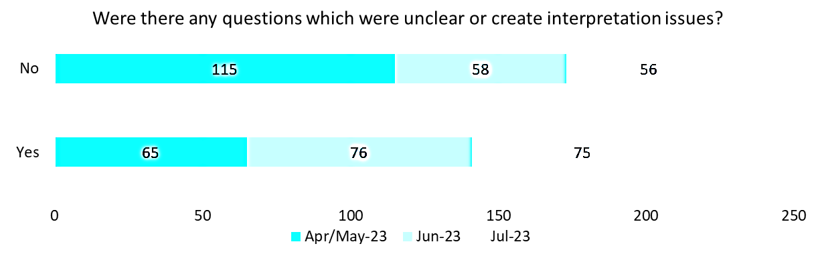

When examining the aggregated data from the three surveys, it's important to highlight that while most respondents reported no issues with questions causing interpretation problems, this was not the case in the June and July surveys, where the majority did encounter such issues, as seen in the graph below.

#### Figure 73: Survey response – unclear IAT questions



### Which question created interpretation issues and how to improve them?

Assessors were asked to provide feedback to validate their reasoning behind submitting an answer of ‘yes’ to the previous question and how the questions could be improved.

The improvements assessors suggested including:

#### Table 44: Assessors’ suggested improvements for IAT questions

| **Misinterpretation issues** | **Instances mentioned** | **Assessors’ suggested improvement** |
| --- | --- | --- |
| Goal setting question are repetitive:  "What is the difference between "goal" and "What is the client's goal"?" | 201 | * Combined question and/or clarify meaning |
| Some questions have an only have a “Yes” or “No” response | 28 | * Provide the option to include explanatory text * Include a "sometimes" option * Include a N/A options |
| Carer hours scale - difficult and time consuming to capture | 17 | * Include a more specific question regarding what task the carer supports with * Use a weekly scale * Included the Care Giver Strain Index |
| Drops down boxes are limiting | 15 | * Use a text box instead to allow assessors to describe and not prescribe. |
| Function question while completing a hospital assessment are not always applicable | 11 | * Make optional for hospital assessments |
| Psychological question requires rewording/ shortening | 10 | * Assessors provided examples: * Change “Not being able to stop or control worrying last 2 weeks” to “If you worry, are you able to stop yourself worrying?” |
| Housework - light and heavy housework have the same definition | 10 | * Define light vs. heavy housework tasks |
| Frailty questions creating confusion:  “Do you have any difficulty walking up 10 steps?”  “If the person has trouble walking for 10m or tires easily if walking 300m” | 7 | * Change to “Do you have any difficulty walking 10 paces?” as client will regularly interpret this question to be about stairs * Change to "How far can you comfortably walk" |
| Legal or financial issues - the questions are too invasive | 6 | * Consider removing question * Change to a Yes/No or unknown answer |
| Illicit drug use - the questions are too invasive | 5 | * Make alcohol and drugs question optional |
| Recommendations section - assessors found it confusing and difficult | 5 | * Training on recommendation for frequency of services |
| "Do you feel useful to your family" | 4 | * Adjust question to instead ask “Does the family ask for your advice?” |
| Upper body strength - question need rephrasing | 4 | * Change to “Are you able to lift your arms over shoulder height holding an XYZ?” |
| Somatosensory - confusing | 4 | * Somatosensory needs an explanation/help box |

### Current structure and sequence of questions within the IAT

Assessors were encouraged to provide feedback and insights regarding current structure and sequence of questions within the IAT and its adequacy. This multiple-choice question was exclusively featured in the July survey, which received a total of 127 responses.

Among these responses, 88 indicated that they did not find the current structure adequate, 24 responses neither agreed or disagreed, and 15 responses found it adequate.

#### Figure 74: IAT current structure and sequence of questions

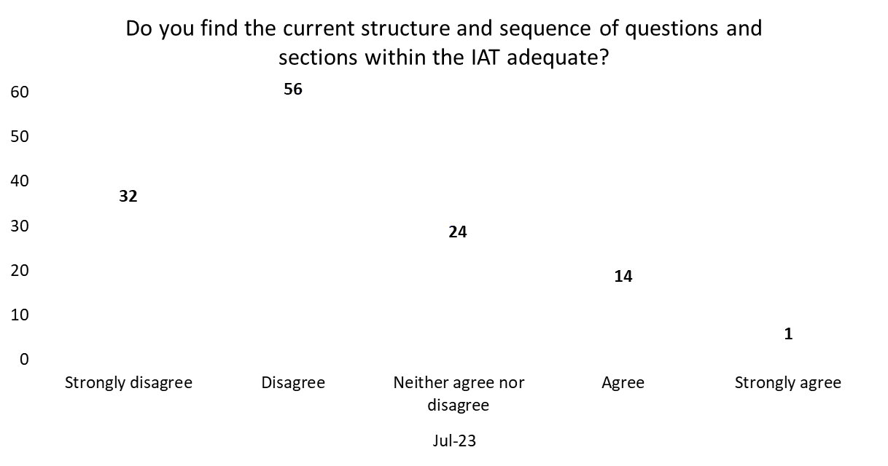

The assessors were also encouraged to provide feedback and suggestions on ways to improve the sequencing of the IAT. The feedback has been spirited by section of the IAT and is listed below with the instances each was mentioned.

The most prevalent feedback and suggestions provided by assessors were:

#### General

* IAT doesn’t flow (57)
* IAT structure should be like NSAF (3)
* The IAT should begin with personal information, background, current support networks (5)
* Assessors completed the assessment in an order driven by the client (7)
* IAT is too long (8)
* Difficult to build rapport with clients (3)

#### Carer profile

* Carer profile should be located later in the assessment (6)
* Carer hours scale is confusing and time consuming (4)

#### Social

* Psychological, Social, Cognition sections should be located later in the assessment (38)
* Social and Psychological should be combined (5)

#### Function and Frailty

* Function should be located towards beginning of the IAT (9)
* The Function and Frailty sections should be combined (2)

#### Medical and Medications

* All Medical and Medication should be located toward the beginning of the IAT (18)
* All Medical and Medication information should be combined (17)

#### Physical and Personal Health

* Physical and Personal health located toward the beginning of the IAT (3)

#### Cognition

* Cognitive assessment tools (DSSI) should be located later in the IAT (3)
* Psychological and Cognitive should be located next to each other in the IAT (3)

#### Psychological

* Social and Psychological should be combined (2)
* Psychological and Cognitive should be combined (4)

#### Home and Personal safety

* Home safety should be located towards the end of the IAT (1)

#### Current access to services

* Current access to services should be located towards the start of the IAT (3)

### What do you think the department’s future assessment guidance material should cover?

Assessors were invited to share their thoughts on the content that future assessment guidance material from the department should address. It should be noted that this query also includes feedback on the training that was provided to assessors before the trial began. The question was presented in an open-text format, permitting assessors to offer as much detail as needed. Across the three surveys, a cumulative total of 208 responses were gathered for this question, and these insights have been compiled below.

* Additional training material requests (55)
* Improve IAT User Guide (47)
* In depth IAT question information and explanation (21)
* Prolonged access training environment (16)
* Update The Aged Care Assessment Manual (15)
* Service recommendation selection guidance (13)

### Additional feedback

In the June 2023 monthly assessor survey, an additional feedback question was introduced to give assessors the opportunity to share any information or feedback they believed hadn’t been addressed by previous questions. This question was presented in an open-text format, without a character limit, enabling assessors to provide comprehensive input. Assessors provided extensive responses concerning both the IAT and the IAT Live Trial. The most common responses have been categorised into themes and are presented below.

#### Carer profile

* Carer hours question is unclear (4)
* Carer input/type of support is not captured (4)

#### Cognitive

* GPCOG is inappropriate (11)
* Appropriateness of cognitive tool (7)
* MMSE recommendations (5)
* RUDAS recommendations (3)

#### Communications

* Client consent (3)

#### Function

* Sequencing and categorisation recommendations (3)
* Hospital assessment recommendations (3)
* Additional response options (3)
* Section is too long (2)

#### IAT functionality

* Drop down boxes limit the detail assessors can provide (5)
* Tool restricts assessors’ professional judgement (4)
* IAT is less intuitive than the NSAF (4)
* Additional text boxes (3)
* Character limits should be increased (3)

#### IAT question feedback

* Questions do not flow in a logical and coherent manner (23)
* IAT feels too simplified (8)
* Some questions are inappropriate/intrusive (8)
* Questions are repeated/duplicated (8)
* There are too many questions/IAT is too long (5)
* Questions are too prescriptive (3)

#### Language and wording suggestion

* Questions including phrases such as “in the last 4 weeks’ may not accurately reflect normality for the client (4)
* Questions should be more strength-based (3)

#### Physical and Personal health

* Illicit drug and alcohol use question is invasive (4)
* Swallowing concerns needs description (3)
* Section lacks response options (3)

#### Social

* DSSI is not appropriate (6)

# Appendix C: Fortnight Check-In Call Responses

## Sequencing workshop

#### Table 45: Fortnightly Assessor check-In call Minutes

|  |  |
| --- | --- |
| Fortnightly check-In session | Link to fortnightly check-In Minutes |
| Fortnightly assessor check-in 5 June 2023 |  |
| Fortnightly assessor check-in 19 June 2023 |  |
| Fortnightly assessor check-in 03 July 2023 |  |
| Fortnightly assessor check-in - sequencing workshop |  |
| Fortnightly assessor check-in - Triaging questions |  |

# Appendix D: Cost breakdown

Operational costs for the IAT Live Trial have been detailed below in Table 46. Discourse My Assessor chat CoP costs are for maintaining web hosting for My Assessor chat CoP. GoDaddy domain name service costs are for maintaining the website domain name of My Assessor chat CoP.

#### Table 46: Operational cost breakdown

|  |  |
| --- | --- |
| **Cost description** | **Amount (including GST)** |
| Discourse My Assessor chat CoP - monthly hosting cost | US$300per month |
| GoDaddy - Domain name service cost | AU$21.95 (per annum) |

Provisional costs for the IAT Live Trial have been documented in Table 47. Ethics approvals costs are the fees charged by ethics committees for their services in providing ethics approval for the IAT Live Trial.

#### Table 47 : Provisional cost breakdown

|  |  |  |
| --- | --- | --- |
| **Cost description** |  | **Amount (excluding GST)** |
| Ethics approvals | Bellberry | AU$6,600 |
|  | AIATSIS | AU$3,630  AU$1,815 |
|  | AHCSA | AU$0 |
|  | Total | AU$12,045 |

Health.gov.au

All information in this publication is correct as at September 2023

1. The use of ACAT within this report includes the ACAS in Victoria. 
2.
3. In the 20 August 2023 PM report, location information was not recorded for 18 First Nations assessments. In this table the State of each assessment with missing location information has been manually updated to reflect location information contained in PM Reports since 20 August 2023 or inferred by AMO Outlet in cases where that location data remains unavailable.