Bonded Return of Service System BRoSS

Bonded Medical Program

Participant User Guide

January 2024

# Contents

Contents 2

Welcome to the Bonded Medical Program 3

Introduction 3

About the Bonded Medical Program 3

Bonded Participants 3

Participant Obligations 3

Completing your Return of Service Obligation (RoSO) 4

Eligible RoSO locations 4

What is the Bonded Return of Service System (BRoSS) 5

1. How to log in to the Bonded Return of Service System (BRoSS) 5

2. Accepting your Bonded Medical Program Firm Offer Place 10

3. Navigating your Participant Dashboard 15

4. Entering Medical Course duration or attendance changes 18

5. Entering a Planned RoSO Event 21

6. Edit a Planned RoSO Event 25

7. Completing Student Phase 26

8. Entering your Internship information 28

9. Activating your Planned RoSO Event 31

10. Edit your Current Activated RoSO Event 34

10.1 Entering Per-day RoSO in a current RoSO Event 35

11. Completing your Internship Phase 38

12. Completing Current RoSO Event 39

13. Commencing Prevocational Training Phase 43

14. Entering your Vocational Specialty information in the Vocational Phase 45

15. Completing your Vocational Phase – Attaining your Fellowship 48

16. Requesting an Extension to Program Timeframe 50

17. Withdrawing from the Program 53

17.1 Withdrawing for Program participants or Previous Bonded Medical Places (BMP) Scheme participants who have opted-in 55

17.2 Withdrawing for Previous Medical Rural Bonded Scholarship (MRBS) Scheme participants who have opted-in 60

18. Additional assistance 65

# Welcome to the Bonded Medical Program

## Introduction

The purpose of this guide is to aid participants of the Bonded Medical Program (the Program) when using the Bonded Return of Service System (BRoSS), through every stage of the Program.

## About the Bonded Medical Program

The Program was implemented to help address the shortage of medical professionals in regional, rural, and remote areas of Australia. The Program provides a Commonwealth Supported Place (CSP) in a medical course at an Australian university in exchange for participants working in eligible locations after they graduate.

On completion of their medical course, Program participants commit to work in an eligible regional, rural, and remote area for up to three (3) years (156 weeks) as part of their ‘Return of Service Obligation’ (RoSO) under the Program.

The Program is delivered and supported by legislation:

* [Part VD of the Health Insurance Act 1973](https://www.legislation.gov.au/Series/C2004A00101)
* [Health Insurance (Bonded Medical Program) Rule 2020](https://www.legislation.gov.au/Series/F2019L01513) (the Rule)
* Information about participant privacy can be found at: [Privacy Act 1988](https://www.legislation.gov.au/Series/C2004A03712)

More information and links to the legislation is available on the Department of Health and Aged Care website: <http://www.health.gov.au>.

## Bonded Participants

The Program is intended for new students starting their university medical course. However, existing legacy scheme participants of the Medical Rural Bonded Scholarship (MRBS) Scheme and Bonded Medical Places (BMP) Scheme can also apply to opt-in to the Program.

## Participant Obligations

Once you are a bonded participant of the Program, you must adhere to the obligations listed in the relevant legislative instruments. These include:

* completing your RoSO in an eligible regional, rural, or remote (Modified Monash Model (MMM) 2-7) areas and being undertaken in accordance with subsection 16(1) of the [Rule](https://www.legislation.gov.au/Series/F2019L01513).
* keep all notifiable event and milestones up to date in BRoSS, in accordance with subsection 15(1-4) of the [Rule](https://www.legislation.gov.au/Series/F2019L01513).
* keeping your personal details up to date, as per subsection 15(1.1) of the [Rule](https://www.legislation.gov.au/Series/F2019L01513), so you continue to receive all required correspondence from the department.

## Completing your Return of Service Obligation (RoSO)

As stated in ‘Part 2 – Return of Service Obligation (RoSO)’ of the [Rule](https://www.legislation.gov.au/Series/F2019L01513), bonded participants have 18 years to complete their return to service from the date they completed their medical course, with the following requirements:

* The three (3) years of RoSO can be completed over the 18-year period and can be undertaken in the following ways:
* full-time, part-time or on a per-day basis
* as a fly-in/fly-out doctor in eligible locations
* on-call services in an eligible location
* paid leave that is accrued from the rendering of such a professional service
* outreach services in an eligible location
* aeromedical evacuation and retrieval services to patients in an eligible location; and
* telehealth services in an eligible location and delivered to patients in an eligible location.
* Under Section 9(3) of the [Rule](https://www.legislation.gov.au/Series/F2019L01513), you are only able to reduce your RoSO by up to 18 months prior to Fellowship or within the first 12 years of your 18-year period. Once you become a Fellow or have commenced the 13th year of your 18-year period, whichever occurs first, you are able to complete the remaining 18 months of RoSO.

## Eligible RoSO locations

As per Section 10 – Eligible locations under the [Rule](https://www.legislation.gov.au/Series/F2019L01513), bonded participants need to consider the following prior to entering your RoSO plan.

* Any geographic area that is classified as MMM 2, MMM 3, MMM 4, MMM 5, MMM 6 or MMM 7.
* Distribution Priority Areas (DPA) for general practitioners, which are locations with a shortage of medical practitioners but does not include inner metropolitan areas.
* outer and unclassified metropolitan Districts of Workforce Shortage (DWS) for specialists, which are locations with poor access to specialists, but does not include inner metropolitan areas.

When entering your RoSO plan into BRoSS, the system will advise if the location is eligible or not. If you have questions regarding the eligibility of the location, you can email us at [BondedMedicalProgram@health.gov.au](mailto:BondedMedicalProgram@health.gov.au).

# What is the Bonded Return of Service System (BRoSS)

The Bonded Return of Service System (BRoSS) is the web-portal to assist bonded participants to plan, monitor and manage their own RoSO and notifiable event obligations under the Program.

BRoSS has extensive in-system guidance, notifications, and messaging so that participants are assisted throughout their Program experience. Information entered in BRoSS is used to support the bonded participant in tracking their progress in the Program, while supporting them to plan for their next stages and meet their Program obligations.

Bonded participants are responsible for ensuring that their own BRoSS record is kept up to date and contains information about the milestones and events they have achieved so that these count towards meeting their legislative requirements.

BRoSS has been built to incorporate the latest and most effective security and personal information authentication processes.  BRoSS complies with the [Privacy Act 1988](https://www.legislation.gov.au/Series/C2004A03712).

1. How to log in to the Bonded Return of Service System (BRoSS)
   1. You will need to have a myGov account to log in to BRoSS. Go to [myGov Home](https://my.gov.au/).

* If you do not have a myGov account, please go to 'Create account' and follow the prompts to create an account. Log into your myGov account.
* If you do have a myGov account, go to ‘**Sign in.’**

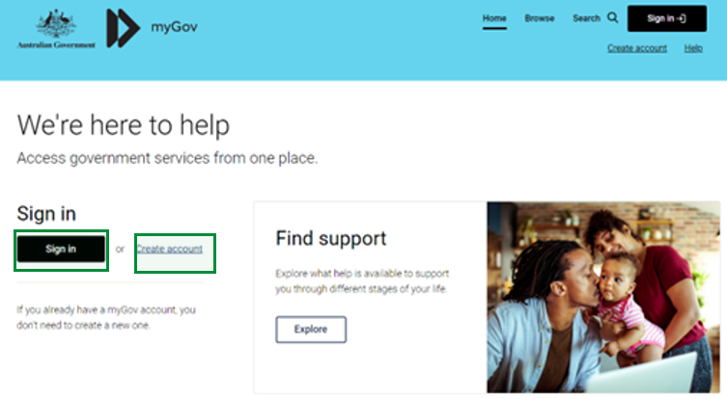

* 1. Sign in with your myGov details.

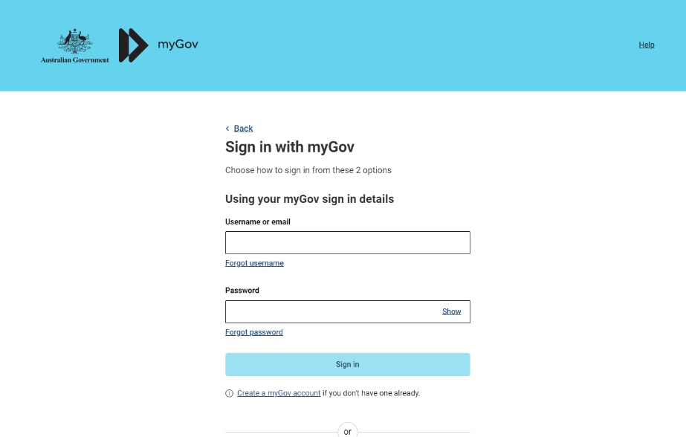

* 1. Authenticate your login.

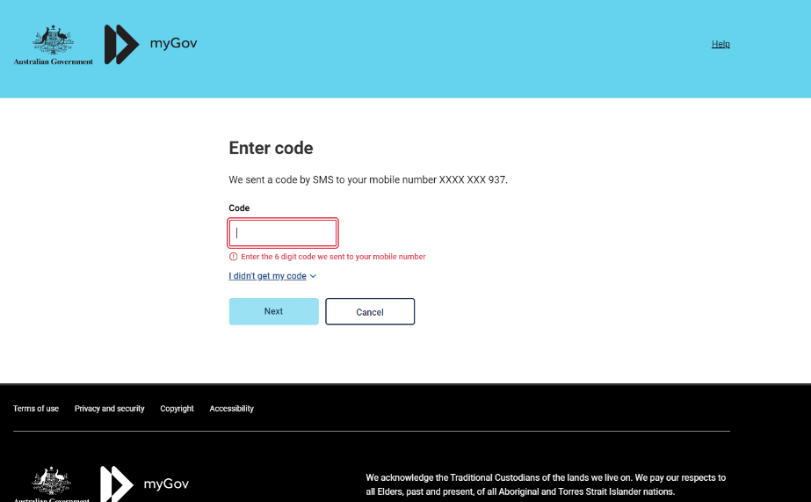

* 1. You will need to link the ‘**Department of Health Applications Portal**’ to your services by clicking the ‘**View and link services**’.

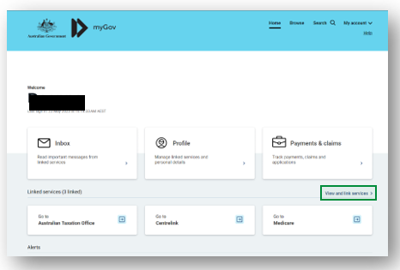

* 1. Scroll to the service and click ‘**Link**’. 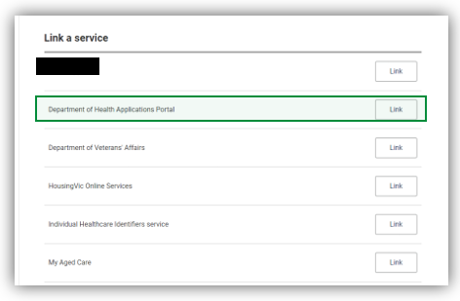
  2. You will be taken to the Health Data Portal page, click **‘Log in**’.

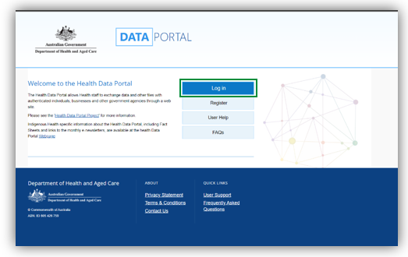

* 1. Select ‘**Login with myGov**’ as your log-in credential choice.

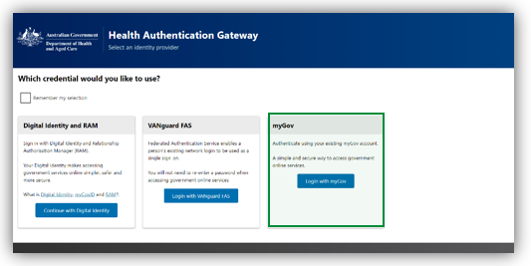

* 1. Enter your BRoSS user ID and your linking code on the **'Health Authentication Gateway'** page**.**

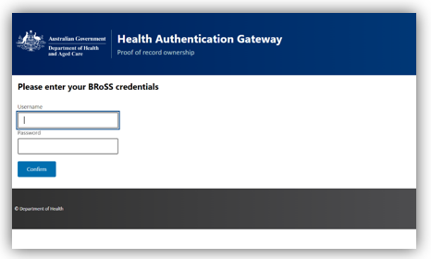

**Please note:** This will be a once-off action. Once you have linked '**Department of Health Applications Portal**' as a service, the next time you try to sign in to BRoSS you will not be required to enter your BRoSS User ID (Username) and linking code or Temporary Password (Password).

Your BRoSS user ID and linking code will be found within the ‘**Firm offer**’ email or the ‘**Welcome to the Bonded Medical Program**’ email sent to your registered primary email address.

* 1. You will be taken to the Health Data Portal, on the menu bar, select **'BRoSS'**.

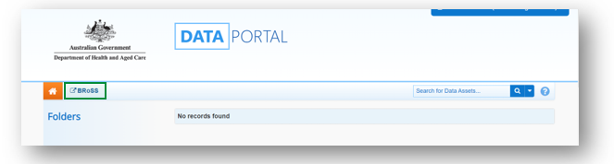

* 1. Your dashboard will open – proceed to step 2.

1. Accepting your Bonded Medical Program Firm Offer Place

Once your university position has been confirmed, you will receive an email from the department - **‘FIRM OFFER APPLICANT – BONDED MEDICAL PROGRAM’** which will contain information on the Bonded Medical Program including your BRoSS User ID and Temporary Password to log in to the system.

After logging in to your BRoSS record following the steps in the ‘How to Log in to the Bonded Return of Service System (BRoSS)’, your ‘**My dashboard**’ page will open.

Review all the information on the left-hand side of the page by opening the accordions.

Under ‘**Update your details**’ accordion, review and update your ‘**Personal contact details**’ and ‘**Mailing address**’ information by clicking on the ‘**Edit**’ button on the bottom of the page. Ensure all mandatory fields (marked orange in the Edit pages) are correct and click ‘**Save**’.

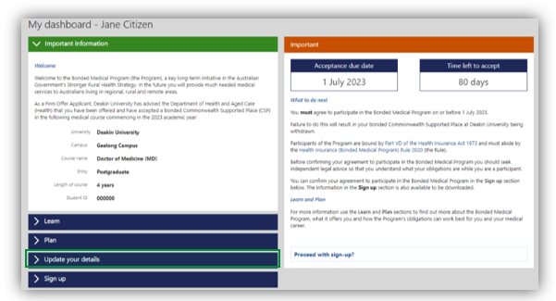

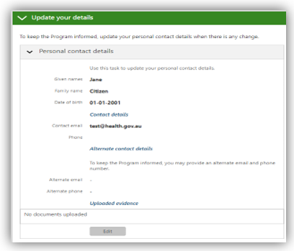

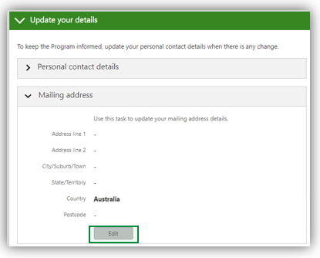

Once your details are updated either click on the ‘**Proceed with Sign-up**’ link or open the ‘**Sign-up**’ accordion for the agreement to participate.

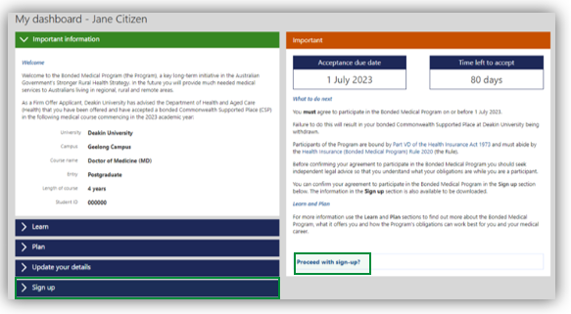

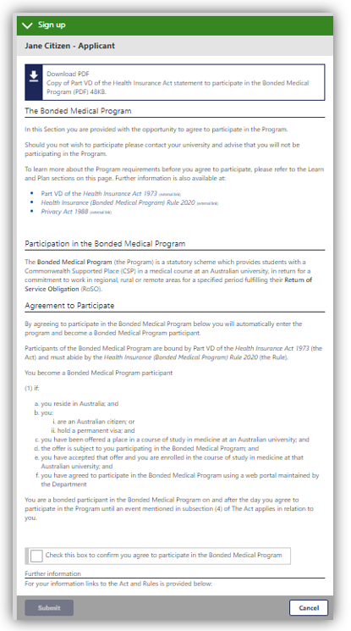

Read the information and if you agree, check the ‘**tick box**’ and click ‘**submit**’.

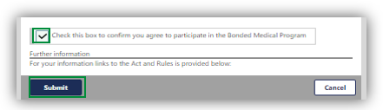

A pop-up page will confirm your acceptance into the Program. Click ‘**Go**’.

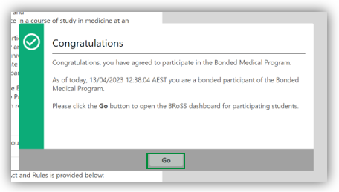

Now you are a participant of the Program, your dashboard will update with the latest information about your obligations under the Program and your progression through your career.

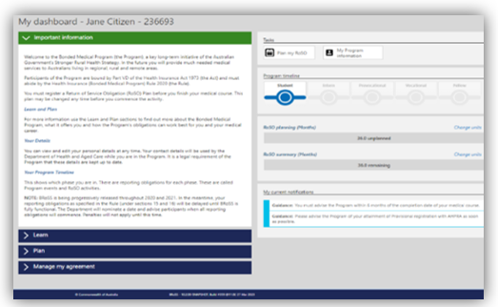

1. Navigating your Participant Dashboard

When logging in after accepting your place in the Program or opting-in from your Legacy Scheme, your personal dashboard will contain information to guide you through your obligations under the Program.

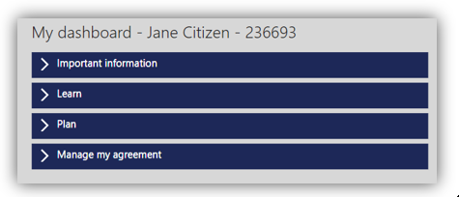

**Important Information:** is used to communicate key messages about the Program to participants.

**Learn:** contains helpful information about the Program and your obligations, including your reporting requirements from the time you join the Program to the time you exit. BRoSS will assist you in managing your reporting requirements and advise what support is available to you to answer any Program questions.

BRoSS contains all functionalities for participants to self-manage their reporting obligations. This includes in-built messaging, guidance and emails which will alert participants to their reporting obligations even if you have not logged into BRoSS for a time.

**Plan:** contains helpful information about the Program and your RoSO obligations, including eligible work types, how and when you can complete your RoSO and what tools are available in BRoSS to help you plan, activate, and complete your RoSO via the self-management functions.

**Manage My Agreement:** contains a couple of key functionalities. Here you can download a copy of your agreement to participate, which includes your official commencement date. You can also request a Program extension for exceptional circumstances only and/or a Program withdrawal quote calculation.

**Tasks**

The Tasks banner on the right, will change depending on the phase you are currently at and will allow you to quickly jump straight to planning your RoSO, managing your RoSO activities and notifiable events or manage your personal details.

**Student Phase Tasks**

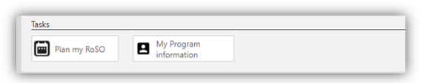

**Internship to Fellow Phase Tasks**

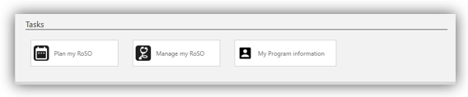

**Program Timeline**

The ‘**Program Timeline**’ shows your last updated phase. You can click directly on your current phase or previous phase, to take you to the related notifiable events and any RoSO activities.

A green icon with a tick indicates that this phase of the timeline has been completed, a blue icon indicates that the phase is still underway, and the greyed-out icons represent the phase(s) yet to be commenced.

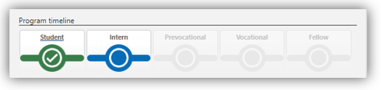

**RoSO Planning and Summary Bar**

These bars show the amount of RoSO you have planned (orange), current/commenced (blue) or completed (green) and your remaining RoSO balance (grey).

The ‘**Change units**’ button located to the right of the section will change the way your RoSO is displayed, from weeks to months and vice versa.

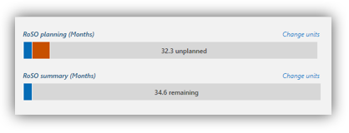

**My Current Notifications**

The ‘**My current notifications**’ area provides guidance on actions that are required to be undertaken in BRoSS. It will also let you know if you are approaching a reporting deadline.

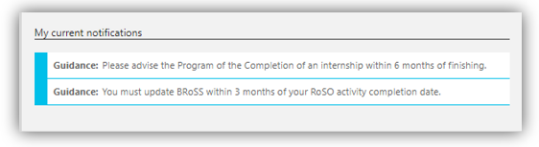

**BRoSS Guidance Bar** –is an in-system guidance feature built into every page on the right-hand side listed as ‘Guidance’. Click on the arrow to read about the current page, Program information and what each field is for. To close the ‘Guidance’ bar click on the arrow and it will close.

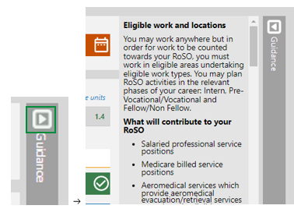

1. Entering Medical Course duration or attendance changes

Under the Program you are required to update your BRoSS record with your attendance during your time at university. To update this information, from your ‘**Dashboard**’ under ‘Tasks’, click the ‘**My Program information**’ button.

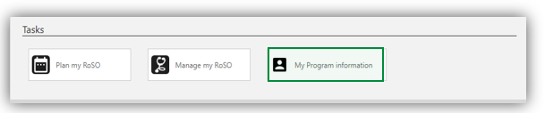

In the ‘**My Program information**’ page, you will need to go down to open the ‘**Medical course timeframe**’ accordion.

Medical course timeline showing length of course (determined by University), expected completion date (calculated by BRoSS and Actual completion date (automatically uploads from student phase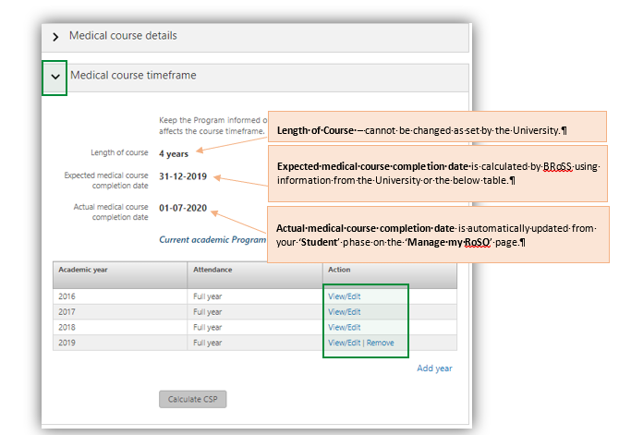

When you click on the ‘**View/Edit’** link under the Action column, the ‘**Edit: Course attendance’** page will open to allow you to update your attendance for this year. Click ‘**Edit**’ button to update the information on the page. You will need to upload your required evidence to be able to ‘**Save**’ any updates.

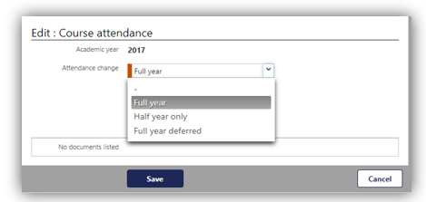

If you have deferred or repeated a year, you will need to use the ‘**Add year**’ link and update the ‘**Add: Course Attendance**’ for that year using the drop-down options, then upload your relevant evidence and click ‘Save’ to go back to the ‘**Medical course timeframe**’ accordion.

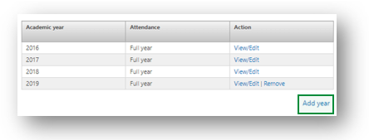

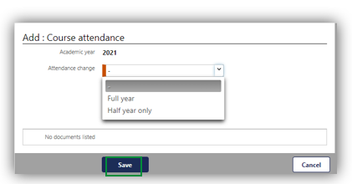

Your ‘**Expected medical course completion date**’ will be updated with your changes.

Medical course timeframe summarisng years of study. Orange box no 1 explains the warning message indicating the difference between course length and number of years of study.
The second orange points to the 'calculate CSP' button which will allow the participant to see at an estimated repayment amount.

1. Entering a Planned RoSO Event

Under the Program you are required to enter a Planned RoSO event:

**For participants joining as a new student**: you must register a RoSO plan no later than the day you finish your medical course. You are then required to log into BRoSS every six months from the completion date of your medical course to confirm or update the details of your RoSO plan.

**For opted-in Bonded legacy scheme participants**: you must register a plan within three (3) months from the date of opt-in. You are then required to log into BRoSS every six (6) months to confirm or update your personal details or the details of your RoSO plan.

To plan a RoSO activity, click on the ‘**Plan a RoSO activity**’ button on the ‘**Manage my RoSO**’ page from your ‘**Dashboard**’, this will take you to the ‘**Plan a RoSO activity**’ page.

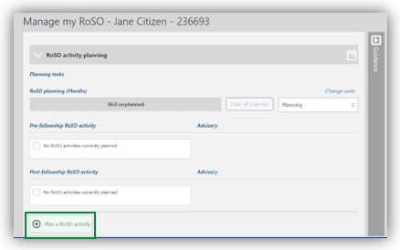

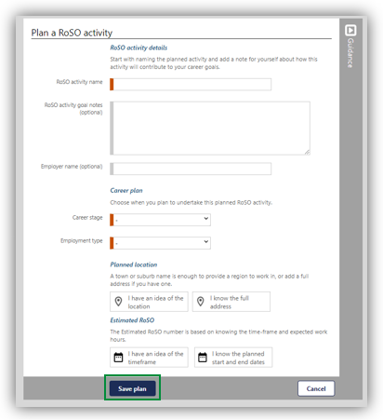

All mandatory fields are marked in orange, which includes:

* **RoSO Activity Name**: When naming your RoSO activity provide a descriptive title for this specific RoSO activity. This could include the Practice Name and Location.
* **Career Stage**: as RoSO activities can be planned in advance, the career stage selection is to identify the stage in which the RoSO activity may be completed in.

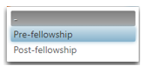

* **Employment Type:** you can select one of the following employment types, this will need to match your ‘**Expected hours per week**’ entered in the Estimated RoSO information.

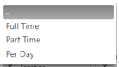

**Please note**: work can be undertaken in the following basis:

**Full Time**: 35 hours or over per week.

**Part Time**: at least 20 hours, but less than 35 hours per week.

**Per Day**: less than 20 hours in a week.

* **Planned location**: can either be searched by selecting a generic search ‘**I have an idea of the location**’ button or entering the full address by selecting ‘**I know the full address**’.

When using the ‘**I have an idea of the location**’ selection, enter the suburb or town to get the planned location eligibility. Noting: this will only advise of the MMM classification and not the DWS or DPA results.

When using the ‘**I know the full address**’ selection, enter the full address of the location into the ‘**Find an address**’ bar, pre-filled results will show below the bar, select the correct address by clicking on the relevant address from the drop-down menu.

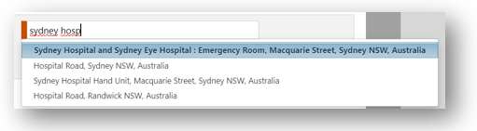

* Once you have selected the location, BRoSS will inform you if the location is eligible by displaying a red, orange or green automated banner.

**Please note:**

BRoSS contains an in-bult eligible location search function. Participants can enter a town, suburb, or the full street address, BRoSS will return an immediate assessment of the location eligibility. BRoSS will also let you know if that location is eligible for use towards scaling benefits.

Once you have reached your Vocational phase, you can review your eligible DWS or DPA locations for your specialty though BRoSS. There is no longer a need to contact the department to require your specialty location to be assessed. If BRoSS returns an ineligible location assessment you can request the department to review this by selecting ‘**location override**’ this will automatically generate a case ticket in the department’s case management system.

**Please note:** all inner metropolitan location override requests will be automatically denied per the [Rule](https://www.legislation.gov.au/Series/F2019L01513).

**Estimated RoSO**: once you know the location is eligible you must enter the dates and hours for the RoSO activity. You can enter this using a proposed period for future RoSO planning that is not confirmed by selecting the **‘I have an idea of the timeframe**’ button or if you know the exact period by selecting the ‘**I know the planned start and end dates**’ button.

You will be required to enter the ‘**Commencement date**’, the ‘**Proposed completion date**’ and the ‘**Expected hours per week**’. Once these mandatory fields (orange fields) are completed select ‘**Calculate**’ this will display the amount of RoSO that can potentially be reduced from your obligation for this period of work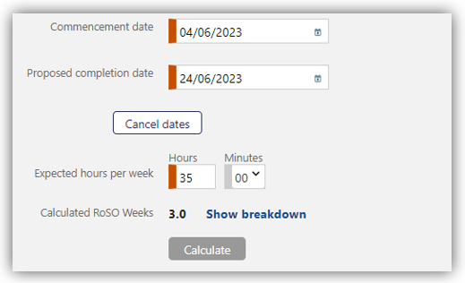

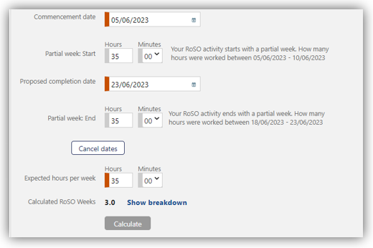

To finalise the plan, select ‘**Save Plan**’ at the bottom of the page.

**Please note**: BRoSS calculates a week from Sunday to Saturday, if your start date or end date falls on a day different to these, you will be asked to enter your partial week hours for a specific period.

1. Edit a Planned RoSO Event

You can edit a ‘**Planned RoSO activity**’ at any time by clicking on the RoSO activity name in blue text in the ‘**RoSO Activity planning**’ accordion.

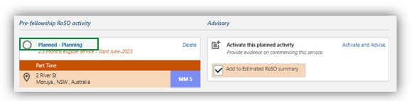

Click the ‘**Edit**’ button on the ‘**Planned RoSO activity**’ page to edit the details, then click ‘Save’ to update the ‘**Planned RoSO activity**’.

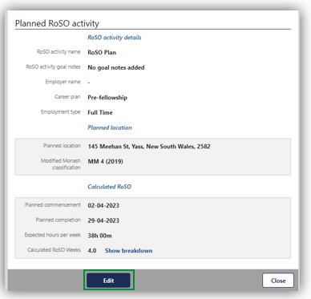

Edit all the required information and click ‘**Save**’.

1. Completing Student Phase

To update your **‘Student’** phase with your medical course completion, go to your ‘**Manage my RoSO**’ page and select the ‘**Studen**t’ accordion.

You can get to your ‘**Manage my RoSO**’ page by clicking on the ‘**Student**’ button under the Program timeline.

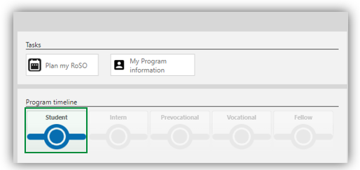

On the ‘**Completion of medical course’** tile click the ‘**Advise**’ link.

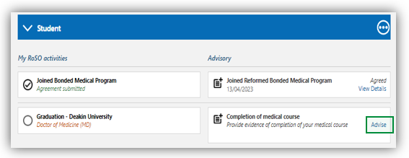

In the ‘**Advisory: Completion of medical course’** fill in the required information, upload your evidence and click ‘**Submit**’.

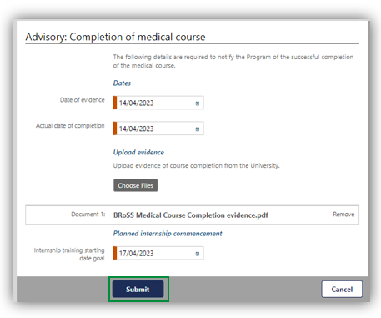

After submitting this advisory, your ‘**Student**’ accordion will change to green with a tick and the ‘**Intern**’ accordion will now be blue.

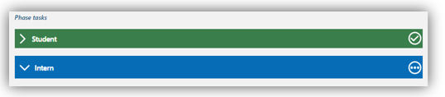

1. Entering your Internship information

To update your ‘**Intern**’ phase with your APHRA registration and internship details, go to your ‘**Manage my RoSO’** page and then select the ‘**Intern**’ Accordion.

You can get to your ‘**Manage my RoSO’** page from your dashboard by clicking on either the ‘**Manage my RoSO**’ button or the ‘**Intern**’ button under the Program timeline. 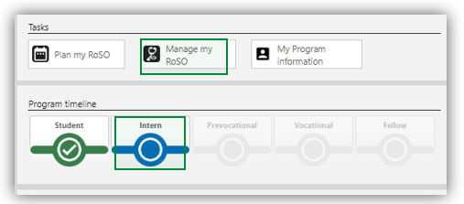

To enter your ‘**Provisional registration with APHRA**’ click on the ‘**Advise**’ link.

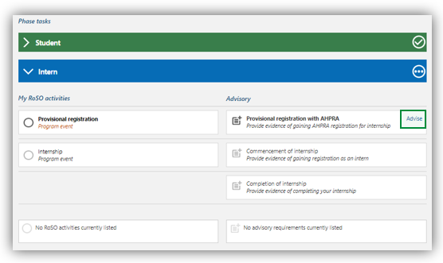

In the ‘**Advisory: Provisional registration with APHRA’** complete the mandatory fields (orange fields) and upload the required evidence. Click ‘**Submit**’ once completed.

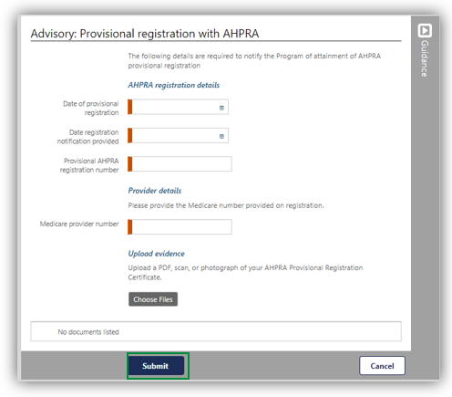

You will be taken back to the ‘**Manage my RoSO**’ page, there will now be green text with a tick next to the event tile.

To enter your ‘**Commencement of internship**’ details click the ‘**Advise**’ link.

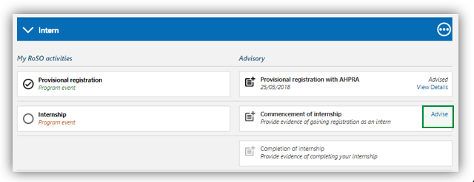

In the ‘**Advisory: Commencement of internship**’ complete the mandatory fields (orange fields), adding your facility address and upload the required evidence. Click ‘**Submit**’ once completed.

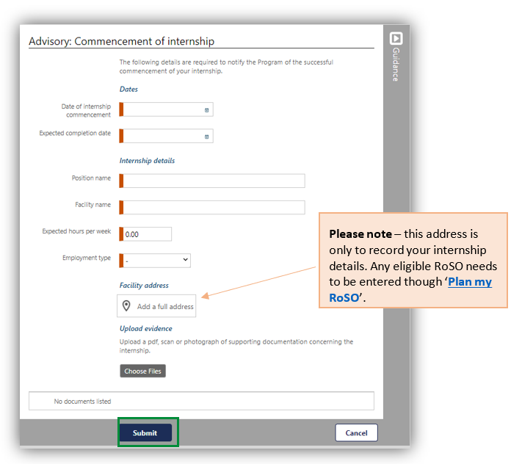

You will be taken back to the ‘**Manage my RoSO**’ page, there will now be three dots next to the event title that indicate your internship activation has been advised.

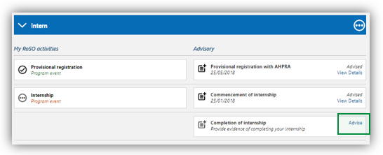

1. Activating your Planned RoSO Event

To activate a previously planned RoSO event, open your ‘**Manage my RoSO**’ page by clicking on the ‘**Plan my RoSO**’ button.

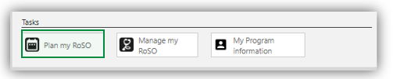

Under the ‘**RoSO activity planning**’ accordion, it will show all your planned RoSO events. When you are ready to activate/commence your plan, click on the ‘**Activate and Advise**’ link.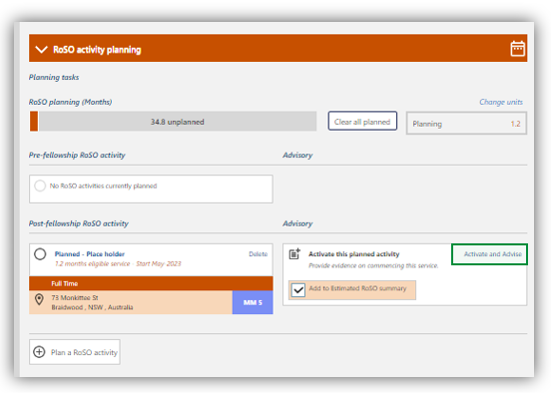

A pop-up window will show to confirm you wish to activate this RoSO plan. To continue click ‘**OK**’.

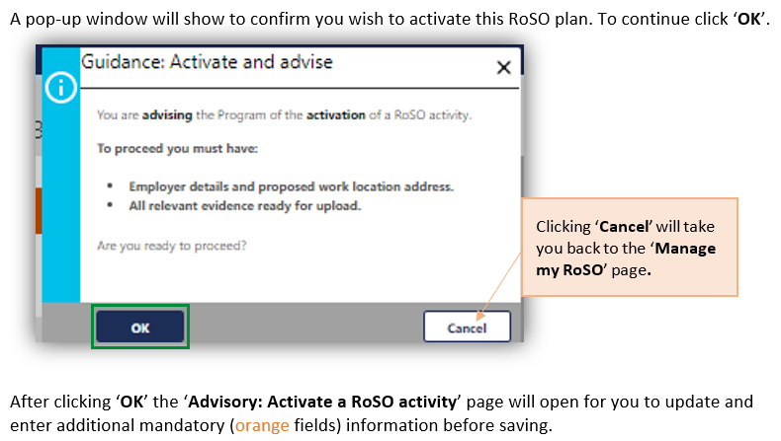

After clicking ‘OK” the ‘Advisory: Activate a RoSO activity’ page will open for you to update and enter additional mandatory (orange fields) information before saving.

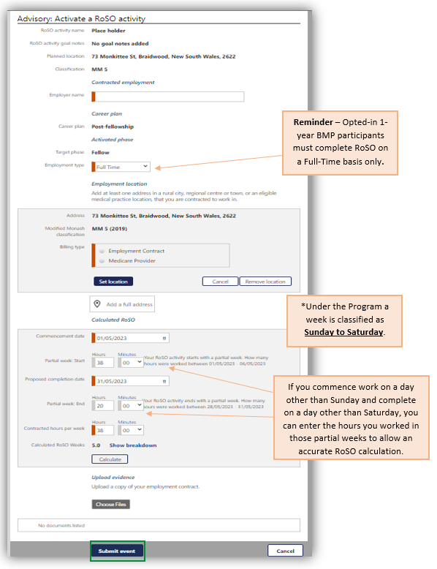

1. Edit your Current Activated RoSO Event

You can edit your current activated RoSO activity at any time by clicking on the RoSO activity name in the correct phase accordion.

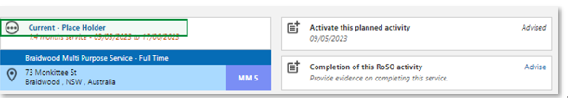

Click the ‘**Edit**’ button on the ‘**Activated RoSO activity**’ page to edit the details, then click ‘**Save**’ to update the Planned RoSO activity.

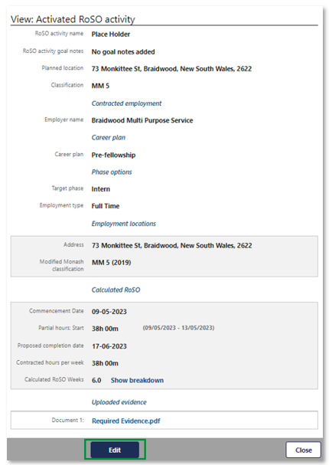

1. Entering Per-day RoSO in a current RoSO Event

To update a Per day basis plan, open your ‘**Manage my RoSO’** page and click on the blue RoSO activity title.

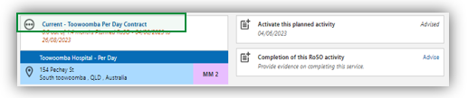

This will allow you to update your daily hours and locations via the ‘**View: Activated RoSO activity**’. Scroll to the bottom to view the ‘**Hours by week**’ section. Click ‘**Edit**’ against your current week to enter your hours and locations. 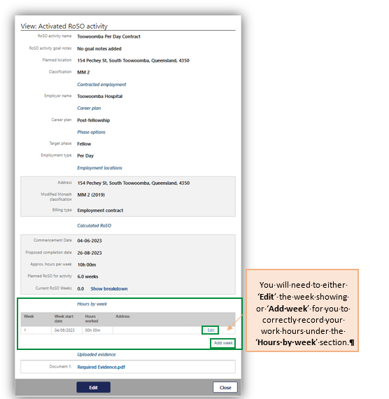

**Please note**: If your work week does not show, you can add additional weeks by clicking ‘**Add week’** link.

You will need to either ‘**Edit**’ the week showing or ‘**Add week**’ for you to correctly record your work hours under the ‘**Hours by week**’ section.

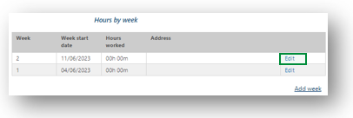

Click on the ’**Edit**’ link of the week you need to update. The ‘**Edit week entry’** page will open.

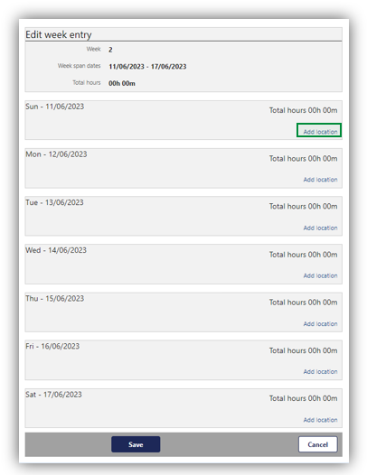

Click on the ‘**Add location’** link and enter the hours and location(s) worked that day from the dropdown menu.

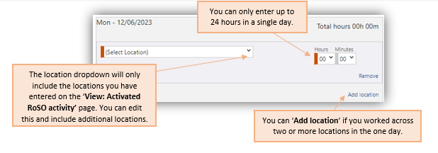

Once you have entered all your data for the day(s)/week, click ‘**Save**’ at the bottom of the page. You will be taken back to your ‘**View: Activated RoSO activity**’ page.

**Please note**: Your ‘**Current RoSO weeks**’ will show once you have accumulated greater than 20 hours of RoSO.

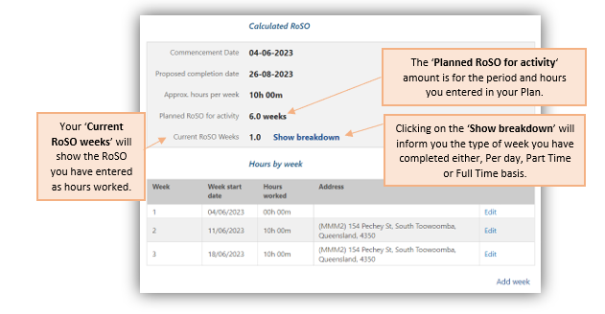

1. Completing your Internship Phase

On the completion of your internship training, you will need to update your BRoSS ‘**Intern**’ phase on your ‘**Manage my RoSO’** page.

You can get to your ‘**Manage my RoSO**’ page from your dashboard by clicking on either the ‘**Manage my RoSO**’ button or the ‘**Intern**’ button under the Program timeline.

Click on the ‘**Advise**’ link on the ‘**Completion of internship**’ tile.

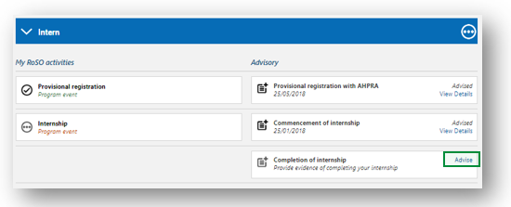

Enter the date you completed your internship and click ‘**Submit**’.

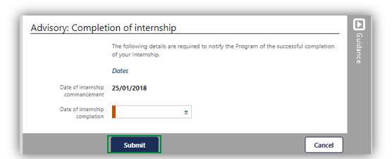

Your ‘**Manage my RoSO**’ page will update so your ‘**Intern**’ phase will now be green, and your ‘**Prevocational**’ phase will be blue.

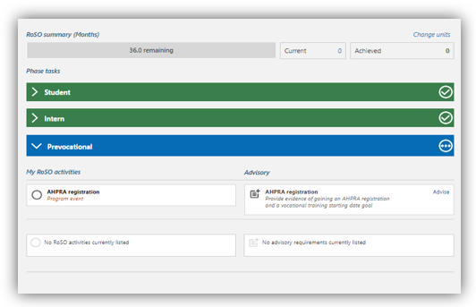

1. Completing Current RoSO Event

To update you current RoSO activity with your completion information, go to your ‘**Manage my RoSO**’ page and then open the relevant phase accordion for your RoSO activity.

Once you have your current RoSO event on the page, click the ‘**Advise**’ link on the ‘**Completion of this RoSO activity**’ tile.

**Please note:** You are required to update BRoSS within 3 months after your RoSO activity completion date to avoid a possible Program breach and a loss of RoSO as per the [Rule](https://www.legislation.gov.au/Series/F2019L01513).

A pop-up for the ‘**Guidance: Completion of this RoSO activity**’ page will show to ensure you have the correct information before you proceed. If you are ready to proceed, click the ‘**OK**’ button.

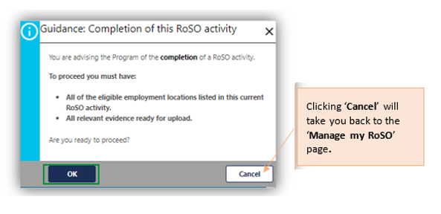In the ‘**Advisory: Completion of this RoSO activity’** complete the mandatory fields (orange fields) and upload the relevant evidence. Once updated click the ‘**Submit**’ button to complete this RoSO activity. The view page will then show, and you can ‘**Edit**’ the information if required or click ‘**Close**’ to exit the page.

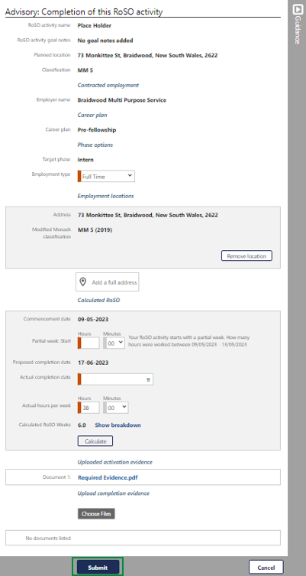

Your RoSO event will now show as green as it has been completed. This activity will reflect in your RoSO summary bar as green.

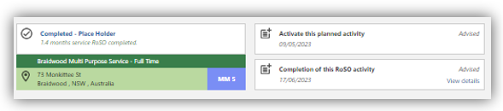

**Please note:** All completed RoSO is subject to the department’s approval as per the legislative requirements under the [Rule](https://www.legislation.gov.au/Series/F2019L01513).

1. Commencing Prevocational Training Phase

To update your ‘**Prevocational**’ phase with your APHRA registration and Medicare provider number, go to your ‘**Manage my RoSO**’ page and then under the ‘**Prevocational**’ Accordion.

You can get to your ‘**Manage my RoSO**’ page from your dashboard by clicking on either the ‘**Manage my RoSO**’ button or the ‘**Prevocational**’ button under the Program timeline.

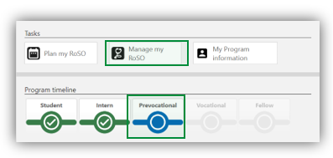

To enter your ‘**APHRA registration**’ click on the ‘**Advise**’ link under the ‘**Prevocational**’ accordion.

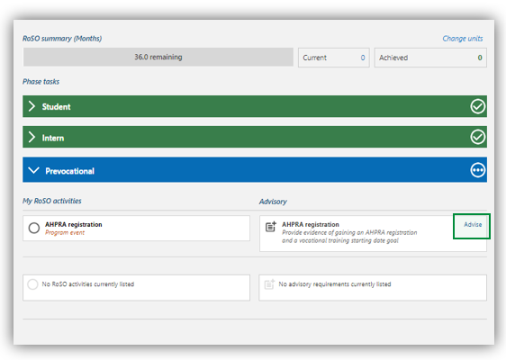

In the ‘**Advisory: General registration with AHPRA**’ page, complete all mandatory fields (orange fields) and upload the required evidence.

The final field ‘Vocational training goal’ is a date that you think you will commence training with your specialty college, this date can be changed at any time and triggers the BRoSS automated reminders.

Click ‘**Submit**’ once completed.

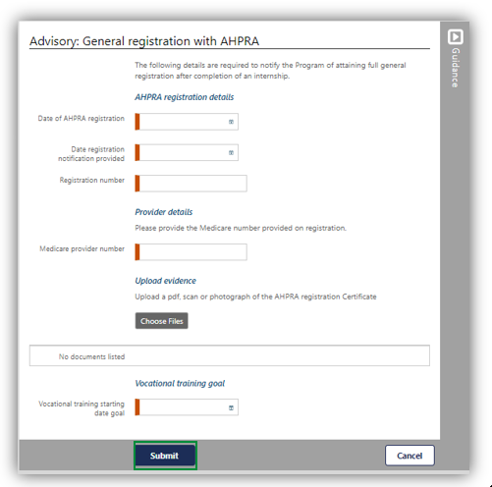

1. Entering your Vocational Specialty information in the Vocational Phase

To update your ‘**Vocationa**l’ phase with your training college details, go to your ‘**Manage my RoSO**’ page and then under the ‘**Vocational**’ accordion.

You can get to your ‘**Manage my RoSO**’ page from your dashboard by clicking on the ‘**Manage my RoSO’** button or the ‘**Prevocational**’ phase under the Program timeline.

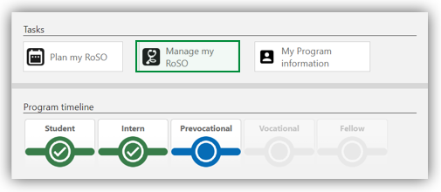

The ‘**Vocational**’ accordion will be greyed out until you ‘**Advise**’ of your ‘**Commencement of vocational training**’ by clicking on the ‘**Advise**’ link.

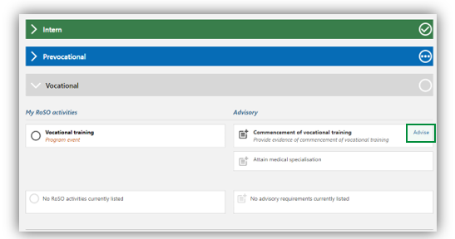

In the ‘**Advisory: Commencement of vocational training**’ page, complete all mandatory fields (orange fields) and upload the required evidence.

When entering your specialty work placement details, you are required to provide your work contract or Medicare provider number (including location specific provider number).

Click ‘**Submit**’.

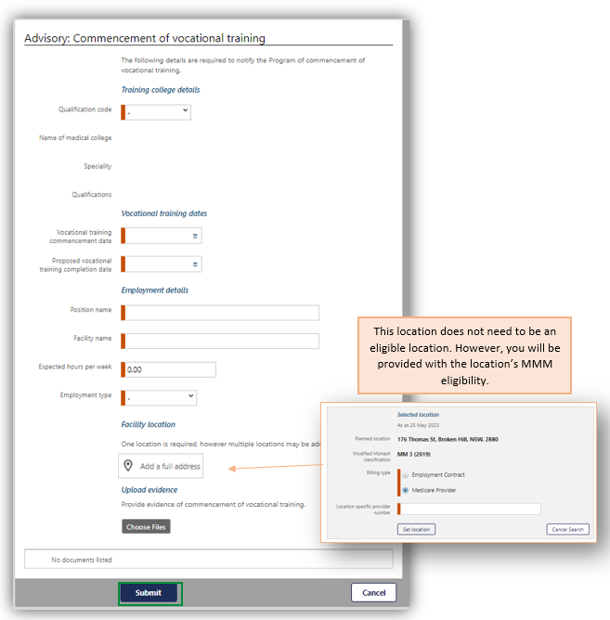

Once completed, the accordion will change to blue as it is now your current phase.

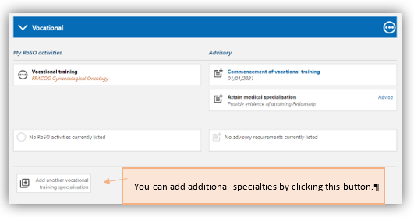

1. Completing your Vocational Phase – Attaining your Fellowship

To update your ‘**Vocational**’ phase with your fellowship details, go to your ‘**Manage my RoSO**’ page and then under the ‘**Vocational**’ accordion.

You can get to your ‘**Manage my RoSO**’ page from your dashboard by clicking on either the ‘**Manage my RoSO**’ button or the ‘**Vocational**’ button under the Program timeline.

Under the ‘**Vocational**’ accordion, click on the ‘**Advise**’ link on the ‘**Attain medical specialisation**’ tile.

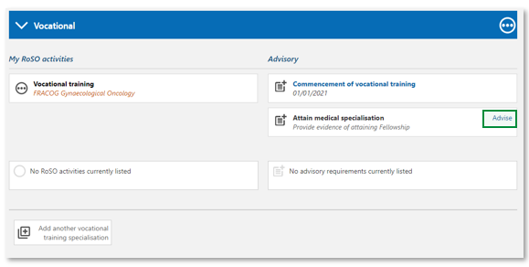

The ‘**Advisory: Attain medical specialisation**’ page will open. Enter the date you attained your Fellowship, upload the required evidence, and click ‘**Submit****’.**

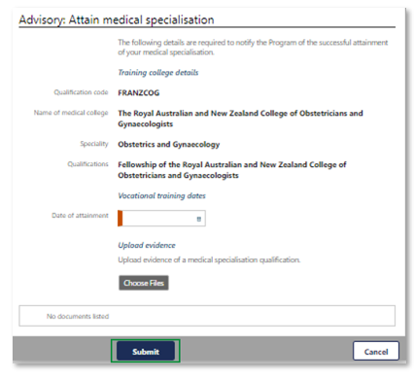

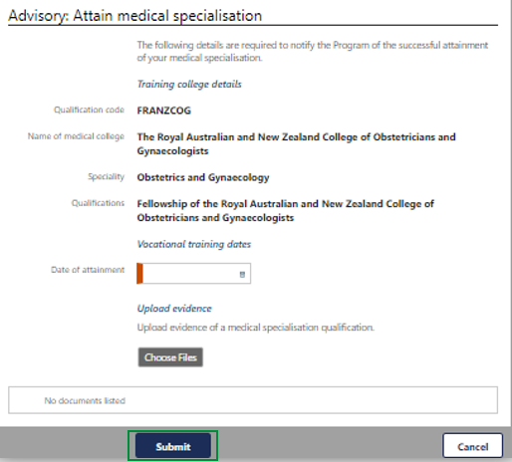

Your ‘**Manage my RoSO**’ page will update so your ‘**Fellow**’ phase will now be blue, and your ‘**Vocational**’ phase will be green.

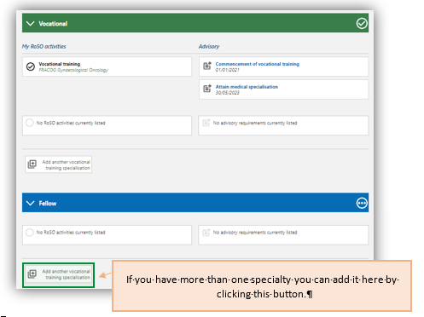

**Please note:** at this point you can commence your remaining RoSO as per the [Rule](https://www.legislation.gov.au/Series/F2019L01513).

If you have more than one specialty you can add it here by clicking this button.

1. Requesting an Extension to Program Timeframe

As a Bonded participant you may request for an extension of time to complete your RoSO due to exceptional circumstances (with evidence) before the end of the 18-year period.

To do this, click on the ‘**Manage my agreement**’ accordion on the bottom left side of the ‘**My dashboard**’ page.

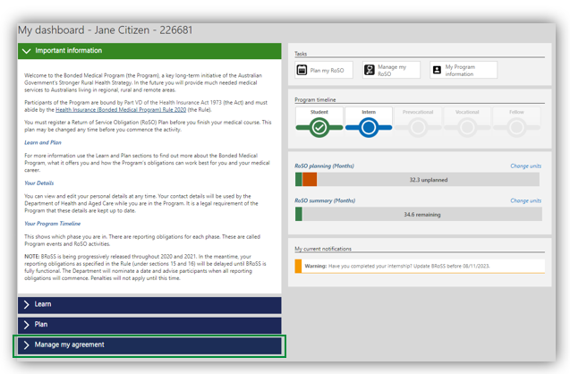

The ‘**Manage my agreement**’ accordion will open. Click on the ‘**Program extension**’ button.

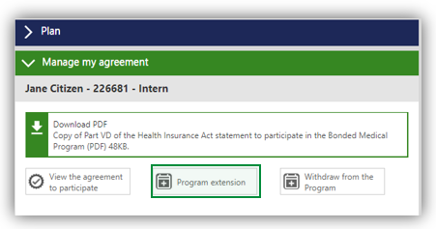

The ‘**My Program information’** page will open, click on the ‘**Program extension**’ accordion at the bottom of the page. This page will include your Program current completion date, to continue with your extension request.

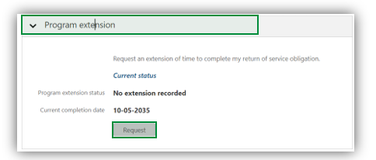

Click the ‘**Request**’ button, to enter your ‘**Proposed completion date’** and upload the required evidence.

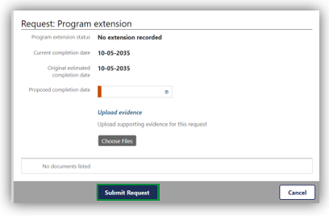

Once you click on the ‘**Submit Request**’ button, the below ‘**Warning**’ page will show, click ‘**OK**’ to continue with your extension request.

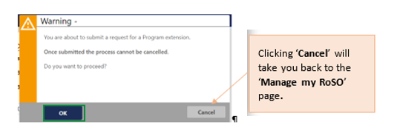

Your ‘**Program extension**’ accordion will update to ‘**Pending**’ status and show your extension request(s) with information and ‘**Status**’. You can ‘**View/Edit**’ your request(s) and attached evidence.

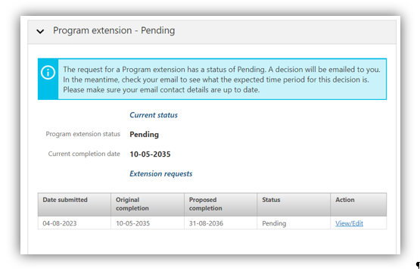

The Program team will review your request and contact you if additional evidence is required. You will be notified once a decision has been determined.

If you would like to cancel your request, please email the [BondedMedicalProgram@health.gov.au](mailto:BondedMedicalProgram@health.gov.au) providing your details and the reason of cancellation.

1. Withdrawing from the Program

Once you have agreed or opted-in to the Program you can withdraw at any time. You can request a ‘**Withdrawal Repayment estimate’** report by clicking the ‘**My dashboard**’ page, open the ‘**Manage my agreement**’ accordion on the bottom left side of the dashboard.

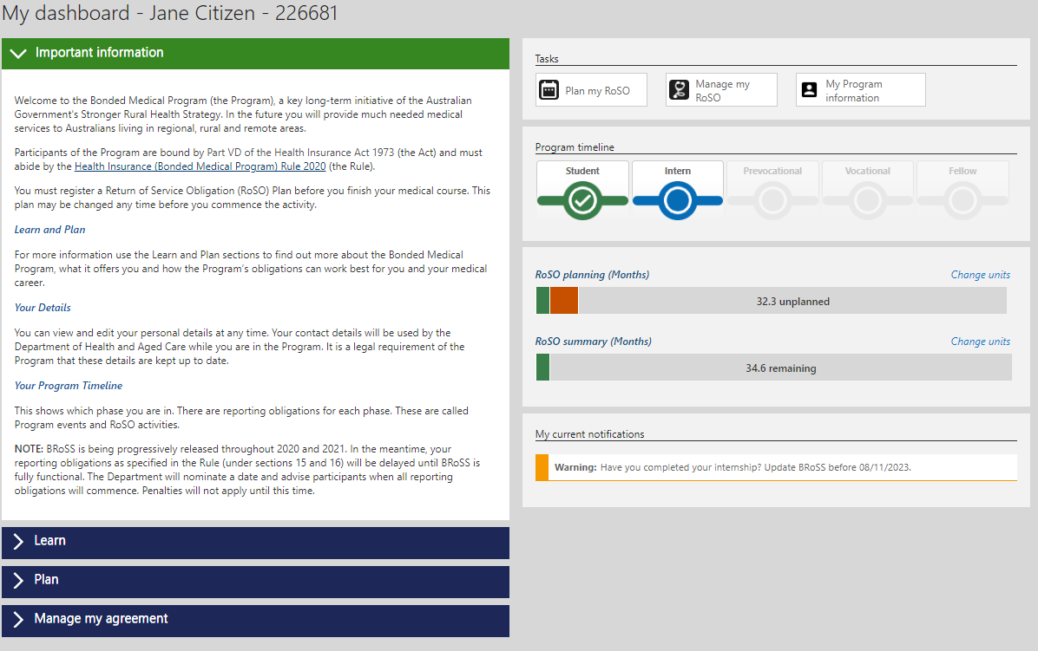

The ‘**Manage my agreement**’ accordion will open. Click on the ‘**Withdraw from the Program**’ button.

Image of Management my agreement and option to 'withdraw from the program'


**Please note**: The opening pages will be different depending on whether you have opted-in to the Program via the BMP Scheme the MRBS Scheme or began with the Program. These processes are detailed in the following sections.

* 1. Withdrawing for Program participants or Previous Bonded Medical Places (BMP) Scheme participants who have opted-in

Once you have clicked on the ‘**Withdraw from the Program**’ button the ‘**Estimate: Withdraw from the Program**’ page will open. Enter the ‘**Proposed withdrawal date**’ and click ‘Next’.

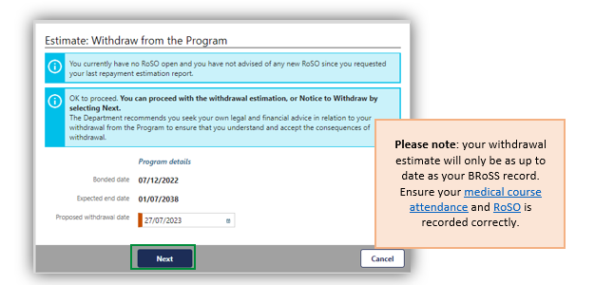

In the ‘**Estimated: Withdraw from the Program**’ page, the information about your withdrawal and your repayment calculation will reflect with a report available to download. Click ‘**Close**’ once reviewed.

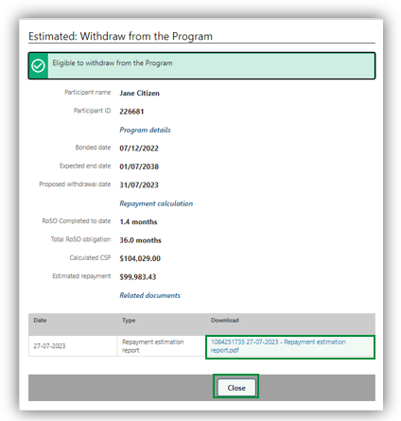

You will return to the ‘**My dashboard**’ page. If you would like to continue with your withdrawal request or get an updated withdrawal repayment estimate, open your ‘**Manage my agreement**’ accordion and then click on the ‘**Withdraw from the Program**’ button.

The ‘**View: withdraw from the Program**’ page will open. There are two options available on this page:

1. you can get a new withdrawal repayment estimate by clicking on the ‘**Re-estimate**’ button. This will update your ‘**Estimate: Withdraw from the Program**’ page and provide a new repayment figure and report as detailed above.
2. continue with your withdrawal by clicking on the ‘**Withdraw**’ button, which will take you to the ‘**View: Withdraw from the Program’** page.

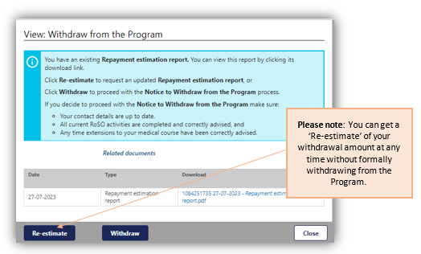

After clicking on the ‘**Withdraw**’ button, the pop-up ‘**Warning**’ page will show. Click ‘**OK**’ to continue with your withdrawal from the Program.

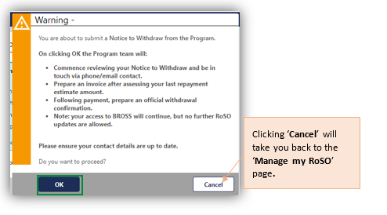

The ‘**Advise: Withdraw from the Program**’ page will allow you to update and complete your withdrawal request. Once completed click ‘**Next**’ to submit the request.

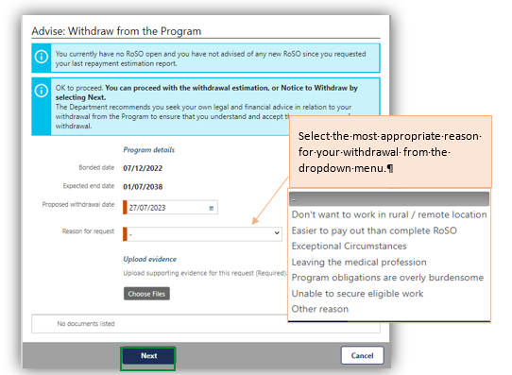

**Please note:** if you select the ‘**Exceptional Circumstances**’ – you will be required to provide additional information in a new field and upload any evidence to support your request.

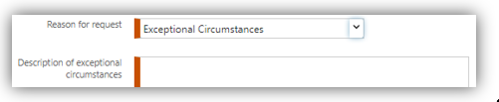

If you select ‘**Other**’ you will also be required to provide additional information in the new field. 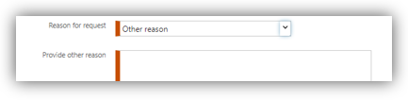

After clicking ‘**Next**’ the ‘**Advised: Withdrawal from the Program**’ page will show your withdrawal information that will be provided to the Program team for your withdrawal request.

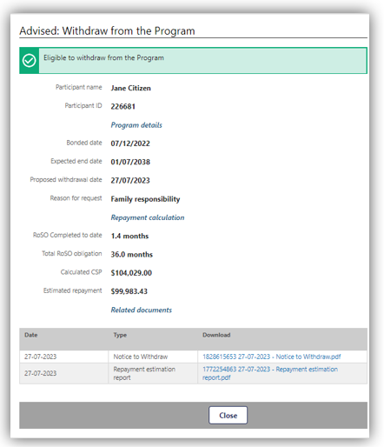

The Program team will review your withdrawal request and contact you if additional evidence is required. You will be provided with an invoice once your withdrawal request is processed.

For ‘**Exceptional Circumstances**’ the Program team will send you a confirmation email with the decision outcome.

If you would like to cancel your withdrawal request, please email the [BondedMedicalProgram@health.gov.au](mailto:BondedMedicalProgram@health.gov.au) providing your details and the reason of cancelation.

* 1. Withdrawing for Previous Medical Rural Bonded Scholarship (MRBS) Scheme participants who have opted-in

Once you have clicked on the **‘Withdraw from the Program’** button the **‘Estimate: Withdraw from the Program’** page will open. Enter the **‘Proposed withdrawal date’** and click **‘Next****’**.

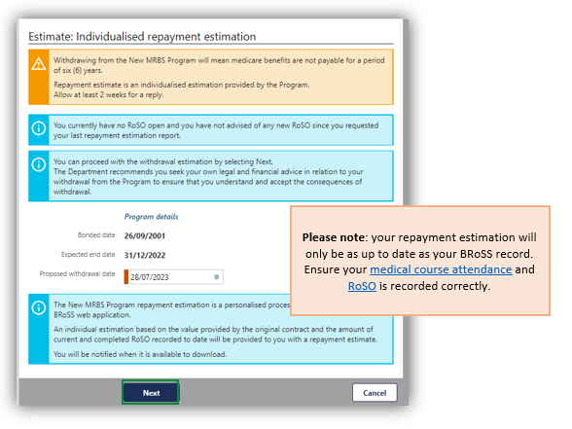

**Please note:** Withdrawing from the Program as an opted-in MRBS participant will mean Medicare benefits are not payable for a period of six (6) years.

After clicking on the ‘**Next**’ button the pop-up ‘**Warning**’ page will show, click ‘**OK**’ to continue with your withdrawal request from the Program.



The ‘**Estimated: Withdraw from the Program**’ page will open with your ‘**Repayment estimation request**’ document that has been provided to the Program team, to assess your request and provide an estimate of your repayment amount.

Clicking ‘**Cancel**’ will take you back to the ‘**Manage my RoSO**’ page**.**

Screenshot of the estimated withdrawal of the Program including a waning that withdrawal from the new MRBS Program will mean medicare benefits are not payable for a period of 6 years. Allow up to 2 weeks for a reply.

A reminder that the estimation request is yet to be assessed and any more RoSO completed will impact the estimation. Estimate of repayment amount can be accessed here.


**Please note:** Once your request is submitted, an estimate of your repayment amount will be emailed to you within four (4) weeks, based on your current BRoSS record. The estimate will account for all currently active and completed RoSO activities up to the proposed withdrawal date.

Once you receive your estimate from the Program team, go to the ‘**My dashboard**’ page.

Open your ‘**Manage my agreement**’ accordion and then click on the ‘**Withdraw from the Program**’ button to open the ‘**View: Withdrawal from the Program**’ page. Your ‘**New MRBS repayment estimation.pdf**’ can be downloaded from here.

There are two options on this page:

1. you can get a new withdrawal repayment estimate by clicking on the ‘Re-estimate’ button, this will take you back to the ‘Estimate: Withdraw from the Program’ page as detailed above.
2. continue with your withdrawal by clicking on the ‘Withdraw’ button which will take you to the ‘**View: Withdraw from the Program’** page.

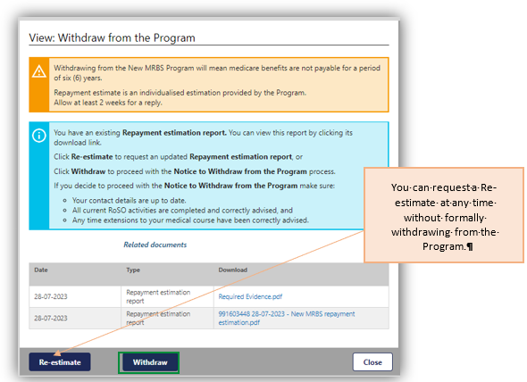

After clicking on the ‘**Withdraw**’ button the pop-up ‘**Warning**’ page will show. Click ‘**OK**’ to confirm and continue with your withdrawal from the Program.



The ‘**Advise: Individualised repayment estimation’** page, will show for you to update and complete for your withdrawal request, once completed click ‘**Next**’ to submit your withdrawal.

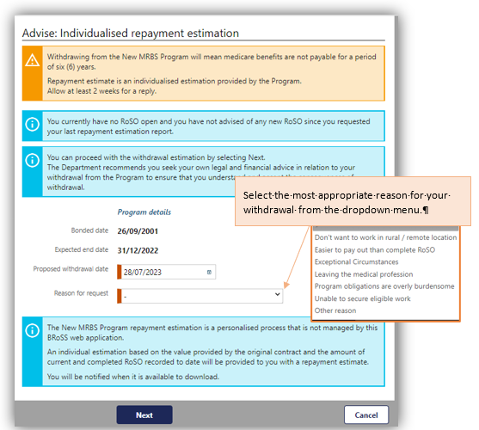

**Please note:** if you select the ‘**Exceptional Circumstances**’ – you will be required to provide additional information in a new field and upload any evidence to support your request.

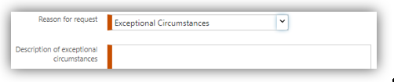

If you select ‘**Other**’ you will also be required to provide additional information in the new field.

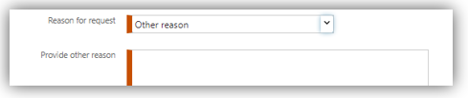

After clicking ‘**Next**’ the ‘**Advised: Withdrawal from the Program**’ page will show your withdrawal information that will be provided to the Program team for your withdrawal request.

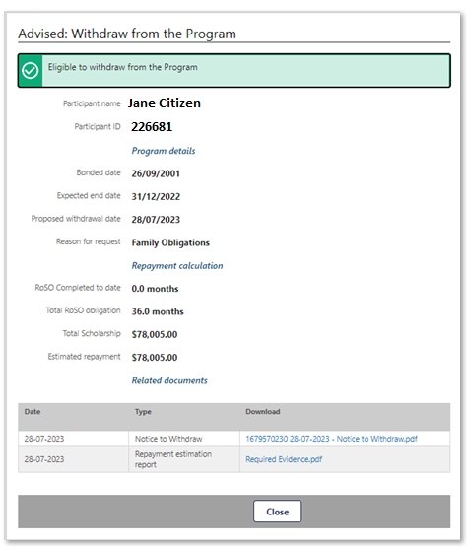

The Program team will review your withdrawal request and contact you if additional evidence is required. You will be provided with an invoice once your withdrawal request is processed.

For ‘**Exceptional Circumstances**’ the Program team will send you a confirmation email with the decision outcome.

If you would like to cancel your withdrawal request, please email the [BondedMedicalProgram@health.gov.au](mailto:BondedMedicalProgram@health.gov.au) providing your details and the reason of cancelation.

1. Additional assistance

To learn about your obligations under the Program, please refer to the [*Health Insurance (Bonded Medical Program) Rule 2020* (the Rule)](https://www.legislation.gov.au/Series/F2019L01513) and [*Part VD of the Act*](https://www.legislation.gov.au/Series/C2004A00101). Details regarding your privacy can be found at [*Privacy Act 1988.*](https://www.legislation.gov.au/Series/C2004A03712)

If you require further Program information or assistance, please contact the Department of Health and Aged Care at:

* Website: [Bonded Medical Program](https://www.health.gov.au/our-work/bonded-medical-program) which contains instructional BRoSS videos,
* Email: [BondedMedicalProgram@health.gov.au](mailto:BondedMedicalProgram@health.gov.au) using the subject title format: Bonded Medical Program – your name – request type, or Telephone: 1800 987 104 (Monday-Friday, 8:30am to 5:00pm AEST/AEDT).