ASSAD 2022–2023: Australian secondary school students’ use of alcohol and other substances

Prepared by:

Maree Scully, Ian Koh, Emily Bain, Melanie Wakefield, Sarah Durkin

Centre for Behavioural Research in Cancer

Cancer Council Victoria

Prepared for:

Australian Government Department of Health and Aged Care

December 2023

Table of Contents

Introduction 1

Method 2

Survey design and procedure 2

Questionnaire 3

Sample size 3

Data analysis 4

Results 6

Alcohol use 6

Drinking prevalence among Australian secondary school students 6

Trends in prevalence of drinking among Australian secondary school students 8

Sources and types of alcohol 13

Drinking locations 15

Self-described drinking status 16

Intentions to get drunk 16

Negative experiences after drinking 17

Parental permission for secondary supply 18

Other substances 19

Analgesics 19

Trends in prevalence of analgesic use among Australian secondary school students 20

Tranquilisers 21

Trends in prevalence of tranquiliser use among Australian secondary school students 22

Cannabis 23

Trends in prevalence of cannabis use among Australian secondary school students 24

Trends in use of other substances 25

Trends in any illicit drug use 26

Ethno-botanicals and synthetic drugs 28

Substance use education 29

Mental health and use of health services 30

Summary 31

Acknowledgements 32

References 33

Appendix 34

Survey items 34

Sample weighting procedure 52

Additional results tables 53

# Introduction

Despite evidence of a decline in alcohol use among young people since the 2000s, a substantial proportion of Australian adolescents still engage in drinking behaviours that put their health at risk.1, 2 Drinking alcohol from a young age has both short- and long-term consequences for the individual’s wellbeing. For example, underage drinkers are more likely to engage in violent behaviour,3 use other drugs,4 and have poorer school outcomes.5 They are also more likely to develop alcohol use disorders in the future,6 and to experience deficits in cognitive and emotional functioning that may persist into adulthood.7

Early initiation of illicit drug use has also been linked with adverse outcomes and increased risk of dependence later in life.8 While illicit drug use is less prevalent among young people than alcohol use,1, 2 ongoing monitoring of these behaviours is important given that specific substances can vary in popularity over time.9

This report presents national secondary student alcohol and other substance use data from the 2022/2023 Australian Secondary Students’ Alcohol and Drug (ASSAD) survey. The ASSAD survey is the largest national survey of adolescent substance use in Australia, and is administered on school premises (i.e., without parental involvement), which has been shown to result in higher (and likely more valid) estimates of health risk behaviours compared to surveys conducted in the home setting.10

The report examines students’ prevalence of drinking and other substance use in 2022/2023 and over time. We further present data on students’ behaviours relating to the use of alcohol, over-the-counter drugs (for non-medical reasons) and cannabis.

# Method

## Survey design and procedure

Data on Australian adolescents’ alcohol and other substance use prevalence were obtained from the 2022/2023 ASSAD survey. First conducted in 1984, this triennial survey assesses secondary students’ use of tobacco, e-cigarettes, alcohol, over-the-counter drugs (for non-medical purposes) and other substances in Australia. From March 2022 to July 2023, we conducted the thirteenth survey in this series. The survey was postponed from 2020 due to the COVID-19 pandemic’s consequent restrictions on school survey involvement.

The survey uses a standard sampling procedure and core questionnaire throughout all states and territories in Australia. The Australian Centre for Educational Research (ACER) drew a national sample of schools for the survey, excluding schools with fewer than 100 student enrolments. The sample was stratified by education sector (government, Catholic and independent) to reflect state-wide distributions.

Permission was requested from each sampled school to conduct the survey. If the school declined to participate, participation was sought from a list of potential replacement schools selected at random by ACER with similar demographic and education sector characteristics. In 2022/2023, the survey was completed via an online questionnaire for the first time. Schools in most jurisdictions were also given the option of having classroom teachers administer the survey in place of research staff, a procedure that has been successfully used internationally for other school-based surveys on similar topics (e.g., the COMPASS study in Canada; the European School Survey Project on Alcohol and Other Drugs; the Health Behaviour in School-aged Children (HBSC) study). These changes in protocol from previous ASSAD survey rounds were implemented to provide greater flexibility and to minimise potential COVID-related disruptions to data collection. Importantly, evidence from a large school-based US study measuring adolescent drug use behaviours showed little difference in prevalence when comparing online versus paper-and-pencil administration modes.11

Secondary students in Australia from 83 schools (school response rate: 6%) were surveyed between March 2022 and July 2023 using an online self-report questionnaire. Students completed the survey independently and anonymously.

## Questionnaire

A full list of the questions asked of students in this report is presented in Appendix Table A1. In brief, to measure alcohol use, students were asked if they have ever had even part of an alcoholic drink (‘lifetime (ever) drinking’), had an alcoholic drink in the last twelve months (‘past year drinking’), had an alcoholic drink in the last four weeks (‘past month drinking’), and the number of alcoholic drinks had on each of the last seven days (‘past week drinking’ if they had an alcoholic drink on any of these days). To measure use of over-the-counter drugs (i.e., analgesics, tranquilisers) and other substances (i.e., cannabis, inhalants, hallucinogens, MDMA (ecstasy), cocaine, dexamphetamines, methamphetamines, heroin, pharmaceutical opioids, performance or image enhancing drugs), students were asked to indicate the number of times, if ever, they had used or taken the substance in four time periods: last week, last four weeks, last year and lifetime. Students could choose from seven response categories, ranging from ‘none’ to ‘40 or more times’.

## Sample size

A total of 11,145 students in Years 7 to 12 were surveyed across Australia. Students with large amounts of missing data (n=203) and students who either did not provide their age or date of birth (n=95) or were not aged between 12 and 17 years (n=415) were removed from the data set. Students whose responses were consistently implausible or exaggerated (n=118) were also removed from the data set. This left 10,314 valid cases in the final data set (Table 1).

Table 1: Number of Australian secondary school students aged between 12 and 17 years surveyed in 2022/2023 by gender and age.

|  |  |  |  |  |  |  |  |
| --- | --- | --- | --- | --- | --- | --- | --- |
| **Gender** | **Age (years)** | | | | | |  |
| **12** | **13** | **14** | **15** | **16** | **17** | **12-17** |
| 1. Male | 1. 569 | 1. 1,033 | 1. 1,066 | 1. 1,072 | 1. 1,041 | 1. 653 | 1. 5,434 |
| 1. Female | 1. 536 | 1. 764 | 1. 802 | 1. 863 | 1. 929 | 1. 707 | 1. 4,601 |
| 1. Other | 1. 29 | 1. 53 | 1. 46 | 1. 50 | 1. 53 | 1. 28 | 1. 259 |
| 1. Not stated | 1. 5 | 1. 5 | 1. 2 | 3 | 1. 4 | 1. 1 | 1. 20 |
| 1. **Total** | 1. **1,139** | 1. **1,855** | 1. **1,916** | 1. **1,988** | 1. **2,027** | 1. **1,389** | 1. **10,314** |

## Data analysis

Data were analysed using Stata/MP 16.1 and the sample was weighted to align with population distributions of 12- to 17-year-old students in Australia by sex, age and education sector.12 See Appendix for more detailed information on the weighting process.

All analyses adjusted for the clustering of students within each school.

Descriptive statistics are presented to determine the proportion of students who reported drinking and other substance use behaviours and attitudes. Due to small cell sizes, we do not report prevalence estimates for the ‘other’ and ‘not stated’ gender categories; however, they are included in the total prevalence estimates.

We ran chi-square tests to examine differences between male and female students and younger (12- to 15-year-old) and older (16- to 17-year-old) students in drinking and other substance use prevalence. We used logistic regression to test for differences in the proportions of students who had consumed alcohol or used other substances across the survey years [1996 to 2022/2023 (reference category)], and controlled for age, education sector (government, Catholic and independent), state/territory and sex.

Due to the large sample size and probability of type 1 error, only associations statistically significant at p<0.01 are discussed in this report.

Please note that caution should be exercised when interpreting trends over time due to:

Changes in the national survey methodology for 2022/2023 (e.g., shift from pen-and-paper to online survey mode, providing schools with the option of having classroom teachers administer the survey in place of research staff in some jurisdictions).

The additional time lag between the COVID-delayed 2022/2023 survey round and the previous ASSAD survey round in 2017 (i.e., five years instead of three years).

Data collection being spread across two academic school years for the most recent survey round (cf. a single academic school year as has occurred for all previous survey rounds).

The smaller number of schools and students included in the final sample for 2022/2023 which reduces the precision of the prevalence estimates (i.e., the confidence intervals around each estimate are larger).

95% confidence intervals (CIs) for estimates presented in tables have been reported and relative standard errors (RSEs) for all estimates were examined. RSEs allow for the standard error of estimates from survey data to be expressed in a comparable way. The standard error measures how much an estimate is likely to deviate from the true value in the actual population. The RSE is the standard error divided by the survey estimate, expressed as a percentage. RSEs of 25%-50% and greater than 50% have been noted using a single (#) or double hash (##) symbol respectively in the tables and figures and should be interpreted with caution—these indicate a high level of sampling error. Where a RSE was greater than 50%, statistical comparisons were not performed.

Additional results tables showing drinking and other substance use prevalence estimates for male and female students separately, broken down by age group where appropriate, are included in the Appendix (Tables A2 to A11).

# Results

## Alcohol use

### Drinking prevalence among Australian secondary school students

In 2022/2023, nearly two-thirds (65%) of secondary school students in Australia reported having ever consumed alcohol, including just a few sips (Table 2). Overall, 44% had consumed an alcoholic drink in the past year, 22% had drank in the past month, and around one in ten (11%) had drank in the past week. Only 4% of students had engaged in risky drinking in the past week (i.e., consumed five or more drinks on any day during this period).

Older students were significantly more likely than younger students to have consumed alcohol in each recency period. There were no significant differences in drinking prevalence between male and female students.

Table 2: Alcohol use among Australian secondary school students by gender and age group, 2022/2023.

|  |  |  |  |  |  |
| --- | --- | --- | --- | --- | --- |
| **Recency period** | **Total** | **Genderb** | | **Age group** | |
| **Males** | **Females** | **12-15** | **16-17** |
| **(n=10,135)a** | **(n=5,382)** | **(n=4,428)** | **(n=7,060)** | **(n=3,075)** |
| %  (95%CI) | %  (95% CI) | %  (95% CI) | %  (95% CI) | %  (95% CI) |
| **Lifetime (ever) drinking** | 64.8  (60.8-68.5) | 62.3  (58.1-66.4) | 66.7  (62.3-70.8) | **59.0**  **(55.0-62.9)** | **77.9**  **(71.9-83.0)** |
| **Past year drinking** | 43.7  (39.6-47.9) | 40.5  (36.5-44.5) | 46.8  (41.5-52.1) | **35.0**  **(31.0-39.2)** | **63.8**  **(58.1-69.1)** |
| **Past month drinking** | 22.2  (19.6-25.1) | 19.9  (17.0-23.2) | 24.9  (20.6-29.6) | **16.0**  **(13.9-18.3)** | **36.6**  **(31.8-41.7)** |
| **Past week drinking** | 10.8  (9.0-12.9) | 10.0  (7.6-13.1) | 11.6  (9.6-14.1) | **7.3**  **(6.0-9.0)** | **18.9**  **(15.4-22.9)** |
| **Risky drinking** | 3.8  (2.9-4.8) | 3.6  (2.6-4.8) | 4.1  (3.1-5.4) | **1.6**  **(1.1-2.3)** | **8.8**  **(7.0-11.0)** |

95% CI: 95% confidence interval

a The total n (weighted) varied slightly (<2%) for each recency period due to missing data.

b ‘Other’ and ‘Not stated’ genders were omitted from analysis due to small cell sizes.

**Green shading and bolding** = Significant difference by gender or age group at p<0.01.

To further assess risky drinking prevalence, students who had ever consumed an alcoholic drink (i.e., more than a few sips) were asked to indicate if they have had five or more alcoholic drinks on any one occasion when they have been drinking over four separate recency periods (i.e., lifetime, past year, past month, last two weeks).

As reflected in Table 3, 81% of students who had ever consumed an alcoholic drink had engaged in risky drinking in their lifetime, with a slightly lower proportion reporting risky drinking in the past year (77%). Just under half (46%) had consumed at least five drinks on any one occasion in the past month and nearly one-third (30%) had engaged in this behaviour in the last two weeks. Risky drinking was more prevalent among older (vs. younger) students who had ever consumed an alcoholic drink for the lifetime, past year and past month recency periods. No significant gender differences in risky drinking behaviour were observed.

Table 3: Risky drinking among Australian secondary school students who had ever consumed an alcoholic drink by gender and age group, 2022/2023.

|  |  |  |  |  |  |  |
| --- | --- | --- | --- | --- | --- | --- |
| **Recency period** | **Total** | **Genderb** | | | **Age group** | |
| **Males** | **Females** | **12-15** | | **16-17** |
| **(n=2,879)a** | **(n=1,424)** | **(n=1,340)** | **(n=1,354)** | | **(n=1,525)** |
| %  (95%CI) | %  (95% CI) | %  (95% CI) | %  (95% CI) | | %  (95% CI) |
| **Lifetime** | 81.1  (77.6-84.1) | 80.1  (76.2-83.5) | 82.0  (77.1-86.1) | **75.2**  **(68.6-80.7)** | | **86.4**  **(82.2-89.7)** |
| **Past year** | 76.7  (73.3-79.9) | 74.9  (70.3-79.0) | 78.4  (73.1-82.8) | **70.2**  **(64.2-75.5)** | | **82.5**  **(78.3-86.1)** |
| **Past month** | 46.2  (42.0-50.3) | 43.4  (38.4-48.4) | 49.7  (43.7-55.7) | **38.9**  **(33.5-44.6)** | | **52.6**  **(47.3-57.9)** |
| **Last two weeks** | 29.9  (25.7-34.3) | 28.5  (23.8-33.6) | 31.8  (26.9-37.2) | 25.4  (20.0-31.7) | | 33.9  (28.5-39.7) |

95% CI: 95% confidence interval

a The total n (weighted) varied (<6%) for each recency period due to missing data.

b ‘Other’ and ‘Not stated’ genders were omitted from analysis due to small cell sizes.

**Green shading and bolding** = Significant difference by gender or age group at p<0.01.

### Trends in prevalence of drinking among Australian secondary school students

Figure 1 shows drinking trends over time for lifetime (ever) drinking, past year drinking, past month drinking, past week drinking and risky drinking among Australian secondary school students.

For each recency period, the prevalence of student drinking is at its lowest level in 2022/2023. The proportion of students who reported consuming alcohol in the past month was significantly lower in 2022/2023 compared to 2017 (22% vs. 27%), as was the proportion of students who had consumed alcohol in the past week (11% vs. 15%). However, there were no significant differences in the prevalence of lifetime, past year or risky drinking between 2017 and 2022/2023.

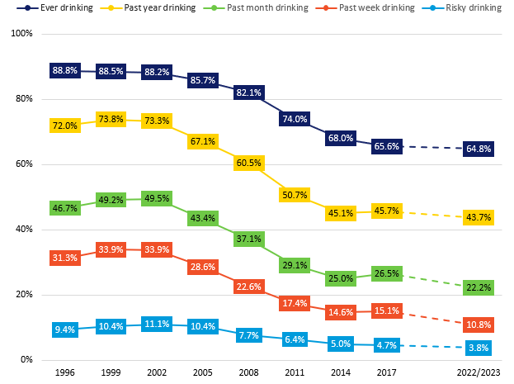

Figure 1: Alcohol use over time among Australian secondary school students by recency, 1996-2022/2023.

Note: The dotted line between 2017 and 2022/2023 indicates that caution should be exercised when interpreting this trend (see Method for further details).

Figure 2 shows lifetime (ever) drinking over time among Australian secondary school students by age group. Among younger students, the proportion who reported having ever consumed alcohol started declining in the mid-2000s but has subsequently plateaued, with no significant difference in the prevalence of ever drinking observed between 2017 and 2022/2023 (58% vs. 59%). Among older students, the proportion who reported having ever consumed alcohol has continued to decline since the mid-2000s and is at its lowest level in 2023/2023. However, while the prevalence of ever drinking among older students was lower in 2022/2023 compared to 2017 (78% vs. 83%), this difference was not significant.

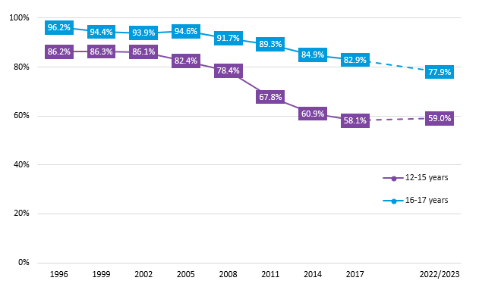

Figure 2: Lifetime (ever) drinking over time among Australian secondary school students by age group, 1996-2022/2023.

Note: The dotted line between 2017 and 2022/2023 indicates that caution should be exercised when interpreting this trend (see Method for further details).

Figure 3 shows past year drinking over time among Australian secondary school students by age group. Among younger students, the prevalence of past year drinking was at a similar level in 2022/2023 as that observed in 2017 (both 35%). In contrast, a significantly lower proportion of older students reported having consumed alcohol in the past year in 2022/2023 compared to 2017 (64% vs. 72%).

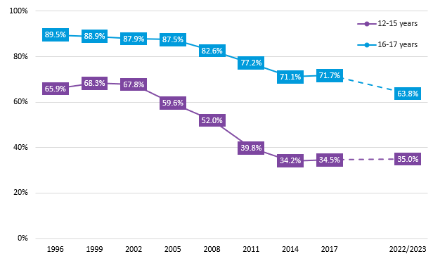

Figure 3: Past year drinking over time among Australian secondary school students by age group, 1996-2022/2023.

Note: The dotted line between 2017 and 2022/2023 indicates that caution should be exercised when interpreting this trend (see Method for further details).

Figure 4 shows past month drinking over time among Australian secondary school students by age group. The prevalence of past month drinking was significantly lower in 2022/2023 compared to 2017 among older students (37% vs. 49%) but not younger students (16% vs. 17%).

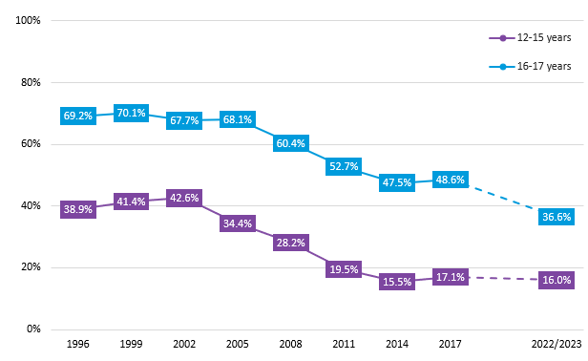

Figure 4: Past month drinking over time among Australian secondary school students by age group, 1996-2022/2023.

Note: The dotted line between 2017 and 2022/2023 indicates that caution should be exercised when interpreting this trend (see Method for further details).

Figure 5 shows past week drinking over time among Australian secondary school students by age group. A similar pattern was observed for past week drinking as was found for past month drinking. Specifically, a significantly lower proportion of older students reported having consumed alcohol in the past week in 2022/2023 compared to 2017 (19% vs. 29%); however, the difference in proportions between these two survey years for the younger age group was not significant (7% vs. 9%).

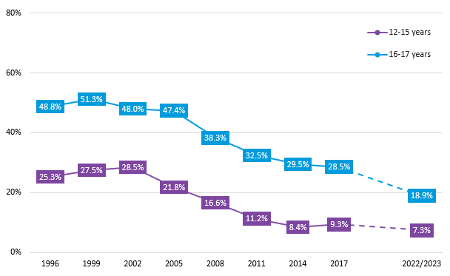

Figure 5: Past week drinking over time among Australian secondary school students by age group, 1996-2022/2023.

Note: The dotted line between 2017 and 2022/2023 indicates that caution should be exercised when interpreting this trend (see Method for further details).

Figure 6 shows risky drinking over time among Australian secondary school students by age group. Among younger students, the prevalence of risky drinking was at a similar level in 2022/2023 as that observed in 2017 (both 2%). Among older students, the proportion who engaged in risky drinking in the past week was lower in 2022/2023 compared to 2017 (9% vs. 11%); however, this difference was not significant.

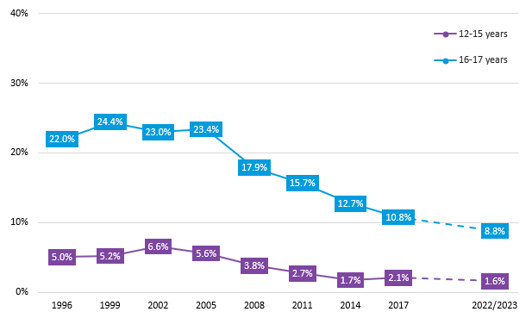

Figure 6: Risky drinkinga over time among Australian secondary school students by age group, 1996-2022/2023.

Note: The dotted line between 2017 and 2022/2023 indicates that caution should be exercised when interpreting this trend (see Method for further details).

a Students who reported consuming five or more drinks on any day in the past week were categorised as having engaged in risky drinking.

### Sources and types of alcohol

Australian secondary school students who reported drinking alcohol in the past week (i.e., ‘current drinkers’) were asked to indicate what type of alcoholic drink they usually have and how they accessed their last alcoholic drink. As shown in Figure 7, the most common type of alcohol usually consumed by current drinkers was premixed spirits (42%) followed by spirits (21%) and ordinary beer (14%). The most notable gender differences were that over half (54%) of female current drinkers nominated premixed spirits as their usual type of drink (vs. 29% for males) while around a quarter (24%) of male current drinkers indicated that they usually consumed ordinary beer (vs. 4% for females).

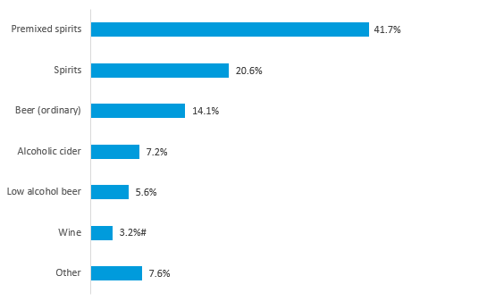

Figure 7: Most common type of alcohol usually consumed by Australian secondary school students who had consumed alcohol in the past week, 2022/2023 (n=1,015).

Note: Percentages are rounded and may not add up to 100%. Only students indicating one usual type of drink were included in this analysis.

# Estimate has a relative standard error of 25% to 50% and should be used with caution.

Nearly half (47%) of all current drinkers obtained their last alcoholic drink from their parent/s (Figure 8). Around a quarter (23%) accessed it from a friend, including 14% who specified that their friend was 18 years or older. Just under one in ten students (9%) indicated that they got someone else to buy their last alcoholic drink, 6% took it from home without permission and a further 6% reported buying it themselves. Younger current drinkers tended to be more likely than older current drinkers to obtain alcohol from their parent/s (52% vs. 42%), while older current drinkers tended to be more likely than younger current drinkers to get someone else to buy alcohol for them (14% vs. 5%).

Where current drinkers indicated that someone else had bought them alcohol (n=91), this was most commonly a friend who was 18 years or older (65%). Among current drinkers who had bought themselves alcohol (n=58), 44% reported purchasing it from a licensed liquor store.

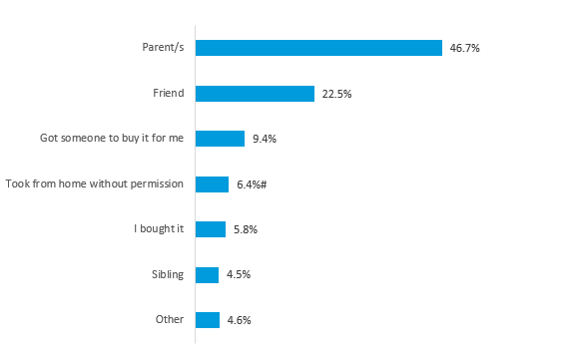

Figure 8: Source of last alcoholic drink among Australian secondary school students who had consumed alcohol in the past week, 2022/2023 (n=1,040).

Note: Percentages are rounded and may not add up to 100%. Only students indicating one source of alcohol were included in this analysis.

# Estimate has a relative standard error of 25% to 50% and should be used with caution.

### Drinking locations

Just over one-third (35%) of current drinkers reported consuming their last alcoholic drink at home, while around a quarter (26%) were at a party (Figure 9). A further 17% of current drinkers indicated they were at a friend’s house when they had their last alcoholic drink, with the remaining 21% nominating another location (e.g., hotel, pub, bar or tavern, a park or recreation area, a beach). Drinking at home tended to be more common among younger current drinkers (43% vs. 28% for older current drinkers). Conversely, drinking at a party tended to be more common among older current drinkers (36% vs. 16% for younger current drinkers). Overall, 69% of current drinkers indicated that there was adult supervision when they had their last alcoholic drink, with no significant difference observed by age group.

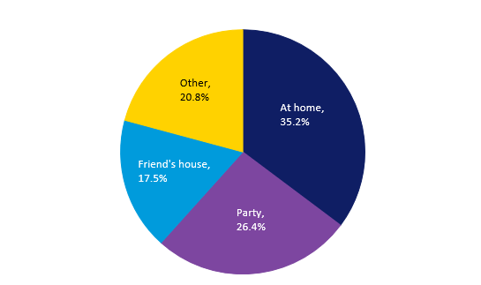

Figure 9: Most common locations for having last alcoholic drink among Australian secondary school students who had consumed alcohol in the past week, 2022/2023 (n=1,065).

Note: Percentages are rounded and may not add up to 100%. Only students indicating one drinking location were included in this analysis.

### Self-described drinking status

A majority of students (73%) described themselves as non-drinkers when prompted, while 15% considered themselves to be occasional drinkers. Just under one in ten students (9%) reported being a party drinker. Only a very low proportion of students described themselves as a light (3%) or heavy drinker (1%). Younger students tended to be more likely than older students to describe themselves as non-drinkers (83% vs. 52%). In contrast, older students tended to be more likely than younger students to consider themselves to be occasional (24% vs. 11%) or party (19% vs. 4%) drinkers.

### Intentions to get drunk

Among current drinkers, around one-third (35%) of students reported that they intend to get drunk either most times or every time they drink alcohol. A further 35% of students indicated that they intend to get drunk a few times or sometimes, while over a quarter (29%) never intend to get drunk when they consume alcohol. This pattern did vary by age group, with younger current drinkers more likely to never intend to get drunk when they drink alcohol (44% vs. 17%) whereas older current drinkers were more likely to intend to get drunk at least most times they drink alcohol (47% vs. 21%).

### Negative experiences after drinking

Over half (54%) of all current drinkers reported experiencing at least one negative outcome after drinking alcohol in the past year, and this did not significantly vary by gender or age group. As Figure 10 illustrates, the most common negative event experienced by current drinkers was vomiting (29%) followed by doing something they later regretted (24%). Trying smoking (20%) or drugs (17%) were also commonly occurring negative events that current drinkers reported experiencing after drinking alcohol. Female current drinkers were more likely than male current drinkers to have done something they later regretted (28% vs. 19%), as were older compared to younger current drinkers (29% vs. 18%). Older current drinkers were also more likely than younger current drinkers to have vomited (35% vs. 22%) or tried smoking (26% vs. 13%) or drugs (25% vs. 9%) after drinking alcohol in the past year.

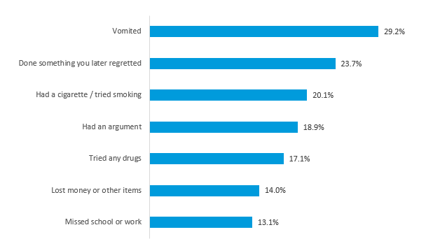

Figure 10: Main negative outcomes experienced after drinking alcohol in the past year among Australian secondary school students who had consumed alcohol in the past week, 2022/2023 (n=1,040).

Note: Percentages do not sum to 100% as multiple responses were allowed and only the most common negative outcomes are shown.

### Parental permission for secondary supply

When asked to think back to the last time someone who was not their parent or legal guardian gave them alcohol to drink, 40% of students who had ever consumed an alcoholic drink (i.e., more than a few sips) indicated that this person did not have their parents’/legal guardian’s permission to give them alcohol (Figure 11). Almost one-third (31%) indicated they definitely did have permission, while 11% were somewhat confident they had permission. Just under one in five students who had ever consumed an alcoholic drink (18%) had never been given alcohol by someone that was not their parent or legal guardian. Younger students tended to be more likely to have never been given alcohol by someone else other than their parent (24% vs. 12%), whereas older students tended to be more likely to indicate that they definitely had permission from their parent to be given alcohol by someone else (36% vs. 26%).

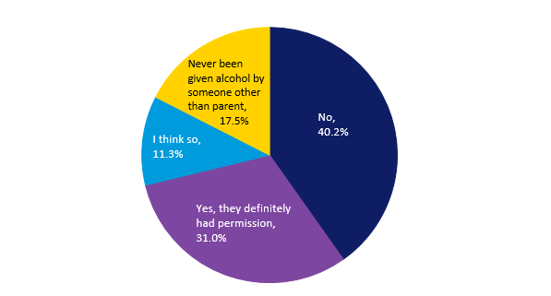

Figure 11: Permission from parent to be given alcohol by someone else among Australian secondary school students who had ever consumed an alcoholic drink, 2022/2023 (n=2,912).

Note: Percentages do not sum to 100% as multiple responses were allowed and only the most common negative outcomes are shown.

## Other substances

### Analgesics

In 2022/2023, most students reported having used painkillers or analgesics (e.g., Panadol, Nurofen or Disprin) for any reason in their lifetime (87%) and in the past year (83%; Table 4). Just under two-thirds of students (65%) had taken an analgesic in the past month, while around two-fifths (41%) had taken one in the past week.

Female students were significantly more likely than male students to report analgesic use in each of the four recency periods (i.e., lifetime, past year, past month, past week). In addition, older students were significantly more likely than younger students to have used an analgesic in the past month (69% vs. 62%).

Table 4: Analgesic use among Australian secondary school students by gender and age group, 2022/2023.

|  |  |  |  |  |  |  |
| --- | --- | --- | --- | --- | --- | --- |
| **Recency period** | **Total** | **Genderb** | | | **Age group** | |
| **Males** | **Females** | **12-15** | | **16-17** |
| **(n=9,678)a** | **(n=5,113)** | **(n=4,257)** | **(n=6,775)** | | **(n=2,903)** |
| %  (95% CI) | %  (95% CI) | %  (95% CI) | %  (95% CI) | | %  (95% CI) |
| **Lifetime (ever) use** | 87.2  (85.5-88.8) | **82.8**  **(80.4-84.9)** | **92.1**  **(90.0-93.7)** | 86.1  (84.0-87.9) | | 89.8  (86.8-92.2) |
| **Past year use** | 83.1  (81.0-85.1) | **77.4**  **(74.1-80.3)** | **89.4**  **(87.3-91.2)** | 81.9  (79.5-84.1) | | 86.0  (82.8-88.7) |
| **Past month use** | 64.6  (61.5-67.5) | **54.2**  **(51.0-57.5)** | **76.2**  **(73.2-79.0)** | **62.5**  **(58.5-66.3)** | | **69.5**  **(65.9-72.9)** |
| **Past week use** | 40.7  (37.9-43.5) | **30.8**  **(27.9-33.9)** | **51.5**  **(47.7-55.2)** | 39.2  (35.4-43.1) | | 44.2  (40.1-48.3) |

95% CI: 95% confidence interval

a The total n (weighted) varied slightly (<3%) for each recency period due to missing data.

b ‘Other’ and ‘Not stated’ genders were omitted from analysis due to small cell sizes.

**Green shading and bolding** = Significant difference by gender or age group at p<0.01.

Among students who had used analgesics in the past year, the most common reasons given for taking their last analgesic were for a headache or migraine (males: 40%; females: 33%) and to ease cold or flu symptoms (males: 36%; females: 23%). Another often cited reason among male students was for pain associated with playing sport (13%), while nearly one-third of female students (31%) had taken their last analgesic due to menstrual pain. Only 1% of students indicated having no medical reason for taking their last analgesic.

Students who had used analgesics in the past year most commonly reported getting their last analgesic from their parent or legal guardian (90%).

### Trends in prevalence of analgesic use among Australian secondary school students

Figure 12 shows lifetime (ever) and past month use of analgesics over time among Australian secondary students by age group. The prevalence of lifetime analgesic use was significantly lower in 2022/2023 compared to 2017 among both younger (86% vs. 94%) and older (90% vs. 96%) students. However, there was no significant difference in the prevalence of past month analgesic use between 2017 and 2022/2023 for either age group.

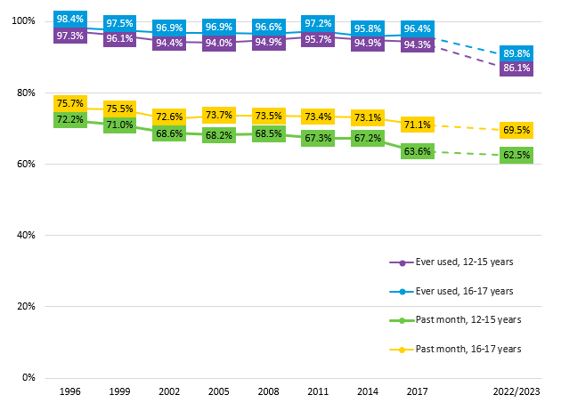

Figure 12: Analgesic use over time among Australian secondary school students by recency and age group, 1996-2022/2023.

Note: The dotted line between 2017 and 2022/2023 indicates that caution should be exercised when interpreting this trend (see Method for further details).

### Tranquilisers

In 2022/2023, just under one in five students (18%) reported ever using tranquilisers (e.g., Valium, Xanax, Mogadon, Diazepam, Temazepam, Serepax or Rohypnol) for non-medical reasons (Table 5). Around one in ten students (11%) had used tranquilisers in the past year, 6% in the past month, and 4% in the past week. Female students were significantly more likely to have used tranquilisers for non-medical reasons in the past month compared to male students (7% vs. 5%). No significant differences in tranquiliser use were observed between younger and older students.

Table 5: Tranquiliser use among Australian secondary school students by gender and age group, 2022/2023.

|  |  |  |  |  |  |  |
| --- | --- | --- | --- | --- | --- | --- |
| **Recency period** | **Total** | **Genderb** | | | **Age group** | |
| **Males** | **Females** | **12-15** | | **16-17** |
| **(n=9,479)a** | **(n=5,008)** | **(n=4,168)** | **(n=6,637)** | | **(n=2,843)** |
| %  (95% CI) | %  (95% CI) | %  (95% CI) | %  (95% CI) | | %  (95% CI) |
| **Lifetime (ever) use** | 18.0  (15.9-20.2) | 16.1  (13.7-18.8) | 19.8  (17.1-22.9) | 19.0  (16.8-21.4) | | 15.7  (12.5-19.4) |
| **Past year use** | 11.0  (9.8-12.4) | 9.4  (7.8-11.3) | 12.2  (10.5-14.2) | 11.2  (9.7-13.0) | | 10.6  (8.3-13.3) |
| **Past month use** | 5.6  (4.9-6.4) | **4.6**  **(3.7-5.7)** | **6.6**  **(5.6-7.9)** | 5.5  (4.6-6.6) | | 5.7  (4.4-7.4) |
| **Past week use** | 3.7  (3.2-4.3) | 3.0  (2.3-3.9) | 4.4  (3.6-5.5) | 3.5  (2.8-4.3) | | 4.1  (3.2-5.3) |

95% CI: 95% confidence interval

a The total n (weighted) varied very slightly (<1%) for each recency period due to missing data.

b ‘Other’ and ‘Not stated’ genders were omitted from analysis due to small cell sizes.

**Green shading and bolding** = Significant difference by gender or age group at p<0.01.

Among students who had used tranquilisers in the past year, almost two-thirds (65%) indicated that they got it from their parent or legal guardian, while a further 17% reported being prescribed them. Note, reported use of prescribed tranquilisers for non-medical reasons may include incorrectly reported medical use.

### Trends in prevalence of tranquiliser use among Australian secondary school students

Figure 13 shows lifetime (ever) and past month use of tranquilisers over time among Australian secondary students by age group. Among older students, the proportion who reported having ever used tranquilisers for non-medical reasons was significantly lower in 2022/2023 compared to 2017 (16% vs. 21%). In contrast, there was no significant difference in the prevalence of lifetime tranquiliser use between these two survey years among younger students (19% vs. 18%). The proportion of students reporting past month tranquiliser use was relatively similar in 2022/2023 compared to 2017 for both age groups.

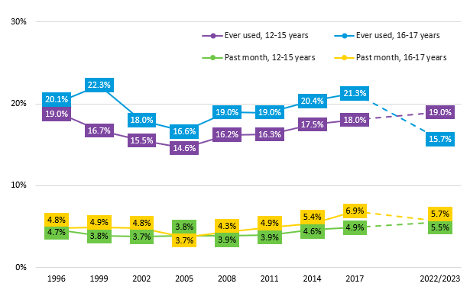

Figure 13: Tranquiliser use over time among Australian secondary school students by recency and age group, 1996-2022/2023.

Note: The dotted line between 2017 and 2022/2023 indicates that caution should be exercised when interpreting this trend (see Method for further details).

### Cannabis

In 2022/2023, 13% of students reported having used cannabis in their lifetime (Table 6). A similar proportion of students (12%) had used cannabis in the past year, while 7% reported use in the past month and 4% reported use in the past week. Older students were significantly more likely than younger students to report using cannabis across all recency periods. No significant differences in cannabis use by gender were observed.

Table 6: Cannabis use among Australian secondary school students by gender and age group, 2022/2023.

|  |  |  |  |  |  |  |
| --- | --- | --- | --- | --- | --- | --- |
| **Recency period** | **Total** | **Genderb** | | | **Age group** | |
| **Males** | **Females** | **12-15** | | **16-17** |
| **(n=9,523)a** | **(n=5,022)** | **(n=4,193)** | **(n=6,671)** | | **(n=2,852)** |
| %  (95% CI) | %  (95% CI) | %  (95% CI) | %  (95% CI) | | %  (95% CI) |
| **Lifetime (ever) use** | 13.4  (11.0-16.2) | 11.6  (9.1-14.7) | 14.8  (12.3-17.6) | **9.0**  **(6.8-11.7)** | | **23.8**  **(19.6-28.5)** |
| **Past year use** | 11.8  (9.7-14.4) | 10.2  (7.8-13.2) | 13.1  (10.9-15.7) | **7.8**  **(5.8-10.4)** | | **21.2**  **(17.4-25.6)** |
| **Past month use** | 6.6  (5.2-8.4) | 5.9  (4.3-8.0) | 6.7  (5.2-8.6) | **4.6**  **(3.4-6.3)** | | **11.3**  **(8.8-14.5)** |
| **Past week use** | 3.8  (2.8-5.1) | 4.2  (2.8-6.2) | 3.4  (2.5-4.7) | **2.6**  **(1.7-3.9)** | | **6.7**  **(4.9-9.0)** |

95% CI: 95% confidence interval

a The total n (weighted) varied very slightly (<1%) for each recency period due to missing data.

b ‘Other’ and ‘Not stated’ genders were omitted from analysis due to small cell sizes.

**Green shading and bolding** = Significant difference by gender or age group at p<0.01.

Most students who had used cannabis in the past year reported usually smoking it from a bong or a pipe (56%) or as a joint (30%). Three-quarters (75%) of past year users indicated that they usually smoke or use cannabis with others, while around one in six (16%) used cannabis by themselves and with others about equally often. When prompted as to where they last smoked or used cannabis, past year users most commonly reported being at a friend’s home (39%) followed by at their own home (19%), at a party (15%) or in a park (14%).

### Trends in prevalence of cannabis use among Australian secondary school students

Figure 14 shows lifetime (ever) and past month use of cannabis over time among Australian secondary students by age group. Among younger students, the prevalence of cannabis use has remained stable since the late 2000s. Conversely, following a slight upward trend between 2008 and 2017, the prevalence of both lifetime (24% vs. 30%) and past month (11% vs. 16%) cannabis use among older students was significantly lower in 2022/2023 compared to 2017.

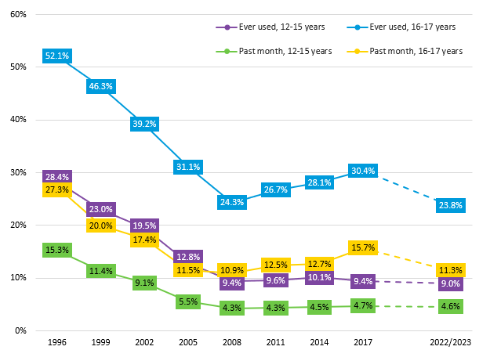

Figure 14: Cannabis use over time among Australian secondary school students by recency and age group, 1996-2022/2023.

Note: The dotted line between 2017 and 2022/2023 indicates that caution should be exercised when interpreting this trend (see Method for further details).

### Trends in use of other substances

Only a few changes over time in the prevalence of lifetime use or past month use of other substances were observed (Table 7). Specifically, a significantly higher proportion of students reported ever use of inhalants (e.g., deliberately sniffing from spray cans or deliberately sniffing things like glue, paint, petrol, thinners, nangs or poppers in order to get high or for the way it makes them feel) in 2022/2023 compared to 2014 (20% vs. 16%). In contrast, a significantly lower proportion of students reported lifetime (3% vs. 5%) and past month (1% vs. 2%) use of MDMA (ecstasy), and past month use of cannabis (7% vs. 8%), in 2022/2023 compared to 2017; however, it should be noted that the absolute difference in proportions for past month MDMA use was small.

In general, student use of illicit substances other than cannabis (i.e., hallucinogen, amphetamines, cocaine, opioids and MDMA) has remained uncommon across recent survey years.

Table 7: Prevalence of use of other substances over time among Australian secondary school students by recency, 2014-2022/2023.

|  |  |  |  |  |  |  |
| --- | --- | --- | --- | --- | --- | --- |
| **Substance** | **Lifetime use** | | | **Past month use** | | |
| **2014** | **2017** | **2022/23** | **2014** | **2017** | **2022/23** |
| % | % | % | % | % | % |
| **Analgesics** | **95.2** | **94.9** | **87.2** | **69.0** | 65.9 | **64.6** |
| **Tranquilisers** | 18.3 | 19.0 | 18.0 | 4.9 | 5.5 | 5.6 |
| **Cannabis** | 15.8 | 15.9 | 13.4 | 7.1 | **8.1** | **6.6** |
| **Inhalants** | **15.9** | 17.7 | **20.3** | 6.1 | 7.4 | 7.4 |
| **Hallucinogens** | 2.8 | 3.3 | 2.7 | 0.9 | 1.1 | 0.8 |
| **MDMA (ecstasy)** | 3.1 | **5.1** | **3.2** | 1.3 | **2.1** | **1.1** |
| **Cocaine** | 1.9 | 2.2 | 1.9 | 0.8 | 0.8 | 0.6 |
| **Dexamphetaminesa** | - | 1.5 | 2.0 | - | 0.6 | 0.9 |
| **Methamphetaminesa** | - | 1.6 | 1.7 | - | 0.8 | 0.7 |
| **Heroina** | - | 0.8 | 0.6 | - | 0.5 | 0.2# |
| **Pharmaceutical opioidsa** | - | 5.4 | 5.2 | - | 1.9 | 1.4 |
| **Performance enhancing drugs** | 2.3 | 2.3 | 2.3 | 1.1 | 1.0 | 0.9 |

a Prior to 2017, students were asked about amphetamine use overall, and about heroin and other opiate use in a single question. Thus, no direct comparisons to 2014 can be made.

# Estimate has a relative standard error of 25% to 50% and should be used with caution.

**Green shading and bolding** = Significant difference from 2022/2023 at p<0.01.

### Trends in any illicit drug use

Any illicit drug use is a measure of the proportion of students who used at least one type of illicit drug (i.e., cannabis, hallucinogen, amphetamines, cocaine, opioids and MDMA). As cannabis is the illicit drug most commonly used by students, with much higher prevalence of use than other illicit drugs, it is of interest to examine any illicit drug use both with and without cannabis included.

In 2022/2023, 15% of students reported having ever used an illicit drug including cannabis, while 8% reported usage in the past month (Figure 15). When excluding cannabis, 6% of students reported having ever used an illicit drug, while just 2% reported usage in the past month. While each prevalence was at its lowest level in 2022/2023, the only significant difference between 2017 and 2022/2023 was for past month illicit drug use (excluding cannabis); however, the absolute difference in proportions was very small.

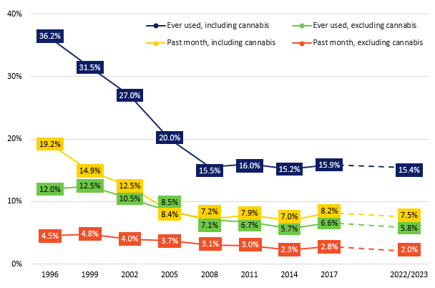

Figure 15: Any illicit drug usea over time among Australian secondary school students by recency, 1996-2022/2023.

Note: The dotted line between 2017 and 2022/2023 indicates that caution should be exercised when interpreting this trend (see Method for further details).

a Illicit drugs includes hallucinogens, amphetamines, cocaine, opioids and MDMA (and cannabis where indicated). Prior to 2017, single questions were used to measure amphetamine use and opioid use respectively. As this difference may have affected the measure of use of any illicit drug, only methamphetamine use and heroin use were included for 2017 and 2022/2023 when considering trends.

As Figure 16 shows, the prevalence of any illicit drug use (including cannabis) has remained relatively stable since 2008 among younger students. Although the proportion of older students reporting lifetime or past month illicit drug use was lower in 2022/2023 compared to 2017, these differences were not statistically significant.

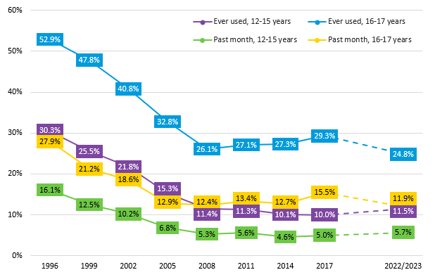

Figure 16: Any illicit drug use (including cannabis)a over time among Australian secondary school students by recency and age group, 1996-2022/2023.

Note: The dotted line between 2017 and 2022/2023 indicates that caution should be exercised when interpreting this trend (see Method for further details).

a Illicit drugs includes cannabis, hallucinogens, amphetamines, cocaine, opioids and MDMA. Prior to 2017, single questions were used to measure amphetamine use and opioid use respectively. As this difference may have affected the measure of use of any illicit drug, only methamphetamine use and heroin use were included for 2017 and 2022/2023 when considering trends.

As shown in Figure 17, patterns in use of any illicit drug over time by age group were similar when excluding cannabis as were found when cannabis was included. However, the prevalence of past month illicit drug use (excluding cannabis) among older students was significantly lower in 2022/2023 compared to 2017 (3% vs. 5%).

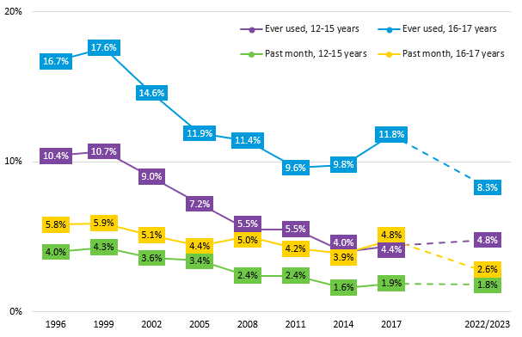

Figure 17: Any illicit drug use (excluding cannabis)a over time among Australian secondary school students by recency and age group, 1996-2022/2023.

Note: The dotted line between 2017 and 2022/2023 indicates that caution should be exercised when interpreting this trend (see Method for further details).

a Illicit drugs includes hallucinogens, amphetamines, cocaine, opioids and MDMA. Prior to 2017, single questions were used to measure amphetamine use and opioid use respectively. As this difference may have affected the measure of use of any illicit drug, only methamphetamine use and heroin use were included for 2017 and 2022/2023 when considering trends.

### Ethno-botanicals and synthetic drugs

Just 1% of students reported using any ethno-botanicals (e.g., Kava, Salvia, Kratom) in the past year. Similarly, use of synthetic cannabis/cannabinoids or other synthetic drugs was very low, with 2% of students using them in the past year; although it should be noted that some students may not be aware that they have consumed synthetic drugs as they are often used as adulterants in other drugs.

## Substance use education

Nearly three-quarters of students (73%) reported receiving at least some level of alcohol education at school in the last year, while just under two-thirds (64%) recalled some lesson time being spent on illicit drug education (Figure 18). Students’ recall of the number of lessons they had received on each substance use topic did not significantly vary by gender. However, younger students tended to be more likely than older students to indicate they had not received any lessons about illicit drugs in the last year (39% vs. 29%).

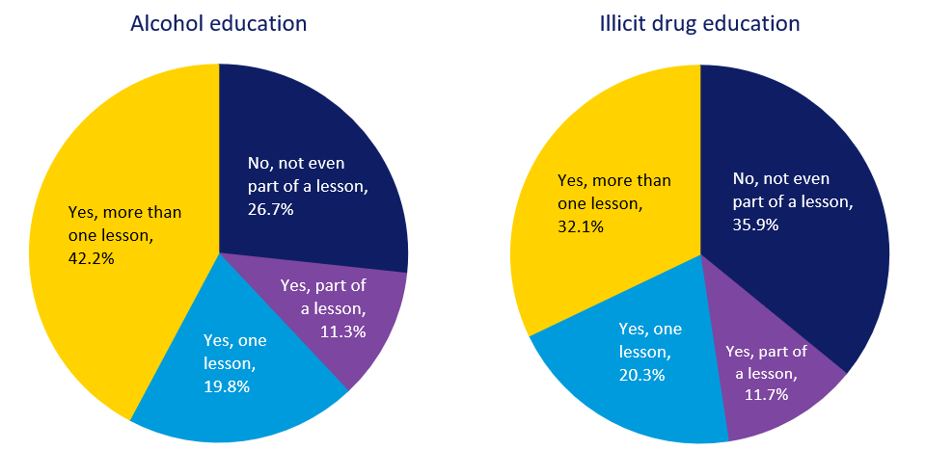

Figure 18: Prevalence of Australian secondary school students recalling receiving alcohol education (n=8,959) or illicit drug education (n=9,206) at school in the last year, 2022/2023.

## Mental health and use of health services

Around one in five students (19%) reported that they had been diagnosed or told by a doctor or nurse that they have a mental health condition, while a further 20% of students indicated that they did not know. Male students tended to be more likely than female students to report that they had never been diagnosed with a mental health condition (69% vs. 55%), while younger students tended to be more likely than older students to be unsure when asked this question (22% vs. 14%).

Seventeen percent of students indicated that they had seen a health professional in the past year for emotional or behavioural problems. Seeking health professional support for alcohol and/or drug related problems was uncommon (2%).

# Summary

This study found that nearly two-thirds (65%) of Australian secondary school students had ever tried alcohol and more than one in five (22%) had consumed alcohol in the past month. Significantly higher drinking prevalence was observed among older than younger students across all recency periods (i.e., lifetime, past year, past month, past week and risky drinking). There was, however, evidence of declines in alcohol use in the older age group between 2017 and 2022/2023. In contrast, alcohol use among younger students appears to have plateaued since 2014.

A majority of current (past week) drinkers indicated that they usually drink either premixed spirits (42%) or spirits that were not premixed (21%). Parents were the most common source of alcohol for current drinkers (47%), with few students reporting that they bought their own alcohol (6%). Age group differences in where students consumed their last alcoholic drink were apparent, with younger current drinkers often reporting being at home (43%) whereas drinking at a party was the most common location among older current drinkers (36%).

Use of analgesics was widespread, particularly among females, with students typically taking them to ease the pain associated with a headache/migraine or to relieve cold or flu symptoms. Overall, cannabis was the most commonly used illicit drug, albeit with significantly higher prevalence for older students. However, as seen with drinking prevalence, there was evidence in the older age group of declining use of cannabis between 2017 and 2022/2023 with no change in cannabis use among younger students over the same period. In general, students infrequently reported having ever used other illicit drugs (i.e., hallucinogens, amphetamines, cocaine, opioids and MDMA). When considered collectively, 15% of all students had ever used any illicit drug (including cannabis), while this dropped to just 6% when cannabis was excluded.

# Acknowledgements

The 2022/2023 ASSAD survey was funded by the Australian Government Department of Health and Aged Care, state and territory governments, and Cancer Councils in Victoria, South Australia, Queensland and Tasmania. We gratefully acknowledge the government and non-government education authorities, the school principals, teachers, and students who cooperated to make this study possible. We also thank McNair yellowSquares, CoreData WA and Cancer Council South Australia for their assistance with data collection, and the ASSAD state and territory coordinators for their support in helping to organise the survey.

# References

**1** Australian Institute of Health and Welfare. *National Drug Strategy Household Survey 2019*. Canberra, Australia, 2020.

**2** Guerin N, White V. ASSAD 2017 Statistics & Trends: Australian secondary students’ use of tobacco, alcohol, over-the-counter drugs, and illicit substances. Second edition. Prepared for: Drug Strategy Branch Australian Government Department of Health. Centre for Behavioural Research in Cancer, Cancer Council Victoria: Melbourne, Australia, July 2020. Available from: <https://www.cancervic.org.au/downloads/cbrc/R20_NG_ASSAD%202017%20National%20Report_2nd%20Ed.pdf>.

**3** Jones RM, Van Den Bree M, Zammit S, Taylor PJ. Change in the relationship between drinking alcohol and risk of violence among adolescents and young adults: a nationally representative longitudinal study. *Alcohol and Alcoholism* 2020; 55(4): 439-47.

**4** Freeman T, White VM, Roche AM. Which Australian secondary school students are at risk of illicit drug use? *Drug and Alcohol Review* 2011; 30(6): 589-96.

**5** Williams GC, Battista K, Leatherdale ST. An examination of how age of onset for alcohol, cannabis, and tobacco are associated with school outcomes in grade 12. *Addictive Behaviors* 2020; 102: 106215.

**6** Zeigler DW, Wang CC, Yoast RA, Dickinson BD, McCaffree MA, Robinowitz CB, Sterling ML. The neurocognitive effects of alcohol on adolescents and college students. *Preventive Medicine* 2005; 40(1): 23-32.

**7** Lees B, Meredith LR, Kirkland AE, Bryant BE, Squeglia LM. Effect of alcohol use on the adolescent brain and behavior. *Pharmacol Biochem Behav* 2020; 192: 172906.

**8** Lubman DI, Hides L, Yucel M, Toumbourou JW. Intervening early to reduce developmentally harmful substance use among youth populations. *Med J Aust* 2007; 187(7 Suppl): S22-5.

**9** Miech RA, Johnston LD, Patrick ME, O'Malley PM, Bachman JG, Schulenberg JE. *Monitoring the Future national survey results on drug use, 1975-2022: Secondary school students*. Institute for Social Research, University of Michigan: Ann Arbor, MI, 2023. Available from: <https://monitoringthefuture.org/wp-content/uploads/2022/12/mtf2022.pdf>.

**10** Brener ND, Eaton DK, Kann L, Grunbaum JA, Gross LA, Kyle TM, Ross JG. The association of survey setting and mode with self-reported health risk behaviors among high school students. *Public Opinion Quarterly* 2006; 70(3): 354-74.

**11** Miech RA, Couper MP, Heeringa SG, Patrick ME. The impact of survey mode on US national estimates of adolescent drug prevalence: results from a randomized controlled study. *Addiction* 2020; 116(5): 1144-51.

**12** Australian Bureau of Statistics. *Schools, 2022*. ABS: Canberra, Australia, 2023. Available from: <https://www.abs.gov.au/statistics/people/education/schools/latest-release#cite-window1>.

# Appendix

## Survey items

Table A1: ASSAD 2022/2023 alcohol and other substance use survey items.

| **Survey question** | **Eligible sample** |
| --- | --- |
| At the present time, do you consider yourself:   1. A non-drinker 2. An occasional drinker 3. A light drinker 4. A party drinker 5. A heavy drinker | All |
| Have you **ever** had even part of an alcoholic drink?   1. No 2. Yes, just a few sips 3. Yes, I have had fewer than 10 alcoholic drinks in my life 4. Yes, I have had more than 10 alcoholic drinks in my life | All |
| Have you had an alcoholic drink in the last **twelve months?**   1. Yes 2. No | All |
| Have you had an alcoholic drink in the last **four weeks?**   1. Yes 2. No | All |
| This question is about the number of alcoholic drinks you had during the last **seven days**, including yesterday. Enter the number of alcoholic drinks you had on each day of the past week:  SUNDAY: __ drinks  SATURDAY: __ drinks  FRIDAY: __ drinks  THURSDAY: __ drinks  WEDNESDAY: __ drinks  TUESDAY: __ drinks  MONDAY: __ drinks | All |
| What alcoholic drink do you **usually** have?   1. Ordinary beer 2. Low alcohol beer 3. Wine (bottle or cask (goon)) 4. Wine cooler (e.g., West Coast Coolers) 5. Champagne or sparkling wine (e.g., Spumante, Passion Pop) 6. Alcoholic cider (e.g., Apple, Pear, Strongbow, Magners, Woodchuck, Rekorderlig) 7. Premixed spirits (e.g., Bacardi Breezer, Vodka Cruiser, Smirnoff Ice, Jim Beam and Cola, Wild Turkey and Cola, Bundaberg Rum and Cola, UDL, etc.) 8. Spirits (e.g., rum, brandy, whisky, gin, vodka) 9. Liqueurs including premixed liqueurs (e.g., Tia Maria, Kahlua, Midori, Baileys, Jagermeister, etc.) 10. Alcoholic energy drinks premixed (e.g., Elevate Bomb, Smirnoff Ice Double Black & Guarana, Hi NRG) 11. Alcoholic seltzer (e.g., White Claw, Good Tides, Rainbird, Fellr) 12. Other (please specify) | Past week drinkers |
| Where, or from whom, **did you get** the **last** alcoholic drink?   1. My parent(s)/legal guardian(s) gave it to me 2. My brother or sister gave it to me 3. I took it from home without my parent(s)/legal guardian(s) permission 4. Friend who is over 18 gave it to me 5. Friend who is under 18 gave it to me 6. I got someone to buy it for me 7. I bought it 8. Other (please specify)   If answered “**I bought it**”: Where did you buy it from?   1. At a hotel, pub, bar or tavern 2. At a licensed liquor store 3. At a supermarket 4. At a walk-in bottle shop at a pub or hotel 5. At a drive-in bottle shop 6. At a restaurant/cafe 7. At a dance venue / dance party / music festival / concert 8. At a nightclub 9. At a sporting event 10. At a sports club (e.g., Leagues, surfing, football) 11. Through the Internet 12. By phone, mail order 13. Other (please specify) | Past week drinkers |
| If someone else bought alcohol for you, who was this person?   1. Friend who is 18 or over 2. Brother/sister or other relative who is 18 or over 3. Friend who is not yet aged 18 4. Brother/sister or other relative who is not yet 18 5. Stranger who was able to buy alcohol 6. Parent/legal guardian 7. Other (please specify) | Past week drinkers |
| Where did you drink your **last** alcoholic drink?   1. At a beach 2. At a park or recreation area 3. At a hotel, pub, bar, or tavern 4. At a dance venue / dance party / music festival / concert 5. At a nightclub 6. At a party 7. At a restaurant / cafe 8. At a sporting event 9. At a sports club (e.g., Leagues, surfing, football) 10. At my school 11. At my home 12. At my friend's home 13. In a car or other vehicle 14. Other (please specify) | Past week drinkers |
| Was an adult supervising you and/or your friends when you had this drink?   1. Yes 2. No | Past week drinkers |
| How often on an occasion that you drink alcohol, do you intend to get drunk?   1. Never 2. A few times 3. Sometimes 4. Most times 5. Every time 6. Don’t know | Past week drinkers |
| How many times, if any, have you had 5 or more alcoholic drinks on any one occasion when you have been drinking:   1. In the last **two weeks** 2. In the last **four weeks** 3. In the last year 4. In your **lifetime**   Options for each row (i-iv)   1. None 2. Once or twice 3. 3-5 times 4. 6-9 times 5. 10-19 times 6. 20-39 times 7. 40 or more times | Ever consumed an alcoholic drink (i.e., more than a few sips) |
| In the past 12 months, after drinking alcohol, have you?  Select **all** that apply.   1. Done something you later regretted 2. Been attacked or assaulted 3. Lost some money or other items 4. Created a public disturbance or nuisance 5. Stole something 6. Driven a motor vehicle 7. Verbally abused someone 8. Physically threatened someone 9. Hit someone or had a fight 10. Had an injury that needed to be seen by a Doctor 11. Caused damage to property 12. Had an argument 13. Been admitted to hospital overnight 14. Been taken home by police 15. Missed school or work 16. Been sick (vomited) 17. Tried any drugs 18. Had a cigarette or tried smoking 19. Been in trouble with the police 20. Had to go to a Hospital Emergency Department 21. Other (please specify) 22. None of the above | Past week drinkers |
| Think back to the last time someone who was **not** your parent or legal guardian gave you alcohol to drink. Did that person have your parent’s/legal guardian’s permission to give you the alcohol?   1. No 2. I think so 3. Yes, they definitely had permission 4. I have never been given alcohol by someone who was not my parent/legal guardian | Ever consumed an alcoholic drink (i.e., more than a few sips) |
| How many times, if ever, have you used or taken painkillers/analgesics such as paracetamol (e.g., Panadol), ibuprofen (e.g., Nurofen), or aspirin (Dispirin), **for any reason**:   1. In the last week 2. In the last four weeks 3. In the last year 4. In your **lifetime**   Options for each row (i-iv)   1. None 2. Once or twice 3. 3-5 times 4. 6-9 times 5. 10-19 times 6. 20-39 times 7. 40 or more times | All |
| Last time you used a painkiller/analgesic, did you use it because you…?   1. Had a headache or migraine 2. Had a cold or 'flu 3. Had a toothache or pains associated with a dental procedure 4. Had pains associated with playing sports (e.g., injury, strain) 5. Menstrual/period pain 6. Had other types of pain (please specify) 7. Wanted to – there was no medical reason for using it 8. Other (please specify) | Ever used painkillers |
| Where, or from whom, **did you get** your **last** painkiller/analgesic?   1. My parent(s)/legal guardian(s) gave it to me 2. My brother or sister gave it to me 3. I took it from home without my parent(s)/legal guardian(s) permission 4. Friends gave it to me 5. A member of staff at my school gave it to me 6. A member of staff at my sporting club gave it to me 7. I bought it 8. Other (please specify) | Ever used painkillers |
| How many times, if ever, have you used or taken sleeping tablets, tranquillisers, sedatives or benzodiazepines, such as Valium, alprazolam (Xanax, Xannies), Mogadon, Diazepam, Temazepam (Mazzies, Vallies, Moggies, Jellies), Serepax (Serries) or Rohypnol (Rohies, Roofies, Barbs) **other than for medical reasons (i.e., we are not asking you about times you have used them for medical reasons)**:   1. In the last week 2. In the last four weeks 3. In the last year 4. In your **lifetime**   Options for each row (i-iv)   1. None 2. Once or twice 3. 3-5 times 4. 6-9 times 5. 10-19 times 6. 20-39 times 7. 40 or more times | All |
| Where, or from whom, did you get your last sleeping tablet, tranquiliser, sedative or benzodiazepine from?   1. My parent(s)/legal guardian(s) gave it to me 2. I am prescribed sedatives/tranquilisers by my doctor/paediatrician, or psychiatrist 3. My brother or sister gave it to me 4. I took it from home without parent(s)/legal guardian(s) permission 5. I bought it from someone 6. I was given it by someone 7. I traded or swapped something for it with someone 8. Other (please specify) | Ever used tranquillisers |
| How many times, if ever, have you smoked or used marijuana/cannabis (grass, hash, dope, weed, mull, yarndi, gunja, pot, a bong, a joint, edibles, THC):   1. In the last week 2. In the last four weeks 3. In the last year 4. In your **lifetime**   Options for each row (i-iv)   1. None 2. Once or twice 3. 3-5 times 4. 6-9 times 5. 10-19 times 6. 20-39 times 7. 40 or more times | All |
| When you use marijuana/cannabis do you usually:   1. Smoke it as a joint (reefer, spliff) 2. Smoke it from a bong or a pipe 3. Eat it – prepared at home (e.g., brownie) 4. Eat it – commercial package (e.g., nerds, gummies) 5. Vape it from an e-cigarette 6. Other (please specify) | Ever smoked marijuana/cannabis |
| Do you usually smoke or use marijuana/cannabis by yourself or with others?   1. By myself 2. With others 3. By myself and with others about equally often | Ever smoked marijuana/cannabis |
| **Where** did you last smoke or use marijuana/cannabis?   1. At a hotel, pub, bar, or tavern 2. At a dance venue, dance party, or music festival / concert 3. At a nightclub 4. At a party 5. At my home 6. At my friend's home 7. At a sports club (e.g., Leagues, surfing, football) 8. At the beach 9. In a park 10. In a car or other vehicle 11. At my school 12. Other (please specify) | Ever smoked marijuana/cannabis |
| How many times, if ever, have you used or taken performance or image enhancing drugs (e.g., steroids, muscle, roids, or gear) **without a doctor's prescription** in an attempt to make you better at sport, to increase muscle size or to improve your general appearance:   1. In the last week 2. In the last four weeks 3. In the last year 4. In your **lifetime**   Options for each row (i-iv)   1. None 2. Once or twice 3. 3-5 times 4. 6-9 times 5. 10-19 times 6. 20-39 times 7. 40 or more times | All |
| How many times, if ever, have you deliberately sniffed (inhaled) from spray cans or deliberately sniffed things like glue, paint, petrol, thinners, nitrous oxide, nangs, amyl nitrite, jungle juice, or poppers in order to get high or for the way it makes you feel:  This does not include sniffing white-out, liquid paper, textas, pens, nasal sprays or puffers used for asthma.   1. In the last week 2. In the last four weeks 3. In the last year 4. In your **lifetime**   Options for each row (i-iv)   1. None 2. Once or twice 3. 3-5 times 4. 6-9 times 5. 10-19 times 6. 20-39 times 7. 40 or more times | All |
| How many times, if ever, have you used or taken dexamphetamines (e.g., dex, dexies) other than for medical reasons (i.e., we are not asking you about times you have used them for medical reasons):   1. In the last week 2. In the last four weeks 3. In the last year 4. In your **lifetime**   Options for each row (i-iv)   1. None 2. Once or twice 3. 3-5 times 4. 6-9 times 5. 10-19 times 6. 20-39 times 7. 40 or more times | All |
| How many times, if ever, have you used or taken meth/amphetamines (e.g., speed, meth, ice):   1. In the last week 2. In the last four weeks 3. In the last year 4. In your **lifetime**   Options for each row (i-iv)   1. None 2. Once or twice 3. 3-5 times 4. 6-9 times 5. 10-19 times 6. 20-39 times 7. 40 or more times | All |
| How many times, if ever, have you used or taken MDMA (e.g., Ecstasy, E, molly, pingers, pills, bickies, caps):   1. In the last week 2. In the last four weeks 3. In the last year 4. In your **lifetime**   Options for each row (i-iv)   1. None 2. Once or twice 3. 3-5 times 4. 6-9 times 5. 10-19 times 6. 20-39 times 7. 40 or more times | All |
| How many times, if ever, have you used or taken cocaine:   1. In the last week 2. In the last four weeks 3. In the last year 4. In your **lifetime**   Options for each row (i-iv)   1. None 2. Once or twice 3. 3-5 times 4. 6-9 times 5. 10-19 times 6. 20-39 times 7. 40 or more times | All |
| How many times, if ever, have you used or taken heroin (e.g., smack, horse, skag, hammer, H):   1. In the last week 2. In the last four weeks 3. In the last year 4. In your **lifetime**   Options for each row (i-iv)   1. None 2. Once or twice 3. 3-5 times 4. 6-9 times 5. 10-19 times 6. 20-39 times 7. 40 or more times | All |
| How many times, if ever, have you used or taken pharmaceutical opioids (narcotics) such as methadone, morphine, oxycodone, codeine, buprenorphine, fentanyl, tramadol or tapentadol **other than for medical reasons? (i.e., we are not asking you about times you have used them for medical reasons)**:   1. In the last week 2. In the last four weeks 3. In the last year 4. In your **lifetime**   Options for each row (i-iv)   1. None 2. Once or twice 3. 3-5 times 4. 6-9 times 5. 10-19 times 6. 20-39 times 7. 40 or more times | All |
| How many times, if ever, have you used or taken hallucinogens (e.g., LSD, acid, trips, magic mushrooms, datura, angel’s trumpet):   1. In the last week 2. In the last four weeks 3. In the last year 4. In your **lifetime**   Options for each row (i-iv)   1. None 2. Once or twice 3. 3-5 times 4. 6-9 times 5. 10-19 times 6. 20-39 times 7. 40 or more times | All |
| In the last **twelve months**, have you used or taken any of the following ethno-botanicals?  Select **all** that apply   1. Kava 2. Salvia 3. Kratom 4. Khat 5. Betel 6. Other ethno-botanical (please specify) 7. I do not use any ethno-botanicals / I did not use any of the above | All |
| In the last **twelve months**, have you used or taken any of the following synthetic cannabis/cannabinoids or other new synthetic drugs?  Select **all** that apply   1. Synthetic cannabis/cannabinoids (e.g., K2, Spice, Kronic, Northern Lights) 2. Synthetic hallucinogens (e.g., 2C-B/2C-I/2C-E, DOI, Foxy-methoxy, Bromo-DragonFLY, Trypstacy, NBOMe, NBomb, Smiles) 3. Synthetic cathinones (e.g., MDPV, Ivory Wave, Bath Salts, mephedrone, Meow meow, M-kat) 4. Etizolam 5. DMT 6. Illicit synthetic opioids (e.g., acetylfentanyl) 7. Other Synthetic Substance (e.g., Benzo-fury, MXE) (please specify) 8. I did not use any synthetic cannabis/cannabinoids or new synthetic drugs / I did not use any of the above | All |
| During [2021/2022] (last year), did you have any lessons or parts of lessons at school that were about **drinking alcohol?**   1. No, not even part of a lesson 2. Yes, part of a lesson 3. Yes, one lesson 4. Yes, more than one lesson | All |
| During [2021/2022] (last year), did you have any lessons or parts of lessons at school that were about **illicit drugs?**   1. No, not even part of a lesson 2. Yes, part of a lesson 3. Yes, one lesson 4. Yes, more than one lesson | All |
| Have you ever been diagnosed or told by a doctor or nurse that you have a mental health condition?   1. Yes 2. No 3. Don’t know / not sure | All |
| In the **past 12 months**, have you seen a health professional (e.g., General Practitioner/GP, Psychologist, School Counsellor) because of any alcohol use, drug use, emotional problems or behavioural problems?  Select **all** that apply.   1. No, I have not seen a health professional for these reasons 2. Yes, I have seen a health professional for alcohol and/or drug related problems 3. Yes, I have seen a health professional for emotional and/or behavioural problems | All |

## Sample weighting procedure

As outlined in the Method, the sample was weighted to align with population distributions of 12- to 17-year-olds students in Australia by sex, age and education sector.12 In the 2022/2023 ASSAD survey, an ‘other’ gender response option was included for the first time. The Australian Bureau of Statistics (ABS), on which we base our weights, only provides student enrolment data for males and females. Where students’ sex was reported as neither male nor female (or was not stated/inadequately described) in 2022, the ABS randomly assigned them either a male or female status. Thus, to ensure that our population weights accurately reflected the ABS student enrolment data for 2022, we replicated their approach (i.e., students whose gender was reported as ‘other’ or was not stated were randomly assigned either a male or female status for weighting purposes). When examining prevalence by gender in this report, we do not provide prevalence estimates for the ‘other’ and ‘not stated’ gender categories due to the small cell sizes; however, these students are included in the total prevalence estimates.

## Additional results tables

Table A2 shows that, for both gender sub-groups, older students were more likely than younger students to report having consumed alcohol in each recency period (i.e., lifetime, past year, past month, past week, risky). Significant gender differences within age groups were also evident, with higher prevalence of ever drinking and past year drinking found among older female students (vs. older male students) and higher prevalence of risky drinking found among younger female students (vs. younger male students).

Table A2: Alcohol use among Australian secondary school students by age group within gender, 2022/2023.

|  |  |  |  |  |
| --- | --- | --- | --- | --- |
| **Recency perioda** | **Males** | | **Females** | |
| **12-15** | **16-17** | **12-15** | **16-17** |
| **(n=3,766)** | **(n=1,618)** | **(n=3,027)** | **(n=1,400)** |
| %  (95% CI) | %  (95% CI) | %  (95% CI) | %  (95% CI) |
| **Lifetime (ever) drinking** | **56.9**  **(52.6-61.0)** | **75.0**  **(68.2-80.8)** | **60.1**  **(55.3-64.7)** | **81.0**  **(75.0-85.9)** |
| **Past year drinking** | **31.9**  **(28.5-35.5)** | **60.4**  **(54.1-66.3)** | **37.3**  **(31.6-43.5)** | **67.2**  **(61.2-72.8)** |
| **Past month drinking** | **13.6**  **(11.3-16.3)** | **34.6**  **(28.5-41.3)** | **18.8**  **(15.3-22.8)** | **38.1**  **(30.9-45.8)** |
| **Past week drinking** | **6.3**  **(4.3-9.1)** | **18.7**  **(14.7-23.5)** | **8.4**  **(6.7-10.5)** | **18.6**  **(14.1-24.1)** |
| **Risky drinking** | **1.0**  **(0.7-1.6)** | **9.6**  **(7.5-12.3)** | **2.3**  **(1.5-3.6)** | **8.0**  **(5.9-10.9)** |

95% CI: 95% confidence interval

a The total n (weighted) varied slightly (<2%) for each recency period due to missing data.

**Green shading and bolding** = Significant difference by age group within gender at p<0.01.

**Orange shading and bolding** = Significant difference by age group within gender and by gender within age group at p<0.01.

Table A3 shows that both younger and older female students were more likely to have used analgesics in each recency period compared to younger and older male students respectively. Older female students were also more likely than younger female students to report lifetime and past month analgesic use, whereas no significant age group differences were observed among male students.

Table A3: Analgesic use among Australian secondary school students by age group within gender, 2022/2023.

|  |  |  |  |  |
| --- | --- | --- | --- | --- |
| **Recency perioda** | **Males** | | **Females** | |
| **12-15** | **16-17** | **12-15** | **16-17** |
| **(n=3,604)** | **(n=1,508)** | **(n=2,920)** | **(n=1,337)** |
| %  (95% CI) | %  (95% CI) | %  (95% CI) | %  (95% CI) |
| **Lifetime (ever) use** | **82.0**  **(79.3-84.5)** | **84.5**  **(79.9-88.2)** | **90.5**  **(87.7-92.8)** | **95.4**  **(93.5-96.8)** |
| **Past year use** | **76.2**  **(72.3-79.7)** | **80.2**  **(74.9-84.6)** | **88.2**  **(85.4-90.5)** | **92.0**  **(88.8-94.4)** |
| **Past month use** | **52.8**  **(48.8-56.8)** | **57.5**  **(51.6-63.2)** | **73.3**  **(69.6-76.7)** | **82.5**  **(78.8-85.7)** |
| **Past week use** | **29.4**  **(25.8-33.3)** | **34.1**  **(28.7-40.0)** | **49.6**  **(44.8-54.5)** | **55.4**  **(49.9-60.8)** |

95% CI: 95% confidence interval

a The total n (weighted) varied slightly (<3%) for each recency period due to missing data.

**Yellow shading and bolding** = Significant difference by gender within age group at p<0.01.

**Orange shading and bolding** = Significant difference by age group within gender and by gender within age group at p<0.01.

Table A4 shows that, among the older age group, a higher proportion of female students reported having used tranquilisers for non-medical reasons in the past month and past week compared to male students. No significant differences in tranquiliser use were found by age group when looking at male and female students separately, or by gender for the younger age group.

Table A4: Tranquiliser use among Australian secondary school students by age group within gender, 2022/2023.

|  |  |  |  |  |
| --- | --- | --- | --- | --- |
| **Recency perioda** | **Males** | | **Females** | |
| **12-15** | **16-17** | **12-15** | **16-17** |
| **(n=3,533)** | **(n=1,475)** | **(n=2,858)** | **(n=1,310)** |
| %  (95% CI) | %  (95% CI) | %  (95% CI) | %  (95% CI) |
| **Lifetime (ever) use** | 16.7  (14.0-19.9) | 14.6  (11.2-18.9) | 21.4  (18.5-24.5) | 16.5  (12.7-21.2) |
| **Past year use** | 9.5  (7.4-12.1) | 9.3  (6.6-12.9) | 12.5  (10.5-14.8) | 11.7  (9.2-14.8) |
| **Past month use** | 4.9  (3.8-6.2) | **3.9**  **(2.6-6.0)** | 6.3  (5.1-7.8) | **7.5**  **(5.5-10.1)** |
| **Past week use** | 3.3  (2.5-4.3) | **2.3#**  **(1.3-4.1)** | 3.7  (2.8-4.9) | **6.0**  **(4.2-8.4)** |

95% CI: 95% confidence interval

a The total n (weighted) varied very slightly (<1%) for each recency period due to missing data.

# Estimate has a relative standard error of 25% to 50% and should be used with caution.

**Yellow shading and bolding** = Significant difference by gender within age group at p<0.01.

Table A5 shows similar age group differences for lifetime, past year and past month cannabis use among both males and females, with prevalence higher for older students compared to younger students. Older female students were also more likely than younger female students to have used cannabis in the past week. No significant differences in cannabis use between male and female students within each age group were found.

Table A5: Cannabis use among Australian secondary school students by age group within gender, 2022/2023.

|  |  |  |  |  |
| --- | --- | --- | --- | --- |
| **Recency perioda** | **Males** | | **Females** | |
| **12-15** | **16-17** | **12-15** | **16-17** |
| **(n=3,543)** | **(n=1,479)** | **(n=2,877)** | **(n=1,316)** |
| %  (95% CI) | %  (95% CI) | %  (95% CI) | %  (95% CI) |
| **Lifetime (ever) use** | **7.8**  **(5.5-10.9)** | **20.7**  **(15.7-26.6)** | **9.4**  **(7.0-12.5)** | **26.6**  **(22.1-31.6)** |
| **Past year use** | **6.6**  **(4.5-9.5)** | **18.8**  **(14.1-24.6)** | **8.4**  **(6.2-11.4)** | **23.4**  **(19.4-28.0)** |
| **Past month use** | **4.0#**  **(2.5-6.5)** | **10.4**  **(7.5-14.2)** | **4.3**  **(3.2-6.0)** | **11.9**  **(8.9-15.8)** |
| **Past week use** | 3.2#  (1.7-5.8) | 6.6  (4.4-9.5) | **2.0**  **(1.3-2.9)** | **6.7**  **(4.6-9.6)** |

95% CI: 95% confidence interval

a The total n (weighted) varied very slightly (<1%) for each recency period due to missing data.

# Estimate has a relative standard error of 25% to 50% and should be used with caution.

**Green shading and bolding** = Significant difference by age group within gender at p<0.01.

Table A6 shows that, among younger students, there were no significant differences in the prevalence of ever drinking, past year drinking, past month drinking or past week drinking between 2017 and 2022/2023 for either male or female students. However, the proportion of younger male students who had engaged in risky drinking in the past week (i.e., consumed five or more drinks on any day during this period) was significantly lower in 2022/2023 compared to 2017.

Table A6: Alcohol use over time among Australian secondary school students aged 12 to 15 years by gender, 1996-2022/2023.

|  |  |  |  |  |  |  |  |  |  |  |
| --- | --- | --- | --- | --- | --- | --- | --- | --- | --- | --- |
| **Recency period** | **Gendera** | 1996 | 1999 | 2002 | 2005 | 2008 | 2011 | 2014 | 2017 | 2022/2023 |
| % | % | % | % | % | % | % | % | % |
| **Lifetime (ever) drinking** | Males | **87.6** | **87.9** | **87.7** | **83.4** | **78.6** | **70.0** | 61.7 | 60.8 | 56.9 |
|  | Females | **84.8** | **84.7** | **84.6** | **81.4** | **78.2** | **65.5** | 60.1 | 55.3 | 60.1 |
| **Past year drinking** | Males | **68.6** | **70.8** | **70.3** | **61.2** | **53.2** | **41.5** | 35.1 | 36.0 | 31.9 |
|  | Females | **63.1** | **65.6** | **65.4** | **57.8** | **50.8** | 38.1 | 33.2 | 32.9 | 37.3 |
| **Past month drinking** | Males | **41.3** | **44.8** | **45.8** | **35.6** | **28.9** | **20.6** | 15.6 | 18.2 | 13.6 |
|  | Females | **36.3** | **37.9** | **39.4** | **33.0** | **27.5** | 18.4 | 15.4 | 15.8 | 18.8 |
| **Past week drinking** | Males | **27.4** | **30.3** | **31.5** | **23.4** | **17.1** | **12.2** | 8.7 | 10.2 | 6.3 |
|  | Females | **23.1** | **24.6** | **25.6** | **20.1** | **16.1** | 10.2 | 8.2 | 8.5 | 8.4 |
| **Risky drinking** | Males | **6.1** | **6.2** | **7.8** | **6.5** | **4.1** | **3.3** | **2.1** | **2.5** | 1.0 |
|  | Females | 3.9 | 4.2 | **5.3** | **4.6** | 3.5 | 2.1 | 1.3 | 1.6 | 2.3 |

a ‘Other’ and ‘Not stated’ genders were omitted from analysis due to small cell sizes.

**Green shading and bolding** = Significantly different to 2022/2023 at p<0.01.

Table A7 shows that, among older male students, the prevalence of past year drinking, past month drinking and past week drinking was significantly lower in 2022/2023 compared to 2017. Among older female students, significant differences in drinking prevalence between 2017 and 2022/2023 were observed for the past month and past week recency periods.

Table A7: Alcohol use over time among Australian secondary school students aged 16 to 17 years by gender, 1996-2022/2023.

|  |  |  |  |  |  |  |  |  |  |  |
| --- | --- | --- | --- | --- | --- | --- | --- | --- | --- | --- |
| **Recency period** | **Gendera** | 1996 | 1999 | 2002 | 2005 | 2008 | 2011 | 2014 | 2017 | 2022/2023 |
| % | % | % | % | % | % | % | % | % |
| **Lifetime (ever) drinking** | Males | **96.3** | **95.0** | **93.7** | **95.1** | **91.1** | **88.2** | **83.7** | 81.0 | 75.0 |
|  | Females | **96.0** | **93.8** | **94.0** | **94.2** | **92.3** | **90.3** | 86.1 | 84.8 | 81.0 |
| **Past year drinking** | Males | **89.7** | **89.1** | **88.1** | **88.0** | **82.0** | **75.9** | **70.4** | **69.5** | 60.4 |
|  | Females | **89.4** | **88.7** | **87.6** | **87.1** | **83.2** | **78.5** | 71.8 | 73.9 | 67.2 |
| **Past month drinking** | Males | **70.4** | **69.9** | **69.8** | **70.0** | **61.8** | **52.2** | **47.3** | **48.1** | 34.6 |
|  | Females | **68.0** | **70.3** | **65.6** | **66.2** | **59.0** | **53.2** | **47.7** | **49.1** | 38.1 |
| **Past week drinking** | Males | **51.8** | **52.6** | **51.3** | **50.1** | **41.4** | **34.0** | **29.8** | **30.7** | 18.7 |
|  | Females | **45.9** | **50.0** | **44.8** | **44.8** | **35.3** | **31.0** | **29.2** | **26.5** | 18.6 |
| **Risky drinking** | Males | **26.9** | **28.8** | **27.6** | **28.3** | **21.2** | **18.1** | **15.6** | 13.2 | 9.6 |
|  | Females | **17.2** | **20.2** | **18.5** | **18.7** | **14.7** | **13.3** | 9.8 | 8.4 | 8.0 |

a ‘Other’ and ‘Not stated’ genders were omitted from analysis due to small cell sizes.

**Green shading and bolding** = Significantly different to 2022/2023 at p<0.01.

Table A8 shows that, among all male students, the prevalence of alcohol use was significantly lower in 2022/2023 compared to 2017 for all recency periods except lifetime drinking. In contrast, there were no significant differences in drinking prevalence observed among all female students between 2017 and 2022/2023.

Table A8: Alcohol use over time among Australian secondary school students aged 12 to 17 years by gender, 1996-2022/2023.

|  |  |  |  |  |  |  |  |  |  |  |
| --- | --- | --- | --- | --- | --- | --- | --- | --- | --- | --- |
| **Recency period** | **Gendera** | 1996 | 1999 | 2002 | 2005 | 2008 | 2011 | 2014 | 2017 | 2022/2023 |
| % | % | % | % | % | % | % | % | % |
| **Lifetime (ever) drinking** | Males | **89.8** | **89.7** | **89.3** | **86.5** | **82.0** | **75.2** | **68.1** | 66.6 | 62.3 |
|  | Females | **87.8** | **87.3** | **87.2** | **85.0** | **82.3** | **72.8** | 67.9 | 64.5 | 66.7 |
| **Past year drinking** | Males | **73.8** | **75.6** | **75.2** | **68.2** | **61.0** | **51.3** | **45.4** | **45.8** | 40.5 |
|  | Females | **70.1** | **72.0** | **71.5** | **66.0** | **60.0** | 50.1 | 44.8 | 45.6 | 46.8 |
| **Past month drinking** | Males | **48.5** | **51.4** | **52.4** | **44.6** | **37.7** | **29.6** | **24.8** | **26.9** | 19.9 |
|  | Females | **44.8** | **46.9** | **46.7** | **42.3** | **36.4** | 28.7 | 25.1 | 26.2 | 24.9 |
| **Past week drinking** | Males | **33.5** | **36.2** | **36.9** | **30.3** | **23.6** | **18.4** | **14.8** | **16.1** | 10.0 |
|  | Females | **29.2** | **31.6** | **30.9** | **26.9** | **21.6** | **16.4** | **14.5** | 14.1 | 11.6 |
| **Risky drinking** | Males | **11.3** | **12.1** | **13.2** | **12.2** | **8.7** | **7.5** | **6.0** | **5.6** | 3.6 |
|  | Females | **7.5** | **8.6** | **9.0** | **8.6** | **6.7** | 5.4 | 3.9 | 3.7 | 4.1 |

a ‘Other’ and ‘Not stated’ genders were omitted from analysis due to small cell sizes.

**Green shading and bolding** = Significantly different to 2022/2023 at p<0.01.

Table A9 shows that ever and past year use of analgesics was significantly lower in 2022/2023 compared to 2017 for both male and female students. While there was no significant difference in past month analgesic use between 2017 and 2022/2023 for either gender sub-group, the prevalence of past week use of analgesics among female students was significantly higher in 2022/2023 compared to 2017.

Table A9: Analgesic use over time among Australian secondary school students aged 12 to 17 years by gender, 1996-2022/2023.

|  |  |  |  |  |  |  |  |  |  |  |
| --- | --- | --- | --- | --- | --- | --- | --- | --- | --- | --- |
| **Recency period** | **Gendera** | 1996 | 1999 | 2002 | 2005 | 2008 | 2011 | 2014 | 2017 | 2022/2023 |
| % | % | % | % | % | % | % | % | % |
| **Lifetime (ever) use** | Males | **97.0** | **95.5** | **94.0** | **93.2** | **93.8** | **95.0** | **93.1** | **93.2** | 82.8 |
|  | Females | **98.3** | **97.6** | **96.2** | **96.4** | **96.9** | **97.3** | **97.3** | **96.7** | 92.1 |
| **Past year use** | Males | **93.9** | **91.8** | **89.8** | **89.9** | **89.6** | **91.2** | **89.4** | **88.9** | 77.4 |
|  | Females | **96.6** | **95.7** | **94.2** | **94.1** | **95.0** | **95.3** | **95.3** | **94.7** | 89.4 |
| **Past month use** | Males | **67.2** | **66.2** | **63.0** | **63.0** | **63.2** | **61.7** | **61.3** | 57.3 | 54.2 |
|  | Females | **79.0** | 78.2 | 76.2 | 76.4 | 76.7 | 76.5 | 76.9 | 74.5 | 76.2 |
| **Past week use** | Males | **35.9** | **37.2** | 35.1 | 34.5 | 34.4 | 32.7 | 33.7 | 31.9 | 30.8 |
|  | Females | 46.7 | 46.8 | **45.8** | 46.1 | 46.7 | **45.2** | 47.6 | **45.5** | 51.5 |

a ‘Other’ and ‘Not stated’ genders were omitted from analysis due to small cell sizes.

**Green shading and bolding** = Significantly different to 2022/2023 at p<0.01.

Table A10 shows that male students were significantly less likely to report past year use of tranquilisers for non-medical reasons in 2022/2023 compared to 2017. Conversely, the proportion of female students reporting past week tranquiliser use was significantly higher in 2022/2023 compared to 2017. No significant differences in lifetime or past month use of tranquilisers were observed between 2017 and 2022/2023 among male or female students.

Table A10: Tranquiliser use over time among Australian secondary school students aged 12 to 17 years by gender, 1996-2022/2023.

|  |  |  |  |  |  |  |  |  |  |  |
| --- | --- | --- | --- | --- | --- | --- | --- | --- | --- | --- |
| **Recency period** | **Gendera** | 1996 | 1999 | 2002 | 2005 | 2008 | 2011 | 2014 | 2017 | 2022/2023 |
| % | % | % | % | % | % | % | % | % |
| **Lifetime (ever) use** | Males | 18.9 | 18.5 | 16.3 | 14.8 | 16.2 | 16.9 | 17.3 | 19.6 | 16.1 |
|  | Females | 19.7 | 17.9 | 16.1 | **15.5** | 17.8 | 17.3 | 19.4 | 18.5 | 19.8 |
| **Past year use** | Males | 11.3 | 10.3 | 8.8 | 8.6 | 9.0 | 10.5 | 10.8 | **12.8** | 9.4 |
|  | Females | 13.0 | 11.2 | 10.0 | **9.4** | 10.5 | 11.7 | 13.3 | 12.4 | 12.2 |
| **Past month use** | Males | 4.6 | 4.1 | 3.9 | 3.8 | 4.1 | 4.1 | 4.5 | 5.8 | 4.6 |
|  | Females | **4.8** | **4.1** | **4.1** | **3.8** | **3.9** | **4.3** | 5.2 | 5.2 | 6.6 |
| **Past week use** | Males | 2.7 | 2.5 | 2.5 | 2.2 | 2.5 | 2.2 | 2.7 | 3.7 | 3.0 |
|  | Females | **2.4** | **1.9** | **2.2** | **2.1** | **2.1** | **2.2** | **3.1** | **3.0** | 4.4 |

a ‘Other’ and ‘Not stated’ genders were omitted from analysis due to small cell sizes.

**Green shading and bolding** = Significantly different to 2022/2023 at p<0.01.

Table A11 shows that, among all male students, the prevalence of lifetime, past year and past month cannabis use was significantly lower in 2022/2023 compared to 2017. However, among all female students, the proportion reporting cannabis use in each recency period has remained relatively stable since the mid-2000s.

Table A11: Cannabis use over time among Australian secondary school students aged 12 to 17 years by gender, 1996-2022/2023.

|  |  |  |  |  |  |  |  |  |  |  |
| --- | --- | --- | --- | --- | --- | --- | --- | --- | --- | --- |
| **Recency period** | **Gendera** | 1996 | 1999 | 2002 | 2005 | 2008 | 2011 | 2014 | 2017 | 2022/2023 |
| % | % | % | % | % | % | % | % | % |
| **Lifetime (ever) use** | Males | **37.5** | **32.0** | **27.5** | **19.4** | 14.4 | **16.2** | **17.1** | **16.7** | 11.6 |
|  | Females | **31.6** | **26.7** | **22.6** | 16.1 | 12.7 | 13.4 | 14.4 | 15.0 | 14.8 |
| **Past year use** | Males | **33.1** | **26.6** | **22.8** | **15.6** | 12.0 | **13.8** | **14.4** | **15.0** | 10.2 |
|  | Females | **28.2** | **22.7** | **18.6** | 12.9 | 10.7 | 11.6 | 12.6 | 13.8 | 13.1 |
| **Past month use** | Males | **21.1** | **15.5** | **13.2** | **8.7** | 6.9 | 7.9 | 8.3 | **8.8** | 5.9 |
|  | Females | **15.8** | **11.9** | **9.7** | 5.6 | 5.4 | 5.7 | 5.8 | 7.4 | 6.7 |
| **Past week use** | Males | **13.7** | **10.2** | **8.0** | 5.4 | 4.5 | 4.5 | 5.0 | 5.3 | 4.2 |
|  | Females | **8.7** | **6.3** | **5.2** | 2.9 | 2.5 | 2.7 | 2.9 | 3.5 | 3.4 |

a ‘Other’ and ‘Not stated’ genders were omitted from analysis due to small cell sizes.

**Green shading and bolding** = Significantly different to 2022/2023 at p<0.01.