Introductory slide:
MRFF Webinar - From research plan to research proposal: addressing MRFF priorities in grant applications - 23 November 2023

Co-hosts:
* Dr Masha Somi, Chief Executive Officer, Health and Medical Research Office 
* Prof Caroline Homer AO, Deputy Chair, Australian Medical Research Advisory Board

# Contents

1. **Setting MRFF research priorities**
   1. National consultation – Professor Caroline Homer AO
2. **Expert Advisory Panels (EAPs)**
   1. How EAPs work – Professor Maree Teesson AC
   2. Consumer involvement – Ms Shannon Calvert
3. **Shaping grant applications to address research priorities**
   1. Useful guides – Assoc Professor Jacqui Macdonald
   2. Forming the grant application – Professor Michael Berk
   3. Consumer involvement – Ms Shannon Calvert
4. **Questions and answers**

# MRFF Priorities – overarching documents

* The **MRFF Strategy** and **Priorities** are set by the **Australian Medical Research Advisory Board (AMRAB)**.
  + **AMRAB** is an independent group of experts that advises the Minister for Health and Aged Care.
  + The **Strategy** sets out the vision, aim and strategic objective of the MRFF.
  + The **Priorities**:
* Outline key areas for investment
* Are set every 2 years following a national consultation.
* **The 2nd MRFF 10-Year Investment Plan** (2022-23 to 2031-32):
  + Implements the **MRFF Strategy** and **Priorities** by allocating $6.3 billion over 10 years.
  + Outlines **21 initiatives** and maps them to the **Priorities**.
  + The plan is available at <https://www.health.gov.au/campaigns/mrff>.

# Priorities 2022-2024

Consumer-Driven Research

Research Infrastructure and Capability

Translation and Commercialisation

Comparative Effectiveness Research

Preventive and Public Health Research

Primary Care Research

Health and Medical Researcher Capacity and Capability

Aboriginal and Torres Strait Islander Health

Priority Populations

Antimicrobial Resistance

Global Health and Health Security

Health Impacts from Environmental Factors

Data, Digital Health and Artificial Intelligence

# Expert Advisory Panels

* Expert Advisory Panels (EAPs) give detailed advice to the Minister for Health and Aged Care on how to meet MRFF funding priorities by developing:
  + Roadmaps and Implementation Plans (Research Missions 10-year programs of work)
  + Research Plans (4 priority areas for investment – childhood mental health, post-acute sequelae of COVID-19 (PASC), primary health, and Targeted Translation Research Accelerator).
* Members are selected and appointed by the Minister for Health and Aged Care.

# Principles for Consumer Involvement

A **consumer** is a person with lived experience as a patient, client, potential patient, user of health services, and/or providing support as a carer, family or community member

Research funded through MRFF will involve consumers:

* **In every type of research**, including basic science, public health, preventive health, translation and clinical research.
* **At all stages of research**, from defining the need/priority of a research question, refining the research question and research design through to conduct of the research and sharing and translation of results.
* **In partnership with researchers**, with consumers respected and recognised for the valuable and complementary knowledge, expertise and perspectives they bring to the research.
* **Effectively**, with sufficient time, resources and depth of relationships to enable consumers to understand and actively engage with and contribute to the research.
* **Sensitively and safely,** through research teams with strong and broad capacity and capabilities in consumer involvement, appropriate training and a supportive environment for consumers, and clearly defined and agreed roles.
* **With broad diversity and equity**, with the goal of increasing involvement of priority populations through culturally safe and appropriate engagement.

*\*Implementation ideas and examples of what ‘good’ consumer involvement looks like are provided within the Principles document* [*https://www.health.gov.au/resources/publications/principles-for-consumer-involvement-in-research-funded-by-the-medical-research-future-fund*](https://www.health.gov.au/resources/publications/principles-for-consumer-involvement-in-research-funded-by-the-medical-research-future-fund?language=en)*\**

# Grant Opportunity Guidelines

* The Health and Medical Research Office considers the MRFF Strategy and Priorities and other strategic documents, including Research Plans when designing grant opportunities.
* Grant opportunity guidelines are published on **GrantConnect** (www.grants.gov.au).
* Each grant opportunity:
  + is different – look beyond the title to the **objectives and outcomes** (section 1.3), **eligibility criteria** (section 3) and **selection criteria** (section 5)
  + must meet the objective of the MRFF initiative it sits within (e.g. primary care must be a focus of grants under the requires researchers to identify how they will contribute to the MRFF Measures of Success Primary Health Care Research initiative)
  + requires researchers to identify how they will contribute to the MRFF Measures of Success(section 5 – assessment criteria 1 and 4)
  + includes assessment criteria that are focused on outcomes (Impact, Methodology, Capacity/Capability/Resources, Overall Value and Risk)

# Key considerations when applying

**How well does the application align with the:**

Objectives and intended outcomes:
* See section 1.3 of the Grant Opportunity Guidelines.
* Project Impact criterion.

Monitoring, Evaluation and Learning Strategy:
* See the MRFF Measures of Success as described in the Monitoring, Evaluation and Learning Strategy.
* Project Impact and Overall Value and Risk of the Project criteria outcomes. 

Grant model:
*Check the intent of the grant model.
*Project Methodology criterion.

Watch MRFF Webinar – Assessing MRFF grants: Insights from assessors to learn more about the MRFF grant assessment process: <https://www.health.gov.au/resources/videos/medical-research-future-fund-webinar-assessing-mrff-grants-insights-from-assessors-15-march-2023?language=en>.

# Consumer involvement in research projects

Examples of descriptors to strengthen consumer involvement in research and engagement with priority populations:

1. Project Impact:
   * **demonstrate** how the views and values of consumers, the community, health providers and/or other end users have informed the proposed research
2. Project Methodology:
   * **describe** how consumers have been involved in the trial design
3. Capacity, Capability and Resources to deliver the project:
   * 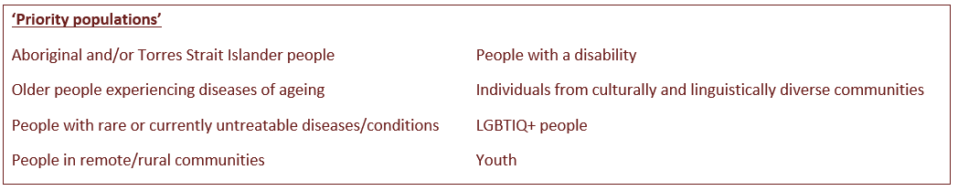projects that specifically focus on the health of priority populations should **demonstrate** that the research team includes **leadership by the priority population**.

# Thank you for your time

# Subscribe to MRFF News: www.health.gov.au/using-our-websites/subscriptions/subscribe-to-mrff-newsletter Send any questions to: MRFF@health.gov.au Register for MRFF grants opportunities: www.grants.gov.au Follow Health Twitter for MRFF updates: @healthgovau #MRFF