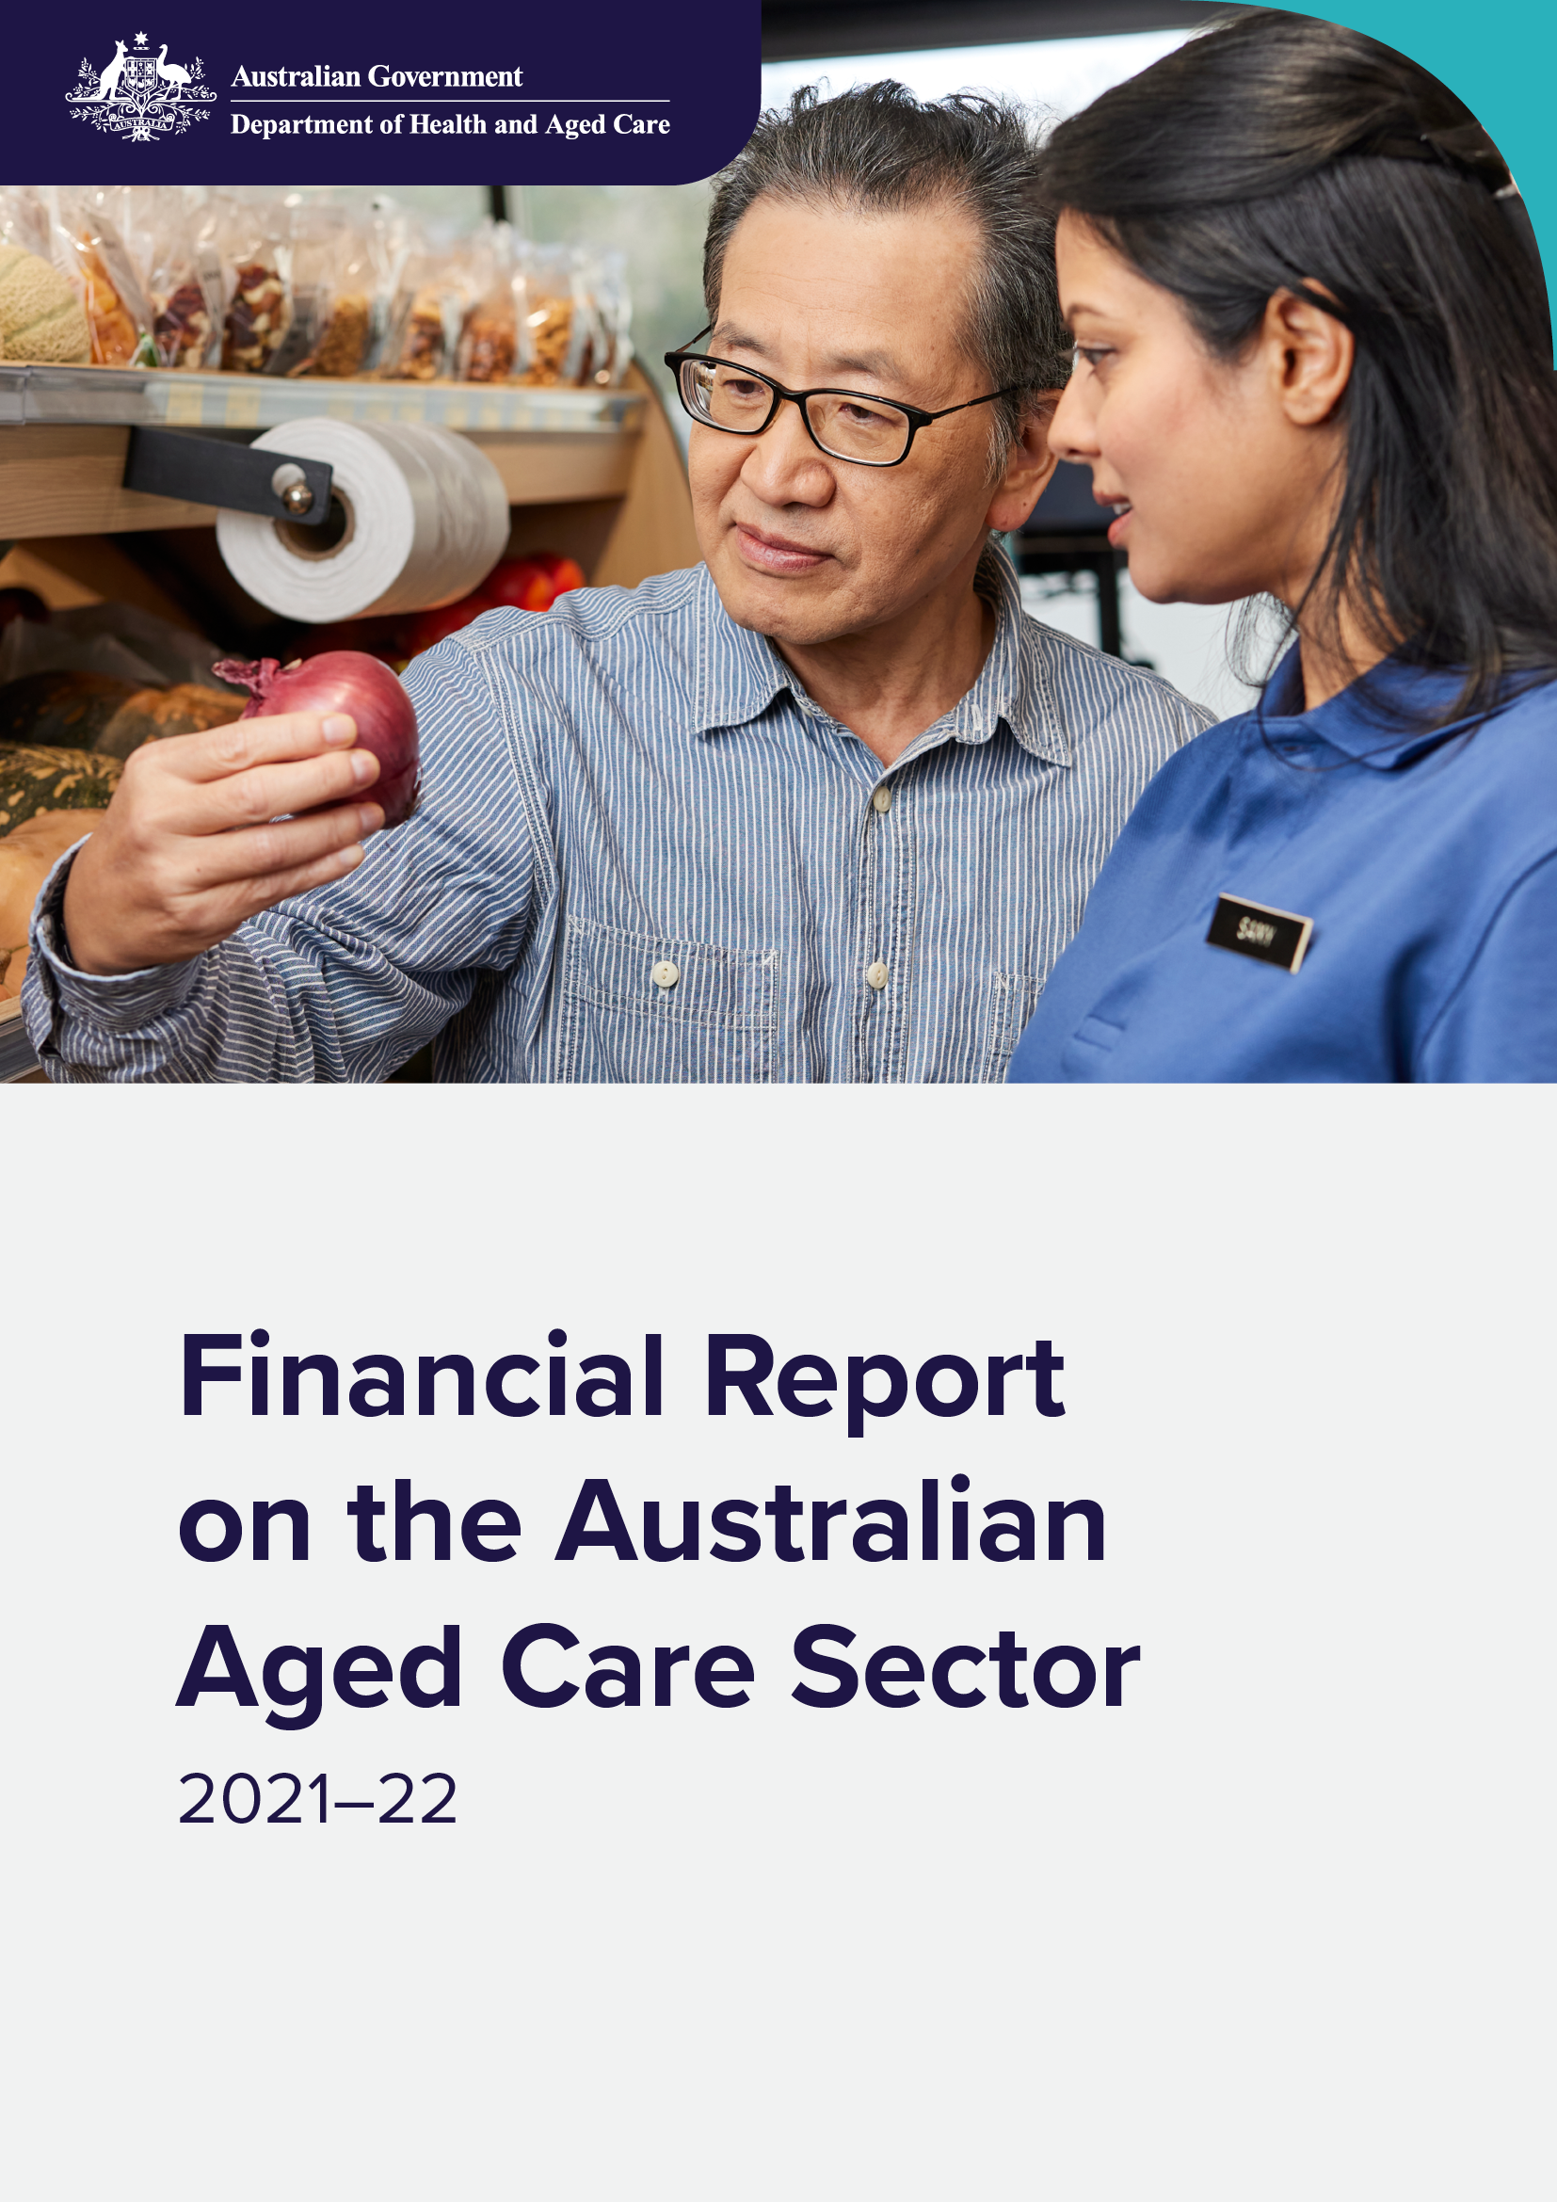

Contents
Introduction 6
Summary of findings 7
Reforming Australia’s aged care system 10
Increased funding for care 10
Fair pay for aged care workers 11
Transparency and accountability 12
Digital Transformation 13
Rural and remote and First Nations elders 13
A roadmap for reform 15
This report 16
Methodology 16
What’s new or changed 17
Report summary 20
1 Home care 24
1.1 Recipients 24
1.2 Providers 26
1.3 Funding 27
1.4 Financial summary 28
1.5 Financial performance – revenue 31
1.6 Financial performance – expenditure 32
1.7 Operating performance 33
2 Residential care: residents and providers 41
2.1 Residents 41
2.2 Providers 48
3 Residential care: financial performance 53
3.1 Operational funding 53
3.2 Financial summary 55
3.3 Financial performance – revenue 60
3.4 Financial performance – expenditure 65
3.5 Operating performance 70
4 Residential care: balance sheet 79
4.1 Balance sheet 79
5 Commonwealth Home Support Programme 100
5.1 Recipients 100
5.2 Providers 101
6 Future demand for aged care 105
Glossary 134
Charts, tables and figures index 140
Charts 140
Tables 143
Figures 144



Introduction
The Department of Health and Aged Care has prepared the 2021-22 Financial Report on the Australian Aged Care Sector to share data and analysis on the financial performance of the sector.
This report covers home care (including the Commonwealth Home Support Programme) and residential aged care.
The Financial Report on the Australian Aged Care Sector (FRAACS) is principally based on providers’ performance for the 2021–22 financial year and shows relevant comparisons from previous years.
The objective of this report is to increase transparency of the aged care sector, and help older Australians, their families and carers make informed decisions about their care.
Aged care service providers can also use the report to compare their own financial performance with sector-level results.
Using financial information submitted by providers through the Aged Care Financial Report (ACFR), the FRAACS acts as an annual authoritative record of the aged care sector’s financial performance.
FRAACS complements other transparency measures implemented by the department, including:
- Launched in February 2023, Quarterly Financial Snapshots (QFS) on the financial performance of the aged care sector, to build transparency and ensure timely reporting of key financial performance data.
- From December 2022, Star ratings for residential aged care have supported older Australians and their representatives to make more informed choices about their aged care.
- Commencing from 1 October 2022, ongoing quarterly food and nutrition reporting details trends and analysis on food and nutrition expenditure in residential care.
- Since November 2022, non-Government residential providers must publish their General Purpose Financial Report (GPFR) within 5 months of the end of the provider's financial year.
To further build on these important transparency and accountability measures, from early 2024, the department will:
- Publish more information on each residential and home care service on My Aged Care, including income and expenditure. For residential services, the department will also publish information about provider’s expenditure on: care (including labour costs); catering; maintenance; cleaning and laundry; and administration.
- Publish more information on approved providers’ operations via My Aged Care including:
- diversity information, which incorporates whether a provider’s governing body includes representatives from any diversity demographic (e.g. First Nations communities) and initiatives to support a diverse and inclusive environment for care recipients/residents and staff at each service,
- the most common kinds of feedback and complaints and
- key improvements made to service quality.

Summary of findings
Consistent with the 2020-21 FRAACS, this report highlights the financial stress experienced by providers in the residential aged care sector during the 2021-22 financial year.
The residential care sector operated at a loss of $2.264 billion in total. This equates to an average net loss per resident per day of $32.97. Most of this result was attributed to a loss of $14.86 per resident per day for the accommodation funding stream, which included a loss of $813 million in bed license amortisation, and a loss of $6.37 for COVID-19 related expenses.
The $813 million bed license amortisation loss is a result of the removal of the Aged Care Approvals Round (ACAR) and the need for providers to readjust the treatment of bed licences as intangible assets. The impact of bed license amortisation will not be ongoing post 1 July 2024, when residential aged care places will be allocated directly to older people, rather than providers. For more information on ACAR, please visit the departments website:
Places to people – Embedding choice in residential aged care | Australian Government Department of Health and Aged Care
Occupancy rates can have a significant impact on provider profitability if they fall below levels that are insufficient to cover fixed costs. This can impact the viability and overall financial performance of providers. In 2021-22, occupancy within residential aged care continued to decline, falling to an average of 86.2 per cent. The occupancy rates across 2021-22 continued to be impacted by COVID-19 as preferences for older Australians entering residential aged care changed during this time.
For providers delivering residential aged care services, profitability challenges were demonstrated by negative average earnings before interest, tax, depreciation and amortisation (EBITDA) per resident per year. In 2021-22, the average EBITDA declined for a fifth consecutive year to negative $46 per resident per year, a further decline from $3,771 per resident per year in 2020-21.
While this decrease followed a trend in recent years, the decrease was greater in 2021-22 than all previous years. This decrease can be likely attributed to a large increase in COVID-19 expenses and increasing labour costs across all expense categories.
Residential aged care providers received $306 million in 2021-22 in COVID-19 grants and subsidies. There were a number of COVID-19 grants that residential aged care providers could apply for in 2021-22, including the COVID-19 Viability Fund, COVID-19 Aged Care Workforce Bonus Payments and the COVID-19 Aged Care Preparedness Packages.
In the 2021-22 ACFR, providers self-reported $742 million in COVID-19 grant reimbursements that had been claimed but not yet approved or paid. This amount is not recognised as income for 2021-22 in this report, and it is a self-reported provider figure that is based on the available COVID-19 grants in 2021-22. The department continues to work through these claims and assess them in 2022-23. The correlating approved COVID-19 grant funding may vary from the providers’ self-reported figure.
The department continues to process grant applications across all the different COVID-19 grants and subsidies; including, but not limited to, Aged Care Worker COVID-19 leave payment grants which opens in the early part of the 2023-24 financial year and the COVID-19 Aged Care Support Program Extension grant which closed on 31 March 2023.
Care is primarily funded by the Australian Government. In 2021-22, the funding model used for residential care was the Aged Care Funding Instrument (ACFI). From 1 October 2022, the Australian National Aged Care Classification (AN-ACC) funding was introduced. The introduction of AN-ACC, together with independent pricing, will likely see positive improvement for the sector in coming years.
When comparing care income with care expenses, there was a positive result of $19.36 per resident per day. On the other hand, the accommodation category continues to result in a significant loss at the sector level, with providers reporting a result of negative $14.86 per resident per day in 2021-22. This represents the largest decrease of all categories of income and expenditure in 2021-22, falling by $14.22 per resident per day from 2020-21. This continues to demonstrate the need to focus on accommodation funding reform to improve the financial performance of aged care providers.
The home care sector remains profitable, however there was a decrease in profitability for the 2021-22 financial year. In 2021-22, EBITDA per home care recipient per year was $1,232, down from $1,792 in 2020-21. Net profit before tax (NPBT) also decreased from $1,566 per care recipient per year in 2020-21 to $1,013 in 2021-22. NPBT per care recipient per day also decreased in 2021-22 to $2.78, down from $4.29 in 2020-21.
The decrease in EBITDA and NPBT for home care providers reported in the 2021-22 FRAACS represents a return to similar profit levels to 2018-19 and 2019-20.
The trend of increased demand for home care packages continued in 2021-22. The department is continuing to develop reforms that support older Australians to remain in their own homes for longer. A new Support at Home Program will commence from 1 July 2025 and will reform the delivery of in-home care. This includes assessment, provider funding and regulation of the market. Support at Home will put a greater focus on reablement and restorative care.

Reforming Australia’s aged care system
The financial performance of the residential aged care sector has been declining since 2016-17 and has likely reached its lowest point in the 2021-22 financial year. In 2021-22, the residential care sector experienced a collective loss of $2.264 billion (a decrease of $1.41 billion on 2020-21), losing on average $32.97 per resident per day (a decrease of $20.59 per resident per day on 2020-21). In future FRAACS reports we expect to see improvements in sector financial performance as a result of key aged care reforms which have come into effect following the 2021-22 financial year, including:
- the implementation of the AN-ACC funding model, which commenced on 1 October 2022
- an additional 9,500 home care places in 2023-24
- the expanded role of the Independent Health and Aged Care Pricing Authority (IHACPA), which will provide advice to Government to ensure care funding moves in line with the costs of delivering care. IHACPA’s first recommendation to Government was delivered in May 2023 and AN-ACC funding increased by 17 per cent
- funding for higher wages for aged care workers
- additional Australian Government investment into care and nursing, which will restore confidence in the quality of residential aged care.
The residential aged care sector has already seen improvements since the commencement of the AN-ACC funding model on 1 October 2022 as shown through the second QFS for 2022-23. The department will continue to monitor the financial performance of the sector through the Quarterly Financial Report and publish this financial performance in the QFS.
In addition, the Australian Government is continuing to reform the Australian aged care system through critical initiatives aimed at driving structural change, improving financial sustainability, and increased transparency. A new Aged Care Taskforce was established in June 2023 to provide advice to the Government on funding arrangements for aged care to ensure the aged care system is fair and equitable for all Australians. Improving the system to ensure long-term sustainability for the future of aged care remains a priority for the Australian Government. These key reforms, including a number of 2022-23 October Budget and 2023-24 Budget measures, are detailed below.

Increased funding for care
The Australian Government funds and regulates residential aged care to ensure aged care providers can deliver well-staffed and consistent high-quality and safe care. Funding for residential aged care is delivered through the AN-ACC funding model.
As part of the 2023-24 Budget, the Government announced an investment of
$11.1 billion for residential aged care over the next four years from 1 July 2023 and this builds on around $15.7 billion of previous Budget announcements from 2021-22 over the forward estimates to 2026-27. Since 2020-21, the average funding per resident per day has increased from $186 under the ACFI to an estimated $260 in 2023-24 under AN-ACC, representing an increase of $74 or approximately 40% in average funding per resident per day in 3 years.
This additional funding of $11.1 billion includes:
- $10.1 billion to implement the new AN-ACC price of $243.10 as recommended by the IHACPA to fund the 15 per cent Fair Work Commission (FWC) wage increase, as well as other increases in care costs since AN-ACC was introduced on 1 October last year;
- an additional $116 million to establish a new $10.80 hotelling supplement per resident per day;
- an additional $6 million to establish a new one-off grant opportunity under the existing AN-ACC Transition Fund to support residential aged care services with specific characteristics, such as those in isolated communities and in remote and very remote locations to cover higher care costs related to their location for the 2023-24 financial year only;
- an additional $743 million to cover the costs of delivering 215 care minutes, over three years from 2024-25 following the 15 per cent FWC wage increase; and
- an additional $178 million to align the 24/7 registered nurse supplement with the 15 per cent increase in award wages.
The increase to the AN-ACC price from $206.80 (excluding the former $10 Basic Daily Fee Supplement) to $243.10 represents 17.6 per cent increase. The former $10 Basic Daily Fee Supplement will be rolled into a new $10.80 hotelling supplement, which will commence from 1 July 2023 and be paid in addition to the AN-ACC price.
The AN-ACC price will be set annually, based on advice from the IHACPA, to ensure care funding moves in line with the actual costs of delivering care. IHACPA has released the Residential Aged Care Pricing Advice 2023-24 and Technical Specifications, which details IHACPA’s pricing methodology used to develop the 2023-24 pricing advice to the Government.

Fair pay for aged care workers
The Australian Government is investing $11.3 billion to deliver on its commitment to fund the outcome of the FWC Aged Care Work Value Case. On
21 February 2023, the FWC made a decision in the Aged Care Work Value Case for an increase to award wages for many aged care workers of 15 per cent, which took effect from 30 June 2023. The wage increase is expected to benefit around 250,000 registered nurses, enrolled nurses, assistants in nursing, personal care workers, head chefs and cooks, recreational activities officers (lifestyle workers) and home care workers.
In order to deliver this pay rise, residential care funding will increase by $8.5 billion over the next 4 years, the Home Care Package Program subsidy will increase by $2.2 billion, and the Commonwealth Home Support Programme (CHSP) grant will increase by $310 million. The Government is also funding historic leave liabilities in 2023-24 worth $98.7 million.
The Aged Care Work Value case continues with the FWC considering further increases for direct care workers in the sector and whether wage increases should also be applied to ancillary staff, including administration and support workers. The Government has also committed to fund the FWC’s decision in relation to this case following the outcome of deliberations.
The department will monitor how much providers spend on wages through both the Quarterly Financial Report and QFS.

Transparency and accountability
The Australian Government is delivering stronger regulation, reporting and improved data so that older people living in Australia, their families and carers will have the right information to choose their provider.
The Government has invested $72.3 million in 2023–24 to develop a new regulatory framework and prudential model which will enable a more risk-based and proportionate approach to regulation.
This includes an additional $12.9 million to enhance the Aged Care Quality and Safety Commission’s (ACQSC) role as the prudential regulator of aged care. This will deliver a more stable and viable sector, and in doing so support the continuity and quality of aged care services for older Australians.
Regulation will also be strengthened with up to 720 spot checks by the ACQSC on food in residential aged care per year and up to 500 independent Menu and Meal Time Quality Assessments by dietitians per year to build sector capability ($12.9 million over 2 years).
Transparency will also be improved through a number of initiatives ($139.9 million over 4 years) including:
- enhancing Star Ratings with an expanded scope, including more information to inform choice for older people
- enhancing independent resident experience surveys with around 20 percent of residents annually
- introducing new staffing quality indicators in residential aged care, and work to expand quality indicators into home care, and
- implementing a new requirement for providers to give residents a monthly care statement outlining the care and services they have received.

Digital Transformation
Delivering on reforms will require a strong and modernised aged care sector. The Government committed $312.6 million in the October 2022-23 Budget to invest in aged care information, communication and technology (ICT) systems to strengthen the transparency, integrity, and accountability of aged care providers by facilitating the efficient transmission of information and data in near real-time.
This investment will allow aged care providers to report their compliance obligations more easily and quickly through Business to Government connectivity, and to view and manage their own business, service and regulatory compliance information using a modernised ICT platform – the Government Provider Management System – thereby reducing their administrative burden and allowing aged care staff to dedicate more time to meaningful care.
It also means older Australians, their families and carers will have access to more accurate and timely information, will be able to see transparently the cost of services, and will have a simple platform for making payments when receiving care in their home.
An Aged Care Digital Strategy and Aged Care Data Strategy are also being developed and will be completed by the end of 2023. These strategies will provide the aged care sector with a clear and purposeful vision of how digital technology and processes will shape the aged care system from now until 2030, and how the use of data in aged care can support the provision of high-quality care that maximises the health and wellbeing of older people in Australia.
The needs of older people will underpin these strategies, ensuring that they are well-supported and provided with consistent, and equitable access to information and services they need, when they need them. A supporting implementation plan will set out practical initiatives and activities required to realise the longer-term vision for the use of data and digital processes in aged care.

Rural and remote and First Nations elders
Improving the lives of older Australians living in rural and remote areas and First Nations elders receiving care remains a priority for the Australian Government.
The Australian Government recognises the challenges of rural and remote aged care such as higher operating costs, fluctuations in demand for services, smaller populations and service size which impact on financial viability and sustainability of services.
There are workforce shortages across the aged care sector; these are exacerbated in rural and remote areas with difficulties attracting and retaining suitably qualified workforce. The AN-ACC funding model recognises and reflects the variation in costs of providing care based on the characteristics of a facility, including location.
From 1 July 2023 non-specialised remote and very remote facilities (MMM 6-7) are forecast to receive on average approximately $328 per bed day, which is $68 more than the sector average AN-ACC funding of $260.
The Australian Government also recognises that First Nations elders are not well serviced by the existing aged care system. First Nations elders are not accessing aged care services in the numbers or at the levels commensurate with need. This includes in urban settings where most First Nations people live, and in remote areas where it can be difficult to get the range of services needed.
The intergenerational impacts of colonisation continue to cause trauma, and prolonged experiences of personal and institutional discrimination have led to a mistrust of government and some aged care providers. Access and assessment processes are not always culturally safe, and there is a lack of trauma aware and healing informed service provision. Some First Nations elders don’t have access to an Aboriginal Community Controlled Health Service and mainstream alternatives do not adequately meet their needs.
The department is implementing a number of First Nations specific measures and working across the Ageing and Aged Care Group on mainstream reforms to help address the barriers to aged care for First Nations people. First Nations elders will benefit from an investment of $77.3 million over 4 years to improve access to high quality care for First Nations elders and ensure services are accessible on Country.
This funding includes an additional $52.1 million over the next 2 years to deliver residential care in very remote areas, to improve viability and ensure First Nations elders continue to receive care on Country. It is funded under the National Aboriginal and Torres Strait Islander Flexible Aged Care (NATSIFAC) Program.
A further $8.1 million over 3 years will support all 43 NATSIFAC services to transition from being administered under a grant agreement to being regulated under the new Aged Care Act.
Additionally, $8.2 million in funding will build the capacity of Aboriginal Community-Controlled Organisations, to deliver aged care services to First Nations elders, $5.3 million will improve First Nations elders access to culturally safe, trauma-aware and healing informed aged care services and $1.7 million will support the establishment of an interim First Nations Aged Care Commissioner.
In addition to the $77.3 million over 4 years, rural, remote and First Nations communities around Australia will benefit from an investment of $27 million over 4 years to strengthen access to care and support in regions where market conditions do not support an adequate range of aged care, disability support and veterans’ care services. Funding will support 10 place-based integrated care and commissioning trials that will work with local stakeholders to help build a more joined-up, collaborative care and support sector that facilitates a wider range of services and workforce.

A roadmap for reform
Within a decade, there will be more people aged over 65 years than under 18 living in Australia for the first time in history. The workforce is also ageing. The total proportion of people working in Australia of traditional working age, 15 to 64 years, is predicted to decline.
Australia will need a fair and equitable aged care system to be sustainable for the long-term and meet the needs of an ageing population. To achieve this, an evaluation of system funding is essential, to build upon the Royal Commission’s recommendations.
In this context, a new Aged Care Taskforce has been established to review aged care funding arrangements and develop options to make the system fair and equitable for all Australians. The Taskforce provides an opportunity for targeted and thorough consideration of system funding arrangements to ensure that they are equitable, embed innovation, and include a future focus that adjusts to the changing pattern of demographics, needs and circumstances of older Australians.
The work of the Aged Care Taskforce will also seek to align its recommendations with the Government’s National Strategy for the Care and Support Economy.
The Taskforce will also inform the final design of the Support at Home Program which will commence on 1 July 2025, to allow time to further refine the design.
For more information on the 2023-24 Budget please visit: https://www.health.gov.au/resources/publications/delivering-the-largest-ever-pay-rise-to-aged-care-workers-budget-2023-24?language=en

This report

Methodology
The 2021-22 FRAACS presents and analyses 2021–22 financial year data provided by aged care providers and data held by the department. Data collection for the ACFR opens in August and providers are required to submit information by the end of October. The department then undertakes a data cleansing and analysis process to ensure the information is accurate.
The principal data sources are financial and administrative data collected by the department:
- From home care providers:
  - ACFRs
- From residential care providers:
  - ACFRs
  - GPFR
  - Annual Survey of Aged Care Homes (SACH) and
  - Published aged care accommodation prices (My Aged Care website)
- From CHSP providers:
  - CHSP Data Exchange
- Other general data:
  - the 2021–22 Report on the Operation of the Aged Care Act 1997 (ROACA), and previous editions
  - quarterly home care data reports
  - the 2020 National Aged Care Workforce Census and Survey
National Aboriginal and Torres Strait Islander Flexible Aged Care program providers do not currently report financial data via ACFRs or GPFRs, therefore financial data for this program is not included in the 2021-22 FRAACS.
Multi-purpose services or providers under the Short-term Restorative Care Programme are only required to complete the Annual Prudential Compliance Statement (APCS) component of the ACFR. Short-term Restorative Care providers also must complete an income and expense statement. However, analysis of this data is not included in this report.
When discussing the financial performance of providers in this report, EBITDA is the main measure used to analyse profitability. This is because EBITDA excludes items such as interest (both income and expense) and tax expenditures, which can vary depending on the financing decisions of an organisation; and non-cash expenses, such as depreciation and amortisation which can vary greatly based on the size and age of facilities and other assets, and on ownership type and depreciation methods.
EBITDA can be used to compare organisations with each other and against industry averages and is a useful measure of core profit trends because it eliminates some of the extraneous factors mentioned above. This is particularly important when analysing aged care given the diversity of ownership and capital structures. EBITDA helps to smooth out these factors.
This report also refers to NPBT which assists in making comparisons between organisations that are subject to different tax treatments.
Financial information on home care and residential care included in this report is collected through the ACFR. The Accountability Principles 2014, made under Section 96–1 of the Aged Care Act 1997, require approved providers to submit a financial report in a form approved by the Secretary of the department. For providers of residential care, the ACFR must be accompanied by an audited GPFR and accompanying audit opinion. The ACFR submitted by home care providers is not required to be audited and should not be considered a GPFR.
It is important to be mindful of the sector composition and the varying objectives of providers when interpreting the data. The aged care sector continues to be dominated by not-for-profit providers. Traditional profit-based measures are not always consistent with the mission and objectives of not-for-profit providers.

What’s new or changed
This is the second annual FRAACS. The 2021-22 FRAACS has undergone some changes since the inaugural report to enhance the reader’s experience. The 2021-22 FRAACS provides continuity of data while removing out of context or outdated data, to ensure there is consistency and transparency on the reporting of funding and financing of the aged care sector.
Key changes include:
- A new streamlined structure aimed at reducing duplication and improving readability.
- Each chapter has been structured to present recipients first, followed by provider information, and finally financial information.
- The consolidated sector overview is now available at the beginning of the report.
The department will continue to refine the FRAACS and welcomes feedback from stakeholders to better understand what data is most valuable and how to best present this information. This will inform the development of future reports for the sector. Each report has built on the last, producing a substantial body of in-time and trend data on the funding and financing of the aged care sector.
The 2020-21 FRAACS can be accessed at: https://www.health.gov.au/resources/publications/financial-report-on-the-australian-aged-care-sector-2020-21
Prior to 2020-21, the Aged Care Financing Authority (ACFA) provided the Minister responsible for aged care with an annual report on the funding and financing of the aged care sector. Although ACFA ceased to operate from 30 June 2021, all previous ACFA reports provided to the Minister can be accessed at:
https://www.health.gov.au/committees-and-groups/aged-care-financing-authority-acfa#annual-reports-on-funding-and-financing-of-the-aged-care-industry

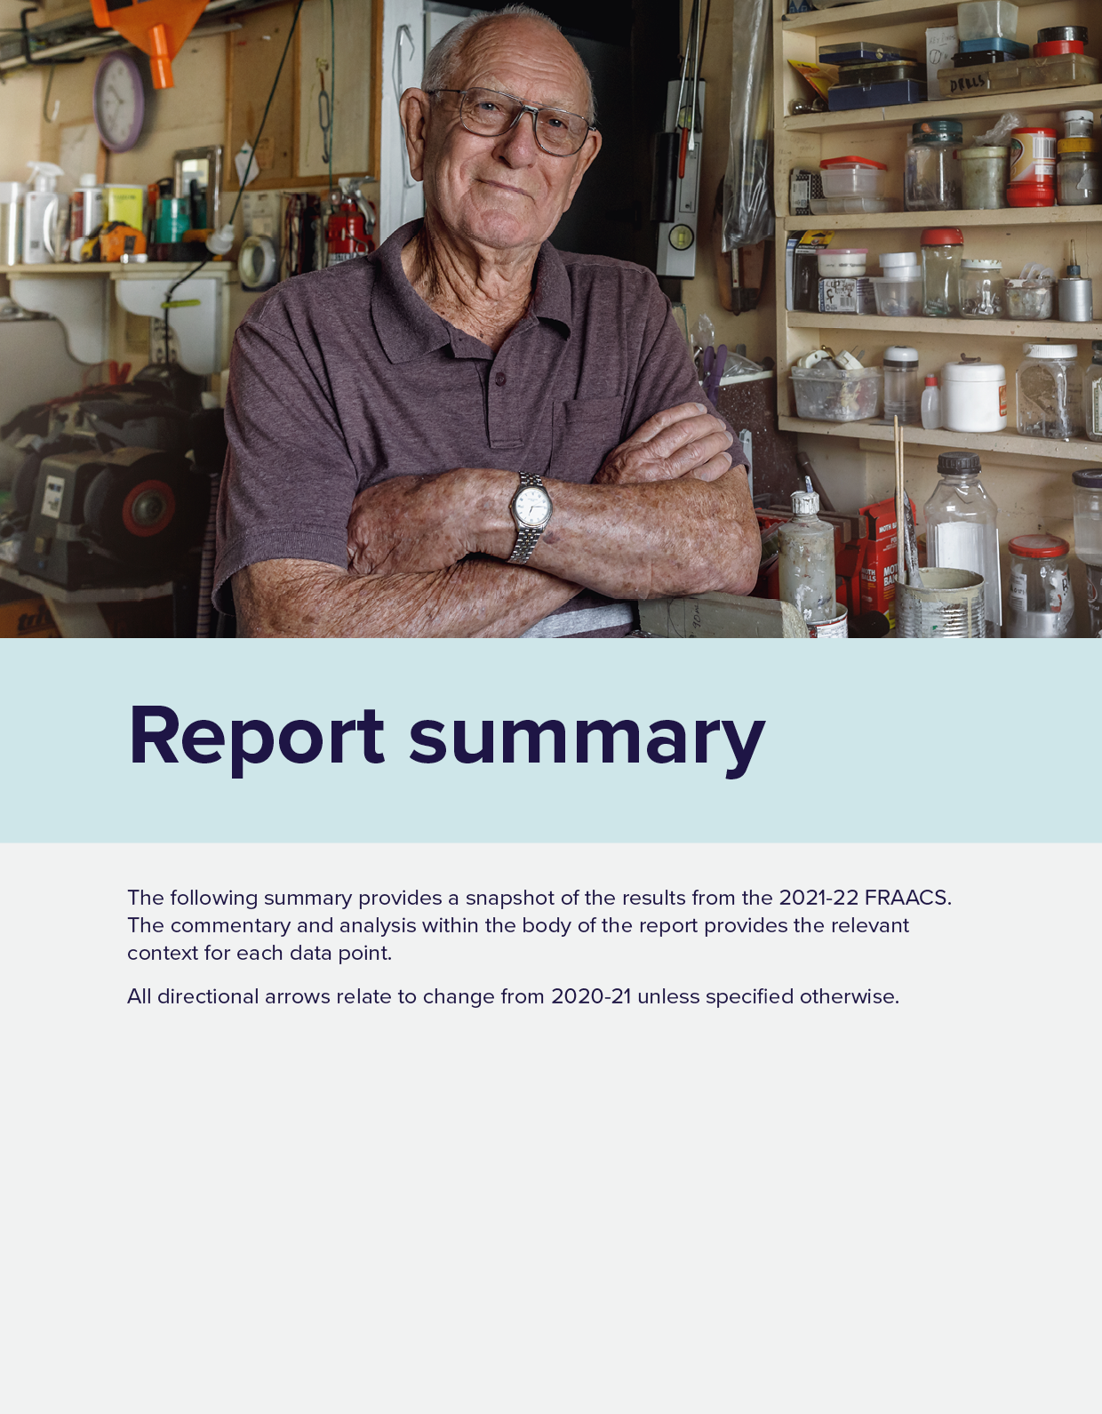

Report summary
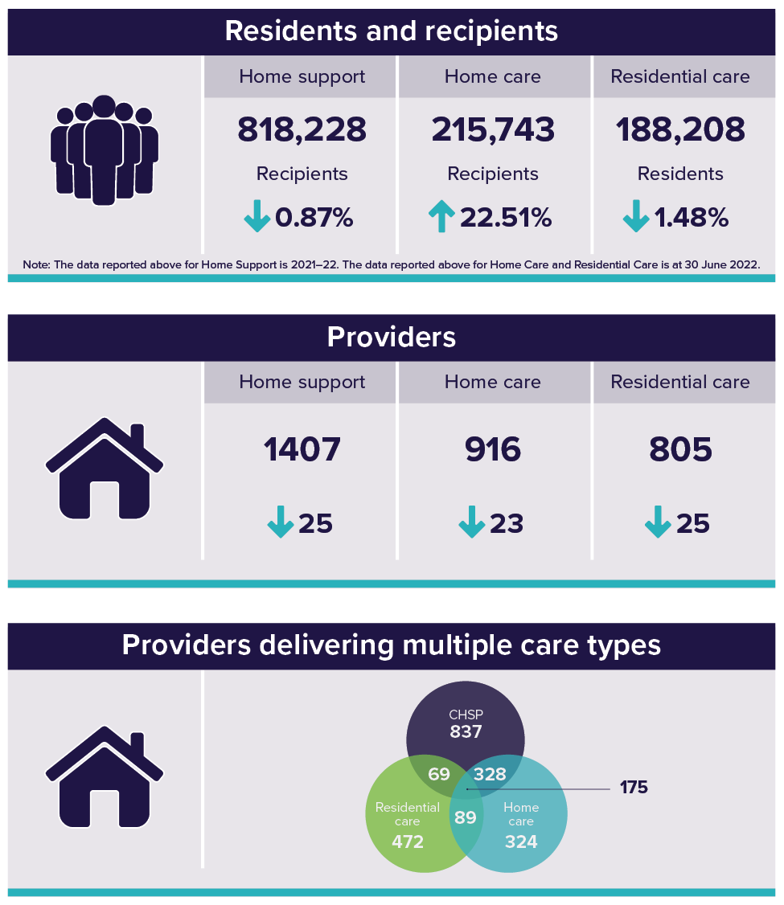
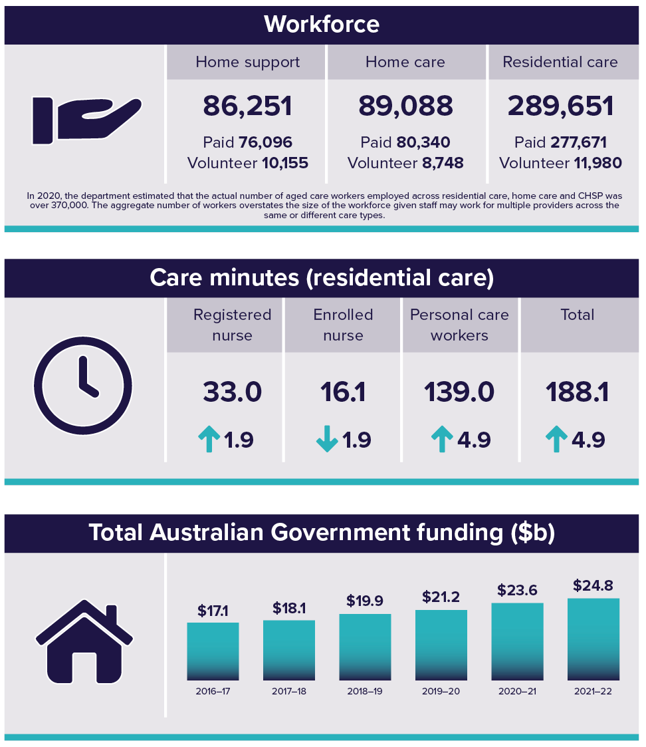
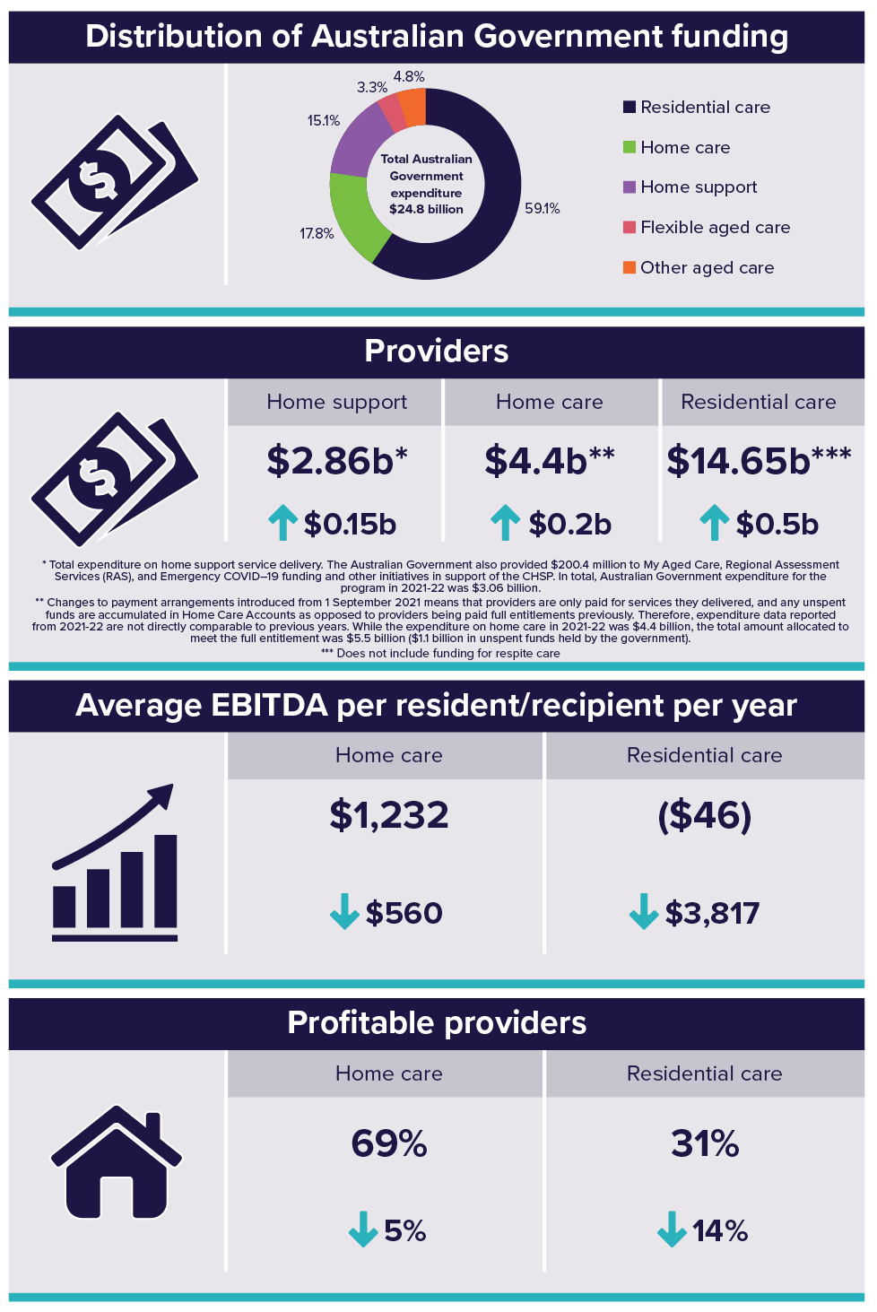

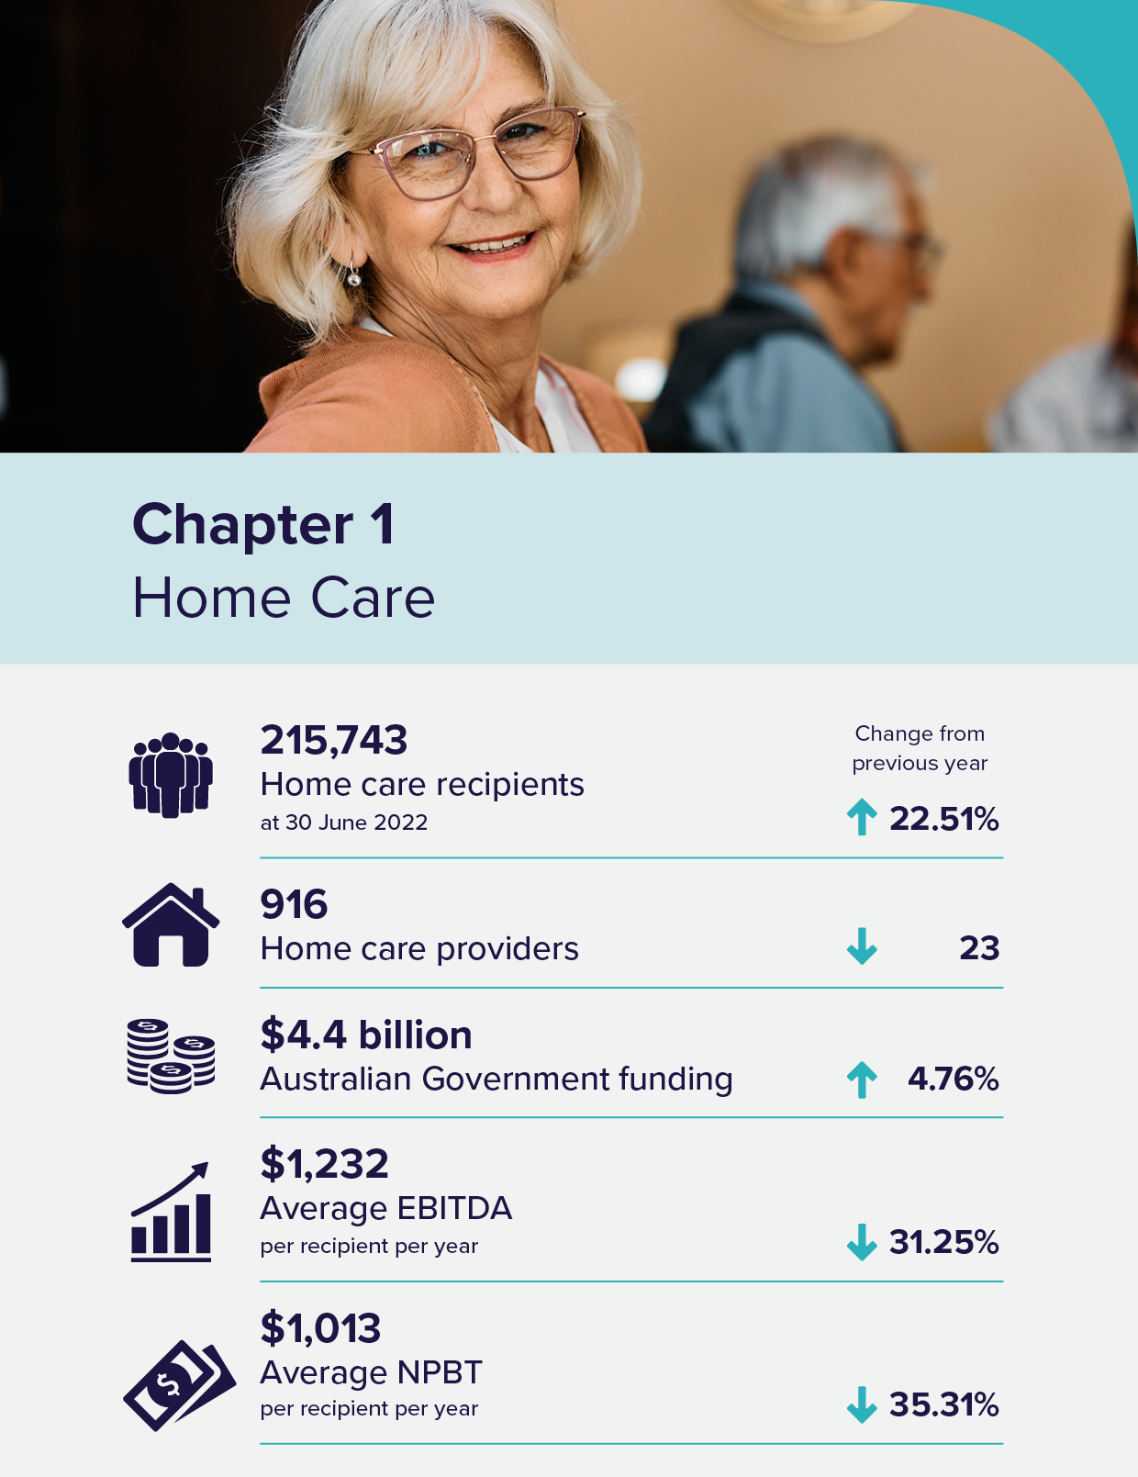

Home care
The Home Care Packages Program
Home care packages allow recipients to access a range of services and equipment which assists them to live independently in the community. Home care packages are delivered on a consumer directed care basis.
To obtain access to a home care package, individuals are first assessed by an independent Aged Care Assessment Team (ACAT) which determines eligibility for a package and the level of the package. Many people assessed as eligible to receive a package are also assessed as eligible for residential care. Once assessed as eligible for home care, an individual can elect to opt into the National Priority System (NPS). They are then offered a home care package when one becomes available. A person’s place in the NPS is based on their date of approval and priority as assessed by an ACAT.
The number of available home care packages continues to increase as older Australians increasingly prefer to remain in their home for longer. A new Support at Home Program will commence 1 July 2025 and the existing Home Care Packages (HCP) Program will continue until then.

Recipients
Table 1.1 shows the increase in overall home care recipient numbers for the past 5 years. As at 30 June 2022, there were 215,743 recipients in a package, up from 176,105 at 30 June 2021. This number has more than doubled since 30 June 2019.
Level 2 had the highest proportion of packages allocated (41 per cent), followed by level 3 (31 per cent), level 4 (22 per cent) and level 1 (5 per cent).
Table 1.1: Home Care Recipients in a package at 30 June 2018 to June 2022
 | 30-Jun-18 | 30-Jun-19 | 30-Jun-20 | 30-Jun-21 | 30-Jun-22
Total Recipients | 91,847 | 106,707 | 142,436 | 176,105 | 215,743
CALD Recipients | 22,525 | 27,427 | 38,740 | 50,767 | 64,192
First Nations elders | 2,86 | 3,280 | 3,417 | 3,734 | 5,773
By Level
Level 1 | 4,841 | 8,516 | 16,418 | 17,405 | 11,677
Level 2 | 51,496 | 47,734 | 58,842 | 71,020 | 88,993
Level 3 | 12,693 | 20,193 | 29,336 | 45,603 | 67,053
Level 4 | 22,817 | 30,264 | 37,840 | 42,077 | 48,020
By Remoteness
Major cities | 61,676 | 72,903 | 98,766 | 123,022 | 152,729
Inner regional | 23,037 | 26,147 | 32,257 | 36,632 | 41,990
Outer regional | 6,054 | 6,560 | 10,194 | 15,087 | 19,151
Remote | 616 | 671 | 823 | 960 | 1,149
Very remote | 464 | 426 | 394 | 404 | 724
By Provider type
For-profit | 15,545 | 22,317 | 37,043 | 52,942 | 71,563
Not-for profit | 69,944 | 77,156 | 96,185 | 112,422 | 131,980
LST government | 6,358 | 7,234 | 9,208 | 10,741 | 12,200

Length of stay in home care
Chart 1.1 shows the median time spent in the home care program at exit was around 18 months in 2021-22. The average length of stay was approximately 27 months.
Chart 1.1: Median and average length of stay in home care, by year of exit, 2014-15 to 2021-22
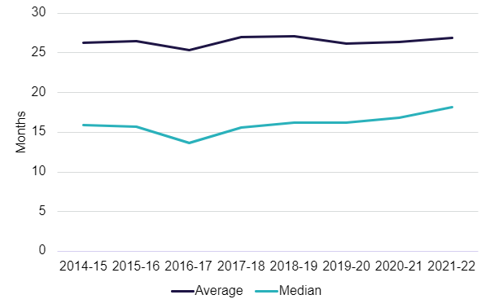
As shown in Chart 1.2, since 2017-18, fewer recipients from each annual entry cohort are leaving home care in their first year. There was a decrease of 4 percentage points from 26 per cent of recipients leaving in their first year of home care in 2017-18 to 22 per cent in 2021-22.
Chart 1.2: Cumulative proportion of home care recipients leaving home care during their first year by year of entry, 2017-18 to 2021-22
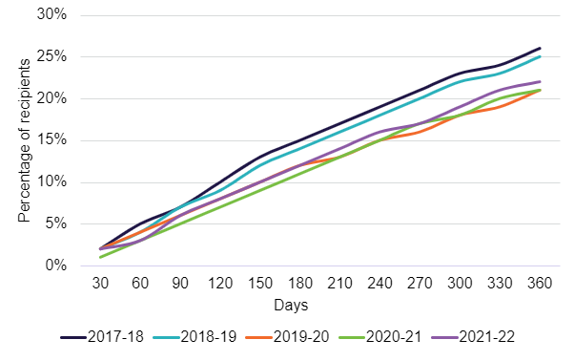

Providers
Table 1.2 presents a breakdown of home care providers by ownership type and location at 30 June 2022. Not-for-profit providers represented 52 per cent of the sector, while for-profit providers made up 36 per cent.
The location indicates where a provider, service or resident/recipient is located based on whether they are metropolitan or regional areas. Metropolitan is all major cities and regional is any area outside of a major city. A provider is classified as metropolitan if more than 70 per cent of its services are located in metropolitan areas and similarly classified as regional if more than 70 per cent of its services are located in regional areas.

Table 1.2: Number of home care providers and number of recipients, at 30 June 2022
 |  |  | Ownership type |  |  | Location
 | 30-June-2021 | 30-June-2022 | For-profit | Not-for-profit | LST government |  | Metropolitan | Regional | Metropolitan & regional
Number of providers | 939 | 916 | 334 | 473 | 109 |  | 521 | 313 | 82
 |  |  | 36% | 52% | 12% |  | 57% | 34% | 10%
Number of recipients | 176,105 | 215,743 | 71,563 | 131,980 | 12,200 |  | 152,729 | 63,014 | n/a
 |  |  | 33% | 61% | 6% |  | 71% | 29% | n/a

Funding
In 2021-22, total Australian Government expenditure on home care subsidies and supplements was $4.4 billion, up from $4.2 billion in 2020-21 as shown in Chart 1.3
Chart 1.3: Australian Government expenditure on home care, 2017-18 to 2021-22
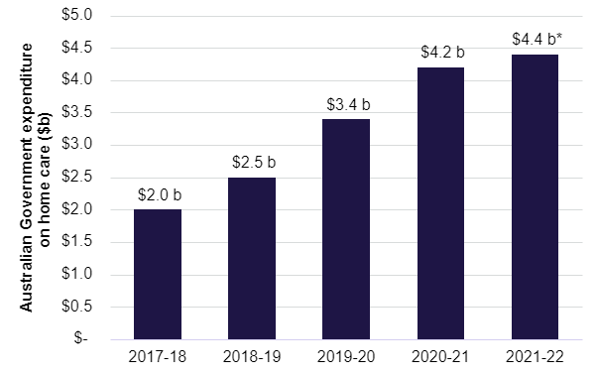
Note: *Changes to payment arrangements introduced from 1 September 2021 means that providers are only paid for services they delivered, and any unspent funds are accumulated in Home Care Accounts as opposed to providers being paid full entitlements previously. Therefore, expenditure data reported from 2021-22 are not directly comparable to previous years. While expenditure on home care in 2021-22 was $4.4 billion, the total amount allocated to meet the full entitlement was $5.5 billion ($1.1 billion in unspent funds held by the government).

Unspent funds and home care account balance
Unspent funds are the total amount of a recipient’s package funds which have accrued but not yet been spent on goods or services. The source of these funds can be Australian Government subsidies or fees collected from the recipient.
Unspent funds are held by either:
- the provider – these funds are split into the Australian Government (subsidy) and care recipient (fees) portions
- the Government – in a home care account for the person
The 2019-20 Budget measure, Improved Payment Arrangements for HCP Program was implemented in stages. From 1 September 2021, changes to the treatment of unspent funds mean that unspent funds no longer accrue with providers but instead accrue in a care recipient’s Home Care Account managed by Services Australia. While many providers still hold unspent funds on behalf of care recipients from before 1 September 2021, these funds will be used to meet care recipient needs and will either reduce over time or be returned to the Australian Government on exit.
Unspent funds and Home Care Account Balances accumulate for a variety of reasons, including:
- recipients wish to save a proportion of their budget for future events
- the services that the recipient wants are not available
- the recipient is reluctant to allow people into their home
- misconceptions that the money not spent under the package belongs to the recipient or
- the recipient does not require all the funds allocated to them.
The total amount of unspent funds at 30 June 2022 was $2.3 billion, an increase on the 30 June 2021 amount of $1.7 billion. The total unspent funds are the sum of the Home Care Account Balance held by Services Australia on behalf of the recipient ($1.23 billion) and the unspent funds held by providers (accumulated prior to 1 September 2021) on behalf of the recipient ($1.07 billion).
Over time, it can be expected that the unspent funds balance will diminish, and the Home Care Account Balance will fluctuate according to market demand and supply.

Financial summary
Table 1.3 provides an overview of the 2021-22 financial performance of home care providers, including a breakdown by ownership type, location and scale.
Table 1.3: Summary of financial performance of home care providers, 2021-22
 | All providers | For profit | Not for profit | LST government | Metropolitan | Regional | Metropolitan and Regional | Single Service | 2 to 6 Services | 7 and More Services
Total revenue($m) | $4,689.80 | $1,521.00 | $2,910.90 | $258.00 | $3,091.60 | $781.60 | $816.70 | $1,591.20 | $1,037.60 | $2,061.00
Total expenses($m) | $4,492.40 | $1,446.80 | $2,795.90 | $249.70 | $2,946.60 | $773.10 | $772.70 | $1,492.00 | $1,003.40 | $1,997.00
Profit($m) | $197.42 | $74.13 | $114.94 | $8.36 | $144.91 | $8.53 | $43.97 | $99.18 | $34.19 | $64.05
EBITDA($m) | $240.13 | $92.77 | $138.10 | $9.26 | $169.23 | $18.84 | $52.06 | $109.00 | $41.70 | $89.43
Average EBITDA | $1,232.00 | $1,485.00 | $1,142.00 | $809.00 | $1,364.00 | $511.00 | $1,533.00 | $1,727.00 | $956.00 | $1,015.00
Average NPBT | $1,013.00 | $1,187.00 | $950.00 | $730.00 | $1,168.00 | $232.00 | $1,295.00 | $1,572.00 | $784.00 | $727.00
EBITDA margin | 5.1% | 6.1% | 4.7% | 3.6% | 5.5% | 2.4% | 6.4% | 6.8% | 4.0% | 4.3%
NPBT margin | 4.2% | 4.9% | 3.9% | 3.2% | 4.7% | 1.1% | 5.4% | 6.2% | 3.3% | 3.1%
Table 1.4 shows the summary of home care providers’ income and expense statement per care recipient per day for the last 5 years.
Provider income per recipient is split by the major types of income. In 2021-22, care management and package management service fees were 28 per cent of provider income, an increase from 27 per cent in 2020-21. Provision of care/direct care represented almost 44 per cent of provider income, a decrease from 49 per cent in 2020–21.
The average provider expenditure per recipient per day in 2021-22 was $63.16 ($23,053 per year), down from $64.49 in 2020-21. Total direct service expenses represent 64 per cent of total expenses per recipient per day, while administration and support costs represent 21 per cent of total costs, and care management costs represented 11 per cent of total costs. Total direct service costs in 2021-22 were $40.17, down from $44.78 in 2020-21, while administration and support costs were $13.50, up from $9.37 in 2020-21.
The Home Care sector generated a profit result of $2.78 per care recipient per day in 2021-22, down from $4.29 in 2020-21. This was the first decrease in profitability shown in the prior 5 years reporting as illustrated in Table 1.4 which shows a consistent upward trend in profitability per care recipient per day since 2017-18 to 2020-21, then a dip in profitability in 2021-22.
While profits gradually increased from 2017-18 to 2020-21, there was a decline in revenue and expenses per resident per day during this period. In 2021-22, profit was impacted because the decline in expenses ($1.33) was not proportionate to the decline in revenue ($2.84). In other years, expenses declined at a greater rate than revenue which allowed providers to increase profitability. In 2021-22, expenses declined in all categories, except for administration and support which increased by $4.13.
Utilisation of available funds may have also impacted revenue in 2021-22 as the sector adjusted to the introduction of the Improved Payments Arrangement (IPA) in September 2021, as providers no longer hold unspent funds on behalf of recipients.
Table 1.4: Summary of income and expense statement per care recipient per day, 2017-18 to 2021-22
 | 2017-18 | 2018-19 | 2019-20 | 2020-21 | 2021-22
Income
Provision of care / direct care services | $47.94 | $49.57 | $35.38 | $33.65 | $28.75
Provision of care / sub-contracted services | - | - | $11.75 | $14.63 | $14.61
Care management service fees | $9.72 | $10.35 | $11.05 | $11.36 | $10.89
Package management service fees | $12.10 | $11.49 | $8.55 | $7.11 | $7.62
Unspent funds and exit amounts deducted | $0.16 | $0.15 | $0.11 | $0.12 | $0.06
COVID-19 funding | - | - | $0.56 | $1.17 | $0.26
Other revenue | $2.11 | $2.07 | $0.97 | $0.73 | $3.74
Total income | $72.03 | $73.62 | $68.37 | $68.78 | $65.94
Expenses
Internal direct care services expenses
Employee and agency staff labour costs | $29.99 | $28.83 | $25.49 | $24.13 | $18.81
Other internal direct care services expenses | - | - | - | - | $2.00
Total internal direct care services expenses | $29.99 | $28.83 | $25.49 | $24.13 | $20.81
External direct care services expenses
Sub-contracted or brokered client services | $10.32 | $11.47 | $11.50 | $13.60 | $10.83
Other external direct service expenses | - | - | - | - | $8.53
Total external direct care service expenses | $10.32 | $11.47 | $11.50 | $13.60 | $19.36
Care related expenses | $6.94 | $8.01 | $7.69 | $7.05 | -
Total direct service expenses | $47.25 | $48.31 | $44.68 | $44.78 | $40.17
Care management expenses | $10.26 | $10.28 | $7.96 | $7.08 | $7.24
Administration and support expenses
Administration and support labour expenses | $9.26 | $9.58 | $9.52 | $9.37 | $10.54
Other administration and support expenses | - | - | - | - | $2.96
Total administration and support expenses | $9.26 | $9.58 | $9.52 | $9.37 | $13.50
Depreciation and interest costs | $0.74 | $0.69 | $0.58 | $0.62 | $0.60
COVID-19 expenses | - | - | $0.39 | $0.65 | $0.41
Motor vehicle expenses | - | - | $0.62 | $0.57 | $0.69
Other expenses | $1.94 | $2.03 | $1.45 | $1.42 | $0.55
Total expenses | $69.45 | $70.89 | $65.21 | $64.49 | $63.16
Home care segment profit/(loss) | $2.58 | $2.73 | $3.17 | $4.29 | $2.78
Notes:
- Provision of care/services charged to recipients includes income recognised from recipients’ packages and private home care recipients. This amount will include Government subsidies and supplements, recipient contributions in the form of the basic daily fee, income tested care fees, top-ups and private contributions.
- Management fees charged to recipients is the amount of income recognised for ongoing management and coordination of the recipients’ packages and care requirements.
- Administration fees charged to recipients is the amount of income recognised for ongoing administration of recipients’ packages.
- Income derived from unspent package funds reflects income remaining from a recipient’s care package when a recipient left the home care service (prior to the February 2017 changes). No income can be derived from unspent funds since the change. Exit amounts deducted by the provider when ceasing to provide home care to a recipient may be charged after this date.
- Other revenue includes other sources of income generated from running the home care services such as state and territory payments, recipient payments for non-home care services, trust distribution, donations and bequests, interest earned on investments, insurance and gains from the sale of assets.

Financial performance – revenue
Home care revenue consists of Australian Government contributions in the form of subsidies and supplements paid on behalf of home care package holders, and a small contribution from recipients (the basic daily fee and income tested fees). Total revenue can also include other revenue sources (such as recipient contributions for non-home care related services, interest income and state and territory government payments).
Recipient contributions in 2021-22 reported by providers totalled around $111 million, compared with $96 million in 2020-21.
In 2021-22, total sector revenue (including Australian Government funding) for all home care providers was $4.69 billion, up from $3.97 billion in 2020–21, an increase of 18 per cent. The increase mainly reflects the significant increase in the number of home care packages. Unspent funds held by providers ($1.07 billion at 30 June 2022) are not treated as revenue.
Table 1.5 provides a breakdown of revenue according to provider ownership type, location and scale per recipient per day for 2021-22. In terms of ownership type, for-profit providers have higher revenue per recipient per day than not-for-profit providers ($66.71 per recipient per day compared with $65.94). Metropolitan providers reported a higher average income per recipient per day ($68.28) than their regional counterparts ($58.10).
In terms of scale, single service providers recorded the highest revenue per recipient per day with $69.09 compared with larger scale providers ($65.15 for two to six services and $64.07 for providers with seven or more services).
Table 1.5: Home care revenue per care recipient per day, by ownership type, location and scale, 2021-22
 | Direct care services | Sub-contracted services | Care management service fees | Package management service fees | COVID-19 funding | Other income | Total
Ownership
For-profit | $27.37 | $15.36 | $8.06 | $7.06 | $0.30 | $8.54 | $66.71
Not-for-profit | $30.72 | $13.58 | $12.21 | $7.68 | $0.24 | $1.51 | $65.94
LST government | $15.50 | $22.82 | $12.40 | $9.99 | $0.13 | $0.86 | $61.71
Location
Metropolitan | $28.61 | $15.62 | $10.62 | $7.90 | $0.29 | $5.24 | $68.28
Regional | $25.84 | $13.01 | $10.93 | $7.19 | $0.23 | $0.90 | $58.10
Metropolitan and regional | $32.46 | $13.13 | $11.85 | $7.05 | $0.15 | $1.25 | $65.90
Scale
Single service | $31.89 | $17.49 | $10.25 | $7.27 | $0.40 | $1.79 | $69.09
2 to 6 services | $23.16 | $12.65 | $9.34 | $8.16 | $0.26 | $11.58 | $65.15
7 and more services | $29.28 | $13.70 | $12.12 | $7.59 | $0.15 | $1.22 | $64.07
Total sector | $28.75 | $14.69 | $10.89 | $7.62 | $0.26 | $3.73 | $65.94
Financial performance – expenditure
Table 1.6 provides a breakdown of expenditure according to provider ownership type, location and scale per recipient per day for 2021-22. In terms of ownership, not-for-profit providers continue to incur slightly lower expenses per recipient per day than for-profit providers ($63.34 per recipient per day compared with $63.45). The total expenditure per recipient per day has slightly reduced for both for-profit (a reduction of $1.89 per recipient per day) and not-for-profit (a reduction of $1.15 per recipient per day) providers compared with 2020-21. Regional providers reported less average expenses per recipient per day ($57.47) than their metropolitan counterparts ($65.08). In terms of scale, single service providers once again recorded the highest expenses per recipient per day with $64.79 compared with larger scale providers ($63.01 for two to six services and $62.08 for providers with seven or more services).
Table 1.6: Home care expenditure per recipient per day, by ownership type, location and scale, 2021-22
 | Internal Direct care service expenses | External Direct care service expenses | Care management expenses | Admin costs and support expenses | Other expenses and non-direct costs | Total
Ownership
For-profit | $19.85 | $23.28 | $6.15 | $11.89 | $2.27 | $63.45
Not-for-profit | $22.03 | $16.82 | $7.56 | $14.56 | $2.36 | $63.34
LST government | $13.14 | $24.71 | $9.79 | $11.10 | $0.97 | $59.71
Location
Metropolitan | $20.49 | $21.26 | $7.13 | $13.88 | $2.31 | $65.08
Regional | $20.16 | $15.29 | $7.93 | $12.19 | $1.89 | $57.47
Metropolitan and regional | $22.68 | $16.83 | $6.88 | $13.55 | $2.41 | $62.35
Scale
Single service | $23.47 | $19.26 | $6.67 | $13.13 | $2.27 | $64.79
2 to 6 services | $16.40 | $25.46 | $6.83 | $12.11 | $2.20 | $63.01
7 and more services | $21.10 | $16.41 | $7.85 | $14.46 | $2.26 | $62.08
Total sector | $20.81 | $19.36 | $7.24 | $13.50 | $2.25 | $63.16

Operating performance
Over the last 5 years up until 2021-22, there has been an increase in the number of people accessing home care packages, and therefore Australian Government funding for Home Care has also increased. However, there has been an increase in the percentage of providers operating at a loss, and a reduction in earnings per recipient for all provider types, most significantly for regional providers.
The discussion of financial performance in this chapter predominantly relates to earnings before interest, tax, depreciation and amortisation (EBITDA). EBITDA is the commonly used metric for analysis and comparison of the profitability of providers and the sector. Net profit before tax (NPBT), which takes interest, depreciation and amortisation into the calculation, is also used throughout this report.
Financial performance of home care providers was largely summarised on a ‘per package’ basis prior to reform changes from February 2017 which resulted in packages being assigned to recipients. The packages were previously allocated to providers after a competitive tender through an Aged Care Approvals Round (ACAR). Analysis on this basis included the provider’s packages that were not fully utilised in a financial year. Since the reform, analysis is now calculated on a ‘per recipient’ basis. EBITDA calculated on a ‘per recipient’ basis is generally higher when compared with EBITDA calculated on a ‘per package’ basis as unutilised packages are excluded.
In 2021-22, home care providers generated $197 million in total profit, down from $248 million in 2020-21.
As shown in Chart 1.4, in terms of profit per recipient, the average EBITDA decreased to $1,232 from $1,792 in 2020-21, while the average NPBT decreased to $1,013 from $1,566.
Approximately 69 per cent of home care providers achieved a profit in 2021-22, compared with 74 per cent in 2020-21.
Chart 1.4: Summary of financial performance of home care providers, per recipient per year, 2017-18 to 2021-22
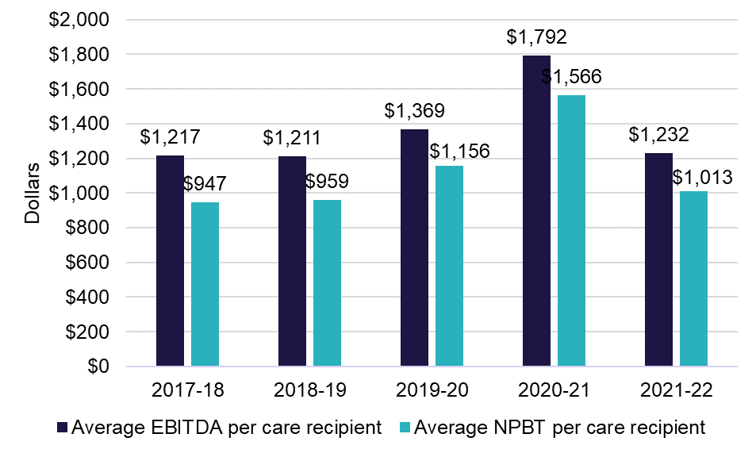
Chart 1.5 shows average EBITDA per recipient by quartile. As has been the case previously, EBITDA varies considerably across the sector with the top quartile of providers performing substantially better than the rest of the home care sector. The average EBITDA for providers in the top quartile decreased to $5,119 per recipient, down from $6,558 the prior year, and the providers in the bottom quartile decreased to negative $2,573, down from negative $1,740.

Chart 1.5: Home care average EBITDA per recipient, by quartile (number of providers in parentheses), 2017-18 to 2021-22
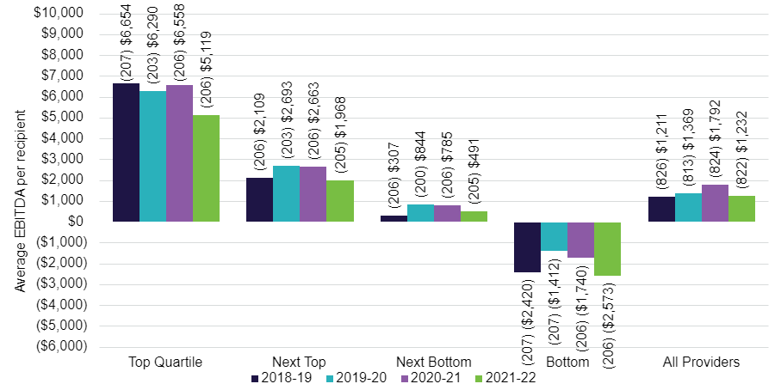
Ownership type
Chart 1.6 shows the overall average EBITDA per recipient per year by ownership over the last 6 years. In 2021-22, for-profit providers recorded a higher average EBITDA per recipient ($1,485) compared with not-for-profit providers ($1,142). In 2020-21, not-for-profit providers average EBITDA was higher ($1,884) compared with for-profit providers ($1,779).
Chart 1.6: Home care average EBITDA per recipient per year, by ownership type, 2017-18 to 2021-22
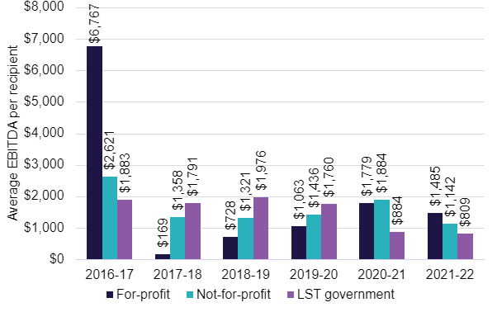

Chart 1.7 shows the quartile analysis of the average EBITDA per recipient per year for home care providers by ownership type in 2021-22. For-profit providers in the top quartile recorded an average of $6,918 per recipient, compared with not-for-profit providers who recorded an average of $4,260. In the bottom quartile, both not-for-profit and for-profit providers recorded a similar negative result of $2,604 and $2,575 respectively.
Chart 1.7: Home care average EBITDA per recipient per year, by quartile and ownership type, 2021-22 (number of providers in parentheses)
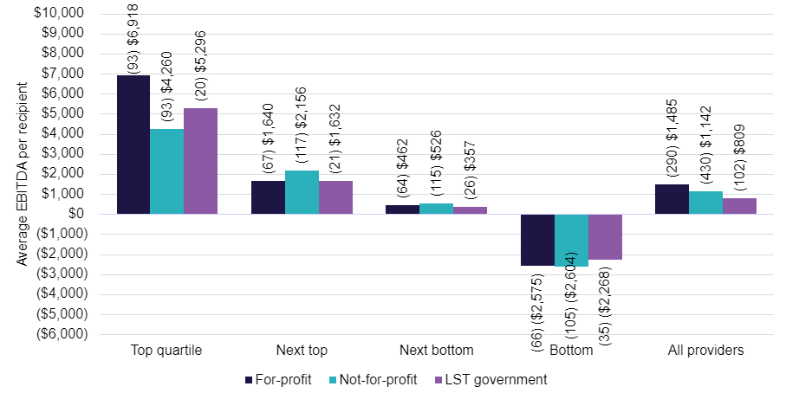

Provider location
As shown in Chart 1.8, when performance is considered by location, providers in regional areas reported an average EBITDA of $511 per recipient, which is a decrease from $1,031 in 2020-21. Metropolitan providers also reported a decrease, with an average EBITDA of $1,364 in 2021-22, down from $2,046 the prior year.
Chart 1.8: Home care average EBITDA per recipient, by provider location, 2017-18 to 2021-22

Chart 1.9 shows the average EBITDA per recipient per year, by quartile and provider location. Quartile analysis shows metropolitan providers outperformed regional providers in both the top and bottom quartiles, and metropolitan providers had an overall higher average EBITDA per recipient compared to regional providers.
Chart 1.9: Home care average EBITDA per recipient per year, by quartile and provider location, 2021-22 (number of providers in parentheses)
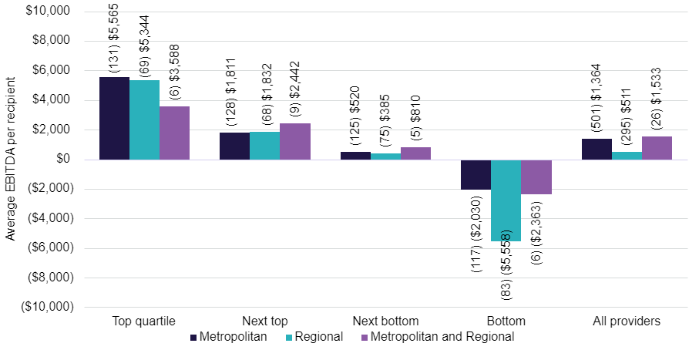

Provider scale
As shown in Chart 1.10, for the first time in past 3 years, providers who operate two to six services had the lowest performance when compared with all other providers, down from $2,248 per recipient per year in 2020-21 to $956 in 2021-22. Single service providers were the only scale type that increased average EBITDA per recipient per year compared to the prior year.
Single service providers EBITDA result demonstrates a relatively stable trend. However, providers with 2 to 6 services in 2021-22 reversed their trend of increasing their EBITDA per resident per day, year on year. This decrease could be associated with the introduction of the IPA and newly introduced policies meaning these providers are having to adjust to new requirements.
Chart 1.10: Home care average EBITDA per recipient per year, by provider scale, 2017-18 to 2021-22
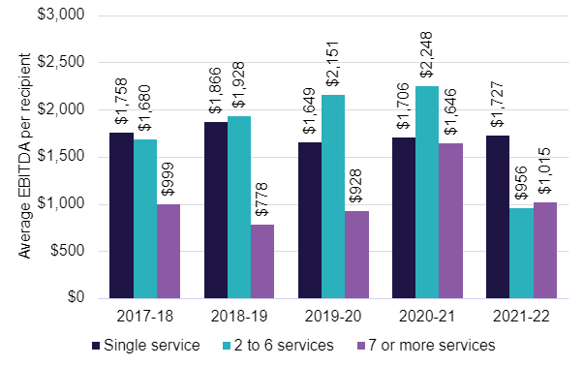Chart 1.11 shows the average EBITDA per recipient per year, by quartile and provider scale. Providers who operate seven or more services reported an average EBITDA of $1,015 per recipient compared with $1,727 for single service providers and $956 for providers with two to six services. Single service providers were by far the best performers in the top quartile and two to six service providers were the worst performers in the bottom quartile.
Chart 1.11: Home care average EBITDA per recipient per year, by quartile and provider scale (number of providers in parentheses), 2021-22
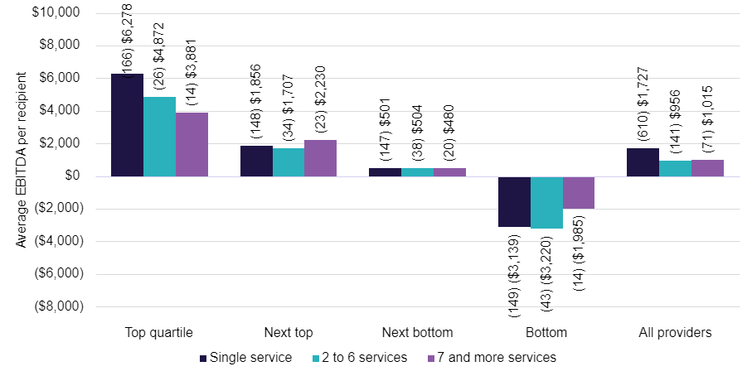

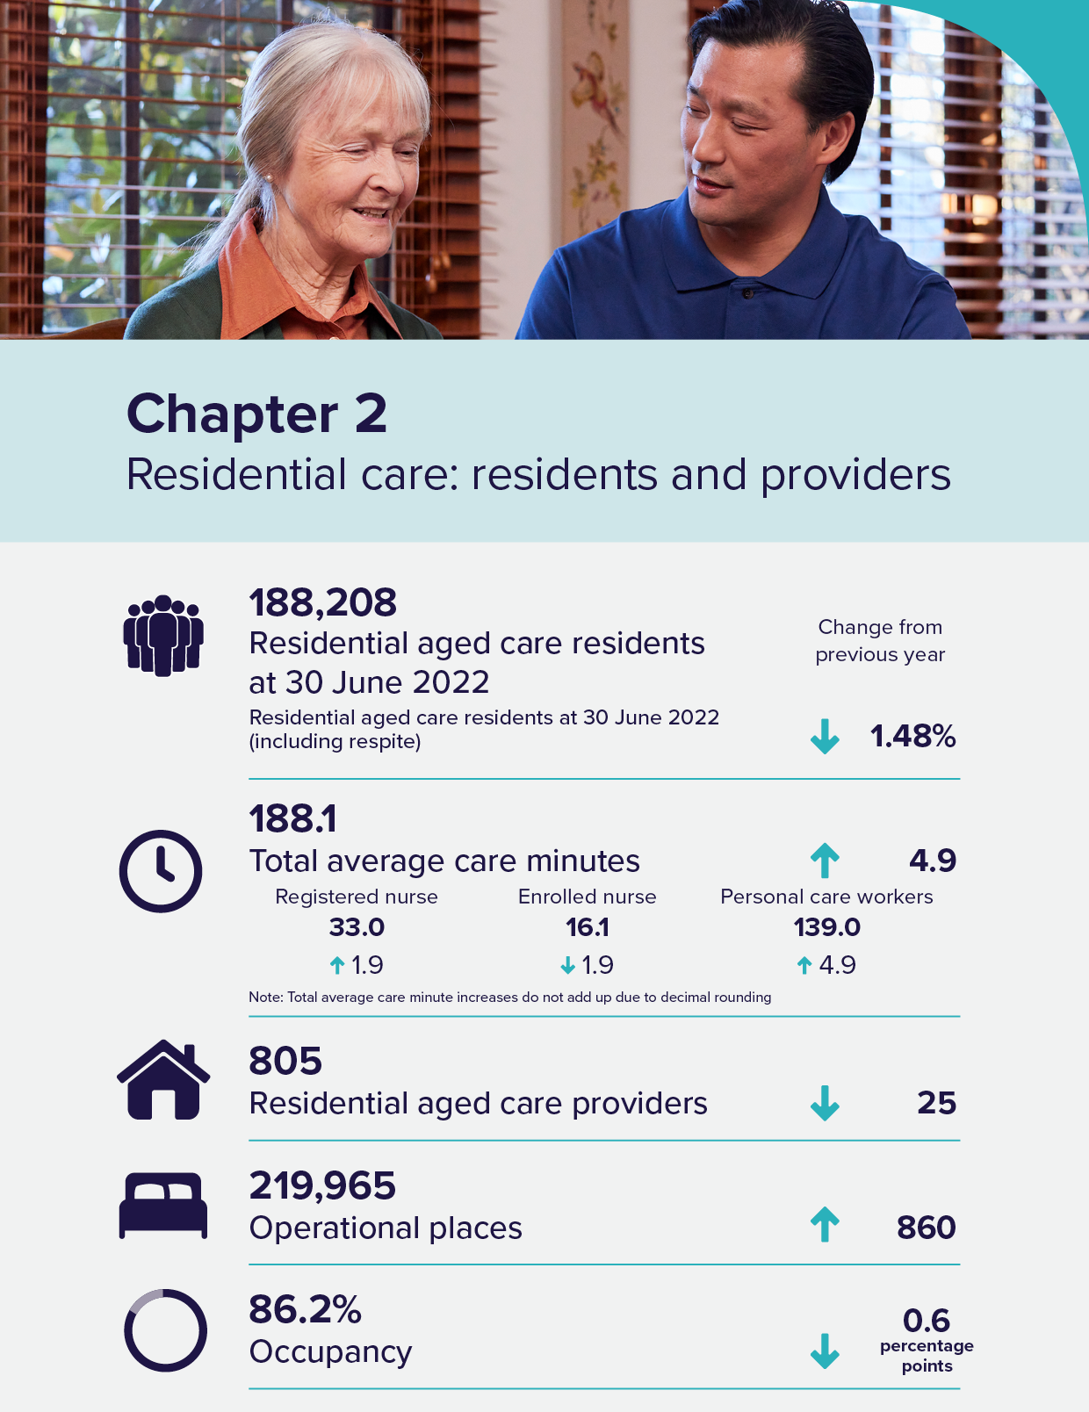

Residential care: residents and providers
Residential aged care ensures Australians who can no longer live independently at home can access higher levels of care in a residential setting. Similar to Home Care, older Australians need an Aged Care Assessment Team (ACAT) assessment to access a residential aged care place. The Australian Government funds residential aged care to make it affordable and accessible for older people living in Australia. Residential aged care includes accommodation and personal care 24 hours a day, as well as access to nursing and general health care services. Care can be provided on either a temporary (respite) or permanent basis.
There are a small number of residential aged care providers that report data in the Aged Care Financial Report (ACFR) on a non-standard financial year. To support the timely reporting of the 2021-22 Financial Report on the Australian Aged Care Sector (FRAACS), the data collected for these providers will be taken from the 2020-2021 ACFR and 2020-21 FRAACS. This will result in some minor duplication of reporting from the 2020-21 FRAACS. The 2022-23 FRAACS will include data for these providers from the 2021-2022 ACFR and will not be duplicated moving forward.

Residents
Table 2.1: Number of residential aged care residents, shows the number of aged care residents in residential care from 30 June 2018 to 30 June 2022. At 30 June 2022, the total number of aged care residents was 188,208, which was a slight decrease on 30 June 2021 numbers of 191,029.
Throughout 2021-22, there was a total of 245,719 individuals who accessed residential aged care, which was a slight increase on the 2020-21 total of 243,117 residents.
Table 2.1: Number of residential aged care residents, 30 June 2018 to 30 June 2022
Year | 30 June 2018 | 30 June 2019 | 30 June 2020 | 30 June 2021 | 30 June 2022
Total residents | 186,597 | 188,773 | 189,954 | 191,029 | 188,208
Permanent residents | 180,923 | 182,705 | 183,989 | 183,894 | 180,750
Respite residents | 5,674 | 6,068 | 5,965 | 7,135 | 7,458
CALD residents | 35,557 | 36,344 | 36,806 | 36,862 | 36,192
First Nations elders | 1,778 | 1,844 | 1,956 | 2,060 | 2,130
Chart 2.1: Average paid care minutes per resident per day, by ownership type, 2021-22 shows the average paid care minutes per resident per day, by provider ownership type for 2021-22. The total average paid care minutes and average registered nurse minutes were reported in the 2020-21 FRAACS. Average care minutes for enrolled nurses and personal care workers have been added to the 2021-22 FRAACS.
The total average care minutes for all providers (including local, state or territory government providers) was 188.1 minutes in 2021-22, up on 183.2 minutes (including local, state or territory government providers) in 2020-21.
Local, state or territory government providers had considerably higher average care minutes per resident per day (239.6 care minutes) compared to other ownership types as they are likely to have other non-Australian Government funding sources that contribute towards the delivery of care.
The average total care minutes per resident per day was 13.5 minutes higher in not-for-profit providers (191.1 care minutes), compared with 177.6 total care minutes for for-profit providers.
Chart 2.1: Average paid care minutes per resident per day, by ownership type, 2021-22
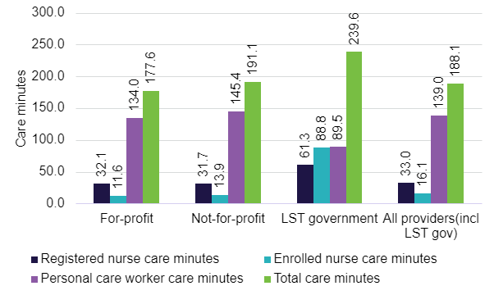
Note: Figures are rounded up to 1 decimal point and the total figures may not add up to the totals due to this.

Admission to residential care
Chart 2.2 shows the proportion of residents who entered permanent residential care after leaving home care. The proportion entering residential care has been dropping consistently since 2015-16, and in 2021-22 the proportion of residents entering permanent residential care after leaving home care stabilised at 45.34 per cent.
Chart 2.2: Proportion of residents entering permanent residential care after leaving home care, 2013-14 to 2021-22
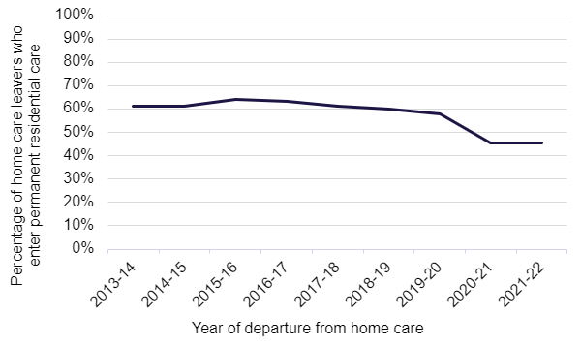

Length of stay in residential care
In 2021–22, the average total length of stay of those living in residential care was 3.1 years. As can be seen in Chart 2.3, the total length of stay has been increasing slightly since 2019-20. Females stayed on average around 1 year longer than males in 2021–22.
The slight increase in average length of stay over the last two years is likely driven by a decrease in admissions in those years. Admissions to permanent care in 2020-21 and 2021-22 were both lower than at any point in the previous five years, and this relatively low number of new entrants has translated into fewer people exiting in that period with stays less than two years. The average length of stay of people exiting in those years has increased as a result.
Chart 2.3: Average length of stay in residential care, by gender and year of entry, 2012-13 to 2021-22
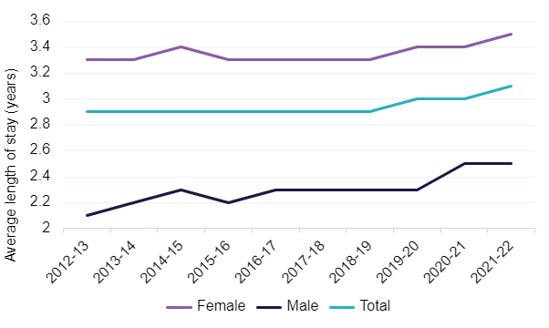
Chart 2.4 shows a slight decrease in the proportion of permanent residents that leave within 3 and 6 months. The proportion of permanent residents that leave within 12 months of first entry has remained steady since 2020-21.
Chart 2.4: Proportion of permanent residents that leave within 3, 6 or 12 months of first entry, 2011-12 to 2021-22
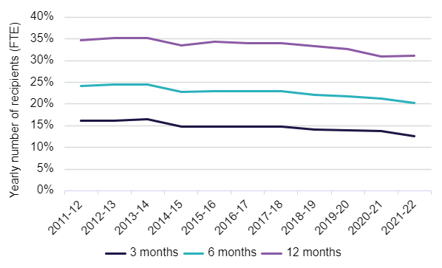

Residential respite care
Residential respite care is short-term care delivered within an aged care facility on either a planned or emergency basis. People are assessed for eligibility by an ACAT, who will approve someone for low care respite or high care respite. A resident can access subsidised residential respite for up to 63 days per financial year, with the possibility of extending for a further 21 days subject to ACAT approval.
As shown in Chart 2.5, the average stay in residential respite care was 30.4 days in 2021-22, an increase from 28.6 days in 2020-21. Since 2018-19, there has been a steady increase in the average length of stay in residential respite care by an average of 1.5 days.
Chart 2.5: Average length of stay (days) in residential respite care, 2017-18 to 2021-22
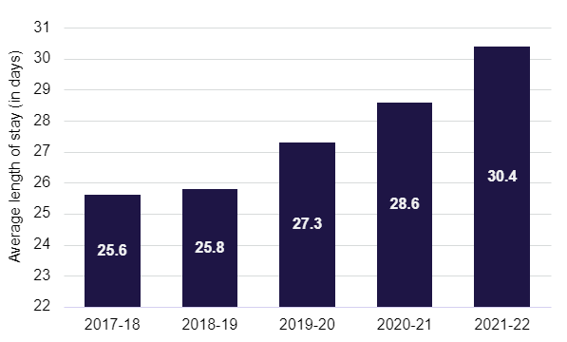
Chart 2.6 shows a clear pattern of respite care usage which is usually for stays of whole weeks at a time. Two weeks is the most common residential respite care length of stay.
Chart 2.6: Frequency of length of respite care stays, 2021-22
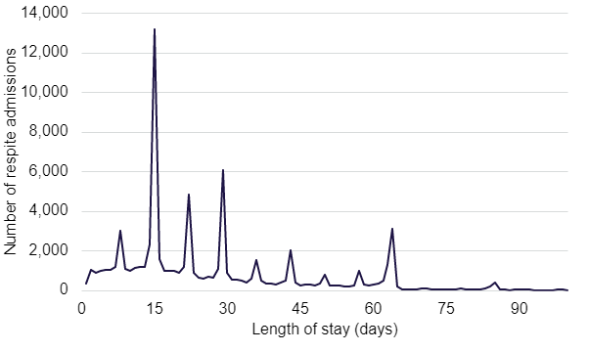

Aged Care Approvals Round and interim arrangements
The Australian Government has introduced changes to residential aged care. The Aged Care Approvals Round process (ACAR), which allocated residential places to providers, has ceased and no further rounds will be held. The last ACAR was held in 2020-21. From 1 July 2024, older Australians will be assigned a place upon being approved for residential aged care. They can take their place to their provider and home of choice. This will mean that instead of providers being restricted to place allocations through an ACAR process, they can increase beds in their residential facilities and develop new facilities more flexibly to be responsive to local community demands for aged care. The changes are designed to increase choice and control for older Australians and increase competition in the market to stimulate ongoing investment to improve care and accommodation offerings. Funding for residential care will continue to flow from the Australian Government directly to the provider.
Transitional arrangements are in place until 30 June 2024 to ensure the ongoing supply of residential aged care in the interim period. These arrangements allow providers to apply directly to the department for an allocation of residential care places if they can deliver care immediately, but do not currently have the places allocated. Since the implementation of these arrangements, a total of 346 residential care places have been allocated through this process.

Supply of subsidised aged care
The Australian Government regulates the supply of home care packages and residential aged care places it funds by specifying targets. These targets, known as the aged care target provision ratios, are based on the number of people aged 70 and over.
Chart 2.7Chart 3.13 shows the residential care ratios for the 5 years to 30 June 2022. The 2021-22 residential care ratio was 74.7, a continued downward trend from 76.4 in 2020-21, and 78.4 in 2019-20.
While the overall aged care target provision ratio comprises residential care, home care, and, since 2016, restorative care places, the reported operational ratio refers only to places assigned to approved providers.
In 2021-22, the residential aged care provision ratio was 78.0 places per 1,000 people over the aged of 70. From 2024-25, for three years, the Australian Government will temporarily reduce the residential aged care provision ratio to 60.1 places per 1,000 people over the age of 70 years. The reduction in the ratio reflects the increasing preference of older Australians to remain in their homes.
Chart 2.7: Residential care achieved ratios, 2017-18 to 2021-22
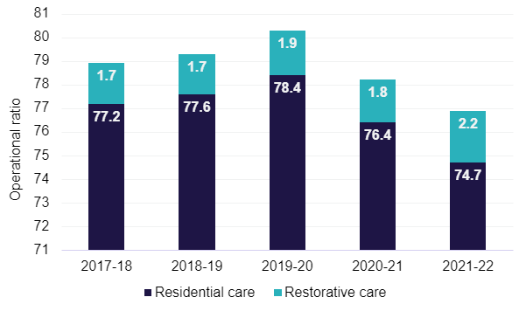

Providers

Supply of residential care
Table 2.2 shows a breakdown of residential care providers at 30 June 2022, presented by ownership type, location and scale.
Location indicates where a provider, service or resident/recipient is located based on whether they are metropolitan or regional areas. Metropolitan is all major cities and regional is any area outside of a major city. A provider is classified as metropolitan if more than 70 per cent of its services are in metropolitan areas and similarly classified as regional if more than 70 per cent of its services are located in regional areas.
At 30 June 2022, there were 805 residential care providers, compared with 830 at 30 June 2021. The largest provider group remained the not-for-profit group (religious, charitable and community-based organisations). They represented 56 per cent of providers and operated 55 per cent of all residential aged care places. For-profit providers accounted for 33 per cent of providers and 42 per cent of places. The remaining providers and places are state and territory and local government-owned providers.
Single aged care facility providers accounted for 19 per cent of all operational residential care places in 2021-22. Conversely, only 3 per cent (23 providers) operated more than 20 facilities, but they accounted for 36 per cent of operational places. The proportion of providers that operate more than 20 facilities is gradually increasing (31 per cent in 2017–18). The proportion of providers that operated between 7 to 19 facilities was 7 per cent (55 providers) and accounted for 23 per cent of operational places.
Table 2.2: Number of providers, facilities, places and residents in residential care, by ownership, location and scale, 30 June 2022
 |  |  | Ownership type |  |  | Location |  |  | Scale
 |  | Total sector 2021-22 | For-profit | Not-for-profit | Government | Metropolitan | Regional | Metropolitan & regional | Single facilities | Two to six facilities | Seven to 19 facilities | 20 or more facilities
Providers | 805 |  | 266 | 453 | 87 | 406 | 310 | 89 | 507 | 220 | 55 | 23
Facilities | 2,671 |  | 929 | 1,515 | 227 | 1,669 | 1,002 | N/A | 507 | 633 | 642 | 889
Operational places | 219,965 |  | 91,658 | 120,137 | 8,170 | 155,138 | 64,827 | N/A | 41,857 | 47,283 | 51,260 | 79,565
Occupancy | 86% |  | 85% | 88% | 85% | 86% | 87% | N/A | 85% | 85% | 86% | 86%
Total residents | 188,208 |  | 77,032 | 104,391 | 6,785 | 132,240 | 55,968 | N/A | 36,007 | 40,220 | 43,410 | 68,571
-Permanent residents | 180,750 |  | 73,370 | 100,761 | 6,619 | 127,032 | 53,718 | N/A | 34,442 | 38,626 | 41,842 | 65,840
- Respite residents | 7,458 |  | 3,662 | 3,563 | 233 | 5,208 | 2,250 | N/A | 1,565 | 1,594 | 1,568 | 2,731

Occupancy in residential care
Occupancy is measured by the total number of days an allocated place is occupied by a resident, divided by the total number of days an allocated place was available to be occupied. The subsequent rates therefore reflect both demand for care (i.e. the number of residents accessing places) and the supply of places made available by providers.
Table 2.3 shows the average occupancy rate across all residential care places was 86.2 per cent in 2021-22, down from 86.8 per cent in 2020-21 and 88.3 per cent in 2019–20. There has been a consistent decline in occupancy rates over the past 5 years. In terms of ownership type, for-profit was the only ownership type to show an increase in occupancy rates up to 84.5 per cent in 2021-22 compared with 84.2 per cent in 2020-21.
Occupancy rates can have a significant impact on profitability if they fall below levels that are insufficient to cover fixed costs. This can impact the viability and overall financial performance of providers. The occupancy rates across 2021-22 continued to be impacted by COVID-19 as preferences for older Australians requiring aged care changed during this time. Combined with high fixed costs, the continuous decline in occupancy has put financial pressure on residential aged care providers.
Table 2.3: Occupancy rates, by organisation type, 2017-18 to 2021-22
Ownership type | 2017-18 | 2018-19 | 2019-20 | 2020-21 | 2021-22
For-profit | 87.9% | 86.5% | 85.3% | 84.2% | 84.5%
Not-for-profit | 92.1% | 91.5% | 90.5% | 88.9% | 87.5%
LST government | 90.3% | 90.4% | 88.3% | 86.5% | 84.8%
All providers | 90.3% | 89.4% | 88.3% | 86.8% | 86.2%
Table 2.4 shows average occupancy by state and territory for the 5 years from 2017-18 to 2021-22.
There continued to be variations in average occupancy by state and territory. South Australia had the highest occupancy with 92.2 per cent, while Victoria reported the lowest with 83.3 per cent. Queensland and Tasmania both reported an increase, whereas all other states and territories reported a decrease. The Northern Territory had the highest decrease, dropping by 5.1 percentage points to 89.8 per cent.

Table 2.4: Occupancy in residential care, by state and territory, 2017-18 to 2021-22
State/territory | 2017-18 | 2018-19 | 2019=20 | 2020-21 | 2021-22
New South Wales | 89.5% | 89.2% | 88.0% | 86.6% | 85.2%
Victoria | 90.2% | 89.0% | 87.9% | 84.2% | 83.3%
Queensland | 89.1% | 88.3% | 86.7% | 87.0% | 88.0%
Western Australia | 93.2% | 90.3% | 89.4% | 88.3% | 88.1%
South Australia | 93.4% | 92.8% | 92.5% | 93.1% | 92.2%
Tasmania | 90.2% | 89.9% | 88.7% | 88.9% | 89.2%
Australian Capital Territory | 91.0% | 89.6% | 89.4% | 87.3% | 85.3%
Northern Territory | 94.4% | 94.3% | 94.0% | 94.9% | 89.8%
Australia | 90.3% | 89.4% | 88.3% | 86.8% | 86.2%
Table 2.5 shows average occupancy in residential care by location for the 5 years from 2017-18 to 2021-22.
There remained a variation in occupancy rates by remoteness location. In 2021–22, occupancy in major cities, inner regional, outer regional and remote locations decreased on the 2020-21 result (by approximately 1 to 3 percentage points). Occupancy in very remote locations increased to 77.6 per cent, up from 75.1 per cent.
Table 2.5: Occupancy in residential care, by location, 2017-18 to 2021-22
Provider location | 2017-18 | 2018-19 | 2019-20 | 2020-21 | 2021-22
Major cities | 90.0% | 88.9% | 88.0% | 86.4% | 85.9%
Inner regional | 91.4% | 91.1% | 89.8% | 88.4% | 87.3%
Outer regional | 90.8% | 90.0% | 87.2% | 86.9% | 86.6%
Remote | 88.4% | 87.6% | 84.4% | 83.5% | 80.3%
Very remote | 77.1% | 71.9% | 72.6% | 75.1% | 77.6%
Australia | 90.3% | 89.4% | 88.3% | 86.8% | 86.2%

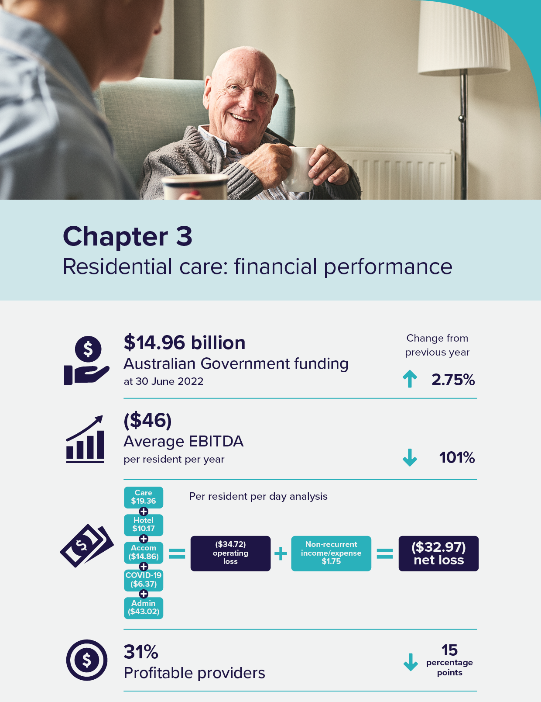

Residential care: financial performance

Operational funding
Operational funding supports day-to-day services such as nursing and personal care, living expenses and accommodation expenses.
A combination of Australian Government and resident contributions provides the operational funding for residential care.
Figure 3.1 shows the different funding types from the Australian Government and residents for operational funding.
The Australian Government determines its contributions on behalf of permanent residents in residential care by setting:
- a basic care subsidy for personal and nursing care. In 2020-2021, this subsidy was determined by the Aged Care Funding Instrument (ACFI)
- the rates of supplements paid to support aspects of residential care that have higher delivery costs and
- the maximum rate of accommodation supplement.
The Australian Government sets the basic respite care subsidy at two levels (low or high) depending on the level of respite care the resident is approved for by the Aged Care Assessment Team (ACAT). The Australian Government also sets the maximum levels for contributions made by residents for the following:
- the maximum rate of the basic daily fee for living expenses (permanent and respite) and
- the maximum means tested care fee that may be charged by providers (permanent only).

Figure 3.1: Residential care services
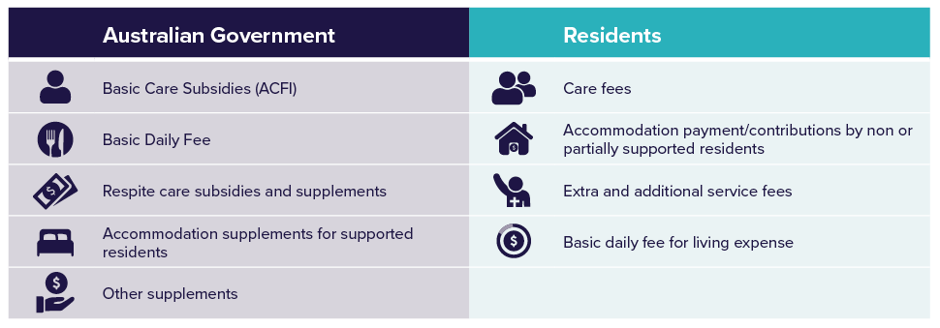
Chart 3.1 shows the proportion of revenue that residential care providers received from the Australian Government in 2021-22. Basic care subsidies (ACFI) comprised by far the greatest share at 79.4 per cent.
Accommodation supplements were the second largest proportion (8.8 per cent).
Chart 3.1: Proportions of provider revenue from the Australian Government, 2021-22 ($m)

Note: Percentages do not add up to total due to rounding
Chart 3.2 shows total Australian Government payments for residential respite care since 2017-18. Payments increased to $509.2 million in 2021-22, up from $458.0 million in 2020-21.
Chart 3.2: Total residential respite care expenditure, 2017-18 to 2021-22 ($m)

Financial summary
Table 3.1 provides a summary of the overall financial performance of residential care providers since 2017-18. Table 3.1 shows that the overall profit of the sector has been declining since 2017-18 and was negative $736 million in 2019–20 and negative $854 million in 2020–21. In 2021-22, this dropped below zero for the third consecutive year and the loss more than doubled, to $2,264 million.
The decrease in net profit before tax (NPBT) and earnings before interest, tax, depreciation and amortisation (EBITDA) margin can be likely attributed to a large increase in COVID-19 expenses and increasing labour costs across all expense categories. A more detailed breakdown of expenses for residential care providers is available in Appendix A.
Table 3.1: Summary of financial performance of residential care providers, 2017-18 to 2021-22
 | 2017-18 | 2018-19 | 2019-20 | 2020-21 | 2021-22
Revenue ($m) | $18,066 | $19,302 | $20,536 | $21,478 | $22,075
Expenses ($m) | $17,631 | $19,037 | $21,273 | $22,332 | $24,339
NPBT ($m) | $435 | $264 | ($736) | ($854) | ($2,264)
NPBT margin | 2.40% | 1.40% | (3.60%) | (4.00%) | (10.30%)
EBITDA ($m) | $1,591 | $1,590 | $1,222 | $713 | ($9)
Average EBITDA per resident per annum | $8,746 | $8,523 | $6,445 | $3,771 | ($46)
EBITDA margin | 8.80% | 8.20% | 6.00% | 3.30% | 0.00%
Table 3.2 shows the financial performance of providers in 2021-22 by ownership type, location and scale. Based on EBITDA per resident per year, for-profit providers outperformed not-for-profit providers, and metropolitan providers significantly outperformed regional and rural providers.
In 2021-22, 31 per cent of providers reported a positive net profit, representing 18 per cent of total operational beds in the residential care sector.
Table 3.2: Summary of financial performance of residential care providers, by ownership, location and scale, 2021-22
 |  |  | Ownership type |  |  | Location |  |  |  |  | Scale
 | Total sector 2021-22 | For-profit |  | Not-for-profit | LST government |  | Metro | Regional | Metro/Regional | Single facility |  | 2 to 6 facilities | 7 to 19 facilities | 20 or more facilities
Revenue ($m) | $22,075 | $9,255 |  | $11,794 | $1,026 |  | $14,225 | $3,148 | $4,702 | $4,087 |  | $4,752 | $5,280 | $7,956
Expenses ($m) | $24,339 | $10,097 |  | $13,046 | $1,196 |  | $15,536 | $3,525 | $5,277 | $4,418 |  | $5,169 | $5,820 | $8,931
Profit ($m) | ($2,264) | ($842) |  | ($1,252) | ($171) |  | ($1,311) | ($378) | ($575) | ($331) |  | ($418) | ($540) | ($975)
EBITDA ($m) | ($9) | $223 |  | ($136) | ($96) |  | $203 | ($143) | ($69) | $26 |  | ($14) | $22 | ($43)
EBITDA p.r.p.a | ($46) | $2,920 |  | ($1,294) | ($13,660) |  | $1,703 | ($5,325) | ($1,655) | $731 |  | ($349) | $503 | ($622)
EBITDA margin | 0.00% | 2.40% |  | (1.20%) | (9.30%) |  | 1.40% | (4.50%) | (1.50%) | 0.60% |  | (0.30%) | 0.40% | (0.50%)
NPBT margin | (10.30%) | (9.10%) |  | (10.60%) | (16.60%) |  | (9.20%) | (12.00%) | (12.20%) | (8.10%) |  | (8.80%) | (10.20%) | (12.30%)
Figure 3.2 shows a visual summary of income and expenses categories within residential care.
In 2021–22, residential aged care providers reported an average loss of $32.97 per resident per day. When comparing care income with total care expenses, there is a positive average care result of $19.36 per resident per day at the sector level. This is a decrease of $5.78 per resident per day from 2020-21 when the care result average was $25.14 per resident per day. This decrease can likely be attributed to the sector spending more on care expenses such as labour to meet the increasing care minute requirements.
From 2020-21 to 2021-22 the Financial Report on the Australian Aged Care Sector (FRAACS) shows that the average care minutes being delivered increased by 4.9 minutes, with registered nurse minutes increasing by an average of 1.80 minutes to an average of 33 minutes. The department expects this trend to continue into 2022-23 as the funding of care through Australian National Aged Care Classification (AN-ACC) is more closely aligned to the delivery of care, and as care minute targets become mandatory from 1 October 2023.
The hotel income and expense comparison shows an average result of $10.17 per resident per day at the sector level. This was an increase of $9.26 from 2020-21 when the hotel result was $0.91. This increase can likely be attributed to the $10 Basic Daily Fee supplement in the 2021-22 financial year.
In 2021-22, the most significant loss-making categories for providers were administration (negative $43.02 per resident per day), accommodation (negative $14.86 per resident per day), and COVID-19 (negative $6.37 per resident per day). The accommodation category represented the largest decrease of all the categories, falling by $14.22 per resident per day from 2020-21 when the accommodation and finance income result was negative $0.64 per resident per day. Most of the accommodation loss of $14.86 per resident per day can be attributed to a loss of $813 million in bed license amortisation.
The $813 million bed license amortisation loss is a result of the removal of the Aged Care Approvals Round (ACAR) and the need for providers to readjust the treatment of bed licences as intangible assets. The impact of bed license amortisation will not be ongoing post 1 July 2024, when residential aged care places will be allocated directly to older people, rather than providers. For more information on ACAR, please visit the department’s website: Places to people – Embedding choice in residential aged care | Australian Government Department of Health and Aged Care
In addition to the COVID-19 income and expenditure reported in Figure 3.2, residential aged care providers self-reported approximately $10.81 per resident per day (or $742 million) in COVID-19 related grant reimbursements that had been claimed but not yet approved or paid in 2021-22. This amount is not recognised as income for 2021-22 in this report, and it is a self-reported provider figure based on available COVID-19 grants in 2021-22. The department continues to work through these claims and assess them in 2022-23. The correlating approved COVID-19 grant funding may vary from the providers’ self-reported figure.
For the first time, the 2021-22 Aged Care Financial Report (ACFR) required providers to report their administration expenses across care, hotel, accommodation and COVID-19 categories. Previously, providers reported administration expenses as a separate stand-alone expense. Noting this was the first-time providers have been required to apportion administration costs, and that only 82 per cent of providers allocated 100 per cent of their administration costs across these categories, this breakdown has not been included in this FRAACS. The department will continue to work with the sector to improve the response rate and accuracy of this data, with a view to including a break-down of administration expenses and trends in administration expenses over-time, in future FRAACS reports.
Figure 3.2: Summary of financial performance, income and expense category comparison, per resident per day, all providers, 2021-22
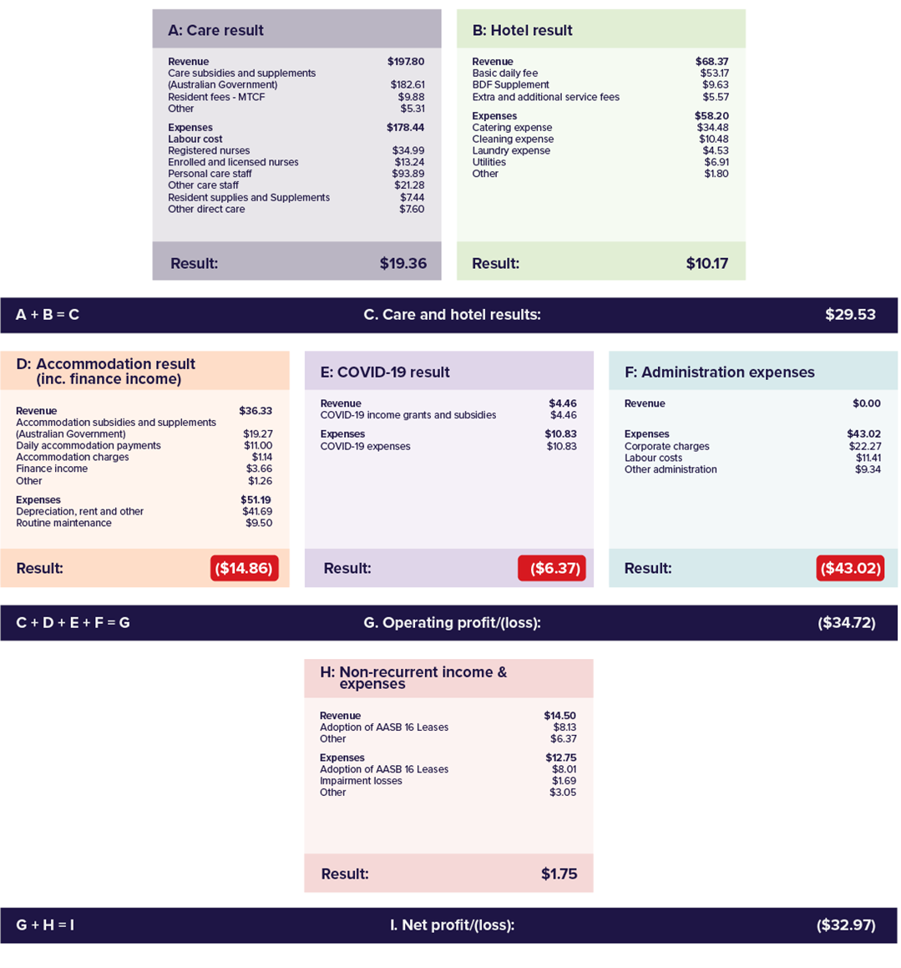
Table 3.3 shows a summary of income and expenses based on functional centres within residential care. The table enables better understanding of sector level financial information and its impact on individual residents by summarising the detailed income statement submitted by providers. A more detailed income statement has been provided in Appendix B to allow providers to benchmark their financial information against the rest of the sector.
Table 3.3 also allows for residents to better understand providers’ expenditure by showing how much is spent (at the sector level) on categories like care, nursing, food, maintenance, cleaning and administration.
From early 2024, the department will publish information at the service level on provider income and expenditure on My Aged Care. This will further contribute to transparency and accountability and support informed decision-making for older Australians and their families.
Table 3.3: Summary of income and expense statement per resident per day, by ownership, 2021-22
 | Not-for-profit | For-profit | LST government | All providers
Income
Recurrent Income
Care income | $191.25 | $201.14 | $259.69 | $197.80
Hotel Services income | $65.98 | $72.03 | $64.30 | $68.37
Accommodation & Finance income | $37.42 | $34.99 | $34.57 | $36.33
COVID-19 income | $4.07 | $4.74 | $7.21 | $4.46
Total Recurrent Income | $298.73 | $312.89 | $365.78 | $306.96
Recurrent Expense
Care expenses:
◦ Labour costs | $165.31 | $151.88 | $260.26 | $163.40
◦ Resident expenses | $7.71 | $7.03 | $7.80 | $7.44
◦ Other care expenses | $5.31 | $10.99 | $5.32 | $7.61
Total Care expenses | $178.32 | $169.91 | $273.39 | $178.44
Hotel Services expenses:
◦ Catering | $34.81 | $33.06 | $44.96 | $34.48
◦ Cleaning | $10.68 | $9.24 | $21.00 | $10.48
◦ Laundry | $4.54 | $4.27 | $7.23 | $4.53
◦ Other hotel expenses | $8.07 | $9.64 | $8.13 | $8.71
Total Hotel expenses | $58.11 | $56.22 | $81.32 | $58.20
Accommodation & Finance expenses:
◦ Routine maintenance | $10.74 | $7.53 | $12.27 | $9.50
◦ Financing interest | $0.36 | $2.68 | $0.33 | $1.30
◦ Depreciation, Rent & Others | $31.65 | $53.10 | $32.88 | $40.39
Total Accommodation & Finance expenses | $42.76 | $63.31 | $45.48 | $51.19
Administration expenses | $42.95 | $42.36 | $51.30 | $43.02
COVID-19 expenses | $10.43 | $11.75 | $6.79 | $10.83
Total Recurrent Expense | $332.56 | $343.54 | $458.27 | $341.68
Recurrent operating profit/(Loss) | ($33.83) | ($30.65) | ($92.49) | ($34.72)
Non - Recurrent Income | $9.25 | $19.76 | $36.00 | $14.50
Non - Recurrent Expense | $8.11 | $19.37 | $10.34 | $12.75
Non-recurrent profit/(loss) | $1.14 | $0.39 | $25.66 | $1.75
Residential Aged Care Segment Profit (Loss) | ($32.68) | ($30.26) | ($66.83) | ($32.97)

Financial performance – revenue
Revenue for residential care providers is broadly described in four categories: care related, living expenses, accommodation and other.
Chart 3.3 shows the proportion of all revenue sources for residential care providers in 2021-22. Revenue from Australian Government care subsidies and supplements accounted for 61 per cent, while revenue from other income accounted for approximately 7 per cent of total provider revenue.
Australian Government accommodation supplements and capital grants revenue accounted for 7 per cent of total provider revenue.
Chart 3.3: Proportions of total residential care provider revenue, 2021-22 ($m)

Table 3.4 provides a breakdown of the revenue reported by residential care providers in 2021-22 compared with the previous two years.
In 2021–22, care related revenue ($13.6 billion) formed the majority (62 per cent) of total revenue earned by residential care providers. This has been the case in previous years and is an increase of $281 million on the previous year. The Australian Government is the primary funder of care related revenue.
Hotel related revenue received from residents, which includes the basic daily fee, extra services fees and additional service fees, accounted for 21 per cent of total revenue ($4.6 billion), an increase of $729.68m (or 19 per cent) on 2020-21.
Table 3.4: Revenue sources for residential care providers, by care, accommodation, living and ‘other’, 2019-20 to 2021-22 ($m)
Revenue sources |  | 2019-20 ($m) | 2020-21  ($m) |  | Change  from 2019-20 to 2020-21 ($m) |  | 2021-22  ($m) |  | Change  from 2020-21 to 2021-22 ($m)
Care related
Basic care subsidy (ACFI) | $11,386.30 |  |  | $11,777.87 | $391.57 | $11,883.39 |  | $105.52
Respite subsidy and supplements | $415.60 |  |  | $455.77 | $40.17 | $501.02 |  | $45.26
COVID-19 funding | $301.10 |  |  | $753.61 | $452.51 | $306.06 |  | ($447.55)
Other supplements | $127.00 |  |  | $156.61 | $29.61 | $155.15 |  | ($1.46)
Resident means tested fee | $648.00 |  |  | $657.01 | $9.01 | $678.64 |  | $21.63
Resident other care fees | $52.30 |  |  | $118.37 | $66.07 | $113.71 |  | ($4.66)
Total care revenue |  | $12,930.30 | $13,919.24 |  | $988.94 |  | $13,637.97 |  | ($281.27)
Hotel
Resident basic daily fee | $3,574.00 |  |  | $3,598.91 | $24.91 | $3,651.14 |  | $52.23
Basic daily fee supplement | $0.00 |  |  | $0.00 | $0.00 | $660.99 |  | $660.99
Extra service fee | $123.40 |  |  | $123.35 | $0.00 | $125.59 |  | $2.24
Additional services fees | $158.10 |  |  | $161.76 | $3.66 | $175.97 |  | $14.21
Total hotel revenue |  | $3,855.50 | $3,884.02 |  | $28.52 |  | $4,613.69 |  | $729.68
Accommodation and finance related
Accommodation supplement | $1,287.80 |  |  | $1,337.39 | $49.59 | $1,323.19 |  | ($14.20)
Accommodation payments from residents | $847.90 |  |  | $828.43 | ($19.47) | $833.48 |  | $5.05
Capital grants | $71.40 |  |  | $75.67 | $4.27 | $131.70 |  | $56.04
Interest | $304.40 |  |  | $223.28 | ($81.12) | $187.07 |  | ($36.21)
Total accommodation and finance related revenue |  | $2,511.50 | $2,464.77 |  | ($46.73) |  | $2,475.45 |  | $10.68
Other income
Donations and fundraising | $37.90 |  |  | $31.44 | ($6.46) | $39.36 |  | $7.92
Gain on sale of assets | $45.90 |  |  | $18.82 | ($27.08) | $22.20 |  | $3.39
Revaluation of assets | $42.20 |  |  | $85.10 | $42.90 | $85.91 |  | $0.81
Imputed interest on RADs - AASB 16 leases | $551.40 |  |  | $509.22 | ($42.18) | $558.59 |  | $49.37
Other | $562.00 |  |  | $565.85 | $3.85 | $641.38 |  | $75.53
Total other revenue | $1,239.40 |  |  | $1,210.42 | ($28.98) | $1,347.43 |  | $137.00
Total residential provider revenue |  | $20,536.50 | $21,478.45 |  | $941.95 |  | $22,074.54 |  | $596.09
Note
- COVID-19 Funding for 2019-20 and 2020-21 includes the total amount of funding received for residential aged care operations through aged care specific COVID-19 measures such as the one-off Residential Care Subsidy Increase or the Workforce Retention Bonus and non-aged-care measures such as JobKeeper.
Chart 3.4 shows the proportion of total revenue that residential care providers received from residents. Consistent with previous years, the Basic Daily Fee formed the greatest share of revenue from residents (65 per cent). Accommodation payments (Daily Accommodation Payments) formed a further 15 per cent of the revenue received and means tested care fees represented 12 per cent. The remaining 8 per cent consisted of extra service fees, additional service fees and other residential care fees.
Chart 3.4: Proportions of residential care provider revenue from residents, 2021-22 ($m)
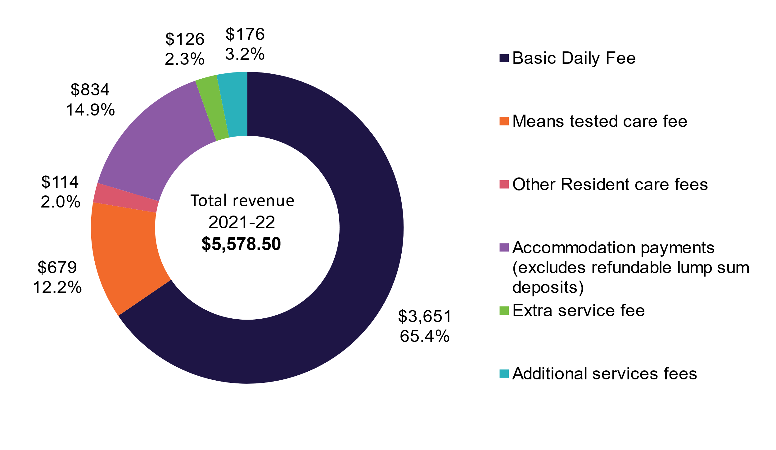
Table 3.5 shows provider revenue sources for 2021-22 compared with the previous two years.
In 2021-22, total revenue was $22.1 billion, up from $21.5 billion in 2020–21 and $20.5 billion in 2019-20. The $596 million increase in 2021-22 can mostly be attributed to $661 million in Basic Daily Fee supplement provided by the Government in 2021-22. COVID-19 revenue decreased in 2021-22 by $448 million, to a sector total of $306 million.
Table 3.5: Revenue sources for residential care providers, Australian Government, resident and ‘other’, 2019-20 to 2021-22 ($m)
Revenue sources | 2019-20 ($million) |  | 2020-21  ($million) | Change from 2019-20 to 2020-21 ($m) |  | 2021-22  ($million) |  | Change from 2020-21 to 2021-22 ($m)
Australian Government
Basic care subsidy (ACFI) |  | $11,386.30 | $11,777.87 | $391.57 | $11,883.39 |  | $105.52
Respite subsidy & supplements |  | $415.60 | $455.77 | $40.17 | $501.02 |  | $45.26
Basic daily fee supplement |  | $0.00 | $0.00 | $0.00 | $660.99 |  | $660.99
COVID-19 funding |  | $301.10 | $753.61 | $452.51 | $306.06 |  | ($447.55)
Other supplements |  | $127.00 | $156.61 | $29.61 | $155.15 |  | ($1.46)
Accommodation supplement |  | $1,287.80 | $1,337.39 | $49.59 | $1,323.19 |  | ($14.20)
Capital Grants |  | $71.40 | $75.67 | $4.27 | $131.70 |  | $56.04
Australia Government funding sources |  | $13,589.20 | $14,556.92 | $967.72 | $14,961.51 |  | $404.59
Resident
Resident basic daily fee |  | $3,574.00 | $3,598.91 | $24.91 | $3,651.14 |  | $52.23
Resident means tested fee |  | $648.00 | $657.01 | $9.01 | $678.64 |  | $21.63
Resident other care fees |  | $52.30 | $118.37 | $66.07 | $113.71 |  | ($4.66)
Accommodation payments from residents |  | $847.90 | $828.43 | ($19.47) | $833.48 |  | $5.05
Extra service fee |  | $123.40 | $123.35 | ($0.05) | $125.59 |  | $2.24
Additional services fees |  | $158.10 | $161.76 | $3.66 | $175.97 |  | $14.21
Resident funding sources |  | $5,403.60 | $5,487.83 | $84.23 | $5,578.53 |  | $90.70
Other income
Interest |  | $304.40 | $223.28 | ($81.12) | $187.07 |  | ($36.21)
Donations and fundraising |  | $37.90 | $31.44 | ($6.46) | $39.36 |  | $7.92
Gain on sale of assets |  | $45.90 | $18.82 | ($27.08) | $22.20 |  | $3.39
Revaluation of assets |  | $42.20 | $85.10 | $42.90 | $85.91 |  | $0.81
Imputed Interest on RADs - AASB 16 Leases |  | $551.40 | $509.22 | ($42.18) | $558.59 |  | $49.37
Other |  | $562.00 | $565.85 | $3.85 | $641.38 |  | $75.53
Other funding sources |  | $1,543.70 | $1,433.71 | ($109.99) | $1,534.50 |  | $100.80
Total revenue |  | $20,536.50 | $21,478.45 | $941.95 | $22,074.54 |  | $596.09
Table 3.6 shows total revenue per resident per day in 2021-22 compared with the previous two years.
Total revenue per resident per day was $321.46, an increase of 3 per cent from 2020-21 ($311.44) and an increase of 8 per cent from 2019-20 ($296.64). This increase is likely due to the $10 Basic Daily Fee Supplement paid in the 2021-22 financial year.
Table 3.6: Residential care provider revenue sources per resident per day, 2019-20 to 2021-22
 | 2019-20 | 2020-21 | Change from 2019-20 to 2020-21 ($m) | 2021-22 |  | Change from 2020-21 to 2021-22 ($m)
Australian Government
Basic care subsidy (ACFI) | $164.47 | $170.78 | $6.31 |  | $173.05 | $2.28
Respite subsidy & supplements | $6.00 | $6.61 | $0.61 |  | $7.30 | $0.69
Basic daily fee supplement | $0.00 | $0.00 | $0.00 |  | $9.63 | $9.63
COVID-19 funding | $4.35 | $10.93 | $6.58 |  | $4.46 | ($6.47)
Other supplements | $1.83 | $2.27 | $0.44 |  | $2.26 | ($0.01)
Accommodation supplement | $18.60 | $19.39 | $0.79 |  | $19.27 | ($0.12)
Capital Grants | $1.03 | $1.10 | $0.07 |  | $1.92 | $0.82
Australian Government funding sources | $196.29 | $211.07 | $14.78 |  | $217.88 | $6.81
Resident
Resident basic daily fee | $51.62 | $52.18 | $0.56 |  | $53.17 | $0.99
Resident means tested fee | $9.36 | $9.53 | $0.17 |  | $9.88 | $0.36
Resident other care fees | $0.76 | $1.72 | $0.96 |  | $1.66 | ($0.06)
Accommodation payments from residents | $12.25 | $12.01 | ($0.24) |  | $12.14 | $0.13
Extra service fee | $1.78 | $1.79 | $0.01 |  | $1.83 | $0.04
Additional services fees | $2.28 | $2.35 | $0.07 |  | $2.56 | $0.22
Resident funding sources | $78.05 | $79.57 | $1.52 |  | $81.24 | $1.67
Other
Imputed Interest on RADs - AASB 16 Leases | $8.00 | $7.38 | ($0.58) |  | $8.13 | $0.75
Other income | $14.33 | $13.40 | ($0.93) |  | $14.21 | $0.81
Other | $22.30 | $20.79 | ($1.51) |  | $22.35 | $1.56
Total revenue | $296.64 | $311.44 | $14.80 |  | $321.46 | $10.03
Notes:
- Extra service subsidy (ESS) reduction does not apply to new residents entering care from 1 July 2014, however it still applies to residents in ESS places who were in care prior to 1 July 2014.

Financial performance – expenditure
Chart 3.5 shows total expenses for the 5 years to 2021-22. Total expenditure in
2021–22 for residential care providers was $24.34 billion, up 9 per cent from
$22.33 billion in 2020-21 and up 14.4 per cent from $21.27 billion in 2019-20.
Chart 3.5: Total expenses, residential care providers, 2017-18 to 2021-22 ($b)
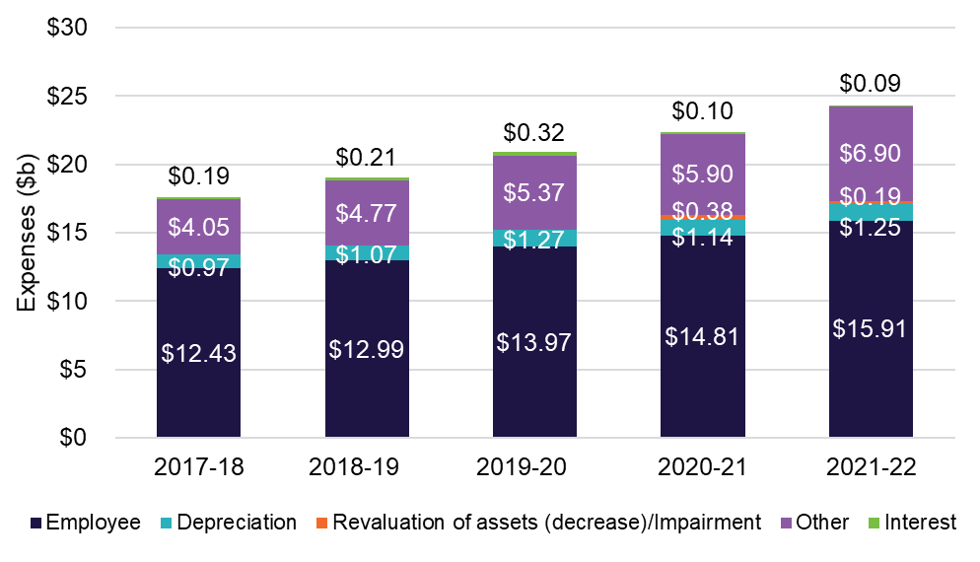
Table 3.7 shows the expenses for residential care providers in 2021-22 compared with the previous two years. In 2021-22, employee expenses were $15.9 billion, up from $14.8 billion in 2020-21 and $14 billion in 2019-20.
The $813 million bed license amortisation loss, which is included in the “other expenses” category, is a result of the removal of the ACAR and the need for providers to readjust the treatment of bed licences as intangible assets. The impact of bed license amortisation will not be ongoing post 1 July 2024.
Table 3.7: Summary of expenses, residential care providers, 2019-2020 to 2021-22
Expenses | 2019-20 ($m) | 2020-21 ($m) | Change from 2019-20 to 2020-21 ($m) | 2021-22 ($m) | Change from 2020-21 to 2021-22 ($m)
Employee | $13,965.10 | $14,814.00 | $848.90 | $15,910.50 | $1,096.50
Depreciation | $1,267.30 | $1,137.40 | ($129.90) | $1,245.00 | $107.60
Financing interest | $323.60 | $96.70 | ($226.90) | $89.30 | ($7.40)
Revaluation of assets (decrease)/Impairment | 351.64 | 383.01 | $31.40 | $194.00 | ($189.00)
Other expenses | $5,365.30 | $5,900.90 | $535.60 | $6,899.80 | $998.90
Total expenses | $21,272.90 | $22,332.10 | $1,059.20 | $24,338.60 | $2,006.50
Notes:
- The increase in Other expenses includes $813 million increase in bed licence amortisation as a result of the removal of the ACAR.
Chart 3.6 presents the key categories of expenses for providers in 2021-22 as a proportion of total expenses. Employee expenses represent 65 per cent of the total expenses incurred by providers, a similar proportion to 2020-21. Other expenses represent the next largest category, at 28 per cent of total costs. Other expenses include amortisation, building repairs and maintenance expenses, rent, utilities and costs associated with employment support activities, cleaning and administration.
Chart 3.6: Proportion of residential care provider total expenses, 2021-22 ($m)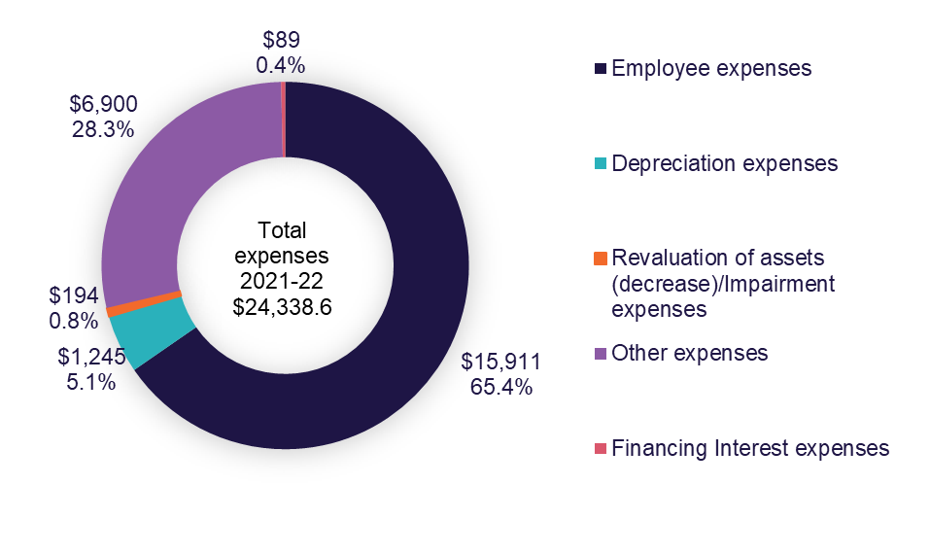
Table 3.8 shows the major expense types for providers, per resident per day, for the 5 years to 2021-22. Over the last five years, total expenses per resident per day have increased from $265.61 to $354.44 per resident per day which represents a 5 per cent increase each year from 2017-18 to 2019-20, followed by a steeper increase of 9.5 per cent in 2020-21 and 2021-22. Other expenses have grown the most rapidly, from $61 to $100.48.
Table 3.8: Summary of residential care provider expenses, per resident per day, 2017-18 to 2021-22
Expenses | 2017-18 | 2018-19 | 2019-20 | 2020-21 | 2021-22
Employee | $187.21 | $190.88 | $201.72 | $214.80 | $231.70
Depreciation | $14.60 | $15.67 | $18.31 | $16.49 | $18.13
Financing interest | $2.81 | $3.02 | $4.67 | $1.40 | $1.30
Revaluation of assets (decrease)/Impairment | - | - | $5.08 | $5.55 | $2.83
Other | $61.00 | $70.08 | $77.50 | $85.56 | $100.48
Total expenses | $265.61 | $279.65 | $307.27 | $323.81 | $354.44
Table 3.9 shows provider expenditure in 2021-22, compared with the previous two years.
Care expenditure relates to the direct costs incurred in providing care for residents within residential care facilities. Care related employee expenses make 50 per cent of total expenditure, making it the largest single expense for providers. This proportion is consistent with recent years. Employee expenses include payments made to nurses, therapists, nutritionists, care managers, health assistants and support staff.
Other care expenses include items such as resident medication, oxygen and related equipment, treatments and procedures, incontinence aids, items that assist mobility, recreation and social activities, rehabilitation support, personal grooming and specific cultural and social events.
Accommodation and finance expenditure, which represents 14.4 per cent of total expenses, relates to the costs incurred in providing accommodation to residents. This includes accommodation, employee expenses, repairs and maintenance, and rent.
Hotel expenditure (which represents 16 per cent of total expenses) relates to the costs incurred in the provision of everyday living services to residents, including employees and contracted services.
Contracted services are payments made to external providers or internal divisions for the provision of catering, cleaning or laundry. Other expenses consist of expenses such as meals, refreshments, other food consumables, bedding materials, toiletry and sanitary goods, cleaning and laundry items.
For leased assets reported in the balance sheet, rent expenses are replaced by depreciation and interest expenses, calculated on the value of the leased asset.
Short-term leases and low value leases are exempt and can still be shown as rent expenses (similar to prior years).
Table 3.9: Breakdown of residential care provider expenses, 2019-20 to 2021-22 ($m)
 | 2019-20 ($m) | 2020-21 ($m) | Change from 2019-20 to 2020-21 ($m) | 2021-22 ($m) | Change from 2020-21 to 2021-22 ($m) | % of total expenses
Care
Employee expenses | $10,162.40 | $10,892.50 | $730.10 | $10,875.60 | ($16.90) | 44.70%
Contracted services | $296.30 | N/A | N/A | $791.20 | $791.20 | 3.30%
Other | $644.80 | $774.60 | $129.80 | $586.80 | ($187.80) | 2.40%
Total care expenses | $11,103.50 | $11,667.10 | $563.60 | $12,253.60 | $586.50 | 50.30%
Accommodation and finance
Employee expenses | $320.50 | $291.50 | ($29.00) | $306.50 | $15.00 | 1.30%
Repairs and maintenance | $472.60 | $515.10 | $42.50 | $474.30 | ($40.90) | 1.90%
Depreciation (i) | $1,267.30 | $1,137.40 | ($129.90) | $1,245.00 | $107.60 | 5.10%
Amortisation | $58.40 | $34.20 | ($24.20) | $812.90 | $778.80 | 3.30%
Rent (i) | $247.00 | $411.60 | $164.60 | $407.20 | ($4.40) | 1.70%
Financing interest (ii) | $323.60 | $96.70 | ($226.90) | $89.30 | ($7.40) | 0.40%
Other | $541.30 | $134.30 | ($407.00) | $179.80 | $45.50 | 0.70%
Total accommodation and finance expenses | $3,230.70 | $2,620.80 | ($609.90) | $3,514.90 | $894.10 | 14.40%
Hotel
Employee expenses | $1,784.70 | $1,899.80 | $115.10 | $1,966.90 | $67.20 | 8.10%
Contracted services | $561.80 | $651.00 | $89.20 | $678.10 | $27.10 | 2.80%
Utilities (iii) | N/A | $459.30 | N/A | $474.60 | $15.30 | 2.00%
Other | $791.90 | $833.00 | $41.10 | $877.00 | $44.00 | 3.60%
Total hotel expenses | $3,138.40 | $3,843.10 | $704.70 | $3,996.70 | $153.60 | 16.40%
Administration
Employee expenses | $1,091.50 | $711.40 | ($380.10) | $811.40 | $100.00 | 3.30%
Management fees (iv) | $606.00 | $1,325.50 | $719.50 | $1,529.60 | $204.10 | 6.30%
Other | $751.30 | $600.40 | ($150.90) | $613.20 | $12.80 | 2.50%
Total administration expenses | $2,448.70 | $2,637.20 | $188.50 | $2,954.20 | $316.90 | 12.10%
COVID-19
Labour costs | $120.00 | $367.80 | $247.40 | $480.80 | $113.00 | 2.00%
Resident support | $20.00 | $34.90 | $14.70 | $36.20 | $1.40 | 0.10%
Preventative measures | $53.00 | $164.80 | $111.60 | $208.90 | $44.10 | 0.90%
Other expenses | $13.00 | $13.30 | ($0.10) | $17.50 | $4.20 | 0.10%
Total COVID-19 expenses | $207 | $580.80 | $373.60 | $743.50 | $162.60 | 3.10%
Other
Revaluation of assets (decrease)/Impairment | $351.60 | $383.00 | $31.40 | $194.00 | ($189.00) | 0.80%
Loss on sale of assets | $17.50 | $25.50 | $8.00 | $17.20 | ($8.30) | 0.10%
Imputed interest expenses on RADs - AASB 16 leases (v) | $561.00 | $483.80 | ($77.20) | $550.10 | $66.30 | 2.30%
Other | $214.20 | $90.70 | ($123.50) | $114.50 | $23.80 | 0.50%
Total other expenses | $1,144.30 | $983.00 | ($161.30) | $875.80 | ($107.20) | 3.60%
Total expenses | $21,272.90 | $22,332.10 | $1,059.20 | $24,338.60 | $2,006.50 | 100.00%
Notes:
- Depreciation of right-of-use assets was reclassified to Rent in 2020-21 FY.
- Financing interest was reclassified to Accommodation & Finance expense in 2021-22 FY.
- Utilities expense was separately collected & reclassified from Accommodation expense to Hotel expense in 2020-21 FY.
- Management Fees included head office Corporate recharge in FY2020-21 and FY2021-22
- AASB 16 Leases, an accounting standard, requires leases to recognise most rental contracts on their balance sheets as right of use assets and corresponding lease liabilities.
Operating performance
Chart 3.7 shows the average EBITDA per resident per year for all residential care providers since 2012-13. EBITDA per resident per year has declined for a fifth year in a row, decreasing from $3,771 in 2020-21 to negative $46 in 2021-22. This is the first negative EBITDA per resident per year result recorded in the past 10 years.
While this decrease followed the trend demonstrated, this decrease was greater than all previous years. This decrease can likely be attributed to a large increase in COVID-19 expenses and increasing labour costs across all expense categories. Total expenses for COVID-19 increased by 27.9 per cent from 2020-21, with providers spending 46.0 per cent more on prevention from $113 million in 2020-21 to $165 million in 2021-22. Across all categories labour costs have increased. Accommodation labour costs increased by 15.4 per cent from $39 million in 2020-21 to $45 million in 2021-22. COVID-19 labour costs increased by 30.7 per cent, from $368 million in 2020-21 to $481 million in 2021-22. The increase in expenses was proportionately greater than the increase in revenue, resulting in the negative EBITDA result for 2021-22.
Chart 3.7: Residential care provider average EBITDA per resident per year, 2012-13 to 2021-22
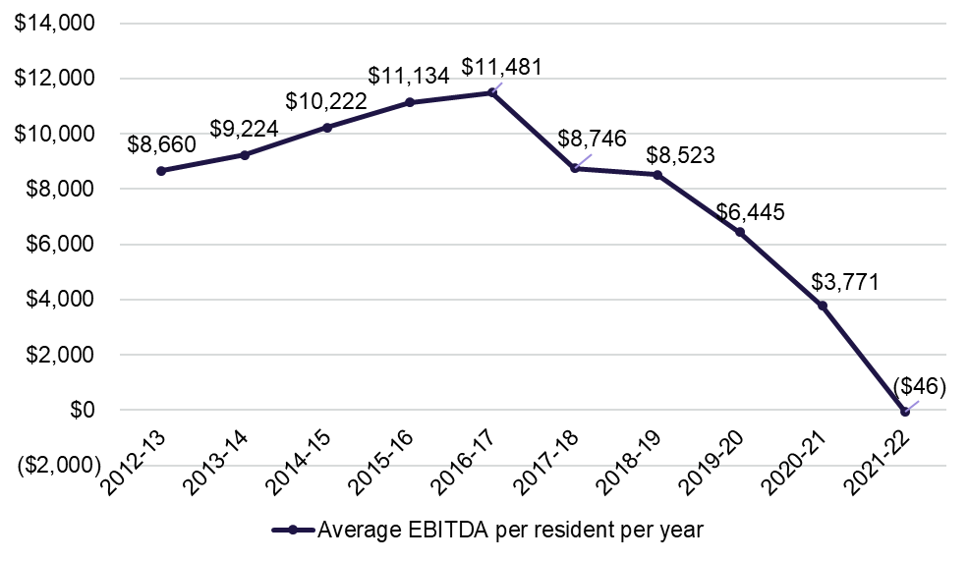
Chart 3.8 presents the EBITDA per resident for 2018-19 to 2021-22 by provider performance quartiles. The average EBITDA per resident per year declined in all quartiles.
The decline since 2018-19 has been far greater for providers in the bottom two quartiles (173 per cent and 88 per cent decrease respectively) than the top two quartiles (27 per cent and 65 per cent decrease respectively).
Chart 3.8: Residential care provider comparative EBITDA per resident per year, 2018-19 to 2021-22, by quartile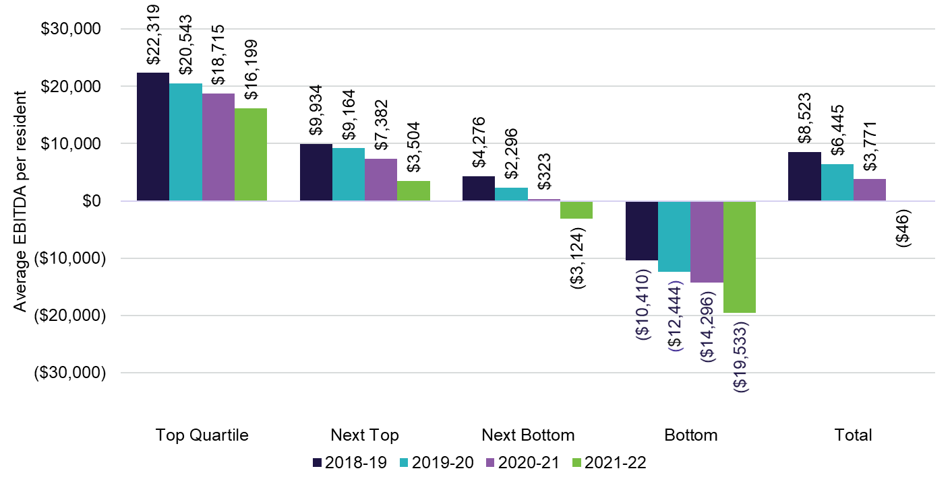
Chart 3.9 shows the performance ratios for the last 3 years by provider ownership type, for both EBITDA and NPBT. In 2021-22, the EBITDA margin for not-for-profit providers was negative 1.2 per cent, down from 3.5 per cent in 2020-21 and 5.4 per cent in 2019-20. For-profit providers also had a declining EBITDA margin of 2.4 per cent, down from 4.4 per cent in 2020–21, and down from 8.5 per cent in
2019-20.

Chart 3.9: Residential care provider operating performance ratios, by ownership type, 2019-20 to 2021-22
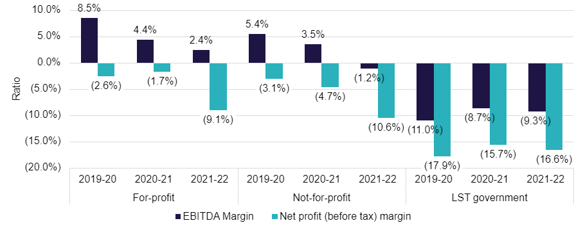
Ownership type
Chart 3.10 3.10 shows the average EBITDA per resident per year for the last 4 years, by provider ownership type. The EBITDA per resident decreased for not-for-profit and for-profit providers. In 2021-22, for-profit providers reported an EBITDA per resident of $2,920, down from $5,162 in 2020-21 (43 per cent decrease). Not-for-profit providers significantly decreased their EBITDA result, from $3,848 in 2020-21 to a negative result of $1,294 (134 per cent decrease) in 2021-22.
The most significant deterioration in EBITDA result was seen in local, state and territory government providers, which declined from negative $1,036 in 2018-19 to negative $13,660 in 2021-22. Local, state and territory government providers reported high expenditure proportionate to revenue in comparison with for-profit and not-for-profit providers, which contributed to the average EBITDA per resident per year result.
Chart 3.10: EBITDA per resident per year, by ownership type, 2018-19 to 2021-22
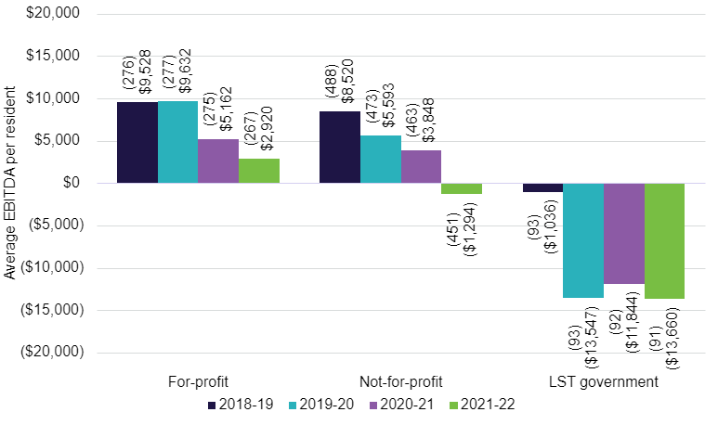
Chart 3.11 shows the average EBITDA per resident per year for residential care providers by quartile and ownership type. The average EBITDA per resident per year in the top quartile was $16,199 while the average in the bottom was negative $19,533. For-profit providers outperformed not-for-profit providers in the top quartile and in the bottom quartile. Not-for-profit providers slightly outperformed for-profit providers in the middle two quartiles.
Not-for-profit providers had a relatively even proportion of providers in each quartile range with the highest proportion being in the next bottom quartile. For-profit providers’ proportions were skewed more towards the top two quartiles with 35 per cent being in the top quartile. Finally, local, state or territory government providers were overwhelmingly in the bottom quartile with approximately 65 per cent of all local, state or territory government providers in this quartile.
Chart 3.11: Residential care provider average EBITDA per resident per year, by quartile (number of providers in parentheses), by ownership type, 2021-22
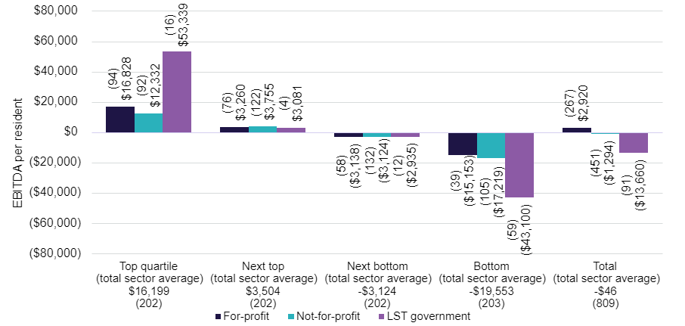 Chart 3.12 shows residential care provider EBITDA per resident by provider location for the last 5 years. Metropolitan providers once again significantly outperformed regional providers with an EBITDA per resident of $1,703 in 2021-22, compared with negative $5,325 for regional providers. Since 2017-18, the EBITDA per resident has declined by 83 per cent for metropolitan providers and 297 per cent for regional providers.

Chart 3.12: Residential care provider EBITDA per resident, by provider location, 2017-18 to 2021-22
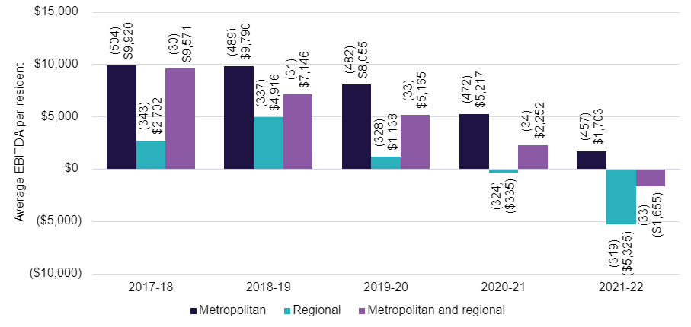
Chart 3.13 residential care provider EBITDA per resident per year by quartile and location. Regional providers in the top quartile reported an average EBITDA per resident of $19,166 which was higher than metropolitan providers who reported $15,624. Regional providers in the bottom quartile reported an average EBITDA of negative $29,516 and metropolitan providers reported an average EBITDA of negative $19,259 per resident per year.
Metropolitan providers had a relatively consistent split between the quartiles, ranging from 20.6 per cent in the bottom quartile to 27.8 per cent in the top quartile. However, regional providers had a much larger proportion of providers in the bottom quartile with 32.3 per cent. Of the providers who operated across metropolitan and regional areas, 45 per cent of them were in the second highest quartile, while 24.2 per cent were in the second lowest quartile.
Chart 3.13: Residential care provider average EBITDA per resident per year, by quartile (number of providers in parentheses), by location, 2021-22
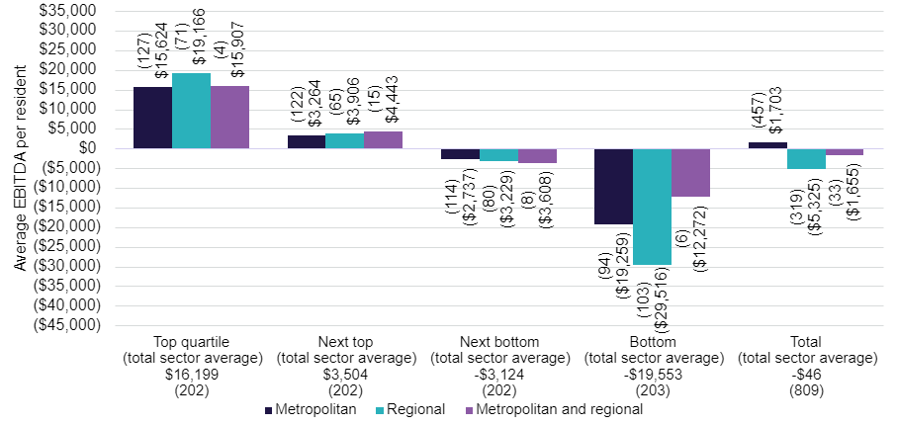
Chart 3.14 residential care provider average EBITDA per resident per year by quartile and scale. Providers with 2 to 6 facilities in the top quartile reported $19,584 EBITDA per resident, which was higher than the other providers who were also in the top quartile. Providers with 20 or more facilities in the top quartile reported an average EBITDA per resident of $9,928.
Single facility providers had relatively consistent proportions in each quartile, with a range from 22.5 per cent in the bottom quartile to 26.3 per cent in the top quartile. Providers operating 2 to 6 facilities had the largest proportion in the bottom quartile with 29.4 per cent of providers. However, there was also a relatively consistent split across the other quartiles with 24.9 per cent operating in the top quartile, 21.7 per cent in the next top and 24 per cent in the third quartile. Providers who operate between 7 and 19 facilities had the highest proportions in the bottom with 32.7 per cent and the second quartile with 30.9 per cent. Finally, providers with 20 or more facilities had the highest proportions in the middle two quartiles, with 39.1 per cent being in the second highest quartile and 30.4 per cent in the second lowest quartile.
Chart 3.14: Residential care provider average EBITDA per resident per year, by quartile (number of providers in parentheses), by provider scale, 2021-22
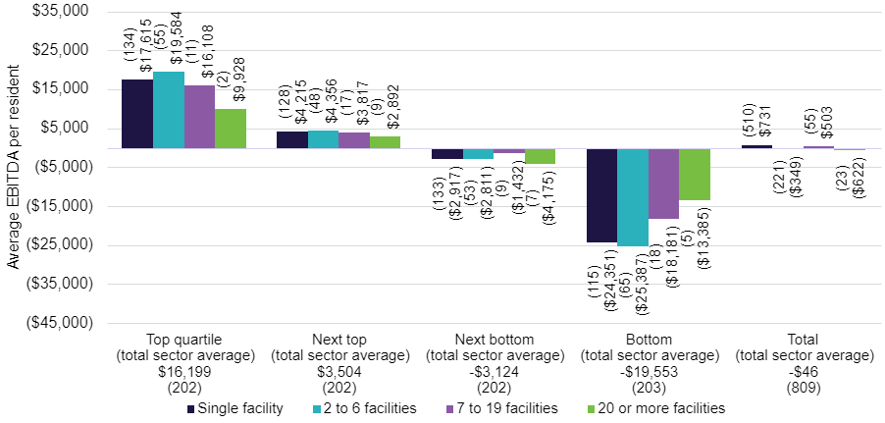
Chart 3.15 shows residential care provider EBITDA per resident per year by provider scale for the last 4 years. In 2021-22, providers with single facilities were the best performing, reporting an average EBITDA of $731 per resident per year. Providers with 7 to 19 facilities were the next best with EBITDA per resident of $503. Providers with 20 or more facilities reported the lowest EBITDA for 2021-22 (negative $622).
Chart 3.15: Residential care provider EBITDA per resident per year, by provider scale (number of providers in parentheses), 2018-19 to 2021-22
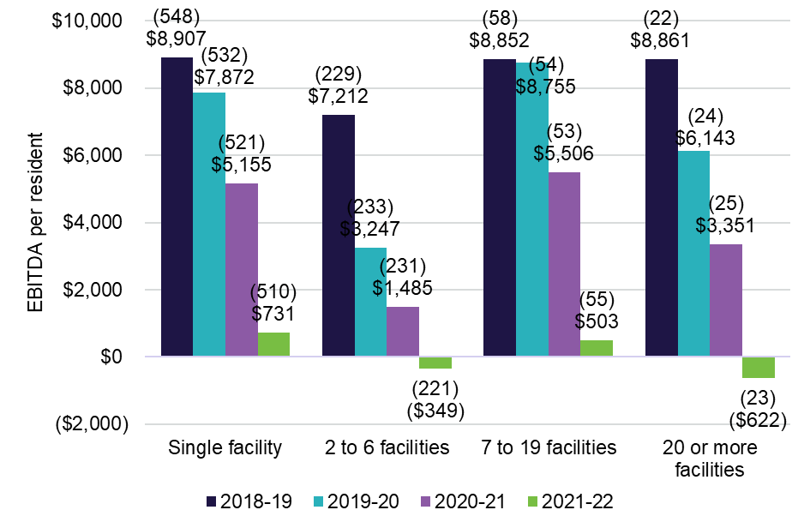
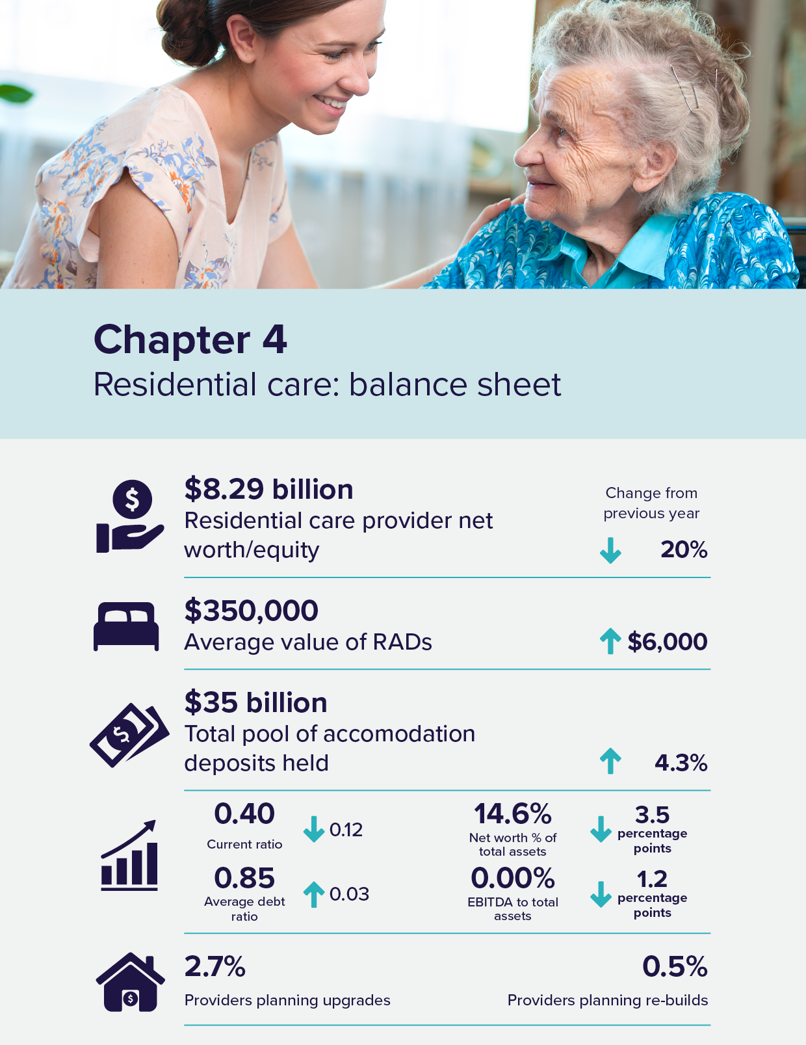

Residential care: balance sheet
Capital for residential care providers is comprised of:
- equity, including retained earnings
- loans from financial or other institutions
- interest free loans from residents in the form of lump sum Refundable Accommodation Deposits (RADs) (bonds pre 1 July 2014)
- capital investment support from the Australian Government by way of capital grants for eligible projects and
- capital endowments.
Lump sum RADs paid by residents, which act as interest free loans to providers, were a significant source of funding for capital investment in residential care.
The investment of accommodation deposits held by providers was a source of interest income, included in the accommodation and finance income reported by providers in their operating statement.
As an alternative to RADs, residents can choose to pay a Daily Accommodation Payment (DAP) or a combination of a RAD and DAP. Partially supported residents contribute towards their accommodation costs through a Refundable Accommodation Contribution (RAC) or Daily Accommodation Contribution (DAC). Fully supported residents cannot be asked to contribute towards their accommodation costs. In this report, references to RADs also include RACs and references to DAPs include DACs.

Balance sheet
Table 4.1 shows a high-level balance sheet summary for residential care providers for the last 5 years. At 30 June 2022, the sector had total assets of $56.6 billion, the first decrease in the past 5 years. Financial assets were $7 billion, down from $8.3 billion in 2020-21.
RADs held in the sector increased to $35.5 billion. In 2021-22, the $35.5 billion in total RADs includes RAD receivables of $965 million, RADs which were expected in 2021-22 but were not received. Excluding RAD receivables would result in a net balance sheet RAD liability of $34.54 billion, which is comparable to the reported $33.3 billion in 2020-21.
This net balance of RADs varies from the amount reported in Chart 4.3 ($35 billion), as $35.5 billion is the amount reported in providers’ balance sheets and includes accounting adjustments and accruals.
Net worth/equity was $8.3 billion, down from $10.4 billion in 2020-21, which is primarily because of current year losses of $2.3 billion.
Table 4.1: Balance sheet of residential care providers, 2017-18 to 2021-22
Assets/liabilities | 2017-18 ($m) | 2018-19 ($m) | 2019-20 ($m) | 2020-21 ($m) | 2021-22 ($m)
Financial assets | $9,047 | $9,248 | $8,931 | $8,274 | $7,012
Fixed assets | $24,061 | $27,997 | $27,675 | $28,241 | $29,995
Right of use assets | - | - | $2,933 | $2,694 | $2,757
Other assets | $15,292 | $15,323 | $16,862 | $18,114 | $16,867
Total assets | $48,400 | $52,568 | $56,401 | $57,323 | $56,631
Refundable accommodation deposits | $27,523 | $30,183 | $32,205 | $34,231 | $35,507
Lease liabilities | - | - | $2,976 | $2,790 | $2,768
Other liabilities | $9,050 | $9,703 | $9,663 | $9,941 | $10,063
Total liabilities | $36,573 | $39,886 | $44,844 | $46,962 | $48,338
Net worth/equity | $11,827 | $12,682 | $11,557 | $10,361 | $8,292
Note:
- AASB 16 Leases, a new accounting standard now requires providers to recognise most rental contracts on their balance sheets as right of use assets and corresponding lease liabilities.
- Short-term leases and low value leases are exempt and can still be shown as rent expense (similar to previous years).
- The $35.5 billion in RADs held at the sector level in 2021-22 does not include $53 million of RADs held by Multi-Purpose Services.
Ownership type
Table 4.2 shows liabilities and net worth/equity as a proportion of total assets by ownership type. At 30 June 2022, RADs accounted for approximately 65 per cent of both for-profit and not-for-profit total assets.
For-profit providers had a higher proportion of liabilities, with their total liabilities being 98 per cent of total assets, compared with not-for-profit providers with 78 per cent.
Table 4.2: Balance sheet, by ownership type, at 30 June 2022 ($m)
 | For-profit ($m) | Not-for-profit ($m) | LST government ($m) | Total sector ($m)
Total assets funded by: | $26,319 | $27,649 | $2,663 | $56,631
Refundable accommodation deposits | $16,978 | $17,853 | $676 | $35,507
Other liabilities (i) | $8,773 | $3,638 | $420 | $12,831
Total liabilities | $25,751 | $21,492 | $1,096 | $48,338
Net worth/equity | $567 | $6,158 | $1,567 | $8,292
As a % of total assets
Refundable accommodation deposits | 64.51% | 64.57% | 25.39% | 62.70%
Other liabilities | 33.33% | 13.16% | 15.75% | 22.66%
Total liabilities | 97.85% | 77.73% | 41.14% | 85.36%
Net worth/equity | 2.15% | 22.27% | 58.86% | 14.64%
Note:
- Other liabilities refers to the current and non-current liabilities listed in Table 4.3 including, accommodation deposits, bank borrowings, related party loans, employee provisions, lease liabilities and other liabilities
Table 4.3 presents the consolidated balance sheet at segment and organisation level for 2021-22.
Fixed assets (predominantly residential aged care facilities) were the single largest asset category held by providers ($30 billion or 53 per cent of total assets). Fixed assets represented 68 per cent of total assets for not-for-profit providers and 35 per cent for for-profit providers.
For the sector, cash ($4 billion) and current financial assets ($2.1 billion) represent 11 per cent of total assets (13 per cent in 2020-21) and 55 per cent of current assets. Again, there are differences between ownership types, with not-for-profit providers holding 71 per cent of current assets in cash and financial assets, while for-profit providers hold only 32 per cent. For-profit providers are more active in placing their funds in other categories of assets, including loans to related party entities.
Intangible assets make up 8 per cent, or $4.3 billion, of total sector assets. Of this, bed licences make up $2 billion. From 1 July 2024, residential care places will be assigned directly to people rather than to providers. This reform, to remove the allocation of places to providers, will affect the intangible assets of those providers who currently recognise the value of their bed licences. Bed licences decreased from $3.2 billion at 30 June 2021 to $2 billion at 30 June 2022, as providers commenced the process of accounting for this change. Providers will write off the remaining $2 billion in bed licences through their operating statement over the next two years. This will continue to impact the sector’s total expenses until 30 June 2024. However, this $2 billion write off of bed licences will not impact the sector’s cash balance as there is no cash outflow.
Table 4.3: Disaggregated balance sheet by provider ownership type, at 30 June 2022 ($m)
 | For-profit ($m) | Not-for-profit ($m) | LST government ($m) | All providers ($m)
Assets
Current assets
Cash | $1,208 | $2,517 | $226 | $3,951
Financial assets | $216 | $1,691 | $163 | $2,070
Trade receivables | $157 | $325 | $43 | $525
RADs & RACs receivable | $551 | $311 | $102 | $965
Related party loans | $2,003 | $648 | $0 | $2,651
Other current assets | $301 | $408 | $19 | $728
Total current assets | $4,437 | $5,900 | $553 | $10,890
Non-current assets
Financial assets | $489 | $414 | $88 | $991
Related party loans | $5,374 | $140 | $1 | $5,516
Work in progress | $406 | $760 | $90 | $1,257
Intangibles - bed licences | $1,593 | $438 | $0 | $2,031
Intangibles - other | $1,828 | $418 | $1 | $2,247
Fixed assets | $9,314 | $18,765 | $1,917 | $29,995
Right of use assets | $2,249 | $504 | $3 | $2,757
Other non-current assets | $629 | $310 | $10 | $949
Total non-current assets | $21,881 | $21,750 | $2,110 | $45,741
Total assets | $26,319 | $27,649 | $2,663 | $56,631
Liabilities
Current liabilities
Accommodation deposits (incl. bonds) | $10,587 | $10,218 | $365 | $21,170
Bank borrowings | $636 | $203 | $2 | $841
Related party loans | $1,060 | $24 | $1 | $1,085
Employee provisions | $699 | $1,109 | $122 | $1,930
Lease liabilities | $174 | $37 | $2 | $213
Other current liabilities | $1,125 | $781 | $170 | $2,076
Total current liabilities | $14,282 | $12,372 | $662 | $27,315
Non-current liabilities
Accommodation deposits (incl. bonds) | $6,391 | $7,636 | $311 | $14,337
Bank borrowings | $999 | $684 | $54 | $1,736
Related party loans | $1,197 | $112 | $0 | $1,309
Employee provisions | $111 | $185 | $39 | $334
Lease liabilities | $2,233 | $322 | $0 | $2,555
Other non-current liabilities | $540 | $181 | $30 | $751
Total non-current liabilities | $11,470 | $9,120 | $433 | $21,023
Total liabilities | $25,751 | $21,492 | $1,096 | $48,338
Net assets | $567 | $6,158 | $1,567 | $8,292
Note:
- The residential disaggregated balance sheet above does not include Accommodation Deposit balances held by Multi-Purpose Services

Liabilities
Chart 4.1 shows residential care provider liability types as a proportion of total assets for the last 5 years. Liabilities include the current and non-current liabilities listed in Table 4.3 (e.g. accommodation deposits, bank borrowings, related party loans, employee provisions, lease liabilities and other liabilities). In 2021-22, total liabilities increased to 85.4 per cent, up from 81.9 per cent the previous year. Net worth/equity was 14.6 per cent, a decrease from 18.1 per cent the previous year. This is the third year in a row that there has been a noticeable decrease in net worth/equity as a proportion of total assets, declining from around 24 per cent prior to 2019-20.
Chart 4.1: Residential care provider liability types as a proportion of total assets, 2017-18 to 2021-22
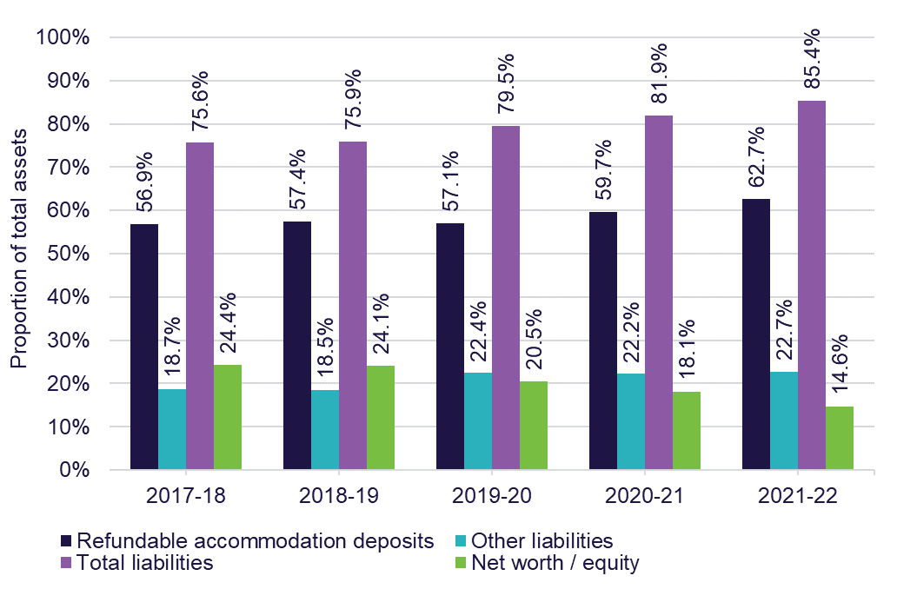
Liabilities by ownership type
Chart 4.2 shows the liabilities and net worth/equity as a proportion of total assets by ownership type for the last 3 years. The proportion of net worth/equity of not-for-profit providers was significantly higher (between 22 and 31 per cent), compared with for-profit providers (between 2 and 7 per cent).

Chart 4.2: Liabilities and net worth as a proportion of total assets, by ownership type, 2019-20 to 2021-22
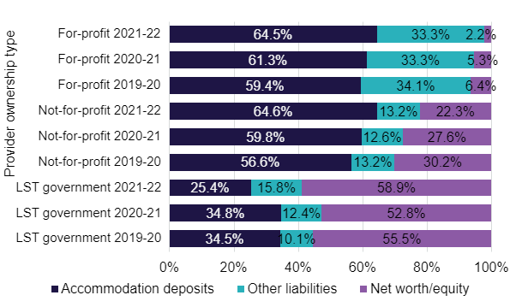
Accommodation deposits
Table 4.4 shows the average value of RADs held by providers for the last 5 years. The average value of RADs continued to increase each year. At 30 June 2022, there were 100,010 RADs held across providers with an average value of $350,000.
Table 4.4: Average value of RADs held by providers, 2017-18 to 2021-22
Year | 2017-18 | 2018-19 | 2019-20 | 2020-21 | 2021-22
Average value of RAD | $303,000 | $318,000 | $334,000 | $344,000 | $350,000
Note: The above calculation uses RADs from both residential aged care providers and multi-purpose facilities
Chart 4.3 shows the total pool of accommodation deposits held by providers since 2014-15, as well as the number of deposits held. The total value of accommodation deposits held by providers continued to grow, from $18.21 billion in 2014–15 to $35 billion in 2021-22. While the value of accommodation deposits continued to grow, the number of accommodation deposits held plateaued.

Chart 4.3: Total value and total number of accommodation deposits held, 2014-15 to 2021-22
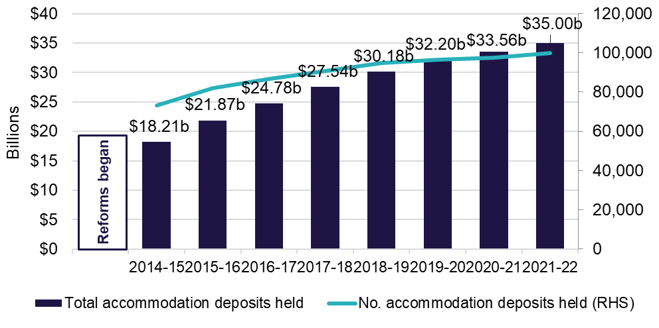Chart 4.4 shows the residents method of accommodation payments for the last 5 years. While the value of accommodation deposits continued to grow, there was a gradual trend away from RADs in favour of DAPs.
The proportion of residents choosing RAD/RACs steadily dropped from 37 per cent in 2017-18 and plateaued in 2020-21 and 2021-22 at 31 per cent.
The proportion of residents choosing DAP/DACs gradually increased from 40 per cent in 2017-18 to 48 per cent in 2021-22.
The trend has been in favour of DAPs in recent years, as low interest rates, opportunity cost of capital gains on the family home and shorter expected length of stay on entry to residential aged care have all made DAPs relatively more appealing. However, the Maximum Permissible Interest Rate has increased rapidly since June 2022, making DAPs significantly higher and less attractive than in 2021-22. Anecdotal evidence indicates that the trend in the declining use of RADs will reverse in 2022-23.
Chart 4.4: Resident method of accommodation payment, 2017-18 to 2021-22
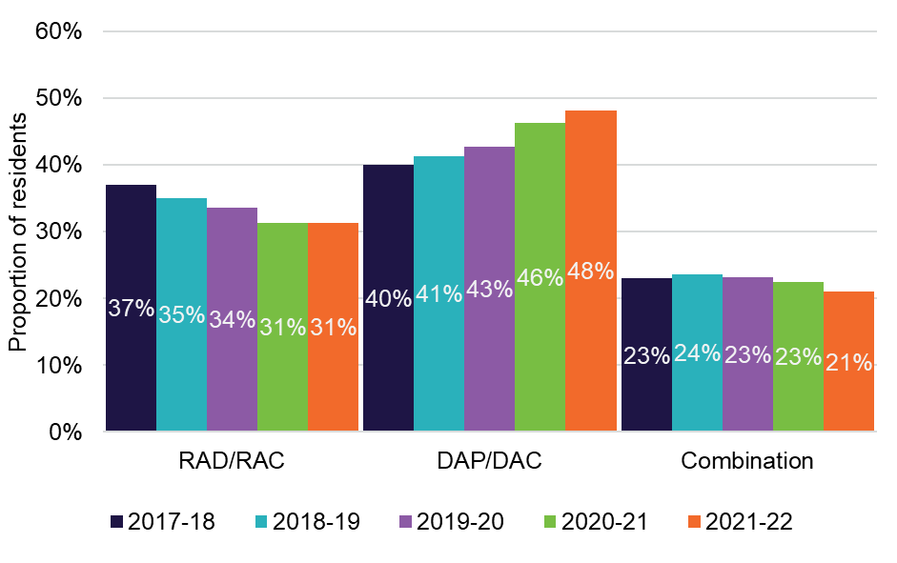
Chart 4.5 shows resident choice of payment method by ownership type for the last 5 years. The decrease in the proportion of RAD/RACs has been noticeable for not-for-profit providers, down from 34 per cent in 2017-18 to 28 per cent in 2021-22. However, there has been a slight increase on 2020-21, by 1 percentage point.
The proportion of residents in for-profit providers choosing RAD/RACs has consistently been higher than the proportion of residents in not-for-profits. However, RAD/RAC take up in for-profit providers also steadily decreased, dropping from 43 per cent in 2017-18 to 36 per cent in 2021-22.
Even though the proportion of new residents that chose to pay their accommodation deposit fully (100 per cent) through a RAD decreased, more than 50 per cent of residents (52 per cent) chose to pay for their accommodation by RAD either in full or in combination with a DAP. This means that the proportion of RADs to the total number of residents is increasing every year.
Chart 4.5: Resident choice of payment method, by ownership type, 2017-18 to 2021-22
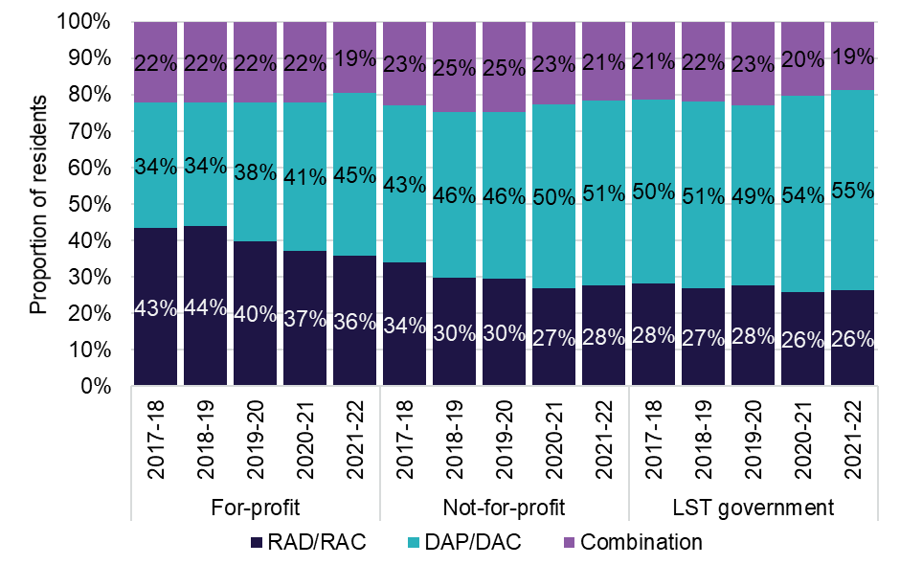
Chart 4.6 shows resident choice of payment by location for the last 5 years. The proportion of RAD/RACs continued to drop in metropolitan areas, falling from 39 per cent in 2017-18 to 33 per cent in 2021-22.
In regional areas, the proportion of RAD/RACs slightly increased from 2020-21 (29 per cent) to 2021-22 (30 per cent), however, this has decreased from 35 per cent in 2017-18 to 30 per cent in 2021-22.
In remote areas, the proportion of RAD/RACs dropped from 29 per cent in 2017-18 to 23 per cent in 2021-22. However, there was a slight increase on 2020-21 by
1 percentage point.
Chart 4.6: Resident choice of payment method, by location, 2017-18 to 2021-22
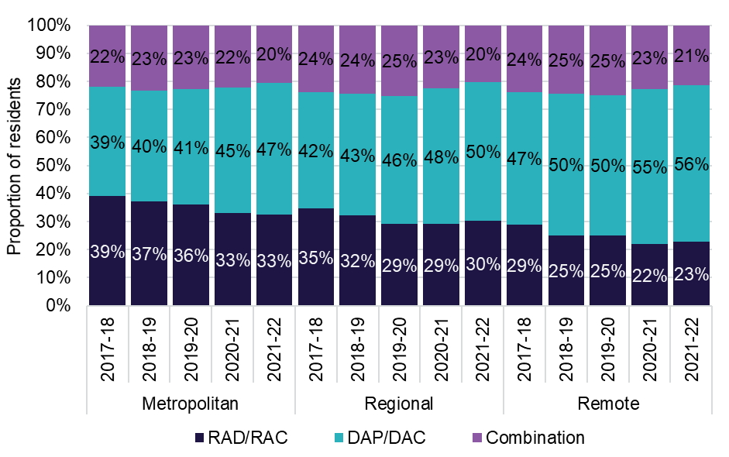
Chart 4.7 shows resident choice of payment method by partially supported and non-supported residents for the last 5 years.
There continued to be a large difference in residents’ payment preference between non-supported residents and partially supported residents.
In 2021-22, 39 per cent of non-supported residents chose to pay their accommodation payment by a RAD/RAC, whereas only 4 per cent of partially supported residents chose this option.
Chart 4.7: Resident choice of payment method, by partially supported and non-supported residents, 2017-18 to 2021-22
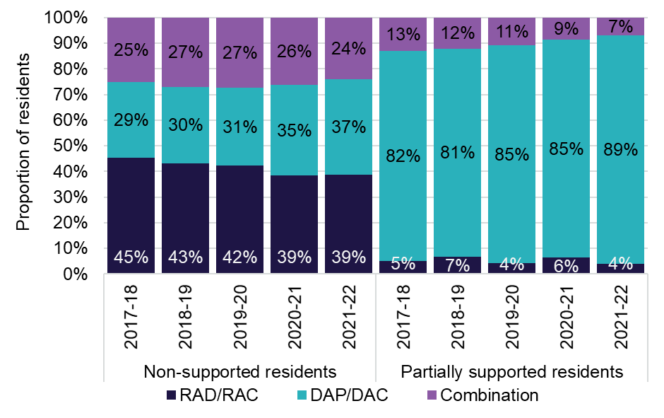

Accommodation deposit prices
Chart 4.8 shows average agreed and published accommodation prices by ownership type for the last 7 years. Published prices are the price advertised by the provider. Residents can negotiate accommodation prices with their provider and the subsequent outcome is the agreed price. This data includes RADs, DAPs and combination payments and covers the price of a residential care room, not the method of payment. For-profit providers have consistently higher published and agreed prices than not-for-profit providers. However, agreed prices for both for-profit and not-for-profit providers are consistently lower than the published prices.
The Aged Care Pricing Commissioner (IHACPA from 2023-24) publish a schedule of fees throughout the year which determines a maximum amount a provider can charge for a RAD. In 2021-22, the maximum RAD a provider could charge without prior approval from the Aged Care Pricing Commission was $550,000.
The overall average agreed price for the sector was $413,000 and the overall average published price for the sector was $466,000, around $53,000 more. In 2021-22, for-profit provider agreed accommodation prices were $426,000 on average, compared with the published accommodation prices that were $500,000 on average. Not-for-profit providers agreed accommodation prices in 2021-22 were $411,000 on average, compared with the published prices of $457,000 on average. This shows that providers are consistently charging less for their rooms than their advertised accommodation prices likely due to the provider and residents negotiating a lower price.
Chart 4.8: Average agreed and published accommodation prices (lump sum equivalent), by ownership type, 2015-16 to 2021-22
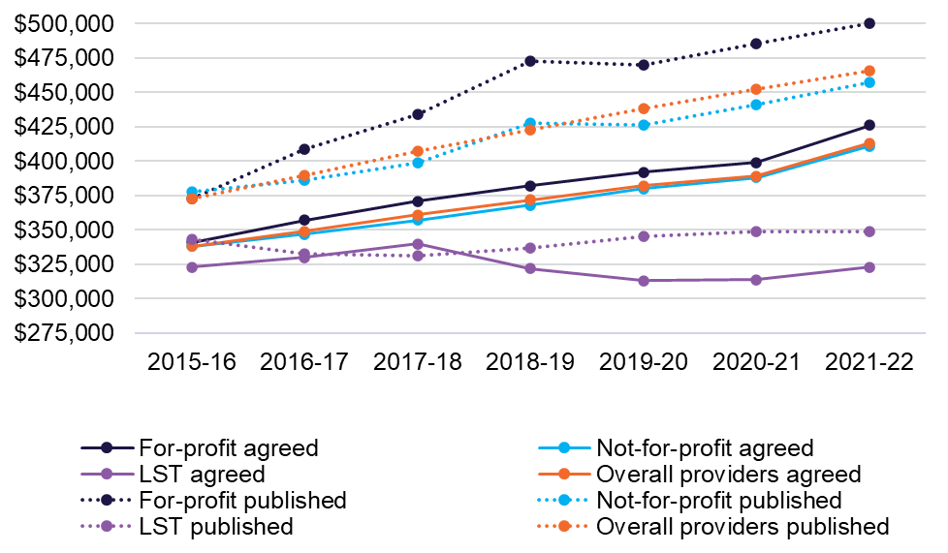
Chart 4.9 shows average agreed and published accommodation prices by location for the last 7 years. As has been the case in previous years, the average published and agreed price in metropolitan areas was significantly higher than in regional and remote areas. In 2021-22, the average published price for metropolitan areas was $505,000, and the average agreed price was $445,000. For regional areas, the average published price was $383,000, and the agreed price was $344,000. For remote areas the average published price was $316,000, and the average agreed price was $280,000.
Chart 4.9: Average agreed and published accommodation prices (lump sum equivalent), by location, 2015-16 to 2021-22
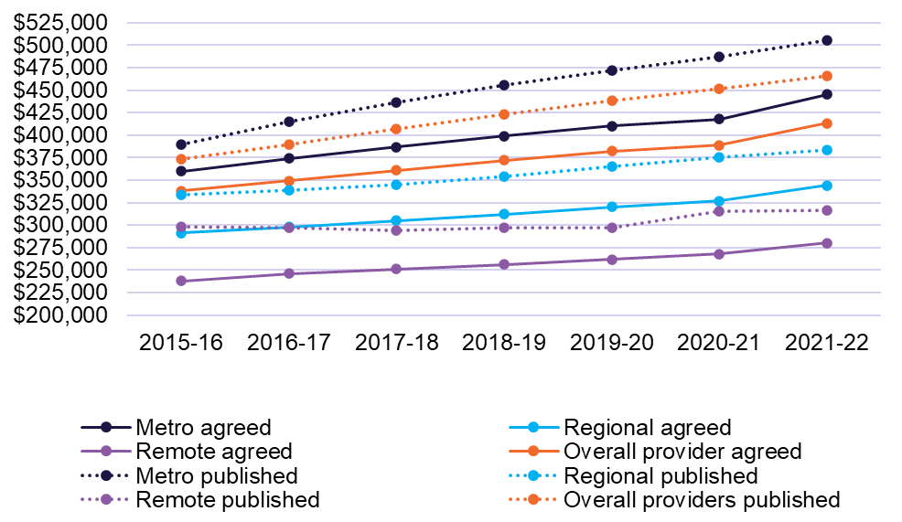
Balance sheet performance ratios
Balance sheet ratios provide a guide as to the financial health of providers through an analysis of their profitability, liquidity and efficiency as well as their net worth. Definitions for the balance sheet ratios are included within the Glossary.
Chart 4.10 shows earnings before interest, tax, depreciation and amortisation (EBITDA) to total assets by provider ownership type for the last 5 years.
The EBITDA to total assets trended downwards in recent years, falling for the whole sector from 3.3 per cent in 2017-18 to 0 per cent in 2021-22. The EBITDA to total assets ratio measures how efficiently a provider is generating EBITDA; a ratio of
0 per cent means they are generating no EBITDA return.
In terms of ownership, for-profit providers dropped to 0.8 per cent in 2021-22, down from 1.5 per cent in 2020-21, and down from 4 per cent in 2017-18. The decline was even greater for not-for-profit providers, down to negative 0.5 per cent in 2021–22, from 1.4 per cent in 2020-21 and 3.1 per cent in 2017-18.
Chart 4.10: EBITDA to total assets, by ownership type, 2017-18 to 2021-22
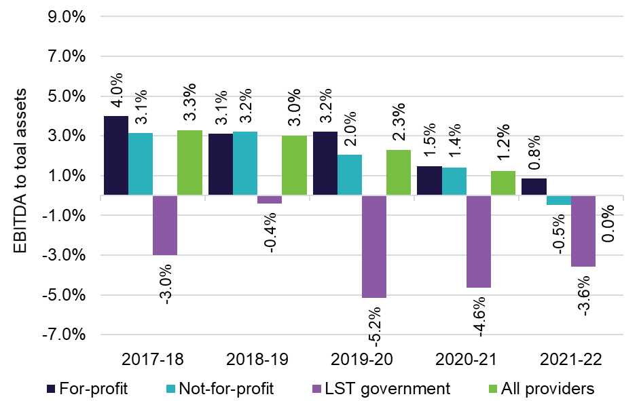Chart 4.11 shows the current ratio by ownership type for the last 5 years. The current ratio is a measure of a provider’s ability to meet its short-term liabilities (for example, debts due within one year) using their short-term assets (for example, assets easily converted into cash). The current ratio for all providers decreased in 2021-22, down to a sector median of 0.40, from 0.52 in 2020-21.
The current ratio for not-for-profit providers decreased, down from 0.65 in 2020-21 to 0.48 in 2021-22, and the current ratio for for-profit providers also decreased to 0.31 from 0.40.
Chart 4.11: Current ratio, by ownership type, 2017-18 to 2021-22
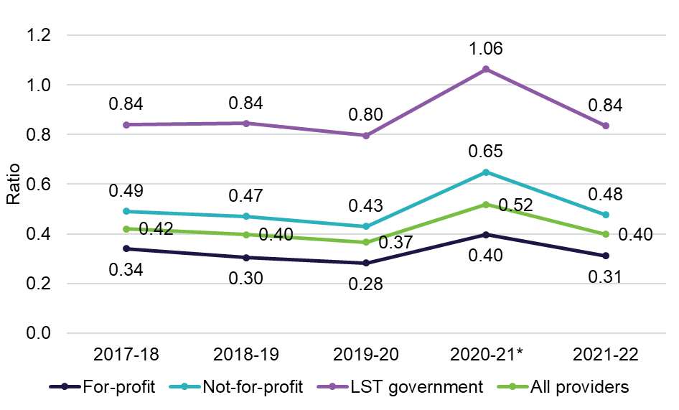
Note: * The increase in current ratio from 2020-21 is due to Refundable Accommodation Deposits (RADs) which are expected to be paid after 12 months being re-classified from current liabilities to non-current liabilities.
Chart 4.12 shows equity to total assets by provider ownership type for the last 5 years. The results for not-for-profit and for-profit provider types gradually decreased in the past 5 years. Not-for-profit providers dropped to 22.3 per cent from 27.6 per cent and for-profit providers reported a drop to 2.2 per cent from 5.3 per cent. There continued to be a notable difference between provider types when looking at the results for the equity to total assets ratio. Not-for-profit providers were generally around 20 to 25 percentage points higher than for-profit providers.
Chart 4.12: Equity to total assets, by ownership type, 2017-18 to 2021-22
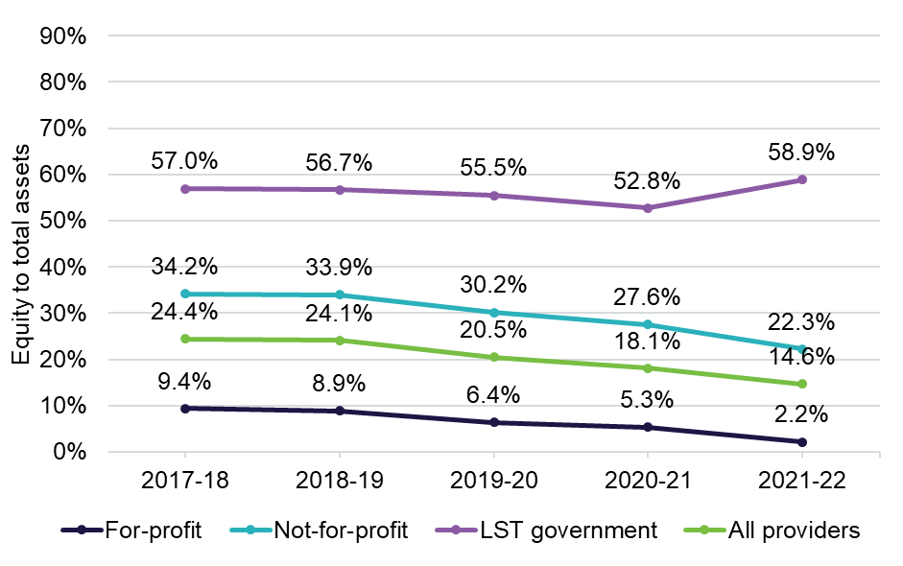
Chart 4.13 shows the average debt ratio by provider ownership type for the last 5 years. The average debt ratio across the sector gradually increased over the last 5 years from 0.76 in 2017-18 to 0.85 in 2021-22.
In 2021-22, for-profit providers reported an increase from 0.95 the previous year to 0.98 and not-for-profit providers reported an increase from 0.72 the previous year to 0.78.
The average debt ratio shows the proportion of organisational assets that were financed through debt. A ratio of more than 1.0 indicates that an organisation has a higher debt level than the value of its assets.
Chart 4.13: Average debt ratio, by ownership type, 2017-18 to 2021-22
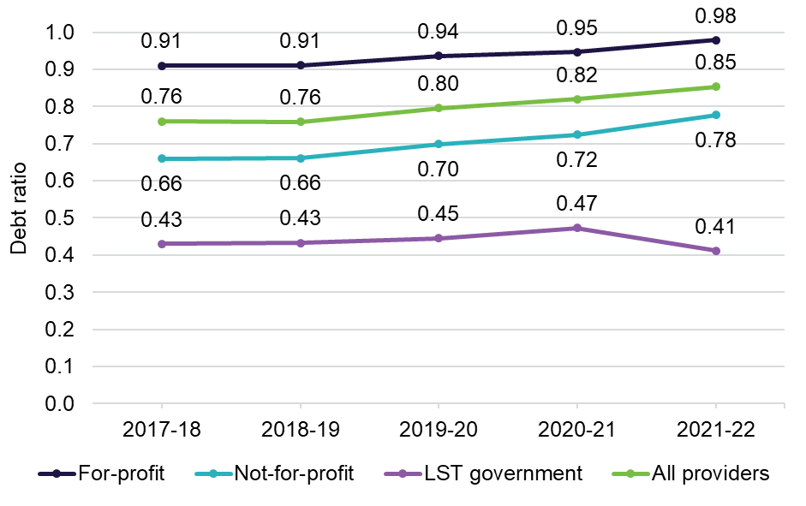
Chart 4.14 shows net assets by provider ownership type for the last 5 years.
Net assets continued to decline to $8.29 billion in 2021-22, down from $10.36 billion in 2020-21 and a peak of $12.68 billion in 2018–19. In 2021-22, for-profit providers reported a decrease to $567 million, down from $1.42 billion (representing a 60 per cent decline). Not-for-profit providers decreased to $6.16 billion in 2021-22, down from $7.96 billion (representing a 23 per cent decline).
Chart 4.14: Net assets, by ownership type, 2017-18 to 2021-22
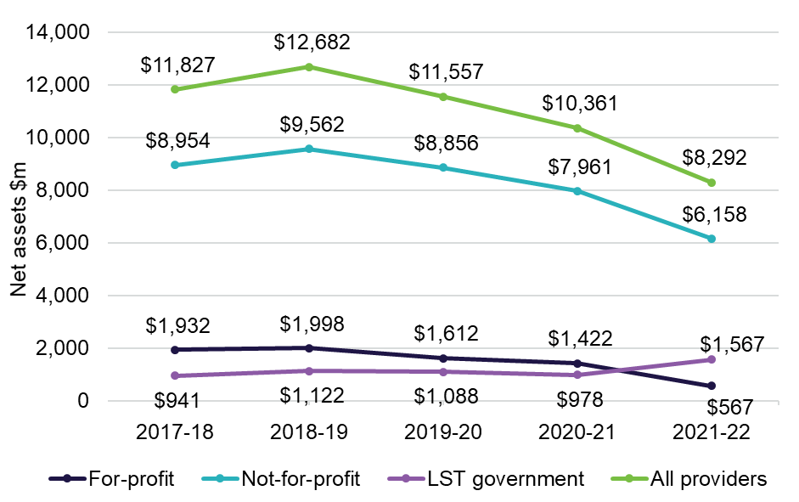
Chart 4.15 cash held as a percentage of accommodation deposit balances by provider ownership type for the last 3 years.
Cash held as a percentage of accommodation deposit balances provides an indication of an organisation’s capacity to repay the accommodation deposit balances from liquid resources. The levels of cash and cash equivalents held by for-profit providers has been around half that of not-for-profit providers. Both not-for-profit and for-profit providers’ cash holdings decreased in 2021-22. Not-for-profit providers decreased to 14.10 per cent in 2021-22, down from 20.91 per cent in
2020-21, while for-profit providers were down to 7.12 per cent from 8.76 per cent the previous year.
Chart 4.15: Cash held as percentage of accommodation deposit balances, by ownership type, 2019-20 to 2021-22
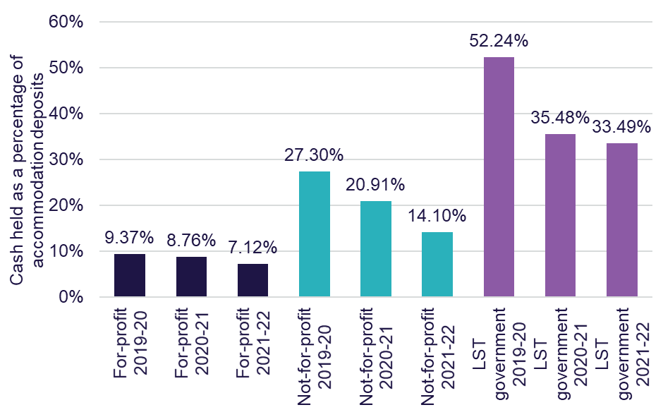
Chart 4.16 shows total assets, net worth/equity and average accommodation deposit value per resident, by ownership type in 2021-22, compared with 2020-21. For the whole sector, the average amount of accommodation deposits held increased to $350,258 per resident, up from $344,372 in 2020-21, an increase of 1.7 per cent. This metric measures the average value of all bonds (pre 1 July 2014) and accommodation deposits (post 1 July 2014) that providers hold.
In terms of net worth/equity, all providers recorded a decrease, down to $45,852 per resident in 2021-22 from $56,400 in 2020-21. The value of total assets per resident for both for-profit and not-for-profit providers also decreased in 2021-22 compared with 2020-21.
Chart 4.16: Total assets, net worth/equity and average accommodation deposit value per resident, by ownership type, 2020-21 and 2021-22
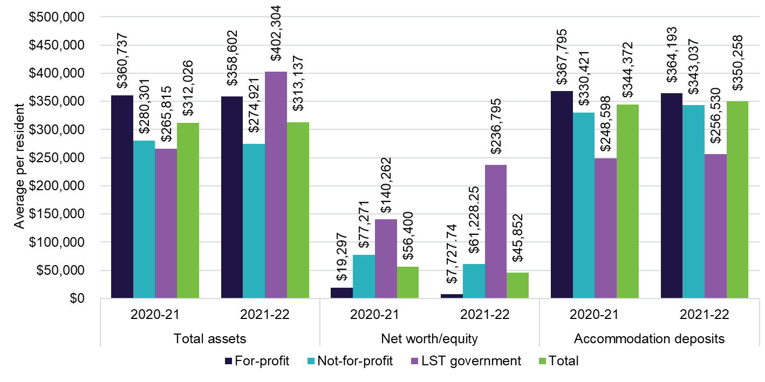
Recent trends in building and investment in residential care
Chart 4.17 shows residential care building activity (completed or in-progress) for the last 5 years. In 2021-22, the total value of completed, or in-progress work was $3.8 billion, down from $4.7 billion in 2020-21 (18.5 per cent decrease).
Expenditure on new buildings dropped by 17.1 per cent in 2021-22, while expenditure on rebuilding activity also dropped, down 14.5 per cent.
The decrease in expenditure is partly attributable to the ongoing fragility and volatility in the broader construction sector which has led to supply chain disruptions, builder shortages and significant cost increases. This has led to lower levels of building activity in the residential aged care sector.
Chart 4.17: Residential care building activity (completed or in-progress), 2017-18 to 2021-22
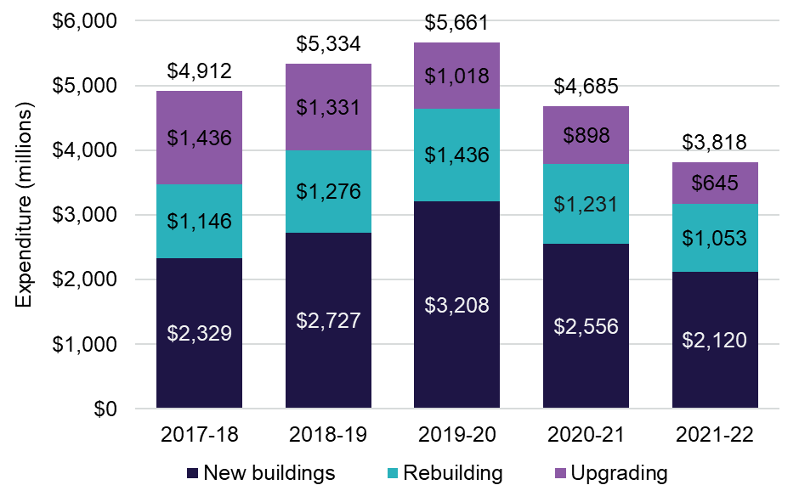
Chart 4.18 shows the proportion of facilities planning to upgrade or rebuild with a comparison of the last 5 years. In 2021-22, the proportion of facilities planning to upgrade was 2.7 per cent, down from 3.5 per cent in 2020-21. The proportion of facilities planning to re-build in 2021-22 slightly decreased, down to 0.5 per cent from 0.7 per cent in 2020-21.
Chart 4.18: Proportion of facilities planning to either upgrade or rebuild, 2017-18 to 2021-22
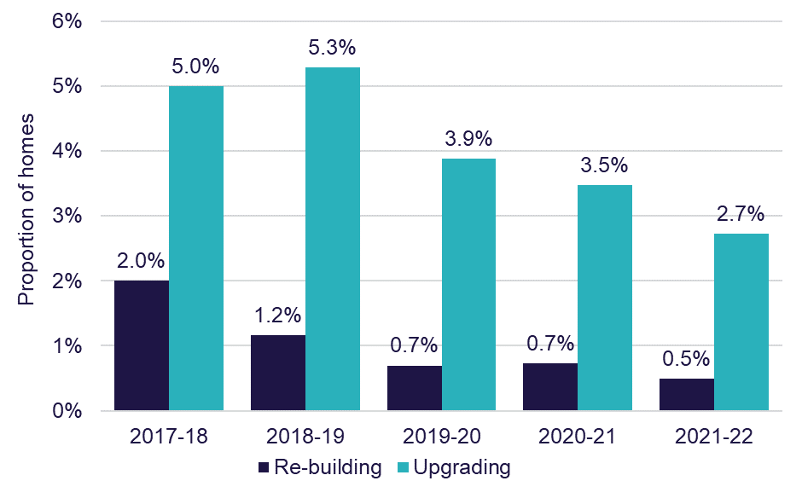
Chart 4.19 shows the number of building approvals (by value) of building works for the 5 years to 2021-22. The total number of builds dropped in 2021-22 for the fifth year in a row, down to 231 from 257 in 2020-21, from a peak of 351 in 2017-18.
Chart 4.19: Number of building approvals, by value of building work, 2017-18 to 2021-22
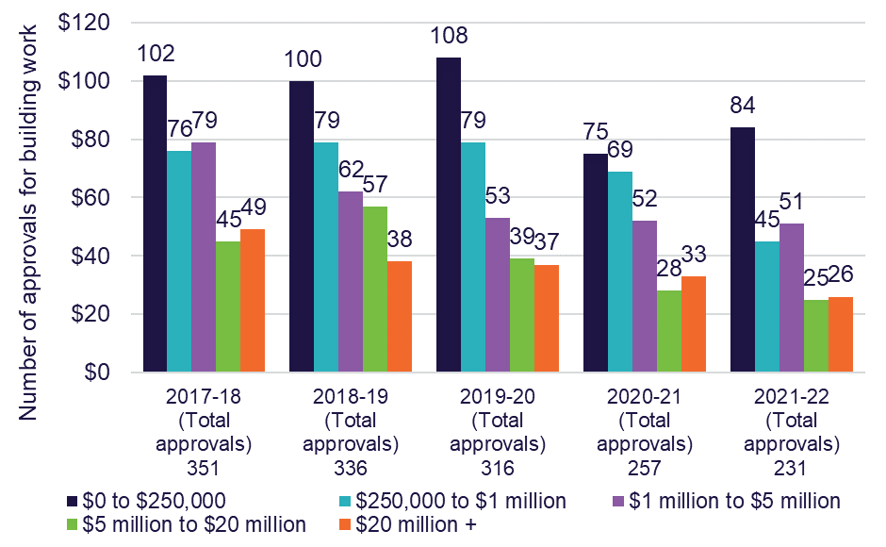
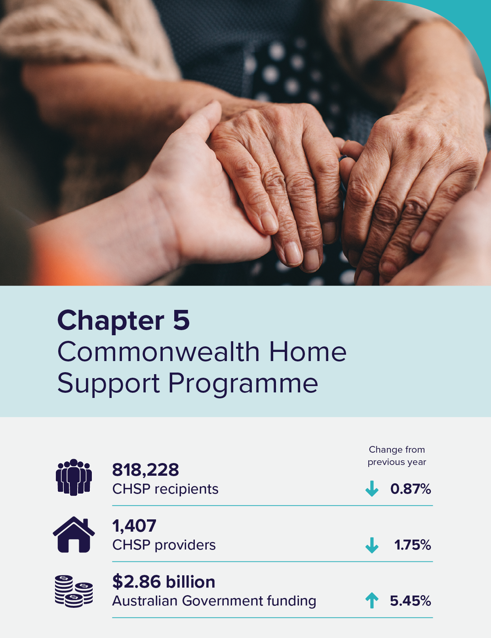

Commonwealth Home Support Programme
In 2021-22, there were 818,228 recipients of the Commonwealth Home Support Programme (CHSP), down from 825,383 in 2020-21. This slight decrease is despite total Australian Government funding of the CHSP increasing from $2.9 billion ($2.7 billion for delivery of CHSP services) in 2020-21 to $3.06 billion ($2.9 billion for delivery of CHSP services) in 2021-22.
To obtain access to the CHSP, individuals are first assessed by either a Regional Assessment Service (RAS) or an independent Aged Care Assessment Team (ACAT).
For individuals who require low-level support to stay independent at home a RAS assessor will visit. For more complex support, an ACAT assessor will provide a more comprehensive assessment and will assist the older person to access either CHSP, a Home Care Package, short-term care or an aged care home.
CHSP providers are not required to complete the annual Aged Care Financial Report (ACFR). As such, the following chapter does not include financial summaries or discussions on the financial performance of CHSP providers. The department monitors CHSP providers through an annual grant acquittal process.

Recipients
Chart 5.1 shows the number of CHSP recipients from 2016-17 to 2021-22. The number of CHSP recipients was 818,228 in 2021-22, which continued the trend of year-on-year decreases since 2017-18 when there were 847,534 CHSP recipients. In 2021-22, 166,830 culturally and linguistically diverse (CALD) Australians were CHSP recipients, similar to the number of recipients in 2020-21 (166,943). The number of First Nations elders who accessed CHSP in 2021-22 was 22,452.
Chart 5.1: Number of CHSP recipients, 2017-18 to 2021-22
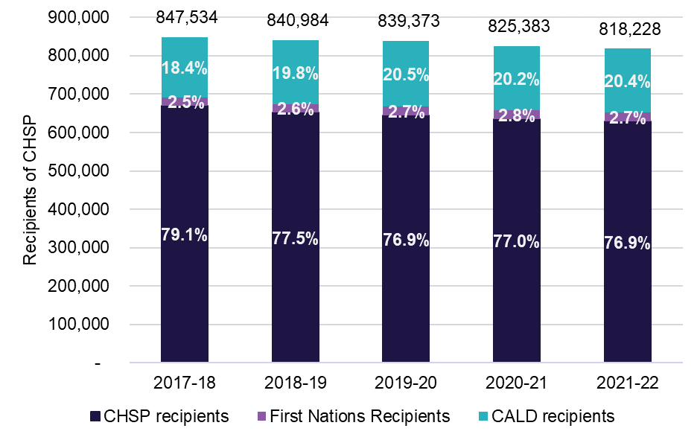

Providers
In 2021-22, the number of CHSP providers continued to decline slightly.
Chart 5.2 shows there were 1,407 CHSP providers in 2021-22, down 25 CHSP providers on the total reported in 2020-21.
The proportion of for-profit providers increased from 7 per cent to 11 per cent, while not-for-profit and local, state or territory government providers decreased by 2 percentage points each in 2021-22. The proportion changes were due to a decrease of 50 not-for-profit and 40 local, state or territory government providers, and an increase of 49 for-profit providers.
Chart 5.2: Providers of CHSP, by ownership type, 2017-18 to 2021-22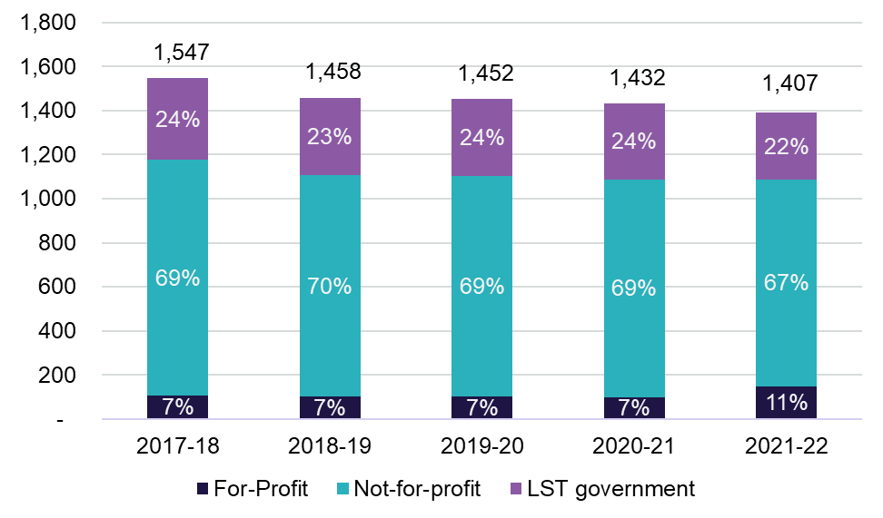
Chart 5.3 shows total expenditure on home support service delivery since 2019-20 along with budgeted expenditure to 2024-25. Total Australian Government funding for home support continues to increase each year. In 2021-22, Australian Government expenditure on the CHSP was $2.86 billion, up from $2.71 billion in 2020-21. The Australian Government also provided $200.4 million to My Aged Care, RAS, and emergency COVID–19 funding and other initiatives in support of the CHSP. In total, Australian Government expenditure for the program in 2021-22 was $3.06 billion.
Chart 5.3: Australian Government expenditure and budgeted expenditure for service delivery of CHSP, 2019-20 to 2024-25
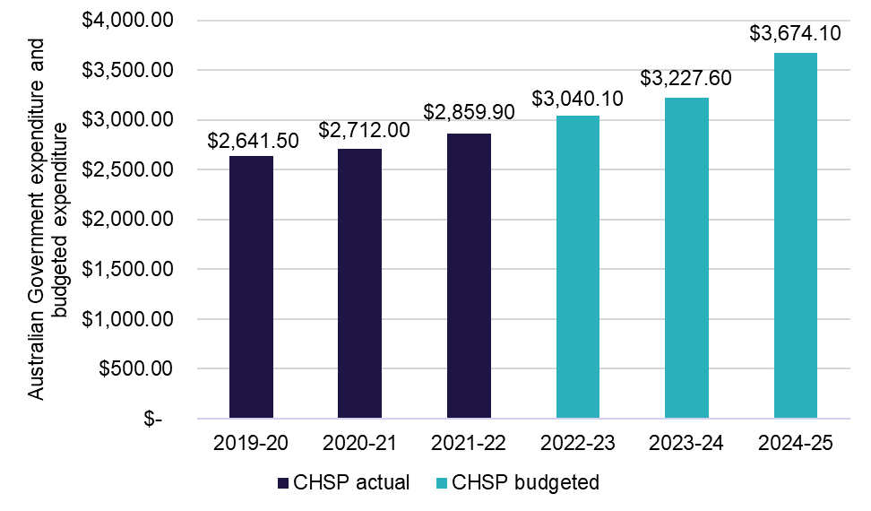
CHSP expenditure for 2019-20 to 2021-22 on each of the major service types is detailed in Table 5.1. In 2021-22, domestic assistance services was the largest expenditure category (20 per cent) with $558.4 million in grant funding, up from $536.1 million the prior year. Social support services was the next largest category, accounting for 18 per cent of expenditure, followed by respite services (12 per cent), nursing services (10 per cent) and allied health and therapy services (10 per cent).
Respite and home modifications and maintenance had the largest increase, both up 12 per cent on 2020-21 expenditure. Specialised support services was the only category to decrease, down approximately 12 per cent from 2020-21 expenditure.
Table 5.1: CHSP expenditure by service type 2019-20 to 2021-22
Service | 2019-20 ($m) | 2020-21 ($m) | 2021-22 ($m)
Social support (i) | $458.1m | $477.3m | $513.5m
Domestic assistance | $522.1m | $536.1m | $558.4m
Nursing | $277.3m | $283.1m | $292.8m
Respite (ii) | $283.1m | $301.3m | $336.6m
Allied health and therapy services | $254.4m | $263.0m | $283.6m
Personal care | $204.7m | $210.1m | $219.8m
Transport | $189.4m | $195.7m | $212.8m
Home modifications and maintenance (iii) | $154.7m | $163.2m | $183.1m
Meals and other food services (iv) | $86.5m | $89.1m | $99.3m
Sector support and development | $45.1m | $40.9m | $42.9m
Assistance with care and housing | $13.8m | $21.2m | $22.9m
Specialised support services (v) | $85.4m | $67.5m | $59.5m
Goods, equipment and assistive technology | $13.6m | $11.7m | $12.2m
Notes:
- Social support includes social support group and social support individual
- Respite includes centre-based respite, cottage respite and flexible respite
- Home modifications and maintenance are 2 separate services in CHSP
- Meals and other food services are 2 separate services in CHSP
- Specialised support services provides services that meet the specialised needs of older people living at home with a particular condition such as dementia or vision impairment



Future demand for aged care
The demand for aged care services will expand with the ageing of the population. This chapter discusses factors that affect demand for the relevant aged care types and how this may to look in the future.
The analysis in this chapter focuses on projections based on current use of aged care and population growth and should not be treated as forecasts of what will happen in terms of future uptake of aged care services.
With the introduction of a more competitive residential aged care system and the phasing out of the Aged Care Approvals Round (ACAR) from 1 July 2024, the department will seek to provide additional market intelligence in future Financial Reporting on the Australian Aged Care Sector (FRAACS) reports. This information is likely to include strengthened forecasting and better information on supply and demand to ensure that the sector has the information it needs to inform business decisions that align with the future population and geographical make up of older Australians.
The department is also developing an Aged Care Market Strategy (Market Strategy) as part of its role as market steward, to ensure that the market meets the needs and preferences of older Australians into the future. The Market Strategy will provide a strategic, guiding framework that outlines the principles the Australian Government wants the aged care market to meet, and how the market should be shaped in alignment with those principles.

Determinants of demand
Demand for aged care services is complex and dependent on a range of demographic, service needs and economic factors. The Royal Commission into Aged Care Quality and Safety (the Royal Commission) noted in its final report summary that “Australia’s changing demographics significantly influence the demand for and provision of aged care. The aged care sector is facing an ageing population with increasing frailty. Australians are living longer than ever before.”
It went on to say: “These changing demographics, together with changes in the patterns of disease and dependency, and in the expectations of older people and society, will impact on demand for aged care in a number of ways. These include the length of stay in residential aged care, the increase in care needs, the demand for a variety of care choices, and the desire of older people to remain in their own homes for as long as possible.”

An ageing population – older people demand more aged care
Chart 6.1 shows the number of people aged 70 years and over for the next 20 years. The ageing of the Australian population over the next 20 years will see the size of the 70 years and over cohort increase by around 1 million people each decade. The older age groups will more than double over this period. The 85 years and over cohort will increase from just over 543,000 people in 2022 to just over 1.1 million people by 2042.
Chart 6.1: Number of people aged 70 years and over, by 5 year age cohort, 2022 to 2042
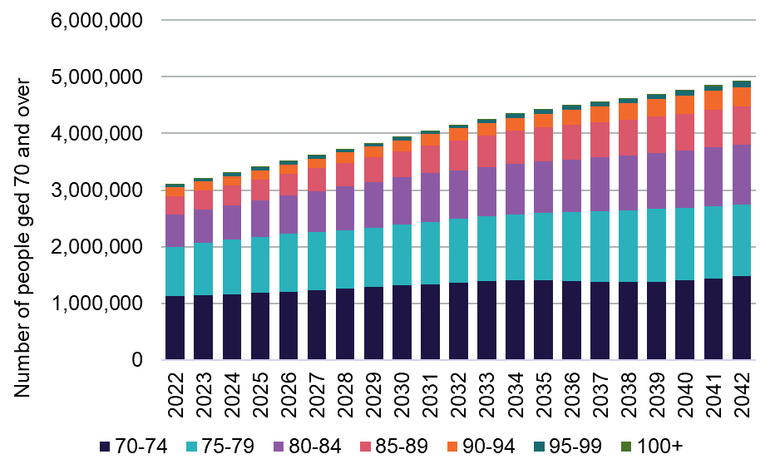
Chart 6.2 shows the proportion of the 70 years and over age group who are aged 85 and over for the next 20 years. The proportion of the 70 and over population who are aged 85 and over will increase from 2027 onwards.
Chart 6.2: Proportion of the 70 years and over age group who are aged 85 and over, 2022 to 2042
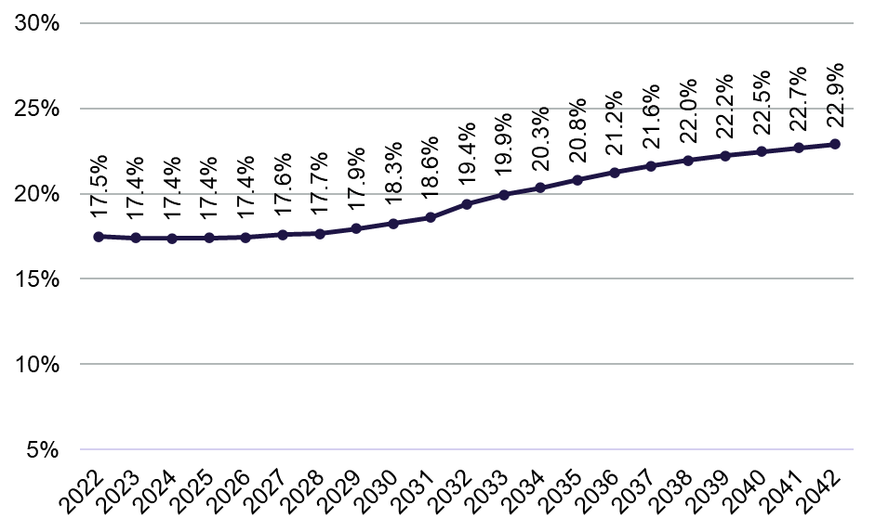
Chart 6.3 and Chart 6.4 shows the proportion of people using residential care and home care, for females and males, at 30 June 2022. The proportion of people who currently use residential and home care package services increases dramatically with age. By age 80, the proportion of older Australians accessing aged care, either through permanent residential care or a home care package is around 13 per cent of females and 8.5 per cent of males. This doubles by age 85 (to 26 per cent of females, and 17 per cent of males) and nearly doubles again by age 92 (to 50 per cent of females and 37 per cent of males). This projection is based on current usage, which may not reflect individual preferences or future demand requirements as the preferences of older Australians’ change.
Chart 6.3: Proportion of females of each age using residential care and home care, 30 June 2022
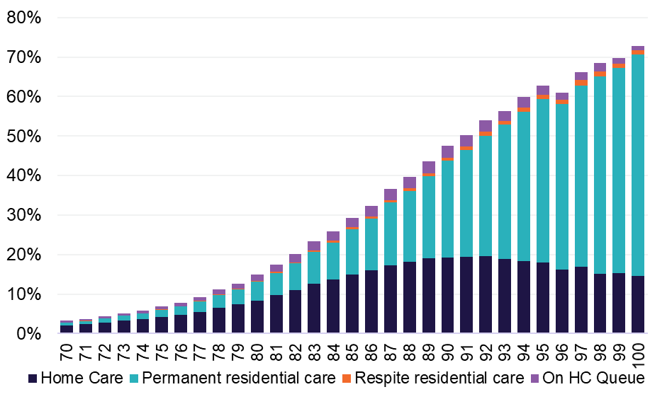
Chart 6.4: Proportion of males of each age using residential care and home care, 30 June 2022
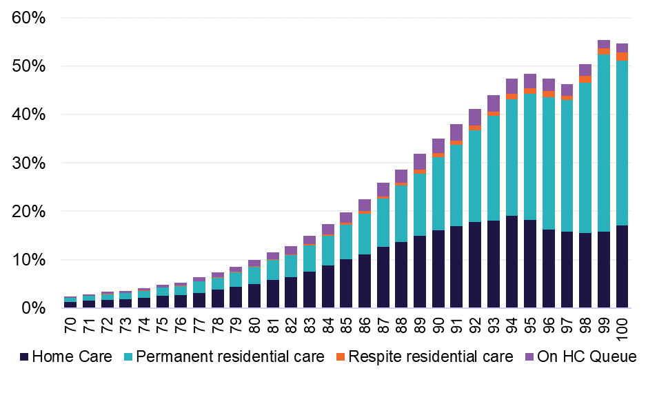

Substitution of residential care and home care
One of the factors that has to be taken into account in projecting demand for aged care is the potential substitutability of service types.
Chart 6.5 shows the utilisation of residential care and home care for the 70 to 99 year old cohort for 20 years to 2022. These cross-sections of data show an increase in the number of older Australians in home care across all age groups and genders. The utilisation of home care has more than doubled across all age groups for both male and females since 2002. The highest increase for males was in the 95 to 99 year old age group, increasing from 3.2 per cent in 2002 to 16.8 per cent in 2022 (an increase in utilisation of home care by 13.6 percentage points). For females, this was the 90 to 94 year old age group, increasing from 3.8 per cent to 19.2 per cent, (equating to a 15.4 percentage point increase).
Residential care utilisation declined across all age groups, reflecting the ability for older Australians to access more home care packages. For males, the utilisation rate in the 90-94 year old age group fell from 24.3 per cent in 2002 to 19.2 per cent in 2022 which represents a decrease of 5 percentage points. For females, the largest decrease in the utilisation of residential aged care was also those aged in the 90 to 94 age group, falling from 39.8 per cent in 2002 to 30.6 per cent 2022; equating to a decrease of 9.2 percentage points.
Chart 6.5: Utilisation of residential care and home care, 70 to 99 year olds, by gender, 2002 to 2022 (Please take note of the vertical axis percentage changes for each of the charts. The changes have been made to make the data more readable)
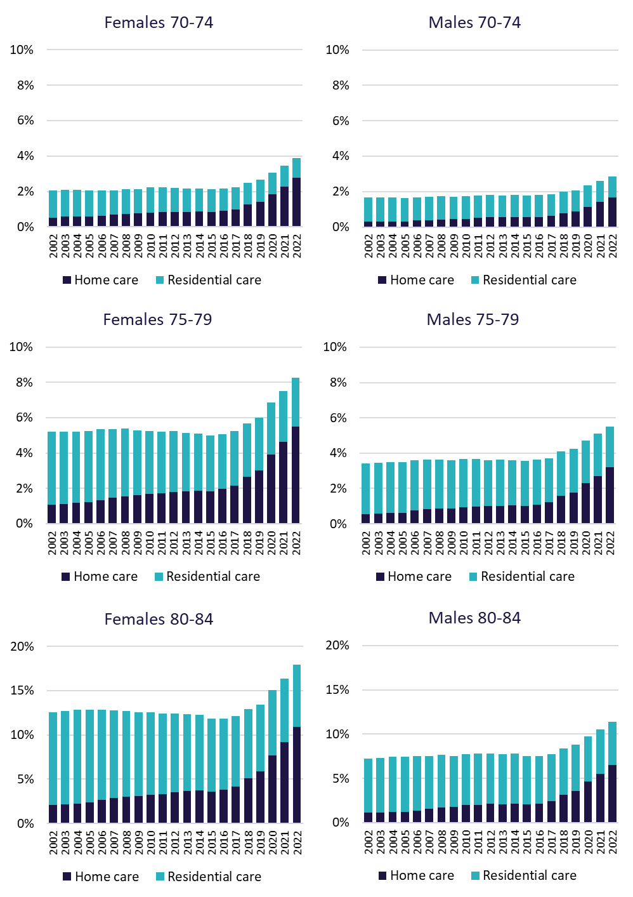
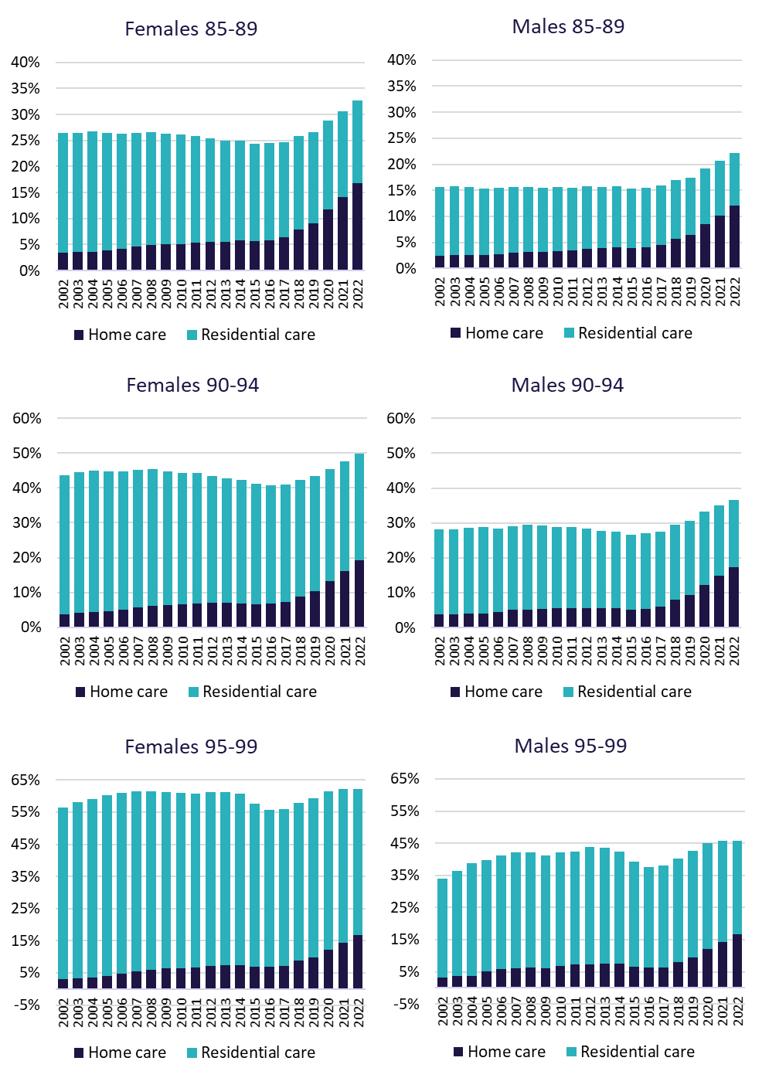

Updated projections
Chart 6.6 shows the number of people projected to be using residential care if the same proportion of people in each age-sex group at 30 June 2022 were to continue to use care and allowed to grow in line with population (using Australian Bureau of Statistics single-year-age and sex population projections).
The estimates of future demand for residential care have been revised down from previous published estimates. A major driver of the reduction in estimated demand is the decline in the rates of age-specific usage that continued to June 2022 (see chart 6.5 showing the proportion of separate age groups that use residential care each year). This trend in usage rates is attributable to the relatively rapid expansion of the Home Care Packages program and its uptake, and the temporary impact of COVID-19.
Chart 6.6: Projected demand for residential care places, 2022 to 2042
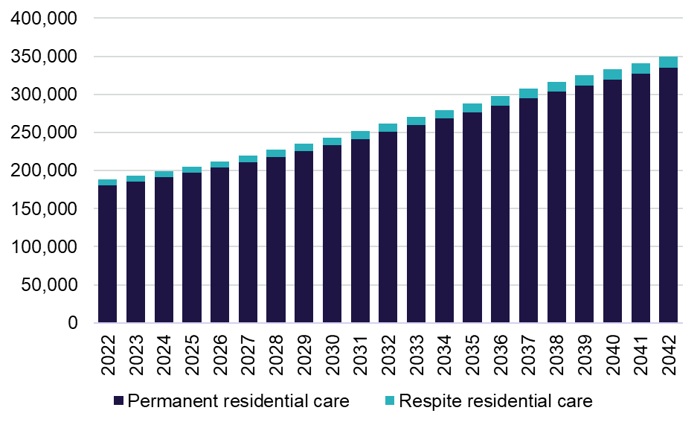
Chart 6.7 shows the projected demand for in home aged care. This includes older Australians who have expressed their demand to receive in home aged care but does not include eligible older Australians who have not sought to access in home aged care. Over the 20 year projection, the average year on year increase is approximately 44,000 new recipients and reaches almost 2 million individuals by 2042.
Chart 6.7: Projected demand for in home aged care, 2022 to 2042
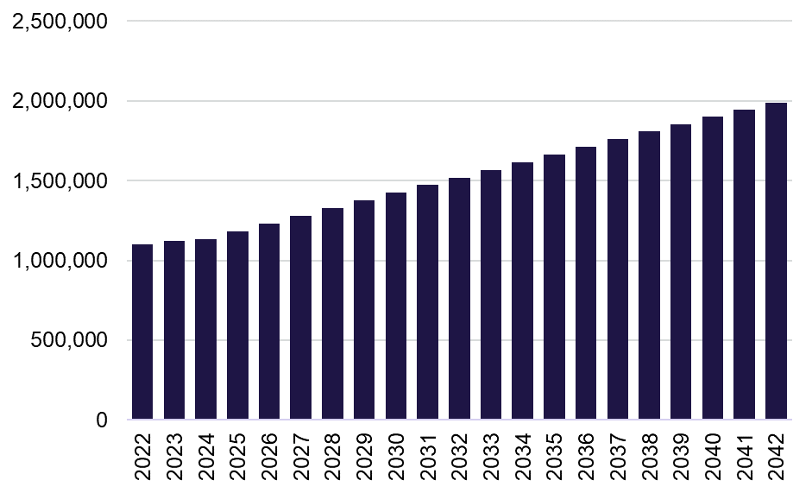



Appendices
Appendix A: Residential Segment Income and Expense Statement, 2021-22
Appendix B: Residential Segment Income and Expense Statement, per resident per day, 2021-22
Appendix C: Financial performance results of home care providers per care recipient per day, by ownership type, by quartile, 2021-22
Appendix D: Financial package results for home care providers per care recipient per annum, by ownership type, by quartile, 2021-22
Appendix E: Home Care segment income and expense statement, 2021-22
Appendix F: Home Care segment income and expense statement, per recipient per day, 2021-22

Appendix A
Residential segment income and expense statement, 2021-22
 | For-profit ($m) | Not-for-profit ($m) | LST providers  ($m) | All providers ($m)
Income
Recurrent income
Care income
Subsidies and supplements (Australian Government) | $5,233.72 | $6,903.21 | $402.63 | $12,539.56
Subsidies and supplements (State/Territory) | $0.77 | $27.83 | $222.26 | $250.86
Resident fees: means-tested care fee | $314.25 | $348.29 | $16.09 | $678.64
Grants: recurrent | $0.49 | $18.67 | $8.56 | $27.72
Other care income | $46.60 | $25.92 | $13.47 | $85.99
Total care income | $5,595.84 | $7,323.92 | $663.02 | $13,582.78
Hotel services income
Basic daily fee | $1,507.42 | $2,007.02 | $136.69 | $3,651.14
BDF supplement | $254.63 | $381.37 | $25.00 | $660.99
Extra service fees | $100.97 | $24.60 | $0.03 | $125.59
Additional service fees | $128.77 | $47.03 | $0.17 | $175.97
Other hotel services Income | $12.07 | $66.83 | $2.28 | $81.18
Total hotel services income | $2,003.86 | $2,526.85 | $164.17 | $4,694.88
Accommodation and finance income
Subsidies and supplements (Australian Government) | $499.49 | $774.48 | $49.22 | $1,323.19
Subsidies and supplements (state / territory) | $0.79 | $2.92 | $8.07 | $11.77
Daily accommodation payments | $274.31 | $458.71 | $22.35 | $755.37
Accommodation charges | $41.88 | $32.12 | $4.10 | $78.10
Interest received - accommodation payments | $28.44 | $34.83 | $0.91 | $64.18
Other accommodation income | $17.06 | $56.81 | $1.38 | $75.25
Interest and investment income | $111.54 | $73.29 | $2.24 | $187.07
Total accommodation and finance income | $973.51 | $1,433.16 | $88.27 | $2,494.94
COVID-19 income
COVID-19 Income | $131.73 | $155.91 | $18.42 | $306.06
Total COVID-19 income | $131.73 | $155.91 | $18.42 | $306.06
Total recurrent income | $8,704.94 | $11,439.84 | $933.87 | $21,078.65
Non-Recurrent Income
Donations, bequests and fundraising | $0.53 | $32.00 | $6.83 | $39.36
Fair value gains on financial assets | $0.94 | $3.60 | $0.00 | $4.54
Fair value gain / asset revaluation increase - other assets | $41.48 | $28.57 | $11.33 | $81.37
Capital grants (Australian Government and LST) | $20.76 | $53.70 | $57.24 | $131.70
Reversal of prior period impairment | $5.19 | $0.00 | $0.00 | $5.19
Realised gains on disposal of assets | $6.78 | $15.33 | $0.08 | $22.20
Effect of adoption of AASB 16 leases - RADs only | $389.50 | $166.90 | $2.19 | $558.59
Other non-recurrent income | $84.62 | $54.09 | $14.22 | $152.94
Total non-recurrent income | $549.80 | $354.18 | $91.90 | $995.89
Total income | $9,254.75 | $11,794.03 | $1,025.77 | $22,074.54
Expense
Care expenses
Employee labour costs
Registered nurses | $903.29 | $1,160.25 | $188.03 | $2,251.56
Enrolled and licensed nurses (registered with the NMBA) | $236.60 | $406.37 | $209.60 | $852.57
Personal care staff / assistants in nursing | $2,414.80 | $3,576.86 | $161.16 | $6,152.82
Care management staff | $161.08 | $337.59 | $39.19 | $537.86
Allied health | $102.59 | $117.08 | $10.41 | $230.08
Diversional therapy / lifestyle / recreation / activities officer | $145.84 | $179.91 | $15.13 | $340.88
Other employee staff | $17.94 | $30.22 | $15.28 | $63.44
Total employee labour costs | $3,982.13 | $5,808.28 | $638.79 | $10,429.20
Agency labour costs
Registered nurses | $41.12 | $101.54 | $8.52 | $151.17
Enrolled and licensed nurses (registered with the NMBA) | $10.80 | $43.18 | $2.33 | $56.32
Personal care staff / assistants in nursing | $91.79 | $196.28 | $6.70 | $294.78
Allied health | $83.18 | $162.71 | $6.23 | $252.12
Diversional therapy / lifestyle / recreation / activities officer | $1.20 | $4.64 | $0.03 | $5.87
Other employee staff | $3.23 | $4.19 | $0.21 | $7.63
Total agency labour costs | $231.33 | $512.55 | $24.01 | $767.89
Contract labour - management entity staff costs | $12.05 | $9.53 | $1.68 | $23.26
Total direct care labour costs | $4,225.51 | $6,330.36 | $664.48 | $11,220.35
Resident expenses
Medical supplies | $85.23 | $134.77 | $10.68 | $230.68
Incontinence supplies | $44.59 | $66.69 | $4.45 | $115.74
Nutritional supplements | $12.88 | $21.10 | $1.69 | $35.68
Health living expenses | $1.07 | $1.78 | $0.20 | $3.05
Other resident services and consumables | $51.79 | $70.77 | $2.90 | $125.46
Total resident expenses | $195.57 | $295.11 | $19.92 | $510.60
Other direct care expenses
Workcover premium (care employee labour) | $92.59 | $137.48 | $8.42 | $238.49
Payroll Tax (care employee labour) | $168.41 | $2.68 | $0.46 | $171.55
Quality, compliance and training external costs | $12.17 | $22.62 | $1.56 | $36.35
Chaplaincy / pastoral care | $0.23 | $20.01 | $0.13 | $20.38
Other direct care expenses | $32.42 | $20.37 | $3.03 | $55.81
Total other direct care expenses | $305.82 | $203.16 | $13.59 | $522.57
Total care expenses | $4,726.89 | $6,828.64 | $697.99 | $12,253.52
Hotel expenses
Catering expenses
Employee labour costs | $537.75 | $676.79 | $52.77 | $1,267.31
Consumables | $285.51 | $374.22 | $22.64 | $682.37
Contract services - internal | $4.51 | $74.95 | $30.07 | $109.54
Contract services - outsourcing | $91.98 | $207.09 | $9.32 | $308.39
Total catering expenses | $919.75 | $1,333.06 | $114.80 | $2,367.61
Cleaning expenses
Employee labour costs | $162.04 | $237.43 | $36.25 | $435.72
Consumables | $39.58 | $68.73 | $4.79 | $113.10
Contract services - internal | $1.17 | $2.32 | $9.51 | $13.01
Contract services - outsourcing | $54.31 | $100.43 | $3.07 | $157.80
Total cleaning expenses | $257.11 | $408.90 | $53.61 | $719.62
Laundry expenses
Employee labour costs | $80.95 | $96.10 | $6.95 | $184.00
Consumables | $15.60 | $21.11 | $1.13 | $37.85
Contract services - internal | $0.69 | $8.75 | $4.28 | $13.73
Contract services - outsourcing | $21.56 | $48.03 | $6.10 | $75.69
Total laundry expenses | $118.81 | $173.99 | $18.46 | $311.26
Utilities | $191.00 | $266.42 | $17.22 | $474.64
Motor vehicle expenses | $3.77 | $10.72 | $1.02 | $15.50
Other hotel expenses
Workcover premium (hotel services employee labour) | $17.21 | $20.89 | $0.88 | $38.98
Payroll tax (hotel services employee labour) | $34.89 | $0.47 | $0.07 | $35.43
Quality, compliance and training external costs | $2.26 | $3.19 | $0.04 | $5.50
Other hotel expenses | $19.18 | $7.50 | $1.50 | $28.19
Total other hotel expenses | $73.55 | $32.05 | $2.50 | $108.10
Total hotel expenses | $1,563.99 | $2,225.14 | $207.61 | $3,996.74
Administration expenses
Corporate recharge | $554.42 | $902.39 | $72.79 | $1,529.59
Employee labour costs | $325.17 | $372.03 | $29.15 | $726.35
Workcover premium (aged care home admin employee labour) | $13.21 | $21.32 | $1.19 | $35.72
Payroll tax (aged care home admin employee labour) | $18.21 | $0.46 | $0.04 | $18.71
Fringe benefits tax | $1.66 | $0.40 | $0.12 | $2.19
Quality, compliance and training external costs | $5.98 | $21.35 | $1.06 | $28.39
Insurances | $29.13 | $57.49 | $2.03 | $88.64
Other administration costs | $230.75 | $269.23 | $24.58 | $524.56
Total administration expenses | $1,178.53 | $1,644.67 | $130.96 | $2,954.16
Accommodation and finance expenses
Employee labour costs | $11.96 | $28.67 | $4.41 | $45.04
Depreciation - building | $150.46 | $532.79 | $65.17 | $748.42
Depreciation - right of use assets AASB 16 | $149.34 | $28.15 | $0.22 | $177.71
Depreciation - other assets | $232.28 | $255.81 | $8.48 | $496.57
Amortisation | $569.16 | $243.55 | $0.21 | $812.92
Refurbishment costs | $51.15 | $22.64 | $0.88 | $74.66
Rent for buildings - not captured by AASB 16 | $114.42 | $10.30 | $1.97 | $126.69
Interest expense - lease liabilities AASB 16 | $81.77 | $20.98 | $0.00 | $102.75
Interest paid (RAD / bond) | $47.48 | $39.71 | $1.05 | $88.24
Financing interest | $74.46 | $13.97 | $0.85 | $89.29
Routine maintenance expenses
Employee labour costs | $65.91 | $115.21 | $8.68 | $189.79
Repairs and maintenance | $123.52 | $261.77 | $14.31 | $399.60
Contract services - internal | $4.71 | $3.66 | $5.71 | $14.09
Contract services - outsourcing | $15.49 | $30.83 | $2.62 | $48.94
Total routine maintenance expenses | $209.63 | $411.47 | $31.32 | $652.42
Workcover premium (accommodation employee labour) | $3.95 | $2.18 | $0.21 | $6.34
Payroll tax (accommodation employee labour) | $2.15 | $0.14 | $0.00 | $2.29
Other accommodation expenses | $63.14 | $27.10 | $1.34 | $91.58
Total accommodation and finance expenses | $1,761.34 | $1,637.47 | $116.11 | $3,514.92
COVID-19 expenses
Labour costs | $210.04 | $256.99 | $13.75 | $480.78
Resident support | $14.27 | $21.75 | $0.21 | $36.23
Preventative measures | $81.57 | $81.04 | $2.65 | $165.25
Infection prevention and control (IPC) lead expenses | $14.20 | $29.03 | $0.46 | $43.68
Other COVID-19 expenses | $6.81 | $10.45 | $0.27 | $17.54
Total COVID-19 expenses | $326.89 | $399.26 | $17.33 | $743.48
Total recurrent expense | $9,557.64 | $12,735.17 | $1,170.01 | $23,462.82
Non-recurrent expenses
Fair value losses on financial assets | $4.97 | $37.31 | $0.84 | $43.12
Fair value loss / asset revaluation decreases on other assets | $19.28 | $15.41 | $0.07 | $34.75
Impairment loss | $56.14 | $49.23 | $10.80 | $116.17
Realised losses on disposal of assets | $5.83 | $11.26 | $0.09 | $17.19
Effect of adoption of AASB16 leases - RADs only | $389.05 | $158.85 | $2.18 | $550.07
Other non-recurrent expenses | $63.62 | $38.41 | $12.42 | $114.45
Total non-recurrent expenses | $538.89 | $310.47 | $26.39 | $875.76
Total expense | $10,096.53 | $13,045.64 | $1,196.41 | $24,338.58
Net profit/(loss) | ($841.78) | ($1,251.62) | ($170.64) | ($2,264.04)

Appendix B
Residential Segment Income and Expense Statement, per resident per day, 2021-22
 | Not-for-profit | For-profit | LST providers | All providers
Income
Recurrent income
Care income
Subsidies and supplements (Australian Government) | $180.26 | $188.12 | $157.70 | $182.61
Subsidies and supplements (State/Territory) | $0.73 | $0.03 | $87.05 | $3.65
Resident fees: means-tested care fee | $9.10 | $11.30 | $6.30 | $9.88
Grants: recurrent | $0.49 | $0.02 | $3.35 | $0.40
Other care income | $0.68 | $1.68 | $5.27 | $1.25
Total care income | $191.25 | $201.14 | $259.69 | $197.80
Hotel services income
Basic daily fee | $52.41 | $54.18 | $53.54 | $53.17
BDF supplement | $9.96 | $9.15 | $9.79 | $9.63
Extra service fees | $0.64 | $3.63 | $0.01 | $1.83
Additional service fees | $1.23 | $4.63 | $0.07 | $2.56
Other hotel services income | $1.75 | $0.43 | $0.89 | $1.18
Total hotel services income | $65.98 | $72.03 | $64.30 | $68.37
Accommodation and finance income
Subsidies and supplements (Australian Government) | $20.22 | $17.95 | $19.28 | $19.27
Subsidies and supplements (state / territory) | $0.08 | $0.03 | $3.16 | $0.17
Daily accommodation payments | $11.98 | $9.86 | $8.75 | $11.00
Accommodation charges | $0.84 | $1.51 | $1.61 | $1.14
Interest received - accommodation payments | $0.91 | $1.02 | $0.36 | $0.93
Other accommodation income | $1.48 | $0.61 | $0.54 | $1.10
Interest and investment income | $1.91 | $4.01 | $0.88 | $2.72
Total accommodation and finance income | $37.42 | $34.99 | $34.57 | $36.33
COVID-19 income
COVID-19 income | $4.07 | $4.74 | $7.21 | $4.46
Total COVID-19 income | $4.07 | $4.74 | $7.21 | $4.46
Total recurrent income | $298.73 | $312.89 | $365.78 | $306.96
Non-Recurrent Income
Donations, bequests and fundraising | $0.84 | $0.02 | $2.68 | $0.57
Fair value gains on financial assets | $0.09 | $0.03 | $0.00 | $0.07
Fair value gain / asset revaluation increase - other assets | $0.75 | $1.49 | $4.44 | $1.18
Capital grants (Australian Government and state) | $1.40 | $0.75 | $22.42 | $1.92
Reversal of prior period impairment | $0.00 | $0.19 | $0.00 | $0.08
Realised gains on disposal of assets | $0.40 | $0.24 | $0.03 | $0.32
Effect of adoption of AASB 16 leases - RADs only | $4.36 | $14.00 | $0.86 | $8.13
Other non-recurrent income | $1.41 | $3.04 | $5.57 | $2.23
Total non-recurrent income | $9.25 | $19.76 | $36.00 | $14.50
Total income | $307.98 | $332.66 | $401.77 | $321.46
Expense
Care expenses
Employee labour costs
Registered nurses | $30.30 | $32.47 | $73.65 | $32.79
Enrolled and licensed nurses (registered with the NMBA) | $10.61 | $8.50 | $82.09 | $12.42
Personal care staff / assistants in nursing | $93.40 | $86.80 | $63.12 | $89.60
Care management staff | $8.82 | $5.79 | $15.35 | $7.83
Allied health | $3.06 | $3.69 | $4.08 | $3.35
Diversional therapy / lifestyle / recreation / activities officer | $4.70 | $5.24 | $5.92 | $4.96
Other employee staff | $0.79 | $0.64 | $5.98 | $0.92
Total employee labour costs | $151.67 | $143.14 | $250.20 | $151.88
Agency labour costs
Registered nurses | $2.65 | $1.48 | $3.34 | $2.20
Enrolled and licensed nurses (registered with the NMBA) | $1.13 | $0.39 | $0.91 | $0.82
Personal care staff / assistants in nursing | $5.13 | $3.30 | $2.62 | $4.29
Allied health | $4.25 | $2.99 | $2.44 | $3.67
Diversional therapy / lifestyle / recreation / activities officer | $0.12 | $0.04 | $0.01 | $0.09
Other employee staff | $0.11 | $0.12 | $0.08 | $0.11
Total agency labour costs | $13.38 | $8.31 | $9.40 | $11.18
Contract labour - management entity staff costs | $0.25 | $0.43 | $0.66 | $0.34
Total direct care labour costs | $165.31 | $151.88 | $260.26 | $163.40
Resident expenses
Medical supplies | $3.52 | $3.06 | $4.18 | $3.36
Incontinence supplies | $1.74 | $1.60 | $1.74 | $1.69
Nutritional supplements | $0.55 | $0.46 | $0.66 | $0.52
Health living expenses | $0.05 | $0.04 | $0.08 | $0.04
Other resident services and consumables | $1.85 | $1.86 | $1.13 | $1.83
Total resident expenses | $7.71 | $7.03 | $7.80 | $7.44
Other direct care expenses
Workcover premium (care employee labour) | $3.59 | $3.33 | $3.30 | $3.47
Payroll tax (care employee labour) | $0.07 | $6.05 | $0.18 | $2.50
Quality, compliance and training external costs | $0.59 | $0.44 | $0.61 | $0.53
Chaplaincy / pastoral care | $0.52 | $0.01 | $0.05 | $0.30
Other direct care expenses | $0.53 | $1.17 | $1.19 | $0.81
Total other direct care expenses | $5.31 | $10.99 | $5.32 | $7.61
Total care expenses | $178.32 | $169.91 | $273.39 | $178.44
Hotel expenses
Catering expenses
Employee labour costs | $17.67 | $19.33 | $20.67 | $18.46
Consumables | $9.77 | $10.26 | $8.87 | $9.94
Contract services - internal | $1.96 | $0.16 | $11.78 | $1.60
Contract services - outsourcing | $5.41 | $3.31 | $3.65 | $4.49
Total catering expenses | $34.81 | $33.06 | $44.96 | $34.48
Cleaning expenses
Employee labour costs | $6.20 | $5.82 | $14.20 | $6.35
Consumables | $1.79 | $1.42 | $1.88 | $1.65
Contract services - internal | $0.06 | $0.04 | $3.72 | $0.19
Contract services - outsourcing | $2.62 | $1.95 | $1.20 | $2.30
Total cleaning expenses | $10.68 | $9.24 | $21.00 | $10.48
Laundry expenses
Employee labour costs | $2.51 | $2.91 | $2.72 | $2.68
Consumables | $0.55 | $0.56 | $0.44 | $0.55
Contract services - internal | $0.23 | $0.02 | $1.68 | $0.20
Contract services - outsourcing | $1.25 | $0.77 | $2.39 | $1.10
Total laundry expenses | $4.54 | $4.27 | $7.23 | $4.53
Utilities | $6.96 | $6.87 | $6.75 | $6.91
Motor vehicle expenses | $0.28 | $0.14 | $0.40 | $0.23
Other hotel expenses
Workcover premium (hotel services employee labour) | $0.55 | $0.62 | $0.35 | $0.57
Payroll tax (hotel services employee labour) | $0.01 | $1.25 | $0.03 | $0.52
Quality, compliance and training external costs | $0.08 | $0.08 | $0.02 | $0.08
Other hotel expenses | $0.20 | $0.69 | $0.59 | $0.41
Total other hotel expenses | $0.84 | $2.64 | $0.98 | $1.57
Total hotel expenses | $58.11 | $56.22 | $81.32 | $58.20
Administration expenses
Corporate recharge | $23.56 | $19.93 | $28.51 | $22.27
Employee labour costs | $9.71 | $11.69 | $11.42 | $10.58
Workcover premium (aged care home admin employee labour) | $0.56 | $0.47 | $0.47 | $0.52
Payroll tax (aged care home admin employee labour) | $0.01 | $0.65 | $0.02 | $0.27
Fringe benefits tax | $0.01 | $0.06 | $0.05 | $0.03
Quality, compliance and training external costs | $0.56 | $0.21 | $0.42 | $0.41
Insurances | $1.50 | $1.05 | $0.79 | $1.29
Other administration costs | $7.03 | $8.29 | $9.63 | $7.64
Total administration expenses | $42.95 | $42.36 | $51.30 | $43.02
Accommodation and finance expenses
Employee labour costs | $0.75 | $0.43 | $1.73 | $0.66
Depreciation - building | $13.91 | $5.41 | $25.52 | $10.90
Depreciation - right of use assets AASB 16 | $0.74 | $5.37 | $0.09 | $2.59
Depreciation - other assets | $6.68 | $8.35 | $3.32 | $7.23
Amortisation | $6.36 | $20.46 | $0.08 | $11.84
Refurbishment costs | $0.59 | $1.84 | $0.34 | $1.09
Rent for buildings - not captured by AASB 16 | $0.27 | $4.11 | $0.77 | $1.85
Interest expense - lease liabilities AASB 16 | $0.55 | $2.94 | $0.00 | $1.50
Interest paid (RAD / bond) | $1.04 | $1.71 | $0.41 | $1.29
Financing interest | $0.36 | $2.68 | $0.33 | $1.30
Routine maintenance expenses
Employee labour costs | $3.01 | $2.37 | $3.40 | $2.76
Repairs and maintenance | $6.84 | $4.44 | $5.60 | $5.82
Contract services - internal | $0.10 | $0.17 | $2.24 | $0.21
Contract services - outsourcing | $0.81 | $0.56 | $1.03 | $0.71
Total routine maintenance expenses | $10.74 | $7.53 | $12.27 | $9.50
Workcover premium (accommodation employee labour) | $0.06 | $0.14 | $0.08 | $0.09
Payroll tax (accommodation employee labour) | $0.00 | $0.08 | $0.00 | $0.03
Other accommodation expenses | $0.71 | $2.27 | $0.53 | $1.33
Total accommodation and finance expenses | $42.76 | $63.31 | $45.48 | $51.19
COVID-19 expenses
Labour costs | $6.71 | $7.55 | $5.39 | $7.00
Resident support | $0.57 | $0.51 | $0.08 | $0.53
Preventative measures | $2.12 | $2.93 | $1.04 | $2.41
Infection prevention and control (IPC) lead expenses | $0.76 | $0.51 | $0.18 | $0.64
Other COVID-19 expenses | $0.27 | $0.24 | $0.11 | $0.26
Total COVID-19 expenses | $10.43 | $11.75 | $6.79 | $10.83
Total recurrent expense | $332.56 | $343.54 | $458.27 | $341.68
Non-recurrent expenses
Fair value losses on financial assets | $0.97 | $0.18 | $0.33 | $0.63
Fair value loss / asset revaluation decreases on other assets | $0.40 | $0.69 | $0.03 | $0.51
Impairment loss | $1.29 | $2.02 | $4.23 | $1.69
Realised losses on disposal of assets | $0.29 | $0.21 | $0.04 | $0.25
Effect of adoption of AASB16 leases - RADs only | $4.15 | $13.98 | $0.85 | $8.01
Other non-recurrent expenses | $1.00 | $2.29 | $4.87 | $1.67
Total non-recurrent expenses | $8.11 | $19.37 | $10.34 | $12.75
Total expense | $340.66 | $362.91 | $468.61 | $354.43
Net profit/(loss) | ($32.68) | ($30.26) | ($66.83) | ($32.97)

Appendix C
Financial performance results of home care providers per care recipient per day, by ownership type, by quartile, 2021-22
 | Top quartile | Next top | Next bottom | Bottom | Total
For-profit
Number of providers | 93 | 67 | 64 | 66 | 290
Provision of care / direct care services | $55.91 | $15.65 | $23.86 | $27.13 | $27.37
Provision of care / sub-contracted services | $17.10 | $9.87 | $18.39 | $17.39 | $15.36
Client/case management fees charged | $9.63 | $5.28 | $8.83 | $10.14 | $8.06
Admin and management of packages | $7.35 | $8.61 | $5.03 | $8.43 | $7.06
Exit amounts deducted | $0.03 | $0.01 | $0.01 | $0.01 | $0.01
COVID-19 funding | $0.62 | $0.21 | $0.15 | $0.51 | $0.30
Other income | $2.84 | $24.46 | $0.35 | $2.03 | $8.53
Total expenses | $75.04 | $60.05 | $56.38 | $74.06 | $63.45
Net profit before tax | $18.42 | $4.04 | $0.23 | ($8.42) | $3.25
Not-for-profit
Number of providers | 93 | 117 | 115 | 105 | 430
Provision of care / direct care services | $30.58 | $30.61 | $30.37 | $31.47 | $30.72
Provision of care / sub-contracted services | $13.09 | $13.15 | $15.26 | $12.75 | $13.58
Client/case management fees charged | $12.71 | $11.96 | $11.43 | $13.10 | $12.21
Admin and management of packages | $9.60 | $7.38 | $7.83 | $6.28 | $7.68
Exit amounts deducted | $0.11 | $0.06 | $0.07 | $0.09 | $0.08
COVID-19 funding | $0.26 | $0.18 | $0.29 | $0.27 | $0.24
Other income | $0.72 | $1.52 | $1.28 | $2.09 | $1.43
Total expenses | $55.96 | $59.46 | $65.51 | $73.82 | $63.34
Net profit before tax | $11.11 | $5.40 | $1.02 | ($7.78) | $2.60
Local state or territory government
Number of providers | 20 | 21 | 26 | 35 | 102
Provision of care / direct care services | $27.06 | $13.48 | $12.31 | $17.03 | $15.50
Provision of care / sub-contracted services | $9.09 | $25.53 | $27.29 | $19.71 | $22.82
Client/case management fees charged | $13.29 | $9.46 | $16.24 | $13.18 | $12.40
Admin and management of packages | $8.59 | $12.90 | $7.16 | $8.48 | $9.99
Exit amounts deducted | $0.12 | $0.08 | $0.15 | $0.09 | $0.10
COVID-19 funding | $0.12 | $0.10 | $0.10 | $0.22 | $0.13
Other income | $1.38 | $0.96 | $0.04 | $0.87 | $0.76
Total expenses | $45.36 | $58.25 | $62.38 | $66.18 | $59.71
Net profit before tax | $14.29 | $4.27 | $0.91 | ($6.61) | $2.00
All providers
Number of providers | 206 | 205 | 205 | 206 | 822
Provision of care / direct care services | $38.29 | $25.03 | $26.78 | $29.36 | $28.75
Provision of care / sub-contracted services | $14.19 | $13.08 | $17.15 | $14.41 | $14.69
Client/case management fees charged | $11.77 | $9.83 | $10.60 | $12.36 | $10.89
Admin and management of packages | $8.87 | $8.13 | $6.65 | $6.97 | $7.62
Exit amounts deducted | $0.09 | $0.05 | $0.05 | $0.07 | $0.06
COVID-19 funding | $0.36 | $0.19 | $0.22 | $0.33 | $0.26
Other income | $1.40 | $8.17 | $0.84 | $1.99 | $3.67
Total expenses | $61.49 | $59.54 | $61.61 | $73.34 | $63.16
Net profit before tax | $13.48 | $4.92 | $0.69 | ($7.86) | $2.78

Appendix D
Financial package results for home care providers per care recipient per year, by ownership type, by quartile, 2021-22
 |  | Top quartile | Next top | Next bottom |  | Bottom |  | Total
For-profit
Number of providers |  | 93 | 67 | 64 |  | 66 |  | 290
Total revenue per recipient |  | $34,112.00 | $23,391.00 | $20,664.00 |  | $23,959.00 |  | $24,347.00
Total expenses per recipient |  | $27,390.00 | $21,917.00 | $20,580.00 |  | $27,031.00 |  | $23,161.00
NBPT per recipient |  | $6,722.00 | $1,474.00 | $85.00 |  | ($3,072.00) |  | $1,187.00
Not-for-profit
Number of providers |  | 93 | 117 | 115 |  | 105 |  | 430
Total revenue per recipient |  | $24,480.00 | $23,675.00 | $24,284.00 |  | $24,106.00 |  | $24,069.00
Total expenses per recipient |  | $20,426.00 | $21,702.00 | $23,911.00 |  | $26,946.00 |  | $23,119.00
NBPT per recipient |  | $4,054.00 | $1,972.00 | $373.00 |  | ($2,840.00) |  | $950.00
Local state or territory government
Number of providers |  | 20 | 21 | 26 |  | 35 |  | 102
Total revenue per recipient |  | $21,772.00 | $22,817.00 | $23,103.00 |  | $21,744.00 |  | $22,523.00
Total expenses per recipient |  | $16,556.00 | $21,260.00 | $22,770.00 |  | $24,155.00 |  | $21,793.00
NPBT per recipient |  | $5,216.00 | $1,557.00 | $333.00 |  | ($2,411.00) |  | $730.00
Total
Number of providers |  | 206 | 205 | 205 |  | 206 |  | 822
Total revenue per recipient |  | $27,362.00 | $23,531.00 | $22,740.00 |  | $23,902.00 |  | $24,068.00
Total expenses per recipient |  | $22,442.00 | $21,733.00 | $22,487.00 |  | $26,771.00 |  | $23,054.00
NPBT per recipient |  | $4,920.00 | $1,798.00 | $253.00 |  | ($2,868.00) |  | $1,013.00

Appendix E
Home Care segment income and expense statement, 2021-22
 |  |  | For Profit |  |  | Not For Profit |  |  | LST |  |  | All Providers
Income |  |  | ($m) |  |  | ($m) |  |  | ($m) |  |  | ($m)
◦ Direct care services |  |  | $624.0 |  |  | $1,356.0 |  |  | $65.0 |  |  | $2,045.0
- Domestic |  |  | $379.0 |  |  | $899.0 |  |  | $44.0 |  |  | $1,322.0
- Nursing |  |  | $72.0 |  |  | $49.0 |  |  | $5.0 |  |  | $126.0
- Allied health |  |  | $4.0 |  |  | $42.0 |  |  | $3.0 |  |  | $49.0
- Other |  |  | $169.0 |  |  | $366.0 |  |  | $14.0 |  |  | $548.0
◦ Sub-contracted services |  |  | $350.0 |  |  | $599.0 |  |  | $95.0 |  |  | $1,045.0
- Domestic |  |  | $107.0 |  |  | $159.0 |  |  | $34.0 |  |  | $299.0
- Nursing |  |  | $11.0 |  |  | $19.0 |  |  | $3.0 |  |  | $33.0
- Allied health |  |  | $42.0 |  |  | $77.0 |  |  | $8.0 |  |  | $127.0
- Other |  |  | $191.0 |  |  | $345.0 |  |  | $50.0 |  |  | $586.0
◦ Care management service fees |  |  | $184.0 |  |  | $539.0 |  |  | $52.0 |  |  | $775.0
◦ Package management service fees |  |  | $161.0 |  |  | $339.0 |  |  | $42.0 |  |  | $542.0
◦ Exit amounts deducted |  |  | $0.0 |  |  | $3.0 |  |  | $0.0 |  |  | $4.0
◦ Handling fee |  |  | $4.0 |  |  | $17.0 |  |  | $2.0 |  |  | $23.0
◦ COVID-19 funding |  |  | $7.0 |  |  | $11.0 |  |  | $1.0 |  |  | $18.0
◦ Other income |  |  | $191.0 |  |  | $46.0 |  |  | $1.0 |  |  | $238.0
Total income: |  |  | $1,521.0 |  |  | $2,911.0 |  |  | $258.0 |  |  | $4,690.0
Expenses
Internal direct service costs
Labour cost - internal direct Care - employee
◦ Registered nurses |  |  | $19.0 |  |  | $47.0 |  |  | $3.0 |  |  | $69.0
◦ Enrolled and licensed nurses (registered with the NMBA) |  |  | $6.0 |  |  | $10.0 |  |  | $0.0 |  |  | $16.0
◦ Personal care staff / other unlicensed nurses |  |  | $341.0 |  |  | $654.0 |  |  | $34.0 |  |  | $1,028.0
◦ Allied health |  |  | $3.0 |  |  | $26.0 |  |  | $1.0 |  |  | $29.0
◦ Other employee staff |  |  | $22.0 |  |  | $108.0 |  |  | $4.0 |  |  | $135.0
Total labour Costs - internal direct Care - employee |  |  | $391.0 |  |  | $845.0 |  |  | $42.0 |  |  | $1,278.0
Labour cost - internal direct care - agency care staff
◦ Registered nurses |  |  | $0.0 |  |  | $2.0 |  |  | $0.0 |  |  | $2.0
◦ Enrolled and licensed nurses (registered with the NMBA) |  |  | $0.0 |  |  | $0.0 |  |  | $0.0 |  |  | $0.0
◦ Personal care staff / other unlicensed nurses |  |  | $9.0 |  |  | $20.0 |  |  | $1.0 |  |  | $31.0
◦ Allied health |  |  | $1.0 |  |  | $3.0 |  |  | $0.0 |  |  | $4.0
◦ Other agency staff |  |  |  | $1.0 |  |  | $4.0 |  |  |  | $0.0 |  | $5.0
Total labour costs - internal direct care - agency care staff |  |  |  | $12 |  |  | $28 |  |  |  | $1 |  | $42
◦ Payroll tax - care staff |  |  |  | $16.0 |  |  | $2.0 |  |  |  | $0.0 |  | $18.0
◦ Care related expenses |  |  |  | $27.0 |  |  | $60.0 |  |  |  | $9.0 |  | $96.0
◦ Motor vehicle expenses |  |  |  | $8.0 |  |  | $40.0 |  |  |  | $1.0 |  | $49.0
◦ Other internal direct service costs |  |  |  | $6.0 |  |  | $38.0 |  |  |  | $3.0 |  | $46.0
Total internal direct service costs expenses |  |  |  | $460 |  |  | $1,013 |  |  |  | $56 |  | $1,529
External direct service costs
Sub-contracted or brokered client services - external direct care service cost
◦ Registered nurses |  |  |  | $9.0 |  |  | $13.0 |  |  |  | $3.0 |  | $24.0
◦ Enrolled and licensed nurses (registered with the NMBA) |  |  |  | $1.0 |  |  | $3.0 |  |  |  | $0.0 |  | $4.0
◦ Personal care staff / other unlicensed nurses |  |  |  | $152.0 |  |  | $150.0 |  |  |  | $25.0 |  | $327.0
◦ Allied health |  |  |  | $66.0 |  |  | $79.0 |  |  |  | $7.0 |  | $152.0
◦ Other sub-contracted/brokered staff |  |  |  | $123.0 |  |  | $122.0 |  |  |  | $20.0 |  | $265.0
External direct care service cost - sub-contracted or brokered client services |  |  |  | $350.0 |  |  | $366.0 |  |  |  | $54.0 |  | $770.0
◦ Consumables |  |  |  | $31.0 |  |  | $112.0 |  |  |  | $5.0 |  | $148.0
◦ Home modifications |  |  |  | $25.0 |  |  | $33.0 |  |  |  | $5.0 |  | $64.0
◦ Client capital purchases |  |  |  | $62.0 |  |  | $94.0 |  |  |  | $11.0 |  | $167.0
◦ Transport services |  |  |  | $13.0 |  |  | $19.0 |  |  |  | $3.0 |  | $35.0
◦ Commission/brokerage fee/franchisee fee |  |  |  | $14.0 |  |  | $7.0 |  |  |  | $1.0 |  | $22.0
◦ Other external direct service costs |  |  |  | $35.0 |  |  | $111.0 |  |  |  | $25.0 |  | $171.0
Total external direct service costs expenses |  |  |  | $531 |  |  | $743 |  |  |  | $103 |  | $1,377
Care management
◦ Wages and salaries - care management staff |  |  |  | $131.0 |  |  | $324.0 |  |  |  | $40.0 |  | $495.0
◦ Payroll tax - care management staff |  |  |  | $6.0 |  |  | $1.0 |  |  |  | $0.0 |  | $7.0
◦ Motor vehicle expenses |  |  |  | $4.0 |  |  | $9.0 |  |  |  | $1.0 |  | $13.0
Total care management expenses |  |  |  | $140 |  |  | $334 |  |  |  | $41 |  | $515
Administration and support
◦ Wages and salaries - administration & non-care staff |  |  |  | $150.0 |  |  | $246.0 |  |  |  | $25.0 |  | $420.0
◦ Workers compensation insurance |  |  |  | $15.0 |  |  | $30.0 |  |  |  | $1.0 |  | $45.0
◦ Payroll tax - administration and non-care staff |  |  |  | $6.0 |  |  | $1.0 |  |  |  | $0.0 |  | $7.0
◦ Administration costs and management fees |  |  |  | $101 |  |  | $367 |  |  |  | $21 |  | $488
- Education/training & quality control expense |  |  |  | $6.0 |  |  | $9.0 |  |  |  | $1.0 |  | $15.0
- General insurances |  |  |  | $5.0 |  |  | $4.0 |  |  |  | $0.0 |  | $10.0
- Rent, utilities, and property outgoings |  |  |  | $15.0 |  |  | $24.0 |  |  |  | $2.0 |  | $41.0
- IT and communication expenses |  |  |  | $19.0 |  |  | $26.0 |  |  |  | $2.0 |  | $48.0
- Corporate recharge |  |  |  | $10.0 |  |  | $257.0 |  |  |  | $10.0 |  | $278.0
- Other administration costs |  |  |  | $44.0 |  |  | $47.0 |  |  |  | $6.0 |  | $97.0
◦ Depreciation expenses |  |  |  | $11.0 |  |  | $23.0 |  |  |  | $1.0 |  | $34.0
◦ Interest expenses |  |  |  | $7.0 |  |  | $1.0 |  |  |  | $0.0 |  | $8.0
Total administration and support expenses |  |  |  | $290 |  |  | $666 |  |  |  | $47 |  | $1,003
◦ COVID-19 expenses |  |  |  | $7.0 |  |  | $21.0 |  |  |  | $1.0 |  | $29.0
◦ Other expenses |  |  |  | $18.0 |  |  | $20.0 |  |  |  | $1.0 |  | $39.0
Total expenses: |  |  |  | $1,447.0 |  |  | $2,796.0 |  |  |  | $250.0 |  | $4,492.0
Net profit/(loss) before tax: |  |  |  | $74.0 |  |  | $115.0 |  |  |  | $8.0 |  | $197.0

Appendix F
Home Care segment income and expense statement, per care recipient per day, 2021-22
 |  |  | For Profit | Not For Profit | LST | All Providers
Income
◦ Direct care services |  |  | $27.4 | $30.7 | $15.5 | $28.8
- Domestic |  |  | $16.6 | $20.4 | $10.5 | $18.6
- Nursing |  |  | $3.2 | $1.1 | $1.1 | $1.8
- Allied health |  |  | $0.2 | $1.0 | $0.7 | $0.7
- Other |  |  | $7.4 | $8.3 | $3.3 | $7.7
◦ Sub-contracted services |  |  | $15.4 | $13.6 | $22.8 | $14.7
- Domestic |  |  | $4.7 | $3.6 | $8.1 | $4.2
- Nursing |  |  | $0.5 | $0.4 | $0.7 | $0.5
- Allied health |  |  | $1.8 | $1.7 | $1.9 | $1.8
- Other |  |  | $8.4 | $7.8 | $12.1 | $8.2
◦ Care management service fees |  |  | $8.1 | $12.2 | $12.4 | $10.9
◦ Package management service fees |  |  | $7.1 | $7.7 | $10.0 | $7.6
◦ Exit amounts deducted |  |  | $0.0 | $0.1 | $0.1 | $0.1
◦ Handling fee |  |  | $0.2 | $0.4 | $0.5 | $0.3
◦ COVID-19 funding |  |  | $0.3 | $0.2 | $0.1 | $0.3
◦ Other income |  |  | $8.4 | $1.0 | $0.3 | $3.4
Total income: |  |  | $66.7 | $65.9 | $61.7 | $65.9
Expenses
Internal direct service costs
Labour cost - internal direct care - employee
◦ Registered nurses |  |  | $0.8 | $1.1 | $0.7 | $1.0
◦ Enrolled and licensed nurses (registered with the NMBA) |  |  | $0.3 | $0.2 | $0.1 | $0.2
◦ Personal care staff / other unlicensed nurses |  |  | $14.9 | $14.8 | $8.1 | $14.5
◦ Allied health |  |  | $0.1 | $0.6 | $0.3 | $0.4
◦ Other employee staff |  |  | $1.0 | $2.5 | $1.0 | $1.9
Total labour costs - internal direct care - employee |  |  | $17.2 | $19.1 | $10.1 | $18.0
Labour cost - internal direct care - agency care staff
◦ Registered nurses |  |  | $0.0 | $0.0 | $0.0 | $0.0
◦ Enrolled and licensed nurses (registered with the NMBA) |  |  | $0.0 | $0.0 | $0.0 | $0.0
◦ Personal care staff / other unlicensed nurses |  |  | $0.4 | $0.5 | $0.3 | $0.4
◦ Allied health |  |  | $0.1 | $0.1 | $0.0 | $0.1
◦ Other Agency staff |  |  | $0.0 | $0.1 | $0.0 | $0.1
Total labour costs - internal direct care - agency care staff |  |  | $1 | $1 | $0 | $1
◦ Payroll tax - care staff |  |  | $0.7 | $0.1 | $0.0 | $0.3
◦ Care related expenses |  |  | $1.2 | $1.4 | $2.1 | $1.4
◦ Motor vehicle expenses |  |  | $0.3 | $0.9 | $0.3 | $0.7
◦ Other internal direct service costs |  |  | $0.3 | $0.9 | $0.6 | $0.7
Total internal direct service costs expenses |  |  | $20 | $23 | $13 | $22
External direct service costs
Sub-contracted or brokered client services- external direct Care service cost
◦ Registered nurses |  |  | $0.4 | $0.3 | $0.6 | $0.3
◦ Enrolled and licensed nurses (registered with the NMBA) |  |  | $0.0 | $0.1 | $0.1 | $0.1
◦ Personal care staff / other unlicensed nurses |  |  | $6.7 | $3.4 | $6.0 | $4.6
◦ Allied health |  |  | $2.9 | $1.8 | $1.6 | $2.1
◦ Other sub-contracted/brokered staff |  |  | $5.4 | $2.8 | $4.7 | $3.7
External direct care service cost - sub-contracted or brokered client services |  |  | $15.4 | $8.3 | $13.0 | $10.8
◦ Consumables |  |  | $1.4 | $2.5 | $1.2 | $2.1
◦ Home modifications |  |  | $1.1 | $0.8 | $1.2 | $0.9
◦ Client capital purchases |  |  | $2.7 | $2.1 | $2.6 | $2.4
◦ Transport services |  |  | $0.6 | $0.4 | $0.7 | $0.5
◦ Commission/brokerage fee/franchisee fee |  |  | $0.6 | $0.2 | $0.2 | $0.3
◦ Other external direct service costs |  |  | $1.5 | $2.5 | $5.9 | $2.4
Total external direct service costs expenses |  |  | $23 | $17 | $25 | $19
Care management
◦ Wages and salaries – care management staff |  |  | $5.7 | $7.4 | $9.6 | $7.0
◦ Payroll tax - care management staff |  |  | $0.3 | $0.0 | $0.0 | $0.1
◦ Motor vehicle expenses |  |  | $0.2 | $0.2 | $0.2 | $0.2
Total care management expenses |  |  | $6 | $8 | $10 | $7
Administration and support
◦ Wages and salaries - administration & non-care staff |  |  | $6.6 | $5.6 | $6.0 | $5.9
◦ Workers compensation insurance |  |  | $0.6 | $0.7 | $0.2 | $0.6
◦ Payroll tax – administration & non-care staff |  |  | $0.3 | $0.0 | $0.0 | $0.1
◦ Administration costs and management fees |  |  | $4 | $8 | $5 | $7
- Education/training & quality control expense |  |  | $0.3 | $0.2 | $0.1 | $0.2
- General insurances |  |  | $0.2 | $0.1 | $0.0 | $0.1
- Rent, utilities and property outgoings |  |  | $0.7 | $0.5 | $0.5 | $0.6
- IT and communication expenses |  |  | $0.9 | $0.6 | $0.5 | $0.7
- Corporate recharge |  |  | $0.5 | $5.8 | $2.5 | $3.9
- Other administration costs |  |  | $2.0 | $1.1 | $1.4 | $1.4
◦ Depreciation expenses |  |  | $0.5 | $0.5 | $0.2 | $0.5
◦ Interest expenses |  |  | $0.3 | $0.0 | $0.1 | $0.1
Total administration & support expenses |  |  | $13 | $15 | $11 | $14
◦ COVID-19 expenses |  |  | $0.3 | $0.5 | $0.2 | $0.4
◦ Other expenses |  |  | $0.8 | $0.5 | $0.3 | $0.6
Total expenses: |  |  | $63.5 | $63.3 | $59.7 | $63.2
Net profit/(loss) before tax: |  |  | $3.3 | $2.6 | $2.0 | $2.8

Glossary
Term | Definition
AASB | Australian Accounting Standards Board
Accommodation supplement | The accommodation supplement is payable on behalf of residents receiving permanent residential aged care who do not have the capacity to contribute to all or part of the cost of their accommodation.
Aged Care Act 1997 (the Act) | The primary legislation governing the provision of aged care services. In May 2021 the Government announced that a new act would be written to be operational by July 2023. Work is underway on the New Aged Care Act.
Aged Care Approvals Round (ACAR) | A competitive application process that enables prospective and existing approved providers of residential aged care to apply for a range of new Australian Government funded aged care places and financial assistance in the form of a capital grant. In May 2021, the former Government announced that the 2021 ACAR would be the last round held and from 1 July 2024, residential care places will be allocated directly to recipients.
Aged Care Assessment Team (ACAT) | ACATs are teams of medical and allied health professionals who assess the physical, psychological, medical, restorative, cultural and social needs of frail older people and help them and their carers to access appropriate levels of support.
Aged Care Financial Report (ACFR) | A reporting template introduced for the 2016–17 reporting year that consolidates prudential and financial reporting information that was previously separately reported. The ACFR consolidates information previously reported through the Annual Prudential Compliance Statement, the Survey of Aged Care Homes, the Home Care Financial Report and the Short-Term Restorative Care Financial Report.
Aged Care Financing Authority (ACFA) | ACFA was a statutory committee that provided independent advice to the Australian Government on funding and financing issues. ACFA operated from 2012 following the Living Longer Living Better (LLLB) reforms until 30 June 2021 when it was discontinued.
Aged Care Funding Instrument (ACFI) | The classification instrument used in 2021-22 to calculate subsidies to residential aged care facilities. The Government announced in May 2021 that the ACFI would replace be replaced by the Australian National Aged Care Classification (AN-ACC) from October 2022.
Aged Care Pricing Commissioner (ACPC) | The Aged Care Pricing Commissioner is an independent, statutory office holder appointed in 2012 following the Living Longer Living Better (LLLB) reforms under the Aged Care Act 1997 and reported to the Minister for Aged Care.
Agreed accommodation price | Accommodation prices agreed between providers and prospective residents prior to entry, as reported by providers through the Aged Care Entry Record.
Approved provider | An approved provider of aged care is an organisation that has been approved by the Secretary of the department to provide residential care, home care or flexible care under the Aged Care Act 1997.
Assistance with Care and Housing for the Aged (ACHA) | ACHA is a program which provides a range of supports for eligible clients, who are at risk of becoming homeless or are homeless, to remain in the community through accessing appropriate, sustainable and affordable housing and linking them to community care. From 1 July 2015 the ACHA program was incorporated into the new Commonwealth Home Support Programme.
Australian National Aged Care Classification (AN-ACC) | The Australian Government provides subsidies to approved residential aged care providers through the Australian National Aged Care Classification (AN-ACC) funding model. The AN-ACC model commenced in October 2022.
Bed days | The number of days for which a residential care place was available to be occupied by care recipients.
Bond Asset Cover | Provides an indication of the extent to which the accommodation bond liability is covered by assets. It is calculated as Total Assets/Total Accommodation Bonds.
Care days | The number of days for which care was actually provided to a care recipient in an aged care place.
Cash as a proportion of accommodation deposits | Cash and cash equivalents in the form of financial assets, as a proportion of refundable accommodation deposit balances provides an indication of an organisation’s capacity to repay the accommodation deposit balances with liquid resources.
Commonwealth Home Support Programme (CHSP) | This program provides entry-level support services designed to help frail older people stay in their homes. It was introduced on 1 July 2015, consolidating four former programs: Commonwealth Home and Community Care (HACC); the National Respite for Carers Program (NRCP); Day Therapy Centres (DTC); and Assistance with Care and Housing for the Aged (ACHA).
Community Aged Care Package (CACP) | A package of services provided to a person in their own home. This type of care was replaced on 1 August 2013 when the new home care package levels 1–4 were introduced. A CACP package is generally consistent with the level of care provided in a level 2 home care package.
Consumer Directed Care (CDC) | Consumer Directed Care in home care gives older Australians greater choice over their own lives by allowing them to decide what types of care and services they access and how those services are delivered.
Consumer Price Index (CPI) | CPI measures the changes in the price of a fixed basket of goods and services, acquired by household residents who are resident in the eight state and territory capital cities.
Culturally and Linguistically Diverse (CALD) | Older Australians who have particular cultural or linguistic affiliations due to their:  place of birth or ethnic origin;  main language other than English spoken at home; or  proficiency in spoken English.
Current Ratio | Represents the ability to meet short–term debt through current assets. A current ratio of more than one indicates that an organisation’s current assets exceed its current liabilities. It is calculated as Current Assets/Current Liabilities.
Daily Accommodation Contribution (DAC) | An amount paid by a partially supported resident as a contribution toward their accommodation costs in a residential aged care facility, calculated on a daily basis and paid periodically.
Daily Accommodation Payment (DAP) | An amount paid by a non-supported resident towards their accommodation costs in a residential aged care facility calculated on a daily basis and paid periodically.
Debt Ratio | The debt ratio is calculated by dividing an organisation’s total liabilities by its total assets and provides an indication of the degree of financing of an organisation. Within the aged care sector, total liabilities will consist of an organisation’s refundable accommodation deposits as well as other secured and unsecured debt balances. An organisation’s total assets will include cash and asset balances to which the refundable accommodation deposits may have been applied. As total liabilities increase as a proportion of total assets, the higher levels of debt could reflect the use of additional borrowings used to fund an organisation’s improvements and expansions.
Department of Health and Aged Care | The department that administers the Aged Care Act 1997 and regulates the aged care industry on behalf of the Australian Government.
Earnings Before Interest, Tax, Depreciation and Amortisation (EBITDA) | Net profit after tax with interest, tax, depreciation, and amortisation added back to it, and can be used to analyse and compare profitability between companies and industries because it eliminates the effects of financing and accounting decisions.
EBITDA margin | EBITDA margin shows the average net profit after tax (with interest, taxes, depreciation and amortisation added back into it) generated for each $1 of revenue earned. It’s calculated as EBITDA/total revenue.
Equity to total assets ratio | Net worth/total equity as a proportion of total assets provides an indication of solvency. For the for-profit providers, it shows the proportion of an organisation’s assets which have been contributed by the owners/ shareholders. For the not-for-profit and government providers, equity typically consists of retained earnings and revaluation reserves. The lower the ratio suggests that an organisation has used more debt to fund its asset balances.
Facility | A residential aged care facility, approved under the Aged Care Act 1997 to provide government subsidised accommodation and care.
Flexible care | For those in either a residential or home care setting, that may require a different care approach than that provided through mainstream residential and home care.
General Purpose Financial Report (GPFR) | An audited financial report that is submitted by providers with their unaudited Aged Care Financial Report (ACFR). While the ACFR provides a greater level of detail the GPFR is the only audited report and is used to verify information provided.
Government provider | In the context of this report, the term references a provider that is owned by a local, state or territory government.
Gross Domestic Product (GDP) | GDP is the market value of all officially recognised final goods and services produced within a country in a year, or over a given period of time.
High care facility | A facility where over 80 per cent of residents were classified as ‘high care’. The distinction between high care and low care in permanent residential care was removed from 1 July 2014.
Higher accommodation supplement | A higher maximum accommodation supplement was introduced on 1 July 2014 for aged care facilities that have been built or significantly refurbished since 20 April 2012.
Home and Community Care (HACC) | A previous program that provided basic support and maintenance to people living at home to help avoid premature or inappropriate admission to long-term residential care. The former Australian Government HACC program was consolidated into the new CHSP from 1 July 2015.
Home care | Home based care provided through a home care package to help older Australians to remain in their own homes. Home care is provided through the Home Care Packages Program.
Home care package | A package of services, delivered though the Home Care Packages Program, tailored to meet the care needs of a person living at home. The package is coordinated by an approved home care provider, with funding provided by the Australian Government (with some contributions from the recipient). Home care packages range from level 1 to 4 depending on the care needs of the recipient.
Home Care Packages Program | An Australian Government funded program which has as its objectives to assist people to remain living at home and enable recipients to have choice and flexibility in the way that care and support is provided at home. The Home Care Packages Program commenced on 1 August 2013.
Homeless supplement | A supplement paid to better support residential aged care facilities that specialise in caring for people with a history of, or at risk of, homelessness. This funding is in addition to the funding provided under the viability supplement.
Improved Payment Arrangements for home care | In Phase 1 (implemented on 1 February 2021), home care providers began receiving the full amount of funding in arrears each month, regardless of the services provided to the care recipient in the claim period. In Phase 2 (from 1 September 2021), home care providers began receiving funding based on the actual services delivered to care recipients in the previous month. This aligns home care with other Australian Government funded programs like the National Disability Insurance Scheme, as well as modern business practices.
Increasing choice in home care | From 27 February 2017, funding for a home care package followed the recipient, replacing the former system where home care places were allocated to individual approved providers to deliver services in a particular location or region.
Interest Coverage | Shows the number of times that EBITDA will cover interest expense. Indicates an organisation’s ability to service the interest on its debt. It is calculated as EBITDA/Interest Expense.
Location | Indicates where a provider, service or resident/recipient is located based on whether they are metropolitan or regional areas. Metropolitan is all major cities and regional is any area outside of a major city. A provider is classified as metropolitan if more than 70 per cent of its services are located in metropolitan areas and similarly classified as regional if more than 70 per cent of its services are located in regional areas.
Low care facility | A facility where over 80 per cent of residents were classified as ‘low care’. The distinction between high care and low care in permanent residential care was removed from 1 July 2014.
Maximum accommodation price | Maximum accommodation prices are set by residential care providers for a room (or bed in a shared room) and published on My Aged Care. These are maximum prices (providers and residents may agree lower amounts), that apply to residents who are not eligible for Government support for their accommodation costs.
My Aged Care | The main online entry point to the aged care system in Australia. My Aged Care aims to make it easier for older people, their families, and carers to access information on ageing and aged care, have their needs assessed and be supported to find and access services.
National Respite for Carers Program (NRCP) | The NRCP aims to support caring relationships between carers and their dependent family members or friends by facilitating access to information, respite care and other support appropriate to their individual needs and circumstances and those of the people for whom they care. The NRCP was integrated into the CHSP from 1 July 2015.
National Priority System | People who have been approved for home care and have indicated they are actively seeking services are placed in the National Priority System, with each person’s place in the system based on the time and date of their approval for home care and their priority for service (medium or high).
Net Assets Value | The net assets value provides an indication of the value of an organisation. The net assets value is determined by taking the total assets of an organisation and subtracting total liabilities. A low net assets value or a decrease in the value over time indicates higher levels of financial risk for lenders and residents/recipients.
Net Profit Before Tax (NPBT) | The NPBT is determined by revenue minus expenses for the period except for taxes.
Net Profit (Before Tax) Margin | Shows the average profitability generated on each $1 of total revenue. It is calculated as Net Profit Before Tax / total revenue.
Non-supported residents | Residents who have been assessed (based on a means test) as able to pay the full cost of their accommodation and contribute toward their care costs. Non-supported residents pay a basic daily fee, accommodation payment and means tested care fee (may still receive some assistance with care costs).
Operational places | Operational place refers to a residential care place that was allocated to a provider and has since become available for a person to receive care.
Partially supported residents | Residents who have been assessed (based on a means test) as eligible for full Government assistance with their care costs, but able to make a part contribution to their accommodation costs. Partially supported residents pay a basic daily fee and accommodation contribution.
Per recipient per annum (prpa) | An annual average financial figure relating to home care recipient.
Per recipient per day (prpd) | A daily average financial figure relating to home care recipient.
Per resident per annum (prpa) | An annual average financial figure relating to residential aged care residents that converts financial data to daily amount per resident.
Per resident per day (prpd) | A daily average financial figure relating to residential aged care residents.
Provisionally allocated places | Residential care places allocated through Aged Care Approval Rounds that are not yet operational.
Quarterly Financial Report (QFR) | A quarterly reporting template introduced for the July to September 2022 quarter as a broader initiative to improve financial reporting and strengthen prudential compliance for approved aged care providers.
Refundable Accommodation Contribution (RAC) | An amount paid as a lump sum by a partially supported resident as a contribution toward their accommodation costs in a residential aged care facility.
Refundable Accommodation Deposit (RAD) | An amount paid as a lump sum by a non-supported resident for their accommodation costs in a residential aged care facility.
Regional | Geographic region outside of a major city and classified by the Australian Bureau of Statistics as inner regional, outer regional, remote and very remote.
Regional Assessment Services (RAS) | RAS provides in home, face to face assessments of new and existing clients/carers to assess their eligibility to access CHSP services.
Report on the Operations of the Aged Care Act 1997 (ROACA) | A legal requirement under the Act, the ROACA is tabled in Parliament in November each year and presents an annual snapshot of facts and figures on Australian Government funded aged care services in Australia.
Residential aged care | A program that provides a range of care options and accommodation for older people who choose not to continue living in their own homes.
Restorative care | Care focusing on enhancing the physical and cognitive function of people who have lost, or are at risk of losing, condition and independence. The Short-Term Restorative Care (STRC) Programme, which commenced in February 2017, is a flexible care program to provide restorative care to older people to improve their capacity to stay independent and living in their own homes.
Retained earnings | Refers to the percentage of net earnings not paid out as dividends, but retained by the company to be reinvested in its core business, or to pay debt. This is recorded under shareholders’ equity on the balance sheet.
Retention amounts | An amount that an approved provider was allowed to deduct per month from an accommodation bond for up to five years. The maximum retention amount was set by the Australian Government. Retentions were no longer permitted for residents entering residential aged care after 1 July 2014.
Return on Assets | Indicates the productivity of assets employed in the organisation. It is calculated as EBITDA/total assets.
Return on Equity/ Return on Net Worth | Indicates the productivity of equity/net worth employed in the organisation. It is calculated as EBITDA/net worth.
Scale (providers) | Refers to the number of facilities operated by a residential care provider or the number of services operated by a home care provider.
Size (providers) | Refers to the number of beds operated by a single residential aged care facility.
Supported residents | Residents who have been assessed (based on a means test) as eligible for full Government assistance with their care and accommodation costs. Supported residents only pay a basic daily fee.
Survey of Aged Care Homes (SACH) | Each year SACH seeks information on accommodation payments and planned and actual building activity during the previous financial year for each operating residential aged care service.
Target provision ratio | The Australian Government target of subsidised operational residential care places and allocated home care packages. These targets are based on the number of persons for every 1,000 people aged 70 years or over. The population-based provision formula ensures that the supply of services increases in line with the ageing of the population.
Transition care | For those requiring time-limited, goal-oriented and therapy-focused packages of services after a hospital stay.
Viability supplement | The viability supplement aims to improve the financial position of smaller, rural and remote aged care services that incur additional costs due to their location and are constrained in their ability to realise economies of scale due to smaller numbers of care recipients. The viability supplement also provides additional funding for residential care providers who specialise in services to First Nations Australians, or people who are homeless, or who are at risk of becoming homeless, in recognition of the often higher costs associated with providing specialised care.
Working Capital | Defined as current assets less current liabilities.

Charts, tables and figures index

Charts
Chart 1.1: Median and average length of stay in home care, by year of exit, 2014-15 to 2021-22 25
Chart 1.2: Cumulative proportion of home care recipients leaving home care during their first year by year of entry, 2017-18 to 2021-22 26
Chart 1.3: Australian Government expenditure on home care, 2017-18 to 2021-22 27
Chart 1.4: Summary of financial performance of home care providers, per recipient per year, 2017-18 to 2021-22 34
Chart 1.5: Home care average EBITDA per recipient, by quartile (number of providers in parentheses), 2017-18 to 2021-22 35
Chart 1.6: Home care average EBITDA per recipient per year, by ownership type, 2017-18 to 2021-22 35
Chart 1.7: Home care average EBITDA per recipient per year, by quartile and ownership type, 2021-22 (number of providers in parentheses) 36
Chart 1.8: Home care average EBITDA per recipient, by provider location, 2017-18 to 2021-22 37
Chart 1.9: Home care average EBITDA per recipient per year, by quartile and provider location, 2021-22 (number of providers in parentheses) 37
Chart 1.10: Home care average EBITDA per recipient per year, by provider scale, 2017-18 to 2021-22 38
Chart 1.11: Home care average EBITDA per recipient per year, by quartile and provider scale (number of providers in parentheses), 2021-22 39
Chart 2.1: Average paid care minutes per resident per day, by ownership type, 2021-22 42
Chart 2.2: Proportion of residents entering permanent residential care after leaving home care, 2013-14 to 2021-22 43
Chart 2.3: Average length of stay in residential care, by gender and year of entry, 2012-13 to 2021-22 44
Chart 2.4: Proportion of permanent residents that leave within 3, 6 or 12 months of first entry, 2011-12 to 2021-22 44
Chart 2.5: Average length of stay (days) in residential respite care, 2017-18 to 2021-22 45
Chart 2.6: Frequency of length of respite care stays, 2021-22 46
Chart 2.7: Residential care achieved ratios, 2017-18 to 2021-22 47
Chart 3.1: Proportions of provider revenue from the Australian Government, 2021-22 ($m) 53
Chart 3.2: Total residential respite care expenditure, 2017-18 to 2021-22 ($m) 54
Chart 3.3: Proportions of total residential care provider revenue, 2021-22 ($m) 60
Chart 3.4: Proportions of residential care provider revenue from residents, 2021-22 ($m) 62
Chart 3.5: Total expenses, residential care providers, 2017-18 to 2021-22 ($b) 64
Chart 3.6: Proportion of residential care provider total expenses, 2021-22 ($m) 66
Chart 3.7: Residential care provider average EBITDA per resident per year, 2012-13 to 2021-22 69
Chart 3.8: Residential care provider comparative EBITDA per resident per year, 2018-19 to 2021-22, by quartile 70
Chart 3.9: Residential care provider operating performance ratios, by ownership type, 2019-20 to 2021-22 71
Chart 3.10: EBITDA per resident per year, by ownership type, 2018-19 to 2021-22 72
Chart 3.11: Residential care provider average EBITDA per resident per year, by quartile (number of providers in parentheses), by ownership type, 2021-22 73
Chart 3.12: Residential care provider EBITDA per resident, by provider location, 2017-18 to 2021-22 74
Chart 3.13: Residential care provider average EBITDA per resident per year, by quartile (number of providers in parentheses), by location, 2021-22 75
Chart 3.14: Residential care provider average EBITDA per resident per year, by quartile (number of providers in parentheses), by provider scale, 2021-22 76
Chart 3.15: Residential care provider EBITDA per resident per year, by provider scale (number of providers in parentheses), 2018-19 to 2021-22 76
Chart 4.1: Residential care provider liability types as a proportion of total assets, 2017-18 to 2021-22 82
Chart 4.2: Liabilities and net worth as a proportion of total assets, by ownership type, 2019-20 to 2021-22 83
Chart 4.3: Total value and total number of accommodation deposits held, 2014-15 to 2021-22 84
Chart 4.4: Resident method of accommodation payment, 2017-18 to 2021-22 85
Chart 4.5: Resident choice of payment method, by ownership type, 2017-18 to 2021-22 86
Chart 4.6: Resident choice of payment method, by location, 2017-18 to 2021-22 87
Chart 4.7: Resident choice of payment method, by partially supported and non-supported residents, 2017-18 to 2021-22 87
Chart 4.8: Average agreed and published accommodation prices (lump sum equivalent), by ownership type, 2015-16 to 2021-22 88
Chart 4.9: Average agreed and published accommodation prices (lump sum equivalent), by location, 2015-16 to 2021-22 89
Chart 4.10: EBITDA to total assets, by ownership type, 2017-18 to 2021-22 90
Chart 4.11: Current ratio, by ownership type, 2017-18 to 2021-22 91
Chart 4.12: Equity to total assets, by ownership type, 2017-18 to 2021-22 92
Chart 4.13: Average debt ratio, by ownership type, 2017-18 to 2021-22 93
Chart 4.14: Net assets, by ownership type, 2017-18 to 2021-22 94
Chart 4.15: Cash held as percentage of accommodation deposit balances, by ownership type, 2019-20 to 2021-22 95
Chart 4.16: Total assets, net worth/equity and average accommodation deposit value per resident, by ownership type, 2020-21 and 2021-22 95
Chart 4.17: Residential care building activity (completed or in-progress), 2017-18 to 2021-22 96
Chart 4.18: Proportion of facilities planning to either upgrade or rebuild, 2017-18 to 2021-22 97
Chart 4.19: Number of building approvals, by value of building work, 2017-18 to 2021-22 97
Chart 5.1: Number of CHSP recipients, 2017-18 to 2021-22 100
Chart 5.2: Providers of CHSP, by ownership type, 2017-18 to 2021-22 100
Chart 5.3: Australian Government expenditure and budgeted expenditure for service delivery of CHSP, 2019-20 to 2024-25 101
Chart 6.1: Number of people aged 70 years and over, by 5 year age cohort, 2022 to 2042 105
Chart 6.2: Proportion of the 70 years and over age group who are aged 85 and over, 2022 to 2042 106
Chart 6.3: Proportion of females of each age using residential care and home care, 30 June 2022 107
Chart 6.4: Proportion of males of each age using residential care and home care, 30 June 2022 107
Chart 6.5: Utilisation of residential care and home care, 70 to 99 year olds, by gender, 2002 to 2022 (Please take note of the vertical axis percentage changes for each of the charts. The changes have been made to make the data more readable) 109
Chart 6.6: Projected demand for residential care places, 2022 to 2042 111
Chart 6.7: Projected demand for in home aged care, 2022 to 2042 112

Tables
Table 1.1: Home Care Recipients in a package at 30 June 2018 to June 2022 24
Table 1.2: Number of home care providers and number of recipients, at 30 June 2022 27
Table 1.3: Summary of financial performance of home care providers, 2021-22 29
Table 1.4: Summary of income and expense statement per care recipient per day, 2017-18 to 2021-22 30
Table 1.5: Home care revenue per care recipient per day, by ownership type, location and scale, 2021-22 32
Table 1.6: Home care expenditure per recipient per day, by ownership type, location and scale, 2021-22 33
Table 2.1: Number of residential aged care residents, 30 June 2018 to 30 June 2022 41
Table 2.2: Number of providers, facilities, places and residents in residential care, by ownership, location and scale, 30 June 2022 48
Table 2.3: Occupancy rates, by organisation type, 2017-18 to 2021-22 49
Table 2.4: Occupancy in residential care, by state and territory, 2017-18 to 2021-22 50
Table 2.5: Occupancy in residential care, by location, 2017-18 to 2021-22 50
Table 3.1: Summary of financial performance of residential care providers, 2017-18 to 2021-22 54
Table 3.2: Summary of financial performance of residential care providers, by ownership, location and scale, 2021-22 55
Table 3.3: Summary of income and expense statement per resident per day, by ownership, 2021-22 58
Table 3.4: Revenue sources for residential care providers, by care, accommodation, living and ‘other’, 2019-20 to 2021-22 ($m) 60
Table 3.5: Revenue sources for residential care providers, Australian Government, resident and ‘other’, 2019-20 to 2021-22 ($m) 62
Table 3.6: Residential care provider revenue sources per resident per day, 2019-20 to 2021-22 63
Table 3.7: Summary of expenses, residential care providers, 2019-2020 to 2021-22 65
Table 3.8: Summary of residential care provider expenses, per resident per day, 2017-18 to 2021-22 66
Table 3.9: Breakdown of residential care provider expenses, 2019-20 to 2021-22 ($m) 67
Table 4.1: Balance sheet of residential care providers, 2017-18 to 2021-22 78
Table 4.2: Balance sheet, by ownership type, at 30 June 2022 ($m) 78
Table 4.3: Disaggregated balance sheet by provider ownership type, at 30 June 2022 ($m) 79
Table 4.4: Average value of RADs held by providers, 2017-18 to 2021-22 82
Table 5.1: CHSP expenditure by service type 2019-20 to 2021-22 101

Figures
Figure 3.1: Residential care services 53
Figure 3.2: Summary of financial performance, income and expense category comparison, per resident per day, all providers, 2021-22 57

The QFS uses information from the Quarterly Financial Report (QFR) which is shorter than the ACFR and doesn’t include any audited information, allowing the department to publish the QFS closer to the end of each quarterly reporting period.
Other types of respite care can be accessed through the CHSP or through a home care package.
A residential respite ‘stay’ refers to a single stay and is from when they enter to when they exit, no matter the duration.
Note this figure excludes recipients of home care packages who access residential respite care.
Actual grant support that will be paid to providers may vary from the claimed amount following the grant assessment process.
Note the total administration expenses in Figure 3.2 have not been apportioned across the care, hotel, accommodation and COVID-19 categories.

