**Evaluation of the Remote Area Health Corps**

Remote Health

6 February 2023

**Nous Group acknowledges Aboriginal and Torres Strait Islander peoples as the First Australians and the Traditional Custodians of country throughout Australia. We pay our respect to Elders past, present and emerging, who maintain their culture, country and spiritual connection to the land, sea and community.

This artwork was developed by Marcus Lee Design to reflect Nous Group’s Reconciliation Action Plan and our aspirations for respectful and productive engagement with Aboriginal and Torres Strait Islander peoples and communities.

Disclaimer:

Nous Group (Nous) has prepared this report for the benefit of the Australian Government Department of Health and Aged Care (the Client).

The report should not be used or relied upon for any purpose other than as an expression of the conclusions and recommendations of Nous to the Client as to the matters within the scope of the report. Nous and its officers and employees expressly disclaim any liability to any person other than the Client who relies or purports to rely on the report for any other purpose.

Nous has prepared the report with care and diligence. The conclusions and recommendations given by Nous in the report are given in good faith and in the reasonable belief that they are correct and not misleading. The report has been prepared by Nous based on information provided by the Client and by other persons. Nous has relied on that information and has not independently verified or audited that information.

© Nous Group

Contents

1 Executive Summary 1

2 Introduction, context and methodology 2

2.1 Context and overview 2

2.2 Methodology 3

3 Evaluation findings 8

3.1 Relevance and coherence 8

3.2 Effectiveness and impact 16

3.3 Efficiency 32

3.4 Sustainability 34

4 Recommendations 36

4.1 Recommendations to enhance immediate service delivery 36

4.2 Recommendations to enhance the impact of RAHC into the future 38

Acknowledgement and thanks

Nous gratefully acknowledges and thanks all key stakeholders who generously gave their time to support the evaluation. In particular, we thank ACCHO and NT Health leadership for their support with organising site visits, and the leadership and staff at the site visit locations.

# Executive Summary

The Remote Area Health Corps (RAHC) was established in 2008 as a not-for-profit subsidiary of Aspen Medical, funded under the Indigenous Australians’ Health Programme: Stronger Futures Northern Territory. It was designed to address ongoing and chronic workforce shortages in remote Aboriginal communities in the Northern Territory (NT) by both facilitating short-term placements (three to 12-weeks) and building the pool of professionals with the skills and capabilities to deliver high-quality, culturally safe care in communities – with a focus on urban based professionals who had previously not worked in remote settings.

Nous Group (Nous) was engaged by the Australian Government Department of Health and Aged Care (the Department) to complete an independent review of the RAHC model, and (where appropriate) how this model was being implemented and delivered by the current service provider. This evaluation builds on a previous 2018 evaluation.

Overall, the evaluation found that RAHC is a well-regarded provider of health professionals (HPs) – particularly nurses and, to a lesser extent oral health professionals – to fill short-term, on-demand workforce shortages. RAHC HPs are seen as high-quality and a ‘safe pair of hands’, including when compared to HPs from other placement agencies. This is in large part due to RAHC’s training and credentialling process, incorporating both online and in-person clinical and cultural competency training, and access to nurse educator support for new-to-remote nurses.

Whilst the model intended to provide a wide range of HPs – including General Practitioners and allied health – placement numbers for these HPs have been very low in recent years.

RAHC HPs are a cost-effective way for individual clinics to address shortages, given that under the RAHC model, clinics cover only the cost of individual salaries – RAHC subsidises other costs such as logistics and travel, education and training, and credentialling. Where alternative short-term placements are available through other agencies these costs – in addition to a profit margin – are borne directly by clinics or passed on to clinics through agency pricing.

The effectiveness of RAHC has been hampered in recent years due to organisational inefficiencies – including a lack of responsiveness, cumbersome bureaucracy, and limited promotional and marketing activities. These were exacerbated by the COVID-19 pandemic. RAHC leadership have begun to take steps to address some of these identified inefficiencies – it is not possible to yet see the impact of these efforts.

Furthermore, whilst the model continues to successfully support short-term placements, the evaluation identified a number of potential areas of focus to enhance effectiveness. In the first instance, RAHC needs to prioritise its efforts to build the pool of workers willing, eligible and with the skills to complete placements. The current pool has stagnated (and for some HPs shrunk) over time. By rebuilding the pool, the model can continue to sustainably contribute to addressing short-term needs and demands.

RAHC was initially established to address a known market failure – that is, that it was extremely difficult to attract short-term staff to remote clinics in Aboriginal communities in the NT. There was an identified need for the Australian Government to step into this space to ensure ongoing primary care service delivery.

In the years since RAHC was established, there have been a number of new entrants to the market (including for-profit providers of short-term placements that have a focus on rural and remote settings). Given the ongoing challenges with workforce in the NT, it remains appropriate that the RAHC model sit alongside and complement these other providers – such as through focusing on placements to clinics and locations that find it difficult to attract HPs through other providers, or on needed specialities or professions.

However, to ensure ongoing value for money, there is an opportunity for the model to do more than act solely as a short-term placement agency in competition with other non-subsidised providers. There is a need for the Department to consider building on the unique features of the model – enabled as a result of government subsidy – to contribute to strategic outcomes, broader workforce uplift, and innovative placement arrangements such as team models and job-share arrangements.

The overarching recommendation to the Department is that it should continue immediate funding for a RAHC model that has focus on short-term placements and is explicitly targeted at remote Aboriginal communities in the NT. There is scope to refine the focus on the HPs supported, and for the model to take a more strategic approach to engagement with key stakeholders. Through this, the model can make a contribution over time to sustainable longer-term workforce solutions, whilst still addressing urgent and ongoing needs.

The evaluation makes seven specific recommendations to enhance the effectiveness of RAHC (Table 1). The first four should be done in partnership with the current service provider, and can likely be achieved within the existing funding envelope.

RAHC’s unique features mean that it is well placed to partner with stakeholders to design culturally appropriate and sustainable solutions. These features include Aboriginal governance and leadership structures, a strong focus on workforce development, and status as a not-for-profit agency with good links to the Department. This evaluation offers an opportunity to ensure that the RAHC model is set up for the future, so that it can deepen the impact it has in addressing workforce shortages in the NT

Table 1 | Evaluation recommendations

|  |  |  |
| --- | --- | --- |
| # | Recommendation | |
| Recommendations to enhance immediate service delivery  *These should be progressed by the Department in partnership with the current RAHC service provider* | | |
| 1 | Ensure that RAHC’s focus remains on the NT | |
| 2 | Continue to support RAHC to provide short-term placements, particularly directed to needed specialities and to clinics and communities that struggle to recruit health professionals through other means | |
| 3 | Ensure that RAHC reprioritises efforts to rebuild the workforce of health professionals eligible to complete placements | |
| 4 | Enhance contract and grant management processes |
| Recommendations to enhance the impact of RAHC into the future  *These should be progressed by the Department prior to selecting a service provider to deliver a refined model* | | |
| 5 | Work with key stakeholders to explore options to enhance the model in order to contribute to longer-term, strategic workforce solutions |
| 6 | Conduct detailed market scoping and analysis to inform the refined model |
| 7 | Undertake an Approach to Market to identify the provider best placed to deliver the refined model efficiently and effectively | |

# Introduction, context and methodology

This section presents an introduction and overview to the evaluation of the Remote Area Health Corps (RAHC) including the evaluation methodology

Nous Group (Nous) was engaged by the First Nations Division, Australian Government Department of Health and Aged Care (the Department) to conduct an evaluation of the Remote Area Health Corps (RAHC) model. The purpose of the evaluation was to determine if the RAHC model is the most appropriate and effective model for addressing workforce shortages and supporting access to primary health care for residents of remote NT communities.

## Context and overview

Health outcomes in remote areas of the Northern Territory (NT) are significantly lower than elsewhere in Australia. For example, life expectancy in the NT outside of Darwin is 75.1 years, compared to 82.5 years in Darwin and more than 84 in Sydney, Melbourne and Perth.[1] Higher rates of chronic disease and key health risk factors, particularly for Aboriginal Territorians[2] in remote areas, are well documented.

In combination with a range of social determinants of health, low service availability in remote areas of the NT, driven in large part by workforce challenges, is a key contributor to these poor health outcomes.

### In recognition of ongoing workforce challenges, in 2008 the then Australian Government Department of Health provided funding to establish the Remote Area Health Corps (RAHC)

RAHC is delivered by a not-for-profit subsidiary of Aspen Medical (Aspen) funded under the Indigenous Australians’ Health Programme: Stronger Futures Northern Territory.[3] The ultimate aim of RAHC is to “…recruit, culturally orientate and deploy health professionals to enable the provision of increased primary health care services to assist in addressing the shortfall in health service delivery in remote Indigenous NT communities…[with a] focus on recruiting urban-based health professionals”.[4] In 2021-22 the not-for-profit that delivers RAHC received $6.4 million in funding, of which it spent $5.4 million (with the difference due to fewer placements than anticipated).

### RAHC was last evaluated in 2018 – this independent evaluation, conducted by Social Compass, found RAHC was relevant, and effective at supporting placements and attracting, credentialling and upskilling urban-based health professionals

The overarching aim of the 2018 evaluation was to determine the extent to which RAHC was achieving its 5 objectives, which were defined as:[5]

* Objective 1. Consult with Indigenous health service providers in the NT about their workforce needs.
* Objective 2. Attract and recruit urban-based health professionals to take up short-term placements in remote Indigenous communities in the NT.
* Objective 3. Train and develop the health professionals who have been attracted and recruited.
* Objective 4. Ensure appropriate, CARPA Standard Treatment Manual (current edition) guided training, cultural orientation, and Work Health and Safety training as relevant to remote and isolated work is completed by the recruited health professionals.
* Objective 5. Deploy those health professionals to remote Indigenous communities on short-term placements of up to three months.

That evaluation found that RAHC had achieved its five objectives to a large extent. It was found to be a strong provider of short-term placements in remote communities, and to have a stringent credentialling and education and training process that delivered high-quality health professionals. The evaluation found that RAHC could develop a more strategic relationship with ACCHOs, AMSANT and other relevant peak organisations.

This current evaluation of RAHC builds on the previous evaluation, taking a long-term lens to determine if the RAHC model remains appropriate and effective. The evaluation takes into account the performance of RAHC pre the COVID-19 pandemic (i.e. up to January 2020), during the peak of the pandemic (across 2020, 2021 and into 2022), and in the context of December 2022, where Australia has moved to a post-crisis pandemic response.

## Methodology

### The evaluation commenced in September 2022 and concluded in January 2023

The overarching purpose of the evaluation was to explore whether the RAHC model is the most appropriate and effective model for addressing workforce shortages in remote communities in the NT, with a focus on the impact of the program on workforce and primary health care service availability.

### The evaluation was guided by a program logic model, which mapped inputs and activities to outputs and outcomes

A program logic describes the logical connection between:

* Context. The background for the program and the environment in which it is being delivered, including why the program is considered relevant and appropriate.
* Inputs. The resources that are used to deliver the program.
* Activities. The activities that are undertaken as part of the program, building on the inputs.
* Outputs. The results of activities (both quantitative and qualitative).
* Outcomes. The short, medium and long-term changes that are expected as a result of activities and outputs.

A program logic for RAHC (Figure 1) was developed as part of the initial stages of the evaluation, drawing from desktop research. It was then tested with key stakeholders including representatives from the Department and RAHC leadership.

A program logic needed to be developed as part of the evaluation process, as the foundation documents for RAHC (such as an initial program logic or new policy proposal (NPP) documentation) were not available to the evaluation.

Figure 1 | Program logic for RAHC

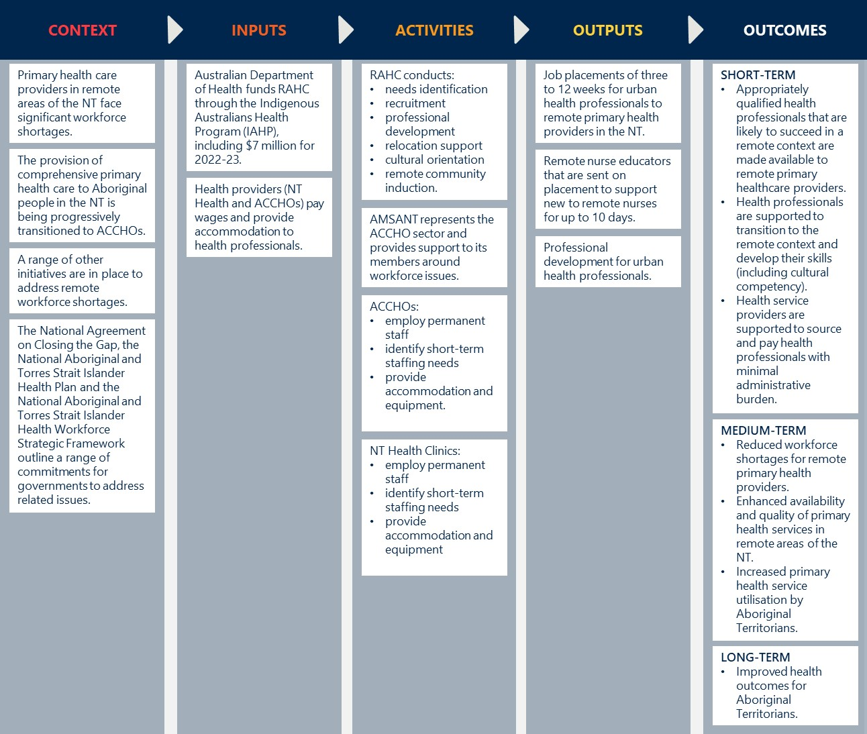

### Key evaluation questions (KEQs) guided data collection and analysis

Four KEQs and associated research questions are presented in Table 2.

Table 2 | Key evaluation questions and their related sub-questions

|  |  |
| --- | --- |
| Evaluation questions | Research questions |
| KEQ 1: How appropriate is the design of the RAHC? | 1.1 To what extent is the RAHC’s design appropriate? |
| 1.2 To what extent is the RAHC’s design acceptable and relevant to the remote Aboriginal communities it serves? |
| KEQ 2: How effective is the RAHC in addressing workforce shortages in remote NT communities? | 2.1 To what extent has the RAHC been implemented as designed? |
| 2.2 To what extent has the RAHC delivered on its contractual performance expectations? |
| 2.3 How engaged and satisfied are stakeholders with the program overall? |
| 2.4 How effective has the RAHC been in identifying and attracting quality health professionals who are likely to succeed in a remote context (short-term outcome)? |
| 2.5 How effective has the RAHC been in supporting health professionals to transition to the remote context and develop their skills (short-term outcome)? |
| 2.6 How effective has the RAHC been in supporting health service providers (NT Health clinics and ACCHOs) to source and pay health professionals with minimal administrative burden (short-term outcome)? |
| 2.7 How effective has the RAHC been in delivering on its medium-term outcomes?   * + Reduced workload shortages for remote primary health providers.   + Enhanced availability and quality of primary health services in remote areas of the NT.   + Increased primary health utilisation by Aboriginal Territorians. |
| 2.8 What factors have supported and detracted from the RAHC’s effectiveness? |
| KEQ 3: To what extent is there continued need for job placement and training for temporary placements in remote NT health clinics and ACCHOs? | 3.1 To what extent are the RAHC’s outcomes sustainable without further support? |
| 3.2 What lessons are there from other models exist to address short term workforce shortages? |
| 3.3 How effective are other initiatives to increase the remote health workforce in the NT expected to be (likely trends in workforce supply)? |
| 3.4 How is the demand for the primary health workforce expected to evolve over the next five years? |
| KEQ 4: What changes could improve the effectiveness and efficiency of work currently undertaken by RAHC? | 4.1 What changes could improve effectiveness? |
| 4.2 How efficiently have RAHC resources been used? |
| 4.3 What changes could improve efficiency? |

### The evaluation gathered data from multiple sources – including desktop review, quantitative data analysis, consultations and site visits

Table 3 presents an overview of evaluation data sources.

Table 3 | Evaluation data sources and analysis approach

|  |  |
| --- | --- |
| Method | Description and Purpose |
| **Desktop Review** | Rapid desktop review of relevant data and documents provided by the Department and other key stakeholders including RAHC and Aspen in order to develop a thorough understanding of the aims and purpose of RAHC, whether and how these have changed overtime, and any previously documented impacts of RAHC.  Note that many documents from the inception of RAHC – including any original grant application or new policy proposal (NPP) were not made available to the evaluation.  This review was complemented by a rapid review of national and international literature to understand other models of delivering health care in remote communities. |
| **Quantitative data** | Analysis of RAHC performance and financial reports and other data (such as placement data) to understand RAHC activities, outputs, and impact.  This data was complemented by an analysis of health workforce data provuded by the Department (through the Health Demand and Supply Utilisation Patterns and Planning Tool (HeaDS UPP)) to develop a picture of the health workforce in the NT, and understand key factors that may impact clinics’ need for RAHC placements. |
| **Key informant interviews and focus groups** | Consultations with more than 30 individual stakeholders to understand stakeholders’ perspectives on the RAHC model, capture its impact, and explore how it could be improved. These consultations included:   * Interviews with ACCHO leadership including all ACCHO CEOs through the Aboriginal Medical Services Alliance NT (AMSANT) Board. * Interviews with NT Health leadership. * Interviews with senior NT Primary Health Network stakeholders. * Interviews with other key stakeholders involved in health workforce development, planning and delivery in the NT including AMSANT. * One consultation with the RAHC Board and individual consultations with select Board Directors (where appropriate). * Interviews with RAHC leadership (ongoing throughout the evaluation). * One focus group with RAHC staff. * Three focus groups with HPs who have completed RAHC placements (including both nursing and oral health professionals). |
| **Survey of current and former RAHC HPs** | Development and distribution of a short online survey for current and former RAHC HPs. The survey was designed to understand the HPs’ purpose for joining RAHC, their experience with RAHC and their placements, and how RAHC could be improved into the future. |
| **Survey of ACCHO and NT government clinics eligible for RAHC placements** | A short survey to all ACCHO clinics and NT Government clinics eligible for RAHC placements was planned. The intention of the survey was to determine clinics’ impressions of RAHC, rationale for choosing RAHC over other placement providers, and understand perspectives from clinics with different usage patterns (e.g. high users as compared to low users).  ACCHO and NT Government leadership advised that there was limited utility in distributing the survey, as clinic leadership would have little awareness of or direct engagement with RAHC.  As a result, the planned survey was not distributed, with insights generated through other activities. |
| **Site visits to eight selected clinics** | Site visit to eight clinics across the NT to understand how RAHC is being delivered on-the-ground. Sites were selected based on criteria, including:   * Clinic governance and management – ensuring a mix of ACCHO and NT Government run clinics (four of each). * Geography – ensuring spread across all regions of the NT. * Community size – ensuring spread across small, medium and large communities. * Number and type of placements – ensuring spread across clinics that have heavily used RAHC and those that have sparsely used RAHC.   The four NT Government clinics were:   * Ali Curung Health Centre (Ali Curung, Barkly region). * Borroloola Health Centre (Borroloola, Big Rivers region). * Flynn Drive Dental (Alice Springs, Central Australia region). * Jabiru Community Health Centre (Jabiru, Top End region).   The four ACCHO clinics were:   * Anyinginyi Health Centre Tennant Creek (Anyinginyi, Barkly region). * Miwatj Health Aboriginal Corporation (Miwatj, East Arnhem region – note that based on advice from Miwatj, this was conducted as a virtual visit across all Miwatj sites) * Mpwelarre Health Service (Ltyentye Apurte / Santa Teresa) (Central Australian Aboriginal Congress, Central Australia region). * Timber Creek Health Centre (Katherine West Health Board, Big Rivers region) |

### Data was triangulated from all sources to generate robust insights and recommendations

An adapted version of the evaluation criteria developed by the Organisation for Economic Co-operation and Development’s (OECD) Development Assistance Committee (DAC) was used as a normative framework for analysis and reporting (Figure 2).[6]

Figure 2 | Evaluation criteria used for analysis and reporting

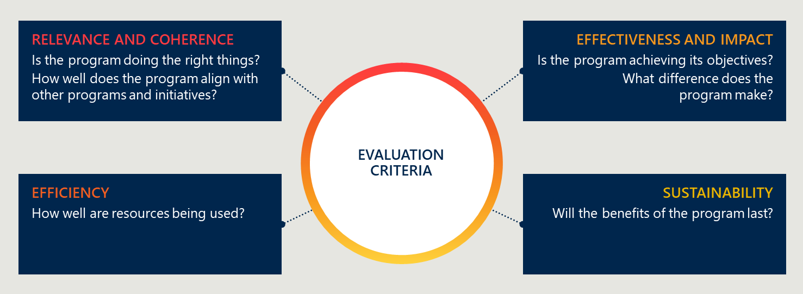

# Evaluation findings

This section presents key findings from the evaluation. It is structured according to the evaluation criteria defined in Section 2.2:

* Relevance and coherence
* Effectiveness and impact
* Efficiency
* Sustainability

## Relevance and coherence

### RAHC was designed to address ongoing workforce shortages in the NT through both supporting short-term placements and building the pool of professionals with the skills to deliver remote care

RAHC[7] was established in 2008 by the then Australian Government Department of Health, funded under the Indigenous Australians’ Health Programme: Stronger Futures Northern Territory.[8] The model is delivered through a not-for-profit subsidiary of Aspen Medical (Aspen). This report explores both the appropriateness of RAHC as a model for addressing short-term workforce shortages, and (where possible) how that model is currently being delivered by the service provider.

In June 2015, the Department undertook an Approach to Market (ATM) to identify the organisation best placed to deliver the model to June 2018. Aspen was successful in this ATM – and new funding agreements have been directly signed since June 2018 to enable ongoing operations.[9]

RAHC’s current stated aim is to “…recruit, culturally orientate and deploy health professionals to enable the provision of increased primary health care services to assist in addressing the shortfall in health service delivery in remote Indigenous NT communities…[with a] focus on recruiting urban-based health professionals”.[10] It seeks to achieve this through:

* Supporting the delivery of primary care through placing General Practitioners (GPs), nurses, oral health practitioners, ear health practitioners, and other allied health practitioners in remote communities for short-term placements (three to 12-weeks).
* Building the pool of high-quality, well trained and culturally safe HPs who are available and have the skills to complete placements in remote communities – with a focus on targeting urban-based professionals and HPs who do not otherwise work in remote settings.

RAHC was designed to operate only in the NT, reflecting the uniqueness of primary care service delivery in the Territory, including:

* Highly inaccessible and extremely remote areas.
* A large Aboriginal population.
* A high proportion of primary care services delivered through the community-controlled sector.
* Ongoing challenges with recruitment and retention of HPs, over and above those faced by other jurisdictions.

RAHC is explicitly not a recruitment agency.[11] Although most stakeholders consulted in the evaluation referred to RAHC as an agency, RAHC leadership and staff describe it as a program designed to work closely with Aboriginal communities and other key stakeholders to build the workforce pipeline and strategically address ongoing workforce challenges.

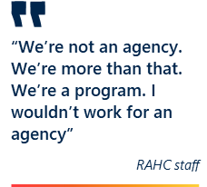The evaluation was not able to access documents related to the original design and intent of RAHC – including the ultimate aim, program logic, or theory of change – given that:

* There has been significant changeover in staff within the Department managing the RAHC contract, and a subsequent loss of institutional memory.
* There have been recent changes in leadership within the RAHC organisation – with the current National Manager in the role for only six-months as of December 2022 – contributing to loss of institutional memory.

### The model remains appropriate given the significant and ongoing shortage of primary health professionals and challenges with delivery of primary care in the NT

The RAHC model of providing government funding to RAHC to allow it to focus on supporting primary care delivery and bolstering the available workforce is appropriate, given significant and ongoing workforce challenges in the NT.

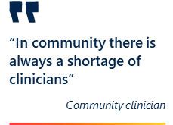Health outcomes in remote areas of the NT are significantly lower than elsewhere in Australia. For example, life expectancy in the NT outside of Darwin is 75.1 years, compared to 82.5 years in Darwin and more than 84 in Sydney, Melbourne and Perth.[12] Higher rates of chronic disease and key health risk factors, particularly for Aboriginal Territorians in remote areas, are well documented. In combination with a range of social determinants of health, low service availability in remote areas of the NT is a key driver of these poor health outcomes.

Research from the Australian Institute of Health and Welfare (AIHW) and others confirms that Australians living in remote areas and very remote areas generally have poorer access to health services than people in regional areas and major cities.[13] This is particularly true in the NT, especially for Territorians in remote and very remote communities. For example:

* The average of number of Medicare-subsidised GP services per person across Australia (6.65 per person)[14] is significantly higher than in remote and very remote areas of the Northern Territory (3.9 and 2.8 per person respectively).[15]
* The average number of dentists per 1,000 people in Australia is 0.61 dentists,[16] whilst the NT has 0.34 dentists per 1,000 people.[17]

Poorer access to primary health services, and resultant poorer outcomes, are in large part driven by workforce challenges. For example:

* The *NT Health Strategic Plan 2023 – 2028* includes improving workforce attraction and retention as a key strategic objective, highlighting this as a strategic challenge across the health system.[18]
* Data from the AIHW, reported by AMSANT, indicates an overall 43 per cent increase in workforce vacancies in the NT over the past five years, with much higher rates in very remote areas of the NT.[19]
* Annual turnover rates of remote area nurses (RANs) in the NT (148 per cent) and Aboriginal health practitioners (80 per cent) are very high, and 12-month stability rates are low (48 per cent and 76 per cent respectively).[20]
* There has been little to no change in workforce availability in recent years, as demonstrated by trends in GP services per capita and GP full time equivalent (FTE) availability in the NT. Both of these measures are lower in remote and very remote areas – the areas targeted by RAHC (Figure 3).[21]

Figure 3 | Trends in GP services per capita and GP FTE for the NT, 2015 to 2021[22]

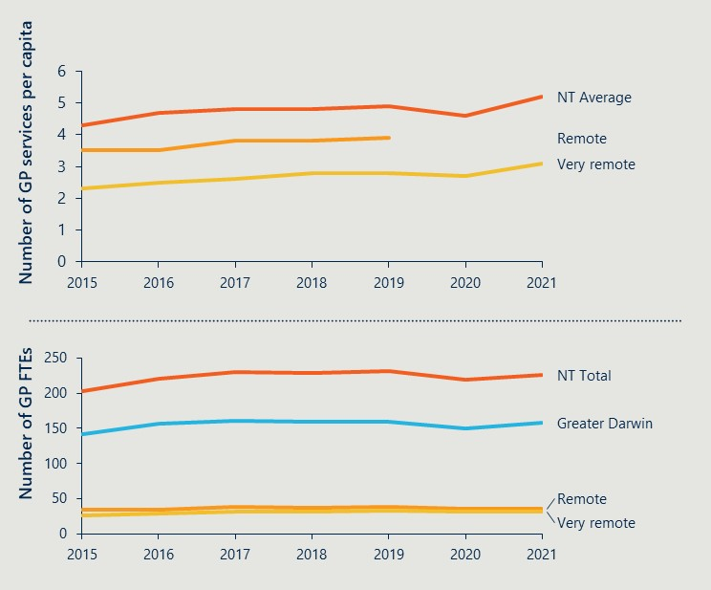

### RAHC’s focus on delivering short-term placements remains relevant – although there are a number of organisations that now also operate in this space

RAHC as a subsidised model was established in direct response to challenges with staffing clinics in remote, predominately Aboriginal communities in the NT – that is, without RAHC there were many clinics that could not fill any vacancies.[23] In essence, the RAHC model was addressing a known market failure.

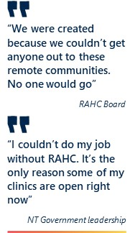Since RAHC was established, this market failure has been partially (although not fully) addressed by the entrance of for-profit short-term placement agencies, including those that specialise in rural and remote settings:[24]

* During site visits, many stakeholders noted that placements advertised by RAHC were also advertised (and often filled) by these other providers.
* Many RAHC HPs who were consulted had also completed placements for other providers or had considered signing up for other providers.
* More than half of respondents to the HP survey (53 per cent, 37/70) had participated in other short-term placement programs.

However, RAHC remains particularly relevant for smaller or more remote communities, who would otherwise struggle to recruit HPs regardless of the pay or incentives offered. In some of these communities, RAHC is the only option to fill short-term vacancies and is highly valued.

The evaluation also highlighted the ongoing challenges with longer-term recruitment and retention. All clinics that were engaged throughout the evaluation noted their reliance on short-term agencies (both RAHC and other providers) to address staffing shortages. Therefore, there remains a clear need for short-term placement agencies such as RAHC.

For all clinics, RAHC’s value add in the short-term placement space, as a result of its subsidised funding, is:

* The education and training that RAHC provides, including cultural orientation, and the credentialling process which assures clinics of the quality of health professionals being placed through RAHC.
* The value for money it provides clinics. As a government-subsidised program, RAHC HPs directly cost clinics less than HPs offered by other providers. This is discussed further below under Efficiency.

Figure 4 presents stakeholder reflections on the role of RAHC in supporting short-term placements.

Figure 4 | Stakeholder reflections on the role of RAHC in supporting short-term placements

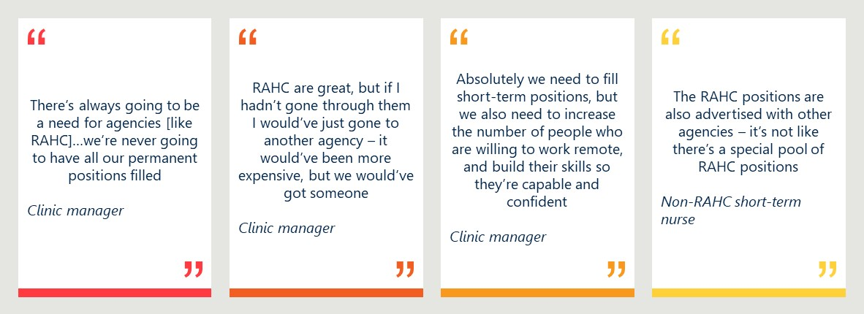

### RAHC operates in a crowded strategic environment

Given the importance of health workforce issues nationally, and the additional constraints in regional, rural and remote areas, there are a range of initiatives, policy reforms and programs under consideration and/or implementation. For example:

* The federal Stronger Rural Health Strategy (SRHS), that is intended to provide a strategic approach to address health workforce issues across all regional, rural and remote areas of Australia.
* The Northern Territory Aboriginal Health Forum (NTAHF), which has established a taskforce to address immediate workforce issues and a working group to develop an action plan to guide a collective approach to addressing health workforce challenges in the NT, including by drawing on a stocktake of existing actions.
* The Department has released the National Aboriginal and Torres Strait Islander Health Workforce Strategic Framework and Implementation Plan, in addition to the existing National Medical Workforce Strategy, National Mental Health Workforce Strategy and the National Aboriginal and Torres Strait Islander Health Plan.
* A range of health workforce related programs and initiatives across the NT, including new allied health degrees at Charles Darwin University, the Workforce Incentive Program (WIP) – Doctor Stream, the More Doctors for Rural Australia Program (MDRAP) and Remote Incentive Bursaries.
* The Northern Territory Primary Health Network (NTPHN) takes a leading role on primary health workforce issues. This includes running a specific NT GP locum program.

There are four layers of factors that impact the appropriateness, effectiveness and efficiency of RAHC:

1. The underlying structural challenge. At its root, workforce constraints are a result of a combination of high demand resulting from underlying social determinants of health and higher burden of disease, and constrained supply resulting from the lower relative attractiveness of living in remote areas for staff and families, professional isolation, and workload challenges. For example, the AIHW13 cites research by Medical Deans Australia and New Zealand (MDANZ), that shows that graduating medical students have shown consistent preference for practicing in capital cities. In 2020, 65 per cent of surveyed medical students indicated a preference to work in capital cities. In contrast, only 17 per cent of students indicated a preference to work in regional cities, small towns, or small communities.
2. Policy responses to these structural challenges. The Australian (and to some extent NT) Government have a range of policy levers available to address these issues, but must balance overall system settings that apply nationally with specific settings to address challenges in remote areas. Funding models and resulting incentives for health professionals are particularly important.
3. A range of programmatic responses. Governments, peak bodies and other system stakeholders have put in place a range of programmatic responses that are designed to mitigate the impacts of the underlying structural challenge and the impacts (intended or unintended) of policy responses. RAHC is one of many such programmatic responses, alongside other government-funded services (such as Rural LAP and the NT PHN locum program), and private providers of short-term placements.
4. Community expectations and attitudes. RAHC operates in a highly sensitive political and cultural environment. As a result, there is a high degree of scrutiny and expectation from communities and health services. The transition to community control can have a significant impact on workforce issues. This makes the building of cultural competency particularly important.

### RAHC’s intended model provides unique value add and fills a needed gap, when compared to other mechanisms for supporting primary care delivery in remote communities in the NT

As noted above, RAHC is one of many approaches for addressing workforce shortages and improving access to primary care in the NT. Stakeholders including RAHC leadership emphasised that the model as designed is unique in that it intends to:

* Focus its support on remote Aboriginal communities, including ensuring that HPs are appropriately trained to deliver culturally safe and responsive care and that workforce solutions meet the specific needs and context of remote Aboriginal communities in the NT. Other placement agencies do not have this specific focus.
* Support and encourage placements of longer duration (up to 12-weeks, within the boundaries of ‘short-term placements’), as opposed to short-term fly in fly out (FIFO) / drive in drive out (DIDO) or locum services (which may be as short as two weeks). Placements longer in length are beneficial as they reduce administrative burden on clinics, enable HPs to build relationships with clinic staff, enable HPs to build relationships with community and community members, and contribute to supporting continuity of care. Note that whilst RAHC encourages placements of longer duration, actual placement lengths are driven by immediate clinic need and HP preferences.
* Build the overall pool of HPs who have the skills and competencies to work in remote areas, through active recruitment, and in-depth education and training. There is a specific focus on recruiting urban-based health professionals and on HPs who have not otherwise worked in remote areas – RAHC has an explicit aim not to recruit staff already working in remote communities (either in the NT or in other jurisdictions).
* Contribute to supporting permanent staff in the clinics in which it operates. Daily rates for RAHC HPs are explicitly aligned with the rates received by permanent staff. This is both cost effective for clinics, but is also designed so that it does not incentivise permanent staff to leave their roles for more lucrative short-term placements. RAHC leadership also emphasised that they support HPs to transition to permanent roles in clinics, whereas other providers of short-term placements actively discourage this transition, including charging clinics or HPs significant fees when this occurs.

Table 4 (overleaf) provides an overview of other models that are used to address workforce shortages, including how these models differ from RAHC.

### RAHC’s Aboriginal-led governance and leadership is appropriate, given the program’s specific focus on addressing the needs of Aboriginal communities

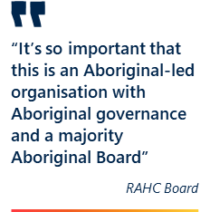RAHC’s Board Chair, a majority of Board members and the newly appointed RAHC National Manager are all Aboriginal or Torres Strait Islander, ensuring that RAHC is guided by significant Aboriginal and Torres Strait Islander leadership. This leadership model is important and appropriate, given RAHC’s specific focus on supporting Aboriginal communities in the NT.

As a result of this leadership model, when compared to other existing providers of short-term HPs, RAHC is well placed to:

* Understand the specific needs of Aboriginal communities, accounting for important context.
* Work with communities and providers – including ACCHOs – to ensure that solutions to identified needs are culturally safe and culturally appropriate.
* Ensure that remote Aboriginal communities – that may otherwise be unable to recruit short-term HPs – have the staffing they need to deliver high-quality and safe care.
* Ensure that HPs who are placed in Aboriginal communities have the right skills and competencies, and are appropriately oriented, to deliver culturally safe and culturally appropriate care.

Few stakeholders mentioned RAHC’s Aboriginal governance or leadership model, indicating that this is not known, or it is not seen as a unique value add.

Table 4 | Overview of models to address workforce shortages

|  |  |  |  |
| --- | --- | --- | --- |
| Model type | Brief description and intended key features | Costs | Examples |
| RAHC | * Federal government subsidised, delivered through not-for-profit subsidiary of Aspen Medical. * Provide HPs for three to 12-week placements in communities. * Support building the pool of workers with necessary skills and experience to work in remote communities. * Focus and direct placements to remote communities in the NT, where it may otherwise be difficult to place HPs. * Provide HPs based on clinic needs and demands – responsive to clinic requests (inc. for HP type and length of placement). | * Clinics pay salary and other in-community costs directly. * Salary costs are equivalent to NT Government / ACCHO salaries. * RAHC covers cost of recruitment, training and transport and logistics. | * RAHC |
| Short-term placement agencies[25] | * Private / commercial organisations. * Provide HPs for two to 12-week placements in communities (anecdotally, placements rarely last longer than six-weeks). * Provide HPs based on clinic needs and requests – demand driven. * Do not actively work with clinics to direct HPs to remote Aboriginal communities in the NT. | * Clinics pay total cost including airfares and logistics. * Salary costs are frequently higher than permanent staff – to account for short-term nature of placements and commercial positioning of agencies. * HPs responsible for costs related to training / upskilling / ongoing professional development. | * Alliance Rural & Remote Health |
| Locum agencies | * Private / commercial organisations and government-run organisations. * Provide HPs for very short-term placements in communities (often one – two weeks, up to four weeks), primarily to provide relief when permanent staff are on leave or unwell. | * For private organisations, clinics will pay total cost including airfares and logistics. * Costs may be higher due to the very short-term and often last-minute nature of the work. * Government subsidised organisations will cover the costs of recruitment, travel and logistics.[26] | * Rural Locum Assistance Program (LAP) * NTPHN GP locum program |
| Fly-in fly-out (FIFO) / drive-in drive-out (DIDO) | * Government-run or subsidised organisations. * Provide day or overnight placements – professionals fly in, deliver services, and then fly out. * Most appropriate for specialities where there is not a day-to-day need for service delivery in remote communities (e.g. hospital-based specialist care; allied health care). | * Usually covered as part of routine government service delivery – clinics incur no additional costs. | * Royal Flying Doctor Service[27] and Rural Health West[28] |
| Telehealth / virtual health | * Private / commercial organisations, not-for-profit organisations, and delivered as part of routine government service delivery. * Provide on-demand clinical support when in-person staff are not available (inc. overnight). * Often provided as part of routine clinical care. | * For private / commercial organisations and not-for-profit organisations, clinics will pay the cost of the consultation. * Costs may be higher due to the on-demand and after-hours nature of the work. * For services provided by government, clinics would usually incur no additional costs. | * Health Access[29] * South Australian Virtual Emergency Services (SAVES)[30] |

## Effectiveness and impact

### RAHC met its contractual obligations and key performance indicators up to 2019, but the COVID-19 pandemic and other factors since have created performance challenges

The 2022-23 grant guidelines and RAHC performance reports indicate that RAHC has two key performance indicators (KPIs) against which it must report against annually:

1. Number of health professional placements (total across all placements) – target changes year on year.
2. Proportion of NT Health clinics’ requests for health professional placements that are responded to in a given year – annual target of 100 per cent.

Table 5 presents data related to KPI 1 for FY2013-14 to FY2021-22. RAHC consistently met and exceeded placement targets from 2013 to 2018. There was a marked deviation beginning in 2019 – with the organisation delivering only 71 per cent of intended placements in 2019, 56 per cent in 2020 and 35 per cent in 2021.

This deviation can be partly explained by the COVID-19 pandemic, which impacted:

* The number of health professionals available to complete placements, as many were redirected to or actively chose to shift to COVID-19 preparation and response roles including vaccination efforts.
* The ability of HPs to complete placements, as movement between jurisdictions was exceedingly difficult during periods of the pandemic.
* The willingness of HPs to complete placements, as many were concerned that snap jurisdictional and/or community lockdowns would see them stuck in remote communities for significant periods of time.

Note that RAHC was temporarily expanded during the pandemic to allow the placement of HPs in Aboriginal community-controlled organisations across Australia. Table 5 includes only placements in the NT during this period.

Table 5 | Data related to KPI 1 (FY2013-14 to FY2021-22)

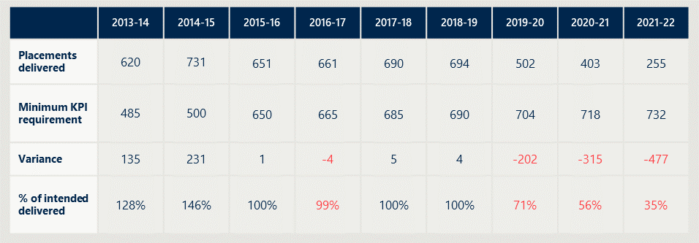

### Recent performance reports do not report explicitly on achievement against the second KPI – related to responsiveness

The 2017 evaluation reported that the RAHC organisation was meeting the 100 per cent responsiveness target. Recent progress reports made available to the evaluation (including those from 2019, 2020 and 2021) do not report progress against this KPI and this data was not made available to the evaluation – although RAHC leadership and staff reported their impression that the organisation was highly responsive.

By contrast, throughout the evaluation stakeholders reported challenges and frustrations with organisational responsiveness – including their impression that while the RAHC model was appropriate and well regarded, the organisation did not always respond to requests to fill workforce shortages.

The current KPIs are not comprehensive or nuanced enough to track effectiveness and efficiency, or to support the Department in guiding the delivery of RAHC. There is a need to revisit KPIs, in partnership with RAHC leadership, to ensure robust and relevant data is collected and consistently reported. The data presented in performance reports – which report on achievements including recruitment, placement length, repeat placements, locations of placements, and training content and delivery – could be used to define a new suite of KPIs.

### RAHC is successfully contributing to addressing short-term workforce shortages in remote communities in the NT – it is seen as the “agency of choice” for many clinics and for certain types of health professionals

Since inception in 2008, RAHC has delivered a total of 7,295 placements across all professions. This equates to 646.6 FTE years of service delivered in the NT.

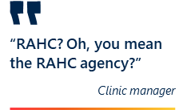RAHC is seen as a high-quality, placement/recruitment agency, particularly when compared to other for-profit agencies. Throughout the evaluation, stakeholders frequently referred to the “RAHC agency”, and compared it to other short-term agencies including commercial entities.

RAHC is the “provider of choice” for short-term placements for many clinics due to a number of factors resulting from its subsidised funding, including:

* RAHC HPs are less costly to individual clinics. RAHC’s model is such that clinics pay RAHC HPs the same hourly rate (or very close to) as their permanent staff. RAHC also cover the costs of transport to and from clinics, pre-departure accommodation and other logistical expenses, and education, training and insurance. By contrast, agency staff are more expensive to clinics as they receive a higher hourly rate of pay, and clinics are expected to cover the cost of transport, other logistics, and agency profit margin.
* Perceptions that RAHC HPs are higher quality than other agency staff. Clinic staff and clinic management frequently reported that RAHC HPs are better trained and higher quality than staff from other short-term placement agencies. This was attributed this to RAHC’s rigorous credentialling process and pre-placement training program.
* Perceptions that RAHC HPs are more equipped to provide culturally safe and culturally appropriate care. All stakeholders spoke highly of RAHC’s cultural orientation training program. It is particularly important that this training is tailored to the unique nature of individual communities, and that it is not delivered under a “one size fits all” approach.
* The additional support provided to RAHC HPs, particularly the remote educator program. There is significant value associated with the remote educator program – whereby RAHC sends a remote educator on placement alongside a new-to-remote nurse for up to 10 days. The program means that new nurses can start seeing patients immediately. By contrast, new nurses from other agencies frequently require “hand holding” for days or weeks before they are confident and comfortable to see patients independently.

HPs who have participated in RAHC were also complimentary of the model. Of those who responded to the RAHC HP survey:

* 68 per cent were satisfied or very satisfied with the training and other support provided by RAHC to prepare them for placements.
* 55 per cent agreed that they had access to appropriate cultural advice and mentoring whilst on placement.
* 57 per cent agreed or strongly agreed that they had access to appropriate psychosocial support whilst on placement.
* 80 per cent agreed or strongly agreed that they knew who to turn to if they had questions or needed support whilst on placement.

As set up, RAHC may be attracting HPs who are purpose driven and keen to expand their skills, rather than those motivated by financial incentives. Of those who responded to the survey:

* 63 per cent reported joining RAHC because of a desire to support Aboriginal people and communities.
* 37 per cent reported joining RAHC because of a desire to build the skills needed to work in remote areas.
* 36 per cent reported joining RAHC because of the impression that RAHC provided more training and support than other organisations.[31]

Stakeholder reflections on the importance of RAHC, including the important role RAHC plays in supporting the delivery of primary care services in remote communities, are presented in Figure 5.

Figure 5 | Stakeholder reflections on the importance and value of RAHC

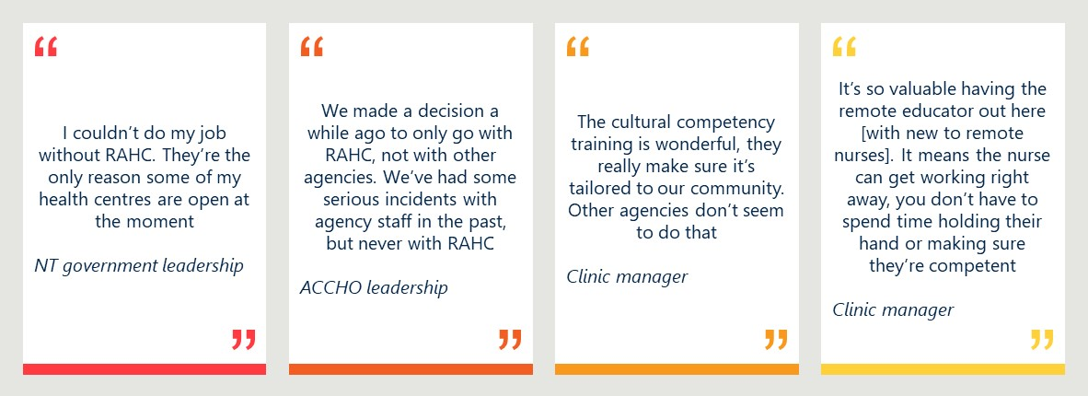

### RAHC placements are overwhelmingly nursing focused, with some oral health professionals – there are minimal General Practitioner and allied health placements

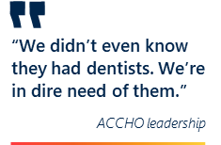Whilst originally intended to place a broad range of primary care HPs – including General Practitioners, nurses, allied health, ear health, and oral health professionals – the program has narrowed in scope. Since 2013-14, Registered Nurses have accounted for approximately 50 per cent of total placements and oral health professionals for approximately 30 per cent of all placements (Figure 6). The focus on nursing is reinforced by the RAHC website, which specifically references primary health care nursing when discussing the role of HPs during placements.[32]

There are several reasons for this narrowing of scope, including:

* Other government-supported programs that provide these professionals and better meet their needs and expectations, particularly General Practitioners. Stakeholders noted the existence of both the Rural Locum Assistance Program (Rural LAP) and NT Primary Health Network’s GP locum service. It is possible that clinics are procuring HPs through these programs, especially where these programs actively support shorter-term placements (including locum relief). As discussed above, the need for GP placements remains high, and this narrowing of scope may reflect a lack of focus or attention on replenishing the pool of GPs available through the RAHC model. However, stakeholders noted that it is also challenging to secure short-term GP placements through these other means.
* Poor awareness by clinics of the other HPs available through RAHC. In site visits, stakeholders including clinic managers and other staff referred to “the RAHC nurses”, indicating that the program is primarily known for providing a nursing workforce. Whilst NT Government clinics tended to be aware of and use other professions – particularly oral health – ACCHO clinics were often not aware the other HPs could be secured through RAHC.
* An overall shortage of HPs available. Stakeholders noted the overall challenges facing the health workforce in Australia – not just in regional, rural and remote areas. There is a shortage of professionals, particularly General Practitioners, with Australia facing an expected shortage of 10,600 GPs by 2031.[33] As a result, it may be difficult for RAHC to attract HPs to complete placements.

Whilst there is a known difference in need between professions – for example, clinics have many more nursing positions, and therefore it is expected that there would be more nursing placements – the evaluation did not find that the difference in placement numbers is due to lack of demand.

Figure 7 (overleaf) provides an overview of the distinct features of RAHC’s support to different HPs.

Figure 6 | RAHC placements, by profession (2013-14 to 2021-22)

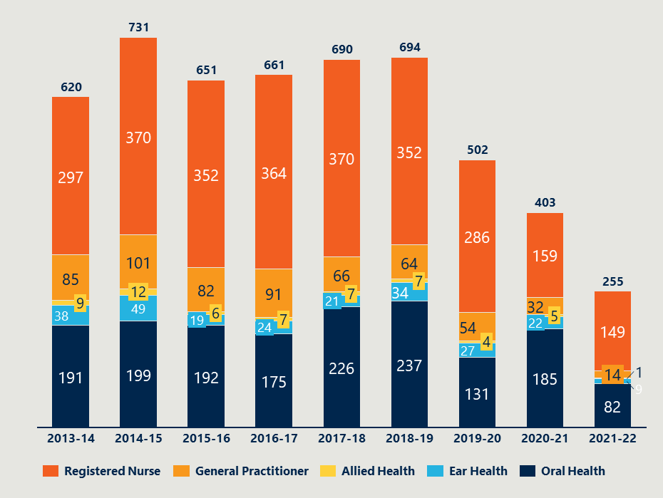

Figure 7 | Overview of RAHC engagement with different clinical specialities

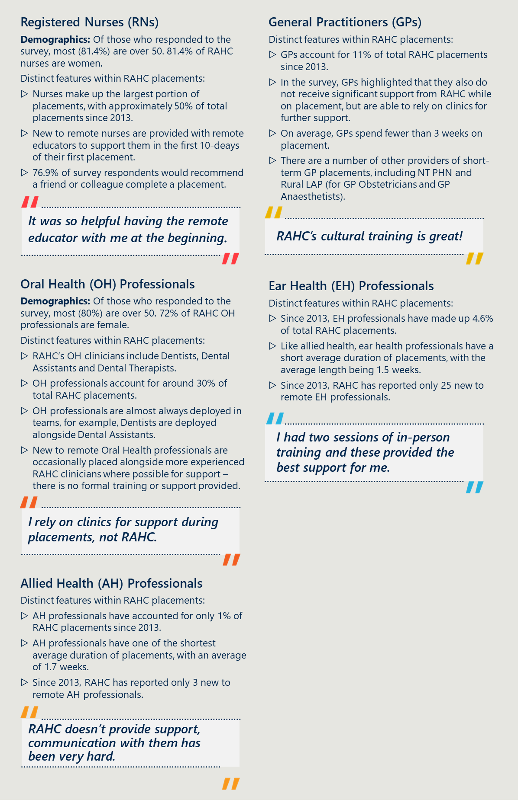

### On average, RAHC placements are at the shorter end of the supported placement length, and for some professions shorter than the specified RAHC minimum of three-weeks

Table 6 presents an overview of average placement length, by financial year, by profession, highlighting the shorter-term nature of placements since 2013-14 – noting that RAHC supports placements between three and 12-weeks in length.

The evaluation uncovered a number of reasons for the shorter-term duration of placements, including:

* Health professional preferences. Many HPs highlighted their preference for shorter-term placements, particularly when their permanent home is inter-state. Many expressed a desire for placements of six-weeks, noting that this was the maximum amount of time they could spend in communities before needing time off for rest and relaxation.
* Speciality needs. Some stakeholders noted that whilst longer-term placements may be appropriate for nursing, they are less appropriate for specialities such as oral health and allied health. It can be difficult for these HPs to take extended periods of time away from work to complete longer-term placements. It may also not be necessary for some specialities to spend extended periods of time in communities – for example, oral health professionals can likely provide all services needed to a community in two-weeks or fewer.

Stakeholders including NT Government representatives, ACCHO leadership, and clinic managers all expressed a preference for longer-term nursing staff placements.

The appropriateness and value of placement length varies by profession – for some HPs – such as oral health, ear health, and allied health professionals – the three-week minimum placement is not necessary, and clinical work can be completed in shorter periods of time. RAHC should evaluate the length of its different specialties and actively support different placement lengths, particularly where this will increase the pool of professionals available to complete placements.

Table 6 | Average placement length, by profession (2013-14 to 2021-22)

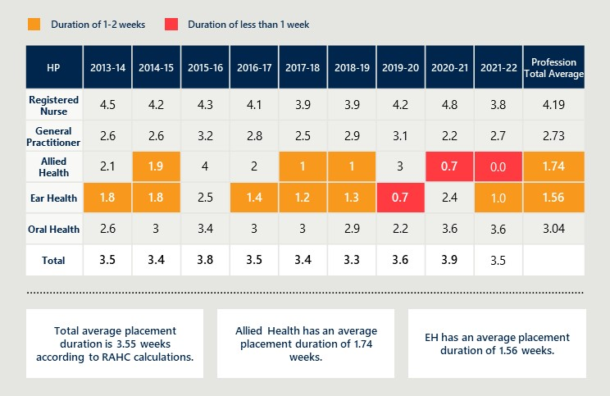

Longer-term placements were reported to be beneficial for multiple reasons, including:

* 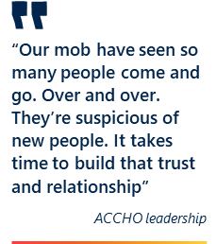Supporting the delivery of high-quality and culturally safe care. All stakeholders reported that community members – particularly Aboriginal community members – tend to be wary of new HPs. They noted that it takes time for new HPs to build trust, relationships and rapport. These are essential for understanding patient medical history and for supporting continuity of care – clinic staff reported that patients are more likely to return for follow up appointments if they know and trust their HP.
* Building trust and rapport within the clinic team. Clinic leadership from both NT Government and ACCHO clinics noted the value of longer-term placements for creating a cohesive clinic team. Frequent, short-term placements can result in poor team cohesion and impact work environment and experience for HPs on placement as well as the broader clinic team.
* Providing maximal benefit to the clinic, including the ability and confidence to work independently. Many stakeholders noted the time it takes new HPs to come up-to-speed with clinic processes and procedures – which can take between two and four-weeks. During this learning time, clinic leadership reported that HPs provided less benefit to the clinic.

### RAHC is successfully building the skills and competencies of those already in the program, as well as those outside the program who are interested in remote work

As noted previously, the majority of stakeholders consulted as part of the evaluation spoke very highly of RAHC HPs. These HPs were seen as high quality and safe, particularly when compared to staff from other agencies. On the rare instances that there was a quality issue with a RAHC HP, this had been swiftly dealt with and resolved.

RAHC leadership, staff and RAHC HPs all highlighted the important role of RAHC’s training program in ensuring HPs were adequately prepared for placements (Figure 8).

Figure 8 | RAHC HPs survey responses regarding the importance of pre-placement training

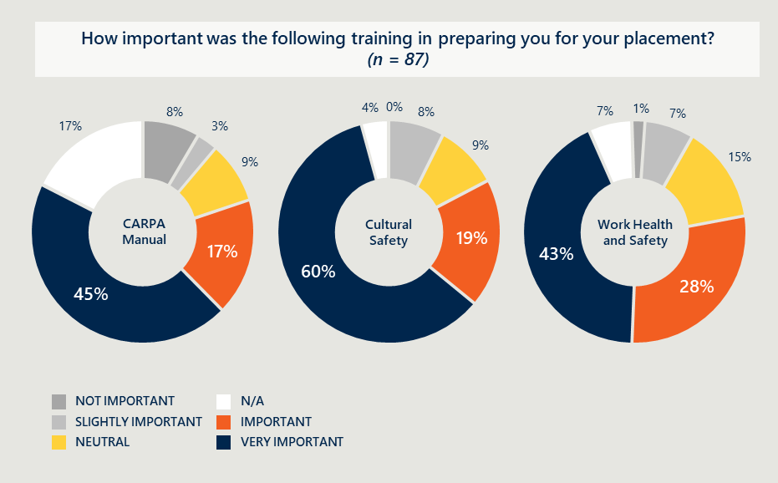

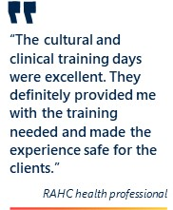In particular, clinic leadership reported the importance of the one-day cultural safety training to orient HPs to their placement locations, and support them to deliver culturally safe and responsive care. Feedback from HPs themselves emphasised the quality and effectiveness of the cultural safety training provided as part of the RAHC model, with some noting that similar training was not provided by other providers of short-term placements.[34]

Many stakeholders – including clinic leadership and HPs from other providers of short-term placements – praised RAHC for making their online training available to HPs outside the program. According to RAHC internal data, 93 per cent of all online users of RAHC’s training modules are non-RAHC professionals. Through making this training available broadly, RAHC is contributing to building capacity across the workforce (not just for RAHC HPs).

In addition to online training and two-days of in-person training and orientation prior to the first placement, RAHC offers new-to-remote nurses the opportunity to be paired with a remote educator for the first 10-days of their first placement. The offer of a remote educator is highly valued by both HPs and clinic staff – with both highlighting this as a unique value add of RAHC, not provided by other agencies, but which helps to ensure the delivery of safe and high-quality care in communities:

* 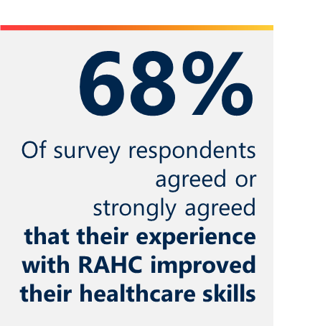For health professionals, being accompanied by a remote educator provided them with a sense of safety and security in an unknown and stressful environment. These HPs were comforted by the presence of an experienced professional who could guide them in their first days, ensuring that they were fully across the scope of work and tasks expected of nurses in remote settings.
* For clinics, having a remote educator alongside a new HP meant that these new HPs could be “fully operational” from the first day. Without the educator, clinic leadership and staff reported that new-to-remote nurses require significant support (including in some instances side-by-side mentoring). This takes existing staff focus away from patient delivery and can make it feel as if a new to remote nurse is an additional burden rather than a valued resource.

Notably, the remote educator positions are only available for new-to-remote nurses. Non-nurse RAHC HPs reported much less in-person support during their placements. In many cases, these HPs relied instead on more experienced RAHC professionals that they were working alongside, or on guidance from staff in their placement location.

### RAHC is actively facilitating return placements, potentially contributing to positive outcomes associated with enhanced continuity and quality of care.

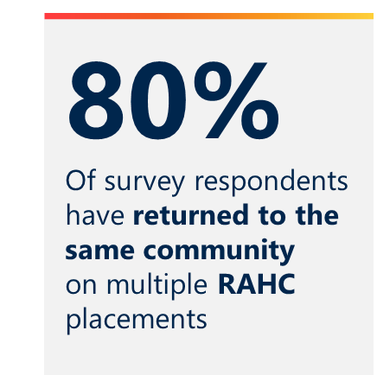During interviews, RAHC leadership and staff reported that they actively encourage and support RAHC HPs to return to the same community on multiple placements.

RAHC does not directly measure how many HPs return to the same community. Instead, RAHC measures if individuals complete more than one placement a year (a repeat placement). Data indicates that close to 80 per cent of all HPs across all RAHC-supported specialities complete at least one repeat placement each year (Table 7). According to several consultations and surveys, most RAHC clinicians have reported completing these repeat placements in the same community.

There is significant value that arises from repeat placements in the same community, including:

* Opportunities to build and maintain relationships with the community, leading to greater trust, rapport, and ultimately better patient outcomes. As with placements of longer duration (discussed previously), stakeholders highlighted that repeat placements build trust and rapport with community members. This may encourage community members to come to the clinic more frequently and to be more open with clinic staff. Trust and relationships may also contribute to the delivery of culturally safe and culturally appropriate care.
* Provision of greater continuity of care. When HPs complete repeat placements, they get to know community members and their medical history – meaning that they can provide holistic treatment to patients, rather than focusing solely on the issue the patient has presented with on a particular day.
* Reduced burden on clinic leadership and clinic staff. HPs on repeat placements are able to contribute effectively from the first day of their placement. They already know their colleagues, clinic processes and procedures (such as referral pathways), and clinic systems (such as the electronic medical records system in use).

Table 7 | Percentage of RAHC HPs that complete a repeat placement, by profession   
(2013-14 to 2021-22)

Table 7 show the Percentage of RAHC HPs that complete a repeat placement, by profession 
(2013-14 to 2021-22)


There is scope for RAHC to deepen or formalise innovative employment arrangements to facilitate repeat placements such as job share arrangements – where two or more HPs fill one full-time equivalent (FTE) position. Under these arrangements, HPs would agree to formal rotations of a set number of weeks (for example six-weeks in community, six-weeks out of community) for 12-months or more. These models benefit:

* Clinics, as clinics have guaranteed staff for extended periods of time contributing to enhanced team morale, and do not need to spend time and effort frequently finding short-term staff.
* Health professionals, as HPs have guaranteed employment with known time off for rest and recuperation.
* Communities, as community members are able to build trust and rapport with HPs who are known to them, contributing to enhanced continuity of care.

### New-to-remote placements have declined over time, particularly since COVID-19, indicating that RAHC is having less of an impact on building the pool of workers

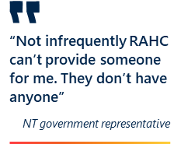In addition to actively addressing workforce gaps through supporting placements, RAHC intends to contribute to building the pool of high-quality, well trained and culturally safe HPs who can complete these placements.

However, data indicates that RAHC’s contribution to building the pool of workers has slowed:

* The total number of new-to-remote RAHC placements has halved from a high of 124 HPs in 2014-15 to 61 in 2018-19 (Figure 9).
* Almost two-thirds of respondents to the HP survey (63 per cent, 51/81) have been involved with RAHC for more than three-years, and almost a quarter (23 per cent, 19/81) have been involved with RAHC for more than 10-years.

Coupled with high repeat placement rates, reported above, this indicates that there has been a stagnation in the overall pool of HPs completing RAHC placements.

RAHC leadership noted that the very low numbers of new-to-remote placements in 2020-21 and 2021-22 were due to the impact of the COVID-19 pandemic. Health professionals – particularly those who had not worked in a remote context before – were likely unwilling to move into this space due to fears of intra-state lockdowns. Note, however, that the number of new-to-remote placements has been in decline since before the pandemic.

Figure 9 | New-to-remote RAHC placements, by profession (2013-14 to 2021-22)

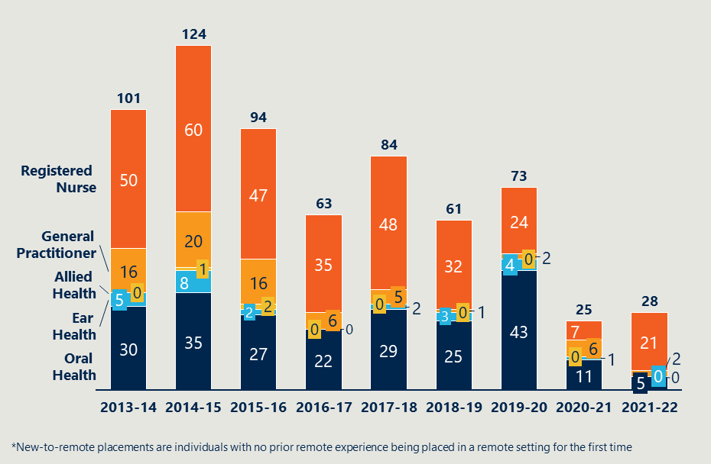

### RAHC placements generally align with population density, some clinics receive multiple placements, whilst others receive few or none

Figure 10 presents an overview of RAHC placements since 2013 alongside the population density of the Northern Territory, both mapped by location. Generally, placements tend to align with the population distribution of the NT, with large clusters of placements around key population centres such as Tennant Creek, Katherine and Alice Springs (and surrounds). Clusters of placements also form in areas that can more easily be accessed from Darwin such as Wadeye, Galiwinku and Maningrida.

Figure 10 | Placement and population distribution across the NT[35]

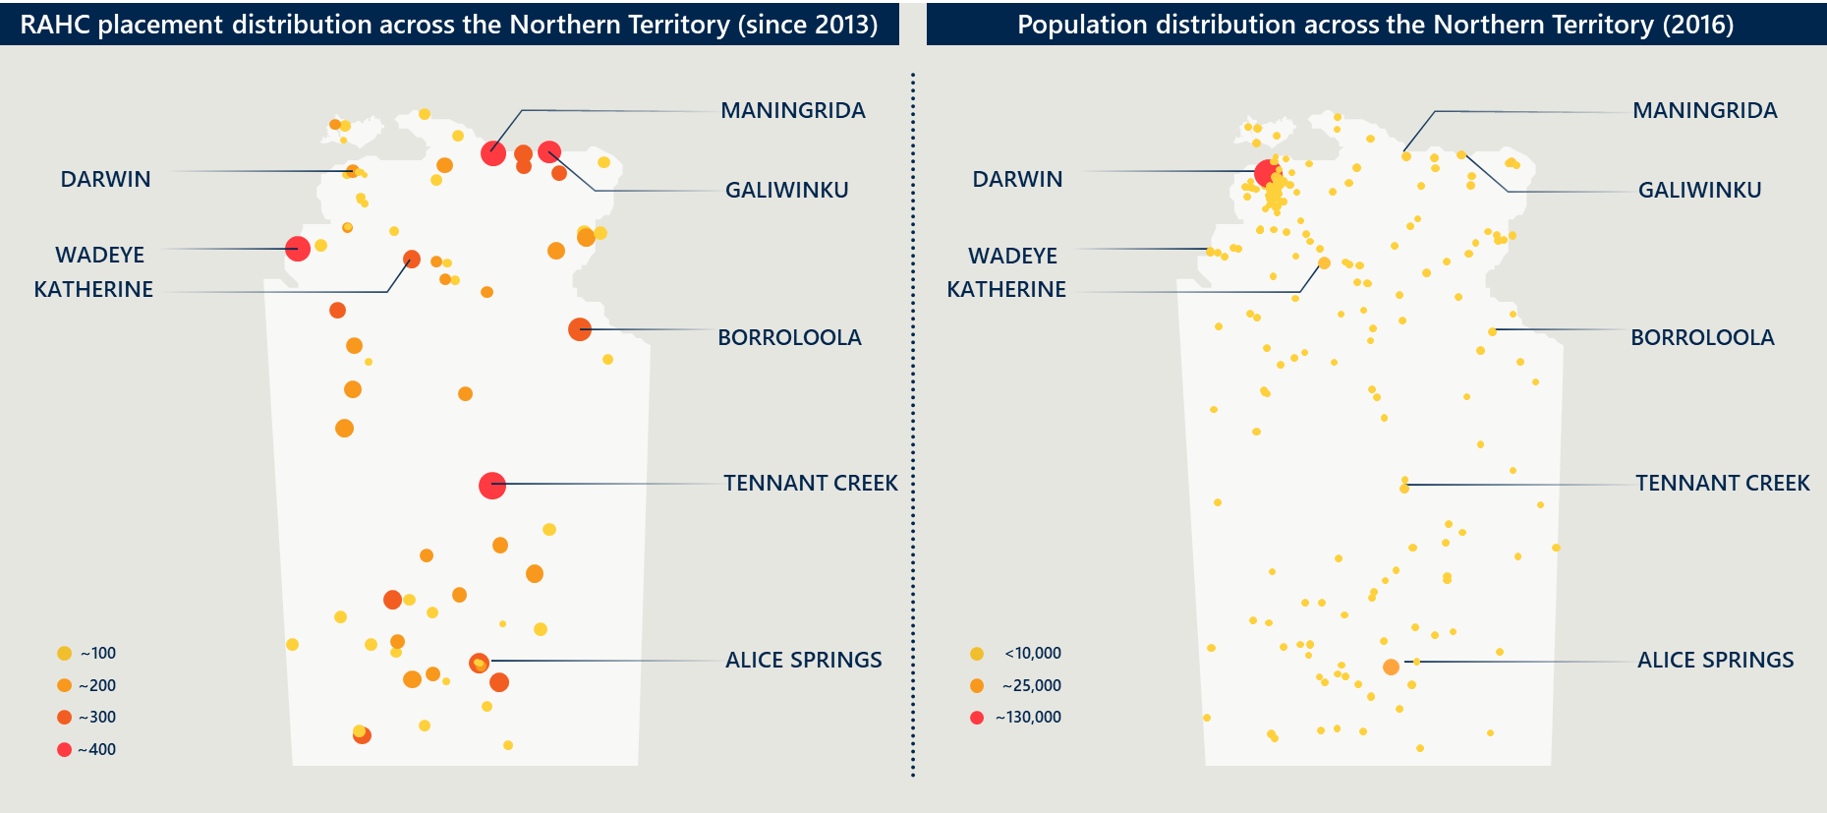

Table 8 highlights that almost 90 per cent of RAHC placements are in the most remote areas of the NT, aligned with its intended purpose of supporting remote communities, and reflective of the overall Modified Monash Model (MMM) classification of the NT.

Table 8 | RAHC placements by MMM remoteness classification, since 2013

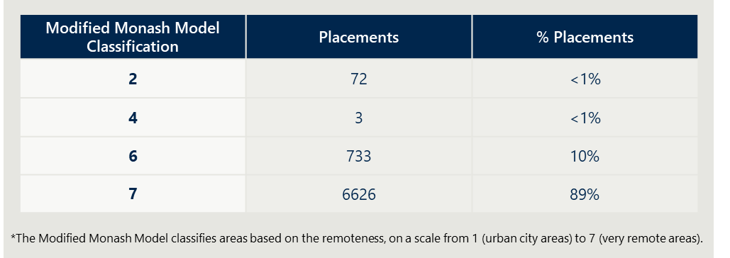

Stakeholders identified a number of factors that influence distribution of placements, including:

* Health professional preference. RAHC operates such that HPs are able to pick and choose the clinics and communities in which they are placed, rather than being directed to clinics that have the most or most urgent need. In instances where a clinic does have an urgent need, RAHC staff will proactively call HPs to determine their availability and willingness to complete these placements, but cannot direct HPs to take these placements.
* Proximity to major population centres and associated amenities. As highlighted in Figure 10, clinic placements cluster around major population centres (such as Alice Springs and Tennant Creek) – this likely reflects greater need. Health professionals highlighted the benefits from placements in these larger communities such as access to supermarkets and other amenities, better access to WiFi and connectivity, and the ability to easily come and go from placements, rather than long drives to remote areas.
* Other geographic factors. Figure 10 highlights a cluster of placements in the Top End, East Arnhem and on the Tiwi Islands – there are more placements than expected, given the relative remoteness, size of some of these communities, and population density. Some RAHC HPs and other non-RAHC short-term staff highlighted important geographic factors such as proximity to the ocean as influencing their placement decisions.
* Clinic need and demand. Some clinics serve larger population bases than other, and as such have a greater need for RAHC HPs.
* 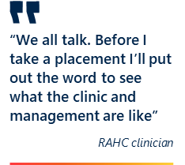Clinic reputation. RAHC HPs and other non-RAHC short-term staff reported relying on HP word of mouth to determine whether or not to take a placement. Key factors influencing their decisions include the reputation of clinic leadership and the perceived work / team culture within the clinic.
* Community reputation. RAHC HPs and other non-RAHC short-term staff reported choosing to go to communities where their colleagues had previously had positive experiences. Factors leading to negative experiences (and thus reluctance to go on placements) included perceived safety and security issues, poor internet and other connectivity, and poor (or unsafe) housing.

Where clinics received few or no RAHC placements, stakeholders attributed this to factors including:

* Remoteness of clinics. Clinic leadership and staff highlighted that it is “easier” to attract HPs to clinics closer to large population centres and with good transport links.
* 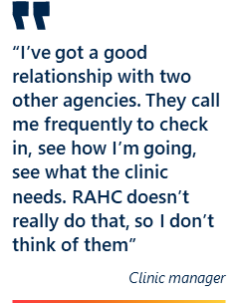Clinic management relationship with other providers. One ACCHO who infrequently used RAHC noted that this was because the ACCHO has a good pre-existing relationship with two other providers of short-term HPs (both private companies). These providers had built a good rapport with key ACCHO staff, checked in frequently, and were able to proactively anticipate clinic needs. Because of these relationships, this ACCHO did not think to contact RAHC to source placements.
* Poor prior experience with the RAHC service provider, including lack of responsiveness. Some clinics highlighted poor prior experiences with RAHC, including instances where the service provider had not responded to their request for HPs, or where they were unable to source a HP despite repeated attempts. Following these experiences, some clinics chose not to subsequently engage with RAHC.

### Two-thirds of RAHC placements are to NT Government run clinics – this proportion has been consistent since 2013

Figure 11 presents the distribution of placements by clinic type (NT Government run or ACCHO run). Since FY2013, with the exception of FY2021, each year approximately two-thirds of RAHC placements are to NT Government run clinics. In FY2021-22, only 27 per cent of placements were to ACCHO run clinics.

Figure 11 | RAHC placements by placement location (2013 - 2021)

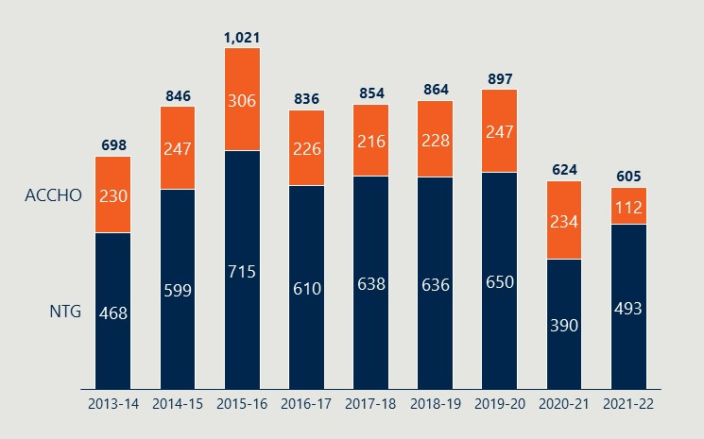

This variation is surprising given the context of service delivery in the NT, which is actively supporting transition to community control. Data from AMSANT indicates that in 2021-22 Aboriginal community-controlled health services treated 76 per cent of the total number of regular clients within the Aboriginal primary health care system and provided two-thirds of the total episodes of care (with the remaining third provided by the NT Government primary health care system).[36], [37]

This variation has not changed over time despite significant efforts over the past decade to transfer NT Government clinics to community control. As clinics transferred to the ACCHO sector (and therefore the total number of ACCHO run clinics increased), it is reasonable to expect that placement numbers in ACCHO run clinics would also increase. This has not been seen in the data.

Figure 12 presents placement data by clinic type, stratified by profession. This data highlights a difference in the HPs that complete placements in ACCHO run clinics and in NT Government run clinics. ACCHO run clinics receive few to no oral health professionals (dentists, dental assistants and dental therapists) and ear health professionals. This aligns with the sentiments gathered through consultations, where some ACCHO clinic leadership were unaware that RAHC places these HPs.

Potential reasons for this variation include:

* The structure of service delivery for oral health and ear health in remote communities. The NT Government largely provides oral and ear health services to remote communities on an outreach basis, servicing both NT Government and ACCHO run clinics. RAHC oral health and ear health professionals participate in these outreach services, which are classified at NT Government placements. This approach reduces the need for placements in ACCHO run clinics.
* Differences in the way NT Government and ACCHOs manage short-term need and interact with RAHC. Consultations highlighted that NT Government has a much more centralised approach to management of workforce shortages, as compared to ACCHOs – particularly for nursing staff. NT Government has centralised coordinators that work within one of the five NT Health regions – and that oversee placements for all clinics within that region. Coordinators are likely more aware of the range of RAHC professions and choose placements from several agencies (RAHC and for-profit agencies) based on availabilities and costs. By contrast, each individual ACCHO engages directly with RAHC (and other agencies) to communicate their clinic needs. This may mean that NT Government representative engagement is more efficient, and these clinics are able to secure a diverse range of HPs before ACCHO clinics.
* Greater ability for ACCHO clinics to support innovative employment models, potentially reducing their reliance on short-term placements. Consultations with NT Government stakeholders highlighted the difficulty faced by government in facilitating innovative employment models such as job shares and fly in fly out arrangements – this is due in large part to public service regulations. By contrast, ACCHO clinics have more flexibility with employment models and may therefore be more able to hire HPs on their own contracts, rather than relying on RAHC.

Figure 12 | RAHC placements stratified by profession type, type of clinic and year

### Figure 12 is a stacked bar graph and a table showing the RAHC placements stratified by profession type, type of clinic and year In recent years, the effectiveness and impact of the model has been hindered by organisational challenges

Across the evaluation, stakeholders reported a number of challenges engaging with RAHC as an organisation – with significant negative impacts, as detailed in Table 9.

Table 9 | Identified RAHC challenges and associated impact on the program

|  |  |  |
| --- | --- | --- |
| Identified challenge | Impact | |
| Organisational leadership based outside of the NT | * Key stakeholders – including ACCHO leadership, and NT Government and ACCHO run clinic leaders – have the impression that RAHC does not understand the realities of service delivery in remote areas. * Key stakeholders have the impression that RAHC leadership is more focused on the needs of the federal Department – including continuing to secure grant funding – rather than committed to the needs of the NT. * RAHC leadership may be unable to effectively build and sustain relationships with key stakeholders. |
| Poor and inconsistent communication from RAHC to all stakeholders | * Clinic leadership struggle to get a response from RAHC regarding their requests for placements. These clinics either fill placements through a different provider (with subsequent financial implications) or are unable to fill needed placements (with significant impact on service delivery). * Existing RAHC HPs do not know until the last minute whether their placement is confirmed, resulting in unnecessary stress and anxiety and leading some HPs to remove themselves from the RAHC pool in favour of other alternatives. In some instances, this may also lead to additional financial costs for RAHC (e.g. as they must pay last minute airfares). * Potential RAHC HPs do not have their queries and expressions of interest responded to in a timely manner, leading them to either choose other providers or decide not to pursue remote work. In both instances, the pool of available RAHC HPs does not grow. |
| Overly burdensome credentialling process | * Existing RAHC HPs are required to resubmit extensive documentation for recredentialling every three-years. These documents to not appear to be stored in a central RAHC system, resulting in stress and frustration for HPs. Some HPs choose to leave RAHC rather than go through the recredentialling process. * Potential RAHC HPs do not experience an easy or streamlined process. They receive multiple and occasionally conflicting requests, often from different contacts within the RAHC organisation. This results in frustration and may see potential HPs exit the program rather than continue through the process – further shrinking the pool of available RAHC HPs. * Note that all stakeholders highlighted the importance of the credentialling process for guaranteeing the quality of RAHC HPs – this was seen as a significant value add of RAHC, one not offered by other placement providers. |
| Poor or non-existent marketing and promotional efforts | * Some clinics – particularly ACCHO run clinics – may not know about RAHC, may not know about the diversity of HPs available through RAHC, or may not know how RAHC can support them, and may therefore not look to RAHC to address workforce shortages. * Potential RAHC HPs do not know that RAHC exists, and therefore will not sign up with the program – contributing to further limiting growth in potential RAHC HPs, and limiting the potential impact of the program. * In the survey of RAHC HPs, close to half (42 per cent, 33/77) reported entering the program through word of mouth. |

### RAHC has recently begun organisational redesign. This – coupled with recent new leadership – may begin to address some of these identified challenges

In mid-2022 the RAHC organisation appointed a new National Manager. Under the guidance of the new National Manger, the organisation has begun an organisational review and redesign that may begin to address some of the identified challenges highlighted with delivery of the model. These include:

* Reviewing and redesigning the organisational structure to better meet the needs of clinics and HPs – including having dedicated workforce support officers.
* Streamlining communication processes so that RAHC HPs (current and potential) have a clear and consistent point of contact.
* Streamlining the credentialling processes so that requirements are clear from the outset, resulting in less duplication of effort and reduced frustration for all stakeholders.

These are all positive moves; however it is too early in organisational redesign for the impact of any of these changes to have been noted by stakeholders or to be reflected in evaluation findings.

### Some stakeholders reported that RAHC’s impact may have been diminished by its connection with a for-profit organisation

RAHC leadership and staff highlighted a number of important benefits from their status as a not-for-profit subsidiary of Aspen, including:

* Ability to build upon and leverage existing systems such as HR and IT systems – without this connection, RAHC would have to procure systems independently. The evaluation did not verify whether the organisation reimburses Aspen for access and use of these systems.
* Access to an international network of health experts, to provide advice and guidance when needed.
* Ability to leverage an international brand and name recognition to attract international leaders to sit on the Board, and to hire talent.
* Ability to draw on resources when needed, for example using Aspen charter flights to transport HPs to community. The evaluation did not verify whether these resources are provided free-of-charge, at-cost, or at market rates (and the subsequent financial impact this may have).

However, some clinics and other key stakeholders think less highly of RAHC given its association with a for-profit organisation. Whilst stakeholders acknowledge and understand that RAHC is a not-for-profit subsidiary, there is a sense that the overarching for-profit body is driven by return on investment rather than social good.

There is, therefore, an opportunity to improve RAHC’s marketing and communications to demonstrate its purpose-driven approach and independence from the overarching organisation, and to highlight the benefits that are seen from the association with Aspen.

### There are benefits that come from RAHC being delivered by an independent third party

The evaluation identified benefits to RAHC being delivered by an independent third party – which is seen to be impartial to NT Government and ACCHO requests for placement and support.

There is a concern that if RAHC were to be delivered by either of these groups, the program would end up prioritising placements to meet group needs (i.e. that if RAHC were delivered by NT Government, it would prioritise filling shortages in NT Government clinics over ACCHO run clinics). Note that this concern may become less relevant in the future as more NT Government clinics transition to community control.

## Efficiency

### At the clinic level, RAHC appears to be delivering services with minimal administrative burden

At the clinic level, RAHC appears to be efficient, with minimal administrative burden. Stakeholders appreciated that RAHC independently arranged for HP travel and pre-departure accommodation, as this removed additional administrative tasks.

As discussed above, this efficiency may not be seen by RAHC HPs or by those within NT Government and ACCHOs who directly liaise with the RAHC organisation. Some RAHC HPs reported challenges with timely and accurate pay – with one former HP noting consistent challenges, resulting in them leaving the program – but this was not a widespread view.

### RAHC costs between $5 million and $6 million each year, of which direct placement expenses account for between 29 per cent and 43 per cent

Figure 13 presents RAHC’s expenditure for the past four years. Its largest expenses are operating expenses and placement expenses, with minimal amounts allocated to governance and marketing. RAHC’s budget has increased year-on-year since 2018-19.

Since 2019-20, placement expenses have decreased, coinciding with these years having fewer placements than expected. This has resulted in a consistent annual underspend.

Figure 13 | RAHC expenses grouped by function (2018-19 to 2021-22)

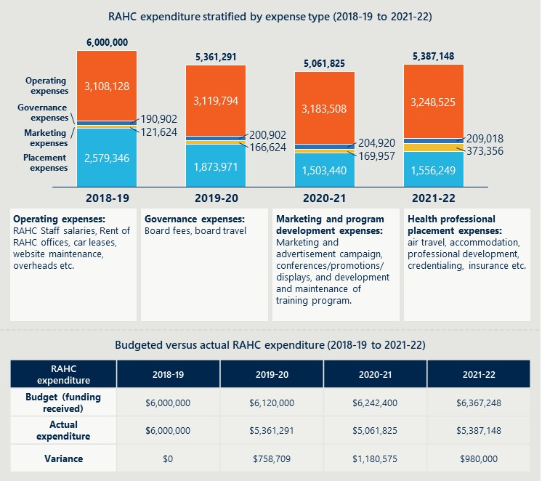

Financial data indicates that less than half of RAHCs total operating budget is spent on direct placement expenses – ranging from 43 per cent in 2018-19 to 29 per cent in 2020-21 and 2021-22. Placement expenses include costs associated with travel expenses, accommodation, professional development, credentialling and insurance.

RAHC’s total operating costs have remained relatively stable over the four-years, accounting for around $3.1 million per annum. Note that operating costs also include costs related to placements and service delivery (e.g. costs for staff to fill placements; costs for staff to support HPs whilst on placement) but are not categorised as direct placement costs.

The shift in the proportion of RAHC’s total budget that is allocated to placements is also reflected in cost per placement day. Figure 14 presents RAHC cost per placement per day for 2013 to 2021. It indicates that this cost has been increasing over time, from a low of $254 per placement per day (2015) to a high of $535 per placement per day (2021).

The higher costs in 2020 and 2021 can be accounted for given the smaller number of placements delivered in these years, driven by the impact of the COVID-19 pandemic. Although placement numbers dropped – and therefore associated placement costs dropped – overall operating costs remained the same.

Nonetheless, the data indicates a trend of increasing costs per placement per day since 2015, indicating a drop in efficiency over the past seven years. This, alongside reports that some RAHC systems and processes are inefficient and overly burdensome, and that RAHC could communicate more effectively with clinics and HPs, indicates a need to review organisational structures and processes. RAHC leadership reported that this organisational review and refresh is already underway.

Figure 14 | RAHC cost per placement per day (2013 to 2021)

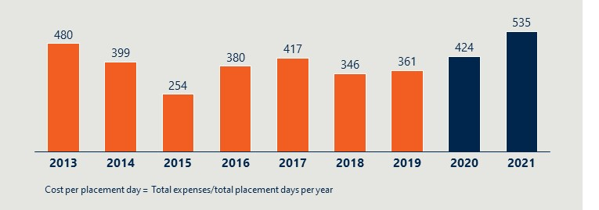

### RAHC is cost effective for clinics. More work is needed to quantify the extent to which RAHC is an efficient use of overall government funding

As noted previously, RAHC is just one of many providers of short-term workforce placements including for-profit providers. It represents a cost-effective model for clinics directly, as government funding subsidises costs that clinics would otherwise bear (Figure 15).

Further work – such as a detailed market analysis – is needed to determine whether RAHC represents an overall efficient use of Australian Government resources. This work should take into account the overall cost of RAHC placements – combining both the direct costs incurred by clinics and RAHC subsidies – and compare this to the overall cost of employing short-term staff through other agencies.

It may be that there are more efficient mechanisms for investing the $6 million per annum provided to the not-for-profit subsidiary which operates RAHC, which would deliver similar outcomes in terms of delivery of short-term placements, and enhancing the quality of HPs. These options could include providing this funding directly to ACCHOs, NT Government or clinics to cover the costs of short-term HPs from for-profit agencies.

Figure 15 | Model to detail RAHC impact on cost effectiveness and efficiency for clinics

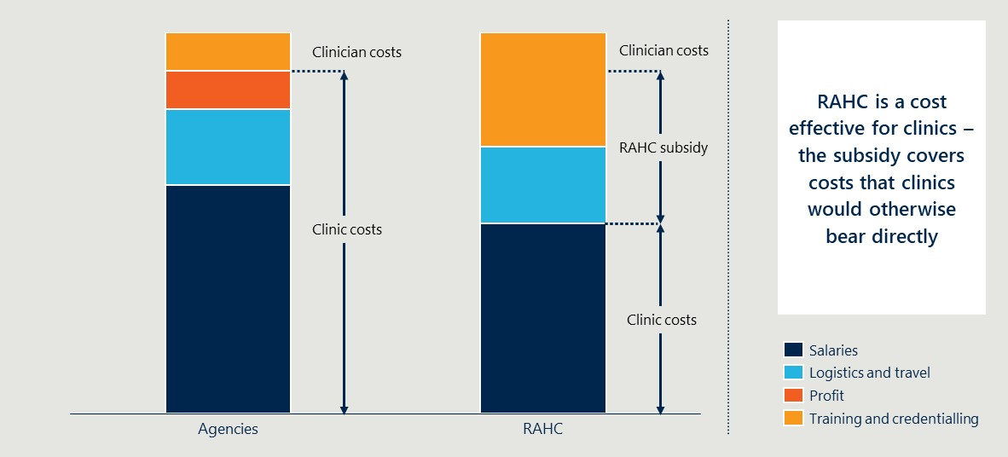

## Sustainability

### RAHC has a predominantly transactional rather than strategic partnership with NT Government and, to a lesser extent, ACCHOs

The evaluation highlighted that key stakeholders, particularly NT Government, have a transactional rather than strategic partnership with RAHC – stakeholders see RAHC as a high-quality and cost-effective provider of HPs for short-term placements. Clinics look to RAHC alongside other agencies and providers to meet their immediate workforce needs.

Some ACCHO stakeholders expressed a desire for a more strategic relationship with RAHC, such as collaborating to design efforts to implement strategic and sustainable approaches to workforce challenges. Some efforts have commenced in this space – for example, one ACCHO worked with RAHC to design a model where two teams of nurses would rotate through ACCHO clinics every six-weeks. Unfortunately this approach did not proceed, as RAHC were unable to provide needed HPs. This innovation should be encouraged, given the benefits of these approaches to enhanced continuity of care.

This transactional relationship represents a missed opportunity for RAHC – particularly given RAHC’s Aboriginal governance and leadership model. As an Aboriginal-led organisation, RAHC is ideally placed to work strategically with ACCHOs, NT Government and communities to identify community health needs and collaboratively develop culturally appropriate solutions.

### RAHC provides a highly valuable short-term solution to a chronic and systemic challenge. The model could be leveraged to also contribute to more sustainable, longer-term outcomes

There are a number of opportunities to leverage the RAHC model to embed RAHC’s unique value add, and to contribute to enabling more sustainable outcomes. These efforts should continue alongside RAHC’s delivery of short-term placements, and can likely be done by existing staff within the existing funding envelope. These opportunities include:

* 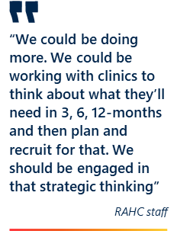Working closely with clinics and communities to support strategic thinking and proactive planning. As currently delivered, RAHC responds to clinics’ expressed needs – that is, RAHC will provide a HP to meet a need identified by a clinic and for the time period requested. There is an opportunity to explore how the model could be more proactive and strategic. For example, RAHC could work closely with clinics to identify and plan for the future health needs of communities – and then develop recruitment strategies and upskilling programs to ensure the model is able to meet these needs.
* More closely engaging with education and training providers to build the workforce of the future. RAHC aims to contribute to building the pool of HPs who have the skills and capabilities to work in remote communities. Whilst this can be achieved through re-energising marketing and promotional activities (and thereby encouraging new HPs to apply to RAHC), there is also an opportunity for RAHC to work closely with education and training providers (including universities and TAFE) to provide early career practical learning opportunities. This could involve, for example, supporting students to complete placements in remote clinics as part of their clinical training.
* Exploring innovative models of employment that are not otherwise available to clinics. Changing workforce expectations mean that it is unlikely that remote clinics will ever be fully staffed with permanent employees. As a result, clinics increasingly need to look to innovative employment models such as job share models (where two or more HPs share a role, each rotating through a set period of time). NT Government stakeholders noted that it is difficult (if not impossible) under current public sector rules for NT Government run clinics to offer these types of employment. There is an opportunity for RAHC to work with clinics to explore and enable these innovative employment models – and through this contribute to reducing workforce shortages whilst supporting continuity of care.

During the evaluation, RAHC leadership indicated that opportunities such as strategic partnerships are currently being considered and integrated as core components of the service delivery model. RAHC has begun to partner and work closely with clinics and communities to deeply understand workforce needs and provide holistic short-term support that directly addresses the critical needs of the community. These solutions are intended to provide greater support to communities beyond short-term placements, although short-term placements have always been and remain the model’s focus. For example, work has commenced to partner with an ACCHO to deliver a specialised multi-disciplinary team of HPs that can address multiple community needs.

RAHC leadership also reported efforts to develop strategic relationships with peak Aboriginal and Torres Strait Islander bodies such as National Aboriginal and Torres Strait Islander Health Workers and Practitioners (NAATSIHWP), the Australian Indigenous Doctors’ Association (AIDA), and the Congress of Aboriginal and Torres Strait Islander Nurses and Midwives (CATSINaM), and other NT-based health organisations such as NTPHN. RAHC intends to activate these partnerships to deliver innovative employment models such as multi-disciplinary teams of Aboriginal and Torres Strait Islander HPs to support local communities.

These opportunities are too early in implementation for results to be reflected in evaluation findings.

# Recommendations

This section presents recommendations to enhance RAHC into the future

The evaluation found that RAHC is a high-quality and cost-effective (to clinics) provider of nurses and, to a lesser extent, oral health professionals. It is effective at addressing short-term workforce shortages, and is well received by key stakeholders.

The evaluation identified seven recommendations structured across two themes:

1. Recommendations to enhance immediate service delivery of the current model. These recommendations should be actioned as soon as practical, and can occur simultaneously.
2. Recommendations to enhance the impact of RAHC into the future. These recommendations should be actioned within the next 2-years, and should occur in sequence. Work to review and refine the RAHC model should commence early, so that the Department is in a position to complete an Approach to Market within 18-months and commence refined service delivery in 2025.

## Recommendations to enhance immediate service delivery

### Recommendation 1 | Ensure that RAHC’s focus remains on the NT

Primary health care workforce shortages remain a significant area of concern for the NT. Given this, and the unique challenges related to service delivery in the Territory, it is relevant and appropriate that the RAHC model continue to focus solely on the NT.

There is a significant risk that should the program expand, the number of HPs choosing to take up placements in remote Aboriginal communities in the NT would decline – as HPs would choose more desirable and accessible communities in other jurisdictions.

During the COVID-19 pandemic RAHC operations (through the Remote ACCHS Workforce Response (RAWR)) expanded to support Aboriginal community-controlled organisations in other jurisdictions. This was appropriate in the context – given closed inter-state borders and extreme workforce challenges – but should be wound back now that Australia has shifted from preparedness and crisis response to day-to-day management of the pandemic.

Should the pandemic context shift again – for example should a new variant require a return to the highest-level public health measures – RAHC could again explore temporary expansion outside the NT.

### Recommendation 2 | Continue to support RAHC to provide short-term placements, particularly directed to needed specialities and to clinics and communities that struggle to recruit health professionals through other means

RAHC is seen as a cost-effective means by which clinics can access high-quality HPs to address short-term workforce shortages, particularly nurses and oral health professionals. The model should continue into the immediate future, but noting that efforts are needed by the organisation that delivers RAHC to address concerns around inefficiencies, overly burdensome processes, and poor communication.

There are a number of other providers of HPs to address short-term workforce shortages – as delivery continues, the Department should work to ensure that RAHC is complementing rather than competing with these providers:

* General Practitioners | Historically, only a small percentage of RAHC placements are GPs (1.5 per cent in 2018-19, 2.7 per cent in 2019-20), and GP placements are on average shorter than RAHC’s minimum three weeks (average of 2.73 weeks from 2013-14 to 2021-22). This suggests that clinics’ needs for GPs are being met through other means – such as government-funded locum programs (including the NT PHN GP locum program and Rural LAP), or private locum providers. RAHC may not be adding additional value in this space and should consider ceasing to include GPs in the model.
* Nurses | Nurses represent more than 50 per cent of all placements, and are associated with the RAHC model. There are multiple other providers of short-term nursing staff that are already supporting clinics to meet workforce needs. Clinics in more desirable locations – such as bigger towns, or those close to tourist centres and national parks – have fewer challenges recruiting nurses from non-RAHC providers. RAHC should consider directing efforts to support clinics and communities that otherwise struggle to fill workforce shortages (that is, they are not able to recruit nurses from other agencies).
* Oral health | Oral health practitioners represent 30 per cent of all placements. These services are needed and well received by clinics, and there do not appear to be many other providers of services. There are some clinics that are not aware that RAHC provides oral health practitioners, which likely means that these services are underused. RAHC is providing value in this space, and could provide additional value into the future. Note that RAHC may need to explore making placement lengths shorter (and revisiting the three-week recommended minimum) to encourage more oral health professionals to complete placements.
* Ear health and other allied health | Ear health and other allied health have historically represented a very small number of placements (5.9 per cent in 2018-19 and 6 per cent in 2019-20). This may indicate limited demand for these HPs, limited understanding that these HPs are available through RAHC, limited supply of these HPs to complete placements, or a mismatch between placement length and HP availability. As with oral health, RAHC may need to explore making placement lengths shorter (and revisiting the three-week recommended minimum). RAHC should think strategically – in partnership with key stakeholders and communities – as to whether the program provides value in this space.

In addition, the Department should work with the service provider to ensure that the model continues to meet a genuine workforce need and addresses ongoing market failures. In the current context, this may mean working to ensure that the model prioritises placements in clinics and locations that otherwise struggle to recruit HPs through other providers.

### Recommendation 3 | Ensure that RAHC reprioritises efforts to rebuild the workforce of health professionals eligible to complete placements

RAHC cannot provide an effective service or address ongoing workforce challenges if it does not have the HPs available to complete placements. Data indicates that RAHC’s pool of HPs has stagnated in recent years – there has been a steady decline in the number of new-to-remote placements, and high numbers of repeat placements (indicating that the pool is not growing year on year).

Almost half of HPs who responded to the survey (33/77, 43 per cent) entered the program via word of mouth. In addition, RAHC staff reflected that promotion and marketing activities had not been an area of focus in recent years.

### Recommendation 4 | Enhance contract and grant management processes

RAHC was established in 2008 and has received ongoing funding since. There was an Approach to Market (ATM) undertaken in June 2015, with Aspen emerging as the successful applicant. The most recent grant agreement (2022-23) includes only two high-level key performance indicators (KPIs) – one related to numbers of placements, and one related to responsiveness to NT Health clinics.

The Department should review and, if appropriate, update and add to these KPIs. New or modified KPIs can help the Department to effectively guide RAHC activities. Table 10 presents a non-exhaustive of potential KPIs the Department could consider effectively guide RAHC activities – note that targets for these (if any) would also need to be agreed.

Table 10 | Potential additional KPIs

|  |  |
| --- | --- |
| Suggested KPI | Rationale |
| Number of health professionals entering the model (by professional type) | Focuses RAHC effort on rebuilding the pool of health professionals available to complete placements. Numbers should be stratified by profession – noting that targets (if any) will be higher for some professions than others. | |
| Number of new-to-remote placements (by professional type) | Focuses RAHC effort on converting new entrants to the model to placements in community. | |
| Number of health professionals undertaking repeat placements (by professional type) | Focuses RAHC effort on encouraging repeat placements, as this represents good value for RAHC investment in training and upskilling, and supports positive outcomes associated with continuity of care.  Focuses RAHC effort on innovative models that encourage and support repeat placements. | |
| Number of health professionals undertaking repeat placements in the same community (by professional type) | Focuses RAHC effort on encouraging repeat placements to the same community, as this further supports positive outcomes associated with continuity of care and may contribute to delivery of culturally safe and culturally appropriate care.  Focuses RAHC effort on innovative models that encourage and support repeat placements in the same community. | |

Any new KPIs should be discussed with RAHC in advance, to ensure that KPIs effectively measure desired outcomes and do not lead to perverse incentives or unintended negative consequences.

## Recommendations to enhance the impact of RAHC into the future

### Recommendation 5 | Work with key stakeholders to explore options to enhance the model in order to contribute to longer-term, strategic workforce solutions

Whilst the RAHC model is effectively addressing short-term workforce challenges at a local level, the evaluation highlighted opportunities to leverage the program so that it can continue to do this whilst best contributing to longer-term workforce solutions.

The Department should work with the First Nations health sector broadly to explore options to refine the model, which may include:

* Working closely with clinics and communities to support strategic thinking and proactive planning. The model could be adapted to support closer engagement with clinics to identify and plan for the future health needs of communities – and then develop recruitment strategies and upskilling programs to ensure the model is able to meet these needs.
* More closely engaging with education and training providers to support building the workforce of the future. There is an opportunity for the model to be adapted to support closer engagement and partnerships with education and training providers (including universities, TAFE and other related programs such as First Nations Traineeships or Indigenous Allied Health Australia Academies) to provide early career practical learning opportunities. This could involve, for example, partnering with TAFE and universities to provide student placements in remote clinics as part of their clinical training.
* Exploring innovative models of employment that are not otherwise available to clinics. There is an opportunity for the model to be adapted to support closer engagement with clinics to explore and deliver innovative employment models that cannot otherwise be supported (e.g. are not available through NT Government). For example, employment models that enable remote health professionals to job share one FTE position are not currently allowed by NT Government governance processes and therefore could be a potential opportunity for RAHC.
* Exploring opportunities to make subsidised HPs available through other providers. The evaluation found that RAHC is highly valued as it is cost-effective to clinics – the subsidy provided by the Australian Government means that RAHC HPs directly cost clinics less than HPs procured through other providers. There is an opportunity to make current funding available to other providers of short-term HPs so that they can also offer subsidised HPs, so long as these providers meet a defined set of standards (related to factors such as overall quality of HPs; level and type training provided to HPs including cultural competency training; level and type of support provided whilst on placement). Clinics would then still be able to access HPs at the subsidised rate, but would have a larger number of providers to choose from – introducing competition and innovation into the market.
* Exploring how the model could be leveraged for broader health workforce uplift or as a marker of quality. The evaluation found that RAHC HPs are considered high-quality and safe, including when compared to HPs from other placement agencies. This is a direct result of the model’s clinical and cultural training and credentialling process – which can be provided due to government funding. There is an opportunity to explore expanding this training and credentialling to all HPs seeking to complete short-term placements in the NT (regardless of whether they are placed through RAHC or through another agency). In essence, the RAHC brand would then become a marker of quality, and would provide assurance to all clinics as to the clinical and cultural competencies of HPs procured through any agency.

Any exploration around refining the model should occur in close consultation and partnership with key stakeholders including ACCHOs, NT Government, AMSANT and NT PHN. This will ensure that a refined model aligns with and does not duplicate other work occurring across the Territory.

### Recommendation 6 | Conduct detailed market scoping and analysis to inform the refined model

The model as currently designed is a cost-effective solution for individual clinics, as the government subsidy covers the cost of accommodation, logistics, training and credentialling. However, it is not possible in this evaluation to determine the overall efficiency of RAHC – that is, whether RAHC represents an efficient use of government money.

Once a refined model has been designed and agreed, the Department should commission a detailed market scoping and analysis to complete an in-depth economic costing of the proposed model, and compare this to other available solutions. The outcome of this scoping and analysis can be used to make decisions regarding future program continuation or expansion.

### Recommendation 7 | Undertake an Approach to Market to identify the provider best placed to deliver the refined model efficiently and effectively

There are multiple providers of short-term HPs, including a number that have a specific focus on rural and remote recruitment. It is possible that these providers (or a consortia) could effectively and efficiently deliver the refined RAHC model.

Once the Department has designed and agreed a refined model, it should complete an Approach to Market to identify the most appropriate provider to deliver this refined model and assure value for money.

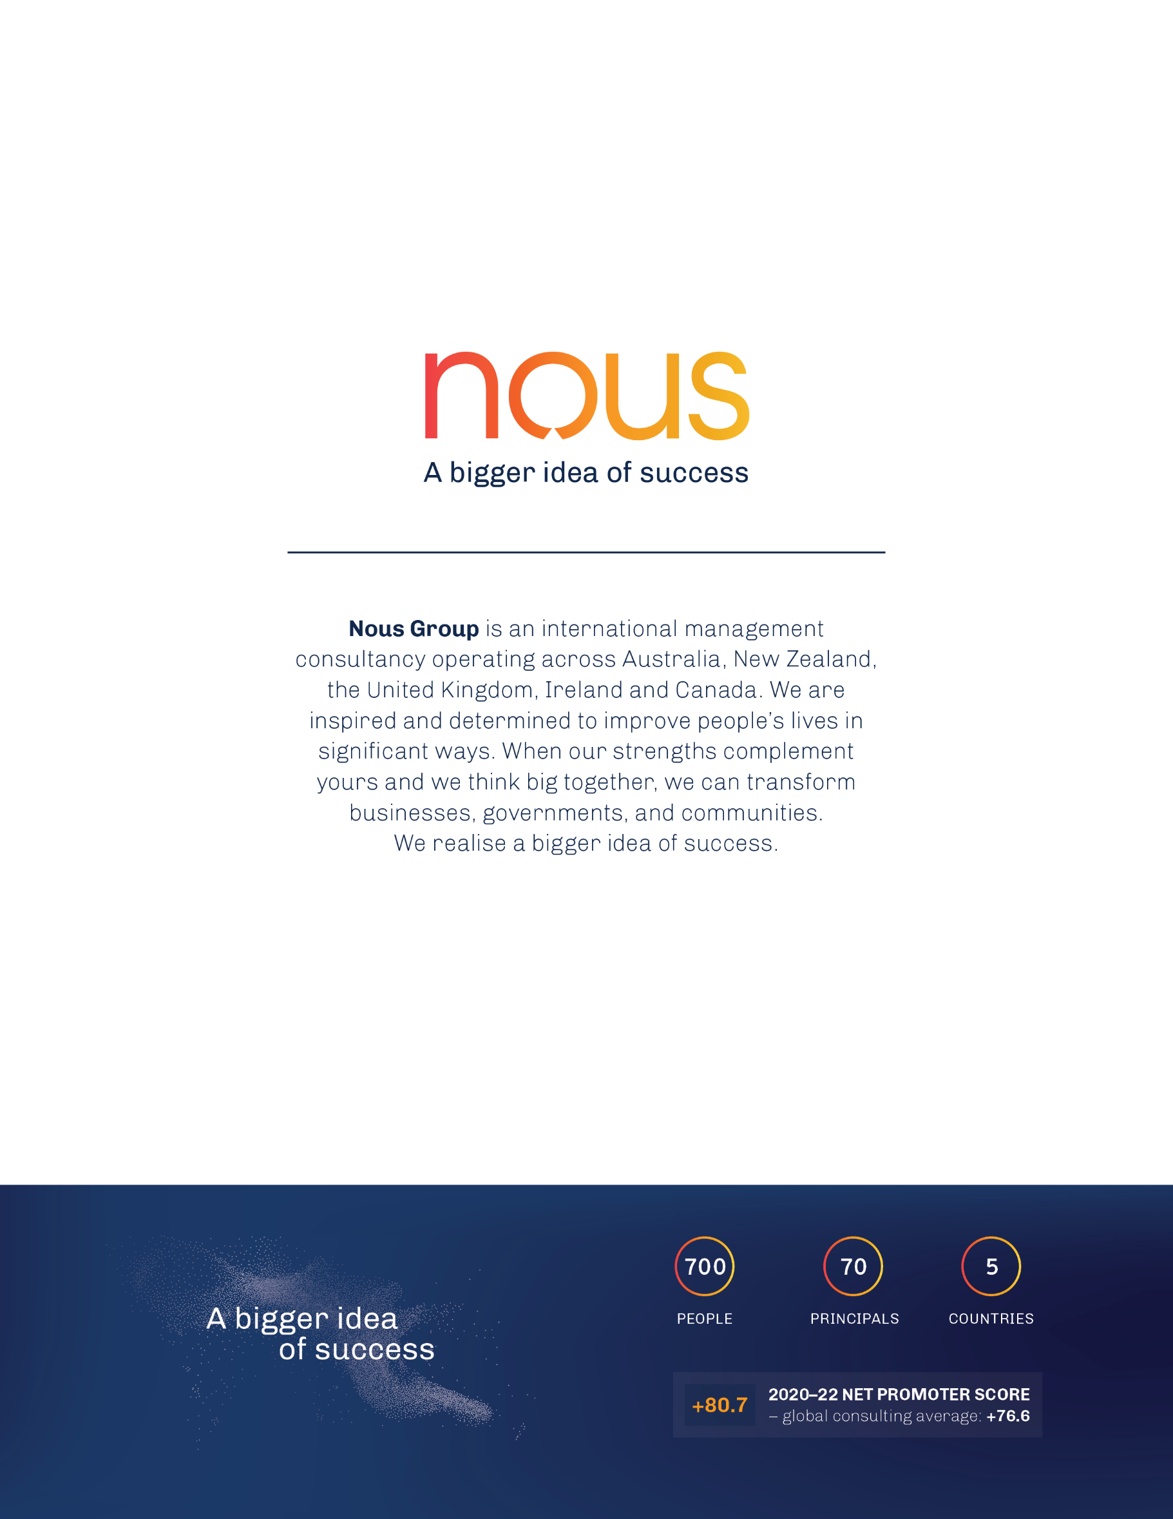

1. Rural and remote health, Australian Institute of Health and Welfare, <https://www.aihw.gov.au/reports/rural-remote-australians/rural-and-remote-health>, 2022.
2. Note that this report refers to Aboriginal communities and Aboriginal Territorians, as Aboriginal people are the traditional owners of the lands of the Northern Territory. This should be read as encompassing Torres Strait Islander people and communities where appropriate.
3. About Us, Remote Area Health Corps, <https://www.rahc.com.au/about-us>.
4. About Us, Remote Area Health Corps, <https://www.rahc.com.au/about-us>.
5. Evaluation of the Remote Area Health Corps (RAHC) Program Final Report, Social Compass, 2018. Prepared for the Department.
6. Evaluation Criteria, OECD, <https://www.oecd.org/dac/evaluation/daccriteriaforevaluatingdevelopmentassistance.htm>.
7. Note that throughout this evaluation, the RAHC model is referred to as RAHC. Where evaluation findings or recommendations speak to delivery of the model through the not-for-profit subsidiary, this is referred to as the service provider or the RAHC organisation.
8. About Us, Remote Area Health Corps, <https://www.rahc.com.au/about-us>.
9. RAHC Performance Report 2019: Reporting period 1 July 2019 to 31 December 2019.
10. About Us, Remote Area Health Corps, <https://www.rahc.com.au/about-us>.
11. FAQs, Remote Area Health Corps, <https://www.rahc.com.au/faqs>.
12. Rural and remote health, Australian Institute of Health and Welfare, <https://www.aihw.gov.au/reports/rural-remote-australians/rural-and-remote-health>, 2022.
13. Health workforce, Australian Institute of Health and Welfare, <https://www.aihw.gov.au/reports/workforce/health-workforce>, 2022.
14. Health care safety and quality, Australian Institute of Health and Welfare, <https://www.aihw.gov.au/reports/health-care-quality-performance/health-care-safety-and-quality>, 2022.
15. Health Demand and Supply Utilisation Patterns Planning Tool (HeaDS UPP), Department of Health and Aged Care, 2022.
16. Health Care Resources: Dentists, OECD, <https://stats.oecd.org/index.aspx?queryid=30177>, 2022.
17. Health Demand and Supply Utilisation Patterns Planning Tool (HeaDS UPP), Department of Health and Aged Care, 2022.
18. NT Health Strategic Plan 2023 – 2028, NT Health, 2022. Draft for discussion (not publicly available).
19. Workforce crunch – NT ACCHO clinical workforce challenges and proposed immediate areas for action, AMSANT, 2021.
20. Wakerman, J et. al., Remote health workforce turnover and retention: what are the policy and practice priorities?, 17:99, Human Resources for Health, 2019.
21. Health Demand and Supply Utilisation Patterns Planning Tool (HeaDS UPP), Department of Health and Aged Care, 2022.
22. 2020 and 2021 figures for the Number of GP services per capita in remote NT have been excluded due to suppression of the HeaDS UPP data provided to the evaluation
23. Reported by the RAHC Board during a consultation in December 2022.
24. See for example Talent Quarter (<https://talentquarter.com/recruitment-specialities/>), E4 Recruitment (<https://www.e4recruitment.com.au/nursing>) and Alliance Rural and Remote Health (<https://www.allianceruralremote.com.au/>)
25. Frequently Asked Questions, Alliance Rural & Remote Health, <https://www.allianceruralremote.com.au/rural-remote-nursing/faq>.
26. The process, Rural LAP, <https://www.rurallap.com.au/for-individuals/the-process>.
27. What we do, Royal Flying Doctor Service, <https://www.flyingdoctor.org.au/what-we-do/>.
28. Nurses and Midwives, Rural Health West, <https://ruralhealthwest.com.au/vacancies/nurses-and-midwives/>.
29. 24/7 On-Demand Virtual Care, Health Access, <https://www.remotegp.org.au/>.
30. South Australian Virtual Emergency Service (SAVES), RDWA, <https://www.ruraldoc.com.au/saves>.
31. Note that in the survey, respondents could select multiple answers to this question
32. FAQs, Remote Area Health Corps, <https://www.rahc.com.au/faqs>.
33. The general practitioner workforce: why the neglect must end, Australian Medical Association, 2022.
34. Note that learning to deliver culturally safe and responsive care is a lifelong journey – RAHC training provides appropriate pre-placement support, but should not be considered exhaustive.
35. Note that there are a small number of placements officially categorised as occurring in Darwin (MM 2 and MM 4). These placements appear to be with NT Hearing and the Hearing Health Program (both NT government services). It is likely that although these placements are categorised as Darwin, HPs were working in remote communities in an outreach capacity.
36. AMSANT Annual Report 2021-2022, AMSANT, <https://www.amsant.org.au/wp-content/uploads/2022/11/AMSANT-Annual-Report-2021-2022-Web.pdf>, 2022.
37. Note that this data would also include services delivered in Darwin, which is not within scope of RAHC.