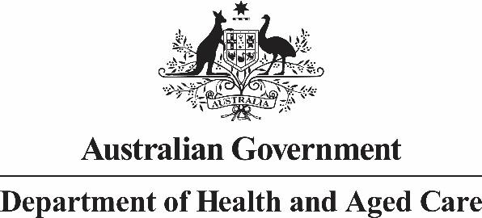

Allied Health Industry Reference Group Meeting nine: 6 December 2023 Summary of Outcomes

The Australian Government Chief Allied Health Office convened the ninth Allied Health Industry Reference Group (AHIRG) meeting on 6 December 2023.

Topics discussed:

* Allied health research
* Representatives from the National Health and Medical Research Council (NHMRC) and Health and Medical Research Office (HMRO) sought feedback from members on current barriers to support allied health research opportunities; and discussed challenges with accurately classifying research as ‘allied health’.
* Update on Reform of General Practice Incentive Programs
* The Australian government gave a presentation on the review of General Practice Incentive Programs, and sought feedback in relation to the Workforce Incentives Program-Practice Stream (WIP-PS).
* Guidance for allied health professionals on delegating to and supervision of Allied Health Assistants (AHAs).
* Members provided feedback on the latest draft guidance document, noting it will be circulated in early 2024 to the aged care, disability and AHA sectors for feedback.
* Other business
* It was reported that the Australian government is working with state and territory governments to develop a National Allied Health Workforce Strategy.
* It is in the early stages of development however further information will soon be available on the Department of Health and Aged Care website.

## Next Steps:

1. Members will send any further feedback on allied health research (including standardised definitions or data collections) to the NHMRC (via [caho@health.gov.au](mailto:caho@health.gov.au)).
2. The Australian Government will send a survey link to members in relation to the Reform of General Practice Incentive Programs.
3. Members will provide any additional feedback on the draft AHA guidance to [caho@health.gov.au](mailto:caho@health.gov.au) by 22 December 2023.