Aged Care Assessment Program Service Effort Attribution Study

Interjurisdictional Committee Briefing

**Prepared by nous.**

5 July 2023

Acknowledgement of Country: From the Lands of both the Ngunnawal and Wurundjeri people

# The Aged Care Assessment Program is delivered by multiple workforces and variable processes

Nous was engaged by the Department of Health and Aged Care to conduct an effort attribution study (EAS), to comprehensively review the end-to-end aged care assessment process.

EAS aimed to observe and detail specific activities, activity times taken, and people involved in the assessment process currently performed by Aged Care Assessment Teams (ACATs).

The EAS findings documented provide a baseline of assessment activities, reflect the variability and complexity of workload across the country and forms the foundation for future planning.

EAS data comprised approximately 750 hours of observations from 30 ACAT outlets across Australia. Analysis revealed the end-to-end assessment duration and opportunities for improvement.

On average, the end-to-end assessment process takes 5 hours to complete, with the direct assessment activities taking 1.2 hours. The write up of the support plan activity is the most time consuming.

Assessments observed in regional locations required 15 percent more time than assessments in metropolitan locations.

Assessments for culturally and linguistically diverse (CALD) clients take slightly longer than those of the general population. Different ways of working across ACAT outlets impact the duration of the assessment activities.

The implications of the EAS are structured around 4 key areas to successfully inform the implementation of the streamlined Single Assessment System:

1. Efficiency – Streamlining processes and ACAT structures, support planning, improving technology uptake.
2. Flexibility – Allowing flexibility to account for individual client needs.
3. Responsiveness – Defining the purpose and function of ACATs, roles and responsibilities of all key stakeholders.
4. Visibility – Implementation relies upon readily available quantity and quality data, renewed KPIs, and staff experience data.

The EAS explored 3 key lines of enquiry:

1. What are the activities that occur during an end-to-end assessment?
2. How long do these activities take?
3. How are the activities completed, and who completes them?

A total of 30 ACAT outlets were observed across the country with approximately 750 hours of observation.

# Summary of observations

The EAS dataset, shaped by iterative and robust observation, provides the foundation for future planning.

A considered approach to data collection ensured consistency and reliability:

* Observed outlets were distributed across metropolitan, regional and remote locations.
* Participating ACAT outlets reflected the diversity of ACATs across the country.
* The study primarily observed assessors, while including other vital supporting roles in the end-to-end assessment.

It involved:

* 117 days of observations
* 749 total hours
* 170 staff observed across roles including assessors, intake staff, admin and delegates
* 30 outlets across 8 states and territories
* 94 direct assessments observed
* 744 assessments observed in parts or whole.

# Findings

At the highest level, EAS observations were grouped into 3 broad categories.

* 82% of activities observed were part of the end-to-end assessment process.
* This comprised of 15% of observations being direct assessments, and 67% of observations being other assessment-related activities.
* 18% of the time observed involved activities directly not attributable to assessment, primarily: training and certification; managing performance; technology systems admin; and other administrative tasks.

Figure 1: Breakdown of observation hours

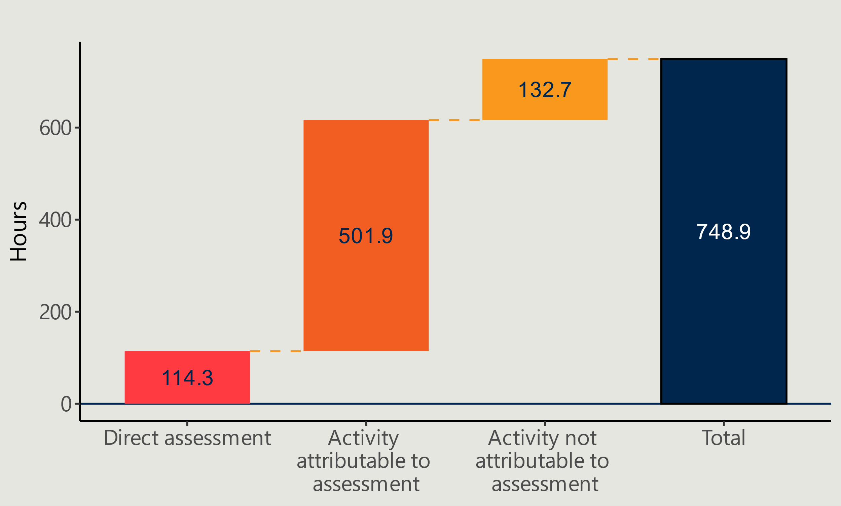

## Direct assessment activities account for about 25% of the total time observed for end-to-end assessment activities

* Completion of the Support Plan / NSAF accounts for 28% of the observed time while Direct Assessment accounts for 24%.
* Overall assessment time could be reduced by using new technologies to improve efficiencies; however, clients and staff were both cautious with the integration of unknown tools.
* Access to client records made the assessment process more efficient. Delays occurred due to health providers' unresponsiveness and insufficient information provided.

Figure 2: Average length of end-to-end assessment process

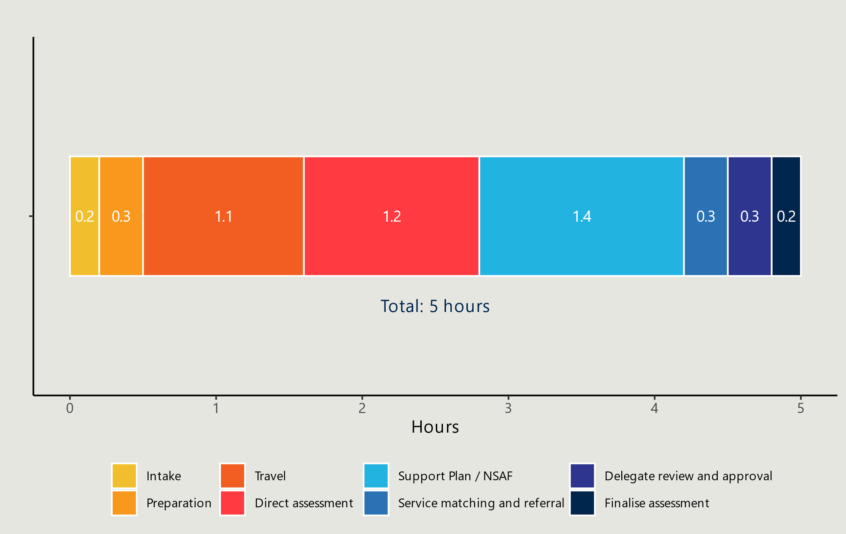

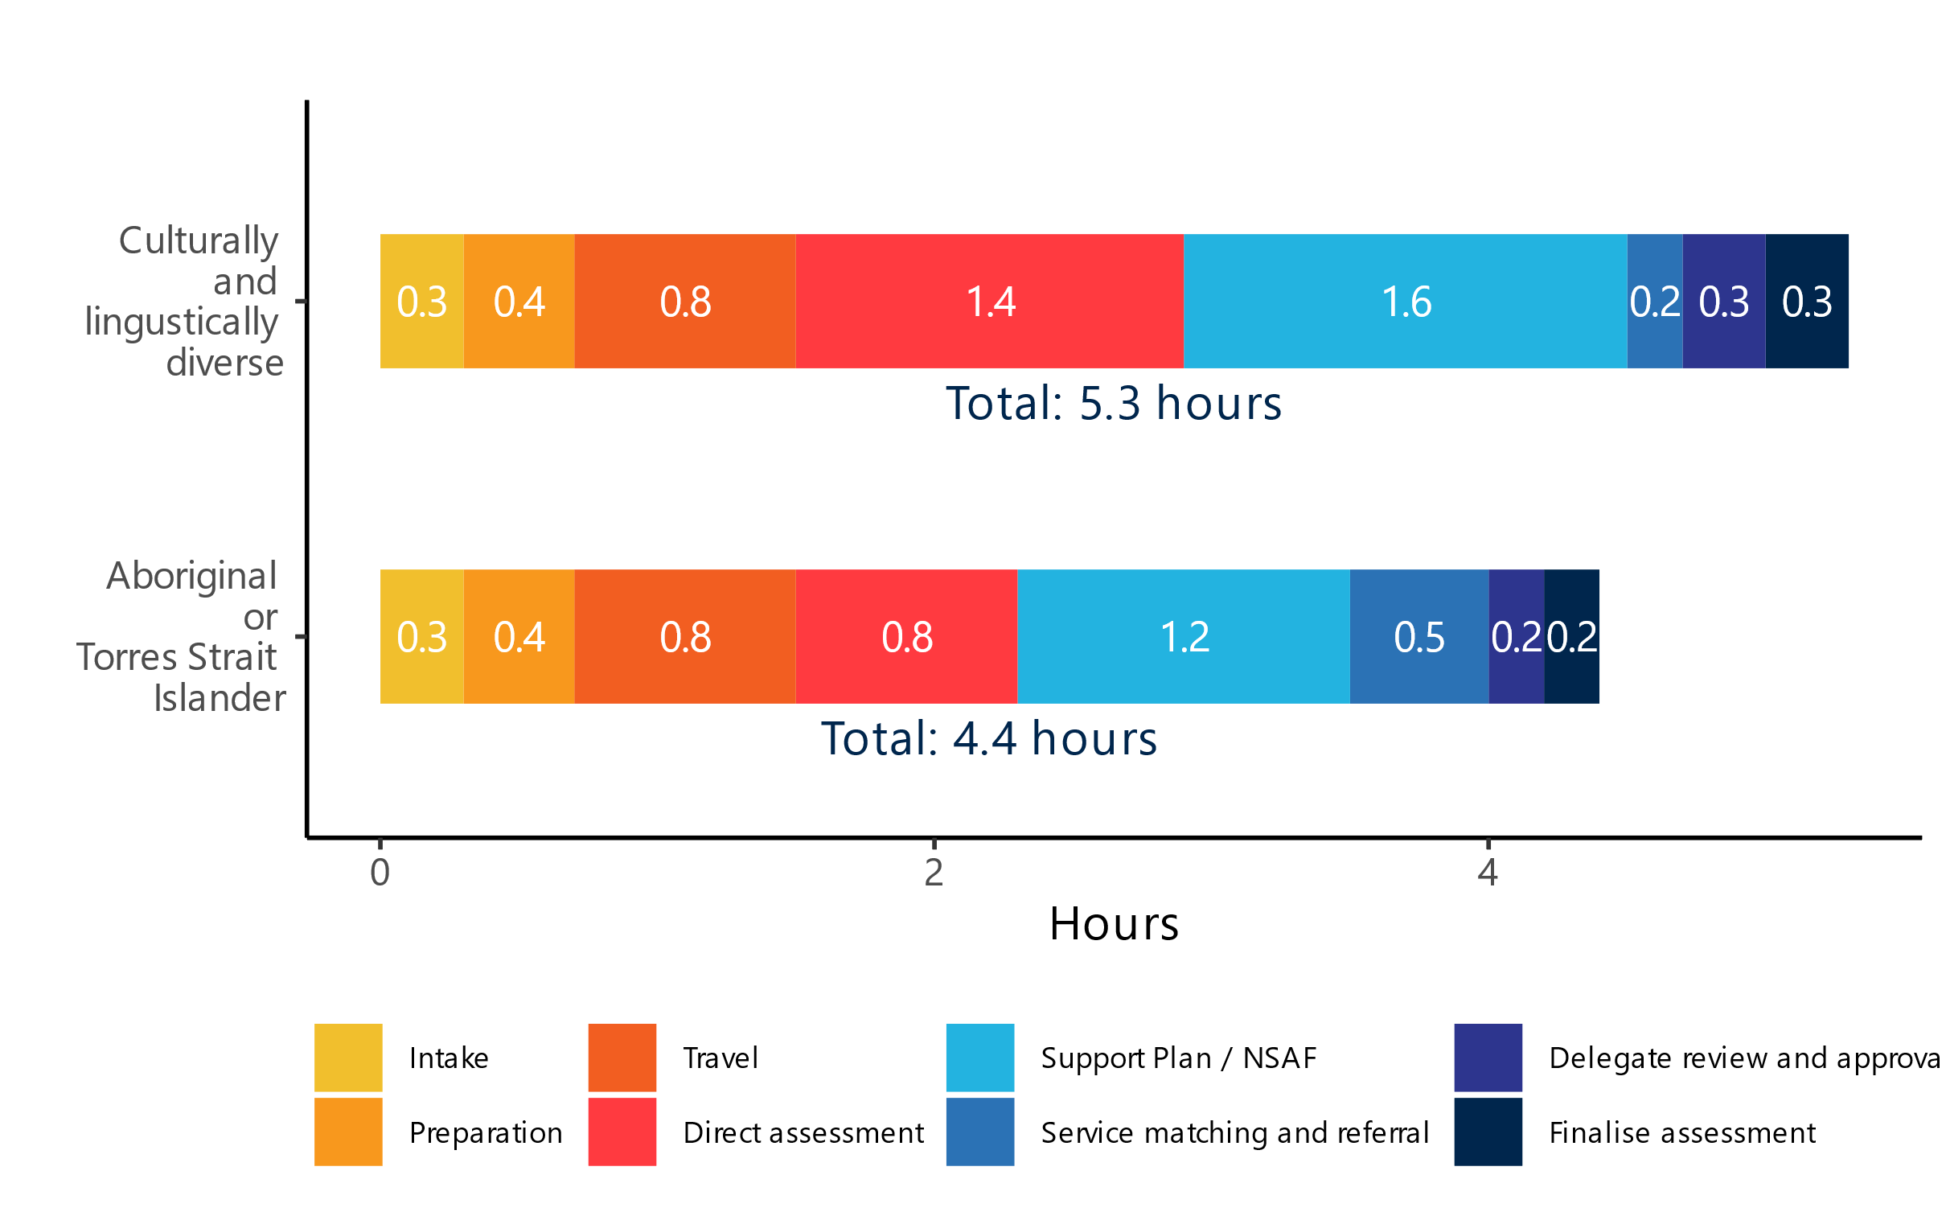Legend

## Duration of assessment activities varied by client complexity, health literacy, outlet processes, logistical challenges, and technology uptake

Direct assessment duration varied due to:

* client complexity
* client’s understanding of the process
* involvement of other parties present during the assessment
* unexpected interruptions and other logistical challenges.

Figure 3: Distribution of the duration of direct assessments

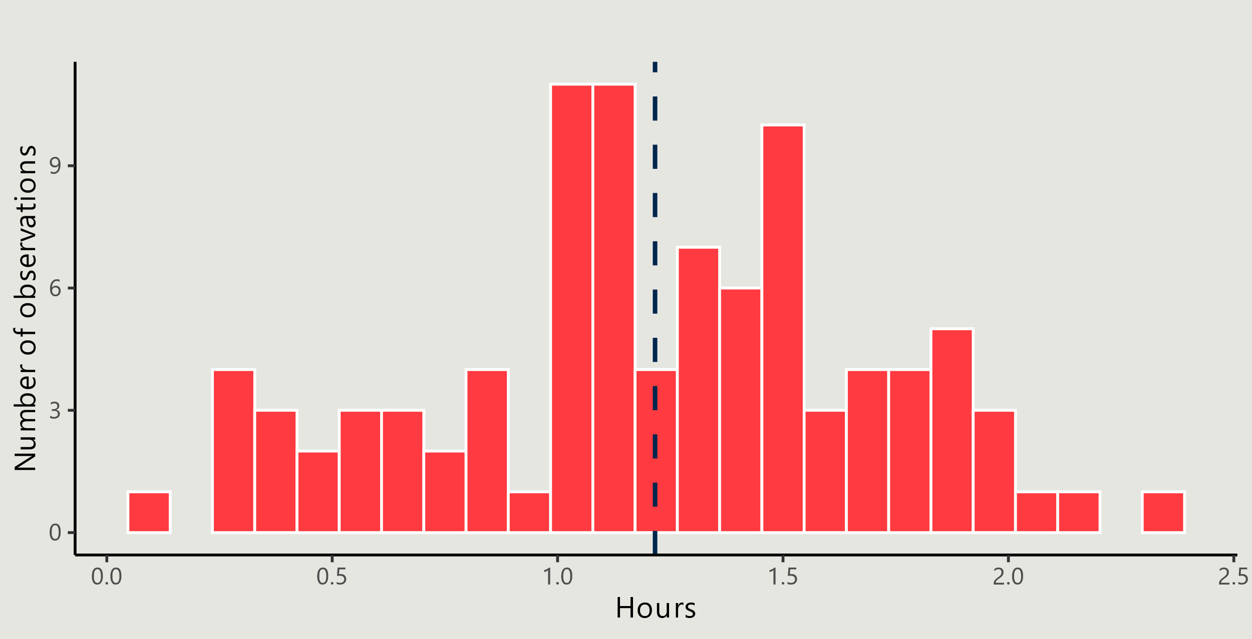

The Support Plan and NSAF activity varied due to:

* complexity of the support plan requirements
* difficulty in accessing relevant supporting information
* the occasional need to duplicate various steps in the process
* other technological challenges.

Figure 4: Distribution of the duration of direct assessments

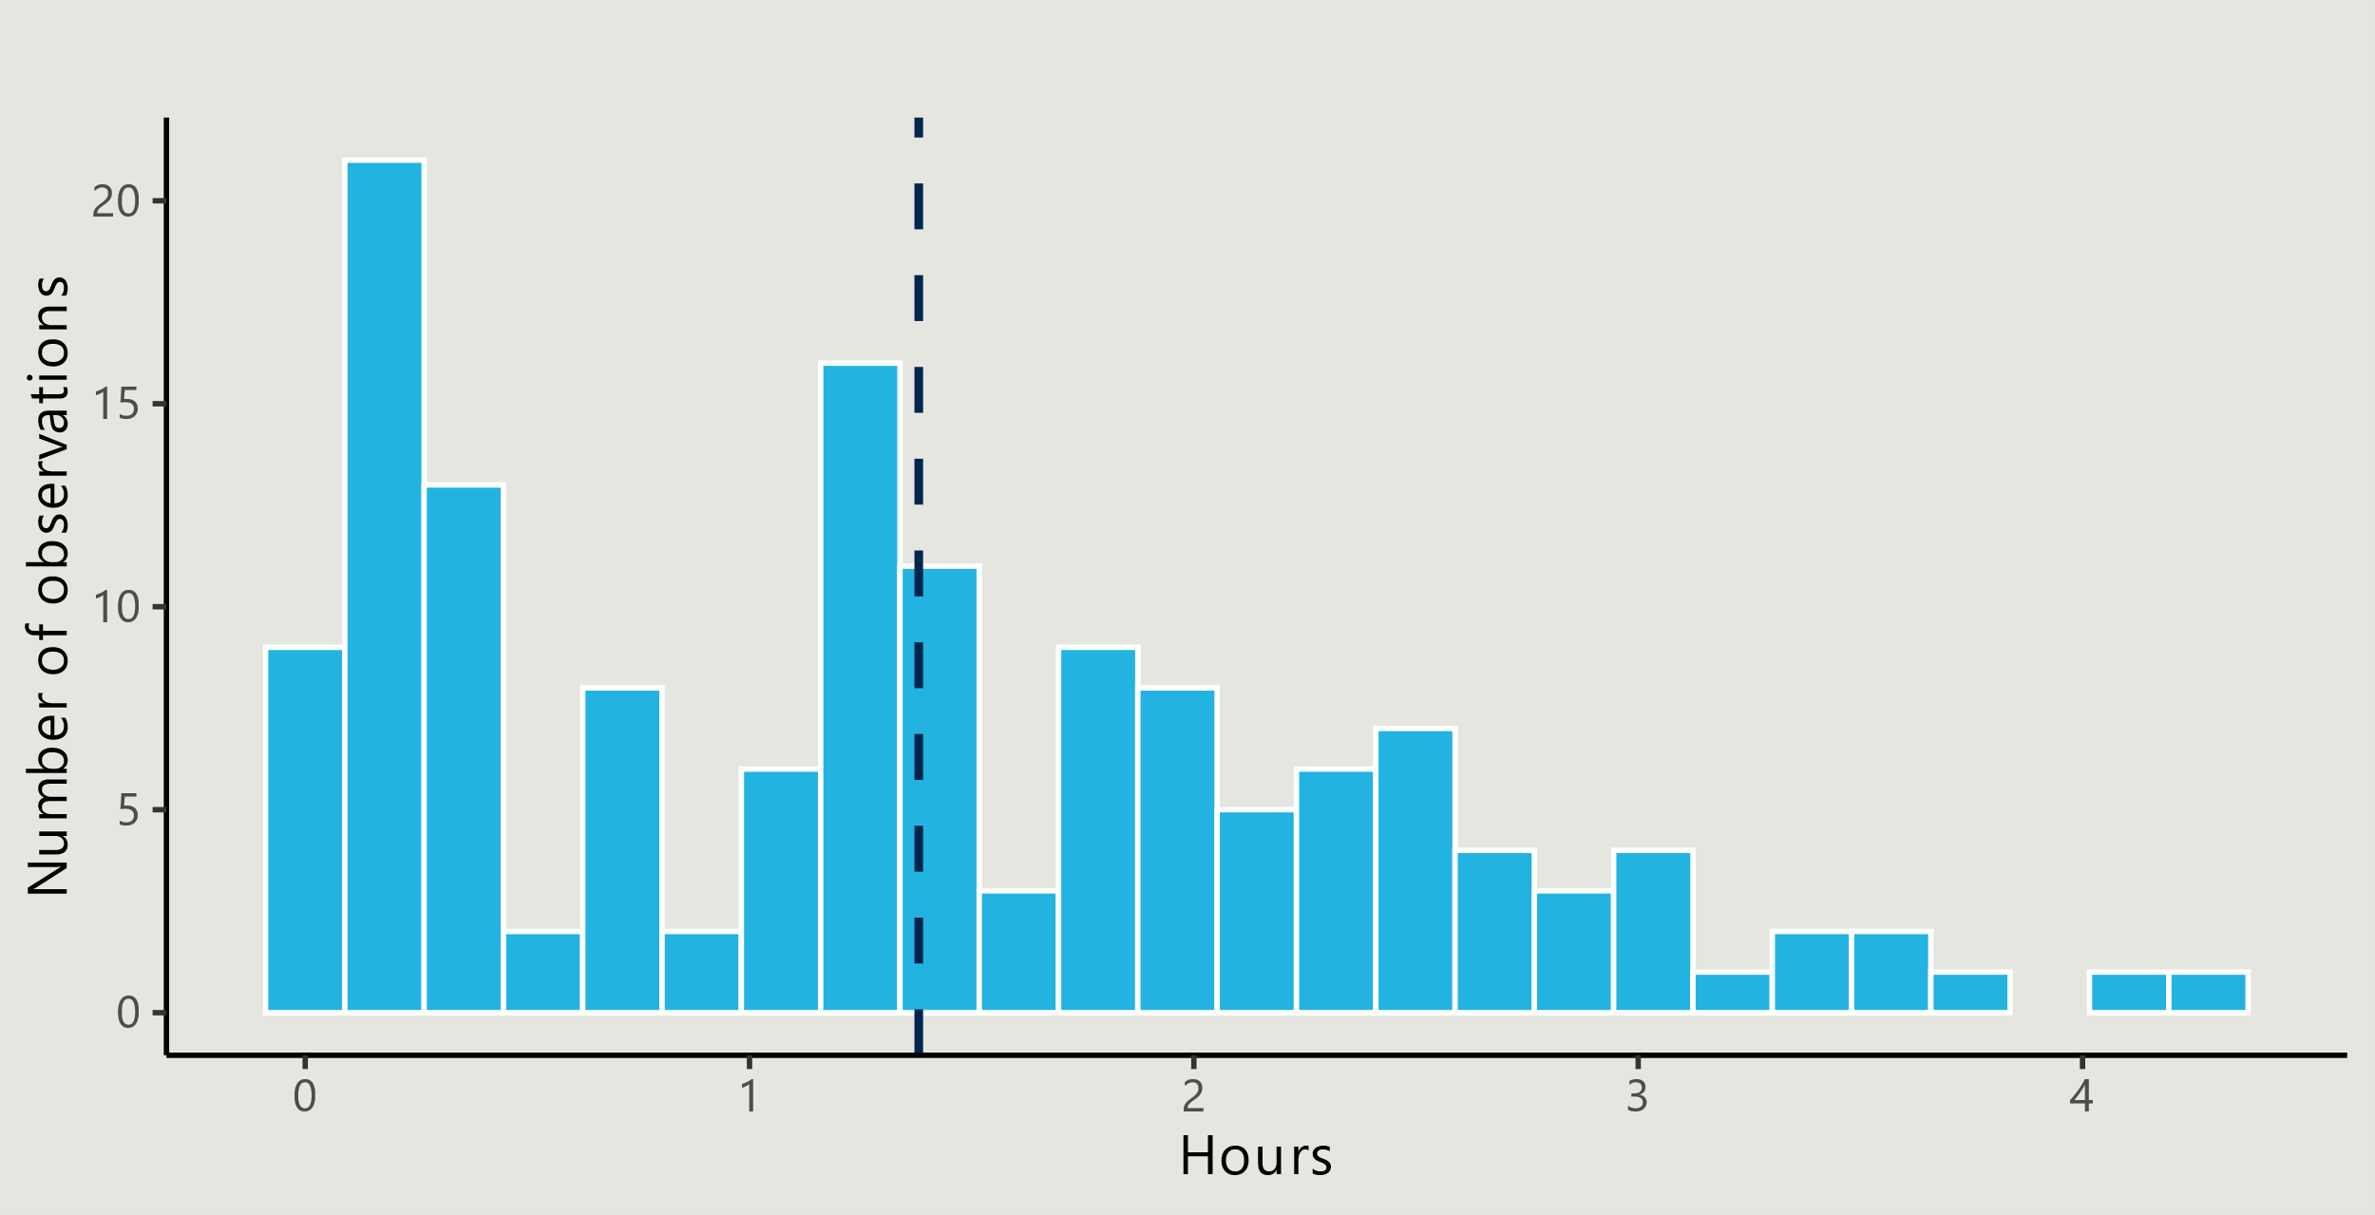

## Average end-to-end assessment length varied by location and client demographic

The end-to-end assessment process is longer by 15% in regional and 13% in remote areas than in metro areas. This is mostly driven by the time taken to complete the Support Plan / NSAF, which is 36% longer in regional and rural areas than metro areas.

Figure 5: Average length of assessment by geography

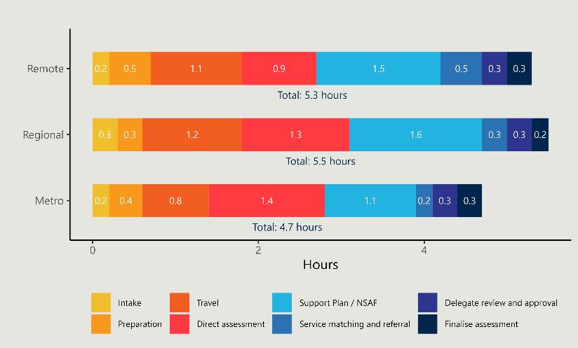



## The end-to-end assessment process for CALD clients, on average, takes 18 minutes longer than the average length of end-to-end assessment

Whereas assessments for Aboriginal and Torres Strait Islander clients are 36 minutes shorter on average than for non-Indigenous clients, with direct assessment observed as significantly shorter on average.

Figure 6: Average length of assessment for First Nations and CALD clients

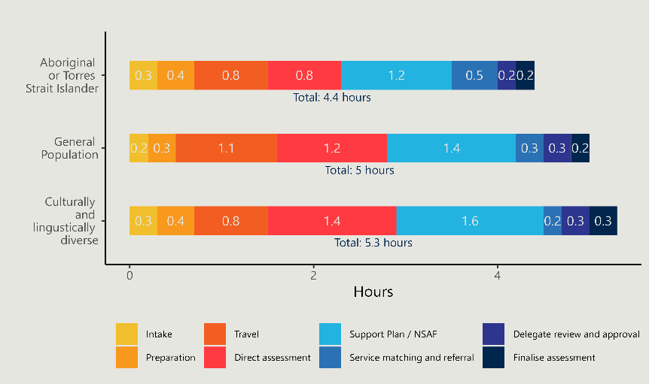



Note: *General Population* includes both the Aboriginal and Torres Strait Islander and CALD populations.

## Observations across the 30 outlets in the study identified enablers and challenges

### Team structure

* The use of experienced clinicians in triage roles can streamline processes.
* Dedicated admin and booking staff ease workload pressures for assessors.
* An efficient intake process can make the assessment activities down the line easier.

### Case coordination

* Strong relationships across the broader health network support effective case coordination.
* Assessors support clients in the most vulnerable, and complex situations.
* Clients often visit or contact ACAT outlets directly for support and information.

### Technology

* The use of the assessor app can streamline the end-to-end assessment process.
* ACATs have developed workarounds to respond to the unstable MAC platform.
* Telehealth and virtual care can facilitate efficient assessments.

### Adapting processes to meet client needs

* Assessments for Aboriginal and Torres Strait Islander clients benefited from assessors’ cultural knowledge.
* Modified assessment tools allow for more culturally appropriate assessments.
* Access to interpreters for CALD clients is often challenging, and can slow down the end-to-end assessment process.

# Implications

## Implications from these findings can inform the implementation of a Single Assessment System

### Efficiency

* Streamline intake.
* Review approach to support planning.
* Improve quality and uptake of technology.
* Optimise ACAT structure.

### Flexibility

* Accommodate clients with special needs.
* Incorporate culturally appropriate approaches for Aboriginal and Torres Strait Islander clients.
* Consider ongoing role of telehealth.

### Visibility

* Gather data on assessment duration.
* Monitor client and staff experience.
* Set new Key Performance Indicators.

### Responsiveness

* Clearly define purpose and function of assessment teams.
* Formalise connections across the assessment system.
* Confirm roles and responsibilities of key stakeholders.

# Appendix

## Categorisation of end-to-end assessment activities

The following table shows how the activities were mapped into categories and high-level ‘buckets’ for analysis.

| Activity buckets | Activity categories | Activity subcategories | |
| --- | --- | --- | --- |
| Direct assessment | Direct assessment | * Assess client care needs and condition | * Develop NSAF and Support Plan with client |
| Activity attributable to an assessment | Intake | * Process referral forms (prioritise and triage) * Investigate assessment: follow up on client details and screen for eligibility. | * Accept referral on MAC portal * Refer to team for assessment * Write clinical intervention (if required) |
| Preparation | * Schedule assessment * Confirm assessment with attending parties * Review client records, care requirements and home visit details | * Conduct pre-assessment screening (COVID and safety check) * Prepare interpreter/translator (if required) * Prepare travel arrangements including address details and transport |
| Travel | * Travel to and from client residence to conduct the direct assessment |  |
| Service matching and referral | * Case coordination * Generate referral codes (for delegate approval) | * Contact service provider * Issue referral codes |
| Support Plan / NSAF | * Case conferencing * Complete SP/NSAF (and IAT if relevant) * Complete documentation offline, ono paper or digital writing platform | * Confirm client details/information for writeup * Review and submit documentation to delegate |
| Delegate review and approval | * Delegate review – feedback to the assessor if required | * Delegate approval – develop approval letter and record approval in MAC portal |
| Finalise assessment | * Edit SP/NSAF (subject to delegate feedback) * Record assessment outcome in MAC | * Update eMR * Send assessment outcome to client and relevant care providers |
| Support Plan Review | * Schedule SPR * Request retrospective statements | * Conduct SPR * Refer for new assessment (if required) |
| Activity not attributable to an assessment | Training/certification | * Complete My Aged Care standard accredited and non-accredited training | * Delegate training * Onboarding new staff |
| Accessing and setting up the MAC portal | * Request access to MAC portal * Login to MAC portal to access or update client records | * General setup (i.e. create or edit staff profile/details) |
| Administrative tasks | * Managing information | * Attend meetings, answer phone calls and general emails |
| Manage performance | * Record and report on KPIs | * Manage individual staff and team performance |