

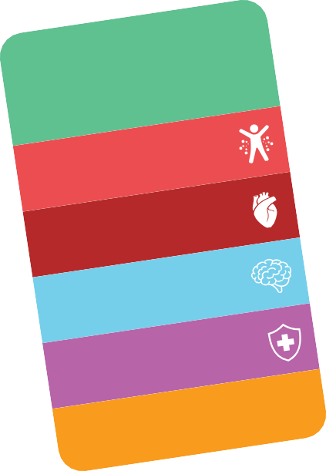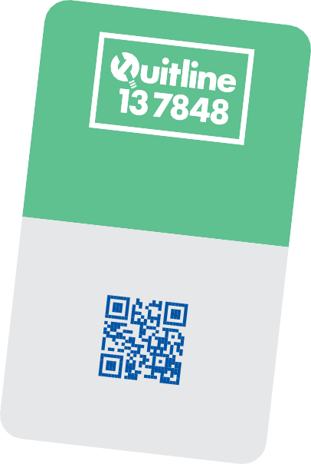

Call today to request

a callback from a

Quitline Counsellor.

**quitnow.gov.au**

Scan the QR code for strategies to

help you stop smoking for good.

**Good things**

**happen when you**

**stop smoking!**

**12**

**hours**

Most nicotine has left your body.

**24**

**hours**

Oxygen reaches your heart more easily.

**after**

**7**

**weeks**

**Health promotion inserts**

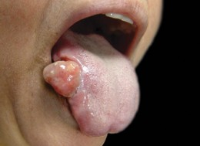

**Smoking causes cancer in your mouth.**

**tobaccofacts.gov.au**

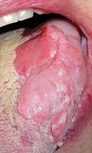

* **visit quitnow.gov.au**

**Living with mouth cancer is difficult.**

Surgery to remove mouth cancer can leave your face deformed.

Treatment can damage your senses of taste and smell.

**Want to talk about quitting?**

* **Call Quitline 13 7848**
* **talk to your doctor or pharmacist**

Your mental health may improve.

**2**

**months**

Your immune system starts recovering.

**quit before pregnancy**

**:**

Your baby’s more likely to be a healthy weight.

**tobaccofacts.gov.au**

**Removal of voice box**



**Smoking causes THROAT CANCER.**

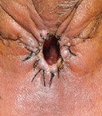

* **Call Quitline 13 7848 • talk to your doctor or pharmacist • visit quitnow.gov.au**
* need surgery to remove part of your throat
* lose your voice
* need to breathe through a hole in your neck

People who smoke are 11 times more likely to get cancer of the voice box.

**A hole for breathing made after surgery to remove a tumour**

**You CAN quit smoking.**

**If you get throat or voice box cancer you may:**



**Future policy option: warnings on cigarette sticks**

**Toxic addiction**

**Poisons in every puff**

**Causes 16 cancers**

**What is this costing you?**

*Market tested messages

**Potential graphic health warnings**