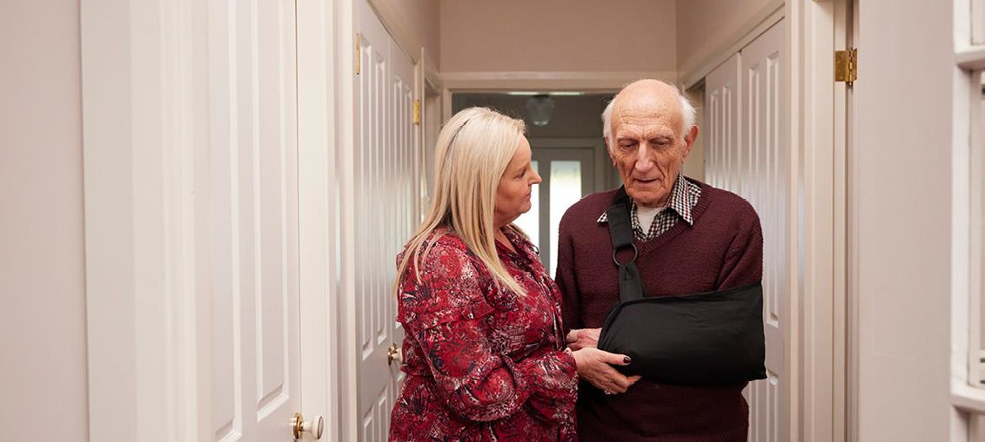

Information for residents, families or carers when a residential aged care home is closing

You may have seen or heard about residential aged care homes closing and you may be concerned that your home, or a home where a family member or friend is living may close.

When a residential aged care home closes it can be upsetting for residents, their families and friends, carers and the local community. There is help and support available.

# Responsibilities of aged care providers

If a residential aged care home is closing the aged care provider is required to lead the closure in an orderly and safe manner, which includes:

* ensuring you, your family and carers, are provided with information about your rights
* engaging early with the Government including the Aged Care Quality and Safety Commission which is the main contact for the quality and safety of aged care services
* telling you the intended date of closure (at least 14 days after notice is given), the reason for the closure and when residents are being asked to leave
* communicating clearly and managing the closure with you, your family and carers, as well as staff
* finding you suitable, affordable alternative accommodation that meets your care needs – (you won’t have to leave until that happens) – or you, your family or representative may choose to independently look for a new aged care home

# Accommodation at a new provider

**Let’s change aged care together**

We invite Australians to continue to have their say about the aged care reforms.

Visit **agedcareengagement.health.gov.au**

Phone **1800 318 209** (Aged care reform free-call phone line)

For translating and interpreting services, call 131 450 and ask for 1800 318 209.

To use the National Relay Service, visit nrschat.nrscall.gov.au/nrs to choose your preferred access point on their website, or call the NRS Helpdesk on 1800 555 660.

There may be a change to the accommodation costs when you transfer to another aged care home:

* The amount you can be asked to pay at the new home will depend on a means assessment when you enter that home, or the room price you agree to.
* You will need to enter into another accommodation agreement with your new residential aged care home and agree to a room price before you move.

# Relocation arrangements

* Your current aged care provider may offer to organise and cover any costs associated with your relocation to another aged care home.
* Talk to your aged care home to find out how these arrangements will be managed.

# Clinical needs

* Your current aged care provider will help transfer information about your clinical needs and records to a new aged care home.
* Talk to your aged care provider to understand whether they will notify other allied health professionals about this change.

# Aged care supports

If you have more questions a range of supports are available to help you through a closure:

* If you have a concern or complaint contact the **Aged Care Quality and Safety Commission** on 1800 951 822 or visit [www.agedcarequality.gov.au](http://www.agedcarequality.gov.au/).
* The **Older Persons Advocacy Network** helps older people, their families and carers work through issues with their aged care. Call 1800 700 600 or visit [www.opan.org.au](http://www.opan.org.au/).
* The **My Aged Care** website at [www.myagedcare.gov.au](http://www.myagedcare.gov.au/) provides information residential aged care homes and the services they provide. Or call 1800 200 422.