Government Provider Management System (GPMS) - Quick reference guide: Adding a new Quarterly Financial Report (QFR) Financial Reporting user

This guide is designed to support Organisation Administrators to add new Financial Reporting users to the GPMS provider portal so they can access the QFR application. These user roles can be added at the provider level.

There are two types of Financial Reporting users:

* Financial Reporting Data Entry user­
  + Data Entry users can enter data into the QFR, but not submit the QFR report.
* Financial Reporting Submission users
  + Submission users have permissions to enter data and submit the report (access to complete everything in QFR).

## Adding a user at the provider level

To add a new user at the provider level, complete the following actions:

1. In the Manage users screen, ensure the provider account is highlighted, and select the + Add New User button.

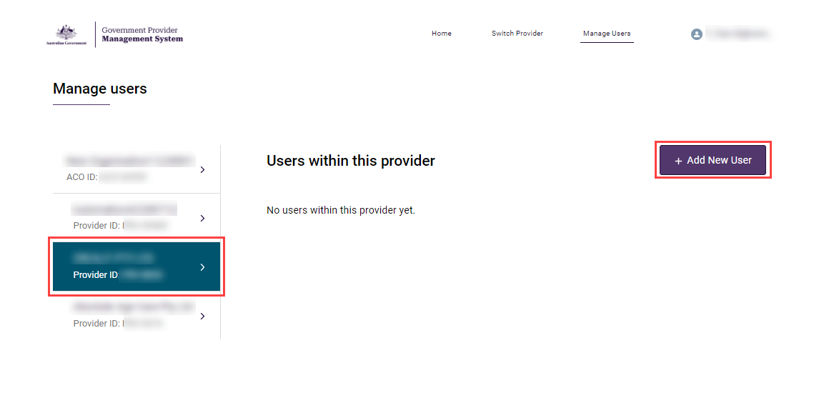

1. In the Add new provider user screen, enter the new user’s company email address, and select the Next button.

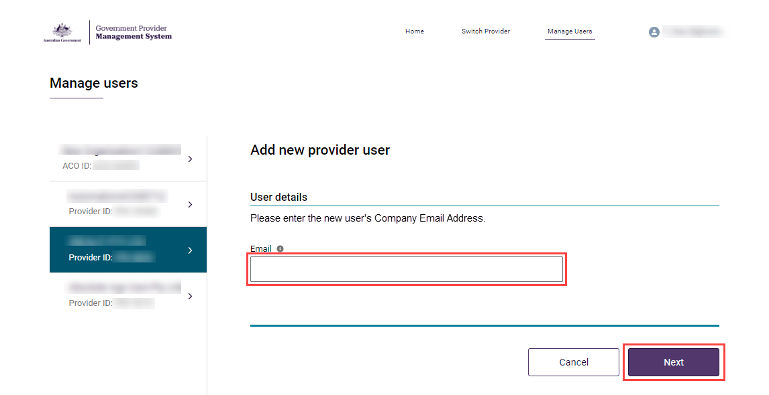

1. Add the new user’s Salutation, First name, Surname, and Date of birth.
2. Under User roles, tick the check box for Financial Reporting Data Entry or Financial Reporting Submission.

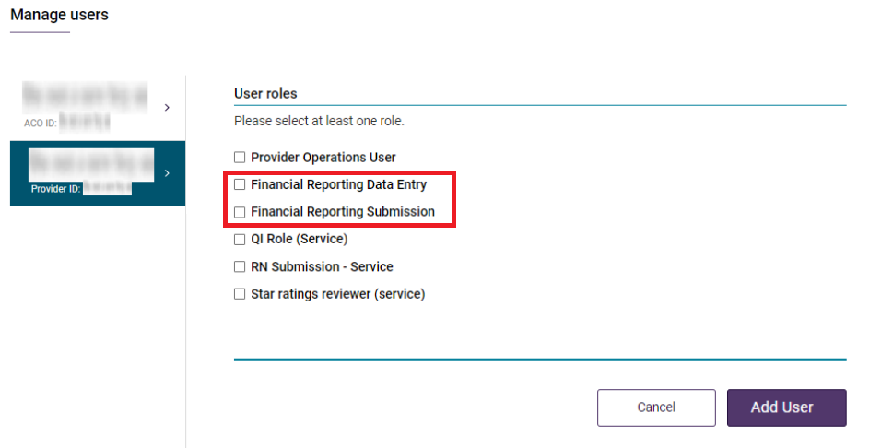

The Manage Users screen will display again. A green banner will display at the top of the screen advising an invitation has been sent to the new user. The new user will need to select the link in the email and log into GPMS to complete their registration.

