Prepared by the Australian Digital Health Agency for the Australian Department of Health and Aged Care 30 June 2023.

**Document control**

This document is maintained in electronic format and is uncontrolled in printed form. It is the responsibility of the user to verify that this copy is the latest revision.

**Copyright © 2023 Australian Digital Health Agency**

This document is copyright. All rights reserved. No part of this document may be used, reproduced or altered in any form or by any means, without prior written consent of the Australian Digital Health Agency (Agency)  No part of this document may be reproduced or used in any form or by any means whatsoever without the permission of the Agency.

All copies of this document must include this copyright statement and the information in its entirety.

**Disclaimer**

The Australian Digital Health Agency (“the Agency”) makes the information and other material (Information) in this document available on an ‘as is’ basis and in good faith but without any representation or warranty as to its accuracy or completeness. The Agency cannot accept any responsibility for the consequences of any use of the Information.  The Information is of general nature only, and it is up to the person using or relying on the information to ensure that it is accurate, complete and suitable for its intended use.

*Attribute this publication (and any material sourced from it) using the following citation:*

*Australian Digital Health Agency. Exploring Allied Health information sharing: Healthcare provider and healthcare recipient perspectives. Sydney. 2023.*

Table of contents

Glossary 4

Definitions 4

Key Abbreviations 4

Executive summary 6

Responses to key research questions 8

Overarching value proposition 10

Introduction 14

Methodology 15

Qualitative sample frame 16

Quantitative sample frame – online surveys 18

Key findings 21

Healthcare Providers 21

Allied Health Professionals 38

Healthcare Recipients 44

My Health Record 56

Appendix A: Additional data and charts 59

Segmenting variables used to describe healthcare recipient survey participants 59

# Glossary

For the purposes of this report the following definitions apply.

|  |  |  |
| --- | --- | --- |
| Definitions of study participants | | |
| **Healthcare Providers** refer to those other than Allied Health Professionals including:   * General Practitioners * Primary Care Providers (Registered Nurses)* * Medical specialists including those working in:   + Anaesthesia   + Emergency medicine   + Physician   + Oncology   + Addiction medicine   + Neurology   + Obstetrics and gynaecology   + Pain medicine   + Pathology   + Psychiatry   + Public health medicine   + Radiation oncology   + Surgery | **Healthcare Recipients** including:   * All Australians noting those who receive or are likely to receive allied healthcare services including:   + Carers and parents   + Older Australians   + Australians with chronic or complex healthcare needs   + People who have experienced an acute healthcare episode and accessed allied healthcare | **Allied Health Professionals** including the following provider types:   * Audiologists * Chiropractors * Dietitians * Exercise physiologists * Osteopaths * Physiotherapists * Psychologists * Podiatrists * Occupational therapists * Speech pathologists |

*Primary Care Providers included in qualitative rounds only.

## Key Abbreviations

AH - Allied Health

AHP - Allied health professional

GP - General Practitioner

HCP - Healthcare Providers including General Practitioners, Primary Care Providers,   
 Registered Nurses and Medical Specialists

EMR - Electronic Medical Record

|  |  |
| --- | --- |
|  |  |

Executive summary

# Executive summary

Background and methodology

The 200,000 Allied Health Professionals (AHPs) in Australia represent the largest clinical workforce in the Australian healthcare system, yet they are poorly integrated into the digital health system. This study was commissioned to complement a broader piece looking at the technical, legislative, financial and cultural barriers that AHPs face in adopting digital health tools like My Health Record. The specific objectives of this study were to understand the Allied Health (AH) data most useful to healthcare recipients and other healthcare providers (HCPs), identify barriers and enablers for healthcare recipients and HCPs accessing and using information uploaded to My Health Record by AHPs and identify the AH clinical data most valuable to HCPs and healthcare recipients.

The study consisted of 2 rounds of qualitative research with AHPs (total N=27), HCPs (total N=61) and healthcare recipients (total N=29), as well as a quantitative survey of AHPs (N=100), General Practitioners (GPs) (N=152), medical specialists (N=30) and healthcare recipients (N=1500).

Key findings

This research identified that while HCPs and AHPs are, on the surface, satisfied with the amount of information they receive from each other about their shared healthcare recipients, there is substantial room for improvement, with few ‘very satisfied’ with the scope of clinical information sharing at present.

This study has revealed a satisficing effect, where HCPs and AHPs have become accustomed to working with a lack of clear, detailed information from each other.

* While HCPs and AHPs report that the health information they currently receive is sufficient, very few (< 10%) are ‘very satisfied’ with the current state of information sharing, they rely on a patchwork system of different modes of communication and very few report to have access to all the information they need, when they need it. This inevitably leads to reported duplication, wastage and additional administrative workload.
* AHPs and medical specialists are less satisfied than GPs overall with the information they receive, only 36% of AHPs and 43% of specialists are satisfied with the overall level of communication they have with GPs. In contrast, 69% of GPs are satisfied with the overall level of communication with specialists and 53% are satisfied with the information they receive from AHPs. These figures belie an even larger opportunity for improvement as only tiny proportions of each group are ‘very satisfied’ with the current information flows.
* Healthcare recipients are largely satisfied with the information they receive from their providers (e.g. 81% satisfied, 32% very satisfied with information from their GP), but are less satisfied with the flow of information between different parts of the health system (e.g. 56% satisfied, 13% very satisfied with sharing between AHPs and GPs), and find they have to repeat themselves, maintain their own health data and take responsibility for sharing it with the rest of their healthcare team – a task for which many report to feel ill-equipped. Those with complex or chronic health conditions report to be overwhelmed from the effort required to co-ordinate care.
* Nearly all (87%) healthcare recipients agree that they should have access to all the information that AHPs create about them, and that their lives would be easier if they did (72%). They express the need to be able to share this information with other AHPs and HCPs in their team.

HCPs believe that AH clinical information can play a critical role in healthcare – particularly information from psychologists and physiotherapists.

* They prioritise information pertaining to critical or urgent healthcare needs and complex health conditions including chronic disease, co-morbidities and mental health.
* Many HCPs are both referring to AHPs and reviewing information provided by AHPs ‘most days.’ They tend to receive this information in the form of typed letters or notes and via fax.
* While the qualitative research demonstrated that the specific information HCPs require to support healthcare recipient care is largely dependent on the clinical presentation and AH discipline involved, they prioritise AH clinical information that pertains to treatment(s) provided, treatment plans, progress, goals and AH assessments.
* HCPs tend to receive the clinical information they want around treatments provided by AHPs, as well as treatment plans and follow-ups, but there is evidence of substantial ‘sharing gaps’ in other information that they would like to see, including diagnostic results, instructions or procedures to follow, suggestions and referrals to complementary services and advice, tips and coping mechanisms.
* GPs are less satisfied with the information they receive from AHPs than medical specialists, and only 6% are ‘very satisfied’ with the information they receive from AHPs. The qualitative research indicated that HCPs engaged in team-based care are more engaged with AH clinical information. Those who work alongside or in the same building as AHPs tend to have more opportunity for informal, but high-quality sharing via opportune conversations.
* Healthcare recipients also identified a range of information sharing gaps, indicating that their GPs are less likely to receive their AHP treatment plans and treatments, diagnostic results, progress reports and treatment goals than they would like.

When HCPs need AH clinical information, they typically seek it out by first speaking with their healthcare recipients, who report they aren’t always able to provide what their HCP needs. Where the healthcare recipient lacks information, HCPs then reach out to the AHPs, often by telephone. This takes time and effort and adds to their already busy work schedule, however they suggest they have become accustomed to this way of working and do not report an urgent or pressing need for change.

Healthcare recipients are largely comfortable sharing nearly all AH clinical information with their GPs, but have mixed views regarding the need for their GPs to share all their health information with every AHP. They report preferring their GP to play a central co-ordinating role, controlling which HCPs have access to which information.

* 41% of healthcare recipients feel that AHPs should only have access to what is relevant to treat their condition. Participants suggest that there is little need for all AHPs to have access to their sexual or mental health information, for example.
* The qualitative research provided evidence that many HCPs have a similar view, and that healthcare recipients should have more control over which HCPs and AHPs get to see certain information.

An automated approach to information sharing through existing software is highly preferred with some suggesting that an integrated system would require very little change management and incentivisation – that it may not require significant change if the AH clinical information was incorporated into current IT systems.

The value proposition of improved AH clinical information sharing is that all parts of the health system will have access to more information, when and where it is needed, and be able to deliver better health outcomes for healthcare recipients as a result.

While nearly all HCPs are aware of My Health Record, this research suggests it is not currently utilised for sharing AH clinical information. For some, it plays a key role in their management of healthcare recipients. They see its potential, and how it could offer a much better way of sharing information and communicating with healthcare recipients and other parts of the healthcare system, but several barriers keep them from fully engaging.

* AHPs – especially those not working in public health settings - are less familiar with My Health Record and often lack access to a system capable of integrating with My Health Record. This research highlighted that both training and better integration with their practice information systems are key ways in which to support their engagement with the system.
* HCPs in this research suggest that encouraging compulsory use of My Health Record in the public sector to upload healthcare recipient information will be required to establish a solid base of usage. While they report this will have limited effect on the private sector, they also recommend financial incentives.

Conclusion

The results of this research highlight that while there is substantial room for improvement in the way that AHPs and HCPs share clinical information between them, due to a satisficing effect, they report limited impetus for change at present. Low expectations around information sharing are being met, rather than exceeded, and addressed using cumbersome manual processes that create inefficiencies and wastage in the system. This research also highlights frustration among healthcare recipients who report limited sharing of information between their AHPs and HCPs. This requires healthcare recipients to manage their own healthcare information and take responsibility for sharing it. Consequently, healthcare recipients report having to repeat their histories to all providers in their healthcare team. Many feel ill-equipped to take on this responsibility and those with complex and chronic health conditions are overwhelmed.

My Health Record offers an opportunity to improve information sharing between AHPs and HCPs and healthcare recipients. Healthcare recipients report being comfortable sharing their AH clinical information on My Health Record, but repeatedly stressed the need for appropriate controls to enable them to selectively share relevant and appropriate information with their AHPs and HCPs.

Currently a lack of engagement by AHPs with My Health Record impacts the availability of AH clinical information in the system, this influences information sharing between HCPs and AHPs. This limits the potential to improve healthcare outcomes for healthcare recipients, particularly those with complex and chronic health conditions who are under the care of multiple providers. Improving engagement with AH clinical information within My Health Record requires raising AHP awareness and participation, while HCPs report that training, software integration and compulsory use of My Health Record in the public sector would further encourage use to support improved healthcare recipient outcomes.

# Responses to key research questions

Healthcare Providers

|  |  |
| --- | --- |
| **Key Research Question** | **Findings** |
| What are the views of GPs, medical practitioners and other relevant HCPs regarding the value of AH clinical information uploaded to My Health Record? | HCPs value AH clinical information and they value the opportunity to have access to all clinical information that will allow them to provide better care for their healthcare recipients. |
| What AH clinical information, if any, do HCPs currently view in My Health Record? | HCPs are not routinely seeking out AH clinical information in My Health Record, in part because it is often unavailable, and AHPs are largely unaware and unfamiliar with My Health Record. |
| What clinical information would HCPs want to receive from AHPs? | HCPs perceive information that is critical and/or urgently required to inform the treatment of their patient as most valuable. Key pieces of AH clinical information that HCPs report wishing to receive include treatment details, treatment plans, progress reports and details of assessments. |
| In what format do HCPs want to receive AH clinical information? | HCPs want information in an easy to access format, online and preferably integrated within an existing system. AH clinical information should be easily accessible with user-friendly layouts and navigation tools. |
| What incentives or supports would be effective in increasing HCPs accessing AH clinical information in My Health Record? | HCPs believe that training and education, as well as automation through software integration would most likely influence an increase in information sharing.  Some HCPs believe that uptake would be increased in public health services by introducing mandatory uploading of AH clinical information into My Health Record, and in the private sector by the introduction of financial incentives. |
| Are there particular clinical areas that would benefit most from better integration of AH clinical information in My Health Record? (For example, chronic health conditions, mental health conditions). | HCPs providing team-based care for patients with chronic, complex healthcare needs and in circumstances where information is critical and/or urgently required to inform treatment, would benefit most from better integration of AH clinical information in My Health Record. |

Healthcare Recipients

|  |  |
| --- | --- |
| **Key Research Question** | **Findings** |
| How would access to AH clinical information simplify or improve a healthcare recipient’s healthcare experience? | For healthcare recipients with chronic or complex health needs or under the care of multiple HCPs, increased access to AH clinical information would significantly simplify and improve their healthcare experience. It would offer substantial relief from the challenges of managing their healthcare administration. |
| Have healthcare recipients experienced lack of access to AH clinical information resulting in problems for them/ their HCPs? | Most healthcare recipients have experienced a situation where they have not been able to easily access their healthcare information. This led to reported frustration, and an increase in the need to repeat their history, and take on responsibility for managing their healthcare information. However, few suggested that it created “problems” for them or their HCPs as any missing information was easily sourced. |
| What information from AHPs would healthcare recipients like to be able to view in My Health Record? | If given the option to have information available on My Health Record, healthcare recipients believe all AH clinical information should be uploaded. However, they are clear that they want control over who sees which information and when. |
| What information from AHPs would healthcare recipients not like added to My Health Record? | There is sensitive information (e.g., information related to mental health) which healthcare recipients want to ensure is protected. However, they are open to having this available, with controls in place that enable them to give permission for HCPs and AHPs to access to relevant health information. |
| What information would healthcare recipients want their AHPs to receive from other HCPs? | This research indicates mixed preferences amongst healthcare recipients regarding the information they wish to be shared with their AHPs. While some reported they would like to share their full medical history, others indicated they only want to share what is necessary for them to know for the specific issue they are treating.  However, there was stronger sentiment towards the sharing of specific healthcare information, including their medications, imaging results, and other diagnoses. |
| What information would healthcare recipients want other HCPs to receive from their AHPs? | Healthcare recipients largely report that all AH clinical information should be shared with their HCPs, particularly their GP. Forms of AH clinical information that were identified as key to share included information regarding treatments, treatment plans, progress reports, diagnostic tests and treatment goals. |

## Overarching value proposition

* For those with **chronic or complex health needs or with multiple healthcare professionals** in their circle of care, increased access to AH clinical information **would significantly simplify and improve their healthcare experience**. It would offer substantial relief from the challenges of managing their health care administration.
* For those with **less complex health needs**, access to AH clinical information would be considered helpful, but not essential.
* Most healthcare recipients have experienced a situation where they have **not been able to easily access** their health care information however **few would suggest that it created “problems”** for them or their healthcare providers. Any missing information was easily sourced.
* If given the option to have information available on My Health Record, health care recipients believe **all AH clinical information should be uploaded** however they are clear – **they want control** over who sees this information and when.
* There is **some sensitive information** (in particularly mental health related information) which they want to **ensure is protected** however they are open to having this available – as long as they have the **controls in place that require them to give permission** to access.

There is universal agreement that improved information sharing by all HCPs achieves better health outcomes for all healthcare recipients

The key benefit of increasing and improving access to AH clinical information for all cohorts was identified as the **opportunity for better health outcomes for all healthcare recipients**. HCPs, AHPs and healthcare recipients were aware of the importance of AH clinical information sharing in healthcare services and of the role it plays in:

* **Ensuring timely, accurate diagnosis and more effective and timely interventions**; and
* **The collective and collaborative design of treatment plans** that leverage the knowledge, experience and expertise of all providers in team-based care.

“As a medical doctor, my role in interacting with Allied Health Professionals is crucial when it comes to the care and support of patients, especially those with complex conditions like Parkinson's disease who require safe supports at home. I work collaboratively with Allied Health Professionals to ensure a comprehensive and well-rounded approach to patient care.”  
(Medical specialist, public hospital)

“Working together with other healthcare providers helps. One person who kind of communicates with others would be good. Recently, I was advised to change my medication. My neurologist communicated with my cardiologist to see if I should remove one of my medications. So that was good in itself.” (Healthcare recipient, chronic health condition)

In addition, participants highlighted a range of other benefits of information sharing amongst HCPs and AHPs including:

* **Alleviating HCP recipient concerns** about being personally responsible for having to repeatedly share their healthcare needs and healthcare journey.

“I'll see a number of specialists…, and I've asked them all to communicate. And neither of them are aware that that I've been to see the other - they're not aware of the appointment. I have to recap – I have to tell them. I suppose you have to help them help you. But they don't seem to do any pre reading or any for your appointment at all. They've got no idea until you tell them.”  
(Healthcare recipient, older Australian)

“I have seen a woman who had a significantly poor outcome after surgery. I did urodynamics without having access to a complete assessment and plan from physiotherapy. The woman had to repeat a traumatic story again and retell her current condition which was distressing.”  
(Registered nurse)

* **Creating efficiencies** with information sharing, minimising the need for tests and information to be duplicated by different members of a healthcare team, and saving time because members of a healthcare team don’t need to source information already provided.

“It will save them time, wouldn’t it? They wouldn’t have to look for it or ask for it, if they shared it, everyone would just have it.” (Healthcare recipient, parents and carer)

* **Ensuring accurate and up-to-date information** providing a holistic data set of healthcare recipients’ journeys and healthcare interactions.

“I don't know where to begin. I feel sometimes like if I tell people, they'll think you're lying. You can't have that many things wrong with you. I have multiple spinal problems. Osteoporosis of cervical spine osteoarthritis of the lumbar spine. I get cut out two slip discs. I get chronic pain from that.” (Healthcare recipient, chronic health condition)

“Having access to that information is absolutely crucial to so many decisions we make on a day-to-day basis. For example, I have a patient in hospital at the moment who is currently suitable for discharge from a medical point of view, however he is not safe from a mobility perspective. Having access to the physiotherapist's assessment and plan directly affects how I will manage the patient, and that specialised assessment is very valuable information.” (Medical specialist, private hospital)



|  |  |
| --- | --- |
|  |  |

Background and methodology

# Introduction

Background

There are over 200,000 AHPs working in Australia, which makes them the largest clinical workforce in primary care. Despite positive adoption of telehealth, especially during the COVID-19 pandemic, there are barriers that prevent AHPs from using certain digital health tools at the same rates as other HCPs. AHPs are a diverse group, employed in a range of settings and workplaces, requiring a tailored approach to enable them to use specified digital health tools at the same rates as other HCPs.

In 2022-23 the Department of Health and Aged Care (DOHAC) undertook a project to identify and understand any technical, financial, legislative, or cultural barriers to progress the development and availability of My Health Record-enabled versions of AH clinical information systems and the adoption and use of My Health Record-enabled clinical information systems by AHPs. This work will provide a detailed understanding of the barriers and enablers from the perspectives of AHPs and software vendors.

Objectives

To complement the work being undertaken to understand AHP and software vendor perspectives, the Australian Digital Health Agency (the Agency) were engaged to complete a research project which aimed to:

* Scope the core dataset of AH clinical information most useful for healthcare recipients and HCPs that refer to, or receive referrals from, AHPs;
* Identify the barriers and enablers to healthcare recipients and HCPs accessing and using information uploaded by AHPs to My Health Record; and
* Identify the AH clinical information most valuable to healthcare recipients.

Research questions addressed in this project

The research sought to answer the following questions:

**Healthcare providers**

* What are the views of GPs, medical practitioners and other relevant healthcare providers regarding the value of AH clinical information uploaded to My Health Record?
* What AH clinical information, if any, do HCPs currently view in My Health Record?
* What clinical information would HCPs want to receive from AHPs?
* In what format do HCPs want to receive AH clinical information?
* What incentives or supports would be effective in increasing HCPs accessing AH clinical information in My Health Record?
* Are there particular clinical areas that would benefit most from better integration of AH clinical information in My Health Record (for example, chronic health conditions, mental health conditions)?

**Healthcare recipients**

* How would access to AH clinical information simplify or improve healthcare recipients’ healthcare experience?
* Have healthcare recipients experienced lack of access to AH clinical information resulting in problems for them or their HCP?
* What information from AHPs would healthcare recipients like to be able to view in My Health Record?
* What information from AHPs would healthcare recipients not like added to My Health Record?
* What information would healthcare recipients want their AHPs to receive from other HCPs?
* What information would healthcare recipients want other HCPs to receive from their AHPs?

## Methodology

To support the data collection and research activities required to fulfill the aims of the Allied Health Research Project, the Agency engaged independent research consultancy firm, Where*to* Research (Where*to*). The Agency and Where*to* have worked collaboratively to co-design the research activities and resources used throughout.

The research comprised a combined qualitative and quantitative approach to meet the research objectives. Using a series of fieldwork sprints, the research provided an opportunity for concepts to be qualitatively tested and refined based on the insights, and then re-tested with the final insights validated using a large-scale quantitative sample. The project was comprised of 5 Sprints:

* **Sprint 1: Project set-up (Preparing):** a review of the evidence, finalisation of the methodology and the approach for healthcare recipient and HCPs.
* **Sprint 2: Qualitative fieldwork (HCP Deep Diving):** an exploration of responses to the proposed solutions, gathering qualitative feedback to evaluate and refine the proofs of concept.
* **Sprint 3: Qualitative fieldwork (HCP Refinement and Healthcare recipient Deep Diving):** further testing to validate refinements made from recommendations provided in Sprint 2 to ensure successful translation.
* **Sprint 4: Quantitative fieldwork (Healthcare recipient and HCP Evaluating):** a survey of healthcare recipients, primary, secondary (optional) and acute care operators to confirm and extend the findings, allowing for generalisation to the broader population of healthcare recipients and HCPs.
* **Sprint 5: Knowledge Transfer:** analysing and reporting, undertaking presentations, developing knowledge translation tools etc.

## Qualitative sample frame

Round 1: Healthcare Providers (HCPs) and Allied Health Professionals (AHPs)

N=3 online bulletin boards held 8 – 10 May 2023, with a total N=43 participants. All participants were screened to ensure they had experience sharing clinical information between AHPs and HCPs when providing care to healthcare recipients.

|  |  |  |  |  |  |  |  |
| --- | --- | --- | --- | --- | --- | --- | --- |
| Bulletin board 1: AHPs | |  | Bulletin board 2: Combined AHPs and HCPs | |  | Bulletin board 3: HCPs | |
| **Provider type** | **n** |  | **Provider type** | **n** |  | **Provider type** | **n** |
| Audiologist | 2 |  | Nurse | 1 |  | GP/ Primary Care Providers (Registered Nurses) | 7 |
| Chiropractor | 2 |  | Exercise Physiologist | 1 |  | Medical specialist | 5 |
| Dietician | 3 |  | Occupational Therapist | 3 |  |  |  |
| Exercise Physiologist | 2 |  | Physiotherapist | 3 |  |  |  |
| Occupational Therapist | 1 |  | Psychologist | 2 |  |  |  |
| Osteopath | 1 |  | Speech Pathologist | 1 |  |  |  |
| Physiotherapist | 3 |  | Specialist | 3 |  |  |  |
| Psychologist | 1 |  |  |  |  |  |  |
| Speech Pathologist | 2 |  |  |  |  |  |  |
| **Total** | **17** |  | **Total**  *\*N=1 HCP recruited but did not complete* | **14** |  | **Total**  *\*N=6 HCPs recruited but did not complete* | **12** |

Round 2: Healthcare recipients and Healthcare Providers (HCPs)

N=4 discussion groups with healthcare recipients held 25 May 2023, with a total N=29 participants. Each group, identified in the table below, included participants who have received care from an AHP in the past 12 months.

|  |  |  |
| --- | --- | --- |
| Healthcare recipient discussion groups | | |
| Parents and carers | Parents of young children aged under 5 years of age (including pregnant) and carers of older people (not in aged care) or people with disability | 7 |
| People with more complex health conditions | Chronic health conditions such as diabetes, respiratory illness, mental health, with a mix of ages | 8 |
| People who recently experienced an acute health episode | Respiratory event, fractured or broken bone, heart attack, stroke, seizure, asthma attack, sports injury, accident, injury | 7 |
| Older Australians (60+ years old) | Not in aged care facility – living in the community/ at home | 7 |
| **Total** *N=3 recruited but did not attend | | **29** |

N=1 online bulletin board held Tuesday 23 May – Tuesday 20 June, with a total N=45 participants. All participants were screened to ensure they had experience sharing clinical information between AHPs and HCPs when providing care to healthcare recipients.

|  |  |
| --- | --- |
| HCPs (no AHPs) | |
| Primary Care Providers (Registered Nurses) | 9 |
| GPs | 30 |
| Medical specialists | 6 |
| **Total** *N=3 HCP recruited but did not complete Part 4 | **45** |

## Quantitative sample frame – online surveys

Healthcare Professionals (HCPs) and Allied Health Professionals (AHPs) – quantitative sample

|  |  |  |
| --- | --- | --- |
| Demographic break | Specification | Sample size (N) |
| Total HCP Sample |  | **N=282** |
|  | General Practitioner | 152 |
| Medical Specialist | 30 |
| Allied Health Professional | 100 |
| Age | 18-34 | 104 |
| 35-49 | 117 |
| 50-64 | 53 |
| 65+ | 8 |
| State | New South Wales | 91 |
| Victoria | 79 |
| Queensland | 64 |
| South Australia | 21 |
| Western Australia | 20 |
| Tasmania | 4 |
| Northern Territory | 2 |
| Australian Capital Territory | 1 |
| Location | Metropolitan | 203 |
| Regional/ rural | 79 |
| CALD | Communicate only in English with patients/ clients | 122 |
| Communicate in a language other than English with some patients/ clients | 160 |
| Allied Health sample |  | **N=100** |
| Physiotherapist | 28 |
| Speech pathologist | 19 |
| Occupational therapist | 16 |
| Psychologist | 7 |
| Dietitian | 6 |
| Exercise physiologist | 5 |
| Audiologist | 3 |
| Chiropractor | 3 |
| Podiatrist | 3 |
| Osteopath | 1 |
| Other | 10 |
| Medical Specialist sample |  | **N=30** |
| Anaesthesia | 5 |
| Emergency medicine | 4 |
|  | Physician | 4 |
| Oncology | 2 |
| Addiction medicine | 1 |
| Neurology | 1 |
| Obstetrics and gynaecology | 1 |
| Pain medicine | 1 |
| Pathology | 1 |
| Psychiatry | 1 |
| Public health medicine | 1 |
| Radiation oncology | 1 |
| Surgery | 1 |
| Other | 6 |

Healthcare recipients – quantitative sample

|  |  |  |
| --- | --- | --- |
| Demographic break | Specification | Sample size (N) |
| Total healthcare recipient Sample | **Allied health care recipients** | **1,500** |
| Age | 18-34 | 454 |
| 35-49 | 388 |
| 50-64 | 336 |
| 65+ | 322 |
| State/Territory | New South Wales | 471 |
|  | Victoria | 396 |
|  | Queensland | 308 |
|  | South Australia | 103 |
|  | Western Australia | 160 |
|  | Tasmania | 25 |
|  | Northern Territory | 11 |
|  | Australian Capital Territory | 25 |
| Location | Metropolitan | 993 |
| Regional/ rural | 407 |
| Group membership | LGBTQIA+ | 130 |
|  | CALD | 131 |
|  | Disability | 173 |
|  | Lived experience of homelessness | 51 |
|  | Refugee | 11 |
|  | Prefer not to say | 15 |



|  |  |
| --- | --- |
|  |  |

Key findings

# Key findings

## Healthcare Providers

HCPs value the role of AHPs in meeting healthcare needs

Participants were proactive in highlighting the value of all HCPs working collaboratively to provide the best possible outcomes for healthcare recipients. GPs and other HCPs agreed that AHPs provide an essential role in healthcare, and that there are significant opportunities for AHPs to contribute to, support and in some cases lead diagnosis, treatment and monitoring to deliver the best outcomes for the healthcare recipient.

“Work with them [AHPs] collectively to ensure positive patient outcomes. Open communication between all AHPs, doctors and patients regarding progress and future plans is imperative to optimise patient outcomes.” (Oncologist, metro area)

“[It’s important to] understand that each person has an individual role to play in the delivery of care to the patients, although receiving input and collaboration throughout the disciplines will provide the best care possible suited to each individual patient.” (Registered nurse, mental health)

“In my view, every information gathered by AHP is important. Sometimes there can be something that AHP has picked up on or perhaps patient was comfortable sharing with them.”  
(GP, Aboriginal and Torres Strait Islander healthcare service)

The survey results indicated that HCPs frequently refer their healthcare recipients to AHPs and review information provided by AHPs - as depicted in Figure 1.

* 86% of GPs made referrals to AHPs for their healthcare recipients multiple times a week; 32% reported doing so daily.
* Most GPs (89%) reviewed information provided to them by AHPs at least once a month; 69% reviewed multiple times a week.
* Similarly, although to a slightly lesser extent than GPs, more than half (54%) of medical specialists reported making referrals to AHPs multiple times a week. Among them, 27% made referrals to AHPs every day.
* 90% of medical specialists reported reviewing information provided to them by AHPs at least once a month, with 67% reviewing multiple times a week.

Figure : Frequency of referring a healthcare recipient to an AHP and reviewing AH clinical information

32% of GPs refer to an allied health professional every day, 54% refer most days and 9% refer around once a week. 
26% of GPs review information provided by an allied health professional every day, 43% most days, 20% around once a week and 7% around once a fortnight. 
By comparison, 27% medical specialists refer to an allied health professional every day, 27% most days, 33% around once a week and 7% less often. 30% of medical specialists review information provided by an allied health professional every day, 37% most days, 23% around once a week and 10% less often. 

As outlined below, while all AH clinical information is considered valuable by HCPs, not all is viewed as essential. For some HCPs, AH clinical information is considered to be critical to their role, while others place less emphasis on how it might influence their ability to provide care for their healthcare recipient. This related to their on-going relationship with their healthcare recipient, and the type of AHPs that they are seeing.

**HCPs operating in team-based care are more likely to value AH clinical information**

Those operating as part of a healthcare team are more likely to value the AH clinical information and acknowledge the importance of holistic care and information sharing.

“Occasionally it’s their opinion on diagnosis, but most of the time it’s what exactly they’ve been doing with the patient… that is, their management, and what progress the patient has been making with them. This is across the board, regardless of the type of AH professional.”  
(GP, metro area)

“We want normally just one or two clinical questions answered.” (GP, metro area)

The data reveals a satisficing effect – HCPs and AHPs have become used to limited sharing of data and developed their practices around this

Overall, there is acknowledgement by HCPs that AH clinical information is helpful and provides valuable details relevant to the diagnosis and treatment plans of healthcare recipients. HCPs noted that although they have access to a substantial amount of information about their healthcare recipients, AH clinical information has a role in understanding a healthcare recipient’s full medical history, treatment plans and progress.

Most HCPs report being satisfied with the current level of AH clinical information sharing from AHPs. Few identified a specific need for more information from AHPs or the need to improve their access to this information. In many cases, they are simply doing without it.

“Generally, any information I receive is useful to some extent, as long as it's not a frequent update saying the same thing every month.” (GP, regional area)

**Almost all HCPs and AHPs feel information sharing could be better. In comparison with information sharing by other HCPs, GPs report to be less satisfied with the information received from AHPs.**

While the data shows that GPs are generally satisfied with information AHPs shared with them about their healthcare recipients and somewhat satisfied with their overall level of communication with AHPs, they are substantially more satisfied with their communication with medical specialists.

The qualitative responses from HCPs showed that they can largely access the AH clinical information they need, and when they don’t, they manage without it. They reflected on the situations when information was not forthcoming however their responses did not indicate a sense of frustration or concern. They accepted it to be the environment in which they are operating.

“I currently don't have access to outpatient allied health reviews. I see a lot of patients in the pre-admission clinic who see allied health as an outpatient, usually physiotherapists, and it would be good to see their notes to have an understanding of their mobility and exercise tolerance.”  
(GP, metro area)

The quantitative data also supports this, demonstrating that very few HCPs and AHPs are ‘very satisfied’ with the current system. It reveals a satisficing effect, where HCPs and AHPs have become used to the status quo of limited information sharing, and consequently have developed their practices around having incomplete access to patients’ healthcare records.

The figures below show the level of satisfaction of GPs, medical specialists and AHPs regarding communication and information shared between them:

* While 60% of GPs report being satisfied with information shared by AHPs, only 7% are ‘very satisfied’ revealing enormous room for improvement. Most GPs report information sharing from AHPs could be better.
* In comparison, 79% of GPs report being satisfied with the information medical specialists share with them, although in a similar pattern to AHPs, only 8% are ‘very satisfied’, demonstrating there is equally room for improvement in clinical information sharing between HCPs.
* Similarly, GPs are less satisfied with the level of overall communication with AHPs (55%, 3% ‘very satisfied’) than with other medical specialists (76%, 7% ‘very satisfied’).
* Conversely, medical specialists are more satisfied (53%) with information shared by AHPs than with information shared by GPs (43%).
* Medical specialists are substantially more satisfied with their overall communication with AHPs (67%) than with overall communication with GPs (43%).

**AHPs are dissatisfied with the healthcare information shared with them by other HCPs**

While HCPs highlight a level of satisfaction with the information AHPs share with them, AHPs report that HCPs often do not share information with them.

AHPs expressed a high level of dissatisfaction with the information that comes from other HCPs:

* + - Only 49% indicated that they are satisfied with the information that GPs share with them about their shared healthcare recipients; and
    - In respect to the overall level of communication they have with their healthcare recipient’s GP, only 37% of AHPs reported that they were satisfied.

Figure : GPs’ satisfaction with communication and information shared by medical specialists and AHPs

71% of GPs are satisfied with the information that other medical specialists share with them about their patients. 
69% of GPs are satisfied with overall communication with other medical specialists. 
55% of GPs are satisfied with the information allied health professionals share with them about their patients
53% of GPs are satisfied with overall communication with allied health professionals. 

Figure : Medical specialists’ satisfaction with communication and information shared by AHPs and GPs

60% of medical specialists are satisfied with overall communication with allied health professionals. 
53% are satisfied with the information allied health professionals share with them. 
40% are satisfied with the overall level of communication they have with their patient's GP. 
30% are satisfied with the information their patients GP share with them. 

Figure : AHPs’ satisfaction with communication and information shared by GPs and medical specialists

46% of allied health professionals are satisfied with the information their patient's GP or specialist shares with them. 
36% are satisfied with the overall communication they have with their patient's GPs. 

Evidence from the qualitative phase suggests that GPs perceive medical specialists to be more forthcoming and timely with information sharing compared with AHPs, who they report can be less effective in their general communications.

“Often no report is received after assessment, the doctor is unaware of management plan and progress concerns” (GP, public and private practice)

As shown in Figure 5 and Figure 6 below, GPs (62%) and medical specialists (29%) dissatisfied with the AH clinical information shared with them about their healthcare recipients cited ineffective communication as the key reason for this dissatisfaction. Other reasons for dissatisfaction included the quality of information shared is low, lack of clarity, or that the way it is delivered is ineffective.

Figure : GPs – reasons for dissatisfaction with information shared by AHPs

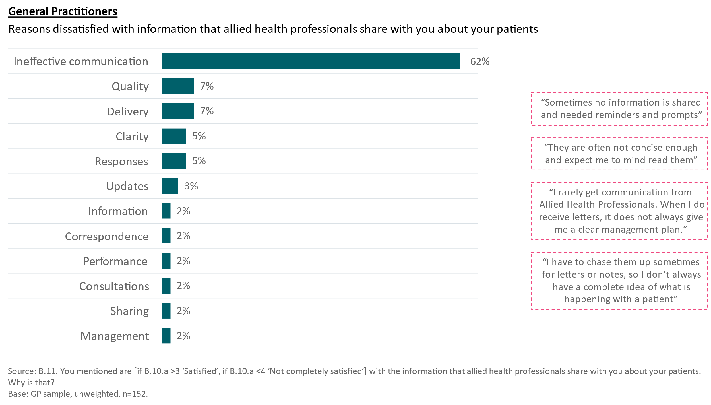

Figure : Medical Specialists – reasons for dissatisfaction with information shared by AHPs

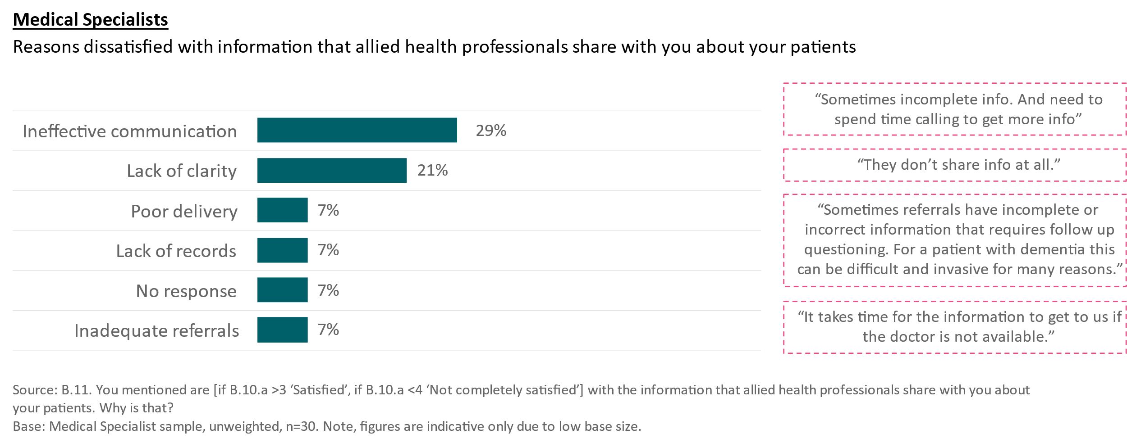

**The current way of accessing AH clinical information is viewed as sufficient**

In the current environment in which they are operating, most HCPs believe they have access to any critical information that they need to treat their healthcare recipients. They view the current system of sharing AH clinical information as sufficient – in that they generally receive or can source the priority information if it’s not readily available.

In addition to reporting moderate levels of satisfaction with the information they receive; they explained that, while in many ways how they currently access the information is not always efficient, they can access AH clinical information relatively easily when they need it.

“Owing to our paper medical records, there are occasionally issues accessing records when other clinicians have them. Short of that and poor handwriting (generally our forte and not an issue among allied health), there are generally no issues to obtaining allied health information if it exists.” (GP, regional area)

“Often you have to sift through a few pages of notes to just read the one line or sentence that you were looking for.” (GP, regional area)

However, determining what information they need, liaising with a healthcare recipient for specific information, obtaining AH contact details, and where necessary, making contact, can be time consuming - and potentially distracts them from important facts or other patients. This is simply accepted by many HCPs, and they have become used to this way of working.

**HCPs have lower expectations of streamlined proactive information sharing from AHPs and these are being met**

While HCPs are not highlighting significant deficiencies in the current way of working, they are also not looking specifically for opportunities to improve. Therefore, most accept that how they receive this information is the standard operating procedure.

### HCPs agree they have a role to play in encouraging information sharing between all HCPs and AHP

HCPs acknowledged the importance of information sharing between all providers, highlighting the direct relationship between communication and collaboration amongst HCPs and better health outcomes for healthcare recipients.

They agreed that they have a role in encouraging their colleagues to share information not just with them but with other providers within a healthcare recipient’s healthcare team. Many reflected on the risks of poor communication and inaccurate, incomplete or out-of-date information and agreed that there should be a solution designed to address this.

“Health professionals can advocate for the importance of sharing clinical information among different healthcare disciplines. They can emphasise the benefits of integrated care, improved communication, and better patient outcomes that result from sharing relevant information.”  
(GP, public hospital)

“Often, we receive no reports. The patient may return requesting further investigations and report that Allied Health Professional has advised the same, however the doctor has not received any communication.” (GP, metro area)

### AH clinical information is being shared with HCPs predominantly in hard copy or via fax

The format in which HCPs access AH clinical information reflects the level of digitisation within HCP or AHP work environments. As indicated in Figure 7, 76% of HCPs report receiving typed letters or notes from AHPs and 59% are receiving AH clinical information via fax. Others have integrated digital information management systems into their practice and share information via email. Those with connectivity within their health service or organisation, share information via an online portal or hub. Almost half of GPs (49%) and medical specialists (45%) report receiving emailed AH clinical information.

Some HCPs highlighted that a lack of digital literacy or connectivity in their workplace impacted the manner in which they shared and received health information and suggested that a digital solution would enable more efficient information sharing.

“Most of the time I refer patients to them, all of us in private practice, and we liaise via letters to each other where appropriate. Rarely via phone call if required.” (GP, metro area)

“Letters are faxed or emailed to my clinic. Once received our admin team  
allocate the document to the patient file and doctor to review.”  
(GP, public hospital emergency department and nursing home visits)

GPs tend to be more likely to receive medical specialist clinical information via a secure messaging service compared to their communication with AHPs.

Figure : Most common communication channels between GPs and AHPs/Medical Specialists

The most common communication channel between GPs and allied health professionals is typed letters/notes (76%) followed by fax (59%) and email (49%). 
The most common communication channel between GPs and medical specialists is typed  letters/notes (85%) followed by fax (57%) and secure messaging service (47%). 

**Current communication systems reflect a manual process**

The use of letters and faxes indicates a level of manual information sharing however, as outlined above, HCPs are generally satisfied with the information shared by AHPs. There is a view that the current system is sufficient despite it lacking the efficiencies and effectiveness of an online system. Most HCPs are not demanding changes to the way in which they access AHP information which suggests it may not be considered as important as they report. For many HCPs, there is no significant case for change – the current way of working, for most, is giving them what they need from AHPs.

### AH clinical information is prioritised based on two key factors: criticality of healthcare need and complexity of health condition

The AH clinical information that is most important to HCPs is information that assists with diagnosing, treating, and monitoring healthcare recipients with:

* **Urgent and critical healthcare needs** who require potentially lifesaving treatment; and
* **Complex health conditions** such as chronic disease, complex co-morbidity health issues and mental illness who often have multiple HCPs caring for them.

#### Urgent and critical healthcare needs

HCPs prioritised information that could potentially assist them in delivering urgent and critical healthcare for healthcare recipients experiencing a potentially life-threatening medical episode. They were particularly concerned about the impact of missing information that could be key to their diagnosis or when making treatment decisions. Given the urgency and time critical nature of decision making in these medical situations, access to the right AH clinical information is considered very important.

“Timely and relevant correspondence including recommendations based on their assessment. An example would be podiatrist visits which identifies significant vascular complications from a chronic disease which would warrant involvement of a vascular specialist, or closer medical review or wound management.” (GP, metro area, emergency department)

In less critical or urgent scenarios, AH clinical information is considered less important, but is appreciated if it is available. HCPs were not able to identify the specific AH clinical information that is less important in general clinical scenarios, however were able to describe the value of the information within the context of the healthcare recipient’s level of criticality. As outlined below, they agreed that in treating their healthcare recipients, it is helpful to have access to as much health information as possible, in a format that they could easily navigate to find the details most relevant to the situation they were managing.

#### Complex health conditions

HCPs explained that AH clinical information is important to have available when a healthcare recipient’s needs are complex or complicated. In these cases, having a more complete picture of the healthcare recipient’s needs and health status allows them to avoid mistakes, make more accurate diagnoses, and informed treatment decisions.

They noted that in complex cases, healthcare recipients are often seeing multiple HCPs, and in these cases, the importance of AH clinical information is increased. In these scenarios, they prefer that all HCPs in the healthcare team have access to the same information to ensure a shared understanding of the healthcare recipient’s needs, the diagnoses, treatment plans and progress.

“Currently I work mainly with physiotherapists in the outpatient pre-admission clinic and during our pain rounds. Recently the physiotherapist in the pre-admission clinic who completed an ECG for a patient brought it to me immediately and we found that the patient was in rapid atrial fibrillation. I was able to send her to ED and she was subsequently admitted under cardiologist for treatment.” (Anaesthetic Doctor, metro hospital)

“A local diabetic educator was aware much sooner than I was about a patient's escalating blood glucose levels and was able to contact me and recommend a change to their insulin regimen.”  
(GP, rural area)

However, in the qualitative research, there was no urgency or criticality expressed in the need to have AH clinical information to be able to do their job. Few HCPs reported that a lack of AH clinical information significantly impeded their ability to provide healthcare for their healthcare recipients. In most situations, unless the information is addressing a specific critical and urgent healthcare need or is required to inform a diagnosis or treatment regime, they do not proactively seek it. HCPs were more likely to describe scenarios where they **might** call an AHP to obtain information because it **could** be helpful rather than because it was essential to their decision making. Many HCPs identified phone calls as the most effective way to access the required information however as outlined below, AHPs were not always responsive to these requests.

“Correspondence from physio helps... some allied health professionals don't write back correspondence and that doesn't help us in managing the patient. Sometimes we call the physio/ OT and ask for their opinion.” (GP, metro area)

“Receiving a phone call from them when there is something serious going on is good. Could be better if they send written info as soon as possible in a letter. For quick answers and immediate response, usually phone call is best.” (GP, metro area)

There was some emphasis placed on information provided by specific AH disciplines which relates also to the sense of criticality and urgency of the healthcare recipient’s healthcare need.

Both qualitative and quantitative research highlighted the relevance of information from psychologists and other mental health professionals as highly valuable to ensure all HCPs are aware of any mental health issues or treatments regarding their shared healthcare recipient. This relates to both the complexity of a health condition and the urgency, with many HCPs acknowledging that there are many factors involved in providing healthcare to a healthcare recipient with mental illness. In mental health cases, they see great value in ensuring all HCPs have access to the complete treatment plan and progress. Figure 8 highlights results from the survey.

Figure : Impact of information from AHPs on GPs/Medical Specialists’ diagnostic or treatment decisions

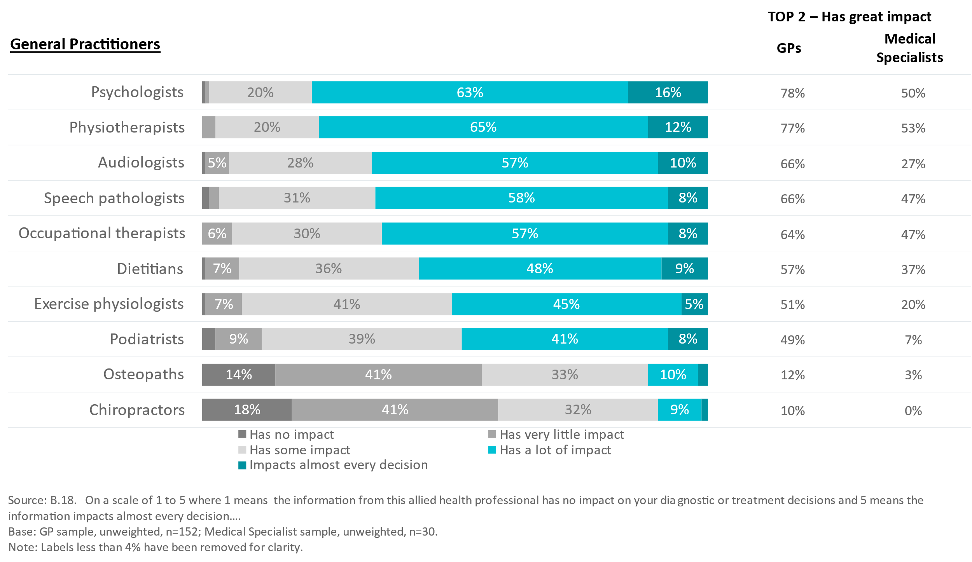

### The need to access AH clinical information in critical or urgent circumstances requires easy access and navigation

#### The design of the information sharing interface must promote easy access and navigation

HCPs were critical of AH clinical information that is lengthy and difficult to comprehend. They want easily accessible information and the ability to find what they need to know quickly, with detailed information perceived to be cumbersome and impractical. Similarly, information that documents interactions between an AHP and a healthcare recipient without offering information that might influence diagnosis or treatment plans is considered less helpful.

“[Information I don’t need is] detailed examination and history of every single consultation which is not going to change a patient’s treatment plan.” (GP, private health service)

HCPs identified a clear need for any information platform, system or process that shared AH clinical information to be accessible, easy to search and navigate, and user-friendly. They explained that they require a format that visually identifies information that should be prioritised based on criticality, urgency and for some, recency.

“Any major alerts at the top… for example falls risk, hearing or visual aids used, any risk of harm to self/ staff. Clear headings, no confusing shorthand used. Collapsible so if there is a lot of information to get through, scrolling doesn't feel endless. Clear dates of assessments and treatments.” (Anaesthetic doctor, metro hospital)

“I want Allied Health Professionals to use our clinical information system so I always have access to the information.” (GP, Aboriginal and Torres Strait Islander health service, remote community)

HCPs in the qualitative research were asked to provide examples of websites or apps which they identified as offering a user-friendly interface with the ideal design and layout. Figure 9 showcases a sample of the preferred formats that highlight simple layouts, easy access and navigation.

Figure : Online interfaces with ideal design and layouts relevant to AH clinical information sharing

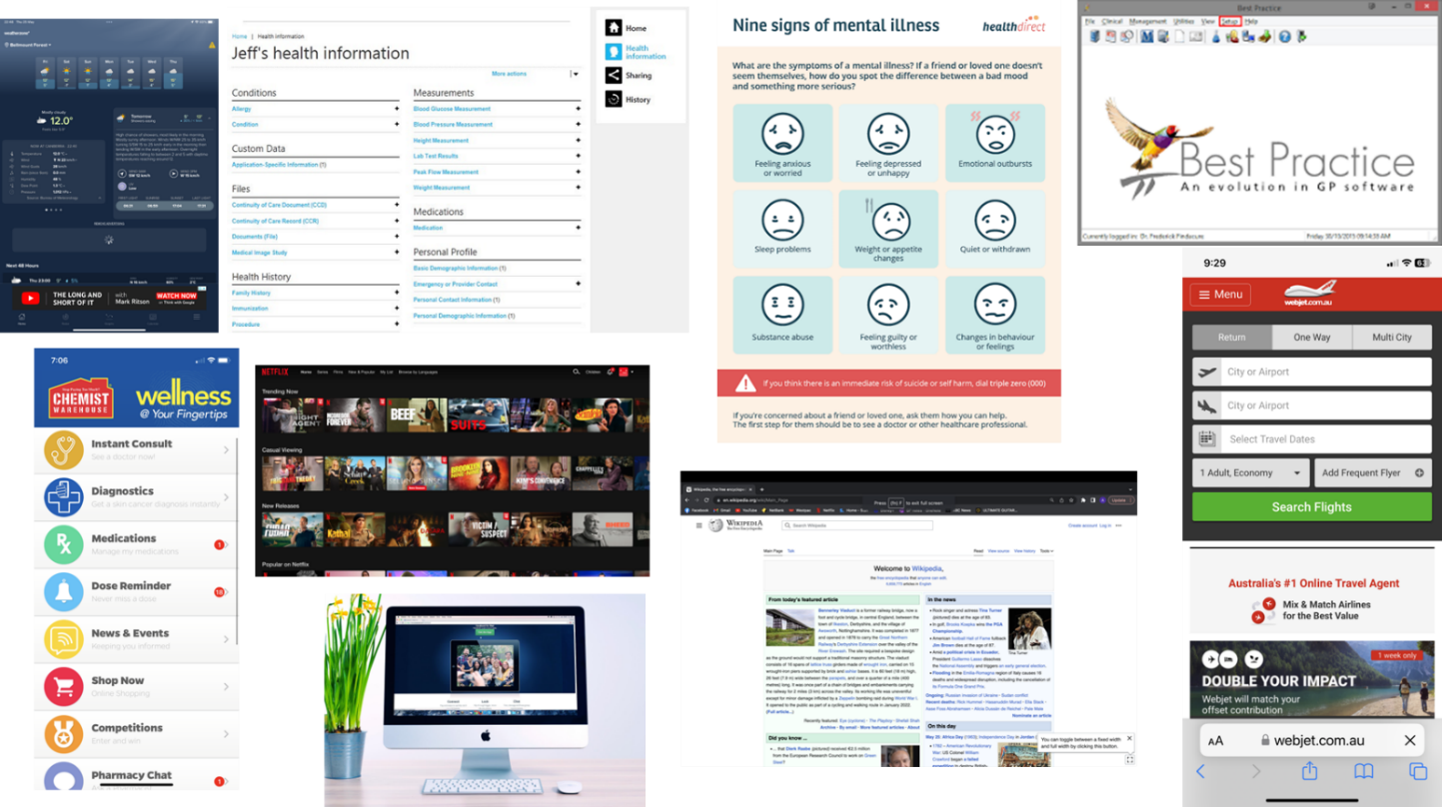

#### HCPs value timeliness and ability to access AH clinical information when they need it

A high proportion of HCPs identified a lack of communication, and in particular a lack of responsiveness and timely information sharing when working with AHPs. They also cited experiences of inaccurate, incomplete, and outdated AH clinical information. While they agreed that AH clinical information is important, the real value exchange comes from having access to critical and urgent information that contributes to assessment and treatment of chronic and complex healthcare needs, when they need it.

In these situations, many HCPs have developed systems and processes, some manual, some digital, to obtain relevant AH clinical information. This primarily involves phone calls and chasing, and many report that eventually, they receive what they ask for, although this involves an administrative burden.

“Most Allied Health Professionals do not write back to the GP. We often have to contact them for information. Psychologists are the exception. (GP, metro area)

“[What doesn’t work is] requesting written info all the time. They [AHPs] don't always give it.”  
(GP, regional area)

### HCPs value AH clinical information that explains treatment, plans and progress

HCPs seek to understand what treatment has been recommended to their healthcare recipients by AHPs, primarily to ensure they consider this within their own treatment plans. They are concerned about inefficiencies and duplication in healthcare provision and prefer to leverage knowledge gained from prior interactions to ensure that they build on what another HCP has recommended or prescribed. They report a level of respect for the knowledge and experience of most AHPs noting that some offer specialist knowledge in important healthcare services.

“[It’s about] regular communication, respecting each other's respective areas of expertise. Getting Allied Health staff involved in patient care early on.” (Medical specialist, public health service)

HCPs explained that this information is **particularly valuable when healthcare recipients don’t know, can’t recall or lack access to their medical history and treatment plans**.

“When a patient can vaguely remember doing something but not quite sure what they tried, we often have to start again, wasting time with investigations which may already have been done, therapeutic trials which may already have been done. [A] written summary would have been helpful.” (GP, metro area)

Figure 10 illustrates the noticeable ‘sharing gaps’ in information between GPs and AHPs. There is a disparity between the types of information GPs currently receive from AHPs and the information they would like to receive with GPs wanting more specific information about diagnostic results, instructions/ procedures to follow, suggestions or referrals to complementary services or supports and advice, tips and tricks.

Figure : Information GPs currently receive and would like to receive from AHPs

The information GPs currently receive from AHPs the most are treatments provided (81%), treatment plan / follow up (75%) and progress reports (68%). 
The information GPs would like to receive from AHPs the most are treatment plan / follow up (74%), progress reports (72%), and treatment goals (68%). 

**There is a shortfall between the information about AH treatments that HCPs want and what they have access to**

A substantial proportion of GPs expressed a desire to receive more information from AHPs, such as specific instructions/ procedures to follow, suggestions for complementary services or supports, advice on coping mechanisms, and more. These findings shed light on the tremendous potential for improvement in sharing healthcare recipients’ information between GPs and AHPs. Addressing these ‘sharing gaps’ presents an opportunity for more comprehensive and healthcare recipient-centred care.

### HCPs who engage in team-based care are more engaged with AH clinical information

There are HCPs who have a higher propensity to seek out and engage with AH clinical information to ensure a better health outcome for their healthcare recipients. These are:

* **HCPs who currently work in a collaborative work environment** with other healthcare services can see the opportunity for information sharing with their colleagues, and of the value of team-based care where all HCPs work together and discuss healthcare recipient diagnosis, treatment plans and progress.

“Working with psychologists for patients with suicidal ideation can be challenging. As they are in the same building, we have been able to just chat about the patients.” (GP, metro area)

* **HCPs with healthcare recipients who have chronic and/or complex health conditions,** who have more urgent health issues, and who are seeing multiple HCPs. In these cases, HCPs are more likely to prioritise seeking out and accessing AH clinical information to ensure they are making informed decisions about their healthcare recipients based on all the relevant information.
* **HCPs who discussed a more holistic approach to healthcare** were also more likely to proactively seek opportunities to better understand AHP interactions. While their healthcare recipient’s healthcare needs may not be critical or complex, their approach to collaborative healthcare and the concept of team-based care places more emphasis on AH clinical information.

“In our rural town our close relationships work well. We've met each of the local AHPs, know what they look like, and this makes our confidence in calling them easier.” (GP, rural area)

These HCPs are more likely to be proactive in developing both formal and informal systems and processes that ensure they have timely access to the AH clinical information they need. These systems and processes are in most cases digitised and include an online component, however others in these situations are still relying on manual ways of accessing information. This meets the immediate sharing need but is reported to come with extra administration and an impact on efficiency.

### HCPs identify privacy and security of healthcare recipient information, incompatibility with existing software, bias and time required to change as key barriers to sharing information online

HCPs identified several challenges to introducing an online information sharing system to improve access to AH clinical information. The key issues identified were:

* **Privacy and security of information concerns**: HCPs raised the potential for information that is shared online to be viewed by HCPs who may not need to see the information, compromising the privacy and confidentiality of healthcare recipient’s information. They suggested that healthcare recipient control of the information is key to ensuring that only those who have permission can view the AH clinical information.
* **Software incompatibility:** HCPs identified the practical issue of software integration of an online information platform with existing medical practice applications noting that the investment in a new system, including IT solutions and training, could prove costly and time consuming for many practices.
* **Bias or assumptions from having access to additional information:** some, but not all, HCPs identified the potential issue of HCPs relying too much on AH clinical information instead of undertaking their own assessment which could result in bias or assumptions about diagnosis and/or treatment options.
* **Time:** HCPs raised concerns about the time they expect would be needed to learn how to access AH clinical information shared online but also in an ongoing way to review and monitor the information.

**Software integration with a more system-wide online information portal is perceived as a significant challenge**

The practical issue of software integration appeared to be the primary barrier to adoption with most HCPs willing to invest in working with a new system to leverage the benefits that it would offer around better healthcare recipient outcomes.

“In my role, it's less about the quality and content of the information, and more about the lack of access to it when the source is community allied health. Usually, the information available is of high quality and relevant.” (Specialist, public emergency department)

“In my practice, I find the limiting factor is the clinical software we use, which is Communicare. Allied Health Professionals have been diligent and prompt in their response and letter writing.”  
(GP, Aboriginal and Torres Strait Islander healthcare service)

### Training and education, software integration and financial incentives are considered likely to influence change in online information sharing

HCPs varied in their response to a question of what would be most likely to increase AH clinical information sharing online, with most suggesting that training and education is required to raise awareness of the importance of sharing information and training is required to show HCPs and AHPs how to share and access it (depending on what system is used).

**The use of existing technology and software is the preferred solution to information sharing than introducing new software**

An automated approach to information sharing through existing software is highly preferred with some suggesting that an integrated system would require very little change management and incentivisation – that it may not require significant change if the AH clinical information was incorporated into current IT systems.

These comments relate primarily to the option of using My Health Record as the online information sharing portal however most HCPs raised these as influential incentives for any online solution for information sharing.

Further, there was a high proportion who nominated the need to cover the financial costs of introducingthe change, particularly for those who don’t have existing digital platforms or connectivity. This financial incentive, in their view, should also be offered to compensate HCPs for their time to learn and administer the data management requirements of AH clinical information sharing.

“Training and education would work if the sessions were short. Health professionals are already time poor, adding more for them to engage in will likely result in poor attendance rate.”  
(Registered nurse, metro area)

“Likely to improve uptake at least initially. Ongoing usability more of a concern – if there is ongoing workload duplication then financial incentive should account for this.”  
(GP, metro area)

## Allied Health Professionals

While this study focused primarily on HCPs other than AHPs, a small qualitative and quantitative sample of AHPs was included to allow a comparison with HCP perceptions of the opportunities and barriers for AHPs sharing information with those of AHPs.

### AHPs agree there is value in sharing information with other HCPs

AHPs report being equally supportive of collaborating and sharing information about their healthcare recipients with other HCPs, agreeing it delivers better healthcare recipient care and outcomes.

### There is a lack of awareness of the opportunity to proactively share AH clinical information with others

As noted earlier in this report, AHPs are significantly more dissatisfied with the lack of information compared with other HCPs, however many report their way of working is standard practice for AH services. In the quantitative survey results, 49% indicated they were satisfied (and only 3% ‘very satisfied’) with the information that their healthcare recipient’s GPs share with them. Additionally, only 37% indicated they were satisfied with the overall level of communication they have with their healthcare recipient’s GPs, with only 1% reported being ‘very satisfied’.

Figure : AHPs’ satisfaction with communication and information shared by GPs

46% of allied health professionals are satisfied with the information their patient's GP or specialist shares with them. 
36% of allied health professionals are satisfied with the overall level of communication they have with their patient's GP. 

### The current way of working is viewed as sufficient

Like the views of other HCPs engaged through this project, AHPs report that the current ways of working, to which they have become accustomed and comfortable with, as sufficient. AHPs generally report there is enough information being shared already, and they can usually access information they need when they need it.

They appear to manage without information deemed to be helpful but not essential, and while they agree that it would contribute to better health outcomes if they had all healthcare information relevant to their patient, they tend to accept what they have and provide treatment based on what they know. Upon prompting, they suggested there is a need for change; however like HCPs, they had low expectations of streamlined communication and information sharing, and these thresholds are currently being met.

As described in Figure 12, the way in which AHPs share information varies widely with 66% utilising emails, and 60% producing typed letters/notes. Many reported printing these and posting them or handing them to healthcare recipients to share with other HCPs as required. By comparison, 33% of medical specialists utilise emails, and 80% type letters / notes. Some AHPs acknowledged that their current way of working may not be the most efficient yet did not suggest the need specifically to address this.

“We print and send these reports via fax and post to GPs, usually print and send to other AHPs as well, as email is not as secure as the post (which, having dealt with Australia Post a lot, seems laughable.” (Speech Pathologist)

Figure : Most common communication channels between AHPs/Medical Specialists and GPs

GPs communicate most commonly with allied health professionals through email (66%), typed letters and notes (60%) and verbally (30%). 
GPs communicate most commonly with medical specialists through typed letters and notes (80%), fax (37%) and email (33%). 

### AHPs report a level of unfamiliarity with My Health Record

In the qualitative research, AHPs from public health settings were more likely to be aware of the availability of AH clinical information in My Health Record compared to those in private practice, however those working in a public health service were also more likely to access information in electronic medical records (EMRs).

“Audiologists have never had access to My Health Record. None of the companies I worked for explored using it, so I know very little about it.” (Audiologist)

The qualitative research also showed that:

* Use of My Health Record is not seen as common practice among AHPs, and few are accessing it regularly. Many do not know how to access it, and their practice management and/or clinical information software do not facilitate easy use.
* There is also a view that their healthcare recipients are not using My Health Record, so AHPs are not familiar with it as a tool for sharing and/or accessing AH clinical information. Some believe that My Health Record will only be beneficial if all providers are using it.
* Sole practitioners in private practice are concerned about the time it would take to update My Health Record for each healthcare recipient (as well as existing internal records) and the impact this could have on their billable hours.
* While AHPs report to understand the positive impacts on the care of healthcare recipients that would come from better My Health Record integration, barriers would need to be addressed to get buy in and engagement.

**AHPs report a lack of access to MHR as a key reason for not using it**

Most AHPs believe that if they had access to MHR and if their patients and their other HCPs were using it, they would be more likely to also use it. Currently the lack of widespread engagement with MHR means that AHPs are less proactive in arranging access. The qualitative research suggests that AHPs in public healthcare settings are more aware of MHR and/or an EMR which is used to capture patient information.

The quantitative research reinforces these findings. Figure 13 shows that 25% of AHPs reported a general lack of interest in using My Health Record and a further 34% said they had no reason to explain why they don’t use it. In the qualitative research, AHPs explained that a lack of access for AHPs meant it wasn’t available for them to use.

Figure : AHP reasons for not using My Health Record

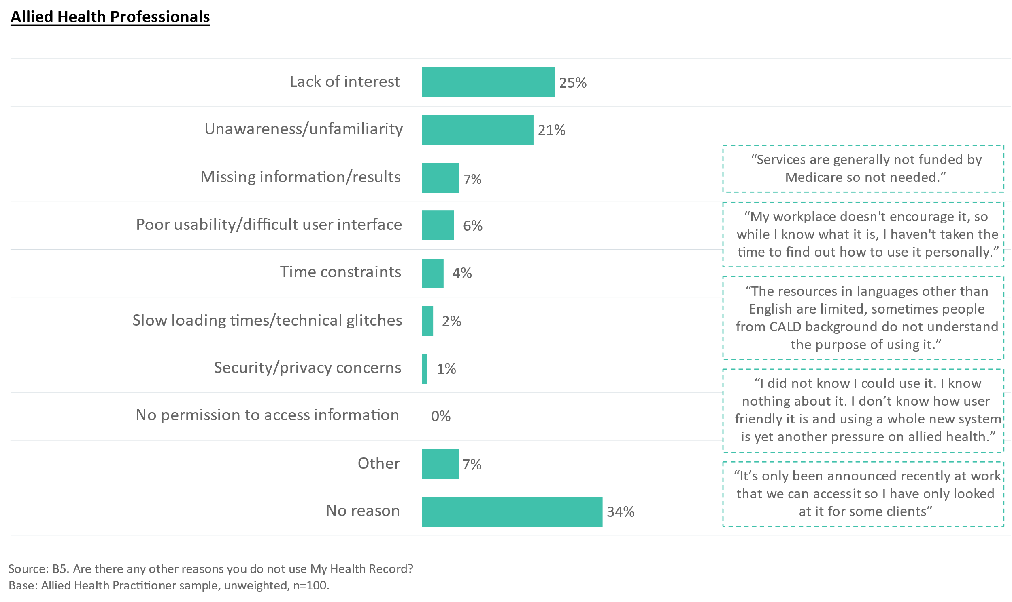

While 92% of AHPs who have used My Health Record reported that they have viewed information in a healthcare recipient’s My Health Record, only 30% said they had uploaded information to a healthcare recipient's My Health Record (Figure 14).

Figure : Usage of My Health Record by AHPs while providing care

30% of allied health professionals uploaded information to a patient's My Health Record. 
92% of allied health professionals viewed information in a patient's My Health Record. 

Figure 15 details the barriers that AHPs experience in using and accessing My Health Record. It shows that 44% AHPs report that they do not know how to use My Health Record well, supporting the qualitative research finding that many AHPs acknowledged that they were not aware that they could share their information via My Health Record, suggesting a need for awareness and training. AHPs reported that there is limited take up of My Health Record and therefore limited information available online making it difficult. There is a view that it will only be beneficial if all practitioners are using it; while 41% said they don’t use My Health Record because not enough HCPs use it, 33% said their healthcare recipients are not using it and 30% reported that their own clinical information systems are not compatible with My Health Record.

Very few AHPs believe that My Health Record is not effective (15%), that it is not user-friendly (15%) or that they are concerned about the privacy and security of personal information on My Health Record (17%).

This analysis suggests that familiarity, accessibility and clinical cultural norms are the major barriers for AHPs.

“No training for Allied Health staff around My Health Record, not taught in universities. Not often used in private practice or community MH settings - no easy way to learn or understand the benefit and ethical considerations.” (Psychologist)

“We get enough information through internal notes. Also, I didn't think of it [using My Health Record]. Also many clients opt out.” (Physiotherapist)

“I think lots of people don’t trust the system and chose to actively remove themselves from the system when it commenced.” (Speech Pathologist)

Figure : Barriers to utilising My Health Record among AHPs

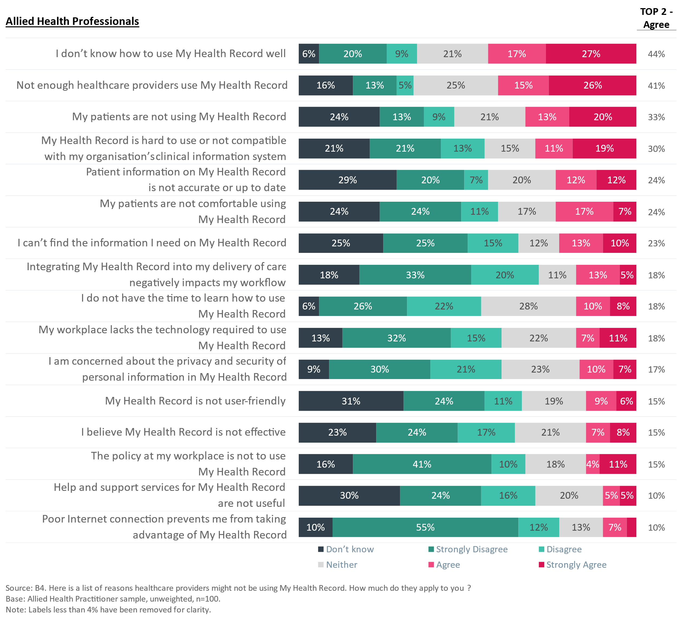

In line with these findings, the quantitative survey results highlight that training and education, as well as better technology and software integration with their practice, are the two most important changes that could be made to support AHP uptake of My Health Record (see Figure 16). Other actions that could play a role include providing financial incentives to cover the costs of technology, training and administration, as well as promotion through professional registration boards and regulations mandating use of My Health Record. Given the findings around time barriers for sole practitioners to learn how to use My Health Record, this analysis suggests that special effort or focus may be required for those without the support of a larger practice.

Figure : Preferred supports for AHPs to encourage use of My Health Record

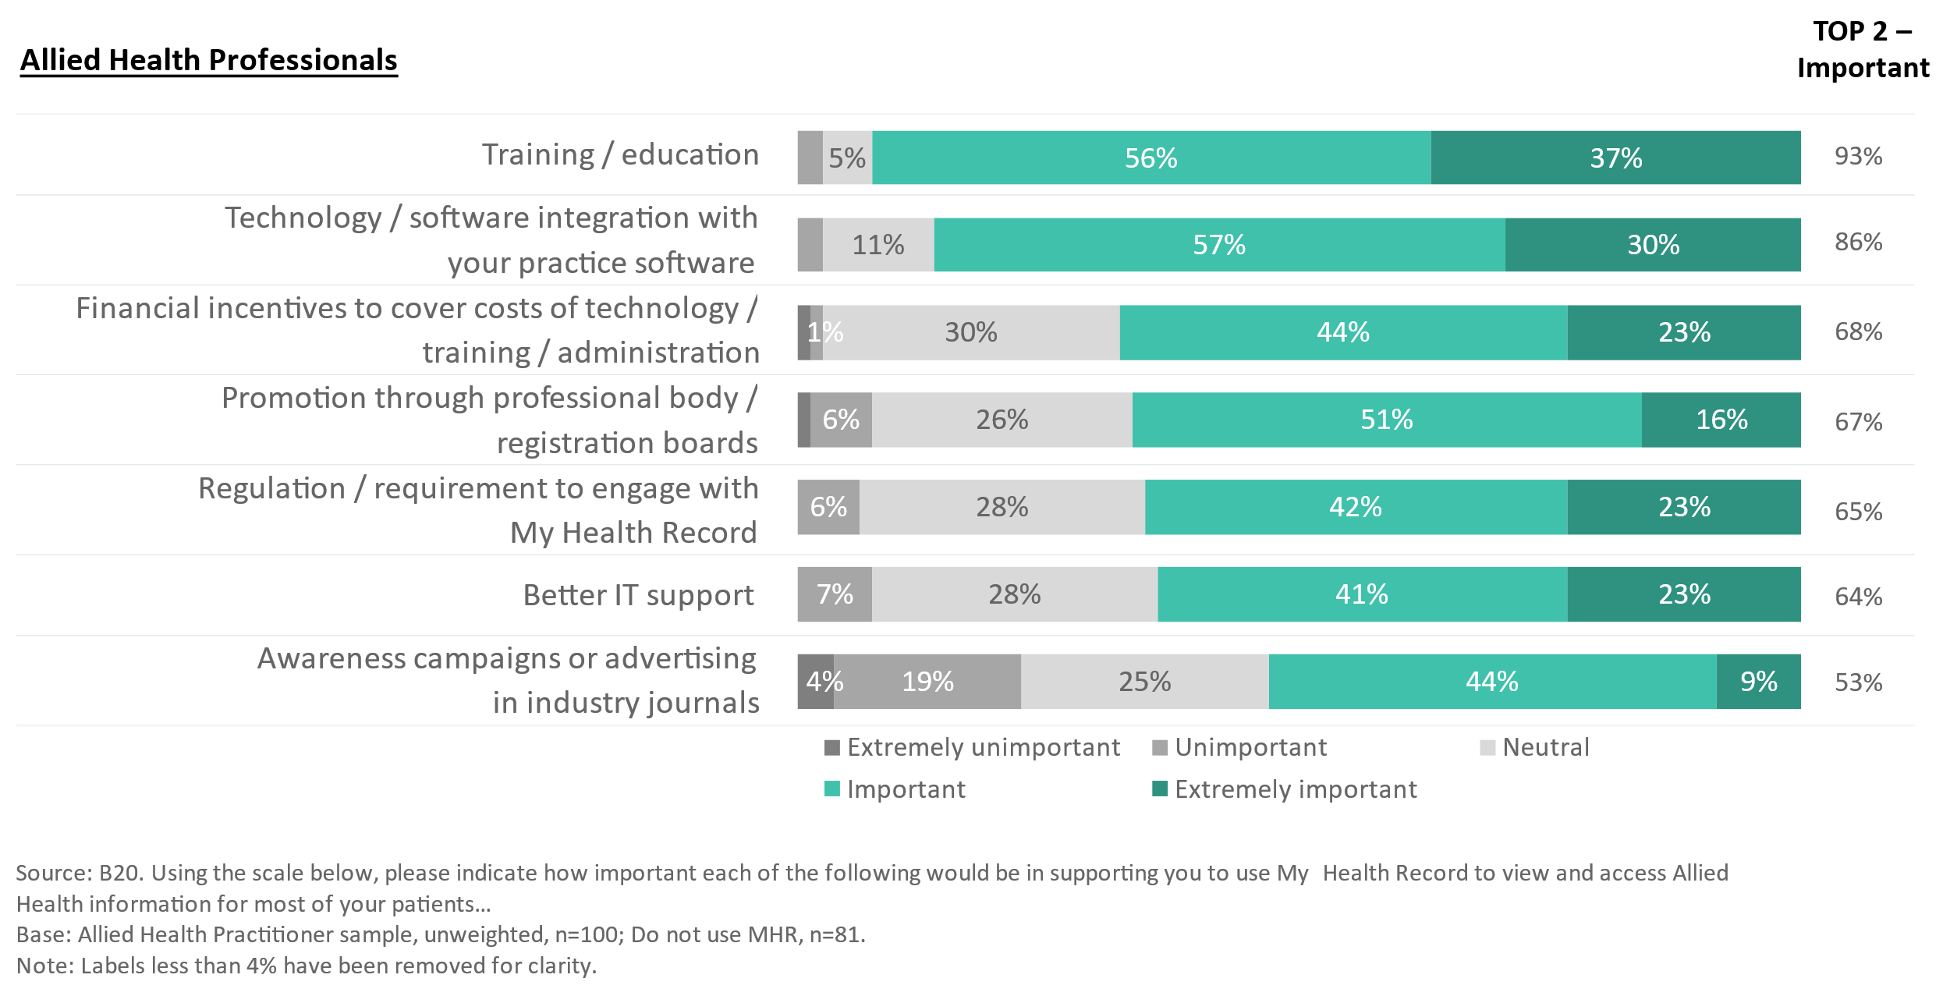

## Healthcare Recipients

### Key healthcare recipient context

To provide some overall context for the quantitative healthcare recipient we present in this study, Figure 17, below shows the AHPs that healthcare recipients have accessed over the last three years.

* Overall, physiotherapists (34%), psychologists (21%), chiropractors (17%) and podiatrists (16%) are the AHPs that are most frequently accessed.
* AHP usage differs significantly by age:
  + Those in the oldest age band (65+ years) are far more likely to have accessed a podiatrist or audiologist compared to those in younger age bands; and
  + Younger participants are far more likely to have accessed a psychologist compared with those in the older age bands.

Figure : Allied health professionals accessed

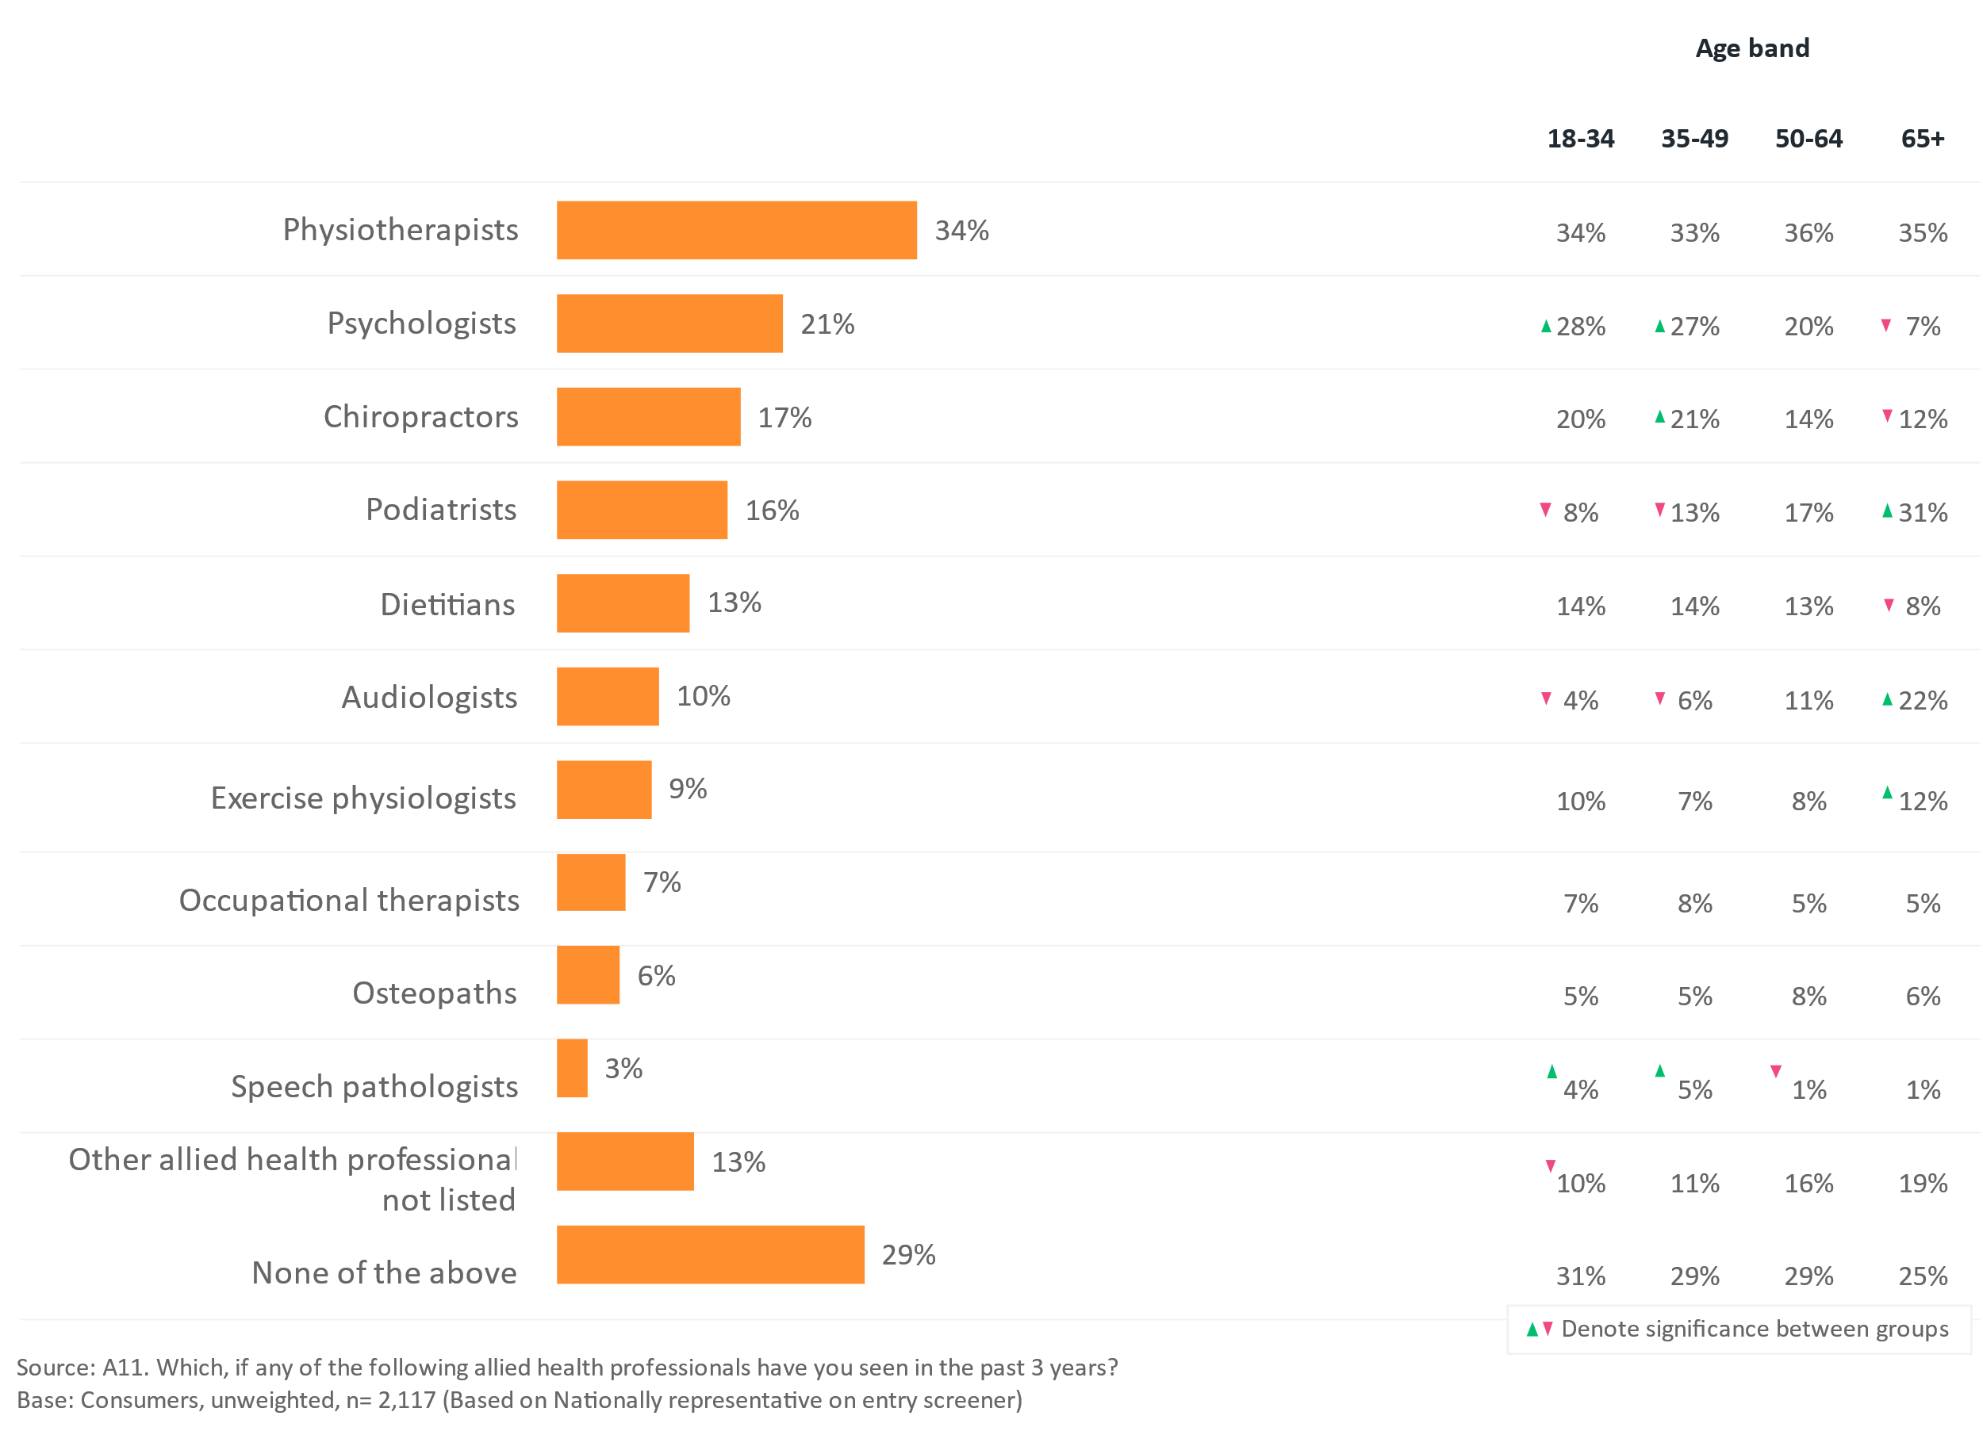

Lower for:

* Low health literacy (65%)
* Low digital health literacy (68%)
* Care free (70%)
* Technophobes (52%)

Digital Health Literacy

Health Concern

Mostly true + Very true (4-5)

### Healthcare recipients express a critical need for all HCPs to share information: those with chronic/complex conditions and their carers are exhausted by their “healthcare administration”

Healthcare recipients appear to be significantly more frustrated by the lack of information sharing between members of their healthcare teams compared with HCPs and AHPs.

The qualitative research highlighted that the onus of sharing the information that different AHPs and HCPs need at different times tends to fall on inexperienced or ill-equipped healthcare recipients who say they can forget important details, wonder whether they have understood correctly, and have to repeat themselves.

* For those who are more proactive, they report they are required to push to get access to information to share with others, rather than the HCPs and AHPs taking responsibility for the information sharing.
* Many report that no-one else is taking responsibility for asking providers to share information to improve health outcomes.
* Many described the challenges of “healthcare administration” such as keeping track of documents, plans and appointments as exhausting.

“There's nothing worse than getting back to your GP, and then he'll say, okay, so how did you go, you know, he should know, he should know. And me telling him is in layman's terms. I would rather him have that information in a professional manner. Because I might miss something who's to know that I'm going to you know, tell him everything that happened and it's my interpretation. I'm not a professional.” (Healthcare recipient, experienced an acute health episode)

The quantitative survey results demonstrate a differential in the levels of satisfaction between the information HCPs share with their healthcare recipients, and the information healthcare recipients understand the HCPs in their healthcare team to be sharing with each other. The survey results highlight substantial scope for improved AH clinical information sharing.

Figure 18 shows that healthcare recipients are satisfied with the information their healthcare professionals share with them, 81% say they are satisfied overall, with the proportion ‘very satisfied’ with the information shared by their GP significantly higher (32%) than by both AHPs (27%) and medical specialists (25%).

Figure : Healthcare recipient satisfaction with information shared with them

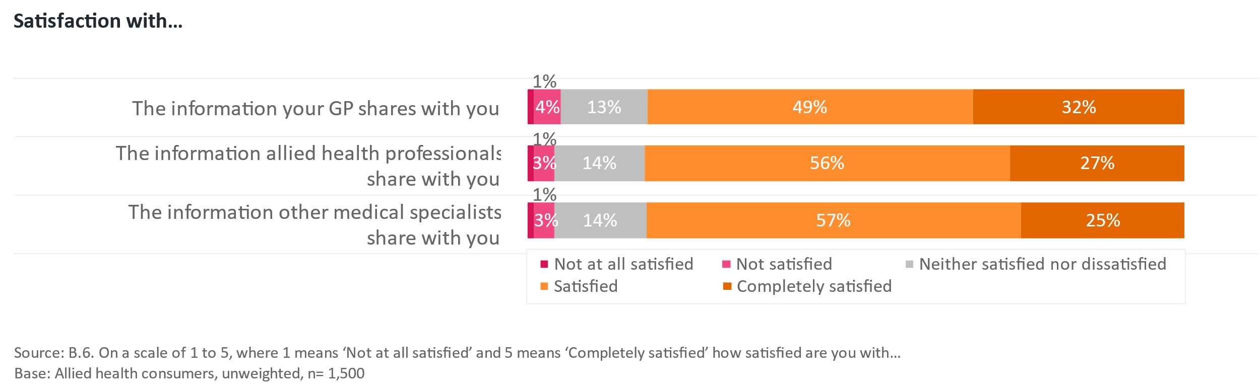

However, Figure 19 shows much lower levels of satisfaction with information that their HCPs share with each other. Only 56% are satisfied with the information their AHPs share with their GP (and only 13% are very satisfied). A similar proportion (58%) are satisfied with the information their GP shares with other HCPs (with 15% very satisfied), while more (65%) are satisfied with the information other medical specialists share with the GP (and 17% are very satisfied).

* The gap in satisfaction between what health information that healthcare recipients report is shared with them, and that shared between GPs, AHPs and medical specialists belies another important point. The proportion of healthcare recipients who are ‘very satisfied’ with information sharing within their healthcare team ranges from 13% ‘very satisfied’ with the information AHPs share with their GP to 17% ‘very satisfied’ with the information shared by medical specialists and their GP. This closely reflects the results seen in the HCP section above, highlighting considerable room for improvement.

Figure : Satisfaction with inter-HCP information sharing

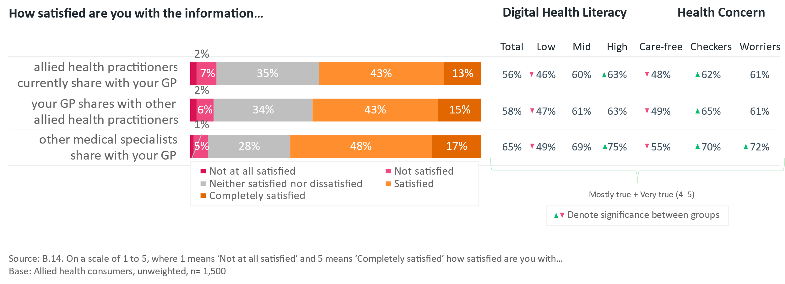

* Consumers with lower levels of digital health literacy are less likely to be satisfied with the information shared between their GPs, AHPs and medical specialists compared with those with higher levels of digital health literacy (as seen in Figure 19). This could be because they are less equipped to share it themselves. Those healthcare recipients who were identified as having higher levels of health concern (see Appendix A) – the ‘Checkers’ and ‘Worriers’ are significantly more likely to be satisfied than the ‘Carefree’, potentially for similar reasons. It should be noted that healthcare recipients with higher levels of health concern, were also significantly more likely to report having chronic conditions.

Healthcare recipients provide a range of reasons for the satisfaction or dissatisfaction – summarised in Figure 20.

* Reasons for satisfaction include a stronger shared understanding of the issues, the right information being shared at the right time, and merely having no issues or problems with the information shared, delivering effective communications within their healthcare team, saving them time and effort.
* The major reason for dissatisfaction is a lack of shared awareness, founded on ineffective communication that creates uncertainty, breaches confidentiality and creates inefficiency.

Figure : Reasons for satisfaction and dissatisfaction

The most common reason healthcare recipients are satisfied with information sharing between their GP and allied health professional are shared awareness of issues (12%) and sharing right info at right time (10%). 
The most common reason healthcare recipients are dissatisfied with information sharing between their GP and allied health professional are lack of shared awareness (35%) and ineffective communication (15%). 

Currently, healthcare recipients receive a range of information from AHPs with 52% reporting the receipt of treatment plans or follow-up information, and 50% receiving instructions or procedures to follow (Figure 21).

* Those with lower levels of health concern are less likely to receive information on treatments provided (44%), diagnostic results (43%) or advice, tips and coping mechanisms (42%). Only 31% receive suggestions or referrals to complementary services or supports, or information about treatment goals (30%).
* Those with higher levels of health concern are significantly more likely to receive treatment plans/ follow up, progress reports and information to support funding applications, possibly reflecting that people in this group are significantly more likely to have chronic conditions (Figure 21).

Figure : Information currently received from AHPs

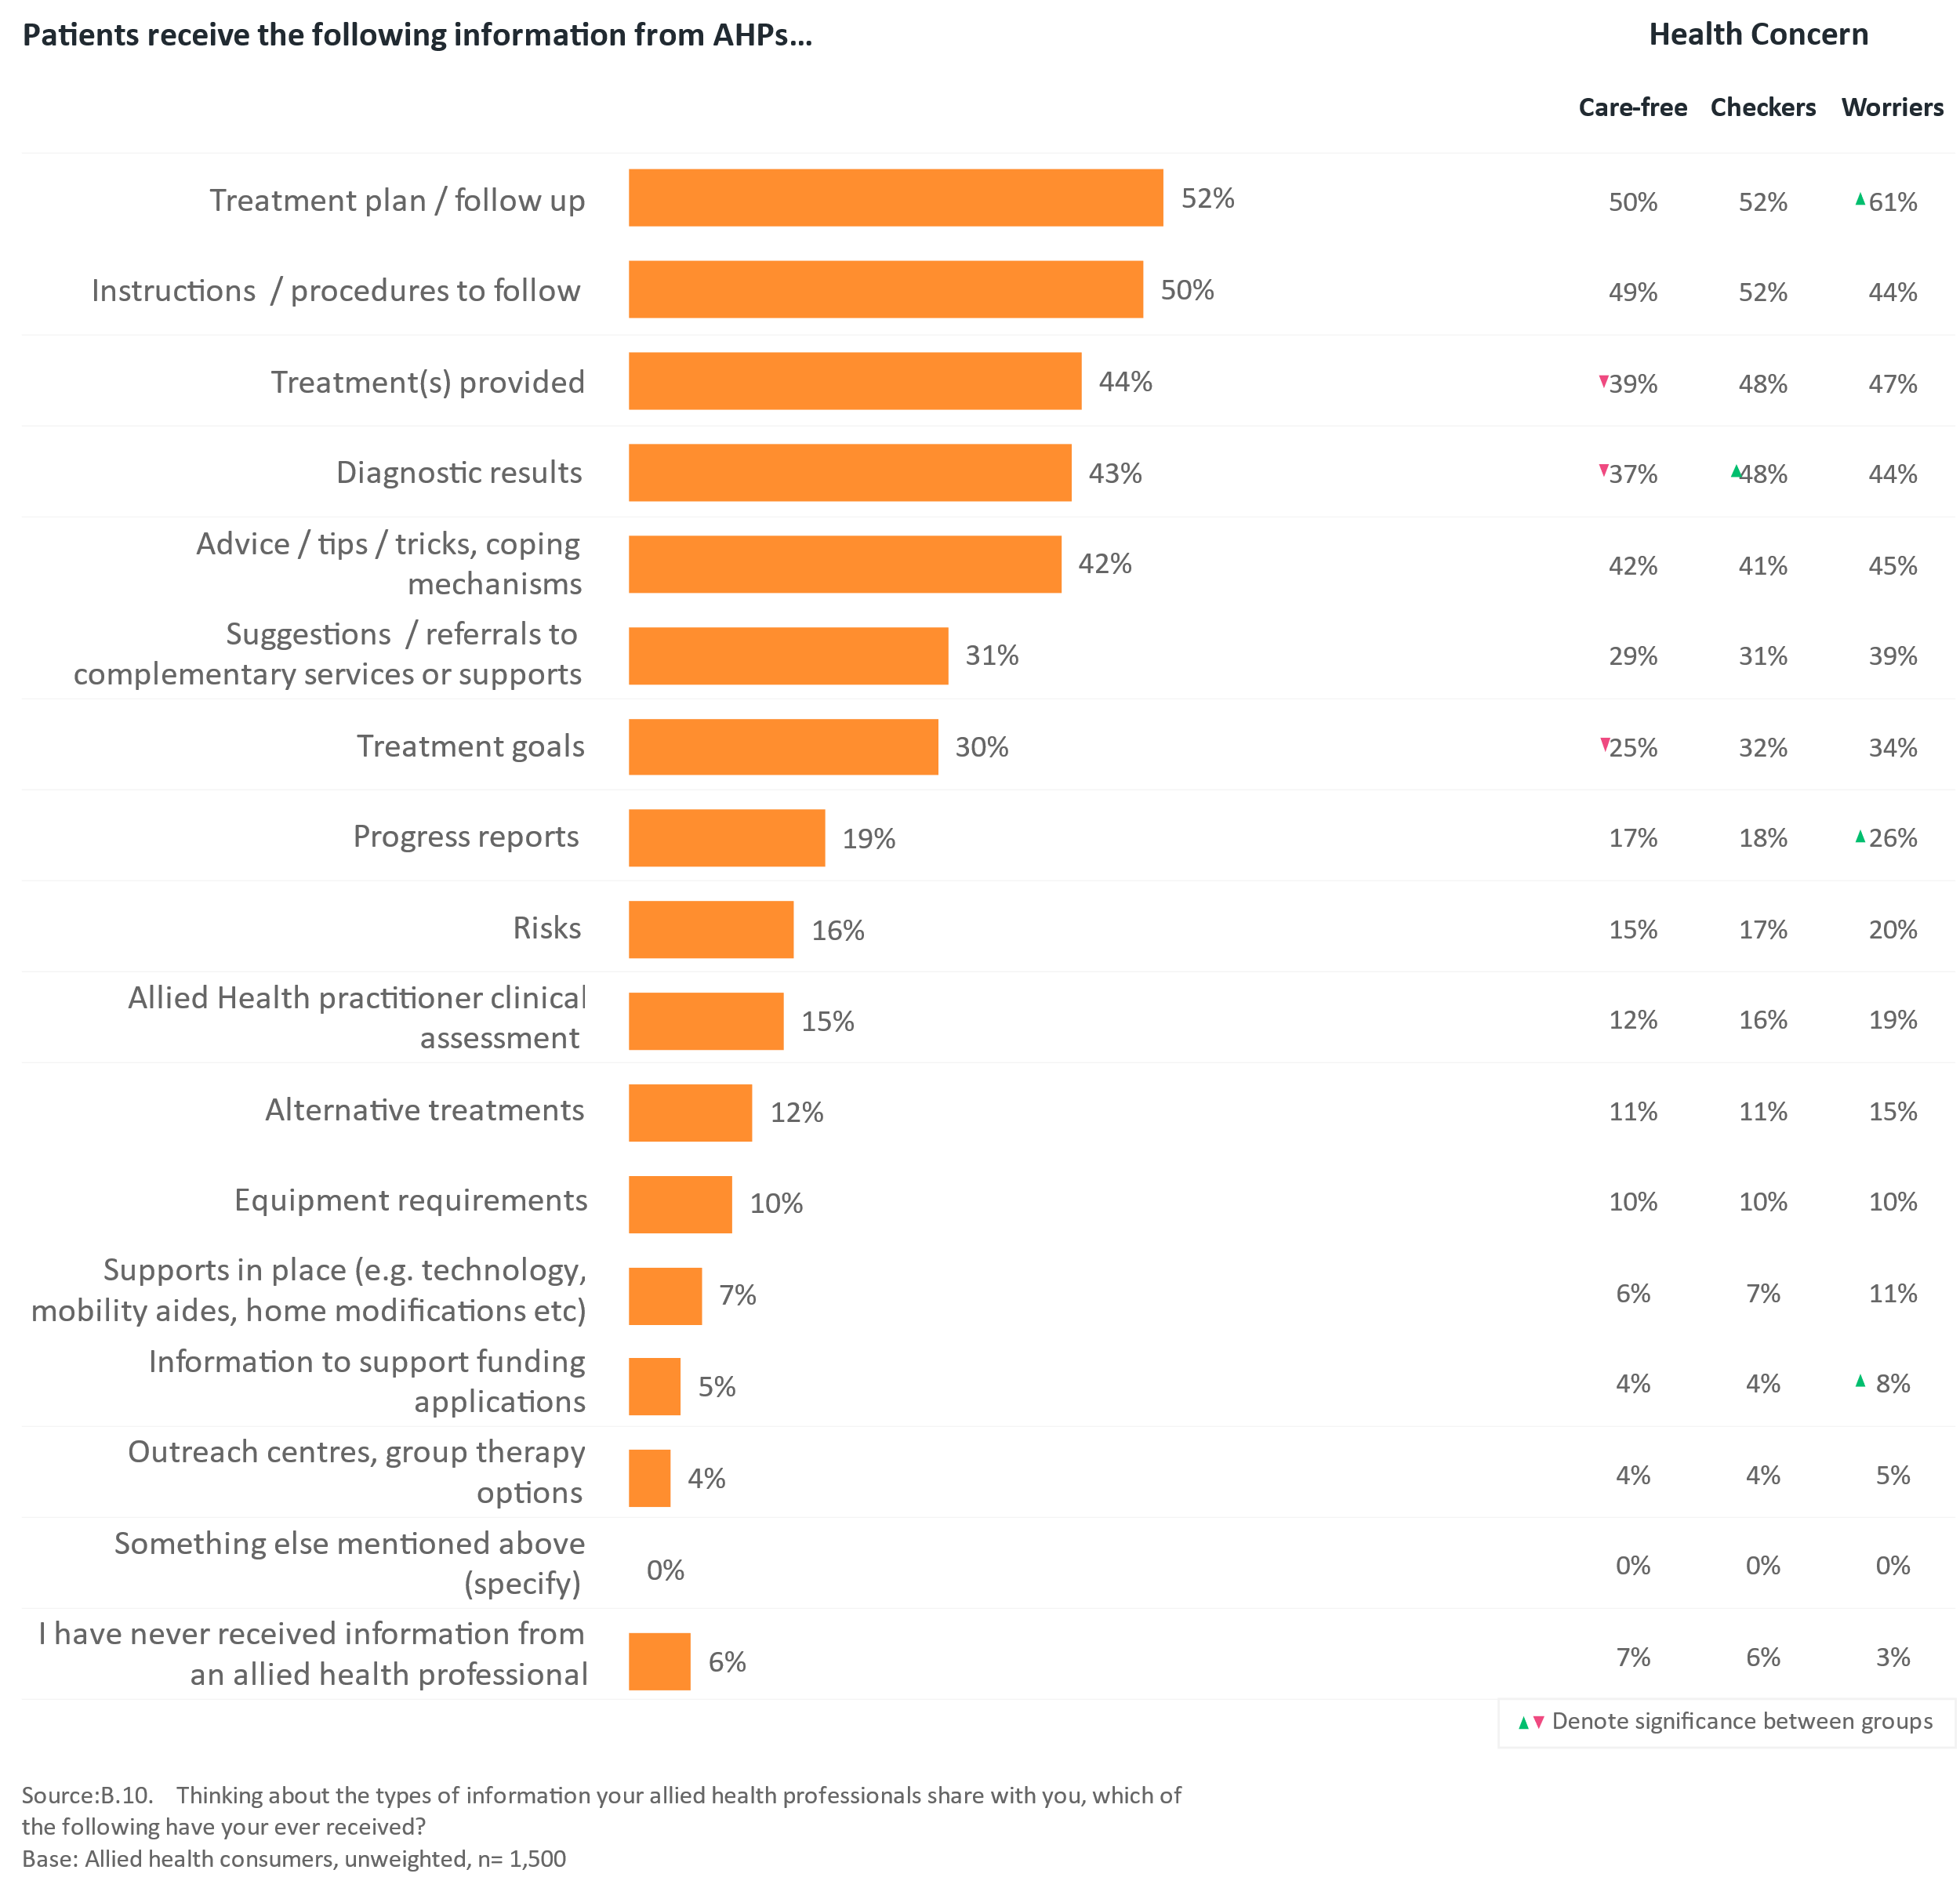

Healthcare recipients receive information from GPs and from AHPs in similar ways: largely verbally, but also via email, typed and hand-written notes. Healthcare recipients are more likely to receive information from GPs (15%) via My Health Record compared to AHPs (11%), although only a small proportion of participants receive information through this channel.

Figure : GP and AHP information sharing

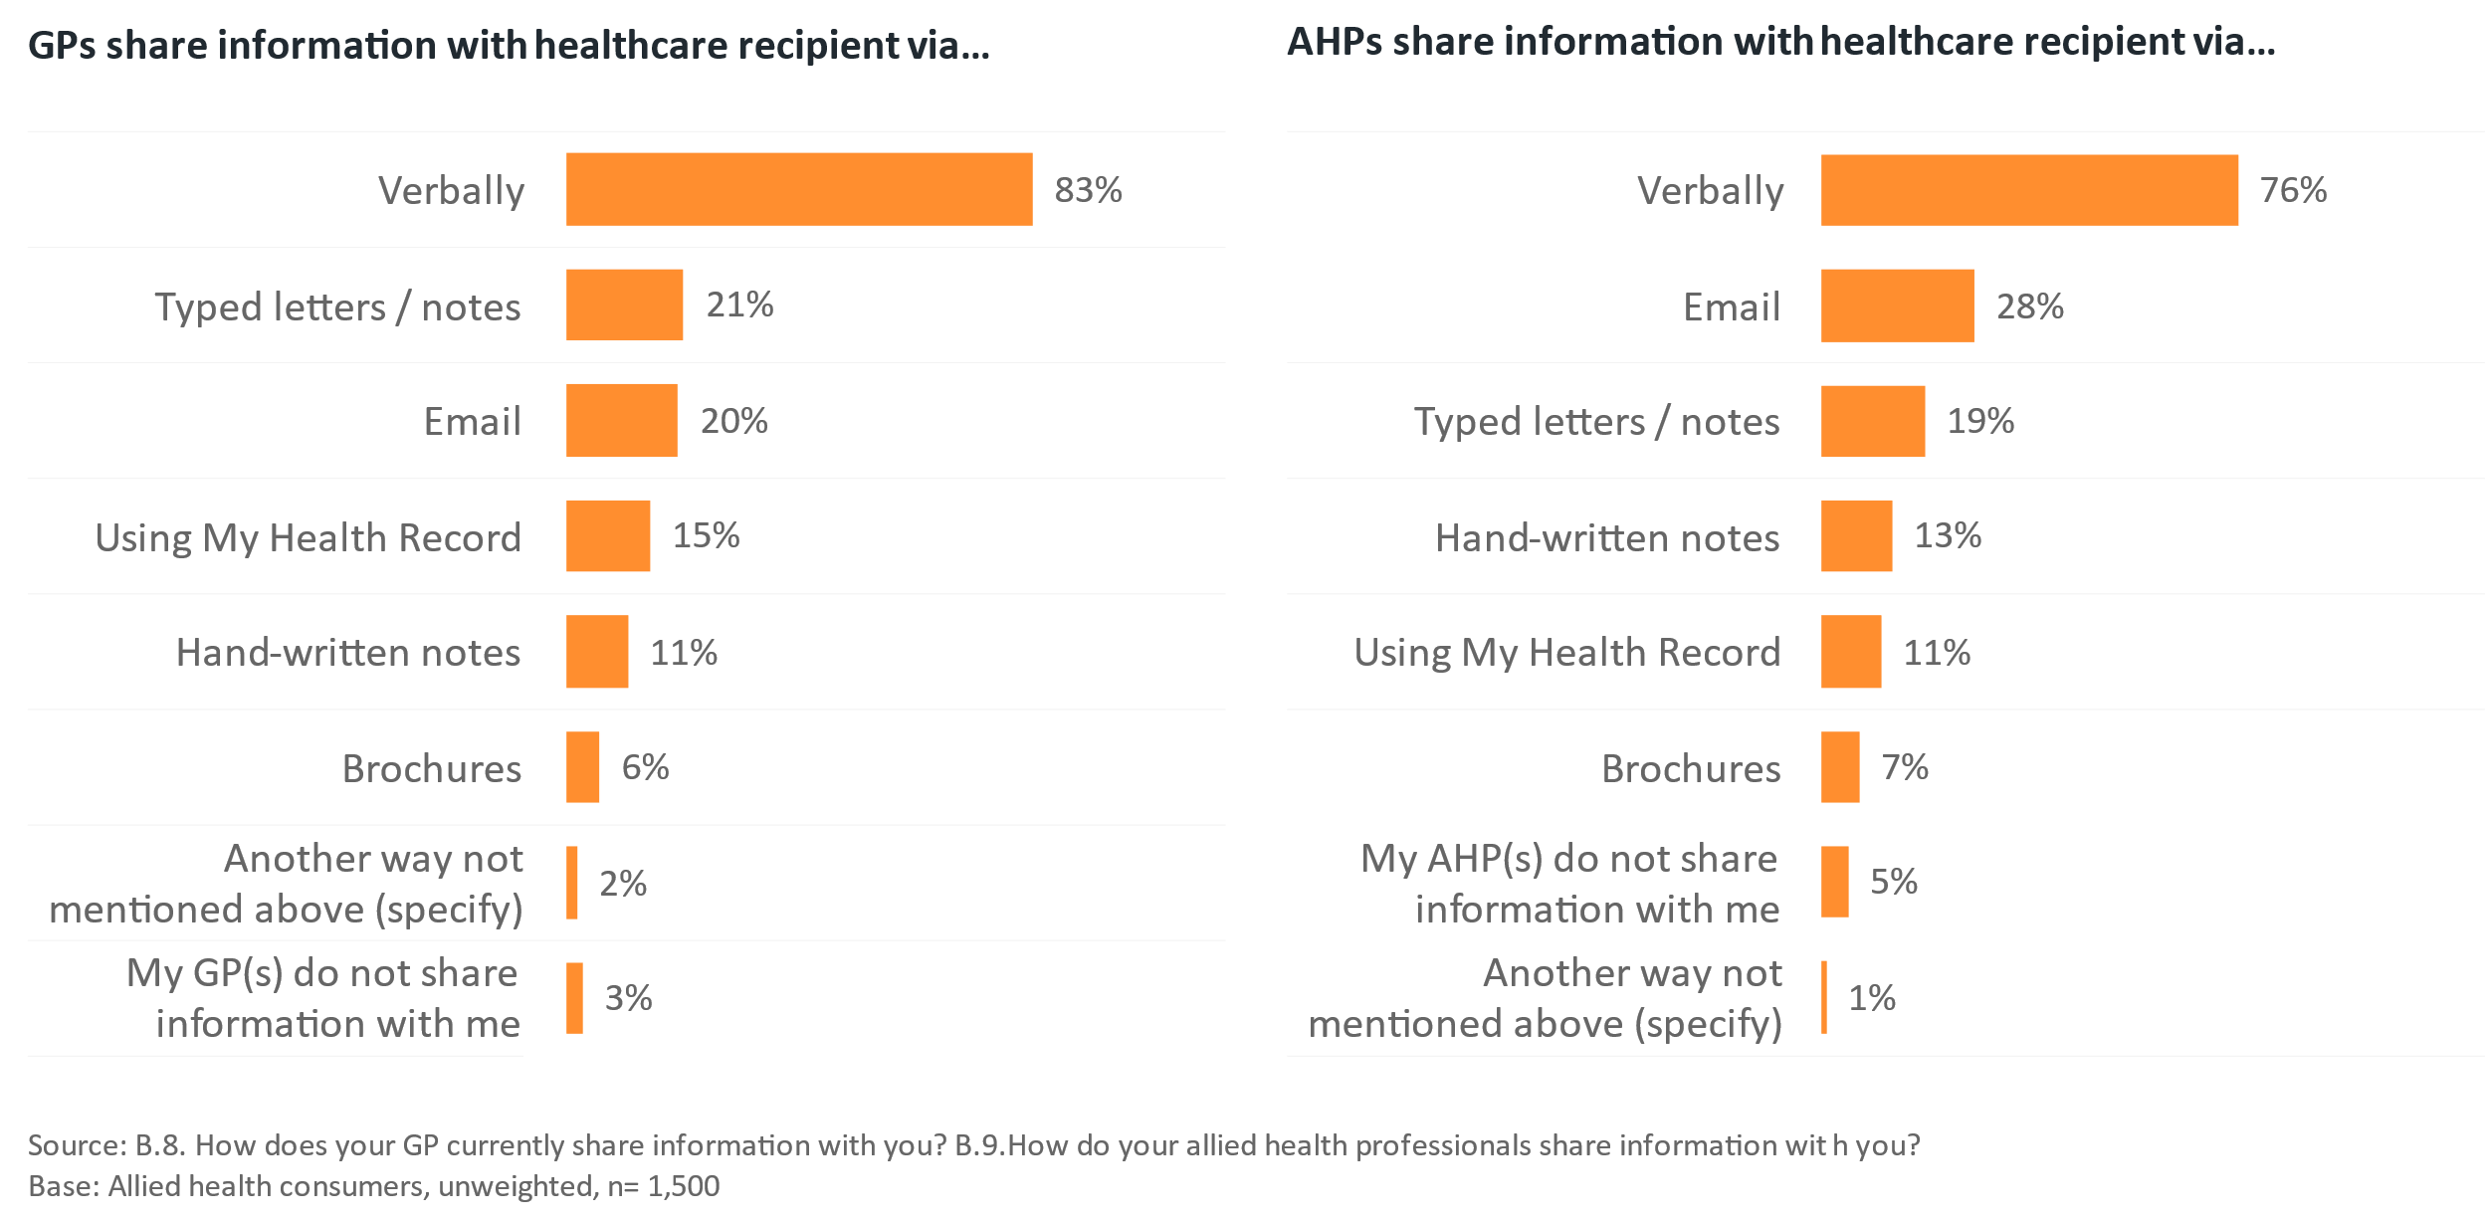The qualitative research with consumers showed that a majority want to share most, if not all their health information with their GP, including all information created by AHPs.

The quantitative results also show that healthcare recipients want to be able to share more information with the GPs. For every information type presented in the survey, a greater proportion wanted that form of AH clinical information shared with their GP, than they report currently receiving from their AHPs themselves.

Figure 23 demonstrates these ‘sharing gaps’. Substantial proportions of healthcare recipients would like to share treatment plans, treatments provided, diagnostic results, progress reports treatment goals, AHP assessments and risks with their GP, but do not currently get this information from their AHPs – highlighting potential for improvement in the healthcare recipient experience.

Figure : Information that healthcare recipients would like to share with GPs compared to what they currently receive from AHPs

The information healthcare recipients would most like allied health professionals to share with their GP are their treatment plan / follow up (65%), treatments provided (62%), diagnostic results (61%) and progress reports (57%). 
There are currently substantial gaps in information patients would like to share with their GP but don't receive from allied health professionals. 

### Control of AH clinical information that is shared is essential

Qualitative research with healthcare recipients showed there was little consensus on the types of AH clinical information that are of higher priority than others. Rather, participants expressed the need to have everything made available to those who could need it. Healthcare recipients generally feel ill-equipped to identify what information is important and what is not and would rather that the burden of making these decisions did not rest on them as they may not know which details could be vital to an effective diagnosis or treatment.

“You don’t know what’s important necessarily, I mean I’m not a doctor, and I wouldn’t know – you just need to be able to share everything with the people that need it.”  
(Healthcare recipient, carer)

“I mean there could be a hint – like that story shows – from any one of the healthcare people you see, that you know, there’s something serious that others have missed.”  
(Healthcare recipient, chronic health condition)

The quantitative survey results support this view. The majority (87%) agree they’d like to have access to all the information that AHPs create about them. A slightly lower proportion (72%) agree their lives would be easier if they had access to information from AHPs (Figure 24).

* However, despite this desire for something better, only 27% of healthcare recipients agree or strongly agree that they have had issues because they didn’t have the right information from AHPs when they needed it.

Figure : Attitudes around AH clinical information

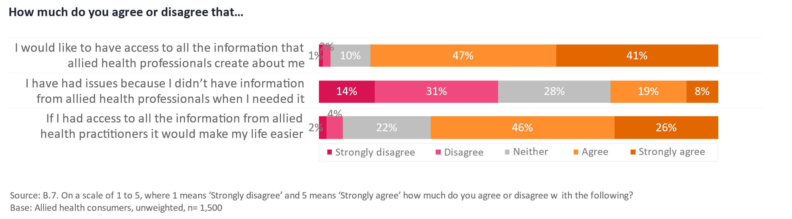

In the qualitative research, those with chronic and complex health conditions and their carers were more adamant about the need for all information to be held somewhere central.

**Control – or at least the sense of control - is paramount**

Control can mean healthcare recipients having access to all their information when and where they need it, but it can also mean being able to redact or remove pieces that include sensitive information, such as sexual and mental health, histories of abuse or neglect, divorce or information that is either personally distressing or (in their view) irrelevant to the treatment they are seeking.

“Yeah, confirmation bias is saying – Oh, you've had a mental health consult in the past. So it's probably just that, rather than going, let's do the additional investigations that are required to eliminate all the physical possibilities.” (Healthcare recipient, chronic health condition)

“But if there's something that you're like, I don't feel comfortable with it, then they shouldn't be allowed to have it either. So it's very much the individual person, and how they feel about, okay.” (Healthcare recipient, experienced an acute health episode)

Healthcare recipients completing the survey were asked about their levels of comfort in sharing AH clinical information with their GP, and their level of comfort in uploading such information to My Health Record. Figure 26 shows these results.

Those not comfortable with sharing their AH clinical information with their GP were asked a follow-up question to explain why. Some of the responses are shown below in Figure 25.

* These responses reinforce the qualitative findings around healthcare recipients seeking to have control over their AH clinical information.
* They want to be able to maintain confidentiality, are concerned about online security and some even have a lack of trust in the GP to be able to use, particularly mental health, information effectively and for their advantage.

Figure : Reasons why healthcare recipients would not be comfortable sharing information with their GP

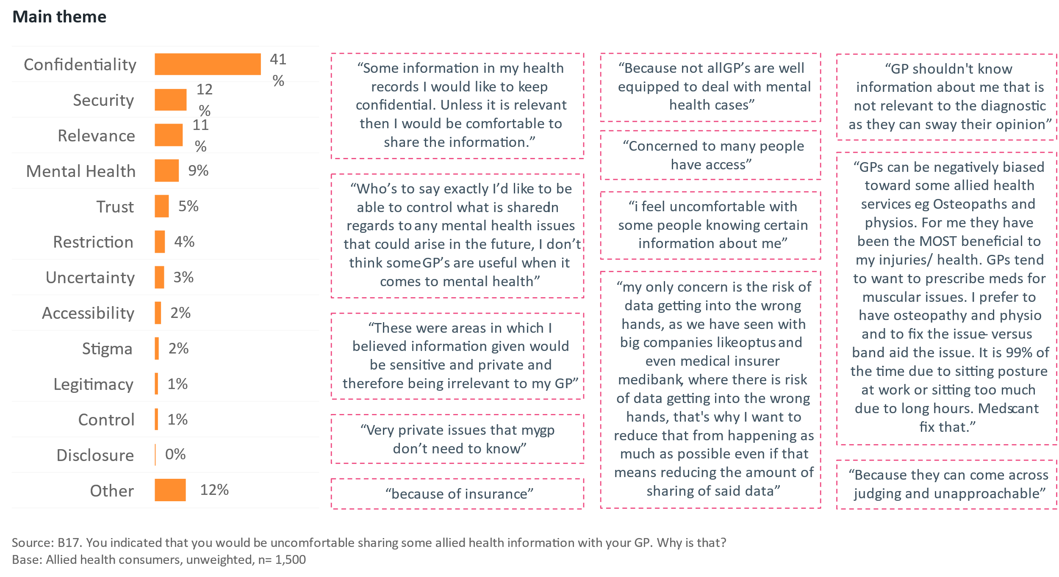

At an overall level, healthcare recipients appear largely comfortable with the concept of sharing their AH clinical information via My Health Record. Around three-quarters (72%-79%) are comfortable in doing so across most of the AH disciplines included in the survey.

* **The exception to this was information provided by psychologists, which significantly fewer (67%) express being comfortable sharing compared with other AH disciplines.**

This data also shows that healthcare recipients are significantly more comfortable sharing AH clinical information with their GP than they are with uploading it to My Health Record for all AH disciplines.

Figure : Comfort in sharing AH clinical information

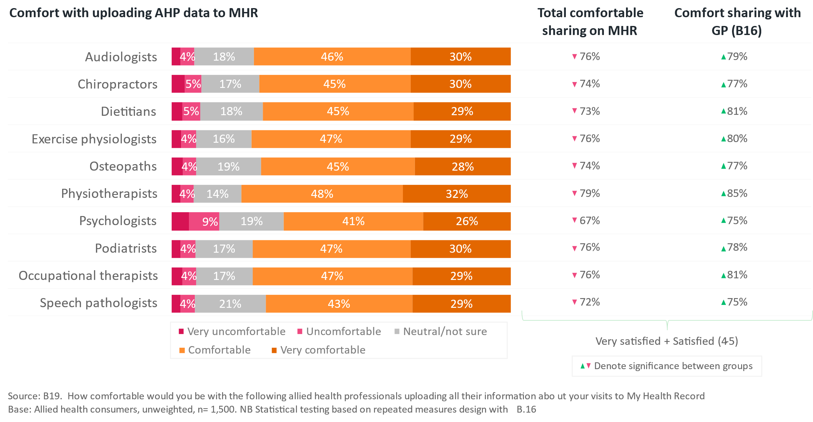

The survey also sought to understand whether a healthcare recipient’s level of comfort with sharing information would be different in an emergency. Seventeen percent indicated they were uncomfortable with sharing at least one of the listed AHP’s clinical information to My Health Record. These participants were asked a follow-up question asking whether they would comfortable doing so in an emergency. The results of this comparison are shown in Figure 27.

At an overall level, this comparison shows that many healthcare recipients would no longer be uncomfortable with information being shared in a medical emergency. This indicates that for some healthcare recipients, the value of having AH clinical information available to HCPs in an emergency may outweigh their initial reservations regarding sharing this information in My Health Record.

Figure 27: Comparison between level of comfort with sharing information regularly and in an emergency

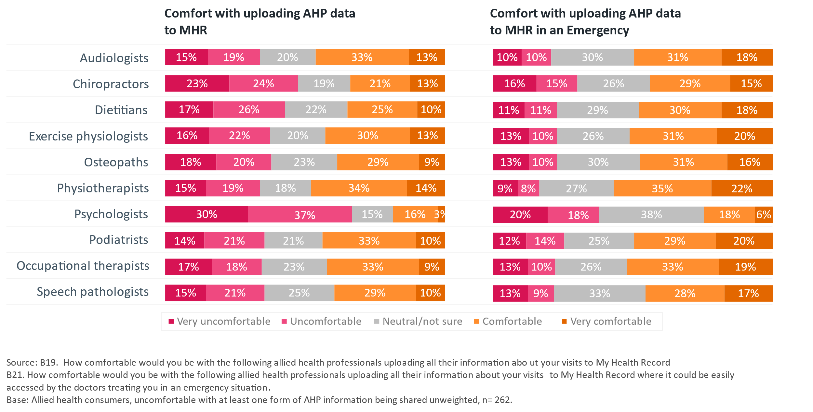

In qualitative group discussions, many healthcare recipients suggested they don’t want every AHP to have access to their full medical records, rather, they would prefer that their GP only shares the necessary information required to treat their issue. Others were more open and felt there was benefit in their AHPs having access to more information.

“Once you’ve had prostate cancer, it affects everything, and everyone involved with your health needs to know about it, so I’m an open book, and I share everything with everyone.”  
(Healthcare recipient, chronic health condition)

“It only should be whatever is in their field of treatment. But the other way, coming back to the GPs should be everything.” (Healthcare recipient, older Australian)

“Your GP should be like the body of the octopus, sending information out to the legs, and getting information back, but only sending the allied health what they need [to know].”  
(Healthcare recipient, older Australian)

The quantitative survey indicates mixed preferences amongst healthcare recipients, 41% indicated they only want to share what is necessary for them to know for the specific issue they are treating, however 46% reported they would like to share their full medical history, as demonstrated in Figure 29.

* However, even more felt it worthwhile for AHPs to know about their medications (57%), imaging results (50%) and other diagnoses (50%).

Figure 28: Healthcare recipient preferences on sharing information with AHPs

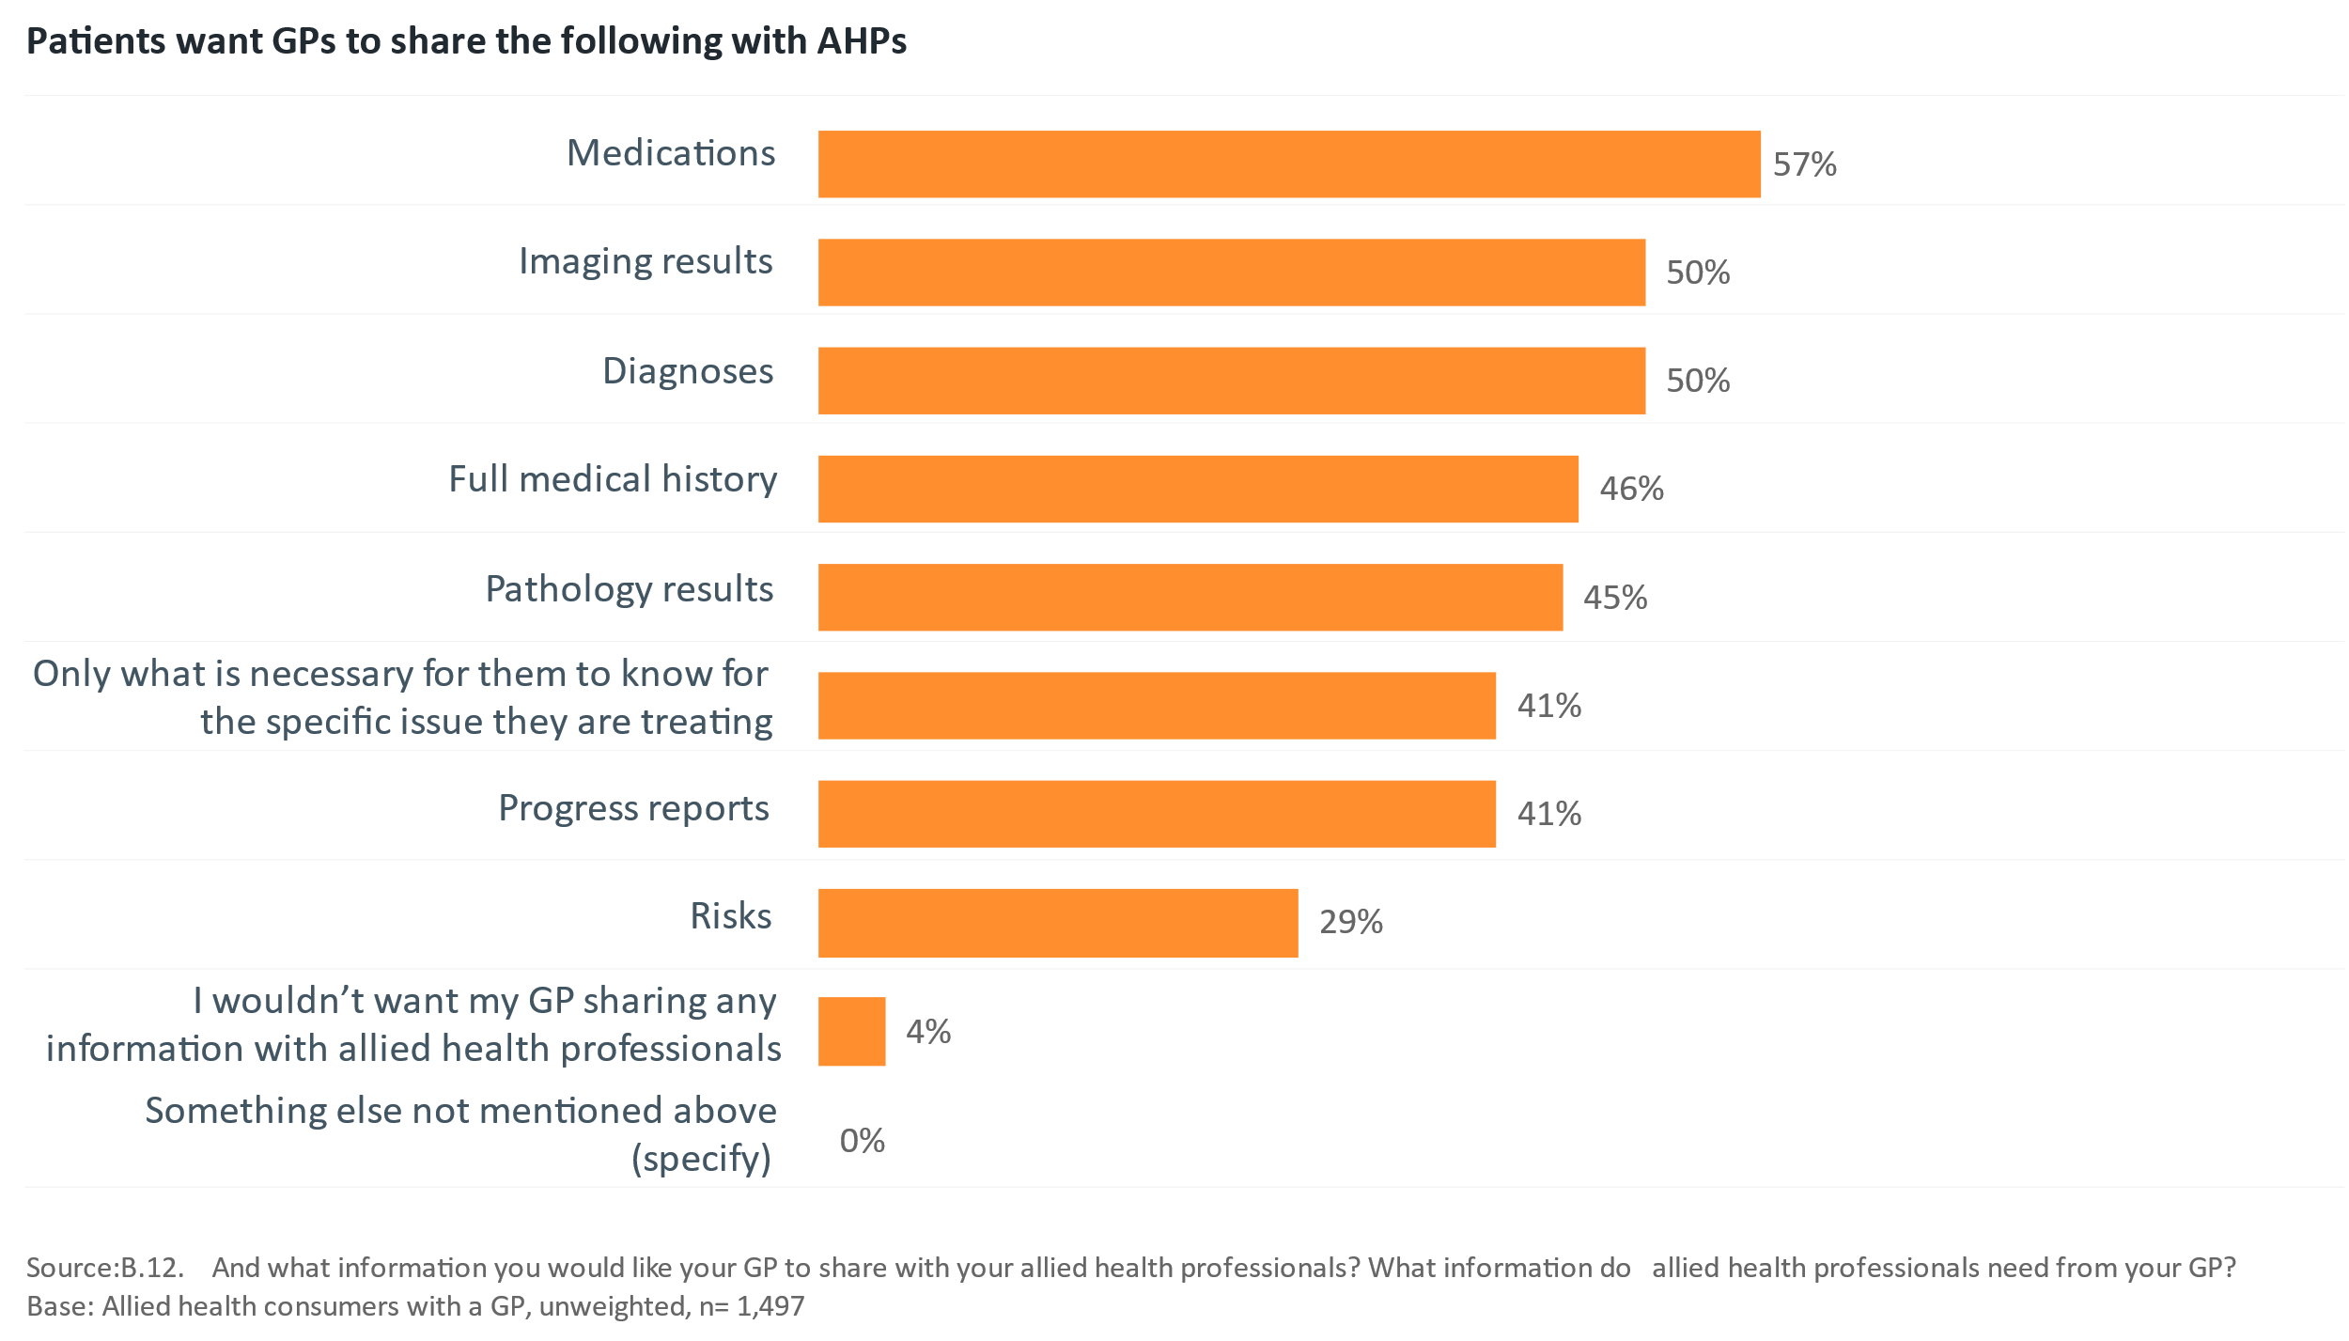

Comparing the results shown earlier that demonstrate GPs and other HCPs value mental health information above all other AH clinical information in their clinical decision making, with the fact that this is the precise area consumers are least comfortable with sharing highlights an important tension for any clinical information sharing system to manage.

### GPs are most commonly the central stakeholder in team-based care – but not always

Most healthcare recipients view their GP as the central point of contact best suited to acting as the coordinator between different parts of what can be a complex and overwhelming health system. They feel that the responsibility for coordinating information including AH clinical information sharing sits primarily with this central role and that they should be initiating the discussions with other HCPs, including AHPs, to ensure all information is available in one place.

* However, having a GP in this central coordinating role is not universal – some healthcare recipients rely more heavily on a medical specialist or in some cases, an AHP, as their primary care partner. This makes broad accessibility an important consideration in the design of an information sharing system.
* Healthcare recipients believe they should also be encouraged by their primary care provider to engage with an online system such as My Health Record so they too can encourage their other HCPs to engage with it.

## My Health Record

### An online system for information sharing would be highly valued

Healthcare recipients across the groups talked about the potential value of being able to seamlessly share their clinical information with their healthcare team via an online system.

For some healthcare recipients, My Health Record plays this role very well, and they are very happy with their ability to access what they need, when they need it.

For others, the use of My Health Record raises concerns – chiefly the risk of data breaches, but also the risk of confidential information being shared without their consent, and the risk of not being able to get an unbiased diagnosis or fresh perspective on their issues with a full previous history being shown.

“I don’t like the idea of having all my stuff in one place, it seems risky to me.”  
(Healthcare recipient, experienced an acute health episode)

“There’s definitely some things I wouldn’t want on My Health Record – I want to be able to control who sees what.” (Healthcare recipient, experienced an acute health episode)

“I would hopefully have that opt in that a few others have said, to tick the My Health Record if I wanted to, you'd actually like to say, no, I don't want that information anywhere near My Health Record” (Healthcare recipient, chronic health condition)

“I just very recently had this almost identical conversation with the person who I nanny for, who is in charge of an emergency department. And we were talking about My Health Record. And she told me, they just don't use it. There's not enough on there. There's not enough, too much can be missed if they rely on that. So better not to use it at all.”  
(Healthcare recipient, carer)

“Yeah, I'm concerned about that, too. You know, having all of that sort of private information on there. I'm happy just for my doctor to have it comprehensively on his system.”  
(Healthcare recipient, chronic health condition)

### There is low self-reported engagement with My Health Record

Of the surveyed healthcare recipients, 73% report having a My Health Record. Those with higher levels of health literacy (78%) and digital health literacy (80%) are significantly more likely to have one, as are ‘Worriers’ (79%) with high levels of self-reported health concern, and ‘Innovators’ (80%) at the leading edge of the technology adoption curve (details regarding these definitions can be found in Appendix A). This suggests that targeting communications or, for example, GP-led interventions, for healthcare recipients with lower levels of education (which correlate with lower levels digital and health literacy), or among groups such as culturally and linguistically diverse Australians, to communicate the benefits and reassure them about the risks, may be an effective way to increase uptake.

Figure 29: My Health Record usage among healthcare recipients

Majority of healthcare recipients have a My Health Record (73%). 
13% report it to be very true that they use their My Health Record. 9% report it to be very true that they use their My Health Record for everything to do with their health. 15% report it to be very true that their My Health Record has all their health information on it. 

However, overall levels of reported usage are low with only 39% agreeing they use My Health Record, and only 31% agreeing they use My Health Record for everything to do with their health. Nearly half (48%) of users agree that My Health Record “…has all their health information on it.”

More engaged healthcare recipients – those with higher levels of health concern and health literacy - are more likely to be using it as a repository for all their relevant health information.

The data further suggests that there are some significant barriers to greater usage of My Health Record amongst healthcare recipients. 60% of healthcare recipients are at least somewhat concerned about My Health Record being hacked (Figure 30), with 34% being very concerned. 52% are at least somewhat concerned about the security of My Health Record.

* Further analysis shows that this concern about security of My Health Record has a direct relationship with level of comfort in sharing AH clinical information via the system. Those concerned about the security of My Health Record rate their level of comfort in sharing AH information 11-18 percentage points lower (depending on the AHP) than those not concerned (not shown).

Figure 30: Level of concern about aspects of My Health Record

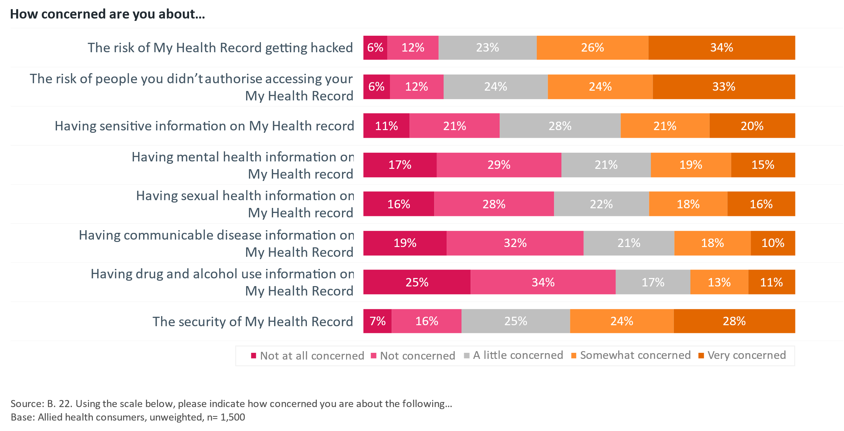

A similar proportion (57%) are at least somewhat concerned about the risk of someone they didn’t authorise accessing their My Health Record (33% very concerned). The risks posed by sensitive information, including information about mental health, sexual health, communicable diseases and drug and/or alcohol misuse are more polarising. The level of concern varies broadly amongst healthcare recipients, suggesting there is not a universal consensus regarding attitudes towards having sensitive information included in My Health Record, and that further consideration should be given to the role of controls within the system to support healthcare recipients when sharing or withholding this information from HCPs and AHPs.

### A lack of engagement with My Health Record by all cohorts limits its value

A key insight from this project is that sharing of AH clinical information has value to both HCPs and healthcare recipients.

HCPs believe few other HCPs are interacting with My Health Record and there is little healthcare recipient demand for them to use the system. Healthcare recipients report that they largely aren’t informed about the benefits of My Health Record by their GPs and aren’t encouraged to use it more.

This limited uptake and usage impacts its overall usefulness at present for sharing AH clinical information – it can’t function as a system for sharing where most aren’t accessing it.

# Appendix A: Additional data and charts

## Segmenting variables used to describe healthcare recipient survey participants

To further understand healthcare recipient survey participant’s underlying values and behaviours that may influence their attitudes towards, and experiences of healthcare, a range of segmenting questions were employed in the survey. The results form psychographic profiles with which data can be segmented and are outlined in Figure 32.

The key dimensions used to provide comparisons between groups of healthcare recipients and provide further insight into the responses of survey participants have been referred to within this report where statistically significant. These dimensions are:

**Health concern**

* 40% of healthcare recipients are considered ‘Carefree’ when it comes to their health, only going to see a medical professional when a new issue arises.
* 46% of healthcare recipients are ‘Checkers,’ reporting to receive regular check-ups from their HCPs and AHPs.
* The remaining 14% are ‘Worriers’, who report to be actively monitoring their health or always worried about their health. Within this research project, participants in this group were also more likely to report to suffer from chronic health conditions and more likely to be seeing a range of medical specialists, as shown in Figure 28.

**Digital health literacy**

* For the purposes of reporting, digital health literacy was considered when analysing the survey data. The digital health literacy scale is divided into a bottom quartile (‘low’), the interquartile range (‘mid’) and the top quartile (‘high’) to show how differences in digital health literacy affect responses to other items in the survey.
* Healthcare recipients with high digital health literacy are much more likely to be ‘Checkers,’ moderately concerned about their health. Digital health literacy was not significantly correlated with age or gender.
* Notably, health literacy and digital health literacy are highly correlated amongst survey participants.

**Health literacy**

* The health literacy scale used in this survey is centred around participants’ confidence with respect to understanding of medical information.
* Health literacy is correlated with age – older people tend to have higher levels of health literacy, and this measure also tends to be significantly higher among women.
* Both health literacy and digital health literacy are highly correlated with level of education.

**Technology adoption**

* This dimension represents the technology adoption curve plays a role in understanding how people think about digital solutions of all kinds – including digital health solutions. Typically, the ‘laggards’ and ‘technophobes’ are significantly less likely to have engaged with digital health solutions like My Health Record, and preference traditional, paper-based ways of communications. Significant correlations between this dimension and the survey items reported in the quantitative analysis were not found.

Figure : Key psychographic profile of Allied Health Healthcare recipients

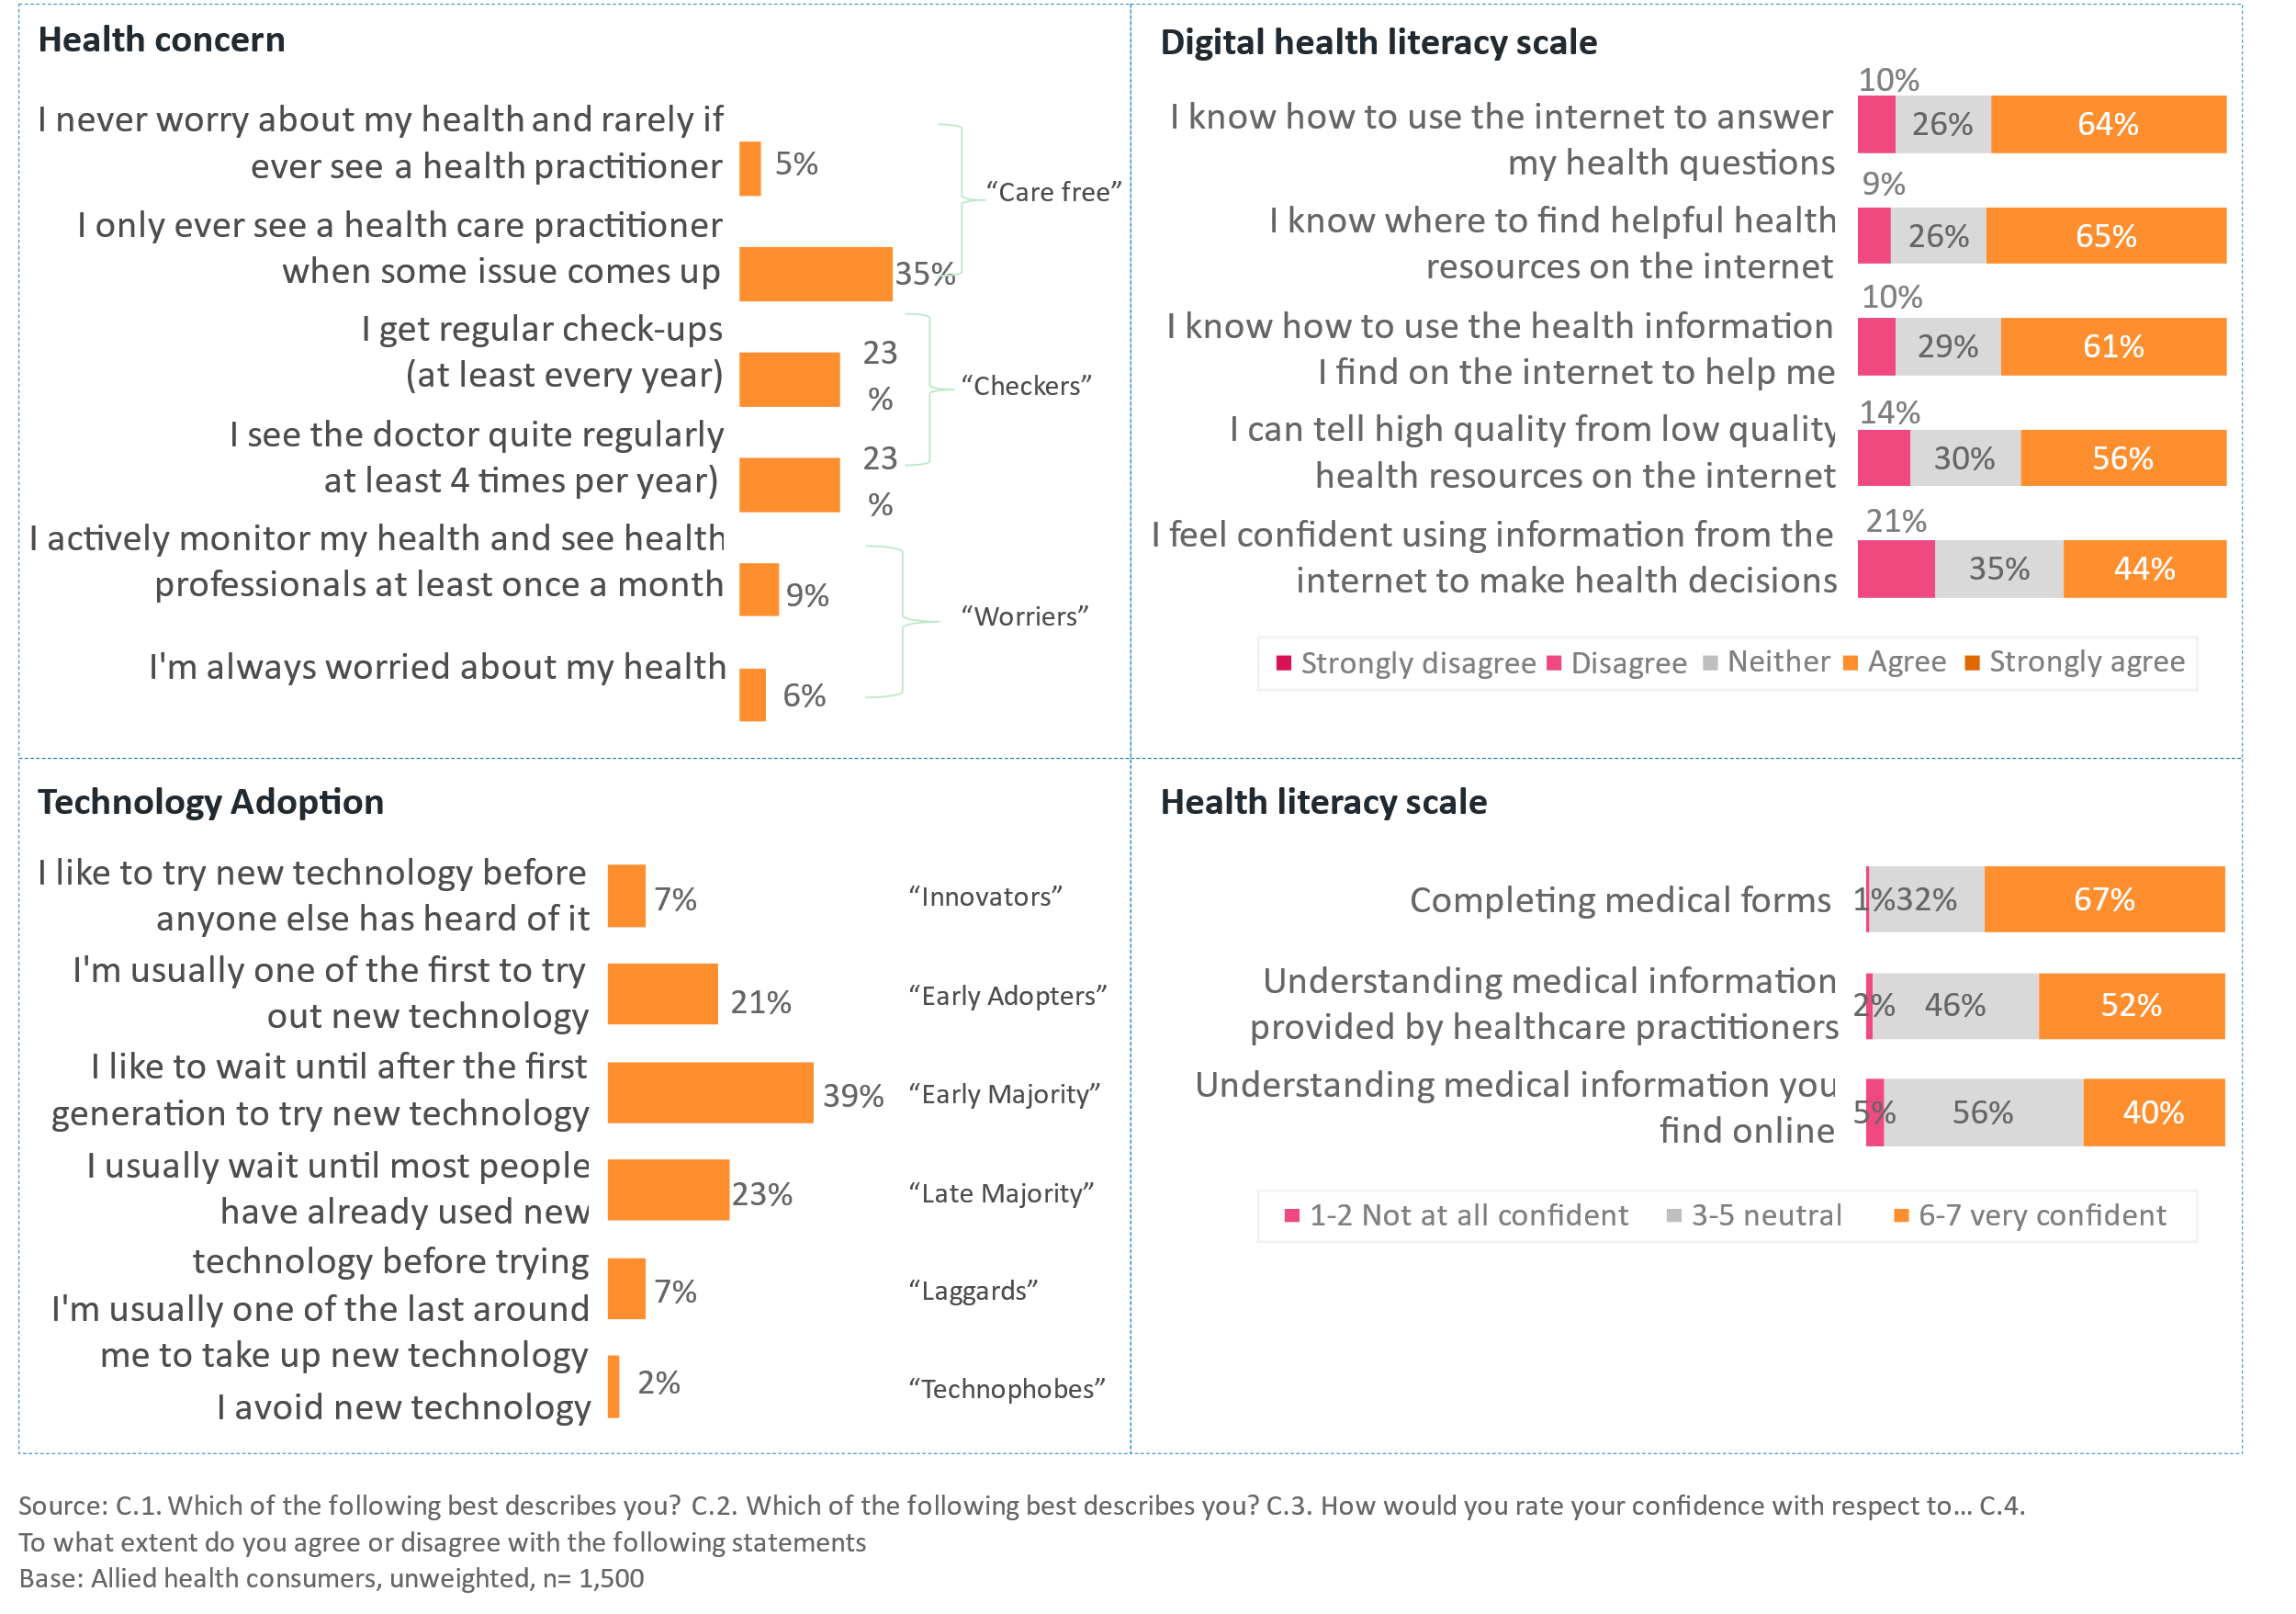

Figure : Medical specialists visited in the last year

