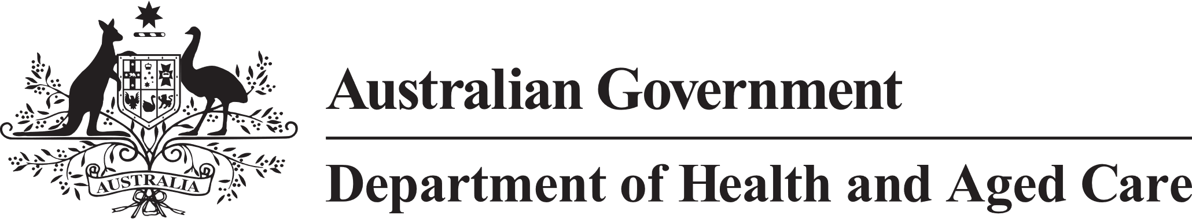

**Council of Elders**

# Communique – 23 & 24 November 2023

***Since this meeting, the Department has released an exposure draft of the Bill for the new Act for public consultation. The consultation will run until 16 February 2024. Members of the public and interested organisations can provide their feedback and help shape the Bill before it is introduced to Parliament in 2024. More information is available at:*** [***www.health.gov.au/aged-care-act-consultation***](http://www.health.gov.au/aged-care-act-consultation)

The Council of Elders came together in Canberra on 23 and 24 November 2023 for the last face to face meeting of the year and last face to face meeting of this term of the Council.

We reflected on the importance of the Council’s role in bringing the voices of older people into the policy considerations of the government on aged care, particularly given the significant reforms underway. We reflected on some of our achievements in helping ensure government policy and engagement processes took greater account of the needs of older people. We will be sharing a summary of the Council’s achievements with you soon.

**Deep Dive discussion Stigma around Dementia –** Council decided after its discussion on Dementia earlier this year to have a dedicated discussion about addressing stigma associated with dementia. As tackling dementia stigma will require effort by all governments, state and territory departments of health were invited to observe our discussion. Council also drew on the first-hand experience of a member living with dementia.

Members discussed how stigma negatively impacts service delivery, care, the ability of older people to exercise their rights, and the quality of life for people living with dementia and their families. We discussed the potential value of a sustained campaign to improve attitudes towards dementia. Blame can create dementia stigma so it is important to be careful in the language that we use to promote brain health.

Dementia stigma effects how people living with dementia are able to exercise their right to make decisions about their life and dying well. More nuanced ways of measuring an older person’s legal capacity will help to support continued decision-making control for people living with dementia. We discussed how nationally consistent powers of attorney arrangements could help and ways to better protect the rights of people living with dementia in substituted decision-making systems.

**Support at Home** – Council discussed the proposed funding arrangements for care management under Support at Home. This included a discussion of new classification arrangements under which people will be assigned a quarterly budget that aligns to a classification at assessment. Council discussed the importance of ensuring the bundle of services agreed with the assessor aligns to the person’s needs and preferences, and that there is some flexibility to make adjustments over time to meet individual needs. The Council emphasised the importance of early interventions to support older people with lower needs for care to remain independent and active at home. Council also highlighted the importance of the new assessment model in delivering support more quickly. *(Note: this Council discussion was held before the* [*government decision to extend CHSP*](https://www.health.gov.au/ministers/the-hon-anika-wells-mp/media/support-at-home-to-be-rolled-out-in-two-stages#:~:text=The%20Hon%20Anika%20Wells%20MP,-Minister%20for%20Aged&text=28%20November%202023-,The%20new%20Support%20at%20Home%20Program%20will%20be%20delivered%20in,Restorative%20Care%20(STRC)%20Programme.)*)*

The Council brought to government’s attention instances of older people only being offered one type of service by providers, irrespective of their support needs. Older people want transparency about the services that should be available to them so we will keep an eye on this.

**Aged Care Data and Digital Strategy** – Council discussed the draft Strategy and the initial feedback from public consultation. We were pleased to hear that the department will develop ways to engage older people from culturally and linguistically diverse backgrounds. We emphasised the importance of an ‘ask-once’ approach to safe and effective information sharing across government platforms, so older people do not need to continually re-tell their story. And giving older people choice about how they access information and interact with the aged care system. We suggested strategies to improve older people’s digital confidence.

**Provider Finances and Operations** – Council was encouraged to learn about new, public provider financial and operational information that will be provided on My Aged Care from early 2024. The new information, along with other information that speaks to the quality of services, like personal discussions with providers and Star Ratings, will help drive improved standards of care for older people. Council suggested ways to help older people to make the best use of the new information.

**Other matters** – Council discussed the incidence of COVID-19 in residential aged-care facilities and urged government to maintain efforts to protect the health of older people. We discussed the Aged Care Taskforce, and strategies the department is using to engage with First Nations. We also met with the Acting Inspector-General of Aged Care to discuss policy issues he is seeking advice on.

The next term of the Council of Elders will meet in early 2024.