Australian Influenza Surveillance Report – 2023 End of Season Summary

Communicable Disease Epidemiology and Surveillance Section (CDESS)

December 2023

**Reporting period:** Throughout the end of season summary, the seasonal period refers to data from week 14 (week ending 09 April 2023) to week 41 (week ending 15 October 2023), and the reporting period refers to data from 01 January to 15 October 2023. The 5-year average includes data for 2016, 2017, 2018, 2019, and 2022. The years 2020 and 2021 have been excluded due to the suppression of influenza virus circulation by COVID-19 mitigation measures in these years.

The Department of Health and Aged Care acknowledges the providers of the many sources of data used in this report and greatly appreciates their contribution.

## Key Messages

It is important to note that due to the COVID-19 epidemic in Australia, data reported from the various influenza surveillance systems may not represent an accurate reflection of influenza activity. Results should be interpreted with caution, especially where comparisons are made to previous influenza seasons. Interpretation of influenza data from April 2020 onwards should take into account, but are not limited to: the impact of social distancing measures; likely changes in health seeking behaviour of the community including access to alternative streams of acute respiratory infection specific health services; and focussed testing for COVID-19 response activities. For information on COVID-19 incidence, severity, and distribution in Australia, please refer to the [COVID-19 epidemiology reports](https://www1.health.gov.au/internet/main/publishing.nsf/Content/novel_coronavirus_2019_ncov_weekly_epidemiology_reports_australia_2020.htm).

**Season summary:**

* The 2023 influenza season was characterised by an early peak and longer duration, but overall lower clinical severity and societal impact, than many pre-COVID-19 pandemic influenza seasons. This was likely influenced by the high effectiveness of the 2023 seasonal influenza vaccine, and the predominant circulation of influenza A(H1N1) and influenza B viruses:
  + Influenza A(H1N1) is typically associated with less severe illness in older adults compared to influenza A(H3N2);
  + Influenza B viruses primarily affected younger people in 2023, who are generally at lower risk of severe complications and death; and
  + Vaccine effectiveness against influenza A(H1N1) and influenza B is usually higher than against A(H3N2) and was confirmed to be high in 2023 interim analyses.
* However, vaccination coverage was low overall in 2023, especially in children, and severe presentations to sentinel hospitals in children were reported throughout the season.
* Seasonal vaccination remains a safe and effective way to protect against severe influenza.

**Activity:**

* The 2023 influenza season peaked earlier compared to most pre-COVID-19 pandemic years, with a similar trend to the first half of the 2019 season. While influenza and influenza-like illness (ILI) activity levels were lower than average across all systems, it was a longer season following the large peak of laboratory-confirmed influenza notifications in late June. Notifications decreased slowly for the remainder of the season.

**Severity:**

* Clinical severity for the 2023 influenza season was considered low overall, although the number of deaths in children aged under 16 years reported by sentinel hospitals was higher than in many pre-COVID-19 pandemic years.
* In the reporting period, of the 252,296 notifications of laboratory-confirmed influenza, 376 influenza-associated deaths were notified to the National Notifiable Disease Surveillance System (NNDSS).
* From the commencement of seasonal surveillance in April 2023, there were 3,696 sentinel hospital admissions, of which 256 (7%) were admitted directly to ICU.

**Impact:**

* Given the high level of influenza activity in the community, but the relatively low clinical severity of the season overall, it is likely there was low to moderate impact on society during the reporting period.

**At-risk populations:**

* Children aged 05–09 years had the highest influenza notification rates during the reporting period, followed by children aged 0–04 years. The notification rate was lowest among adults aged 70–74 years.

**Virology:**

* The majority of notifications of laboratory-confirmed influenza reported to the NNDSS during the reporting period were influenza A (58%), of which 95% were influenza A(unsubtyped); 5% were influenza A(H1N1); and 0.82% were influenza A(H3N2). Influenza B accounted for 40% of notifications; influenza A&B accounted for 0.32% of notifications; and 2% of influenza notifications were untyped.

**Vaccine match, effectiveness, and coverage:**

* Of the 3,751 samples referred to the WHOCC during the 2023 season, 98% of influenza A(H1N1) isolates, 84% of influenza A(H3N2) isolates, and 99% of influenza B/Victoria isolates characterised were antigenically similar to the corresponding vaccine components, indicating a good vaccine match this season.
* Based on interim estimates, the 2023 influenza vaccine significantly reduced the risk of general practice presentation and hospitalisation with influenza.
* Influenza vaccine coverage rates were lower in 2023 than in 2022, and lower overall in First Nations peoples.

## Introduction

Each year, the influenza virus changes and different strains can circulate in the population. There are two types of influenza that cause clinically meaningful disease in humans: A and B. Influenza A is further differentiated into subtypes, of which A(H1N1) and A(H3N2) commonly circulate in humans. These types and subtypes can be associated with a greater or lesser burden of disease in different population subgroups. Depending on the susceptibility of the population, the influenza types/subtypes that are circulating, and the changes to the virus itself, the influenza season can be very different year to year. No one single surveillance system provides the full picture on influenza epidemiology, because influenza is a common disease and its presenting symptoms are not specific to influenza infection.

The epidemiology of influenza is informed by a number of different systems based in the community, laboratories, primary care and hospitals, as well as official deaths and notifiable diseases data. Our surveillance systems help us to understand influenza activity, severity of the infection in individuals and impact of the illness on society in Australia. We are also able to monitor which influenza viruses are circulating, which populations might be more affected, the effectiveness of the vaccine, and any resistance to antiviral drugs that has developed. Throughout the influenza season in Australia these systems are reported in the Australian Influenza Surveillance Report at <https://www.health.gov.au/resources/collections/aisr>.  For further details about information contained in this report please contact the Influenza Surveillance Team ([flu@health.gov.au](mailto:flu@health.gov.au)).

* Data in this summary is reported by International Organization for Standardization (ISO) 8601 weeks, with the week ending on Sunday. Throughout the summary, where the year-to-date is presented, this includes data from 1 January to 15 October 2023. NNDSS data are analysed and reported based on diagnosis date, which is the true onset date of a case if known, otherwise it is the earliest of the specimen date, the notification date, or the notification received date. NNDSS data were extracted on Friday 24 November 2023.
* In interpreting these data, it is important to note that changes in notifications over time may not solely reflect changes in disease prevalence or incidence. Depending on the disease, the number of notifications may be influenced by changes in testing policies; changes in case definitions; changes in testing practices and screening programs; the use of less invasive and more sensitive diagnostic tests; and periodic awareness campaigns.
* In particular, analyses including data from 2020 and 2021 should be interpreted with caution. Influenza activity in 2020 and 2021 was unusual due to the suppression of influenza virus circulation by COVID-19 mitigation measures. Data from these years may reduce five-year averages and affect analyses of usual seasonal trends. **Therefore, the years 2020 and 2021 are excluded in this report when comparing the current season to historical periods when influenza virus has circulated without public health restrictions. Where referenced, the five-year average in this report refers to the average of data from the years 2016, 2017, 2018, 2019, and 2022.**
* Due to the dynamic nature of the NNDSS and other surveillance systems, data in this report are subject to retrospective revision and may vary from data reported in other national reports and reports by states and territories. Detailed notes on interpreting the data presented in this report are available at the Department of Health and Aged Care's [Australian Influenza Surveillance Report website](https://www.health.gov.au/resources/collections/aisr?utm_source=health.gov.au&utm_medium=redirect&utm_campaign=digital_transformation&utm_content=flureport). While every care has been taken in preparing this report, the Commonwealth does not accept liability for any injury or loss or damage arising from the use of, or reliance upon, the content of the report. Delays in the reporting of data may cause data to change retrospectively. For further details about information contained in this report please contact the Influenza Surveillance Team ([flu@health.gov.au](mailto:flu@health.gov.au)).

## Analysis

### Activity

Activity measures the capacity of the circulating influenza viruses to spread from person to person and may be measured indirectly through systems that monitor influenza-like-illness (ILI) and more directly through systems that monitor laboratory-confirmed influenza.

* During the reporting period, laboratory-confirmed influenza and ILI activity increased sharply throughout May and peaked in June. Activity decreased steadily throughout July, then decreased more gradually toward the end of the season (Figures 1-3).
  + Compared to recent years, influenza activity in 2023 peaked at a similar time to the 2022 and 2019 seasons in June/July, much earlier than the 2016-2018 seasons that peaked in August/September (Figure 1).
* During the 2023 seasonal period, the proportion of FluTracking participants reporting ILI (fever and cough) peaked at 1.62% in early June (week 22). Reports of fever and cough among FluTracking participants were below the 5-year mean throughout the season (Figure 2).
* During the 2023 season, sentinel ASPREN GPs reported between 0.48 to 9.48 consultations due to ILI per 1,000 consultations per week, with the highest ILI rate observed in late June (week 26, 9.48 per 1,000 consultations) (Figure 3).
  + Nationally, the average sentinel GP ILI consultation rate for the reporting period in 2023   
    (4.79 per 1,000 consultations) was 27% lower compared to the 5-year mean for the same period (6.52 per 1,000 consultations).
* Influenza circulated at moderate levels throughout the 2023 season. During the seasonal period, 21% (292/1,400) of patients presenting to sentinel GPs with ILI who were tested for respiratory viruses, tested positive for influenza.
* There were 252,296 notifications of laboratory-confirmed influenza to the National Notifiable Diseases Surveillance System (NNDSS) during the reporting period – 1.45 times the 5-year mean (n=174,053) for this period.

**Figure 1:** Notifications of laboratory-confirmed influenza, Australia, 1 January 2016 to 15 October 2023, by year and week of diagnosis*

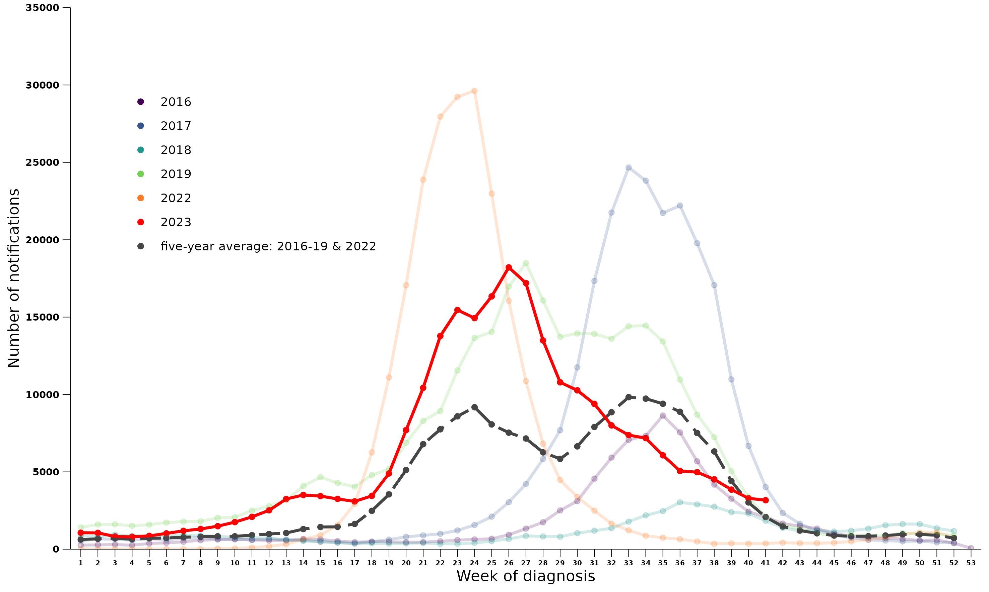

**Source:** NNDSS

*NNDSS data are preliminary and subject to change as updates are received, with most recent weeks considered particularly subject to revisions. The years 2020 and 2021 are excluded when comparing the current season to historical periods when influenza virus has circulated without public health restrictions. Please refer to Introduction for interpretation of the five-year average.

**Figure 2:** Proportion of new fever and cough cases among FluTracking participants, Australia, 2016 to 2023, by year and week of report*^

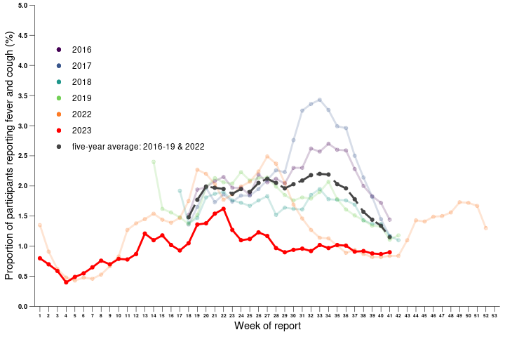

**Source:** FluTracking

*All data are preliminary and subject to change as updates are received, with most recent weeks considered particularly subject to revisions.

^FluTracking have expanded their reporting period from 2020 onwards due to COVID-19. As such, five-year historical comparisons are not available for data reported before May and after October for any year before 2020. The years 2020 and 2021 are excluded when comparing the current season to historical periods when influenza virus has circulated without public health restrictions. Please refer to Introduction for interpretation of the five-year average.

**Figure 3:** Unweighted rate of ILI reported from ASPREN sentinel GP surveillance systems, Australia, 1 January 2016 to 15 October 2023, by year and week*

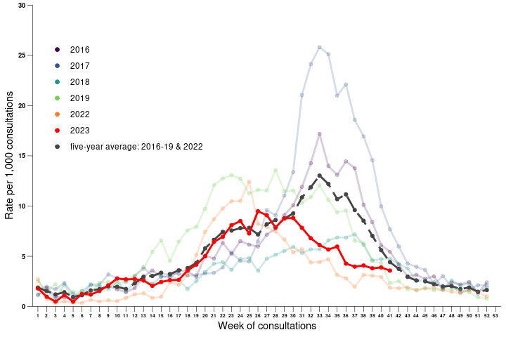

**Source:** ASPREN

*All data are preliminary and subject to change as updates are received, with most recent weeks considered particularly subject to revisions. The years 2020 and 2021 are excluded when comparing the current season to historical periods when influenza virus has circulated without public health restrictions. Please refer to Introduction for interpretation of the five-year average.

#### Severity

Severity is a measure of adverse outcomes or complications as a result of influenza, such as hospital referrals, admissions, need for intensive care, and deaths.

* From the commencement of seasonal surveillance in April 2023, there were 3,696 admissions with confirmed influenza to sentinel hospitals – 1.3 times the 5-year mean (n=2,935) (Figure 4).
  + There were 39 deaths in admitted patients with confirmed influenza: a case fatality rate of 1.1%. This is below the 5-year mean case fatality rate of 2.1%.
  + Of these 39 deaths, 9 were in children aged less than 16 years. This is higher than in 2022 (2 deaths) but lower than 2019 (11 deaths) and the case fatality rate for children admitted to sentinel hospitals in 2023 (0.41%) was similar to the 5-year mean (0.36%).
* Of the 252,296 notifications of laboratory-confirmed influenza during the 2023 season, there were 376 influenza-associated deaths notified to the NNDSS (Figure 5).
  + In recent years, the proportion of laboratory-confirmed influenza cases notified to the NNDSS as having an influenza-associated death (case fatality rate) has ranged from 0.15% in 2022 to 0.49% in 2017, with a 5-year mean of 0.31%. In the 2023 reporting period, the case fatality rate was 0.15%.
  + The median age of deaths notified was 76 years (range: 0–101 years).
  + The number and rate of influenza-associated deaths notified to the NNDSS was highest in people aged 85 years and over, with a case fatality rate of 3.46% (Figure 5).
  + 74% of influenza-associated deaths were attributed to influenza A(unsubtyped), 12% to influenza B, 11% to influenza A(H1N1), 2% to untyped influenza, and 1% to influenza A(H3N2).
  + ***Note****: the number of influenza-associated deaths reported to the NNDSS does not represent the true mortality associated with this disease. The number of deaths is reliant on the follow-up of cases to determine the outcome of their infection. The follow-up of cases is not a requirement of notification and are only inclusive of laboratory-confirmed cases of influenza. Due to retrospective revision, the variation across jurisdictions in methodology, representativeness, and timeliness of death data, year on year comparisons of deaths in notified cases of influenza may not be reliable.*
* The Australian Bureau of Statistics (ABS) provides an alternative source of influenza mortality data. During the COVID-19 pandemic, the ABS began producing ‘Provisional Mortality Statistics’ reports, which provide data on preliminary counts of doctor certified deaths by date of occurrence for Australia.
  + As of the most recent report (reporting period 01 January to 31 August 2023), there were 273 deaths due to influenza in 2023. Of the 273 deaths due to influenza, 71% were certified between May and July, coinciding with peak influenza activity in Australia. There were 347 influenza-associated deaths recorded in the NNDSS in the same period.
  + ***Note:*** *the number of deaths caused by influenza captured in ABS datasets may differ from the number of influenza-associated deaths reported to the NNDSS. This may be due to deaths caused by influenza captured in ABS datasets that do not meet the NNDSS* [*influenza surveillance case definition*](https://www.health.gov.au/resources/publications/influenza-laboratory-confirmed-surveillance-case-definition?language=en) *(requiring laboratory confirmation), greater accuracy in cause of death attribution reported to the ABS, and due to the reasons detailed above regarding underrepresentation of the true mortality associated with this disease in the NNDSS.*

**Figure 4:** Number of influenza hospitalisations at sentinel hospitals, from April to October, 2016 to 2023 by year and week of diagnosis*

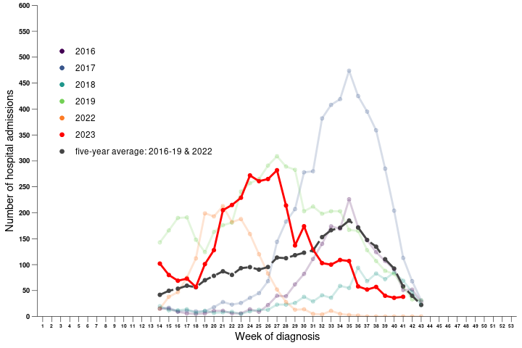

**Source:** FluCAN

*All data are preliminary and subject to change as updates are received, with most recent weeks considered particularly subject to revisions. The years 2020 and 2021 are excluded when comparing the current season to historical periods when influenza virus has circulated without public health restrictions. Please refer to Data considerations for interpretation of the five-year average.

**Figure 5:** Number of influenza-associated deaths notified to the NNDSS and case fatality rate by 5-year age group, 1 January to 15 October 2023*

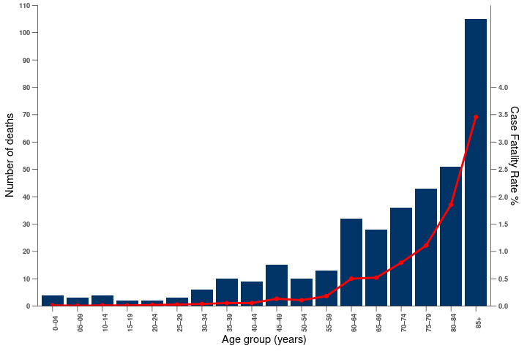

**Source:** NNDSS

* All NNDSS data are preliminary and subject to change as updates are received. The number of influenza-associated deaths reported to the NNDSS does not represent the true mortality associated with this disease. The number of deaths is reliant on the follow-up of cases to determine the outcome of their infection. The follow-up of cases is not a requirement of notification and are only inclusive of laboratory-confirmed cases of influenza. Due to retrospective revision, the variation across jurisdictions in methodology, representativeness and timeliness of death data, year on year comparisons of deaths in notified cases of influenza may not be reliable.

#### Impact

Impact measures how influenza affects society, including stress on health-care resources and societal and economic consequences.

* Given the high level of influenza activity in the community, but the relatively low clinical severity of the season overall, it is likely there was low to moderate impact on society and the healthcare system as a result of circulating influenza during the 2023 season.
* During the 2023 seasonal period, 1.08% (weekly average) of FluTracking participants reported having fever and cough, with 0.78% (weekly average) of participants reporting time off regular duties while unwell with fever and cough. This was below the 5-year mean of 1.88% of participants reporting fever and cough, and 1.32% of participants taking time off regular duties while experiencing fever and cough.

#### Geographical distribution of influenza activity

* During the reporting period, influenza notification rates were highest in Qld   
  (1,278 notifications per 100,000 population), followed by NSW (1,115 notifications per 100,000 population) (Table 1). The overall Australian notification rate was 971 notifications per 100,000 population.
* During the reporting period, influenza notifications peaked in half of jurisdictions in week 27 (ACT, NSW, SA, and Tas). Notifications peaked slightly earlier in Vic (week 23), WA (week 24), and Qld (week 25), and peaked during the interseasonal period in NT (week 13).
  + There was variation in the shape of the season across jurisdictions, with notifications taking longer to decrease following the peak in Vic, SA, and ACT.
* Although there was variation in the distribution of influenza A and influenza B throughout the reporting period (as discussed in the Virology section below), influenza A accounted for the majority of influenza notifications in all jurisdictions except the NT, where influenza B accounted for the majority of notifications.
  + Subtyping information was not available for all laboratory-confirmed influenza A notifications, but where subtyping information was available, all jurisdictions reported a greater proportion of influenza A(H1N1) than A(H3N2).

**Table 1:** Laboratory-confirmed influenza notifications to the NNDSS and notification rate per 100,000 population, 1 January to 15 October 2023

| **Jurisdiction** | **ACT** | **NSW** | **NT** | **QLD** | **SA** | **TAS** | **VIC** | **WA** | **Total** |
| --- | --- | --- | --- | --- | --- | --- | --- | --- | --- |
| Number of notifications | 3,412 | 90,911 | 2,116 | 68,016 | 18,003 | 3,179 | 47,276 | 19,383 | **252,296** |
| Notification rate per 100,000 population | 747 | 1,115 | 844 | 1,278 | 989 | 556 | 715 | 696 | **971** |

#### At-risk populations

At-risk populations are people who may be more susceptible to infection with the influenza virus and/or who may be more likely to experience severe outcomes from their infection.

* During the 2023 season, notification rates were highest in people aged 05–09 years (2,984 notifications per 100,000 population), followed by those aged 0–04 years (2,042 notifications per 100,000 population), and those aged 10–14 years (1,872 notifications per 100,000 population). Notification rates were lowest in those aged 70–74 years (397 notifications per 100,000 population).
  + While the higher notification rates observed in children during the 2023 season were relatively consistent with previous years, the lower notification rates in older adults (65 years and older) are unusual compared to pre-COVID-19 influenza seasons.
  + These lower notification rates in older adults were also observed in the 2022 influenza season and may be impacted by ongoing COVID-19 mitigation measures and higher vaccination coverage (see Vaccine match, effectiveness, and coverage section below) in this population.
* During the 2023 season, influenza A accounted for the highest rate of notifications across most age groups, however influenza B accounted for the highest rate of notifications in those aged between 10 and 29 years old.
* Since seasonal surveillance commenced, of the 3,696 patients with confirmed influenza admitted to FluCAN sentinel hospitals, 72% were children aged younger than 16 years*, 17% were adults aged 16 to 64 years, and 11% were adults aged 65 years or older.
  + ***\*****Hospital admissions in children under 16 years of age are over-represented in the FluCAN data in order to provide increased information on this at-risk population. The age distribution of hospital admissions in the FluCAN sentinel surveillance system may not reflect the age distribution of all influenza admissions nationally.*
  + 6% of children aged younger than 16 years admitted with confirmed influenza in the reporting period were admitted directly to ICU, compared to 12% of adults aged 16 to 64 years, and 5% of adults aged 65 years or older.
  + 39% of children aged younger than 16 years admitted with confirmed influenza in the reporting period had known co-morbidities, compared to 63% of adults aged 16 to 64 years, and 87% of adults aged 65 years or older.

#### Virology

* During the reporting period, 58% of notifications of laboratory-confirmed influenza reported to the NNDSS were influenza A (146,866/252,296), of which 95% were influenza A (unsubtyped); 5% were influenza A(H1N1); and 0.82% were influenza A(H3N2). Influenza B accounted for 40% of notifications (99,757/252,296), and influenza A&B accounted for 0.32% of notifications (807/252,296). 2% of notifications were untyped (4,866/252,296).
  + Similar influenza A and influenza B typing/subtyping distributions were observed in data from sentinel general practices (ASPREN), sentinel hospitals (FluCAN), and the National Influenza Centres.
  + The proportion of influenza B cases in the 2023 season was higher than in many recent seasons. While the majority of cases at the beginning of the season were influenza A, there was a gradual shift to a higher proportion of influenza B cases (especially in children and younger adults) later in the season, though this trend has now reversed (Figure 6).
* From 1 January to 15 October 2023, the WHOCC characterised 3,751 influenza viruses, of which 56% (2,116/3,751) were influenza A(H1N1), 10% (366/3,751) were influenza A(H3N2), and 34% (1,269/3,751) were influenza B/Victoria. No samples were positive for B/Yamagata.
* Of the 1,383 influenza A(H1N1) samples tested for neuraminidase inhibitor resistance, 4 (0.29%) demonstrated reduced inhibition to Oseltamivir. None of the influenza A(H3N2) or influenza B/Victoria samples tested for neuraminidase inhibitor resistance demonstrated reduced inhibition to Oseltamivir or Zanamivir.

**Figure 6:** Percent of notifications of laboratory-confirmed influenza, Australia, 1 January to 15 October 2023, by subtype and week of diagnosis*

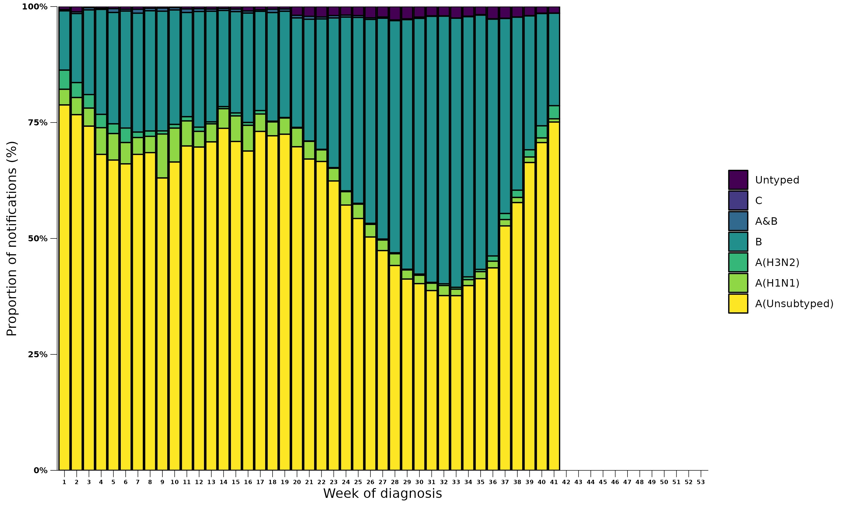

Source: NNDSS

* All data are preliminary and subject to change as updates are received.

#### Vaccine match, effectiveness, and coverage

##### Vaccine match

* During the 2023 season, of the 3,751 samples referred to the WHOCC, 98% (2,073/2,116) of influenza A(H1N1) isolates, 84% (306/366) of influenza A(H3N2) isolates, and 99% (1,252/1,269) of influenza B/Victoria isolates were antigenically similar to the corresponding vaccine components, indicating a good vaccine match this season.

##### Vaccine effectiveness

Vaccine effectiveness is a measure of the protective effect of influenza vaccines against influenza and its complications and is typically between 40–60%. This means that vaccinated individuals are roughly 40–60% less likely to get influenza or severe influenza than unvaccinated people. It is monitored by several sentinel influenza surveillance systems in Australia. Vaccine effectiveness varies from season to season based on the antigenic similarity between vaccine strains and circulating strains of influenza.

* Interim vaccine effectiveness estimates indicate that vaccination with the 2023 seasonal influenza vaccine significantly reduced the risk of general practice attendance and hospitalisation with influenza.
  + Overall estimated interim vaccine effectiveness against GP presentation with influenza was 64% (95% CI: 46%, 77%).
  + Overall estimated interim vaccine effectiveness against hospitalisation with influenza was 68% (95% CI: 59%, 74%).
  + Estimated vaccine effectiveness against both general practice attendance and hospitalisation with influenza appeared to be higher for influenza B than for influenza A in 2023.

##### Vaccine coverage

The seasonal influenza vaccine is recommended for everyone aged 6 months and over. In Australia, it is available free under the National Immunisation Program for people most at risk of severe influenza infection, including:

* children aged 6 months to less than 5 years
* people aged 65 and over
* Aboriginal and Torres Strait Islander people aged 6 months and over
* pregnant women
* people with certain medical conditions aged 6 months and over

Since 1 March 2021, all influenza vaccinations given in Australia have been required to be reported to the Australian Immunisation Register (AIR). Frome these data, vaccination coverage rates can be estimated for the Australian population.

* Influenza vaccination coverage in the Australian population over the 2023 season (up to 1 October 2023) was approximately 32% overall, which is lower than the estimated overall coverage in 2022 (39%).
* Across age groups, vaccination coverage in 2023 was much higher in those aged 65 years and over (64%) compared to those aged under 5 years (29%) and between 5 and 64 years (25%).
* Overall vaccination coverage for First Nations peoples in 2023 (24%) was lower than in the total Australian population, and lower in First Nations peoples aged under 5 years (21%) and 5-64 years (22%) compared to the total Australian population. However, vaccination coverage in First Nations peoples aged 65 years and over (63%) was similar to coverage in this age group in the total Australian population.