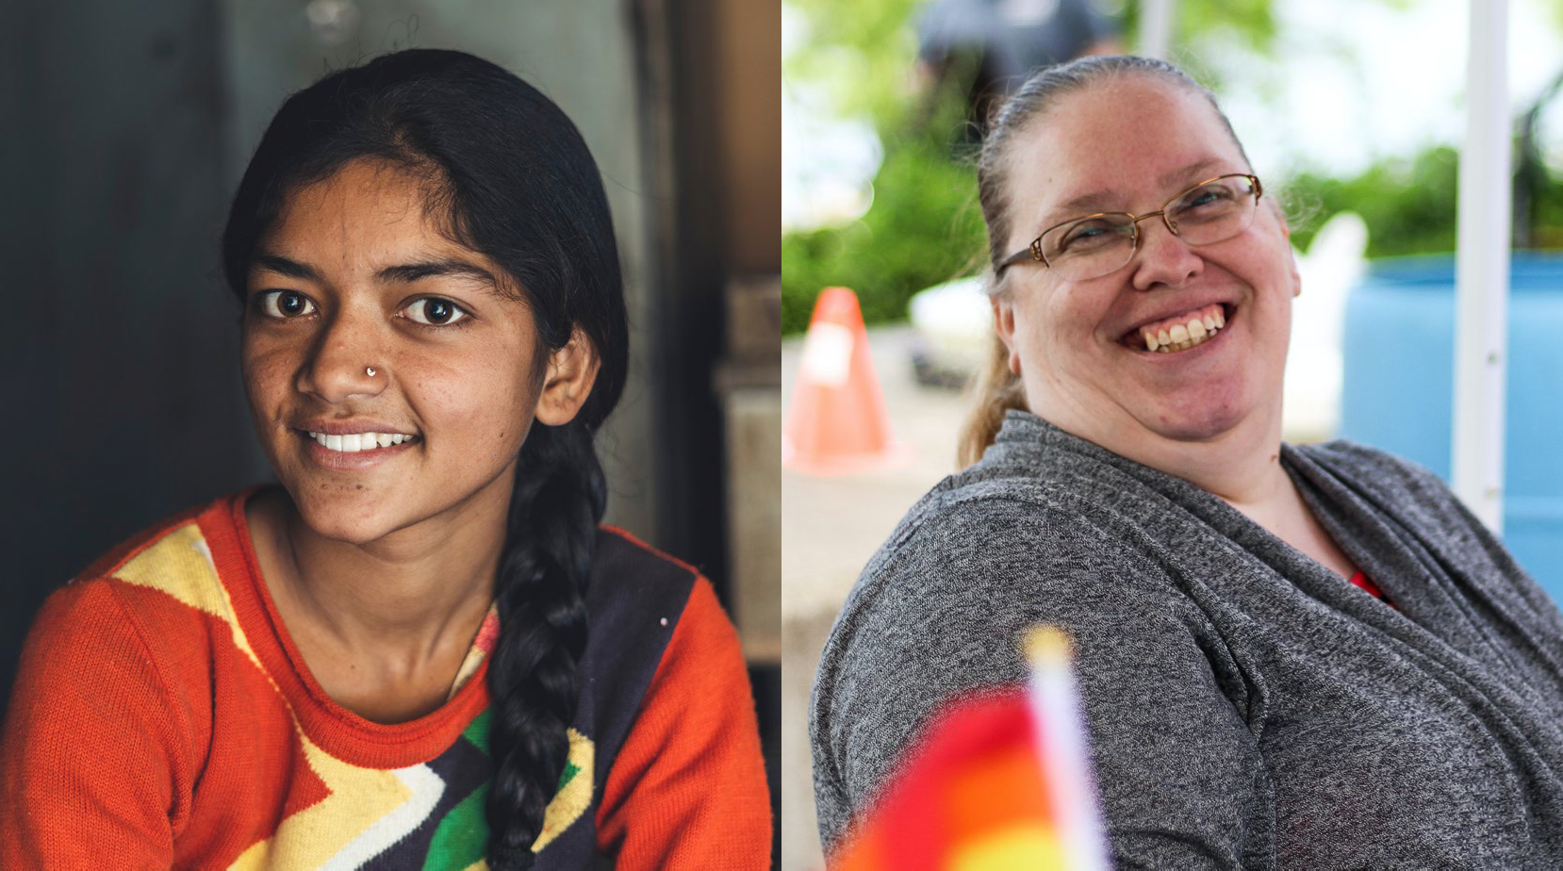



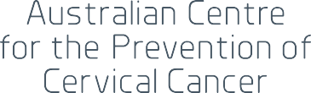

NATIONAL STRATEGY FOR THE ELIMINATION OF
CERVICAL CANCER IN AUSTRALIA
A pathway to achieve equitable elimination of cervical cancer as a public health problem by 2035

November 2023

CONTENTS NATIONAL STRATEGY FOR THE ELIMINATION OF CERVICAL CANCER IN AUSTRALIA

CONTENTS

PAGE 1
NATIONAL STRATEGY FOR THE ELIMINATION OF CERVICAL CANCER IN AUSTRALIA

On 17 November 2021, the Minister for Health announced a collaboration with the Australian Centre for the Prevention of Cervical Cancer (ACPCC) to develop a National Strategy for the Elimination of Cervical Cancer in Australia (Strategy). This Strategy was funded by
the Australian Government, with the aim to inform the Department of Health and Aged Care’s future activities to eliminate cervical cancer as a public health problem in Australia by 2035.
Following extensive consultation, including consumer and community input, this Strategy was delivered to the Minister for Health and Aged Care, the Hon Mark Butler MP for consideration.

GOVERNANCE
This Strategy was developed with guidance from many partners and subject matter experts.

A Department of Health and Aged Care Steering Committee provided strategic advice and oversight from health policy areas that are important to the success of this Strategy. Additionally, an expert advisory group and four sub-advisory groups were established to represent the health sector and community members across Australia, including priority community groups.
These groups have provided strategic guidance and deep expertise to help develop this Strategy. For our full list
of advisory and working group members, refer to the project website https://acpcc.org.au/elimination/.

ACKNOWLEDGEMENT
ACPCC, together with our project partners, would like to acknowledge the Traditional Custodians of the lands and waterways on which we all work together to provide the information, supports, and services needed to eliminate cervical cancer across all parts of Australia.
We acknowledge the Elders, past, present and future, and the ongoing connection of Aboriginal and Torres Strait Islander people to this land. We especially thank all Aboriginal and Torres Strait Islander people who have provided their leadership, excellence, and partnership in the development of this Strategy, and support the right of Aboriginal and Torres Strait Islander people to lead and develop the initiatives needed to support the health and wellbeing of their own communities.

Thank you to all our partners, stakeholders, and subject matter experts for their contribution and guidance in the development of the National Strategy for the Elimination
of Cervical Cancer in Australia.

PAGE 2

EXECUTIVE SUMMARY

The National Strategy for the Elimination of Cervical Cancer (Strategy) outlines
Australia’s commitment to achieving equitable elimination of cervical cancer as a public health problem by 2035, and the objectives and actions needed to achieve this goal.
Australia has aligned its goal of achieving elimination of cervical cancer with the World Health Organisation’s (WHO) goal; the agreed elimination threshold is less than four cases per 100,000 women in all countries worldwide within the next century. To put countries on the path to elimination, the WHO set three targets that each country should achieve by 2030 and then maintain and improve upon in the coming decades, the so-called 90:70:90 targets. These targets have been set for all countries worldwide, regardless of current income, Human Papillomavirus (HPV) vaccination and cervical screening status.
WHO targets*
- 90% of girls to be fully vaccinated with the HPV vaccine by 15 years of age
- 70% of women to be screened by 35 and again by 45 years of age using a high precision test
i.e., an HPV polymerase chain reaction (PCR) test
- 90% of women identified with cervical disease receive treatment for pre-cancerous lesions or management of invasive cancer
* The WHO 2030 targets have been developed for a global context, particularly for Low- and Middle-income countries and therefore focus only on cis-gender girls and women. We respectfully acknowledge that these targets may not be inclusive of all people with a cervix as they are currently written.
The Australian Strategy aligns with and builds upon the associated targets of the WHO Global Strategy across HPV vaccination, cervical screening, and treatment, often called the ‘three pillars of elimination’.
Whilst this Strategy focuses on cervical cancer elimination, it is worth noting that there are broader benefits of HPV vaccination given HPV also causes other cancers in the vulva, vagina, penis, anus, and oropharynx as well as genital warts.
In 2020, Australia reported that 80.5% of girls were fully vaccinated by age 15; 67.3% of women1 aged 45 to 49 years participated in cervical screening in 2018 to 2021 (and participation was 62% of women aged 25 to 74 years); 85.8% of those with pre-cancer identified in 2020 received treatment within six months; and Queensland data showed over 90% treatment rates for cervical cancer (no national data available).
Given Australia’s track record of success in cervical cancer prevention and control, the global targets are well within our reach. This Strategy therefore builds upon the WHO targets.

NATIONAL STRATEGY FOR THE ELIMINATION OF CERVICAL CANCER IN AUSTRALIA

1 AIHW data reports ‘women’ in the denominator. We respectfully acknowledge that these rates may not be inclusive of all people with a cervix.

PAGE 3
NATIONAL STRATEGY FOR THE ELIMINATION OF CERVICAL CANCER IN AUSTRALIA

AUSTRALIA’S ELIMINATION TARGETS
By 2030, Australia will achieve the following targets:
- Extending the 90% HPV vaccination target to include boys as well as girls
- Extending the 70% screening target to 5-yearly participation for eligible 25- to 74-year-olds, rather than twice in a lifetime and
- Lifting the target for treatment to 95%, as a commitment to achieving elimination as equitably as possible, leaving no-one behind.
As well as achieving these targets, this Strategy aims to strengthen the positive experience of eligible people during cervical cancer prevention and care.
Eliminating cervical cancer in Australia by the year 2035 could make Australia the first country in the world to actively achieve this goal.
This Strategy should be read in conjunction with the Australian Cancer Plan, the National Preventive Health Strategy 2021-2030 and the Aboriginal and Torres Strait Islander Cancer Plan being developed by the National Aboriginal Community Controlled Health Organisation. Many challenges and their solutions for cervical cancer also apply broadly to other cancers and will also be considered in both documents.
As cervical cancer is almost entirely preventable, any disparities in cervical cancer outcomes are largely due to inequity. It is therefore vital that this Strategy is concurrent with whole-of-systems approaches to address wider societal inequities and determinants of
health in Australia. This Strategy aligns with the vision, and cervical cancer prevention related goals, outlined in the National Preventive Health Strategy 2021-2030. This Strategy focuses exclusively on priorities and actions that are specific to eliminating cervical cancer in Australia.

AUSTRALIA’S VISION
Elimination is within Australia’s reach, and, with timely commitment and action, this Strategy’s vision can be achieved:
An Australia where preventable cervical cancer is a disease of the past, in which Australia’s diverse communities have equitable access to information and to culturally safe and inclusive vaccination, screening and treatment services.
In line with the vision, this Strategy:
- Addresses current inequities and does not entrench further inequity
- Takes a strengths-based, community-led approach
- Recognises the importance of active partnerships with civil society, Aboriginal Community Controlled Health Organisations and other priority population groups to co-design and deliver community initiatives and services
- Promotes cultural appropriateness, inclusivity, safety, and trust, and
- Focuses on person-centred approaches.

PAGE 4

STRATEGIC PRIORITIES TO ACHIEVE CERVICAL CANCER ELIMINATION BY 2035

VISION: An Australia where preventable cervical cancer is a disease of the past, in which Australia’s diverse communities have equitable access to information and to culturally safe and inclusive vaccination, screening and treatment services.

Priority populations
Aboriginal and Torres Strait Islander people
Culturally and linguistically diverse people
People who are LGBTQ+ and people who are intersex
People with disability
People living in rural and remote areas

NATIONAL STRATEGY FOR THE ELIMINATION OF CERVICAL CANCER IN AUSTRALIA

 | Vaccination | Screening and pre-cancer treatment | Treatment | Timely availability of cancer incidence and mortality data
WHO  targets | 90% of girls to be fully vaccinated with the HPV vaccine by 15 years of age | 70% of women to be screened (twice) by 35 and again by 45 years of age using a high precision test i.e., an HPV PCR-based test | 90% of women identified with cervical disease to receive treatment for  pre-cancerous lesions or management of invasive cancer | Incidence = < 4 new cases per 100,000
Strategic targets | 90% of all eligible people will be vaccinated against HPV | 70% of eligible people will be screened every 5 years | 95% of eligible people will receive optimal treatment for pre-cancer and cancer | Incidence = < 4 new cases per 100,000
Strategic objectives | Optimise the delivery of school-based HPV immunisation programs in all jurisdictions to maximise equity and achieve high coverage | Promote cervical screening regularly with the public and strategically with  under-screened groups | Ensure communities and patients have  equitable access to quality information about cervical cancer symptoms and that each cancer patient has tailored information about their diagnosis, intended treatment and planned optimal care pathway | Ensure that Australia has access to timely and accurate cervical cancer incidence and mortality data
 | Optimise the reach and funding of complementary out-of-school HPV immunisation programs to achieve equity in delivery for all, including priority and medically high-risk populations (catch-up) | Increase access to screening, colposcopy and follow-up by expanding who can offer these services, and where and how they are offered, to improve reach and uptake
 |  |  | Develop and implement a road map of coordinated care, with communities of practice, to optimise the delivery of safe, quality care to all patients
 | Develop a method to enable annual reporting of HPV vaccination coverage for priority and medically high-risk populations to monitor equity in immunisation | Collect, use, and release data to enable and monitor equity of access to cervical screening and pre-cancer treatment services | Drive improvements in cervical cancer management through a data collection framework supporting  systemic monitoring and enhancement of the quality of care, in alignment with Australian Cancer Plan

To deliver a positive, culturally safe and inclusive experience of prevention and care


PAGE 5
NATIONAL STRATEGY FOR THE ELIMINATION OF CERVICAL CANCER IN AUSTRALIA

PAGE 6
NATIONAL STRATEGY FOR THE ELIMINATION OF CERVICAL CANCER IN AUSTRALIA


NEXT STEPS
This Strategy is the result of evidence synthesis, quality insights and ideas from multiple stakeholders. Continued engagement is important to bring the strategic priorities and actions to life and uphold the right of women and people with a cervix to high quality, people-centred health services and care.
Key elements for implementation of this Strategy include:
- Coordinated efforts to expand and establish new, strategic, adaptable, and innovative partnerships to support and sustain implementation. Working with communities that understand the diverse nature
of the implementation challenges will honour the commitment of this Strategy to tackling inequities.
- Close alignment with the other emerging targets
of key areas of health reform and with whole- of-government approaches by the Australian
Government. This includes the Australian Cancer Plan, Aboriginal and Torres Strait Islander Cancer Plan, National Preventive Health Strategy 2021-2030, Primary Health Care 10 Year Plan, National Aboriginal and Torres Strait Islander Health Plan, and the National Agreement on Closing the Gap.
- Transparent accountability mechanisms to maintain momentum and uphold responsibility. Interim milestones which best deliver the achievement of equity for 2025 and 2030 should be identified from the strategic actions. These interim milestones should
be used in conjunction with the annual C4 Cervical Cancer Elimination Report to track progress towards cervical cancer elimination and enable Australia to report back against global commitments to the WHO Global Strategy.
- Prioritising timeliness of national cervical cancer incidence data to be able to confirm attainment of the elimination threshold in Australia. We have the potential to be the first country in the world to
actively achieve elimination. Knowing when the goal has been achieved is currently impacted by a four-to- five-year delay in the availability of national cervical cancer incidence data.

PAGE 7
NATIONAL STRATEGY FOR THE ELIMINATION OF CERVICAL CANCER IN AUSTRALIA

INTRODUCTION

This Strategy outlines Australia’s commitment to achieving equitable elimination of cervical cancer as a public health problem by 2035. Further, it outlines objectives and actions needed to achieve this goal.

THE GLOBAL CONTEXT
In 2018, the World Health Organisation (WHO) first proposed that cervical cancer could be eliminated as a public health problem (see Box 1) and in 2020, following endorsement from Member States, the WHO’s strategy of achieving the elimination of cervical cancer was released, with Australia playing a major role in the development of the Global Strategy.
The Global Strategy defines the threshold for elimination as less than four cases of cervical cancer per 100,000 women and the associated 2030 global elimination scale up targets for vaccination, screening and treatment, the so-called 90:70:90 targets (shown in Figure 1). These are supported by modelling demonstrating that implementation of the Global Strategy can achieve elimination in all countries within the next 100 years.1 These targets have been set for all countries worldwide regardless of income and current HPV vaccination and cervical screening status.
There has been remarkable progress made in technologies available for both primary prevention (through HPV vaccination), secondary prevention (through cervical screening using HPV testing and treatment of pre-cancer) and management of invasive cancer. Achieving a cervical cancer incidence rate of less than four per 100,000 is therefore realistic.
Box 1. The meaning of elimination




WHO 2030 TARGETS*

Elimination of any disease as a public health problem is achieved when there are fewer cases than an agreed low threshold.
The World Health Organisation and member states have agreed on an elimination target of less than four cases of cervical cancer for every 100,000 women.
Elimination differs from eradication, which is when there are no recorded cases.
Crucially, when a disease is eliminated, prevention measures need to continue to maintain the low rates of disease.

* The WHO 2030 targets have been developed for a global context, particularly for Low- and Middle-income countries and therefore focus only on cis-gender girls and women. We respectfully acknowledge that these targets may not be inclusive of all people with a cervix as they are currently written.

90% of girls to be fully vaccinated with the HPV vaccine by 15 years of age

70% of women to be screened by 35 and again by 45 years of age using a high precision test i.e., an HPV polymerase chain reaction
(PCR) test

90% of women identified with cervical disease receive treatment for pre-cancerous lesions or management of
invasive cancer

Figure 1. WHO 90-70-90 scale up targets to be met by 2030 for countries to be on the path towards cervical cancer elimination1

- Global strategy to accelerate the elimination of cervical cancer as a public health problem. Geneva: World Health Organisation; 2020. Licence: CC BY-NC-SA 3.0 IGO. Available at: https://www.who.int/publications/i/item/9789240014107

PAGE 8

AUSTRALIA’S CURRENT STATUS AGAINST THE WHO CERVICAL CANCER ELIMINATION TARGETS
Australia reported that 80.5% of girls were fully vaccinated by age 15 in 2020; 67.3% of people aged 45 to 49 years participated in cervical screening in 2018 to 2021 (participation was 62% of women2 aged 25 to 74 years); 85.8% of those with pre-cancer identified in 2020 received treatment within 6 months; and Queensland data showed over 90% treatment rates for cervical cancer (no national data available) as highlighted in Figure 2.


Incidence
Australia
6.5 new cases per 100,000 (2018)

AUSTRALIA’S ELIMINATION TARGETS
Given Australia’s track record of success in cervical cancer prevention and control, this Strategy builds upon the Global WHO targets with more ambitious but still achievable targets that are appropriate to our setting:
- Extending the 90% HPV vaccination target to include boys as well as girls
- Extending the 70% screening target to 5-yearly participation for eligible 25- to 74-year-olds, rather than twice in a lifetime and
- Lifting the target for treatment to 95%, as a commitment to achieving elimination as
equitably as possible, leaving no-one behind.
As well as achieving these targets (Figure 3), this Strategy aims to strengthen the positive experience of eligible people during cervical cancer prevention and care.

WHO target
≤4 new cases per 100,000

Vaccination
Australia
80.5% of females aged 15 years in 2020 were fully HPV vaccinated1

Screening
Australia
67% of women aged 45-49 years participated in cervical screening between 2018 to 20212

Treatment
Australia
85.8% of pre-cancers were treated within 6 months (2020).
No national data available on cancer treatment. Queensland data (2015-2019) show 95% were treated in metro, 96% in regional and 90% in rural/remote areas.

WHO target
90% of girls to be fully vaccinated
with the HPV vaccine by 15 years of age

WHO target
70% of women to be screened by 35 and again by 45 years of age using a high precision test i.e., an HPV PCR-based test

WHO target
90% of women identified with cervical disease to receive treatment for pre-cancerous lesions or management of invasive cancer

NATIONAL STRATEGY FOR THE ELIMINATION OF CERVICAL CANCER IN AUSTRALIA
  - Australian Immunisation Register (AIR) via the National Centre for Immunisation Research and Surveillance. Sex (Female) as recorded on AIR (Medicare derived).
  - Australian Institute of Health and Welfare (2022). Cancer screening programs: quarterly data, AIHW, Australian Government, accessed 26 October 2022.

Figure 2. Australia’s current status against the WHO cervical cancer elimination targets

- AIHW data reports ‘women’ in the denominator. We respectfully acknowledge that these rates may not be inclusive of all people with a cervix.

PAGE 9
NATIONAL STRATEGY FOR THE ELIMINATION OF CERVICAL CANCER IN AUSTRALIA

90% of all eligible people will be vaccinated against HPV

70% of eligible people will be screened every 5 years

95% of eligible people will receive optimal treatment
for pre-cancer and cancer

Positive, culturally safe and inclusive experience of prevention and care

Figure 3. Australia’s 2030 cervical cancer elimination targets

Eliminating cervical cancer in Australia by the year 2035 could make Australia the first country in the world to actively achieve elimination.

2023
Launch of Australia’s National Strategy to Eliminate Cervical Cancer

2030
Australia achieves
WHO targets of 90:70:90

2035
Australia is one of the first countries to eliminate cervical cancer

2120
All countries worldwide eliminate cervical cancer






Figure 4. Australia and the global cervical cancer elimination journey.


PAGE 10
NATIONAL STRATEGY FOR THE ELIMINATION OF CERVICAL CANCER IN AUSTRALIA

- VISION

Our vision is of an Australia where preventable cervical cancer is a disease of the past, in which Australia’s diverse communities have equitable access to information and to culturally safe and inclusive vaccination, screening and treatment services.
By implementing this Strategy, Australia will create an environment in which all people have inclusive and equitable access to vaccination, screening, pre-cancer treatment and cancer management services that meet their needs. This will make preventing, curing, and surviving cervical cancer a reality ultimately leading to elimination by 2035. This Strategy also outlines the systems that need to be developed to enable timely, accurate and transparent reporting of progress towards elimination and maintenance of this status in the years beyond.

PAGE 11
NATIONAL STRATEGY FOR THE ELIMINATION OF CERVICAL CANCER IN AUSTRALIA

ACHIEVING EQUITY

AN EQUITY AND A
STRENGTHS-BASED APPROACH

Cervical cancer is almost entirely a disease of inequity; without systematically addressing inequities, Australia will not
achieve elimination. Cervical cancer occurs most commonly in people who do not have access to culturally appropriate and inclusive information, vaccination services and/or screening services. This may be compounded by limited access to culturally safe, inclusive, and high-quality treatment services.
Throughout the development of this Strategy, the need to address inequities has been recognised, starting with the approach to governance, the structure of the sub-advisory groups, the development of the Technical Paper, the consultation process and the structure and content of this document.
This Strategy aims to address known disparities in access to services and outcomes, and to build upon the many strengths of our existing health systems and communities. While this Strategy focuses on health
systems and care to prevent and control cervical cancer, it recognises that it is vital to have concurrent whole-of- systems approaches to address wider societal inequities and social determinants of health in Australia.
Every level of our health system needs to ensure that services meet the needs of all people in their respective communities. The health system needs to
provide education, training and continuing professional education support across all three pillars, including support for new initiatives such as self-collection.
Health services must also continually address access barriers, such as the needs of people affected by trauma for example. Eliminating cervical cancer requires genuine community-led models to ensure that services are truly fit for purpose.
This Strategy embraces a set of five principles to guide equitable and impactful action at national, state and territory, and local level. Each strategic priority and action recommended in this Strategy:
- Aims to address existing inequities and to not entrench further inequity
- Takes a strengths-based, community-led approach
- Embraces active partnerships with civil society, community-controlled organisations and priority population groups to co-design and deliver community initiatives and services
- Has cultural appropriateness, safety, and trust at its core, and
- Focuses on person-centred approaches.
This Strategy recognises the right to equitable prevention and care for all people, including but not limited to:
  - Aboriginal and Torres Strait Islander people
  - People from culturally and linguistically diverse backgrounds (including immigrants, refugees, and asylum seekers)
  - People who identify as lesbian, gay, bisexual, transgender, queer, and/or asexual or who are intersex
  - People with disability, and
  - People living in remote and rural areas.
This Strategy has dedicated strategic priorities and actions for each of these priority populations (refer to pages 28-59). This Strategy also recognises that some people identify with a number of populations which can expose them to compounding forms of health inequity, discrimination and marginalisation.

PAGE 12
NATIONAL STRATEGY FOR THE ELIMINATION OF CERVICAL CANCER IN AUSTRALIA

“Everyone who is presenting with advanced cervical disease is, by definition, a part
of a priority population in that they are under-screened or unscreened.”
- Kim Hobbs, Clinical Specialist Social Worker, Westmead Hospital, NSW
This Strategy should also be read in conjunction with the Australian Cancer Plan, the National Preventive Health Strategy 2021-2030 and the forthcoming Aboriginal and Torres Strait Islander Cancer Plan being developed by the National Aboriginal Community Controlled Health Organisation. Many issues in cervical cancer also apply broadly to other cancers and will be considered in the Australian Cancer Plan and the Aboriginal and Torres Strait Islander Cancer Plan.

Aboriginal and Torres Strait Islander peoples, communities and organisations
This Strategy acknowledges the prevailing strength and endurance of Aboriginal and Torres Strait Islander people, their families and communities as the world’s oldest living cultures. It acknowledges that colonisation, enduring dispossession and racist policies have – and continue to – actively produce unacceptable health inequities.
In line with the commitment from all Australian governments and Aboriginal and Torres Strait Islander representatives in the National Agreement on Closing the Gap (National Agreement), this Strategy recognises its obligations to overcome the entrenched inequities and inequality faced by too many Aboriginal and Torres Strait Islander people in relation to cervical cancer.

This is a part of ensuring Aboriginal and Torres Strait Islander rights to health and a future free from this almost entirely preventable disease.
The four priority reforms outlined in the National Agreement provide a powerful roadmap to strong and positive ways of working together towards cervical cancer elimination: 1) formal partnerships and shared decision making, 2) building the community-controlled sector,
3) transforming government organisations and 4) shared access to data and information at a regional level.
The Aboriginal Community Controlled Health sector plays a vital role in realising a future free from cervical cancer through exceptional leadership in holistic
care, with strong Aboriginal and Torres Strait Islander governance and self-determination.
Addressing cervical cancer inequities is at the core of achieving cervical cancer elimination for all,
including Aboriginal and Torres Strait Islander women and people with a cervix. Addressing inequities requires recognition of the ongoing and unwavering commitment, self-determination and leadership
of Aboriginal and Torres Strait Islander people, communities and organisations.
Refer to 7: Strategic priorities and actions for Aboriginals and Torres Strait Islander people.

PAGE 13
NATIONAL STRATEGY FOR THE ELIMINATION OF CERVICAL CANCER IN AUSTRALIA


EQUITY CASE STUDY:
A patient’s perspective

Ashlee Williams
Cervical cancer survivor and consumer representative on the Treatment Sub-Advisory Group for the National Strategy for the Elimination of Cervical Cancer in Australia

“Thank you for this amazing opportunity to have a say and share my voice on behalf of First Nations People, young women, my family and community. I feel it is such an honour and this really does help me feel that my experience was for a greater purpose.”

I am a very proud Wadi Wadi, Dharawal and Wandi Wandian young woman of the Yuin Nation, from the south coast of NSW.
I am the second youngest of 11. I have seven sisters and three brothers. My dad is the eldest of 16 and my mum the eldest of four. Big immediate family.
At the time of my diagnosis, I was a 26-year-old mum of two children. I suffered, unaware of symptoms
of cervical cancer for years. I was referred to Chris O’Brien Lifehouse in Sydney – three hours away from my home – where my cancer was identified as
advanced. Radiation, brachytherapy and chemotherapy had to begin immediately. I was away from family, my children and my community for four months.
I had an aggressive tumour, over 5cm. The cancer had already reached my lymph nodes and invaded my whole cervix. I was deemed inoperable.
As a survivor looking back on the whole process from finding out information about the symptoms, the treatments, therapies, appointments … it is a serious task. I was lucky to have my partner caring for me and managing the steps. All the staff we met were so compassionate, empathetic and welcoming, especially for the two of us who are First Nations people.
I worry for those who are not so lucky and are battling their cancer journey solo. We need a platform where information is easily accessible. We need community Champions to give us hope. We need agencies to provide personal, individualised care. We need the Federal Government to support life-saving treatments.
We need health practitioners and specialists to use language that we understand and not medical jargon. We need everyone, from administrative staff to specialists and senior leaders, to have ongoing cultural awareness training. We need to normalise cancer conversations in the community and in education.
Key things to consider are:
- My experience is not isolated – First Nations women are seven times more likely to receive sub-optimal care and late detection of cervical cancer
- Trials and services need to be equitably accessible
- Elders, influential and trusted healthcare practitioners and/or survivors, need to be invited into the conversations

PAGE 14

STRATEGIC PRIORITIES AND ACTIONS

This Strategy is centred around 10 strategic priorities (highlighted in boxes) that are accompanied by a set of actions. They were informed by the findings of the Technical Paper and the consultation process. The potential impact of these strategies and actions, and examples of initiatives and approaches that could be scaled up, are illustrated with case studies selected
NATIONAL STRATEGY FOR THE ELIMINATION OF CERVICAL CANCER IN AUSTRALIA
1 Ensure that Australia has access to timely and accurate cervical cancer incidence and mortality data.
from the consultation process.
This Strategy also aims to strengthen the positive experiences of eligible people across cervical cancer prevention and care. This includes facilitating increased participation in immunisation programs, removing barriers to screening, and encouraging people to
seek timely treatment. Common elements across this Strategy include:
- The ongoing need to improve access, cultural safety and inclusivity across the health system.
- The need to work in partnership with communities to effectively communicate with and inform them about the vision, timeline and goal of cervical cancer elimination.
- A focus on training and education of the workforce to increase cultural safety, provide trauma-informed care, and reduce the stigma and discrimination that people from priority populations often feel when accessing health care.
- The need for improvements in data to allow more effective and meaningful monitoring and evaluation, supporting the improvement of services and the degree to which these services meet the needs of priority populations.

TIMELY AVAILABILITY OF CANCER INCIDENCE AND MORTALITY DATA


Actions
- Ensure that Australia has access to timely and accurate cervical cancer incidence and mortality data.
  - Review the timeliness of cervical cancer notifications from each of the state and territory cancer registers to the Australian Cancer Database (ACD), and investigate opportunities to accelerate the availability of national cervical cancer data, aiming to have it available by November 1st of each calendar year, for the preceding year.
  - Ensure that this accelerated reporting also includes currently reported stratifications including rates for Aboriginal and Torres Strait Islander people by remoteness, by socio- economic status, and by state and territory.
  - Build on the currently available breakdowns to ensure timely reporting of cancer incidence and mortality for Aboriginal and Torres Strait Islander people in all jurisdictions, people of culturally and linguistically diverse backgrounds, people with disability, people who identify as lesbian, gay, bisexual, transgender, queer, and asexual, people who are intersex, and other priority populations as this data become available.
  - Add cancer registry data into the data assets that are included as enduring linkages in the Multi-Agency Data Integration Project (MADIP) to facilitate this. When cancer data are included in MADIP, consider reporting on individual-level socioeconomic status, rather than area-level measures.

PAGE 15
NATIONAL STRATEGY FOR THE ELIMINATION OF CERVICAL CANCER IN AUSTRALIA

VACCINATION

Actions
- Optimise the delivery of school-based HPV immunisation programs in all jurisdictions to maximise equity and achieve high coverage.
- Optimise the delivery of school-based HPV immunisation programs in all jurisdictions to maximise equity and achieve high coverage.
- Optimise the reach and funding of complementary out-of-school HPV immunisation programs to achieve equity in delivery for all, including priority and medically high-risk populations (catch-up).
- Develop a method to enable annual reporting of HPV vaccination coverage for priority and medically high-risk populations to monitor equity in immunisation.
  - Review and revise communication planning materials and provide educational opportunities in schools to improve adolescent, parent, family, and caregiver as well as school staff understanding of HPV vaccination and the elimination strategy. This should occur through strong partnerships between health, education
and non-government organisations to provide an integrated approach to HPV vaccination literacy that spans key learning areas, is supported by
a whole-of-school approach, and fosters health literacy.3

  - Utilise technology to support digital reminders and put clear communication and follow-up protocols in place to ensure that the school and the consenting carer are aware when a vaccine dose has been missed and receive clear remedial instructions.
  - Provide in-school vaccination catch-up opportunities where possible. From 2023,
a single dose HPV vaccine schedule has been introduced; the implementation plan for single dose vaccination should provide for opportunities for in-school vaccination
to ensure individuals who miss doses have more opportunities to be vaccinated.
  - Fund and develop routine program processes that can identify lower coverage schools and develop tailored solutions to improve local coverage.

- Coordinated with actions 5.1 and 8.1

PAGE 16
NATIONAL STRATEGY FOR THE ELIMINATION OF CERVICAL CANCER IN AUSTRALIA


- Optimise the reach and funding of complementary out-of-school HPV immunisation programs to achieve equity in delivery for all, including priority and medically high-risk populations (catch-up).
  - Fund and promote HPV vaccine catch-up strategies with out-of-school and priority populations, their representatives and service providers. Ensure equity in availability of catch- up opportunities across jurisdictions and for the most marginalised groups, for example, adolescents in youth detention. Consider alternative community locations and providers, for example, GP clinic settings, Aboriginal Community Controlled Health Organisations, pharmacies and community events, potentially in tandem with screening. Develop workforce strategies to expand reach, for example, Aboriginal Health Practitioners and sexual health nurses.
  - Implement GP and health care provider education, training and quality improvement activities relating to immunisation that support routine use of the Australian Immunisation Register (AIR) data to check HPV vaccination status for all patients aged 14-25 years, address vaccine hesitancy and assess mature minor competence.
- Develop a method to enable annual reporting of HPV vaccination coverage for priority and medically high- risk populations to monitor equity in immunisation.
  - Leverage data linkage through the MADIP to monitor engagement, elimination progress and outcomes for priority populations, using demographic and other variables to define priority populations and medically higher risk groups within the linked dataset.

PAGE 17
NATIONAL STRATEGY FOR THE ELIMINATION OF CERVICAL CANCER IN AUSTRALIA

VACCINATION CASE STUDY 1:
NSW school-based catch-up program

ISSUE: Since the HPV immunisation program started in 2007 in Australia, school programs have experienced challenges in ensuring that students complete the full course. Studies indicated that many parents were not aware that a dose had been missed nor how to organise a catch-up dose through primary care.4,5 In NSW in 2011 there was a 10% gap between dose 1 and 3 despite routine processes to advise parents when a dose was missed and a follow-up letter from the HPV vaccine register the following year.6

From 2012, NSW progressively increased catch-up opportunities so that students who receive at least one dose of HPV vaccine in Year 7 can receive the second (and now final) dose during Year 8. This has significantly improved course completion rates.
SOLUTION: The NSW Department of Health worked closely with education authorities to facilitate a new process by which those who had missed a dose in Year 7 were able to catch-up that
dose in the subsequent school year. Following implementation in 2012, dose 3 coverage rose to 81.4%, an 11-percentage point improvement.5 As shown below, there was no similar improvement in other jurisdictions (the two second-most populous states of Victoria and Queensland are shown, where more gradual improvements in coverage were achieved over the period).

CONCLUSION: Routinely providing catch-up doses in the school setting, rather than requiring parents to organise these through primary care, significantly improves coverage and course completion. This will be especially important from 2023 onwards, now that the recommended schedule for the HPV vaccine has changed from two doses to one dose. It is hoped that State and Territory Governments continue to offer two visits each year, in order to provide a second opportunity to vaccinate students who were away on the date of the first visit.

100%
Coverage Percentage (%)
95%
90%
85%
80%
75%
70%
65%
60%

71.6%
NSW QLD VIC

69.3% 71.2%

81.4% 82.4%

2012 2013 2014 2015 2016

Year
Figure 5. Dose 3 coverage in NSW, Queensland and Victoria, in females by age 15 between 2012 and 2016.5
The NSW 2015 15-year-old cohort were the first offered catch-up vaccination in school the following year (age 12 in 2012).

- Staples C, Butler M, Nguyen J, Durrheim DN, Cashman P, Brotherton JML. Opportunities to increase rates of human papillomavirus vaccination in the New South Wales school program through enhanced catch-up. Sex Health. 2016 Nov;13(6):536-539. doi: 10.1071/SH15132.
- Watson M, Lynch J, D’Onise K, Brotherton JML. Barriers to better three-dose coverage with HPV vaccination in school-based programs. Aust N Z J Public Health 2014;38(1):91-92.
- Historical Human Papillomavirus (HPV) immunisation coverage rates. Available at: https://www.health.gov.au/resources/publications/historical-human- papillomavirus-hpv-immunisation-coverage-rates

PAGE 18
NATIONAL STRATEGY FOR THE ELIMINATION OF CERVICAL CANCER IN AUSTRALIA







VACCINATION CASE STUDY 2:
Developing Optimised Vaccination Engagement in
Specialist Schools for HPV – the DOVES (HPV) project

“As we edge closer to the elimination of cervical cancer in Australia, we must
ensure that no one is left behind and that we address vaccine equity so that no-one suffers this almost entirely preventable disease”
- Professor Margie Danchin, Group Leader, Vaccine Uptake, Murdoch Children’s Research Institute
Young people with disabilities experience lower HPV vaccination rates than their typically developing peers7 and also face additional barriers to cervical screening and accessing cancer treatment. As such, HPV vaccination
provides a crucial safety net against HPV-related cancers in this vulnerable population. There is limited understanding of the multiple barriers to HPV vaccine uptake in specialist school-based programs and how best to address them to ensure increased vaccine confidence and uptake.
The Cancer Council Victoria and the Murdoch Children’s Research Institute, funded by the Victorian Department of Health, undertook research to identify barriers to vaccine uptake among adolescents with disabilities in Victorian specialist schools. Formative qualitative research with adolescents with disabilities, their families, school staff and council staff identified a complex array of access and acceptance barriers in both urban and rural schools.
Drawing on the insights and relationships generated from the research, co-design workshops are being conducted with adolescents, parents, schools, and council staff to design tailored strategies to increase HPV and routine vaccine uptake.
Future phases of this project will pilot these strategies in schools, and then develop and promote best practice guidelines.

- O’Neill J, Newall F, Antolovich G, Lima S, Danchin M. Vaccination in people with disability: a review. Hum Vaccin Immunother. 2020;16(1):7-15. doi: 10.1080/21645515.2019.1640556.

PAGE 19
NATIONAL STRATEGY FOR THE ELIMINATION OF CERVICAL CANCER IN AUSTRALIA

SCREENING AND PRE-CANCER TREATMENT

- Promote cervical screening regularly with the public and strategically with under-screened groups.
- Increase access to screening, colposcopy and follow-up by expanding who can offer these services, and where and how they are offered, to improve reach and uptake.
- Collect, use, and release data to enable and monitor equity of access to cervical screening and pre-cancer treatment services.

Actions
- Promote cervical screening regularly with the public and strategically with under-screened groups.
  - Undertake regular targeted tailored campaigns and activities for under-screened groups complemented by evidence-based, inclusive population-wide public awareness activities and mass media delivered through appropriate channels.8
  - Work with priority communities, including respected members, cervical cancer survivors, people with lived experience and community- controlled organisations who serve these communities, to co-create, design and test best approaches to reach the community, including the content of campaigns and information materials. Ensure campaigns are informed by the success and implementation strategies from previous campaigns and formative research, noting that materials may need to enhance community health literacy about HPV and cervical cancer.
  - Trial and utilise technology to support digital invitations, reminders, and navigation to follow- up activities for people with screening results that require further investigation.
- Increase access to screening, colposcopy and follow-up by expanding who can offer these services, and where and how they are offered, to improve reach and uptake.
  - Provide a clear pathway to enable appropriately trained registered nurses, Aboriginal Health Workers, Aboriginal Health Practitioners, and midwives to be able to independently request and sign the pathology form for a cervical screening test (and be eligible for Medicare reimbursement).
  - Establish a clear national pathway to train and accredit registered nurses and GPs to provide colposcopy.
  - Resource a pilot to scale up point-of-care HPV testing, with links to care, for remote communities.
  - Resource pilots and, where successful, resource scale-up and routine provision of innovative screening models such as peer- led and community-developed services and telehealth approaches. Work with community- controlled organisations to develop models, scale up successful models, and share best practice approaches.
- Collect, use, and release data to enable and monitor equity of access to cervical screening and pre-cancer treatment services
  - Routinely report all program indicators stratified by key population demographics, expanding reporting to include all priority populations, and introduce routine monitoring of performance against the WHO pre-cancer treatment indicator.
  - Promote the importance of data collection, training all staff to collect demographic data sensitively in order to improve the recording of all demographic fields (Aboriginal and/or Torres Strait Islander status, country of birth, gender), including additional fields not yet captured on the National Cancer Screening Register (NCSR) and information that affects clinical management such as immune status.
  - Enhance clinical information systems in primary health care settings to enable automated uploading of relevant demographic information to integrate with the NCSR.
  - Add cancer registry data and screening data from the NCSR into the data assets that are included as enduring linkages in the MADIP.
  - Enable clinicians and healthcare services to readily generate reports that can support
continuous quality improvement initiatives by identifying patients who are under-screened and indicate current participation rates to inform efforts that drive engagement.
  - Provide visibility to primary care providers of current waiting times for colposcopy services so that this can be factored into referrals and improve timeliness of care.

- Coordinated with actions 2.1 and 8.1

PAGE 20


SCREENING CASE STUDY 1:
CheckOUT: Community-designed solutions to overcome barriers to care

“I liked being asked about language for my anatomy – I’ve never been asked that before and I never even thought it was ok to ask doctors to use different language.”
ACON is Australia’s largest community-based LGBTQ+ health organisation, located in NSW. In 2015/16, ACON commenced health promotion work to increase awareness about cervical screening and improve screening rates among LGBTQ+ people with a cervix.
Starting with a project called At Your Cervix, ACON evolved this work into an inclusive, narrative-driven, award winning cervical screening campaign directed at sexuality and gender diverse people with a cervix: The Inner Circle.
Linked to the aims of the campaign, ACON and Family Planning NSW (FPNSW) developed a clinical service that directly addressed barriers to cervical screening among LGBTQ+ people. This service, CheckOUT, was co-designed by community and clinicians to address and remove barriers in each
Peer workers provide leadership within the clinic which is immediately reassuring to clients. The Peer greets the client, and asks them to fill out a registration form, which allows the client to select their pronouns, gender, sex assigned at birth
and intersex status. Following trauma-informed practices and health expertise, the Peer then guides the consultation, explaining and sign-posting each step, reversing the onus of ‘education burden’
often felt by LGBTQ+ people in clinical settings. The service user experience is one of seamless cooperation by the Peer workers and the nurse.
Demand for this service exceeded expectations.
In client surveys, the service received almost 100% satisfaction ratings, with significant feedback expressing relief and happiness with the service. Working in partnership, community and clinicians can design and deliver the highest quality healthcare that puts the person at the centre – and in more control – of their health care experience. CheckOUT is an important model for consideration with
other priority populations who are key to Australia reaching its cervical cancer elimination goals.

element of the clinical service.

Experiences of discrimination, judgement, needing to ‘educate the clinician’ and inappropriate language were identified as strong deterrents for LGBTQ+ people accessing cervical screening. ACON and FPNSW co-designed training for both clinicians
NATIONAL STRATEGY FOR THE ELIMINATION OF CERVICAL CANCER IN AUSTRALIA
and peer workers to ensure knowledge, skills and competence within the service were aligned to providing a safe, inclusive, culturally competent and clinically excellent service.

“The entire experience was awesome (I know it’s strange to say that a medical check-up was awesome) but the people there were so, so nice, understanding, and very informative. They were all respectful and I felt no shame when sharing my personal details. They’re there to genuinely help and that’s exactly how it felt. 10/10 *applause*.”

PAGE 21
NATIONAL STRATEGY FOR THE ELIMINATION OF CERVICAL CANCER IN AUSTRALIA

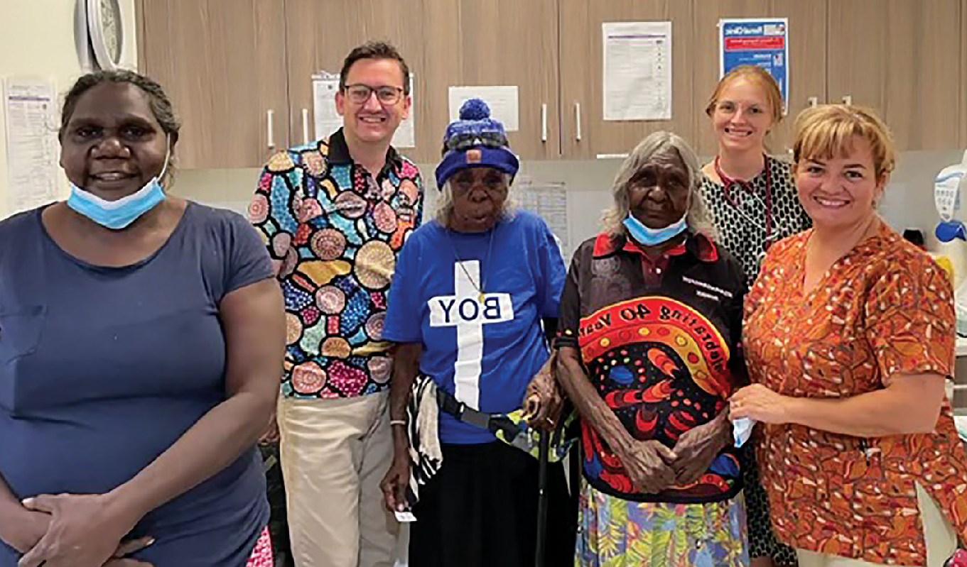
SCREENING CASE STUDY 2:
The Prevent Project,
University of Notre Dame Australia (WA)

The Prevent Project, led by the University of Notre Dame Australia in partnership with other leading experts in cervical screening, is trialing a portable screening and same day colposcopic assessment model in the Kimberley region. It allows eligible participants to collect their own screening sample, receive a test result within an hour of testing,
and access a specialist doctor during the same visit. This service is delivered by the Kimberley Obstetrics and Gynaecology Outreach Team who provide medical care to some of the most remote communities in the world. Through community invitation (critical to success), this service model has been offered to participants who attend the Broome Regional Aboriginal Medical Service
(an Aboriginal Community Controlled Health Organisation), or who reside in the Warmun, Beagle Bay and Bidyadanga communities.
To date, approximately 100 Aboriginal and/ or Torres Strait Islander people have been
screened, and our anecdotal evidence suggests that participants’ acceptability and preference for this service model is very high and appears to be attracting women who were not participating in the standard screening program.
Further information and updates can be viewed at: https://www.thepreventproject.com/. The final project evaluation will be released in early 2023.

PAGE 22

TREATMENT

Actions

- Ensure communities and patients have equitable access to quality information about cervical cancer symptoms and that each cancer patient has tailored information about their diagnosis, intended treatment and planned optimal care pathway.
  - Promote public understanding of cervical cancer signs and symptoms, the role of early detection, and the opportunity for cure.9
  - Provide information, consultation and support (for example, utilising the expertise of
nurses and allied health professionals) such that patients and their families/carers fully
understand and contribute their own preferences and needs to their individual care pathway.
  - Provide patients with the information, access to financial support and support personnel
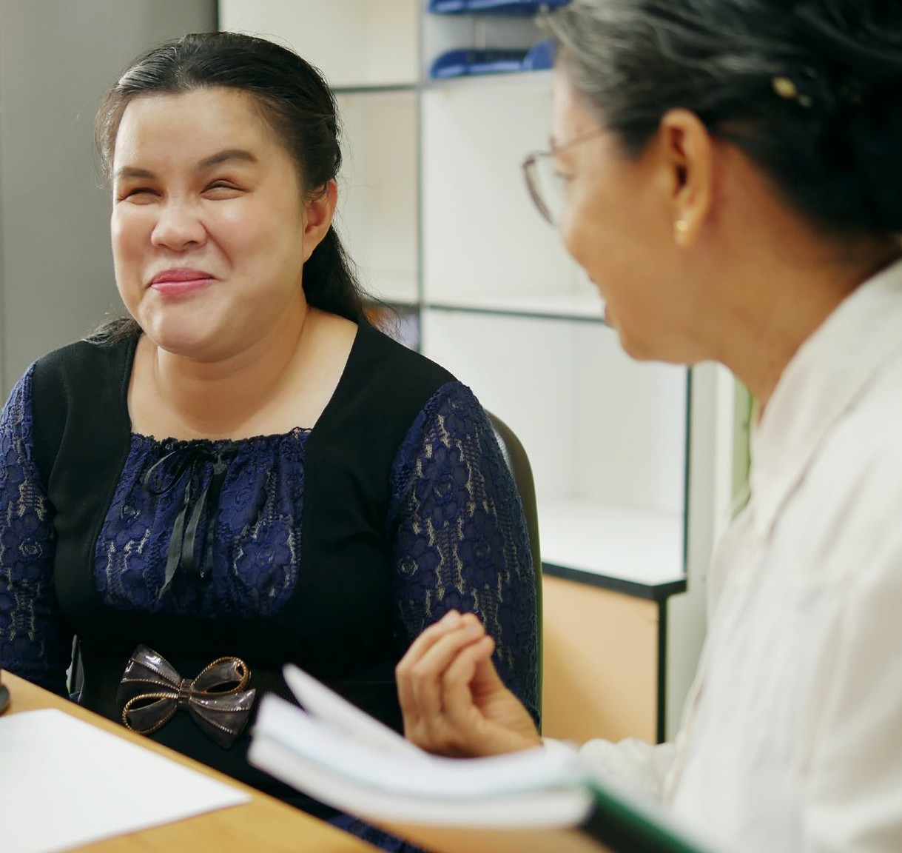
needed to navigate the health system, including informing them that they can have a person/ people of their choice accompanying them whenever needed.
8.4.
Enable incremental improvement by conducting routine patient-related evaluation measures (PREMs) to assess patient satisfaction, feeding results back to shape training and development of personnel, patient information materials and health service systems as appropriate. Ensure information collected captures patient diversity and experiences according to their sex, gender and sexual orientation, ethnicity, Aboriginal
and Torres Strait Islander status and disability. Ensure this information accords to national standards for data collection.

NATIONAL STRATEGY FOR THE ELIMINATION OF CERVICAL CANCER IN AUSTRALIA
- Ensure communities and patients have equitable access to quality information about cervical cancer symptoms, and that each cancer patient has tailored information about their diagnosis, intended treatment and planned optimal care pathway.

- Develop and implement a road map of coordinated care, with communities of practice, to optimise the delivery of safe, quality care to all patients.

- Drive improvements in cervical cancer management through a data collection framework supporting systematic monitoring and enhancement of the quality of care, in alignment with the Australian Cancer Plan.

- Coordinated with actions 2.1 and 5.1

PAGE 23
NATIONAL STRATEGY FOR THE ELIMINATION OF CERVICAL CANCER IN AUSTRALIA

- Develop and implement a road map of coordinated care, with communities of practice, to optimise the delivery of safe, quality care to all patients.
  - Realise a coordinated approach to patient care, from diagnosis to survivorship and palliative care, that is tailored to local population needs and diversity. This includes identifying and meeting the training and resourcing needs of key professionals.
  - Establish communities of practice, whereby multidisciplinary teams oversee processes and standards of care and take responsibility for actively building relationships within and across jurisdictions. This can enable a level of safety and trust when a patient is required to travel
to receive quality care. Tertiary centres should actively nurture relationships with services expert in caring for priority populations, for example Aboriginal Community-Controlled Health Organisations and LGBTQ+ specialised health services.
  - Optimise a hub-and-spoke model ensuring continuity of care for those diagnosed with cervical cancer to bring “quality to patients” where possible (for example palliative care) and “patients to quality” where necessary for highly specialist care (for example brachytherapy). Noting that palliative care services should be integrated into all levels of health care systems, including primary care.
  - Identify and leverage quick wins by translating successful service models to new jurisdictions and ensure longer-term solutions that may require policy change or workforce reforms. Consider models aimed at addressing workforce issues, such as building an additional supportive role for gynaecologic nurses or additional workforce skills within a multidisciplinary team. Genuine partnership with priority populations and communities will improve the provision
of culturally safe care and enhance access to treatment.
- Drive improvements in cervical cancer management through a data collection framework supporting systematic monitoring and enhancement of the quality of care, in alignment with the Australian Cancer Plan.
  - Enhance and harness the data collected in the National Gynaecological Oncology Registry (NGOR) cervical cancer module to inform continuous improvement in care
(equity of access, quality, and safety) based on incidence, stage, and mortality data, key clinical quality indicators, as well as patient reported evaluation and outcome measures (PROMs).
  - Conduct annual cervical cancer audits using data from the NCSR, cancer registries and NGOR together with HPV genotype information determined and reported for
all cervical cancers.
  - Consolidate current clinical guidance and quality standards through developing national guidelines for the management of cervical cancer and utilise the NGOR to monitor adherence.

PAGE 24

TREATMENT CASE STUDY 1:
A patient’s perspective

NADIA’S HISTORY
Nadia* is a 45-year-old single, nulliparous woman of Islamic faith. She migrated to Australia with her mother 15 years ago as a refugee, following the death of her husband in armed conflict. Nadia has no other family living in Australia. She lives with her mother in rented accommodation and works in casual employment as a cleaner. Nadia only had access to minimal education in her home country, has basic English language skills and poor health literacy. There were no HPV immunisation or cervical screening programs
in her country of origin.

NADIA’S PRESENTATION
Nadia presented to the Emergency Department with vaginal bleeding, anaemia and enlarged kidneys, due to obstruction of her urine outlet. She had symptoms for several months but was frightened to see a doctor and thought her symptoms were due to menopause. Nadia was admitted to hospital and investigations confirmed late-stage cervical cancer (stage 3B Squamous Cell Carcinoma). Recommended treatment was chemoradiation and brachytherapy.

“My oncologist asked about my screening history. My reaction was only sex workers in my country have cervical screening.
I thought I am an unworthy person. My cancer is punishment”.
NADIA’S EXPERIENCES
Nadia didn’t attend her simulation appointment and explained to her Clinical Nurse Consultant, “I can’t take that much time off work. I won’t have any income”. She was referred to a Social Worker for comprehensive psychosocial assessment
to facilitate completing her treatment and improve her patient experience. Nadia learnt about Centrelink payments and other support organisations. She also received psycho-education to address her feelings of stigma and shame, and work through her beliefs about cervical screening and cancer.

“My oncologist offered me a healthcare interpreter, but I declined as I am concerned about confidentiality and “gossip” in my community”.
Nadia was offered the following support:
- A multidisciplinary team to deliver culturally safe care that included being respectful of Muslim beliefs, using female examiners/ chaperones, and being aware of taboos around communication about cancer and prognosis.
- Referral to a clinical psychologist (there was significant trauma history identified with Nadia, and her cancer diagnosis triggered and exacerbated PTSD symptoms).
- Provision of plain language and translated information about treatment and expected side-effects.

NATIONAL STRATEGY FOR THE ELIMINATION OF CERVICAL CANCER IN AUSTRALIA

* Not her real name

PAGE 25
NATIONAL STRATEGY FOR THE ELIMINATION OF CERVICAL CANCER IN AUSTRALIA

TREATMENT CASE STUDY 2:
A patient’s perspective
WA Cancer & Palliative Care Network,
Clinical Implementation Unit, North Metropolitan Health Service

DAISY’S HISTORY
Daisy* is a 44-year-old Aboriginal woman from Wiluna (a small town from the Midwest region in WA). She is a single mother with four children of varying ages between four and 21. Daisy and her children live with Daisy’s mother in government housing. Daisy did not complete school and her literacy is poor. She does not have a job and relies on welfare to provide for herself and her family. She has not had the HPV vaccine or ever had any cervical screening. She has a history of marijuana and alcohol use.
DAISY’S DIAGNOSIS AND PRESENTATION
Daisy presented to Carnarvon hospital with abnormal, heavy vaginal bleeding and pelvic pain. After further investigations were completed,
she was transferred by the Royal Flying Doctors Service to King Edward Memorial Hospital where she was confirmed to have a late stage (stage 4B) cervical cancer. She was recommended to have combined chemotherapy and radiotherapy followed by brachytherapy. In WA chemotherapy and radiotherapy for cervical cancer is treated at two separate tertiary sites.
DAISY’S TREATMENT AND ONGOING CARE
Due to the complexities of this case the multidisciplinary team were heavily involved from diagnosis, in planning her treatment, arranging accommodation and transport from Wiluna to Perth and supporting her psychosocial and financial needs.
The Gynaecology Cancer Nurse Coordination team located in Perth liaised with Daisy’s GP who arranged a face-to-face appointment with her explaining the importance of compliance with appointments and treatment. They liaised with the Patient Assisted Transport Scheme (PATS) in WA to find her suitable accommodation for a lengthy period in Perth as well as the rural Cancer Nurse Coordination team located in the mid-west to support Daisy when she returned home, to assist
her with getting to Perth and to ensure her children were cared for at home while she was away.
The social work team including our Aboriginal Liaison Officer were heavily involved ensuring Daisy’s psychosocial and financial needs were met whilst receiving treatment. PATS also arranged for a weekend trip home during treatment so she could see her children.
Daisy was very concerned about her community at home not finding out about her diagnosis, she felt she would be rejected from the community.

“If my community find out about this, I’ll be kicked out, turned away, they’ll think I’ve been sleeping around and me and my kids won’t be accepted anymore.”
Daisy’s journey was a turbulent one, despite the many health care workers involved in her care, she missed her children, she struggled being in the city and wanted to get home to family and country.

* Not her real name

PAGE 26

NEXT STEPS

This Strategy is the result of evidence synthesis, quality insights and ideas from multiple stakeholders.
NATIONAL STRATEGY FOR THE ELIMINATION OF CERVICAL CANCER IN AUSTRALIA
Implementation of this strategy will require close coordination between the Australian Government and States and Territories to bring together different constituencies, sectors, relevant peak bodies and
professional organisations, civil society groups, Aboriginal Community Controlled Health Organisations, local program leaders and community partners for a coherent and coordinated effort, particularly through expanding
or establishing new, strategic, adaptable, and innovative partnerships to support and sustain implementation.
The continued engagement of these and new partners is an important component in bringing the identified strategic priorities and actions to life. Working with communities that understand the diverse nature of the
implementation challenges will honour the commitment of this strategy to tackling inequities and uphold the right of women and people with a cervix to high quality, people-centred, culturally safe and inclusive health services.
For successful and equitable cervical cancer elimination in Australia, there needs to be close alignment with the emerging targets of other key areas of health reform and with whole-of-government approaches by the Australian Government. This includes the Australian Cancer Plan, the Aboriginal and Torres Strait Islander Cancer Plan, the Primary Health Care 10 Year Plan, National Aboriginal and Torres Strait Islander Health Plan, the National Agreement on Closing the Gap, and the National Preventive Health Strategy 2021-2030.
The implementation of this Strategy should build on the National Consumer Engagement Strategy for
Preventive Health and National Health Literacy Strategy, both of which were listed as immediate priorities in the National Preventive Health Strategy and are currently under development (due for completion in mid-2023).
Australia has the potential to be the first country in the world to actively achieve elimination. Knowing whether the goal has been achieved is currently impacted by the current four-to-five-year delay in the availability of cervical cancer incidence data. To be able to confirm reaching the elimination threshold in Australia, it is a priority to address the timeliness of national cervical cancer incidence data.
Transparent accountability mechanisms are essential to maintain momentum and uphold responsibility.
Interim milestones which best deliver the achievement of equity for 2025 and 2030 should be identified from the strategic actions. These interim milestones should be used in conjunction with the annual C4 Cervical Cancer Elimination Report to track progress towards cervical cancer elimination and enable Australia to report
back against global commitments to the WHO Global Strategy.
Elimination is within Australia’s reach, and with timely commitment and action, this Strategy’s vision can be achieved:

An Australia where preventable cervical cancer is a disease of the past, in which Australia’s diverse communities have equitable access to information and to culturally safe and inclusive vaccination, screening and treatment services.

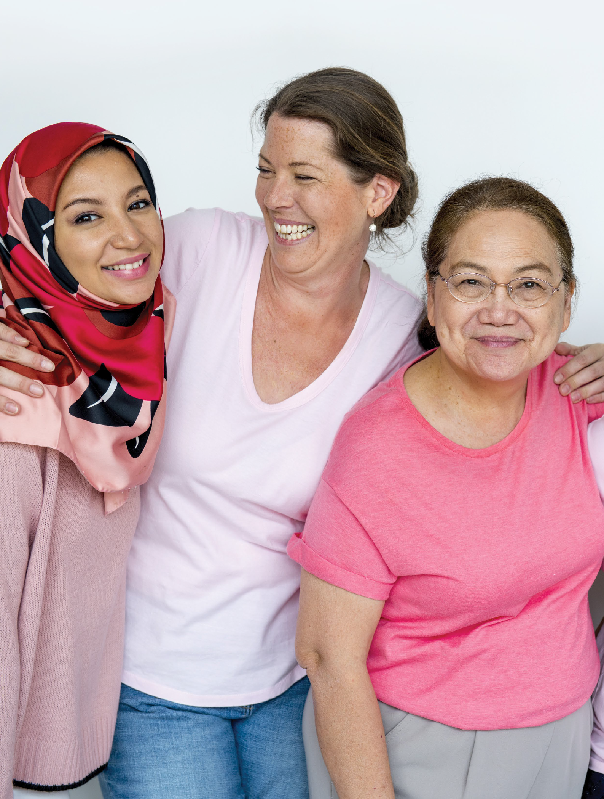
PAGE 27
NATIONAL STRATEGY FOR THE ELIMINATION OF CERVICAL CANCER IN AUSTRALIA

PAGE 28
NATIONAL STRATEGY FOR THE ELIMINATION OF CERVICAL CANCER IN AUSTRALIA
Note: italicised words indicate where the action has been tailored for this population.

ABORIGINAL AND TORRES STRAIT ISLANDER PEOPLE: STRATEGIC
PRIORITIES AND ACTIONS

Ensure that Australia has access to timely and accurate cervical cancer incidence and mortality data.
    - Review the timeliness of cervical cancer notifications from each of the state and territory cancer registers to the Australian Cancer Database (ACD) and investigate opportunities to accelerate the availability of national cervical cancer data. Aim to have the data from the preceding year available by November 1st of each calendar year.
    - Ensure that this accelerated reporting also includes currently reported stratifications, including rates for Aboriginal and Torres Strait Islander people, by remoteness, by socio-economic status and by all states and territories.
    - Build on the currently available breakdowns to ensure timely reporting of cancer incidence and mortality for Aboriginal and Torres Strait Islander people in all jurisdictions, people of culturally and linguistically diverse backgrounds, people with disability, people who identify as lesbian, gay, bisexual, transgender, queer, and asexual, people who are intersex, and other priority populations as these data become available.
    - Add cancer registry data into the data assets that are included as enduring linkages in the Multi- Agency Data Integration Project (MADIP) to facilitate this. When cancer data are included in MADIP, consider reporting on individual-level socioeconomic status, rather than area-level measures. Facilitate
dissemination of disaggregated data and key findings to Aboriginal and Torres Strait Islander communities in timely and culturally safe ways.

Vaccination

Optimise the delivery of school-based HPV immunisation programs in all jurisdictions to maximise equity and achieve high coverage for all Aboriginal and Torres Strait Islander students.
    - In partnership with Aboriginal and Torres Strait Islander health and communication experts, review and revise communication planning materials for Aboriginal and Torres Strait Islander students and their communities and provide educational opportunities in schools and communities to improve Aboriginal and Torres Strait Islander adolescent, parent, family and caregiver as well as school staff understanding of HPV vaccination and the elimination strategy. This should occur through strong partnerships between health and education to provide
an integrated approach to HPV vaccination literacy that spans key learning areas, is supported by a whole-of- school approach, and fosters health literacy.10
    - Utilise technology to support digital reminders and put clear communication and follow-up protocols in place to ensure that the school and the consenting carer are aware when a vaccine dose has been missed and that they then receive clear remedial instructions, including how to access vaccination locally through Aboriginal Community Controlled Health Organisations (ACCHOs) and other culturally appropriate services.

- Coordinated with actions 5.1 and 8.1

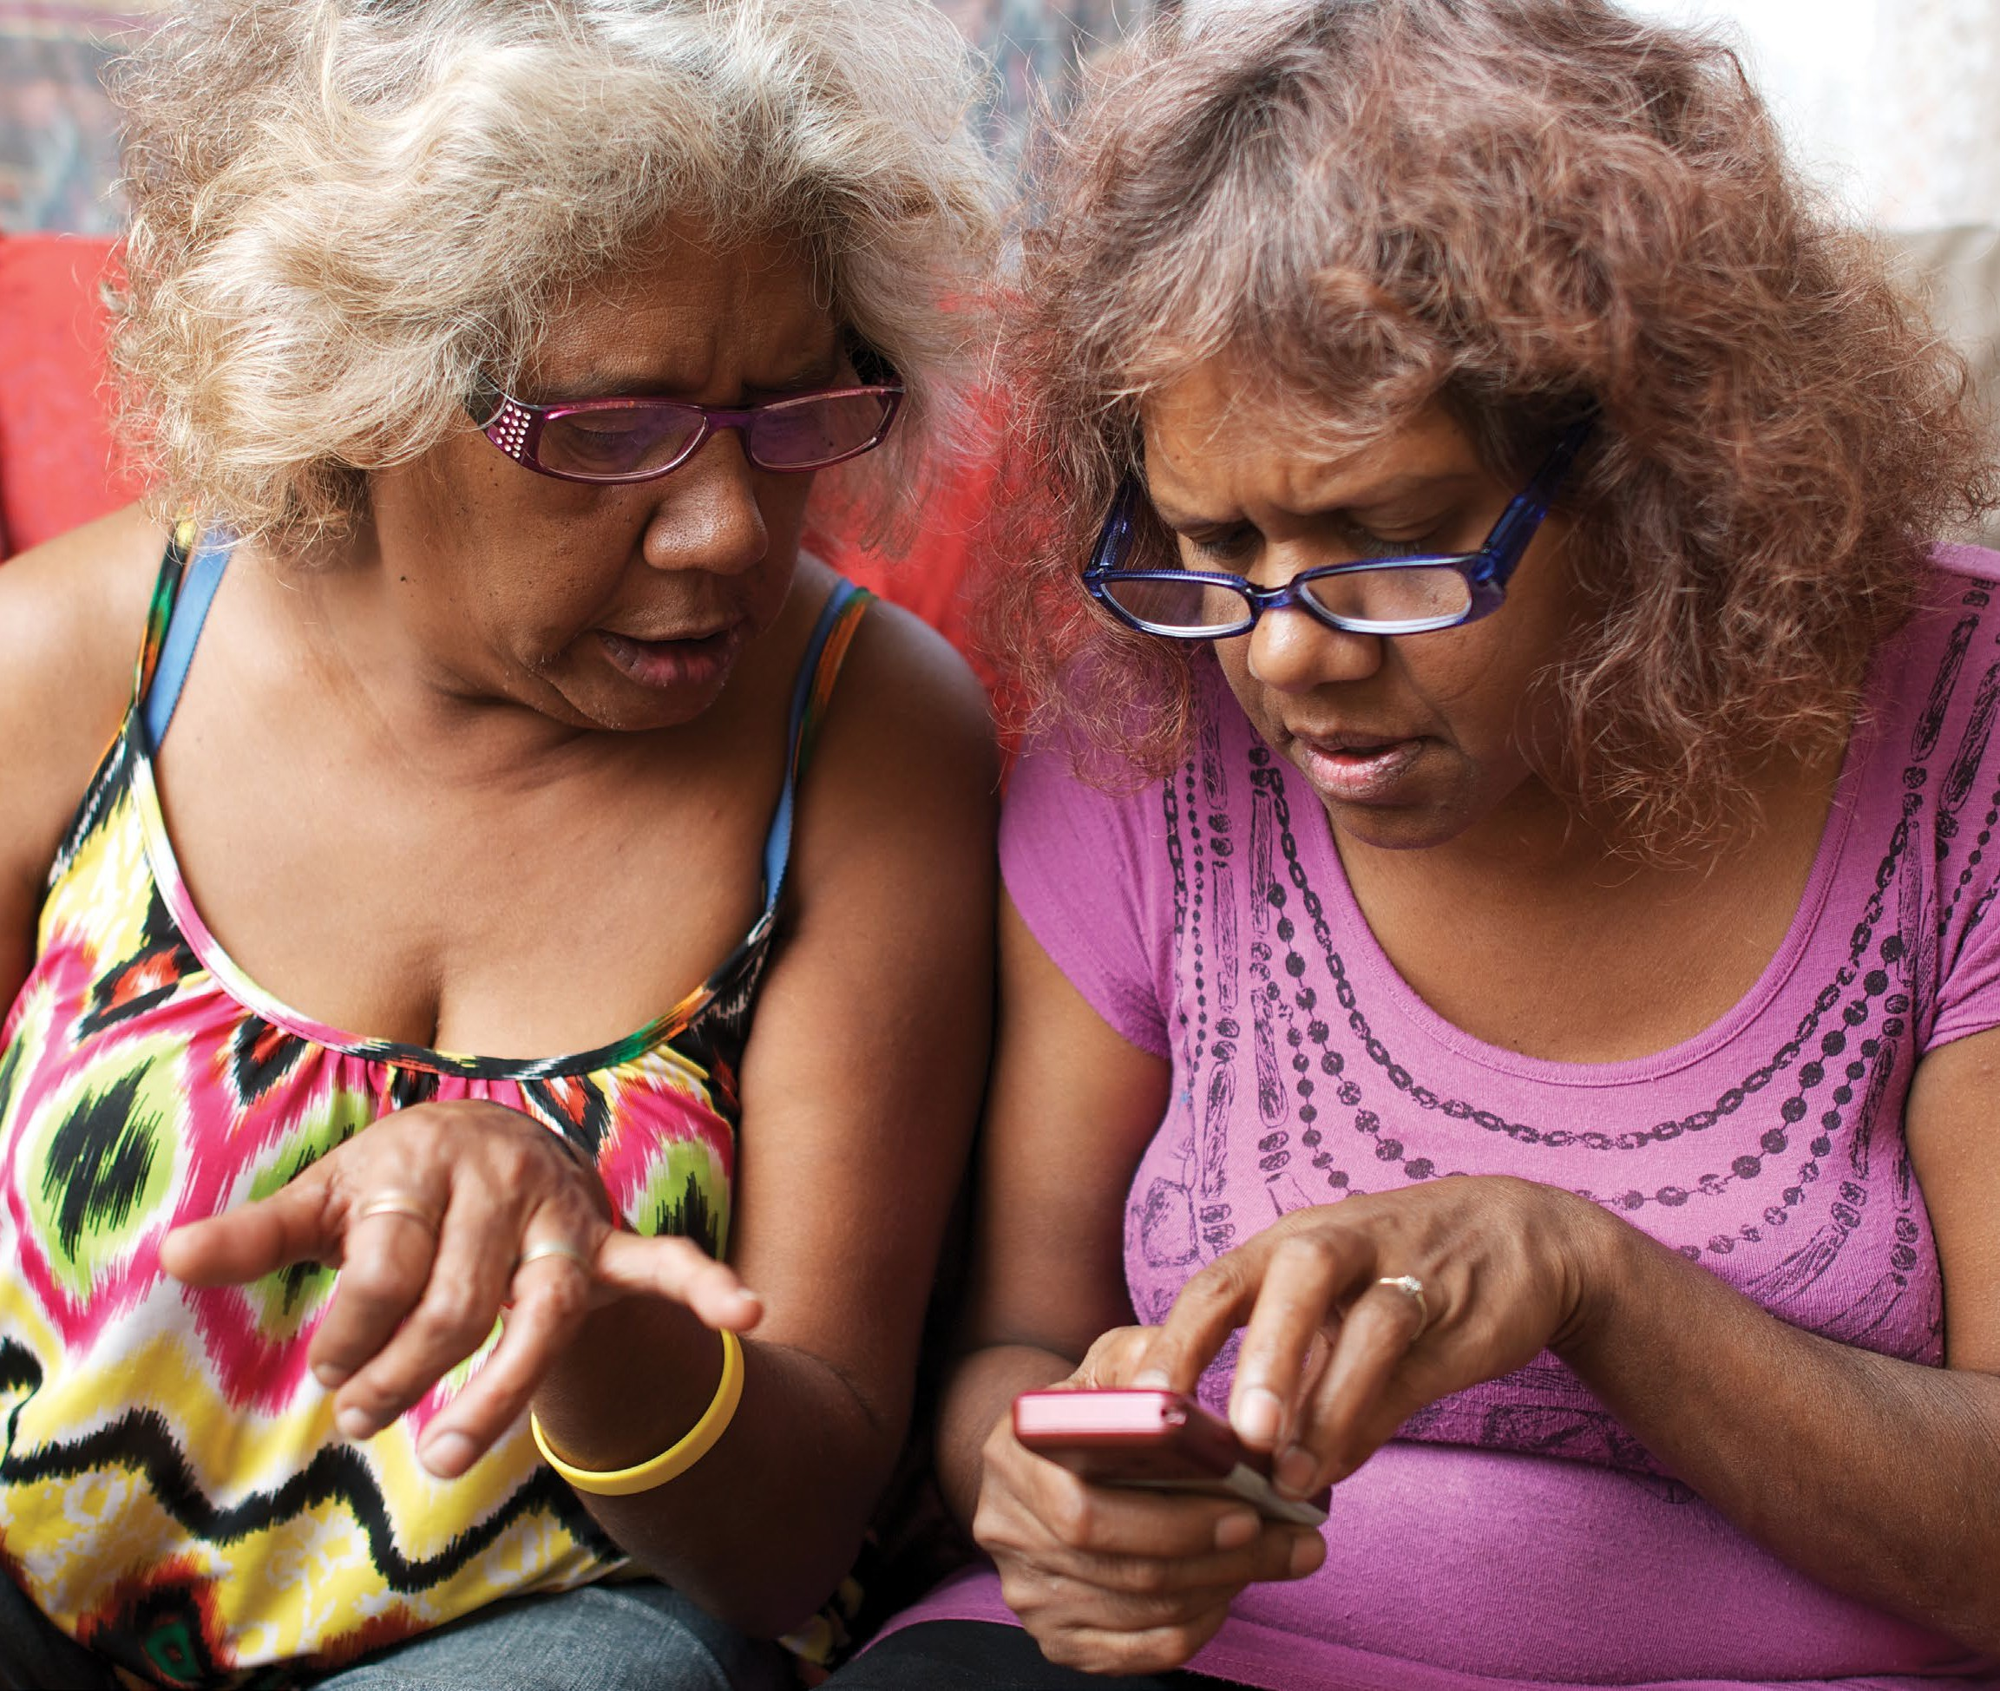
PAGE 29
NATIONAL STRATEGY FOR THE ELIMINATION OF CERVICAL CANCER IN AUSTRALIA

    - Provide in-school vaccination catch-up opportunities where possible. Should a single dose vaccination strategy be introduced, ensure that the implementation plan does not reduce opportunities for in- school vaccination as part of the reduction in required doses; and that the evidence of equal efficacy is communicated clearly to providers and the community.
    - Fund and develop routine program processes that can identify schools with lower coverage and develop tailored solutions to improve HPV vaccination uptake, including working in partnership with Aboriginal and Torres Strait Islander community-controlled services, peak bodies and community. Fund and support Aboriginal liaison staff with dedicated time in schools to promote engagement with vaccination. Build on the strengths
of the ACCHO sector and their leadership to develop tailored solutions that will support the acceptability, community support for, experience and understanding of school-based HPV vaccination among Aboriginal and Torres Strait Islander adolescents.

NATIONAL STRATEGY FOR THE ELIMINATION OF CERVICAL CANCER IN AUSTRALIA

PAGE 30

Optimise the reach and funding of complementary out-of-school HPV immunisation programs to achieve equity in delivery for all, including Aboriginal and Torres Strait Islander people and medically high-risk populations (catch-up).
    - Fund and promote HPV vaccine catch-up strategies with out-of-school Aboriginal and Torres Strait Islander people, their peak bodies, communities and ACCHOs. Ensure equity in availability of catch-up opportunities across jurisdictions and for the most marginalised groups, for example adolescents in youth detention. Consider alternative community locations and providers, for example GP clinic settings, ACCHOs, pharmacies, community events, and Aboriginal Immunisation Officers in Public Health Units. Develop workforce strategies to expand the reach of Aboriginal Health Practitioners.
    - Implement GP and health care provider education, training and quality improvement activities relating to immunisation that support routine use of the Australian Immunisation Register (AIR) data to check HPV vaccination status for all patients aged 14-19 years, address vaccine hesitancy, assess decision-making capacity among vaccine recipients for the decision to vaccinate, and ensure cultural competence to meet the needs of Aboriginal and Torres Strait Islander patients.

  - Develop a method to enable annual reporting of HPV vaccination coverage for Aboriginal and Torres Strait Islander people and medically high-risk populations to monitor equity in immunisation.
    - Leverage data linkage through the MADIP to monitor engagement, elimination progress and outcomes for
Aboriginal and Torres Strait Islander people, using demographic and other variables and a reference group to develop a community-accepted definition as to whether a person is identified as Aboriginal and/or Torres
Strait Islander within the linked dataset. Facilitate dissemination of key findings to Aboriginal and Torres Strait Islander communities in timely and culturally safe ways.

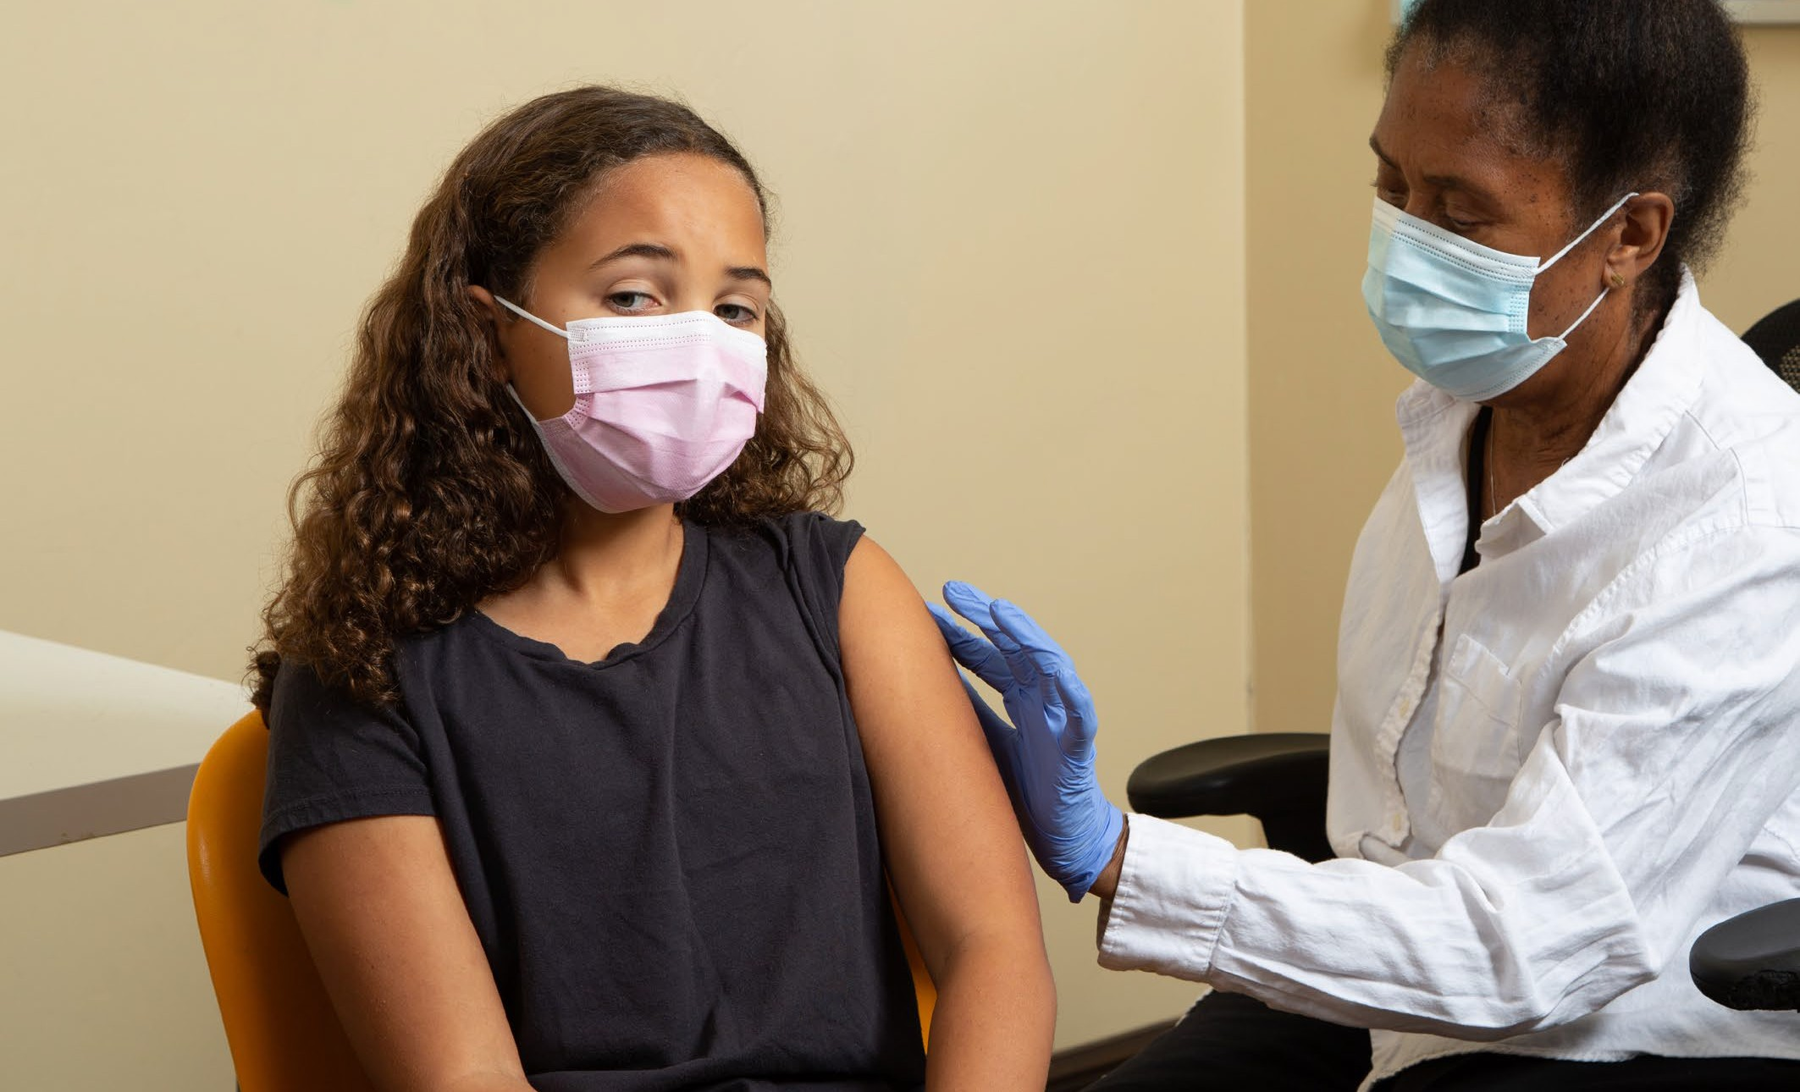

PAGE 31
NATIONAL STRATEGY FOR THE ELIMINATION OF CERVICAL CANCER IN AUSTRALIA

Screening and pre-cancer treatment

Promote cervical screening regularly with the public and strategically with under-screened groups.
    - Undertake regular targeted, tailored campaigns and activities for under-screened groups including campaigns and activities specifically focused on and designed by and for Aboriginal and Torres Strait Islander peoples, complemented by evidence-based, inclusive population-wide public awareness activities and mass media, delivered through appropriate channels.11
    - Work with priority communities, in particular Aboriginal and Torres Strait Islander peoples, including community leaders and community Elders, cervical cancer survivors, ACCHOs and other community-controlled organisations who serve these communities, to co-create, design and test best approaches to reach the community, including the content of campaigns and information materials. Ensure campaigns are informed by the success and implementation strategies from previous campaigns and formative research, noting that materials may need to enhance community health literacy about the purpose and function of the cervix.
    - Trial and utilise technology to support digital invitations, reminders, and navigation to follow-up activities for people with screening results that require further investigation.

  - Increase access to screening, colposcopy and follow-up for Aboriginal and Torres Strait Islander peoples by expanding who can offer these services, and where and how they are offered, to improve reach and uptake.
    - Provide a clear pathway to enable appropriately trained registered nurses, Aboriginal and Torres Strait Islander Health Workers, Aboriginal Health Practitioners and midwives to independently request and sign the pathology form for a cervical screening test (and be eligible for Medicare reimbursement). Expand the scope of practice for Aboriginal and Torres Strait Islander Health Workers and Aboriginal Health Practitioners to participate in the provision of screening services more actively.
    - Establish a clear national pathway to train and accredit registered nurses and GPs to provide colposcopy.
    - Fund and support ACCHOs to scale promotion, screening and follow-up services for and with community.
    - Resource a pilot to scale-up point-of-care HPV testing for remote communities, with links to care. Pilots in remote Aboriginal and Torres Strait Islander communities need to be developed with specific communities to meet their needs. Genuine community engagement, partnership and leadership is critical. See Screening Case Study 2 (The PREVENT Project) for an example.
    - Resource pilots and, where successful, resource scale-up and routine provision of innovative screening models such as peer-led and community-developed services and telehealth approaches. Work with community-controlled organisations, including ACCHOs, across a range of settings (urban, suburban and regional, as well as remote/very remote as noted in 6.4) to develop models, scale up successful models, and share best practice approaches.

- Coordinated with actions 2.1 and 8.1

NATIONAL STRATEGY FOR THE ELIMINATION OF CERVICAL CANCER IN AUSTRALIA

PAGE 32

  - Collect, use, and release data to enable and monitor equity of access to cervical screening and pre-cancer treatment services for Aboriginal and Torres Strait Islander peoples.
    - Routinely report all program indicators stratified by key population demographics including Aboriginal and/ or Torres Strait Islander status, expand reporting to include all priority populations, and introduce routine monitoring of performance against the WHO pre-cancer treatment indicator.
    - Promote the importance of data collection, training all staff to collect demographic data sensitively in order to improve the recording of all demographic fields (such as Aboriginal and/or Torres Strait Islander status, country of birth and gender), additional fields not yet captured on the NCSR and information that affects clinical management (such as immune status). Aboriginal and Torres Strait Islander people should lead the development of training, and data collection should align with standard questions and ethnicity data protocols, including the National Agreement on Closing the Gap.
    - Enhance clinical information systems in primary health care settings to enable automated uploading for relevant demographic information to integrate with NCSR.
    - Add cancer registry data and screening data from the NCSR into the data assets that are included as enduring linkages in the MADIP. There are limitations with using routinely collected data for this purpose and different data collections may contain differing Aboriginal and/or Torres Strait Islander identification for an individual. Data governance must include Aboriginal and/or Torres Strait Islander people to optimise how to resolve these differences to maximise the utility, safety and validity of the data, from the perspectives of monitoring health care for an individual, and data sovereignty principles.
    - Enable clinicians and healthcare services to readily generate reports that can support continuous quality improvement initiatives through identifying patients who are under-screened and indicating current participation rates to inform efforts that drive engagement.
    - Provide visibility to primary health care providers of current waiting times for colposcopy services, so that this can be factored into referrals and improve timeliness of care. Consider whether services are culturally safe and appropriate, and individual circumstances, such as the need for travel.

PAGE 33
NATIONAL STRATEGY FOR THE ELIMINATION OF CERVICAL CANCER IN AUSTRALIA

Treatment

Ensure communities and patients have equitable access to quality information about cervical cancer symptoms and that each cancer patient has tailored information about their diagnosis, intended treatment and planned optimal care pathway.
    - Promote public understanding of cervical cancer signs and symptoms, the role of early detection and the opportunity for cure through working in partnerships with Aboriginal and Torres Strait Islander people and community-controlled services.12
    - Provide information, consultation, and support (for example, utilising the expertise of Aboriginal and Torres Strait Islander health workers and practitioners, nurses, allied health professionals) such that patients and their families/carers fully understand and contribute their own preferences and needs to their individual care pathway, ensuring cultural competence to meet the needs of Aboriginal and Torres Strait Islander patients and their families.
    - Provide patients with the information, access to financial support and support personnel they need to navigate the health system, including informing them that they can have a person/people of their choice accompanying them whenever needed, as well as providing access to Aboriginal and Torres Strait liaison staff within the health system. Expand the inclusion and involvement of Aboriginal and Torres Strait Islander Health Workers and Practitioners within the wider health system to improve cultural safety for Aboriginal and Torres Strait Islander patients.
    - Facilitate continual quality improvement by conducting routine patient-related evaluation measures (PREMs) to assess patient satisfaction, feeding results back to shape training and development of personnel, patient-information materials and health service systems as appropriate. Aboriginal and Torres Strait Islander people should lead the development of relevant training materials. Ensure information collected captures patient diversity and experiences according to their sex, gender and sexual orientation, ethnicity, Aboriginal and Torres Strait Islander status, and disability status. Ensure this information accords to national standards
for data collection.

Develop and implement a road map of coordinated care, with communities of practice, to optimise the delivery of safe, quality care to all patients.
    - Realise a coordinated approach to patient care from diagnosis to survivorship and palliative care that is tailored to local population needs and diversity. This includes: identifying and meeting the training and resourcing needs of key professionals (including but not limited to ensuring access to culturally safe services and a supportive workforce for Aboriginal and Torres Strait Islander peoples; inclusive and
accessible care for those with disability; in-language culturally relevant resources and provision of care for culturally and linguistically diverse communities and; sex, gender and identity-sensitive services and care forLGBTQ+ people and people who are intersex); and supporting culturally safe patient journeys and transition of care between primary, secondary, tertiary and quaternary services.
    - Establish communities of practice, where multidisciplinary teams oversee processes and standards of care, and take responsibility for actively building relationships within and across jurisdictions, ensuring services are culturally safe and appropriate for Aboriginal and Torres Strait Islander peoples. This can enable a level of safety and trust when a patient with pre-cancer or cancer is required to travel to receive quality care. Tertiary centres should actively nurture relationships with services expert in caring for priority populations (for example, ACCHOs, LGBTQ+ specialised health services).

- Coordinated with actions 2.1 and 5.1

NATIONAL STRATEGY FOR THE ELIMINATION OF CERVICAL CANCER IN AUSTRALIA

PAGE 34

    - Optimise a hub-and-spoke model ensuring continuity of care for those diagnosed with cervical cancer to bring “quality to patients” where possible (for example palliative care) and “patients to quality” where
necessary for highly specialist care (for example brachytherapy), ensuring access to culturally safe services and a supportive workforce for Aboriginal and Torres Strait Islander peoples. Noting that palliative care services should be integrated into all levels of health care systems including primary care.
    - Identify and leverage quick wins by translating successful service models to new jurisdictions and ensure longer-term solutions that may require policy change or workforce reforms. Consider appropriately funded models aimed at addressing workforce issues, such as building an additional supportive role for gynaecologic nurses. Genuine partnership with priority populations and communities will improve the provision of culturally safe and inclusive care and enhance access to treatment.

Drive improvements in cervical cancer management through a data collection framework supporting systematic monitoring and enhancement of the quality of care, in alignment with the Australian Cancer Plan, the National Aboriginal and Torres Strait Islander Cancer Plan and National Agreement on Closing the Gap.
    - Enhance and harness the data collected in the NGOR cervical cancer module to inform continuous improvement in care (equity of access, quality, and safety) based on incidence, stage and mortality data, key clinical quality indicators, as well as patient reported evaluation and outcome measures (PROMs). Facilitate dissemination of disaggregated data and key findings to Aboriginal and Torres Strait Islander communities in timely and culturally safe ways.
    - Conduct annual cervical cancer audits using data from the NCSR, cancer registries and NGOR together with HPV genotype information determined and reported for all cervical cancers.
    - Consolidate current clinical guidance and quality standards through developing national guidelines for the management of cervical cancer and utilise the NGOR to monitor adherence.

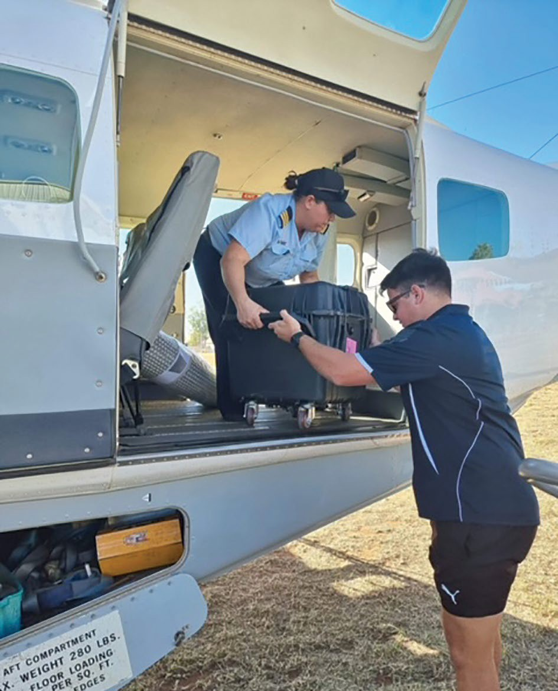

PAGE 35
NATIONAL STRATEGY FOR THE ELIMINATION OF CERVICAL CANCER IN AUSTRALIA

CULTURALLY AND LINGUISTICALLY DIVERSE PEOPLE (CALD):
STRATEGIC PRIORITIES AND ACTIONS
Note: italicised words indicate where the action has been tailored for this population.

Ensure that Australia has access to timely and accurate cervical cancer incidence and mortality data.
    - Review the timeliness of cervical cancer notifications from each of the state and territory cancer registers to the Australian Cancer Database (ACD), and investigate opportunities to accelerate the availability of national cervical cancer data. Aim to have the data for the preceding year available by 1st November
each calendar year.
    - Ensure that this accelerated reporting also includes currently reported stratifications including rates for Aboriginal and Torres Strait Islander people, by remoteness, by socio-economic status and by state and territory.
    - Build on the currently available breakdowns to ensure timely reporting of cancer incidence and mortality for Aboriginal and Torres Strait Islander people in all jurisdictions, people of CALD backgrounds, people with disability, people who identify as lesbian, gay, bisexual, transgender, queer, and asexual, people who are intersex, and other priority populations as these data become available.
    - Add cancer registry data into the data assets that are included as enduring linkages in the Multi-Agency Data Integration Project (MADIP) to facilitate this. When cancer data are included in MADIP, consider reporting on individual-level socioeconomic status, rather than area-level measures.

Vaccination

  - Optimise the delivery of school-based HPV immunisation programs in all jurisdictions to maximise equity and achieve high coverage for students from CALD backgrounds.
    - Review and revise communication planning materials for students from CALD backgrounds and their communities, and provide educational opportunities in schools in a culturally safe and appropriate way, and in language, if necessary, to improve adolescent, parent, family, and caregiver as well as school staff understanding of HPV vaccination and the elimination strategy. This should occur through strong
partnerships between health and education to provide an integrated approach to HPV vaccination literacy that spans key learning areas, is supported by a whole-of-school approach, and fosters health literacy.13
    - Utilise technology to support digital reminders and put clear communication and follow-up protocols in place to ensure that schools and consenting caregivers are aware when a vaccine dose has been missed and receive clear instruction on how to catch-up, including how to access vaccination locally through General Practitioners, community health services and other organisations that provide culturally safe and appropriate services to people from CALD backgrounds.

- Coordinated with actions 5.1 and 8.1

NATIONAL STRATEGY FOR THE ELIMINATION OF CERVICAL CANCER IN AUSTRALIA

PAGE 36

    - Provide in-school vaccination catch-up opportunities where possible. From 2023 a single dose HPV vaccine schedule has been introduced; the implementation plan for single dose vaccination should provide for opportunities for in-school vaccination to ensure individuals who miss doses have more opportunities to be vaccinated. Fund and develop routine program processes that can identify lower coverage schools and develop tailored solutions to improve local coverage.
    - Fund and develop routine program processes that can identify schools with lower coverage and develop tailored solutions to improve HPV vaccination uptake, including working in partnership with CALD community health champions, peak bodies and communities. Fund and support CALD and other liaison staff with dedicated time in schools to promote engagement with vaccination. Build on the strengths of the community health sector and their leadership to develop tailored solutions that will support the acceptability, community support for, experience and understanding of school-based HPV vaccination among CALD adolescents.

  - Optimise the reach and funding of complementary out-of-school HPV immunisation programs to achieve equity in delivery for all, including people from CALD backgrounds, refugees and asylum seekers and medically high-risk populations (catch-up).
    - Fund, implement and promote HPV vaccine catch-up strategies with out-of-school adolescents including those from CALD backgrounds, refugees and asylum seekers, their peak bodies, health services and communities. Ensure equity in availability of catch-up opportunities across jurisdictions and for the most marginalised groups, for example, adolescents in youth detention. Consider alternative community locations, events and providers potentially in tandem with screening, for example, GP clinic settings, pharmacies, community health services and develop workforce strategies to expand reach.
    - Implement GP and healthcare provider education, training and quality improvement activities relating to immunisation that support routine use of the Australian Immunisation Register (AIR) data to check
HPV vaccination status for all patients aged 14-19 years, address vaccine hesitancy, and assess decision- making capacity among vaccine recipients for the decision to vaccinate, including familiarity with HPV vaccine catch-up schedules for migrants, refugees and asylum seekers.

Develop a method to enable annual reporting of HPV vaccination coverage for people from CALD backgrounds and medically high-risk populations to monitor equity in immunisation.
    - Leverage data linkage through the MADIP to monitor engagement, elimination progress and outcomes
for people from culturally and linguistically diverse backgrounds, using demographic and other variables and a reference group to develop community-accepted definitions as to whether a person is identified as part of a CALD community within the linked dataset.

PAGE 37
NATIONAL STRATEGY FOR THE ELIMINATION OF CERVICAL CANCER IN AUSTRALIA


Screening and pre-cancer treatment

Promote cervical screening regularly with the public and strategically with under-screened groups including CALD people.
    - Undertake regular targeted tailored campaigns and activities for under-screened groups including campaigns and activities specifically focused on and designed by and for CALD people, complemented by evidence-based, inclusive population-wide public awareness activities and mass media delivered through appropriate channels.14
    - Work with priority communities, including a range of respected community members, community influencers, cervical cancer survivors and people with lived experience of cervical abnormalities from CALD peoples, and community-based organisations that serve these communities, to co-develop campaign and information materials, and come up with best approaches to reach the community, including the content (language
and visual) of campaigns and information materials. Ensure campaigns are informed by the success and implementation strategies from previous campaigns and formative research, noting that materials may need to acknowledge female genital cutting/mutilation (FGC/M) and its resultant effects on screening participation, and enhance the community health literacy about HPV and cancer of the cervix.
    - Trial and utilise technology to support digital invitations, reminders, and navigation to follow-up activities for CALD people with screening results that require further investigation, recognising the extra support that this group may require.

- Coordinated with actions 2.1 and 8.1

NATIONAL STRATEGY FOR THE ELIMINATION OF CERVICAL CANCER IN AUSTRALIA

PAGE 38

Increase access to screening, colposcopy and follow-up for CALD people by expanding who can offer these services, and where and how they are offered, to improve reach and uptake.
    - Provide a clear pathway to enable appropriately trained registered nurses, Aboriginal Health Workers and Practitioners, and midwives to independently request and sign the pathology form for a cervical screening test (and be eligible for Medicare reimbursement).
    - Establish a clear national pathway to train and accredit registered nurses and GPs to provide colposcopy.
    - Resource a pilot to scale up point-of-care HPV testing, with links to care, for remote communities.
    - Resource pilots and, where successful, resource scale-up and routine provision of innovative screening models such as peer-led and community-developed services. Work with community-based organisations that provide services to CALD people to develop models, scale up successful models, and share best practice approaches. Deliver targeted solutions to people arriving from countries with no screening programs or FGC/M practices to address issues/concern/disparities associated with stigma, discrimination and trauma when providing cervical screening, including self-collection.

Collect, use and release data to enable and monitor equity of access to cervical screening and pre-cancer treatment services for CALD people.
    - Routinely report all program indicators stratified by key population demographics, expand reporting to include all priority populations, including CALD people, and introduce routine monitoring of performance against the WHO pre-cancer treatment indicator. Work with a reference group representing culturally and linguistically diverse people to develop appropriate stratification of indicators that balance granularity and meaningful differences with the availability, validity and size of data for different measures.
    - Promote the importance of data collection on cultural and linguistic diversity, and train all staff to collect demographic data sensitively in order to improve the recording of all demographic fields (Aboriginal and/ or Torres Strait Islander status, country of birth, language spoken at home, gender). This can be expanded to include additional fields not yet captured on the NCSR and information that affects clinical management such as immune status.
    - Enhance clinical information systems in primary health care settings to enable automated uploading for relevant demographic information to integrate with NCSR.
    - Add cancer registry data and screening data from the NCSR into the data assets that are included as enduring linkages in the MADIP. There are limitations with using routinely collected data for this purpose and the different routine data collections may contain differing information about an individual. Data governance should include representatives from CALD communities to optimise how to resolve these differences and maximise the utility and validity of the data, from the perspectives of both monitoring and health care for
an individual.
    - Enable clinicians and healthcare services to readily generate reports that can support continuous quality improvement initiatives by identifying patients who are under-screened and indicate current participation rates in terms of priority population to inform efforts that drive engagement.
    - Provide visibility to primary care providers of current waiting times for colposcopy services, so that this can be factored into referrals and improve timeliness of care. Take an individual’s cultural and language needs, including for translation, into account when referring.

PAGE 39
NATIONAL STRATEGY FOR THE ELIMINATION OF CERVICAL CANCER IN AUSTRALIA

Treatment

Ensure communities and patients have equitable access to quality information about cervical cancer symptoms and that each cancer patient has tailored information about their diagnosis, intended treatment and planned optimal care pathway.
    - Promote public understanding of cervical cancer signs and symptoms, the role of early detection and the opportunity for cure including campaigns and activities specifically focused on, and designed by and for, CALD people. Including providing the information in the primary language of key communities to increase CALD communities’ understanding of cervical cancer and reduce the stigma and fear associated with a cervical cancer diagnosis by reiterating that most cervical cancers can be successfully treated if detected early.15
    - Provide information, consultation, and extra support CALD people may require in navigating health services (for example, utilising the expertise of nurses and allied health professionals) such that patients and their families/carers fully understand, voice their needs, and contribute to a patient-centred care pathway. The information should be designed by and be specifically for CALD people.
    - Provide patients with the information and access to financial support and support personnel for navigating the health system. This includes information regarding having a person/people of their choice accompanying them whenever needed and that an interpreter will always be provided, in person whenever possible. Information provided should be designed by and for culturally and linguistically diverse people.

    - Enable incremental improvement by conducting routine patient-related evaluation measures (PREMs) to assess patient satisfaction, feeding results back to shape training and development of personnel, patient information materials and health service systems as appropriate. Ensure information collected captures patient diversity and experiences relevant for CALD people. Ensure this information accords to national standards for data collection.

- Coordinated with actions 2.1 and 5.1

NATIONAL STRATEGY FOR THE ELIMINATION OF CERVICAL CANCER IN AUSTRALIA

PAGE 40

Develop and implement a road map of coordinated care, with communities of practice, to optimise the delivery of safe, quality care to all patients.
8.9.1 Realise a coordinated approach to patient care from diagnosis to survivorship and palliative care that is tailored to local population needs and diversity. This includes identifying and meeting the training and resourcing needs of key professionals (including but not limited to in-language culturally relevant resources and provision of care for CALD communities).
    - Establish communities of practice, where multidisciplinary teams oversee processes and standards of care, and take responsibility for actively building relationships within and across jurisdictions. This can enable a level of safety and trust when a patient with pre-cancer or cancer is required to travel to receive quality care. Tertiary centres should actively nurture relationships with services expert in caring for priority populations, which will require liaising with specialised community-controlled organisations for CALD people. It will also require engagement with community leaders, community influencers and being aware of cultural differences that may prevent some patients from accessing optimal care.
    - Optimise a hub-and-spoke model ensuring continuity of care for those diagnosed with cervical cancer to bring “quality to patients” where possible (for example palliative care) and “patients to quality” where
necessary for highly specialist care (for example brachytherapy). The design of these models should include representation from CALD people.
    - Identify and leverage quick wins by translating successful service models to new jurisdictions and ensure longer-term solutions that may require policy change or workforce reforms. Consider appropriately funded models aimed at addressing workforce issues, such as building an additional supportive role for gynaecology nurses. Genuine partnership with priority populations and communities will improve the provision of culturally safe and inclusive care and enhance access to treatment.

Drive improvements in cervical cancer management through a data collection framework supporting systematic monitoring and enhancement of the quality of care, in alignment with the Australian Cancer Plan.

    - Enhance and harness the data collected in the NGOR cervical cancer module to inform continuous improvement in care (equity of access, quality, and safety) based on incidence, stage, and mortality data, key clinical quality indicators, as well as patient reported evaluation and outcome measures (PROMs). Where feasible, data on patients’ country of birth, duration of time living in Australia, first language and language spoken at home, should be collected.
    - Conduct annual cervical cancer audits using data from the NCSR, cancer registries and NGOR together with HPV genotype information determined and reported for all cervical cancers.
    - Consolidate current clinical guidance and quality standards through developing national guidelines for the management of cervical cancer and utilise the NGOR to monitor adherence.

PAGE 41
NATIONAL STRATEGY FOR THE ELIMINATION OF CERVICAL CANCER IN AUSTRALIA

PEOPLE WHO ARE LGBTQ+ AND PEOPLE WHO ARE INTERSEX:
STRATEGIC PRIORITIES AND ACTIONS

Note: italicised words indicate where the action has been tailored for this population.

Ensure that Australia has access to timely and accurate cervical cancer incidence and mortality data.
    - Review the timeliness of cervical cancer notifications from each of the state and territory cancer registers to the Australian Cancer Database (ACD) and investigate opportunities to accelerate the availability of national cervical cancer data. Aim to have the data for the preceding year available by November 1st of each calendar year.
    - Ensure that this accelerated reporting also includes currently reported stratifications including rates for Aboriginal and Torres Strait Islander people, by remoteness, by socio-economic status, and by state and territory.
    - Build on the currently available breakdowns to ensure timely reporting of cancer incidence and mortality for Aboriginal and Torres Strait Islander people in all jurisdictions, people of culturally and linguistically
diverse backgrounds, people living disability, people who identify as lesbian, gay, bisexual, transgender, queer, and asexual, people who are intersex, and other priority populations as these data become available. Use Australian Bureau of Statistics (ABS) Standards for Sex, Gender, Variations of Sex Characteristics and Sexual Orientation Variables16 when recording information to ensure comparability and compatibility between data sets related to the health of LGBTQ+ and intersex people across disease types.
    - Add cancer registry data into the data assets that are included as enduring linkages in the Multi-Agency Data Integration Project (MADIP) to facilitate this. When cancer data are included in MADIP, consider reporting on individual-level socioeconomic status, rather than area-level measures.


- Australian Bureau of Statistics. Standard for Sex, Gender, Variations of Sex Characteristics and Sexual Orientation Variables [Internet]. Canberra: ABS; 2020 [cited 2022 November 7]. Available from: https://www.abs.gov.au/statistics/standards/standard-sex-gender-variations-sex-characteristics-and-sexual- orientation-variables/latest-release.

NATIONAL STRATEGY FOR THE ELIMINATION OF CERVICAL CANCER IN AUSTRALIA

PAGE 42

Vaccination

  - Optimise the delivery of school-based HPV immunisation programs in all jurisdictions to maximise equity and achieve high coverage including for students who already identify

as LGBTQ+ or who are intersex.
    - Review and revise communication planning materials and provide educational opportunities in schools to ensure language used is inclusive, and make it clear the HPV vaccination is relevant and important for everyone including students who identify as LGBTQ+ or are intersex. These communications should target adolescents, parents, family and caregivers as well as school staff to increase understanding of HPV,
HPV vaccination and the elimination strategy through strong partnerships between health, education and non-government organisations towards an integrated approach to HPV vaccination literacy that spans key learning areas, is supported by a whole-of-school approach, and fosters health literacy.17
    - Utilise technology to support digital reminders and put clear communication and follow-up protocols in place to ensure that the school and the consenting carer are aware when a vaccine dose has been missed and then receive clear remedial instructions, including how to access vaccination through LGBTQ+ and intersex specific community health services and other LGBTQ+ and intersex-friendly services.
    - Provide in-school vaccination catch-up opportunities where possible. From 2023 a single dose HPV vaccine schedule has been introduced; the implementation plan for single dose vaccination should provide for opportunities for in-school vaccination to ensure individuals who miss doses have more opportunities to be vaccinated. Fund and develop routine program processes that can identify lower coverage schools and develop tailored solutions to improve local coverage.
    - Fund and develop routine program processes that can identify schools with lower coverage and develop tailored solutions to improve HPV vaccination uptake, including working in partnership with LGBTQ+ and intersex-friendly health services, peak bodies, community and youth support such as youth mental health and homeless services.


- Coordinated with actions 5.1 and 8.1

PAGE 43
NATIONAL STRATEGY FOR THE ELIMINATION OF CERVICAL CANCER IN AUSTRALIA



  - Optimise the reach and funding of complementary out-of-school HPV immunisation programs to achieve equity in delivery for all, including people who already identify as LGBTQ+ or who are intersex and medically high-risk populations (catch-up).
    - Fund and promote HPV vaccine catch-up strategies with out-of-school adolescents including those who identify as LGBTQ+ or who are intersex, their peak bodies, health services and communities. Ensure equity in availability of catch-up opportunities across jurisdictions and for the most marginalised groups, for example, adolescents in youth detention. Consider alternative community locations and providers, for example, GP clinic settings, Aboriginal Community Controlled Health Organisations, LGBTQ+ and intersex health organisations, pharmacies and community events, potentially in tandem with screening. Develop workforce strategies to expand reach, for example, sexual health nurses.
    - Implement GP and LGBTQ+ and intersex health care provider education, training and quality improvement activities relating to immunisation that support routine use of the Australian Immunisation Register (AIR) data to check HPV vaccination status for all patients aged 14-19 years, address vaccine hesitancy, and assess decision-making capacity among vaccine recipients for the decision to vaccinate.

  - To monitor equity in immunisation, develop a method to enable annual reporting of HPV vaccination coverage for people who identify as LGBTQ+ or who are intersex, and for medically high-risk populations.
    - Leverage data linkage through the MADIP, to monitor engagement, elimination progress and outcomes for people who identify as LGBTQ+ or who are intersex, using demographic and other variables and reference groups to develop community accepted definitions and a consent process as to whether a person is identified as LBGTQ+ or intersex within the linked dataset.

NATIONAL STRATEGY FOR THE ELIMINATION OF CERVICAL CANCER IN AUSTRALIA

PAGE 44

Screening and pre-cancer treatment

Promote cervical screening regularly with the public and strategically with under-screened groups.
    - Undertake regular targeted, tailored campaigns and activities for under-screened groups, including campaigns and activities specifically focused on and designed by gender-diverse and sexuality-diverse people who have a cervix, complemented by evidence-based, inclusive population-wide public awareness activities and mass media, delivered through appropriate channels.18 Ensure that LGBTQ+ people and people who
are intersex are represented in any mass media and resources that are developed. Campaigns, websites and resources should use appropriate language and appropriate imagery (including choice of colours) to represent people with a cervix who are not cisgender women.
    - Work with LGBTQ+ and intersex communities, including respected community members, cervical cancer survivors, community-controlled LGBTQ+ and intersex organisations and specialised health services that serve LGBTQ+ and intersex communities, to co-create, design and test best approaches to reach the community, including the content of campaigns and information materials. Ensure campaigns are informed by the success and implementation strategies from previous campaigns and formative research. Materials may need to enhance community health literacy about HPV and cervical cancer.
    - Trial and utilise technology to support digital invitations, reminders, and navigation to follow-up activities for people with screening results that require further investigation.

  - Increase access to screening, colposcopy and follow-up for people who already identify as LGBTQ+ or who are intersex by expanding who can offer these services, and where and how they are offered, to improve reach and uptake.
    - Provide a clear pathway to enable appropriately trained registered nurses, sexual health nurses, Aboriginal Health Workers, Aboriginal Health Practitioners and midwives to be able to independently request and sign the pathology form for a cervical screening test (and be eligible for Medicare reimbursement).
    - Establish a clear national pathway to train and accredit registered nurses and GPs to provide colposcopy.
    - Resource a pilot to scale up point-of-care HPV testing, with links to care, for remote communities.
    - Resource pilots and, where successful, resource scale-up and routine provision of innovative screening models for people who identify as LGBTQ+ or who are intersex such as peer-led and community-developed services. Work with LGBTQ+ and intersex community organisations to develop models, scale up successful models, and share best practice approaches. Provide services that ensure culturally safe care from appointment through to screening and follow-up. Make people aware of what to expect at a screening visit and consider needs around a screening visit more holistically – for example establish culturally safe terminology, develop strategies that an individual can use to signal to the provider during the procedure if they feel unsafe or want it to stop, and provide post-screening counselling for people who may be triggered by screening. Provide options for people including bringing a friend for support, inserting the speculum themselves, requesting a smaller speculum, and self-collection.

- Coordinated with actions 2.1 and 8.1

PAGE 45
NATIONAL STRATEGY FOR THE ELIMINATION OF CERVICAL CANCER IN AUSTRALIA

  - Collect, use, and release data to enable and monitor equity of access to cervical screening and pre-cancer treatment services for people who identify as LGBTQ+ or who are intersex.
    - Routinely report all program indicators stratified by key population demographics, expand reporting to include all priority populations, including people who identify as LGBTQ+ or who are intersex, and introduce routine monitoring of performance against the WHO pre-cancer treatment indicator. In order to routinely report on program indicators separately for gender-diverse people with a cervix, this information needs to be captured. The NCSR can record gender, but it is unclear to what extent the data are accurate or complete. Some measures will not be able to be routinely reported until the recommendations for incorporating gender identification are adopted into the national Census.
There is not yet the explicit capacity on the NCSR to record diversity of sexuality. Approaches to adequately monitor progress towards elimination targets for this group need to be developed in collaboration with the LGBTQ+ and intersex community, as use of routine data may not be the most appropriate approach.
Use ABS standards for Sex, Gender, Variations of Sex Characteristics and Sexual Orientation Variables when recording information to ensure comparability and compatibility between data sets related to the
health of LGBTQ+ and intersex people across disease types. The best ways of capturing and reporting data to reflect the experiences of the diverse LGBTQ+ and intersex communities should be developed in consultation with those communities, and may require control by the individual over who can view the data collected.
    - Promote the importance of data collection on gender diversity, training all staff to collect demographic data sensitively in order to improve the recording of all demographic fields (Aboriginal and/or Torres Strait Islander status, country of birth, gender), including additional fields not yet captured on the NCSR and
information that affects clinical management such as immune status. Training relating to routinely collecting information about gender should involve gender-diverse people. The best ways of capturing and reporting data on gender, and in enrolling people with a cervix who do not identify as women into the National Cervical Screening Program (NCSP), should be developed in consultation with gender-diverse people. This may require control by the individual over who can view the data collected.
Consult with trans men and other gender diverse people on appropriate ways and opportunities to use gender data captured on the NCSR or other health systems, such as tailoring routine communication from the NCSP – for example envelopes without NCSP branding may be preferred by trans men; or an LGBTQI+ health check could be offered (with triggers for GP to do comprehensive screening), to ensure all screening (including cervical screening) is done and individual’s needs are identified.
    - Enhance clinical information systems in primary health care settings to enable automated uploading for relevant demographic information to integrate with NCSR.
    - Add cancer registry data and screening data from the NCSR into the data assets that are included as enduring linkages in the MADIP including information on gender diversity, when the recommendations for incorporating gender identification are adopted into the national Census.
    - Enable clinicians and healthcare services to readily generate reports that can support continuous quality improvement initiatives by identifying patients who are under-screened and indicate current participation rates to inform efforts that drive engagement.
    - Provide visibility to primary care providers of current waiting times for colposcopy services, so that this can be factored into referrals and improve timeliness of care. Ensure there are appropriate, safe and inclusive colposcopy services available for people who identify as LGBTQ+ or who are intersex and provide information about how/where to find queer-friendly services for follow-up.



PAGE 46
NATIONAL STRATEGY FOR THE ELIMINATION OF CERVICAL CANCER IN AUSTRALIA

Treatment

Ensure communities and patients have equitable access to quality information about cervical cancer symptoms and that each cancer patient has tailored information about their diagnosis, intended treatment and planned optimal care pathway.
    - Promote public understanding of cervical cancer signs and symptoms, the role of early detection and the opportunity for cure. Campaigns and activities should be specifically focused on and designed by gender- diverse and sexuality-diverse people and LGBTQ+ and intersex people should be represented in any mass media and resources that are developed. Campaigns, websites and resources should use appropriate language and appropriate imagery (including choice of colours) to represent people with a cervix who are not cisgender women.19
    - Provide information, consultation and support (for example, queer-friendly services and resources) such that patients and their families/carers fully understand and contribute their own preferences and needs to their individual care pathway.
    - Provide patients with the information, access to financial support and support personnel they need to navigate the health system, including informing them that they can have a person/people of their choice accompanying them whenever needed, as well as provide access to spaces where they feel safe and ensure that they are always addressed correctly. This awareness is particularly important for people with a cervix who are not cisgender women and are required to access care within a “women’s health” environment.
    - Enable incremental improvement by conducting routine patient-related evaluation measures (PREMs) to assess patient satisfaction, feeding results back to shape training and development of personnel, patient information materials and health service systems as appropriate. Ensure sensitively collected information captures patient diversity and experiences according to their sex, gender and sexual orientation. Ensure this information accords to national standards for data collection.

- Coordinated with actions 2.1 and 5.1

PAGE 47
NATIONAL STRATEGY FOR THE ELIMINATION OF CERVICAL CANCER IN AUSTRALIA

Develop and implement a road map of coordinated care, with communities of practice, to optimise the delivery of safe, quality care to all patients.
    - Realise a coordinated approach to patient care from diagnosis to survivorship and palliative care that is tailored to local population needs and diversity. This includes identifying and meeting the training and resourcing needs of key professionals (including but not limited to ensuring access to safe services and a supportive workforce for LGBTQ+ and intersex people reflecting sex, gender and identity-sensitive services and care). Consultation with trans men and other gender diverse people to assist with development of training and education of health professionals in trauma-informed care so that people from LGBTQ+ and intersex communities feel safe to access treatment.
    - Establish communities of practice, where multidisciplinary teams oversee processes and standards of care, and take responsibility for actively building relationships within and across jurisdictions. This can enable a level of safety and trust when a patient with pre-cancer or cancer is required to travel to receive quality care. Tertiary centres should actively nurture relationships with services expert in caring for priority populations (for example, LGBTQ+ and intersex specialised health services).
    - Optimise a hub-and-spoke model ensuring continuity of care for those diagnosed with cervical cancer to bring “quality to patients” where possible (for example palliative care) and “patients to quality” where
necessary for highly specialist care (for example brachytherapy). Queer-friendly services are key to ensure that the LGBTQ+ and intersex community feel respected and safe when accessing care. Noting that palliative care services should be integrated into all levels of health care systems including primary care.
    - Identify and leverage quick wins by translating successful service models to new jurisdictions and ensure longer-term solutions that may require policy change or workforce reforms. Consider appropriately funded models aimed at addressing workforce issues, such as building an additional supportive role for gynaecology nurses. Genuine partnership with priority populations and communities will improve the provision of culturally safe care and inclusive and enhance access to treatment.

Drive improvements in cervical cancer management through a data collection framework supporting systematic monitoring and enhancement of the quality of care, in alignment with the Australian Cancer Plan.
    - Enhance and harness the data collected in the NGOR cervical cancer module to inform continuous improvement in care (equity of access, quality, and safety) based on incidence, stage, and mortality data, key clinical quality indicators, as well as patient reported evaluation and outcome measures (PROMs). Data on patient gender and sexuality should be routinely collected by NGOR to enable monitoring of key clinical quality indicators to ensure equity for gender diverse and sexually diverse people.
    - Conduct annual cervical cancer audits using data from the NCSR, cancer registries and NGOR together with HPV genotype information determined and reported for all cervical cancers.
    - Consolidate current clinical guidance and quality standards through developing national guidelines for the management of cervical cancer and utilise the NGOR to monitor adherence.

PAGE 48
NATIONAL STRATEGY FOR THE ELIMINATION OF CERVICAL CANCER IN AUSTRALIA
Note: italicised words indicate where the action has been tailored for this population.

PEOPLE WITH DISABILITY: STRATEGIC PRIORITIES
AND ACTIONS

Ensure that Australia has access to timely and accurate cervical cancer incidence and mortality data.
    - Review the timeliness of cervical cancer notifications from each of the state and territory cancer registers to the Australian Cancer Database (ACD) and investigate opportunities to accelerate the availability of national cervical cancer data. Aim to have the data for the preceding year available by November 1st
of each calendar year.
    - Ensure that this accelerated reporting also includes currently reported stratifications including rates for Aboriginal and Torres Strait Islander people, by remoteness, by socio-economic status and by state and territory.
    - Build on the currently available breakdowns to ensure timely reporting of cancer incidence and mortality for Aboriginal and Torres Strait Islander people in all jurisdictions, people of culturally and linguistically diverse backgrounds, people with disability i.e., cognitive and/or physical impairment, people who identify as lesbian, gay, bisexual, transgender, queer, and asexual, people who are intersex, and other priority populations as these data become available.
    - Add cancer registry data into the data assets that are included as enduring linkages in the Multi-Agency Data Integration Project (MADIP) to facilitate this. When cancer data are included in MADIP, consider reporting on individual-level socioeconomic status, rather than area-level measures.




PAGE 49
NATIONAL STRATEGY FOR THE ELIMINATION OF CERVICAL CANCER IN AUSTRALIA

Vaccination

Optimise the delivery of school-based HPV immunisation programs in all jurisdictions to maximise equity and achieve high coverage for students with disability.
    - Review and revise communication planning materials such as decision aid tools for students with disability and their communities and provide educational opportunities in both mainstream and special schools to improve adolescent, parent, family and caregiver, and school staff understanding of HPV vaccination and the elimination strategy. This should occur through strong partnerships between health, education and
non-government organisations to provide an integrated approach to HPV vaccination literacy that spans key learning areas, is supported by a whole-of-school approach, and fosters health literacy.20
    - Utilise technology to support digital reminders and put clear communication and follow-up protocols in place to ensure that the school and the consenting carer are aware when a vaccine dose has been missed and receive clear remedial instructions, including how to access vaccination locally through services that meet the needs of students with disability.
    - Provide in-school vaccination catch-up opportunities where possible. From 2023 a single dose HPV vaccine schedule has been introduced; the implementation plan for single dose vaccination should provide for opportunities for in-school vaccination to ensure individuals who miss doses have more opportunities to be vaccinated. Fund and develop routine program processes that can identify lower coverage schools and develop tailored solutions to improve local coverage.
    - Fund and develop routine program processes that can identify schools with lower coverage and develop tailored solutions to improve HPV vaccination uptake, including working in partnership with disability health services, peak bodies and community.

Optimise the reach and funding of complementary out-of-school HPV immunisation programs to achieve equity in delivery for all, including people with disability and medically high-risk populations (catch-up).
    - Fund and promote HPV vaccine catch-up strategies with out-of-school adolescents including those with disability, their peak bodies, health services and communities. Ensure equity in availability of catch-up opportunities across jurisdictions and for the most marginalised groups, for example, adolescents in youth detention. Consider alternative community locations and providers, for example, GP clinic settings, Aboriginal Community Controlled Health Organisations, pharmacies, and community events, potentially in tandem with screening. Develop workforce strategies to expand reach, for example, inclusion of HPV vaccination in the scope of disability service providers and expansion of HPV vaccination nursing workforce to include community outreach.
    - Implement GP and disability service provider education, training and quality improvement activities relating to immunisation that support routine use of the Australian Immunisation Register (AIR) data to check
HPV vaccination status for all patients aged 14-19 years, address vaccine hesitancy, and assess decision- making capacity among vaccine recipients for the decision to vaccinate.

Develop a method to enable annual reporting of HPV vaccination coverage for people with disability and medically high-risk populations to monitor equity in immunisation.
    - Leverage data linkage through the MADIP to monitor engagement, elimination progress and outcomes for people with disability, using demographic and other variables and a reference group to develop community accepted definitions as to whether a person is identified as with disability within the linked dataset.

- Coordinated with actions 5.1 and 8.1

NATIONAL STRATEGY FOR THE ELIMINATION OF CERVICAL CANCER IN AUSTRALIA

PAGE 50

Screening and pre-cancer treatment

Promote cervical screening regularly with the public and strategically with under-screened groups.
    - Undertake regular targeted, tailored campaigns and activities for under-screened groups including campaigns and activities specifically focused on and co-designed by people with disability, complemented by evidence-based, inclusive population-wide public awareness activities and mass media delivered through appropriate channels21.
    - Work with people with disability, and those who support them, including cervical cancer survivors, and community-controlled organisations who serve these communities, to co-create, design and test best approaches to reach the community, including the content of campaigns and information materials. Ensure information on appointments, reminders, results and follow-up is accessible to people with disability and people who support them. Ensure campaigns are informed by the success and implementation strategies from previous campaigns and formative research, noting that materials may need to enhance community health literacy about HPV and cancer of the cervix.
    - Trial and utilise technology to support digital invitations, reminders, and navigation to follow-up activities for people with screening results that require further investigation. Ensure these technologies are accessible to people with disability and people who support them.

Increase access to screening, colposcopy and follow-up for people with disability by expanding who can offer these services, and where and how they are offered, to improve reach and uptake.
    - Provide a clear pathway to enable appropriately trained registered nurses, Aboriginal Health Workers and Practitioners, and midwives to independently request and sign the pathology form for a cervical screening test (and be eligible for Medicare reimbursement).
    - Establish a clear national pathway to train and accredit registered nurses and GPs to provide colposcopy.
    - Resource a pilot to scale up point-of-care HPV testing, with links to care, for remote communities.
    - Resource pilots and, where successful, resource scale-up and routine provision of innovative screening models such as peer-led and community-developed services. Work with community-controlled organisations that serve people with disability to develop models, scale up successful models, and share best practice approaches. Provide services that feel and are trustworthy and safe (from appointment through to screening and follow-up) and make people aware of what to expect at a screening visit. Consider their needs holistically and deliver services in a way that is integrated with the provision of services to people with disability who have other complex needs and healthcare requirements, and ensuring continuity of disability- inclusive care.

- Coordinated with actions 2.1 and 8.1

PAGE 51
NATIONAL STRATEGY FOR THE ELIMINATION OF CERVICAL CANCER IN AUSTRALIA

Collect, use, and release data to enable and monitor equity of access to cervical screening and pre-cancer treatment services for people with disability.
    - Routinely report all program indicators stratified by key population demographics, expand reporting to include all priority populations, including people with disability, and introduce routine monitoring of performance against the WHO pre-cancer treatment indicator.
    - Promote the importance of data collection, training all staff to collect demographic data sensitively in order to improve the recording of all demographic fields (Aboriginal and/or Torres Strait Islander status, country of birth, gender), including additional fields not yet captured on the NCSR such as on disability and information that affects clinical management such as immune status. Consult with people with disability, and people who support people with disability, on appropriate ways and opportunities to use data about disability captured on the NCSR or other health systems, such as tailoring routine communication from the NCSP.
    - Enhance clinical information systems in primary health care settings to enable automated uploading for relevant demographic information to integrate with NCSR.
    - Add cancer registry data and screening data from the NCSR into the data assets that are included as enduring linkages in the MADIP which includes data from the National Disability Insurance Scheme (NDIS) and Survey of Disability, Ageing and Carers.
    - Enable clinicians and healthcare services to readily generate reports that can support continuous quality improvement initiatives by identifying patients who are under-screened, and indicating current participation rates to inform efforts that drive engagement.
    - Provide visibility to primary care providers of current waiting times for colposcopy services, so that this can be factored into referrals and improve timeliness of care. Provide information about how and where to find colposcopy services, considering an individual’s physical access needs and any needs for additional support

or tailored information (for example Easy English, Braille, pictograms, large-print materials, videos and/or, access to Auslan interpreters and face-to-face conversations) and ensure continuity of disability-inclusive care.

NATIONAL STRATEGY FOR THE ELIMINATION OF CERVICAL CANCER IN AUSTRALIA

PAGE 52

Treatment

Ensure communities and patients have equitable access to quality information about cervical cancer symptoms and that each cancer patient has tailored information about their diagnosis, intended treatment and planned optimal care pathway.
    - Promote public understanding of cervical cancer signs and symptoms, the role of early detection and the opportunity for elimination, including campaigns and activities specifically focused on and designed by people with disability.22
    - Provide information, consultation, and support such that patients and their families/support people fully understand and contribute their own preferences and needs to their individual care pathway. Particularly accounting for an individual’s physical access needs and any needs for additional support or tailored information (for example, low vision, hearing impairment).
    - Provide patients with the information, access to financial support and support personnel they need to navigate the health system, including informing them that they can have a support person/people/ assistance animal as required, accompanying them whenever needed.
    - Enable incremental improvement by conducting routine patient-related evaluation measures (PREMs) to assess patient satisfaction, feeding results back to shape training and development of personnel, patient information materials and health service systems as appropriate. Ensure information collected captures patient diversity and experiences according to their sex, gender and sexual orientation, ethnicity, Aboriginal and Torres Strait Islander and disability status. Ensure this information accords to national standards for data collection.

Develop and implement a road map of coordinated care, with communities of practice, to optimise the delivery of safe, quality care to all patients.
    - Realise a coordinated approach to patient care from diagnosis to survivorship and palliative care that is tailored to local population needs and diversity. This includes identifying and meeting the training and resourcing needs of key professionals.
    - Establish communities of practice, where multidisciplinary teams oversee processes and standards of care, and take responsibility for actively building relationships within and across jurisdictions. This can enable a level of safety and trust when a patient with pre-cancer or cancer is required to travel to receive quality care. Tertiary centres should actively nurture relationships with services expert in caring for priority populations (for example, NDIS).
    - Optimise a hub-and-spoke model ensuring continuity of care for those diagnosed with screen-detected cancer and bring “quality to patients” where possible (for example palliative care) and “patients to quality” where necessary for highly specialist care (for example brachytherapy), tailoring the approach to the patient’s disability to ensure quality care is always delivered. Noting that palliative care services should be integrated into all levels of health care systems, including primary care.
    - Identify and leverage quick wins by translating successful service models to new jurisdictions and ensure longer-term solutions that may require policy change or workforce reforms. Consider appropriately funded models aimed at addressing workforce issues, such as building an additional supportive role for gynaecology nurses. Genuine partnership with priority populations and communities will improve the provision of culturally safe and inclusive care and enhance access to treatment.

- Coordinated with actions 2.1 and 5.1

PAGE 53
NATIONAL STRATEGY FOR THE ELIMINATION OF CERVICAL CANCER IN AUSTRALIA


Drive improvements in cervical cancer management through a data collection framework supporting systematic monitoring and enhancement of the quality of care, in alignment with the Australian Cancer Plan.
    - Enhance and harness the data collected in the NGOR cervical cancer module to inform continuous improvement in care (equity of access, quality, and safety) based on incidence, stage, and mortality data, key clinical quality indicators, as well as patient reported evaluation and outcome measures (PROMs).
    - Conduct annual cervical cancer audits using data from the NCSR, cancer registries and NGOR together with HPV genotype information determined and reported for all cervical cancers.
    - Consolidate current clinical guidance and quality standards through developing national guidelines for the management of cervical cancer and utilise the NGOR to monitor adherence.

PAGE 54
NATIONAL STRATEGY FOR THE ELIMINATION OF CERVICAL CANCER IN AUSTRALIA
Note: italicised words indicate where the action has been tailored for this population.

PEOPLE LIVING IN RURAL AND REMOTE AREAS: STRATEGIC
PRIORITIES AND ACTIONS

Ensure that Australia has access to timely and accurate cervical cancer incidence and mortality data.
    - Review the timeliness of cervical cancer notifications from each of the state and territory cancer registers to the Australian Cancer Database (ACD) and investigate opportunities to accelerate the availability of national cervical cancer data. Aiming to have the data available for the preceding year by November 1st of each calendar year.
    - Ensure that this accelerated reporting also includes currently reported stratifications including rates for Aboriginal and Torres Strait Islander people, by remoteness, by socio-economic status and by state and territory.
    - Build on the currently available breakdowns (which includes remoteness area of residence) to ensure timely reporting of cancer incidence and mortality for Aboriginal and Torres Strait Islander people in all
jurisdictions, people of culturally and linguistically diverse backgrounds, people with disability i.e., cognitive and/or physical impairment, people who identify as lesbian, gay, bisexual, transgender, queer, and asexual, people who are intersex, and other priority populations as these data become available.
    - Add cancer registry data into the data assets that are included as enduring linkages in the Multi-Agency Data Integration Project (MADIP) to facilitate this. When cancer data are included in MADIP, consider reporting on individual-level socioeconomic status, rather than area-level measures.
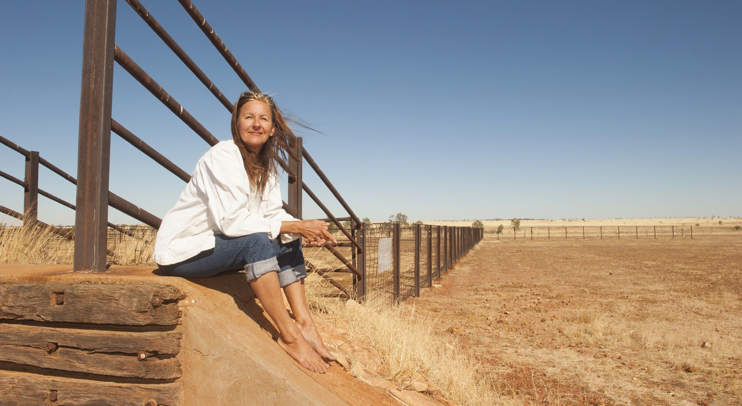

PAGE 55
NATIONAL STRATEGY FOR THE ELIMINATION OF CERVICAL CANCER IN AUSTRALIA

Vaccination

  - Optimise the delivery of school-based HPV immunisation programs in all jurisdictions to maximise equity and achieve high coverage for students living in rural and remote areas.
    - Review and revise communication planning materials for students and families living rural and remote areas and provide educational opportunities in schools to improve adolescent, parent, family and caregiver as well as school staff understanding of HPV vaccination and the elimination strategy. This should occur through strong partnerships between health, education and non-government organisations to provide an integrated approach to HPV vaccination literacy that spans key learning areas, is supported by a whole-of- school approach, and fosters health literacy.23
    - Utilise technology to support digital reminders and put clear communication and follow-up protocols in place to ensure that the school and the consenting carer are aware when a vaccine dose has been missed and receive clear remedial instructions, including how to access vaccination locally through services available in rural and remote areas.
    - Provide in-school vaccination catch-up opportunities where possible. From 2023 a single dose HPV vaccine schedule has been introduced; the implementation plan for single dose vaccination should provide for opportunities for in-school vaccination to ensure individuals who miss doses have more opportunities to be vaccinated. Fund and develop routine program processes that can identify lower coverage schools and develop tailored solutions to improve local coverage.
    - Fund and develop routine program processes that can identify schools with lower coverage and develop tailored solutions to improve HPV vaccination uptake, including working in partnership with rural and remote health services, peak bodies and community.

Optimise the reach and funding of complementary out-of-school HPV immunisation programs to achieve equity in delivery for all, including people living in rural and remote areas and medically high-risk populations (catch-up).
    - Fund and promote HPV vaccine catch-up strategies with out-of-school adolescents including those living in rural and remote areas, their peak bodies, health services and communities. Ensure equity in availability of catch-up opportunities across jurisdictions and for the most marginalised groups, for example, adolescents in youth detention. Consider alternative community locations and providers, for example, GP clinic settings, Aboriginal Community Controlled Health Organisations, pharmacies, and community events, potentially in tandem with screening. Develop workforce strategies to expand reach, for example, collaboration with the Royal Flying Doctors Service of Australia.
    - Implement GP and rural and remote health care provider education, training and quality improvement activities relating to immunisation that support routine use of the Australian Immunisation Register (AIR) data to check HPV vaccination status for all patients aged 14-19 years, address vaccine hesitancy, and assess decision making capacity among vaccine recipients for the decision to vaccinate.

- Coordinated with actions 5.1 and 8.1

NATIONAL STRATEGY FOR THE ELIMINATION OF CERVICAL CANCER IN AUSTRALIA

PAGE 56

  - Develop a method to enable annual reporting of HPV vaccination coverage for people living in rural and remote areas and medically high-risk populations to monitor equity in immunisation.
11.4.1 Leverage data linkage through the MADIP, to monitor engagement, elimination progress and outcomes for priority populations, using demographic and other variables to define priority populations and medically higher risk groups within the linked dataset.

Promote cervical screening regularly with the public and strategically with under-screened groups.
    - Undertake regular targeted tailored campaigns and activities for under-screened groups, including rural and remote communities, complemented by evidence-based, inclusive population-wide public awareness activities and mass media delivered through appropriate channels24.
    - Work with priority communities, including rural and remote communities, including respected members, cervical cancer survivors, and community-controlled organisations who serve these communities, to co- create, design and test best approaches to reach the community, including the content of campaigns and information materials. Ensure campaigns are informed by the success and implementation strategies from previous campaigns and formative research, noting that materials may need to enhance community health literacy about HPV and cancer of the cervix.
    - Trial and utilise technology to support digital invitations, reminders and navigation to follow-up activities for people with screening results that require further investigation.

Increase access to screening, colposcopy and follow-up in rural and remote areas by expanding who can offer these services, and where and how they are offered, to improve reach and uptake.
    - Provide a clear pathway to enable appropriately trained registered nurses, Aboriginal Health Workers and Practitioners, and midwives to independently request and sign the pathology form for a cervical screening test (and be eligible for Medicare reimbursement).
    - Establish a clear national pathway to train and accredit registered nurses, GPs and Aboriginal Health Practitioners to provide colposcopy.
    - Resource a pilot to scale up point-of-care HPV testing, with links to care, for remote communities (see Screening Case Study 2 (The PREVENT Project – for example).
    - Resource pilots in rural and remote communities and, where successful, resource scale-up and routine provision of innovative screening and follow-up care models such as peer-led and community-developed services, telehealth approaches and innovative ways of providing and delivering colposcopy. Work with community-controlled organisations and key healthcare providers in rural and remote regions, such as the Royal Flying Doctors Service, to develop models for screening and follow-up services (for example point of care, mobile, self-collection or other approaches), scale up successful models, and share best practice approaches.

- Coordinated with actions 2.1 and 8.1

PAGE 57
NATIONAL STRATEGY FOR THE ELIMINATION OF CERVICAL CANCER IN AUSTRALIA

  - Collect, use, and release data to enable and monitor equity of access to cervical screening and pre-cancer treatment services for people living in rural and remote areas.
    - Routinely report all program indicators stratified by key population demographics, expand reporting to include all priority populations, and introduce routine monitoring of performance against the WHO pre- cancer treatment indicator.
    - Promote the importance of data collection, training all staff to collect demographic data sensitively in order to improve the recording of all demographic fields (Aboriginal and/or Torres Strait Islander status, country of birth, gender), including additional fields not yet captured on the NCSR and information that affects clinical management such as immune status.
    - Enhance clinical information systems in primary health care settings to enable automated uploading for relevant demographic information to integrate with the NCSR.
    - Add cancer registry data and screening data from the NCSR into the data assets that are included as enduring linkages in the MADIP.
    - Enable clinicians and healthcare services to readily generate reports that can support continuous quality improvement initiatives by identifying patients who are under-screened and indicate current participation rates to inform efforts that drive engagement.
    - Provide visibility to primary care providers of current waiting times for colposcopy services, so that this can be factored into referrals and improve timeliness of care for people living in rural and remote areas.

Treatment

Ensure communities and patients have equitable access to quality information about cervical cancer symptoms and that each cancer patient has tailored information about their diagnosis, intended treatment and planned optimal care pathway.
    - Promote public understanding of cervical cancer signs and symptoms, the role of early detection and the opportunity for elimination, including campaigns and activities specifically focused on and designed by people living in rural and remote areas.25
    - Provide information, consultation and support (for example, utilising the expertise of nurses and allied health professionals) allowing rural and remote patients and their families/carers to fully understand and contribute their own preferences and needs to their individual care pathway.
    - Provide rural and remote patients with the information, access to financial support and support personnel they need to navigate the health system, including informing them that they can have a person/people of their choice accompanying them whenever needed.
    - Enable incremental improvement by conducting routine patient-related evaluation measures (PREMs) to assess patient satisfaction, feeding results back to shape training and development of personnel, patient information materials and health service systems as appropriate. Ensure information collected captures patient diversity and experiences according to their sex, gender and sexual orientation, ethnicity, Aboriginal and Torres Strait Islander, and disability status. Ensure this information accords to national standards for data collection.

- Coordinated with actions 2.1 and 5.1

NATIONAL STRATEGY FOR THE ELIMINATION OF CERVICAL CANCER IN AUSTRALIA

PAGE 58

Develop and implement a road map of coordinated care, with communities of practice, to optimise the delivery of safe, quality care to all patients.
    - Realise a coordinated approach to patient care from diagnosis to survivorship and palliative care that is tailored to local population needs and diversity. This includes: identifying and meeting the training and resourcing needs of key professionals (including but not limited to ensuring access to culturally safe services and a supportive workforce for Aboriginal and Torres Strait Islander peoples; inclusive and accessible care for those with disability; in-language culturally relevant resources and provision of care for culturally and linguistically diverse communities and; sex, gender and identity-sensitive services and care for LGBTQ+ people who live in rural and remote areas).
    - Establish communities of practice, where multidisciplinary teams oversee processes and standards of care, and take responsibility for actively building relationships within and across jurisdictions. This can enable a level of safety and trust when a patient with pre-cancer or cancer is required to travel to
receive quality care. Tertiary centres should actively nurture relationships with services expert in caring for priority populations (for example, Aboriginal and Torres Strait Islander Community Controlled Health Organisations) located within rural and remote areas.
    - Optimise a hub-and-spoke model ensuring continuity of care for those diagnosed with cervical cancer to bring “quality to patients” where possible (for example palliative care) and “patients to quality” where
necessary for highly specialist care (for example brachytherapy). Noting that palliative care services should be integrated into all levels of health care systems including primary care, especially to those living in rural and remote areas.
    - Identify and leverage quick wins by translating successful service models to new jurisdictions and ensure longer-term solutions that may require policy change or workforce reforms. Consider appropriately funded models aimed at addressing workforce issues, such as building an additional supportive role for gynaecology nurses. Genuine partnership with priority populations and communities will improve the provision of culturally safe and inclusive care and enhance access to treatment.

PAGE 59
NATIONAL STRATEGY FOR THE ELIMINATION OF CERVICAL CANCER IN AUSTRALIA

Drive improvements in cervical cancer management through a data collection framework supporting systematic monitoring and enhancement of the quality of care, in alignment with the Australian Cancer Plan.
    - Enhance and harness the data collected in the NGOR cervical cancer module to inform continuous improvement in care for rural and remote patients (equity of access, quality, and safety) based on incidence, stage, and mortality data, key clinical quality indicators, as well as patient reported evaluation and outcome measures (PROMs).
    - Conduct annual cervical cancer audits using data from the NCSR, cancer registries and NGOR together with HPV genotype information determined and reported for all cervical cancers.
    - Consolidate current clinical guidance and quality standards through developing national guidelines for the management of cervical cancer and utilise the NGOR to monitor adherence.




PAGE 60
NATIONAL STRATEGY FOR THE ELIMINATION OF CERVICAL CANCER IN AUSTRALIA

PAGE 61
NATIONAL STRATEGY FOR THE ELIMINATION OF CERVICAL CANCER IN AUSTRALIA

GLOSSARY

Aboriginal or Torres Strait Islander person | A person of Aboriginal and/or Torres Strait Islander descent who identifies as an Aboriginal and/or Torres Strait Islander. Other terms are sometimes used interchangeably, such as Indigenous and First Nations people
ABS | Australian Bureau of Statistics
ACD | Australian Cancer Database
ACPCC | Australian Centre for the Prevention of Cervical Cancer
ACCHO | Aboriginal Community Controlled Health Organisation  A primary health care service initiated and operated by the local Aboriginal community to deliver holistic, comprehensive, and culturally appropriate health care to the community which controls it, through a locally elected Board of Management
AIHW | Australian Institute of Health and Welfare
AIR | Australian Immunisation Register
Allied health | Health professionals who are not specialists, doctors, dentists, nurses or midwives. They use evidence-based practices to prevent, diagnose and treat various conditions and illnesses
CALD | People who are culturally and linguistically diverse
Cancer incidence | The number or rate of new cases of cancer diagnosed in a population during a given time period
Cancer mortality | Number or rate of cancer deaths in a population during a given time period
Cervical screening | Cervical screening tests look for HPV infections in the cervix. If HPV is found, the screening participant can be monitored and have further tests to make sure any signs of abnormal cell changes are found early and can be treated  In Australia, women and people with a cervix can have a screening test every five years from age 25 to 74 through the National Cervical Screening Program. An HPV test is the recommended cervical screening test for the best prevention and early detection outcomes
Cervical cancer treatment | Ensuring that people diagnosed with cervical cancer receive high quality, timely, affordable and effective treatment, support, and palliative care when required is an important part of achieving cervical cancer elimination in Australia  Australia has no official national clinical guidelines for cervical cancer treatment. However, the Cancer Institute NSW operates the eviQ program, providing nationally endorsed evidence-based cancer treatment information in Australia. It is embedded into clinical practice, policy and oncology information systems (OMIS) across the country  The optimal care pathway for cervical cancer was released in January 2020, to guide healthcare practitioners in providing patient-centred, optimal cancer care at each step of the cancer prevention to treatment pathway
Co-design | The term ‘co-design’ reflects shared decision-making authority through genuine partnerships
Community | A group of people sharing a common interest (for example, cultural, social, political, health, economic interests). Different types of communities are likely to have different perspectives and approaches to their involvement in the health system

NATIONAL STRATEGY FOR THE ELIMINATION OF CERVICAL CANCER IN AUSTRALIA

PAGE 62

Community-controlled | A process which allows the local Aboriginal community to be involved in its affairs in accordance with whatever protocols or procedures are determined by the Community
Community-led | Community-led approaches are those that are led by a collective, community process rather than organisations or authorities outside the community. It has become an essential way of working to combat power imbalances that exist between traditional 'authorities' and the communities who are facing inequities
Cultural safety | Cultural safety is determined by individuals, families and communities. Culturally safe practice is the ongoing critical reflection of health practitioner knowledge, skills, attitudes, practising behaviours and power differentials in delivering safe, accessible and responsive healthcare free of racism
Disability | An umbrella term for any or all of the following: an impairment of body structure or function, a limitation in activities, or a restriction in participation
Eligible people  (for HPV vaccination) | HPV vaccine is free under the National Immunisation Program for young people aged approximately 12 to 13. The vaccine is primarily provided through school immunisation programs. Adolescents who missed the HPV vaccination at 12 to 13 years of age can catch-up for free up to age 26
Eligible people (for screening) | People eligible for a Cervical Screening Test are aged between 25 and 74, are sexually active or ever have been and are a woman or person with a cervix
Elimination of disease | Elimination of any disease, as a public health problem, is achieved when there are fewer cases than an agreed low threshold  This differs from eradication when there are no recorded cases, and this is permanent  Crucially, when a disease is eliminated, prevention measures with associated enabling environment need to continue to maintain the low rates of disease  The World Health Organisation and member states have agreed on an elimination target of below four cases of cervical cancer for every 100,000 women
Health equity | All people having a fair opportunity to attain their full health potential, and no one should be disadvantaged in achieving this potential if it can be avoided
Health inequity | Differences in health status between population groups that are socially produced, systematic in their unequal distribution across the population, avoidable and unfair
Health literacy | The capacity to access, understand, appraise and use information to make health- related decisions in everyday life
HPV | Human papillomavirus, known as HPV, causes almost all cases of cervical cancer. HPV is an extremely common virus that around 90% of people will have at least once in their lifetime. It is transmitted during sexual activities through skin-to-skin or skin-to- mouth contact of the genital parts of the body  Some cancers of the vulva, vagina, penis, anus, and oropharynx (back of the throat, including the base of the tongue and tonsils) are also caused by HPV
HPV immunisation | Australia’s National Immunisation Program offers an HPV vaccine that protects against nine different types of HPV which can cause cancer (or genital warts). All young people are offered this vaccination at school at the age of 12-13 years, or they can access it through their general practitioner
Intersex | People who have innate sex characteristics that do not fit medical and social norms for female or male bodies, and that create risks or experiences of stigma, discrimination and harm
LGBTQ+ | People who identify as Lesbian, Gay, Bisexual, Trans, Queer, and '+' represents minority gender identities and sexualities not explicitly included in the term LGBTQ

PAGE 63
NATIONAL STRATEGY FOR THE ELIMINATION OF CERVICAL CANCER IN AUSTRALIA

MADIP | Multi-Agency Data Integration Project  A secure data asset combining information on health, education, government payments, income and taxation, employment, and population demographics (including the Census) over time
NCSP | National Cervical Screening Program
NCSR | National Cancer Screening Register
NDIS | National Disability Insurance Scheme
Never-screened | The term “never-screened” refers to women and people with a cervix who are eligible to have a cervical screening test through the National Cervical Screening Program but have never had one, for any reason
Partnerships | Partnerships require the sharing of decision-making, power, control, resources, responsibility and accountability. In partnerships, trust is built and there is an agreed and shared purpose, vision and intent in working together in a supportive and transparent way. Partners design and review outcomes together and problem solve solutions
Peak Body | A peak body is an Australian term for an advocacy group or trade association, an association of industries or groups with allied interests. They are generally established for the purposes of developing standards and processes, or to act on behalf of all members when lobbying government or promoting the interests of the members.  While there is no official granting of Peak Body status, peak bodies are widely accepted as the legitimate “voice” or representative of a profession or industry, as opposed to just a geographic/commercial/cultural/political subset of that profession, as evidenced by requests for media comment and inclusion in government consultations
Person-centred | Where the person is placed at the centre of the service and treated as a person first
Pre-cancerous lesions | Early changes to the cells of the cervix that are abnormal and may eventually develop into cervical cancer
Pre-cancer treatment | Pre-cancers of the cervix are treated by identifying the area of abnormal cervical tissue and removing it to prevent worsening or spread to other areas of the cervix
Priority populations | Communities who are under-screened and never screened. It also includes groups of people who experience inequities in access to HPV vaccination and cervical cancer treatment and palliative care
Strengths-based | Strengths-based approaches are based on the premise that inherent strengths and resilience can be unlocked with structured support. This approach recognises that individuals live within families, communities and a culture that also have strengths and resources that will contribute to wellbeing
Three pillars | The three tools to eliminate cervical cancer as a public health problem:  - Pillar 1: HPV vaccination  - Pillar 2: cervical screening and treatment for cervical pre-cancers  - Pillar 3: treatment and care of cervical cancer
Under-screened | The term under-screened includes women and people with a cervix who have had a cervical screening test at least once and are eligible to have another screening test through the National Cervical Screening Program, but they are currently significantly overdue for their next screening test for any reason
WHO | World Health Organisation


PAGE 64
NATIONAL STRATEGY FOR THE ELIMINATION OF CERVICAL CANCER IN AUSTRALIA

MORE INFORMATION
Project information, including project governance, governance members, and updates, can be accessed via the project website: https://acpcc.org.au/elimination/





PAGE 65
NATIONAL STRATEGY FOR THE ELIMINATION OF CERVICAL CANCER IN AUSTRALIA



Australian Centre for the Prevention of
Cervical Cancer

Corp-Mkt-Pub 179 V1

