

National Aged Care Mandatory Quality Indicator Program Manual 1.0

# National Aged Care Mandatory Quality Indicator Program Manual 1.0

This publication is published by the Australian Government Department of Health as a manual to administer the National Aged Care Mandatory Quality Indicator Program.

# Copyright Notice

© 2015, 2016 and 2019 Commonwealth of Australia as represented by its Department of Health (**Australian Government Department of Health**) and the State of Victoria as represented by its Department of Health and Human Services (**Victorian Department of Health**), except for the images and referenced text in Chapter 5.

© 2016 National Pressure Ulcer Advisory Panel in respect of the images and referenced text in Chapter 5.

This work is copyright. You may copy, print, download, display and reproduce the whole or part of this work in unaltered form for your own personal use or, if you are part of an organisation, for internal use within your organisation, but only if you or your organisation:

1. do not use the copy or reproduction for any commercial purpose, and
2. retain this copyright notice and disclaimer as part of that copy or reproduction.

Apart from rights as permitted by the *Copyright Act 1968* (Cth),or allowed by this copyright notice*,* all other rights are reserved, including (but not limited to) all commercial rights. Unauthorised use of a copy or reproduction is strictly prohibited.

# Acknowledgements

The Public Sector Residential Aged Care Services Quality Indicators in this manual were adapted by the Australian Government Department of Health from materials developed by the Victorian Department of Health. These and other copyright material belonging to the Victorian Department of Health, have been reproduced with the permission of the Victorian Department of Health.

The images and referenced text in Chapter 5 have been reproduced with the permission of National Pressure Ulcer Advisory Panel.

# Disclaimer

The information in this manual does not constitute, and must not be relied upon as, medical or clinical advice. Any medical questions must be referred to, and obtained from, an independent medical or clinical adviser.

# Assistance

For further assistance, please contact the My Aged Care provider and assessor helpline on 1800 836 799. The helpline will be available between 8am and 8pm Monday to Friday, and between 10am and 2pm on Saturday local time across Australia, except for public holidays.

# Contents

1. Introduction to the National Aged Care Mandatory Quality Indicator Program 7

1.1. Overview 7

1.1. How the information for the QI Program will be collected and managed 7

2. The indicators in the QI Program 8

3. Definitions 9

4. Timeframes and processes 10

5. QI 1: Pressure injuries 11

5.1. Key terms for QI 1: Pressure injuries 11

5.2. Classification of pressure injuries 12

5.3. Measurements and assessments for QI 1: Pressure injuries 14

5.3.1. Exclusions 15

5.3.2. Inclusions 15

5.4. Information to be compiled or otherwise derived for QI 1: Pressure injuries 15

5.5. How to report QI 1: Pressure injuries 15

5.6. How to record information in My Aged Care 16

5.7. Record keeping 16

5.8. Additional resources for QI 1: Pressure injuries 16

6. QI 2: Use of physical restraint 16

6.1. Key terms for the QI 2: Use of physical restraint 16

6.2. Measurements and assessments for QI 2: Use of physical restraint 18

6.2.1. Exclusions 18

6.2.2. Inclusions 18

6.3. Information to be compiled or otherwise derived for QI 2: Use of physical restraint 19

6.4. How to report QI 2: Use of physical restraint 19

6.5. How to record information in My Aged Care 19

6.6. Record keeping 19

6.7. Additional resources for QI 2: Use of physical restraint 20

6.8. Examples to assist with counting QI 2: Use of physical restraint 20

7. QI 3: Unplanned weight loss 21

7.1. Key terms for QI 3: Unplanned weight loss 21

7.1.1. Significant unplanned weight loss 22

7.1.2. Consecutive unplanned weight loss 22

7.2. Measurements and assessments for QI 3: Unplanned weight loss 22

7.2.1. Exclusions 23

7.2.2. Inclusions 23

7.3. Information to be compiled or otherwise derived for QI 3: Unplanned weight loss 23

7.4. How to report QI 3: Unplanned weight loss 23

7.5. How to record information in My Aged Care 23

7.6. Record keeping 24

7.7. Additional resources for QI 3: Unplanned weight loss 24

8. How to submit QI data and access reports 24

8.1. Introduction 24

8.2. Cut-off dates to submit the raw QI data 24

8.3. What happens if QI data is incorrectly entered or entered late 25

8.4. How to become a user of the Provider Portal 25

8.5. What different users can do in the Provider Portal 25

8.6. How to provide access to the QI application in the Provider Portal 26

8.7. How to set the QI Targets for a residential care service 29

8.8. How to enter quarterly QI data for a residential care service 32

8.9. How to access QI reports 37

8.10. How to read residential care services’ QI reports 41

Appendix 1—Data collection template example 44

Scheduling QI data collection 44

Appendix 2 - More information on QI 1: Pressure injuries 46

Evidence to support this QI 46

Defining pressure injuries 46

Pressure injuries in residential care services 46

Adverse clinical events and pressure injuries 47

Causes of pressure injuries 47

Resources 50

Appendix 3 - Example templates for recording data for QI 1: Pressure injuries 51

Pressure injuries data collection sheet 51

Pressure injuries data recording sheet 52

Appendix 4 - More information on QI 2: Use of physical restraint 53

Evidence to support this QI 53

The significance of physical restraint in residential care services 53

Adverse clinical events and the use of physical restraint 54

Why physical restraint occurs 56

Resources 59

Appendix 5 - Example templates for recording data for QI 2: Use of physical restraint 60

Physical restraint data collection sheet 60

Physical restraint data recording sheet 61

Comments 61

Additional information in relation to the comments section 62

Appendix 6 - More information on QI 3: Unplanned weight loss 64

Evidence to support this QI 64

Unplanned weight loss in residential care services 65

Adverse clinical events and unplanned weight loss 66

Causes of unplanned weight loss 66

Resources 70

Appendix 7 - Example templates for recording data for QI 3: Unplanned weight loss 72

Unplanned weight loss data collection sheet 72

Unplanned weight loss data recording sheet 73

Comments 73

# Introduction to the National Aged Care Mandatory Quality Indicator Program

## Overview

From 1 July 2019, participation in the National Aged Care Mandatory Quality Indicator Program (QI Program) will be a requirement for all Commonwealth subsidised residential care services. The objective of the QI Program is that providers will have robust, valid data to support continuous quality improvement in the care they provide to aged care recipients.

The QI Program will:

* provide a set of meaningful and measurable Quality Indicators (QIs) to assist residential care services to monitor and improve important aspects of care
* enable residential care services to monitor and identify trends in their performance over time, compare with other services, and implement improvements that will promote quality of care and quality of life
* over time, provide nationally comparable QI data across residential care services in Australia
* develop an evidence base to facilitate quality improvement initiatives
* enhance community understanding of quality in residential care services over time through publication of information about the QIs
* provide more information to consumers and residential care recipients to assist with choices and decision making about residential care services over time.

## How the information for the QI Program will be collected and managed

The QI Program involves specific methods for collecting, recording, submitting, and interpreting information about the QIs. It is important for the reliability of the QI Program that residential care services use the methods exactly as prescribed in this instruction manual.

Residential care services will record and submit their QI data into the [My Aged Care Provider Portal](https://www.myagedcare.gov.au/service-providers) (the Provider Portal) as prescribed in Sections 5, 6 and 7 of this manual.

The Provider Portal will:

* capture, process and display information from residential care services about their QI data
* provide reports to residential care services in relation to their QI data.

Residential care services will be able to interpret raw QI data and related reports and use this information to influence quality of care and implement continuous quality improvement.

If a residential care service engages a commercial benchmarking service to manage its clinical QI data, it needs to ensure the benchmarking service can provide the required data to the Secretary of the Australian Government Department of Health, or the Secretary’s delegate, in accordance with the legislative requirements.

# The indicators in the QI Program

The QI Program involves collecting data for three QIs that address important aspects of quality of care in clinical areas. Each indicator has categories for which data is collected through assessments and measurements, and information is compiled or derived, to provide to the Secretary.

Data needs to be collected for a total of 10 categories across the three QIs for residential care services:

| **QI 1: Pressure injuries** | Six stages, and each represents a category of data to be collected:   * Stage 1 * Stage 2 * Stage 3 * Stage 4 * Unstageable * Deep tissue |
| --- | --- |
| **QI 2: Use of physical restraint** | Two categories:   * Intent to restrain * Use of physical restraint devices |
| **QI 3: Unplanned weight loss** | Two categories:   * Significant unplanned * Consecutive unplanned |

# Definitions

The definitions ascribed to the terms below are intended to apply for the purposes of the QI Program only.

## Care recipient

A person living in a residential care service.

## Department

The Australian Government Department of Health.

## End-of-life (terminal) care

A form of palliative care that is appropriate when the care recipient is in the final weeks or days of life.

## My Aged Care ([myagedcare.gov.au](https://www.myagedcare.gov.au/))

The start point to access Australian Government funded services.

## Occupied bed days (OBD)

The number of days in care in the subsidy claiming system.

## Palliative care

Palliative care is an approach that improves the quality of life of care recipients and their families facing problems associated with life-threatening illness, through prevention and relief of suffering by early identification and impeccable assessment and treatment of pain and other physical, psychosocial and spiritual issues.

## Physical restraint

See definitions in *6.1 Key terms for the QI 2: Use of physical restraint*

## Pressure injury

See definitions in *5.1. Key terms for the QI 1: Pressure injuries*

## Provider Portal

The Provider Portal within the My Aged Care website: <https://www.myagedcare.gov.au/>

## QI rate for the quality indicators

The rate for each of the quality of care indicators is a rate per 1000 OBD. The rate is derived using the following formula:

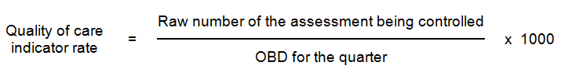

## Quality indicators (QIs)

* QI 1: Pressure injuries
* QI 2: Use of physical restraint
* QI 3: Unplanned weight loss

## Quarters

* Quarter 1 (1 July to 30 September)
* Quarter 2 (1 October to 31 December)
* Quarter 3 (1 January to 31 March)
* Quarter 4 (1 April to 30 June)

## Raw QI data

The number of occurrences counted for each of the 10 categories for the three QIs.

## Residential care Service

A Commonwealth subsidised residential aged care service, also referred to as an Outlet in My Aged Care.

## Secretary or Secretary’s delegate

This is the Secretary or the Secretary’s delegate of the Australian Government Department of Health.

## Unplanned weight loss

See definitions in *7.1 Key terms for QI 3: Unplanned weight loss*

# Timeframes and processes

Residential care services will collect raw QI data and enter it via the Provider Portal. Data is collected quarterly and based on the financial year calendar.

Providers must submit QI data by the 21st day of the month after the end of each quarter.

| **Quarter** | **Date range** | **Due date** |
| --- | --- | --- |
| 1 | 1 July to 30 September | 21 October |
| 2 | 1 October to 31 December | 21 January |
| 3 | 1 January to 31 March | 21 April |
| 4 | 1 April to 30 June | 21 July |

The Provider Portal will use the raw QI data to produce reports for each residential care service. Residential care services will be able to access these reports through the Provider Portal. Reports including the previous quarter’s data will be available one month after the end of each quarter.

An example data collection template is at *Appendix 1*.

# QI 1: Pressure injuries

## Key terms for QI 1: Pressure injuries

A pressure injury is a localised injury to the skin and/or underlying tissue, usually over a bony prominence, as a result of pressure, shear, or a combination of these factors ([Australian Wound Management Association](https://www.woundsaustralia.com.au/) (AWMA) 2012; AWMA 2014; [National Pressure Ulcer Advisory Panel](https://www.npuap.org/) (NPUAP), [European Pressure Ulcer Advisory Panel](http://www.epuap.org/) and Pan Pacific Pressure Injury Alliance[1] 2014).

Previous terms used include pressure ulcer, bed sore and decubitus ulcer. In Australia, as part of the Pan Pacific region, the term pressure injury has been adopted and should be used.

For the purpose of the QI Program, the NPUAP Pressure Injury Stages for Pressure Injuries will be used as reference. The NPUAP for Pressure Injuries is available from the [National Pressure Ulcer Advisory Panel website](https://www.npuap.org/resources/educational-and-clinical-resources/pressure-injury-staging-illustrations/).

**Six categories are measured and assessed in relation to pressure injuries:**

* Stage 1 pressure injuries: non-blanchable erythema of intact skin
* Stage 2 pressure injuries: partial-thickness skin loss with exposed dermis
* Stage 3 pressure injuries: full-thickness skin loss
* Stage 4 pressure injuries: full-thickness loss of skin and tissue
* Unstageable pressure injuries: obscured full-thickness skin and tissue loss
* Suspected deep tissue injuries: persistent non-blanchable deep red, maroon or purple discolouration.

These categories are defined by the following classifications.

## Classification of pressure injuries

The following information describing pressure injuries and stages is from a pressure injury and staging poster developed by the NPUAP:

(Available at: <https://www.npuap.org/resources/educational-and-clinical-resources/pressure-injury-staging-illustrations/>)

© National Pressure Ulcer Advisory Panel September 2016 │www.npuap.org

### PRESSURE INJURY AND STAGES

A pressure injury is localized damage to the skin and underlying soft tissue usually over a bony prominence or related to a medical or other device. The injury can present as intact skin or an open ulcer and may be painful. The injury occurs as a result of intense pressure, prolonged pressure or pressure in combination with shear. The tolerance of soft tissue for pressure and shear may also be affected by microclimate, nutrition, perfusion, co-morbidities and condition of the soft tissue.

#### Stage 1 Pressure Injury: Non-blanchable erythema of intact skin

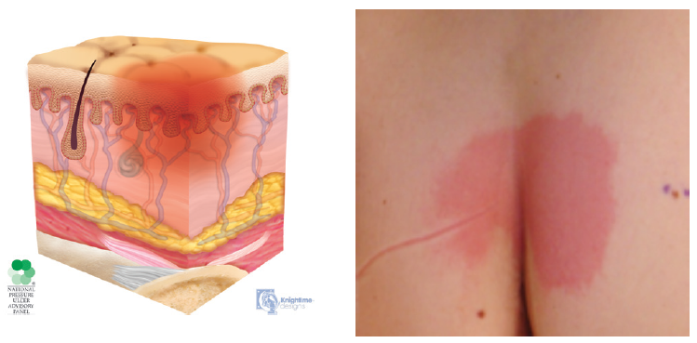Intact skin with a localized area of non-blanchable erythema, which may appear differently in darkly pigmented skin. Presence of blanchable erythema or changes in sensation, temperature, or firmness may precede visual changes. Color changes do not include purple or maroon discoloration; these may indicate deep tissue pressure injury.

#### Stage 2 Pressure Injury: Partial-thickness skin loss with exposed dermis

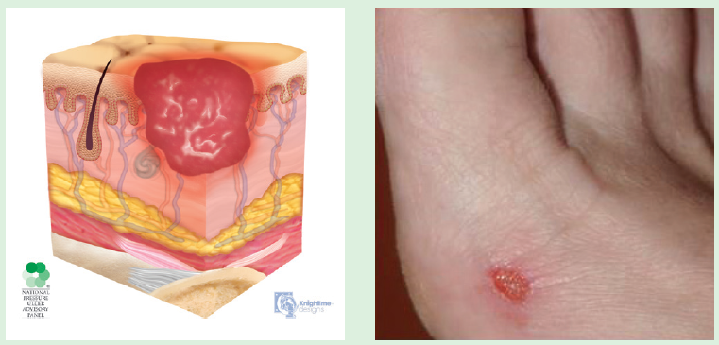Partial-thickness loss of skin with exposed dermis. The wound bed is viable, pink or red, moist, and may also present as an intact or ruptured serum-filled blister. Adipose (fat) is not visible and deeper tissues are not visible. Granulation tissue, slough and eschar are not present. These injuries commonly result from adverse microclimate and shear in the skin over the pelvis and shear in the heel. This stage should not be used to describe moisture associated skin damage (MASD) including incontinence associated dermatitis (IAD), intertriginous dermatitis (ITD), medical adhesive related skin injury (MARSI), or traumatic wounds (skin tears, burns, abrasions).

#### Stage 3 Pressure Injury: Full-thickness skin loss

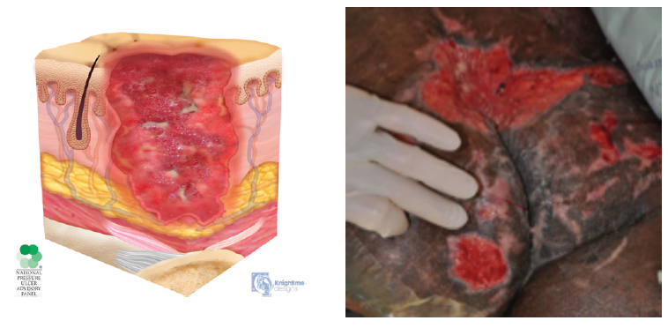Full-thickness loss of skin, in which adipose (fat) is visible in the ulcer and granulation tissue and epibole (rolled wound edges) are often present. Slough and/or eschar may be visible. The depth of tissue damage varies by anatomical location; areas of significant adiposity can develop deep wounds. Undermining and tunneling may occur. Fascia, muscle, tendon, ligament, cartilage or bone are not exposed. If slough or eschar obscures the extent of tissue loss this is an Unstageable Pressure Injury.

#### Stage 4 Pressure Injury: Full-thickness loss of skin and tissue

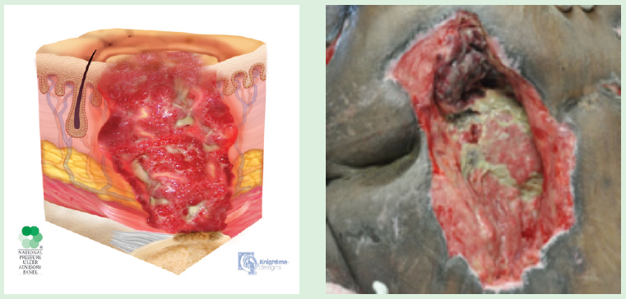Full-thickness skin and tissue loss with exposed or directly palpable fascia, muscle, tendon, ligament, cartilage or bone in the ulcer. Slough and/or eschar may be visible. Epibole (rolled edges), undermining and/or tunneling often occur. Depth varies by anatomical location. If slough or eschar obscures the extent of tissue loss this is an Unstageable Pressure Injury.

#### Unstageable Pressure Injury: Obscured full-thickness skin and tissue loss

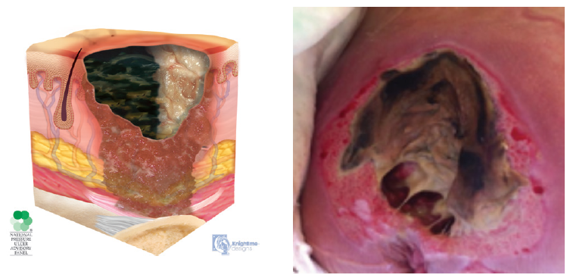Full-thickness skin and tissue loss in which the extent of tissue damage within the ulcer cannot be confirmed because it is obscured by slough or eschar. If slough or eschar is removed, a Stage 3 or Stage 4 pressure injury will be revealed. Stable eschar (i.e. dry, adherent, intact without erythema or fluctuance) on an ischemic limb or the heel(s) should not be softened or removed.

#### Deep tissue pressure Injury: Persistent non-blanchable deep red, maroon or purple discoloration

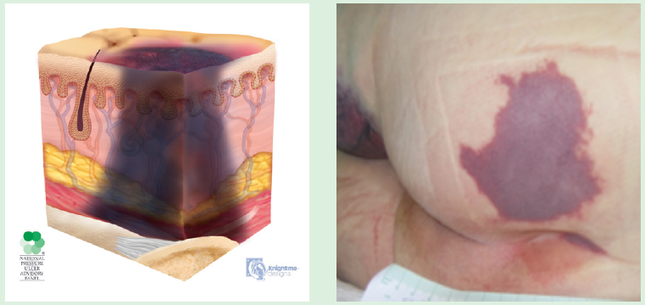Intact or non-intact skin with localized area of persistent non-blanchable deep red, maroon, purple discoloration or epidermal separation revealing a dark wound bed or blood filled blister. Pain and temperature change often precede skin color changes. Discoloration may appear differently in darkly pigmented skin. This injury results from intense and/or prolonged pressure and shear forces at the bone-muscle interface. The wound may evolve rapidly to reveal the actual extent of tissue injury, or may resolve without tissue loss. If necrotic tissue, subcutaneous tissue, granulation tissue, fascia, muscle or other underlying structures are visible, this indicates a full thickness pressure injury (Unstageable, Stage 3 or Stage 4). Do not use DTPI to describe vascular, traumatic, neuropathic, or dermatologic conditions.

© National Pressure Ulcer Advisory Panel September 2016 │www.npuap.org

More information regarding QI 1: Pressure injuries is at *Appendix 2*.

## Measurements and assessments for QI 1: Pressure injuries

For the purposes of section 26(a) of the [*Accountability Principles 2014*](https://www.legislation.gov.au/Series/F2014L00831), approved providers must make assessments and measurements in accordance with the following:

1. Measurements and assessments must be done exactly as described in this manual.
2. Information from existing data sets (e.g. incident reporting systems) must not be used where information has been collected differently to what is described in this manual.
3. Every care recipient must be assessed for six stages of pressure injuries once each quarter. Residential care services should use the NPUAP Pressure Injury Stages as a reference point.
4. The care recipient must be told about the assessment and asked for their permission to include their data in the QI Program. If they withhold permission, note this in the comments section of the residential care service comments column on the data collection sheet.
5. Assessment needs to be done by doing a full-body assessment of the care recipient. This can be done as part of the care recipient’s usual personal care.
6. Measurements and assessments must be through actual observation on or around the same time/date in each quarter.
7. Measurement and assessments must be consistent. For example, two staff members independently observing a care recipient with a pressure injury must both correctly identify the stage of the pressure injury and report it in the same way.

### 5.3.1. Exclusions

Nil.

### 5.3.2. Inclusions

Respite care and end-of-life palliative care recipients must be counted.

## Information to be compiled or otherwise derived for QI 1: Pressure injuries

For the purposes of section 26(b) of the [*Accountability Principles 2014*](https://www.legislation.gov.au/Series/F2014L00831), approved providers must compile or otherwise derive from these measurements and assessments the following information:

1. The number of each stage of pressure injuries for each care recipient.
2. The total number of occurrences of pressure injuries assessed at each stage of the NPUAP at each service at which the approved provider provides residential care.
3. Any related comments for each service at which the approved provider provides residential care.

Example data collection sheets are at *Appendix 3*.

## How to report QI 1: Pressure injuries

For the purposes of section 26(c) of the [*Accountability Principles 2014*](https://www.legislation.gov.au/Series/F2014L00831)*,* approved providers must submit the QI data into the Provider Portal. The information required for submitting data to the Provider Portal is outlined in *Section 8: How to submit QI data and access reports*.

If there is uncertainty about the presence and stage of a pressure injury, consult with a suitably qualified health practitioner.

## How to record information in My Aged Care

In giving information to the Secretary pursuant to section 26(c) of the[*Accountability Principles 2014*](https://www.legislation.gov.au/Series/F2014L00831), approved providers must address the following matters in the comments section in My Aged Care:

1. Note the number of care recipients (including respite care recipients) admitted during the current reporting quarter, where injuries were present on admission, and include in the count.
2. In subsequent quarters, include these injuries in the ordinary count—no comment is needed.
3. Note if the pressure injury developed while the care recipient was away from the residential care service, for example, while in hospital.
4. Note where the pressure injury relates to a care recipient receiving end-of-life palliative care.

## Record keeping

Approved providers must, in accordance with Section 88 of the [*Aged Care Act 1997*](https://www.legislation.gov.au/Series/C2004A05206), keep records relating to measurements and assessments and information compiled for the purposes of section 26(a)(b)and(c) of the [*Accountability Principles 2014*](https://www.legislation.gov.au/Series/F2014L00831).

## Additional resources for QI 1: Pressure injuries

More information and resources related to QI 1: Pressure injuries are at *Appendix 2* and *Appendix 3*.

# QI 2: Use of physical restraint

## Key terms for the QI 2: Use of physical restraint

For the purposes of the QI Program, restraint means any practice, device or action that interferes with a care recipient’s ability to make a decision or restricts a care recipient’s free movement. Physical restraint means any restraint other than:

* a chemical restraint, or
* the use of medication prescribed for the treatment of, or to enable treatment of, a diagnosed mental disorder, a physical illness or a physical condition.

This quality indicator collects data relating to two categories: intent to restrain and physical restraint devices.

**Intent to restrain** is the intentional restriction of a care recipient’s voluntary movement or behaviour by the use of a device, or removal of mobility aids, or use of physical force for behavioural purposes.

This measure requires observation and recording of any instance where any restraint equipment or action is in place to **intentionally** restrain (definition A below) a care recipient using devices or actions contained in the definitions B or C below.

**Physical restraint devices** is about counting all devices in use at the time of the assessments for any reason in accordance with definition B. These are to be counted whether they are being used to intentionally restrain a care recipient or not.

The data collected under this quality indicator comprises the following data elements:

|  |
| --- |
| A: Intent to restrain Intent to restrain refers to physical restraint including, but is not limited to:   * the intentional restriction of a care recipient’s voluntary movement or behaviour by the use of a device, or removal of mobility aids, or use of physical force * actions to limit a care recipient to a particular environment.  B: Physical restraint devices The following devices and equipment are considered to be physical restraint:   * bedrails * chairs with locked tables * seatbelts other than those used during active transport * safety vests * shackles * manacles.  C: Other restraints Definitions A and B do not list all possible physical restraints. The placement of furniture, use of concave mattresses, lap rugs with ties or any other devices used with the intention to restrict free movement should each be included in intent to restrain.  Actions such as intentionally locking care recipients in their rooms or a room must also be included in intent to restrain. |

## Measurements and assessments for QI 2: Use of physical restraint

There are two categories of information for measurement and assessment for use of physical restraint. These are:

* intent to restrain
* use of physical restraint devices.

For the purposes of section 26(a) of the [*Accountability Principles 2014*](https://www.legislation.gov.au/Series/F2014L00831), approved providers must make assessments and measurements in accordance with the following:

1. Measurements and assessments must be done exactly as described in this manual.
2. Information from existing data sets (e.g. incident reporting systems) must not be used where information has been collected differently to what is described in this manual.
3. Every care recipient must be assessed for intent to restrain and physical restraint devices.
4. The care recipient must be told about the measurements and assessments and asked for their permission to include their data in the QI Program. If they withhold permission, note this in the comments section of the residential care service comments column on the data collection sheet.
5. The residential care service must carry out a total of nine observation assessments over the quarter. The residential care service must identify three assessment days in the quarter, approximately the same time each quarter. The residential care service must, on each of these assessment days, conduct three assessments of all care recipients—one in the morning, one in the afternoon and one at night.
6. Observation assessments must be unannounced to staff and care recipients.
7. All devices in definition B in use at the time of the assessments must be counted, whether they are being used to intentionally restrain a care recipient or not.

### Exclusions

Secure areas and perimeter alarms **are not** included for the purpose of the use of physical restraint indicator.

### Inclusions

Respite care recipients must be included in the observational assessments.

## Information to be compiled or otherwise derived for QI 2: Use of physical restraint

For the purposes of section 26(b) of the [*Accountability Principles 2014*](https://www.legislation.gov.au/Series/F2014L00831), approved providers must compile or otherwise derive from these measurements and assessments the following information:

* The total number of intents to restrain (definition A) a care recipient at the time of the assessment.
* The number of restraint devices used (definition B).

## How to report QI 2: Use of physical restraint

For the purposes of section 26(c) of the [*Accountability Principles 2014*](https://www.legislation.gov.au/Series/F2014L00831)*,* approved providers must submit the QI data into the Provider Portal. The information required for submitting data to the Provider Portal is outlined in *Section 8: How to submit QI data and access reports*.

## How to record information in My Aged Care

In giving information to the Secretary pursuant to section 26(c) of the[*Accountability Principles 2014*](https://www.legislation.gov.au/Series/F2014L00831), approved providers must address the following matters in the comments section in My Aged Care:

* Include the following in the comments section on the data recording sheet for **intent to restrain**:
* Record the total number of actual care recipients who were being intentionally restrained at any time during the assessments.
* Record the number of restraints used that are specifically requested by the resident and/or their family or advocate.
* Include the following in the comments section on the data recording sheet for **physical restraint devices**:
* Record the number of uses of restraint that were specifically requested by the care recipient and/or their family or advocate.

## Record keeping

Approved providers must, in accordance with Section 88 of the [*Aged Care Act 1997*](https://www.legislation.gov.au/Series/C2004A05206), keep records relating to measurements and assessments and information compiled for the purposes of section 26(a)(b)and(c) of the [*Accountability Principles 2014*](https://www.legislation.gov.au/Series/F2014L00831).

## Additional resources for QI 2: Use of physical restraint

More information and resources related to QI 2: Use of physical restraint are at *Appendix 4*and*Appendix 5*.

## Examples to assist with counting QI 2: Use of physical restraint

|  |
| --- |
| ***Example 1***  If it is observed that bedrails (definition B, physical restraint device) are in use to intentionally restrict a resident from getting out of bed (definition A, intent to restrain), then the count would be:   * ‘1’ for intent to restrain, and * ‘1’ for physical restraint devices.   If the resident is also intentionally restrained (definition A, intent to restrain) with a safety vest (definition B, physical restraint device), then the total count would be:   * ‘2’ for intent to restrain, and * ‘2’ for physical restraint devices. |

|  |
| --- |
| ***Example 2***  If a resident is being intentionally restrained (definition A, intent to restrain) in both:   * a deep chair (definition C, other restraints); and * with a lap rug with ties (definition C other restraints);   then the count would be:   * ‘2’ for intent to restrain, and * ‘0’ for physical restraint devices. |

|  |
| --- |
| ***Example 3***  If a resident is intentionally (definition A, intent to restrain) locked in their room (definition C, other restraints), then the count would be:   * ‘1’ for intent to restrain, and * ‘0’ for physical restraint devices.   If the resident is also sitting at a locked table (definition B, physical restraint device), then the count would be:   * ‘2’ for intent to restrain, and * ‘1’ for physical restraint devices. |

|  |
| --- |
| ***Example 4***  If it is observed that bedrails (definition B, physical restraint device) are in use without the intention to restrain (e.g. at the resident’s request) then the count would be:   * ‘0’ for intent to restrain, and * ‘1’ for physical restraint devices. |

|  |  |
| --- | --- |
| Information | **Important note**  Restraint should only ever be used **as a last resort**, once alternatives are exhausted and for a limited time only.  Physical restraint can only be used after conditions, set out in the [*Quality of Care Amendment (Minimising the Use of Restraints) Principles 2019*](https://www.legislation.gov.au/Details/F2019L00511), are met. |

# QI 3: Unplanned weight loss

## Key terms for QI 3: Unplanned weight loss

For the purposes of the QI Program, unplanned weight loss is where there is no written strategy and ongoing record relating to planned weight loss for the care recipient.

This QI covers both significant unplanned weight loss and consecutive unplanned weight loss.

### Significant unplanned weight loss

Significant unplanned weight loss is unplanned weight loss equal to or greater than three kilograms over a three-month period. This result is determined by comparing the care recipient’s weight at the last weigh this quarter (three-month period) with their weight at the last weigh last quarter. Both these weights must be available to provide this result.

### Consecutive unplanned weight loss

Consecutive unplanned weight loss is unplanned weight loss of any amount every month over three consecutive months of the quarter. This can only be determined if the care recipient is weighed on all three occasions.

## Measurements and assessments for QI 3: Unplanned weight loss

For the purposes of section 26(a) of the [*Accountability Principles 2014*](https://www.legislation.gov.au/Series/F2014L00831), approved providers must make assessments and measurements in accordance with the following:

1. Measurements and assessments must be done exactly as described in this instruction manual.
2. Information from existing data sets (e.g. incident reporting systems) must not be used where information has been collected differently to what is described in this manual.
3. Care recipients must be weighed at around the same date and time as the previous month on the same weighing device.
4. The care recipient must be told about the assessment and asked for their permission to include their data in the QI Program. If they withhold permission, note this in the comments section of the residential care service comments column on the data collection sheet.
5. Care recipients must be weighed in clothing of a similar weight each time and deduct this from the total weight to arrive at a result.
6. Count the number of care recipients for significant unplanned weight loss and consecutive unplanned weight loss, for each care recipient, and obtain a total for each and related comments for the residential care service.
7. Calibrate weighing devices in accordance with manufactures guidelines.

### Exclusions

All care recipients must be assessed for unplanned weight loss, except for:

* care recipients who are absent, for example, in hospital
* care recipients receiving end-of-life palliative care
* respite care recipients.

### Inclusions

All care recipients must be assessed for unplanned weight loss except those listed in 7.2.1

## Information to be compiled or otherwise derived for QI 3: Unplanned weight loss

For the purposes of section 26(b) of the [*Accountability Principles 2014*](https://www.legislation.gov.au/Series/F2014L00831), approved providers must compile or otherwise derive from these measurements and assessments the following information:

* The total number of care recipients who experienced a significant unplanned weight loss for the quarter.
* The total number of care recipients who experienced consecutive unplanned weight loss for the quarter.

## How to report QI 3: Unplanned weight loss

For the purposes of section 26(c) of the [*Accountability Principles 2014*](https://www.legislation.gov.au/Series/F2014L00831)*,* approved providers must submit the QI data into the Provider Portal. The information required for submitting data to the Provider Portal is outlined in *Section 8: How to submit QI data and access reports*.

## How to record information in My Aged Care

In giving information to the Secretary pursuant to section 26(c) of the[*Accountability Principles 2014*](https://www.legislation.gov.au/Series/F2014L00831), approved providers must address the following matters in the comments section in My Aged Care:

* the number of care recipients who chose not to have their data included in the program or are excluded as listed in 7.2.1.
* whether any care recipients were included in both categories; that is if they lost three kilograms or more and lost weight every month for three months.

## Record keeping

Approved providers must, in accordance with Section 88 of the [*Aged Care Act 1997*](https://www.legislation.gov.au/Series/C2004A05206), keep records relating to measurements and assessments and information compiled for the purposes of section 26(a)(b)and(c) of the [*Accountability Principles 2014*](https://www.legislation.gov.au/Series/F2014L00831)*.*

## Additional resources for QI 3: Unplanned weight loss

More information and resources related to QI 3: Unplanned weight loss is at *Appendix 6* and *Appendix 7*.

|  |  |
| --- | --- |
| Information | **Important note**   * Any unplanned and unexpected weight loss should be investigated promptly and appropriate treatment commenced. * If a care recipient cannot be weighed, it is still good practice to monitor them using alternative means such as mid-arm or calf circumference. This ensures changes are identified and appropriate strategies put in place. |

# How to submit QI data and access reports

## Introduction

As part of the QI Program, pursuant to section 26 of the [*Accountability Principles 2014*](https://www.legislation.gov.au/Series/F2014L00831), residential care services enter their raw QI data through the Provider Portal for each indicator, unless otherwise agreed by the department (for example, if using a commercial benchmarking company. The QI data must be entered every quarter (three months).

After the residential care service has entered the raw QI data, the system collates the QI data, calculates the QI rates, summarises the information and produces the residential care service reports. Residential care services are notified after the QI rates are calculated using the occupied bed days (OBD) data. Residential care services can then access their reports through the Provider Portal.

## Cut-off dates to submit the raw QI data

As indicated in *Section 4: Timeframes and processes*, the cut-off date for QI data entry is  
the **21st day of the month after the end of each quarter**.

Therefore, based on the financial year calendar, the raw QI data must be submitted no later than:

| **Quarter** | **Date range** | **Due date** |
| --- | --- | --- |
| 1 | 1 July to 30 September | 21 October |
| 2 | 1 October to 31 December | 21 January |
| 3 | 1 January to 31 March | 21 April |
| 4 | 1 April to 30 June | 21 July |

## What happens if QI data is incorrectly entered or entered late

Residential care services can contact the My Aged Care provider and assessor helpline on **1800 836799** for assistance to enter the residential care service raw QI data after the cut-off date, or to correct incorrectly entered QI data. The reports prepared for residential care services that have not entered their QI data will have null values for that quarter.

If a provider does not comply with the new requirements, including a deliberate misrepresentation of QI data, the department and the Aged Care Quality and Safety Commission will be able to investigate non-compliance and, if substantiated, take proportionate regulatory action.

## How to become a user of the Provider Portal

In the first instance, a new user should contact their residential care services My Aged Care Organisational Administrator, who can create a new user account for staff through the Provider Portal.

## What different users can do in the Provider Portal

| **TASK / ROLE** | **Staff Member** | **Team Leader** | **Administrator** |
| --- | --- | --- | --- |
| **Provide access to the QI application for staff** | No | No | Yes |
| **Manage the roles within the QI application** | No | No | Yes |
| **Enter QI data** | Yes | Yes | Yes |
| **Save QI data** | Yes* | Yes* | Yes |
| **Submit QI data** | No | No | Yes |

* Note: Once the report is saved as final, the Administrator can submit the data

## How to provide access to the QI application in the Provider Portal

Only the Administrator can add the QI application for staff members and team leaders.

To do this, the Administrator must add the ‘Quality indicator’ tile option for relevant staff members and team leaders, using the following process.

1. Login to the Provider Portal.
2. Select ‘Staff administration’ from the home page.

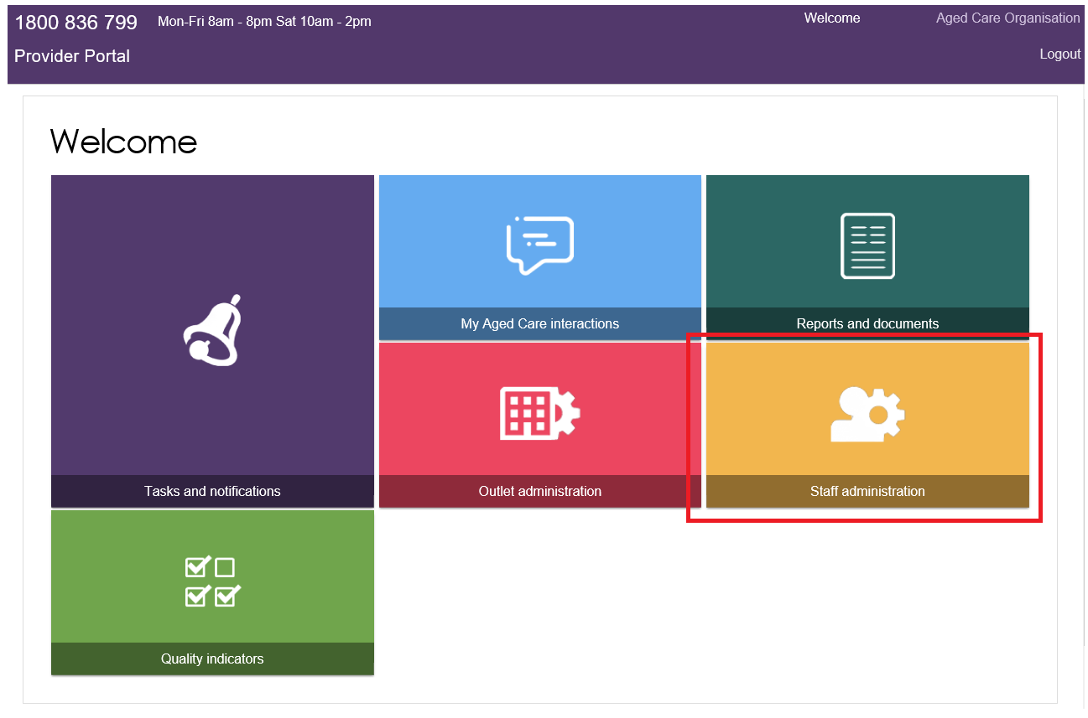

1. Once on the ‘Staff administration’ page, click on the staff member the residential care service would like to access to the QI application.

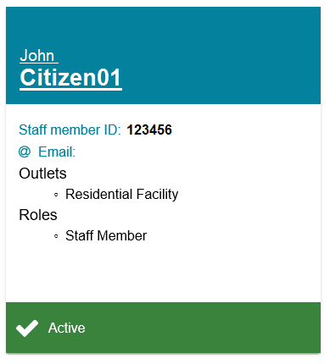

For more information about how to add a staff member to the residential care service, please refer to [My Aged Care Provider Portal user guide part one—administrator functions](https://agedcare.health.gov.au/programs-services/quality-indicators-for-aged-care/information-for-service-providers/my-aged-care-provider-portal-user-guide-part-one-administrator-functions).

1. Click ‘Edit staff details’.

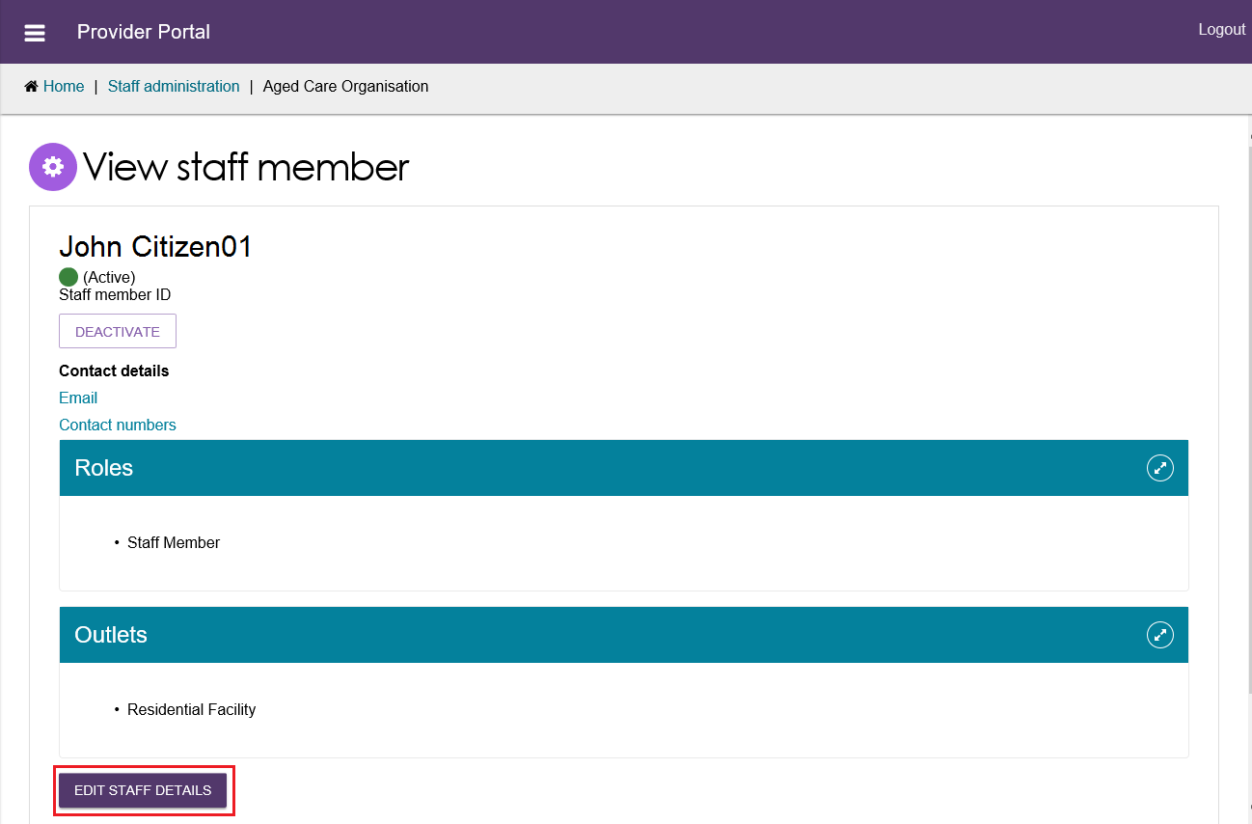

1. Click ‘Assign roles’.

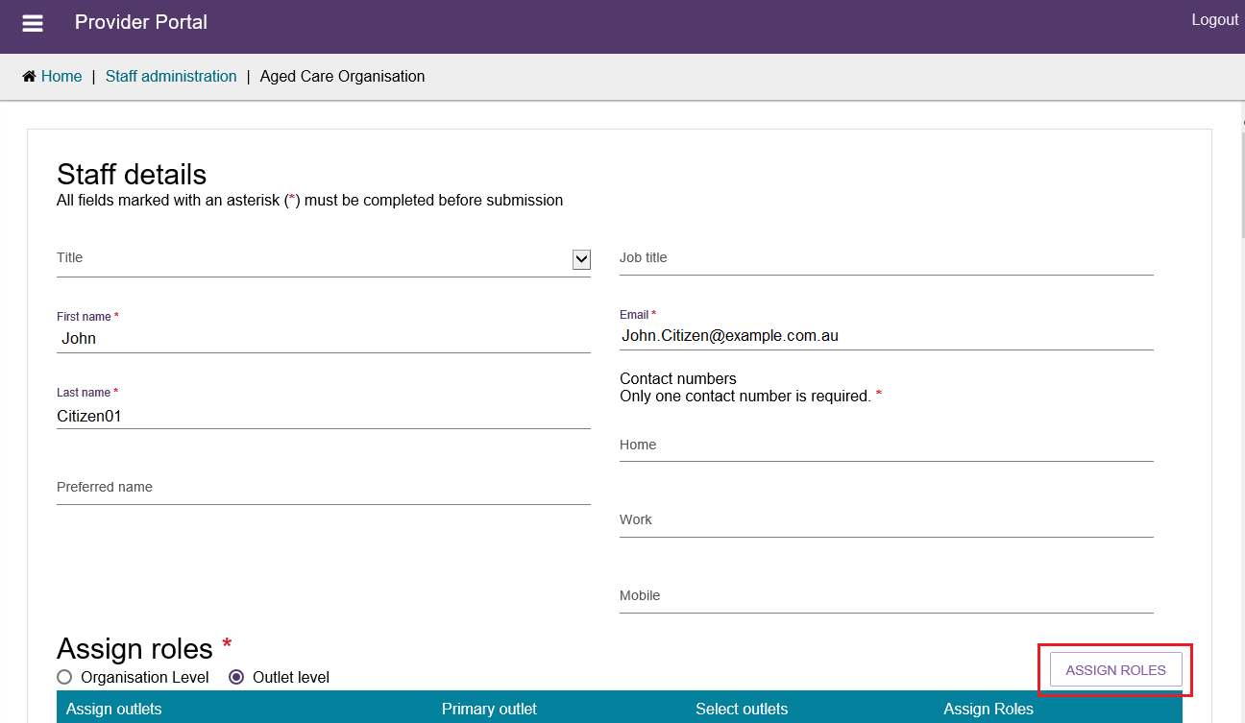

1. Click the check box for participating for ‘Quality Indicators’ and click on ‘Save’ (this will take you back to the QI home page).

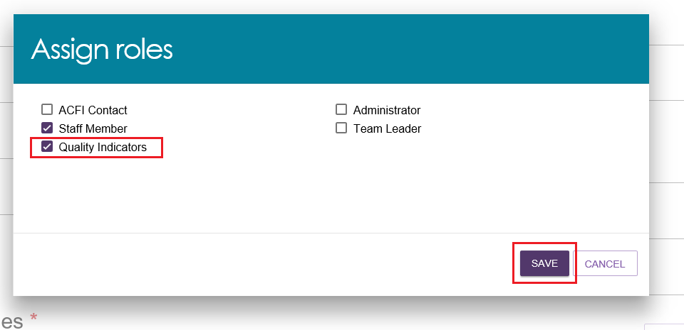

1. The staff member can now log into the Provider Portal and they will find the new ‘Quality Indicators’ tile on their home page.

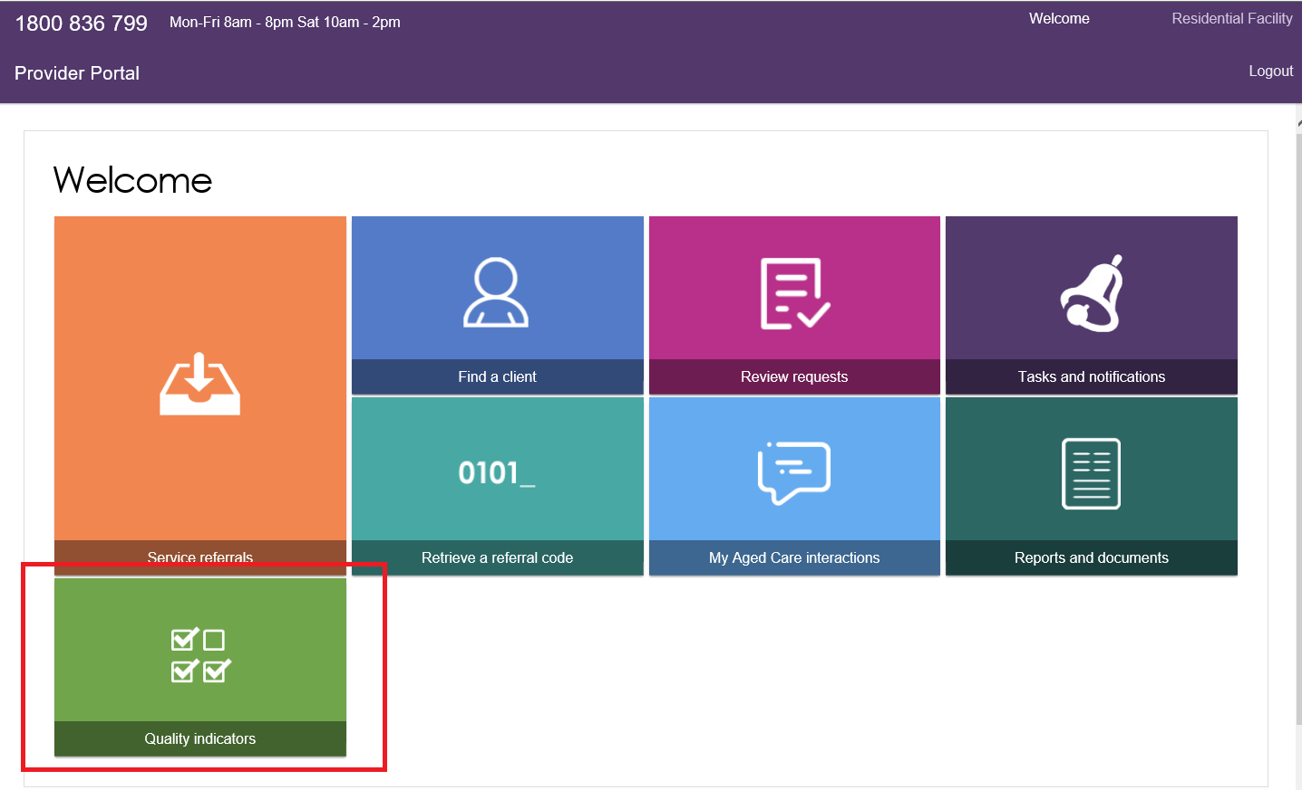

## How to set the QI Targets for a residential care service

Note: In the Provider Portal, a residential care service is referred to as an Outlet.

The Administrator can set targets for a service for each QI. The targets are not set by the department.

To enter the QI Targets, follow the steps below.

1. From the landing page, click on the ‘Quality Indicators’ tile.
2. Click ‘Select facility’ to find the residential care service you are setting targets for.

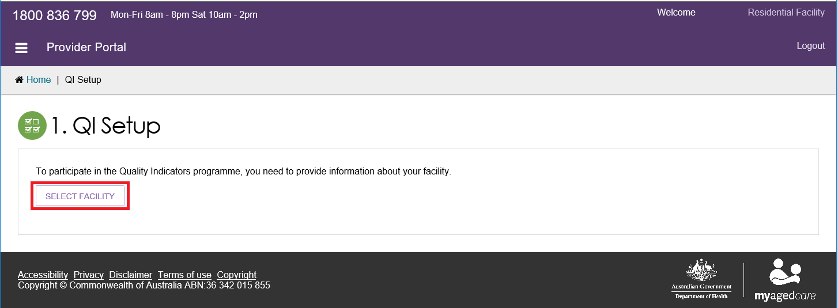

1. Click on the relevant facility.

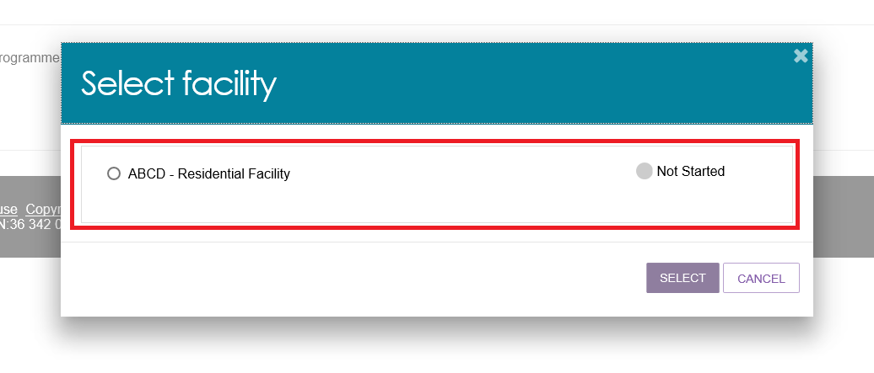

1. Click on ‘Select’.

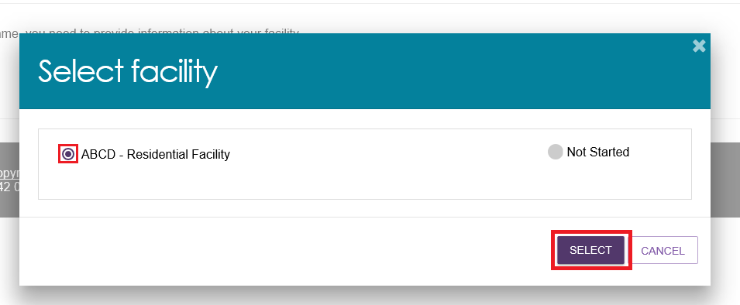

1. Click on ‘Continue’.

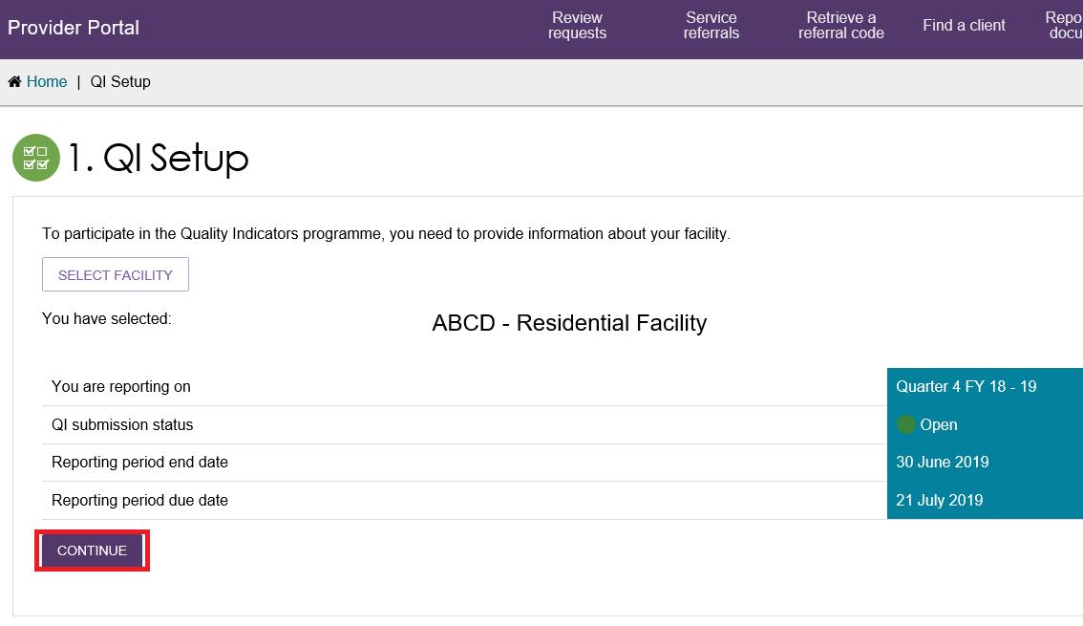

1. Select the expand icon next to ‘Setup QI Target/s’.

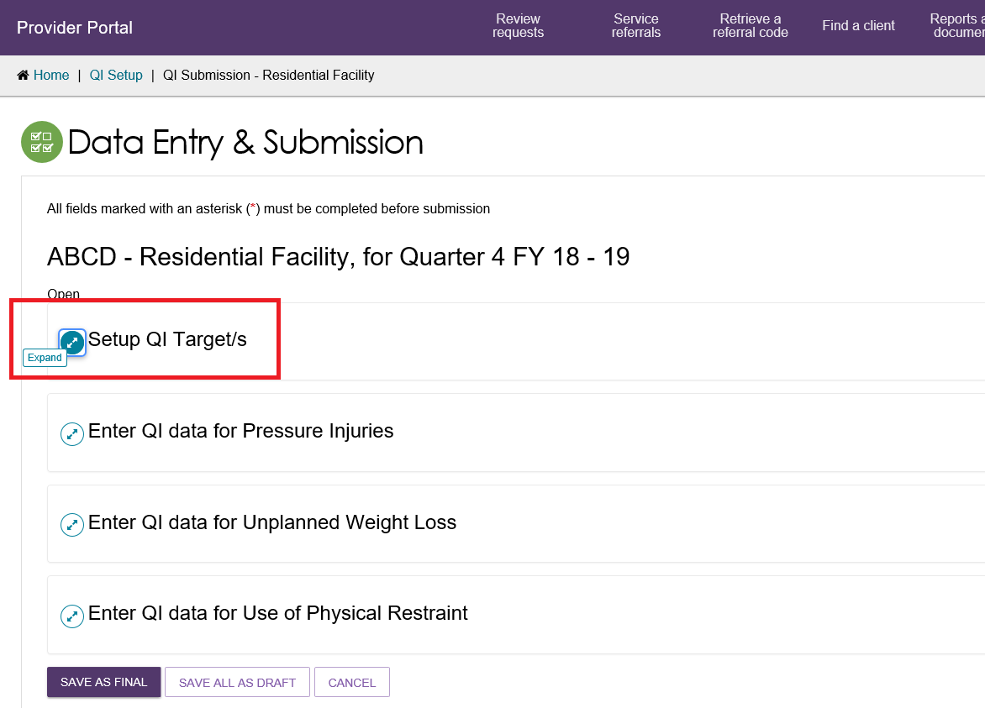

1. Enter the residential care service targets for each QI.

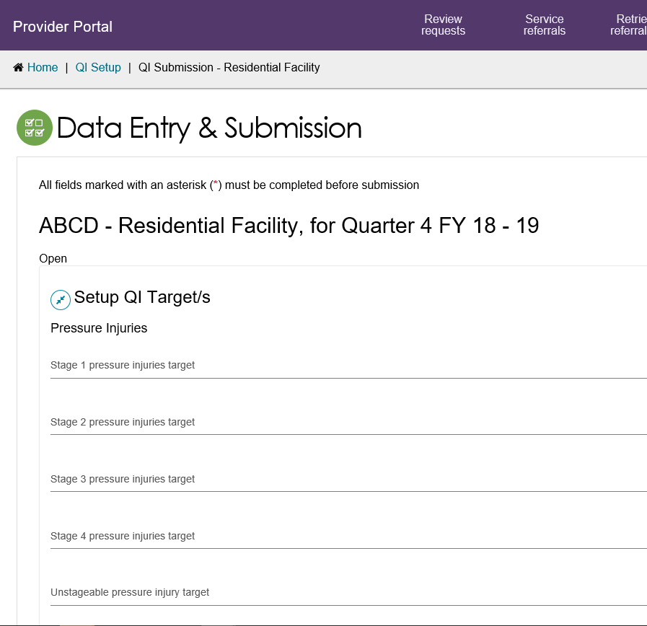

|  |  |
| --- | --- |
| Information | **Note**  If the residential care service is setting QITargets, these should be based on the residential care service’s QI rates. |

1. Once all the targets are entered, click ‘Save Targets’.

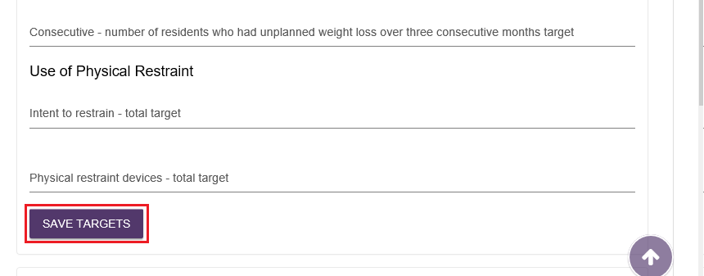

## How to enter quarterly QI data for a residential care service

|  |  |
| --- | --- |
| Information | **Note**  In the Provider Portal, a residential care service is referred to as an ***Outlet***. |

There are five stages when entering QI data:

| **Stage** | **Description** |
| --- | --- |
| **Not started** | **Screen shot for the 'not started' icon**  The Outlet data entry has not been opened or viewed this quarter. |
| **Open** | Screenshot of the 'open' icon  The Outlet data entry has been started but no data has been saved. This happens when you select the Outlet but cancel before saving data or use the ‘Clear’ button. |
| **In progress** | Screenshot for the in progress icon.  The Outlet data has been entered and saved as draft, but not yet saved as final or submitted. |
| **Final** | Screenshot of the 'final' icon  The Outlet data is saved as final and is ready for the Administrator to submit for the quarter. |
| **Submitted** | Screenshot for the 'submitted' icon.  The Administrator has submitted the Outlet data for the quarter. |

Team leaders and staff members can enter and save data as final, once the Administrator has given them access to the QI application. However, only the Administrator can submit the quarterly QI data.

The residential care service may choose to ‘Save as draft’ at any time and come back later to ‘Save as a final’, which sends the data to the Administrator for submission.

The residential care service can also choose to clear the data and restart or cancel the entire submission.

To enter the QI data, follow the steps below.

1. From the landing page, click on the ‘Quality indicators’ tile.

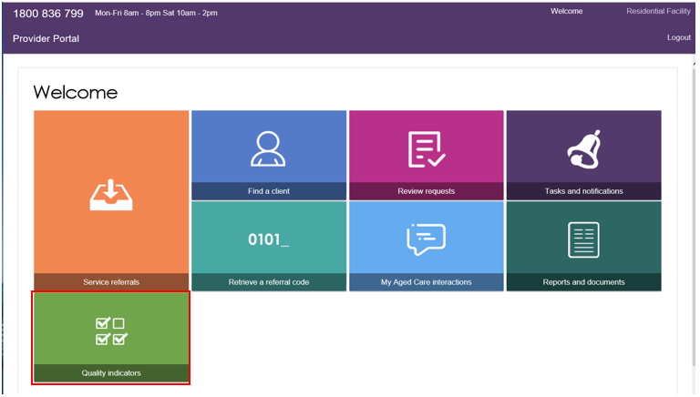

1. Click ‘Select Facility’ to bring up the residential care services you can submit QI data for.

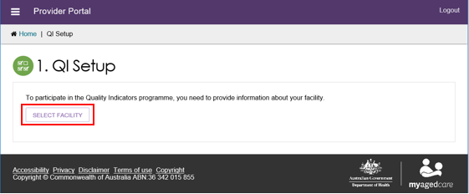

1. Click on the relevant facility that you would like to submit QI data for, and click ‘Select’.

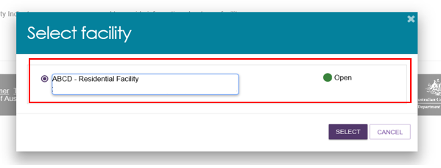

1. Click on ‘Continue’.

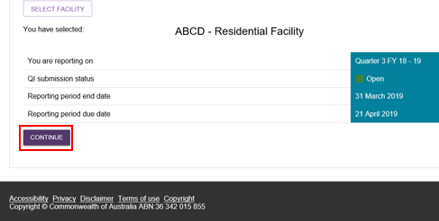

1. Select the expand icon for each QI.

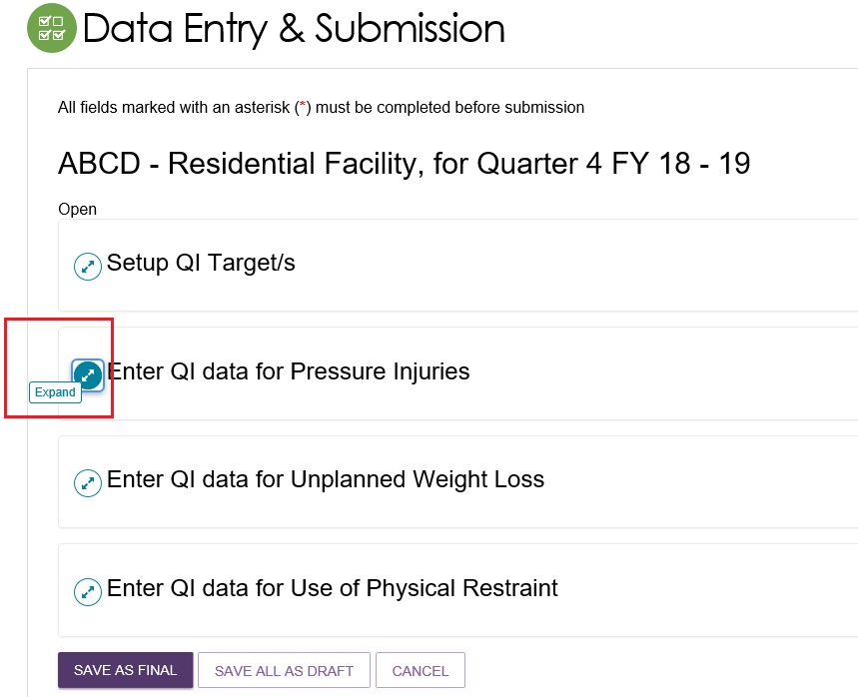

1. The fields you need to complete will drop down. Fill in the fields for each QI.

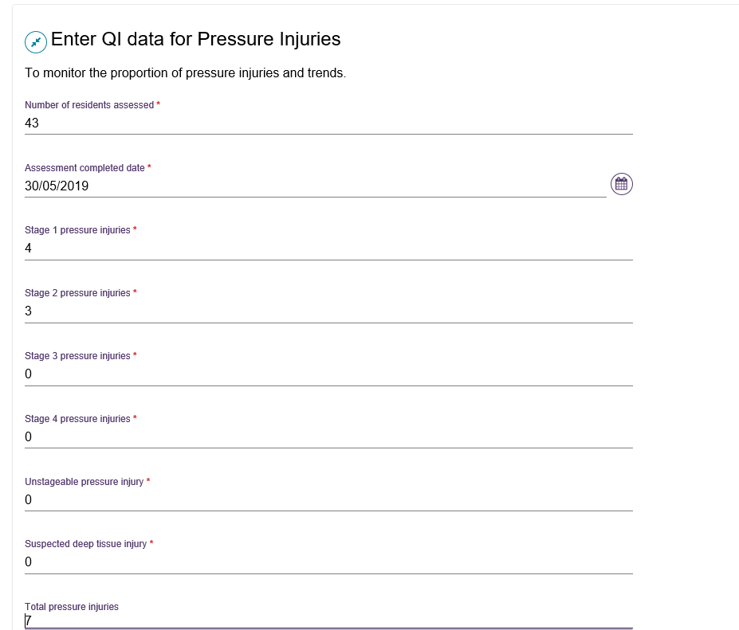

1. A green tick will appear once the all QI data is entered for the relevant QI.

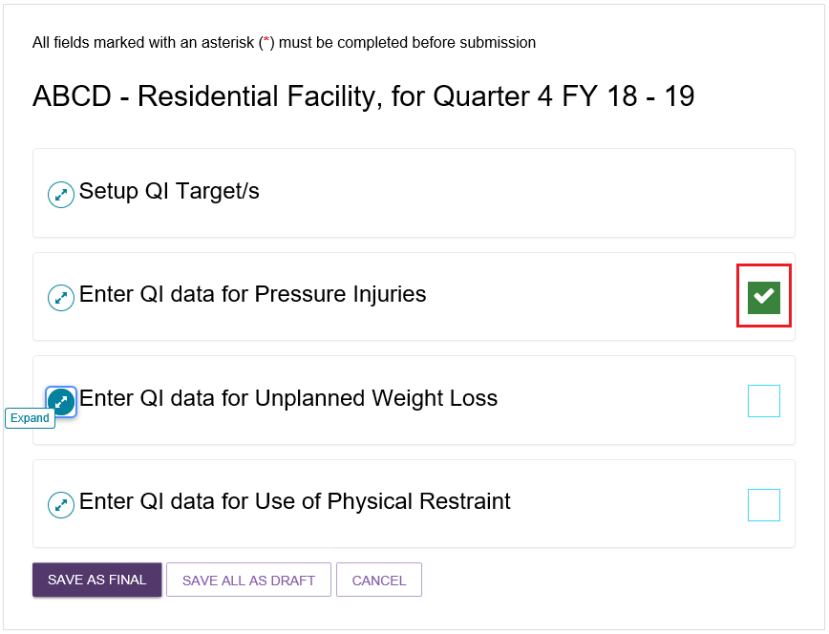

1. This step is only for staff members or team leaders. Review the QI data entered to ensure it is correct, then click ‘Save as Final’. This sends a notification message to the Provider Portal Administrator that the QI data is ready to be submitted.

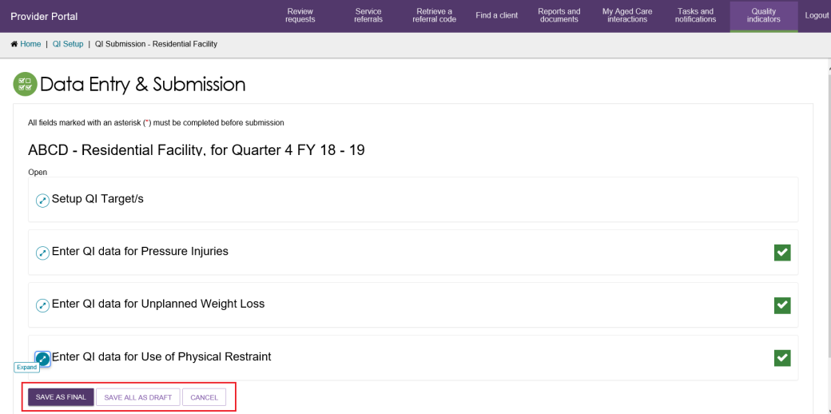

1. If you are the Administrator you should review the QI data before submitting it for the quarter. Once ready, click ‘Submit’ to submit the residential care service’s QI data for the quarter.

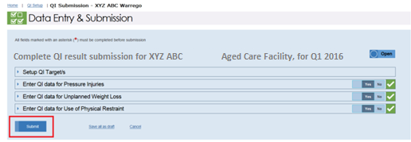

1. A ‘Submit confirmation’ screen will come up with the conditions of submission. Click ‘Yes’ or ‘No’.

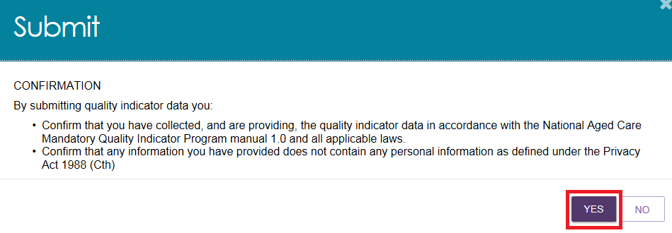

|  |  |
| --- | --- |
| Information | **Note**  If the Administrator clicks ‘No’, the system will return to the data submission screen and the data will not be submitted. |

1. Once the Administrator has clicked ‘Yes’, the residential care service QI data for the quarter will be submitted. The Administrator can now select another service to submit data for, or select ‘Continue’ to view the submitted data. The Administrator can also select another area of the My Aged Care Provider Portal at the top of the screen and exit the QI application.

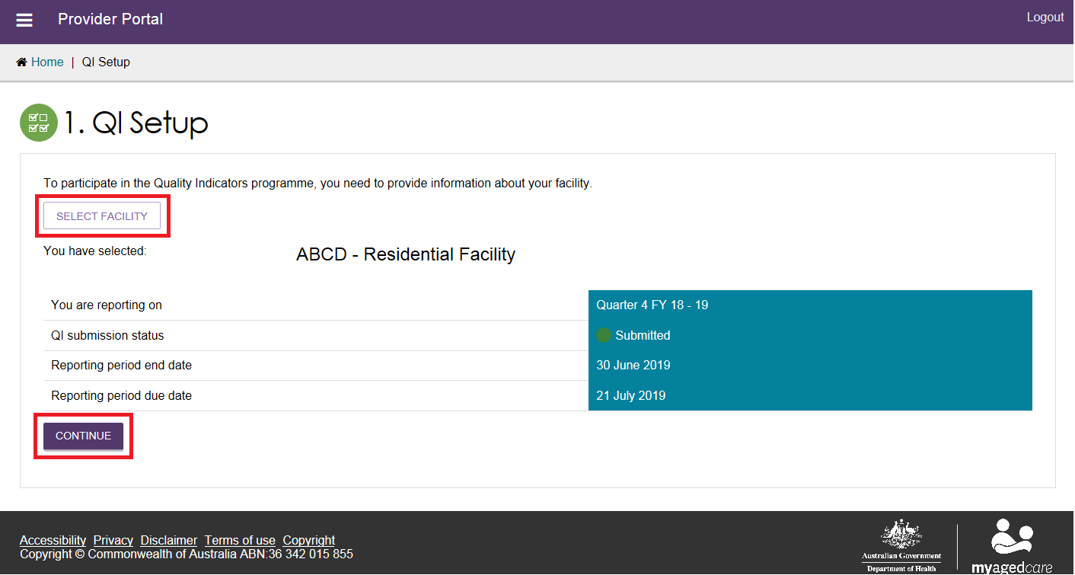

## How to access QI reports

To access QI Reports follow the steps below.

1. From the landing page, click on the ‘Reports’ tile.

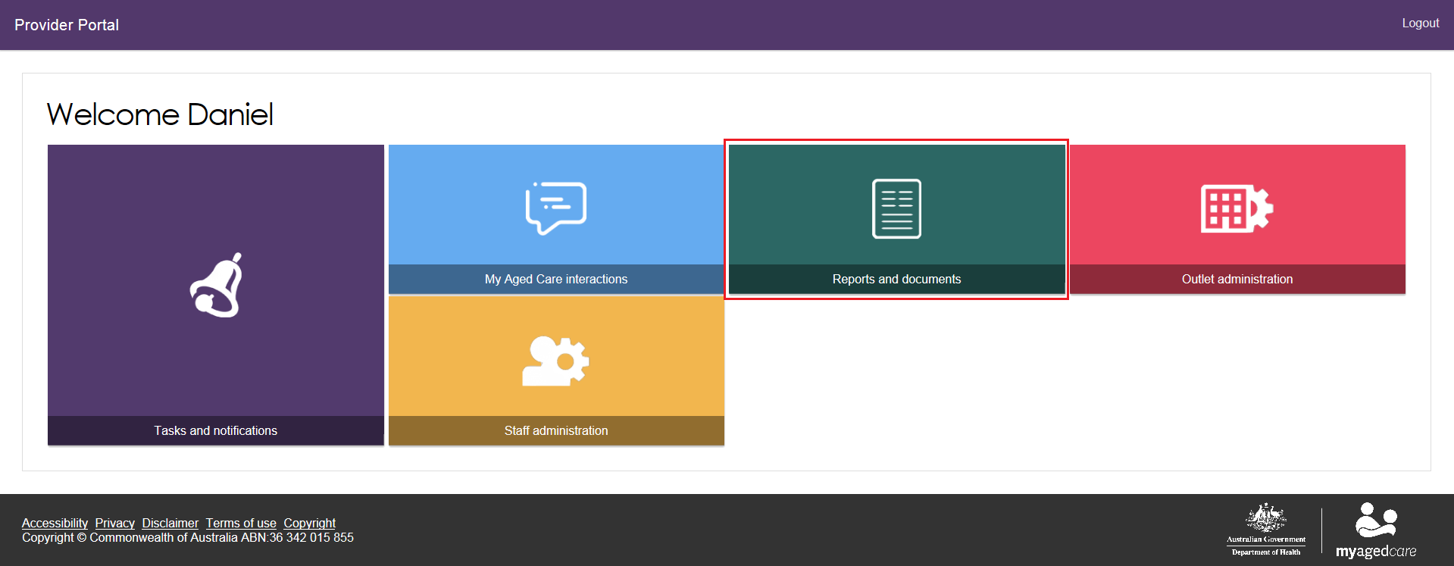

1. Select the report you want to view or download.

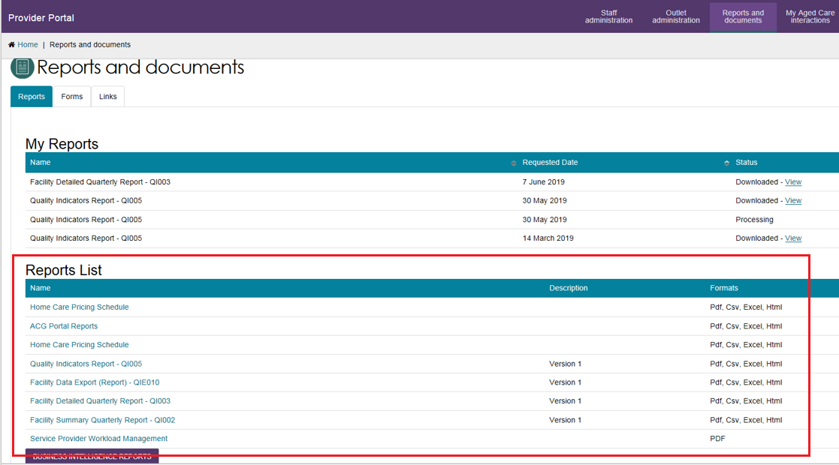

1. You must fill in the three mandatory fields, shown with asterisks, to request a report.

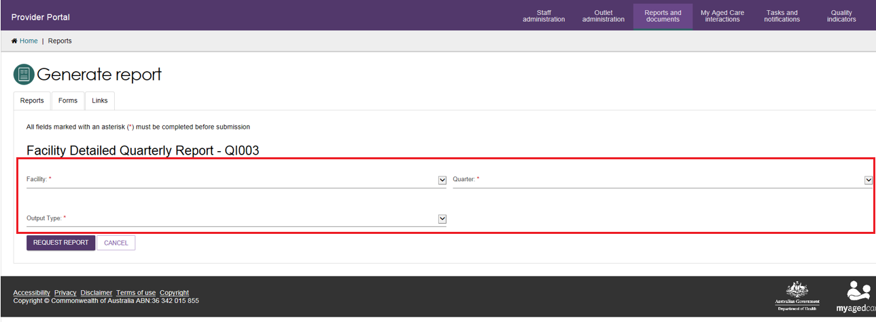

1. Click on the ‘Facility’ field and choose the relevant facility.

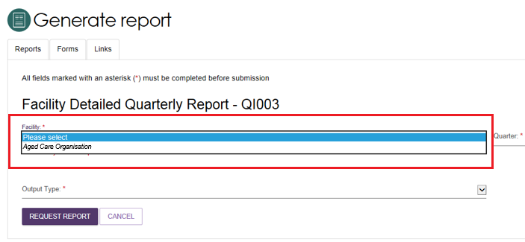

1. Click on the ‘Quarter’ field and choose the relevant quarter.

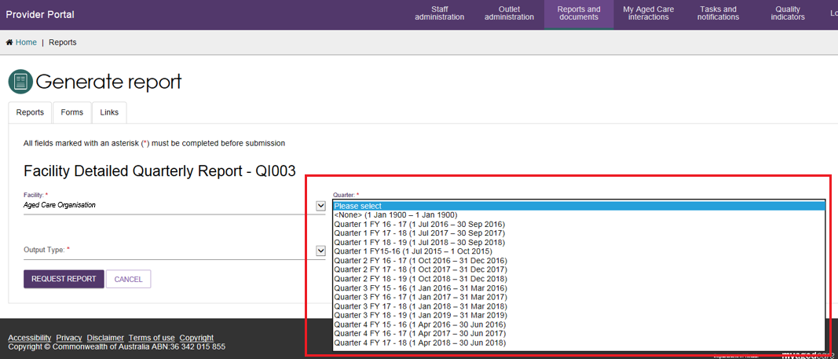

1. Click on the ‘Output Type’ field and choose the format you would like the report to be produced in—that is, PDF (for printing), CSV and Excel (for extracting data), or HTML (for viewing in an internet browser).

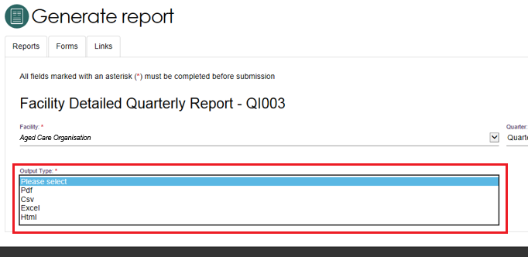

1. Once all the mandatory fields are completed, click on ‘Request report’.

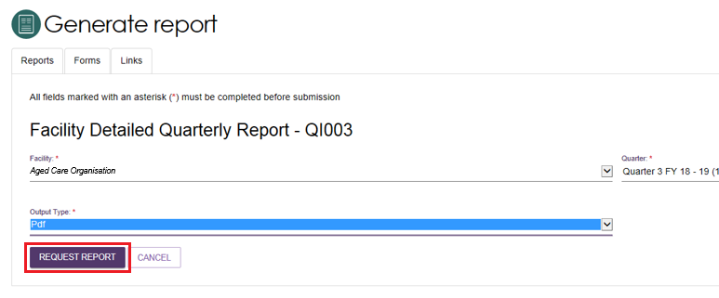

1. The report will then be generated.

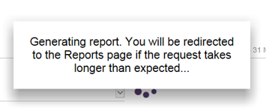

1. Once the report is generated, you can choose to open, save, or cancel the report.



1. Click open or save to view the report.

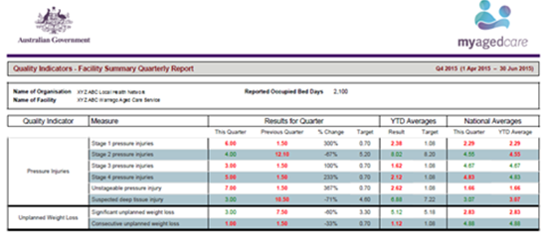

1. You can access all recently requested reports from the ‘Reports and forms’ page.

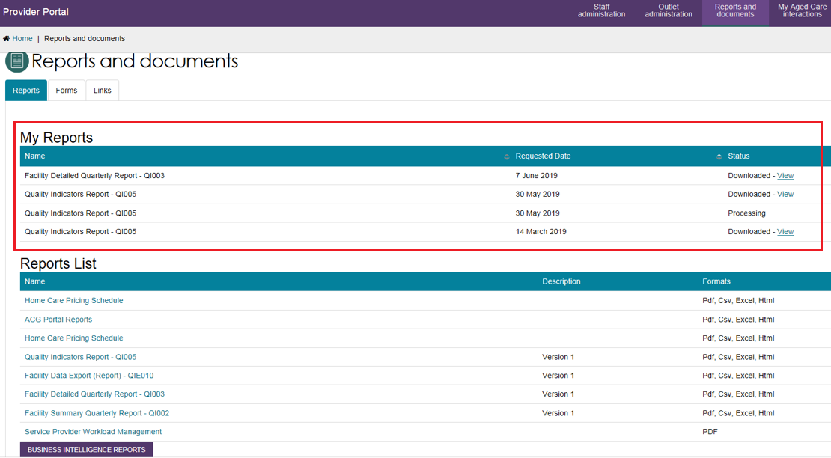

## How to read residential care services’ QI reports

Residential care services can run three reports and a data extract for their service through the Provider Portal Reports tab. The following pages show examples of these three reports. The data extract only provides data that was entered for your service.

### QI002—Facility Summary Quarterly Report

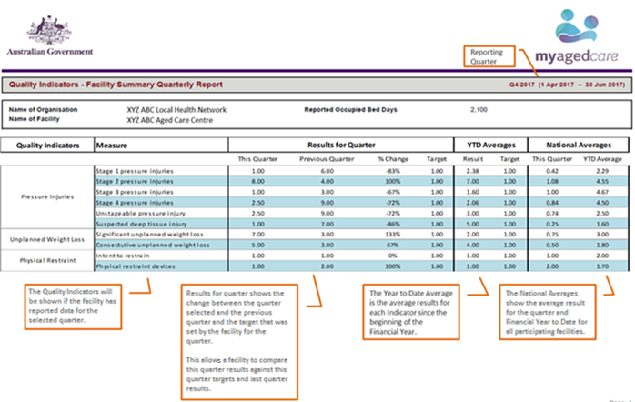

### QI003—Facility Detailed Quarterly Report

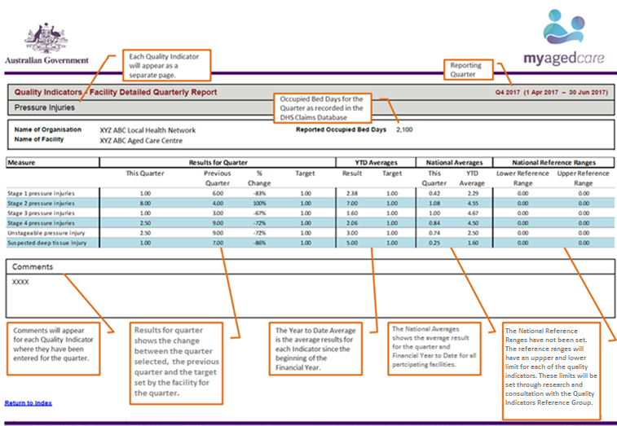

### QI005—QI Report

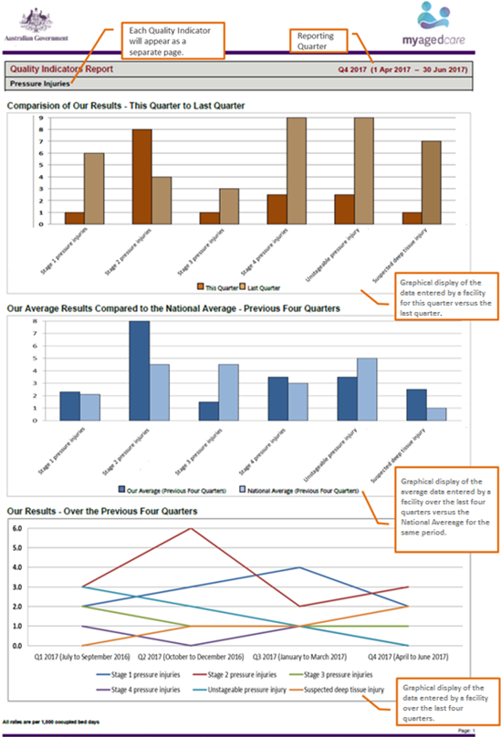

# Appendix 1—Data collection template example

You can use or adapt this example template to help you plan your collection and recording of QI data.

## Scheduling QI data collection

|  |  |  |  |  |  |
| --- | --- | --- | --- | --- | --- |
| **Residential care service name:**  **Schedule for QI data collection**  **Quarter 3 2019 – 2020, January 1 to 31 March 2019** | | | | | |
|  | | | | | |
| **Quality indicator** | **Advice** | **Date of collection** | | **Responsibility** | |
| **QI 1. Pressure injuries** | Every care recipient will be assessed for pressure injuries once each quarter.  The assessment can be conducted either by assessing every care recipient over a set period of up to 14 days, or by identifying an assessment date for each care recipient and completing the assessment on the same day for each quarter. | Assessment period:  All care recipients over 14 days  _____/_____/2019  to  _____/_____/2019  OR  A date for each care recipient | | Name:  _________________ | |
| **QI 2. Use of physical restraint** | Every care recipient will be assessed by observation for use of physical restraint.  There are two categories to be collected for physical restraint during each assessment.  Identify three assessment days in each quarter. On each of these days, conduct three observations of the care recipients—one during the morning, one in the afternoon and one at night. This is a total of nine observation assessments over the quarter.  Observations should be unannounced. Do not disclose the timing of the observation to staff, except for the person conducting the observation. | Assessment 1 on  _____/_____/2019 | | Assessment 1:  Morning observation:    Afternoon observation:    Night observation: | |
| Assessment 2 on  _____/_____/2019  Assessment 3 on  _____/_____/2019 | | Assessment 2:  Morning observation:    Afternoon observation:    Night observation:    Assessment 3:  Morning observation:    Afternoon observation:    Night observation: | |
| **QI 3. Unplanned weight loss** | Every care recipient, except exclusions, will be assessed for unplanned weight loss.  There are two categories to be collected by assessing the records of all participating care recipients’ weight each month of the quarter.  Regularly calibrate weighing devices.  Weigh care recipients at around the same date and time as the previous weigh on the same weighing device.  Weigh care recipients in clothing of a similar weight each weigh in and deduct this from the total weight to arrive at a result. | Weigh care recipients each month and record on a QI data collection sheet.  Assess for unplanned weight loss at the end of each month. Assessment day:  Month 1 _____/_____/2019  Month 2 _____/_____/2019  Month 3 _____/_____/2019 | | Name:    Name: | |
| **Data submission to the My Aged Care Provider Portal (when and responsible team member)** | | | _____/_____/2019 | | Name: |

# Appendix 2 - More information on QI 1: Pressure injuries

## Evidence to support this QI

This QIhighlights pressure injuries as a major and prevalent health concern for older people.

Substantial evidence and research demonstrates that the development of pressure injuries are a significant issue for older people living in residential care services.

## Defining pressure injuries

A pressure injury as defined by the Australian Wound Management Association (2014) as ‘a localised injury to the skin and/or underlying tissue usually over a bony prominence, as a result of pressure, shear and/or friction, or a combination of these factors.’

Pressure injury classification systems provide a consistent method of assessing and documenting pressure injuries. However, determining the severity and scale of the problem, and the degree of tissue involvement and exact causal determinants has been inconsistent, with varying data and terminology used around the world.

Australian representatives have been working with many countries in order to develop the international clinical practice guideline with an international classification system using the following six categories/stages (National Pressure Ulcer Advisory Panel, September 2016):

* Stage 1 pressure injuries: non-blanchable erythema of intact skin
* Stage 2 pressure injuries: partial thickness skin loss with exposed dermis
* Stage 3 pressure injuries: full-thickness skin loss
* Stage 4 pressure injuries: full-thickness tissue loss of skin and tissue
* Unstageable pressure injuries: obscured full-thickness skin and tissue loss
* Suspected deep tissue injuries persistent non-blanchable deep red, maroon or purple discolouration.

## Pressure injuries in residential care services

Older people are particularly vulnerable to developing pressure injuries.

Age-related changes to skin integrity, malnutrition, chronic disease, immobility, incontinence, impaired cognitive status and frailty are issues associated with advanced age and are all cited as risks factors that can contribute to the development of pressure injuries

(Jaul 2010; WOCNS 2010; NPUAP 2009; Holm et al. 2007; Santamaria et al. 2005; Bates-Jensen 2001).

The Victorian Department of Health’s *Pressure ulcer point prevalence survey* (PUPPS 3) conducted in 2006 demonstrated that out of 1222 patients identified as having pressure injuries, 988 (80.85 per cent) were 60 years of age or older.

## Adverse clinical events and pressure injuries

The most significant adverse clinical event associated with pressure injuries is an increased risk of mortality.

The Victorian Quality Council (VQC) points out in its 2004 report, *Pressure ulcers: a cause for concern*,that from 2001 to 2003, 923 deaths occurred as a direct or indirect result of a pressure injury.

Authors such as Jaul (2010), Takahashi (2008), Capon et al. (2007), Santamaria et al. (2005), all concur that pressure injuries significantly increase an older person’s risk of mortality.

Common causes of death as a result of pressure injury development include osteomyelitis[2] and septicaemia (Jaul 2010; Bates-Jensen 2001). Osteomyelitis is an infection of the bone and may be acute or chronic (Skinner 2006).

Wound infection is also an adverse clinical event associated with pressure injury. Infection can cause wound deterioration and stop the pressure injury from healing (Whitney et al. 2006), which may in turn reduce mobility and physical function, and increase the risk of morbidity.

It may also increase the risk of developing cellulitis (Moore and Cowman 2007). The risk of infection increases if necrotic tissue is present in the pressure injury. Necrotic tissue forms an environment that promotes bacterial growth (Bluestein and Javaheri 2008; Bates-Jensen and MacLean 2007 and Macklebust and Sieggreen 2001). Infection most commonly occurs in Stages III and IV pressure injuries as they are open wounds and necrotic tissue may be present (Moore and Cowman 2007).

Pain is also cited as an adverse clinical event associated with pressure injury development (Jaul 2010; Bates-Jensen and MacLean 2007).

## Causes of pressure injuries

A number of risk factors contribute to the development of pressure injuries.

Friction and shearing are two common terms often used to describe how pressure injuries occur. Friction refers to two surfaces moving across each other, the result being the formation of a wound. This commonly occurs when a person is pulled across bed linen. Moisture also increases friction.

Shearing occurs when two surfaces move parallel to each other, for example when a person is positioned upright in a bed they tend to slide downward and their skin and bed linen shear to cause a wound (Dealey 2005).

Significantly for residential care services, older age is frequently cited in the available evidence as a common risk for the development of pressure injuries. Jaul (2010) states that 70 per cent of pressure injuries occur in people who are aged 70 years or older.

Aside from the incidence of comorbidities and chronic diseases associated with older age that may contribute to pressure injury development, specific age-related changes to skin also increase the risk of occurrence (Jaul 2010; Dealey 2005; and Macklebust and Sieggreen 2001).

These changes include:

* loss of skin elasticity
* loss of collagen
* thinning of subcutaneous tissue
* reduced muscle mass
* reduced perfusion and oxygenation of tissue
* increased fragility and dryness.

There are a number of other reasons why pressure injuries occur, all of which are relevant to residential care services. These reasons are summarised below in *Table 1: Factors contributing to pressure injury development and residential care service.*

Table 1: Factors contributing to pressure injury development and residential care services

| Issue | Relevance to pressure injury development and residential care service |
| --- | --- |
| Nutrition | Poor nutrition or malnutrition can reduce skin elasticity and lead to anaemia, which in turn reduces the flow of blood and oxygen to tissues. This can lead to the development of pressure injuries.  Malnutrition also reduces muscle and fat that normally protect or ‘pad’ bony prominences. The reduced protection and increased exposure of bony prominences can lead to a greater risk of developing pressure injuries.  In addition, care recipients with a pressure injury who do not have adequate nutritional intake will have delayed wound healing. Nutrients supplied may only maintain current health and not be sufficient to build new tissue, and the pressure injury may worsen. |
| Mobility | Care recipients with reduced mobility, and who are bed- or chair-bound, have an increased risk of pressure injury development.  They have greater exposure to friction and shearing forces, as well as direct pressure against skin surfaces.  In addition, care recipients with reduced mobility may not be able to reposition themselves. Reduced mobility is cited in the evidence as the greatest risk for pressure injury development. |
| Comorbidities and chronic disease | The presence of chronic disease and comorbidities may increase care recipients’ need for bed rest and can reduce mobility.  Physiologically (depending on the type of disease or illness) blood flow and oxygenation to tissues may be reduced, muscle wastage may occur and the resident may also become malnourished. |
| Incontinence | Incontinence may be a risk factor for pressure injury development, particularly urinary incontinence which results in skin maceration leading to an increase in friction against the skin.  Frequent washing of the skin due to urinary and faecal incontinence may reduce the skin’s natural oils and lead to dryness.  Washing with soap removes the natural oils, so soap alternatives are often suggested. |
| Restraint | Care recipients who are restrained either physically or chemically have an increased risk of pressure injury development due to a decrease in mobility. |
| Contracture | Pressure redistribution means spreading the weight (load) over the largest surface area.  If a person becomes contracted, then the surface area is reduced, thus predisposing them to higher pressures. |

*Source*: adapted from Elliot 2011; Amir et al. 2010; AIHW 2010; Jaul 2010; Dealey 2005; Barrois et al. 2008; Bluestein and Javaheri 2008; Holm et al. 2007; Whitney et al. 2006; AIHW 2003; Baumgarten et al. 2003; Wilkes et al. 1996.

The evidence highlights that care recipients are at risk of pressure injuries. The following resource list (below) and pressure injury risk management framework (at *Figure 1*) may assist residential facilities in their prevention and management of pressure injuries.

## Resources

A range of resources are available to assist residential facilities identify and manage pressure injuries.

* [National Pressure Ulcer Advisory Panel (NPUAP) Pressure Injury Staging Illustrations](https://www.npuap.org/resources/educational-and-clinical-resources/pressure-injury-staging-illustrations/)
* [Australian Wound Management Association website](https://www.woundsaustralia.com.au/), which includes *Prevention and treatment of pressure ulcers: clinical practice guidelines* *2014*
* Victoria Department of Health, [*Pressure ulcer basics online education program*](http://elearning.health.vic.gov.au/PressureUlcerBasics/index.htm) (currently being updated to include an additional stage for pressure injuries)
* [Joanna Briggs Institute](https://joannabriggs.org/), Best Practice information sheets, *Prevention of pressure related damage* and *Management of Pressure related tissue damage* (available with membership)
* Queensland Health 2012, tools and resources developed for the [National Safety and Quality Service Standards: Standard 8 Preventing and Managing Pressure Injuries](https://www.health.qld.gov.au/__data/assets/pdf_file/0029/433478/pip-audit-def.pdf)
* West Australian Government Department of Health wound education modules (now hosted by [Wound Innovations](https://www.woundinnovations.com.au/education/#modules))

#### Figure 1: Pressure injury risk management framework

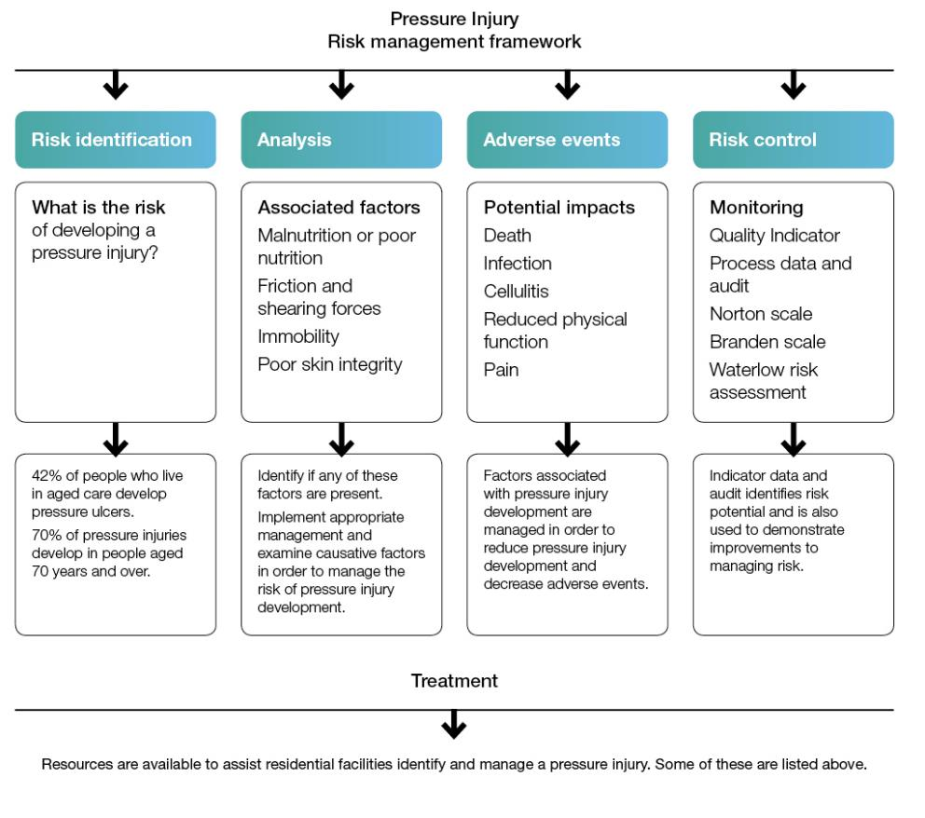

*Source:* adapted with permission from Victorian Department of Health 2015, *Quality Indicators in public sector residential aged care services, Resource materials, January 2015 edition.* Victorian Department of Health and Human Services, Melbourne.

# Appendix 3 - **Example templates for recording data for QI 1: Pressure injuries**

## Pressure injuries data collection sheet

You can adapt this example collection sheet for use when collecting QI data from each resident each quarter for QI 1: Pressure injuries.

|  |  |  |  |  |  |  |  |  |  |
| --- | --- | --- | --- | --- | --- | --- | --- | --- | --- |
| **Quality indicator 1. Pressure injuries** | | | |  | | | | | |
| **Facility name** | | | |  | | | | | |
|  | | | | | | | | | |
| **Reporting quarter date** | | | |  | | | | | |
| **Assessment date** | **Resident (include all care recipients)** | **Stage**  **1** | **Stage**  **2** | | **Stage**  **3** | **Stage**  **4** | **Unstageable** | **Suspected deep tissue injuries** | **Comments** |
| 3 August 2019 | Mrs Example code 114 | 0 | 0 | | 1 | 0 | 0 | 0 | This resident is new and the injury was present on admission. |
| 3 August 2019 | Mr Example code 115 | 1 | 0 | | 0 | 0 | 0 | 0 | This resident is receiving end-of-life palliative care. |
| 4 August 2019 | Ms Example code 116 | 3 | 0 | | 0 | 2 | 0 | 0 | This resident is new and the injury was present on admission. |
| **Total** | **3** | **4** | **0** | | **1** | **2** | **0** | **0** | 3 x Stage 1; 1 x Stage 3 and 2 x Stage 4 present on admission.  1 x Stage 1 from a resident receiving end-of-life palliative care. |

## Pressure injuries data recording sheet

You can adapt this example recording sheet for use when summarising your QI data collected (see pressure injuries data collection sheet above) for QI 1: Pressure injuries.

This information is the total for the facility for each quarter, which is submitted to the department through the Provider Portal.

|  |  |  |  |  |  |  |  |  |
| --- | --- | --- | --- | --- | --- | --- | --- | --- |
| **Quality indicator 1. Pressure injuries** | | | |  | | | | |
| **Name of facility** | | | |  | | | | |
| **Reporting quarter date** | | | |  | | | | |
| **Assessment completed date** | | | |  | | | | |
| **Total number of care recipients assessed** | | | |  | | | | |
| **Total number of care recipients in the facility** | | | |  | | | | |
|  | | | | | | | | |
|  | **Stage 1** | **Stage 2** | **Stage 3** | | **Stage 4** | **Unstageable** | **Suspected deep tissue injuries** | **Total injuries** |
| **Number of pressure injuries** |  |  |  | |  |  |  |  |

**Comments**

* Note any pressure injuries reported above that have been present since admission. From the example above, ‘3 x Stage 1; 1 x Stage 3 and 2 x Stage 4 present on admission’. In subsequent quarters, include these injuries in the ordinary count, no comment needed.
* Note the number of pressure injuries reported above that developed while the resident was away from the facility, for example, while in hospital or on holiday. From the example above, ‘nil’.
* Note the number of pressure injuries reported above that relate to a resident receiving end-of-life palliative care. From the example above, ‘1 x Stage 1’.
* Include care recipients receiving respite care.

# Appendix 4 - More information on QI 2: Use of physical restraint

## Evidence to support this QI

This QI highlights the use of restraint as a major issue for older people.

Substantial evidence and research demonstrates that the use of physical restraint as having significant impacts for older people living in residential care services.

The following devices and equipment are considered to be physical restraint:

* bedrails
* chairs with locked tables
* seatbelts other than those used during active transport
* safety vests
* shackles
* manacles.

## The significance of physical restraint in residential care services

The incidence of physical restraint in residential care services across Australia is poorly documented. However, available evidence suggests an incidence of 15 to 30 per cent (Johnson et al. 2009).

Evidence suggests the prevalence of physical restraint use in residential care services is between 12 and 49 per cent (Alzheimer’s Australia 2014).

Rationale for the use of restraint is often embedded in the perception that it reduces risks to resident safety (and the safety of others) as a result of falls, wandering, aggression, agitation and unpredictable behaviour.

There is also evidence that suggests older people living in residential care services are physically restrained due to inadequate staff supervision.

Research indicates that the use of physical restraint can cause negative physical and psychological outcomes (Engberg et al. 2008). There may also be an inaccurate perception that using physical restraint to minimise risks to the resident’s safety does not constitute restraint. Regardless of the rationale for its use, any method of physical restraint should always be regarded as such (Australian Government Department of Health and Ageing 2012).

The variations in the incidence of physical restraint cited above are likely due to organisations’ different understandings of what actually constitutes restraint. This is supported by Meyer et al. (2008) and Fogel et al. (2009).

Regardless of the incidence of physical restraint, it is a significant issue in aged care because it is an infringement of the individual’s right to freedom and dignity (Gelkopf et al. 2009; Meyer et al. 2008; Royal College of Nursing 2008; Timmins 2008). This does not align with the objectives of the Commonwealth *Charter of Aged Care Rights* (*Aged Care Act 1997*).

Evidence also shows restraint may actually cause or exacerbate the adverse outcomes its use was attempting to address (Engberg et al. 2008). For example, physical restraint used to restrict unsafe movement of a resident who has delirium and is aggressive exacerbates their delirium and aggression (Australian and New Zealand Society for Geriatric Medicine 2012).

This example highlights the importance of understanding:

* what physical restraint is
* its appropriateness in residential care service
* the negative outcomes associated with it.

## Adverse clinical events and the use of physical restraint

Decisions to use or not use physical restraint may raise ethical questions and dilemmas for care workers. These challenges can be difficult and may not be easily resolved.

When deciding whether or not to use physical restraint, it may be difficult to avoid harm, as injury can be caused by either course of action.

Healthcare workers have an obligation to all those in their care, and if enabling one person’s freedom results in harm to others, then decision makers need to justify their decision based on the consequence of applying or not applying restraint (Royal College of Nursing 2008).

There is substantial evidence showing the negative consequences associated with physical restraint and the older person. The evidence does not support the view that the use of physical restraint maintains safety and reduces the incidence of adverse clinical events such as falls.

However, the literature acknowledges that in some situations the use of physical restraint may be the last option available to manage a specific issue.

The psychological and physical adverse outcomes for care recipients caused by physical restraint can be serious. Research indicates that physical restraint clearly impacts on a resident’s mental health, including their emotional wellness and social engagement.

Castle (2006) demonstrates that care recipients who are restrained are more likely to become more impaired with respect to cognitive performance, depression and social engagement. They conclude that if facilities reduce the use of physical restraint, the prevalence of care recipients’ mental health problems is also likely to decline.

Other adverse events associated with physical restraint and the older person examined by several studies include damage to the individual’s dignity and autonomy as a result of being physically restrained.

The Australian and New Zealand Society for Geriatric Medicine (2012) cites emotional desolation, withdrawal, fear and anger as consequences of physical restraint.

Gastmans and Milisen (2005) add that an older person who is physically restrained may experience loss of dignity, social isolation, loss of self-respect and identity, and feelings of shame. These points are also supported by authors such as Timmins (2008) and Stubbs et al. (2009).

Mortality associated with or as a cause of physical restraint is cited frequently in available evidence (Australian and New Zealand Society for Geriatric Medicine 2012; Agens 2010; Lane and Harrington 2011; McCabe et al. 2011).

Gastmans and Milisen (2005) state that physical restraint is associated with an increased risk of mortality related either directly to the restraint device or associated with the restraint device. For example a resident may be restrained to reduce the risk of falling, but may in fact experience a fall as a result of being restrained, which then results in a head injury and ultimately death.

There are a number of other adverse clinical events aside from mortality associated with restraint cited in the available evidence; these are presented in *Figure 2* below.

#### Figure 2: Adverse clinical events, other than mortality, associated with restraint

*List of adverse clinical events associated with restraint
*

*Source:* Adapted from Feng et al. 2009, Gelkopf et al. 2009, Pellfolk et al. 2010, Knox 2007, Meyer et al. 2008, Fogel et al. 2009, Timmins 2008, Agens 2010, Lane and Harrington 2011, Evans et al. 2003, Gastmans and Milisen 2005.

## Why physical restraint occurs

There are many reasons why physical restraint is used in the residential care services. However, there is no evidence that demonstrates physical restraint is of any benefit to care recipients.

Available evidence does suggest there may be situations where physical restraint is sometimes required because all other options used to manage resident safety have failed.

The general consensus of the literature evaluated concludes there are six common reasons why physical restraint is rationalised for use among older people (Agens 2010; Australian and New Zealand Society for Geriatric Medicine 2012; Evans et al. 2003; Gelkopf et al. 2009; Huang et al. 2009; Knox 2007; Lane and Harrington 2011; McCabe et al, 2011; Meyer et al, 2008; Pellfolk et al. 2010; Saarnio and Isola 2009; Timmins, 2008).

These are:

* prevention of falls
* management of aggressive/inappropriate behaviour
* prevention of injury to the confused resident
* prevention of wandering
* reducing interference with ‘treatments’ and medical devices
* risk reduction during periods of low/inadequate staff supervision.

When measured against the adverse outcomes of the use of restraint outlined above it is clear that these rationales are contradictory. In addition, the Australian and New Zealand Society for Geriatric Medicine (2012) clearly states the use of physical restraint should never be used to compensate for inadequate staffing numbers.

Wang and Moyle (2005) also point out physical restraint is often perceived as a preventive strategy to reduce risks to care recipients. This is also supported by authors such as Johnson et al. (2009) and the Victorian Institute of Forensic Medicine (2006).

The use of physical restraint has also been linked to nursing and care worker knowledge, education and understanding of what constitutes restraint and the appropriateness of its application in the residential care services setting. This skill set has been demonstrated as inadequate in international studies (Huang et al. 2009).

This issue is highlighted by Johnson et al. (2009), who examine a restraint minimisation Programme in an Australian residential aged care facility. Nursing staff consistently demonstrated a belief that the benefits of physical restraint far outweighed the negatives associated with it.

Saarnio and Isola (2009) state that nursing staff may not be fully aware of alternative options, making it difficult for them to make an informed decision about its use. This is a significant issue considering nursing staff in residential aged care facilities are often the key decision makers regarding the use of physical restraint (Gelkopf et al. 2009; Huang et al. 2009).

Another issue is the request for the use of physical restraint by the resident or resident’s family. The previous Australian Government Department of Health and Ageing (2012) made a clear statement about requests for restraint by family members:

A family member or legal representative does not have the legal power to require that a care recipient be restrained. This is a clinical decision that must be made by appropriately qualified people.

The reasons for the decision to restrain and the process by which the decision was reached should be documented, as those making the decision are legally accountable for the decisions and consequences.

Source: *Decision-making tool: supporting a restraint free environment in residential aged care*, p. 22.

Several studies discuss resident perceptions of being physically restrained at their own request. Care recipients request the use of restraint because they believe it makes them feel ‘safe’ (Gastmans and Milisen 2005), it can stop them from falling (Gallinagh et al. 2001), and they trust that nursing and care staff are making the right decision to restrain them (National Ageing Research Institute 2005).

Physical restraint is often used to manage behavioural and psychological symptoms of dementia and to prevent falls.

However, the evidence indicates restraint does not prevent falls or fall-related injuries (Qureshi 2009) and, indeed, is likely to exacerbate behaviours.

A restraint-free care environment is the recommended standard of care (Rathnayake 2012). The *Quality of Care Amendment (Minimising the use of Restraints) Principles 2019* set out specific requirements that limit the use of chemical and physical restraint in a residential setting. The regulations provide that restraint is only to be used as a last resort and require providers to satisfy certain conditions before restraint is be used, including in the case of physical restraint, assessment by an approved health practitioner. Providers must regularly monitor and review any consumer who is subject to restraint.

The National Aged Care Mandatory Quality Indicator Program (QI Program) provides a carefully defined indicator for aged care residential services to meaningfully measure, monitor the use of physical restraint over time and to continuously improve their performance. Services that record the use of physical restraint for the purpose of the QI Program must also satisfy the new requirements/approved provider responsibility where physical restraint is used: [*Quality of Care Amendment (Minimising the Use of Restraints) Principles 2019*.](https://www.legislation.gov.au/Details/F2019L00511)

The evidence highlights that restraint places care recipients at risk of adverse events. The following resource list and physical restraint risk management framework (at *Figure 3*) may assist residential facilities in the prevention and management of physical restraint.

#### Figure 3: Physical restraint risk management framework

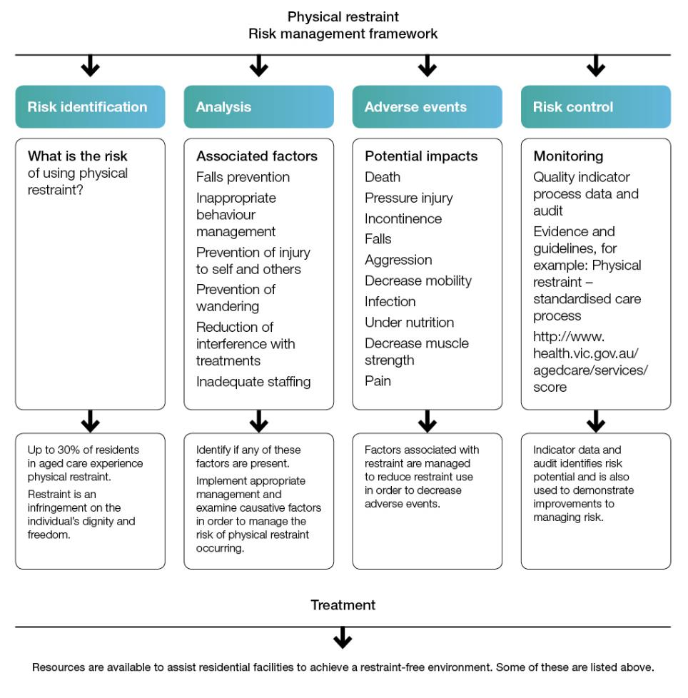

Source: adapted with permission from Victorian Department of Health 2015, Quality Indicators in public sector residential aged care services, Resource materials, January 2015 edition. Victorian Department of Health and Human Services, Melbourne.

## Resources

A range of resources and information is available to support residential care services to achieve a restraint free environment.

* Australian Government Department of Health and Ageing 2012, [*Decision-Making Tool: Supporting a Restraint Free Environment in Residential Aged Care*](https://agedcare.health.gov.au/publications-articles/resources-learning-training/decision-making-tool-responding-to-issues-of-restraint-in-aged-care/decision-making-tool-supporting-a-restraint-free-environment-in-residential-aged-care)
* Victorian Department of Health 2014, [*Standardised care process (SCP): physical restraint*](https://www2.health.vic.gov.au/Api/downloadmedia/%7B76B648D3-19FA-4307-A12D-C68B2E5FA2F2%7D)

New South Wales Department of Health 2006, [*Guidelines for working with people with challenging behaviours in residential aged care facilities—using appropriate interventions and minimising restraint*](http://www.health.nsw.gov.au/policies/gl/2006/pdf/GL2006_014.pdf)

# Appendix 5 - **Example templates for recording data for QI 2: Use of physical restraint**

## Physical restraint data collection sheet

You can adapt this example collection sheet for use when collecting QI data from each resident each quarter for QI 2: Use of physical restraint.

|  |  |  |  |  |  |
| --- | --- | --- | --- | --- | --- |
| **Quality indicator 2. Use of physical restraint** | |  | | | |
| **Name of facility** | |  | | | |
| **Reporting quarter date** | |  | | | |
|  | | | | | |
| **Assessment 1: Date / /**  **Time**  **By** | **Observation**  **(morning)** | | **Observation**  **(afternoon)** | **Observation**  **(night)** | **Total** |
| **Intent to restrain**—total number of restraints. |  | |  |  | Box 1 |
| **Physical restraint devices**—total number of restraints. |  | |  |  | Box 2 |
| **Assessment 2: Date / /**  **Time**  **By** | **Observation**  **(morning)** | | **Observation**  **(afternoon)** | **Observation**  **(night)** | **Total** |
| **Intent to restrain**—total number of restraints |  | |  |  | Box 3 |
| **Physical restraint devices**—total number of restraints |  | |  |  | Box 4 |
| **Assessment 3: Date / /**  **Time**  **By** | **Observation**  **(morning)** | | **Observation**  **(afternoon)** | **Observation**  **(night)** | **Total** |
| **Intent to restrain—**total number of restraints |  | |  |  | Box 5 |
| **Physical restraint devices—**total number of restraints |  | |  |  | Box 6 |

## Physical restraint data recording sheet

You can adapt this example recording sheet for use when summarising your QI data collected (see physical restraint data collection sheet above) for QI 2: Use of physical restraint.

This information is a total for the facility for each quarter which is submitted to the department through the Provider Portal.

|  |  |  |  |  |  |  |  |  |
| --- | --- | --- | --- | --- | --- | --- | --- | --- |
| **Quality indicator 2. Use of physical restraint** | |  | | | | | | |
| **Name of facility** | |  | | | | | | |
| **Reporting quarter date** | | Example: Quarter 1 2019 – 2019, July 1 to 30 September 2019 | | | | | | |
|  | | | | | | | | |
| **Assessment date 1:** | |  | | **Number of care recipients assessed:** | | |  | |
| **Assessment date 2:** | |  | | **Number of care recipients assessed:** | | |  | |
| **Assessment date 3:** | |  | | **Number of care recipients assessed:** | | |  | |
|  | | | | | | | | |
|  | **Assessment Day 1** | | **Assessment Day 2** | | **Assessment Day 3** | **Total for all 3** | |
| **Intent to restrain** | From Box 1 | | From Box 3 | | From Box 5 | Box 1 + 3 + 5 | |
| **Physical restraint devices** | From Box 2 | | From Box 4 | | From Box 6 | Box 2 + 4 + 6 | |

### Comments

Intent to restrain:

* Indicate the total number of care recipients who were intentionally restrained during any of the audits.
* Record the number of uses of restraint in the total that were specifically requested by the care recipients and/or their family and/or advocate. This will be the total of the three assessments, which is Box 7 + 9 + 11 from the table below. For example, ‘12 restraint uses from the total were water chairs requested by family.’

Physical restraint devices:

* Record the number of uses of restraint in the total that were specifically requested by the care recipients and/or their family and/or advocate. This will be the total of the three assessments, which is Box 8 + 10 + 12 from the table below. For example, ‘three restraint uses from the total were bedrails requested by some care recipients for security’.
* Include any other relevant comments in relation to intent to restrain or physical restraint devices.

### Additional information in relation to the comments section

You can adapt this example collection sheet for use when collecting QI data from each care recipient for the comments section.

Physical restraint data collection sheet in relation to the comments section

|  |  |  |  |  |  |
| --- | --- | --- | --- | --- | --- |
| **Quality indicator 2. Use of physical restraint** |  | | | | |
| **Name of facility** |  | | | | |
| **Reporting quarter date** |  | | | | |
|  | | | | | |
| **Assessment 1:**  **Date / /**  **Time**  **By** | | **Observation**  **(morning)** | **Observation**  **(afternoon)** | **Observation**  **(night)** | **Total** |
| **Intent to restrain**—total number of restraints requested by a resident and/or their family and / or advocate. | |  |  |  |  |
| **Physical restraint devices**—total number of restraints requested by a resident and/or their family and/or advocate. | |  |  |  |  |
| **Assessment 2: Date / /**  **Time**  **By** | | **Observation**  **(morning)** | **Observation**  **(afternoon)** | **Observation**  **(night)** | **Total** |
| **Intent to restrain**—total number of restraints requested by a resident and/or their family and/or advocate. | |  |  |  |  |
| **Physical restraint devices**—total number of restraints requested by a resident and/or their family and/or advocate. | |  |  |  |  |
| **Assessment 3: Date / /**  **Time**  **By** | | **Observation**  **(morning)** | **Observation**  **(afternoon)** | **Observation**  **(night)** | **Total** |
| **Intent to restrain**—total number of restraints requested by a resident and/or their family and/or advocate. | |  |  |  |  |
| **Physical restraint devices**—total number of restraints requested by a resident and/or their family and/or advocate. | |  |  |  |  |

# Appendix 6 - More information on QI 3: Unplanned weight loss

## Evidence to support this QI

This QI highlights unplanned weight loss as a major issue among older people.

Substantial evidence and research demonstrates that unplanned weight loss is significant among older people living in residential care services.

Unplanned weight loss is generally a clinical symptom of another disease process or syndrome including:

* protein-energy malnutrition
* anorexia of ageing
* sarcopenia
* illness and/or disease severity
* polypharmacy—medication side effects and interactions.

There is a particularly close correlation between unplanned weight loss and protein‑energy malnutrition. Prevalence of malnutrition in the residential aged care setting ranges from 40 to 70 per cent (Watterson et al. 2009).

Two key Australian studies have concurred that the prevalence of malnutrition in residential aged care is approximately 50 per cent (Banks et al. 2007; Gaskill et al. 2008). In addition to this, those most at risk are care recipients over the age of 90 and/or those with high-level care needs (Banks et al. 2007; Gaskill et al. 2008; Watterson et al. 2009).

Normal weight loss for the older person can be expected to be only 0.1 to 0.2 kilograms a year (Wallace and Schwartz 2002).

The Dietitians Association of Australia (Watterson et al. 2009) has identified that measuring weight loss over time can predict malnutrition.

However, there is some variation regarding the definition of clinically significant weight loss in relation to malnutrition.

The International Statistical Classification of Diseases and Related Health Problems, Tenth Revision, Australian Modification (ICD-10AM) criteria for the diagnosis of malnutrition is as follows:

* Severe—body mass index (BMI) less than 18.5 kg/m2 **or** unintended weight loss of more than 10 per cent
* Mild and moderate—BMI less than 18.5 kg/m2 **or** unintended weight loss of more than 5–9 per cent.

The National Institute for Health and Care Excellence (NICE) in the United Kingdom provides three options for defining malnutrition:

* BMI less than 18.5 kg/m2
* unintentional weight loss of more than 10 per cent in the last three to six months
* BMI less than 20kg/m2 **and** unintentional weight loss of more than 5 to 9 per cent.

The minimum dataset used in the United States defines unintentional weight loss as a decrease of more than 5 lbs (2.3 kg) in one month, or more than 10 lbs (4.5 kg) in six months.

## Unplanned weight loss in residential care services

Unplanned weight loss is highlighted in the literature as a significant health issue among older people, particularly those living in residential care services. Statistics regarding its prevalence vary.

Study data from Alibhai et al. (2005), Ruscin et al. (2005) and Payette et al. (2000) report the range of unplanned weight loss in adults over the age of 65 as 13 to 27 per cent, whereas an older study by Finch et al. (1998) has indicated that the prevalence is 31 per cent for those over the age of 65 in long-term care.

Unplanned weight loss should not be dismissed as natural age-related change (McMinn et al. 2011). Many causes of weight loss can be addressed if detected early (Dyck and Schumacher 2011). Nurses and other members of the care team play an important role in screening care recipients at risk of malnutrition or where there is clinical concern, and ensuring they receive adequate nutritional care (Chen et al. 2007; Hickson 2006; Merrell 2012; Watterson et al. 2009).

In the United States, weight loss is a key indicator of care provision in the long-term care environment (Morley et al. 2004). The Centers for Medicare and Medicaid Services (CMS) define unplanned weight loss in terms of avoidable and unavoidable. The focus is on the care provider’s standards of practice in the identification, implementation, monitoring and evaluation of weight loss issues.

Avoidable weight loss is identified when it is evident that the care provider has failed to maintain standards of practice in nutritional management. Unavoidable weight loss is established when it is clear that despite adherence to practice standards, the resident continues to lose weight.

## Adverse clinical events and unplanned weight loss

A number of adverse events may occur as a result of unplanned weight loss in the elderly. These issues have a significant effect on the quality of life of older people in aged care (American Dietetic Association 2010; Banks et al. 2010; Beattie et al. 2014; Courtney et al. 2009; Dyck and Schumacher 2011; Metalidis et al. 2008; Watterson et al. 2009).

However, it should be noted that for 10 to 36 per cent of older people, the aetiology (cause) of weight loss is unknown (Hartford Institute for Geriatric Nursing 2006).

Evidence suggests that unplanned weight loss among older people has a direct correlation with an increased risk of mortality (ADA 2010; Australian and New Zealand Society for Geriatric Medicine 2007; Beattie et al. 2014; Challa et al. 2007; Tamura et al. 2013) within one year (Thomas et al. 2013).

This point is also supported by the British Geriatrics Society (2011), which states: ‘a number of studies have now shown that the relative risk of death is consistently highest in those underweight than those overweight and in older people this may be even higher than those who are obese’.

This risk further increases when unplanned weight loss is classified as clinically significant.

Unplanned weight loss increases the rate of bone loss, particularly in the hip (McMinn et al. 2011; Raynaud-Simon 2009). Where weight loss is 5 per cent or more from baseline weight, it will double the risk of falls and hip fractures among older people (Australian and New Zealand Society for Geriatric Medicine 2007; Watterson et al. 2009). Evidence also links unplanned weight loss to the development of pressure injuries (ADA 2010; Australian and New Zealand Society for Geriatric Medicine 2007; Challa et al. 2007; Iizaka et al. 2010; Raynaud-Simon 2009).

Wound healing is also impaired by poor nutritional intake, especially a poor intake of protein (Challa et al. 2007; BAPEN 2012; Gaillard et al. 2008; Raynaud-Simon 2009). Inactivity or becoming bed bound can occur due to functional decline, loss of strength and mobility (BAPEN 2012; Challa et al. 2007). In turn this can increase the risk of pressure injury development and poor recovery from chest infection (BAPEN 2012; National Collaborating Centre for Acute Care United Kingdom 2006).

## Causes of unplanned weight loss

There are a number of reasons why unplanned weight loss may occur in older people living in residential care services.

Unplanned weight loss in the elderly is a highly complex and multifaceted health concern that can involve social, environmental, emotional, psychiatric and physiological issues (Crogan and Evans 2009; Hartford Institute for Geriatric Nursing 2006; Dyck and Schumacher 2011; Strajkovic et al. 2011; Van Lanke et al. 2012).

Pain, illness, chronic, malignant and neurological disease can all contribute to weight changes in the older person (ADA 2010; McMinn et al. 2011; Social Care Institute for Excellence (SCIE) 2009).

However, the growing prevalence of dementia and its link to weight loss raises concern. Several studies indicate that the presence of dementia is linked to unplanned weight loss.

The current evidence is described in the report on nutrition and dementia published by Alzheimer’s Disease International (Prince et al. 2014). Dementia affects the areas of the brain responsible for the control of appetite and energy (Prince et al. 2014).

However, weight loss can commence long before the symptoms of cognitive decline appear and increase as the disease progresses (Albanese et al. 2013; Kurrle et al. 2012; Miyamoto et al. 2011).

According to the Australian Institute of Health and Welfare (2012), 53 per cent of nursing home care recipients (nationally) have a diagnosis of dementia. A study by Irving (2003) found that care recipients with dementia exhibit a much lower BMI compared with care recipients without dementia.

When considering the relationship between unplanned weight loss and dementia, it is important to take into account the behavioural and other characteristics of dementia that could result in unplanned weight loss. Authors such as Prince et al. (2014), Kurrle et al. (2012), Aselage et al. (2011), Chang and Roberts (2008), Miyamoto et al. (2011), Gaskill et al. (2008) and Smith and Greenwood (2008) have explored these issues.

This includes factors such as:

* pacing and wandering resulting in untreated increased caloric intake needs
* inability to feed self
* no longer knowing how to eat (apraxia)
* decline in communication skills
* inability to recognise food as food (agnosia)
* paranoia and mistrust regarding food
* forgetting to eat.

Some of these behaviours are described as aversive (causing strong dislike or disinclination). Gillette Guyonette et al. (2007) describe aversive feeding behaviours as:

* dyspraxia and agnosia—unable to use utensils properly or recognise food
* resistance—avoiding food, refusing to open mouth, spitting out the food, and aggression towards the person assisting them
* oropharyngeal dysphagia—problems with control with mouth, tongue and swallowing
* changed behaviours and food preferences—wandering, refusal to eat requested food, altered preferences for taste or texture of food.

Many studies discuss the presence of protein energy malnutrition (PEM) among care recipients in aged care. PEM is the loss of lean body mass and adipose tissue that occurs as a result of low consumption of energy and protein (Raynaud-Simon 2009; Suominen et al. 2009; Australian and New Zealand Society for Geriatric Medicine 2007). Unplanned weight loss is a symptom of PEM (Miyamoto et al. 2011).

Another concept explored in the literature is physiological age-related changes. While weight loss and malnutrition are not an inevitable consequence of ageing, the physiological changes that occur in older adults can increase the risk of it occurring (Hickson 2006).

These changes include:

* decreased senses of taste and smell
* changes to dentition (i.e. loss/damage of teeth, poorly fitting dental prosthesis, poor oral health)
* early satiety (feeling fuller quicker)
* reduced appetite
* changes in the gastrointestinal tract that lead to poor nutrient absorption
* reduction in cellular capacity to store water
* increased frailty
* swallowing difficulties
* reduced eye sight.

These changes all contribute to unplanned weight loss (ADA 2010; Australian and New Zealand Society for Geriatric Medicine 2007; Benelam 2009; Dyck and Schumacher 2011; Gaskill et al. 2008; Tamura et al. 2013).

This process of age-related physiological change is sometimes called ‘anorexia of ageing’ (ADA 2010; Australian and New Zealand Society for Geriatric Medicine 2007; Raynaud-Simon 2009; Smith and Greenwood 2008).

There is also a correlation between unplanned weight loss in the elderly and polypharmacy, medication side effects and interactions (ADA 2010; Beattie et al. 2014, Hartford Institute for Geriatric Nursing 2006; Strjkovic et al. 2011).

Polypharmacy is a significant health issue among older people. It can cause nausea, vomiting, diarrhoea, anorexia and dysgeusia (distortion of taste) (Alibhai et al. 2005; McMinn et al. 2011; SCIE 2009). These are all factors that can lead to unplanned weight loss. Research conducted by Agostini and colleagues (2004) demonstrated that the risk of weight loss among older people increased with the more medicines they consumed.

Limited research has been conducted regarding the relationship between the ‘eating environment’ in residential aged care and unplanned weight loss by authors such as Nijs et al. (2006).

A more recent study by Ullrich et al. (2014) identified that protected meal times and proactive nutritional support overseen by nurses are necessary components to the management of unplanned weight loss and malnutrition in residential facilities.

Staffing issues can also affect unplanned weight loss in care recipients, including:

* resourcing and failure to prioritise staff duties to provide adequate assistance at meal times (Chubb et al. 2006; Dyck and Schumacher 2011; 2006; SCIE 2009; Taumra et al. 2013; Ullrich et al. 2014)
* poor staff knowledge and/or training in nutritional care (Chubb et al. 2006; SCIE 2009)
* systems and practices that either fail to identify the nutritional needs of care recipients or fail to communicate these needs to staff (Chubb et al. 2006; SCIE 2009)
* inadequate support, particularly for care recipients who are unable to communicate their nutritional needs, choices and preferences verbally (Carrier et al. 2007; SCIE 2009; Ullrich et al. 2014).

Issues related to the quality of, and access to, food choices that meet care recipients’ cultural, religious and personal food preferences should be considered (Crogan and Evans 2009; Dyck and Schumacher 2011; SCIE 2009).

Authors such as Brush and Calkins (2008) and Smith and Greenwood (2008) discuss the value of adjusting the eating environment to improve eating among care recipients, especially those with dementia.

Adjustment strategies include:

* reduction of visual and auditory stimulation
* limiting courses of food to one at a time (to limit confusion over choice)
* use of appropriate lighting
* increasing visual contrast between table linen and crockery (for example, if both table linen and crockery are white, care recipients may not be able to distinguish the location of food).

Depression and other psychological factors can also cause unplanned weight loss (ADA 2010; Chen et al. 2007; Crogan and Evans 2009; Hartford Institute for Geriatric Nursing 2006; McMinn et al. 2011; SCIE 2009; Tamura et al. 2013). In fact, Dyck (2007), and Dyck and Schumacher (2011) have indicated that the risk of weight loss in care recipients with depression is three times higher than those without depression.

Depression among older people in Australia is a growing concern (Dow et al. 2011). A recent systematic review of prevalence data relating to psychological issues in residential aged care facilities found that 4 to 82 per cent of older people have depression to some degree (Seitz et al. 2010). McMinn et al. (2011) state that older people with depression may experience unplanned weight loss due to loss of appetite and reduced motivation to eat.

This leads to discussion about the nature of weight loss and functional decline. Age-related physiological changes also involve the loss of muscle mass and strength, a condition called sarcopenia (ADA 2010; Miller and Wolfe 2008; Morley et al. 2006). This can impair care recipients’ functional ability by 30 to 50 per cent, as well as compromise their ability to eat independently (Paddon-Jones et al. 2008; Ullrich et al. 2014).

Functional decline associated with chronic disease can also lead to unplanned weight loss.

The American Dietetic Association (2010) states that chronic disease may lead to prescribed or self-imposed dietary restrictions and food intake that limits food variety and the intake of nutrients. For example, an individual with heart disease may limit or eliminate all fats and foods containing fats. Where possible, restrictive diets should be avoided (ADA 2010).

The practical physical limitations that occur as a result of chronic disease should also be considered. For example an individual with chronic obstructive pulmonary disease (COPD) may find it too difficult to prepare meals due to shortness of breath or may become short of breath while eating, and as result may only eat partial amounts of meals. Similarly a person with Parkinson’s disease may be unable to prepare meals due to reduced dexterity as a result of tremors, and may require partial or full assistance with eating, leading to similar outcomes to those individuals with COPD.

There are other broader issues that can contribute to unplanned weight loss among older people.

The evidence highlights that care recipients are at risk of unplanned weight loss. The following resource list and unplanned weight loss risk management framework (at *Figure 4*) may assist residential care services in the prevention and management of unplanned weight loss.

## Resources

A range of resources are available to assist residential care services to manage a care recipient’s nutrition and unplanned weight loss.

* Victorian Department of Health, [Standardised care process: unplanned weight loss](https://www2.health.vic.gov.au/Api/downloadmedia/%7BAC33D10F-363C-4EDB-91AE-3FFB4CF9B2B9%7D)
* Victorian Department of Health, [Standardised care process: dehydration](https://www2.health.vic.gov.au/Api/downloadmedia/%7BB062AC61-4DED-4389-BAE1-075000DC2940%7D)
* Victorian Department of Health, [Well for life: improving nutrition and physical activity for residents of aged care facilities](http://www.health.vic.gov.au/agedcare/maintaining/wellforlife_pubs.htm)
* Dietitians Association of Australia 2009, ‘[Evidence-based guidelines for nutritional management of malnutrition in adult patients across the continuum of care](http://www.clinicalguidelines.gov.au/browse.php?treePath=&pageType=2&fldglrID=1617&)’, *Nutrition & Dietetics*, vol. 66, suppl. 3, S1–S34

#### Figure 4: Unplanned weight loss risk management framework.

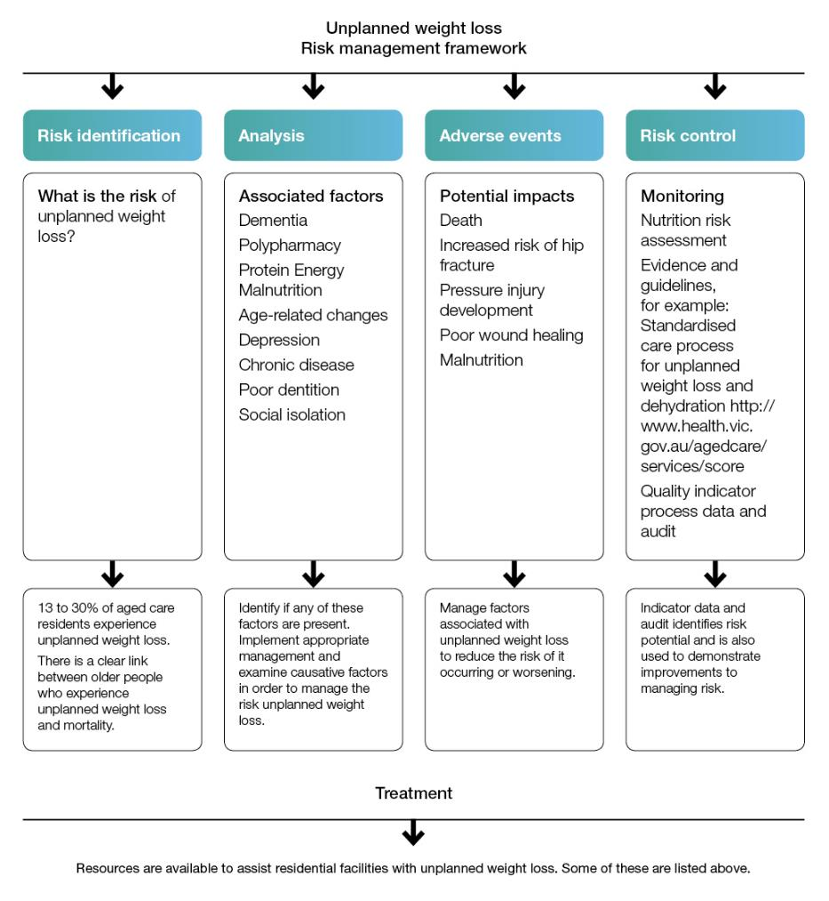

*Source:* adapted with permission from Victorian Department of Health 2015, *Quality Indicators in public sector residential aged care services, Resource materials*, January 2015 edition. Victorian Department of Health and Human Services, Melbourne.

# Appendix 7 - Example templates for recording data for QI 3: Unplanned weight loss

## Unplanned weight loss data collection sheet

You can adapt this example collection sheet for use when collecting QI data from each care recipient each quarter for QI 3: Unplanned weight loss.

|  |  |  |  |  |  |  |  |  |  |  |  |  |
| --- | --- | --- | --- | --- | --- | --- | --- | --- | --- | --- | --- | --- |
| Quality indicator 3. Unplanned weight loss  *(please note that all weights are in kgs)* | | | | |  | | | | | | | |
| Facility name | | | | |  | | | | | | | |
| Reporting quarter date | | | | |  | | | | | | | |
| Assessment date | | | | |  | | | | | | | |
|  | | | | | | | | | | | | |
| **1** | **2** | **3** | **4** | **5** | | **6** | **7** | **8** | **9** | **10** | **11** | **12** |
| **Resident** | **Weight carried forward from previous month** | **July/**  **Oct/**  **Jan/**  **Apr** | **Kgs**  **+**  **Or**  **-** | **Aug/**  **Nov/**  **Feb/**  **May** | | **Kgs**  **+**  **Or**  **-** | **Sep/**  **Dec/**  **Mar/**  **Jun** | **Kgs**  **+**  **Or**  **-** | **Total**  **+ or – for Quarter** | **1\***  **Lost 3 kg or more this quarter**  **Y or N** | **2#**  **Lost every month**  **Y or N** | **Comments** |
| Mrs Example Code 114 | 83.5 | 83.7 | +0.2 | 82.8 | | -0.9 | 80.4 | -2.4 | -3.1 | Y | N |  |
| Mr Example Code 115 | 76.3 | 76.0 | -0.3 | 75.5 | | -0.5 | 75.3 | -0.2 | -1.0 | N | Y |  |
| Ms Example Code 116 | 80.0 | 80.0 | - | - | | - | 80.5 | +0.5 | +0.5 | N | N/A | In hospital in February and weight could not be measured, therefore not included  for either  measure in  the total |
|  |  |  |  |  | |  |  |  |  |  |  |  |
|  |  |  |  |  | |  |  |  |  |  |  |  |
|  |  |  |  |  | |  |  |  |  |  |  |  |
|  |  |  |  |  | |  |  |  |  |  |  |  |
|  |  |  |  |  | |  |  |  |  |  |  |  |
|  |  |  |  |  | |  |  |  |  |  |  |  |
|  |  |  |  |  | |  |  |  |  |  |  |  |
| **Total** |  |  |  |  | |  |  |  |  |  | **1** | **1** |

## Unplanned weight loss data recording sheet

You can adapt this example recording sheet for use when summarising your QI data collected (see unplanned weight loss data collection sheet above) for QI 3: Unplanned weight loss. This information is the total for the facility for each quarter which is submitted to the department through the Provider Portal.

|  |  |
| --- | --- |
| Unplanned weight loss |  |
| Name of facility |  |
| Reporting quarter date |  |
| Assessment date |  |

**Significant unplanned weight loss.** This is the number of care recipients who experienced over the three month period unplanned weight loss equal to or greater than three kilograms.

|  |  |
| --- | --- |
| Number of care recipients whose weight was monitored | Number of care recipients who experienced significant unplanned weight loss |
|  |  |

**Consecutive unplanned weight loss.** This is if a care recipient experiences unplanned weight loss of any amount every month over the three consecutive months of the quarter. This can only be determined if the care recipient is weighed on all three occasions.

|  |  |
| --- | --- |
| Number of care recipients whose weight was monitored | Number of care recipients who experienced consecutive unplanned weight loss |
|  |  |

**Note**: If a care recipient is in hospital on any of the weigh dates, they are excluded from both measures.

### Comments

* Explain any difference between total care recipients and the number of care recipients whose weight was monitored. For example, care recipients who died, care recipients who were in hospital for one or more of the weighs and care recipients who chose not to participate in the monitoring. From the example data collection sheet above, ‘one care recipient was in hospital on the second weigh day’.
* Indicate the number of care recipients who were included in both measures; that is if they lost three kilograms or more over the three months and lost weight every month for the three months. From the example data collection sheet above, ‘nil’.
* Include any other comments.

1. The Pan Pacific Pressure Injury Alliance is made up of the: Australian Wound Management Association (AWMA), Hong Kong Enterostomal Therapists Association Society (HKETA), New Zealand Wound Care Society (NZWCS), and the Wound Healing Society Singapore.
2. A pressure injury can provide an inlet for bacteria to enter the body and cause osteomyelitis.