Innovative Models of Care (IMOC) Sector Briefing

2:30pm AEDT, 15 November 2023

# IMOC Sector Briefing

## Slide 4: Session Outline

To provide information about the Round 5 grant opportunity under the Innovative Models of Care (IMOC) Program.

* Program overview
* Current IMOC projects
* Grant Opportunity FAQs

## Slide 5: IMOC Program Overview

The IMOC Program’s primary focus is to:

* trial innovative and multidisciplinary models of primary care; and
* evaluate whether the models improve provision of health care in rural and remote communities and lead to better health outcomes.

## Slide 6:IMOC Grant Round 4 Outcomes

* Round 4 closed on 7 August 2023.
* Seven applications were approved for funding totalling $9.6 million.
* Successful trials will be announced shortly by Government.
* Unallocated funds were rolled into Round 5.

## Slide 7: IMOC Grant Round 5

### 2.1.1 The grant opportunity

This grant opportunity supports organisations in rural and remote communities (in Modified Monash (MM) Model 3-7 areas) to:

* implement locally co-designed, **innovative**, sustainable, practical, culturally safe and community-supported **multidisciplinary** models of primary care; and/or
* build local **multidisciplinary** workforce capacity to address the specific health needs of a community or region and improve primary health care access in thin markets.

Your application should consider both dot points (above) and address at least one of them.

## Slide 8: IMOC Round 5 Funding

* Total funding available through IMOC Round 5 is $17.6 million.
* Organisations may apply for Grant funding of up to $1.6 million to conduct a five-year trial (to December 2027).
* Funding per organisation is capped at $400,000 per year.

## Slide 9: Characteristics of innovative models of care

* Innovative
* Multidisciplinary
* Model of Care
* Community-led
* Culturally safe and responsive
* Rural and remote
* Sustainable

## Slide 10: Examples of Innovative Models of Care

* Care coordination / Collaborative team care models
* Multidisciplinary team with specific primary care lead
* Expanded scope of practice models
* Virtual models of care
* Hybrid models

## Slide 11: Current IMOC Trials

### GP Down South (Western Australia)

Clinical Care Co-ordination team

### Beechworth Health Service (Victoria)

Comprehensive care planning

### Outback Futures (Queensland)

Work-In Work-Out model of care

### NSW Rural Doctors Network

* LHD single employer across sub-region
* Co-design of shared GP model of care
* GP-led multidisciplinary team care for chronic-disease management
* Sustainable shared GP model
* Community-based shared medical appointment model

*Figure 1: Map of current IMOC sites*

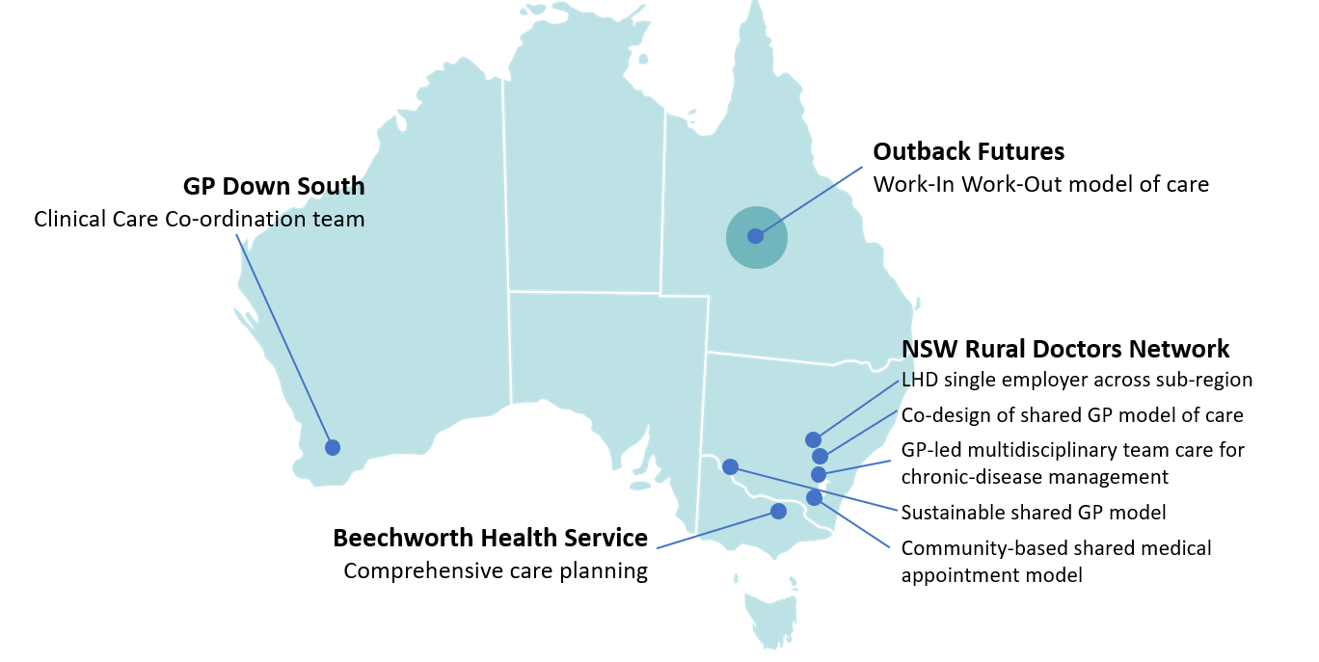

## Slide 12: Grant Opportunity FAQs

## Slide 13: Question: Who is eligible to apply?

* Organisations who meet the eligibility requirements may apply (Section 4: Eligibility Criteria).
* Applications that do not meet all eligibility criteria will not progress to assessment.

## Slide 14: Question: What are the key changes from Round 4 to 5?

* Multidisciplinary models that build workforce capacity are now eligible.
* Budgets may include salaries and related costs of clinical staff to provide strategic oversight of the trial (capped at 5 per cent).
* Applications for models of care that are not yet trial ready are now eligible.

## Slide 15: Question: What applications are not eligible?

Applications are ineligible for funding and will not be further assessed if:

* funding is sought for service delivery (e.g. clinical salaries)
* the activity is only to evaluate a current trial
* total funding sought is more than $1.6 million
* co-design of the model of care has not commenced

## Slide 16: Question: How can grant funding be spent?

* Building trial awareness and engagement
* Administration and management of trial
* Completion of co-design
* Development of trial protocols, survey data and reporting
* Stakeholder consultation or data gathering
* IT assets essential to model delivery
* Training
* Evaluation of trial

## Slide 17: Question: How do I apply?

Funding applications must be submitted through GrantConnect.

*Figure 2: Grant Opportunity GO6535 on GrantConnect*

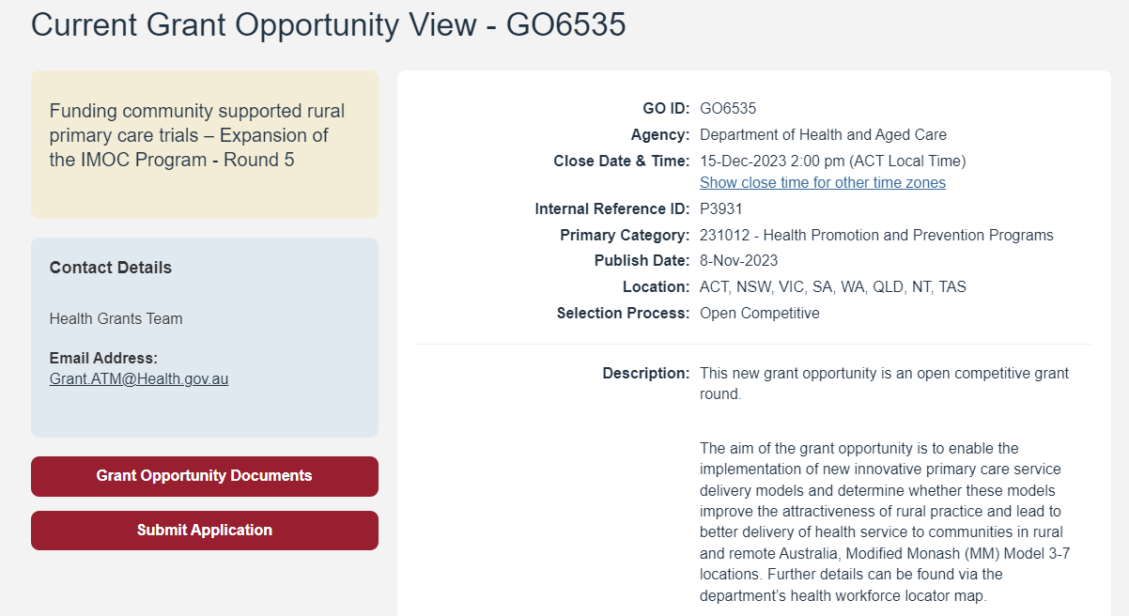

## Slide 18: Question: How will my application be assessed?

1. Criterion 1: Alignment with grant objectives and outcomes
2. Criterion 2: Community and service stakeholder co-design and collaboration
3. Criterion 3: Organisational capacity and capability to deliver a trial.
4. Criterion 4: Efficient, effective, economical and ethical use of grant funds.

## Slide 19: Question: Who do I contact if I require more information?

[grant.atm@health.gov.au](mailto:grant.atm@health.gov.au)