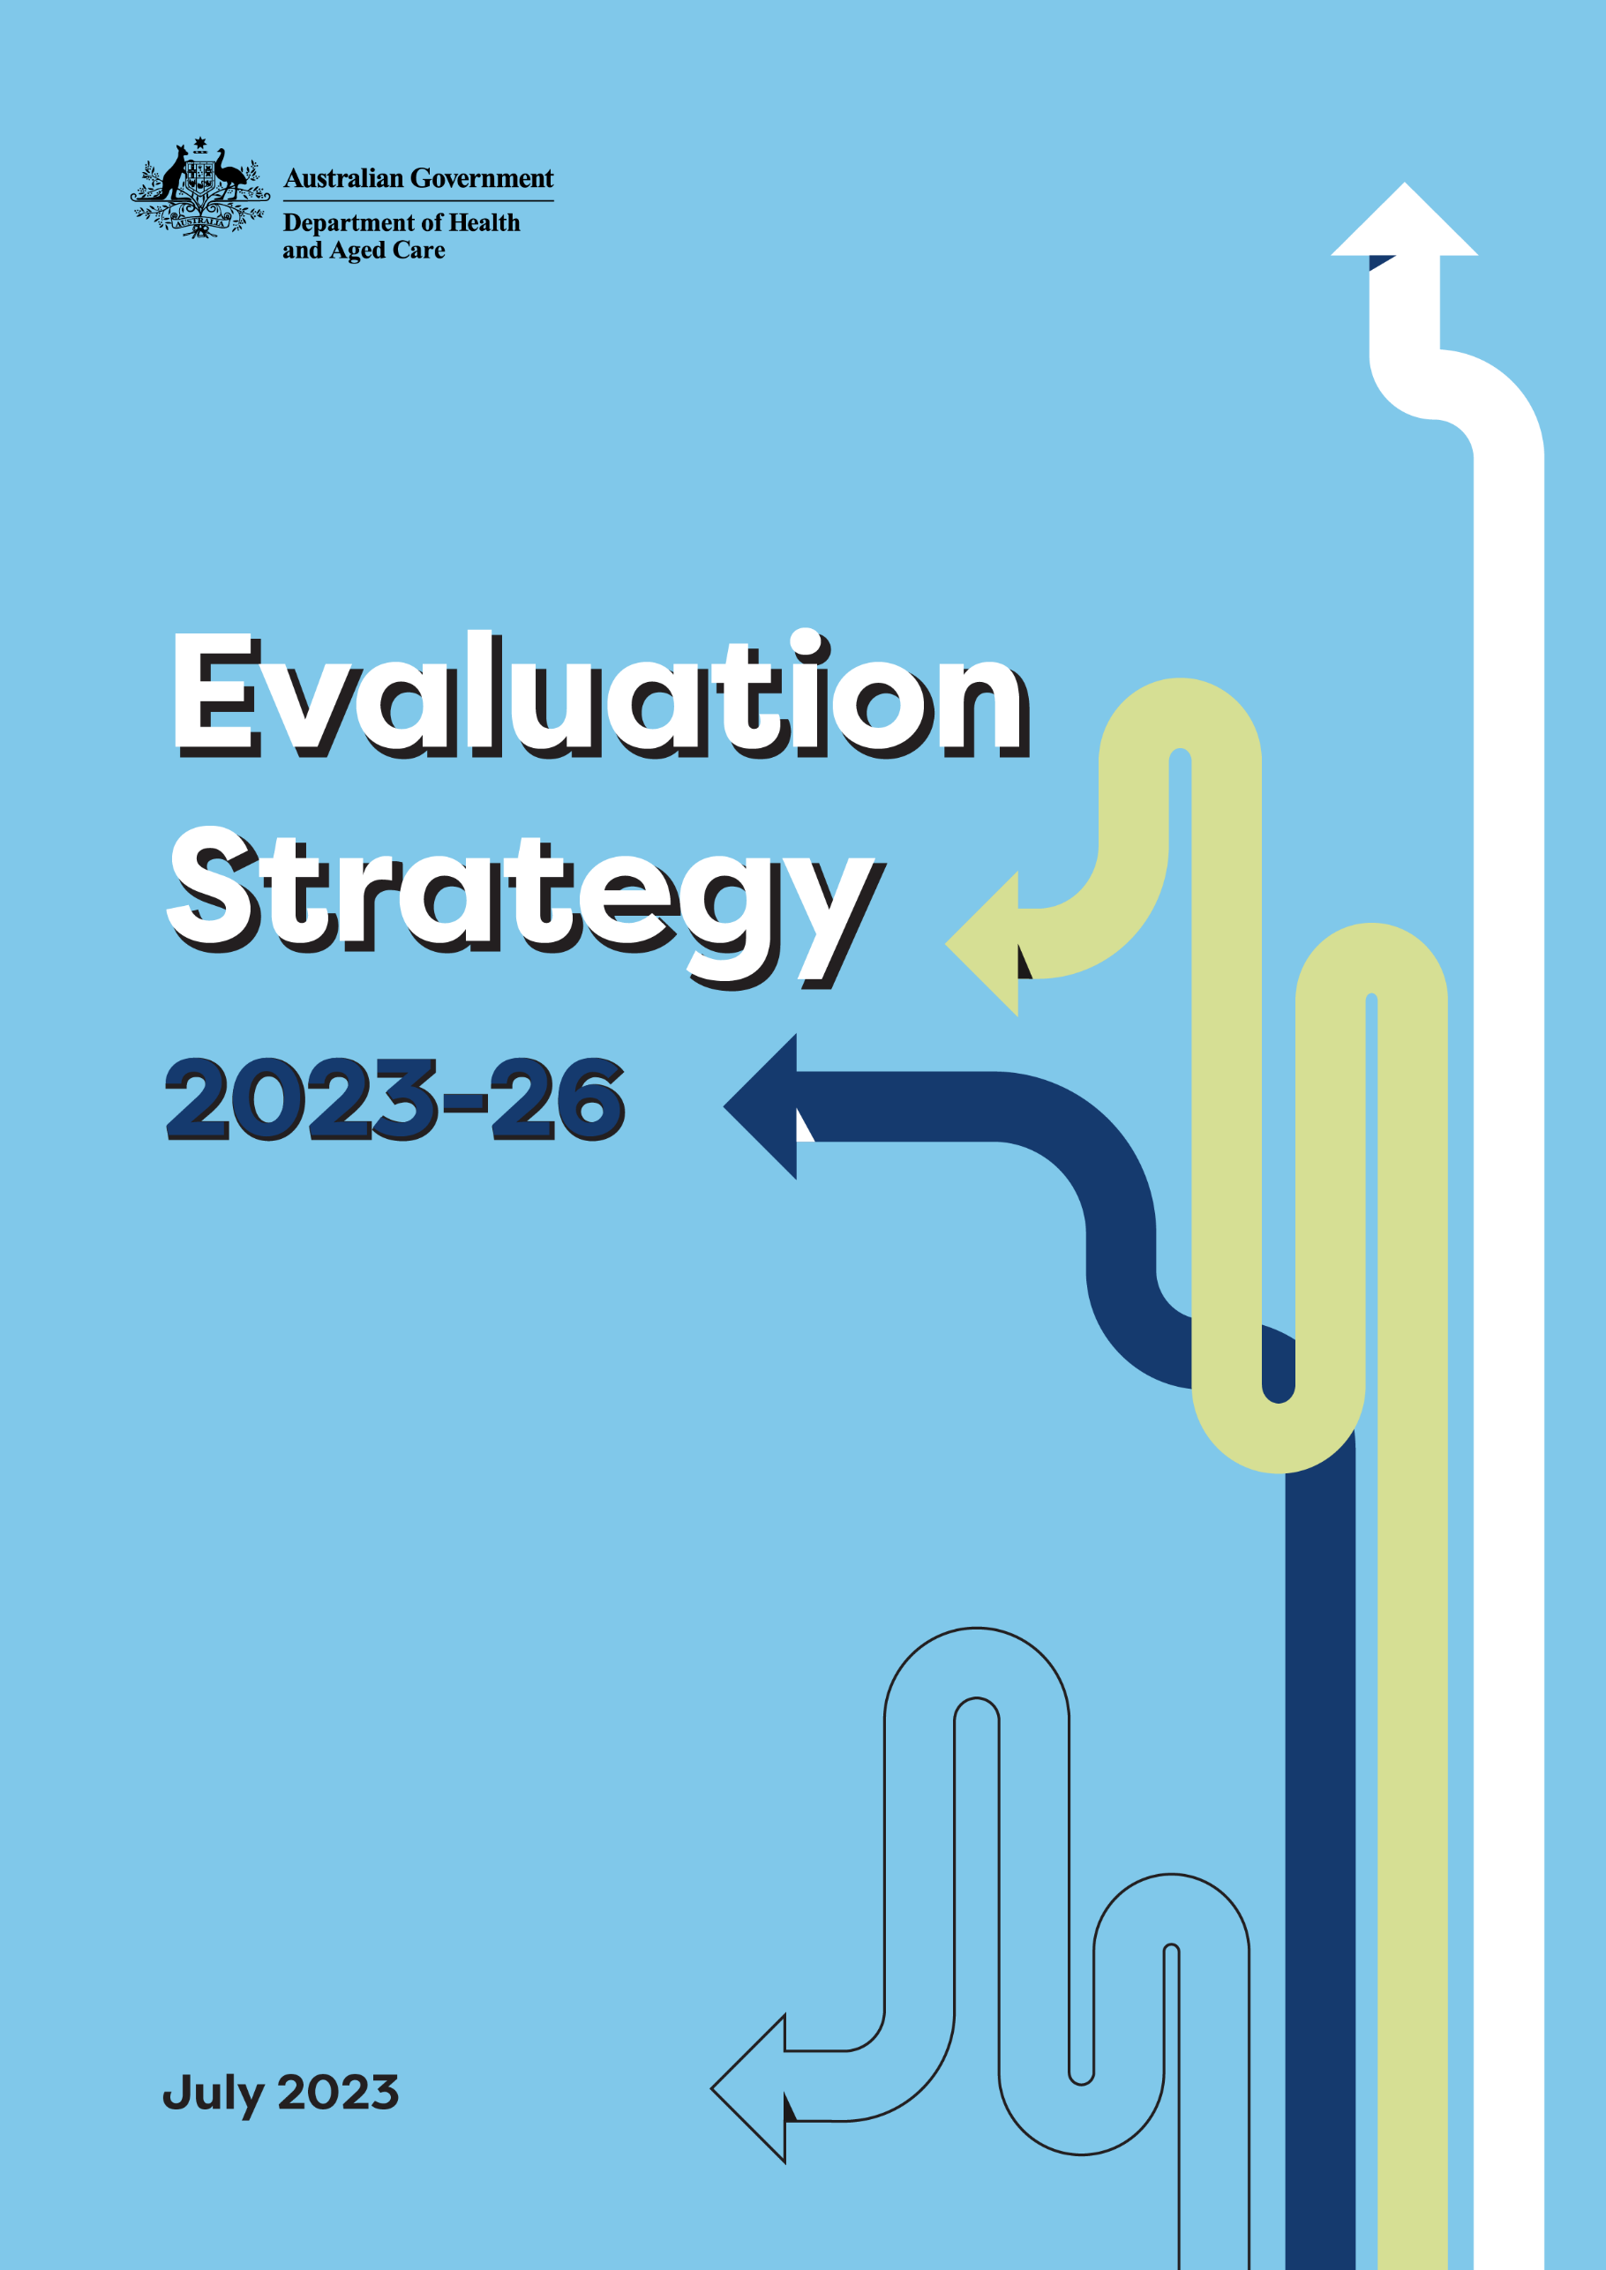

# Contents

Acknowledgement of Country 1

Message from the Secretary 2

Foreword 3

Introduction 4

What is evaluation and why is it important? 6

Evaluation principles 9

Prioritising evaluation efforts 10

Strategic priority areas 12

Governance of evaluations 14

Monitoring and reviewing the Strategy 15

Implementation plan 17

Glossary of useful evaluation terms 19

Strategy on a Page 21

# Acknowledgement of Country

We, the Department of Health and Aged Care, acknowledge the Traditional Owners and Custodians of Country throughout Australia. We recognise the strength and resilience of Aboriginal and Torres Strait Islander people, and acknowledge and respect their continuing connections and relationships to country, rivers, land and sea.

We acknowledge the ongoing contribution Aboriginal and Torres Strait Islander people make across the health and aged care systems and wider community. We also pay our respects to Elders past, present and future and extend that respect to all Traditional Custodians of this land.

We acknowledge and respect the Traditional Custodians whose ancestral lands are where our Health and Aged Care offices are located.

# Message from the Secretary

I am pleased to present the Department of Health and Aged Care’s *Evaluation Strategy 2023-26.*

Providing better health and wellbeing for all Australians, now and for future generations, lies at the heart of the department’s mission. We need policies and programs to deliver outcomes as intended, with performance tracked, and resources used appropriately, effectively and efficiently. Success requires our policies and programs to be based on the best available evidence.

This Strategy provides a whole-of-department approach to guide the consistent, robust and transparent evaluation of programs and policies. It commits us to answer the question: “so what difference do our policies and programs make?”, to ensure our focus remains on supporting Australians to live long, happy and healthy lives across all stages of their life journey.

At its core, this Strategy is about cultural change. It encourages us to make a much-needed shift away from a culture where evaluation is conducted as an afterthought, towards one where evaluation is an integral component of sound performance management.

The good news is we are not starting from scratch – this Strategy builds on good work that is happening across many areas of the department and, indeed, across the APS. For example, the department’s Assurance Framework includes guidance on assurance activities around project evaluation. This Strategy is also intended to support other work happening across the department, such as the department’s *Data Strategy 2022-2025*.

The Strategy aligns with whole-of-government guidance and follows the direction of other government departments. The Government’s APS Reform Agenda, the Commonwealth Evaluation Policy, and the new Australian Centre for Evaluation provides us with strong support in achieving the Strategy’s vision.

The Strategy is just the beginning – it outlines a cohesive pathway forward to help us embed evaluation activities throughout the policy or program lifecycle, build evaluation capability, and ensure evaluation findings are appropriately used. An implementation plan will be developed to complement the Strategy that provides detailed information on the concrete activities to be delivered under each of the priorities.

This is a living Strategy. We will continue to track progress towards our vision and adjust course as we need to. This will help all of us identify good practice and share lessons learned as we implement this Strategy.

Finally, I would like to take this opportunity to thank all of you who participated in consultations to shape the development of the Strategy. The Strategy is our Strategy – and it is stronger because of your input.

Blair Comley PSM

Secretary

# Foreword

The tumult of the global pandemic required large-scale service delivery changes for government. It also provided us the opportunities to work together, especially with jurisdictions, to drive fast improvements when needed across all four pillars of reform: strong and sustainable Medicare, hospitals, mental health and medical research. In this context, there is a deep need for effective data and evidence to underpin the work of the department.

Evaluation helps us to gain an understanding of what works and what doesn't, for whom and why. This kind of knowledge helps us to learn and improve what we do and supports decision-making with the best available evidence.

Evaluation is integral to continual improvement - it is not a singular, or 'tick the box' exercise. Evaluation supports evidence-informed policy development, public accountability, learning and performance reporting. Therefore, evaluation needs to be planned across the lifecycle of a program, from the very start. The Strategy promotes and supports a culture of improvement.

We cannot do this alone. We must work closely with our partners in the health portfolio, other parts of government, and the research community. The Strategy commits us to be transparent, credible, ethical and culturally appropriate when undertaking evaluation activities, particularly in the collection, assessment and use of information.

We must ensure that evaluation findings are provided to appropriate stakeholders to support continuous improvement, accountability and decision-making. Reimaging our governance will be core to helping us achieve this vision. We will review and, where needed, update our evaluation governance so that our arrangements are clear and transparent.

All staff have a role to play in ensuring we make best use of evaluation – this is central to the department achieving its broader objectives. That is why this Strategy focuses on building staff capability. We believe that all staff should have a baseline of evaluation literacy.

The key to a successful evaluation strategy is always the people involved. I encourage everyone in the department to take part and make better use of evaluation as we design and deliver health services to the Australian community.

Blair Exell

Deputy Secretary

# Introduction

Better evaluation of government policies and programs[1] is a key election commitment by the new Government. The department published its first evaluation strategy in 2016. Since that time, significant effort has been invested to establish initial systems and processes and build capacity across the department. This Strategy is seeking to further embed and strengthen evaluation capacity, culture and capability in the department in order to inform the ongoing evolution of our policies and programs, and support us in our resource allocation and decision-making responsibilities.

The Strategy complements the 2023-24 Budget announcement to establish the Australian Centre for Evaluation (ACE). The ACE will partner with the department to develop robust evidence on whether policies and programs achieve their intended outcomes and deliver value for money. The Strategy will also inform the policy architecture and a consistent decision-making framework to underpin the Budget measure ‘Reinvesting in Health and Aged Care Programs’which will reallocate funds to priority areas of needinformed by robust and contestable evidence*.*

These activities will ultimately help to ensure that the department’s policies and programs effectively meet their objectives and deliver an affordable, quality health and aged care system and better health, ageing and sport outcomes for all Australians.

**Objective**

The Strategy provides a framework to strengthen policy and program evaluation practice and culture, and increase the use of evaluation evidence for decision making, planning and reporting. It provides a principles-based approach for the conduct of evaluations across the department, and can be used to help plan how government programs and activities will be evaluated across the policy cycle in line with best practice approaches.

**Foundation**

The Strategy complements and builds on the Enhanced Commonwealth Performance Framework under the *Public Governance, Performance and Accountability Act 2013 (*PGPA Act). The department’s overall planning and reporting framework is summarised in Figure 1. Evaluations provide an opportunity to look beyond performance monitoring and reporting and consider how well the program is achieving its objectives. Evaluations provide meaningful information and evidence on a program or policy’s aim and purpose in terms of its effectiveness and efficiency and the activities that focused on that purpose.

***Figure 1: The department’s overall planning and reporting framework***

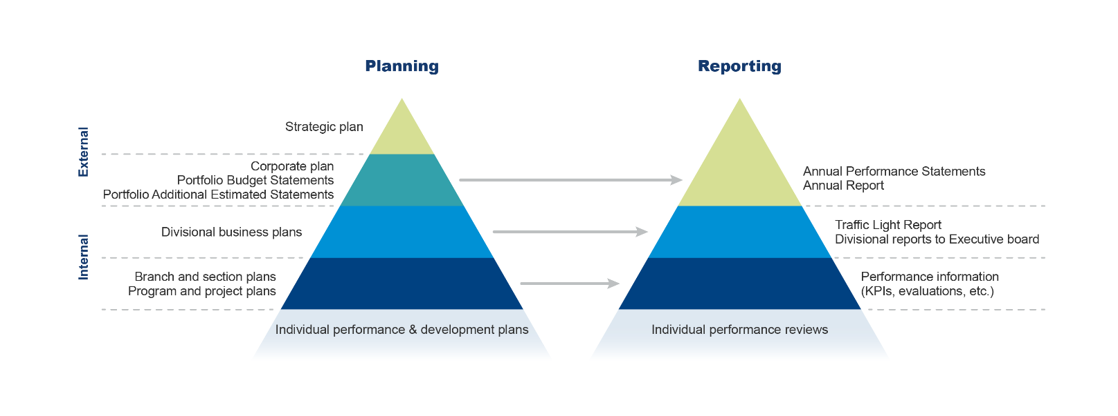

Source: Department of Health (2018), Performance Measurement and Reporting Framework.

**Audience**

The Strategy is written for a number of audiences:

* The Strategy applies to all departmental employees and will be used by key governance committees, including the Program Assurance Committee (PAC) and the Executive Committee (EC) to guide evaluation efforts.
* It is also intended to provide information and transparency to other agencies, stakeholders, the Australian Parliament and public regarding how the department is meeting its statutory requirements and is efficiently, effectively and appropriately conducting its activities and realising its objectives.

The Strategy is not intended to be a standalone document for evaluation and performance measurement. It is supported by a range of internal and external resources including:

* the department’s Performance Measurement and Reporting Framework
* the department’s Assurance Framework
* the department’s Data Strategy
* the Department of Finance Commonwealth Evaluation Policy and Toolkit
* the Enhanced Commonwealth Performance Framework
* the Productivity Commission’s Indigenous Evaluation Strategy 2020
* the Australian National Audit Office Best Practice Guide – Successful Implementation of Policy Initiatives.

# What is evaluation and why is it important?

Evaluation in the department is defined as[2]:

*The systematic and objective assessment of the design, implementation or results of a government program or activity for the purposes of continuous improvement, accountability and decision-making. It provides a structured and disciplined analysis of the value of policies, programs and activities at all stages of the policy cycle.*

Evaluation is a process to understand whether a policy or program is fit for purpose, how it is implemented and operated, and what effect it had – for whom, how and why. Evaluation is not a one-off exercise. It is an ongoing process of analysing information and evidence about what is working well and what is not working in order to inform policy and program development and improvement. Ultimately, evaluation provides evidence to inform whether a particular policy and program should be continued, changed, or ceased. Evaluation findings may also be used to inform the development, implementation and refinement of other similar initiatives.

To ensure evaluations generate reliable information and evidence, it is essential that evaluation is considered early in the policy and program cycle. Evaluations need to be tailored to the characteristics of a policy or program, the questions that require answering, the timing of decisions, and the resources available. A one size fits all approach to evaluation is not appropriate.

The policy and program cycle generally consists of four phases: Development, Planning, Implementation, and Transition. Evaluation has a role throughout the cycle and contributes to the cumulative evidence base about a policy or program. Figure 2 provides an overview of the role of evaluation and evaluation activities across the policy and program cycle.

***Figure 2: Overview of evaluation within the policy and program cycle***

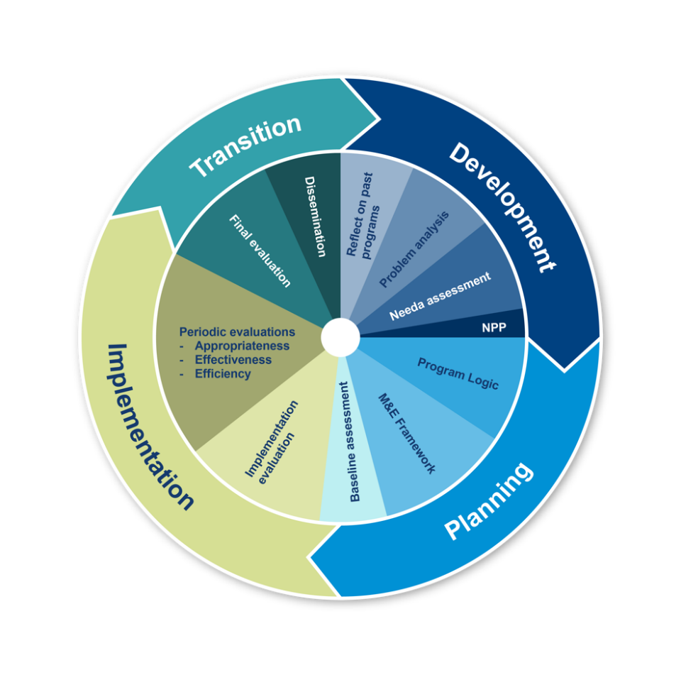

Source: Department of Health Evaluation Strategy 2016-2019

For existing policies and programs that were implemented without evaluation in mind, evaluation can be planned and initiated at appropriate intervals to inform policy and program development and improvement – such as through a mid-way or post-hoc evaluation.

**Why evaluate?**

Evaluations should contribute to a high-quality, useful and accessible body of evidence that governments, organisations and communities have confidence to use when designing, modifying and implementing health policies and programs. Evaluation is complementary to the audit process in the department.

The main drivers behind the department’s increasing interest in evaluating its policies and programs are represented in the 4As of evaluation[3].

* **Accountability**: the PGPA Act established a core set of obligations that apply to all Commonwealth entities.
* **Allocation:** informing investment decision of policies and programs for great returns.
* **Analysis:** providing reliable and robust information and evidence to support evidence-based policy development, program design and implementation.
* **Advocacy:** evidence-based articulation and communication of the value of the department’s work and provide greater confidence for stakeholders and build trust in government.

Figure 3 illustrates the various evidence-generating activities that help the department to meet high standards of governance, performance and accountability. Many share similar approaches and analytical techniques, and together, represent the fundamental links in an accountability and assurance chain that is designed to contribute to continuous improvement and better public administration, and to identify better practice approaches.

***Figure 3: The department’s evidence gathering activities***

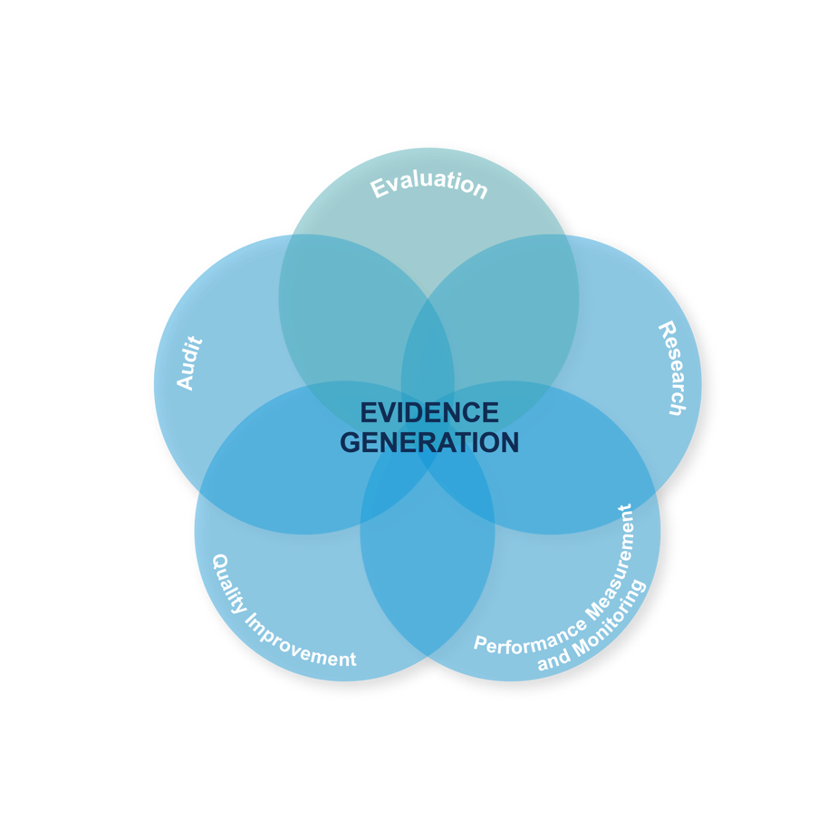

Source: Department of Finance (2021), *Evaluation in the Commonwealth*, Commonwealth of Australia

In this context, evaluation is one way of generating evidence to measure and assess the extent to which government programs and activities are achieving their objectives and outcomes. Along with other evidence-generating activities, evaluation supports the department to meet its obligations under the PGPA Act and associated instruments, and related whole-of-government frameworks and policies.

**What should be evaluated?**

Any new or existing policy, program, project or strategy or any types of intervention, including those focusing on corporate services delivery, are in scope for the Strategy.

Health technology and other technical regulatory assessments (such as those involving pharmaceuticals, medical devices, medical procedures and therapeutic assessments) are outside the scope of this Strategy as evaluation in these areas is governed under a Statutory Office Holder.

**Types of evaluation**

Evaluation can occur at different times over the life of a policy or program and take different forms depending on the focus of evaluation and the evaluation questions to be answered. Three main forms of evaluation address different aspects of a policy or program: process, outcome, and economic evaluation.

All three forms may be addressed through both formative evaluation (looking forwards) to identify opportunities for improvement and summative evaluation (looking back) to determine what has been achieved.

What type of evaluation is best suited in a particular situation depends on a combination of:

* the stage and maturity of the program or activity
* the issue or question being investigated
* what data or information is already available
* the timing of when evaluation findings are required to support continuous improvement, accountability or decision-making.

It is important to select tools and approaches that are fit for purpose based on the specific program or activity and the purpose of the evaluation.

# Evaluation principles

To ensure evaluations are both credible and useful to the department’s decision-makers, it is essential that evaluations are conducted to a consistently high standard. Table 1 outlines the key principles that should apply to evaluations conducted by the department. These principles are consistent with the new Commonwealth Evaluation Policy.

***Table 1: Evaluation principles***

|  |  |
| --- | --- |
| **Evaluations should be...** | **Characteristics of the evaluation principles** |
| **Fit for purpose** | * Evaluations should be proportionate to the size, significance and risk of the policy or program. The costs of the evaluation should be commensurate with the value of information and risk profile of the program. * Methods should differentiate between evaluations to inform program administration and evaluations to inform policy decisions. |
| **Useful** | * Evaluations to inform program delivery should be designed for the purposes of continuous improvement and accountability against objectives, while evaluation for decision-making should be designed for the purpose of defining achievable outcomes. |
| **Robust** | * Evaluations apply robust research and analytical methods to assess impact and outcomes. * Robust data and evidence should provide performance insights and drive continuous improvement for programs in the delivery stage. * Relevant stakeholders are consulted and participate in the evaluation as appropriate. |
| **Ethical and culturally appropriate** | * Ethical and culturally appropriate approaches should be considered in all evaluation activities, including for the collection, assessment and use of information. |
| **Credible** | * Evaluations should be conducted by people who are technically and culturally capable. * The collection and analysis of evidence should be undertaken in an impartial and systematic way, having regard to the perspectives of all relevant stakeholders. * Evaluations should adhere to appropriate standards of integrity and independence. |
| **Transparent where appropriate** | * Evaluation findings should be transparent by default unless there are appropriate reasons for not releasing information publicly. * To support continuous improvement, accountability and decision-making, evaluation findings should be provided to appropriate stakeholders. |
| **Embedded** | * Evaluation planning is routinely undertaken at the new policy proposal (NPP) stage and completed early in the design of programs. * Routine collection and analysis of an existing policy and program performance information to provide indicators of progress towards objectives. * Evaluation should use existing infrastructure data assets where possible. |
| **Timely** | * Evaluation planning is guided by the timing of critical decisions to ensure sufficient bodies of evidence are available when needed. |

Source: Adapted from Department of Health Evaluation Strategy 2016-2019 and Department of Finance (2021) Commonwealth Evaluation Policy and Toolkit.

# Prioritising evaluation efforts

The appropriate timing and type of evaluation required to support continuous improvement, accountability and decision-making needs to be determined on a case-by-case basis to ensure the overall approach is fit for purpose.

It is not feasible, cost effective or appropriate to fully evaluate all government activities and programs. The cost of evaluation must be balanced against the risk of not evaluating, noting that sometimes performance monitoring by itself will be sufficient to meet the performance reporting requirements under the PGPA Act*.*

It is important that evaluations adhere to the principle of proportionality – that is, evaluation should be proportionate to the size, significance and risk of a policy or program.

To inform a system of prioritisation and provide guidance on evaluation effort and resourcing, policies and programs are risk assessed and classified into one of three evaluation ‘tiers’; higher risk, higher profile evaluations generally involve a greater level of evaluation resources and effort, as well as more defined governance and oversight arrangements.

Priorities should be determined based on the following considerations:

* Priority (strategic importance) - how important and valuable the policy or program is to overall departmental objectives and in terms of other competing priority areas.
* Funding - the overall funding for the policy or program.
* Risk - the policy or program’s overall risk. This may include how difficult it is to estimate the impact of the policy or program (the outcomes are uncertain or difficult to measure).
* Impact - how likely the policy or program will impact the lives of Australians.
* Evidence - what is the evidence base for the policy or program to date.

The table below provides an overview of the three evaluation tiers, including policy and program characteristics, and potential features of an evaluation. There may also be times where a Budget or Cabinet decision or legislation determine the type of evaluation and when it should be conducted.

***Table 2: Evaluation tiers***

|  |  |  |  |  |
| --- | --- | --- | --- | --- |
| **Tier** | **Policy or program characteristics** | | **Indicative evaluation features** | |
| **One** | **Priority**  **Funding**  **Risk**  **Impact**  **Evidence** | High strategic significance or opportunity  High level of funding  High risk  High (e.g. health outcomes)  Lack of current evidence base (e.g. emerging policy area, new program) | Extensive consultation  High resource allocation  High quantitative data requirements  Comprehensive qualitative  Comprehensive evaluation reports |
| **Two** | **Priority**  **Funding**  **Risk**  **Impact**  **Evidence** | Medium strategic importance or opportunity  Moderate level of funding  Medium risk  Moderate (e.g. health outcomes)  Lack of current evidence base (e.g. new or untested program) | Moderate consultation  Medium quantitative data requirements  Targeted qualitative  Full evaluation reports | |
| **Three** | **Priority**  **Funding**  **Risk**  **Impact**  **Evidence** | Low strategic importance or opportunity  Small level of funding  Low risk  Low (e.g. health outcomes)  Existing evidence base (e.g. similar to other policies/programs) | Primarily existing quantitative data  Low resource allocation  Limited consultation  Simplified evaluation reports | |

Source: Adapted from Department of Health Evaluation Strategy 2016-2019 and Department of Industry, Innovation and Science Evaluation Strategy 2017-2021.

**A Rolling Schedule of Evaluations**

The department currently does not have an evaluation schedule to prioritise our evaluation efforts. Our approach to an evaluation schedule is a rolling schedule model. Instead of shifting course every four years for a new schedule period, we will continuously assess and adjust our schedule with a more adaptive response to the department’s changing priorities.

The Schedule will be developed by the Evaluation Centre in consultation with divisions, as a guide to how and when evaluation should be conducted. The Schedule covers a rolling four-year period using the tiering system in Table 2 to identify evaluations of the highest priority and strategic importance. The development of the Schedule will adopt a strategic, risk-based, whole-of-department approach to prioritising evaluation effort. The Evaluation Centre will take account of existing audit and research activities when developing the Schedule.

The Program Assurance Committee will endorse the Schedule. The Schedule will be reviewed on an annual basis to ensure that the quality and relevance of evaluation requirements is maintained at a high-level.

# Strategic priority areas

Four initial priority areas have been identified to implement the Strategy and will be conducted throughout 2022-23 and 2023-24. A work plan will be developed for each action area that details the key activities, deliverables (outputs) and performance measures. Through delivering on the action areas, the department will move towards a ‘developing’ state of evaluation maturity (see Table 3) that can be built upon in subsequent years.

The department supports the maturity approach outlined in the Strategy, recognising progressive improvement in evaluation planning and practices over time, and notes that progressive improvement requires both a strong focus on building evaluation capacity and ensuring that policy and program areas have access to, or are able to collect, the data they need to effectively undertake robust evaluations.

**Priority Area 1 - Ensure the most important policies and programs are evaluated**

Central to the Strategy is to conduct evaluations in areas that are most important to Heath and Aged Care and where there are gaps in the evidence base. The department also needs to ensure evaluation becomes embedded within strategic planning, reporting and decision-making processes. This will be achieved through:

|  |
| --- |
| **Action 1.1:** Evaluation Centre, supported by divisions, should develop, and operationalise a tiering system to systematically identify evaluation priorities.  To identify evaluation priorities at the departmental level, the Evaluation Centre will assess all new policies and programs, and undertake a stocktake of existing policies and programs, to determine which policies and programs should be prioritised for evaluation under the Strategy. The stocktake will adopt a criteria-based tiering system outlined in Table 2.  **Action 1.2:** The Evaluation Centre, under the guidance of the PAC, should publish a rolling Schedule of Evaluations on the department’s website on an annual basis, which details:   * policies and programs that contribute to department-wide evaluation priorities * how the department identified high priority policies and programs * a plan for how and when the department’s identified policies and programs will be evaluated over the next four years (or how they will become ready for evaluation). |

**Priority Area 2 – Planning early for evaluation**

Evaluations should be planned early – ideally during policy and program development – to ensure that the right questions are asked, useful baseline and monitoring data are identified and collected, opportunities for engaging stakeholders in the evaluation are identified, and adequate resources are available to undertake high-quality evaluations. This will be achieved through:

|  |
| --- |
| **Action 2.1:** Divisions should consider evaluation requirements of new policies and proposals in the ‘Policy Case’ of NPPs.  **Action 2.2:** Divisions, supported by the Evaluation Centre, should ensure new and existing policies and programs are evaluation ready by:   * setting out the program’s logic model * identifying key evaluation questions, indicators and data sources * selecting appropriate types and timing of future evaluations.   **Action 2.3:** Divisions should ensure adequate resources are available to undertake high-quality evaluations. |

**Priority Area 3 – Building capability to conduct and manage high-quality evaluations**

To undertake high-quality evaluations in line with the Strategy, the department needs to ensure that those designing, commissioning, managing and conducting evaluations have the capability – including the skills, experience and understanding – to comply with the Strategy. This will be achieved through:

|  |
| --- |
| **Action 3.1:** Divisions, supported by the Evaluation Centre, should ensure they have access to the skills required to undertake or commission evaluations consistent with the Strategy.  Evaluation Centre ’s support should include:   * developing departmental-specific evaluation resources, tools and templates * providing online training for staff who commission, conduct and use evaluations * establishing an online community of practice for staff who are involved in evaluations * establishing processes through which staff can seek secondments or other opportunities to broaden or deepen their experience evaluating policies and programs * utilising the new Whole of Government evaluation panel to identify a cohort of evaluators for undertaking high-quality evaluations * active use of the Evaluation Hub SharePoint site as a collaborative online platform.   **Action 3.2:** Divisions, supported by the Evaluation Centre, should ensure that they have access to, or are able to collect, the data they need to effectively undertake evaluations under the Strategy. Data planning should consider:   * what data are needed to answer evaluation questions * what existing data are available and suitable for the evaluation and what additional data should be collected and when.   **Action 3.3:** Evaluation Centre, supported by divisions, should develop a catalogue of available data assets and guidance on how to use them for evaluations (e.g. administrative and publicly available longitudinal surveys). |

**Priority Area 4 – Enhancing the use of evaluations**

The use of evaluation evidence will be improved by having high-quality, timely and credible evaluations that answer questions that are relevant to policy makers. Policy makers and other users of evaluation evidence also need to be able to access evaluation findings in formats that are useful. This will be achieved through:

|  |
| --- |
| **Action 4.1:** Regular publication of important evaluation reports either in their entirety or using executive summaries.  **Action 4.2:** Evaluation Centre, supported by divisions, should establish an evaluation clearing house as a repository for reports of evaluations of departmental policies and programs on Evaluation Hub SharePoint Site.  **Action 4.3:** Divisions, supported by the Evaluation Centre, should refer to past relevant evaluations when developing new policies or programs.  **Action 4.4:** Executives champion the use of evaluation to inform strategic decision-making. |

# Governance of evaluations

Delivering high-quality and fit for purpose evaluations requires adherence to the evaluation principles (outlined in Table 1), and appropriate governance and quality assurance arrangements. For evaluations within the department, the following roles and responsibilities apply:

**Executive Committee**

Chaired by the Secretary, the EC is responsible for the overall governance, management, policy leadership and strategic direction of the department. It has responsibility for oversight of the department’s evaluation activity, including:

* considering the implications for the department of Tier One and Tier Two evaluation findings, including whether the department will implement the recommendations
* determining whether an evaluation report will be published in its entirety or executive summary only.

**Program Assurance Committee**

The role of the PAC under this Strategy is to provide oversight of evaluation activity across the department and to utilise evaluation evidence to inform strategic policy and planning.

Under this Strategy, the PAC will:

* approve and monitor the application of the evaluation tiering system
* endorse a rolling Schedule of Evaluations which includes evaluations being or that will be conducted in the department, and to monitor evaluation progress and reporting (greater monitoring focus will be applied to programs and policies categorised as Tier One and Tier Two)
* provide guidance on strategic and/or cross-cutting evaluations to be conducted
* ensure adequate resourcing of, and cooperation with, the Evaluation Centre
* grant final approval of Tier One and Tier Two evaluation reports before internal publication.

**Divisions**

Each division is responsible for funding and conducting evaluations of their policies and programs.

Divisions will:

* provide advice on the stocktake of department-wide evaluation priorities and development of the rolling Schedule of Evaluations
* consider evaluation requirements when developing NPPs
* ensure all new and existing policies and programs have a program logic and a monitoring and evaluation framework (evaluation ready)
* sign-off on the monitoring and evaluation framework and evaluation plans
* procure evaluation services and manage relationships with evaluators
* manage evaluation deliverables
* consider and document the uptake of evaluation recommendations
* as required, provide updates to the PAC and the EC on evaluation progress, findings and recommendations, coordinated through the Evaluation Centre.

**Evaluation Centre**

The Evaluation Centre works in partnership with divisions to support the development and delivery of high-quality evaluations. It will:

* support the PAC’s role in evaluation, including collating and updating the rolling Schedule of Evaluations
* provide expert advice and guidance to divisions on planning and conducting evaluations
* provide quality review and assurance on key evaluation documents, including monitoring and evaluation frameworks and evaluation plans
* provide expert advice and guidance on data needs for an evaluation including review of suitability of existing data for evaluation and make recommendations on potential improvements
* develop evaluation resources and tools to support this Strategy
* work to build departmental evaluation capability, including provision of seminars and workshops, facilitating secondments and on-the-job learning opportunities
* manage strategic and/or cross-cutting evaluations identified by the PAC.

**Evaluation Reference Groups**

Evaluations, particularly Tier One evaluations, conducted by the department may be overseen by a Steering Committee or Reference Group. Depending on their role, they may:

* provide advice and guidance to responsible sections and evaluators on the design and conduct of an evaluation
* sign-off key evaluation plans and deliverables.

Generally, a Steering Committee has some form of sign-off function, while a Reference Group would only have an advisory role.

**Audit and Risk Committee**

The roles of evaluators and auditors are quite different but they have similar outputs – both inform performance reporting and address public accountability requirements. There are strategic linkages and synergies between the two functions. When planning an evaluation or audit and identifying lessons learned to inform policy development and programme delivery, evaluation and audit activity should be considered and coordinated. The responsibilities of the department’s Audit and Risk Committee are outlined below.

The Audit and Risk Committee – established in accordance with the PGPA Act – provides independent advice and assurance to the department’s executive on the appropriateness of the department’s accountability and control framework, independently verifying and safeguarding the integrity of the department’s financial and performance reporting.

# Monitoring and reviewing the Strategy

The Evaluation Centre will monitor and report on the performance of the department against the Strategy using an evaluation maturity framework (see Table 3).

The monitoring process will provide incentives for the department to implement the Strategy’s principles and actions and allow good practice to be identified and lessons shared.

The Evaluation Centre will produce regular reports that outline findings and recommendations based on their monitoring of the Strategy’s implementation. The first report will be released two years after the Strategy is endorsed, then annually thereafter. This report will:

* assess the extent to which the department has complied with the Strategy and have implemented the Strategy effectively
* identify good and or/innovative practice in the evaluation of policies and programs
* assess the extent to which the Strategy has been effective in encouraging high-quality and useful evaluations
* formalise evaluation priorities, including identifying areas for cross-agency evaluations
* provide recommendations on how the implementation of the Strategy could be improved.

The Evaluation Centre will undertake a comprehensive review of the Strategy by 1 January 2026 before developing the next one.

***Table 3: Measuring evaluation maturity over the period of the Strategy***

|  |  |  |  |
| --- | --- | --- | --- |
| **Action Area** | **Where we are now** | **Developing** | **Mature** |
| **1. Ensure important policies and programs are evaluated** | The department does not publish agency-wide evaluation planning documents, such as a rolling Schedule of Evaluations.  Evaluation awareness is low and is as a response to identified problems. | A Schedule of Evaluations is established and monitored.  Widespread awareness of the benefits of evaluation. | The department publishes key evaluation planning documents.  Evaluation perceived as an integral component of sound performance management. |
| **2.Planning early for evaluation** | Evaluation is often disconnected from planning and decision-making. | NPPs routinely include evaluation requirements (where applicable).  A growing proportion of policies and programs are evaluation ready. | Evaluation is embedded in strategic planning, reporting and decision-making processes.  Evaluation practice is embedded in the department’s performance planning and reporting framework and policy/program cycle. |
| **3. Building capability to conduct and manage high-quality evaluations** | Evaluation knowledge and skills are limited, despite pockets of expertise.  Data needs for evaluation are not routinely identified early. | Evaluation capability building initiatives are developed and rolled out.  Guidance for data planning is being developed. | Staff understand and apply evaluative thinking across policies and programs.  Good data available and enables high-quality evaluation. |
| **4. Enhancing the use of evaluations** | Evaluation reports are not routinely published.  No repository of good practice and lessons learned. | Regular publication of Tier One and Tier Two evaluation reports on the Evaluation Hub, where appropriate. | The department synthesises evaluation findings and an evaluation clearing house is established.  Evaluation findings are increasingly shared and inform continuous improvement across policies and programs. |

# Implementation plan

The implementation plan will focus on supporting the delivery of the “Reinvesting in Health and Aged Care Programs” 2023-24 Budget measure. A key element of this measure is to design and implement an enhanced evaluation framework to ensure decision making on funding is evidence-based. This Strategy will guide the design and implementation of this framework. It will include:

* A description of each activity to be delivered under the Strategy, aligned with the strategic objectives and priorities.
* The timing for each activity, taking into account sequencing of activities between 2023 and 2026.
* Executive evaluation champions from divisions who will lead each activity, and any key delivery partners.
* Measures of success, to help understand how implementation is progressing and whether outcomes are being achieved.

The implementation plan will be developed in close consultation with Executive evaluation champions and other key stakeholders. This will ensure that:

* Executive evaluation champions from divisions agree on the activities that need to be delivered, and the sequence of these activities.
* The implementation plan does not duplicate activities that are contained in other strategies and plans.

Implementing the Strategy’s principles and actions and putting in place the governance arrangements to support the Strategy should be undertaken within two years of the EC endorsing the Strategy (Table 4). The initial focus (within the first six months) will be on nominating Executive evaluation champions and establishing the governance arrangements and tools for implementing the Strategy. Executive champions will be key in promoting and advocating for evaluation in their respective divisions. Within the first year, the department will start planning for and conducting evaluations in line with the Strategy’s principles and actions. The focus then moves to sharing evaluation findings and lessons from implementation and establishing transparent accountability mechanisms.

***Table 4: Proposed implementation timeline for the Strategy***

|  |  |
| --- | --- |
| **Actions by divisions**  **Through nominated Executive evaluation champions** | **Actions by Evaluation Centre** |
| **Within first six months** | |
| Nominate Executive evaluation champions  Assist with stocktake of department-wide evaluation priorities (**Action 1.1**)  Provide input to the rolling Evaluation Schedule of Evaluations (**Action 1.2**) | Develop a communication plan  Develop prioritisation tools and undertake stocktake of department-wide evaluation priorities (**Action 1.1**)  Relaunch Evaluation Hub (**Action 3.1**) |
| **Within one year** | |
| Begin to develop capability and awareness of available data for undertaking evaluations (**Action 3.1 and 3.2**)  Begin to develop programs and policies to be evaluation ready (**Action 2.2**)  Participate in capability building activities (**Action 3.1**) | Develop guidance, tools and training to support capability building (**Action 3.1**)  Department-wide evaluation priorities reviewed and published (**Action 1.2**)  Evaluation clearing house established (**Action 4.2**)  Monitoring Strategy implementation and reporting to the PAC |
| **Within two years** | |
| Publish evaluation reports and summaries internally (**Action 4.1**)  Share evaluation reports with the Evaluation Clearing house internally (**Action 4.2**) | First State of Evaluation report published (and every year subsequently) |

Note: timeline is indicative and subject to changes.

# Glossary of useful evaluation terms

| **TERMINOLOGY** | **DEFINITION** |
| --- | --- |
| **Appropriateness** | The extent that a policy/program responds to an identified need, aligns with overarching Health and Aged Care priorities and has a strong causal link between strategies chosen and desired outcomes. |
| **Audit** | Audits involve the independent and objective assessment of all or part of an entity’s operations and administrative support systems – they do not extend to assessing the policy merit of a program or activity. |
| **Assurance** | A discipline that provides a level of confidence that outcomes will be achieved within an acceptable level of risk by ensuring a flow of relevant information throughout the organisation. |
| **Benefit management** | An iterative process that includes the identification, definition, tracking, realisation and optimisation of benefits. To avoid duplication, evaluation terminology can be adjusted to reflect benefits management. |
| **Economic evaluation** | An assessment of the costs and outcomes of a policy/program in comparison with alternative policy/program options. |
| **Effectiveness** | The extent that a policy/program is achieving its objectives. |
| **Efficiency** | The extent that a policy/program inputs are minimised for a given level of program outputs, or to which outputs are maximised for a given level of inputs. |
| **Evaluation plan** | The key planning document for an evaluation. Key sections may include purpose, terms of reference, evaluation questions, methods, deliverables, timings, responsibilities and budget. |
| **Evaluation questions** | Key questions that an evaluation seeks to answer. Evaluation questions are related to the evaluation purpose and may address aspects of effectiveness, appropriateness and efficiency. |
| **Evaluation ready** | A term to describe when a policy or program has a program logic developed and a monitoring and evaluation framework in place, and therefore is ready to be evaluated. |
| **Evaluative thinking** | Critical thinking applied to program design, planning, delivery and evaluation. Involves identifying assumptions, posing questions and reflecting to inform decisive action. |
| **Formative evaluation** | An evaluation approach that is generally applied during the development, planning or implementation stages to provide information about whether there is a need for a policy or program, or how to revise and modify a project or program for improvement. |
| **Monitoring** | Routine collection of program performance information during the implementation phase to determine whether a program is on track and any adjustments required. |
| **Monitoring and Evaluation Framework** | A framework outlines how the success (or otherwise) of a program or policy will be measured over time, including performance indicators and data collection, when evaluation will be conducted, and key evaluation questions. |
| **Outcome** | Changes that are expected to occur after the delivery of an output or several outputs; outcomes are broken down into short, medium and long term, with timeframes defined for the program. |
| **Program Logic** | A program logic model sets out the resources and activities that comprise the program, and the changes that are expected to result from them. It visually represents the relationships between the program inputs, goals and activities, its operational and organisational resources, the techniques and practices, and the expected outputs and effects. |
| **Post Implementation Review** | These evaluations ‘check in’ soon after the programme has begun. This type of evaluation focuses on initial implementation, allowing decision-makers to identify early issues regarding programme administration and delivery and take corrective action. |

# Strategy on a Page - Department of Health and Aged Care Evaluation Strategy 2023-26

|  |  |  |  |  |  |
| --- | --- | --- | --- | --- | --- |
| VISION: Evaluation demonstrates that departmental policies and programs deliver an affordable, quality health, aged care and sport system and better health, ageing and sport outcomes for all Australians | | | | | |
| Objectives: | | Embed and strengthen policy and program evaluation practices  Increase the use of evaluation evidence for decision-making, planning and reporting  Build departmental capability and capacity in evaluation practice | | | |
| Priority  Areas | **1 - Ensure the most important policies and programs* are evaluated** | | **2 - Planning early for evaluation** | **3 - Build capacity to conduct and manage high-quality evaluations** | **4 - Enhance the use of evaluations** |
| Actions | **Action 1.1:** Evaluation Centre, supported by divisions, should develop and operationalise a tiering system to systematically identify evaluation priorities.  **Action 1.2:** The Evaluation Centre, under the guidance of the PAC, should publish a rolling Schedule of Evaluations. | | **Action 2.1:** Divisions should consider evaluation requirements of new policies and proposals in the ‘Policy Case’ of NPPs.  **Action 2.2:** Divisions, supported by the Evaluation Centre, should ensure new and existing policies and programs are evaluation ready by:   * setting out the program’s logic model; * identifying key evaluation questions, indicators and data sources; and * selecting appropriate types and timing of future evaluations.   **Action 2.3**: Divisions should ensure adequate resources are available to undertake high-quality evaluations. | **Action 3.1:** Divisions, supported by the Evaluation Centre, should ensure they have access to the skills required to undertake or commission evaluations consistent with the Strategy.  **Action 3.2:** Divisions, supported by the Evaluation Centre, should ensure that they have access to, or are able to collect, the data they need to effectively undertake evaluations under the Strategy.  **Action 3.3:** Evaluation Centre, supported by divisions, should develop a catalogue of available data assets and guidance on use for evaluations (e.g. administrative and publicly available longitudinal surveys). | **Action 4.1:** Regular publication of important evaluation reports either in their entirety or using executive summaries.  **Action 4.2:** Evaluation Centre, supported by divisions, should establish an evaluation clearing house as a repository for reports of evaluations of departmental policies and programs on Evaluation Hub SharePoint Site.  **Action 4.3:** Divisions, supported by the Evaluation Centre, should refer to past relevant evaluations when developing new policies or programs.  **Action 4.4:** Executives champion the use of evaluation to inform strategic decision-making. |
| Guided by the Productivity Commission’s *Indigenous Evaluation Strategy 2020*, Commonwealth Evaluation Policy*, Health Performance Measurement and Reporting Framework* | | | | | |
| *\*Strategy includes evaluation of new and existing policies and programs and corporate services but excludes pharmaceuticals, medical devices and medical procedures.* | | | | | |

1. Policies and programs are generic terms which include a policy, program, project or strategy or any types of intervention (herein collectively referred to as a policy or program) in this strategy.
2. Department of Finance (2021), Commonwealth Evaluation Policy and Toolkit.
3. Adapted from Morgan Jones M, Grant J, et al. Making the grade: methodologies for assessing and evidencing research impact. In: Dean A, Wykes M, Stevens H, editors. Seven Essays on Impact. DESCRIBE project report for JISC. Exeter: University of Exeter; 2013. p. 25–43.