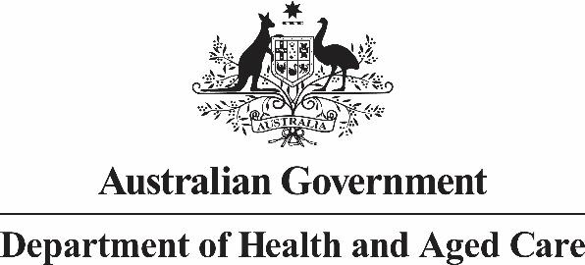

# Chief Nursing and Midwifery Officer

**An update from Chief Nursing and Midwifery Officer Professor Alison J McMillan PSM regarding midwifery professional indemnity insurance**

The Department of Health and Aged Care has been working with the Minister for Health and Aged Care to find a solution to the gap in professional indemnity insurance for endorsed midwives providing intrapartum (labour) care to women outside hospital prior to a planned hospital birth.

We are still working through implementation of the solution with the insurance provider. The solution will make available indemnity cover to endorsed midwives so they will have cover for providing intrapartum (labour) care to women outside hospital prior to a planned hospital birth. This will be backdated to 17 October 2023, which is the date this gap in cover was raised with Government. In the interim, it’s important that you continue to work to the advice provided in my previous correspondence of [31 October 2023](https://www.health.gov.au/news/newsletters/a-letter-from-chief-nursing-and-midwifery-officer-alison-mcmillan-psm-regarding-midwifery-indemnity-insurance?language=en).

The Department has been actively engaging with all our stakeholders throughout this process and acknowledge the profound impact this issue has on women and midwives, especially in Australia’s First Nation’s communities. We continue to work in partnership with Birthing on Country providers to ensure First Nations women have continuous access to culturally safe care with a known midwife.

Yours sincerely

Professor Alison J McMillan PSM

Chief Nursing and Midwifery Officer

10 November 2023