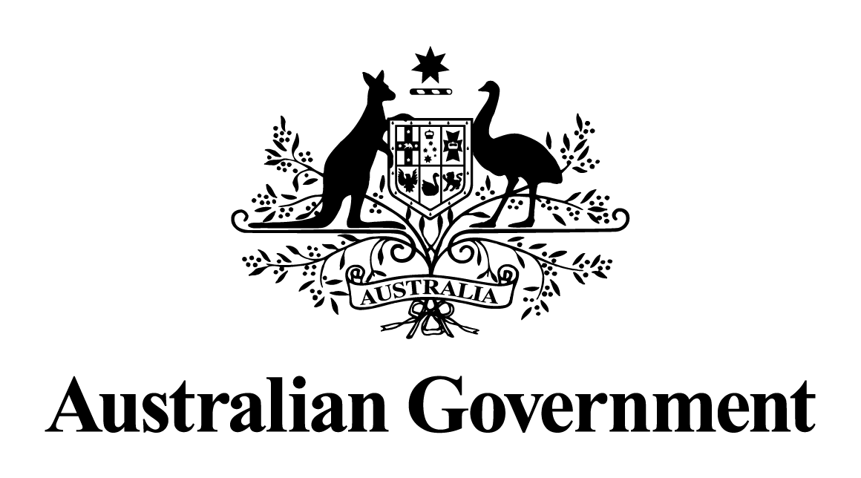

Australian Government response to the   
Parliamentary Joint Committee on Law Enforcement Inquiry report:

Public communications campaigns targeting drug and   
substance abuse

**Introduction**

The Australian Government welcomes the Final Report of the Parliamentary Joint Committee on Law Enforcement Inquiry on *Public communications campaigns targeting drug and substance abuse*.

The Government would like to thank all those who were involved in the Parliamentary Joint Committee on Law Enforcement (the committee) and those who made written submissions and gave evidence at the public hearings.

The Government acknowledges that illicit drugs continue to have a significant impact on individuals, families and communities across Australia and is committed to preventing the uptake and reducing the harms associated with use. Illicit drugs are also a cause for concern given the involvement of serious and organised crime syndicates producing and trafficking them.

The Government also acknowledges the ongoing need for targeted public communications campaigns in reducing the demand for illicit drugs and encouraging behavioural change. Drug use is often influenced by an individual’s beliefs and attitudes and the socio-cultural environment within which they find themselves. By increasing awareness of the harms of drug use and encouraging behaviour change, campaigns may reduce people’s motivations towards drug use.

The Government undertakes a range of reduction and prevention activities focusing on harm minimisation of drug use in Australia, through the overarching framework of the *National Drug Strategy 2017-2026* (the Strategy). The Strategy includes ‘targeted communication strategies’ as a method to achieve its overall aim of preventing and minimising drug-related harms, consistent with the priority action of ‘*preventing uptake, delaying first use and reducing use.’*

The committee’s Final Report made four recommendations addressing a range of areas across communications, including the efficacy of different approaches to drug-related campaigns, best practice approaches to designing and implementing campaigns and other related matters.

The Government notes the recommendations of the Final Report. This response specifically addresses the recommendations identified in the Final Report. It has been coordinated and prepared by the Department of Health and Aged Care, with input from the Attorney-General’s Department and the Department of Home Affairs.

**Australian Government Response to Final Report**

***Recommendation 1***

*2.90 The committee recommends that the Australian Government implement a new public communications campaign via the National Drugs Campaign that will support law enforcement agencies’ efforts to reduce current and future illicit drug demand. The campaign should include the targeted use of social media.*

**Response:**

The Australian Government **supports** this recommendation.

The Australian Government has a strong history of campaigning against the use of illicit drugs, beginning in 1985 with the ‘National Campaign Against Drug Abuse’ followed by a series of targeted campaigns in the 1990s under the branding ‘The Drug Offensive’. There are clear benefits and economies in developing and implementing these initiatives at the national level, maximising opportunities afforded by the cost-efficiencies and agenda-setting and a consistent approach with national media and stakeholders.

To date, the National Drugs Campaign (NDC) has been based on a harm minimisation approach and plays an important role as an awareness-raising and prevention initiative. There have been many phases of campaign activity addressing different audiences and specific drugs to respond to current and emerging drugs.

Any campaign developed to reduce current and future illicit drug use and demand would likely include the targeted use of social media. This channel was particularly effective in reaching crystal methamphetamine (ice) users during the most recent phase of the NDC under the National Ice Action Strategy.

In line with Australian Government advertising requirements and best practice, final media placement decisions are based on formative research recommendations and expert advice from the master media buying agency, currently Universal McCann.

***Recommendation 2***

*3.75 The committee recommends future Australian Government communications campaigns include the following characteristics:*

* *contain targeted messages on the dangers of illicit drug use to key cohorts*
* *reflect the lived experiences of illicit drug users and also the experiences of trusted people, such as teachers and healthcare workers, to establish behavioural change*
* *provide information on addiction treatment off-ramps*
* *include a national schools’ element that will take a multi-component approach to developing protective factors and involve the national education community in its design and implementation*
* *be based on appropriately detailed and considered research and, prior to commencement, have in place both quantitative and qualitative measures for efficacy*
* *take a long-term approach of at least 3–5 years and include a sustained approach to key cohorts over that entire period.*

**Response:**

The Australian Government **supports** this recommendation in principle, noting that specific components will be dependent on formative research recommendations and requirements under the Guidelines on Information and Advertising Campaigns by non-corporate Commonwealth entities (the Guidelines).

All Australian Government campaigns are informed by market research that identifies the need for the campaign, the relevant target audiences and the kinds of messaging and channels that would be most appropriate. This typically involves both quantitative and qualitative methodologies.

In accordance with the Guidelines, creative materials undergo concept testing with the target audiences to ensure they are appropriate and likely to meet the campaign’s objectives. Campaigns need to ensure they do not unintentionally further marginalise or stigmatise people who are at higher risk of experiencing alcohol, tobacco and other drug related harm.

Under the whole-of-government arrangement for evaluation research, benchmarking is conducted prior to campaign launch, with ongoing tracking research while in market. This assesses the effectiveness of the campaign by monitoring changes in the target audiences’ attitudes, knowledge and intended/reported behaviour in relation to the key campaign messages.

***Recommendation 3***

*4.18 The committee recommends the Australian Government establish a formal mechanism to ensure that Commonwealth, State and Territory law enforcement bodies have a strong equal voice in developing policies and strategies to reduce illicit drug demand, including drug treatment services.*

**Response:**

The Australian Government **supports** this recommendation, noting the importance of cross-agency and cross-jurisdictional collaboration and coordination and the need for a balanced approach between health and law enforcement.

The Australian Government’s approach to preventing and reducing harms associated with drug use is set out in the overarching framework of the *National Drug Strategy 2017-2026*. The Strategy guides action by health and law enforcement agencies at both the Commonwealth and state and territory government level, in partnership with service providers and the community. The Strategy outlines the Government’s commitment to supporting the principle of harm minimisation, through the three pillars of supply, demand and harm reduction and a balanced approach between health and law enforcement. Cooperation between law and enforcement, policing, justice and health sectors is essential in delivering effective responses under these three pillars.

***Recommendation 4***

*4.19 The committee recommends the Australian Government support research, potentially by the Australian Institute of Criminology, into the efficacy of addiction treatment programs in reducing drug-related crime recidivism.*

**Response:**

The Australian Government **supports** this recommendation. The Australian Institute of Criminology will undertake a cost-benefit analysis of addiction treatment programs to ascertain their efficacy in reducing drug related criminal activity within an Australian context.