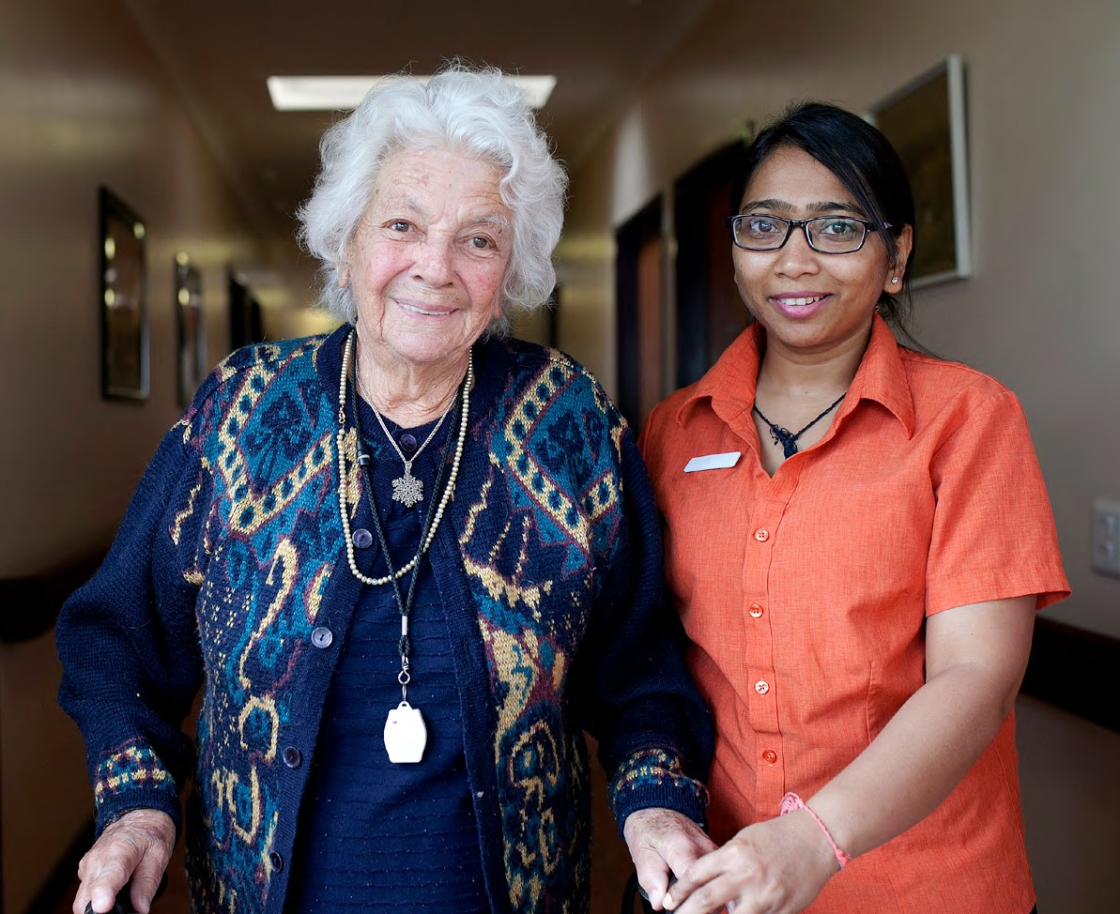

Working in aged care in Australia

Let’s change aged care together

agedcareengagement.health.gov.au/get-involved

# What is changing

for aged care workers?

The Australian Government is making changes to the aged care system in response to the recommendations of the Royal Commission into Aged Care Quality and Safety (Royal Commission).

These changes – known as the aged care reforms – will improve aged care in Australia for all.

To find out more and have your say about the aged care reforms, visit:

agedcareengagement.health.gov.au/get-involved



# Aged care reforms

for aged care workers

In this booklet, you can read more about the aged care reforms and get an idea of:

* what reforms will impact you
* where you can find career opportunities
* how you can get involved.

The people and organisations depicted in these scenarios are not real.

We have created these scenarios to show examples of how the reforms will help to build, train and support aged care workers.

Subscribe to Your Aged Care Newsletter for the latest news and events

health.gov.au/aged-care-newsletter-subscribe

3



# A message from

the Hon Anika Wells MP

Minister for Aged Care Minister for Sport

Build, train and support the aged care workforce

The Royal Commission into Aged Care Quality

and Safety’s Final Report was tabled in Parliament on 1 March 2021. The report is a critical milestone in the

journey to restoring dignity to older people in Australia.

Australia’s aged care system is undergoing genuine change for the benefit of everyone living, caring and working in the sector. Our diverse, skilled and valued aged care workforce is fundamental to putting security, dignity and quality back into aged care.

We have already delivered on several programs and I am committed to:

* expanding opportunities to join the care and support workforce
* attracting new workers and advancing the skills of current workers
* raising wages and providing a supportive workplace.

We are investing $11.3 billion to fund the Fair Work Commission’s decision of a 15 per cent increase to the award wages for many aged care workers.

This is the largest increase to award wages in a work value case under the Fair Work Act and is expected to benefit over 250,000 aged care workers.

We are increasing options to enter the career pathway with Fee-Free TAFE training, specialised online courses, scholarships and prior learning recognition.

We are supporting a work environment where everyone is respected and valued, with the resources for workers to do their jobs well. This includes secure employment, workforce planning and surge assistance where it is needed.

One of the best parts of my job is getting out and talking to aged care workers and volunteers and hearing about their experiences.

By putting people at the centre of what we do, we’re already making the system better for those receiving care and those giving care—people like you.

We are ambitious for aged care and I strongly encourage everyone to have their say.

Together we will make aged care equitable, sustainable and trusted to support older people.

5

# Donna’s story:

Donna is a proud Wiradjuri woman and always wanted to work in aged care. Growing up with many aunties and uncles in her life, she knew that caring for older people was in her DNA. Her mum also works in aged care as a registered nurse.

While Donna was at school, she completed a school-based apprenticeship. When she finished Year 12, she started working at an aged care home as a personal care assistant.

Donna enjoyed the work and applied for an aged care scholarship to become a registered nurse. The scholarship allowed her to take time off from work and finish her studies while not losing out on wages. She took part in specialised aged care clinical placements while she was at uni.

As a graduate nurse, Donna enjoyed the mentoring and leadership training she received from experienced aged care nurses.

Now, as a registered aged care nurse, Donna is grateful for the recent wage rise. The pay rise has increased Donna’s and her mum’s take home pay significantly.

Donna finds working in aged care very rewarding and enjoys being part of a team. She enjoys listening to the stories of the residents she cares for.

‘Working in aged care has given me a lot of career

prospects.

I’m already in a leadership position thanks to some of the free courses and training I

have been able

to access.’

Donna, registered aged

care nurse

6

# More skilled workers

providing appropriate care

The Government is boosting new and existing aged care worker skills.

There are more opportunities for fee-free TAFE training, such as the *Certificate III in Individual Support (Ageing)*, scholarships and online training programs.

### Pay rise for aged care workers

We are providing a pay rise for aged care workers, with award wages for home care employees and nurses rising by 15% from 1 July 2023.

[health.gov.au/topics/aged-care-workforce/what-were-doing/](http://health.gov.au/topics/aged-care-workforce/what-were-doing/better-and-fairer-wages) [better-and-fairer-wages](http://health.gov.au/topics/aged-care-workforce/what-were-doing/better-and-fairer-wages)

### Fee-Free TAFE Courses

Fee-Free TAFE courses will help you begin a rewarding career in aged care. This initiative provides opportunities for school leavers, people seeking a care and support job, workers wanting to re-train or upskill and unpaid carers.

[yourcareer.gov.au/fee-free-tafe](http://yourcareer.gov.au/fee-free-tafe)

### Equip Aged Care Learning Package

Free online learning modules are available to support aged care workers and those interested in caring for older people. Great for refreshing knowledge of aged care.

equiplearning.utas.edu.au

### Scholarships

Find scholarships for personal care workers, nurses and allied health professionals working in aged care.

[acn.edu.au/scholarships](http://acn.edu.au/scholarships)

Watch the video and find out why Mandy loves working in aged care

<https://www.youtube.com/watch?v=U6y-MQEkAaE>

7

# Jack’s story:

Jack is a cook at an aged care home in Ingham, a town in Far North Queensland with a large Italian population.

He is keen to improve his skills so he can make meals that help the residents stay connected to their culture and their memories. Many of the residents he looks after grew up in Italy and moved to the area in the 1950s.

Megan is the general manager at the Ingham aged care home. She keeps on top of the many opportunities now available for aged care staff to get further training.

This contributes to the aged care home’s overall Star Rating of 4.

Megan knows potential residents and their families check the ratings when deciding on care services.

Megan has also been able to hire Italian-speaking staff. She is checking the My Aged Care Find a Provider tool to see if the aged care home meets the My Aged Care Provider

Specialisation Verification Framework criteria as providing specialised care to people from

a culturally and linguistically diverse background.

The team often use the free translating and interpreting services available to aged care providers to communicate important messages to their residents and their families.

‘Food is one of life’s great

pleasures.

I love cooking nutritious, delicious Italian meals that spark memories and

emotions with our residents

and celebrate their culture.’

Jack, aged care home cook

8

# Improving quality

across aged care services

### Care for diverse needs

Aged care providers can tailor their services, staff and organisation to meet the needs of specific groups. These providers can apply to have their specialised services independently verified against the My Aged Care Provider Specialisation Verification Framework.

[health.gov.au/topics/aged-care/providing-aged-care-services/](http://health.gov.au/topics/aged-care/providing-aged-care-services/delivering-quality-aged-care-services/about-specialisation-verification-framework) [delivering-quality-aged-care-services/about-specialisation-](http://health.gov.au/topics/aged-care/providing-aged-care-services/delivering-quality-aged-care-services/about-specialisation-verification-framework) [verification-framework](http://health.gov.au/topics/aged-care/providing-aged-care-services/delivering-quality-aged-care-services/about-specialisation-verification-framework)

### Free Translating and Interpreting Services

Access to skilled interpreters 24 hours a day, 7 days a week, to: approved providers of aged care services, their staff and anyone receiving, or seeking to access, aged care services.

Interpreting services are available for discussions with clients and residents, and to support those you care for to participate in social and cultural activities, including weddings, funerals, family reunions and engaging with social groups.

[tisnational.gov.au](http://tisnational.gov.au/)

Aged care providers can also have documents translated to support a better aged care experience for people from culturally and linguistically diverse backgrounds.

[diversityagedcare.health.gov.au](http://diversityagedcare.health.gov.au/)

### Star Ratings system for residential aged care

Star Ratings can help older people, their families and loved ones make more informed choices about their aged care.

[myagedcare.gov.au/quality/how-are-star-ratings-calculated](http://myagedcare.gov.au/quality/how-are-star-ratings-calculated)

### Watch the video about how Star Ratings work

[health.gov.au/resources/videos/star-ratings-how-to-for-residential-](http://health.gov.au/resources/videos/star-ratings-how-to-for-residential-aged-care) [aged-care](http://health.gov.au/resources/videos/star-ratings-how-to-for-residential-aged-care)

9

## Dinesh’s story:

Dinesh works for an aged care provider located in an eastern suburb of Melbourne, Victoria.

Dinesh attends the Department of Health and Aged Care’s online Tech Talks and webinars on the financial and operational reporting requirements. He uses this information and guidance materials to develop new reporting processes. He’s learning about the new Government Provider Management System (GPMS) which is the Government’s new IT system for aged care providers. The GPMS is designed to replace the current 20-year-old National Approved Provider System (NAPS).

Dinesh’s colleagues track and document care activities and care-related costs. Dinesh uses this information to provide monthly reporting statements to clients.

He also submits the data for the annual Aged Care Financial Report and the Quarterly Financial Report.

Dinesh uses the department’s Financial Report on the Australian Aged Care Sector and Quarterly Financial Snapshot to get a good understanding of the aged care market and opportunities for strategic planning.

The aged care home that Dinesh works at is planning future refurbishments in line with new National Aged Care Design Principles and Guidelines, which commence from 1 July 2024. Dinesh knows this investment will provide a safer, more appealing workplace for staff and that residents will benefit from a more home-like living environment.

‘There’s so much change happening in aged care right now. It’s meant having to change the way we do things.

But these new reporting systems mean we can all have better data about what’s happening in the sector.’

Dinesh, aged care manager

10

## More support

for aged care providers

### Government Provider Management System (GPMS)

GPMS is a new IT system for aged care providers. In the future it will be a master source of information across the aged care system.

[health.gov.au/our-work/government-provider-management-](http://health.gov.au/our-work/government-provider-management-system-gpms) [system-gpms](http://health.gov.au/our-work/government-provider-management-system-gpms)

### Digital Transformation Tech Talk webinars

Supporting aged care providers in understanding how technology can help support them in their business.

[health.gov.au/our-work/digital-transformation-for-the-aged-care-](http://health.gov.au/our-work/digital-transformation-for-the-aged-care-sector/tech-talk-webinars) [sector/tech-talk-webinars](http://health.gov.au/our-work/digital-transformation-for-the-aged-care-sector/tech-talk-webinars)

### Reporting for residential aged care

Find out more about the reporting requirements needed and the improvements being made.

[health.gov.au/topics/aged-care/providing-aged-care-services/](http://health.gov.au/topics/aged-care/providing-aged-care-services/responsibilities) [responsibilities](http://health.gov.au/topics/aged-care/providing-aged-care-services/responsibilities)

### National Aged Care Design Principles and Guidelines

Guidelines are being introduced from 1 July 2024 to provide practical examples of great design in residential aged care.

[health.gov.au/our-work/residential-aged-care/managing-](http://health.gov.au/our-work/residential-aged-care/managing-residential-aged-care-services/improving-accommodation-in-residential-aged-care) [residential-aged-care-services/improving-accommodation-in-](http://health.gov.au/our-work/residential-aged-care/managing-residential-aged-care-services/improving-accommodation-in-residential-aged-care) [residential-aged-car](http://health.gov.au/our-work/residential-aged-care/managing-residential-aged-care-services/improving-accommodation-in-residential-aged-care)e

11

# Ella’s story:

Ella loves her job as a personal care worker in Orange in regional NSW, and she’s good at it.

She moved from the Philippines and is now a permanent resident. Ella found work cleaning homes for an aged care provider.

Ross, Ella’s supervisor, loves her enthusiasm and kindness towards older people.

Ross encourages Ella to enrol in a Fee-Free TAFE course and gives Ella time off to study.

Ella does well in the *Certificate III in Individual Support*. As part of the Certificate III, she learns how to perform a number of different tasks. Ross speaks to Ella about an opportunity to gain more valuable skills in the residential side of the aged care service. Ella is very keen to do this so Ross helps to negotiate some work for Ella to get this experience.

The aged care home is so pleased with Ella that they offer her ongoing work that provides a better, stable income for her. There has also been a recent wage rise for aged care workers, Ella feels her work is valued and supported.

Ella now has full time work.

Ella also completed the free online learning modules to improve her general knowledge of aged care. Ella is now looking at other opportunities for her career and is thinking about applying for a scholarship.

‘My job gives me such personal satisfaction.

I am grateful for the free courses that have helped

me progress my aged care career.’

Ella, aged care personal support worker

12

### School based apprenticeships

Growing the workforce

Start vocational training, earn a wage and get hands on experience in aged care while finishing school.

[australianapprenticeships.gov.au/school-based-apprenticeships](http://australianapprenticeships.gov.au/school-based-apprenticeships)

### Scholarships

Find scholarships for personal care workers, nurses and allied health professionals working in aged care.

[acn.edu.au/scholarships](http://acn.edu.au/scholarships)

### Clinical Placements

Supporting Bachelor and Master of Nursing students with high-quality clinical placements in the care and support sector, including:

* aged care, veterans’ care and disability support.

[health.gov.au/our-work/aged-care-nursing-clinical-placements-](http://health.gov.au/our-work/aged-care-nursing-clinical-placements-program) [program](http://health.gov.au/our-work/aged-care-nursing-clinical-placements-program)

### Transition to Practice

Supporting new aged care nurses with training and professional development. Nurses who take part in the program will receive:

* + specialist training in aged care and gerontological nursing
  + mentorship from senior aged care nurses.

[health.gov.au/our-work/aged-care-transition-to-](http://health.gov.au/our-work/aged-care-transition-to-practice-program) [practice-program](http://health.gov.au/our-work/aged-care-transition-to-practice-program)

### Pay rise for aged care workers

We are providing a pay rise for aged care workers, with award wages for home care employees and nurses rising by 15% from 1 July 2023.

[health.gov.au/topics/aged-care-workforce/what-were-doing/better-](http://health.gov.au/topics/aged-care-workforce/what-were-doing/better-and-fairer-wages) [and-fairer-wages](http://health.gov.au/topics/aged-care-workforce/what-were-doing/better-and-fairer-wages)

13

# Matthew’s story:

Matthew runs an aged care organisation that operates across several regional areas in Western Australia. With an ageing population and baby boomers starting to move into aged care he is finding that demand for aged care is rising.

Matthew is looking to find personal care workers from overseas using the PALM Scheme. He has spoken with other providers who tell him that PALM workers provide an excellent standard of care and become very involved in their local communities.

He has also been able to fill positions in remote areas for nurses, support workers and managers taking holidays or other opportunities through the Rural Locum Assistance Program. Recruiting people permanently in remote locations is difficult, the program has given Matthew the time to find the right people for the job.

He recently entered into an Aged Care Industry labour agreement.

These agreements provide a streamlined pathway for providers to access personal care workers.

‘We now have a very low turnover of staff and many of our staff are from overseas.

My team bring a rich cultural diversity to our residents and our workplace, and we are all

much better for it.’

Matthew, aged care provider

14

Dedicated workers from overseas supporting our workforce

### PALM Scheme

Eligible Australian businesses can hire workers from 9 Pacific countries and Timor-Leste when there are not enough local workers available.

palmscheme.gov.au

Watch how the PALM scheme is supporting aged care in the Northern Territory.

[palmscheme.gov.au/stories/video-aged-care-workers-connecting-](http://palmscheme.gov.au/stories/video-aged-care-workers-connecting-people-and-culture-alice-springs) [people-and-culture-alice-springs](http://palmscheme.gov.au/stories/video-aged-care-workers-connecting-people-and-culture-alice-springs)

### Rural Locum Scheme

Supporting providers with a locum service for sudden departures, annual leave and training.

<https://rurallap.com.au/aged-care/>

### Aged Care Industry Labour Agreement

Streamlines the visa process for qualified direct care workers to work in aged care. Employers need to work with their union to access the program.

[immi.homeaffairs.gov.au/what-we-do/skilled-migration-program/](http://immi.homeaffairs.gov.au/what-we-do/skilled-migration-program/recent-changes/new-aged-care-industry-labour-agreement) [recent-changes/new-aged-care-industry-labour-agreement](http://immi.homeaffairs.gov.au/what-we-do/skilled-migration-program/recent-changes/new-aged-care-industry-labour-agreement)

### Business, Industry and Regional Outreach (BIRO)

Provides information to businesses to help understand visa pathway options for workers.

[immi.homeaffairs.gov.au/visas/employing-and-](http://immi.homeaffairs.gov.au/visas/employing-and-sponsoring-someone/business-industry-and-regional-outreach) [sponsoring-someone/business-industry-and-](http://immi.homeaffairs.gov.au/visas/employing-and-sponsoring-someone/business-industry-and-regional-outreach) [regional-outreach](http://immi.homeaffairs.gov.au/visas/employing-and-sponsoring-someone/business-industry-and-regional-outreach)

15

# David’s story:

David is a home care recruitment manager in Launceston, regional Tasmania. He finds skilled, diverse and compassionate staff to make sure that his employer’s aged care clients receive high quality support and care at home.

David views the pay rise for aged care workers as one of the best things to happen to the sector in years. It’s recognition for the ongoing commitment of staff, but it’s also making his job easier: worker retention is already improving.

It’s been easier to fill vacancies since the Government started helping providers to recruit and train personal care workers. New training programs offered in TAFEs and more university places mean job applicants are better skilled. Apprenticeships in aged care help to find great employees with benefits for employers too.

David’s current staff are also upskilling and completing free online skills modules in areas like dementia, palliative care, managing wounds, preventing falls, infection prevention and control, and supporting older people’s mental health and wellbeing.

David has researched the evidence and resources on the ARIIA Knowledge Hub. He’s interested in making the workplace as efficient as possible and keen to see what others are doing.

Employing trained workers and advancing the skills of current workers helps David to achieve his employer’s workforce requirements and meet the needs of their clients.

‘Most older people want to live in their own home for as long as they can. We’re making this possible by building a well-trained,

experienced homecare team.’

David home care recruitment manager

16

# Supporting people

to stay at home

### Home Care Workforce Support Program

Organisations are working with aged care providers in their area to support worker training and recruitment.

[https://www.health.gov.au/our-work/home-care-workforce-](https://www.health.gov.au/our-work/home-care-workforce-support-program) [support-program](https://www.health.gov.au/our-work/home-care-workforce-support-program)

### Pay rise for aged care workers

We are providing a pay rise for aged care workers, with award wages for home care employees and nurses rising by 15% from 1 July 2023.

[health.gov.au/topics/aged-care-workforce/what-](http://health.gov.au/topics/aged-care-workforce/what-were-doing/better-and-fairer-wages) [were-doing/better-and-fairer-wage](http://health.gov.au/topics/aged-care-workforce/what-were-doing/better-and-fairer-wages)s

### Build, train and support the aged care workforce

We are building opportunities to expand the care and support workforce including those that work in home care. This will allow more skilled workers to deliver safe, consistent, high-quality care for those who want to stay in their home as they age.

[health.gov.au/topics/aged-care-workforce/what-were-doing](http://health.gov.au/topics/aged-care-workforce/what-were-doing/better-and-fairer-wages)/better-and-fairer-wages

### Equip Aged Care Learning Package

Free online learning modules are available to support aged care workers and those interested in caring for older people. Great for refreshing knowledge of aged care.

[equiplearning.utas.edu.au](http://equiplearning.utas.edu.au/)

### ARIIA Aged Care Research & Industry Innovation

A research centre which works closely with aged care workers, providers, researchers and people who use aged care services. Findings will be used to create innovative solutions for the aged care sector to ensure best possible care.

[ariia.org.au](http://ariia.org.au/)

17

# Catherine’s story:

Catherine started out as a registered nurse working in an aged care home 20 years ago. Now she’s the CEO of a large national aged care provider.

The company employs 3,000 staff, including more than 100 nurses, across about 30 aged care homes around the country.

In recent years, finding and retaining a full team of staff has been challenging. But she now feels optimistic because so much is happening to grow the aged care workforce.

Through the Indigenous Employment Initiative program, Catherine has been able to offer training and employment to First Nations staff to work in aged care services specifically catering for First Nations elders.

Some of the roles include chefs, admin, gardeners and personal care workers.

Catherine values the qualified and experienced enrolled nurses on the team. She has recommended to many of them to apply for a scholarship to become a registered nurse. Registered nurses play a critical role in providing complex clinical care for residents and as the need for aged care grows, so does the need for more high performing nurses who are passionate about aged care to enter the sector.

Scholarships, mentoring programs, and better support of nursing students on clinical placements are all helping to encourage more nurses into aged care.

As a former nurse herself, Catherine does everything she can to support and keep nurses in her team and providing the best possible care for older people in Australia.

‘Our staff are the heart of our organisation. The new workforce initiatives help me to build a well-trained and dedicated team. They also show people that aged care can be a rewarding career.’

Catherine, Chief Executive of a national provider

18

# Employing more nurses in aged care homes from July 2023

### Care minutes and 24/7 registered nurses

Residential aged care homes need to have a registered nurse on-site and on duty 24 hours a day, 7 days a week.

From 1 October 2023, all aged care homes will have to meet their individual care requirements based on a sector average target of 200 minutes of care per resident per day, including an average of 40 minutes of care from a registered nurse.

From 1 October 2024, the sector average requirements will increase to 215 minutes of care per resident per day including an average of

44 minutes of care from a registered nurse.

[health.gov.au/our-work/care-minutes-registered-nurses-aged-care](http://health.gov.au/our-work/care-minutes-registered-nurses-aged-care)

### Opportunities for nurses in aged care

We are supporting nurses to enter and build their careers in the aged care sector. Learn about the scholarships, transition programs and clinical placements available to nurses.

[health.gov.au/topics/aged-care-workforce/](http://health.gov.au/topics/aged-care-workforce/opportunities-for-nurses) [opportunities-for-nurses](http://health.gov.au/topics/aged-care-workforce/opportunities-for-nurses)

### Indigenous Employment Initiative Program

First Nations people are supported to gain training and employment to deliver culturally appropriate care to First Nations elders.

The program funds over 80 organisations to employ and train staff to support in the delivery of aged care services.

[health.gov.au/our-work/indigenous-employment-initiative-program](http://health.gov.au/our-work/indigenous-employment-initiative-program)

19



# Have your say

Thousands of people have been involved in shaping the reforms so far through surveys, webinars, online workshops, consultation papers and face-to-face events.

There are plenty of opportunities for you as an aged care worker to have your say about the changes to aged care.

* Register to be kept up to date on consultation opportunities and outcomes through the Aged Care Engagement Hub.
* Meet with us in-person at one of the many upcoming events that we’re attending around Australia.

DT0003811 - V04SEPT2023

Visit agedcareengagement.health.gov.au/get-involved