





Ngayubah Gadan
(Coming together)

Consensus Statement:
Rural and Remote Multidisciplinary
Health Teams

2023


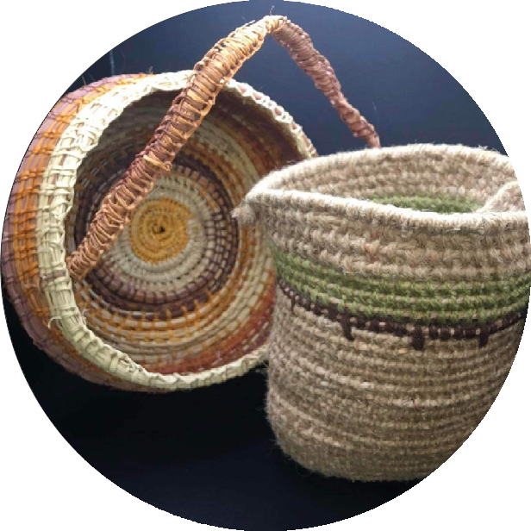
Dilly bags made
by Faye McMillan

Acknowledgement of Country
The Ngayubah Gadan (pronounced nai-yah-bah gah-duhn) Consensus Statement signatories acknowledge the Traditional Owners and Custodians of Country throughout Australia. They recognise and deeply respect the strength and resilience of First Nations Australians and their continuing connection and relationship to rivers, lands and seas.
The Ngayubah Gadan Consensus Statement signatories are committed to the advancement of improved health outcomes for First Nations Australians. The signatories are committed to promoting First Nations Australians’ expertise, opinions and perspectives through their voices, shared stories, leadership, effective feedback mechanisms, and collaborative design processes.
Signatories pay respect to Elders past, present, and emerging, and extend that respect to all First Nations Australians reading this Statement.

Weaving a team
A dilly bag, traditionally made and used by Aboriginal people, is woven from the fibres that are available locally and is made to carry and hold important items. All that a family and community needs may be held in this highly flexible, and sustainable receptacle. A fit for purpose rural and remote multidisciplinary health team (RRMHT) can be likened to a dilly bag, using local fibres woven together to create a supportive whole. Within it one may find tools, food or medicine for self, family and community. The fibres and woven design of a dilly bag reflect the uniqueness of their context having evolved in that place and that climate.
Just as a dilly bag is made in and for a specific context, rural and remote multidisciplinary health teams must be created for local community context and be woven from the diverse skills of those health professionals, practitioners, students and workers who are there; just as the weavers of the dilly bag may bring in threads traded from elsewhere to finish a bag, a rural and remote multidisciplinary health team may involve external and intermittent
health professionals to make it complete.

Thus, we can see that like a dilly bag, a rural and remote multidisciplinary health team Ngayubah Gadan: a coming together of multiple parts to form
a cohesive whole.

Contents
Glossary 2
A message from the National Rural Health Commissioners 4
Signatories to the Consensus Statement 5
Introduction 7
Consultation Process Overview 7
The Ngayubah Gadan Consensus Statement 9
Attachment A - The Ngayubah Gadan Consultation Process 16
References 18
Participants at a Collaborative Care forum - Far West LHD, rural NSW, 2022.

C
o
u
r
t
e
s

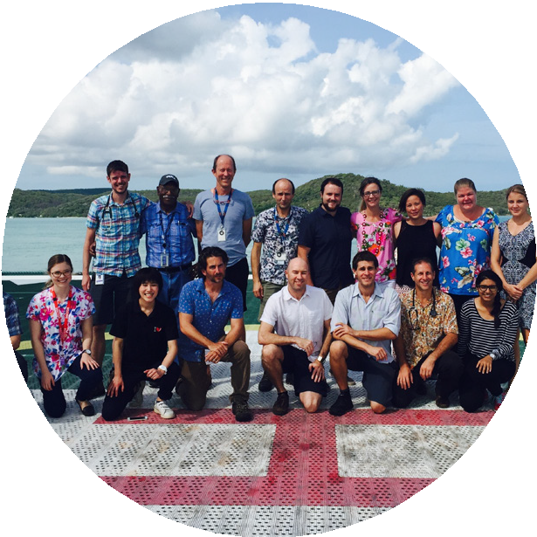
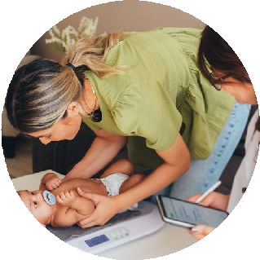
Glossary
y
o
f
Q
u
e
e
n
s
l
a
n
d
H
e
a
l
t
h
Acceptability - is a multi-faceted construct that reflects the extent to which people delivering or receiving a healthcare intervention consider it to be appropriate, based on anticipated or experienced cognitive and emotional responses to the intervention. The theoretical framework of acceptability consists of seven component constructs: affective attitude, burden, perceived effectiveness, ethicality, intervention coherence, opportunity costs, and self-efficacy.1 Acceptability includes application of Culturally Safe care and workplaces.
Allied Health Rural Generalist - An allied health professional delivering services that respond to the broad range of healthcare needs of a rural or remote community. This includes delivering services to people with a wide range of clinical presentations from across the age spectrum and in a variety of clinical settings (inpatient, ambulatory care, community). The primary aim of rural generalist service models is to deliver high quality, safe, effective and efficient services as close to the client’s community as possible.2
Clinical Networks - Clinical networks multidisciplinary networks of clinicians that aim to improve clinical care and service delivery using a collaborative approach to identify patient and health service need and to implement strategies to improve quality of care and patient outcomes.3
Clinician - Refers to health practitioners and qualified health professional who is engaged in clinical practice (that is, in diagnosis and/or treatment of patients including recommending preventive action).
Co-design - involves coming alongside people who experience vulnerabilities, to work with them in creating interventions, services and programs which will work in the context of their lives and will reflect their own values and goals. This involves letting go of professional assumptions about a
group’s perspectives and experiences and actively learning from what people say and do. Expertise, professional knowledge and research is then considered in relation to group input, to add nuance to the possibilities of approaching social problems with specific groups.4
Cultural Safety - is determined by Aboriginal and Torres Strait Islander individuals, families and communities. Culturally safe practise is the ongoing critical reflection of health practitioner knowledge, skills, attitudes, practising behaviours and power differentials in delivering safe, accessible and responsive healthcare free of racism.5
Full scope of practice - Refers to clinicians regularly practicing to the full extent of their knowledge and skill, that factors an individual’s context in which they practice, level of competence and health needs of the community.
Health practitioner - registered by the Australian Health Practitioner Regulatory Agency under the Health Practitioner Regulation National Law Bill.
Health professional - not regulated under the Health Practitioner Regulation National Law Bill but holds recognised tertiary qualifications.
Holistic care - A system of comprehensive or total patient care that considers the physical, emotional, social, economic, and spiritual needs of the person; their response to illness; and the effect of the illness on the ability to meet self-care needs.6
Medical Rural Generalist - A Rural Generalist is a medical practitioner who is trained to meet the specific current and future healthcare needs of Australian rural and remote communities, in a
sustainable and cost-effective way by providing both comprehensive general practice and emergency care and required components of other medical specialist care in hospital and community settings as part of a rural healthcare team.7

2 Ngayubah Gadan Consensus Statement

Model of care - A Model of care broadly defines the way health services are delivered and by whom. It outlines best practice care and services for a person, population group or patient cohort as they progress through the stages of a condition, injury or event. It aims to ensure people get the right care, at the right time, by the right team and in the right place.8
Modified Monash Model (MMM) - is used to differentiate areas of Australia in terms of their remoteness and population. The Commissioner acknowledges that there are important considerations beyond distance and size that distinguish one area of Australia from another and that these can be accommodated in planning and implementation. However, for simplicity, this document occasionally uses collective terms to describe certain areas of Australia and those terms should be taken broadly to have the following meanings:
‘Regional’ means MMM 2 and 3 areas ‘Rural’ means MMM 4 and 5 areas ‘Remote’ means MMM 6 and 7 areas
For more information see:
Modified Monash Model | Australian Government Department of Health and Aged Care.
Ngayubah Gadan [nai-yah-bah gah-duhn] - means Coming Together in the Yidinji language. The Minjil Indigenous cultural group in Gimuy (Cairns) have given their permission to use these words as the name for the Ngayubah Gadan (Coming Together) Summit and Consensus Statement.
Signatories extend their deep gratitude to Minjil cultural group for gifting these words in their living and ancient language, to help us mark this important work.
Person-centred care or interventions - Practice that follows the principle of incorporating the person’s (patient’s) perspective that can mean care is patient-directed because they are sufficiently and appropriately informed to self-determine their care and level of engagement.9
Place-based approach - In a place-based approach, the characteristics of the community and the location can be brought together in an integrated ‘person and place’ approach that focuses on outcomes for people. In this context, the community and its needs should be at the centre of any development. Involving the community in planning, selecting, designing and governing their physical and social infrastructure can be just as important as the facilities and services themselves.10
Primary health care - Primary care, on the other hand, in Australia refers to those services in the community that people go to first for health care: general practices, ACCHS, community pharmacies, many allied health services, mental health services, drug and alcohol services, community health and community nursing services, maternal and child health services, sexual health services and oral health and dental services.11
Rural/Remote Nurse Generalist - Rural and remote Registered Nurses work at an advanced generalist full scope of practice across the lifespan to provide the needed healthcare for their community. While all registered nurses are trained as generalists, rural and remote Registered Nurse practice requires care to be delivered to populations that have significantly higher burden of disease, lower life expectancies, and barriers to health service access not experienced in urban areas.12
Generalist practice encompasses a comprehensive spectrum of activities. It is directed towards a diversity of people with different health needs, takes place in a wide range of health care settings, and it is reflective of a broad range of knowledge and skills. Generalist practice may occur at any point on a continuum from novice to advanced.13
Social and emotional wellbeing - A term used to describe the social, emotional, spiritual, and cultural wellbeing of a person. The term recognises that connection to land, culture, spirituality, family, and community are important to people and can impact on their wellbeing. It also recognises that a person’s social and emotional wellbeing is influenced by policies and past events.14
Sustainability - In the rural and remote health context, the concept of sustainability
refers to the ability of a health service to provide ongoing access to appropriate quality care in a cost- efficient and health effective manner.15

3 Ngayubah Gadan Consensus Statement

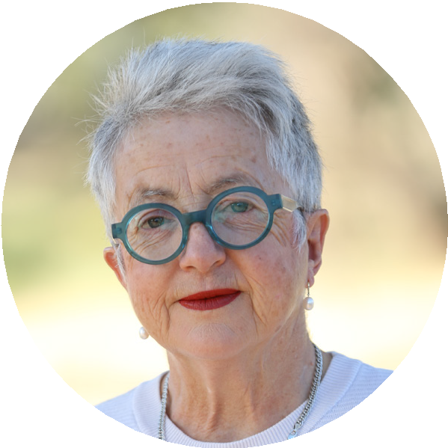
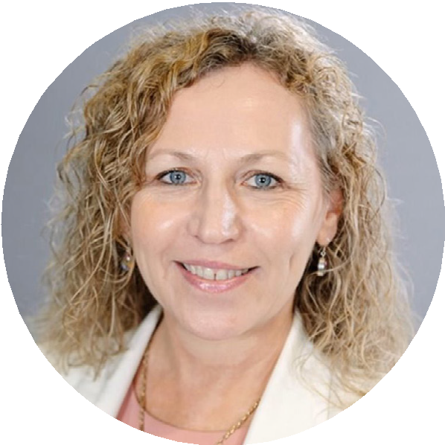
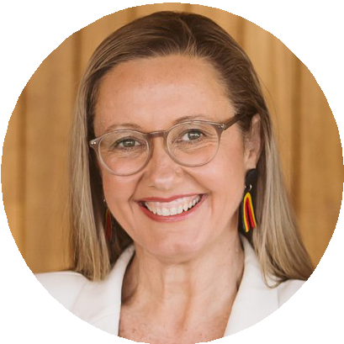
A

message

from the National
Rural Health Commissioners

In our work as a rural health practitioners we have always been part of a multidisciplinary team. The multidisciplinary teams that form in rural and remote communities are responsive to local need and make use of who and what is available; flexibility enables services to respond to changes in health care need and workforce
availability and continue to serve the community. Australia’s rural and remote health professionals work tirelessly often in multidisciplinary teams, to ensure that those within their communities requiring care and assistance have access to critical services. This is the praxis or practical application of theories of health care in rural and remote communities. We seek to provide the necessary and desired care or service function using what we have. Experience tells us that if we are rigid in who does what we may end up with no service being provided. Experience also
tells us that usually there is more than one option for who and how a particular episode of care can be provided.
The COVID-19 pandemic demonstrated that it is possible, when supported by appropriate health policy and funding mechanisms, for health services to learn, to adapt and to be flexible, to rapidly and appropriately respond to changing conditions
to protect the populations they serve. We see a wide variation between the high functioning and adaptive health services in rural and remote
communities of Australia and those that struggle to meet the needs of their communities.
It is our observation that where Rural and Remote Multidisciplinary Health Teams are operating well, a rural health service thrives and provides quality care. To move from observation of suspected impact to evaluation we need to be able to compare like with like and unlike; to do this we need definition of terms. This Consensus Statement is a first step in that process. The Ngayubah Gadan (Coming Together) Summit and proceeding consultation drew together Australia’s key rural and remote health care stakeholders to begin the process of articulating what a Rural and Remote Multidisciplinary Health Team is, how it functions and what support is needed for it to thrive. The Ngayubah Gadan Consensus Statement is the final iteration of the document that began at that Summit.

Adjunct Professor Ruth Stewart,
National Rural Health Commissioner

Professor Faye McMillan and Adjunct Professor Shelley Nowlan
Deputy National Rural Health Commissioners

Imagery above from left to right: Adj. Professor Ruth Stewart, Professor Faye McMillan, Adj. Professor Shelley Nowlan

Signatories

to the Consensus Statement

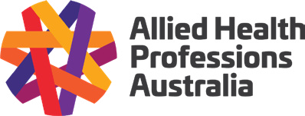

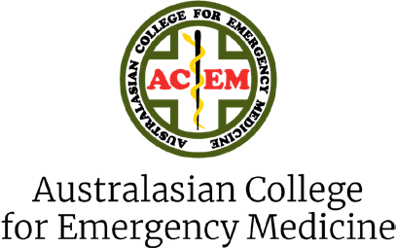
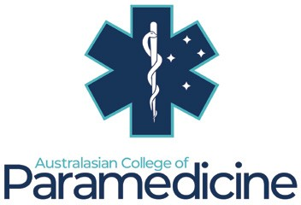

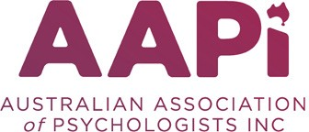
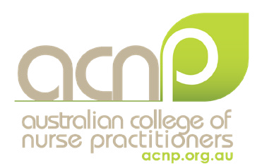

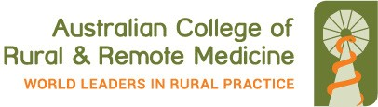
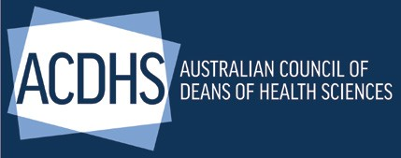
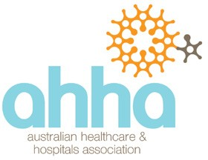


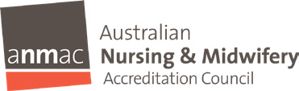
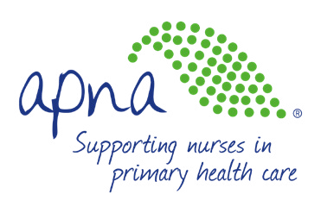
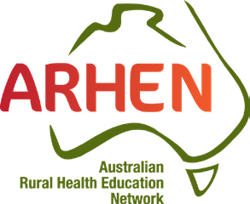
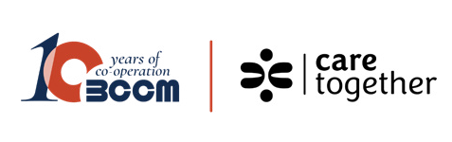
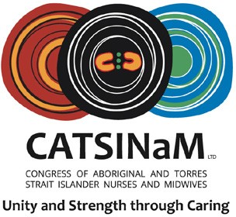
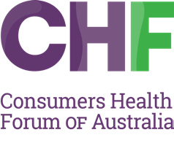




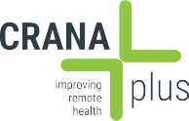


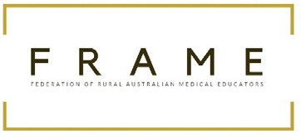


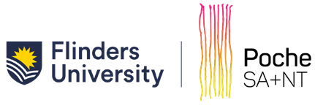



5 Ngayubah Gadan Consensus Statement

Signatories
to the Consensus
Statement

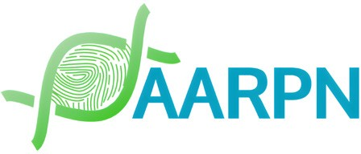
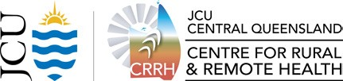




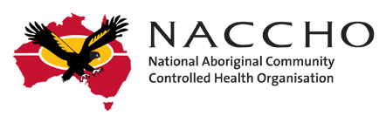
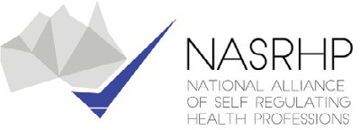

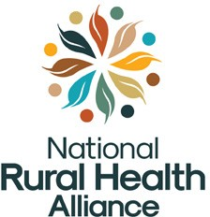







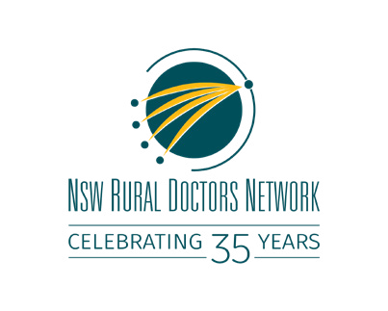



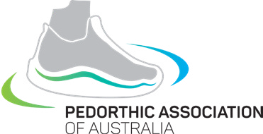

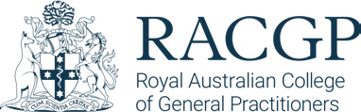


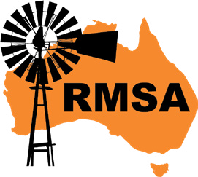
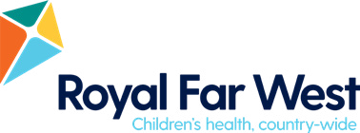
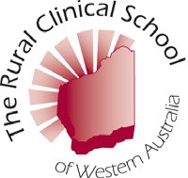


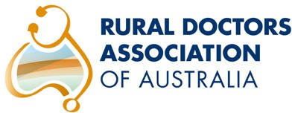
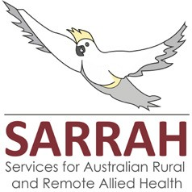
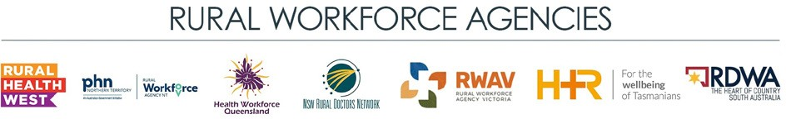





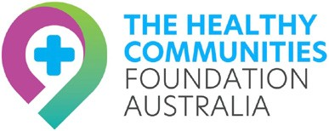




Organisations who wish to endorse the Ngayubah Gadan Consensus Statement are invited to contact the Office of the National Rural Health Commissioner at NRHC@health.gov.au. The Statement Signatories page will be updated quarterly.

6 Ngayubah Gadan Consensus Statement

Ngayubah Gadan (Coming Together) Sustainable Rural and Remote Multidisciplinary Health Teams

Ngayubah Gadan (Coming Together)
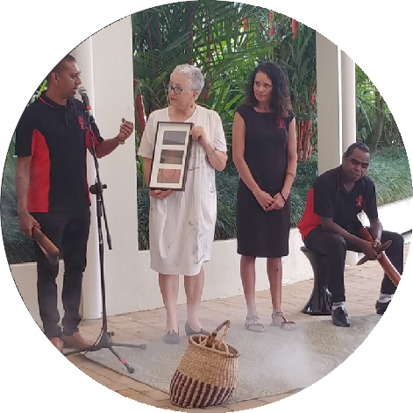
Ngayubah Gadan [nai-yah-bah gah-duhn] means Coming Together in the Yidinji language. The Minjil Indigenous cultural group in Gimuy (Cairns) have given their permission to use these words as the name for the Ngayubah Gadan (Coming Together) Summit (June, 2022) and Consensus Statement. Signatories extend their deep gratitude to Minjil cultural group for gifting these words in their living and ancient language, to help us mark this important work.
u
t
h
S
t
e
w
a
r
t
.
w
e
l
c
o
m
e
t
o
C
o
u
n
t
r
y
.
M
i
n
j
il
c
u
lt
u
r
a
l
g
r
o
u
p
,
R

Introduction
N
g
a
y
u
b
a
h
G
a
d
a
n
S
u
m
m
i
t
In June 2022, more than seventy rural and remote health stakeholders came together to attend the Ngayubah Gadan (Coming Together) Summit in Gimuy/Cairns, Australia. Stakeholders represented a broad range of professions, peak organisations, health services, government departments, training and education providers, clinicians and health students. The purpose of the Summit was to provide the opportunity to share knowledge and experiences about what it is to work in multidisciplinary team care in rural and remote Australian communities.

A key objective of the Summit was to articulate and define the value and importance of developing and investing in rural and remote multidisciplinary health teams with rural generalist expertise in the provision of high-quality care. As a result, the Ngayubah Gadan Consensus Statement (the Statement) was drafted.
The Statement describes the meaning of the term Rural and Remote Multidisciplinary Health Team (RRMHT) and the elements that enable these teams to be sustained and function to deliver high-quality health care to rural and remote communities.
This document describes the consultation process undertaken to develop the Ngayubah Gadan Consensus Statement, the reasons we need to support Rural and Remote Multidisciplinary Health teams and the endorsed Consensus Statement. In the coming months the Office of the National Rural Health Commissioner will develop the accompanying Ngayubah Gadan Guiding Paper. The Guiding Paper will describe in more detail the policy, funding, system and service enablers that can create thriving RRMHT that meet the health needs of rural and remote Australians.

Consultation Process Overview
Consultation to develop the Statement was initiated at the Ngayubah Gadan Summit which constituted the first round of a comprehensive and iterative process. Rural and remote health stakeholders were presented various case studies of multidisciplinary teams operating in rural and remote communities.

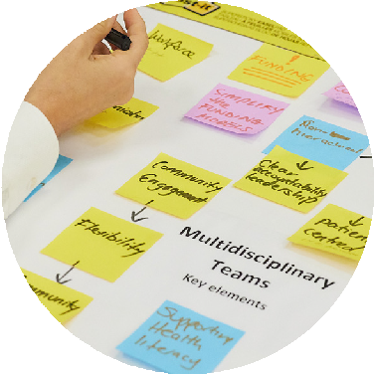
7 Ngayubah Gadan Consensus Statement

This process along with table discussions enabled stakeholders to consider and articulate the fundamental elements of the RRMHT model and what was necessary to include in a consensus statement. Discussions on the first day of the Summit guided the initial drafting of the Statement. On day two the draft was reviewed and further developed by Summit attendees. At the close
of the Summit, it was agreed by participants the draft Statement was ready for wider consultation (described further in Appendix A) to a broader rural and remote stakeholder base of more than 180 stakeholders and organisations.
Following the Summit (round 1), the Ngayubah Gadan Consensus Statement was further refined over three rounds of stakeholder consultation.
This process followed the Delphi methodology commonly applied in health science which acknowledges the opinions of a group of experts or people is more valid, valuable and robust than any one individual’s opinion.16 The multi-staged feedback approach supported participants
to continue to refine the content in detail and allowed the facilitator, the Office of the National Rural Health Commissioner, to consider all feedback as the Statement developed.17 The process supported participants to shape the Statement to its final version.
The final version of the Consensus Statement was then circulated to stakeholders for final endorsement. National and jurisdictional government representatives (inc Primary Health Networks (PHNs)) were not asked to endorse the Statement however they provided high value feedback throughout the consultation. Endorsing organisations are included on page 6.

Why we need a Consensus Statement describing Rural and Remote Multidisciplinary Health Teams
Access to high quality care when it is needed is a key factor in effective disease prevention,
d
e
management of chronic disease and in improving health outcomes.18 In Australia, rural and remote people experience increased difficulty in accessing timely care and as a result, often
a
n
S
u
m
m
i
t
a
t
t
e
n
have poorer health outcomes than people living in metropolitan areas.19
a
y
u
a
d
Rural and remote communities want local and connected health care professionals with whom they can build connections and trust. Neither
fly-in fly-out services or a rotating cycle of locums are considered optimal by communities.
Local determination of health services and co-design of models of care with community ensures appropriateness, acceptability20 and suitability of a service.21 Rural and remote
people deserve high quality health care and are calling for service delivery that is co-designed with community, close to home that provides continuity of care by known carers.
To begin to address current rural and remote health inequities, fit for purpose and locally designed rural and remote models of care with structured support for the health professionals who work within them is imperative. The Rural and Remote Multidisciplinary Health Team model provides the foundation to do this.
Rural and remote health professionals often already work in multidisciplinary teams.
Working in these teams reduces professional isolation and strengthens the support for and connections between individual clinicians. Rural and remote health services are reliant upon strong multidisciplinary team work to optimise the efficiency and effectiveness of the existing workforce, but to date, scant attention has been paid in literature to what a rural and remote multidisciplinary team is, how it functions and what enables this model to thrive. As such, there is no definition or shared agreement of what a RRMHT is in the Australian context. The Statement intends to address this by providing a clear and agreed definition of the RRMHT
and the enablers that support sustainable high functioning teams to deliver high quality care to rural and remote communities.
e
s


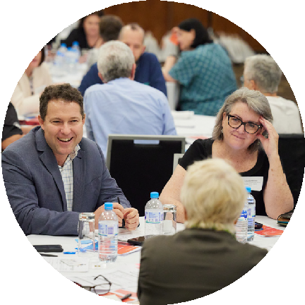
8 Ngayubah Gadan Consensus Statement
N
g
b
a
h
G





The Ngayubah Gadan Consensus Statement
The Ngayubah Gadan Consensus Statement (the Statement) defines ‘Rural and Remote Multidisciplinary Health Teams’ (RRMHT) within the contemporary Australian context. The Statement recognises the contribution of the health workforce in meeting the unique health needs in rural and remote communities.22 23 This Statement is a unified call from rural and remote health stakeholders to support, fund and enable Rural and Remote Multidisciplinary Health Teams to deliver high quality care to the communities they serve.
This Statement can assist policy makers, fundholders, workforce planners, service providers, clinicians and communities and describes the key elements of rural and remote multidisciplinary health teams.
The Statement also describes the system and service enablers in policy and funding, organisational, team and community contexts required to form and support sustainable high functioning teams.
The Statement primarily applies to rural and remote communities and health workforces located in regions classified as Modified Monash Model (MMM) 3 to 7 (further described in the Glossary).
It is important to note that due to increased remoteness, remote and very remote models of care often require unique consideration, design and application that differ to models of care designed for rural communities.24 For this reason, both ‘rural’ and ‘remote’ are referred throughout this Statement.

9 Ngayubah Gadan Consensus Statement

Identifying and eliminating racism, and delivering culturally responsive and safe workplaces and care
Making all health services culturally safe and responsive and free from racism is essential to improving health outcomes for Aboriginal and Torres Strait Islander people and communities and improves overall quality of health provision for all who receive care.25 26 27
Signatories to the Statement commit to and recognise that it is the responsibility of all rural and remote health services and stakeholders to provide environments free from racism.
An essential element in effectively designing, implementing and delivering high quality rural and remote primary health care is ensuring Aboriginal and Torres Strait Islander people, communities and organisations are represented in leadership roles, as fundholders, in policy development, organisational leadership,
co-design, community representation and working in rural and remote multidisciplinary teams.28 This is integral to the delivery of
high-quality care and provides cultural expertise, local community context, deepens trust and improves health outcomes.29
All health service providers have the responsibility to provide culturally safe and responsive workplaces and environments for workers and community. Providing culturally safe and responsive care is particularly important in rural and remote health where, as remoteness of residence increases so does the proportion of Aboriginal and Torres
Strait Islander people. It is important to note and address that Aboriginal and Torres Strait Islander people in remote Australia have some of the poorest health access and outcomes
in the country.30
Any activity related to rural and remote health policy, service delivery, policy development and workforce and organisational planning should be guided by strategies including (but not exclusive to) the National Agreement on Closing the Gap and 2023 Commonwealth Closing the Gap Implementation Plan, the National Aboriginal and Torres Strait Islander Health Plan 2013–2023 and Aboriginal and Torres Strait Islander Health Workforce Strategic Framework and Implementation Plan
2021-2031 and the Office of the National Rural Health Commissioner’s Position Statement: Impacts of racism on the health and wellbeing of Indigenous Australians.
Any strategy, workforce plan or model of care for Aboriginal and Torres Strait Islander communities must be contextualised, developed and implemented around the self- determination of Aboriginal and Torres Strait Islander communities with acknowledgement of the unceded sovereignty of Aboriginal and Torres Strait Islander peoples. Workforce development is about nation building; community consultation is about co-design/
development and ensuring there is meaningful transparency and accountability throughout such processes. In addition to a strong focus on addressing racism and the application of Cultural Safety, investments must favour place- based, relational-centred nation-building work programs to effect substantive change.

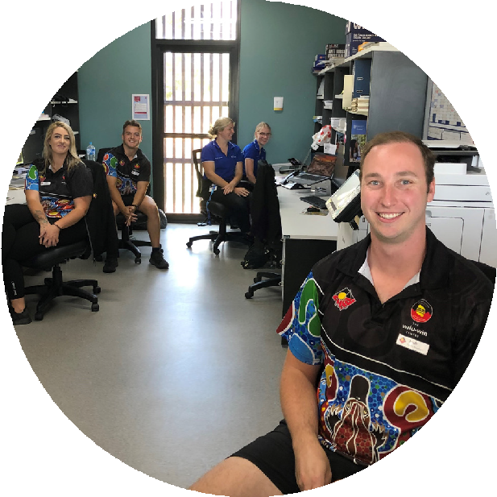
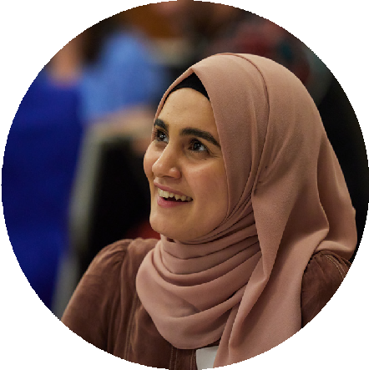
r
a
N
n
g
g
e
a
A
y
u
b
b
o
r
a
i
g
h
i
n
a
l
G
M
a
e
d
d
a
i
c
n
a
l
S
S
e
u
r
v
i
m
c
e
m
i
t
a
t
t
e
n
d
e
e
s
S
t
a
ff
a
t
O
10 Ngayubah Gadan Consensus Statement

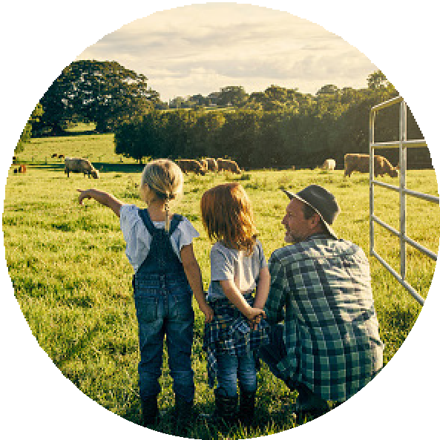

Defining Rural and Remote Multidisciplinary Health Teams
Patient care, and specifically rural and remote patient care, is most effective when managed within place-based, multidisciplinary models of care with teams working together.31 32
RRMHTs comprise health professionals, practitioners, rural generalists, workers and students, including but not limited to health disciplines such as nursing, medicine, allied health, Aboriginal and Torres Strait Islander Health Workers and Practitioners, dental, psychology, pharmacy, midwifery, nurse practitioners, paramedicine and assistant workers such as dental assistants, allied health assistants and physician assistants. Importantly, RRMHTs include non-clinical members such as administrative workers, information technology (IT) workers, community leaders and volunteers.
The core RRMHT is locally based and the composition is determined according to the best possible place based care to meet the health needs of the specific community.
RRMHT members may be employed in different public, private and not for profit health services (forming clinical networks33) and are supported by their organisations to work together to provide the best possible primary health care.
RRMHTs and tertiary care services regularly work together as a result of the need for emergency care, planned hospital care, or to support patients following discharge from a hospital admission. Strong connections between key staff in the tertiary system and RRMHTs, whether

through membership of the RRMHT, or through service level agreements supports better patient outcomes.
The RRMHT may call on outside expertise from visiting or virtually accessible health professionals, including non-General Practice specialists when required.
The RRMHT is closely connected to the communities they serve, working collaboratively to design, improve and deliver appropriate, affordable and accessible models of care
that meet the health and wellbeing needs of the community.
With clearly defined roles, professional autonomy, and communication processes the RRMHT works together to provide high quality, holistic person-centred care to their patients and their community.

The benefits of Rural and Remote Multidisciplinary Health Teams
RRMHTs improve attraction to and retention in rural and remote practice by reducing
professional isolation and burnout.34 35 Drawing together RRMHTs of health professionals and support staff creates capacity for team members to undertake additional roles in education and training, teaching/supervision, telehealth and multi-site practice. 36 37
RRMHTs provide members opportunities in leadership roles, career development and advancement (including advanced clinical practice, managerial, educational and research opportunities) and thereby increase job satisfaction.

11 Ngayubah Gadan Consensus Statement

RRMHTs provide supportive, culturally responsive and safe environments for early career health professionals and increase the potential for local interprofessional education, supervision and succession.
RRMHT models of care provide stimulating jobs, give collegial autonomy to the role, prioritise cultural safety, enable continuity of care and include the patient, carers and all team members in decision-making.38 39
Rural and Remote Multidisciplinary Health Teams have the capacity to be scaled up in times of seasonal tourist migration, natural disasters or other events such as pandemics to support additional health and wellbeing needs including mental health and trauma informed care in rural and remote communities.
RRHMTs ensure a critical mass of health practitioners, professionals and workers to support sustainable on-call demands and a social infrastructure to support team well-being. This needs to be embraced to ensure the health, safety and wellbeing of all rural and remote communities.

System and service enablers to establish and sustain RRMHTs
Primary care multidisciplinary team designs vary across practices, shaped in part by contextual factors perceived as barriers outside of the practices’ control. Facilitating factors within practices (Organisational) provide a culture of support to team members, but they are insufficient to overcome the perceived barriers. Government or organisational policies should avoid one-size- fits-all approaches to multidisciplinary care teams, and instead allow primary care practices to adapt to their specific contextual circumstances.40
There are four key contextual areas that impact the effectiveness and sustainability of RRMHTs and the delivery of high-quality care.
They are as follows:
- Policy and Funding Context
- Organisational Context
- Multidisciplinary Team Context
- Person and Community Context
P
o
r
m
p
u
r
a
a
w
C
o
m
m
u
n
it
y
J
u
s
t
ic
e
C

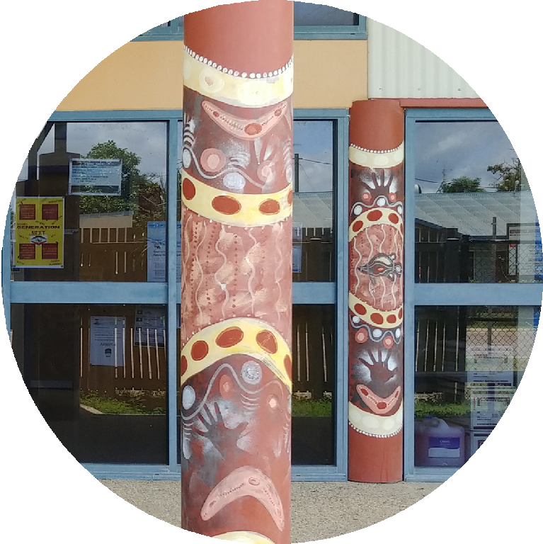
e
n
t
r
e

12 Ngayubah Gadan Consensus Statement


1
2

Policy and Funding Context
Policy development relevant to rural and remote workforce and care models should be based on the foundation that rural and remote communities warrant and deserve the same high standards
of access to healthcare as any other Australian community. While rural and remote models of care may take different forms to those in major cities, they should be designed, implemented, and funded to provide an acceptable level of access to continuous, local, primary health care along with appropriate access to emergency, secondary and tertiary care.
National and jurisdictional health training, workforce and funding policies can enable or hinder the formation and sustainability of RRMHTs and the delivery of high-quality person-centred rural and remote care. To ensure the health needs of rural and remote people and communities are identified and addressed, national, jurisdictional and local health policy must be appropriate for rural and remote settings and fully reflect the context of
the local workforce, person and community. For this to occur, health policy makers must ensure rural and remote health stakeholders and local representatives from across all professional streams, are genuinely consulted throughout the policy cycle. Rural and remote policies need to build in flexibility, be adaptable to local rural and remote settings, and avoid one size fits all, rural and remote health ‘solutions’. They require regional collaborative governance models with authority and autonomy and clear accountabilities. Simply adapting policy originally designed by and for high- density populations in metropolitan settings does not necessarily deliver high quality health services to rural and remote people and communities.
To be effective, rural and remote health policy design and implementation must be
co-designed with, have shared decision making and be developed in close, on-going and genuine consultation with rural and remote health workforces, services and communities.

Organisational Context (Clinical Networks)
Organisational culture and role clarity are determinants of multidisciplinary team effectiveness.41 42 Rural and remote
multidisciplinary health teams can comprise health professionals and workers who are employed across different sectors and organisations, in what is referred to as ‘clinical networks’.43 For this reason, agreed terms of working relationships
and /or agreements such as memorandums of understanding and service level agreements between providers help to give clarity to the way RRMHTs operate. These agreements systemise and provide operational guidance such as IT and data management, facility and infrastructure usage, team structure, wellbeing
and development, conflict resolution processes, procedures for recognising, responding to the harm perpetrated by racism, holding racist behaviours, policies and practices to account, and providing culturally safe and responsive care.
Agreed terms of working also provide structural and operational guidance regarding the use of information technology, information sharing, recruitment, retention and succession planning, funding streams and clinical and cultural governance.

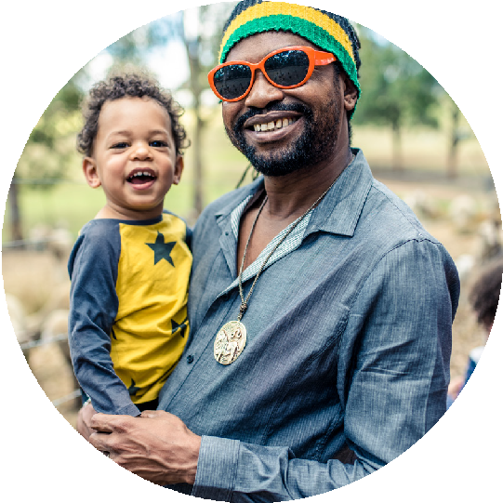

13 Ngayubah Gadan Consensus Statement

3
4

Multidisciplinary Team Context
Sustainable, high functioning and agile RRMHTs form when team members work effectively to their full scope of practice, employ their skills, knowledge and experience, value diversity and commit to the delivery and provision of culturally safe and responsive practice.
Understanding the common purpose, clinical and cultural governance structures and goals, contributes to team cohesion.
To further facilitate team cohesion, operational processes and should clearly document
and consistently describe expectations and functions including (but not exclusive to):
- leadership and decision making
- role clarity and communication case conferencing and continuity of patient care
- interdisciplinary training and education
- professional training, development, and supervision
- recognising and responding to the harm perpetrated by racism and holding racist behaviours, policies and practices to account.
Describing these functions helps to provide clarity and support effective team processes and communication. These key elements determine the ways of working and must be developed and agreed upon collaboratively by the teams and their organisations.
e
e
n
s
l
a
n
d
H
e
a
lt
h

Person and Community Context
To effectively deliver appropriate and high-quality care to rural and remote people and communities, RRMHTs must co-design with, be guided by,
and be responsive to the local community. The demographics and population health needs of a community must be well understood to ensure appropriate and effective models of care and health services are delivered.
For co-design to be successful, comprehensive representation of all in the community must
be achieved. Models of care must provide improved access (lower burden of cost of care, travel, be timely, and culturally safe and responsive to improve health outcomes).
Genuine and respectful community engagement will strongly influence models of care design, improving cultural appropriateness, safety and responsiveness. To increase the probability
of improved personal and population health outcomes models of care must be evaluated with communities.

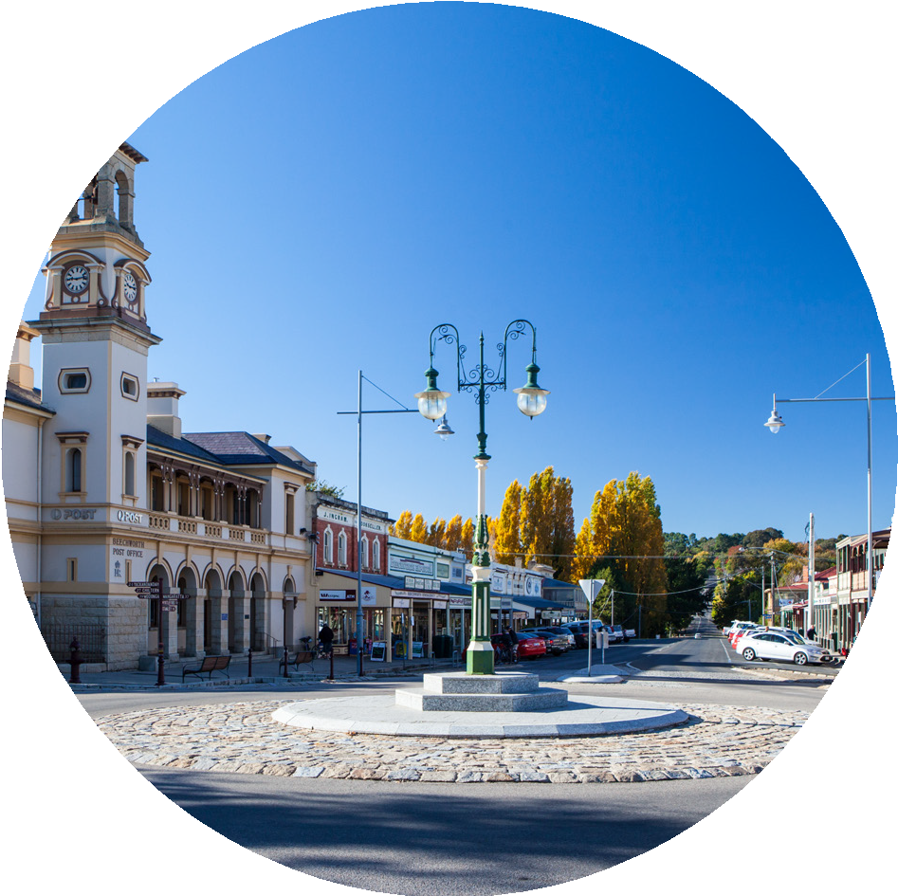
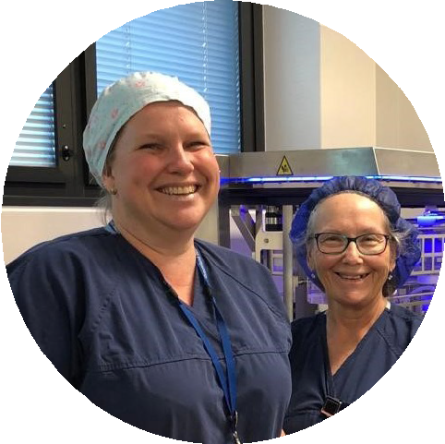
i
t
a
l,
Q
u

14 Ngayubah Gadan Consensus Statement
R
o
m
a
H
o
s
p


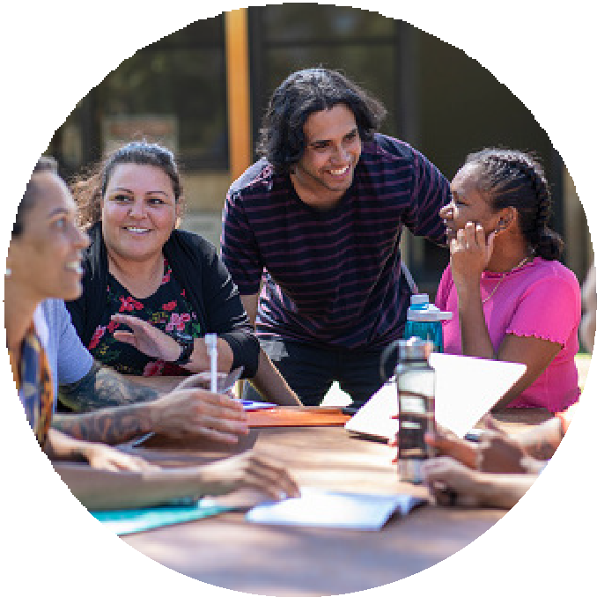
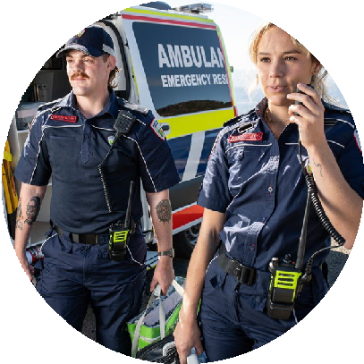
b
u
l
a
n
c
e
T
a
s
m
a
n
i
a
A

m

Concluding Statement
This is a critical time to raise awareness of the vital role that multidisciplinary teams play in high-quality health care delivery in rural and remote Australia.
The Ngayubah Gadan Consensus Statement is a declaration from the rural and remote health sector that the Rural and Remote Multidisciplinary Team model can improve health outcomes in rural and remote Australia.
The articulation of the model by Signatories who endorse the Ngayubah Gadan Consensus Statement provides a shared understanding of the integral elements of Rural and Remote Multidisciplinary Health Teams which make them critical in the efficient, equitable and effective delivery of health services.
The Statement has been developed to be used as a reference for policy makers, fundholders, workforce planners, service providers, clinicians and communities when considering the key elements and enablers required to establish and support high functioning sustainable rural and remote multidisciplinary health teams. It also provides an opportunity to listen to rural and remote communities and to respond with a model of health care that meets their needs, when they occur and in their communities.

15 Ngayubah Gadan Consensus Statement

Attachment A -

The Ngayubah Gadan Consultation Process

Consultation to develop the Statement was initiated at the Ngayubah Gadan Summit which constituted the first round of a comprehensive and iterative process. Rural and remote health stakeholders were presented various case studies of multidisciplinary teams operating in rural
and remote communities. This process along with table discussions enabled stakeholders to consider and articulate the fundamental elements of the RRMHT model and what was necessary to include in a consensus statement. Discussions on the first day of the Summit guided the initial drafting of the Statement. On day two the draft was reviewed and further developed by Summit attendees. At the close of the Summit, it was agreed by participants the draft Statement was ready for wider consultation to a broader rural and remote stakeholder base of more than 180 stakeholders and organisations.
The consultation process was guided by Delphi methodology commonly applied in health science, which acknowledges that the opinions of a group of experts or people is more valid, valuable and robust than any one individual’s opinion.44 The consultation incorporated the Delphi method of a multi-staged feedback approach,
to achieve consensus on how to best describe the key elements of high-functioning RRMHT in a
Statement.45 This approach supported participants to continue to refine the content in detail and allowed the facilitator, the Office of the National Rural Health Commissioner, to consider
all feedback as the Statement developed.46 The process supported participants to shape the Statement to its final version.
Following the Summit (round 1), it was agreed that in order to capture the Summit feedback whilst maintaining a relatively high-level Statement, a Guiding Paper would be drafted to describe in greater detail the elements and enablers of RRMHT.
The Ngayubah Gadan Guiding Paper (to be released in 2023) would be an accompanying document to the Ngayubah Gadan Consensus Statement.
t
h
g
a
t
Round 2 consultation was conducted virtually, circulating the Consensus Statement and the Guiding Paper (further referred to in this document as Consensus Statement for simplicity) to a broader group of rural and remote stakeholders for comment and feedback. Stakeholders were asked to share the Consensus Statement with their networks to broaden consultation reach.
Round 2 consultation included targeted questions for consideration, including formally naming multidisciplinary teams and defining the relevant rural and remote area classification using Modified Monash Model criteria. These questions were based on items for discussion during the Summit, where it was evident that further consideration was required to resolve them.
Including these questions allowed stakeholders to further consider their responses and to include in their round 2 feedback. Feedback was then incorporated into the Consensus Statement,
or in comments on the developing consensus statement document, so stakeholders could view deidentified feedback.
In September 2022, round 3 consultation opened, and the draft Consensus Statement and Guiding Paper incorporating round 2 feedback was circulated to stakeholders. Over round 2, 3 and 4 stakeholders provided comprehensive feedback and incorporated into draft Statement.
The Ngayubah Gadan Consensus Statement was circulated to stakeholders for final endorsement in April 2023. Please note
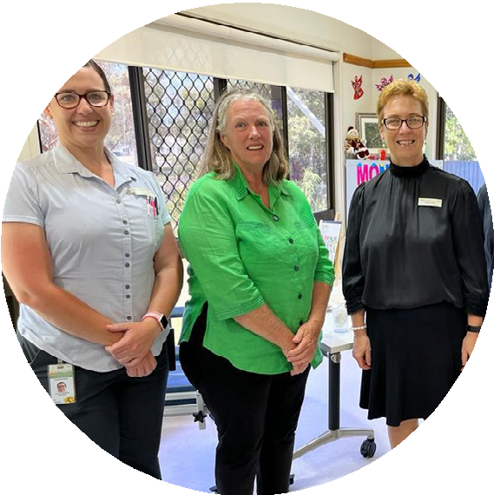
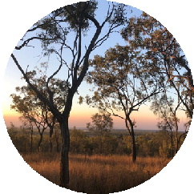
that national and jurisdictional government representatives (and PHNs) were not asked to endorse the Statement however they provided high value feedback throughout the consultation. Endorsing organisations are included on
pages 5 and 6.
u
r
p
o
s
e
H
e
a
l
t
h
S
e
r
v
i
c
e

16 Ngayubah Gadan Consensus Statement
R
u
S
t
e
w
a
r
t
S
t
a
f
f
a
t
A
u
h
e
l
l
a
M
u
l
t
i
p

Figure 1: Ngayubah Gadan Consensus Statement Logic Model

Rural and remote health outcomes are poorer than regional and urban health outcomes

Issue

Workforce maldistribution affects access to primary health care providers and/or inability to deliver cohesive multidisciplinary care

Challenges

Identified need for multidisciplinary teams with rural generalist expertise to meet rural population health needs, as one solution of many solutions needed to address problems

Solution

Ngayubah Gadan Summit and consultation held with key rural health stakeholders to discuss and develop a Consensus Statement and determine key needs across four areas/contexts

Tool/s

Consensus Statement
(co-developed with rural health stakeholder consensus and then publicised to support action needed)

Policy and Funding Context

Organisational Context

Team Context
Population / Community / Client Context

Describes stakeholders and levers with the national and jurisdictional policy environment who/that can enact and enable the formation and sustainability of RRMH teams

Describes stakeholders and levers within organisations (service providers) who/that can enact and enable the formation and sustainability of RRMH teams

Describes stakeholders and levers within teams, both health and non-health professional roles, who/that can enact and enable the formation and sustainability RRMH teams

Describes stakeholders and levers within communities who can determine the RRMH team services and outcomes they need and value





High-functioning, sustainable multidisciplinary teams operating

Improved rural health outcomes
(as defined locally with an engaged heallth service to support informed decisions and outcomes)

17 Ngayubah Gadan Consensus Statement

r
t

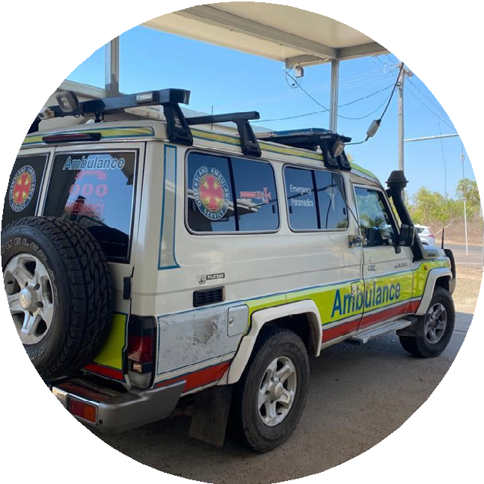
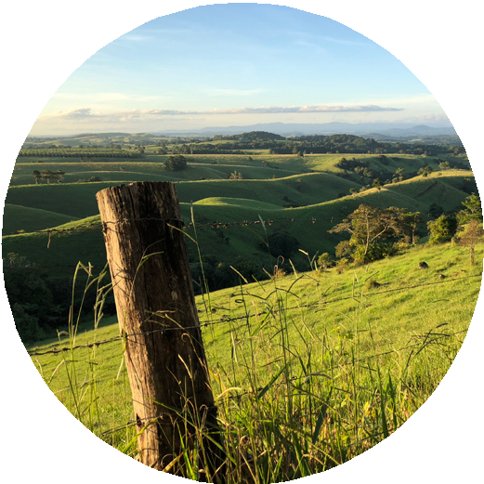
References
R
u
t
h
S
t
e
w
a
r
t
R
u
t
h
S
t
e
w
a
- Sekhon, M, Cartwright, M & Francis, JJ 2017, ‘Acceptability of healthcare interventions: an overview of reviews and development of a theoretical framework’, BMC Health Services Research, vol. 17, no. 88, pp. 1-13.
- Services for Australian Rural & Remote Allied Health 2016, SARRAH Position Statement on Allied Health Professions and Rural Generalism, Canberra, viewed 1 February 2023, <https://www. sarrah.org.au/our-work/policy-and-strategy/publications/149-sarrah-position-statement-on-allied- health-professions-and-rural-generalism>.
- Haines, M, Brown, B, Craig, J, D’Este, C, Elliott, E, Klineberg, E, McInnes, E, Middleton, S, Paul, C, Redman, S & Yano, EM 2012, ‘Determinants of successful clinical networks: the conceptual framework and study protocol’, Implementation Science, vol. 7, no. 1, pp. 1–10.
- Victorian Council of Social Service 2015, Walk alongside: Co-designing social initiatives with people experiencing vulnerabilities, VCOSS, Melbourne. [Adapted]
- Department of Health 2022, National Aboriginal and Torres Strait Islander health workforce strategic framework and implementation plan 2021–2031, Canberra, viewed 1 February 2023,
<https://www.health.gov.au/resources/publications/national-aboriginal-and-torres-strait-islander- health-workforce-strategic-framework-and-implementation-plan-2021-2031>.
- O’Toole, MT (ed.) 2022, Mosby’s dictionary of medicine, nursing & health professionals, 11th edn, St. Louis, Missouri, Elsevier.
- National Rural Generalist Pathway Taskforce 2018, Advice to the National Rural Health Commissioner on the Development of the National Rural Generalist Pathway, report, December, National Rural Health Commissioner, Canberra.
- Agency for Clinical Innovation 2013, Understanding the process to develop a model of care: an ACI framework, version 1.0, New South Wales Health, Chatswood, viewed 1 February 2023,
<https://aci.health.nsw.gov.au/make-it-happen/implementation-support>.
- Santana, MJ, Manalili, KM, Jolley, RJ, Zelinsky, S, Quan, H & Lu, M 2018, ‘How to practice person-centred care: a conceptual framework’, Health Expectations, vol. 21, no. 2, pp. 429-440.
- Department of Health 2022a, National Aboriginal and Torres Strait Islander health workforce strategic framework and implementation plan 2021–2031, Canberra, viewed 1 February 2023,
<https://www.health.gov.au/resources/publications/national-aboriginal-and-torres-strait-islander- health-workforce-strategic-framework-and-implementation-plan-2021-2031>.
- Department of Health 2022, Future focused primary health care: Australia’s primary health Care 10 Year Plan 2022-2032, Canberra, viewed 1 February 2023, <https://www.health.gov.au/resources/ publications/australias-primary-health-care-10-year-plan-2022-2032?language=en>.
- Australian Institute of Health and Welfare 2022, Rural and remote health, AIHW, Canberra, viewed 1 February 2023, <https://www.aihw.gov.au/reports/rural-remote-australians/rural-and-remote-health>
- Chief Nursing and Midwifery Officers Australia 2020, Advanced nursing practice - guidelines for the Australian context, Department of Health, Canberra, viewed 1 February 2023, <https://www.health. gov.au/resources/publications/advanced-nursing-practice-guidelines-for-the-australian-context>.
18 Ngayubah Gadan Consensus Statement

- Department of Health 2022, National Aboriginal and Torres Strait Islander health workforce strategic framework and implementation plan 2021–2031, Canberra, viewed 1 February 2023,
<https://www.health.gov.au/resources/publications/national-aboriginal-and-torres-strait-islander- health-workforce-strategic-framework-and-implementation-plan-2021-2031>.
- Humphreys, JS, Wakerman, J & Wells, R 2006, ‘What do we mean by sustainable rural health services? Implications for rural health research’, Australian Journal of Rural Health, vol. 14, no. 1,
pp. 33-35.
- Keeney, S, McKenna, H & Hasson, F 2011, The Delphi technique in nursing and health research, John Wiley & Sons, Chichester, West Sussex.
- Cataldi, S & Sena, B 2021, ‘Mixed-methods data collection in a study on interprofessional care: Interviews, a survey, and the Delphi technique’, in SAGE Research Methods Cases Part 1, SAGE Publications, London.
- Australian Health Ministers’ Advisory Council 2017, National Strategic Framework for Chronic Conditions, Department of Health, Canberra, viewed 1 February 2023, <https://www.health.gov.au/ resources/publications/national-strategic-framework-for-chronic-conditions?utm_source=health.gov. au&utm_medium=callout-auto-custom&utm_campaign=digital_transformation>.
- Australian Institute of Health and Welfare 2022, Rural and remote health, AIHW, Canberra, viewed 1 February 2023, <https://www.aihw.gov.au/reports/rural-remote-australians/rural-and-remote-health>.
- Sekhon, M, Cartwright, M & Francis, JJ 2017, ‘Acceptability of healthcare interventions: an overview of reviews and development of a theoretical framework’, BMC Health Services Research, vol. 17, no. 88, pp. 1-13.
- Levesque, JF, Harris, MF & Russell, G 2013, ‘Patient-centred access to health care: conceptualising access at the interface of health systems and populations’, International Journal for Equity in Health, vol. 12, no. 18, pp. 1-9.
- Schofield, D, Fuller, J, Wagner, S, Friis, L & Tyrell, B 2009, ‘Multidisciplinary management of complex care’, Australian Journal of Rural Health, vol. 17, no. 1, pp. 45-48.
- Wakerman, J 2009, ‘Innovative rural and remote primary health care models: what do we know and what are the research priorities?’, Australian Journal of Rural Health, vol. 17, no. 1, pp. 21-26.
- Wakerman, J, Bourke, L, Humphreys, J & Taylor, J 2017, ‘Is remote health different to rural health?’, Rural and Remote Health, vol. 17, no. 2.
- Ware, V-A 2013, Improving the accessibility of health services in urban and regional settings for Indigenous people, Resource sheet no. 27. Cat. no. IHW 114, Australian Institute of Health and Welfare and Australian Institute of Family Studies, Canberra.
- Thurber, KA, Walker, J, Batterham, PJ, Gee, GC, Chapman, J, Priest, N, Cohen, R, Jones, R, Richardson, A, Calear, AL, Williams, DR & Lovett, R 2021, ‘Developing and validating measures of self-reported everyday and healthcare discrimination for Aboriginal and Torres Strait Islander adults’, International Journal for Equity in Health vol. 20, no. 1, p. 14.
- Panaretto, KS, Wenitong, M, Button, S & Ring, I 2014, ‘Aboriginal community controlled health services: leading the way in primary care’, Medical Journal of Australia vol. 200, no. 11, pp. 649-52.
- Butler, T, Gall, A, Garvey, G, Ngampromwongse, K, Hector, D, Turnbull, S, Lucas, K, Nehill, C,
Boltong, A, Keefe, D & Anderson, K 2022, ‘A comprehensive review of optimal approaches
to co-design in health with First Nations Australians’, International Journal of Environmental Research and Public Health, vol. 19, no. 23, p. 16166.
- Gwynne, K & Lincoln, M 2017, ‘Developing the rural health workforce to improve Australian Aboriginal and Torres Strait Islander health outcomes: a systematic review’, Australian Health Review, vol. 41, no. 2, pp. 234-238.

19 Ngayubah Gadan Consensus Statement

- ustralian Institute of Health and Welfare 2022, Indigenous health and wellbeing, Australian Institute of Health and Welfare, Canberra, viewed 1 February 2023, <https://www.aihw.gov.au/reports/ australias-health/indigenous-health-and-wellbeing>.
- Bidwell, S & Copeland, A 2017, ‘A model of multidisciplinary professional development for health professionals in rural Canterbury, New Zealand’, Journal of Primary Health Care, vol. 9, no. 4, pp. 292-296.
- Harris, MF, Zwar, NA, Walker, CF and Knight, SM 2011, ‘Strategic approaches to the development of Australia’s future primary care workforce’, Medical Journal of Australia, vol. 194, no. 11, pp.
S88-S91.
- Organisation for Economic Cooperation and Development 2021, Delivering quality education and health care to all: Preparing regions for demographic change, report, OECD Publishing, Paris, viewed 1 February 2023, <https://www.oecd-ilibrary.org/urban-rural-and-regional-development/ delivering-quality-education-and-health-care-to-all_83025c02-en>.
- Willard-Grace, R, Hessler, D, Rogers, E, Dubé, K, Bodenheimer, T & Grumbach, K 2014, ‘Team structure and culture are associated with lower burnout in primary care’, Journal of the American Board of Family Medicine, vol. 27, no. 2, pp. 229–38.
- Willard-Grace R, Hessler D, Rogers E, Dubé K, Bodenheimer T, Grumbach K. Team structure and culture are associated with lower burnout in primary care. J. American Board Family Med. 2014;27:229–38.
- Schofield, D, Fuller, J, Wagner, S, Friis, L & Tyrell, B 2009, ‘Multidisciplinary management of complex care’, Australian Journal of Rural Health, vol. 17, no. 1, pp. 45-48.
- Bidwell, S & Copeland, A 2017, ‘A model of multidisciplinary professional development for health professionals in rural Canterbury, New Zealand’, Journal of Primary Health Care, vol. 9, no. 4,
pp. 292-296.
- Schofield, D, Fuller, J, Wagner, S, Friis, L & Tyrell, B 2009, ‘Multidisciplinary management of complex care’, Australian Journal of Rural Health, vol. 17, no. 1, pp. 45-48.
- Perkins, D, Larsen, K, Lyle, D & Burns, P 2007, ‘Securing and retaining a mental health workforce in Far Western New South Wales’, Australian Journal of Rural Health, vol. 15, no. 2, pp. 94-98.
- Leach, B, Morgan, P, Strand de Oliveira, J, Hull, S, Østbye, T & Everett, C 2017, ‘Primary care multidisciplinary teams in practice: a qualitative study’, BMC Family Practice, vol. 18, no. 1, p. 115
- Lamb, BW, Taylor, C, Lamb, JN, Strickland, SL, Vincent, C, Green, JSA & Sevdalis, N 2013, ‘Facilitators and barriers to teamworking and patient centeredness in multidisciplinary cancer teams: findings of a national study’, Annals of Surgical Oncology, vol. 20, no. 5, pp. 1408-1416.
- JJain, AK, Thompson, JM, Chaudry, J, McKenzie, S & Schwartz, RW 2008, ‘High-performance teams for current and future physician leaders: an introduction’, Journal of Surgical Education, vol. 65, no. 2, pp.145-50.
- McInnes, E, Haines, M, Dominello, A, Kalucy, D, Jammali-Blasi, A, Middleton, S & Klineberg, E 2015, ‘What are the reasons for clinical network success? A qualitative study’, BMC Health Services Research, vol. 15, no. 1, p. 49
- Keeney, S, McKenna, H & Hasson, F 2011, The Delphi technique in nursing and health research, John Wiley & Sons, Chichester, West Sussex.
- Keeney, S, McKenna, H & Hasson, F 2011, The Delphi technique in nursing and health research, John Wiley & Sons, Chichester, West Sussex
- Cataldi, S & Sena, B 2021, ‘Mixed-methods data collection in a study on interprofessional care: Interviews, a survey, and the Delphi technique’, in SAGE Research Methods Cases
Part 1, SAGE Publications, London.

20 Ngayubah Gadan Consensus Statement

© Commonwealth of Australia as represented by the Australian Government Department of Health, 2023
Apart from uses permitted by the Copyright Act 1968 and this copyright notice, all other rights (including all commercial rights) are expressly reserved.
Permitted uses
You may download, display, print, and reproduce the whole or part of this publication in unaltered form for:
- your own personal use;
- use within your organisation; or
- distribution and sharing with third parties, but only if:
- you or your organisation do not use or reproduce the publication for any commercial purpose; and
- if reproduced, this copyright notice and all disclaimer notices are included as part of any reproduction.
This licence does not cover, and there is no permission given for, use of the Commonwealth Coat of Arms or any logos and trademarks (including the logo of the Australian Government Department of Health).
Disclaimer
This publication has been produced independently by Australian Healthcare Associates at the request of the Australian Government Department of Health.
The Australian Government accepts no responsibility for material contained in the publication. The views or recommendations expressed in this publication may include the views or recommendations of third parties and do not necessarily reflect those of the Australian Government or indicate a commitment to a particular course of action.
Providing access to the publication does not constitute an endorsement, approval or recommendation by the Australian Government of any organisation, association, entity, service, program, products or research offered by virtue of any information, material or content within the publication.
The information in this publication is provided on the basis that all persons accessing it undertake responsibility for assessing the relevance and accuracy of its content.
21 Ngayubah Gadan Consensus Statement




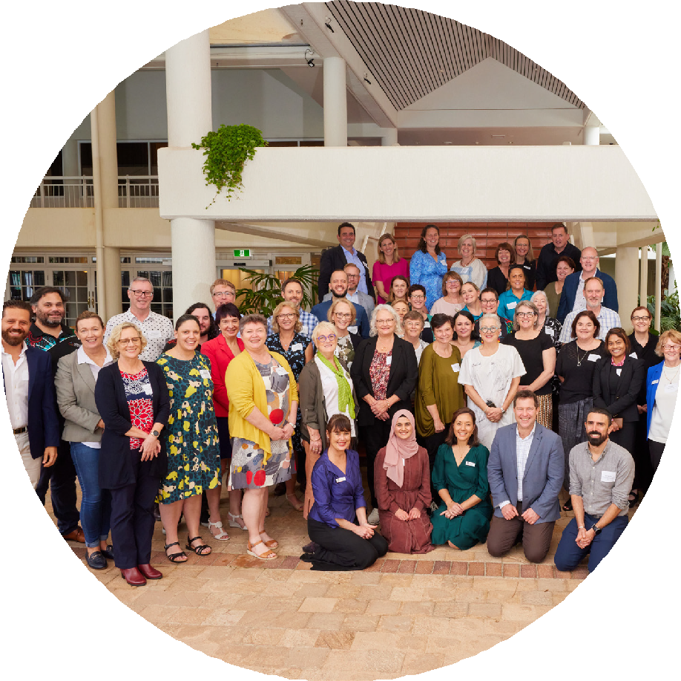

At
t
e
n
d
e
e
s
N
g
a
y
u
b
a
h
G
a
d
a
n
S
u
m
m
it

For more information visit:
health.gov.au/our-work/onrhc

