National Strategy for Health Practitioner Pain Management Education



The National Strategy for Health Practitioner Pain Management Education project was funded through an Australian Government grant and developed by the Faculty of Pain Medicine, Australian and New Zealand College of Anaesthetists.



ANZCA acknowledges the traditional custodians of Country throughout Australia and recognises their unique cultural and spiritual relationships to the land, waters and seas and their rich contribution to society. We pay our respects to ancestors and Elders, past, present and emerging.

ANZCA acknowledges and respects ngā iwi Māori as the Tangata Whenua of Aotearoa and is committed to upholding the principles of the Treaty of Waitangi, fostering the college’s relationship with Māori, supporting Māori fellows and trainees, and striving to improve the health of Māori.

Copyright © 2023 by the Australian and New Zealand College of Anaesthetists.

All rights reserved. None of the contents of this publication may be reproduced, stored in a retrieval system or transmitted in any form, by any means without the prior written permission of the publisher.

Foreword

Pain is a universal human experience, but pain that persists beyond the healing time of an injury or disease is one of the major public health

problems facing Australians. Around one in five of us will suffer persistent pain at some point in our life.

It has never been more urgent, given the complexity of medical care and burgeoning knowledge about the complexities of chronic pain, for health practitioners to be educated in the most effective and up-to-date ways to assess and treat people with these problems.

The *National Strategic Action Plan for Pain Management* recognised this significant issue and this health practitioner education strategy is one of the first tangible outcomes of the implementation phase of the Action Plan.

The Faculty of Pain Medicine of the Australian and New Zealand College of Anaesthetists was uniquely placed to deliver this strategy. Founded in 1998, the Faculty is a unique institution, with a dedication and expertise in pain management education that is broad and deep.

Work on this strategy commenced in June 2020 and, despite the challenges of lockdowns and travel restrictions, a very comprehensive cross-section of stakeholders was actively engaged, their feedback listened to, and outcomes used to shape the final strategy.

On behalf of the Faculty of Pain Medicine, I would like to thank the project team for their enormous effort in developing this comprehensive plan for improving health practitioner pain management education. In years to come I hope it will be seen as the beginning of the end of the era where health practitioners of all disciplines feel unprepared for managing and assessing patients with persistent pain.

I would like to thank the Federal Department of Health for commissioning this *National Strategy for Health Practitioner Pain Management Education*, thereby progressing the implementation of an important aspect of the *National Strategic Action Plan for Pain Management*. I look forward to welcoming the widespread adoption of the recommendations of this strategic roadmap for the betterment of the health and wellbeing of the Australian people.

Sincerely,

Associate Professor Michael Vagg Immediate Past Dean

Faculty of Pain Medicine

Australian & New Zealand College of Anaesthetists

Contents

Overview 10

The burden and impact of pain 17

People living in rural, regional and remote communities 22

Older Australians 23

Children and adolescents 23

Aboriginal and Torres Strait Islander peoples 24

Culturally and linguistically diverse (cald) populations 27

People living with disability 28

Impact on the person living with pain 28

Pain and comorbidities 28

Cost of pain in the community 32

Current healthcare environment – adequacy of meeting needs 33

Pain education for health practitioners 38

International context 39

Australian context 41

A national strategy for health practitioner pain management education 45

Values 55

Principles 56

Goals 63

Implementation plan 67

Conclusion 78

Reference list 81

APPENDIX 1: Australian health strategies and action plans 100

APPENDIX 2: Literature review 103

APPENDIX 3: Stakeholder list 105

APPENDIX 4: Project team 109

### LIST OF TABLES & FIGURES

Figure 1: The International Association for the Study of Pain definition of pain(1) 9

Figure 2: Health practitioners’ education and career continuum 12

Figure 3: The International Association for the Study of Pain definition of chronic pain(13) 18

Figure 4: Prevalence of pain in the Australian population(29) 20

Figure 5: The International Association for the Study of Pain definition of acute pain (13) 21

Figure 6: Factors associated with health inequities in rural, regional and remote Australia (36) 22

Figure 7: Prevalence rates and types of pain in children(53) 24

Figure 8: Racial discrimination experiences of Aboriginal and Torres Strait Islander peoples(60) 26

Figure 9: Proportion of Australia’s population born overseas compared with born in Australia(64) 27

Figure 10: Comorbidities affecting people living with chronic pain compared with those without chronic pain(39) 29

Figure 11: Unintentional drug-related deaths in Australia in 2019(108) 31

Figure 12: The cost of pain in Australia in 2018(33) 32

Table 1: Health practitioner disciplines engaged in the strategy consultation 47

Figure 13: The iterative consultation process 51

Figure 14: Distribution of participants by discipline 52

Figure 15: Distribution of participants by location 52

Figure 16: Literature search strategy 103

Table 2: Breakdown of peer-reviewed and grey literature sources for the four core themes 104

Glossary

Aboriginal and/or Torres Strait Islander person: A person of Aboriginal and/or Torres Strait Islander descent who identifies as an Aboriginal and/or Torres Strait Islander.

Best practice: Best practice is more than practice based on evidence. It represents quality care which is deemed optimal.

Biopsychosocial: A model reflecting the development of illness through the complex interaction of biological factors, psychological factors and social factors.

Community engagement: Working with individuals and communities to establish education solutions for pain management challenges.

Competency framework: An established set of knowledge, skills and professional behaviours recognised as essential for effective pain management.

Continuing professional development: Education for health practitioners to maintain, improve and broaden their knowledge, skills and professional behaviours relevant to their area of practice.

Culturally and linguistically diverse communities: Broad term used to describe communities with diverse languages, ethnic backgrounds, nationalities, traditions, societal structures and religions.

Cultural safety: “Cultural safety is about creating an environment that is safe for Aboriginal and Torres Strait Islander people. This means there is no assault, challenge or denial of their identity and experience. Cultural safety is about: Shared respect, shared meaning and shared knowledge.” (Department of Health, Victoria).

Entry-to-practice: The term ‘entry-to-practice’ covers a broad range of education that may be undertaken prior to an individual entering their area of clinical practice.

Evidence-based: The principle that discipline-specific practices should be based on the best available scientific evidence, rather than tradition, personal judgement, or other influences.

Health: The World Health Organization (WHO) defines health as a state of complete physical, mental and social well-being and not merely the absence of disease or infirmity.

Health practitioner/professional: Any individual who practices a health profession.

Hospitalisation: An episode of hospital care that starts with the formal admission process and ends with the formal separation process.

Industry reference group: An advisory body of health practitioners recognised as having expertise in pain and clinical pain management to provide a healthcare industry perspective.

Interdisciplinary: Denotes that a variety of disciplines are coordinated toward a common and coherent approach in the care of persons living with pain.

Interprofessional learning: When two or more professions learn with, about, and from each other to enable effective collaboration and improve health outcomes.

Iterative consultation: Multiple independent group discussions aimed at generating themes to inform the build, refinement and improvement of goals, principles and action plan.

Learner-centred: When the learner is placed at the centre of learning as an active participant, putting their interests first and recognising that the learner brings their own knowledge, past experiences, education, and ideas to the learning opportunity.

Medicare: A national, government-funded scheme that subsidises the cost of personal medical services for all Australians and aims to help them afford medical care.

Multidisciplinary: Denotes the additive engagement of multiple health practitioners who stay within the boundaries of their fields in providing pain care for persons living with pain.

Partnership: A voluntary agreement between two or more partners to work cooperatively toward a set of shared health outcomes. Partners may include consumers, carers and their communities, health practitioners, learners, educators, educational organisations and/or regulators.

Pharmaceutical Benefits Scheme (PBS): A national, government-funded scheme that subsidises the cost of a wide variety of pharmaceutical drugs, covering all Australians, to help them afford medicines.

Postgraduate education: A period of advanced study undertaken after successful completion of an undergraduate degree level course at a college or university.

Specialist education: A period of advanced vocational education and training in a recognised training program to attain fellowship of an Australian specialist college.

Telemedicine: The remote delivery of health care services, such as health assessments or consultations, over the telecommunications infrastructure.

The International Association for the Study of Pain (IASP): An international learned society promoting research, education, and policies for the understanding, prevention and treatment of pain.

# With gratitude

The Faculty of Pain Medicine acknowledges the valuable input of the many individuals and

organisations that took part in workshops, roundtable discussions, and meetings to shape this strategy.

We would also like to express our sincere appreciation to those individuals who shared their lived experience of pain with us so that we may learn from them.

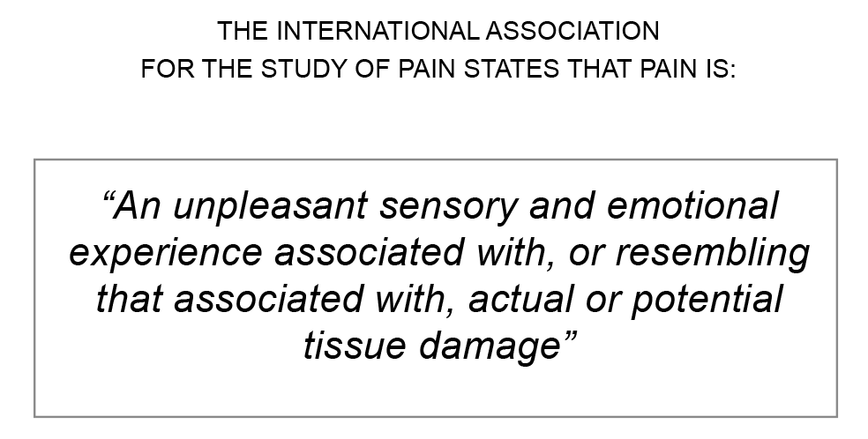

and is expanded upon by the addition of six key notes:

* Pain is always a personal experience that is influenced to varying degrees by biological, psychological, and social factors.
* Pain and nociception are different phenomena. Pain cannot be inferred solely from activity in sensory neurons.
* Through their life experiences, individuals learn the concept of pain.
* A person’s report of an experience as pain should be respected.
* Although pain usually serves an adaptive role, it may have adverse effects on function and social and psychological wellbeing.
* Verbal description is only one of several behaviours to express pain; inability to communicate does not negate the possibility that a human or a nonhuman animal experiences pain.(1)

Figure 1: The International Association for the Study of Pain definition of pain(1)

Overview

The burden of pain in our society has reached crisis point and carries with it high social and economic costs. Despite these factors, many health practitioners have a poor understanding of pain and contemporary management options (2). It is estimated that up to 80 per cent of Australians living with chronic pain may be missing out on best-practice treatments (3). This situation highlights a critical need for improving the knowledge, skills and practice of health practitioners caring for individuals living with pain.

In 2019 the ‘need to improve the pain management-related knowledge and skills of health practitioners’ was identified as a key priority within the National Strategic Action Plan for Pain Management (2).

In 2020 the Australian government demonstrated its commitment to this priority by funding the Faculty of Pain Medicine (FPM), Australian and New Zealand College of Anaesthetists (ANZCA), to develop a national strategic roadmap for health practitioner pain management education.

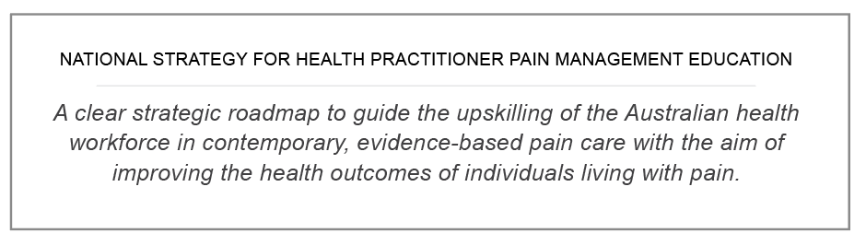The National Strategy for Health Practitioner Pain Management Education provides a blueprint for the future of pain education over the next five to 10 years with its underpinning values, principles, goals and detailed implementation plan. It articulates not only ‘what’ needs to be achieved, but ‘how’ we can achieve the desired goals in the most effective and resource-efficient way, to ensure a meaningful and positive impact for those in the community living with pain.

This strategy should be considered in conjunction with other sector-specific health strategies and broader health workforce plans that include workforce upskilling (Refer to Appendix 1: Australian health strategies and action plans).

## AIM

The overarching aim of the *National Strategy for Health Practitioner Pain Management Education* is that health practitioners receive high quality, evidence-based, contextually relevant and timely education throughout their career-span to support the delivery of best-practice care for individuals living with pain in our community.

## SCOPE

This strategy targets the learning needs of a broad range of key health practitioners (registered, self-regulated and unregulated) at critical points within their education and career continuum including: entry-to-practice programs (vocational and higher education), postgraduate and specialist education, and continuing professional development (Figure 2).

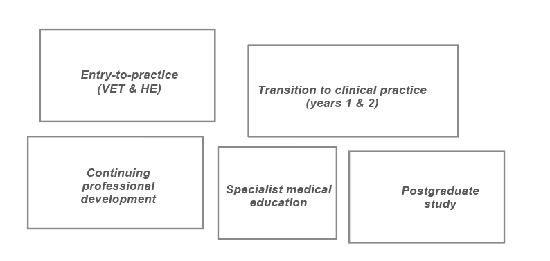Figure 2: Health practitioners’ education and career continuum

## STRATEGY DEVELOPMENT

At the outset of the project in 2020 an extensive environmental scan and literature review *(see Appendix 2*) were undertaken to provide a clear picture of the current state of pain management and the related education of health practitioners. The review provided a foundation on which to build the strategy.

A key strength of the strategy development process was the extensive stakeholder engagement undertaken.

Approximately 180 individuals and organisations from across Australia took part in a series of workshops, roundtable discussions and targeted meetings and the FPM team employed an iterative consultation process to ensure that initial concepts were able to emerge organically and then be further refined. This process established buy-in and set the foundation for partnerships and collaborations in relation to the future implementation of the strategy.

## OUTCOMES

The literature review clearly supported the urgent need for improved pain care and the lack of consistency in high quality pain-related education across health disciplines. Issues such as increasing waiting times for specialist pain care, lack of adequate access to services in rural, regional and remote regions, and emergence of long-COVID make this strategy all the more urgent and relevant.

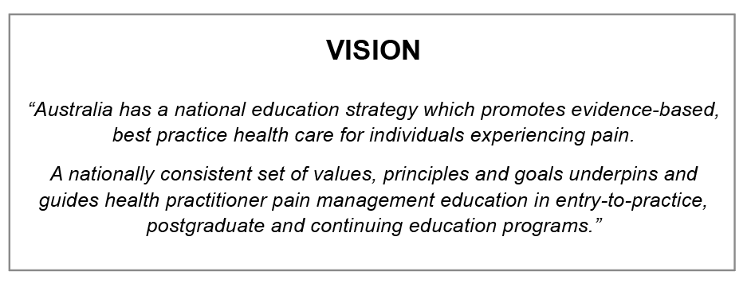Emerging from the iterative consultation process was a clear vision for health practitioner pain management education in Australia:

Stakeholders called for consistency and a ‘common language and understanding’ across health disciplines.

This common understanding will be supported by the set of shared values and principles developed and refined through the iterative consultation process:

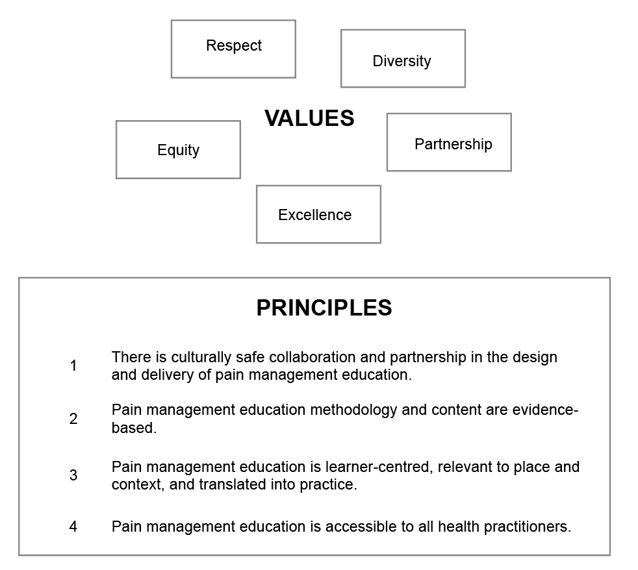

The principles are designed to guide those developing and implementing pain management education, to ensure initiatives are successful, address areas of need, and have maximum impact.

This strategy document unpacks each of the principles, shining a spotlight on issues emerging from the literature and stakeholder discussions, providing a way forward.

Implementation of the strategy has been prioritised through five key goals which form the basis of the strategy’s ‘implementation plan’.

While each goal can be viewed as a potentially stand-alone body of work, it is important to note that the success of goal four will be supported by goals one to three being in place. The need to progress goals one and two is therefore a priority if transformative change is to occur across the entry-to-practice space in a timely way. Fortunately, there is already a body of work emerging from the concurrent *Health Professional Pain Management Education and Training Project* (which has a resource-development focus), that will support the achievement of goal three. This project is discussed later.

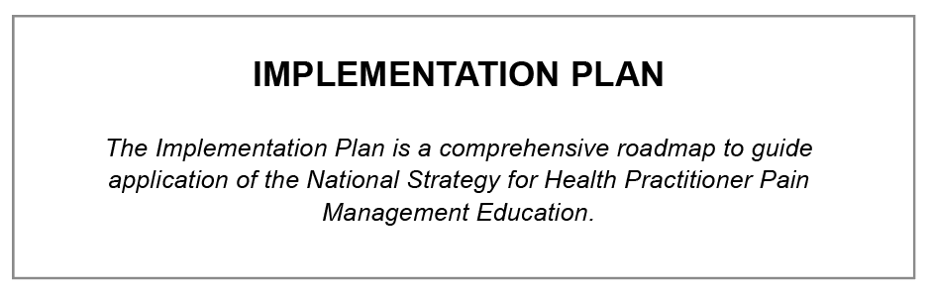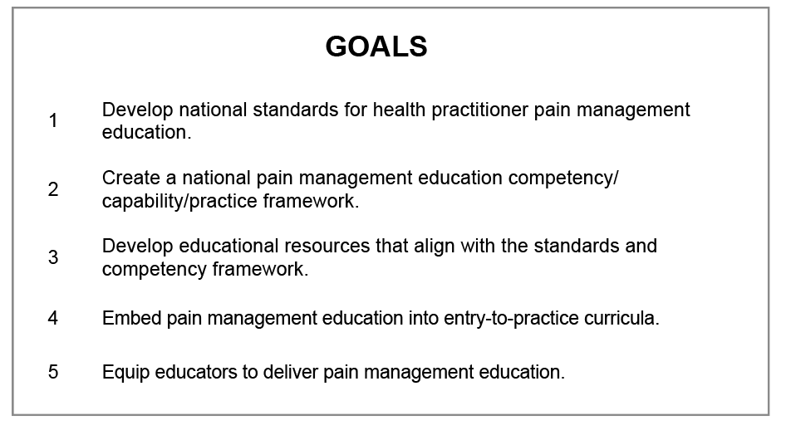To provide clear direction with regard to the recommended actions needed to achieve each of the goals, and to highlight key considerations, a detailed implementation plan has been developed.

The activities and considerations outlined in the implementation plan can be viewed on pages 46 - 51.

Key messages

Underpinning this national strategy is the strong belief in the power of education to effect change. Education initiatives that are: informed by consumers, grounded in best-practice, well-constructed and resourced, relevant to the context of care, accessible for all health workers, and facilitated by skilled educators have the power to change practice and improve health outcomes in the community.

The strategy supports the use of contemporary teaching and learning methods that are applied to practice, incorporate interprofessional dimensions, and are aimed at achieving optimum learning outcomes. Achieving systems-level outcomes that lead to deep and sustainable changes in the way in which health practitioners view, approach and manage pain, requires the application of strategies that are designed to foster inclusion, buy-in and commitment at all levels. It is only through working in true partnership with our communities that we will achieve education solutions that improve the lives of Australians living with pain. This is particularly true when it comes

to priority populations such as Aboriginal and Torres Strait Islander peoples, culturally and linguistically diverse communities, people in the aged care and disability sectors and children and young people.

Australia has a rich tapestry of cultures which is challenging when it comes to designing education that will benefit the whole population. There may be limited awareness of the varied cultural perspectives, beliefs and practices related to pain and pain management amongst culturally and linguistically diverse communities. Engaging directly with these communities in the design and development of education solutions will provide the best opportunity of improving health outcomes.

Lastly, throughout the development of this strategy, it was apparent that there is a clear and urgent need to inform quality pain management and pain management education.

The burden and impact of pain

Globally, there is a crisis in pain care with a disproportionate burden falling onto those in lower socio- economic groups.

Pain continues to be poorly managed globally. The World Health Organisation estimates more than 80 per cent of the world’s population, mostly in low and middle-income countries, lack access to contemporary pain care (4-6). Countries face challenges implementing reforms (7) and in developed countries with few barriers to treatment, attempts over recent decades to improve acute pain management have been less successful than expected.

Chronic pain is a major and increasing cause of morbidity and disability worldwide (13) (Figure 3). Chronic pain pervades all levels of society, disproportionately affecting those from lower socio-economic backgrounds (14). It is commonly associated with a wide range of medical conditions, surgery, and injuries although, in some cases, no physical cause may be identified (13). Investigations into the mechanisms underpinning the transition from acute to chronic pain are incomplete and the distinction between them imprecise, remaining time-based rather than mechanistic (9, 11, 12, 15, 16).

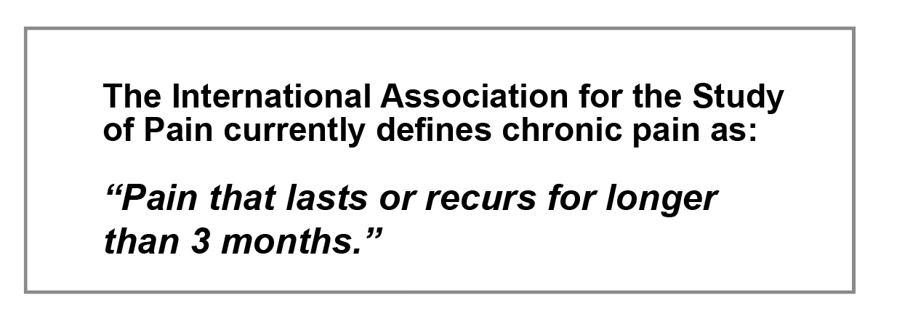

Figure 3: The International Association for the Study of Pain definition of chronic pain(13)

The Global Burden of Diseases Study 2019 (17) reported that musculoskeletal disorders (rheumatoid arthritis, osteoarthritis, low back pain, neck pain, gout, and all others) alone were responsible for 5·9% (4·6–7·3) of the total age-standardised disability-adjusted life-years (DALYs) in 2019, of which 98·1% (97·3–98·7) were years lived with disability (YLDs), equating 150 million (95% UI 109–198) DALYs (18). In addition, headache disorders (migraine, tension-type headache and medication-overuse headache predominantly) were responsible for another 46·6 million (95% UI 9·77–100) YLDs in 2019 (19). All other pain-related disorders add to this total albeit to lesser degrees.

Low back pain and other musculoskeletal diseases form an increasingly large component of the disease burden in countries with a high sociodemographic index such as Australia. Low back pain and headache disorders rank in the top 10 disorders in the 10 to 24-year and 25 to 49-year age groups with musculoskeletal disorders entering the top 10 for the 25 to 49 age group and ranked eleventh in the 50 to 74 age group (9, 16, 18, 19). Importantly,

these disorders also form a much larger component of health expenditure. However, this is yet to be reflected in investments in research to identify more effective treatments and preventative measures (20).

## The COVID-19 pandemic is adding to the burden of pain.

As communities around the world recover from the worst of the COVID-19 pandemic, a new global health challenge has emerged: post-COVID condition/s (21-23) or currently named, ‘long-COVID’.

The various post-COVID conditions are yet to be fully elucidated (22). Reported prevalence varies from one in two to one in five hospitalised patients remaining symptomatic at 12 months post-infection (24, 25); while around three per cent of the general population may self-report symptoms (26). Signs and symptoms vary enormously, fluctuating over time and generally impacting daily functioning (25, 27, 28). However, the various manifestations of pain associated with COVID-19 infection have received little specific attention as yet.

## Pain is one of the most common reasons Australians seek health care.

Almost one in five Australian adults, estimated at 3.24 million in 2018, lives with chronic pain (29-31) (Figure 4). Without action, this number is expected to increase to 5.23 million by 2050 (32, 33).

Patient visits to their general practitioner for the management of chronic back pain, or other unspecified chronic pain, rose by 67% in the decade from 2006-7 to 2015-16, estimated at an additional 400,000 consultations (31).

Pain prevalence differs by age and gender, cultural group and location across Australia, disproportionately affecting females and the elderly, Aboriginal and Torres Strait Islander peoples and Australians living in regional, rural and remote areas (34-36).

Differences in the health burden from painful conditions related to gender are particularly stark. Younger females have a greater risk of violence with intimate partner violence highest among females 40 to 44 years old with the consequent health burden second only to anxiety and depression. Musculoskeletal disorders, osteoporosis and back pain, are the leading causes or health burden in females aged over 45 (Women’s Health Strategy, Appendix 1).

In contrast, more than 70% of the health burden related to injuries is borne by males, including self-inflicted injuries and suicide, transport and workplace accidents, assault, thermal injuries, drowning and falls (Men’s Health Strategy, Appendix 1). Males living in remote Australia experience injury-related hospitalisation at twice the rate of urban males, increasing to four times the rate for transport accidents, and Aboriginals and Torres Strait Islander males having rates double those of non-indigenous males (35,36).

Osteoarthritis and endometriosis alone contribute to very high burdens of pain and disability for around 2.5 million Australians of working age. (37, 38).

In addition, chronic pain is the primary or compounding reason for over 100,000 hospitalisations Australia-wide every year (31, 39), affecting patient management and delaying discharge.

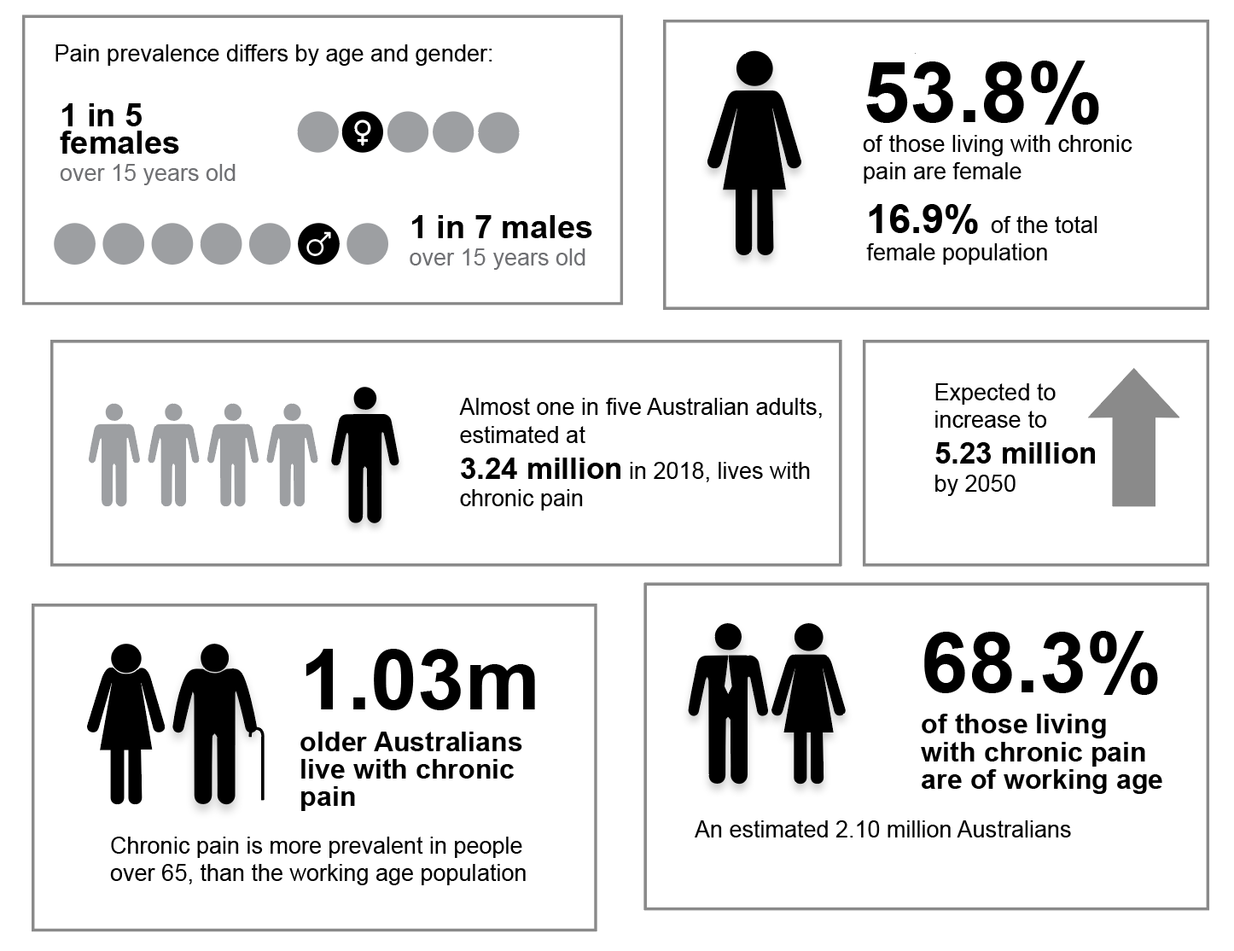Figure 4: Prevalence of pain in the Australian population(29)

Acute pain is considered to last up to seven days but may be prolonged up to 30 days (9). (9) (Figure 5). Its management remains problematic (10) and some Australians will transition to chronic pain following an episode of acute pain, including after surgery. Approximately one in 10 postsurgical patients is estimated to experience continuing pain severe enough to cause ongoing functional impairment (40-43).

Figure 5: The International Association for the Study of Pain definition of acute pain (13)

Figure 6: Factors associated with health inequities in rural, regional and remote Australia (36)

The following content is intended to provide some examples of the issues facing particular priority populations of the Australian community, noting there are many others facing similar challenges.

### People living in rural, regional and remote communities

Australians living in rural, regional and remote areas have on average lower socioeconomic status, more chronic disease, and are faced with higher costs when accessing healthcare in the context of reduced ability to pay (44).

Almost seven million Australians, or 28 per cent of the population, live in diverse places and communities across rural, regional and remote areas, scattered over vast distances. Although Australians living in small rural towns report higher levels of life satisfaction compared with their urban counterparts, they face a range of challenges and health inequities. These include poorer health outcomes, higher rates of hospitalisation, injury and death, including suicide due to living with chronic pain (35, 45, 46). The differences in health outcomes with increasing remoteness may reflect the high proportion of Aboriginal and Torres Strait Islander peoples living in these areas with their concomitant health disparities (35, 36).

Geographical remoteness means that people living in rural, regional and remote areas often pay higher prices for goods and services, travel greater distances to access healthcare, and tend to be on lower incomes(36). Because they experience more socioeconomic disadvantage, they are more likely to delay accessing, or go without, prescription medication and consulting with healthcare practitioners (47) (Figure 6). They have less access to primary health care services, and experience waiting longer for appointments to see a medical specialist or an after-hours general practitioner (47). Pain is one of the most common reasons for emergency ambulance attendances in regional and rural areas (48).

Maldistribution of the health workforce away from rural, regional and remote areas also contributes to poorer health outcomes. Access to allied health practitioners, in particular, is disproportionately low due to barriers to recruitment and retention, training and career pathways in rural, regional and remote areas (44). This, in turn, impacts the provision of services such as the National Disability Insurance Scheme, resulting in irregular treatment and care for those with disabilities and chronic conditions.

Transition to telehealth services accelerated due to the COVID-19 pandemic making healthcare consultations and pain management programs more accessible and affordable (49, 50), however, inconsistent internet connectivity and mobile phone reception in rural, regional and remote areas can be barriers to taking advantage of these services (44).

### Older Australians

One in three Australians over the age of 65 years lives with chronic pain.

The projected ageing of the Australian population is expected to expand the cohort already at increased risk of declining health and reduced function (51). This has major implications for pain care needs considering 1.03 million (one in three) Australians aged over 65 years live with chronic pain already (33) and the relative growth in those aged over 65 years is projected to increase from 16 per cent to 21-23 per cent of the population by 2066 (32, 51).

Experiences of pain change with ageing especially with increasing frailty and cognitive decline but pain is often overlooked in Australians aged 65 years and over. Older Australians bear a disproportionate burden of disease with two of the top three causes, musculoskeletal disorders and dementia (51), associated with pain. In addition, one in three Australians hospitalised for injuries in 2019-20 were aged 65 and over and 15% of older men and 20% of older women were living with severe or profound disability requiring supportive care (51). Within residential aged care, undiagnosed or mismanaged pain is a significant cause of distress behaviours, especially in those with dementia.

### 

### Children and adolescents

Persisting pain in childhood and youth is a predictive factor for pain in adulthood.

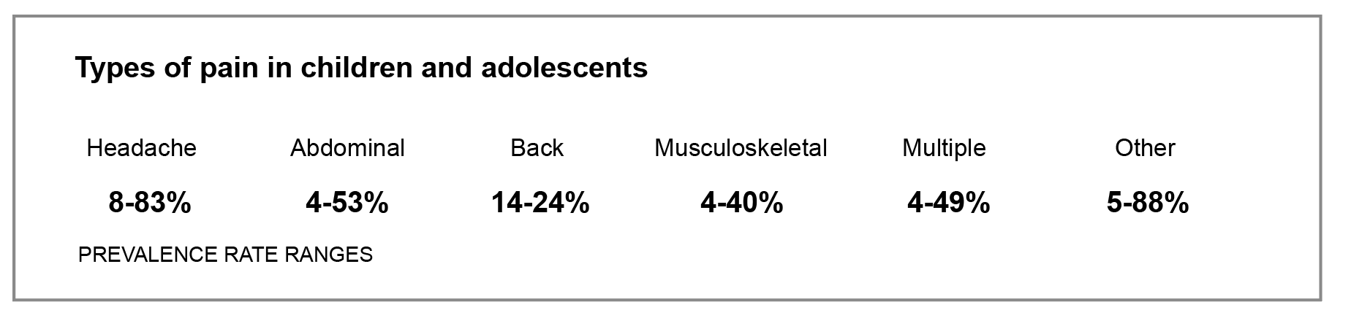Figure 7: Prevalence rates and types of pain in children(53)

Although nationwide studies of persistent pain in Australian children and adolescents are lacking, international data report a prevalence of 24 per cent on average in community-based studies, with rates higher in girls and rising with increasing age (52-54) (Figure 7). A study of musculoskeletal pain conditions in Australian children and adolescents attending primary care practitioners reported musculoskeletal pain was the sixth most common reason for attending for care, noting increases with age and female sex (54). The prevalence of persistent pain in emerging adults (18-29 years) ranges between five and 30 per cent (55). Female sex, familial chronic pain and previous experiences of chronic pain in childhood were consistently reported as associations, and anxiety, depression and sleep impairment were noted both prior to and after the onset of persistent pain.

### Aboriginal and Torres Strait Islander peoples

National prevalence data are lacking on chronic pain in Aboriginal and Torres Strait Islander peoples.

Aboriginal and Torres Strait Islander people experience a higher-than-average burden of disease and lower life

expectancy. This reflects the many health inequities faced by these communities and the systemic, interpersonal and intrapersonal racism and discrimination, especially of those living in regional, rural and remote areas (35, 56, 57) (Figure 8).

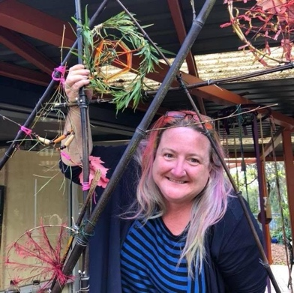

# CLYTIE LIVES ON THE TRADITIONAL LANDS OF THE WURUNDJERI. HER MOB IS THE PANTYIKALI PEOPLE FROM NORTH OF BROKEN HILL.

“I live with multiple health conditions. Going to hospital can be such an ordeal that many of us would rather suffer than go to hospital for anything. Each Emergency Department should have someone trained in dealing with chronic pain. I would like to see doctors work together, listen to their patients, work with allied health more, and increase their knowledge- base on the many pain conditions out there.”

Source: Australian Pain Management Association

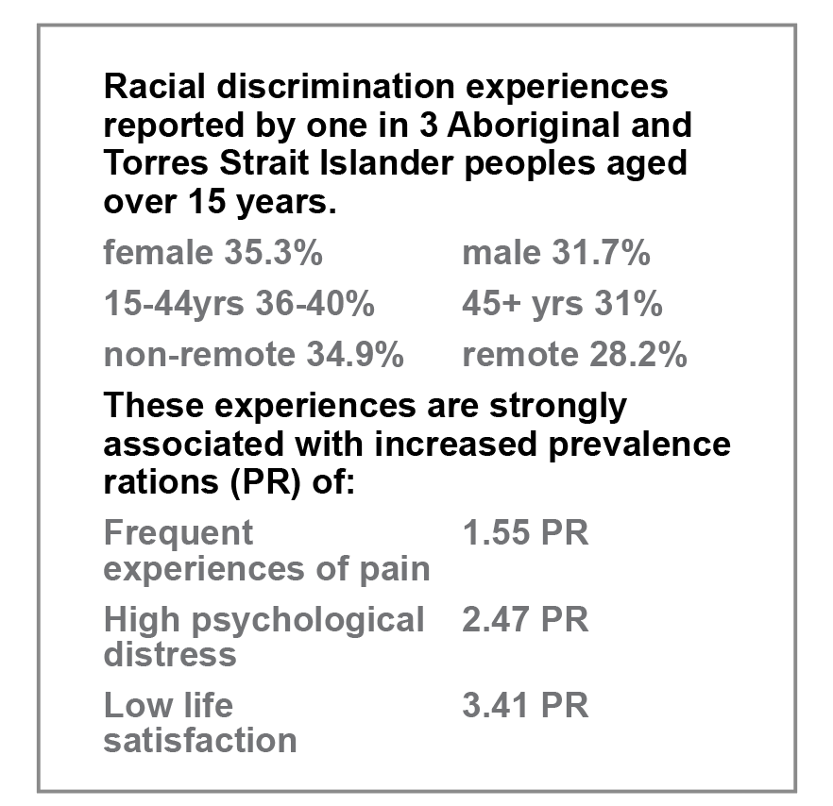

Figure 8: Racial discrimination experiences of Aboriginal and Torres Strait Islander peoples(60)

In early studies on chronic pain in Aboriginal and Torres Strait Islander peoples, the reported prevalence was widely variable (58).

More recent studies, however, have shown a prevalence of equivalent to, if not higher than non-Indigenous Australians, especially considering the impacts of racism and intergenerational trauma from British colonisation (59).

Recent data from The National Study of Aboriginal and Torres Strait Islander Wellbeing, the Mayi Kuwayu Study (60), suggest Aboriginal and Torres Strait Islander peoples experiencing moderate to high levels of discrimination are

1.6 times as likely to have frequent experiences of pain and lower levels of wellbeing than Aboriginal and Torres Strait Islander peoples not reporting discrimination (60).

### Culturally and linguistically diverse (CALD) populations

Australia-specific data concerning pain prevalence in CALD communities remain limited despite known inequities across a range of Australian health settings (61-63).

Migrants to Australia have arrived from North-West Europe and Oceania traditionally, but are now surpassed by those from Asia in particular, with smaller cohorts from several Middle Eastern and North African nations (64) (Figure 9).

The above-average health status of immigrants on arrival wanes with duration of residency in Australia so overall, CALD communities have a higher burden of disease likely due to barriers to accessing care (65, 66).

Australian studies reflect international data showing that language and ethnocultural influences impact the way people experience and understand pain and pain care (63, 66-69). Increasing numbers of migrants and refugees arriving in Australia from areas of conflict where many experienced torture or other physical and/or psychological harms, will add further complexity to pain care needs in these communities well into the future (70-72).

Figure 9: Proportion of Australia’s population born overseas compared with born in Australia(64)

### People living with disability

Pain is at least as common in people living with disability as in the general population.

Around four million Australians or 18 per cent of the Australian population live with a disability (73), many experiencing pain generated by their impairment. Of the eight most common chronic conditions associated with disability burden, arthritis and back pain and related conditions rank third and fourth respectively.

Data on the prevalence of pain in Australians living with intellectual disability are lacking (74, 75); however, the two most common conditions are cerebral palsy, affecting around 35,000 Australians (76), of whom approximately 50% live with an intellectual disability, and Down syndrome, affecting up to 15,000 (77). Limited international data suggest pain may affect up to 74per cent of children and adults with cerebral palsy (76), with a paucity of high-quality research supporting pain management options (78). However, no data exist for Australians with Down syndrome, although they commonly experience a range of musculoskeletal conditions likely to cause pain from early childhood (75).

Despite recent efforts to develop more appropriate pain assessment tools and better tailor management, challenges remain in understanding the biological basis of pain, discerning pain from distress, anxiety and depression and addressing erroneous stereotyped beliefs about pain in all persons living with intellectual disability (79).

### Impact on the person living with pain

Pain may have a significant impact on the quality of life, especially for those living with chronic pain.

Pain affects the ability of individuals to do physical tasks and engage in work and education. It interferes with sleep and relationships with others, impacts on mental health, and often leads to financial difficulties and social exclusion. Low back pain is associated with high rates of work absenteeism(80) and workers’ compensation claims (81). Conversely, the persistence of pain after occupational injury can slow recovery and negatively impact outcomes from worker’s compensation systems (82, 83).

### Pain and comorbidities

Other chronic conditions such as cardiovascular diseases, asthma, diabetes, stroke and bowel disease are associated with an increased risk of experiencing chronic pain (39) (Figure 10).

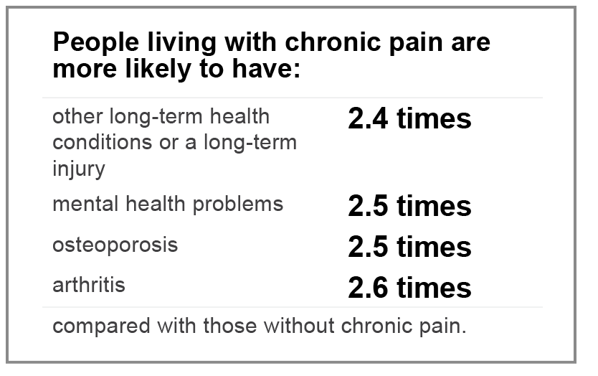

Figure 10: Comorbidities affecting people living with chronic pain compared with those without chronic pain(39)

Smokers and ex-smokers are almost twice as likely to self- report chronic pain (84). Obesity is a risk factor for developing musculoskeletal pain, fibromyalgia, headaches and abdominal pain (85, 86).

Endometriosis and related conditions are associated with recurrent severe acute pain affecting more than 10 per cent of Australian women and girls, transgender, non-binary and gender-diverse people assigned female at birth. Transition to chronic pelvic pain is frequent, partly due to under-recognition, delayed diagnosis and inadequate treatments (87).

Mental health disorders including depression, anxiety, and post-traumatic stress disorder frequently affect those living with chronic pain and are associated with increased rates of suicide (88). Childhood adversity (physical, emotional and sexual abuse, and neglect) increase the risk of and severity of pain in adulthood (89) as does interpersonal trauma in women (90).

# DANIEL LIVES IN ADELAIDE

“I suffer from a condition called Complex Regional Pain Syndrome (CRPS), this is a type of chronic pain. I was diagnosed with this condition at age 12 after falling off a trampoline and breaking my left arm. People unfortunately, that have not suffered with chronic pain, do not understand the highs and lows that you have, both physically and mentally. I have left appointments feeling more hyped up with a plan to move forward but also, in some circumstances more disheartened. Pain isn’t just a feeling, there is an emotion that comes with pain that can stick with you forever. This is what I believe needs to be looked at, making practitioners realise that pain is something that triggers an emotion, which in turn triggers a memory which can be relived over and over again.”

Low socioeconomic status, financial stress (90) and other psychosocial variables including low self-esteem, bullying and social exclusion are known factors contributing to and exacerbated by pain. Job loss (91) and long-term unemployment are more likely, and the need for social security support adds to their stresses (92). Participation in workers’ compensation systems or litigation may delay return to work, slow pain resolution and negatively impact mental health, increasing disability duration (93, 94).

Adverse outcomes of pain treatments add to the individual’s pain burden

Many medications used to treat pain have limited effectiveness leading to prescribing cascades and polypharmacy causing significant harm especially in the elderly (95). Off-label and unlicenced use of medicines for managing pain is common, especially in some patient groups or when pain has been poorly responsive to approved therapies. This is particularly problematic for children and youth for whom trial data are limited and physiological development may affect drug handling (96). Off-label use is associated with the increased risk of adverse drug reactions and other harms as there is relatively limited information available for prescribers, pharmacists, nurses and consumers. Although various guidance has been promulgated, many practitioners may not have considered the medical, ethical and legal implications of such use (97-99).

Between 30 and 40 per cent of people with chronic pain are prescribed an opioid (100). Although low-dose opioids can provide some with an improved quality of life not otherwise achievable (101), long term opioid use is associated with little or no benefit for most (102, 103), risking a wide range of harms and potentially making pain worse (104-107). Benzodiazepines, gabapentinoids, antidepressants, and antipsychotics are often prescribed with opioids, increasing the risk of accidental overdose and death (108) (Figure 11). Simple analgesics are not without potential for harm either (109).

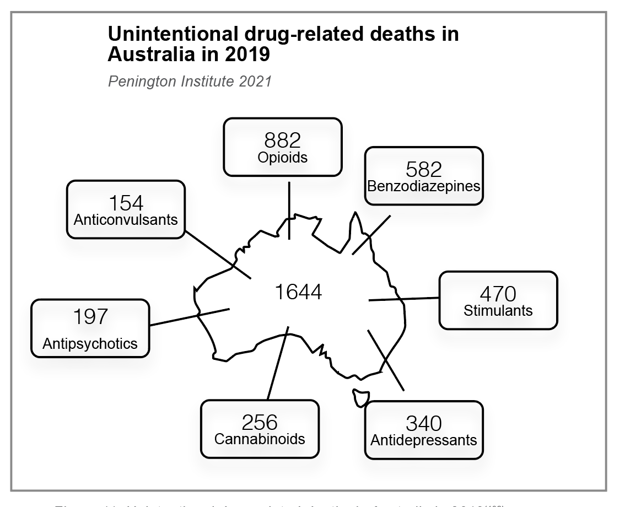

Figure 11: Unintentional drug-related deaths in Australia in 2019(108)

Neuromodulation has been increasingly recommended as an alternative to medications promising more effective outcomes for longer term pain reduction; however, the evidence base supporting this contention is of very low to low certainty with reports of a variety of adverse events, ranging from infection, electrode lead failure and need for reoperation/reimplantation to very serious life-changing/life-threatening events (110). Similarly, the benefits of surgical procedures for chronic pain remain controversial with concerns about poor outcomes, high costs and anaesthesia-related risks (111).

Pain in COVID-19 is often overlooked and under-appreciated

Approximately five per cent of Australian survivors of COVID-19 had persistent symptoms at three months post- infection, including headaches, joint and muscle pain and chest pain (112), with potential for a large number of cases of long-COVID based on early modelling (113).

Headache, abdominal pain, and multiple musculoskeletal and neuropathic pain complaints are commonly reported (114, 115). A range of factors is associated with an increased risk of long-COVID, including working in health or social care, and education settings (116, 117).

Whether long-COVID is distinct from other post-viral syndromes, the pathophysiological mechanisms and impacts of re-infection with new variants remain unclear (118). Consumers have searched for help from a variety of social media and other sources as in-person healthcare consultations have been restricted (119, 120). Targeted treatments are currently limited (23) (121) although many clinical trials are underway, including in Australia (122).

Concerns are already being raised about the disproportionate effects of long-COVID on Australians from socially disadvantaged groups (123). Persons with pre-existing chronic pain and those on long-term opioid therapy for pain are also more likely to be disproportionately affected (124).

### Cost of pain in the community

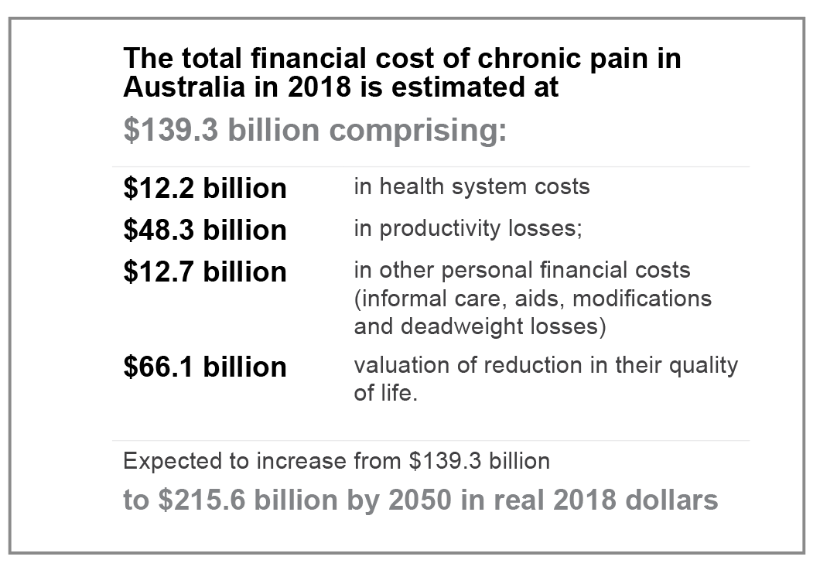The social and financial burden to the individual and their family is enormous and the costs to the Australian economy (up to $A139.3 billion in 2018) due to lost productivity along with rising health and welfare payments (33) (Figure 12).

Figure 12: The cost of pain in Australia in 2018(33)

In 2015, Australians lost 4.8 million years of healthy life due to illness or premature death from disease or injury which is essentially unchanged from 2003. Half of this burden was from living with the impacts of disease and injury (39). Back pain emerged as the second leading cause of burden for adults aged 25–64 in 2015, up from fourth in 2003 (39).

Children experiencing chronic pain may miss school, reduce physical activity and withdraw from social activities and are less likely to reach their educational and employment potential (125-127). No Australian data exist on the financial costs of pain in children and adolescents. However, studies in Canada and the United Kingdom estimate the total healthcare costs alone for adolescents with chronic pain at more than double that for young people without pain (128). The financial impact on families was estimated at £8,000 per adolescent in 2005 (approximately AUD14,500 in 2021 terms) (129).

### Current healthcare environment – adequacy of meeting needs

Up to 80 per cent of Australians living with chronic pain could be missing out on best-practice pain treatments most likely to improve their health and quality of life (130). The reasons are multifactorial and vary according to individual circumstances.

Complexity of pain

No one health practitioner from any single discipline has the knowledge and skills to meet the needs of every person living with pain.

Pain is a complex and personal experience, affected by socio-environmental, psychological, and biological factors. This very complexity means that each person living with pain has specific needs best addressed by a range of health practitioners from different disciplines. A single clinician using a holistic approach within a biopsychosocial framework can be effective, especially when intervening early and when pain is less complex; however, persons with longer-standing pain and other comorbidities may benefit more from a personalised team of clinicians from disciplines specific for their needs.

Models of care

Best-practice pain care involves a multi-component team-based, ideally interdisciplinary approach that is timely, personalised, and consistent with current guidelines (131, 132).

Models of care vary from intradisciplinary to multidisciplinary or interdisciplinary, depending on the needs of the person with pain, the healthcare setting and funding models, and the availability of the required health practitioners and how they interact (131, 132). In Australia, a range of clinical care guidelines grounded in pain education, active and psychological therapies, and self-management skills are available to support best-practice care for the majority of persons with pain who are managed in primary care (133-135). For those with more complex pain care needs referral to a specialist pain management clinic may be appropriate. Multidisciplinary pain management clinics are most commonly located in the public sector and urban-based (136) with a range of pre-clinic education and in-clinic care including one-on-one consultations, targeted pain interventions and group-based treatments of varying duration and intensity. Private pain services more commonly offer a range of care that may be more targeted to specific patient groups. A few specialist clinics are available for children and adolescents, for adults with cancer pain, and for pelvic pain.

The patient-practitioner relationship

Persons living with pain report experiencing stigma by healthcare practitioners and needing to repeatedly justify their requests for pain care (137).

People with pain are more likely to experience stigmatisation and invalidation from others, including in healthcare settings impacting on patient-clinician relationships (138, 139). Most recently, people with long-COVID symptoms report being disbelieved or refused referral to appropriate medical services (140).

Discrepancies exist between consumers’ and health practitioners’ expectations that may impact treatment choices and outcomes, leading to both being dissatisfied (141). Yet, the success of any pain treatment depends on developing a trusting relationship where consumers “feel worthy of care, and hearing their story is integral” (137).

The biomedical paradigm continues to strongly influence health practitioners’ and students’ attitudes to persons reporting pain, unconsciously influencing their judgments and leading to negative appraisal of patients despite the biopsychosocial framework underpinning contemporary pain medicine theory and practice (142-144).

Lost in translation

Many people describe interactions with healthcare systems as ‘an adversarial struggle’ (137).

Communication barriers are common, frequently deterring disadvantaged persons such as those from Aboriginal and Torres Strait Islander and culturally and linguistically diverse communities from seeking care and leading to delays in receiving treatment (34, 35, 58, 62). Barriers due to language and the need for interpreters, not feeling culturally safe, and diverse explanatory models for conceptualising pain as well as geographical and transport barriers, also reduce pain care outcomes for those from these communities (62, 145).

People with vision, speech and/or hearing impairments also experience communication breakdowns due to health

practitioner discomfort approaching them and low awareness of their needs; written healthcare information that is not presented in a suitable format; and reliance on memory to follow instructions (146-148).

Not surprisingly, persons with sensory impairments are also at increased risk of suboptimal care and harms from misunderstandings (149).



# NADINE LIVES IN REGIONAL VICTORIA

“I’m 31 years old with Complex Regional Pain Syndrome & I have had terrible experiences trying to access help in both ED departments as well as seeing other medical professionals due to stigma and a lack of knowledge about my condition. I need compassion, understanding, and not to be asked what drugs I am seeking? or am I looking for my next hit? Stigmas have delayed emergency treatment on several presentations. [Health practitioner] education about chronic pain management is important.”

Source: Australian Pain Management Association

Healthcare practitioners’ knowledge, attitudes and beliefs about pain

Graduates emerging from many Australian tertiary healthcare education programs do not have adequate knowledge, attitudes, and skills to effectively apply contemporary evidence-based pain management (132).

The reasons are complex and may include delivery of pain education, not just content (150). Lack of nationally consistent curricula, clarity about psychosocial contributors to the pain experience, limited ability to identify those contributors and deficient education and training in holistic pain care in most training programs across the career span contribute to difficulties in developing strong clinician-patient therapeutic alliances (132, 142, 151).

Awareness of treatment options

Discrepancies in providing best-practice acute and chronic pain care in clinical practice persist despite well-established clinical care guidelines being available for common pain conditions (152, 153).

Referral to specialist medical services without exhausting non-specialist options is common (154). Although the reasons are likely multi-factorial, general practitioners’ reliance on a biomedical model of pain and lack of understanding of the benefits of allied health practitioners in the treatment of chronic pain are key contributors (132, 154).

Organisational barriers limiting access to other healthcare professionals and inefficient communication between health practitioners often lead to different treatment options and conflicting patient advice and less than optimal outcomes (132).

Financial cost

A range of financial barriers impacts patients accessing holistic pain care (132).

Australians were estimated to personally spend over $12.7 billion on pain care in 2018 (33) in addition to the heavily subsidised state and federal health systems. Australia’s Medicare system (155) disproportionately funds medical consultations, favouring short consultation times, and surgical procedures, leaving persons with pain seeking to engage with allied health practitioners having high out-of-pocket expenses (156). In addition, the Pharmaceutical Benefits Scheme (157) subsidises most medications used for managing chronic pain rendering opioids and antineuropathic drugs as accessible, cheap treatments despite opioids in particular not being recommended as first- line or sole treatments, seldom being effective alone, and often causing significant harm (158, 159).

Service availability and accessibility

Demand continues to exceed availability and most services are located in metropolitan areas with services limited or completely lacking in regional, rural, and remote areas of Australia (136).

Cost, long-term health conditions, and living in areas of socio-economic disadvantage are the most common reasons for delaying or not using health services across all levels of the community (160).

Travel times for those living more than 30 to 60 minutes from a specialist multidisciplinary pain clinic reduce attendance rates and engagement in pain programs, relying instead on single visits or medical practitioner-only consultations (161).

The vast majority of patients requiring public-funded pain care remain reliant on their primary care practitioners (130). Most primary health networks now consider pain an important area of work; however, programs vary widely, based on perceived local needs with the majority being consumer-focused initiatives; far fewer address health practitioner capacity building, and only a small number work at the heath-system level, lacking program standardisation or national coordination (162, 163).

Impact of the changing opioid regulatory environment in Australia

Unintentional overdose of prescription medicines often prescribed for pain is implicated in the early deaths of more than three Australians a day and is 3.5 times more likely in Aboriginal and Torres Strait Islander peoples (108).

In response to rising concerns about the escalating rate of opioid-related deaths in particular and strong links between supply and harm, opioid regulatory changes and real-time prescription monitoring programs have been enacted across Australia over the last five years (159, 164). Codeine rescheduling in 2018 resulted in a significant reduction in codeine-related harms without increased prescribing of other opioids, worsening pain or mental health (165, 166). However, the more recent regulatory changes (smaller pack sizes, boxed warnings and class statements on Product Information (PI), updating of Consumer Medicines Information (CMI), and changes in indications for use(159)) have raised alarm (167-170).

Australians living with persistent pain reported that the reforms had created an additional layer of complexity, increasing difficulty accessing opioid-based medications to manage their pain, perpetuating stigma and isolation leading to loss of function and significant impact on their mental health (168).

Mortality risk is associated with higher opioid doses, but more severe pain, mental health comorbidities, including suicidal intent, and polypharmacy are significant complicating factors (171, 172). Half of the victims of opioid-related deaths in Australia had documented chronic pain (173). Recent recommendations to simply taper long-term opioid therapy prescribed for chronic pain have led to an increase in mental health crises, overdose and death in other jurisdictions (174, 175). Developing national clinical care standards for the use of opioids in acute care endeavours to reduce inappropriate prescribing and supply, especially in hospital settings (176), however, without greater efforts to address co-morbid chronic pain by federal and state health systems, regulatory responses alone will be ineffectual in preventing most opioid-related deaths in Australia and are likely to be harmful (164, 177).

Pain education for health practitioners

### International context

Internationally, pain management education is inadequate across health practitioner disciplines at every career stage.

Surveys of pain content in entry-to-practice curricula for health practitioner disciplines in Europe and North America have repeatedly found limited pain-related curriculum content (178-183). The International Association for the Study

of Pain (IASP) also highlighted insufficient pain content in entry-to-practice curricula and a lack of continuing professional development opportunities related to pain during the 2018 *Global Year for Excellence in Pain Education* (184).

When pain content is included in entry-to-practice curricula, it is often not fit-for-purpose.

Effective pain management involves a multidisciplinary team who take into account the social and psychological factors contributing to pain (132, 185). A small number of published studies include discussion of a biopsychosocial approach to pain management at the entry-to-practice level (186-188). However, pain is often taught using a biomedical lens, with less time given to topics that would help learners understand a biopsychosocial approach to pain management (178, 182). Additionally, didactic teaching methods are often used within a single discipline context, with limited opportunities for interprofessional or applied learning including simulation or experiential learning in the clinical environment (178, 181, 184).

Registration and accreditation standards rarely stipulate competency in appropriate pain assessment and management (184).

There is inadequate published evaluation of what works in pain management education across learning stages, specifically in relation to patient outcomes (178).

Evaluations of pain management education typically measure changes in knowledge and self-reported changes in behaviour and clinical practice (189-192), rather than patient outcomes (184) . A large number of evaluations utilise a pre-test and post-test design, with limited long-term follow up (187, 192-197). Quality improvement initiatives in settings such as a hospital inpatient unit or aged care facility (198, 199) seem better placed to measure changes in patient outcomes over a longer period than research investigating entry-to-practice education. However, even with these initiatives, there is a paucity of published evaluations to illustrate and share best practices in pain management education.

There are pain management education ‘centres of excellence’ across the world, but limited evidence for a coordinated response in any country.

Outside Australia, the United States and Canada are the only English-speaking countries in the world with a government-sponsored national pain strategy. Despite the generally limited availability of effective pain management education, initiatives that may provide inspiration for those implementing education initiatives are highlighted in the boxes below:

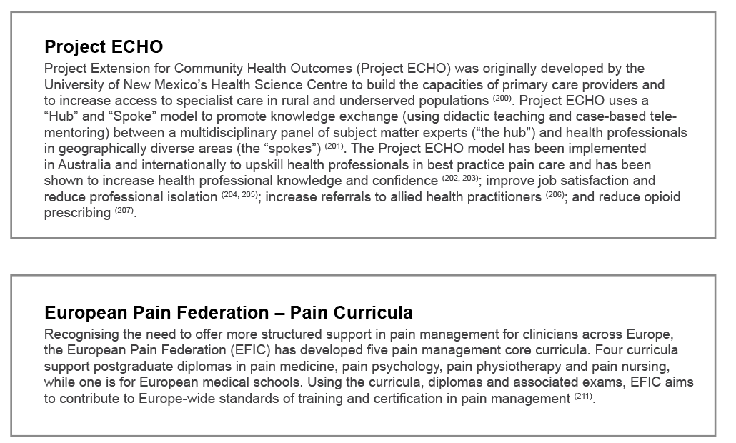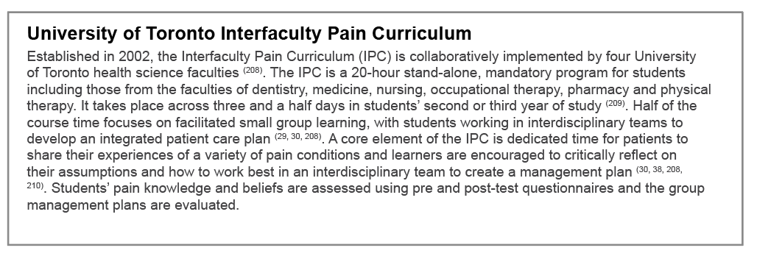

The IASP has developed pain curricula for use in entry-to-practice education, including a specific interprofessional curriculum (212).

These curricula have been utilised to create core competencies in pain management (213) and as a basis for pain management education at the entry-to-practice level (186, 208, 214). However, national surveys have identified that, in general, the curricula are poorly integrated into entry-to-practice education, despite their increased use being cited as key to building a biopsychosocial approach to pain management (178).

### A white rectangular sign with black text Description automatically generatedAustralian context

While centres of excellence exist across the country, there is limited evidence of a national, coordinated approach for pain management education at all levels of learning.

There is a gap in the translation of knowledge into practice, in relation to both pain management education and care. A paucity of evaluated pain management initiatives in the published literature may contribute to this gap, in addition to unhelpful attitudes towards pain (215), and other factors such as the structure of the health system and organisational culture (132, 216).

There is limited Australian-specific evidence concerning the context of pain content in entry-to-practice curricula.

The single published study investigated the delivery of pain medicine education in Australian and New Zealand medical schools found a lack of clearly articulated comprehensive pain curricula or the use of teaching and learning methods appropriate to the complexity of pain (151). Given the lack of published literature on the subject, the manner in which other disciplines are addressing pain management within their curricula is uncertain. A grey literature search illustrated wide variation in the inclusion of pain management within entry-to-practice curricula.

There is a variety of pain management education initiatives in the postgraduate and continuing professional development space.

These offerings use different methodologies, ranging from structured, multidisciplinary postgraduate and short courses (217) and educational visits (210) to self-directed online modules and webinars (218, 219). However, there is no central repository for learners to identify educational offerings and no accreditation system to rate the quality of the education programs and educators. Furthermore, there are currently limited published evaluations of programs demonstrating changes in practice or patient outcomes in the Australian context.

Pain management is not widely included as a required competency by accreditation bodies in Australia.

A search of relevant accrediting council standards identified no reference to pain or pain management as competencies for higher education entry-to-practice course graduates (220-224). However, there are a number of initiatives in the wider clinical standards space. The Australian Commission for Safety and Quality in Healthcare (2022) launched the Low Back Pain Clinical Care Standard (134) and the Society of Hospital Pharmacists of Australia has developed standards of practice in pain management for pharmacy services, with specific areas of focus around education, training and quality improvement (218, 225).

Concurrent with the National Strategy for Health Practitioner Pain Management Education, a Commonwealth Funded Grant for Health Professional Pain Education (G02810) was awarded to a consortium led by the Pain Management Research Institute (University of Sydney).

This grant is resourced over four years, to co-develop and implement digitally-supported interdisciplinary, health and medical professional pain management training programs. Consortium members include University of Sydney (Pain Management Research Institute), Curtin University, the Australian Pain Society in partnership with the National Ageing Research Institute, and the University of South Australia (Pain Revolution). The program of work is positioned to support a collaborative effort with the Faculty of Pain Medicine (FPM) in the implementation of Goal 3 of the *National Strategic Action Plan for Pain Management (2)*.

The intention of the pain training program is to improve the cross-discipline integration and management of chronic pain in partnership with people living with chronic pain and carers. Using this partnership approach, an empirically- derived framework of pain care priorities has been developed (226). The consortium is currently progressing implementation of this framework across members’ pain training programs.

The training programs aim to build Australian health workforce capacity, with a focus on developing practical competencies for all health practitioners to support people living with chronic pain. The program will incorporate guidance on the quality use of medications for those with chronic pain, a train-the-trainer model for pain management by residential aged care providers, and community-based mentoring and support for health practitioners in rural and regional areas across Australia. A digital platform, fit for purpose, will be developed to support ready access to pain training for health practitioners across Australia.

The COVID-19 pandemic has challenged education providers to deliver education and training through the adoption of digital technologies.

It appears this has been successfully achieved and there has been widespread acceptance of the various technologies for online and hybrid courses (231). Online lectures and synchronous discussion are preferred to pre-recorded material (232). Benefits of online learning include accessibility, affordability and flexibility (233, 234). The downside includes fatigue and lack of personal contact (235) as well as information technology issues and staff expertise with technologies (236). It should be noted that students do prefer face-to-face learning (231). The experiences during this critical time of change provides opportunity for future education offerings to be agile enough to incorporate approaches that offer face-to-face and tailored online learning. The use of technologies can encourage the move beyond geographical boundaries of the states to enable a nation-wide approach.

Australian pain management education:

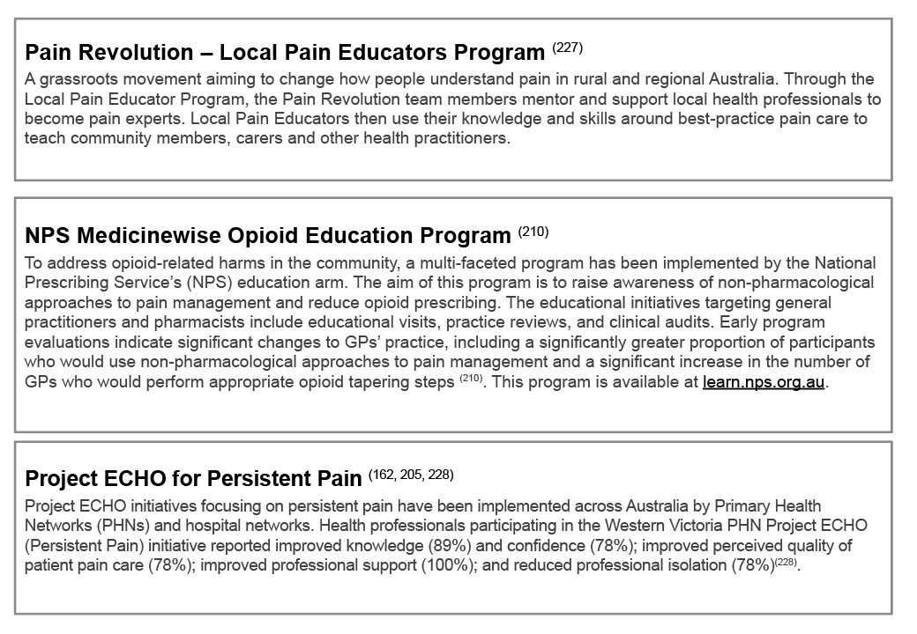(nb: selected examples only)

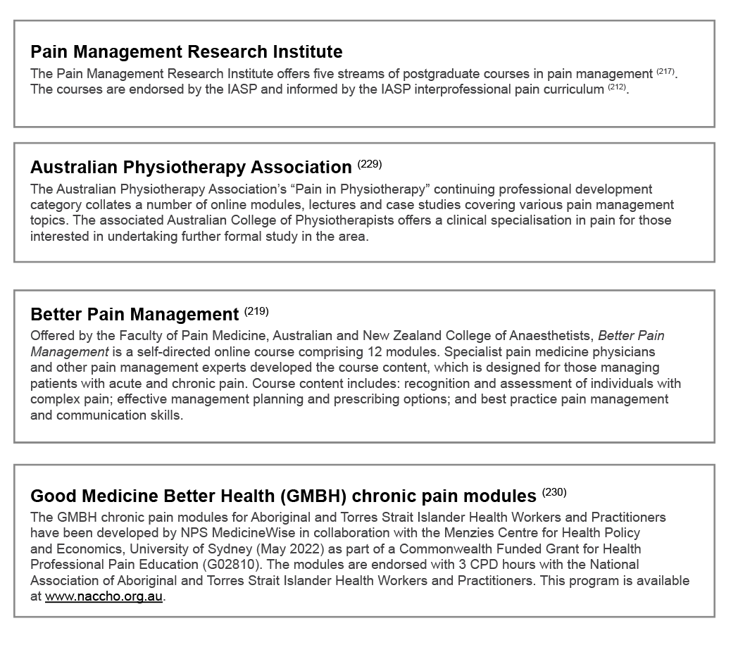

A national strategy for health practitioner pain management education

The literature review provided valuable context and reinforced the need to improve pain management education across Australian health disciplines. To achieve this aim, it was important to provide an overarching strategic roadmap to guide and inform activity over the next five to ten years. The following sections of this document provide an overview of the national strategy development process, the outcomes that emerged from extensive stakeholder engagement and an implementation plan for the future.

## SCOPE

In the context of this strategy, scope was defined in relation to the:

1. range of health disciplines that provide care for individuals with acute or chronic pain; and
2. learning opportunities that were identified across the career-span of these health practitioners.

Most health practitioners will be faced with managing individuals experiencing acute or chronic pain during their career.

The table below shows the key health practitioner disciplines initially considered as comprising a significant proportion of the Australian health workforce engaged in the care of individuals with pain (Table 1).

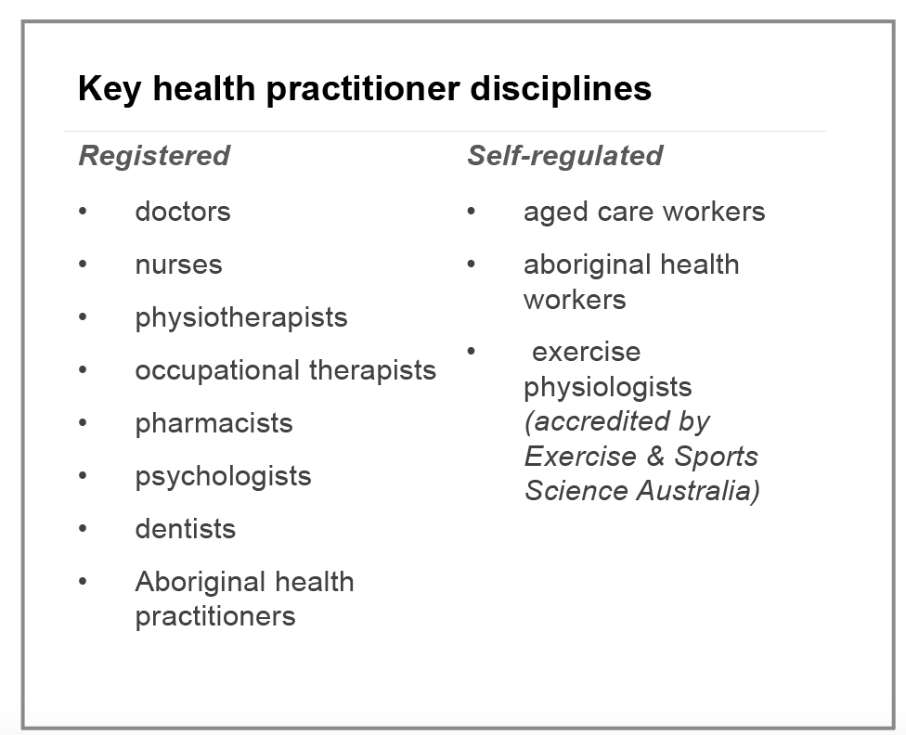Table 1: Health practitioner disciplines engaged in the strategy consultation

Narrowing the scope was in no way meant to exclude other disciplines from the strategy, rather, it assisted the project team in determining the breadth of the initial stakeholder engagement and iterative consultation. It is hoped that the outcomes arising from this education strategy will be more broadly applicable across a wide range of health disciplines.

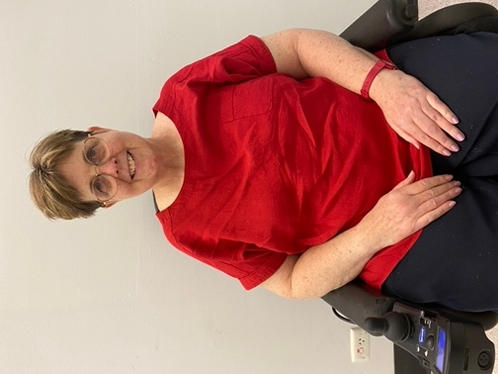

CHRISTINE IS A HEALTHCARE PROFESSIONAL LIVING IN ADELAIDE

“Diagnosed with Multiple Sclerosis (MS) 24 years ago, pain is an ever- present experience for me. It affects me day and night. Most of my pain is not obvious. Much arises from my condition – muscle spasms, sitting in a wheelchair all my waking hours, falls, and wearing incontinence protection. As I am unable to control my limbs, I often knock them hard resulting in cuts and bruises. I have regular ‘torture sessions’, that is, weekly neurophysioptherapy and hydrotherapy, and remedial massage every fortnight. These are essential treatments to maintain function, flexibility and strength. Despite them causing significant pain, I keep having these treatments, so I don’t live as a ‘seized up ball’ unable to do anything. Pain education should be included at every stage of their [health practitioners’] training. It needs to be included in undergraduate curricula and continue through to ongoing professional development to remain up to date with current, evidence- based information. An increased awareness of the impact of pain on people’s lives and provision of excellent management, will be of enormous benefit to the millions of Australians living with pain. We all deserve maximal quality of life so we can realise our full potential.”

Across the career-span of a health practitioner there are a number of points which can be considered as ‘critical learning opportunities’.

Entry-to-practice programs

Undoubtedly the most critical learning opportunities for any health practitioner are during entry-to practice programs where the foundations are set for their future career. Well implemented improvements in best-practice, holistic, multidisciplinary pain management education at this point have the potential for significant positive impact on health consumers living with pain.

The term ‘entry-to-practice’ covers a broad range of education that may be undertaken prior to an individual entering their area of clinical practice. Higher education programs can include bachelor and masters programs, and in some instances, a doctorate. Para-professional and other roles (regulated and unregulated or self-regulated) may involve vocational education and training (VET) at Certificate III, Diploma or Advanced Diploma level.

It is worth noting at this point that there are large proportions of the health workforce, particularly in the aged care and disability sectors, where care is provided by workers without any formal education or training.

Early graduate years

The transition to clinical practice that takes place in the first year or two of a health practitioner’s career provides the important consolidation of knowledge, skills and attitudes acquired during entry-to-practice programs by applying these directly within a range of health care contexts.

During this time new graduates are anxious to assimilate into their work environment and be accepted as part of the ‘team’ (237-240). They can be easily influenced by the culture and clinical practices of their workplace, good and bad. Clinicians recognise the importance of the biopsychosocial principles for managing pain, however barriers exist in terms of confidence, knowledge and skills to implement them (132). This is an important time to reinforce best-practice pain management principles and practice.

Postgraduate clinical programs

Many health practitioners undertake further studies in their chosen field following their entry into practice. This may include undertaking an honours year, graduate certificate and / or diploma, as well as masters and doctoral degrees. It is important that more advanced concepts related to pain management be included in these programs, where relevant, and pain research is fostered and well supported.

Specialist medical training

In Australia specialist medical training is undertaken through recognised specialist medical colleges. Specialist medical colleges must meet *the Standards for Assessment and Accreditation of Specialist Medical Programs and Professional Development Programs by the Australian Medical Council 2015* (241)*.*

Pain is relevant to a broad range of medical specialty areas so it follows that specialist medical training programs should contain contemporary, evidence-based content on pain and pain care relevant to their discipline.

## Specialist physiotherapy training

Specialisation may be undertaken through the Australian College of Physiotherapists leading to qualification as a Fellow of the Australian College of Physiotherapists following the completion of a rigorous two-year training and examination process. A specialisation pathway for pain is one of the nine clinical specialist pathways (229).

Continuing professional development

All registered health practitioners in Australia have a requirement to maintain their currency of knowledge and practice to support them in the delivery of safe and appropriate care. Continuing professional development provides the opportunity to not only facilitate the updating of a clinician’s practice but to fill the knowledge and skill gaps resulting from inadequate coverage of pain management in entry-to-practice and postgraduate education. It also provides the ideal platform for interprofessional education.

STRATEGY DEVELOPMENT

Strategy development incorporated rigorous cycles of literature review, iterative stakeholder consultation, and data analysis and review across the two-year timespan of the project. The following diagram illustrates the key steps involved in the development of the strategy:

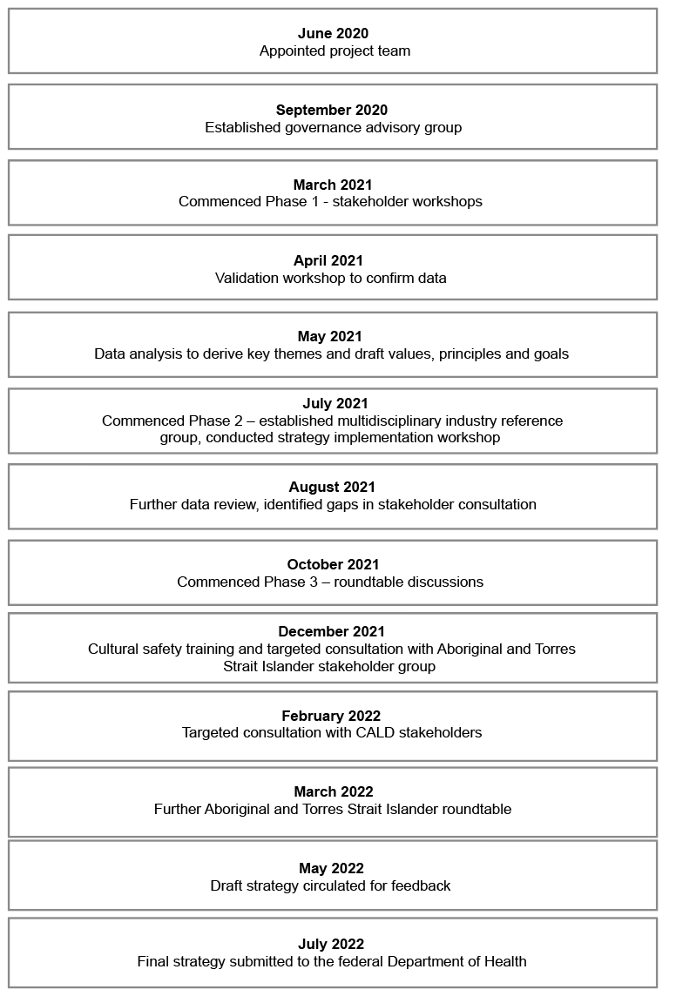

ITERATIVE CONSULTATION

In developing this strategy, the project team undertook an iterative consultation process with a broad range of stakeholders.

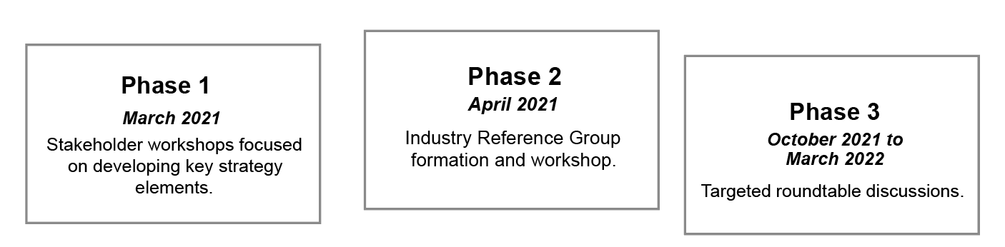The term ‘iterative consultation’ is used deliberately here to signal the difference between the approach taken in this project with that of other initiatives which tend to use stakeholder consultation as a way of ‘sense-checking’ or validating a strategy that has already been developed, albeit perhaps in a draft format.

The iterative consultation process took place across three phases (Figure 13).

Figure 13: The iterative consultation process

PHASE 1

The first round of iterative consultation in March 2021 comprised a series of seven four-hour workshops (combination of virtual and face-to-face), including one dedicated to rural and remote perspectives.

The workshops took the form of facilitated conversations with a focus on developing key elements of the national education strategy including: the vision; underpinning values and principles; goals; and implementation strategies. To ensure all relevant voices were captured, the net was cast wide to include a broad range of stakeholders including:

* consumers;
* health professional educators;
* health care practitioners;
* entry-to-practice students;
* government and other policy makers;
* regulatory bodies; and
* health professional associations.

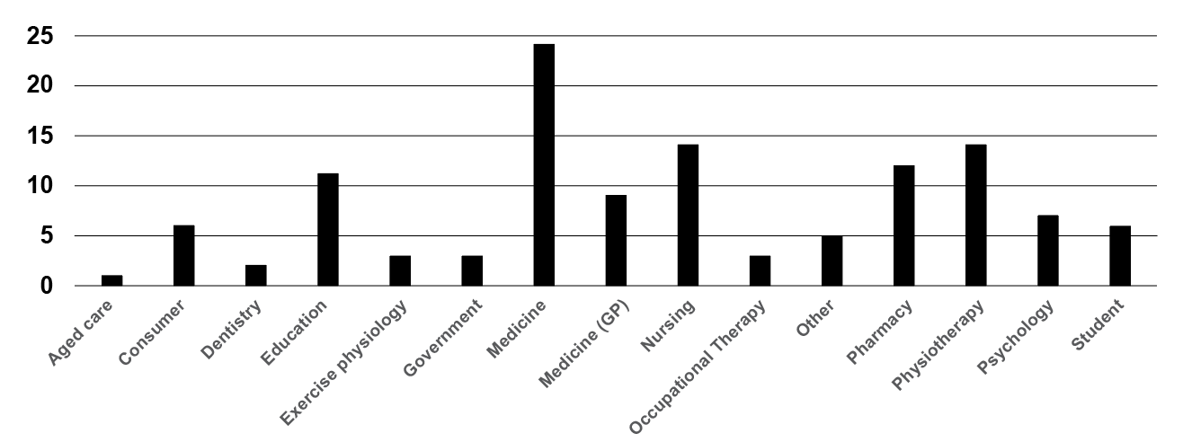Phase one workshop participants totalled 120. The following tables illustrate the range of participants and the numbers from each jurisdiction (Figures 14 and 15).

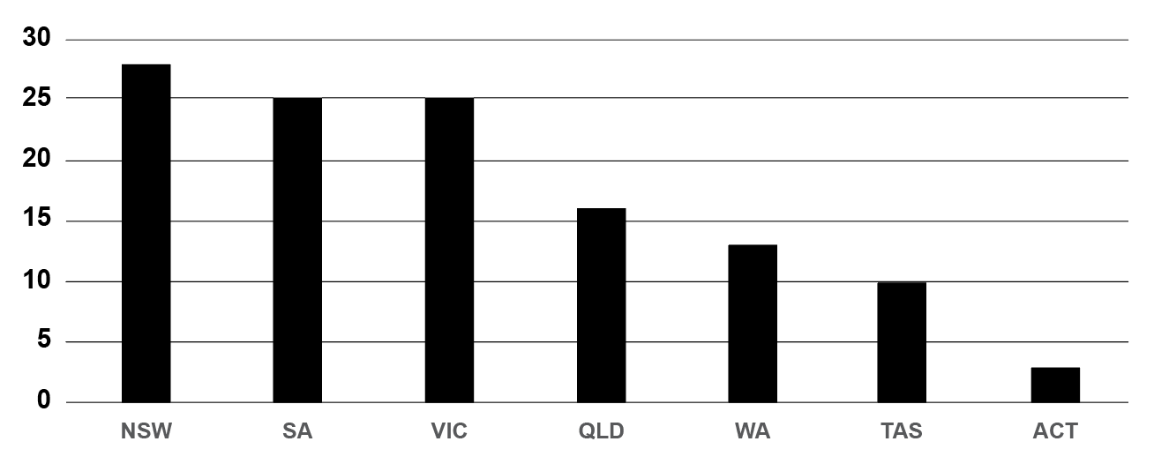Figure 14: Distribution of participants by discipline

Figure 15: Distribution of participants by location

Data gaps identified

At the conclusion of the first phase of consultation the following data issues were identified:

* While there was a high degree of consensus around values, principles and goals, there was a lack of data related to potential implementation strategies.
* The data lacked the voices of some priority populations such as Aboriginal and Torres Strait Islander peoples, culturally and linguistically diverse communities, disability, aged-care, and children and young people.
* There was limited engagement in the workshops by key regulatory and policy agencies.

PHASE 2

In an effort to address the limited data pertaining to implementation strategies an *Industry Reference Group*

was established. This group comprised some representatives from phase one workshops as well as additional representation from government, policy and regulatory groups. A workshop was subsequently held with this group in June 2021 and the data analysed and combined with existing findings.

PHASE 3

Phase three aimed to address gaps in the data in relation to input by key regulatory and policy agencies as well as input from Aboriginal and Torres Strait Islander and culturally and linguistically diverse communities. Five

90-minute roundtable discussions were subsequently convened.

The project team also engaged with several key stakeholders individually for the purpose of providing further explanation and advice. In total the stakeholder engagement included approximately 180 individuals, many of whom were representing the perspectives of key groups and agencies.

This extensive iterative consultation process has shaped the following sections of this education strategy.

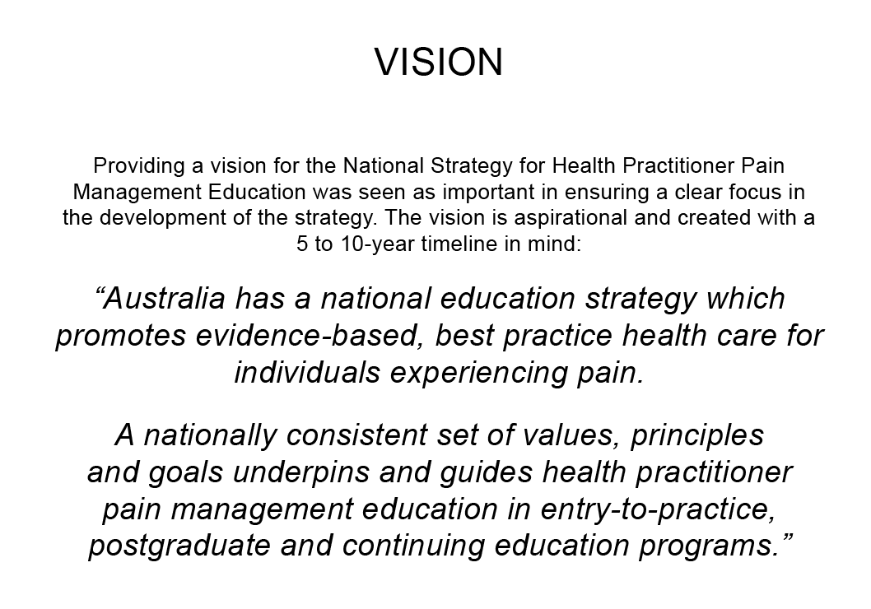

### Values

There was strong agreement among stakeholders that this strategy is supported by a set of underpinning values that speak to all aspects of pain management education developed and delivered across a diverse range of communities. Emerging, with a high degree of consensus, from stakeholder workshops and discussions were the following values:

Diversity

Pain management education, content and delivery reflects the diversity of the community in which it is applied, individuals’ experiences of pain and the unique needs of the learner.

Partnership

The development and delivery of sustainable pain management education is built through authentic, mutually beneficial education partnerships which are founded on a platform of trust and enduring long-term relationships.

Excellence

Within pain management education there is a focus on maintaining high standards and implementing continuous quality improvement.

Equity

Pain management education is accessible to all health practitioners. It supports the right to self- determination and empowers health practitioner communities through partnering in the creation of education solutions.

Respect

The development and delivery of pain management education respects the importance of ‘place’ and ‘community’ and takes place in a culturally safe space with mutual respect for all involved regardless of perceived ‘status’, health discipline, or educational background.

### Principles

The following set of principles was derived through the iterative consultation process described above.

They build on the values and will assist in guiding the way in which we design and deliver pain management education into the future.

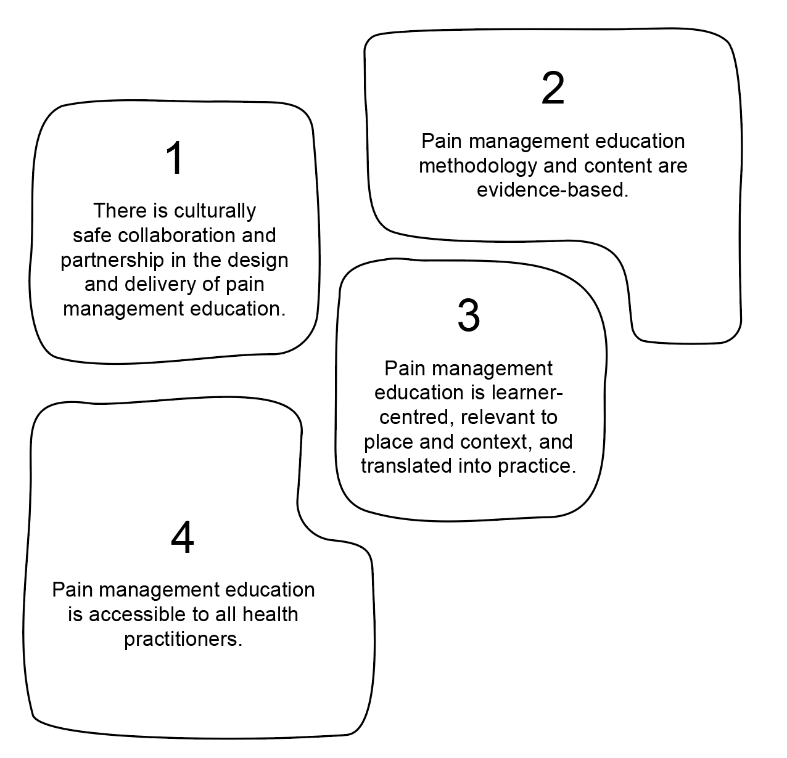

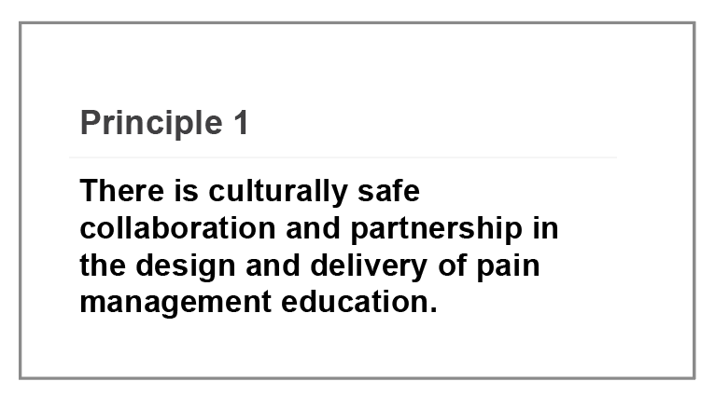

Education programs must be aimed at meaningful outcomes for consumers and direct consumer input into educational delivery can provide extremely powerful and memorable learning opportunities for health practitioners (226).

This means that consumers must be central to program design and delivery. It is important to understand the desired impact and outcomes of health practitioner education from the consumer perspective. Having consumers inform design will ensure that learning outcomes will address their concerns (226).

Engaging consumers in education delivery adds a powerful dimension to the learning experience of health practitioners. For example: the use of storytelling, simulation-based learning and case-based scenarios, that are linked with defined learning outcomes, are excellent ways for learners to engage with consumers. These teaching approaches will increase the readiness for practice of beginning practitioners and are ideal for developing empathy and communication skills. They can be used equally effectively in postgraduate and ongoing learning contexts.

Appropriate development, implementation and translation of education to practice can only happen when we truly understand the communities in which it is applied.

To facilitate the appropriate application of pain management education it is important for education providers to be well connected within the communities in which it is delivered.

Building long-term meaningful relationships and mutually beneficial partnerships, to develop a sense of trust and mutual understanding is pivotal to the success and sustainability of education programs.



# ELLIE LIVES IN BRISBANE, QUEENSLAND

“I am a twenty-six-year young woman living in Brisbane and lived with a diagnosis of Spastic Quadriplegic Cerebral Palsy since birth. At 16, as a consequence of not receiving support and advocacy from a pain management team, my pain was inadequately treated….I was isolated by my pain, made to feel invisible, and my concerns were invalidated. If I could make one request of you as doctors and clinicians it would be please share your power with your patients, work in partnership with them to find solutions set goals and have a shared vision. The patient sitting in front of you cannot be simply summed up or defined in a patient chart. Patients are people to be met before they are conditions to treated.”

Source: Australian Pain Management Association

These partnerships should be founded on the premise of ‘learning from each other’ rather than ‘knowledge giving’, recognising and incorporating the deep learnings that are held by Aboriginal and Torres Strait Islander peoples and culturally and linguistically diverse (CALD) populations.

Partnerships with Aboriginal and Torres Strait Islander communities must involve the broader community, be respectful and cognisant of the significance of ‘place’ and support the right to self-determination and elimination of racism in all its forms.

Australia has a rich and diverse migrant population that is not well served by generic ‘one size fits all’ approaches to education. Education provision must be informed and guided by those who understand the community and cultural contexts to ensure that it has a real impact at the coalface in care provision. Consultation with stakeholders from culturally and linguistically diverse backgrounds highlighted how the complexity of pain is compounded within these communities by many aspects including:

* language barriers;
* past trauma;
* lack of understanding of the Australian health system (242);
* lack of cultural awareness by health workers (243); and
* the disconnect between western medical beliefs and those of other cultures (242).

In all situations, community engagement and program delivery need to be within a culturally safe environment.

The need for effective community partnerships becomes all the more important due to the glaring gaps in research relating to both Aboriginal and Torres Strait Islander peoples and CALD populations and their practices, beliefs, experiences and responses to pain.

Quality educational program design should also involve collaboration and partnership with all key health disciplines, as well as learners, to ensure that educational outcomes are relevant to clinical practice.

Optimal pain management requires a holistic, biopsychosocial approach that is tailored to meet the needs of the individual experiencing pain. This is particularly important in the management of those living with chronic or persistent pain and is reflective of its complexity. For meaningful interdisciplinary collaboration to occur it is important that all participants feel culturally safe, regardless of perceived professional ‘status’, race, culture or social background.

It follows that the design and delivery of programs should reflect this multidisciplinary aspect of pain care and, where practicable, an interprofessional education approach is preferred.

Building collaborative partnerships within and across education and clinical environments to engage key stakeholders will lead to quality, clinically relevant, education solutions. Not all education contexts will lend themselves easily to interprofessional education delivery, however this should not be a barrier to collaboration in program design.

While interprofessional education should ideally involve students and teachers from a range of discipline areas learning with and about each other as they apply their craft, fostering interprofessional education can also be supported through multidisciplinary case-based learning (244, 245) and simulation-based education using standardised patients and actors to play the role of other members of the health team (246, 247).

Developing a common philosophy and language for pain will act as an enabler for interprofessional pain management education.

It is important that pain management education is founded on a common conceptual understanding, philosophical approach and evidence-based model of pain. The foundation of knowledge, skills and professional attributes required in pain management can be viewed as transdisciplinary. A common understanding leads to a generic language and definitions that cross disciplinary boundaries and resonate at all levels of education. There was strong support throughout stakeholder consultations to support the acceptance of the International Association for the Study of Pain (IASP) definition of pain.

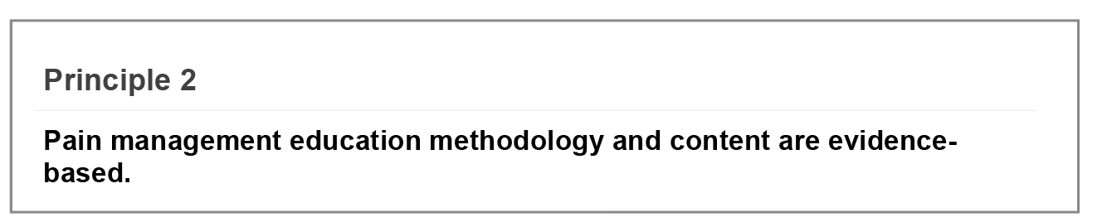

Throughout all stakeholder consultations there was strong consensus around the need for pain management education to be reflective of contemporary knowledge and practice.

It is important, therefore, that all pain management education be based on contemporary, reliable evidence and relevant best-practice guidelines and principles. Evidence-based content should not be developed through a solely ‘biomedical’ lens, rather it should be situated within a ‘holistic’ framework that incorporates the sociocultural, psychological, and spiritual perspectives together with the biophysical dimension.

As evidence continues to evolve, learning must be regularly updated through continuing professional development.

To ensure that a health practitioner’s practice continues to be founded on contemporary evidence it is important that they embrace continuing self-reflection and learning throughout their career. Fostering a culture of continual learning and professional development within entry-to-practice programs, and then supporting this through ongoing education, peer support and mentorship throughout the health practitioner’s career, will support best-practice care delivery.

There is an urgent need for further quality research to support the evidence-base underpinning pain education.

The field of pain management is dynamic in that our understanding of mechanisms of pain and, in particular, chronic pain responses, has changed and grown significantly over the last two decades with research at the core of this change. However, gaps remain in our research, particularly in relation to understanding the experience and effective management of pain within some priority populations, including Aboriginal and Torres Strait Islander peoples and culturally and linguistically diverse communities.

Teaching methods need to be contemporary, evidence-based, fit-for-purpose, cater to a variety of learning styles, and be relevant to the level of the learner.

Evidence-based content alone will not ensure the development of a clinically competent health practitioner and the translation of theory into practice. As stated above, teaching methods need to incorporate best-practice, contemporary approaches. Over the last decade there has been an increasing move away from didactic, teacher- focused educational delivery towards more learner-centred, applied forms of learning.

Assessment in contemporary health practitioner education is also moving away from high stakes summative assessment (assessment of learning) towards more formative assessment (assessment for learning) with a trend towards programmatic or global assessment.

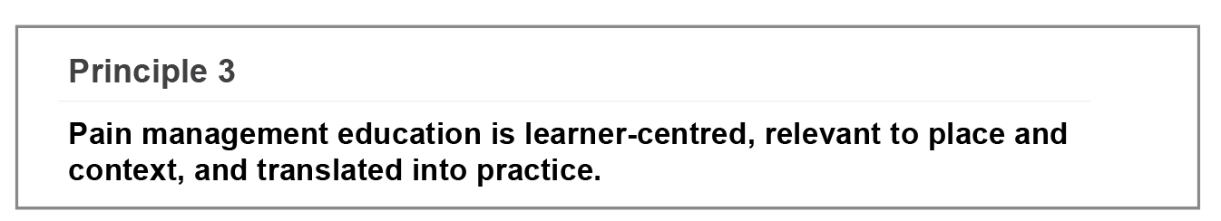

A dynamic and responsive curriculum will have mechanisms for continuous feedback from the clinical coalface and a deep understanding of the community context in which it is delivered.

Pain is an issue within all community environments; however, the geographical, social and cultural contexts of communities can vary greatly. Differing community contexts can impact directly on the health care needs of consumers and the learning needs of health workers on the ground. Pain management education solutions must be flexible enough to be applied across a range of environments.

It is not only important to consider ‘what’ we teach, but to look at ‘how’ we teach pain management to facilitate translation to practice.

Technology is being harnessed to assist in catering to the wide variation in individual learning styles and to enable learners to apply concepts to practice more readily (231). Online learning, simulation-based education (including augmented and virtual reality) and supervised clinical practice all need to be considered as valuable teaching and learning methods in preparing health practitioners for the realities of the workforce or in changing the practices of the existing health workforce.

Pain management education should be flexible, adaptable and affordable to enable clinical capability to be enhanced in the communities with the greatest need.

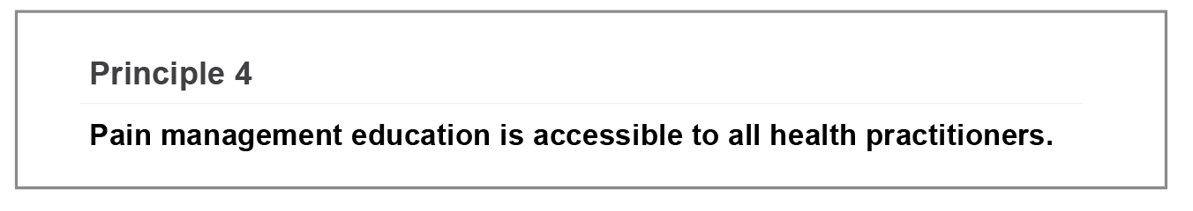

Centralising the development of teaching and learning resources can be an efficient way of reducing the cost by reducing duplication of effort and leveraging expertise across a broad range of organisations and disciplines. Making these resources adaptable and readily available as ‘share-ware’ would also ensure equity in access to quality materials. That said, it is crucial to consider the sustainability issues in maintaining shared resources.

Geographical location should not be a barrier to accessing high quality, relevant pain management education.

Technology has greatly enhanced accessibility to quality education across the vast distances of rural, regional and remote Australia. However, it is important to be aware of the fact that not all geographical areas are well supported by adequate technological infrastructure and not all health practitioners have access to the relevant resources on the ground. Other learning delivery mechanisms must be provided to avoid excluding educators and learners living and working in these circumstances.

Pain management education should be available across a broad range of education levels including: vocational education and training (VET); higher education; and continuing education through education institutions and health networks.

Large sectors of the community are cared for by workers with qualifications attained within the VET sector. Many of these are our most vulnerable groups including: aged care; disability; and Aboriginal and Torres Strait Islander communities. In order to improve the pain care of all Australians living with pain it is important that education solutions are offered to these workers.

Language should not be a barrier to accessing quality education.

Health practitioners, particularly those working within culturally diverse communities, may not have English as their first language. To ensure equity of access in these circumstances, it will be important to provide tailored teaching and learning resources and education.

### Goals

The following goals were derived through the process of iterative consultation and with a view to achieving broad, sustainable system and cultural change.

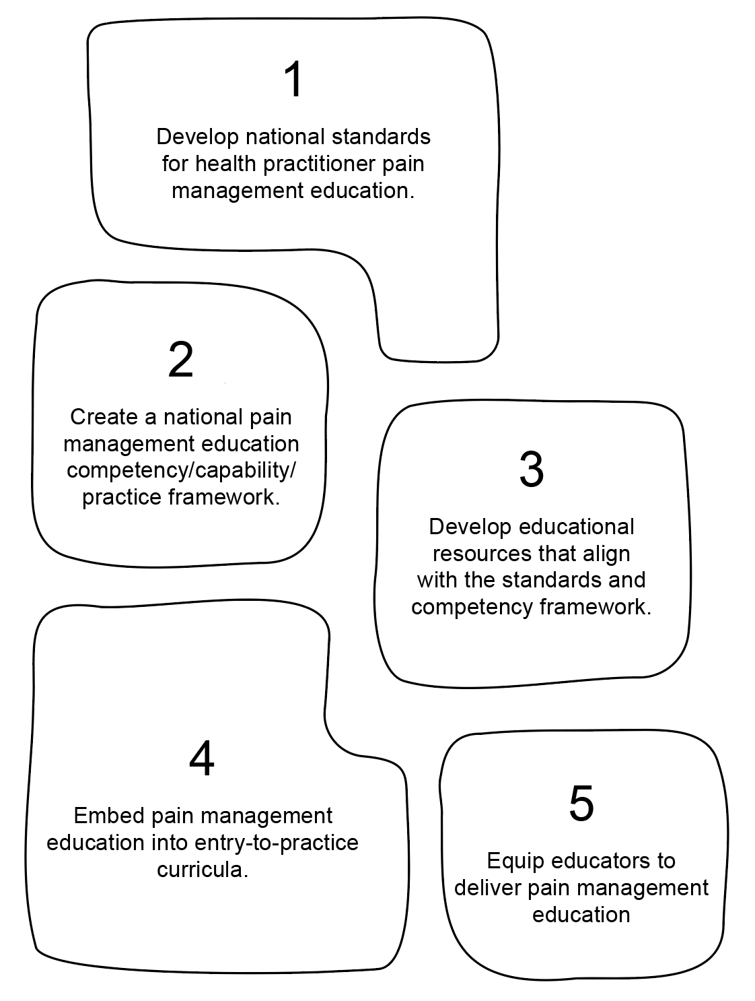

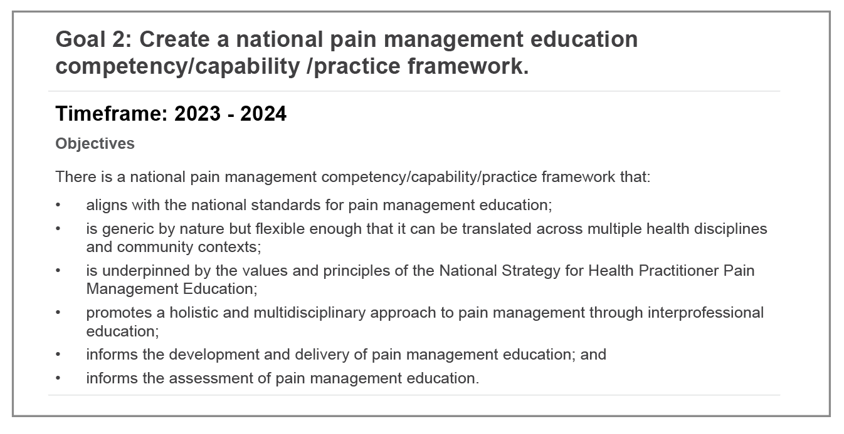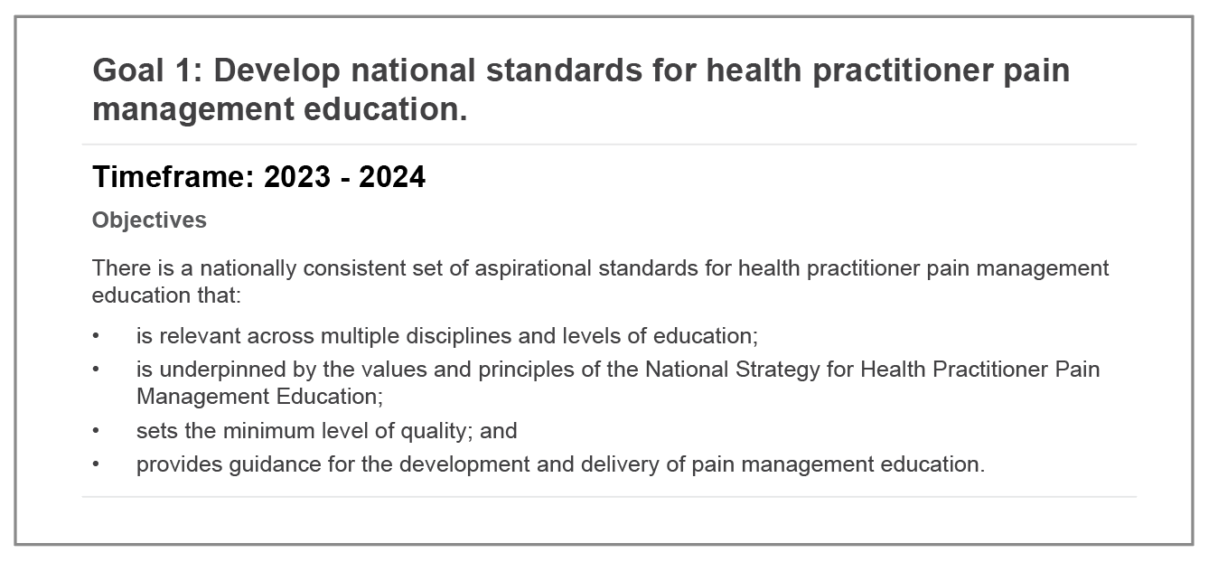A set of well-developed and accepted national standards for health practitioner pain management education should aim to inform policy, education and practice to improve the care of Australians living with pain. National standards will provide a framework for the development and delivery of pain management education, ensuring consistency across disciplines and education sectors. The standards will be a set of concise statements that act as quality markers for health practitioner pain management education. They will also provide a template for changing the way in which we develop and deliver pain education to ensure that it is accessible and relevant for all.

The development of a pain management competency framework (capability/practice framework), that can be applied across a range of health disciplines, education levels, and community contexts, will provide clear guidance to those creating education programs. A competency framework will need to be built on cross-disciplinary engagement and consensus and leverage existing competency frameworks nationally and internationally.

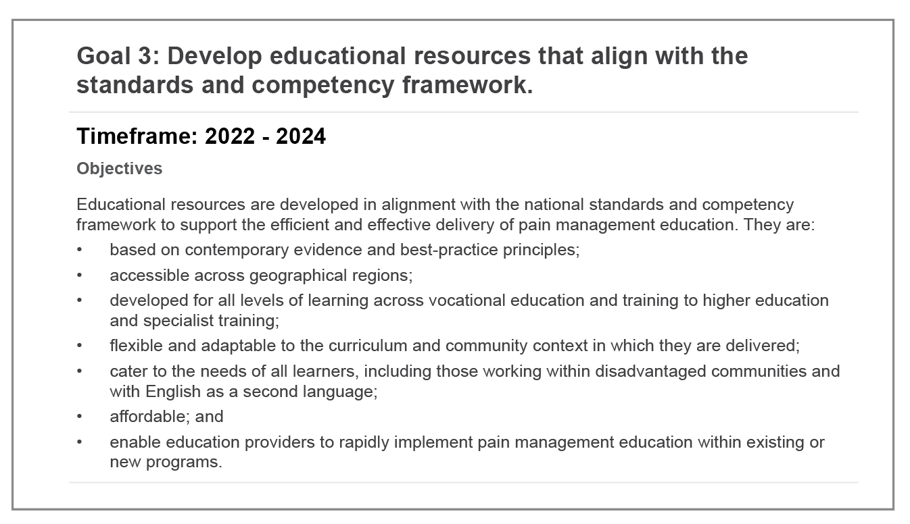

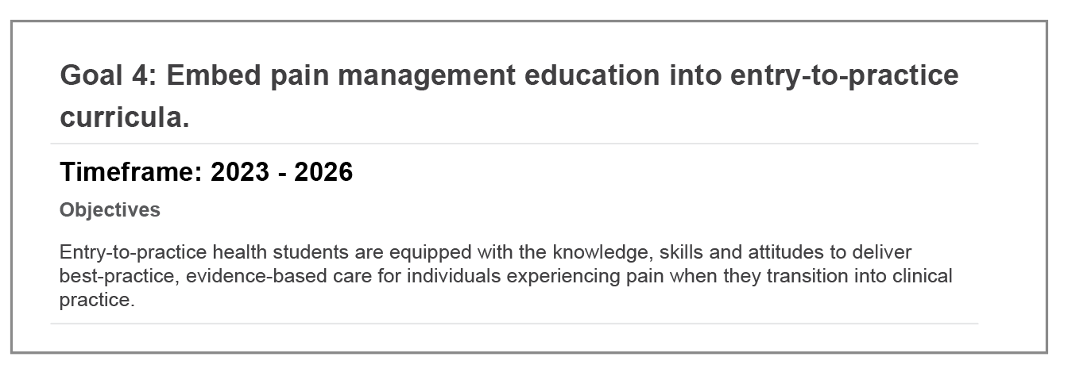Pain management education standards and competencies will directly inform the development of learning resources that are widely available. This will ensure a consistent quality and understanding across health disciplines and they should be underpinned by a common language and a philosophy that supports multidisciplinary pain care.

This is arguably the most ambitious of the strategy’s goals. Ensuring the inclusion of quality pain management education into already crowded entry-to-practice curricula, in a way that is consistent across disciplines, evidence- based, meaningful, and allows for appropriate scaffolding of learning within the framework of individual curriculum designs, is a great challenge. To improve pain care in Australia it is important that pain management content is incorporated across these programs, despite the challenges.

Equally challenging is moving the paradigm of pain care from the dominant ‘biomedical’ western health focus of many health curricula towards a more holistic, biopsychosocial one that incorporates the social, cultural and psychological dimensions of an individual’s experience of pain.

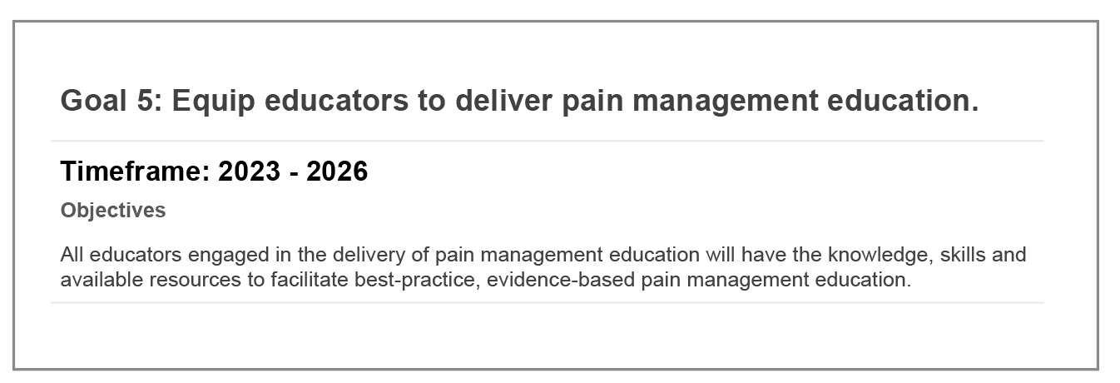Importantly, the first three goals of the strategy will be the ‘enablers’ of change in the entry-to-practice space and form the foundation on which this goal can be built.

Standards, competencies and resources cannot go all the way to delivering quality education across the health disciplines. With the exception of self-directed learning programs, most education environments rely on educators to compile and deliver curricula. One of the challenges for educators in the dynamic area of health care is staying up-to-date with current knowledge and real-world practice.

Pain management theory and practice have changed significantly over the last 15 years and educators will need to be supported in the translation and integration of contemporary knowledge and thinking into their teaching program. They will also need support in the identification of, and access to, effective teaching and learning methods to ensure optimum outcomes for their learners.

Implementation plan

GOAL 1: Develop national standards for pain management education.

|  |  |  |
| --- | --- | --- |
| Timeframe: 2023 - 2024 | | |
| Objectives / outcome measures | Recommended actions | Important considerations |
| There is a nationally consistent set of aspirational standards for health practitioner pain management education that:   * are relevant across multiple disciplines and levels of education; * are underpinned by the values and principles of the National Strategy for Health Practitioner Pain Management Education; * set the minimum level of quality; and * provide guidance in the development and delivery of pain management education. | * Review a range of national and   international standards and draw on these to inform the development of pain management education standards.   * Establish governance and collaborative partnerships to lead extensive stakeholder engagement and co- design. *(Must include consumers at the highest levels).* * Incorporate an iterative consultation process in the development of the standards. High levels of engagement with the right stakeholders will ensure that the standards developed will be relevant in the Australian context of pain care and support their translation into education. Early engagement will also build consensus. * Obtain high-level government and regulatory endorsement of the standards. * Develop and implement a ‘communication strategy’ to accompany the release of the standards. | * There are currently a number of national and international standards that could be drawn from to inform the development of Australian pain management education standards. Ensure alignment with other existing national standards where relevant, e.g: National Safety and Quality Health Service Standards. * Collaborative partnerships with Aboriginal and Torres Strait Islander groups should be formed at the highest level and support their right to self-determination with genuine shared decision making   and supporting the key elements of the *National Aboriginal and Torres Strait Islander Health Plan 2021–2031* (Commonwealth Government, 2021).   * Stakeholder engagement should be broad and include:   + health care consumers from across all sectors (aged care, Aboriginal and   Torres Strait Islander health; disability; culturally and linguistically diverse (CALD) communities; and young people (12-24 years);   * + representation of health disciplines engaged in the management of individuals experiencing pain, including those working with Aboriginal and Torres Strait Islander and CALD communities, paediatric and emerging adults sector, aged care and the disability sector; and   + educators and students from vocational education and training, higher education and specialist medical colleges as well as professional and clinical organisations (across entry-to- practice, postgraduate and continuing education). |
|  |  | * The content of the standards should be underpinned by educational best practice and provide a high-level framework to guide organisations in the application of pain management education. |

GOAL 2: Create a national pain management education competency/capability/practice framework.

|  |  |  |
| --- | --- | --- |
| Timeframe: 2023 - 2024 | | |
| Objectives / outcome measures  There is a national pain management competency framework that:   * aligns with the national standards for pain management education; * is generic by nature but flexible enough that it can be translated across   multiple health disciplines and community contexts;   * is underpinned by the values and principles of the National Strategy for Health Practitioner Pain Management Education; * promotes a holistic and multidisciplinary approach to pain management through interprofessional education; * informs the development and delivery of pain management education; and * informs the assessment of pain management education. | Recommended actions   * Give initial consideration as to whether it is   a ‘competency’ or ‘capability’ framework that is required.   * Review curricula and competency   frameworks nationally and internationally  for applicability in the Australian pain context. For example: IASP curricula.   * Undertake extensive stakeholder engagement and incorporate an iterative consultation process   in the development or refinement of the competencies.   * Obtain high-level government and regulatory endorsement of the competencies. * Develop a self- assessment tool, against the competencies, for existing practitioners to identify their own learning needs. * Develop and implement a dissemination and communication plan to   accompany the release of the competencies. | Important considerations   * It will be important to link with the concurrently funded project: *Commonwealth Grant for Health Professional Pain Education G02810* to build on work already underway in this competency space. * Other terms to consider may be ‘practice framework’ or ‘critical work functions’. Consider what would foster acceptance across a broad range of health education areas. * The framework should be interdisciplinary and outcomes- based, cutting across all levels of a clinician’s career. To achieve this, competencies need to be at   a high enough level to be generic and adaptable across a range of discipline contexts. Very specific, detailed competencies will restrict their usability.   * There should be alignment across regulatory bodies, industry and accreditation bodies to ensure   the framework is accepted. The framework should also focus on what people learn, with an  emphasis on individual reflection and life-long learning.   * Develop ‘champions’ through the stakeholder engagement process. Champions can assist with dissemination of information and in building buy-in across health disciplines and education sectors once the competency framework has been developed. |

GOAL 3: Develop educational resources that align with the standards and competency framework.

|  |  |  |
| --- | --- | --- |
| Timeframe: 2022 - 2024 | | |
| Objectives / outcome measures  Educational resources are developed in alignment with the national standards and competency framework to support the efficient and effective delivery of pain management education. They are:   * based on contemporary evidence and best-practice principles; * accessible across geographical regions; * developed for a range of levels of learning across vocational education and training to higher education and specialist training; * flexible and adaptable to the curriculum and   community context in which they are delivered;   * cater to the needs of all learners, including those working within disadvantaged communities and with English as a second language; * affordable; and * enable education providers to rapidly implement pain management education within existing or new programs. | Recommended actions   * Review the teaching resource needs of educators across sectors to enable the implementation / improvement of pain management education within their area. * Conduct a review of existing resources with a view to their:   + adequacy in meeting the national standards and competencies for pain management education (above);   + ability to be offered broadly and flexibly;   + appropriateness for different education levels: VET, higher education, and specialist education;   + ability to address the pain education needs of health workers providing care within disadvantaged community groups (e.g: Aboriginal and Torres Strait Islander, CALD, disability and aged-care sectors); and   + educational quality and use of contemporary teaching and learning approaches. * Identify resource gaps. * Develop ‘toolkits’ for pain management education for:  1. entry-to-practice programs; 2. postgraduate courses; and 3. continuing education.  * The toolkits should be aligned with the national standards and competencies for pain management and may include: simulation-based education scenarios; case-based learning exercises; stories from the consumer perspective; short online or written modules.   Toolkits should allow flexibility in delivery and the application of individual creativity on the part of the educator. | Important considerations   * It will be important to link with the concurrently funded project: *Commonwealth Grant for Health*   *Professional Pain Education G02810* to build on work already underway in this educational resource space.   * Special consideration should be given to the issue of ‘access’ in the development of resources, particularly within:   + rural, regional and remote environments where information technology infrastructure and resources may not be adequate;   + Aboriginal and Torres Strait Islander communities; and   + culturally and linguistically diverse communities. * In the entry-to-practice and postgraduate education spaces, it is recommended that education resources allow for appropriate integration within an existing   curriculum in a way that allows for horizontal and vertical integration of concepts and promotes the scaffolding of learning across a program. This may mean multiple  small learning resources rather than large discrete modules or units.   * Contemporary teaching and learning approaches can include online and simulation-based learning. * Storytelling by health consumers can be an extremely powerful teaching tool. It will be important to ensure a co-design framework in the development and delivery of these includes stories from within priority populations such as: Aboriginal and Torres Strait Islander communities; culturally and linguistically diverse communities; the disability and aged care sectors; rural, regional and remote communities; and children and young people. |

Continued on next page

GOAL 3: Develop educational resources that align with the standards and competency framework.

|  |  |
| --- | --- |
| Timeframe: 2022 - 2024 | |
| Recommended actions   * The toolkit should contain resources developed with, and for educators within: Aboriginal and Torres Strait Islander communities; the disability and aged-care sectors; and culturally and linguistically diverse communities; and paediatric and emerging adult settings. * Incorporate funding and sustainability processes into toolkit development. * Guidelines will be required for educators on how to appropriately apply the resources in their own area to achieve optimal outcomes for learners in alignment with the standards and competency requirements (*see Goal 5 below*). * Establish an educational resource portal to accommodate ready access to the toolkit. | Important considerations   * A focus on ‘interdisciplinary’ resources is encouraged, including resources that can be applied in education settings where interprofessional education may not be possible due to availability or logistics. In the latter situation, interdisciplinary case-based scenarios and simulations can provide valuable learning tools. * Sustainability of toolkits will need to be considered from the outset in terms of the: lifespan of a resource; process for revision and updating; and outcome evaluation and effectiveness. * Ensure that the pain educator toolkits are accessible for educators for whom English is not their first language. |

GOAL 4: Embed pain management education into entry-to-practice curricula.

|  |  |  |
| --- | --- | --- |
| Timeframe: 2023 - 2026 | | |
| Objectives / outcome measures  Entry-to-practice health students are equipped with the knowledge, skills and  attitudes to deliver best-practice, evidence-based care for individuals experiencing pain at a beginning practitioner level. | Recommended actions   * Form a high-level advisory group to guide the embedding of pain management education into entry-to-practice curricula in both VET and higher education programs. * Develop self-assessment tools for education providers (VET and higher education) to   evaluate the pain management content within their individual curricula, in line with the national standards and competencies.   * Connect education providers with a range of education resources that can be adapted to their curriculum. * Connect educators with the resources outlined in Goal 5 below. | Important considerations   * It will be essential that key regulatory bodies (VET and higher education) are engaged early in this process, whether on the high- level advisory group or in other stakeholder engagement activities. * Additionally, the high-level advisory group should include those who can speak to the educational needs of: Aboriginal and   Torres Strait Islander peoples; culturally and linguistically diverse communities; the aged care and disability sectors; and paediatric and emerging adults sector.   * Education institutions should be encouraged to:   + take an ‘integration and scaffolding’ approach when positioning pain related program within existing curricula;   + adapt the content of their pain management program to ensure that it is appropriate to the communities in which it is situated; and   + incorporate an interprofessional approach to teaching and learning in this space where practicable. |

GOAL 5: Equip educators to deliver pain management education.

|  |  |  |
| --- | --- | --- |
| Timeframe: 2023 - 2026 | | |
| Objectives / outcome measures | Recommended actions | Important considerations   * Engage incentives such as CPD points to encourage uptake. |
| All educators engaged in the delivery of pain management education will have the knowledge, skills and available resources to facilitate best-practice, evidence- based pain management education. | * Develop pain educator toolkits that provide guidance in relation to:   - the standards and competencies for pain management education; |
|  | - available evidence-based education resources; and |
|  | - appropriately introducing resources within their curriculum / program to maximise student learning outcomes. |
|  | * Establish a ‘community of practice’ to support educators to enable: |
|  | - networking; |
|  | - joint resource development and sharing; |
|  | - a platform for communication and dissemination of education, including webinars, podcasts and seminars; and |
|  | - the targeted use of social networking platforms for information sharing and connecting educators. |
|  | * Create a mentorship program and develop champions among educators. |

Conclusion

The National Strategy for Health Practitioner Pain Management Education forms a high-level roadmap for action over the next five to ten years to improve the quality and consistency of Australian health practitioners’ knowledge, attitudes, and skills in contemporary pain care. It addresses goal three of the *National Strategic Action Plan for Pain Management*.

Importantly, the strategy has been developed using an iterative, co-design approach and authentic partnerships with consumers, entry-to-practice students, and a wide range of other stakeholder groups focused on the needs of Australians living with pain. It is hoped that the strategy’s values, principles and goals are shared by all who are committed to providing high-quality pain care for the Australian community.

The strategy is grounded in contemporary educational principles and well-informed by the pain management education literature. Research shows that many clinicians acknowledge the need to utilise biopsychosocial principles in providing pain care, but lack the confidence, knowledge and skills to implement them. This strategy puts forward a high-level plan for an Australia-wide coordinated approach to pain management education across health disciplines and throughout the health practitioners’ career span, to address inconsistencies in approaches to pain management education, and lack of analysis of the impacts on clinical practice and consumer outcomes.

The strategy is wide-ranging. It should be read in conjunction with existing strategies (for example the *National Strategic Action Plan for Arthritis* and the *National Action Plan for Endometriosis*) and other initiatives focusing on framework development and benchmarking with a view to updating existing programs and customising training

to address different health practitioners’ needs and scopes of practice (for example the Commonwealth Funded Health Professional Pain Education (G02810) Grant). These activities provide the foundations for the development of new programs in the future.

The implementation plan has been formulated as a suite of targeted, achievable initiatives that can be taken up by different organisations on behalf of the health sector as a whole or targeted to particular learner groups. Funding from a range of sources including Commonwealth and state governments, and other community-based agencies, will be needed to support the delivery of the strategy to reach key target groups.

Project co-design with consumers is essential and evaluation of individual projects should include consumer- reported outcomes and be mapped against the objectives of the implementation plan, thereby measuring the progress of the strategy over time. Critically, concurrent high-quality research is needed on meaningful consumer outcomes and what models of interprofessional learning facilitate health practitioner engagement in optimal multi and interdisciplinary pain care.

Pain management education for health practitioners alone, however, will not be enough to address all the challenges facing Australians living with pain. This strategy intersects and supports broader health workforce plans. Appendix 1 provides a list of Australian health strategies and action plans.

Finally, pain awareness, health literacy, and pain management education are not the responsibilities of the healthcare and education systems alone. Well-established consumer-based organisations (Australian Pain Management Association, Chronic Pain Australia, Arthritis Foundation and many more) delivering the social support needed for healthy patient outcomes also have a clear role to play. This strategy is a living document and should be reviewed on a regular basis by all engaged in health practitioner pain management education in partnership with the Australian community.

Reference list

1. Raja SN, Carr DB, Cohen M, Finnerup NB, Flor H, Gibson S, et al. The revised IASP definition of pain: concepts, challenges, and compromises. Pain. 2020;161(9):1976.
2. Australian Government, Department of Health. National strategic action plan for pain management. Canberra: Department of Health (Australia); 2019.
3. Henderson JV, Harrison CM, Britt HC, Bayram CF, Miller GC. Prevalence, causes, severity, impact, and management of chronic pain in Australian general practice patients. Pain Med. 2013;14(9):1346-61.
4. Bond M. Pain education issues in developing countries and responses to them by the International Association for the Study of Pain. Pain Res Manag. 2011;16(6):404-6.
5. Bhadelia A, De Lima L, Arreola-Ornelas H, Kwete XJ, Rodriguez NM, Knaul FM. Solving the Global Crisis in Access to Pain Relief: Lessons From Country Actions. Am J Public Health. 2019;109(1):58-60.
6. World Health Organization. Guidelines on the management of chronic pain in children. Geneva: World Health Organization; 2020.
7. Vallath N, Rajagopal MR, Perera S, Khan F, Paudel BD, Tisocki K. Access to pain relief and essential opioids in the WHO South-East Asia region: challenges in implementing drug reforms. WHO South East Asia J Public Health. 2018;7(2):67-72.
8. Carr DB, Goudas LC. Acute pain. The Lancet. 1999;353(9169):2051-8.
9. Kent ML, Tighe PJ, Bruehl S, Turk DC, Dworkin RH. The ACTTION–APS–AAPM Pain Taxonomy (AAAPT) Diagnostic Criteria for Acute Pain Conditions: An Introduction. J Pain. 2019;20(7):743-5.
10. Edgley C, Hogg M, De Silva A, Braat S, Bucknill A, Leslie K. Severe acute pain and persistent post-surgical pain in orthopaedic trauma patients: a cohort study. Br J Anaesth. 2019;123(3):350-9.
11. Beloeil H, Sion B, Rousseau C, Albaladejo P, Raux M, Aubrun F, et al. Early postoperative neuropathic pain assessed by the DN4 score predicts an increased risk of persistent postsurgical neuropathic pain. Eur J Anaesthesiol. 2017;34(10):652-7.
12. Page MG, Katz J, Curtis K, Lutzky-Cohen N, Escobar EM, Clarke HA. Acute pain trajectories and the persistence of post-surgical pain: a longitudinal study after total hip arthroplasty. J Anesth. 2016;30(4):568-77.
13. Treede R-D, Rief W, Barke A, Aziz Q, Bennett MI, Benoliel R, et al. Chronic pain as a symptom or a disease: the IASP Classification of Chronic Pain for the International Classification of Diseases (ICD-11). Pain. 2019;160(1):19-27.
14. Morriss W, Roques C. Pain management in low-and middle-income countries. BJA education. 2018;18(9):265.
15. Searle RD, Simpson MP, Simpson KH, Milton R, Bennett MI. Can chronic neuropathic pain following thoracic surgery be predicted during the postoperative period? Interact cardiovasc thorac surg. 2009;9(6):999-1002.
16. Baca Q, Marti F, Poblete B, Gaudilliere B, Aghaeepour N, Angst MS. Predicting Acute Pain After Surgery A Multivariate Analysis. Ann Surg. 2021;273(2):289-98.
17. GBD 2019 Diseases and Injuries Collaborators. Global burden of 369 diseases and injuries in 204 countries and territories, 1990–2019: a systematic analysis for the Global Burden of Disease Study 2019. The Lancet. 2020;396(10258):1204-22.
18. Vos T, Lim S, Abbafati C, Abbas K, Abbasi M, Abbasifard M. Global burden of GBD 2019 Diseases and Injuries Collaborators. Global Health Metrics. Musculoskeletal disorders - Level 3 cause. Lancet. 2020;369:5162-3.
19. Vos T, Lim S, Abbafati C, Abbas K, Abbasi M, Abbasifard M. Global burden of disease 2019 Diseases and Injuries Collaborators. Global Health Metrics. Headache disorders – Level 2 cause. Lancet. 2020;369:5128-9.
20. Murray CJL, Abbafati C, Abbas KM, Abbasi M, Abbasi-Kangevari M, Abd-Allah F, et al. Five insights from the Global Burden of Disease Study 2019. The Lancet. 2020;396(10258):1135-59.
21. Soriano JB, Murthy S, Marshall JC, Relan P, Diaz JV, WHO Clinical Case Definition Working Group. A clinical case definition of post- COVID-19 condition by a Delphi consensus. The Lancet Infectious Diseases. 2021;22(4):e102–e7.
22. Centers for Disease Control, United States Government. Post-COVID- conditions. 2021 [Available from: [https://www.cdc.gov/](http://www.cdc.gov/) coronavirus/2019-ncov/long-term-effects/index.html#:~:text=Post%2DCOVID%20conditions%20are%20a,can%20have%20 post%2DCOVID%20conditions. (Accessed 29 April 2022).
23. National Institute for Health and Care Excellence (NICE), Scottish Intercollegiate Guidelines Network (SIGN), and Royal College of General Practitioners (RCGP). COVID-19 rapid guideline: managing the longterm effects of COVID-19, London: NICE; 2022 [updated V1.14, 1 March 2022]. Available from: [https://www.nice.org.uk/guidance/ng188/resources/covid19-rapid-guideline-managing-the-longterm-effects-of-covid19-](https://www.nice.org.uk/guidance/ng188/resources/covid19-rapid-guideline-managing-the-longterm-effects-of-covid19-pdf-51035515742) [pdf-51035515742](https://www.nice.org.uk/guidance/ng188/resources/covid19-rapid-guideline-managing-the-longterm-effects-of-covid19-pdf-51035515742) (Accessed 25 April 2022).
24. Huang L, Yao Q, Gu X, Wang Q, Ren L, Wang Y, et al. 1-year outcomes in hospital survivors with COVID-19: a longitudinal cohort study. The Lancet. 2021;398(10302):747-58.
25. Aiyegbusi OL, Hughes SE, Turner G, Rivera SC, McMullan C, Chandan JS, et al. Symptoms, complications and management of long-COVID: a review. J R Soc Med. 2021;114(9):428-42.
26. Ayoubkhani D. Prevalence of ongoing symptoms following coronavirus (COVID-19) infection in the UK: 1 April 2021. Off Natl Stat. 2021:1-16.
27. Magdy R, Eid RA, Fathy W, Abdel-Aziz MM, Ibrahim RE, Yehia A, et al. Characteristics and risk factors of persistent neuropathic pain in recovered COVID-19 patients. Pain Med. 2022;23(4):774-81.
28. Nalbandian A, Sehgal K, Gupta A, Madhavan MV, McGroder C, Stevens JS, et al. Post-acute COVID-19 syndrome. Nat Med. 2021;27(4):601- 15.
29. Miller A, Sanderson K, Bruno R, Breslin M, Neil AL. The prevalence of pain and analgesia use in the Australian population: Findings from the 2011 to 2012 Australian National Health Survey. Pharmacoepidemiology and drug safety. 2017;26(11):1403-10.
30. Blyth FM, March LM, Brnabic AJ, Jorm LR, Williamson M, Cousins MJ. Chronic pain in Australia: a prevalence study. Pain. 2001;89(2-3):127- 34.
31. Australian Institute of Health and Welfare. Chronic Pain in Australia. Canberra: Australian Institute of Health and Welfare; 2020.
32. Australian Bureau of Statistics. Population projections, Australia (2017 – 2066) 2018 [Available from: [https://www.abs.gov.au/statistics/people/](https://www.abs.gov.au/statistics/people/population/population-projections-australia) [population/population-projections-australia.](https://www.abs.gov.au/statistics/people/population/population-projections-australia) (Accessed 13 September 2021).
33. Deloitte Access Economics. The Cost of Pain in Australia. Canberra: Deloitte Access Economics; 2019.
34. Lin IB, Bunzli S, Mak DB, Green C, Goucke R, Coffin J, et al. Unmet needs of Aboriginal Australians with musculoskeletal pain: a mixed- method systematic review. Arthritis Care & Research. 2018;70(9):1335-47.
35. Australian Institute of Health and Welfare. Profile of Indigenous Australians 2020 [Available from: [https://www.aihw.gov.au/reports/australias-](https://www.aihw.gov.au/reports/australias-health/profile-of-indigenous-australians) [health/profile-of-indigenous-australians.](https://www.aihw.gov.au/reports/australias-health/profile-of-indigenous-australians) (Accessed 10 October 2021).
36. Australian Institute of Health and Welfare. Rural & remote health 2019 [Available from: [https://www.aihw.gov.au/reports/rural-remote-](https://www.aihw.gov.au/reports/rural-remote-australians/rural-remote-health/contents/summary) [australians/rural-remote-health/contents/summary](https://www.aihw.gov.au/reports/rural-remote-australians/rural-remote-health/contents/summary). (Accessed 31 May 2022).
37. Rowlands I, Abbott J, Montgomery G, Hockey R, Rogers P, Mishra G. Prevalence and incidence of endometriosis in Australian women: a data linkage cohort study. BJOG. 2021;128(4):657-65.
38. The National Osteoarthritis Strategy Project Group. National Osteoarthritis Strategy. Sydney, Australia: University of Sydney; 2018.
39. Australian Institute of Health and Welfare. Burden of Disease: Australia’s Health 2020 [Available from: [https://www.aihw.gov.au/reports/](https://www.aihw.gov.au/reports/australias-health/burden-of-disease) [australias-health/burden-of-disease.](https://www.aihw.gov.au/reports/australias-health/burden-of-disease) (Accessed 17 August 2021).
40. Macrae W. Chronic post-surgical pain: 10 years on. Br J Anaesth. 2008;101(1):77-86.
41. Crombie IK, Davies HTO, Macrae WA. Cut and thrust: antecedent surgery and trauma among patients attending a chronic pain clinic. Pain. 1998;76(1-2):167-71.
42. Gan TJ. Poorly controlled postoperative pain: prevalence, consequences, and prevention. J Pain Res. 2017;10:2287.
43. Glare P, Aubrey KR, Myles PS. Transition from acute to chronic pain after surgery. The Lancet. 2019;393(10180):1537-46.
44. National Rural Health Alliance Ltd. Allied health workforce in rural, regional & remote Australia. 2019 [Available from: [https://www.ruralhealth.](https://www.ruralhealth.org.au/sites/default/files/publications/fact-sheet-allied-health.pdf) [org.au/sites/default/files/publications/fact-sheet-allied-health.pdf](https://www.ruralhealth.org.au/sites/default/files/publications/fact-sheet-allied-health.pdf) (Accessed 2 May 2022).
45. Wilkins R, Lass I. The household, income and labour dynamics in Australia survey: Selected findings from waves 1 to 16. 2018.
46. Kennedy AJ, Adams J, Dwyer J, Brumby S. Rural suicide risk and physical ill health: A qualitative study of the Victorian Suicide Register, 2009-2015. Aust J Rural Health. 2021;29(6):927-38.
47. Australian Bureau of Statistics. Patient experiences in Australia: Summary of findings, 2021 [Available from: [https://www](http://www.abs.gov.au/statistics/).abs.gov[.au/statistics/](http://www.abs.gov.au/statistics/) health/health-services/patient-experiences-australia-summary-findings/latest-release#key-statistics. (Accessed 18 December 2021).
48. McManamny TE, Dwyer R, Cantwell K, Boyd L, Sheen J, Smith K, et al. Emergency ambulance demand by older adults from rural and regional Victoria, Australia. Australas J Ageing. 2022;41(1):e74-e81.
49. Mesa-Castrillon CI, Simic M, Ferreira ML, Hatswell K, Luscombe G, de Gregorio AM, et al. EHealth to empower patients with musculoskeletal pain in rural Australia (EMPoweR) a randomised clinical trial: study protocol. BMC Musculoskelet Disord. 2021;22(1):1-11.
50. Scriven H, Doherty DP, Ward EC. Evaluation of a multisite telehealth group model for persistent pain management for rural/remote participants. Rural Remote Health. 2019;19(1):[17]-[30].
51. Australian Institute of Health and Welfare. Health of Older People, 2020 [Available from: [https://www.aihw.gov.au/reports/australias-health/](https://www.aihw.gov.au/reports/australias-health/health-of-older-people) [health-of-older-people.](https://www.aihw.gov.au/reports/australias-health/health-of-older-people)
52. Perquin CW, Hunfeld JA, Hazebroek-Kampschreur AA, van Suijlekom-Smit LW, Passchier J, Koes BW, et al. Insights in the use of health care services in chronic benign pain in childhood and adolescence. Pain. 2001;94(2):205-13.
53. King S, Chambers CT, Huguet A, MacNevin RC, McGrath PJ, Parker L, et al. The epidemiology of chronic pain in children and adolescents revisited: a systematic review. Pain. 2011;152(12):2729-38.
54. Henschke N, Harrison C, McKay D, Broderick C, Latimer J, Britt H, et al. Musculoskeletal conditions in children and adolescents managed in Australian primary care. BMC Musculoskelet Disord. 2014;15(1):1-8.
55. Brown D, Schenk S, Genent D, Zernikow B, Wager J. A scoping review of chronic pain in emerging adults. Pain reports. 2021;6(1).
56. Kairuz CA, Casanelia LM, Bennett-Brook K, Coombes J, Yadav UN. Impact of racism and discrimination on physical and mental health among Aboriginal and Torres Strait islander peoples living in Australia: a systematic scoping review. BMC public health. 2021;21(1):1-16.
57. Australian Bureau of Statistics. Stressors, by Sex and Remoteness, Aboriginal and Torres Strait Islander Persons Aged 15 Years and Over—2014–2015, Proportion of Persons [Table 14.3]. In National Aboriginal and Torres Strait Islander Social Survey 2014–2015. Canberra, Australia.: Australian Bureau of Statistics.; 2017.
58. Arthur L, Rolan P. A systematic review of western medicine’s understanding of pain experience, expression, assessment, and management for Australian Aboriginal and Torres Strait Islander Peoples. Pain rep. 2019;4(6).
59. Paradies Y. Colonisation, racism and indigenous health. J Popul Res. 2016;33(1):83-96.
60. Thurber KA, Colonna E, Jones R, Gee GC, Priest N, Cohen R, et al. Prevalence of everyday discrimination and relation with wellbeing among Aboriginal and Torres Strait Islander adults in Australia. Int J Environ Res Public Health. 2021;18(12):6577.
61. Henderson S, Kendall E. Culturally and linguistically diverse peoples’ knowledge of accessibility and utilisation of health services: exploring the need for improvement in health service delivery. Aust J Prim Health. 2011;17(2):195-201.
62. Brady B, Veljanova I, Chipchase L. An exploration of the experience of pain among culturally diverse migrant communities. Rheumatol Adv Pract. 2017;1(1):rkx002.
63. Owens A, Holroyd BR, McLane P. Patient race, ethnicity, and care in the emergency department: a scoping review. CJEM. 2020;22(2):245-53.
64. International Organisation for Migration & United Nations. World migration report. Geneva, Switzerland: International Organization for Migration; 2020.
65. Biddle N, Kennedy S, McDonald JT. Health assimilation patterns amongst Australian immigrants. Economic Record. 2007;83(260):16-30.
66. Anderson KO, Green CR, Payne R. Racial and ethnic disparities in pain: causes and consequences of unequal care. J Pain. 2009;10(12):1187-204.
67. Komaric N, Bedford S, Van Driel ML. Two sides of the coin: patient and provider perceptions of health care delivery to patients from culturally and linguistically diverse backgrounds. BMC Health Serv Res. 2012;12(1):1-14.
68. De Silva T, Hodges PW, Costa N, Setchell J. Potential Unintended Effects of Standardized Pain Questionnaires: A Qualitative Study. Pain Med. 2020;21(2):e22-e33.
69. Brady B, Veljanova I, Chipchase L. Are multidisciplinary interventions multicultural? A topical review of the pain literature as it relates to culturally diverse patient groups. Pain. 2016;157(2):321-8.
70. Harlacher U, Nordin L, Polatin PB. Torture survivors’ symptom load compared to chronic pain and psychiatric in-patients. Torture. 2016;26(2):74-8.
71. Kaur G. Chronic pain in refugee torture survivors. Journal of global health. 2017;7(2):010303.
72. Williams ACdC, Peña CR, Rice AS. Persistent pain in survivors of torture: a cohort study. J Pain Symptom Manage. 2010;40(5):715-22.
73. Australian Institute of Health and Welfare. People with disability in Australia: in brief. Cat. no. DIS 77. Canberra: Australian Institute of Health and Welfare; 2020.
74. McGuire B, Daly P, Smyth F. Chronic pain in people with an intellectual disability: under-recognised and under-treated? J Intellect Disabil Res. 2010;54(3):240-5.
75. McGuire BE, Kennedy S. Pain in people with an intellectual disability. Curr Opin Psychiatry. 2013;26(3):270-5.
76. Penner M, Xie WY, Binepal N, Switzer L, Fehlings D. Characteristics of pain in children and youth with cerebral palsy. Pediatrics. 2013;132(2):e407-e13.
77. Down Syndrome Australia. Down Syndrome population statistics. [Available from: <https://www.downsyndrome.org.au/> (Accessed 19 September 2021).
78. Ostojic K, Paget SP, Morrow AM. Management of pain in children and adolescents with cerebral palsy: a systematic review. Dev Med Child Neurol. 2019;61(3):315-21.
79. Barney CC, Andersen RD, Defrin R, Genik LM, McGuire BE, Symons FJ. Challenges in pain assessment and management among individuals with intellectual and developmental disabilities. Pain reports. 2020;5(4):e821.
80. Hartvigsen J, Hancock MJ, Kongsted A, Louw Q, Ferreira ML, Genevay S, et al. What low back pain is and why we need to pay attention. The Lancet. 2018;391(10137):2356-67.
81. Franklin GM, Wickizer TM, Coe NB, Fulton-Kehoe D. Workers’ compensation: poor quality health care and the growing disability problem in the United States. Am J Ind Med. 2015;58(3):245-51.
82. Asih S, Neblett R, Mayer TG, Gatchel RJ. Does the length of disability between injury and functional restoration program entry affect treatment outcomes for patients with chronic disabling occupational musculoskeletal disorders? J Occup Rehabil. 2018;28(1):57-67.
83. von Schroeder H, Xue C, Yak A, Gandhi R. Factors associated with unsuccessful return-to-work following work-related upper extremity injury. Occup Med. 2020;70(6):434-8.
84. Orhurhu VJ, Pittelkow TP, Hooten WM. Prevalence of smoking in adults with chronic pain. Tob Induc Dis. 2015;13(1):17.
85. Okifuji A, Hare BD. The association between chronic pain and obesity. J Pain Res. 2015;8:399-408.
86. Gilmartin-Thomas JF, Cicuttini FM, Owen AJ, Wolfe R, Ernst ME, Nelson MR, et al. Moderate or severe low back pain is associated with body mass index amongst community-dwelling older Australians. Arch Gerontol Geriatr. 2020;91:104231.
87. Commonwealth of Australia. National action plan for endometriosis. Department of Health Canberra, Australia; 2018.
88. Allingham S, Blanchard M, Tardif H, Quinsey K, Bryce M, Cameron K, et al. Electronic persistent pain outcomes collaboration annual data report 2019. Australian Health Services Research Institute, University of Wollongong; 2020.
89. Felitti VJ, Anda RF, Nordenberg D, Williamson DF, Spitz AM, Edwards V, et al. Relationship of childhood abuse and household dysfunction to many of the leading causes of death in adults: The adverse childhood experiences (ACE) study. Am J Prev Med. 2019;56(6):774-86.
90. Flehr A, Coles J, Dixon JB, Gibson SJ, Brilleman SL, Harris ML, et al. Epidemiology of Trauma History and Body Pain: A Retrospective Study of Community-Based Australian Women. Pain Med. 2021;22(9):1916-29.
91. de Sola H, Salazar A, Dueñas M, Ojeda B, Failde I. Nationwide cross-sectional study of the impact of chronic pain on an individual’s employment: relationship with the family and the social support. BMJ open. 2016;6(12):e012246.
92. Soldatic K, Bowman D, Mupanemunda M, McGee P. Dead ends: how our social security system is failing people with partial capacity to work. Sydney, Australia: University of Western Sydney; 2021.
93. Bartys S, Frederiksen P, Bendix T, Burton K. System influences on work disability due to low back pain: an international evidence synthesis. Health Policy. 2017;121(8):903-12.
94. Russo F, De Salvatore S, Ambrosio L, Vadalà G, Fontana L, Papalia R, et al. Does Workers’ Compensation Status Affect Outcomes after Lumbar Spine Surgery? A Systematic Review and Meta-Analysis. Int J Environ Res Public Health. 2021;18(11):6165.
95. Nunnari P, Ceccarelli G, Ladiana N, Notaro P. Prescribing cascades and medications most frequently involved in pain therapy: a review. Eur Rev Med Pharmacol Sci. 2021;25(2):1034-41.
96. Bell J, Wilson A, Elshaug A, Nassar N. How are we assessing the safety and quality use of medicines used by young people in Australia? J Paediatr Child Health. 2018;54(7):718-9.
97. Gazarian M, Kelly M, McPhee JR, Graudins LV, Ward RL, Campbell TJ. Off-label use of medicines: consensus recommendations for evaluating appropriateness. Med J Aust. 2006;185(10):544-8.
98. van der Zanden TM, Mooij MG, Vet NJ, Neubert A, Rascher W, Lagler FB, et al. Benefit-Risk Assessment of Off-Label Drug Use in Children: The Bravo Framework. Clin Pharmacol Ther. 2021;110(4):952-65.
99. Australian New Zealand College of Anaesthetists. Use of “off label” or drugs beyond licence in pain medicine 2007 [Available from: [https://](https://www.anzca.edu.au/resources/professional-documents/guidelines/use-of-off-label-or-drugs-beyond-licence-in-pain-m) [www.anzca.edu.au/resources/professional-documents/guidelines/use-of-off-label-or-drugs-beyond-licence-in-pain-m.](https://www.anzca.edu.au/resources/professional-documents/guidelines/use-of-off-label-or-drugs-beyond-licence-in-pain-m) (Accessed 2 May 2022).
100. Mathieson S, Wertheimer G, Maher CG, Christine Lin CW, McLachlan AJ, Buchbinder R, et al. What proportion of patients with chronic noncancer pain are prescribed an opioid medicine? Systematic review and meta-regression of observational studies. J Intern Med. 2020;287(5):458-74.
101. Kaboré JL, Saïdi H, Dassieu L, Choinière M, Pagé MG. Predictors of Long-Term Opioid Effectiveness in Patients With Chronic Non-Cancer Pain Attending Multidisciplinary Pain Treatment Clinics: A Quebec Pain Registry Study. Pain Pract. 2020;20(6):588-99.
102. Krebs EE, Gravely A, Nugent S, Jensen AC, DeRonne B, Goldsmith ES, et al. Effect of Opioid vs Nonopioid Medications on Pain- Related Function in Patients With Chronic Back Pain or Hip or Knee Osteoarthritis Pain: The SPACE Randomized Clinical Trial. JAMA. 2018;319(9):872-82.
103. Shah D, Zhao X, Wei W, Gandhi K, Dwibedi N, Webster L, et al. A longitudinal study of the association of opioid use with change in pain interference and functional limitations in a nationally representative cohort of adults with osteoarthritis in the United States. Adv Ther. 2020;37(2):819-32.
104. Colvin LA, Bull F, Hales TG. Perioperative opioid analgesia—when is enough too much? A review of opioid-induced tolerance and hyperalgesia. The Lancet. 2019;393(10180):1558-68.
105. Els C, Jackson TD, Kunyk D, Lappi VG, Sonnenberg B, Hagtvedt R, et al. Adverse events associated with medium- and long-term use of opioids for chronic non-cancer pain: an overview of Cochrane Reviews. Cochrane Database Syst Rev. 2017;10:CD012509.
106. Fountas A, Chai ST, Kourkouti C, Karavitaki N. MECHANISMS OF ENDOCRINOLOGY: Endocrinology of opioids. Eur J Endocrinol. 2018;179(4):R183-R96.
107. Harned M, Sloan P. Safety concerns with long-term opioid use. Expert Opin Drug Saf. 2016;15(7):955-62.
108. Penington Institute. Australia’s Annual Overdose Report. Melbourne: Penington Institute; 2021.
109. Varrassi G, Yeam CT, Rekatsina M, Pergolizzi JV, Zis P, Paladini A. The Expanding Role of the COX Inhibitor/Opioid Receptor Agonist
110. Combination in the Management of Pain. Drugs. 2020;80(14):1443-53.
111. O’Connell NE, Ferraro MC, Gibson W, Rice AS, Vase L, Coyle D, et al. Implanted spinal neuromodulation interventions for chronic pain in adults. Cochrane Database of Systematic Reviews. 2021(12):CD013766.
112. Jonas WB, Crawford C, Colloca L, Kaptchuk TJ, Moseley B, Miller FG, et al. To what extent are surgery and invasive procedures effective beyond a placebo response? A systematic review with meta-analysis of randomised, sham controlled trials. BMJ open. 2015;5(12):e009655.
113. Liu B, Jayasundara D, Pye V, Dobbins T, Dore GJ, Matthews G, et al. Whole of population-based cohort study of recovery time from COVID-19 in New South Wales Australia. The Lancet Regional Health-Western Pacific. 2021;12:100193.
114. Angeles MR, Wanni Arachchige Dona S, Nguyen HD, Le LK-D, Hensher M. Modelling the potential acute and post-acute burden of COVID-19 under the Australian border re-opening plan. BMC public health. 2022;22(1):1-13.
115. Karaarslan F, Güneri FD, Kardeş S. Long-COVID: Rheumatologic/musculoskeletal symptoms in hospitalized COVID-19 survivors at 3 and 6 months. Clin Rheumatol. 2022;41(1):289-96.
116. Nguyen NN, Hoang VT, Dao TL, Dudouet P, Eldin C, Gautret P. Clinical patterns of somatic symptoms in patients suffering from post-acute long-COVID: a systematic review. Eur J Clin Microbiol Infect Dis. 2022:1-31.
117. Asadi-Pooya AA, Akbari A, Emami A, Lotfi M, Rostamihosseinkhani M, Nemati H, et al. Risk Factors Associated with Long-COVID Syndrome: A Retrospective Study. Iran J Med Sci. 2021;46(6):428.
118. Office of National Statistics United Kingdom. Statistical bulletin. Prevalence of ongoing symptoms following coronavirus (COVID-19) infection in the UK: 7 April 2022. Estimates of the prevalence of self-reported long-COVID and associated activity limitation, using UK Coronavirus (COVID-19) Infection Survey data. 2022.
119. Victorian SARS-CoV-2 Reinfection Study Group, Minko C, Haile F, Gu J, Kidd D, Cross M, et al. Second SARS-CoV-2 infections twelve months after initial infections in Australia, confirmed by genomic analysis. Med J Aust. 2022;216(4):199-201.
120. D’Souza RS, Kilgore AE, D’Souza S. Manifestations of Pain During the COVID-19 Pandemic Portrayed on Social Media: A Cross-Sectional Study. Pain Med. 2022;23(2):229-33.
121. Thompson CM, Rhidenour KB, Blackburn KG, Barrett AK, Babu S. Using crowdsourced medicine to manage uncertainty on Reddit: The case of COVID-19 long-haulers. Patient Educ Couns. 2022;105(2):322-30.
122. Jarrott B, Head R, Pringle KG, Lumbers ER, Martin JH. “LONG-COVID”—A hypothesis for understanding the biological basis and pharmacological treatment strategy. Pharmacol Res Perspect. 2022;10(1):e00911.
123. Seidler AL, Aberoumand M, Williams JG, Tan A, Hunter KE, Webster A. The landscape of COVID-19 trials in Australia. Med J Aust. 2021;215(2):58-61.e1.
124. Leeuw E, Yashadhana A, Hitch D. Long-COVID: sustained and multiplied disadvantage. Med J Aust. 2022;216(5):222-4.
125. Tuan W-J, Spotts H, Zgierska AE, Lennon RP. COVID-19 outcomes among adult patients treated with long-term opioid therapy for chronic non-cancer pain in the USA: a retrospective cohort study. BMJ open. 2021;11(11):e056436.
126. Henschke N, Kamper SJ, Maher CG. The epidemiology and economic consequences of pain. Mayo Clin Proc. 2015;90(1):139-47.
127. Lord SM, Tardif HP, Kepreotes EA, Blanchard M, Eagar K. The Paediatric electronic Persistent Pain Outcomes Collaboration (PaedePPOC): establishment of a binational system for benchmarking children’s persistent pain services. Pain. 2019;160(7):1572-85.
128. Palermo TM. Impact of recurrent and chronic pain on child and family daily functioning: a critical review of the literature. J Dev Behav Pediatr. 2000;21(1):58-69.
129. Hogan M-E, Taddio A, Katz J, Shah V, Krahn M. Incremental health care costs for chronic pain in Ontario, Canada: a population-based matched cohort study of adolescents and adults using administrative data. Pain. 2016;157(8):1626-33.
130. Sleed M, Eccleston C, Beecham J, Knapp M, Jordan A. The economic impact of chronic pain in adolescence: methodological considerations and a preliminary costs-of-illness study. Pain. 2005;119(1-3):183-90.
131. Henderson J, Brownlie E, Rosenkranz S, Chaim G, Beitchman J. Integrated Knowledge Translation and Grant Development: Addressing the Research Practice Gap through Stakeholder-informed Research. J Can Acad Child Adolesc Psychiatry. 2013;22(4):268-74.
132. Giusti EM, Castelnuovo G, Molinari E. Differences in multidisciplinary and interdisciplinary treatment programs for fibromyalgia: a mapping review. Pain Res Manag. 2017;2017:7261468.
133. Ng W, Slater H, Starcevich C, Wright A, Mitchell T, Beales D. Barriers and enablers influencing healthcare professionals’ adoption of a biopsychosocial approach to musculoskeletal pain: a systematic review and qualitative evidence synthesis. Pain. 2021;162(8):2154-85.
134. NSW Agency for Clinical Innovation. Management of people with acute low back pain: model of care. Chatswood. 2016.
135. Australian Commission on Safety and Quality in Health Care. Low Back Pain Clinical Care Standard. 2022 [Available from: [https://www.](https://www.safetyandquality.gov.au/standards/clinical-care-standards/low-back-pain-clinical-care-standard) [safetyandquality.gov.au/standards/clinical-care-standards/low-back-pain-clinical-care-standard.](https://www.safetyandquality.gov.au/standards/clinical-care-standards/low-back-pain-clinical-care-standard) (Accessed 1 September 2022).
136. Royal Australian and New Zealand College of Obstetrics and Gynaecology. Australian clinical practice guideline for the diagnosis and management of endometriosis. Melbourne, Australia: RANZCOG; 2021.
137. Hogg MN, Kavanagh A, Farrell MJ, Burke AL. Waiting in pain II: an updated review of the provision of persistent pain services in Australia. Pain Med. 2021;22(6):1367-75.
138. Toye F, Seers K, Barker KL. Meta-ethnography to understand healthcare professionals’ experience of treating adults with chronic non- malignant pain. BMJ open. 2017;7(12):e018411.
139. De Ruddere L, Craig KD. Understanding stigma and chronic pain: a-state-of-the-art review. Pain. 2016;157(8):1607-10.
140. Lyons A. Silence and stigma: Living with chronic pain. newsGP. 23 July 2019 [Available from: [https://www1.racgp.org.au/newsgp/clinical/](https://www1.racgp.org.au/newsgp/clinical/silence-and-stigma-managing-chronic-pain) [silence-and-stigma-managing-chronic-pain.](https://www1.racgp.org.au/newsgp/clinical/silence-and-stigma-managing-chronic-pain) (Accessed 2 May 2022).
141. Ward H, Flower B, Garcia PJ, Ong SWX, Altmann DM, Delaney B, et al. Global surveillance, research, and collaboration needed to improve understanding and management of long-COVID. The Lancet. 2021;398(10316):2057-9.
142. Calpin P, Imran A, Harmon D. A comparison of expectations of physicians and patients with chronic pain for pain clinic visits. Pain Pract. 2017;17(3):305-11.
143. Rankin L, Stålnacke B-M, Fowler CJ, Gallego G. Differences in Swedish and Australian medical student attitudes and beliefs about chronic pain, its management, and the way it is taught. Scand J Pain. 2018;18(3):533-44.
144. Singla M, Jones M, Edwards I, Kumar S. Physiotherapists’ assessment of patients’ psychosocial status: are we standing on thin ice? A qualitative descriptive study. Manual Ther. 2015;20(2):328-34.
145. Twigg OC, Byrne DG. The influence of contextual variables on judgments about patients and their pain. Pain Med. 2015;16(1):88-98.
146. Truong M, Allen D, Chan J, Paradies Y. Racism complaints in the Australian health system: an overview of existing approaches and some recommendations. Aust Health Rev. 2021;46(1):1-4.
147. Allerton L, Emerson E. British adults with chronic health conditions or impairments face significant barriers to accessing health services. Public health. 2012;126(11):920-7.
148. Alhusein N, Macaden L, Smith A, Stoddart KM, Taylor AJ, Killick K, et al. ‘Has she seen me?’: a multiple methods study of the pharmaceutical care needs of older people with sensory impairment in Scotland. BMJ open. 2018;8(8):e023198.
149. Gur K, Dolaner G, Turan SR. Health literacy of hearing-impaired adolescents, barriers and misunderstandings they encounter, and their expectations. Disabil Health J. 2020;13(4):100929.
150. Heine C, Gong CH, Feldman S, Browning C. Older women in Australia: facing the challenges of dual sensory loss. International journal of environmental research and public health. 2020;17(1):263.
151. Fitzgerald K, Vaughan B, Fleischmann M, Austin P. Pain knowledge, attitudes and beliefs of Australian osteopaths drawn from a nationally representative sample of the profession. J Bodyw Mov Ther. 2020;24(4):43-50.
152. Shipton EE, Bate F, Garrick R, Steketee C, Visser EJ. Pain medicine content, teaching and assessment in medical school curricula in Australia and New Zealand. BMC Medical Education. 2018;18(1):110.
153. Phillips JL, Lovell M, Luckett T, Agar M, Green A, Davidson P. Australian survey of current practice and guideline use in adult cancer pain assessment and management: the community nurse perspective. Collegian. 2015;22(1):33-41.
154. Williams CM, Maher CG, Hancock MJ, McAuley JH, McLachlan AJ, Britt H, et al. Low back pain and best practice care: a survey of general practice physicians. Arch Intern Med. 2010;170(3):271-7.
155. Walsh TP, Ferris LR, Cullen NC, Bourke JL, Cooney MJ, Gooi CK, et al. Management of musculoskeletal foot and ankle conditions prior to public-sector orthopaedic referral in South Australia. J Foot Ankle Res. 2019;12(1):1-9.
156. Australian Institute of Health and Welfare. Medicare-subsidised GP, allied health and specialist health care across local areas: 2019–20 to 2020–21.: Australian Government,; 2021 [Available from: [https://www.aihw.gov.au/reports/primary-health-care/medicare-subsidised-health-](https://www.aihw.gov.au/reports/primary-health-care/medicare-subsidised-health-local-areas-2020-21/contents/about) [local-areas-2020-21/contents/about.](https://www.aihw.gov.au/reports/primary-health-care/medicare-subsidised-health-local-areas-2020-21/contents/about) (Accessed 12 April 2022).
157. Allied Health Professions Australia. Treasury Pre-budget submission 2021-22. Melbourne: Allied Health Professions Australia, ; 2021.
158. Australian Government Department of Health. The Pharmaceutical Benefits Scheme: About the PBS [Available from: [https://www.pbs.gov.au/](https://www.pbs.gov.au/info/about-the-pbs) [info/about-the-pbs.](https://www.pbs.gov.au/info/about-the-pbs) (Accessed 12 June 2022).
159. Penington Institute. Penington Institute calls for strong action on pregabalin (Lyrica®). 2019 [Available from: [https://www.penington.org.au/](https://www.penington.org.au/penington-institute-calls-for-strong-action-on-pregabalin-lyrica/) [penington-institute-calls-for-strong-action-on-pregabalin-lyrica/.](https://www.penington.org.au/penington-institute-calls-for-strong-action-on-pregabalin-lyrica/) (Accessed 12 June 2022).
160. Therapeutic Goods Administration, Australian Government. Prescription opioids: Information for health practitioners. Why the changes are being made. 2021 [Available from: [https://www.tga.gov.au/prescription-opioids-information-health-professionals.](https://www.tga.gov.au/prescription-opioids-information-health-professionals) (Accessed 18 April 2022).
161. Australian Bureau of Statistics. Patient experiences in Australia: Summary of findings. 2021 [Available from: [https://www](http://www.abs.gov.au/statistics/).abs.gov[.au/statistics/](http://www.abs.gov.au/statistics/) health/health-services/patient-experiences-australia-summary-findings/latest-release#key-statistics. (Accessed 18 December 2021).
162. Giummarra MJ, Ioannou L, Ponsford J, Cameron PA, Jennings PA, Gibson SJ, et al. Chronic pain following motor vehicle collision. Clin J Pain. 2016;32(9):817-27.
163. De Morgan S, Walker P, Blyth F. Mapping of Chronic Pain Initiatives in Primary Health Networks: Summary of Findings from Consultation with PHNs: The Australian Prevention Partnership Centre and Menzies Centre for Health Policy. Sydney, Australia. 2019.
164. Walker P, De Morgan S, Sanders D, Nicholas M, Blyth FM. Primary care initiatives focused on the secondary prevention and management of chronic pain: a scoping review of the Australian literature. Aust J Prim Health. 2020;26(4):273-80.
165. Dobbin M, Liew DF. Real-time prescription monitoring: helping people at risk of harm. Aust Prescr. 2020;43(5):164-7.
166. McCoy J, Nielsen S, Bruno R. A prospective cohort study evaluating the impact of upscheduling codeine in Australia among frequent users of codeine. Addiction. 2022;117(3):677-86.
167. Middleton M, Nielsen S. Changes in Australian prescription opioid use following codeine rescheduling: A retrospective study using pharmaceutical benefits data. Int J Drug Policy. 2019;74:170-3.
168. Bennett C. The Cobra Effect. The intended and unintended consequences of opioid policy in Australia: Painaustralia.; 2021 [Available from: [https://www.painaustralia.org.au/campaigns/painaustralia-opioid-reforms#:~:text=In%20June%202020%2C%20PBS%20changes,and%20](http://www.painaustralia.org.au/campaigns/painaustralia-opioid-reforms#%3A~%3Atext%3DIn%20June%202020%2C%20PBS%20changes%2Cand%20) deaths%20caused%20by%20opioids. (Accessed 22 April 2022).
169. Chronic Pain Australia. National Pain Survey 2021. 2021 [Available from: [https://static1.squarespace.com/static/60c09e36d6b6dd3bebceda16/](https://static1.squarespace.com/static/60c09e36d6b6dd3bebceda16/t/60fe6cb2f96f69368a2c65c8/1627286709536/National%2BPain%2BSurvey%2B2021.pdf) [t/60fe6cb2f96f69368a2c65c8/1627286709536/National+Pain+Survey+2021.pdf.](https://static1.squarespace.com/static/60c09e36d6b6dd3bebceda16/t/60fe6cb2f96f69368a2c65c8/1627286709536/National%2BPain%2BSurvey%2B2021.pdf) (Accessed 29 June 2022).
170. Hendrie D. GPs blindsided by major changes to opioid pack sizes. NEWS GP. 2020 [Available from: [https://www1.racgp.org.au/newsgp/](https://www1.racgp.org.au/newsgp/professional/gps-pharmacists-and-patients-blindsided-by-major-c) [professional/gps-pharmacists-and-patients-blindsided-by-major-c.](https://www1.racgp.org.au/newsgp/professional/gps-pharmacists-and-patients-blindsided-by-major-c) (Accessed 22 April 2022).
171. Painaustralia. Impact of 2020 opioid reforms on people living august 2020 with chronic pain. Survey report. [Available from: [https://www.](https://www.painaustralia.org.au/static/uploads/files/survey-report-impact-of-2020-opioid-reforms-on-people-living-with-chronic-pain-2020-wfsjyadmmdtz.pdf) [painaustralia.org.au/static/uploads/files/survey-report-impact-of-2020-opioid-reforms-on-people-living-with-chronic-pain-2020-wfsjyadmmdtz.pdf.](https://www.painaustralia.org.au/static/uploads/files/survey-report-impact-of-2020-opioid-reforms-on-people-living-with-chronic-pain-2020-wfsjyadmmdtz.pdf) (accessed 29 June 2022).
172. Campbell G, Noghrehchi F, Nielsen S, Clare P, Bruno R, Lintzeris N, et al. Risk factors for indicators of opioid-related harms amongst people living with chronic non-cancer pain: Findings from a 5-year prospective cohort study. EClinicalMedicine. 2020;28:100592.
173. Wilson J, Lam T, Scott D, Crossin R, Matthews S, Smith K, et al. ‘Extreme personal stress’ and ‘a lot of pain’: Exploring the physical, mental and social contexts of extramedical pharmaceutical opioid use in Australian paramedic case descriptions. Drug Alcohol Rev. 2020;39(7):870-8.
174. Roxburgh A, Hall WD, Gisev N, Degenhardt L. Characteristics and circumstances of heroin and pharmaceutical opioid overdose deaths: Comparison across opioids. Drug Alcohol Depend. 2019;205:107533.
175. Agnoli A, Xing G, Tancredi DJ, Magnan E, Jerant A, Fenton JJ. Association of dose tapering with overdose or mental health crisis among patients prescribed long-term opioids. JAMA. 2021;326(5):411-9.
176. James JR, Scott JM, Klein JW, Jackson S, McKinney C, Novack M, et al. Mortality after discontinuation of primary care–based chronic opioid therapy for pain: a retrospective cohort study. J Gen Intern Med. 2019;34(12):2749-55.
177. Australian Commission on Safety and Quality in Health Care. Opioid Analgesic Stewardship in Acute Pain Clinical Care Standard – Acute care edition. Sydney: ACSQHC; 2022.
178. Weier M, Farrugia A. ‘Potential issues of morbidity, toxicity and dependence’: Problematizing the up-scheduling of over-the-counter codeine in Australia. Int J Drug Policy. 2020;80:102538.
179. Thompson K, Johnson MI, Milligan J, Briggs M. Twenty-five years of pain education research-what have we learned? Findings from a comprehensive scoping review of research into pre-registration pain education for health practitioners. Pain. 2018;159(11):2146-58.
180. Mackintosh-Franklin C. Pain: A content review of undergraduate pre-registration nurse education in the United Kingdom. Nurse Educ Today. 2017;48:84-9.
181. Briggs EV, Battelli D, Gordon D, Kopf A, Ribeiro S, Puig MM, et al. Current pain education within undergraduate medical studies across Europe: Advancing the Provision of Pain Education and Learning (APPEAL) study. BMJ Open. 2015;5(8):e006984.
182. Shipton EE, Bate F, Garrick R, Steketee C, Shipton EA, Visser EJ. Systematic review of pain medicine content, teaching, and assessment in medical school curricula internationally. Pain Ther. 2018;7(2):139-61.
183. Wideman TH, Miller J, Bostick G, Thomas A, Bussieres A, Wickens RH. The current state of pain education within Canadian physiotherapy programs: a national survey of pain educators. Disabil Rehabil. 2020;42(9):1332-8.
184. Briggs EV, Carr EC, Whittaker MS. Survey of undergraduate pain curricula for healthcare professionals in the United Kingdom. Eur J Pain. 2011;15(8):789-95.
185. Wilkinson P, Watt-Watson J. 2018 Global Year for Excellence in Pain Education Fact Sheet 1 - The Gap Between Knowledge and Practice. Washington D.C.: International Association for the Study of Pain; 2018.
186. Mardian AS, Hanson ER, Villarroel L, Karnik AD, Sollenberger JG, Okvat HA, et al. Flipping the pain care model: a sociopsychobiological approach to high-value chronic pain care. Pain Med. 2020;21(6):1168-80.
187. Hush JM, Nicholas M, Dean CM. Embedding the IASP pain curriculum into a 3-year pre-licensure physical therapy program: redesigning pain education for future clinicians. Pain rep. 2018;3(2):e645.
188. Vargovich AM, Schumann ME, Xiang J, Ginsberg AD, Palmer BA, Sperry JA. Difficult Conversations: Training Medical Students to Assess, Educate, and Treat the Patient with Chronic Pain. Acad Psychiatry. 2019;43(5):494-8.
189. Hunter JP, Stinson J, Campbell F, Stevens B, Wagner SJ, Simmons B, et al. A novel pain interprofessional education strategy for trainees: assessing impact on interprofessional competencies and pediatric pain knowledge. Pain Res Manag. 2015;20(1):e12-20.
190. Louw A, Vogsland R, Marth L, Marshall P, Cox T, Landers M. Interdisciplinary Pain Neuroscience Continuing Education in the Veterans Affairs: Live Training and Live-Stream With 1-Year Follow-up. Clin J Pain. 2019;35(11):901-7.
191. Rickert J, Devlin K, Krohn K. Comprehensive care of pain: Developing systems and tools to improve patient care and resident education. Int J Psychiatry Med. 2016;51(4):337-46.
192. Cox T, Louw A, Puentedura EJ. An abbreviated therapeutic neuroscience education session improves pain knowledge in first-year physical therapy students but does not change attitudes or beliefs. J Man Manip Ther. 2017;25(1):11-21.
193. Alford DP, Zisblatt L, Ng P, Hayes SM, Peloquin S, Hardesty I, et al. SCOPE of Pain: An Evaluation of an Opioid Risk Evaluation and Mitigation Strategy Continuing Education Program. Pain Med. 2016;17(1):52-63.
194. Liu Y-M, Lin G-L, Chao K-Y, Jih HJ, Yang B-H, Chiang Y-C. Comparison of the effectiveness of teaching strategies for a pediatric pain management program for undergraduate nursing students: A quantitative evaluation using an objective structured clinical examination. Nurse Educ Pract. 2020;43:N.PAG-N.PAG.
195. Arzani A, Valizadeh S, Poorkaremi S, Taheri Ezbarami Z, Ghojazadeh M. Evaluating the impact of a multimedia training versus lecture training on attitudes and practices in paediatric nurses in children pain management: A randomized controlled trial. Nurs. 2020;7(4):1032-8.
196. Beneciuk JM, George SZ, Greco CM, Schneider MJ, Wegener ST, Saper RB, et al. Targeted interventions to prevent transitioning from acute to chronic low back pain in high-risk patients: development and delivery of a pragmatic training course of psychologically informed physical therapy for the TARGET trial. Trials [Electronic Resource]. 2019;20(1):256.
197. Donovan AK, Wood GJ, Rubio DM, Day HD, Spagnoletti CL. Faculty Communication Knowledge, Attitudes, and Skills Around Chronic Non- Malignant Pain Improve with Online Training. Pain Med. 2016;17(11):1985-92.
198. Kasasbeh MAM, McCabe C, Payne S. Action learning: an effective way to improve cancer-related pain management. J; Clin; Nurs. 2017;26(21-22):3430-41.
199. Muir JC, Davis MS, Fine PG, Kuhl EA, Connor S. A Systematic Assessment and Monitoring Intervention to Improve Pain Management and Quality Reporting Among Home Hospice Patients. J Pain Symptom Manage. 2018;56(6):957-61.
200. Ramira ML, Instone S, Clark MJ. Quality Improvement. Pediatric Pain Management: An Evidence-Based Approach. Pediatr Nurs. 2016;42(1):39-49.
201. Arora S, Kalishman SG, Thornton KA, Komaromy MS, Katzman JG, Struminger BB, et al. Project ECHO: a telementoring network model for continuing professional development. J Contin Educ Health Prof. 2017;37(4):239-44.
202. Zhou C, Crawford A, Serhal E, Kurdyak P, Sockalingam S. The impact of project ECHO on participant and patient outcomes: a systematic review. Acad Med. 2016;91(10):1439-61.
203. Ball S, Stryczek K, Stevenson L, Hearns R, Au DH, Ho PM, et al. A Qualitative Evaluation of the Pain Management VA-ECHO Program Using the RE-AIM Framework: The Participant’s Perspective. Front Public Health. 2020;8:169.
204. Damian AJ, Robinson S, Manzoor F, Lamb M, Rojas A, Porto A, et al. A mixed methods evaluation of the feasibility, acceptability, and impact of a pilot project ECHO for community health workers (CHWs). Pilot and Feasibility Studies. 2020;6(1):1-11.
205. Ball S, Wilson B, Ober S, Mchaourab A. SCAN-ECHO for pain management: implementing a regional telementoring training for primary care providers. Pain Med. 2018;19(2):262-8.
206. Carlin L, Zhao J, Dubin R, Taenzer P, Sidrak H, Furlan A. Project ECHO telementoring intervention for managing chronic pain in primary care: Insights from a qualitative study. Pain Med. 2018;19(6):1140-6.
207. Anderson D, Zlateva I, Davis B, Bifulco L, Giannotti T, Coman E, et al. Improving pain care with Project ECHO in community health centers. Pain Med. 2017;18(10):1882-9.
208. Katzman JG, Qualls CR, Satterfield WA, Kistin M, Hofmann K, Greenberg N, et al. Army and navy ECHO pain telementoring improves clinician opioid prescribing for military patients: an observational cohort study. J Gen Intern Med. 2019;34(3):387-95.
209. Watt-Watson J, Lax L, Davies R, et al. The Pain Interprofessional Curriculum Design Model. Pain Med. 2017;18(6):1040-8.
210. Hunter J, Watt-Watson J, McGillion M, Raman-Wilms L, Cockburn L, Lax L, et al. An interfaculty pain curriculum: lessons learned from six years experience. Pain. 2008;140(1):74-86.
211. NPS Medicinewise Program Evaluation. Evaluation Report - Opioids and the bigger picture when treating chronic pain. Sydney: NPS Medicinewise; 2020 [Available from: [https://www.nps.org.au/cpd/request-a-visit.](https://www.nps.org.au/cpd/request-a-visit) (Accessed 23 February 2022).
212. European Pain Federation. Core curriculum for the European Diploma in Pain Medicine. Brussels: European Pain Federation; 2016.
213. International Association for the Study of Pain. Curricula. Washington D.C.: International Association for the Study of Pain; 2018 [Available from: <https://www.iasp-pain.org/education/curricula/?navItemNumber=647> (Accessed 17 September 2021).
214. Fishman SM, Young HM, Lucas Arwood E, Chou R, Herr K, Murinson BB, et al. Core Competencies for Pain Management: Results of an Interprofessional Consensus Summit. Pain Med. 2013;14(7):971-81.
215. van Lankveld W, Afram B, Staal JB, van der Sande R. The IASP pain curriculum for undergraduate allied health practitioners: educators defining competence level using Dublin descriptors. BMC Medical Education. 2020;20(1):60.
216. Mankelow J, Ryan C, Taylor P, Martin D. The effect of pain neurophysiology education on healthcare students’ knowledge, attitudes and behaviours towards pain: a mixed-methods randomised controlled trial. Musculoskelet Sci Pract. 2020;50:102249.
217. Holliday SM, Hayes C, Dunlop AJ, Morgan S, Tapley A, Henderson KM, et al. Does brief chronic pain management education change opioid prescribing rates? A pragmatic trial in Australian early-career general practitioners. Pain. 2017;158(2):278-88.
218. University of Sydney. Postgraduate and short courses in pain management [Available from: [https://www.sydney.edu.au/medicine-health/](https://www.sydney.edu.au/medicine-health/our-research/research-centres/pain-management-research-institute/postgraduate-and-short-courses-in-pain-management.html)
219. [our-research/research-centres/pain-management-research-institute/postgraduate-and-short-courses-in-pain-management.html.](https://www.sydney.edu.au/medicine-health/our-research/research-centres/pain-management-research-institute/postgraduate-and-short-courses-in-pain-management.html) (Accessed 2
220. September 2021).
221. Society of Hospital Pharmacists of Australia. Talking Pain: Opioid Options and Alternatives. 2021 [Available from: [https://www.shpa.org.au/](https://www.shpa.org.au/talking-pain) [talking-pain.](https://www.shpa.org.au/talking-pain) (Accessed 22 April 2022).
222. Faculty of Pain Medicine. Better Pain Management | Pain Management Course Online.: Australian and New Zealand College of Anaesthetists [Available from: [https://www.betterpainmanagement.com/.](https://www.betterpainmanagement.com/) (Accessed June 29,2022).
223. Australian Medical Council. Standards for Assessment and Accreditation of Primary Medical Programs by the Australian Medical Council 2012. Kingston: Australian Medical Council; 2012.
224. Australian Medical Council. Standards for Assessment and Accreditation of Specialist Medical Programs and Professional Development Programs by the Australian Medical Council 2015. Kingston: Australian Medical Council; 2016.
225. Australian Nursing and Midwifery Accreditation Council. Midwife Accreditation Standards 2021. Canberra: Australian Nursing and Midwifery Accreditation Council; 2021.
226. Australian Pharmacy Council. Accreditation Standards for Pharmacy Programs in Australia and New Zealand. Canberra: Australian Pharmacy Council Ltd.; 2020.
227. Australian Psychology Accreditation Council. Accreditation Standards for Psychology Programs. Melbourne: Australian Psychology Accreditation Council; 2019.
228. Lim D, Hall A, Jordan M, Suckling B, Tuffin PH, Tynan K, et al. Standard of practice in pain management for pharmacy services. J Pharm Pract and Res. 2019;49(3):270-84.
229. Slater H, Jordan JE, O’Sullivan PB, Schütze R, Goucke R, Chua J, et al. “Listen to me, learn from me”: a priority setting partnership for shaping interdisciplinary pain training to strengthen chronic pain care. Pain. 2022;20:10-97.
230. Pain Revolution. Local Pain Educator Program. [Available from: [https://www.painrevolution.org/initiatives/local-pain-educator-](http://www.painrevolution.org/initiatives/local-pain-educator-) program#:~:text=Our%20Local%20Pain%20Educator%20(LPE,Revolution%20trains%20and%20supports%20LPEs. (Accessed 28 June 2022).
231. De Morgan S, Walker P, Blyth F, Huckel Schneider C. Evaluation of Project ECHO (Persistent Pain): Final evaluation report. The University of Sydney: Menzies Centre for Health Policy and Economics, Faculty of Medicine and Health; 2021.
232. Australian Physiotherapy Association. Clinical specialist [Available from: [https://australian.physio/.](https://australian.physio/) (Accessed 29 June 2022).
233. NPS MedicineWise. Good Medicine Better Health. [Available from: [https://www.nps.org.au/good-medicine-better-health.](https://www.nps.org.au/good-medicine-better-health) (Accessed 28 June 2022).
234. Pelletier K, Brown M, Brooks DC, McCormack M, Reeves J, Arbino N, et al. 2021 EDUCAUSE Horizon Report Teaching and Learning Edition. Boulder CO; 2021.
235. Peimani N, Kamalipour H. Online Education in the Post COVID-19 Era: Students’ Perception and Learning Experience. J Educ Sc. 2021;11(10):633.
236. Castro MDB, Tumibay GM. A literature review: efficacy of online learning courses for higher education institution using meta-analysis. Educ Inf Technol (Dordr). 2021;26(2):1367-85.
237. Dhawan S. Online learning: A panacea in the time of COVID-19 crisis. J Educ Technol Syst. 2020;49(1):5-22.
238. Talib MA, Bettayeb AM, Omer RI. Analytical study on the impact of technology in higher education during the age of COVID-19: Systematic literature review. Educ Inf Technol (Dordr). 2021;26(6):6719-46.
239. Martin L. Foundations for Good Practice: The Student Experience of Online Learning in Australian Higher Education during the COVID-19 Pandemic. Australian Government Tertiary Education Quality and Standards Agency. 2020.
240. Ohr SO, Holm D, Giles M. The organisational socialisation of new graduate nurses and midwives within three months of their entrance into the health workforce. Aust J Adv Nurs. 2020;37(2):3-10.
241. Martin R, Mandrusiak A, Lu A, Forbes R. New-graduate physiotherapists’ perceptions of their preparedness for rural practice. Aust J Rural Health. 2020;28(5):443-52.
242. Woit C, Yuksel N, Charrois TL. Competence and confidence with prescribing in pharmacy and medicine: a scoping review. Int J Pharm Pract. 2020;28(4):312-25.
243. Snibsøer AK, Graverholt B, Nortvedt MW, Riise T, Espehaug B. Evidence-based practice profiles among bachelor students in four health disciplines: a cross-sectional study. BMC medical education. 2018;18(1):1-10.
244. Australian Medical Council Limited Specialist Education Accreditation Committee. Standards for assessment and accreditation of specialist medical programs and professional development programs by the Australian Medical Council 2015. Accessed; 2016.
245. Khatri RB, Assefa Y. Access to health services among culturally and linguistically diverse populations in the Australian universal health care system: issues and challenges. BMC public health. 2022;22(1):1-14.
246. Minnican C, O’Toole G. Exploring the incidence of culturally responsive communication in Australian healthcare: The first rapid review on this concept. BMC Heath Serv Res. 2020;20(1):1-14.
247. Thistlethwaite JE, Davies D, Ekeocha S, Kidd JM, MacDougall C, Matthews P, et al. The effectiveness of case-based learning in health professional education. A BEME systematic review: BEME Guide No. 23. Med Teach. 2012;34(6):e421-e44.
248. Topperzer MK, Roug LI, Andrés-Jensen L, Pontoppidan P, Hoffmann M, Larsen HB, et al. Twelve tips for postgraduate interprofessional case- based learning. Med Teach. 2022;44(2):130-7.
249. Herbstreit F, Merse S, Schnell R, Noack M, Dirkmann D, Besuch A, et al. Impact of standardized patients on the training of medical students to manage emergencies. Medicine. 2017;96(5):e5933.
250. Kerr A, Strawbridge J, Kelleher C, Barlow J, Sullivan C, Pawlikowska T. A realist evaluation exploring simulated patient role-play in pharmacist undergraduate communication training. BMC medical education. 2021;21(1):325.

APPENDIX 1: Australian health strategies and action plans

The National Strategy for Health Practitioner Pain Management Education should be read in conjunction with existing health strategies and action plans covering a range of chronic conditions associated with experiencing pain and related health workforce plans including but not limited to those listed below. Relevant State and Territory strategies and action plans should also be considered, as should new strategies and action plans as they are developed over the timeframe of this strategy.

* A Matter of Care: Australia’s Aged Care Workforce Strategy [(https://www.health.gov.au/sites/default/files/a-](http://www.health.gov.au/sites/default/files/a-) matter-of-care-australia-s-aged-care-workforce-strategy.pdf)
* Australia’s Disability Strategy 2021-2031 [(https://www](http://www.ndis.gov.au/understanding/australias-disability-).ndis.gov[.au/understanding/australias-disability-](http://www.ndis.gov.au/understanding/australias-disability-) strategy-2021-2031)
* Fifth National Mental Health and Suicide Prevention Plan [(https://www.mentalhealthcommission.gov](http://www.mentalhealthcommission.gov.au/).au/ getmedia/0209d27b-1873-4245-b6e5-49e770084b81/Fifth-National-Mental-Health-and-Suicide-Prevention- Plan.pdf)
* Fourth Action Plan to Reduce Violence against Women and their Children 2010-2022 [(https://www](http://www.dss.gov.au/).dss.gov[.au/](http://www.dss.gov.au/) sites/default/files/documents/08_2019/fourth_action-plan.pdf)
* Future focussed primary health care: Australia’s Primary Health Care 10 Year Plan 2022-2032 [(https://www](http://www/). health.gov.au/sites/default/files/documents/2022/03/australia-s-primary-health-care-10-year-plan-2022-2032- future-focused-primary-health-care-australia-s-primary-health-care-10-year-plan-2022-2032.pdf)
* National Aboriginal and Torres Strait Islander Health Plan 2021–2031 [(https://www.health.gov.au/sites/default/](http://www.health.gov.au/sites/default/) files/documents/2022/06/national-aboriginal-and-torres-strait-islander-health-plan-2021-2031.pdf)
* National Aboriginal and Torres Strait Islander Health Workforce Strategic Framework and Implementation Plan 2021-2031 [(https://www.health.gov.au/sites/default/files/documents/2022/03/national-aboriginal-an](http://www.health.gov.au/sites/default/files/documents/2022/03/national-aboriginal-and-torres-)d-torres- strait-islander-health-workforce-strategic-framework-and-implementation-plan-2021-2031.pdf)
* National Action Plan for Endometriosis [(https://www.health.gov.au/sites/default/files/national-action-plan-for-](http://www.health.gov.au/sites/default/files/national-action-plan-for-) endometriosis.pdf)
* National Action Plan for the Health of Children and Young People 2020-2030 [(https://www.health.gov](http://www.health.gov.au/).au/ resources/publications/national-action-plan-for-the-health-of-children-and-young-people-2020-2030)
* National Cultural Respect Framework for Aboriginal and Torres Strait Islander Health 2016-2026 (https:// nacchocommunique.files.wordpress.com/2016/12/cultural_respect_framework_1december2016_1.pdf)
* National Drug Strategy 2017-2026 [(https://www.health.gov.au/sites/default/files/national-drug-](http://www.health.gov.au/sites/default/files/national-drug-) strategy-2017-2026.pdf)
* National Injury Prevention Strategy 2020-2030 (in development) [(https://www.health.gov.au/our-work/national-](http://www.health.gov.au/our-work/national-) injury-prevention-strategy#about-the-strategy)
* National Medical Workforce Strategy 2021–2031 [(https://www.health.gov.au/sites/default/](http://www.health.gov.au/sites/default/files/)files/ documents/2022/03/national-medical-workforce-strategy-2021-2031.pdf)
* National Medicines Policy [(https://www.health.gov.au/sites/default/files/documents/2022/09/national-](http://www.health.gov.au/sites/default/files/documents/2022/09/national-) medicines-policy.pdf)
* National Men’s Health Strategy 2020-2030 (the Men’s Strategy) [(https://www.health.gov.au/sites/default/](http://www.health.gov.au/sites/default/files/)files/ documents/2021/05/national-men-s-health-strategy-2020-2030.pdf)
* National Mental Health Workforce Strategy (in development) [(https://www.health.gov.au/committees-and-](http://www.health.gov.au/committees-and-) groups/national-mental-health-workforce-strategy-taskforce)
* National Palliative Care Strategy 2018 [(https://www.health.gov.au/sites/default/files/the-national-palliative-care-](http://www.health.gov.au/sites/default/files/the-national-palliative-care-) strategy-2018-national-palliative-care-strategy-2018.pdf)
* National Road Safety Strategy 2021-2030 [(https://www.roadsafety](http://www.roadsafety.gov.au/sites/default/files/documents/).gov[.au/sites/default/](http://www.roadsafety.gov.au/sites/default/files/documents/)fi[les/documents/](http://www.roadsafety.gov.au/sites/default/files/documents/) National-Road-Safety-Strategy-2021-30.pdf)
* National Strategic Action Plan for Arthritis [(https://www.health.gov.au/sites/default/](http://www.health.gov.au/sites/default/files/documents/2020/08/)fi[les/documents/2020/08/](http://www.health.gov.au/sites/default/files/documents/2020/08/) national-strategic-action-plan-for-arthritis_0.pdf)
* National Strategic Action Plan for Pain Management [(https://www.health.gov.au/sites/default/](http://www.health.gov.au/sites/default/files/)files/ documents/2021/05/the-national-strategic-action-plan-for-pain-management-the-national-strategic-action-plan- for-pain-management.pdf)
* National Strategic Framework for Chronic Conditions (2019) (htt[ps://www.health.gov.au/sites/default/](http://www.health.gov.au/sites/default/files/)fi[les/](http://www.health.gov.au/sites/default/files/) documents/2019/09/national-strategic-framework-for-chronic-conditions.pdf)
* National Strategic Framework for Rural and Remote Health 2020 ([https://www.health.gov.au/sites/default/](http://www.health.gov.au/sites/default/files/)files/ documents/2020/10/national-strategic-framework-for-rural-and-remote-health.pdf)
* National Strategy for the Quality Use of Medicines [https://www.health.gov.au/resources/publications/national-](http://www.health.gov.au/resources/publications/national-) strategy-for-quality-use-of-medicines
* National Statement on Health Literacy (2014) [(https://www.safetyandquality](http://www.safetyandquality.gov.au/publications-and-resources/).gov[.au/publications-and-resources/](http://www.safetyandquality.gov.au/publications-and-resources/) resource-library/national-statement-health-literacy-taking-action-improve-safety-and-quality)
* National Women’s Health Strategy 2020-2030 (the Women’s Strategy) [(https://www.health.gov.au/sites/default/](http://www.health.gov.au/sites/default/) files/documents/2021/05/national-women-s-health-strategy-2020-2030.pdf)
* NDIS National Workforce Plan: 2020-2025 [(https://www](http://www.dss.gov.au/sites/default/files/documents/06_2021/).dss.gov[.au/sites/default/files/documents/06_2021/](http://www.dss.gov.au/sites/default/files/documents/06_2021/) ndis-national-workforce-plan-2021-2025.pdf)

APPENDIX 2: Literature review

At the outset of the project in mid-2020 the project team conducted an environmental scan and literature review with the aim of providing a strong evidence-based foundation on which to build the national strategy for health practitioner pain management education.

## Literature search strategy

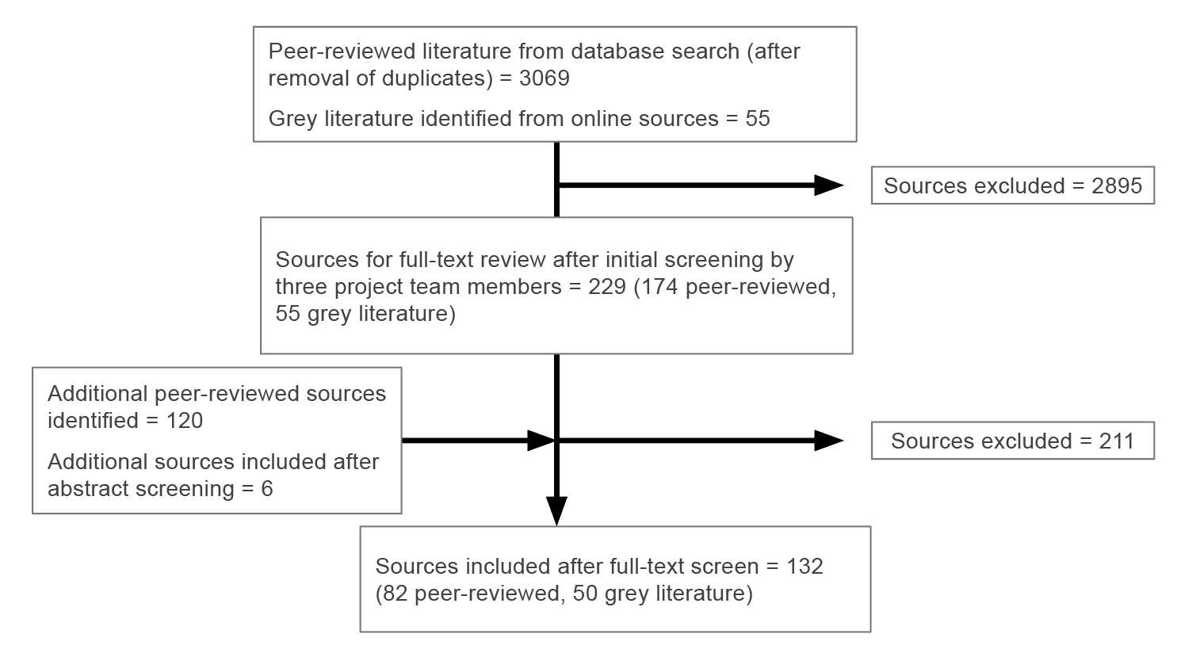The process for inclusion of articles is outlined in Figure 16 below:

Figure 16: Literature search strategy

## Inductive content analysis

Inductive content analysis was used to identify core themes running through the literature, with four core themes identified: i) International and national context; ii) core competencies and curricula; iii) education methods; and iv) change management and implementation. The data under each of these themes was synthesised to develop a picture of the national and international environment of pain management education for health practitioners.

Table 2: Breakdown of peer-reviewed and grey literature sources for the four core themes

|  |  |  |
| --- | --- | --- |
|  | Peer-reviewed literature | Grey literature |
| International and national context | 10 | 27 |
| Core competencies and curricula | 16 | 5 |
| Education methods | 46 | 7 |
| Change management and implementation | 31 | 11 |

APPENDIX 3: Stakeholder list

Organisations

ABSTARR Consulting

Adelaide Primary Health Network Australasian College of Pharmacy

Australasian College of Rural and Remote Medicine Australian and New Zealand Academy of Orofacial Pain Australian Association of Consultant Pharmacy Australian College of Nursing

Australian Commission on Safety and Quality in Healthcare

Australian Dental Association

Australian Government Department of Health and Aged Care

Australian Health Practitioner Regulation Agency Australian Medical Council

Australian National University

Australian Nursing and Midwifery Federation Australian Pain Society

Australian Pain Management Association Australian Pharmacy Council

Australian Primary Healthcare Nurses Association Australian Psychological Society

Australian Rheumatology Association Australian Rural Health Education Network Chronic Pain Australia

College of Intensive Care Medicine Council of Deans of Nursing & Midwifery Council of Presidents of Medical Colleges Curtin University

Deakin University

Department of Veterans’ Affairs Edith Cowan University Epworth Hospital

Exercise & Sports Science Australia Faculty of Pain Medicine

Federation of Ethnic Communities Councils of Australia Federation of Rural Australian Medical Educators Federation University

Flinders University GATE Victoria

Gold Coast Primary Health Network Griffith University

Health Education Australia Holmesglen

Hunter Integrated Pain Service La Trobe University

LIME Network Macquarie University

Medical Deans Australia & New Zealand Murrumbidgee Primary Health Network National Ageing Research Institute National Rural Health Alliance

National Rural Health Student Network

Nepean Blue Mountains Primary Health Network Notre Dame University

NPS Medicinewise Occupational Therapy Australia

Pain Management Research Institute Pain Revolution

Painaustralia

Palliative Care Australia Pharmaceutical Society of Australia Pharmacy Guild of Australia Primary Health Tasmania Queensland Children’s Hospital Queensland Health

Queensland University of Technology ReturnToWorkSA

Royal Australian and New Zealand College of Psychiatrists

Royal Australian College of General Practitioners Royal Hobart Hospital

Rural Doctors Workforce Agency SA Health

Skills IQ

Society of Hospital Pharmacists of Australia South Eastern NSW Primary Health Network St Vincent’s Hospital Melbourne

Swinburne University of Technology TAFE Directors Australia

Tertiary Education Quality and Standards Agency University of Adelaide

University of Melbourne University of New South Wales University of South Australia

University of Southern Queensland University of Sydney

WA Primary Health Alliance

Western Australia Department of Health Western Victoria Primary Health Network

## Governance Advisory Group

## A/Professor Lilon Bandler

## Dr Shayne Bellingham

## A/Professor Anne Burke

## Ms Clare Fitzmaurice

## Dr Chris Hayes

## Fiona Hodson

## Dr Susie Lord

## Helen Maxwell-Wright

## Professor Lorimer Moseley

## Professor Michael K Nicholas

## Dr Jonathan Penm

## Professor Helen Slater

## Dr Milana Votrubec

## Observers

Ms Amanda Daniel

Ms Natalie Lazzari

## Individual contributors

Dr Mehrdad Abbasianasl

Tracey Andrews

Annette Anido

Kylie Ash

Tim Austin

Kathryn Baird

David Barton

Dr Trish Batchelor

Ally Beaden

Jessica Bellamy

John Booth

Dr Katrina Breaden

Dr Heather Bridgman

Melinda Brown

Dr Allyson Browne

Dr Matthew Bryant

Julianne Bryce

Chris Campbell

Mark , Catley

Dr Joel Champion

Angie Clerc-Hawke

Professor Milton Cohen

Kath Cooke

Dr Paul Coughlan

Helen Craig

Professor Wendy Cross

Henry Czupryn

Dr Anne Daly

Stephanie Davies

Dr Simone De Morgan

Kevin de Vries

Dr Rutger de Zoete

Dr Dea Delaney-Thiele

Marie Deverell

Liz Devonshire

Dr Kate Drummond

Susan Edwards

Harry Eeman

Dr Agnieszka Etubus

Dr Clare Fairweather

Rebecca Fechner

Julianne Flower

Mayli Foong

Professor Kirsty Forrest

Dr Hilton Francis

Dr Lia Freestone

Jacqui Gibson

A/Prof Lucy Gilkes

Dr Helen Gneil

Jane Goode

Dr Roger Goucke

Professor Marion Gray Gray

Professor Rainer Haberberger

Anthony Hall

Dr Joanne Harmon

Dr Jonathan Ho

Annie Hopkins

Ben Horgan

Paula Hyland

Jane Jaworski

Rachel Jeffrey

Dr Jacinta Johnson

Tracy Kane-White

TJ Kanhere

Dr Ksenia Kartyk

Professor Debra Kiegaldie

Dr Richard Kwiatek

Kenny Kwon Ho Lee

Dr Kin Key Lau

Mary Lawson

Katrina J Liddiard

Dr Ivan Lin

A/Prof Bruce Lister

Dr David Martyn Lloyd-Jones

Martyn Lloyd-Jones

Dr Nina Loughman

Katrina Martin

Sibin Mathew

Josephine Maundu

Dr Josephine Maundu

Trudy Maunsell

Kate McCluskey

Dr Brett McFarlane

Carly McKeough

Dorothy McLaren

Caroline (Caz) Mcloughlin

Jarrod McMaugh

Joyce McSwan

Tim Mitchell

Alexis Mohay

Professor Tracey Moroney

Barry Morphett

Dr Thileepan Naren

Ms Georgina Neville

Frank New

A/Prof Louisa Ng

Phil Nixon

Mrs Christine Onishko

Rawa Osman

Dr Joshua Pate

Jean-Baptiste Philibert

Gregory Pratt

Dr Laura Prendergast

Victoria Quain

Hannah Quigley

Robyn Quinn

Kate Reed-Cox

Sally Ridgers

Dr Vijay Roach

Sue Rogers

Paul John Sambrook

Duncan Sanders

Dr Steve Savvas

Deborah Schofield

Ben Siddall

Juliiana Simon

Dr Cath Spillier

Beverley Sutton

Fiona Thomas

Ian Thong

Sandi Tutt

A/Prof Mick Vagg

Carla Vasoli

Kat Viti

Dr Coralie Wales

Steve Waller

Dr Linda Walsham

Dr Kim Watkins

Dr Liz Webber

Daria Westerman

Dr Tom Wilkinson

Dr Nicholas Williams

Annie Williams

Megan Willing

Dr Dianne Wilson

Mary Wing

Professor Paul John Wrigley

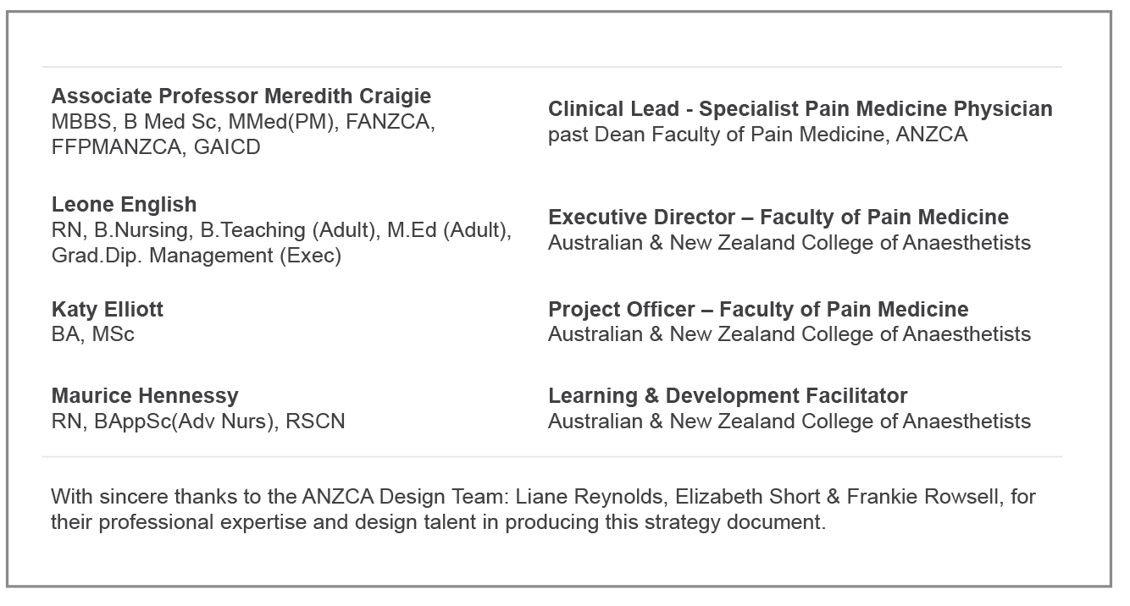APPENDIX 4: Project team

# The Faculty of Pain Medicine, Australian & New Zealand College of Anaesthetists

The Faculty of Pain Medicine was formed in 1998 and it has been pivotal in developing and advancing the field of pain medicine throughout Australia, New Zealand and the Asia Pacific region.

The Faculty provides career-encompassing education and standard setting for the specialty practice of pain medicine. It plays a key role in advocating at state and national levels for the delivery of high- quality multidisciplinary, evidence-based, pain management for communities in Australia and New Zealand.

Fellows of the Faculty will have undertaken a ‘primary’ specialty across a range of disciplines including: general practice; anaesthetics; psychiatry; rehabilitation medicine; and surgery.

They then complete a rigorous two-year post-specialty medical training program. The internationally recognised curriculum provides comprehensive training in pain medicine, with a holistic, socio-psycho-biomedical focus.

The Faculty plays a key role in fostering research activities that improve the evidence-base for pain medicine and continues to be an energising force in shaping the future of pain care delivery nationally and internationally.