# Presentation title slide: MRFF RAO Webinar 28 August 2023 Assoc. Prof. Ruth Griffiths, Director – Patients and Infrastructure Ms Shelley Li, Director – Mission Strategy and Implementation Dr Ragini Singh, Director - Grants Management Office Assoc. Prof. Cindy Thamrin, Director - Performance and EvaluationContents

1. Acknowledgement of Country
2. Webinar overview
3. Open Funding calls
4. MRFF Reporting activities
5. Post-award and key messages
6. Q&A
7. Keep Connected

# MRFF Research Administration Officer Webinars

Aim to:

* provide practical information to the sector and Research Administration Officers (RAOs) in particular about MRFF administrative arrangements
* assist RAOs and potential grantees in better supporting MRFF funded research and researchers
* aid the implementation of any changes to MRFF grant administration
* seek feedback from RAOs, with a view toward continuous improvement of MRFF grant administration

# MRFF Open/Upcoming Funding Calls

**Assoc. Prof. Ruth Griffiths, Director – Patients and Infrastructure**

**Ms Shelley Li, Director – Mission Strategy and Implementation**

* MRFF 2023 Post-Acute Sequelae of COVID-19
* MRFF 2023 Childhood Mental Health
* MRFF 2023 Primary Health
* MRFF 2023 Targeted Translation Research Accelerator

# MRFF Post-Acute Sequelae of COVID-19 (PASC) Research Plan

* 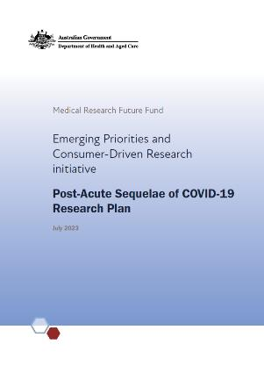$50 million over 5 years from 2023-24 to improve outcomes for people experiencing PASC
  + Funding through the Emerging Priorities and Consumer Driven Research Initiative
* Terms of Reference available at <https://www.health.gov.au/resources/publications/post-acute-sequelae-of-covid-19-pasc-research-plan-expert-advisory-panel-terms-of-reference>

# Purpose of the PASC Expert Advisory Panel

* The EAP will provide the Minister for Health and Aged Care advice on research investments required to meet the following objectives:
  + generate evidence on the current and future impacts of PASC in the specific Australian context (including individual health and wellbeing, carers, communities, health system)
  + design and evaluate clinical pathways and models of care, co-led by general practitioners and primary care, for Australians with PASC, including to address inequities in access and outcomes
  + generate new diagnostic and therapeutic approaches to prevent the occurrence of PASC and/or improve health outcomes for individuals with PASC

# Purpose of the PASC Research Plan EAP cont’d

* Additionally, the EAP is also to consider how to:
  + Consider priority populations, including but not limited to people living in rural, regional and remote communities, First Nations, and Culturally and Linguistically Diverse people

# MRFF Childhood Mental Health Research Plan

* $50 million over 4 years from 2024-25 to support research to improve patient care, translate new discoveries into clinical practice and encourage researchers to work together with consumers.
  + Funding through the Emerging Priorities and Consumer Driven Research Initiative
* Terms of Reference available at <https://www.health.gov.au/resources/publications/childhood-mental-health-research-plan-expert-advisory-panel-terms-of-reference>

# Purpose of the Childhood Mental Health Research Plan Expert Advisory Panel

* The EAP will provide the Minister for Health and Aged Care advice on research investments required to meet the following objectives:
  + generate knowledge on the determinants and protective factors for optimal mental health and wellbeing in children
  + generate knowledge to improve access to, and delivery of, evidence-based treatments and to reduce mental illness and psychological distress in children
  + address inequities in childhood mental health and psychological distress outcomes
  + inform implementation of current and future policies and programs in child mental health.

# Purpose of the Childhood Mental Health Research Plan EAP cont’d

* Additionally, the EAP is also to consider how to:
  + consider priority populations, including but not limited to people living in rural, regional and remote communities, First Nations, and Culturally and Linguistically Diverse people.

# 2023 Primary Health Research Plan

* $50 million over 4 years from 2024-25 to drive innovation in primary care
  + Funding through the Emerging Priorities and Consumer Driven Research Initiative, and Primary Health Care Initiative
* Terms of Reference available at <https://www.health.gov.au/resources/publications/primary-health-research-plan-expert-advisory-panel-terms-of-reference>

# Purpose of the Primary Care Research Plan Expert Advisory Panel

* The EAP will provide the Minister for Health and Aged Care advice on research investments required to meet the following objectives:
  + identify and evaluate multidisciplinary models of primary care (e.g. those relating to voluntary patient registration, innovative models in rural and remote communities, team-based care), to deliver higher quality and more effective care with a focus on addressing inequities in access and outcomes experienced by priority populations
  + enhance linkage and/or use of research data infrastructure sources (e.g. electronic medical record repositories and administrative datasets) to identify and evaluate models of primary care excellence and/or support health system planning
  + support translational research carried out with practitioners in primary care settings, and knowledge transfer among practitioners in primary care and academia to improve person-centred care.

# Purpose of the Primary Care Research Plan EAP cont’d

* Additionally, the EAP is also to consider how to:
  + involve all stakeholders relevant to the research and its translation in its conceptualisation, design and implementation, including health care consumers and providers
  + best support research translation and implementation in primary care to raise the profile of primary care as a field of choice for health practitioners and academics.

# Desk with stethoscope and computer keyboard2023 Targeted Translation Research Accelerator Research Plan

* $77.5 million from 2023-24 to support research into diabetes and cardiovascular disease
  + Research will be into both Type 1 and Type 2 diabetes
  + Funding provided through the Preventive and Public Health Research Initiative
* Terms of Reference available at: <https://www.health.gov.au/resources/publications/targeted-translation-research-accelerator-plan-expert-advisory-panel-terms-of-reference>

# Purpose of the Targeted Translation Research Accelerator Expert Advisory Panel

* The EAP will provide the Minister for Health and Aged Care advice on research investments required to meet the following objectives:
  + accelerate promising therapeutic approaches and devices for the prevention, early detection, management and treatment of disease related complications for diabetes (Type 1 and Type 2) and cardiovascular disease
  + support implementation of effective novel interventions and models of care for patients experiencing multi-morbidity across diabetes (Type 1 and Type 2), cardiovascular disease and their risk factors
  + address inequities in treatment, management, access to care and health outcomes for those experiencing diabetes (Type 1 and Type 2) and cardiovascular disease
  + inform implementation of current and future policies and programs in diabetes (Type 1 and Type 2) and cardiovascular disease.

# Managing MRFF grants

**Dr Ragini Singh**

**Director - Grants Management Office**

* Progress and final reports
* Grants management developments

# Progress and final reports for MRFF grants

Progress and final reports are essential for ensuring achievement of MRFF grant opportunity objectives and outcomes.

* Tips
  + If something is not going to plan, keep Health apprised through the reporting process or contact the grant administration hub to advise of urgent issues occurring outside the reporting cycle.
  + If you’re unable to submit a progress report by the due date, get in touch with the grant administration hub to let them know or consider whether a variation request might be necessary.
  + In addition to risks and mitigation strategies, highlight your wins and newsworthy findings so we can help publicise them.
  + Final reports should not be the first time Health is informed about delays or issues with project implementation. If the project is not going to meet significant milestones and deliverables by the research activity end date, submit a defer in-progress (for delays) or extend end date (for issues) variation request well before the activity end date.

# Contract with solid fillGrants management developments

* Financial reporting
  + For NHMRC-administered grants:
  + project reporting and financial reporting timing are being aligned to eliminate requests for duplicate information
  + financial information will be removed from progress report templates in 2024
  + financial reports will now cover the financial year (July to June)
  + contact NHMRC MRFF Postaward if you are having issues with the change to the financial year financial reports.
* Streamlining the variation process
* for BGH-administered grants, we will shortly release forms to guide content development and procedures to support proactive, complete and timely submission of variation requests.

# Meeting with solid fillClassroom with solid fillGrants management developments

* RAO Seminars
* The Grants Management Office is holding in-person sessions in the Department’s state offices over the next year.
* Eligible organisation staff supporting grants management, including research administration officers and finance officers, are welcome to attend.
* The sessions will offer a group seminar and an individual meeting with each grantee organisation to respond to specific questions about MRFF grants held.
* The sessions will focus on grants management (post-award) topics. Depending on staff availability, pre-award topics may be covered in some group seminars.
* MRFF grants management resources website
* A page with policies, templates and guidance related to MRFF grants (post-award) will be launched soon to make it easier to find grants management resources, regardless of grant administration hub.

# Gender Report Funding Rates Other reports

**Assoc. Prof. Cindy Thamrin**

**Director, Performance and Evaluation**

# MRFF reporting activities

The Department is working on improving its reporting of grants data to the public

* List of grants currently available at <https://www.health.gov.au/summary-of-mrff-grant-recipients>
* Report on financial support for medical research and innovation (latest May 2023, updated every two years) – ***includes funded rates***<https://www.health.gov.au/resources/publications/financial-assistance-to-support-the-australian-medical-research-and-innovation-priorities-2020-2022>
* Gender data report (Aug 2023, updated annually)  
  <https://www.health.gov.au/resources/publications/medical-research-future-fund-report-on-gender-data-for-grant-opportunities-august-2023>
* Themed reports on priority topics
  + Coronavirus research response (Mar 2023)   
    <https://www.health.gov.au/resources/publications/medical-research-future-fund-report-on-the-coronavirus-research-response>
  + Rural, regional and remote health research (Aug 2023) <https://www.health.gov.au/resources/publications/medical-research-future-fund-report-on-funding-for-rural-regional-and-remote-health-research>

# Increasing MRFF data available

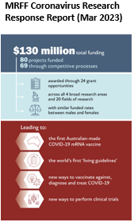**MRFF Financial Assistance Report (May 2023)**

* MRFF financial assistance consistency with 2020–2022 priorities
* **Funded rates**
* MRFF policies, performance and assurance activities
* MRFF highlights and research snapshots…and more

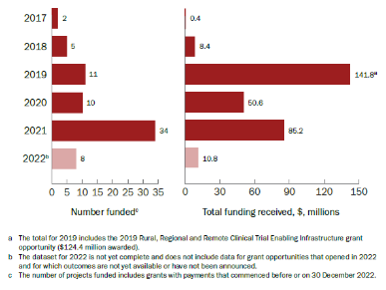**MRFF Report on Funding for Rural, Regional and Remote Health Research (Aug 2023)**

**MRFF investment into RRR focused projects has increased since inception**

* A rural focus has been embedded in a number of grant opportunities (through streams and eligibility criteria)
* Increased funds have been awarded to projects that are undertaken in rural areas, and to projects that address health topics of significance to rural areas of Australia

# Tables from the Financial Assistance Report relating to: * investments across all broad research areas * MRFF funded rates are above 30% (on average) * MRFF funded rates for women and men researchers are comparable * Scientific articles of research supported by MRFF have higher impact than the global average.Some excerpts from the Financial Assistance Report (FAR)

# Image of Appendix G Funded rates of MRFF grant opportunities opened between 7 November and 5 November 2022 (first page).**Some excerpts from the Financial Assistance Report (FAR)**

# 4 graphs relating to the number of applications and funded rates. From inception up to 2021-22, averaged MRFF funded rates for women and men researchers are comparable * 25.7% for both when considering all Chief Investigators * 20.3% and 21.4% when considering leading Chief Investigators 2021–22 was the first financial year where more women than men applied for funding, for both leading and all Chief Investigators Over the years, funded rates have increased progressively for women leading Chief Investigators Gender balance is more equal when considering all Chief Investigators Some excerpts from the Gender Report

# 2 graphs relating to years post-PhD More women leading Chief Investigators applied for funding at a younger age and at an earlier career stage than men… … but funded rates for women tended to be higher at later career stagesSome excerpts from the Gender Report (contd.)

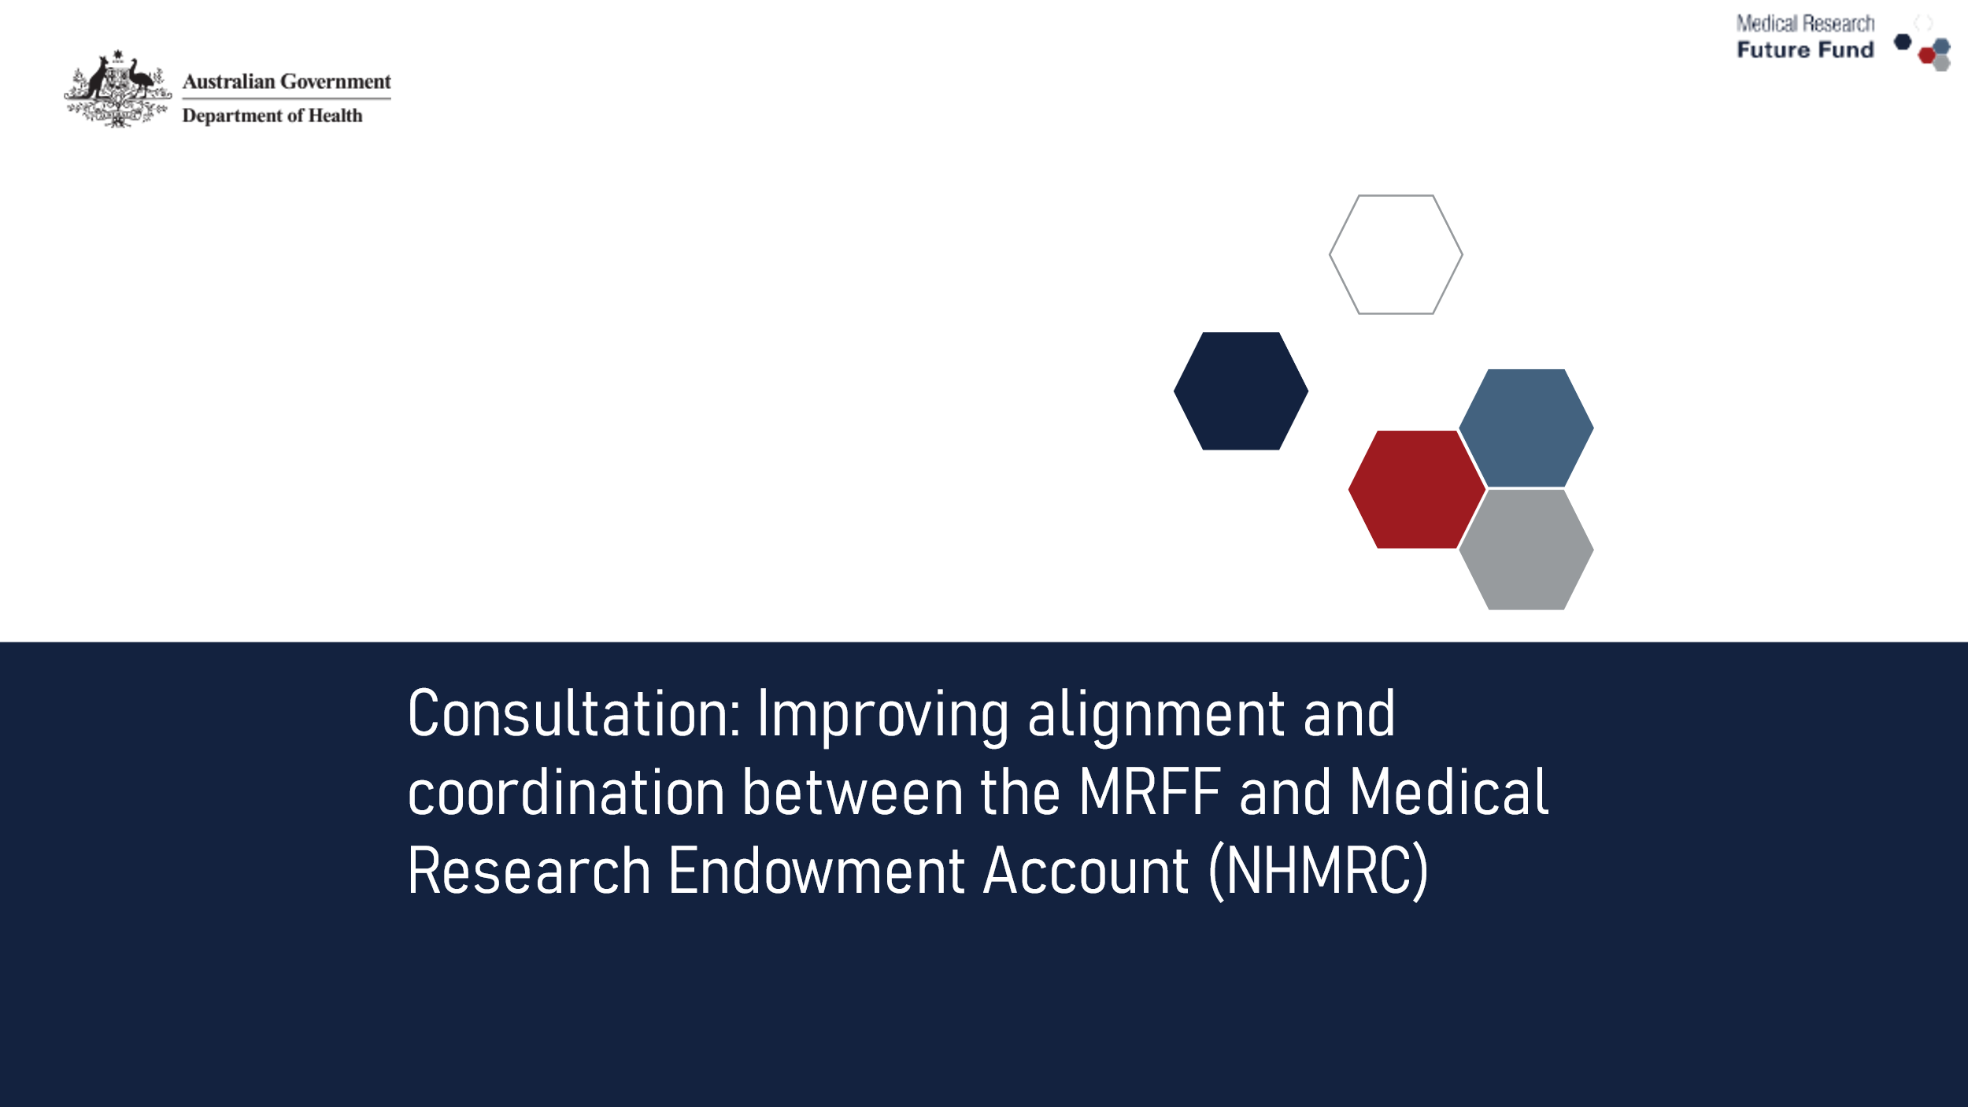

# What we have heard so far

* Diverse (and passionate) views from a broad range of research stakeholders
  + Researchers (universities, MRIs), health providers and services, businesses, consumers, priority populations - First Nations, rural/ regional/ remote, rare diseases
* Value of having both investigator-led and priority-driven approaches are well recognised
* Reform should promote and build on what works well in both funds
* End users of research (especially consumers) want to be involved and have an active role

Q&A

Subscribe to MRFF News: 
www.health.gov.au/
initiatives-and-programs/medical-research-future-fund/mrff-news

Send any questions to: MRFF@health.gov.au

Register for MRFF grants opportunities: 
www.grants.gov.au

Follow Health Twitter for MRFF updates: @healthgovau #MRFF
Keep Connected



Thank you for your time