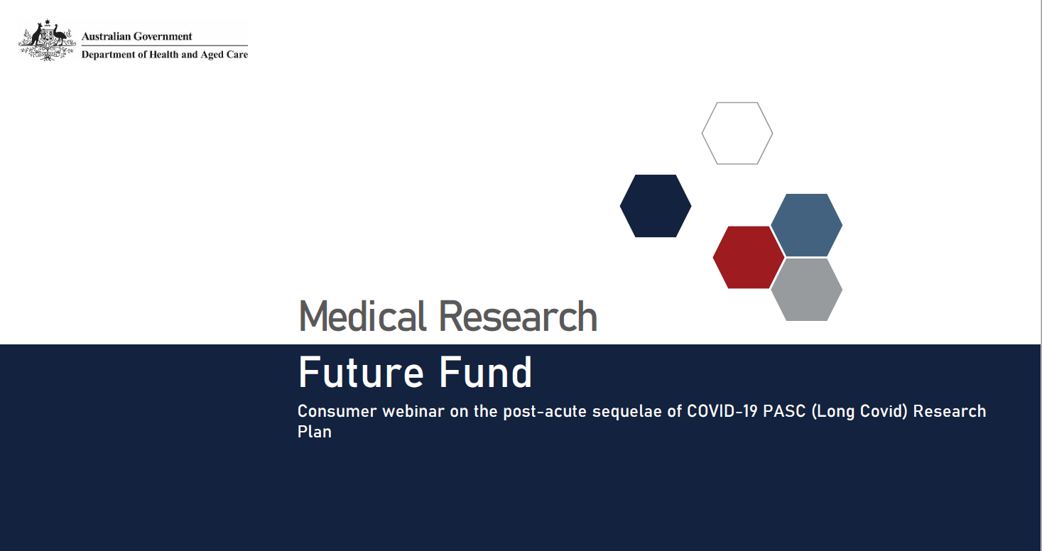

The MRFF funds a wide range of health and medical research
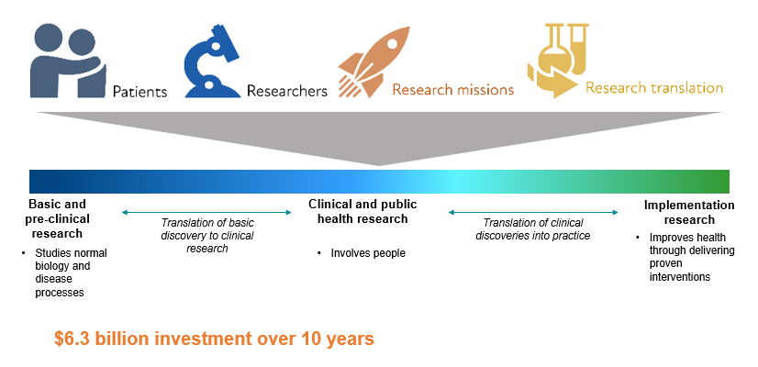

MREA and MRFF
Medical Research Endowment Account (MREA)
- Special account that supports NHMRC grants (~$900 million p.a.)
- Supports investigator-initiated grants in all fields of health and medical research from discovery to clinical, public health and health services research
- Administered by NHMRC, an independent agency in the Health and Aged Care portfolio
Medical Research Future Fund (MRFF)
- $20 billion sovereign fund that supports MRFF grants ($650 million p.a.)
- Supports grants in priority areas of medical research and innovation determined by government on advice of AMRAB following public consultation
- Administered by Health and Medical Research Office (HMRO) in Department of Health and Aged Care

Consumer Involvement in the MRFF

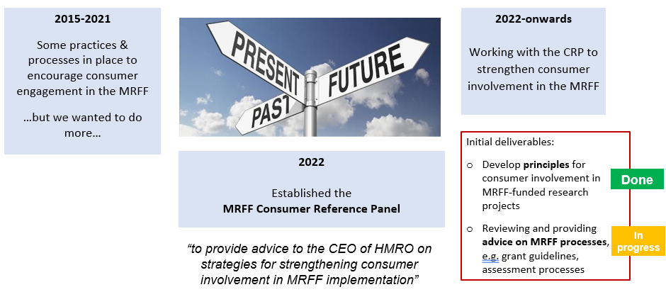

Principles for Consumer Involvement in Research Funded by MRFF

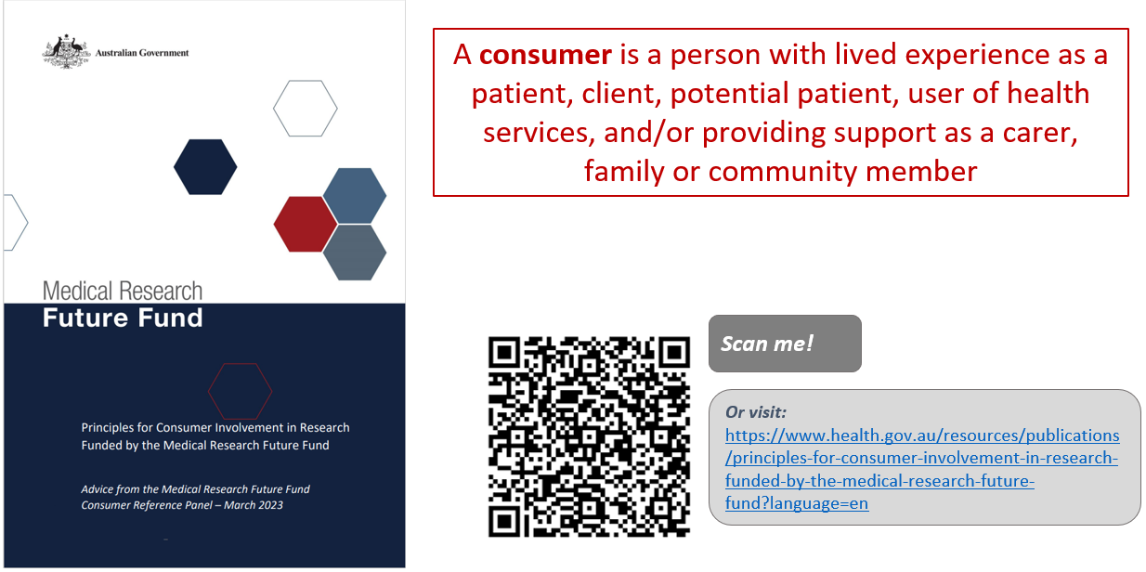

Principles for Consumer Involvement in Research Funded by MRFF
~ WHY? ~
The inclusion and strengthening of the consumer voice will improve the quality, relevance and impact of MRFF-funded research, through:
- More, safe, diverse and effective consumer involvement
- Recognising the valuable perspectives that Australians with lived experience as patients, clients, service users and carers bring to research
- Recognising the diversity of our Australian population and the importance of including these varied life experiences, values and cultures in our research
- Helping researchers, research organisations, consumers and other relevant stakeholders by providing guidance on what ‘good’ consumer involvement looks like

Principles for Consumer Involvement in Research Funded by MRFF (cont.)
- In every type of research, including basic science, public health, preventive health, translation and clinical research.
- At all stages of research, from defining the need/priority of a research question, refining the research question and research design through to conduct of the research and sharing and translation of results.
- In partnership with researchers, with consumers respected and recognised for the valuable and complementary knowledge, expertise and perspectives they bring to the research.
- Effectively, with sufficient time, resources and depth of relationships to enable consumers to understand and actively engage with and contribute to the research.
- Sensitively and safely, through research teams with strong and broad capacity and capabilities in consumer involvement, appropriate training and a supportive environment for consumers, and clearly defined and agreed roles.
- With broad diversity and equity, with the goal of increasing involvement of priority populations through culturally safe and appropriate engagement.

Providing advice on MRFF processes

Light-touch review of assessment criteria descriptors

Pilots in the 2023 MRFF Consumer-Led Research Grant Opportunity:

Consumer Involvement Statement – 2 pages in grant application

Greater consumer involvement in assessment – multiple consumers as full, scoring panel members

Review of the draft NHMRC/MRFF Statement on Sex, Gender, Variations of Sex Characteristics and Sexual Orientation in Health and Medical Research

Reviewing grant opportunity guideline templates

Inputting into research topics/prioritisation

Future Consumer-Led Research Grant Opportunities

MRFF Preventive and Public Health Research Initiative - $100 million over 10 years from 2022-23 allocated to a Consumer-Led Research stream

Further implementation of the CRP principles, e.g.

Guidance for researchers, e.g. costs associated with consumer involvement can be included in MRFF applications

Refresh of the MRFF assessment criteria

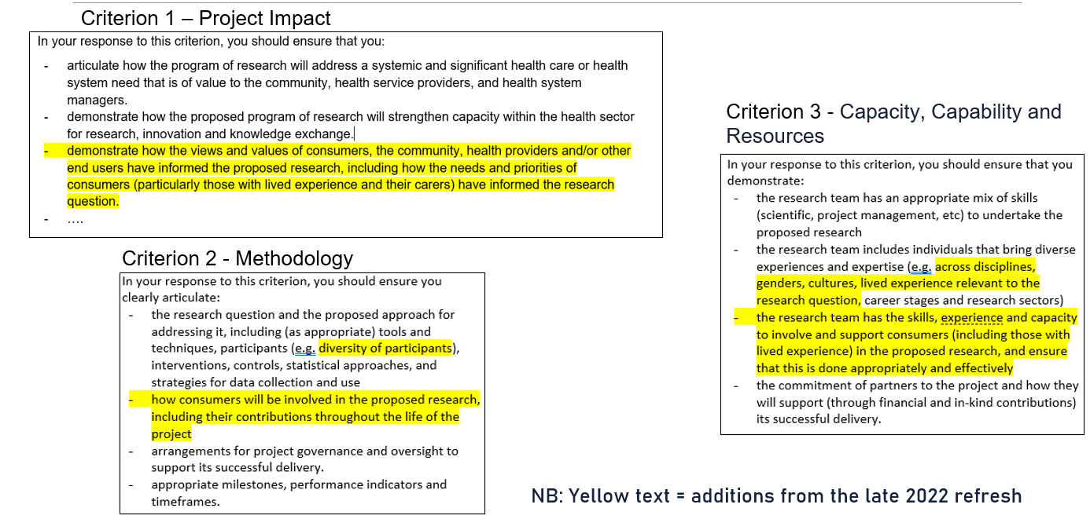

Path to the Post-Acute Sequelae of COVID-19 Research Plan
- The House of Representatives Standing Committee on Health, Aged Care and Sport conducted an inquiry into Long COVID and Repeated COVID Infections
- The inquiry recommendations included establishing a research program on Long COVID that:
  - Includes representation from priority populations
  - Has longer term funding
  - Spans basic science, clinical trials, models of care, health promotion and implementation science
- The need for co-design with consumers was emphasised
- The Minister for Health and Aged Care tasked his department “with developing a national plan to respond to Long COVID, taking into consideration the committee’s findings”
  - The National PASC plan is under development, which will articulate the Government response to the enquiry
  - The Post-Acute Sequelae of COVID-19 (PASC) Research Plan is one part of the response

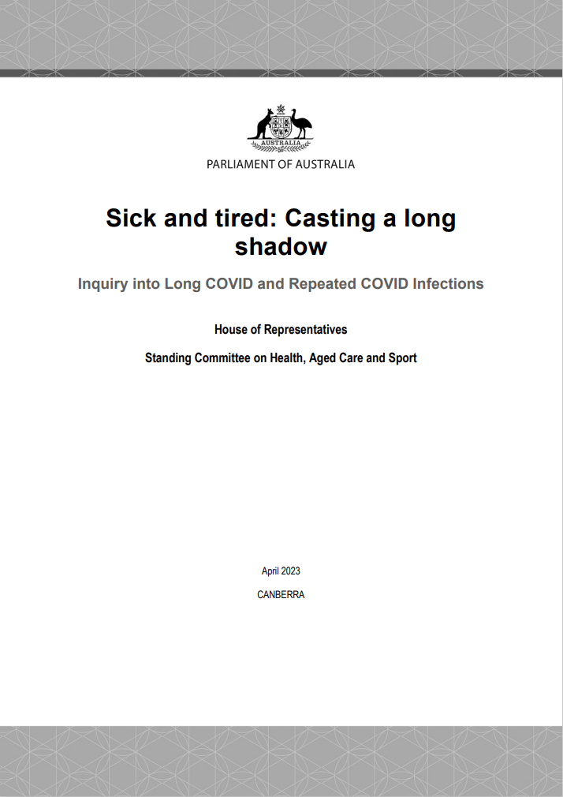

Post-Acute Sequelae of COVID-19 Expert Advisory Panel
- The Australian Government has committed $50 million from 2023-2024 under the MRFF to improve outcomes for people experiencing post-acute sequelae of COVID-19 (PASC) – or Long COVID
- This funding is from the Emerging Priorities and Consumer-Driven Research initiative, which supports high-quality research that improves patient care, translates new discoveries into practice, and encourages consumers and researchers to work together
- An independent Expert Advisory Panel (EAP) was assembled to provide the Minister for Health and Aged Care advice on research investments into PASC, and included:
  - An independent chair
  - A consumer representative
  - Expertise or experience in PASC and/or other post-viral syndromes
  - Expertise in general practice
  - Expertise in allied health
  - Rural and regional representation
  - Expertise in First Nations health

Post-Acute Sequelae of COVID-19 Research Plan
- The Expert Advisory Panel developed a PASC research plan that identifies short (1-2 years) and medium (3-4 years) term priorities that:
  - Generate evidence on the current and future impacts of PASC in Australia
  - Design and evaluate clinical pathways and models of care that address inequities in access and outcomes
  - Find new therapeutic approaches to prevent PASC and/or improving health outcomes for individuals with PASC
- Grant opportunities will fund research beginning in 2024 and 2025
- Most research outcomes expected from 2029

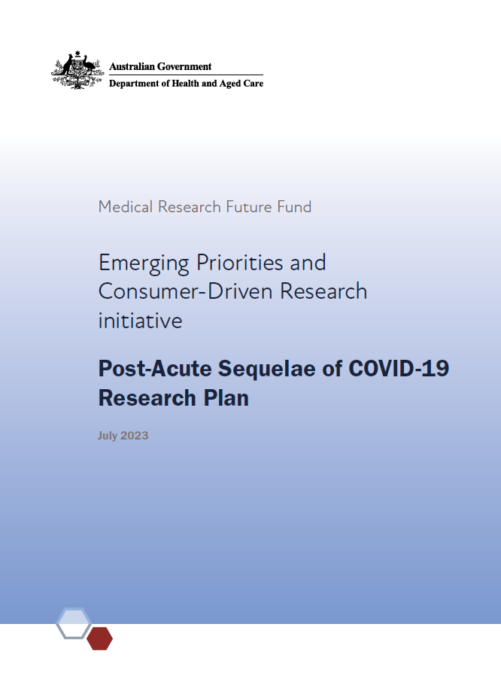

Post-Acute Sequelae of COVID-19 Research Plan

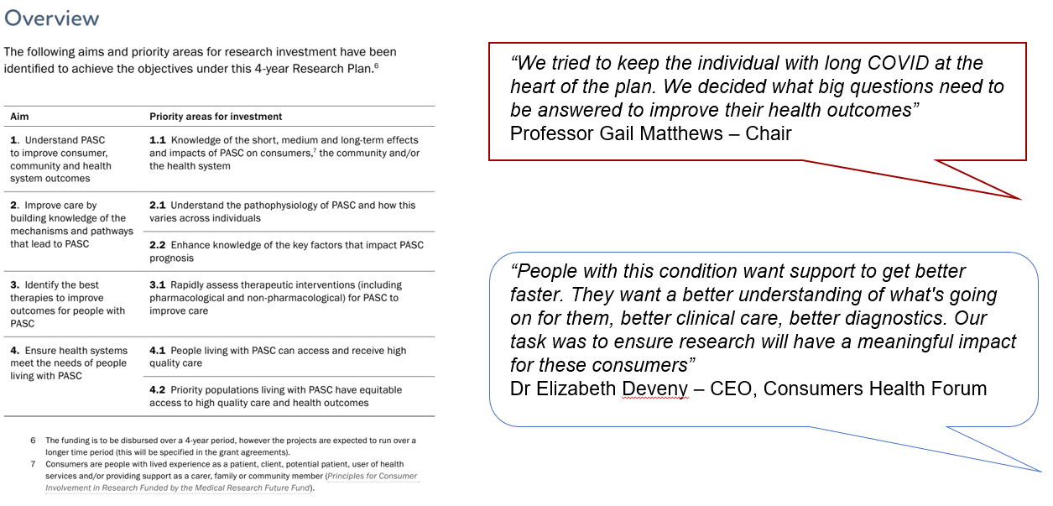

Aim 1. Understand PASC to improve consumer, community and health system outcomes
- Funding will support a large-scale project which seeks to understand the consumer experience of PASC, especially the impacts on physical, mental, social and emotional health
  - Involves partnership with consumers and primary care researchers
  - Includes consumers from priority populations and all age groups
- Outcome: Improving understanding of the impacts of PASC on individuals and the community to inform and improve clinical care and policy responses

- Funding will support a large-scale project to use data collection and informatic approaches to generate knowledge of population-wide impacts of PASC
  - Involves partnership with consumers, health service providers and policy makers
- Outcome: Improving understanding of the impacts of PASC on the Australian health system and society to inform policy and program responses

Aim 2. Improve care by building knowledge of the mechanisms and pathways that lead to PASC
- Funding will support projects that investigate the molecular mechanisms, pathways, biomarkers, as well as the psychosocial, physical, behavioural and other contributors that may help answer questions about PASC
- Outcome: Generate knowledge to support the development of novel diagnostic or monitoring tools, or therapies for individuals living with PASC

Aim 3. Identify the best therapies to improve outcomes for people with PASC
- Funding will support a nationwide clinical trial that will test multiple different therapeutic interventions (including pharmacological and non-pharmacological) for PASC
- Utilises an adaptive trial design to allow rapid assessment of interventions and:
  - Includes primary care settings
  - Includes rural settings and rural researchers
  - Uses a 2-stage funding process
- Outcome: Accelerating the identification of optimal management approaches for people living with PASC

Aim 4. Ensure health systems meet the needs of people living with PASC
- Funding will support projects that improve models of care for people with PASC through co-design with consumers, clinicians and health services
- Models of care will be:
  - Consumer-centered
  - Multidisciplinary
  - Scalable and cost-effective
- Multiple projects will be funded, allowing co-leadership by consumers from the populations the research is intended to benefit, including rural and remote settings, First Nations people, people with a disability, people from culturally and linguistically diverse backgrounds and older people
- Outcome: Improve the quality of care received by people who have symptoms consistent with PASC and/or who are living with PASC, including priority populations

MRFF Grant Assessment Processes

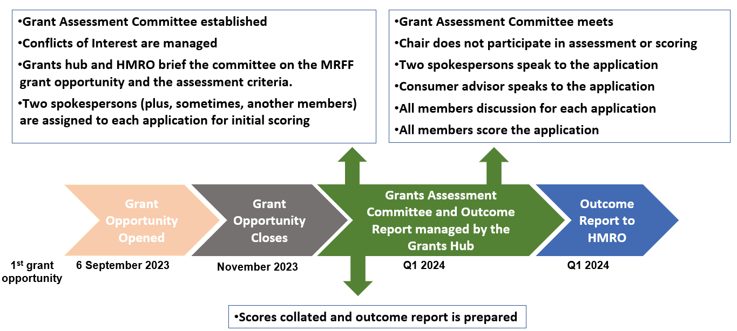

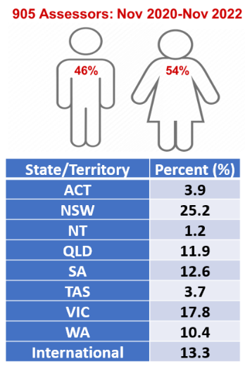
MRFF Grant Assessment Committees
- Members are expert reviewers who come from different backgrounds and bring different perspectives.
- Members are selected on their experiences and expertise in a range of areas including:
  - transdisciplinary
  - academia
  - clinical
  - health services delivery
  - translation of research
  - consumers and patients
  - Aboriginal and/or Torres Strait Islander health
  - industry and commercialisation expertise.

To express interest to be on a GAC:
https://www.nhmrc.gov.au/2022-23-medical-research-future-fund-mrff-grant-opportunities.

Questions on the PASC research plan
- The PASC research plan has generated interest and questions from the community, in particular from those with lived experience
- Questions on:
  - Incorporation of perspectives of patients and those with lived experience
  - The process of research prioritisation and assessment of research grants
- Q and A session is designed to answer some of these questions
Processes which guide research plan design and grant application assessment
- Research was prioritised by the MRFF PASC Expert Advisory Panel
- Grant applications will be assessed by an independent Grant Assessment Committee which includes scientific experts, consumers, industry experts and health service providers
  - Grants are ssessed against selection criteria around project impact, methodology, capacity, capability and resources to deliver the project and overall value and risk
  - Demonstration of the research being informed by analysis of existing and ongoing studies in the field
  - Articulation of methods and involvement of consumers through the research journey

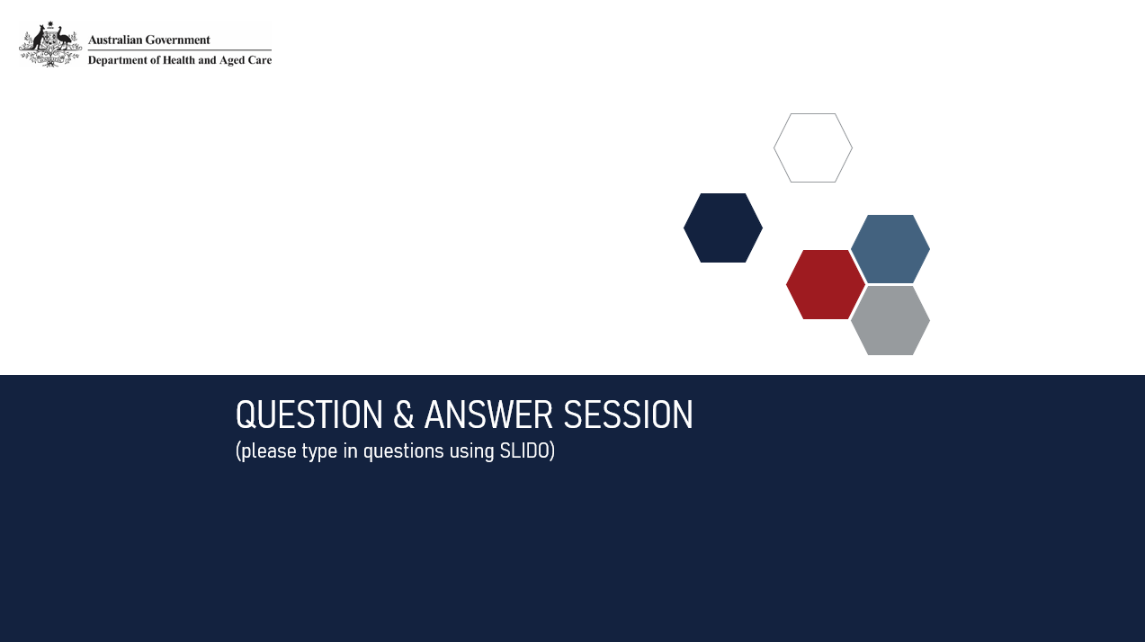

Thank you for your time

