COVID-19 outbreaks in Australian residential aged care facilities

# National snapshot

As at 8:00 am 5 October 2023 there are 940 active COVID-19 cases in 148 active outbreaks in residential aged care facilities across Australia. There have been 65 new outbreaks,   
9 new resident deaths and 871 combined new resident and staff cases reported since   
28 September 2023.

Table 1: Aged Care COVID-19 data as at 8.00am 5 October 2023[1]

| Category | Active*[2]* | Previous  7 days | Cumulative  Total | Previous 7 days |
| --- | --- | --- | --- | --- |
| Outbreaks[3] | 148 | 26 | 16,432 | 65 |
| Residential Aged Care Facilities affected | 148 | 26 | 2,843 | 0 |
| Resident Cases[4] | 733 | 85 | 159,999 | 667 |
| Resident Deaths | N/A | N/A | 5,881 | 9 |
| Staff Cases | 217 | 2 | 92,501 | 204 |

Residential aged care homes with active outbreaks are included in Appendix 1.

**Table 2: Overview of Active Outbreaks in Australia**

|  |  |  |  |  |  |  |  |  |  |
| --- | --- | --- | --- | --- | --- | --- | --- | --- | --- |
|  | ACT | NSW | NT | QLD | SA | TAS | VIC | WA | Total |
| Total Facilities with outbreaks | 2 | 42 | 0 | 15 | 19 | 3 | 62 | 5 | 148 |
| *Total number of active resident cases* | 6 | 137 | 0 | 60 | 121 | 6 | 383 | 20 | 733 |
| *Total number of active staff cases* | 0 | 57 | 0 | 23 | 31 | 3 | 99 | 4 | 217 |
| Total Outbreaks Opened in Previous 7 Days | 1 | 17 | 0 | 11 | 9 | 2 | 24 | 1 | 65 |
| Total Outbreaks Closed in Previous 7 Days | 1 | 7 | 0 | 8 | 5 | 0 | 17 | 1 | 39 |

**Figure 1: National Outbreak Trends in Aged Care**

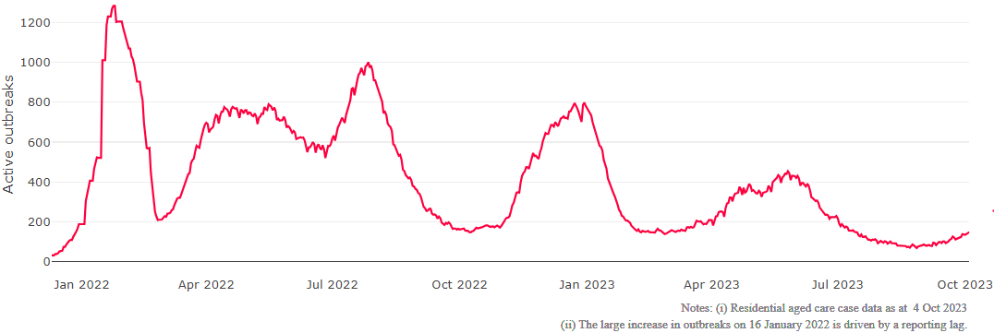

**Figure 2: Trends in Aged Care Cases – December 2021 to Present**

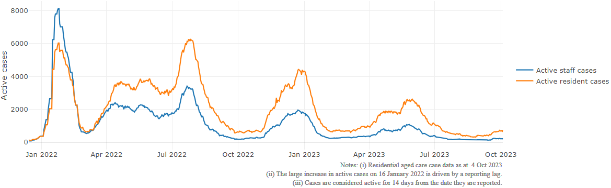

## Mortality

For the period of 1 January 2023 to 15 September 2023, COVID-19 is recorded as the cause of death in 2.7 percent of all deaths in permanent residents in aged care facilities.

Since the beginning of the Omicron outbreak in mid December[5] 2021, there have been 106,446 deaths in residential aged care from all causes (report period from 15 December 2021 to 15 September 2023)[6]. COVID-19 deaths account for 4.7 percent of this figure.

Over the course of the pandemic, all-cause excess mortality in Residential Aged Care was below expected numbers in 2020, and within expected range in 2021.

Due to internal annual reporting cycle updates there is no updated mortality comparison data this week.

Figure 3: COVID-19 Deaths in Residential Aged Care Facilities overlaid with Community deaths

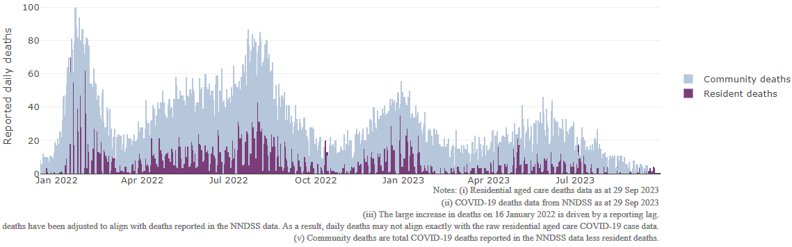

## Workforce in active residential aged care outbreaks

As at 6 October 2023, workforce surge staff have filled a total of 179,992 shifts in aged care services impacted by COVID-19, including 348 in the past 7 days. In the past 7 days (to   
6 October) surge workforce providers have assisted 17 residential aged care homes. These shifts include roles for GPs, nurses, care workers, allied health workers, executive and ancillary staff. This includes:

Table 3: Workforce resources supplied to residential aged care facilities

| Workforce provider | Total Shifts | | Previous 7 days | |
| --- | --- | --- | --- | --- |
| Recruitment, Consulting and Staffing Association | 103,852 | 0 | |
| Healthcare Australia (Workforce Surge) | 14,870 | 0 | |
| Healthcare Australia (NACER) | 2,295 | N/A | |
| Mable | 2,711 | N/A | |
| Aspen Medical | 26,002 | 174 | |
| HealthX | 26,206 | 174 | |
| Torrens | 4,056 | N/A | |

The Australian Defence Force provided support to a total of 542 residential aged care homes between February and September 2022. The ADF deployment ceased on 30 September 2022.

## Oral antiviral treatments

Distribution of the oral anti-viral Lagevrio (Molnupiravir) commenced on 6 February 2022 to all RACFs with outbreak sites prioritised for delivery. The National Medical Stockpile has deployed 48,269 treatment courses of Lagevrio (Molnupiravir) to aged care facilities.

78,459 prescriptions for Lagevrio (Molnupiravir) have been issued to residents in residential aged care facilities, with a further 6,557 prescriptions for Paxlovid (nirmatrelvir + ritonavir) also issued since 28 February 2022 and up to 1 October 2023.

## Vaccination in Residential Aged Care Facilities

People living in residential aged care are a high priority for the Government’s COVID-19 vaccination program.

Older age remains the biggest risk factor for severe COVID-19 disease. Vaccination offers added protection to help reduce the risk of severe illness or hospitalisation of aged care residents.

The department is working with both the aged care and primary care sectors to ensure residents have access to the COVID-19 vaccine. It continues to target support for residential aged care facilities to arrange COVID-19 vaccinations with local primary care providers such as GPs, community pharmacists and Aboriginal Community Controlled Health Services.

As at 4 October 2023:

* 87,883 (51.4%) aged care residents received a booster dose in the last 6 months.
* 422 aged care residents received a booster dose in the last week.

**Table 4: Aged care COVID-19 2023 Booster Doses (data as at 4 October 2023)**

| Jurisdiction | Received booster in last 6 months | |
| --- | --- | --- |
| Residents vaccinated | % of residents vaccinated |
| **National** | **87.8k** | **51.4%** |
| ACT | 1.1k | 51.7% |
| NSW | 27.8k | 50.7% |
| NT | <200 | 39.7% |
| QLD | 17.1k | 49.4% |
| SA | 7.8k | 52.2% |
| TAS | 2.3k | 55.5% |
| VIC | 23.8k | 53.9% |
| WA | 7.7k | 50.0% |

Source: Matched Australian Immunisation Register (AIR) data of residents in permanent residential aged care.

For reporting accuracy, the total aged care resident population only includes residents who have been linked with their vaccination records. As residential aged care populations are fluid, the total population for vaccination are an estimate only and there is an administrative lag with the aged care recipient data which is linked to AIR data. Counts may fluctuate due to enhancements to data over time.

Key: k= thousand

## Infection control and audit

People living in residential aged care homes remain a high priority for the Government’s COVID-19 vaccination program. The Department is continuing to communicate with both the aged care and primary care sectors, reinforcing the importance of uptake and promoting the 2023 booster dose via regular newsletters, bulletins, social media videos and webinars.

All aged care residents who have not had a COVID-19 vaccination, or a COVID-19 infection within the last 6 months, continue to be offered a 2023 booster dose. The added protection from vaccination is especially important for aged care residents and will help reduce the risk of severe illness or hospitalisation.

The Department continues to work with Primary Health Networks to support residential aged care homes across Australia to arrange COVID-19 vaccination in-reach clinics with local primary care providers such as GPs, pharmacists, and Aboriginal Community Controlled Health Services.

As at 5 October 2023, the Commission had conducted 5,596 ICM spot checks to observe infection control practices and PPE protocols in residential aged care facilities.

Table 5: Total Quality Assessment and Monitoring Activities with residential services (including IPC), by type and month 1 March 2020 to 5 October 2023

|  |  |  |  |  |  |  |
| --- | --- | --- | --- | --- | --- | --- |
| Regulatory Activities | 2019-20 (1 Mar - 30 Jun 2020) | 2020-21 | 2021-22 | 2022-23 | 2023-24  (to 5 Oct) | Total |
| ****Site visits**** | 318 | 3,452 | 1,732 | 3,814 | 1,018 | 10,334 |
| ****Non-site activities**** | 3,709 | 8,382 | 6,665 | 1,411 | 104 | 20,270 |
| Total activities | **4,027** | **11,834** | **8,397** | **5,225** | **1,122** | **30,604** |

# Appendix 1: National residential aged care services with Active outbreaks COVID-19

Please note, information reported in this table has been directly reported to the Department of Health and Aged Care by residential aged care facilities. Total cases refers to all staff and resident cases associated with the active outbreak and may not reflect the count of currently active cases. Where numbers have been incorrectly reported, facilities are able to correct these in the COVID-19 Support Portal through My Aged Care. Where a facility is reporting less than six resident or staff cases or less than six deaths, data has been suppressed to protect the privacy of affected individuals (note that “n/p” indicates data is not provided to protect privacy).

| Service Name | State | Resident Deaths | Resident Cases | Staff Cases | Total Incidents |
| --- | --- | --- | --- | --- | --- |
| Goodwin Monash | Australian Capital Territory | <6 | 20 | 8 | 28 |
| Jindalee Aged Care Residence | Australian Capital Territory | 0 | 6 | 0 | 6 |
| Advantaged Care at Prestons Lodge | New South Wales | 0 | <6 | <6 | <6 |
| Alstonville Adventist Aged Care Facility | New South Wales | 0 | <6 | <6 | <6 |
| Anthem | New South Wales | 0 | 8 | <6 | n/p |
| Australian Vietnamese Aged Care Services | New South Wales | 0 | 21 | <6 | n/p |
| Bankstown Terrace Care Community | New South Wales | 0 | 10 | 0 | 10 |
| BaptistCare Caloola Centre | New South Wales | 0 | 6 | <6 | n/p |
| BaptistCare Warabrook Centre | New South Wales | <6 | 14 | 6 | 20 |
| BaptistCare Warena Centre | New South Wales | 0 | <6 | 0 | <6 |
| Benjamin Short Grove | New South Wales | 0 | 11 | <6 | n/p |
| Berkeley Vale Care Community | New South Wales | 0 | 8 | <6 | n/p |
| Boorowa Multi-Purpose Service | New South Wales | 0 | <6 | <6 | 7 |
| Boronia House | New South Wales | 0 | <6 | 0 | <6 |
| Cameron Park Care Community | New South Wales | 0 | <6 | <6 | <6 |
| Catholic Healthcare Gertrude Abbott Aged Care | New South Wales | 0 | 31 | <6 | n/p |
| Catholic Healthcare Percy Miles Villa | New South Wales | 0 | <6 | 0 | <6 |
| Cooinda Hostel | New South Wales | 0 | 7 | 9 | 16 |
| Corowa District Hospital | New South Wales | 0 | 12 | 6 | 18 |
| Dellacourt | New South Wales | 0 | 0 | <6 | <6 |
| Eileen Armstrong House | New South Wales | 0 | 9 | 11 | 20 |
| Estia Health Bankstown | New South Wales | 0 | 0 | <6 | <6 |
| Estia Health Camden | New South Wales | <6 | 19 | 17 | 36 |
| Estia Health Kilbride | New South Wales | 0 | <6 | <6 | <6 |
| Fairlea Aged Care Penshurst | New South Wales | 0 | <6 | 0 | <6 |
| Glenmore Park Care Community | New South Wales | 0 | <6 | 0 | <6 |
| Goondee Aged Care Home | New South Wales | 0 | 9 | 0 | 9 |
| Horton House | New South Wales | <6 | 8 | 0 | 8 |
| Jesmond Aged Care | New South Wales | 0 | <6 | 0 | <6 |
| Loreto Home of Compassion | New South Wales | 0 | <6 | 0 | <6 |
| Melva McDonald Lodge | New South Wales | 0 | <6 | 0 | <6 |
| Mildred Symons House | New South Wales | 0 | 12 | 0 | 12 |
| Navorina Nursing Home | New South Wales | 0 | 0 | <6 | <6 |
| Our Lady Of Consolation Home | New South Wales | 0 | <6 | <6 | <6 |
| Paling Court Residential Aged Care | New South Wales | 0 | <6 | <6 | 7 |
| Randwick Montefiore Home | New South Wales | 0 | <6 | <6 | <6 |
| Regis Rose Bay | New South Wales | 0 | <6 | 0 | <6 |
| RFBI Coffs Harbour Masonic Village | New South Wales | 0 | <6 | <6 | <6 |
| St Hedwig Village | New South Wales | 0 | 12 | <6 | n/p |
| SummitCare Wallsend | New South Wales | 0 | <6 | 0 | <6 |
| Tweed River Care Community | New South Wales | 0 | 8 | <6 | n/p |
| Uniting Edinglassie Emu Plains | New South Wales | 0 | <6 | 0 | <6 |
| Uniting Kingscliff | New South Wales | <6 | <6 | <6 | 8 |
| William Cape Gardens | New South Wales | 0 | <6 | 0 | <6 |
| Beauaraba Lodge | Queensland | 0 | <6 | <6 | <6 |
| Bolton Clarke Rowes Bay | Queensland | 0 | 50 | 14 | 64 |
| Churches of Christ Fair Haven Aged Care Service Maryborough | Queensland | 0 | 22 | 12 | 34 |
| Estia Health Hervey Bay | Queensland | 0 | <6 | 0 | <6 |
| Estia Health Mount Coolum | Queensland | 0 | 6 | <6 | n/p |
| Eventide Home Rockhampton | Queensland | 0 | <6 | 0 | <6 |
| Infinite Care Cleveland | Queensland | 0 | 0 | <6 | <6 |
| Kewarra Beach Aged Care | Queensland | 0 | <6 | <6 | <6 |
| Ozcare - Hervey Bay | Queensland | 0 | 7 | <6 | n/p |
| Ozcare Villa Vincent | Queensland | 0 | 0 | <6 | <6 |
| Parkview | Queensland | 0 | <6 | 0 | <6 |
| Peninsula Palms Retirement Village | Queensland | 0 | 19 | 8 | 27 |
| Regis Chelmer | Queensland | 0 | 17 | <6 | n/p |
| Southern Cross Care Nanango - Karinya | Queensland | 0 | <6 | <6 | <6 |
| St Vincent's Care Services Toowoomba - Nursing Home | Queensland | 0 | 12 | <6 | n/p |
| Aldersgate Aged Care Services | South Australia | 0 | <6 | 9 | n/p |
| Alwyndor Aged Care | South Australia | 0 | 15 | 9 | 24 |
| AnglicareSA Westbourne Park | South Australia | 0 | <6 | <6 | <6 |
| Bupa Enfield | South Australia | 0 | <6 | <6 | <6 |
| Calvary Oaklands | South Australia | 0 | <6 | 0 | <6 |
| Edenfield Family Care | South Australia | 0 | 18 | <6 | n/p |
| Edenfield Family Care - Ramsay | South Australia | 0 | 7 | 0 | 7 |
| Eldercare Hope Valley | South Australia | 0 | 44 | 16 | 60 |
| Estia Health Daw Park | South Australia | 0 | <6 | 0 | <6 |
| Estia Health Hope Valley | South Australia | 0 | <6 | <6 | <6 |
| Klemzig Residential Care Services | South Australia | 0 | <6 | <6 | 6 |
| Oakwood Aged Care | South Australia | 0 | 15 | <6 | n/p |
| Resthaven Malvern | South Australia | 0 | 15 | <6 | n/p |
| Resthaven Paradise | South Australia | 0 | 29 | <6 | n/p |
| Restvale Hostel | South Australia | 0 | <6 | <6 | 7 |
| Sandpiper Lodge Residential Care | South Australia | 0 | <6 | 0 | <6 |
| St Basil's at St Peters | South Australia | 0 | 9 | <6 | n/p |
| The Pines Lodge Residential Care | South Australia | 0 | 6 | <6 | n/p |
| Yeltana Nursing Home | South Australia | 0 | 14 | <6 | n/p |
| Barrington Lodge | Tasmania | 0 | <6 | 0 | <6 |
| Regis Tasmania - Norwood | Tasmania | 0 | 8 | <6 | n/p |
| Uniting AgeWell Aldersgate | Tasmania | <6 | 21 | 11 | 32 |
| Anzac Lodge Private Nursing Home | Victoria | 0 | 10 | <6 | n/p |
| Arcare Castlemaine | Victoria | 0 | <6 | 0 | <6 |
| Arcare Parkview Malvern East | Victoria | 0 | <6 | <6 | 6 |
| Arcare Reservoir | Victoria | <6 | 32 | 13 | 45 |
| Arcare Waterview | Victoria | 0 | 6 | <6 | n/p |
| Avonlea Grange Hostel | Victoria | 0 | <6 | <6 | <6 |
| Baptcare Peninsula View Community | Victoria | 0 | 6 | <6 | n/p |
| Baptcare Wattle Grove Community | Victoria | 0 | 14 | 7 | 21 |
| BlueCross Darnlee | Victoria | 0 | 10 | <6 | n/p |
| BlueCross Scotchmans Creek | Victoria | 0 | 13 | <6 | n/p |
| BSL Aged Care - Clifton Hill | Victoria | 0 | 9 | <6 | n/p |
| Bupa Barrabool | Victoria | 0 | <6 | 0 | <6 |
| Bupa Berwick | Victoria | <6 | 31 | 8 | 39 |
| Bupa Kyneton | Victoria | 0 | <6 | 0 | <6 |
| Calvary Vonlea Manor | Victoria | 0 | 17 | <6 | n/p |
| Campbell Place | Victoria | 0 | <6 | <6 | <6 |
| Clarinda on the Park | Victoria | 0 | <6 | <6 | 6 |
| Coppin Centre | Victoria | 0 | <6 | <6 | <6 |
| Corangamarah | Victoria | 0 | 0 | <6 | <6 |
| Croydon Grove Care Community | Victoria | 0 | 13 | 0 | 13 |
| Cumberland View Aged Care - Whalley Drive | Victoria | 0 | <6 | <6 | <6 |
| Darlingford Upper Goulburn Nursing Home | Victoria | 0 | 8 | 7 | 15 |
| Daylesford Nursing Home | Victoria | 0 | <6 | 0 | <6 |
| Diamond Creek Care Community | Victoria | 0 | 7 | 0 | 7 |
| Embracia in Reservoir | Victoria | 0 | <6 | 0 | <6 |
| Emmy Monash Aged Care | Victoria | 0 | 7 | 0 | 7 |
| Estia Health Grovedale | Victoria | 0 | <6 | 0 | <6 |
| Estia Health Ringwood | Victoria | 0 | 18 | <6 | n/p |
| Estia Health South Morang | Victoria | 0 | <6 | <6 | <6 |
| Faversham House | Victoria | 0 | 35 | 12 | 47 |
| Fronditha Anesi Aged Care Services - Thornbury | Victoria | 0 | 19 | <6 | n/p |
| Havilah on Palmerston | Victoria | <6 | 11 | <6 | n/p |
| Jacaranda Village | Victoria | 0 | <6 | <6 | <6 |
| Jewish Care (Vic) Inc. Residential Homes, Windsor | Victoria | <6 | 11 | <6 | n/p |
| Kowree Nursing Home Unit | Victoria | 0 | <6 | <6 | <6 |
| Little Sisters of the Poor St Joseph's Home | Victoria | 0 | 0 | <6 | <6 |
| Lynbrook Park | Victoria | 0 | 6 | <6 | n/p |
| Marina Residential Aged Care Service | Victoria | 0 | 19 | 0 | 19 |
| MiCare Avondrust Lodge | Victoria | <6 | 22 | 11 | 33 |
| Mornington Bay Care Community | Victoria | 0 | 13 | 0 | 13 |
| Multicultural Aged Care Services Geelong Inc | Victoria | 0 | <6 | 0 | <6 |
| Napier Street Aged Care Services | Victoria | 0 | <6 | <6 | <6 |
| Oxa Care | Victoria | 0 | 29 | 15 | 44 |
| Park Lane Croydon | Victoria | 0 | 22 | <6 | n/p |
| Paynesville Gardens Care Community | Victoria | 0 | <6 | 0 | <6 |
| Regis Armadale | Victoria | 0 | 9 | <6 | n/p |
| Regis Dandenong North | Victoria | 0 | 11 | 0 | 11 |
| Regis East Malvern | Victoria | 0 | 11 | 0 | 11 |
| RM Begg | Victoria | 0 | 15 | 17 | 32 |
| Sea Views Manor | Victoria | 0 | 19 | 8 | 27 |
| Somerville Gardens Care Community | Victoria | 0 | 29 | <6 | n/p |
| Tabulam & Templer Home for the Aged | Victoria | 0 | 9 | 6 | 15 |
| Templestowe Grove Care Community | Victoria | 0 | 26 | 7 | 33 |
| The Heights Donvale | Victoria | 0 | 10 | 0 | 10 |
| Uniting AgeWell Box Hill | Victoria | 0 | 12 | <6 | n/p |
| Uniting AgeWell Manor Lakes | Victoria | 0 | 9 | <6 | n/p |
| Victoria by the Park | Victoria | 0 | <6 | <6 | <6 |
| Victorian Elderly Chinese Hostel | Victoria | 0 | <6 | 0 | <6 |
| Village Glen Aged Care Residences - Capel Sound | Victoria | 0 | 6 | <6 | n/p |
| Walmsley Aged Care | Victoria | 0 | 26 | 12 | 38 |
| Wantirna Views Care Community | Victoria | 0 | 42 | 0 | 42 |
| Warrnambool Place Care Community | Victoria | 0 | <6 | 0 | <6 |
| Aegis Amherst | Western Australia | <6 | 27 | <6 | n/p |
| Aegis Shoalwater | Western Australia | 0 | <6 | <6 | 6 |
| Brightwater Onslow Gardens | Western Australia | 0 | <6 | 0 | <6 |
| Geegeelup Aged Care Facility | Western Australia | 0 | 10 | <6 | n/p |
| J E Murray Home | Western Australia | 0 | 6 | <6 | n/p |

1. Outbreak opening and closure includes changes in the status of exposure sites to outbreaks (and vice versa), which are applied retrospectively to facility records. New case information can also change the status of a recovered site back to an active outbreak site. As a result, changes in active outbreak status may not align with day on day variations to active totals. These adjustments will also affect the number of cases in staff and residents reported each week.
2. Active residents and staff cases are the total currently positive cases in active outbreaks
3. An outbreak is considered to be active pending advice from the relevant Public Health Unit. An outbreak is defined as at least 1 positive case in a resident or 2+ cases in staff.
4. Case numbers and numbers of deaths are dependent upon reporting from facilities and validation of deaths from state and territory governments. This is subject to change as further information is provided.
5. The Omicron outbreak start date has been redefined from late November 2021 to mid December 2021. Changes have been made to align reporting with the start date of Omicron published in the Department’s external facing Epidemiology report.
6. The Department is now accessing aged care deaths data from the SIEBEL dataset. Figures are live and subject to change. Source: Department of Health and Aged Care unpublished data / SIEBEL dataset.