COVID-19 outbreaks in Australian residential aged care facilities

# National snapshot

As at 8:00 am 19 October 2023 there are 1,371 active COVID-19 cases in 185 active outbreaks in residential aged care facilities across Australia. There have been 92 new outbreaks, 13 new resident deaths and 1294 combined new resident and staff cases reported since 12 October 2023.

Table : Aged Care COVID-19 data as at 8.00am 19 October 2023[1]

| Category | Active*[2]* | Previous  7 days | Cumulative  Total | Previous 7 days |
| --- | --- | --- | --- | --- |
| Outbreaks[3] | 185 | 43 | 16,603 | 72 |
| Residential Aged Care Facilities affected | 185 | 43 | 2,844 | 1 |
| Resident Cases[4] | 983 | 270 | 161,588 | 939 |
| Resident Deaths | N/A | N/A | 5,908 | 13 |
| Staff Cases | 388 | 123 | 93,104 | 355 |

Residential aged care homes with active outbreaks are included in Appendix 1.

**Table 2: Overview of Active Outbreaks in Australia**

|  |  |  |  |  |  |  |  |  |  |
| --- | --- | --- | --- | --- | --- | --- | --- | --- | --- |
|  | ACT | NSW | NT | QLD | SA | TAS | VIC | WA | Total |
| Total Facilities with outbreaks | 0 | 40 | 0 | 23 | 24 | 5 | 76 | 17 | 185 |
| *Total number of active resident cases* | 0 | 187 | 0 | 106 | 150 | 14 | 442 | 84 | 983 |
| *Total number of active staff cases* | 0 | 67 | 0 | 41 | 50 | 8 | 178 | 44 | 388 |
| Total Outbreaks Opened in Previous 7 Days | 0 | 23 | 0 | 14 | 12 | 2 | 30 | 11 | 92 |
| Total Outbreaks Closed in Previous 7 Days | 1 | 14 | 0 | 8 | 6 | 2 | 17 | 1 | 49 |

**Figure 1: National Outbreak Trends in Aged Care**

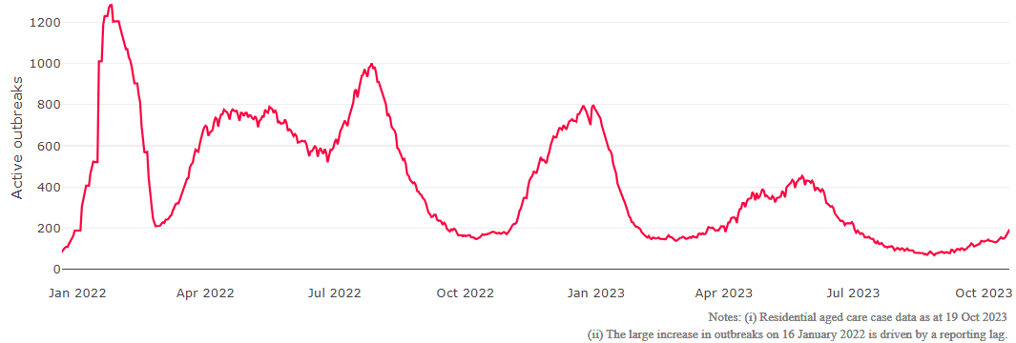

**Figure 2: Trends in Aged Care Cases – December 2021 to Present**

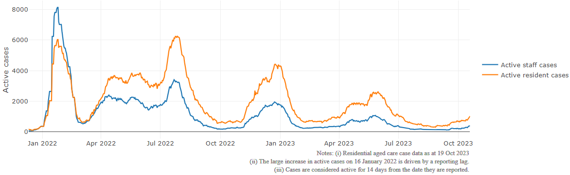

## Mortality

For the period of 1 July 2023 to 12 October 2023, COVID-19 is recorded as the cause of death in 1.2 percent of all deaths in permanent residents in aged care facilities.

Since the beginning of the Omicron outbreak in mid December[5] 2021, there have been 110,530 deaths in residential aged care from all causes (report period from 15 December 2021 to 12 October 2023)[6]. COVID-19 deaths account for 4.5 percent of this figure.

Over the course of the pandemic, all-cause excess mortality in Residential Aged Care was below expected numbers in 2020, and within expected range in 2021.

Figure 3: COVID-19 Deaths in Residential Aged Care Facilities overlaid with Community deaths

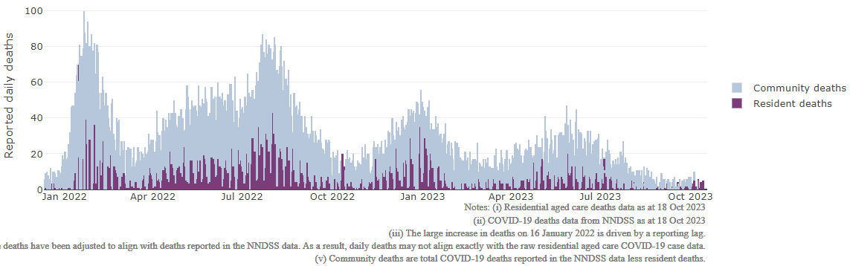

## Workforce in active residential aged care outbreaks

As at 20 October 2023, workforce surge staff have filled a total of 180,832 shifts in aged care services impacted by COVID-19, including 429 in the past 7 days. In the past 7 days (to 20 October) surge workforce providers have assisted 16 residential aged care homes. These shifts include roles for GPs, nurses, care workers, allied health workers, executive and ancillary staff. This includes:

Table 3: Workforce resources supplied to residential aged care facilities

| Workforce provider | Total Shifts | | Previous 7 days | |
| --- | --- | --- | --- | --- |
| Recruitment, Consulting and Staffing Association | 103,852 | 0 | |
| Healthcare Australia (Workforce Surge) | 14,870 | 0 | |
| Healthcare Australia (NACER) | 2,295 | N/A | |
| Mable | 2,711 | N/A | |
| Aspen Medical | 26,369 | 180 | |
| HealthX | 26,679 | 249 | |
| Torrens | 4,056 | N/A | |

The Australian Defence Force provided support to a total of 542 residential aged care homes between February and September 2022. The ADF deployment ceased on 30 September 2022.

## Oral antiviral treatments

Distribution of the oral anti-viral Lagevrio (Molnupiravir) commenced on 6 February 2022 to all RACFs with outbreak sites prioritised for delivery. The National Medical Stockpile has deployed 48,269 treatment courses of Lagevrio (Molnupiravir) to aged care facilities.

80,036 prescriptions for Lagevrio (Molnupiravir) have been issued to residents in residential aged care facilities, with a further 6,763 prescriptions for Paxlovid (nirmatrelvir + ritonavir) also issued since 28 February 2022 and up to 15 October 2023.

## Vaccination in Residential Aged Care Facilities

People living in residential aged care are a high priority for the Government’s COVID-19 vaccination program.

Older age remains the biggest risk factor for severe COVID-19 disease. Vaccination offers added protection to help reduce the risk of severe illness or hospitalisation of aged care residents.

The department is working with both the aged care and primary care sectors to ensure residents have access to the COVID-19 vaccine. It continues to target support for residential aged care facilities to arrange COVID-19 vaccinations with local primary care providers such as GPs, community pharmacists and Aboriginal Community Controlled Health Services.

As at 18 October 2023:

* 82k (48.0%) aged care residents received a booster dose in the last 6 months.
* 757 aged care residents received a booster dose in the last week.

**Table 4: Aged care COVID-19 2023 Booster Doses (data as at 18 October 2023)**

| Jurisdiction | Received booster in last 6 months | |
| --- | --- | --- |
| Residents vaccinated | % of residents vaccinated |
| **National** | **82k** | **48.0%** |
| ACT | 1.1k | 48.7% |
| NSW | 26k | 47.4% |
| NT | <200 | 39.7% |
| QLD | 15.6k | 45.1% |
| SA | 7.1k | 47.7% |
| TAS | 2.1k | 51.0% |
| VIC | 22.5k | 50.9% |
| WA | 7.4k | 48.1% |

Source: Matched Australian Immunisation Register (AIR) data of residents in permanent residential aged care.

For reporting accuracy, the total aged care resident population only includes residents who have been linked with their vaccination records. As residential aged care populations are fluid, the total population for vaccination are an estimate only and there is an administrative lag with the aged care recipient data which is linked to AIR data. Counts may fluctuate due to enhancements to data over time.

Key: k= thousand

## Infection control and audit

People living in residential aged care homes remain a high priority for the Government’s COVID-19 vaccination program. The Department is continuing to communicate with both the aged care and primary care sectors, reinforcing the importance of uptake and promoting the 2023 booster dose via regular newsletters, bulletins, social media videos and webinars.

All aged care residents who have not had a COVID-19 vaccination, or a COVID-19 infection within the last 6 months, continue to be offered a 2023 booster dose. The added protection from vaccination is especially important for aged care residents and will help reduce the risk of severe illness or hospitalisation.

The Department continues to work with Primary Health Networks to support residential aged care homes across Australia to arrange COVID-19 vaccination in-reach clinics with local primary care providers such as GPs, pharmacists, and Aboriginal Community Controlled Health Services.

As at 19 October 2023, the Commission had conducted 5,783 ICM spot checks to observe infection control practices and PPE protocols in residential aged care facilities.

Table 5: Total Quality Assessment and Monitoring Activities with residential services (including IPC), by type and month 1 March 2020 to 19 October 2023

|  |  |  |  |  |  |  |
| --- | --- | --- | --- | --- | --- | --- |
| Regulatory Activities | 2019-20 (1 Mar - 30 Jun 2020) | 2020-21 | 2021-22 | 2022-23 | 2023-24  (to 19 Oct) | Total |
| ****Site visits**** | 318 | 3,452 | 1,732 | 3,814 | 1,189 | 10,505 |
| ****Non-site activities**** | 3,709 | 8,382 | 6,665 | 1,413 | 119 | 20,287 |
| Total activities | **4,027** | **11,834** | **8,397** | **5,227** | **1,308** | **30,792** |

# Appendix 1: National residential aged care services with Active outbreaks COVID-19

Please note, information reported in this table has been directly reported to the Department of Health and Aged Care by residential aged care facilities. Total cases refers to all staff and resident cases associated with the active outbreak and may not reflect the count of currently active cases. Where numbers have been incorrectly reported, facilities are able to correct these in the COVID-19 Support Portal through My Aged Care. Where a facility is reporting less than six resident or staff cases or less than six deaths, data has been suppressed to protect the privacy of affected individuals (note that “n/p” indicates data is not provided to protect privacy).

| Service Name | State | Resident Deaths | Resident Cases | Staff Cases | Total Incidents |
| --- | --- | --- | --- | --- | --- |
| Advantaged Care at Georges Manor | New South Wales | 0 | <6 | 0 | <6 |
| Alstonville Adventist Aged Care Facility | New South Wales | 0 | 14 | 6 | 20 |
| Anglicare Barry Marsh House | New South Wales | 0 | 0 | <6 | <6 |
| Anthem | New South Wales | 0 | 10 | 6 | 16 |
| Aurrum Norah Head | New South Wales | 0 | <6 | <6 | <6 |
| Aurrum Wyoming | New South Wales | 0 | <6 | <6 | <6 |
| Bankstown Terrace Care Community | New South Wales | 0 | 42 | <6 | n/p |
| BaptistCare Caloola Centre | New South Wales | 0 | 12 | 8 | 20 |
| BaptistCare Warabrook Centre | New South Wales | <6 | 35 | 21 | 56 |
| Benjamin Short Grove | New South Wales | 0 | 20 | <6 | n/p |
| Beresford Hall | New South Wales | <6 | 11 | 8 | 19 |
| Bilyara Hostel | New South Wales | 0 | <6 | <6 | <6 |
| Blacktown Nursing Home | New South Wales | 0 | 7 | 0 | 7 |
| Bolton Clarke Macquarie View - Bolton Point | New South Wales | 0 | <6 | 0 | <6 |
| Calvary The Brelsford | New South Wales | 0 | <6 | 0 | <6 |
| Carinya House | New South Wales | 0 | <6 | 0 | <6 |
| Catholic Healthcare Our Lady of Loreto Gardens | New South Wales | <6 | 26 | 12 | 38 |
| Crowley Retirement Village | New South Wales | 0 | 7 | 10 | 17 |
| Estia Health Taree | New South Wales | 0 | 6 | 0 | 6 |
| Glenmore Park Care Community | New South Wales | 0 | 7 | 0 | 7 |
| Hawkesbury Living Pty Limited | New South Wales | 0 | 0 | <6 | <6 |
| Hunters Hill Montefiore Home | New South Wales | 0 | <6 | 0 | <6 |
| Killara Gardens Aged Care | New South Wales | 0 | <6 | 0 | <6 |
| Lansdowne Gardens on Wycombe | New South Wales | 0 | <6 | 0 | <6 |
| Mona Vale House | New South Wales | 0 | <6 | 0 | <6 |
| Moran Stockton | New South Wales | 0 | <6 | 0 | <6 |
| Moran Sylvania | New South Wales | 0 | 6 | <6 | n/p |
| Newmarch House | New South Wales | 0 | <6 | 0 | <6 |
| Our Lady Of Consolation Nursing Home | New South Wales | 0 | 7 | 8 | 15 |
| Pathways Sailors Bay | New South Wales | 0 | <6 | 0 | <6 |
| Presbyterian Aged Care - Apsley Riverview | New South Wales | 0 | <6 | <6 | <6 |
| Shoalhaven Place Care Community | New South Wales | 0 | 8 | <6 | n/p |
| St Elizabeth Home | New South Wales | 0 | <6 | 0 | <6 |
| The Shoreline | New South Wales | <6 | 18 | 12 | 30 |
| Thomas and Rosetta Agst Aged Care Facility | New South Wales | 0 | 8 | 0 | 8 |
| Toongabbie Terrace Care Community | New South Wales | 0 | <6 | <6 | <6 |
| Uniting Griffith | New South Wales | 0 | 11 | <6 | n/p |
| Uniting Hawkesbury Richmond | New South Wales | 0 | 14 | 0 | 14 |
| Uniting Narla Belmont North | New South Wales | 0 | 7 | <6 | n/p |
| Uniting Northaven Turramurra | New South Wales | 0 | 6 | 0 | 6 |
| Bethesda Caring Centre | Queensland | 0 | <6 | 0 | <6 |
| Calvary Gympie Views | Queensland | 0 | <6 | 0 | <6 |
| Calvary Robina Rise | Queensland | 0 | <6 | 0 | <6 |
| Caravonica Waters | Queensland | 0 | 11 | <6 | n/p |
| Carinity Kepnock Grove | Queensland | 0 | <6 | <6 | 7 |
| De Paul Villa Aged Care | Queensland | 0 | <6 | <6 | 7 |
| Eventide Home Rockhampton | Queensland | 0 | <6 | 0 | <6 |
| Glasshouse Views | Queensland | 0 | 0 | <6 | <6 |
| Infinite Care Edmonton Gardens | Queensland | 0 | <6 | 0 | <6 |
| Kirra Beach Care Community | Queensland | 0 | 8 | <6 | n/p |
| Lutheran Services - Trinder Park | Queensland | 0 | <6 | 0 | <6 |
| Parkview | Queensland | 0 | <6 | <6 | 6 |
| Regis Chelmer | Queensland | 0 | 49 | 8 | 57 |
| Regis Kirwan | Queensland | 0 | <6 | <6 | 6 |
| Regis Whitfield | Queensland | <6 | 34 | 22 | 56 |
| Regis Wynnum | Queensland | 0 | <6 | 0 | <6 |
| Regis Yeronga | Queensland | 0 | 8 | <6 | n/p |
| Seasons Living Mango Hill Care Suites | Queensland | 0 | <6 | <6 | <6 |
| Villa Maria Centre | Queensland | 0 | <6 | <6 | 6 |
| Villa Maria Eastern Heights | Queensland | 0 | <6 | 0 | <6 |
| Warrina Innisfail | Queensland | 0 | <6 | <6 | 7 |
| Wheller Gardens - St Marks House | Queensland | 0 | <6 | <6 | <6 |
| Yaralla Place | Queensland | 0 | <6 | <6 | 8 |
| ACH Group Residential Care - Kapara | South Australia | 0 | <6 | 0 | <6 |
| ACH Group Residential Care - Perry Park (high care) | South Australia | 0 | 9 | 0 | 9 |
| Alwyndor Aged Care | South Australia | 0 | 17 | 13 | 30 |
| AnglicareSA Brompton | South Australia | 0 | 7 | <6 | n/p |
| AnglicareSA Westbourne Park | South Australia | 0 | 18 | <6 | n/p |
| Bupa Enfield | South Australia | 0 | 45 | 15 | 60 |
| Calvary Oaklands | South Australia | 0 | <6 | 0 | <6 |
| Clayton Church Homes - Onkaparinga Valley | South Australia | 0 | <6 | 0 | <6 |
| Copperhouse Court Hostel | South Australia | 0 | <6 | 0 | <6 |
| Edenfield Family Care - Ramsay | South Australia | <6 | 13 | <6 | n/p |
| Eldercare The Lodge | South Australia | 0 | 14 | <6 | n/p |
| Eldercare Trowbridge House | South Australia | 0 | 17 | 10 | 27 |
| Estia Health Encounter Bay | South Australia | 0 | <6 | <6 | 6 |
| Estia Health Salisbury East | South Australia | 0 | 14 | <6 | n/p |
| Helping Hand Aged Care - Doreen Bond House | South Australia | 0 | <6 | <6 | 6 |
| Helping Hand Aged Care - Golden Grove | South Australia | 0 | <6 | <6 | 7 |
| Oakwood Aged Care | South Australia | 0 | 20 | <6 | n/p |
| Resthaven Marion | South Australia | 0 | 23 | <6 | n/p |
| Resthaven Port Elliot | South Australia | <6 | <6 | <6 | <6 |
| Restvale Hostel | South Australia | 0 | 8 | <6 | n/p |
| Ridleyton Greek Home for the Aged | South Australia | 0 | <6 | <6 | <6 |
| St Louis Nursing Home | South Australia | 0 | 10 | <6 | n/p |
| The Pines Lodge Residential Care | South Australia | 0 | 9 | <6 | n/p |
| Wheatfields Incorporated | South Australia | 0 | 6 | <6 | n/p |
| Barrington Lodge | Tasmania | 0 | 14 | <6 | n/p |
| Calvary Sandhill | Tasmania | 0 | <6 | 6 | n/p |
| Coroneagh Park | Tasmania | 0 | 10 | <6 | n/p |
| Kanangra Hostel | Tasmania | 0 | <6 | 0 | <6 |
| Mary Ogilvy Home | Tasmania | 0 | <6 | <6 | <6 |
| Allawah Special Care Hostel | Victoria | 0 | 12 | 6 | 18 |
| Arcare Balnarring | Victoria | 0 | 8 | <6 | n/p |
| Arcare Carnegie | Victoria | 0 | <6 | 0 | <6 |
| Arcare Castlemaine | Victoria | 0 | 34 | 13 | 47 |
| Arcare Caulfield | Victoria | 0 | <6 | <6 | 6 |
| Arcare Knox | Victoria | 0 | <6 | 0 | <6 |
| Arcare Parkview Malvern East | Victoria | 0 | 8 | <6 | n/p |
| Aurrum Healesville | Victoria | 0 | <6 | <6 | 8 |
| Bairnsdale Parklands Care Community | Victoria | 0 | <6 | <6 | 7 |
| Banfields Aged Care | Victoria | 0 | <6 | 0 | <6 |
| Bentons Lodge - Residential Aged Service | Victoria | 0 | 15 | 14 | 29 |
| BlueCross Hansworth | Victoria | 0 | <6 | <6 | 6 |
| BlueCross Riverlea | Victoria | 0 | 23 | 9 | 32 |
| BlueCross Scotchmans Creek | Victoria | 0 | 16 | 6 | 22 |
| BlueCross The Gables | Victoria | 0 | 11 | <6 | n/p |
| BlueCross The Mews | Victoria | 0 | 14 | <6 | n/p |
| BlueCross Western Gardens | Victoria | <6 | 28 | 9 | 37 |
| BSL Aged Care - Clifton Hill | Victoria | 0 | 10 | <6 | n/p |
| Bupa Berwick | Victoria | <6 | 31 | 9 | 40 |
| Bupa Clayton | Victoria | 0 | 15 | 8 | 23 |
| Bupa Kyneton | Victoria | 0 | 27 | <6 | n/p |
| Bupa South Morang | Victoria | 0 | <6 | <6 | 6 |
| Clarinda on the Park | Victoria | <6 | <6 | <6 | 6 |
| Clovelly Cottage | Victoria | 0 | <6 | <6 | <6 |
| Craigcare Pascoe Vale | Victoria | 0 | <6 | <6 | <6 |
| Diamond Creek Care Community | Victoria | 0 | 13 | <6 | n/p |
| Doutta Galla Footscray Aged Care Facility | Victoria | 0 | 19 | <6 | n/p |
| Edgarley Home | Victoria | 0 | 7 | 7 | 14 |
| Emerald Hill Residence | Victoria | 0 | 7 | <6 | n/p |
| Estia Health Heidelberg West | Victoria | 0 | 20 | 10 | 30 |
| Estia Health Mount Clear | Victoria | 0 | <6 | <6 | <6 |
| Estia Health Victoria Heights | Victoria | 0 | <6 | <6 | <6 |
| Estia Health Werribee | Victoria | 0 | <6 | 0 | <6 |
| Forest Lodge Residential Aged Care | Victoria | 0 | 12 | 0 | 12 |
| Fronditha Anesi Aged Care Services - Thornbury | Victoria | 0 | 31 | <6 | n/p |
| Havilah Hostel | Victoria | 0 | <6 | <6 | 6 |
| Heathcote Health High Care Service | Victoria | 0 | <6 | <6 | 7 |
| Heathcote Health Low Care Service | Victoria | 0 | <6 | <6 | 7 |
| Heritage Northcote | Victoria | 0 | <6 | 0 | <6 |
| James Barker House | Victoria | <6 | 13 | <6 | n/p |
| John Flynn Retirement Village | Victoria | <6 | 15 | 8 | 23 |
| Karinya | Victoria | 0 | 10 | 7 | 17 |
| Lilydale Aged Care | Victoria | 0 | 20 | 8 | 28 |
| Luson Bloom | Victoria | 0 | 11 | <6 | n/p |
| Margery Cole Residential Care Service | Victoria | 0 | <6 | 0 | <6 |
| Mercy Place Boronia | Victoria | 0 | 9 | 0 | 9 |
| Mercy Place East Melbourne | Victoria | 0 | 22 | 6 | 28 |
| Mercy Place Rice Village | Victoria | 0 | <6 | 0 | <6 |
| MiCare Avondrust Lodge | Victoria | 0 | <6 | 0 | <6 |
| MiCare Margriet Manor | Victoria | 0 | 21 | 9 | 30 |
| Mornington Bay Care Community | Victoria | 0 | 23 | 0 | 23 |
| Morrie Evans Wing Nursing Home | Victoria | 0 | 11 | <6 | n/p |
| Multicultural Aged Care Services Geelong Inc | Victoria | 0 | <6 | 0 | <6 |
| Newmans on the Park | Victoria | 0 | 19 | 10 | 29 |
| Olivet Aged Persons Home | Victoria | 0 | <6 | 0 | <6 |
| Park Lane Croydon | Victoria | 0 | 41 | 10 | 51 |
| Racecourse Grange Residential Care | Victoria | 0 | 7 | <6 | n/p |
| Regis Blackburn | Victoria | 0 | 0 | <6 | <6 |
| Regis Dandenong North | Victoria | 0 | 23 | 0 | 23 |
| Regis Sunraysia | Victoria | 0 | <6 | 0 | <6 |
| Riddell Gardens Hostel | Victoria | 0 | 10 | 0 | 10 |
| RM Begg | Victoria | <6 | 21 | 19 | 40 |
| St Vincent's Care Services Hawthorn | Victoria | 0 | 0 | <6 | <6 |
| Twin Parks Aged Care Centre | Victoria | 0 | 10 | <6 | n/p |
| Uniting AgeWell Manor Lakes | Victoria | <6 | 22 | <6 | n/p |
| Vasey RSL Care Brighton | Victoria | 0 | 13 | <6 | n/p |
| Vasey RSL Care Brighton East | Victoria | 0 | 29 | 6 | 35 |
| Vasey RSL Care Bundoora | Victoria | 0 | <6 | 0 | <6 |
| Victoria by the Park | Victoria | 0 | 0 | <6 | <6 |
| Victoria Grange Residential Aged Care Facility | Victoria | 0 | <6 | 0 | <6 |
| Villa Maria Catholic Homes Bundoora Aged Care Residence | Victoria | 0 | 7 | 0 | 7 |
| Villa Maria Catholic Homes Providence Aged Care Residence | Victoria | 0 | <6 | <6 | <6 |
| Villa Maria Catholic Homes Shanagolden Aged Care Residence | Victoria | 0 | 11 | <6 | n/p |
| Wantirna Views Care Community | Victoria | <6 | 57 | 10 | 67 |
| Westernport Nursing Home | Victoria | 0 | 0 | <6 | <6 |
| Yarraman Nursing Home | Victoria | 0 | 8 | <6 | n/p |
| Aegis Carrington | Western Australia | 0 | 7 | 0 | 7 |
| Alfred Cove Care Community | Western Australia | 0 | 14 | <6 | n/p |
| Augusta MPS | Western Australia | 0 | <6 | <6 | <6 |
| Brightwater Onslow Gardens | Western Australia | 0 | 0 | <6 | <6 |
| Carine Parkside Care Community | Western Australia | 0 | <6 | 0 | <6 |
| Juniper Ella Williams | Western Australia | 0 | <6 | <6 | <6 |
| Juniper Hillcrest | Western Australia | 0 | 0 | <6 | <6 |
| Juniper Sarah Hardey | Western Australia | 0 | <6 | <6 | 8 |
| Juniper St David's | Western Australia | 0 | 13 | <6 | n/p |
| Mercy Place Lathlain | Western Australia | 0 | 10 | <6 | n/p |
| MercyCare Maddington | Western Australia | 0 | <6 | 0 | <6 |
| Murdoch Gardens Care Community | Western Australia | 0 | <6 | 0 | <6 |
| Regents Garden Residential Aged Care Resort - Lake Joondalup | Western Australia | 0 | <6 | 0 | <6 |
| Residency by Dillons Fremantle | Western Australia | 0 | <6 | <6 | <6 |
| SwanCare Kingia/Tandara | Western Australia | 0 | 27 | 16 | 43 |
| ValleyView Residence | Western Australia | 0 | 14 | 19 | 33 |
| Yaandina Aged Care | Western Australia | 0 | <6 | 0 | <6 |

1. Outbreak opening and closure includes changes in the status of exposure sites to outbreaks (and vice versa), which are applied retrospectively to facility records. New case information can also change the status of a recovered site back to an active outbreak site. As a result, changes in active outbreak status may not align with day on day variations to active totals. These adjustments will also affect the number of cases in staff and residents reported each week.
2. Active residents and staff cases are the total currently positive cases in active outbreaks
3. An outbreak is considered to be active pending advice from the relevant Public Health Unit. An outbreak is defined as at least 1 positive case in a resident or 2+ cases in staff.
4. Case numbers and numbers of deaths are dependent upon reporting from facilities and validation of deaths from state and territory governments. This is subject to change as further information is provided.
5. The Omicron outbreak start date has been redefined from late November 2021 to mid December 2021. Changes have been made to align reporting with the start date of Omicron published in the Department’s external facing Epidemiology report.
6. The Department is now accessing aged care deaths data from the SIEBEL dataset. Figures are live and subject to change. Source: Department of Health and Aged Care unpublished data / SIEBEL dataset.