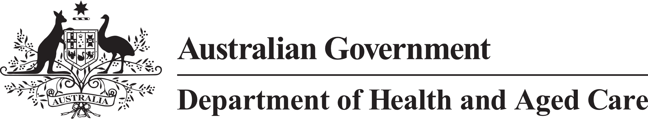

**Council of Elders**

# Communique – 20 September 2023

**Digital Strategy** – Good use of data can make access to information simple which can improve support for older people. Council discussed a holistic approach to developing a digital strategy, including how a strategy could build on the connections older people have to their communities and family. Better use of data could improve coordination of services, especially in health management, the promotion of healthy ageing, disease prevention and reablement. We emphasised the value in a strategy that supports the sharing of information with consent to make older people’s lives easier, while strongly protecting our privacy. We know that smart devices are more and more important, however it is important to keep in mind that older people may be using technology differently from younger generations. Older people appreciate user-friendly, positive, and trustworthy applications. It could be useful to engage younger people in innovation given their in-depth engagement with digital applications, and that they can assist older relatives to access information. Digital literacy programs and sharing information through older technologies that older people may still be using may also help.

**Elder Abuse** – The prevention of elder abuse is extremely important for Council. Council welcomed a dedicated discussion with the Commonwealth Attorney-General’s Department about the development of a second National Plan to Respond to the Abuse of Older Australians. The second National Plan is being developed by the Attorney-General’s Department in collaboration with the Department of Health and Aged Care and the states and territories. Our feedback emphasised the importance of community campaigns to prevent elder abuse, with nuanced approaches for First Nations and culturally and linguistically diverse communities. We emphasised the value of simplifying and strengthening substituted decision-making arrangements across the country. Educating older people about their rights is a critical part of preventing elder abuse. This includes increasing community awareness that older people have the right to change or remove enduring powers of attorney that they have put in place. Members suggested that targeted professional education for people working regularly with older people could improve awareness of elder abuse and ways to address it, as well as helping increase older people’s understanding of their rights.

**Aged Care Act** – Council discussed ways to boost confidence in aged care in a way that meets community expectations. Council particularly talked about some of the complexities related to the Aged Care Quality and Safety Commission and how complaints are handled.

**Ensuring adequate supply of aged care services** – Council discussed what government can do to ensure the future supply of high-quality aged care services across the country. Council feedback focussed on what will be needed to make sure that older people can access services that meet their diverse needs.

The next meeting of the Council of Elders will be held on 20 October 2023.