

Approach to Market

REIMAGINING WHERE WE LIVE

DESIGN IDEAS COMPETITION

Reference ID: Health / E23-145151

UNSPSC: 80111617 Architectural services



This Approach to Market (ATM) is for the provision of design ideas for residential aged care accommodation.   
The Commonwealth of Australia as represented by Department of Health and Aged Care (the Client) is seeking submissions for the provision of design ideas (the Requirement) as described in this ATM. In lodging a submission, Entrants are required to comply with all requirements set out in the ATM Terms.

Statement of Requirement

A.A.1 Key Information and Dates

Entrants should refer to the Competition Brief and ATM Documents for information regarding key dates, minimum content and format requirements, entrant eligibility and conditions of participation.

A.A.2 The Requirement

Entrants should refer to the Competition Brief and ATM Terms to understand the Client’s requirements for the Design Competition.

A.A.3 ATM Distribution

AusTender Distribution

This ATM and any updates are subject to the [AusTender Terms of Use](https://www.tenders.gov.au/?event=public.termsOfUse). Any updates to this ATM will be notified to Entrants via AusTender and all ATM Documents, updates to the ATM Documents and any questions answered by the Professional Adviser in accordance with the Competition Brief will be made available via the [Competition portal](https://reimaginingwherewelive.awardsplatform.com/).

AusTender is the Australian Government’s procurement information system. Access to and use of AusTender is subject to the AusTender Terms of Use. In participating in this ATM process, Entrants must comply with the AusTender Terms of Use and any applicable instructions, processes, procedures and recommendations as advised on AusTender.

A.A.4 Lodgement of Submissions

Submissions (both hard copy and soft copy) must be lodged in accordance with the Competition Brief and ATM Terms. Entrants should pay particular attention to the specific requirements for lodging Submissions in Part 7 of the Competition Brief.

A.A.5 Client’s Contact Officers

A.A.5(a) ATM Contact Officer

For all matters relating to this ATM, the Contact Officer is:

Name/Position: Annabelle Pegrum / Professional Advisor

Email Address: [accommodationdesign.reform@health.gov.au](mailto:accommodationdesign.reform@health.gov.au)

A.A.5(b) Complaints Handling

Any complaints by Entrants related to the Competition must be made promptly in writing to the Complaints Officer, Procurement Advice Team at: [procurement.advice@health.gov.au](mailto:procurement.advice@health.gov.au). Complaints will be handled in accordance with the Client’s Procurement Complaints Handling Policy.

More information about how to make a complaint, what to include when making a complaint and how complaints will be processed is available on the following webpage: <https://www.health.gov.au/about-us/what-we-do/grants-and-tenders#making-a-complaint>.

Approach to Market (ATM) Terms

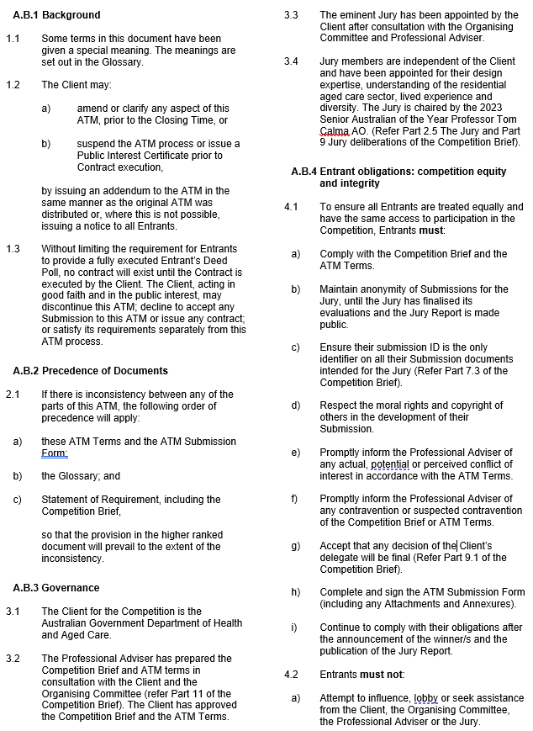

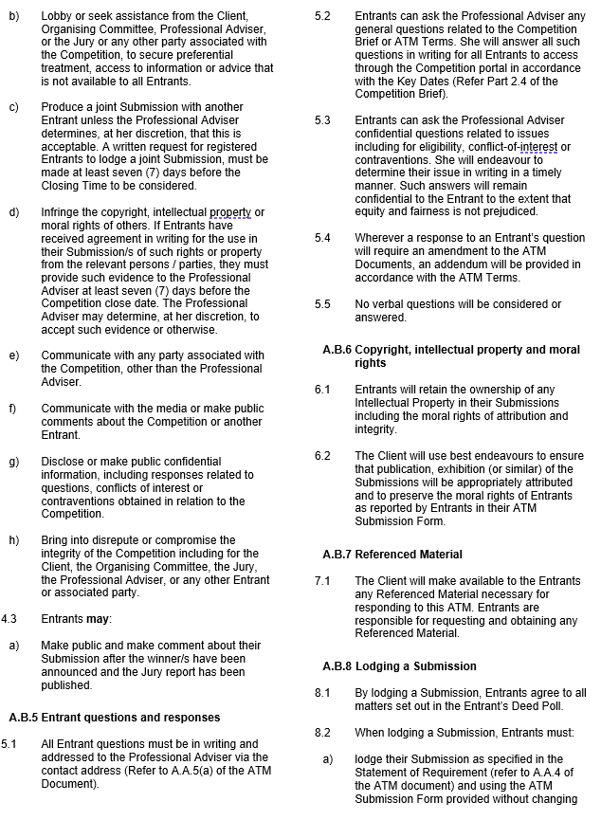

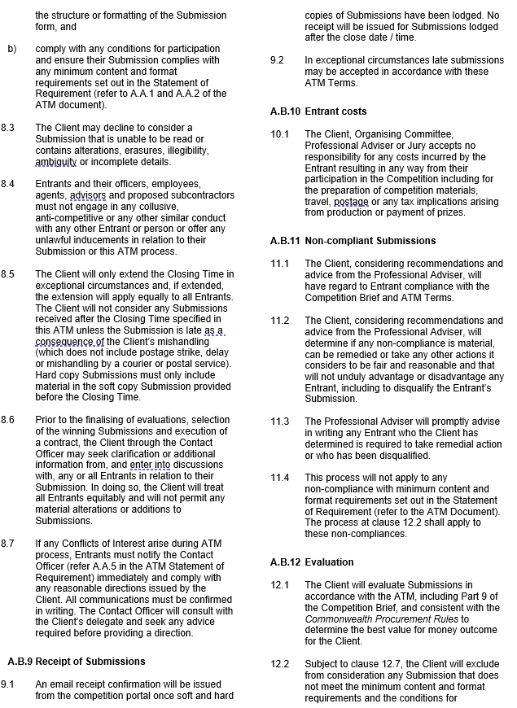

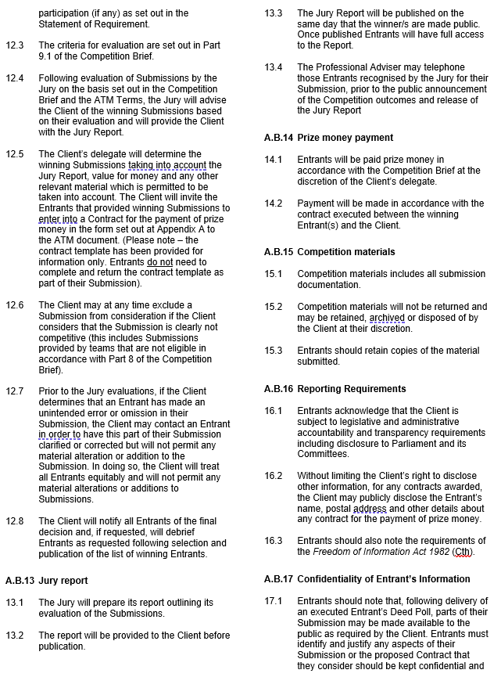

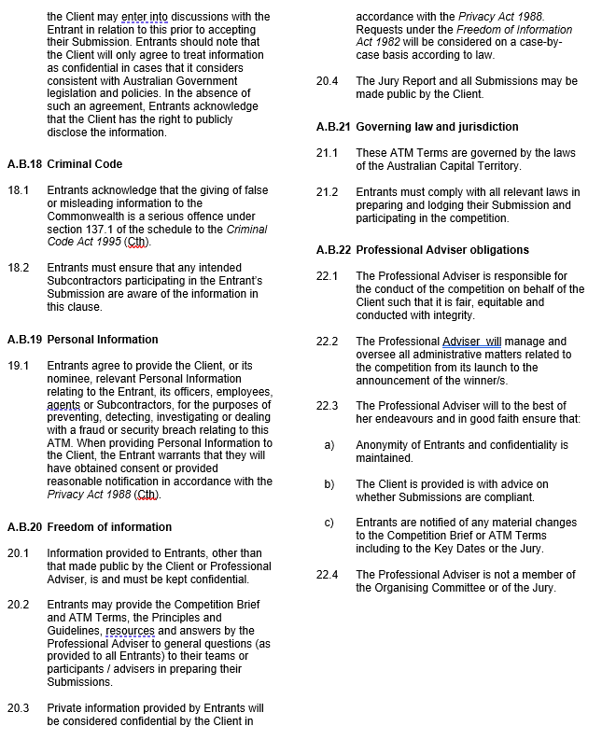

Glossary

In the ATM Documents:

“**Approach to Market**” or “**ATM**” means the notice inviting Entrants to participate in the relevant procurement (the Reimagining Where We Live – Design Ideas Competition) and includes the ATM documents.

“**ATM Closing Date**” means the date on which Submissions are required to be submitted in accordance with this ATM.

“**ATM Documents**” means all of the documents comprising this ATM, including:

* the Statement of Requirement, including the Competition Brief and any Attachments and Annexures to these documents;
* the ATM Submission Form
* this ATM Glossary; and
* the ATM Terms.

“**ATM Glossary**” or “**Glossary**” means this glossary.

“**ATM Submission Form**” means the form included in the section of the ATM Documents titled “Approach to Market (ATM) Submission Form”.

“**ATM Terms**” means the terms that apply to this ATM process (the Reimagining Where We Live – Design Ideas Competition) set out in the section of the ATM Documents titled “ATM Terms”.

“**Business Days**” means a day that is not a Saturday, a Sunday or a public holiday or bank holiday in the place concerned, as defined by the *Corporations Act 2001* (Cth*)*,and also excludes the period between Christmas Day and New Year’s Day.

“**Client**” means the Commonwealth of Australia as represented by Department of Health and Aged Care.

“**Closing Time**” means the closing time as specified in the Approach to Market.

“**Commonwealth Procurement Rules**” means the legislative instrument issued by the Finance Minister under section 105B of the *Public Governance, Performance and Accountability Act 2013* (PGPA Act), which establishes the framework under which entities govern and undertake their own procurement.

“**Competition Brief**” means the section of the ATM documents titled “Competition Brief”.

“**Competition Portal**” means the registration and submission portal for the competition at <https://reimaginingwherewelive.awardsplatform.com/>

“**Competition Website**” means website for the competition at <https://www.health.gov.au/reimagining-where-we-live>.

“**Confidential Information**” means any information that the Entrant does not wish to be shared outside those involved in the Competition. It can include anything that has been acquired, developed or made available to in the course of the Competition. It includes, but is not limited to, information:

# specifically identified as confidential in the Entrant’s Submission in accordance with the ATM Terms.

# where disclosure would cause unreasonable detriment to the owner of the information or another party, or

# where the information was provided under an understanding that it would remain confidential.

“**Conflicts of Interest**” means any actual, apparent or perceived situation where the personal interests of the Entrant, its officers, employees or agents could improperly influence the Competition.

“**Contract**” means the contract to be executed between the Client and the winning Entrants for the payment of prize money in the form of Appendix A to the Statement of Requirement.

“**Entrant**” means any entity that is eligible to respond to this ATM.

“**Entrant’s Deed Poll**” means the deed to be completed and lodged by Entrants as part of their Submission, as set out in Attachment A to the ATM Submission Form.

“**GST**” means a Commonwealth goods and services tax imposed by the GST Act.

“**GST Act**” means *A New Tax System (Goods and Services Tax) Act 1999* (Cth).

“**Intellectual Property**” means all present and future rights conferred by law in or in relation to any of the following:

i. copyright;

ii. rights in relation to circuit layouts, patents, registrable designs or trademarks; and

iii. any other rights resulting from intellectual activity in the industrial, scientific, literary and artistic fields recognised in domestic law anywhere in the world whether registered or unregistered.

“**Jury**” means the jury as described in the Competition Brief.

“**Moral Rights**” means the rights in Part IX of the *Copyright Act 1968* (Cth), including the right of attribution, the right against false attribution and the right of integrity.

“**Personal Information**” means information relating to a natural person as defined in the *Privacy Act 1988* (Cth).

“**Professional Adviser**” means the professional adviser as described in the Competition Brief and ATM Terms.

“**Public Interest Certificate**” means a certificate issued under section 22 of the *Government Procurement (Judicial Review) Act 2018* (Cth).

“**Referenced Material**” means any materials referenced in the ATM, including but not limited to, reports, plans, drawings or samples.

“**Statement of Requirement**” means the section of the Approach to Market with the heading ‘Statement of Requirement’.

“**Submission**” means information provided by an Entrant in response to this ATM.

**Interpretation**

In this ATM, unless stated otherwise:

# if any word or phrase is given a defined meaning, any other part of speech or other grammatical form of that word or phrase has a corresponding meaning

# words in the singular include the plural and words in the plural include the singular

# the words ‘including’, ‘such as’, ‘particularly’ and similar expressions are not used as and are not intended to be interpreted as words of limitation

# a reference to dollars is a reference to Australian dollars

# a reference to any legislation or legislative provision includes any statutory modification, substitution or reenactment of that legislation or legislative provision; and

# clause headings are for reference only and have no effect in limiting or extending the language of the terms to which they refer.

Statement of Requirement – Appendix A

Draft Contract for the Payment of Prize Money

**IMPORTANT:** You do **NOT** need to complete and return this draft contract template with your submission. It has been provided for information only. The Client will offer a Contract for the Payment of Prize Money to winning entrants only at the conclusion of the competition process.

Contract for the Payment of Prize Money

This Contract is made on the ___________________ (Insert Date)

Between:

The Commonwealth of Australia, represented by the Department of Health and Aged Care (Department)

and

[insert legal name, ABN/ACN and ARBN if applicable] (**Entrant**)

Together the parties

DRAFT

1. **Background and Context**

The Entrant’s Submission to the Department’s Approach to Market – Aged Care Design Ideas Competition, Health / E23-145151 (**ATM**) has been selected as a winning Submission following evaluations in accordance with the ATM.

The Entrant has been selected as the [insert name of prize won, e.g. runner up etc].

In light of this selection, and in consideration of the Department’s future use of the Submission (including all information, materials, drawings, designs and documentation provided by the Entrant), the Department will pay to the Entrant the prize money as set out in this Contract.

1. **Definitions**

In this Contract, terms which are capitalised but not defined have the same meaning as the ATM.

1. **Payment of Prize Money**

The following amount of prize money shall be payable to the Entrant following approval of a claim for payment submitted in accordance with clause 4 (**Prize Money Amount**).

|  |
| --- |
| $[insert dollar amount of prize money] AUD. |

1. **Claim for Payment Requirements**

To facilitate payment of the Prize Money Amount, the Entrant must provide a valid claim for payment meeting all of the requirements below to [insert email address for claim for payment]:

(a) the claim for payment is correctly addressed;

(b) the claim for payment reflects all of the Prize Money Amount;

(c) the claim for payment includes accurate and sufficient details for payment to the Entrant’s nominated account;

(d) the claim for payment includes the Purchase Order Number provided by the Department to the Entrant; and

(e) the claim for payment is a valid tax invoice in accordance with the *A New Tax System (Goods and Services Tax) Act 1999* (Cth).

The Department is not required to make a payment of the Prize Money Amount unless and until a valid claim for payment is submitted.

1. **Payment**

Following delivery of a valid claim for payment in accordance with clause 4, and within 20 days, the Department will make payment of the Prize Money Amount to the Entrant’s nominated account.

If the Department fails to pay within 20 days of receiving a valid claim for payment in accordance with clause 4, the Department must pay interest on the unpaid amount at the General Interest Charge Rate calculated in respect of each day that the payment was late.

The Department must pay interest whether or not the Entrant has submitted a separate invoice for the interest amount. Interest will only be payable in accordance with this provision if the interest amount exceeds $100 AUD.

‘**General Interest Charge Rate’** means the means the general interest charge rate determined under section 8AAD of the *Taxation Administration Act 1953* (Cth) on the day payment is due, expressed as a decimal rate per day.

DRAFT

1. **Applicable Law**

The parties agree that the laws of the Australian Capital Territory apply to this Contract and the parties submit to the non-exclusive jurisdiction of the courts of that Territory and of any court that may hear appeals from any of those courts, in connection with this Contract.

1. **Term**

This Contract ends upon the payment of the Prize Money Amount and any interest payable.

1. **Entrant’s Responsibility**

Entrants will be responsible for the splitting of the Prize Money Amount and any interest payable between the team members comprising the Entrant. The Department’s responsibilities under this Contract end upon payment.

**Executed as an agreement**

**Signed** for and on behalf of the Commonwealth of Australia as represented by the Department of Health and Aged Care ABN 83 605 426 759 on:

__________________________

Date

by:

________________________ ___________________________

Printed name of signatory Signature

_______________________________

Position of signatory

in the presence of:

____________________________ ___________________________

Printed name of witness Signature of witness

[*Note to Entrants: the below is provided as guidance only. Entrants will be expected to execute this agreement using one of the relevant execution clauses below. Areas shaded below are placeholders to be filled out when executing. There may be suitable alternatives to these execution blocks where the Entrant is not a company. Please raise any questions in relation to this with the Contact Officer*]

[*Note to Entrants: where an Entrant will execute this Contract in accordance with s 127 of the Corporations Act, this execution block is to be used*]

|  |  |  |  |
| --- | --- | --- | --- |
| **Executed** by **[INSERT NAME]** in accordance with section 127 of the *Corporations Act 2001* (Cth): |  |  |  |
|  |  |  |  |
| Signature of director |  | DRAFT | Signature of company secretary/director ***[delete position as appropriate]*** |
|  |  |  |  |
| Full name of director who states that they are a director of **[INSERT NAME]** |  |  | Full name of company secretary/director ***[delete position as appropriate]*** who states that they are a company secretary/director ***[delete position as appropriate]*** of **[INSERT NAME]** |

*[Note to Entrants: where an Entrant will execute this Contract via an authorised signatory in accordance with s126 of the Corporations Act this execution block is to be used. Please also provide evidence of your authority to enter the agreement on behalf of the Entrant, if requested by the Department*]

|  |  |
| --- | --- |
| **Signed, sealed and delivered** for and on behalf of **[INSERT NAME]** in accordance with section 126 of the *Corporations Act 2001* (Cth) by its authorised signatory: |  |
|  |  |
| Signature of authorised signatory |  |
|  |  |
| Full name of authorised signatory |  |