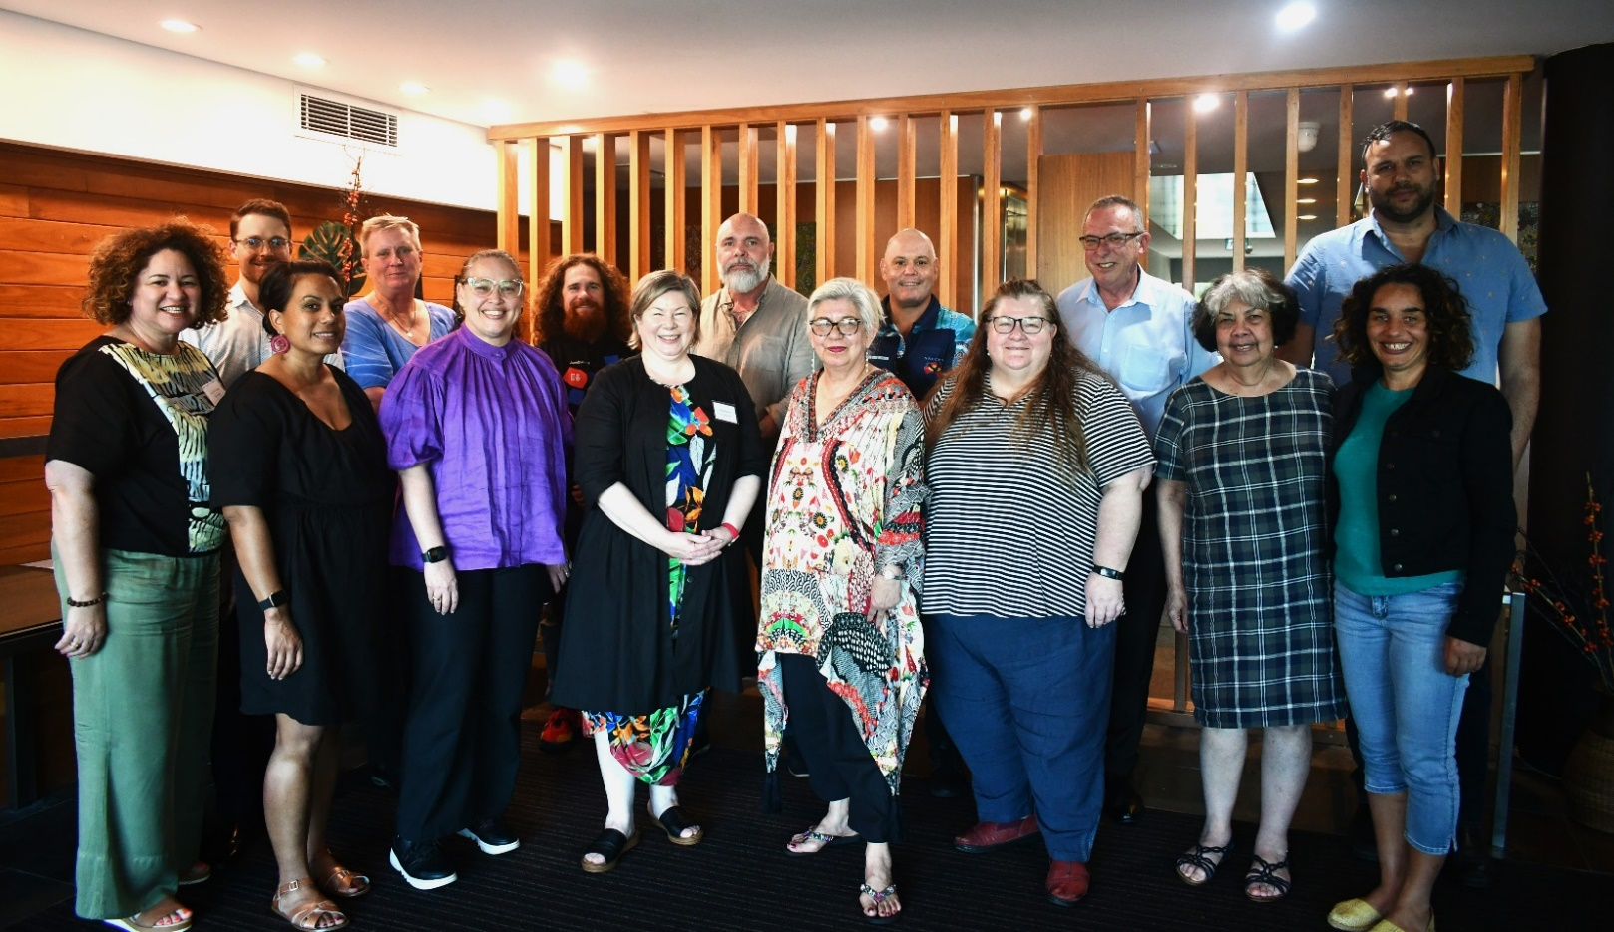Pictured: ***Tanya McGregor*** - Director Aboriginal Health, Department for Health and Wellbeing of South Australia; ***Dr Tim Allen*** -  A/Principal Policy Officer, Mental Health, Alcohol and Drug Directorate of Tasmania; ***Leonie Williamson*** - Senior Advisor - Knowledge Translation, Healing Foundation; ***Cecelia Gore*** - Executive Director, Mental Health, Alcohol and Other Drugs for NT Health;  ***Julie-Ann Guivarra*** – Deputy Chief Executive Officer Policy and Programs, NIAA; ***Dr Paul Gray*** - Associate Professor, Jumbunna Institute of Indigenous Education and Research, UTS; ***Tania Rishniw*** – Government Co-chair and Deputy Secretary Primary and Community Care - Department of Health and Aged Care; ***Dean Bayliss*** - CEO, Healing Works Australia; ***Professor Pat Dudgeon***– First Nations Co-chair and Gayaa Dhuwi (Proud Spirit) Australia Board Director; ***Zaccariah Cox*** - Acting Executive Mental Health Manager, Kimberley Aboriginal Medical Services; ***Monica Kelly*** - Mental Health and Wellbeing Promotion Adviser, Executive  Director, Mental Health and Wellbeing Division, Department of Health; ***Lindsay Hale*** – Deputy Commissioner Operations, WA Mental Health Commission; ***Dr Dawn Casey***, Deputy CEO – NACCHO; ***Matthew Trindall*** - Director, Aboriginal Mental Health, NSW Mental Health Branch; and ***Danielle Dyall* - SEWB Project Manager, Danila Dilba Health Service**

**Closing the Gap Social and Emotional Wellbeing Policy Partnership - Meeting 2 Communique**

The Closing the Gap Social and Emotional Wellbeing (SEWB) Policy Partnership has held its second meeting which took place on the 3rd of August 2023, on Larrakia Country, in Darwin. The meeting was co-Chaired by Professor Pat Dudgeon, Gayaa Dhuwi (Proud Spirit) Australia and Tania Rishniw, Deputy Secretary, Department of Health, and Aged Care.

In line with the intent of the SEWB Policy Partnership, the focus was on progressing the key policy priorities of the partnership. Discussions around refreshing the SEWB Framework and Policy Partnership working plans saw decisions focused on tangible strategies and deliverables moving forward. The key discussion points included:

* First Nation Members Updates
* NACCHO Community and Workforce Supports in the Context of the Referendum
* Overview of Gayaa Dhuwi Declaration Framework and Implementation Plan and the National Aboriginal Torres Strait Islander Suicide Prevention Strategy
* Social and Emotional Wellbeing Framework Refresh
* The Closing the Gap Social and Emotional Wellbeing Policy Partnership Joint Secretariat Annual Work Plan

**Key Decisions by the Partnership:**

1. The Partnership will seek urgent advice from the Department of Education regarding the measures being taken to manage the increased racism emerging around the Voice referendum and racism more generally to ensure protection for First Nations children.
2. First Nations co-chair and other First Nations representatives to be present at Minister’s final National Aboriginal and Torres Strait Islander Suicide Prevention Strategy meeting to ensure genuine decision making.
3. Aboriginal and Torres Strait Islander Community Controlled Health Organisation programs and services to be promoted as a key point of reference and referrals.
4. Resources to be created and distributed across the Partnership networks to support First Nations people dealing with the debate around the Voice that is racist, and discriminatory, as well as cultural burnout.
5. A working group to be established to focus on the SEWB Framework refresh and to report to the Partnership at future meetings as a standing agenda item.
6. Aboriginal and Torres Strait Islander Commissioning Framework wording amended to include "funding services and workforce".

The SEWB Policy Partnership received the following presentations as part of the agenda:

**Kimberley Aboriginal Medical Service on SEWB: Workforce and the Welcome Guide for the Aboriginal Workforce**

Zaccariah Cox shared some of the research and work that has been undertaken in KAMS. Research that explores the experience of SEWB workers and services has taken place. a guide, tailored to Aboriginal and Torres Strait Islander professionals in Social and Emotional Wellbeing (SEWB) teams was outlined and offers vital insights. It delves into SEWB history, its framework, and service possibilities. The guide shares practical wisdom from the Kimberley SEWB workforce, illuminating real-world SEWB application. It covers roles, effective clinic relationships, referral pathways, cultural workplace security, and professional growth. Additionally, it compiles key resources on SEWB, self-harm/suicide, yarning, reflective practice, mental health, SEWB screening tools, and evaluation.

**Aboriginal Health Council of WA SEWB Model of Service Pilot**

The Model of Service Pilot, initiated by the Aboriginal Health Council of Western Australia (AHCWA) and funded ($17.5 million) through the WA Government, is an innovative program trialled across five regional Aboriginal Community Controlled Health Organisations (ACCHOS) within WA. The primary objective of this program is to strengthen social and emotional wellbeing for Aboriginal people and communities by establishing interdisciplinary teams that will deliver culturally safe community development, the provision of comprehensive psychosocial supports, the establishment of precise and effective targeted interventions, and the reinforcement of supported coordinated care within Aboriginal communities. Through this multifaceted approach, the Model of Service Pilot seeks to foster holistic growth and improved health outcomes across Aboriginal populations in Western Australia. Importantly, the co-design process between the State Government and AHCWA was seen as an excellent example of supporting self-determination.

**NACCHO SEWB Workforce Survey Report**

In 2022, NACCHO undertook a workforce survey of its membership organisations SEWB workforce and received up to 60 survey responses. Key themes from the survey were: Culture: SEWB activities must be centred on First Nations culture and community. Resources and Funding: greater, sustainable, and more coordinated resourcing is needed to meet SEWB needs of communities. Workforce and training: there is an ongoing need to develop, retain and build a culturally responsive workforce. Activities and partnerships: SEWB activities are extensive and complex, requiring effective co-design, coordination, and support. Additionally, the presentation discussed the responses, highlighting that 95% of respondents provide SEWB services or support, which commonly consist of counselling, targeted group support, social activities, and life skills programs, case management, and AOD support services.

**NIAA Workforce Development and Support Units (WDSUs) Review**

Julie-Ann Guivarra – Deputy Chief Executive Officer Policy and Programs, National Indigenous Australians Agency, presented on findings from the NIAA Workforce Development Unit Review (not yet published). The purpose of the review was to examine the role and value of WDSUs, gauge SEWB and AOD workforce needs, and consider how best to support workforce development.