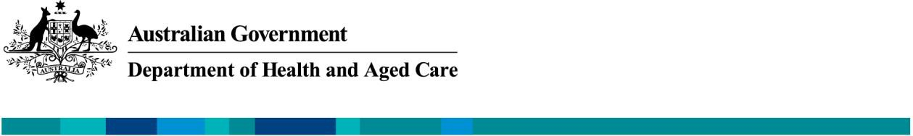

CONNECTING TO THE NATIONAL PRESCRIPTION DELIVERY SERVICE

### Strengthening electronic prescription exchange

In the 2023 May Budget, the Australian Government announced an investment of $111.8 million over four years and $24.2 million ongoing to provide prescription delivery services and related enhancements. This creates certainty for the exchange of nearly 300 million eligible prescriptions each year between prescribers and dispensers. It will extend electronic medication charts into other setting such as palliative care. It includes longer-term policy to mandate the use of electronic prescribing for high risk and high-cost medicines.

The national Prescription Delivery Service (PDS) launched on 1 July 2023 and to continue prescribing or dispensing eligible medications, clinicians and pharmacies must be connected to the national PDS by **30 September 2023.**

Clinicians and pharmacies are advised to [**register urgently**](http://www.erx.com.au/register)with the national PDS provider eRx Script Exchange to allow sufficient time to transition.

#### Establishing the Prescription Delivery Service

Australia’s prescription ecosystem started with the National E-Health Strategy introducing the concept of electronic transfer of prescriptions in 2008. Over the last 14 years, the prescription ecosystem has grown. The growth stems from support from legislative change, funding initiatives and a 15-cent electronic prescription fee (EPF), rebating pharmacies via the Community Pharmacy Agreement. And it was made possible by the innovation and collaboration of the Australian medical software industry. Today, more than 95% of all eligible prescriptions, whether electronic or paper-based, use the prescription delivery service.

The 7th Community Pharmacy Agreement in 2020 stipulated that the current prescription delivery services would be moved out of the 7CPA and toward a direct contracted model. This change would ensure the effectiveness and sustainability of a Prescription Delivery Service.

The transition to a direct model began with a Request for Information (RFI) to explore the current and future state of Prescription Delivery Services, closing in Oct 2021. Informed by the RFI results, the Government announced the Request for Tender for Electronic Prescription Services (Ref: Health/E21- 576909) to engage a single or multiple providers for ongoing Prescription Delivery Services. The tender closed on 2 June 2022 and in May 2023, the department signed a 4-year contract for Fred IT's eRx Script Exchange to supply the national Prescription Delivery Service from 1 July 2023.



**Department of Health and Aged Care –**[**Resources**](https://www.health.gov.au/resources/collections/electronic-prescribing-resources)

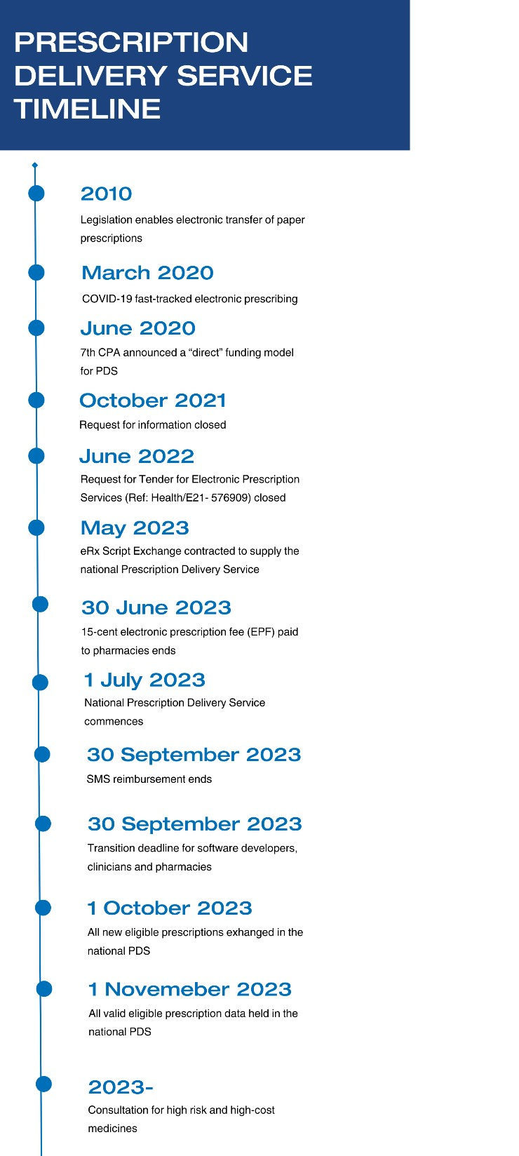**CONNECTING TO THE NATIONAL PRESCRIPTION DELIVERY SERVICE**

#### Benefits of the Prescription Delivery Service

The new PDS streamlines prescription delivery management and includes-

* Government-funded prescription exchange, including SMS fees
* Long-term funding certainty to enable innovation and efficiency
* Clearer governance, including managing issues and risks
* Enhanced capacity for patient-centred support and care
* Reduced complexity of the prescription delivery ecosystem

# WHAT YOU NEED TO KNOW

The 15-cent electronic prescription fee (EPF) paid to pharmacies via the Community Pharmacy Agreement ended **30 June 2023**. The ending of the EPF will maintain a cost-neutral arrangement for pharmacies as they will no longer be charged a 15c fee for eligible prescriptions by the Prescription Delivery Service.

The Australian Digital Health Agency will continue to reimburse the cost of electronic prescribing SMS notifications to **30 September 2023.** SMS notifications will then be funded through the national PDS and free for practices and pharmacies connected to the eRx Script Exchange gateway.

On the horizon are longer-term policy reforms such as

mandating use of electronic prescribing for high risk and high-cost medicines.

Clinicians and pharmacies are advised to **register urgently** to allow sufficient time to transition. To continue prescribing or dispensing eligible medications, practices and pharmacies must be connected to the national PDS by **30 September 2023.**

**Department of Health and Aged Care –** [**Resources**](https://www.health.gov.au/resources/collections/electronic-prescribing-resources) **2**

**CONNECTING TO THE NATIONAL PRESCRIPTION DELIVERY SERVICE**

# YOUR NEXT STEPS

## Clinicians

#### If you are connected to eRx Script Exchange:

No action by you is required at this time.

#### Your practice is not connected to eRx Script Exchange,

* + Register each clinician ASAP on eRx <http://www.erx.com.au/register>
  + Check with your prescribing software provider about any software updates you may need to perform

#### You are unsure if your practice is connected to eRx Script Exchange,

* + Contact your prescribing software provider for more information

### Electronic prescribing eLearning and professional development

The Australian Digital Health Agency offers free continuing professional development (CPD) accredited online training. The eLearning modules can assist with providing an introduction to what an electronic prescription is, how it is prescribed and dispensed, the benefit of Active Script List, and the policy requirements and legislation that underpin the process.

* + [Electronic prescriptions and Active Script List in your practice](https://training.digitalhealth.gov.au/enrol/index.php?id=39)
  + [Introduction to Active Script List for prescribers](https://training.digitalhealth.gov.au/enrol/index.php?id=73).

For training and resources, visit the Australian Digital Health Agency [electronic prescribing hub](https://www.digitalhealth.gov.au/healthcare-providers/initiatives-and-programs/electronic-prescribing/for-prescribers) or download [electronic prescribing resources](https://www.health.gov.au/resources/collections/electronic-prescribing-resources) from the Health website.

Practices are advised to [**register their clinicians urgently**](http://www.erx.com.au/register)with the national PDS provider eRx Script Exchange to allow sufficient time to transition. To continue prescribing eligible medications, a clinician must be connected to the national PDS by **30 September 2023**. And check with your software provider about any updates you may need to perform with your prescribing software.



**Department of Health and Aged Care –** [**Resources**](https://www.health.gov.au/resources/collections/electronic-prescribing-resources) **3**

# YOUR NEXT STEPS

## Pharmacists

#### If you are connected to eRx Script Exchange,

* + No action by you is required at this time.
  + The transaction charges through the PDS and the 15-cent electronic prescription fee (EPF) through Services Australia ended on 1 July 2023.
  + PBS Online claiming will pay the 15c EPF for scripts if they have a date-of-supply prior to 1 July 2023.

#### Your pharmacy service is not connected to eRx Script Exchange, or your pharmacy service was previously registered with eRx Script Exchange but is not currently using the service

* + Register your service ASAP on to eRx on <http://www.erx.com.au/register>
  + Check with your dispensing software provider about any software updates

#### You are unsure if your service is connected to eRx Script Exchange,

* + Contact your dispensing software provider for more information

#### If you are a software developer and not connected to eRx Script Exchange,

* + Ask your customers to register ASAP with eRx on <http://www.erx.com.au/register>
  + To begin the switch to the national PDS contact eRx Script Exchange on

[support@erx.com.au to](mailto:ePrescribing@erx.com.au) register your product.

* + In preparation for achieving conformance to Electronic Prescribing Conformance Profile

[v.3.0.1, visit th](https://developer.digitalhealth.gov.au/electronic-prescribing)e Australian Digital Health Agency electronic prescribing developer hub for resources.

* + *Please note: you will be be connected to the national PDS in the first instance at your current conformance level. We expect connected software developers will be able to start upgrading to CPv3.0.1 conformance in the second half of 2023.*

### Electronic prescribing eLearning and professional development

The Australian Digital Health Agency offers free continuing professional development (CPD) accredited online training. The eLearning modules can assist with providing an introduction to what an electronic prescription is, how it is prescribed and dispensed, the benefit of Active Script List, and the policy requirements and legislation that underpin the process.

* + [Electronic prescriptions and Active Script List in your practice](https://training.digitalhealth.gov.au/enrol/index.php?id=39)
  + [Introduction to Active Script List for prescribers](https://training.digitalhealth.gov.au/enrol/index.php?id=73).

For training and resources, visit the Australian Digital Health Agency [electronic prescribing hub](https://www.digitalhealth.gov.au/healthcare-providers/initiatives-and-programs/electronic-prescribing/for-dispensers) or download [electronic prescribing resources](https://www.health.gov.au/resources/collections/electronic-prescribing-resources) from the Health website.

Pharmacists are advised to [**register urgently**](http://www.erx.com.au/register)with the national PDS provider eRx Script Exchange to allow sufficient time to transition. To continue dispensing eligible medications, a pharmacy must be connected to the national PDS by **30 September 2023**. And check with your software provider about any updates you may need to perform with your dispensing software.

**Department of Health and Aged Care –** [**Resources**](https://www.health.gov.au/resources/collections/electronic-prescribing-resources) **4**

# MORE INFORMATION

The Department of Health and Aged Care, the Australian Digital Health Agency and Fred IT will work with software developers, clinicians and pharmacists to support connection to the simplified Prescription Delivery Service. We want to safeguard access to medicine prescriptions and protect consumers from service disruptions while implementing the national PDS.

An enduring Prescribing Delivery Service is only a first step in realising the longer-term possibilities in digital health. Your continued contribution and support for electronic prescribing is appreciated.

For more questions about electronic prescription policy or to share your perspective, please contact [EPTransition@health.gov.au](mailto:ePrescribing@health.gov.au).

# FAQ

|  |  |
| --- | --- |
| **Will prescriptions issued prior to 1 October remain valid after the transition?** | Yes, all eligible prescription data will transfer to the national PDS. There will be no disruption for consumers by providers switching to the national PDS. No prescriptions will need reissuing. |
| **Why do I need to register my practice’s clinicians or my pharmacy with eRx Script Exchange?** | Access to electronic prescription exchange through the national PDS is at the individual clinician and pharmacy level.  Your software provider will need you to register with [eRx Script Exchange](http://www.erx.com.au/register) ASAP in order to connect you to the national PDS. |
| **I am ready to connect to the national Prescription Delivery Service.** | **Contact eRx Script Exchange**  Phone:1300 700 921  <http://www.erx.com.au/register> Email: [support@erx.com.au](mailto:support@erx.com.au) |

**Department of Health and Aged Care –** [**Resources**](https://www.health.gov.au/resources/collections/electronic-prescribing-resources) **5**

# KEY DATES

|  |  |
| --- | --- |
| **Now** | Confirm service or register with [eRx Script Exchange](http://www.erx.com.au/register) |
| **30 June 2023** | 15-cent electronic prescription fee (EPF) ended  *PBS Online claiming will pay the 15c EPF for scripts if they have a date-of-supply prior to 1 July 2023.* |
| **1 July 2023** | The national Prescription Delivery Services commenced.  Free electronic prescription transfers for prescribing and dispensing starts.  Free SMS notifications for practices and pharmacies connected to eRx Script Exchange gateway starts |
| **30 September 2023** | Reimbursement of electronic prescribing SMS notifications ends.  To continue prescribing or dispensing eligible medications, software developers, clinicians and pharmacies must be connected to the national PDS |
| **1 October 2023** | Any new eligible prescriptions must exchange through the national PDS |
| **1 November 2023** | The national PDS holds all eligible prescription data |

**Transitioning to the national PDS**

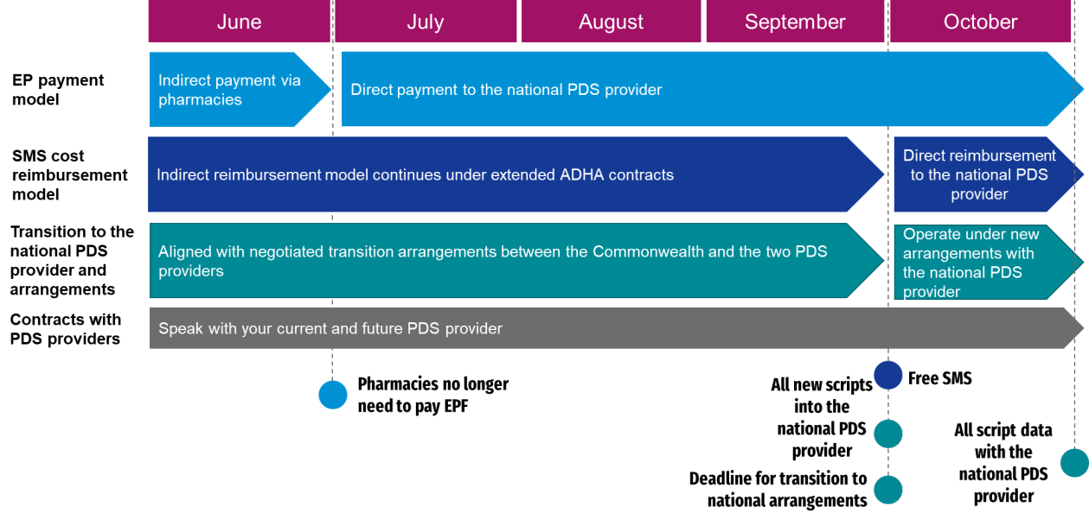

**Department of Health and Aged Care –** [**Resources**](https://www.health.gov.au/resources/collections/electronic-prescribing-resources) **6 **