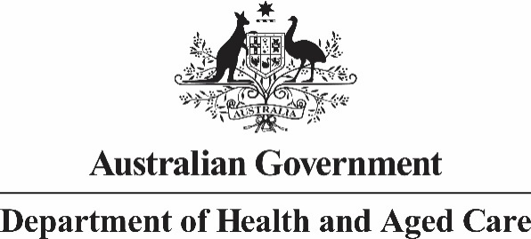

## LGBTIQA+ Health and Wellbeing 10 Year Action Plan Expert Advisory Group 8 September 2023 Meeting Communiqué

The Australian Government is working to improve access to care, support, and better physical health, mental health, and wellbeing outcomes for LGBTIQA+ communities and populations.

The Government recognises LGBTIQA+ people continue to experience discrimination, stigma, isolation, harassment, and violence, which leads to barriers accessing appropriate health care and poorer physical and mental health compared to the general population.

Today, the LGBTIQA+ Health and Wellbeing 10 Year National Action Plan Expert Advisory Group (EAG) held its second meeting, in Melbourne, on the land of the Wurundjeri People of the Kulin Nation.

EAG Members reaffirmed their commitment to undertaking national consultations to guide the National Action Plan. Members discussed the unique challenges and health and wellbeing priorities for people with innate variations in sex characteristics (intersex people), First Nations LGBTIQA+ health and wellbeing priorities, and received an update on national consultation activities.

LGBTIQ+ Health Australia (LHA), presented on the data analysis component of the national consultation undertaken in partnership with Australian Research Centre in Sex Health and Society. The presentation gave a high-level overview of the findings, noting that the data sets did not capture data on people with innate variations of sex characteristics.

Intersex Human Rights Australia presented a paper on the health, wellbeing and needs of people with innate variations of sex characteristics in Australia. In particular, it was noted the distinct and specific needs, circumstances and priorities of people with innate variations of sex characteristics should be considered in designing the National Action Plan.

The EAG also tabled a ‘Call to Action’ that has been submitted to them seeking commitment to improving mental health, health outcomes, and social and emotional wellbeing among Aboriginal and Torres Strait Islander LGBTQIASB+ people. EAG members noted the need to ensure the voices, ideas and priorities of Aboriginal and Torres Strait Islander LGBTQIASB+ people and communities were heard and reflected through national consultation activities informing the National Action Plan.

EAG Members will continue to inform the development of the 10 Year Action Plan for the Health and Wellbeing of LGBTIQA+ People to ensure Australia can implement a plan that addresses health disparities and make improvements across the health system.

**Next steps**

Roundtables with LGBTIQA+ communities and service providers across Australia will be undertaken to hear their ideas and priorities for the National Action Plan.

The EAG will next meet to discuss further updates on national consultation activities, and will continue to inform the development of the first 10 Year National Action Plan for the Health and Wellbeing of LGBTIQA+ people.

**Chair**

**The Assistant Minister for Health and Aged Care, the Hon Ged Kearney MP**

**8 September 2023**

**Melbourne**