Residential Aged Care Accommodation Framework

Final report on the development of the draft National Aged Care Design Principles and Guidelines

September 2023
Funded by the Australian Government Department of Health and Aged Care


Copyright
© 2023 Commonwealth of Australia as represented by the Department of Health and Aged Care

This work is copyright. You may copy, print, download, display and reproduce the whole or part of this work in unaltered form for your own personal use or, if you are part of an organisation, for internal use within your organisation, but only if you or your organisation:
(a) do not use the copy or reproduction for any commercial purpose; and
(b) retain this copyright notice and all disclaimer notices as part of that copy or reproduction.

Apart from rights as permitted by the Copyright Act 1968 (Cth) or allowed by this copyright notice, all other rights are reserved, including (but not limited to) all commercial rights.

Requests and inquiries concerning reproduction and other rights to use are to be sent to the Communication Branch, Department of Health and Aged Care, GPO Box 9848, Canberra ACT 2601, or via email to copyright@health.gov.au


Acknowledgement of Country
We acknowledge that Country for Aboriginal peoples is an interconnected set of ancient and sophisticated relationships.
The University of Wollongong spreads across many interrelated Aboriginal Countries that are bound by this sacred landscape, and intimate relationship with that landscape since creation.
From Sydney to the Southern Highlands, to the South Coast.
From fresh water to bitter water to salt. From City to Urban to Rural.
The University of Wollongong acknowledges the custodianship of the Aboriginal peoples of this place and space that has kept alive the relationships between all living things.
The University acknowledges the devastating impact of colonisation on our campuses’ footprint and commit ourselves to truth-telling, healing and education.
Artwork by Samantha Hill, Dharawal/Wandandian woman

Consortium
The development of the National Design Principles and Guidelines has been undertaken by a consortium comprising: the Centre for Health Service Development (CHSD), Australian Health Services Research Institute (AHSRI), University of Wollongong; Dementia Training Australia’s architectural consultants (Constructive Dialogue Architects); Dementia Training Australia; Dementia Australia; and the Sustainable Buildings Research Centre (SBRC), University of Wollongong.
Project Team: Nick Seemann, Liz Fuggle, David Week, Anita Westera, Darcy Morris, Carol Loggie, Cristina Thompson, Pam Grootemaat, David Fildes, Rachel Rowe, Sally Lambourne, Jackie Hayes, Karen Cmiel, Daniel Daly, Timothy McCarthy, Paul Cooper, Belinda Goodenough, and Robert Gordon
Design Principle Illustrations: Samantha Donnelly
Graphic design: Jeremy Austen, Austen Kaupe
This project has been funded by the Australian Government Department of Health and Aged Care.

Acknowledgments
The project team would like to thank the many stakeholders who participated in the consultation process for their time and valuable insights. We gratefully acknowledge members of the Accommodation Design Reform Team at the Australian Government Department of Health and Aged Care for their contribution to, and guidance throughout this project. The project team thank Stephen Judd, Karen Borg, Richard Fleming, Steve Teulan, Wendy Hubbard, Daniel Jameson, and Michael Lockwood for input and advice throughout the project. We are very appreciative of the input of Dementia Support Australia into the development of the persona characters and scenarios.

A comment about language
Through this report we have endeavoured to use language that is accurate, respectful, inclusive, empowering and non-stigmatising in line with recommendations from Dementia Australia1 and in consideration of other commentary on language.2 We regret any use of language that does not meet this standard or causes offence, whether written by the authors, captured through interview quotes, or included in evidence review citations.

Suggested citation
Seemann N, Fuggle L, Week D, Westera A, Morris D, Loggie C, Thompson C, Fildes D, Grootemaat P, Lambourne S, Goodenough B, and Gordon R (2023) Final Report on the Development of the draft National Aged Care Design Principles and Guidelines. Wollongong, NSW: Centre for Health Service Development, Australian Health Services Research Institute, University of Wollongong.




Contents
Introduction 1
Overview 1
Background and Development 2
Structure 3
Application 4
Personas 5
The Principles and Guidelines at a Glance 7
Principles and Guidelines 12
Design Principle 1 – Enable the Person 12
Design Principle 2 – Cultivate a Home 39
Design Principle 3 – Access the Outdoors 63
Design Principle 4 – Connect with Community 79
Glossary 91
Photo Credits 92
References 94
Appendices 106
Appendix 1 Environmental Sustainability 107
Appendix 2 Enabling Technology 108
Appendix 3 Infection Prevention and Control (IPC) 109

Introduction

Overview
The National Aged Care Design Principles and Guidelines presented in this document have been developed to support the Australian Government’s new Residential Aged Care Accommodation Framework.
The Design Principles and Guidelines provide a comprehensive, evidence-based resource to promote the design of aged care accommodation and support the delivery of high quality, safe, respectful and dignified care.3 They have been designed for a broad range of individuals and groups with a stake in residential aged care services. This includes older Australians, their families, and advocates; aged care accommodation providers and the design professionals they engage to build or renew their aged care homes; health care professionals and staff delivering services to residents; and regulators and policymakers across government. They are structured to support easy navigation across core considerations for aged care environments, and include design checklists and links to supporting evidence.
The Design Principles and Guidelines are compatible with and complement the Aged Care Quality Standards. They aim to support the development of safe and comfortable environments that promote residents’ independence, function and enjoyment.4 Simultaneously, they aim to support development of safe workplaces for staff to provide high quality personal and clinical care. They are underpinned by international principles that recognise the intrinsic value of older people and their right to independence, participation, care, self-fulfilment and dignity.5 The Design Principles and Guidelines reflect a continuation of the shift away from institutional models of care.

Background and Development
The National Aged Care Design Principles and Guidelines build on an existing evidence base and reflect internationally recognised approaches to designing environments for older people.
These Design Principles and Guidelines build on research undertaken over several decades. In particular, the work of recognised dementia design experts including Richard Fleming and Kirsty Bennett,6,7,8 Mary Marshall,9,10 and Margaret Calkins11 has been significant in their development.
The principles of environmental design for dementia developed in the 1980s and 90s remains important and relevant, and has significantly influenced the development of the Design Principles and Guidelines. The relevance of this previous work in current best practice is widely recognised. There is also increasing recognition that this work is not only relevant to support people with dementia, but also benefits others with age-related health and care needs.
The Design Principles and Guidelines seek to address the aspirations of residents and families, while also considering residents’ changing clinical profile: currently half of all residents are living with dementia,12 and half require assistance with mobility.13 They also seek to address staff needs (work health and safety regulations), balancing scale and available resources.
The Design Principles and Guidelines are based on a rigorous review of literature,14 and extensive consultation with older Australians, their families and carers, peak bodies, aged care providers, architects, health and care professionals, and technical experts.15,16
A consistent theme emerging in the development has been the importance of recognising that a home reflects people’s needs and aspirations, an approach consistent with the United Nations Convention on the Rights of Persons with Disabilities.17,18 For this reason, these Design Principles and Guidelines should be a living document able to respond to the changing evidence, and societal and cultural expectations and aspirations.

Structure
The Design Principles and Guidelines are structured to support easy navigation across core design considerations for aged care homes and include design checklists and links to supporting evidence.

Principles
The four Principles seek to address design for all people living and working in residential aged care, incorporate learnings from the COVID-19 pandemic, and facilitate stronger alignment between models of care and design. Each principle responds to an identified design challenge within aged care accommodation and is built around promoting the rights of residents, valuing care staff, and encouraging positive relationships between residents, families and staff.
The Principles follow a logic starting with the experience of the individual in their immediate environment (Principle 1), extending to their broader living environment (Principle 2), engagement with the outdoors (Principle 3) and finally with the broader community (Principle 4). Each Principle states an overarching objective, followed by a series of Guidelines that support social and care outcomes or events.

Guidelines
Each Principle comprises a set of Guidelines that focus on a particular design challenge, providing an overview of key concerns and potential solutions. Each Guideline includes a checklist of potential practical changes that may be adopted and is supported by an evidence-based rationale and scenario illustrating examples of benefits of implementing each Guideline.
- Principle 1 - Enable the Person: To support people living in a place that maintains their health, wellbeing and sense of identity.
- Principle 2 - Cultivate a Home: To create a familiar environment in which people have privacy, control and feel they belong.
- Principle 3 - Access the Outdoors: To support people seeing, accessing and spending time outdoors in contact with nature.
- Principle 4 - Connect with Community: To encourage people to connect with family, friends and community, continuing to participate in meaningful activities.

Application
The Design Principles and Guidelines allow for a variety of design approaches and responses to meet the different circumstances of aged care homes and their residents. Their application should occur collaboratively, with consideration of several key issues.
The Design Principles and Guidelines support co-design through the participation of all stakeholders (residents, families, staff and management).19 Co-design helps ensure that a shared vision is developed and that design approaches and responses are suitably adapted for local contexts. The aim of the Design Principles and Guidelines is to ensure they can be implemented flexibly and applied to the many diverse social, cultural and geographical contexts in which aged care homes operate. The Design Principles and Guidelines are relevant for minor and major refurbishments as well as the construction of new aged care homes.
Cultural diversity, supporting workforce, environmental sustainability, infection prevention and control, and the use of enabling technology are important considerations in any aged care development project. They have relevance to each of the Principles and Guidelines. Where a Checklist item relates to one of these issues, it is accompanied by the symbol shown below. Additional information in relation to the latter three is also provided in Appendix 1 to Appendix 3 respectively.
It is important to highlight that the Design Guidelines do not attempt to repeat information regulated elsewhere, such as the fire suppression provisions under the National Construction Code (NCC), food safety guidance for kitchen design in state-based Food Safety Acts, or manual handling supports regulated under work health and safety legislation. However, they have been written with a view to easily harmonising with those regulations, such as consistency with Class 9c provisions in the NCC.
Similarly, it is important to highlight the connections between the Design Principles and Guidelines and the guidance provided for other aged care services such as Multi-Purpose Services20 and the National Aboriginal and Torres Strait Islander Flexible Aged Care Program.21 However, there are correlations between all services providing residential aged care and a need to harmonise these Design Principles and Guidelines with the guidance provided for other services.
It is recommended that the Design Principles and Guidelines be reviewed periodically and updated to ensure they respond to changing evidence and societal and cultural expectations and aspirations.

Key to Checklist Symbols
- Cultural diversity
- Supporting workforce
- Environmental sustainability
- Infection prevention and control
- Enabling technology

Personas
The Guidelines include fictional personas to help bridge the gap between an abstract understanding of the Guideline and the lived experience of residents and staff. These personas aim to help the reader understand different users’ needs, experiences, behaviour, and goals.

The six personas
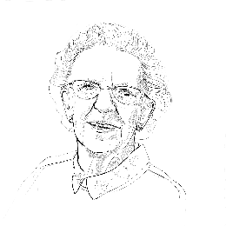
Anne, resident, 96
Anne is from regional Victoria and used to work as a florist. Anne loves handicrafts, flowers, and the Scottish culture of her mother. Anne is not independently mobile and has difficulty with verbal communication and swallowing. She spends much of her time in her room.

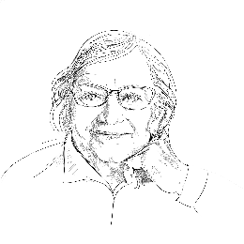
Bianca, resident, 85
Bianca migrated to Australia from Naples, Italy as a teenager. She loves bushwalking, nature, and dogs. Bianca has macular degeneration and a diagnosis of dementia with Lewy Bodies, which increase her risk of falling. She is always keen to go outside.

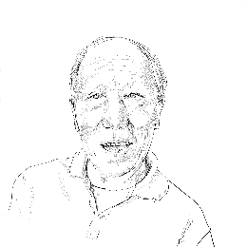
Charlie, resident, 76
Charlie is originally from Hong Kong. He emigrated when he was in his twenties with his wife and baby son. He is living with frontotemporal dementia and has a hearing impairment. Working in a restaurant, Charlie was an early riser, he continues to get up early and look for things to do.

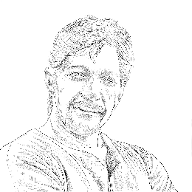
Dave, care worker, 52
He has worked as a carer for 12 years. Dave used to be a mechanic, but had a career change after caring for his mum who lived with dementia. He loves cooking and listening to music.


Eleesha, care worker, 26
Eleesha is a registered nurse in training, originally from the Philippines. She has worked in aged care for 18 months. She has a four-year-old child. Eleesha previously cared for her grandmother at home.


Francine, aged care home manager, 48
Francine is from Sri Lanka and is in charge of operations, care and minor building works. She has been in the role for five months. She trained as a nurse and has three children.

The Principles and Guidelines at a Glance
Principle 1 Enable the Person
  - Personalised Home
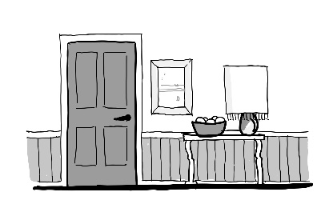
  - Minimal Clutter
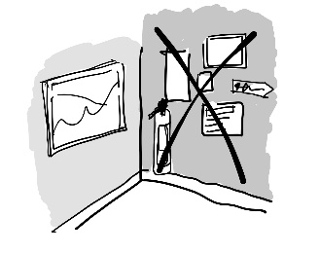
  - Acoustic Comfort
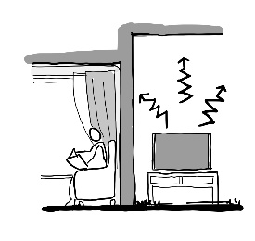
  - Clean Air
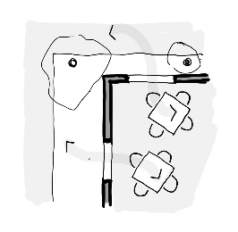
  - Brighter Lighting
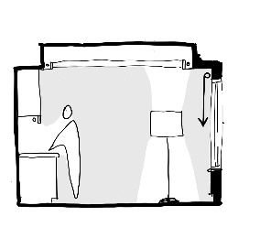
  - Tonal Contrast
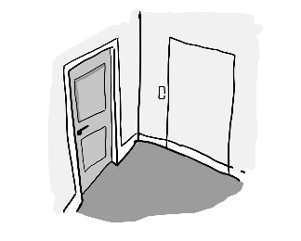
  - Simple Circulation
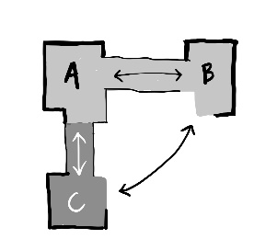
  - Safe Floors
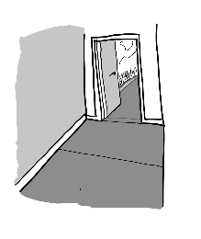
  - Supportive Seating
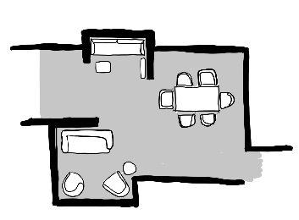
  - Stress-free Toilets
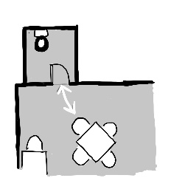
  - Comfortable Temperatures
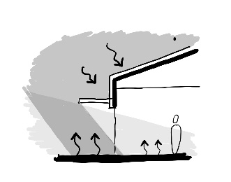
Principle 2 Cultivate a Home
2.1 Small Households
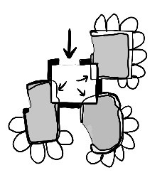
2.2 Private Entries
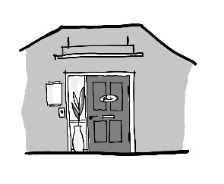
2.3 Domestic Kitchens
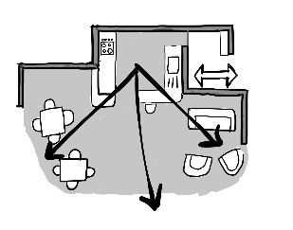
2.4 Room Clusters
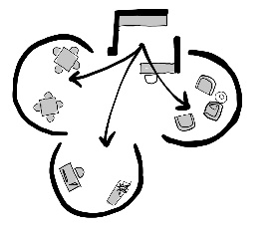
2.5 Enabling Corridors
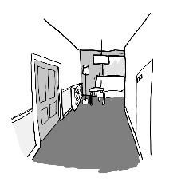
2.6 Private Bedrooms
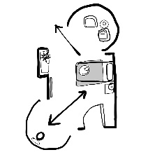
2.7 Ensuite Bathrooms
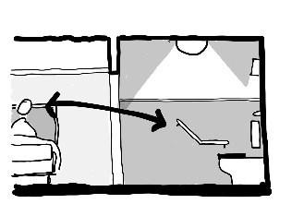
2.8 Appropriate Furniture
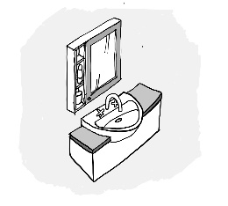
2.9 Clinical Support
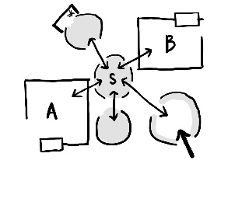
2.10 Private Staffroom
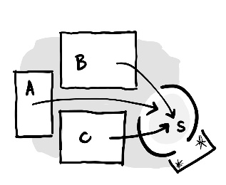
Principle 3 Access the Outdoors
3.1 Dedicated Outdoors
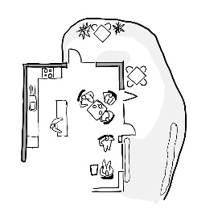
3.2 Garden Connections
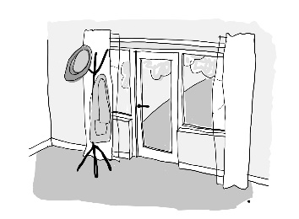
3.3 Garden Verandahs
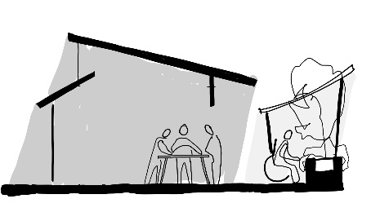
3.4 Garden Destinations
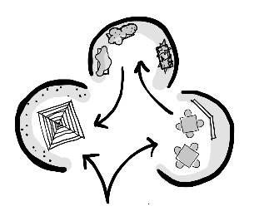
3.5 Clear Paths
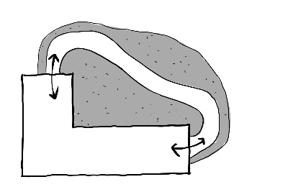
3.6 Nature Indoors
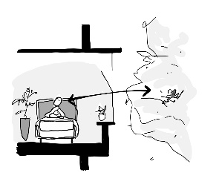
Principle 4 Connect with Community
4.1 Neighbourhood Access
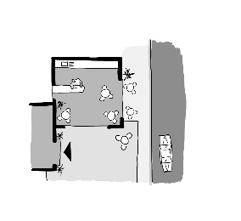
4.2 Community Hub
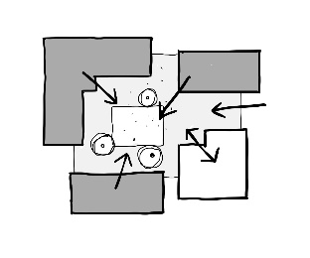
4.3 Easy Navigation to Households
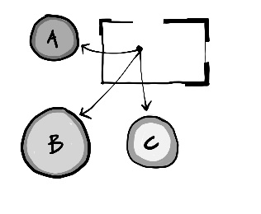
4.4 Integrated Building Form
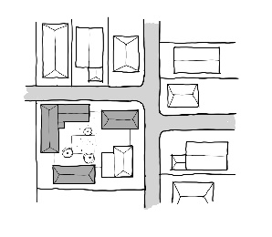

Principles and Guidelines

Design Principle 1 – Enable the Person

Objective
To support people living in a place that maintains their health, wellbeing and sense of identity

Guidelines
- 1.1 Personalised Home
- 1.2 Minimal Clutter
- 1.3 Acoustic Comfort
- 1.4 Clean Air
- 1.5 Brighter Lighting
- 1.6 Tonal Contrast
- 1.7 Simple Circulation
- 1.8 Safe Floors
- 1.9 Supportive Seating
- 1.10 Stress-free Toilets
- 1.11 Comfortable Temperatures

Situation
People move into residential care because their increasing health and care needs mean they can no longer remain living at home. Aged care homes can be challenging for residents due to sensory stimulations (noise, temperature, smells) as well as unfamiliar items (equipment, clinical features) and layouts.
Thoughtful environmental design can however reduce the impact of changing mobility, cognition, continence and frailty that residents may experience, and support their physical, cognitive and psychosocial well-being.

Desired Outcomes
This set of Guidelines applies to all areas in an aged care home, including resident areas within households, access routes to households, and community areas.
The Guidelines build on existing regulatory requirements to more fully address the needs of residents in aged care homes. They include design attributes that are known to support good health, orientation, continence, mobility, participation and meaning for older people.
The aim is to create an environment that is familiar to and supportive of residents, and can adapt to meet their changing needs over time.
The Guidelines include design features that range from simple, low-cost changes that can be introduced to existing buildings to more substantial features that better suit new buildings. The Guidelines associated with Principle 1 require little additional cost if incorporated during the design of a new building. They are also the easiest to apply retrospectively to existing buildings.
Some suggestions require changes to organisational practices (decluttering programs), some can be achieved without construction work (upgrading furniture), and some may be achieved through routine maintenance programs (renewing flooring).
Before The noise, clutter and busyness of the nurses' station, signage clutter and lack of orientation increases confusion and stress of residents
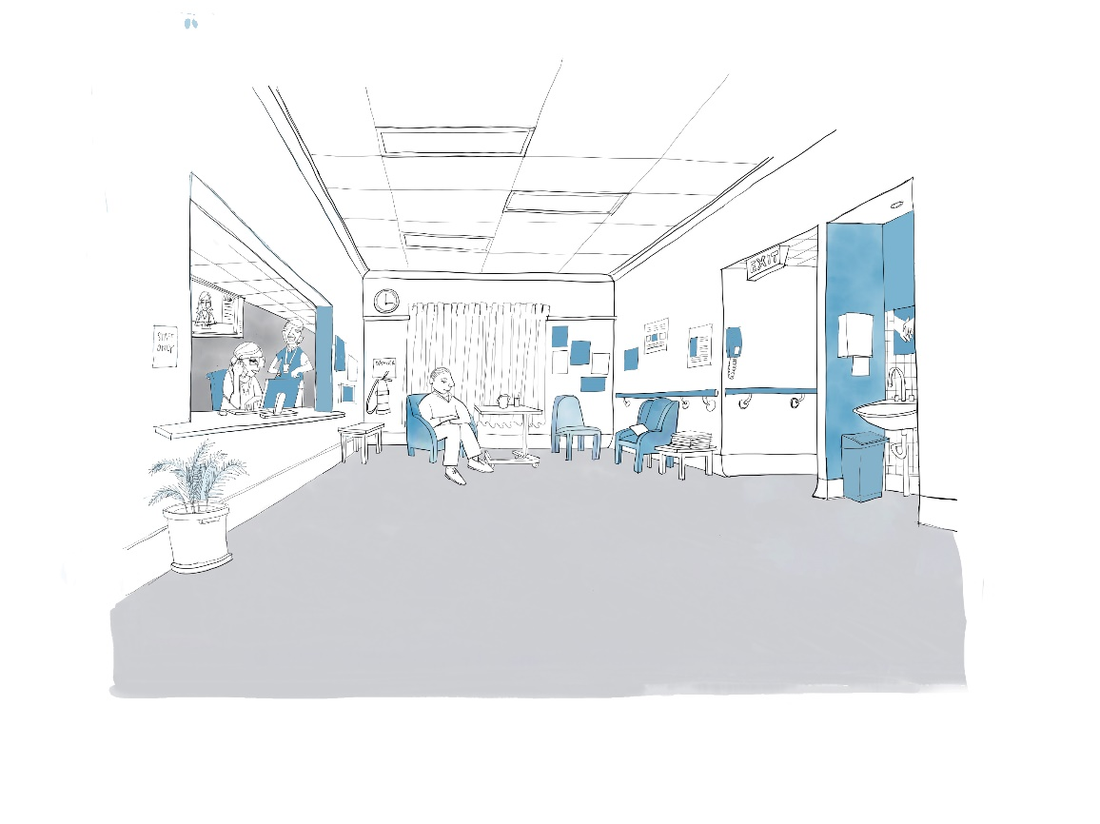
After This is a more comfortable, peaceful environment with the nurses' station removed, basin area discreet, prompting more social activity
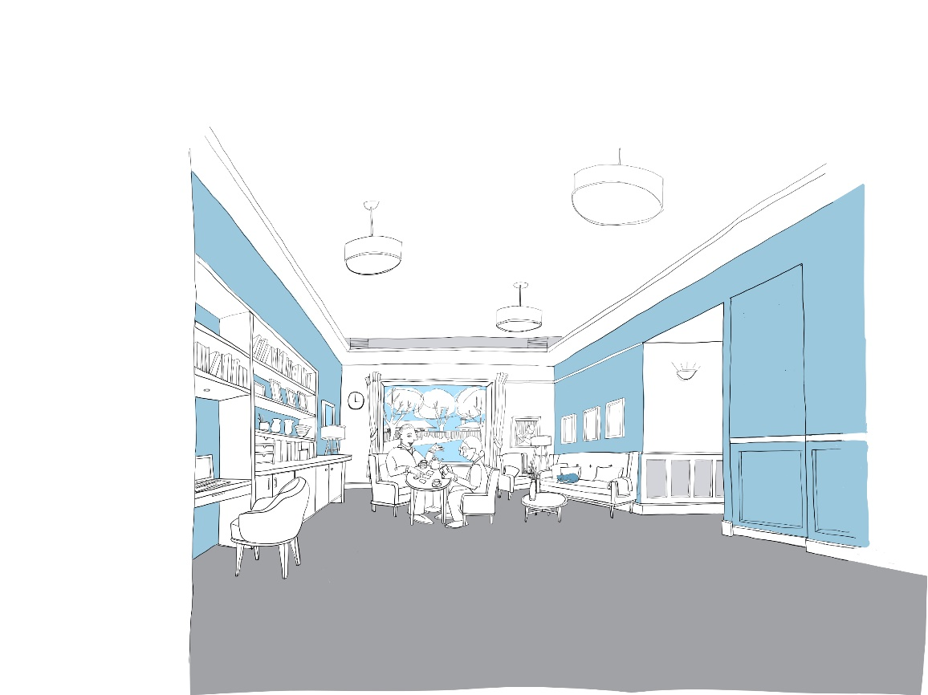

Guideline 1.1 Personalised Home
Bedrooms and living areas are furnished with items from people's lives

Guideline
Encourage residents to decorate the place where they live with furniture, artwork, and other objects from their lives. This starts with bedrooms, but should extend to common resident areas, making the entire home more familiar to them. Room design should allow space for residents to bring their own furniture and have open shelving that they can fill.
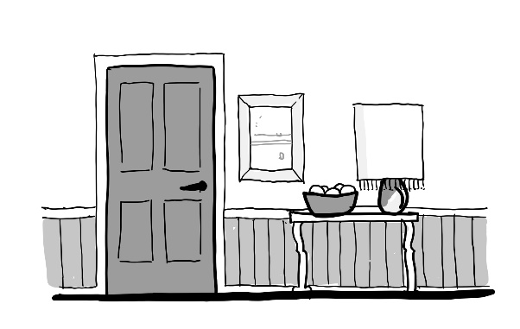

Scenario
People have many objects and mementos to which they’re deeply attached. These help to reinforce a person's sense of identity.
Anne loves all kinds of handicrafts. When she lived at home, she had many pieces of her own work around her. She couldn’t bring many things with her to the home as she moved directly from hospital and does not have immediate family to help make the room more like her own. The room feels stark to her, and she feels uncomfortable knowing that everyone who comes into the room can see her routine marked up on the whiteboard.
While Eleesha knows that Anne enjoys crafts, she has never seen anything Anne has made. It’s important that in Anne’s room Eleesha can see what routine Anne has, and the whiteboard makes this easy.

Rationale
Why is this important? Throughout our lives we fill our homes with items that have meaning for us, remind us of past experiences, and support our daily routines. As we get older, we rely more on this ‘coding’ of a place with familiar items to reinforce self-identity.22,23 The functional, clinical and impersonal design of traditional aged care homes has been reported as making a person feel like they are living in temporary accommodation, not a home.24 Including familiar objects increases the likelihood of someone participating in routine and domestic activities, and can contribute to improved quality of life for older people.25,26 Personal objects can make a place feel like home,27 are highly valued by residents living in aged care homes,28 and can also act as a prompt for staff to tailor their interactions and activities.
What makes a difference? An open kitchen design with familiar fittings can encourage older people to participate in domestic activities, and support autonomy regarding food and drink choices.29 Memory boxes at bedroom doors,30,31 personal furniture, and photographs32 all aid orientation and support an individual’s sense of identity. Double or personal beds are valued, preferably until someone needs a hospital bed. People value knowing what would be provided in a room and having the ability to make the room home-like.33

Outcomes
The whiteboard is now mounted inside the wardrobe door. Anne is happier about this placement. Francine and Eleesha talked about ways of making Anne's room more welcoming.
When Anne's former neighbour next visits, Eleesha asks her if she could bring in some examples of Anne's craft work. Eleesha is amazed by her intricate quilting. One quilt was hung from the picture rail in the bedroom and is a real talking point. One of the larger ones has been hung up in the living room. Anne is really delighted. Several residents and staff have admired it. Eleesha thinks Anne is more likely to enjoy being in the living room because of her quilt being there.

Checklist
- Help residents set up their bedroom with their own furniture, decoration, and everyday items (relates to “Supporting workforce”)
- Implement a policy supporting residents decorating bedrooms, common areas, and outdoor areas with personal items (relates to “Supporting workforce”)
- Promote residents’ culture using personal objects and art in common areas, with no single culture or person dominant (relates to “Cultural diversity”)
- Provide things for people to enjoy their interests; their choice of garden plants, or exercise equipment for example (relates to “Cultural diversity”)
- Provide technology to suit individual requirements (eg, big button remote controls) and good wi-fi coverage (relates to “Enabling technology”)
- Keep personal information secure and out of sight, but accessible to staff, for example in a cupboard or digitally (relates to “Supporting workforce”)
- Avoid aged care home branding in resident household areas
- Ensure there is no legal burden on staff if objects are lost, misplaced or damaged

Guideline 1.2 Minimal Clutter
Resident areas are uncluttered
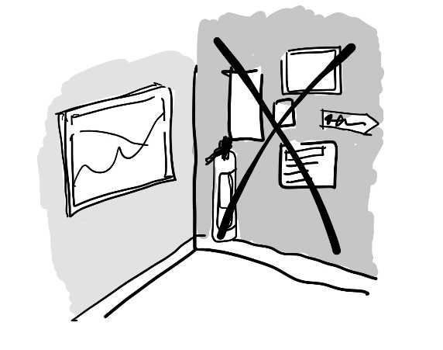

Guideline
Minimise visual clutter. Think through the core purpose of each room or outdoor area from a resident perspective, and remove or discreetly store anything that does not reinforce this purpose. For items in resident areas ask, ‘Would I have this in my own home?’

Scenario
Visual and physical clutter can be distracting and hazardous for older people, and for staff working in aged care.
Bianca is living with macular degeneration which limits her vision considerably. The many posters and notices are distracting and disconcerting. Her fear of falling is made worse by the lifters and trolleys in the corridor which she sometimes bumps into. The hall is so busy with people and things that she is exhausted often just getting from her bedroom to the dining room.
Francine understands that equipment is often left in the corridors by staff due to the lack of storage. She finds it difficult to balance the regulatory requirements regarding notices and equipment while at the same time providing a relaxed, homelike atmosphere for residents.

Rationale
Why is this important? Many people experience sensory overload and physical challenges when presented with busy, cluttered and/or noisy environments, and this can increase as health and care needs change.34 People living with dementia can be particularly susceptible to experiencing disorientation, agitation and confusion in such circumstances.35
What makes a difference? There are a range of simple changes that can be introduced to decrease risk of physical or cognitive stress, including reducing clutter and unnecessary signage/notices from living areas, and providing adequate and accessible storage space for routinely used aids and equipment. Walls and flooring should be relatively plain in terms of patterns and designs to support residents to understand their environment and prevent potential hazards. Avoid branding, lines or signage on floors, contrasting floor wastes and access panels, and realistic prints on floors and walls.36,37,38 Hand basins in hallways should be recessed to decrease visual and physical impact, while also facilitating ready access to support infection control.39,40 Options may also include discreet washbasin cabinets using push-catch opening mechanisms. Avoid mirrors in common areas to reduce the risk of them being misinterpreted or adding to visual clutter.

Outcomes
After consultation with families, all notices were compiled into a digital pack for visitors, and a duplicate paper set held in the reception area. Staff now receive notices by SMS and on their notice board in the staff rooms. All the stores were overhauled, with damaged and out of date items thrown out. This freed up some additional space to store some hoists nearer to bedrooms where they are needed. Bianca feels more confident moving in the hall. There is less information for her to process or things to bump into. Francine feels more confident that information being given out is current and both agree that the corridor looks nice and tidy.

Checklist
- Provide generous, discreet storage for clinical equipment and personal protective equipment close to where it is needed (relates to “Supporting workforce”)
- Check regularly that corridors are free of equipment (relates to “Supporting workforce”)
- Limit use of signage, notices, staff call indicator panels, and CCTV monitors in resident spaces
- Where legislatively necessary, mount signage as discreetly as possible
- Avoid patterns on floors, walls, and seating, limiting pattern use to loose items like cushions, artwork, or throws which can be more easily removed (relates to “Cultural diversity”)
- Avoid murals such as bookcases, nature, or street scenes, and mirrors in common spaces
- Ensure doors and door frames leading to staff-only areas, or locked doors are discreet, blending with adjacent walls
- Rather than signage, create landmarks with familiar objects and artwork to support wayfinding (relates to “Cultural diversity”)

Guideline 1.3 Acoustic Comfort
Unwanted sound (noise) has been removed from resident areas
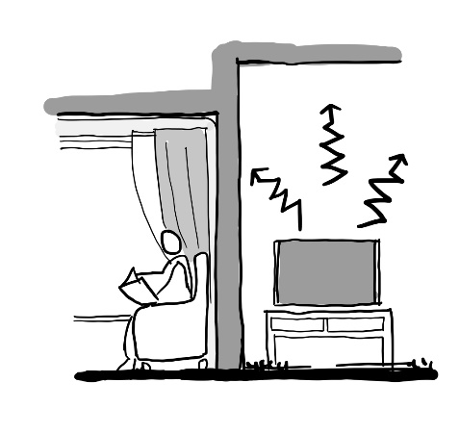

Guideline
Improve the acoustic environment using strategies of noise elimination (by replacing or dampening noisy equipment, doors, alarm systems), separation (especially between bedrooms and quiet rooms), and absorption (using carpet, curtains and other soft furnishings).

Scenario
Noisy environments inhibit clear communication and can increase confusion and disorientation.
Charlie is living with frontotemporal dementia and has a hearing impairment. He is particularly affected by noise. He finds it hard to relax in busy and noisy environments like the dining room during mealtimes. The dining room is quite large and busy. Charlie finds the noise of the plates, the doors banging, and constant chatter almost unbearable.
Dave is aware of the distress experienced by Charlie during mealtimes in the dining room, but has been unable to find an alternative place to eat.

Rationale
Why is this important? Most older people have some degree of impaired hearing affecting their communication and may have hypersensitivity to some noises.41 Noise is a known predictor of confusion, agitation and distress for people living with dementia. It reduces their ability to comprehend conversations or instructions directed at them, or make sense of their environment.42,43,44,45,46,47,48,49 Isolation is a major problem for aged care residents and distracting noise can inhibit conversations or understanding instructions. Mobility and communication challenges make it harder for a person to control their living space and move to quieter areas.50,51 A noisy environment can also impact on the ability of staff and visiting health professionals to accurately assess resident needs.
What makes a difference? Lower noise levels can reduce the experience of pain, reduce use of medication, and improve resident and staff wellbeing,52 and support people sleeping, communicating, and engaging better.53 Reducing the noise level of phones, call systems, alarms, televisions, and groups of people will help.54 Choice of materials can improve acoustics, with carpet more effective than hard flooring. Acoustically isolate commercial kitchens, delivery areas and back of house spaces from residential areas.

Outcomes
Dave measured the sound levels using a free phone app. He highlighted high levels to Francine who then organised professional readings. The noise level was reaching 70dB(A) during mealtimes. Curtains and acoustic sheers were fitted in the dining room and dampeners were fitted to the cupboard doors that were often banging. Heat resistant pads were put under tablecloths to reduce the noise of crockery. Staff became more aware of noise being a problem and made a lot of effort to keep their own noise to a minimum. All these things made a difference to Charlie and others in the room, who didn’t need to speak so loudly to be heard. Dave also suggested they sometimes eat in the garden, and that has also helped Charlie relax.

Checklist
- Establish procedures to reduce noise caused by institutional tasks, specifically acoustically separating commercial kitchens from resident living areas (relates to “Supporting workforce”)
- Audit background noise and reverberation times in each resident area annually
- Aim for 35dB(A) in bedrooms, 40dB(A) in common areas and 45dB(A) elsewhere
- Aim for a reverberation time of < 1sec in common areas, < 0.5sec in sleeping areas, and < 0.8sec in corridors
- Aim for acoustic separation of Rw/STC 50 between bedrooms
- Where possible, reduce reverberation with carpets and soft furnishings
- Ensure alarm and nurse call systems are silent to residents, staff and visitors (relates to “Supporting workforce”)
- Avoid installation of doors that close loudly or otherwise use dampeners
- Provide a separate room close to main living areas, where people can make noise or retreat from a noisier space

Guideline 1.4 Clean Air
Air quality is monitored and there is enough fresh air
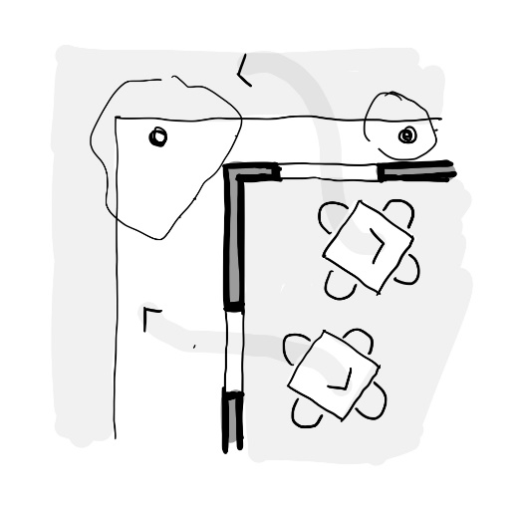

Guideline
Spot-check quality of the air in the building every six months. Open windows and outside doors to create cross ventilation. In any areas where acceptable levels are not being obtained, consult with a mechanical engineer to identify appropriate solutions. Reduce pollutants that are brought into the building, such as new materials releasing harmful gases, or certain cleaning products.

Scenario
Poor air quality impacts respiratory health, and in turn leads to fatigue, confusion, and stress.
Anne can’t open her window by herself.
Eleesha has noticed that other residents are also falling asleep during the day and lack energy, She is a bit concerned about Anne, who has a low mood and sleeps a lot, yet is restless at night.

Rationale
Why is this important? A range of factors contribute to poor air quality in homes. A build up of CO, CO2, particulates, volatile organic compounds (VOCs), odours, or airborne pathogens55,56 can affect health, usability and accessibility. It impairs human performance and social participation causing fatigue, dizziness, confusion, breathing difficulties, and stress.57 The experience of COVID-19 has heightened the importance of airflow and open windows introducing outside air.58,59,60,61 Building codes can allow window opening to achieve adequate ventilation, but in practice mechanical systems often cool a space without fresh air intake, windows are not opened and window restrictors reduce airflow.
What makes a difference? Being aware of areas in the home which are problematic is key. CO2 is a good proxy for general air quality and can be measured with spot checks or permanent devices. If outdoor air quality is good, use outdoor areas for activities, open windows, and create cross-ventilation. Specifying products with low VOC content and using barrier matting to clean people’s shoes reduces airborne pollutants. Evidence shows residents value having control over their environment and being able to open their own windows.62 For this to happen, windows must be easy and intuitive to use.

Outcomes
Spot tests were done of several areas of concern, including Anne’s room and found that CO2 levels were too high. Eleesha now opens Anne’s window and door in the morning to create some cross ventilation and again after lunch if she’s spent a lot of time in there. A small traffic-light indicator lets her know whether levels are okay. Anne does seem brighter and is sleeping better.

Checklist
- CO2 levels act as a good proxy for air quality, keep levels to < 800ppm (relates to “Infection prevention and control”)
- Utilise windows, doors and fans to create cross ventilation providing rooms with access to fresh air (relates to “Environmental sustainability” and “Infection prevention and control”)
- Air from bathrooms and bedrooms to flow outdoors and not into shared areas (relates to “Environmental sustainability” and “Infection prevention and control”)
- Encourage use of outdoor areas to maximise fresh air exposure (relates to “Infection prevention and control”
- Fit air purifying devices with an appropriate HEPA filter (relates to “Environmental sustainability”)
- Use cleaning products, carpets, paint, and other products with a low VOC content
- At building entries, install entry mat systems to remove pollutants from shoes on entry
- Provide controls that are easy to see, accessible, and intuitive to use
Note: Consult with experienced professionals when considering changes to ventilation systems

Guideline 1.5 Brighter Lighting
Lighting designed to suit older eyes, balancing the need for more light with issues of glare and personal control
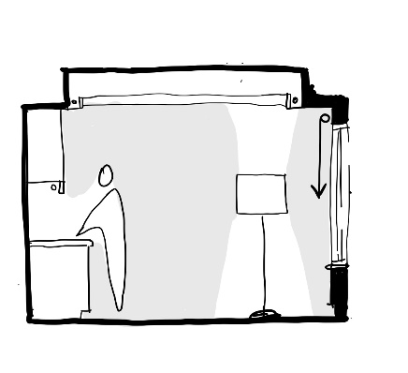

Guideline
Ensure that the general light levels are designed for older people, glare is controlled, and lighting can be reduced at night-time. Provide task-lighting in activity-based areas. Use daylight as much as possible. Enable residents to control lighting, reinforcing autonomy. Use high performance commercial fittings, coupled with domestic-style lighting to ensure a domestic appearance is maintained.

Scenario
Lights need to be brighter for older eyes.
As Bianca’s macular degeneration progresses, her vision has become worse, reducing her confidence. She’s less able to see people’s faces. She’s not sure if they are smiling at her. She used to be always telling jokes and teasing people, but now she finds it harder to be spontaneous.
Eleesha thinks like Bianca is a quiet lady who keeps to herself. She assumes she’s always been like that.

Rationale
Why is this important? Vision is fundamental to enable people to move around easily, participate in daily activities, communicate with others and engage in social settings.63 Vision depends on light levels, surfaces, eye health, and cognitive processing. Most aged care homes conform to codes written for younger eyes, resulting in poor lighting for older people.64,65 Our eyesight deteriorates as we age, becoming more blurred, more sensitive to changes in lighting, and weaker as less light reaches the retina. Dementia can affect visual processing.66,67,68 Poor vision increases risk of falls,69 even more so for people living with dementia.70 An older person also requires significantly more light for the same circadian response as a younger person,71,72 affecting sleep, wakefulness, and mood.73,74,75,76 Staff need good lighting when undertaking clinical assessment.77
What makes a difference? Assessment of lighting is a good first step to support care.78,79 Light levels, luminaire design, and light quality all make a difference. Double the normal levels of ambient light are recommended.80 with higher task lighting to support specific activities and light fittings selected to minimise glare. Daylight provides high levels of light for regulating circadian rhythms (min. 6000 lux-hours/day is recommended). Window furnishings should address glare. Outdoor lighting is needed to support evening activities.

Outcomes
The lighting in the corridor and main living space has been increased to almost double the level it was. Eleesha, who is 26, feels like it is very bright. But Bianca is so much more confident in the space. Bianca goes right up to Eleesha and takes her hands, telling her how pretty her top is today.

Checklist
- Ensure curtains in living rooms are wide open each morning and shut in the evening
- Provide good-sized windows in all living spaces and bedrooms, considering clerestory or forms of skylights where windows are distant (relates to “Environmental sustainability” and “Supporting workforce”)
- Aim for bright ambient light levels of around 300 lux, with reduced evening settings (relates to “Supporting workforce”)
- Aim for lighting of task areas such as tables, inside wardrobes, over toilets and washbasins to be 500 lux (relates to “Supporting workforce”)
- Use matte finishes and shield strong light sources to reflect light off walls and ceilings, avoiding strong shadows
- Choose artificial lighting with a high colour rendering index (CRI of > 85) and a warm light (< 3300K)
- Consider dimmers and lamp placement to allow light levels to suit time of day
- Ensure that any lighting on movement sensors does not dim suddenly or switch off entirely (relates to “Enabling technology”)

Guideline 1.6 Tonal Contrast
Interior design supports objects being easier to see
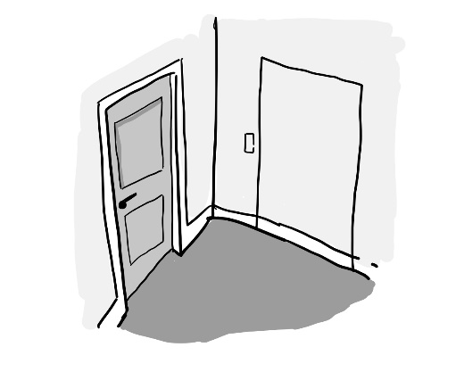

Guideline
Use contrasting tones to clarify key surfaces in a room, such as walls and floors. Further highlight fixtures to which residents should have access, such as seating, light switches, and bedroom doors. Avoid the use of reflective surfaces which confuse perception of the material. Use low contrast to hide or minimise objects that should not stand out, such as staff doors, changes in flooring material, and door thresholds.

Scenario
Strong tonal contrast makes it easier for people with poorer vision to see and engage more confidently.
Bianca is has visual disturbances which make it hard for her to make sense of what she is seeing. In her bathroom she sees a hole in the floor. This is frightening for her.
Eleesha understands that Bianca is misinterpreting the floor drain as a hole. Bianca’s bathroom has light-coloured floor and walls. The toilet is white too. The floor drain appears dark in colour. This is the strongest shape in the area. She tries to persuade her that it is just the drain, but Bianca is not convinced.

Rationale
Why is this important? People with poor vision rely on tonal contrast and good lighting to see and use items. Rather than using a specific hue (such as orange) to make an item visible, it is more helpful to choose the right combination of tones, or light reflectance value (LRV). A light plate on a dark table is more visible than a red plate on a blue table, if the red and blue have the same tonal value.
There is limited evidence that specific colours improve the mood of people.81
In aged care homes, interior design often focuses on aesthetics and less on the effect it has on vision or perception. Problem areas can include contrasting borders or patterned flooring, lack of contrast between walls and floors, use of contrasting items that may appear to be objects, and lack of contrast between furniture and surroundings. Brighter lighting and higher tonal contrast in dining rooms has been associated with residents feeling less agitated, encouraging them to eat meals in shared dining spaces.82
What makes a difference? Tonal contrast is essential between critical surfaces (walls, floors and ceilings) and also between special fixtures (such as sanitaryware or light switches) against their background. Contrasting toilet seats have been widely applied within the industry to improve the visual environment.83

Outcomes
Eleesha campaigned for the flooring in the bathroom to be changed to a darker colour, contrasting with the pan, but similar to the floor drain. A grey toilet seat was fitted to better highlight the edge of the toilet. Now the main thing Bianca sees when she enters the bathroom is the toilet itself, clearly highlighted against the floor and the walls. Her eye isn’t drawn to the drain because it is less pronounced.

Checklist
- Contrast key elements with their background by > 30 LRV (eg toilets, bedroom doors and crockery)
- Contrast seating with flooring by > 20 LRV
- Contrast the bottom edge of walls with flooring by > 30 LRV (commonly achieved using a white skirting)
- Balance the need for tonal contrast with the need to create a domestic and familiar appearance
- Avoid using reflective surfaces such as stainless steel
- Consider cultural impact of the use of colour
Note: Many manufacturers provide LRVs of their products to assist with achieving good tonal contrast. Using a monochrome filter on a smartphone camera can also help identify relative tonal contrast of elements.

Guideline 1.7 Simple Circulation
Simple layouts make it easy for people to find their way
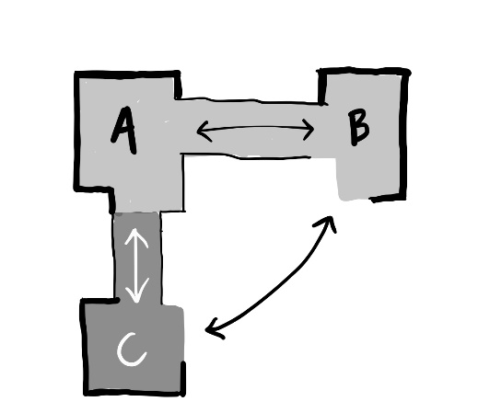

Guideline
Keep circulation simple and easy to navigate without signage, avoiding dead ends. Plan to support bedrooms having a direct line of sight to the main cluster of living rooms and, ideally, to a centrally located kitchen.

Scenario
Complex circulation pathways are difficult to navigate.
Charlie likes to know where he is and can become lost easily. He is frustrated in the unit as there are several corridors of similar colour and style. He ends up in places he doesn’t recognise and cannot find his way back.
Dave spends considerable time throughout the day redirecting Charlie to where he wants to go. Sometimes Charlie is frustrated or irritated when Dave finds him, sometimes in someone else’s room or trying to get out a locked fire exit.

Rationale
Why is this important? Around half of aged care residents require assistance in mobilising, using a walking aid or wheelchair.84 Feeling disoriented in itself can cause significant distress, reduce independence and confidence, particularly those living with dementia.85 If residents are more able to find their way intuitively it reduces impact on staff time.86
What makes a difference? Independent movement is assisted by having shorter distances between key living spaces (eg, bedroom and dining room),87, 88 clear pathways, reduced route complexity, and the presence of landmarks to support orientation.89,90
Having a clear line of sight to a destination supports a person to know where they are going, reducing the risk of confusion and distress, particularly if that person is living with dementia.91 Having a centrally located kitchen or communal space that is clearly visible encourages independence, socialisation and orientation.92,93,94 and staff can focus on engagement.95
Other factors that help include keeping the household size small,96 minimising changes in direction and dead ends, using clear landmarks, and providing regular seating. Bedroom identification is supported by personal items such as photos, while toilets need appropriate signage with graphics.97

Outcomes
As part of creating a household, the unit was broken down into an area with just two corridors. Each of these corridors was themed with colour and artwork. A framed poster of footballer Cheung Chi Doy (one of Charlie’s heroes) was put up close to the lounge where Charlie likes to go and it always catches his eye. Dave uses the poster as an opportunity to talk with Charlie about his interests, as he directs Charlie to the lounge area. Charlie is finding it easier to locate the lounge area because he recognises the poster.

Checklist
- Create a good line of sight between circulation routes and key destinations (relates to “Supporting workforce”)
- Ensure all routes (inside and out) lead to safe, familiar areas
- Avoid or minimise the presence of dead ends
- Where there is more than one circulation route, ensure each looks distinctive through architecture, artwork, and/or landmarks
- Avoid complex layouts such as corridors arranged around a courtyard
- Where the existing layout is complex and signage is needed for wayfinding, provide this in sentence case, sans serif, using simple language, high contrast text, mounted around 1.2m from the floor. Use easy to understand graphics to support interpretation

Guideline 1.8 Safe Floors
Flooring is plain in appearance and easy to clean
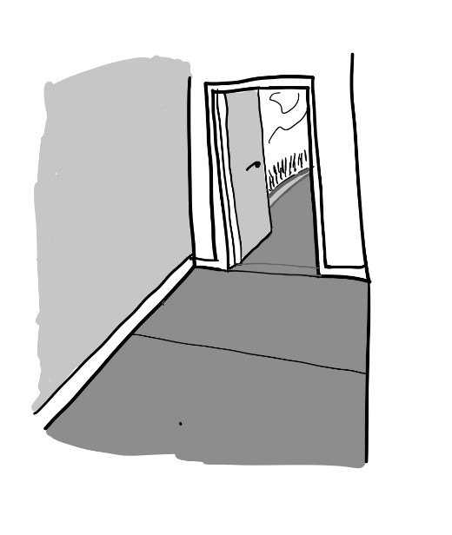

Guideline
Promote level access, indoors and outdoors. Prioritise use of high-quality healthcare carpet generally and low-sheen acoustic vinyl in bathroom, laundry, dining, kitchen, and back of house areas only. Aim for a consistent tone on floor finishes throughout both the public and private areas of the aged care home, including the transition from inside to outside.

Scenarios
Floors that have complex patterns, are dirty, or a strong tonal contrast with other areas are harder for older people with reduced vision to navigate.
The slightly patterned carpet in the lounge seems to shift and move for Bianca. She’s always glad to sit down. There is also an area of strong contrast, where a decorative border in the corridor cuts across in front of her bedroom. Bianca takes a big step to get into the room.
Eleesha tries to reassure Bianca that the floor is stable and even, and safe to walk along.

Rationale
Why is this important? People move into aged care because of one or more cognitive, physical and/or sensory issues, all of which contribute to challenges in moving around independently. When older people fall, they are at risk of sustaining serious injury and around one quarter of all new admissions to aged care occur following a fall.98,99 Falls are a key contributor to decline with 30% of older people never fully recovering from a fall. People living with dementia are eight times more likely to fall than the general population.100
What makes a difference? Selection of floor finish is important to health and safety, with softer finishes generally better at reducing fall risk and severity,101 softening impact and reducing airborne noise. People are more likely to slip and be affected by glare on smooth surfaces. Smooth flooring also contributes to an institutional aesthetic.
Ease of cleaning should be a key consideration in selecting appropriate flooring. Floors should be easily and effectively cleanable for infection control. Flooring should be even, minimise risk of tripping, and avoid level changes. Flooring type should also reflect cultural norms and be appropriate to the local climate.

Outcomes
Francine arranged for the flooring to be changed to a solid colour with no decorative border in the corridor and the lounge. A healthcare grade carpet was installed in the corridor, which has reduced the noise as well as cutting out the glare from the lighting. Spilt liquid still needs to be cleaned up immediately, but it’s less risky when there is a spill. Bianca is more capable of walking to and from the lounge and Eleesha can concentrate on other things. They both feel more relaxed because it is less noisy.

Checklist
- Remove any dark coloured mats from entrances and exits in resident areas, providing fixed matting matching the floor colour if necessary
- Aim for < 5LRV tonal contrast between different finishes (internal flooring, mats, pavers, and threshold strips)
- Provide level access throughout all parts of the building, avoiding even slight changes in level between different areas of flooring, such as thresholds
- Use matte finishes on the floor, favouring carpet over hard finishes where possible and choosing acoustic products
- Avoid varying the texture on the floor, which may make it harder for someone to shuffle
- Where sliding doors are fitted, ensure the bottom track will be flush with finished floor levels and installed to drain away from the door frames, avoiding internal ramping of floors up to a door track

Guideline 1.9 Supportive Seating
Seating choices and positions support rest, comfort and function
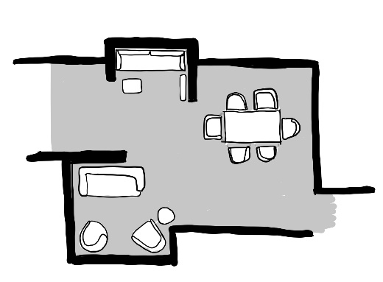

Guideline
Provide additional seating where space allows, particularly in long corridors. In new designs, integrate space for seating rests along corridors and at corridors ends, view points, and changes in direction. Seating should have arms and be varied, easy to see, comfortable, robust, and domestic in style. Fixed seating can be useful in tight spaces.

Scenarios
Having ready access to appropriate seating is particularly important for people with reduced mobility.
Anne is seated almost continually in a comfort chair due to her low level of mobility. There is no space for her to be accommodated in this chair in the dining room, so she eats her meals either in her bedroom or in the small lounge nearest her bedroom. From time-to-time Anne remains there for an extended period.
Eleesha initially found it concerning that Anne has her meals apart from the rest of the group, but she has got used to it now.

Rationale
Why is this important? The vast majority of people living in aged care have difficulty moving independently. Poor design of chairs (too low, high or deep), or infrequent or incorrect placement can make it difficult for people to easily move around between settings and activities.102 This is now recognised as a form of restraint.103,104
What makes a difference? Regular placement of chairs allows people to extend the distance that they can walk and improves their confidence.105 Varied seating accommodates different ergonomic needs and preferences. Thus, offering a variety of seating options and positions throughout the day is important.106
The right seating will improve comfort, visual variety, tactile stimulation, and the ability to function, while reducing agitation, restless behaviour, and incontinence. Seating layouts support opportunities for increased socialisation.107
Most residents use cushions and pillows to relieve discomfort where possible.108 Residents prefer chairs which are above the recommended height for older people, and with armrests.109 If bariatric seating is required, this should be in the style of other seating. Suitable seating outdoors supports people using outdoor areas.

Outcomes
The dining room furniture has been reorganised so that there is space for Anne’s chair to be brought into the room. She is more able to engage when her seat is made upright and enjoys being part of the activity. Eleesha is more aware of what Anne needs when she is in the dining room with everyone else.

Checklist
- Arrange seating to enable people to get in and out of chairs and ensure that they are not restrained by tables or equipment
- Ensure seating is robust and comfortable, providing supportive cushions to help people adapt seating to their needs (relates to “Supporting workforce”)
- Provide seating at frequent intervals to provide the opportunity for rest
- Provide a range of seating options suitable for different needs and body types (relates to “Cultural diversity”)
- Ensure that space exists in living areas for specialist seating such as comfort chairs
- Provide enough seating for staff or visitors to be able to sit with residents at mealtimes (relates to “Cultural diversity”)
- Ensure fabrics are easy to clean

Guideline 1.10 Stress-free Toilets
Toilets are easy to find and use
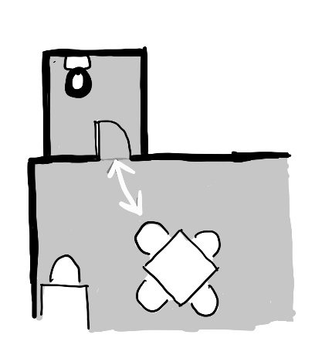

Guideline
Ensure that there are toilets which are accessible from main common spaces, easy to find, recognisable and intuitive to use. Specify fittings which are recognisable to users, often more traditional in style, to help someone recognise the room and use items independently. Toilets should be of a good size, so staff are able to support residents.

Scenario
Not being able to find a toilet quickly challenges dignity and self esteem for people living with mobility, cognitive and continence issues.
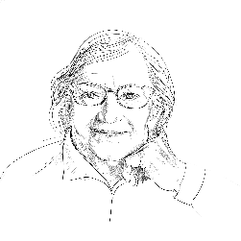
Bianca can use the toilet herself if she is in her ensuite. If she needs to go during lunch, it is a long way to go back to her bedroom and sometimes she doesn’t have much warning. Last week she had an accident at lunchtime and she was mortified. She’s been drinking less because she wants to avoid that happening again.

Eleesha is considering suggesting Bianca wears a pad during lunch to avoid her embarrassment, but she’s not looking forward to talking about that with her.

Rationale
Why is this important? Supporting continence in residential care is a critical concern due to the impacts on residents' health, well-being, and sense of dignity. A consequence of experiencing incontinence is residents may reduce their fluid intake to reduce the risk of further episodes, contributing to dehydration and urinary tract infections. Organisational concerns include staff risks associated with manual handling to assist residents going to the toilet, costs of incontinence products, and laundry requirements.110
Toilets that are not easy to find and use cause people unnecessary disability, shame, lower self-esteem, and greater dependence on others.111 Poor design of ensuite toilets and bathrooms has been raised as a common problem in aged care homes.112
What makes a difference? Easy to see toilets increased their usage eightfold.113 Physical accessibility, tonal contrast,114 and familiarity of the fittings promotes use of toilets and helps staff support residents appropriately. Space for more than one person to assist comfortably is ideal.115 Mirrors can be confusing or disturbing for someone who does not recognise their reflection. Plan toilets to promote privacy within the room, with doors handed to shield the view of the pan in communal areas.

Outcomes
There was a toilet near the dining room, but it was designated just for staff. Now it’s been tidied up a bit and made available for everyone to use. The door was painted to stand out and a clear sign put on the door. Eleesha suggested Bianca sit where she can see it from her seat at the dining table. If she needs to go it’s much easier to get to. Bianca is more relaxed and spends longer at the dining table.

Checklist
- Ensure communal toilets close to dining spaces in resident areas are designated for resident use
- Ensure access to a toilet is visible from each main living area and bedroom (relates to “Supporting workforce”)
- Where a toilet is not visible, provide clear wayfinding signage from each living area
- Make toilet doors distinctive from other doors through style and colour and provide door signage, except in bedrooms
- Ensure toilet doors are easy to open and close, with a familiar handle and lock
- Ensure all fittings and fixtures (flush, taps, basin, toilet, light switch, grabrails) are domestic and familiar
- Provide the ability to remove or cover mirrors on a case-by-case basis
- Make key elements (seat, pan, cistern, floor, wall, basin, and toilet paper) easy to see through tonal contrast and lighting
Note: See also Checklist item 2.7.5

Guideline 1.11 Comfortable Temperatures
Passive and active heating and cooling systems support comfort and safety
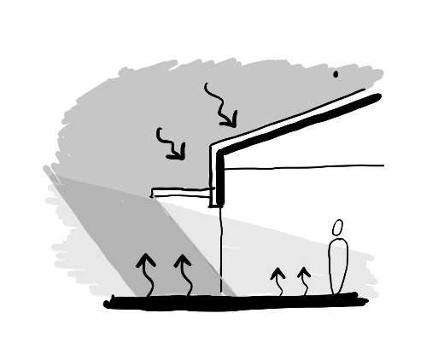

Guideline
Ensure buildings and systems can reliably achieve an internal temperature in the range of 20–26˚C in all seasons. Assess risks for temperature extremes in different parts of a building. Be aware of the particular needs of each resident and plan accordingly.

Scenarios
Keeping the temperature of the environment within certain bounds affects health, longevity, and quality of life.
It seems very cold in the lounge to Bianca. There is a draught that bothers her, but she left her cardigan in her bedroom and does not want to bother anyone to get it.
Eleesha is aware that in the summer she feels warm all the time. She’s moving around so much, but it’s hard to know how to get the temperature right, as Bianca often seems to be cold.

Rationale
Why is this important? As we age it becomes harder to regulate our body temperature and we are comfortable for a narrower range of ambient temperature. Older people are more likely to be sedentary, have less ability to move to a more comfortable place, and in most aged care homes have limited control over room conditions. Heat and cold outside our comfort range affect our ability to cope and our mood.116
Codifying of acceptable temperature ranges in aged care homes has not occurred to date. One Australian study identified that air conditioning systems were not being operated to suit comfort levels for aged care residents.117 In addition, the Australian coroner reported heatwaves take the lives of between 400 and 500 people every year, mostly those who are elderly.118,119
What makes a difference? Monitoring temperature levels and greater local control for residents and staff are critical to comfort.
Providing shade and planting, avoiding large areas of concrete, and the use of water features should all be considered, to support comfortable temperatures outdoors.

Outcomes
Eleesha arranged for the purchase of a couple of extra warm cardigans for Bianca. The temperatures in staff areas are now controlled separately to resident spaces, so that staff can have cooler office spaces, and resident areas are the right temperature for them. This gives Eleesha some relief when she’s out of the resident area, but peace of mind that Bianca is comfortable too.

Checklist
- Understand whether areas inside and outside the building are at risk of over/under heating considering location, orientation, and system design (relates to “Supporting workforce”)
- Ask residents whether they are comfortable in living areas and bedrooms and adjust the system accordingly
- Label or highlight controls that suit individual residents’ needs to support them to control their room temperature
- Ensure buildings and systems can reliably achieve internal temperature in the range 20–26ºC during all seasons (relates to “Enabling technology” and “Supporting workforce”)
- Install back-up power options if necessary (relates to “Enabling technology”)
- In new developments, orientate the building, rooms and glazing to avoid excessive heat gain, exploring passive solutions to reduce over/underheating risk (relates to “Environmental sustainability” and “Supporting workforce”)
- Document a heatwave plan and ensure staff know the dangers of overheating
- Provide sufficient planting and shading to support comfortable outdoor spaces

Built examples
1. Great access to fresh air on all levels of a multistorey building and good use of tone at the door threshold
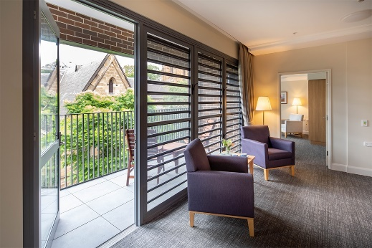
2. Built-in shelving at eye level for personalising living areas
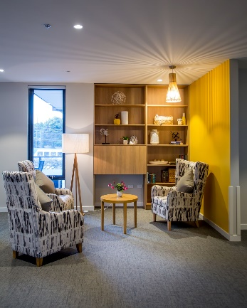
3. Resident dog Zoey is well loved by staff, visitors and residents
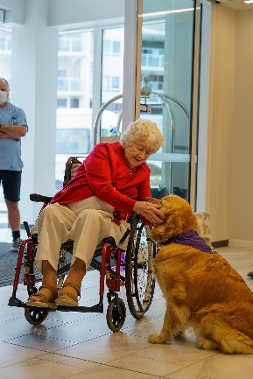
4. Bedrooms with space for personal furniture and belongings
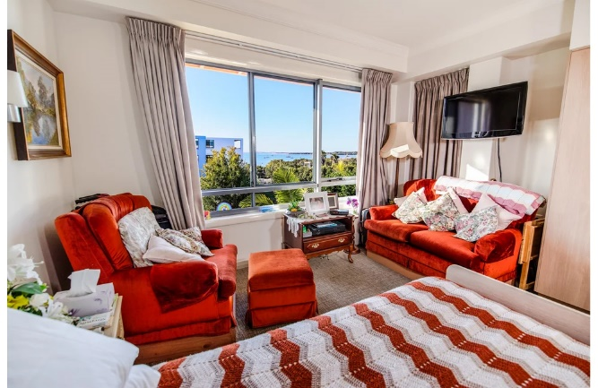
5. Seating that is domestic, dignified, and robust
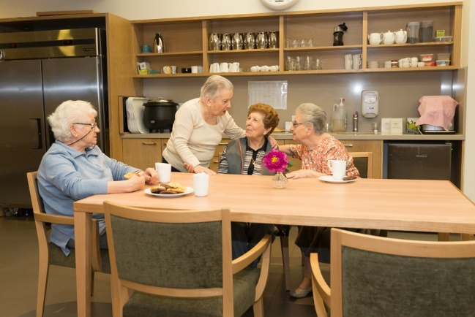
6. Domestic style light fittings reinforcing the purpose of the room
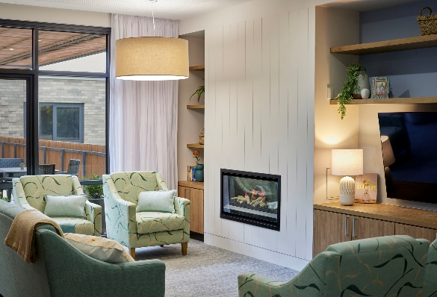
7. Good tonal contrast highlighting the toilet and minimising the transition on the floor from a bedroom
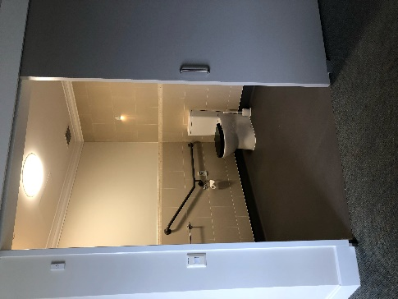
8. A small lounge provides acoustic separation for watching TV or listening to music without disturbing others
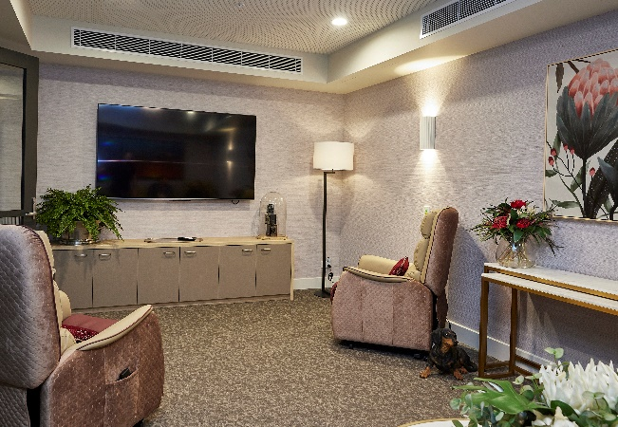

Design Principle 2 – Cultivate a Home

Objective
To create a familiar environment in which people have privacy, control and feel they belong

Guidelines
- 2.1 Small Households
- 2.2 Private Entries
- 2.3 Domestic Kitchens
- 2.4 Room Clusters
- 2.5 Enabling Corridors
- 2.6 Private Bedrooms
- 2.7 Ensuite Bathrooms
- 2.8 Appropriate Furniture
- 2.9 Clinical Support
- 2.10 Private Staffroom

Situation
Historically the design of aged care homes has often focused on care delivery, and less on the experience of living in the home. This focus has unfortunately often led to environments that are hostile to the people living in the home and conversely led to more intensive staff interactions to address resident stress and confusion. Moving into an aged care home can compound a person's disability, affect self-esteem,120 limit social opportunities, and lead to agitation, over-medication, and decline.121 Larger scale settings make it harder for a person to maintain routines that are important to them.122
There is substantial research on small household models having wide-ranging benefits,123,124 such as reducing agitation, pacing, and exit-seeking,125 while improving social interaction, eating, and infection control.126

Desired Outcomes
This Principle aims to support organisations to move towards small household models, following international consensus that the best health and wellbeing outcomes are achieved in living arrangements that bring together 15 or fewer people and promote familiar, domestic activities.127 This requires design features that validate individual preferences and make things as easy as possible for staff.
Shifting to a small household approach is not only about design of the physical environment. It requires a well-defined ‘model of care’ that addresses an approach to governance, operations, staff training,128 and daily activities within a home. A model of care must address the culturally specific needs of each person. This is relevant to everyone, not just Culturally and Linguistically Diverse (CALD) groups, First Nations,129 and specialised services.130
If a small household model of care is clearly defined and implemented, even small changes to the built environment will support that shift. For example, one study of 62 people living with Alzheimer's Disease in specialised units showed that simply adding a fish tank to dining rooms improved their nutritional intake by 21%.131

The Green House Project (USA) aligns design with their model of care through three core values: Real Home (a domestic, familiar, and engaging built environment), Meaningful Life (the power of a “normal” life), and Empowered Staff (ensuring care staff are valued and respected).132
The Royal Commission highlighted the shift to household models as a focus for these Design Guidelines and a recent Australian study identified comparable operational cost to traditional, institutional aged care homes.133
Before The environment is set up for people to be together in large numbers which lends itself to a pre-determined program of activities
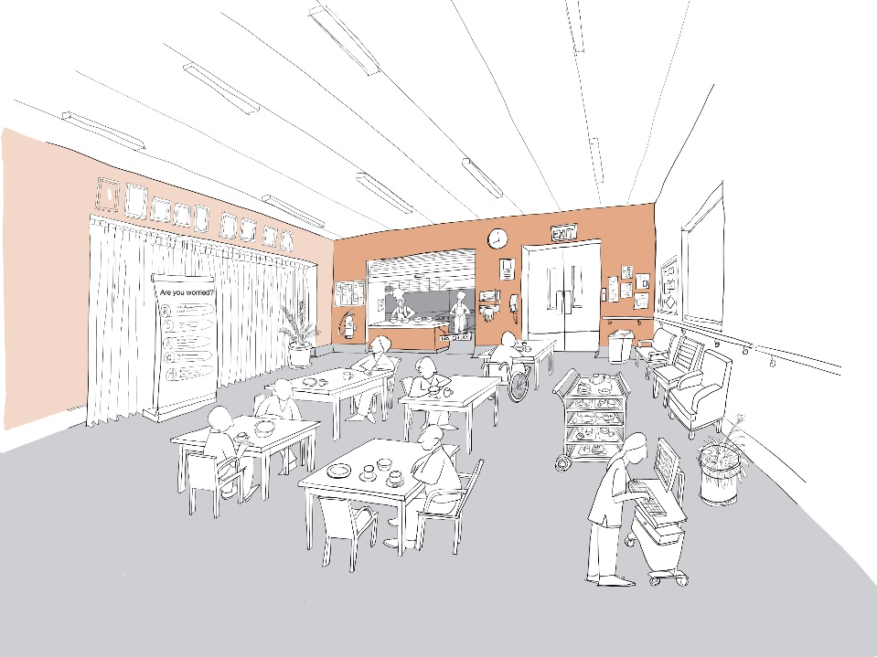
After The environment is set up to encourage smaller groups and domestic activities giving people choice as to how they spend their day
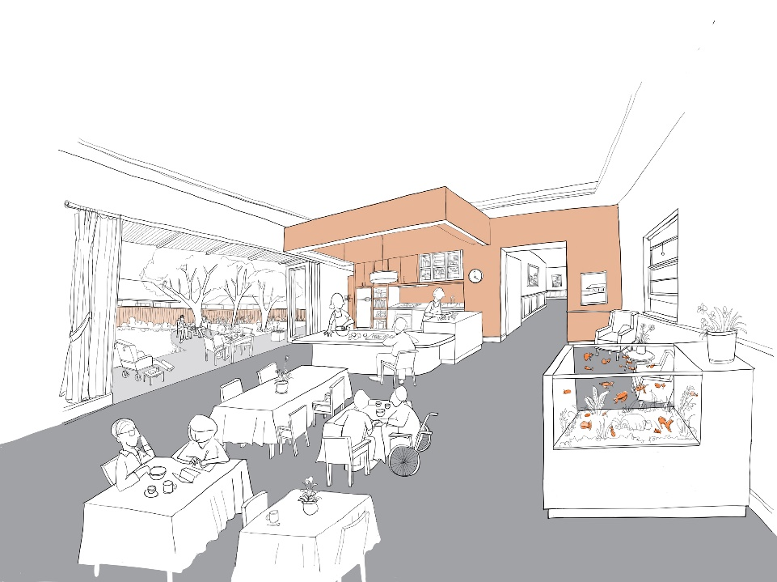

Guideline 2.1 Small Households
People live in groups of no more than 15
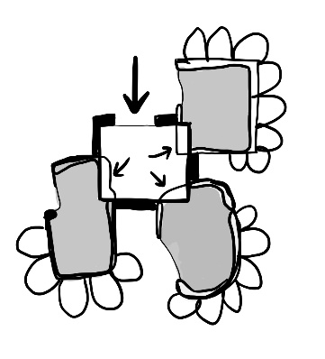

Guideline
3 common ways to implement this Guideline:
- Option 1: Independent Group Home Model – A stand-alone household located within the local community.
- Option 2: Neighbourhood/Village Model – Self-contained households clustered within a complex or larger home.
- Option 3: 'Suite' Model – A collection of co-located ‘suites’ each containing a bedroom, kitchen, outdoor, and living areas.

Scenario
Households with over 15 residents are often impersonal with staff focusing on the needs of many people. They can be disorienting and require residents to walk a long way.
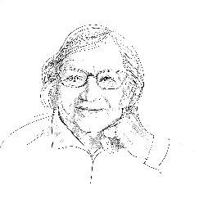
Bianca has three older brothers. Her family home was always busy with people coming and going, but the aged care home seems to her to be full of strangers. There are many people she doesn’t recognise. She feels embarrassed that her hair is not as tidy as she would like it. She’s not sure where exactly she can go in the home. Once she got lost in a completely different area and someone had to bring her back to her room. She felt guilty wasting their time.

Eleesha realises it takes Bianca a moment to relax when she enters a room. Bianca’s eyesight is not great and she wants Eleesha to take her to the lounge room. Eleesha’s happy to do this, but she has a couple of other things she needs to do first.

Rationale
Why is this important? Smaller groups of residents living together record better quality of life than larger care environments.134 Studies have associated smaller group living with less social isolation,135,136,137 better communication and engagement,138 less confusion,139 better orientation and wayfinding,140,141 easier provision of care,142,143,144 lower use of psychotropic medications, and fewer hospitalisations and emergency department presentations.145,146,147 There have been better COVID-19 and general infection control outcomes globally in small households over traditional, institutional configurations.148 Consultations found that several Australian providers have adopted a household model for new builds and are dividing old building stock into smaller living groups.149
What makes a difference? Small scale household environments with an aligned model of care creating a place that looks and feels like ‘home’,150 with staff supporting residents having flexibility in sleep, eating, and showering.151
The study and work associated with the Royal Commission152 identified household models as housing a maximum of 15 people,153,154,155 with staff and residents contributing to domestic activities such as folding laundry and serving themselves food.156,157,158 Consultations found that small household models have been implemented in Australia for over 30 years.

Outcomes
Bianca’s level has been split into two households and each now has its own ‘front door’ and kitchenette. A further door separates the staff area from the resident area. There are now 12 residents in Bianca’s area and each has its own group of staff who can get to know the residents well. Bianca has come to know some of the people with whom she is living. She can see the way to the lounge more easily and is more confident going there on her own. Eleesha now knows all the residents in her assigned household better. When she sees Bianca coming into the lounge by herself Eleesha goes over to compliment her on her hair, because she knows Bianca likes that.

Checklist
- Articulate, train and support staff to implement the model of care (relates to “Supporting workforce” and “Cultural diversity”)
- Set up areas to promote a range of small group domestic activities, which relate to residents' cultures (relates to “Cultural diversity” and “Infection prevention and control”)
- Establish households of 15 people or less living together (relates to “Supporting workforce” and “Infection prevention and control”)
- Work with residents to develop a unique ‘style’ for the household (relates to “Cultural diversity”)
- Create a defined boundary around each household (relates to “Infection prevention and control”)
- If the boundary is a fence, ensure that it is obscured

Guideline 2.2 Private Entries
Household entry design reduces disruption
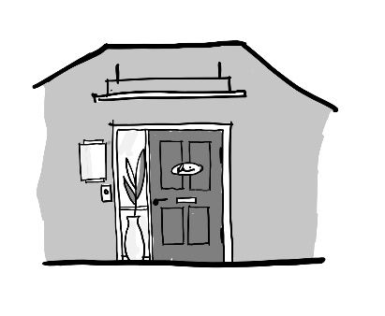

Guideline
Create a single front door to each defined household. Services paths should avoid routes through resident areas. Vestibules can effectively provide a buffer space that controls stimulation, acts as an infection control point, and becomes a place to don/doff PPE. Some back of house activity can require use of alternative entries, but these should be inconspicuous.

Scenario
When residential areas are undefined and there is less control over who goes where, it can lead to reduced privacy and heightened stress for residents.
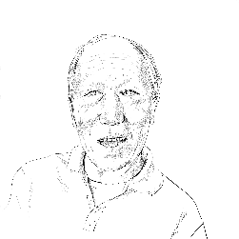
Charlie’s unit leads to another part of the home. He often sits at the entry door, concerned about the number of people coming and going, some are in uniform and others are strangers. He feels stressed. He needs to evaluate so many strange faces. When he worked in the restaurant sometimes things got out of hand on a Friday night and he feels this experience will come in handy if anything happens.

Dave can see when the busyness and noise is becoming too much for Charlie, but finds it difficult to encourage him to move to a quieter area of the unit.

Rationale
Why is this important? People living in aged care homes have poorer levels of physical and cognitive health and are therefore less able to tolerate frequent and high levels of activity in their immediate surrounds. Environments with fewer unwanted interruptions, more privacy and access to quieter rooms are less stressful, leading to more socialisation and less anxiety and depression in residents.159,160 Busy doors can be intrusive, contribute to resident anxiety, and highlight restricted movement.161,162 Clinical activity, operational workflows and too many people are at odds with the need for quiet space and privacy. Homes whose exits are well-camouflaged lead to fewer residents presenting with depression.163
What makes a difference? Establishing smaller households within a larger building creates more privacy and reduces the number of people coming and going, reinforced by a clear boundary. For that boundary to be effective in maintaining resident privacy, regulation of how people enter the household is required and ownership of the area needs to be reinforced.164 This necessitates ensuring that there are clear points of entry for visitors and deliveries. It is also important to prevent staff access, workflows and delivery routes to one household passing through another. While there are concerns about the rights of an individual being compromised by restricted movement,165 the front door needs to balance access control with any potential negative stimulation.166,167 Some providers use vestibules, concealed delivery routes, and other devices to regulate the busyness of entries and staff intrusion.

Outcomes

Francine changed the time when linen was delivered and waste picked up so that it was less intrusive. Breakfast is now served via the domestic kitchen, so food deliveries are not needed at that time. The staff room has been relocated so that fewer staff need to pass through Charlie’s household for their breaks. Overall the number of people moving in and out has been reduced by around 30%. Charlie is more relaxed, and he has been more likely to take part in a game of mah-jong with Bihn, a Vietnamese resident. They have been teaching Dave, though there is some debate about the correct rules.

Checklist
- Reschedule deliveries and adjust workflows to reduce disruption to residents (relates to “Supporting workforce”)
- Create an identifiable entry to each household with a defined, closed door (relates to “Infection prevention and control”)
- The front door should be domestic in scale, style, and operation (relates to “Cultural diversity”)
- Limit views into staff areas and other areas restricted to residents (relates to “Supporting workforce”)
- Provide a vestibule at the entry to each household as a buffer (relates to “Infection prevention and control”)
- Ensure visitors do not enter households through another household or staff area
- Provide dedicated staff and delivery routes to avoid disrupting resident life (relates to “Infection prevention and control” and “Supporting workforce”)

Guideline 2.3 Domestic Kitchens
An open plan domestic kitchen is at the heart of each household
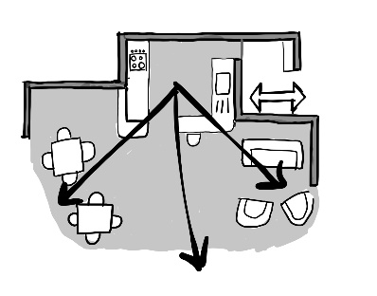

Guideline
Provide a domestic-style kitchen that is accessible to people who live in a household and their visitors. The kitchen should be centrally located and adjacent to the dining area. The domestic kitchen might receive food from a commercial kitchen on or off site, or be the primary place of food preparation. Ideally, at least some preparation of meals occurs in this kitchen. The central location is key to safety as it supports visibility throughout the household and uses passive safety features.

Scenario
The opportunity to be with others and enjoy the stimulation of a positive dining experience is important for everyone. This experience is enhanced by the sights and smells of a domestic kitchen, and this is particularly helpful for people relying on reduced sensory capacity.

Anne often eats in her room. As she is not independently mobile it is difficult for her to be moved to the dining room and she doesn’t want to trouble Eleesha who is already very busy. It feels to her that the food just arrives, and she finds it hard to taste and eat it. She often is surprised by what she is eating. She’s beginning to have trouble swallowing which is frightening for her. She begins to dread mealtimes.
Eleesha assists Anne to eat in her room. She is concerned that Anne is losing weight.

Rationale
Why is this important? Functional, domestic kitchens provide an anchor to environments often overwhelmed by clinical and operational apparatus. Kitchens can contribute to a domestic appearance, support activity meaningful to a resident,168 maintain their connection with daily routines, and bolster independence.169 Fully functioning domestic kitchens which engage residents are a stark contrast to institutional food preparation which reduce meals to a task.170,171 Kitchens provide a powerful landmark to orientation within a household.172 Involvement of residents in sharing family-style meals,173 the preparation of meals, and oversight of food preparation all contribute to nutritional outcomes.174,175 Central kitchens can also support the work of staff 176 and create a positive work environment for them to deliver person-centred care.177 The ability to make or assist in making of meals, stimulates appetite.178
What makes a difference? The key components of a successful kitchen are its presence, the adequacy of the fixtures to support cooking a meal, and the real and perceived access for residents and their families.179,180 Open layouts promote autonomy and food choice181 and lower benches support accessibility to residents.182 Whereas, closed kitchens, locked refrigerators,
and the absence of cooking appliances negatively affect resident independence.183
There is a tension between safety concerns and allowing risk taking to support resident autonomy.184 However, it has been demonstrated that these risks can be successfully managed.

Outcomes
A domestic kitchen was installed next to the dining room. Eleesha has been encouraged to bring Anne (in her comfort chair) into the dining room for lunch. Anne can see what’s happening in the kitchen. Eleesha is serving the food out onto plates and Bianca is helping her getting ketchup from the fridge. It smells like fish and chips.
Anne wonders whether it’s Friday today. They’d always have fish and chips at home on a Friday. Her lunch has mashed potato, but it’s delicious. Anne sits with her and Eleesha at the table and chats about the red snapper and shrimp they used to have on the Amalfi coast.

Checklist
- Provide a domestic, familiar kitchen in each household, open to communal areas (relates to “Cultural diversity”)
- Locate the kitchen next to a dining room, with a view of living areas and corridors (relates to “Supporting workforce”)
- Stock the kitchen with crockery, appliances, and food items, at least as well as a staff kitchen (relates to “Cultural diversity”)
- Provide common appliances, such as an oven, fridge, stove top, microwave, toaster, and kettle (relates to “Cultural diversity”)
- Provide some open shelving or glass fronted cupboards to provide a view of food or crockery
- Position a concealed staff area next to the kitchen for bulk food, equipment, medication, IT, and fire extinguishers (relates to “Supporting workforce”)
- Include passive safety features such as a lockable knife drawer, induction stove top (relates to “Supporting workforce”)

Guideline 2.4 Room Clusters
Households contain multiple areas for smaller groups
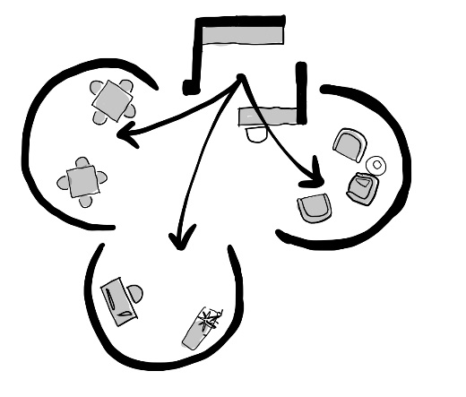

Guideline
Provide a cluster of medium-sized open and closed rooms. This might include an open plan lounge, dining areas, and a kitchen. Also provide at least two domestic amenities which reflect residents' cultures and preferences (eg home office, laundry, shed, art studio, or games room). Ideally one room should be separated acoustically, for music, TV or quiet. Each room’s function should be easy to recognise through interior design, fixtures, and fittings.

Scenario
Large spaces can be overwhelming, busy, noisy, and lack meaning.
The activity room reminds Charlie of work. He feels like he should be working now. He’s still a young man. When he moved to Adelaide, he had to pick up every shift he could at the restaurant to provide for his young family. Now when Charlie tries to help in the kitchen he’s told to sit down. This is so frustrating for him.
Dave tries to encourage Charlie to watch the soccer, or play mah-jong, but as the commercial kitchen is located off the large activity room it is hard to help Charlie engage with a different activity.

Rationale
Why is this important? The spatial layout of rooms can help or hinder a resident's abilities to freely practice hobbies, socialise, or enjoy other forms of recreation.185,186 In more institutional settings, large scale rooms prompt programming for larger scale group activity.
What makes a difference? Providing a cluster of smaller rooms for small-group activity.187,188 Outcomes for residents include people spending more time in communal living spaces and being more likely to be actively engaged compared to traditional units.189,190,191 Smaller living areas make it easier for people to orientate,192 give people helpful reference points193 and reduce withdrawn and apathetic behaviours.194 People who can access a variety of quiet common spaces have been found to be less socially withdrawn or depressed.195 In household models, homelike activities such as meal preparation activities196 and folding laundry were considered normal by residents.197 Compared to traditional homes, these were more engaging, likely to prompt social interaction198,199 and recorded higher quality of life outcomes.200

Outcomes
The main kitchen server hatch was closed up and a smaller domestic kitchen installed in front of it. A games room was created at one end of the room with some sliding doors. They put the mah-jong table in there. It has a rich red carpet and dark wood furniture. It reminds Charlie a little bit of the room in his grandfather’s house in Hong Kong, and he finds it easier to focus on the game. They can slide the glazed doors shut if things get too noisy in the main room.

Checklist
- Provide an open plan lounge, dining room, and kitchen for each household (relates to “Cultural diversity”)
- Provide at least two other domestic amenities within the household that residents can easily use and that relate to residents' cultures and interests (relates to “Cultural diversity”)
- Create domestic sized dining areas for 8 people or less (relates to “Infection prevention and control”)
- Involve residents and families in decision-making about what activities they would like to see happen in each room
- Make the function of each area or room immediately recognisable through relevant furniture, soft furnishings, artwork, and equipment (relates to “Cultural diversity”)
- Create a room which can be made acoustically private for music, TV or quiet
- Ensure there are furnishings and equipment in each room which relate to the specific function of the room (relates to “Cultural diversity”)
- Provide opportunities for residents to decorate or place personal items in the communal rooms and areas (relates to “Cultural diversity”)

Guideline 2.5 Enabling Corridors
Corridors are shorter than 20m and handrails are avoided
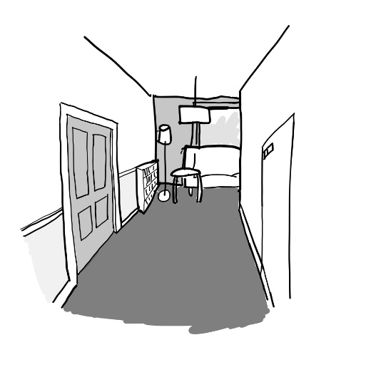

Guideline
Corridors in new builds should be less than 20 metres. In existing buildings, measures should be taken to minimise the effective length of the corridor through use of seating, landmarks, and improved lighting. If corridors are reasonably short and/or seating is provided at regular intervals, it should not be necessary to provide handrails in corridors.

Scenario
Long corridors can create confusion for residents living with cognitive impairment and are harder for people with poor mobility to use.
The distance between Bianca’s bedroom and the main lounge is 30m. She cannot see the lounge from her bedroom, and sometimes she is mixed up as to which way she is facing – towards the lounge or back towards her bedroom. The corridor looks the same everywhere. She feels more confident if she is with Eleesha.
Bianca needs a lot of reassurance and is also quite unsteady. The corridors are difficult to navigate, as her dementia with Lewy Bodies affects her gait. Eleesha would prefer to be with her when she is walking the distance to the lounge so that she knows she is okay.

Rationale
Why is this important? A recent study found that independent mobility in aged care homes was low.201 The study did not identify causal factors. However, length, width and shape of a corridor have all been shown to affect a person’s ability to find their way and increase demands on staff.202,203,204 This is further compounded by residents with vision impairments making it hard for them to see a destination.
What makes a difference? Evidence supports corridors being short.205,206 Navigation is easier in a straight corridor, as each change of direction increases the likelihood of disorientation.207 Long corridors prompt residents to keep walking without purpose often leading to exhaustion and disorientation.208,209 Shorter corridors help with wayfinding and reduce agitation.210 One study recommends a bench or chair located at intervals < 12m. Poor lighting in corridors also compromises resident safety and ability to navigate.211
Building codes currently require handrails in corridors in aged care homes.212 However, the evidence that they are effective in this context is poor, with door configuration often breaking handrails into short sections that conflict with universal access guidance213 and limited evidence that they are used. The NCC allows for performance solutions that permit handrails to be removed. Mobility is more strongly supported by short corridor length, regular seating,214 good paths, and individual case management provisioning people with appropriate mobility aids.215 In addition, handrails are a high touch surface requiring frequent cleaning to minimise infection risk and may reduce the functionality of spaces by limiting where furniture can be located.216 Where they are specified, they should contrast with their background, and be easy to grip.

Outcomes
The lighting in the corridor was significantly improved. A hall table with some flowers and one of Anne’s decorative quilts was put halfway down the corridor. At the far end of the corridor to the lounge, a plush red lounge chair was installed with a coffee table, a painting, and some books.
Bianca can see the hall table when she leaves her bedroom, so she knows to turn towards it to reach the lounge. She finds it easier to see Eleesha’s face and chat to other people as she passes them in the hall.

Checklist
- Design corridors to be 20m or less (relates to “Supporting workforce”)
- Where corridors are longer than 10m, provide regular seating and landmarks
- Ensure door and corridor widths are appropriate to the manoeuvring of equipment (relates to “Supporting workforce” and “Infection prevention and control”)
- Ensure lighting level is good, with a recognisable destination at both ends of a corridor
- Minimise use of handrails in corridors (relates to “Infection prevention and control”)
- Ensure clutter in corridors is minimised (relates to “Supporting workforce” and “Infection prevention and control”)

Guideline 2.6 Private Bedrooms
Each resident has their own bedroom
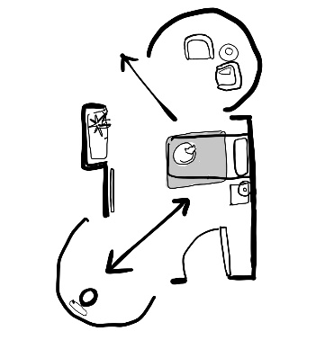

Guideline
Give residents a lockable private bedroom with control over keeping their room how they want it. This includes allowing for layouts that have at least two defined areas, including space to sit, keep plants, rearrange furniture, and decorate the room with personal items.

Scenario
Privacy in bedrooms is crucial to dignity, being the key place over which a resident has some control.
Anne has her own room, but she often feels nervous about other people coming into it. Her door is opposite the main living room and when the door is open, she feels like anyone can see or walk in. But if the door is closed, she feels cut off from the rest of the home. She is worried about what might happen to her if she becomes really ill and cannot tell people to go away or stay out.
Eleesha is also worried about other residents disturbing Anne. A couple of residents, Sally and James, keep going into Anne’s room, because it is so open to the living room. She’s not sure if it is because they are disorientated or are just looking for something to do.

Rationale
Why is this important? Privacy is a key determinant of quality of life in long term care,217 with single rooms requested in consumer surveys.218 They support privacy,219 personalisation, comfort,220 reduced conflict, enhanced wellbeing,221 increased resident satisfaction,222 better socialisation, and a sense of a building as ‘home’.223 Clinical benefits of private rooms include reduced risk of infectious transmission, improved sleep, and reduced use of medications.224,225,226 There is no evidence to support the view that shared rooms reduce the risk of falls.227 There are also palliative care benefits, with focus groups noting that family members would like to stay together in their final days, but are discouraged by crowded environments.228
What makes a difference? Providing single bedrooms and positioning them to avoid directly opening onto communal spaces improves privacy229 and increases socialisation.230 Staff can reinforce resident control and respect their ownership by knocking on the door prior to entering and encouraging them to add personal items to the room.231,232 Privacy is also supported by developing an “in-between” space outside a bedroom that provides a transition and can be controlled by a resident.233 Locks on doors and bed placement such that the entry/exit is not in view add to a sense of physical privacy.234

Outcomes
A tall bookcase divider has been installed in the lounge outside Anne’s room. This limits the view into her bedroom from the living area. After talking it over with Eleesha, her bed position has been changed so that the bed is against the wall. This makes her feel safer and she is still able to be helped out of the bed.
Eleesha is able to divert Sally and James from entering Anne's room by talking about the books in the bookcase. They have been going in less anyway because they can’t see it so well from the living area.

Checklist
- Where shared rooms exist, plan to reduce numbers towards single occupancy
- Where shared rooms exist, ensure privacy can be maintained between bed areas (relates to “Infection prevention and control”)
- Provide lockable, single bedrooms with an external window (relates to “Supporting workforce” and “Infection prevention and control”)
- Locate bedroom access off a corridor, not a communal room, and stagger entries
- Locate bedrooms away from household entry, lifts, delivery areas and other noise
- Avoid glazing in or beside doors, or barn doors that compromise privacy
- Provide generous storage and open shelving for belongings and furniture
- Provide discreet lockable storage for clinical supplies (gloves, medications, etc) (relates to “Supporting workforce”)
- Consider co-joining bedrooms to provide for couples, double beds, and shared rooms as suits the culture of residents
- Ensure there is enough space to support manoeuvring equipment around a bed (relates to “Supporting workforce”)

Guideline 2.7 Ensuite Bathrooms
Each resident has their own private bathroom
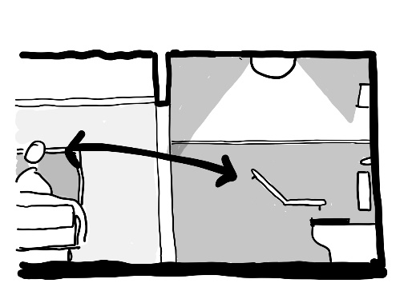

Guideline
Provide residents an ensuite bathroom containing a level access shower, wash basin, and toilet. There should be good storage, and the ability to personalise the room. Provide reinforcing to walls to allow grabrails and enough space for two people to assist a resident comfortably. All fixtures and fittings should be easy to see and intuitive to use.

Scenario
Supported toileting and showering can be a stressful experience for many residents and staff.
Bianca has needed help showering for a few months. It was one reason she moved into the home. Her daughter was finding it increasingly hard to help. She has her own ensuite now, but not being able to see so well and being anxious about falling makes the whole exercise stressful. She cannot see where the toilet is and Eleesha has to help her with everything. It’s embarrassing and after a shower she is exhausted. When her son visits, she never wants him to use the bathroom as she thinks there may be pads and gloves lying around.
Increasingly Eleesha finds Bianca doesn't want a shower, saying she is fine. She’s not sure why, but many residents feel this way. She takes time to help her find the toilet.

Rationale
Why this is important? Provision of an ensuite is highly valued by people living in aged care settings.235 Design of ensuite toilets and bathrooms was found to be one of the five main design flaws in surveyed aged care homes.236 Ensuite bathrooms improve infection control, with poorer outcomes recorded during COVID-19 for residents using shared facilities.237 Ensuites support clinical management especially if good storage is provided. Ensuites are linked with improved quality of life outcomes, hygiene, privacy, and dignity.238
What makes a difference? Providing a view of the toilet from the bedroom239 (ideally from the bedhead) is an important cue supporting independent use of the toilet. Level access inside the ensuite, space for at least two staff to manoeuvre equipment, and well positioned grabrails supports comfortable use. Fixtures and fittings should be familiar and intuitive to use. They must be visible through good lighting and use of tonal contrast. Storage for personal items supports the recognisability of the room and independent use. Built-in storage for clinical items is important to reduce clutter, institutional appearance and to support clinical outcomes.240

Outcomes
The tiling behind the toilet was painted to make the cistern stand out and now Bianca can immediately see the shape of it when she goes in the room. There is a new cabinet with some open shelving for Bianca’s products, and a cupboard for gloves and pads in one corner which keeps them out of the way.
Bianca’s son brought in a painting of the Amalfi coast to hang on the bathroom wall for Bianca which reminds her of her summer holidays as a child and this gives them something to talk about when Eleesha’s helping Bianca shower.

Checklist
- Provide ensuite shower rooms to all bedrooms, working towards single occupancy if there are shared bathrooms
- Where there are bathrooms shared by bedrooms ensure signage is very clear (relates to “Infection prevention and control”)
- Provide open storage in the ensuite for resident’s personal items
- Provide discreet storage in the ensuite for clinical supplies (eg gloves, toilet rolls) (relates to “Supporting workforce” and “Infection prevention and control”)
- Provide direct line of sight to the toilet pan from the bedhead where possible
- Ensure key ensuite fixtures (door, toilet, basin, taps, toilet paper, and grabrails) are easy to see and intuitive to use (relates to “Supporting workforce”)
- Provide a nightlight in the bathroom, which can be turned on or off to suit individual needs
- Provide space for two people to assist someone showering and toileting (relates to “Supporting workforce”)
- Install reinforcing in walls to support installation of grabrails and consider future ceiling hoist installation (relates to “Supporting workforce”)

Guideline 2.8 Appropriate Furniture
Furniture looks domestic and is fit for purpose
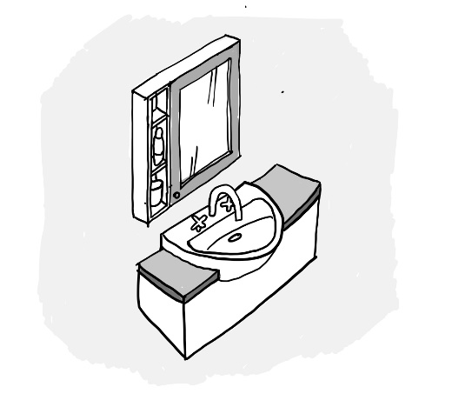

Guideline
Provide robust, ergonomic furniture that is domestic and familiar. Furniture should help the resident recognise the room, and what is happening there.

Scenarios
Furniture and fittings can make the difference between a place feeling like home and being easy to use, or feeling foreign and being disabling.
The dining room reminds Bianca a bit of her school canteen with those hard metal framed chairs and plastic table covers. She misses her heavy oak dining table and matching dining chairs with green velvet upholstery.
Eleesha finds the dining tables and chairs a bit lightweight, but they are easy to move, stack and to clean. The ‘wipe clean’ table covers are actually hard to clean because you can’t wipe the whole surface and things drip down the side.

Rationale
Why is this important? Appropriate furniture and domestic lighting is important to residents, supports their functional abilities, and provides comfort.241 Residents and staff opinions can differ about furniture selection,242 which therefore needs to consider ergonomics, work health and safety, and aesthetic familiarity. Furniture selections and placement both impact safety and dignity. For example, furniture that puts people lower to the ground, such as lower beds, has been shown to reduce falls,243 but can also become a restraint. The research has identified that physical restraint of people who have a cognitive impairment does not actually reduce falls.244,245
What makes a difference? Personal items are significant with furniture identified as holding great emotional value to residents.246 Residents may prefer the larger beds that they used at home, with single beds being unfamiliar to most adults.247 Various suppliers specialise in fit for purpose furniture that has a domestic appearance. Simple things help, like furniture contrasting with its background,248 being set up to support a particular scene, and being placed in a consistent arrangement to help someone recognise a room.249 Specifying easily cleanable, non-porous fabrics also reduces infection risk.250
Other considerations include staff having sufficient space to manoeuvre around beds, family having space to spend time in the bedroom, especially at end of life, and furniture never becoming a restraint, either through positioning or poor specification.

Outcomes
Francine organised some new timber dining chairs from an aged care supplier which has leather-look upholstery. It’s easy to clean and looks much more dignified. They switched out the table covers for fabric ones that can go in the wash. They chose a dark green, which contrasts beautifully with the white crockery. Bianca loves the new look and has been keen to set the tables.

Checklist
- Arrange furniture to promote resident movement and engagement
- Regularly review all furniture, fixtures and finishes and then repair, replace or clean any items which are broken or dirty
- Provide furniture, finishes and fittings which are familiar to an older generation and a domestic style (relates to “Cultural diversity”)
- Use robust furniture and fittings which are not easy to dismantle or tip over
- Ensure high touch point areas (handles, tops of chair backs and arms) are easy to clean (relates to “Infection prevention and control”)

Guideline 2.9 Clinical Support
Care supports are well-placed and discreet
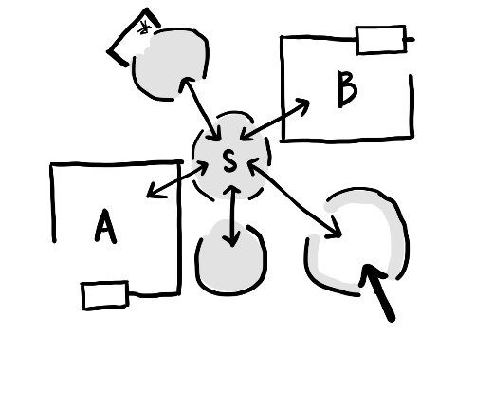

Guideline
Provide sufficient handwashing stations, equipment storage and other clinical supports close to where they are needed. However, locate these items discreetly and conceal the access to staff areas either in joinery or by matching doors to the surrounding walls. Where possible hide clinical space, PPE donning and doffing areas, and staff access routes. Locate staff work areas out of resident areas, ideally allowing easy access to those areas.

Scenario
Increasing quantities of equipment, notices, and clinical paraphernalia provide unhelpful stimuli and reinforce an institutional environment.
Charlie often mistakes the nurses’ station as a reception desk. It confuses him to have a reception desk in his home, this leads him to believe that he is at work rather than at his home.
Dave is often distracted when he is trying to write up notes or do handover in the nurses’ station. It’s quite noisy. He’s also frequently distracted when residents want to interact.

Rationale
Why is this important? A high level of clinical care is needed to support people living in aged care homes. Call systems, signage, storage, and office space enable care and support allied health staff, but institutional clutter and noise reduce homeliness and can be dangerous (eg, PPE can become a choking hazard). While nurse stations are a traditional feature, they can be overstimulating and create barriers between residents and staff.251,252,253
What makes a difference? Careful design and an aligned model of care can support a very high level of clinical care in an unobtrusive way. For example, handwashing stations can be made more discreet in corridor nooks or using touch-free cupboards to support the requirement for robust hand hygiene.254,255,256 Similarly models such as NSW’s ‘Hospital in the Home’ provide excellent outcomes in a home environment,257 this should be achievable within the aged care setting.
Highlighting resident doors258 and concealing staff doors can improve independence and clarify the environment. Ensuring staff signage is small, consistently placed, and at high level supports staff without being intrusive. Provision of good lighting at the bedside and access to rooms for allied health services supports clinical care and team working. Medication being stored securely in bedrooms can avoid hospital-like medication rounds. While expensive, provision of ceiling hoists in bedrooms could be a flexible and more dignified method of supporting people to transfer between bedrooms and ensuites, and more discreet and faster than using mobile hoists. Providing treatment rooms supports staff and reduces hospitalisations.259

Outcomes
The nurses’ station has been turned into an enclosed office. Dave spends less time in there now, but when he is working there, he can completely focus on his work. It’s more private for handover as well. Then when he’s out in the household with Charlie, they are on more of an equal footing and Charlie is more relaxed. Sometimes Dave will do a bit of work out on the dining table and Charlie will look at one of his soccer magazines.

Checklist
- Avoid nurse stations and hide or relocate offices, staff rooms, and meeting rooms
- Enclose nurse stations to create private offices or convert to resident kitchens
- Create discreet or domestic hand washing stations ensuring these are still accessible without contaminating another area (relates to “Supporting workforce” and “Infection prevention and control”)
- Store staff equipment and clinical supplies out of sight, with sufficient storage close to where it is needed (relates to “Supporting workforce” and “Infection prevention and control”)
- Make doors to staff areas colour-matched with adjacent walls with discreet hardware
- Provide a discreet donning/doffing station ideally outside the household (relates to “Supporting workforce” and “Infection prevention and control”)
- Add rooms outside households for clinical procedures to suit allied health needs (relates to “Supporting workforce”)

Guideline 2.10 Private Staffroom
A comfortable place for staff breaks is located away from resident areas
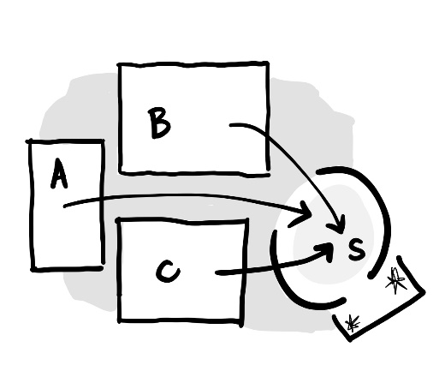

Guideline
Provide staff with a private area away from their work. It should be located outside resident spaces, have a good lounge area and access to a private outdoor space. The area should be connected to a bathroom with shower facilities and a locker room.

Scenario
If there is no dedicated staff area, or it is located far away from the residents, then staff may take their breaks somewhere in the resident area. This can lead to reduced privacy for both the residents and staff.
Charlie feels as if Dave ignores him sometimes when he’s in the garden. Dave is on his phone – Charlie is concerned that maybe he’s talking to someone about him. When Charlie sees him in there, he will bang on the window to get his attention.
Dave’s breaks are short, so he takes his breaks in the garden. He likes to listen to music and check in with his partner. He finds it hard not be distracted by Charlie though. Often, he needs to offload when he’s having a hard shift. He would like to ride his bike to work, but there is currently nowhere he can store his gear, so he takes two buses in the morning.

Rationale
Why is this important? Dedicated staff areas are important for morale and reducing stress for staff.260 Staff morale has been highlighted since the COVID-19 pandemic as being a priority area. Creating separate staff spaces also supports infection prevention and control.
What makes a difference? Separating staff rooms from resident areas, physically and acoustically, maintains the integrity of a resident area as a home. This reduces over-stimulation of residents and institutional clutter that accompanies staff areas,261 and in the case of removing nurses’ stations, made resident areas more welcoming, friendly, and comfortable.262 Access to the staff space should not be via a resident area. Staff rooms with outdoor spaces are beneficial for staff. Staff space should include storage space such as mailboxes,263 and clean, comfortable furniture with kitchen amenities.264

Outcomes
A new staff room was created close to the resident area which is private. It’s not massive, but Dave appreciates having somewhere quiet and separate. Lockers were provided and a shower, so he can now bring his bike in the morning. He loves biking in, and this saves him half an hour in the morning, and everything is less of a juggle. The garden has been made more available for Charlie and others to use now that staff don’t use it so much.

Checklist
- Provide at least one dedicated staff room of a reasonable size located away from the resident area (relates to “Supporting workforce” and “Infection prevention and control”)
- Ensure the space is not accessed via a resident area (relates to “Supporting workforce” and “Infection prevention and control”)
- If the space is currently accessed via a resident area, relocate it or ensure that access is discreet (relates to “Supporting workforce”)
- Make the space visually and acoustically private (relates to “Supporting workforce”)
- Provide amenities here such as the ability to make hot drinks, toast, microwave food, wash up, toilet, shower, and store things securely (relates to “Supporting workforce” and “Cultural diversity”)
- Provide a dedicated, private outdoor space connected to the main staff room with space to sit and eat (relates to “Supporting workforce”)
- Provide technology that staff need such as wi-fi, charging points, TV, and a computer to use during breaks (relates to “Enabling technology” and “Supporting workforce”)

Built examples
1. Private bedrooms with shelving that is easy to personalise, and bedroom doors that are distinctive to support wayfinding in corridors
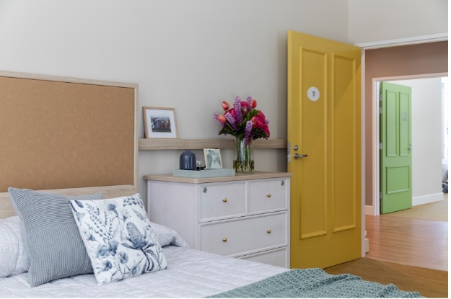
2. A small household with connected kitchen, dining and living areas of a domestic scale
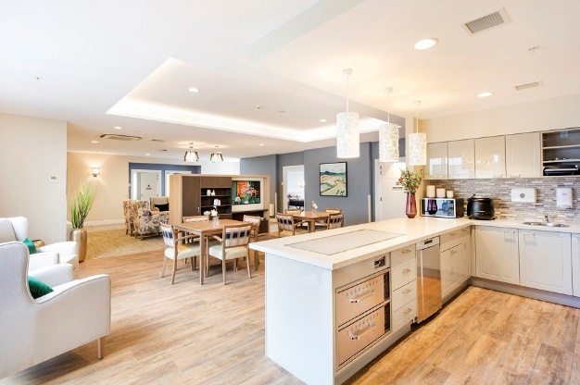
3. A discreet handwash station
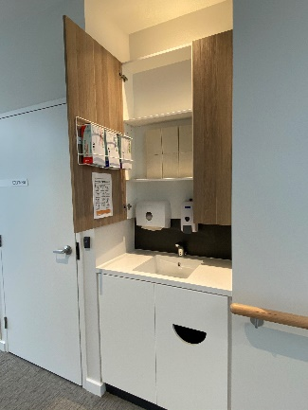
4. A space in the corridor as a discreet area where residents or staff could write, avoiding a clinical appearance
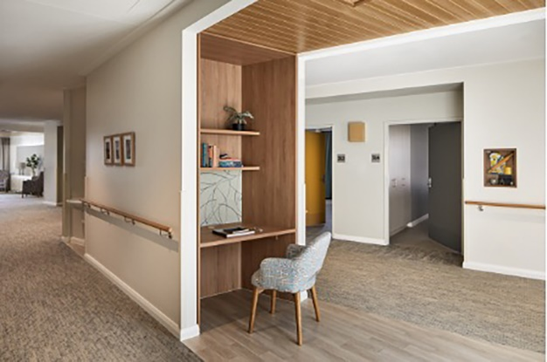
5. An open, functional domestic kitchen connected to the dining room with easy access outside
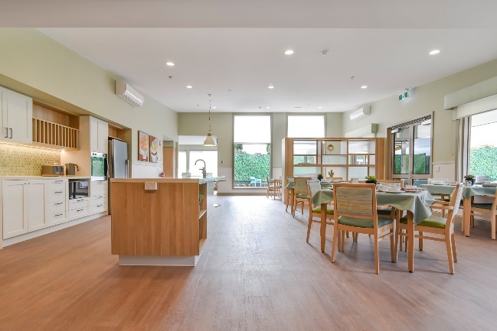
6. Domestic laundries in each household which lead out to the garden
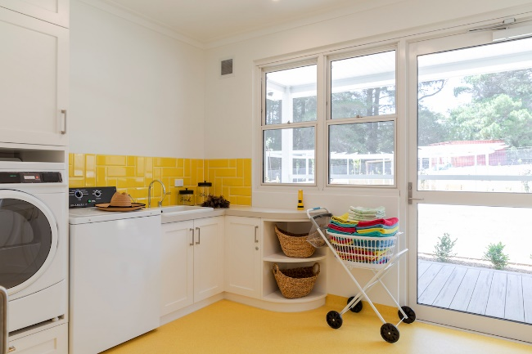
7. Staff doors disguised and resident doors highlighted
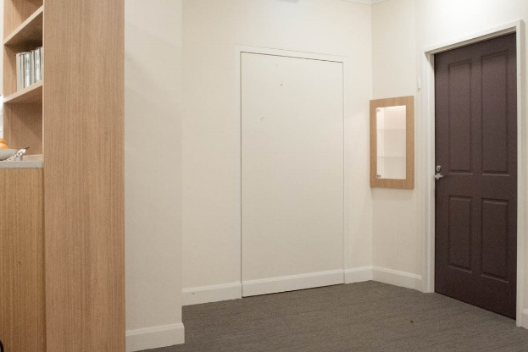
8. Recognisable, private front doors to each household that lead to a vestibule
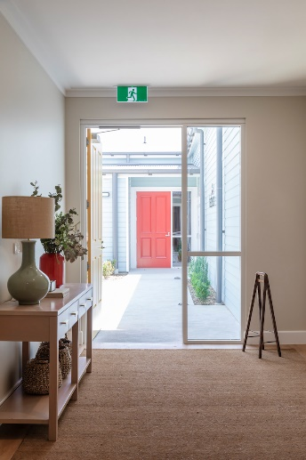

Design Principle 3 – Access the Outdoors

Objective
To support people seeing, accessing and spending time outdoors in contact with nature

Guidelines
- 3.1 Dedicated Outdoors
- 3.2 Garden Connections
- 3.3 Garden Verandahs
- 3.4 Garden Destinations
- 3.5 Clear Paths
- 3.6 Nature Indoors

Situation
People living in care homes typically spend very little time outdoors, despite the evidence-base linking access to outdoors to a range of health, psychological and social outcomes. Access to gardens and balconies contribute to maintaining fitness,265 regulating circadian rhythms,266,267 maintaining bone density, increasing social interaction,268 increasing vitamin D levels,269,270 reducing falls risk and agitation271, and improving outlook on life.272 This is a cumulative positive effect hard to replicate in other ways.
Reduced mobility and independence often make it less likely that residents go outdoors. However, a risk averse culture is really significant, 273 with staff practice identified as the most important factor in determining whether residents use outdoor areas.274
Concerns about safety are often raised as a reason for not using gardens, but the risks involved with not going outdoors far exceed these.275
A clearly articulated model of care that promotes daily access to the outside for every resident is the first step in alleviating concerns about safety. Staff need to know that managers want residents to go outside and risk management strategies are in place to support this.
The physical environment can either help or hinder someone accessing outdoors. The Guidelines below work together to achieve this outcome. However, even a small change to satisfy one Checklist item will improve resident outcomes.

Desired Outcomes
This Principle aims to create outdoor spaces with few barriers to use. This requires good access, easy orientation, and an inviting set of purposeful activities. It aligns with ACQ Standard 5 that addresses movement outdoors.
Before The garden itself is decorative, rather than a place that supports activity for individuals or small groups
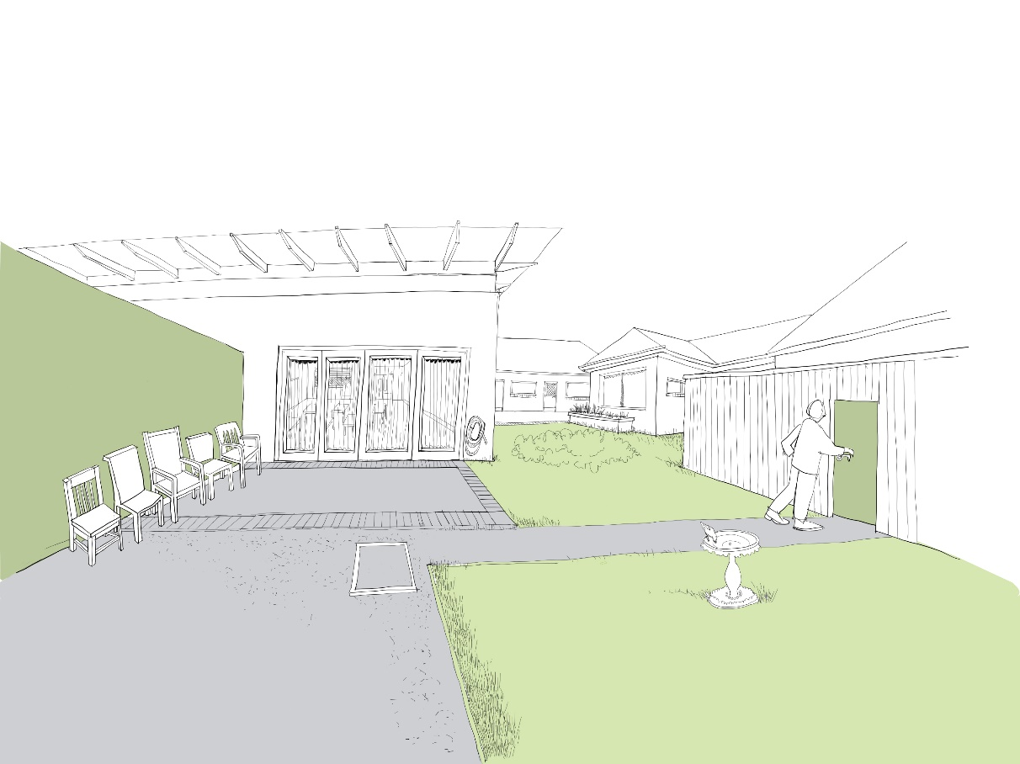
After The garden has been enhanced through introduction of shaded areas, planting, and better pathways
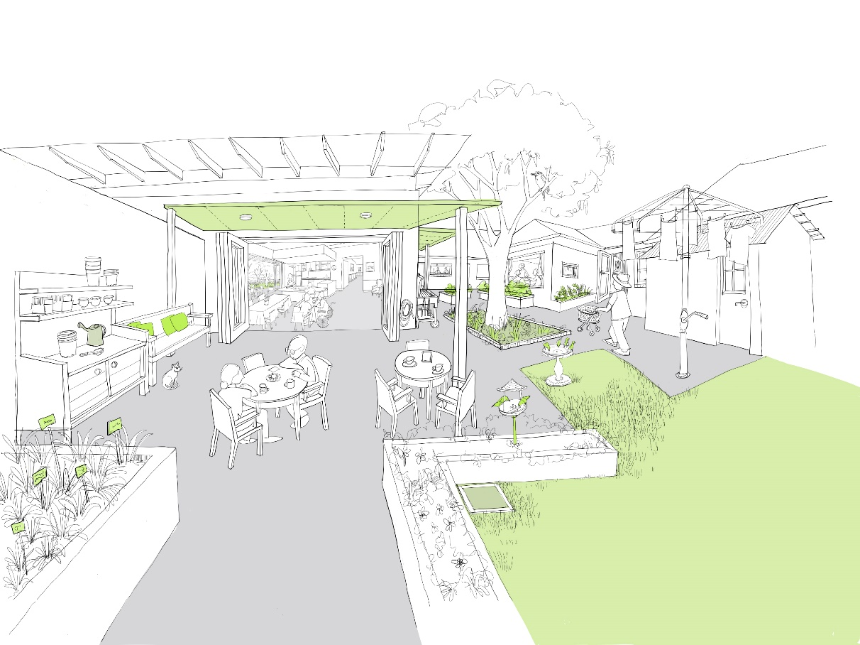

Guideline 3.1 Dedicated Outdoors
A personalised garden or balcony is dedicated to each household
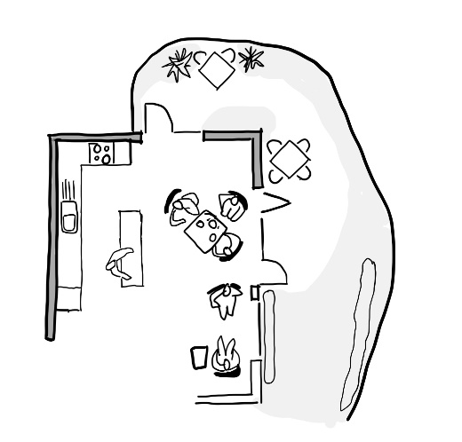

Guideline
Provide a garden or balcony that is an extension of residents’ living space, is safe and has opportunities for meaningful engagement. This requires it to be large enough to support the activities residents enjoy and set up appropriately. The space can be a simple, familiar back yard, balcony, or garden.280 Fences should not make people feel imprisoned. Balcony balustrading height should not prevent people enjoying views, sunshine, or fresh air flow.

Scenario
Having a large undefined garden can make it harder for staff to confidently leave doors unlocked.
During meals in the dining room Charlie tends to become a little irritated and frustrated by excess noise. This has led to instances of him being verbally and physically aggressive towards fellow residents and staff.
Dave knows that going outdoors, where stimulation is more manageable, is often the best way to help Charlie relax. He would be able to eat his meals outside or take a walk, but currently the garden is shared by the whole home. Dave is concerned that if Charlie goes outside by himself, he may get stuck somewhere because the outdoor area is so large and undefined.

Rationale
Why is this important? In most aged care homes, residents spend little time outdoors. Residents on upper levels are even less likely to go out on balconies or downstairs to gardens. Outdoor areas are often attractive, but are not set up to accommodate what residents want to do. In many homes, doors to the outside are kept locked.276
What makes a difference? If outdoor areas are immediately accessible, they provide a sense of autonomy and independence277,278 important irrespective of age or cognitive abilities.279 Having immediate access to an outdoor area has been shown to reduce agitation. Prominent fences can produce a sense of containment for some people.
Upper levels need balconies large enough to support activity. Access is supported when managers provide a clear approach to addressing risk through case management and careful balustrade selection. Residents should not be required to move between levels in order to access an outdoor area.

Outcomes
Francine carried out a risk assessment of the outdoor space with colleagues. A dedicated area of garden was created for Charlie’s household. It is a good size, but not so large that he could get lost or confused. Dave feels much more confident to leave the door unlocked and for Charlie to go out whenever he wants. This has significantly reduced Charlie’s feelings of frustration.

Checklist
- Provide a private outdoor area (a back yard, garden, or a balcony) for each household (relates to “Environmental sustainability” and “Infection prevention and control”)
- Plan activities that encourage use of outdoors and set up furniture and equipment inviting that use each day (relates to “Supporting workforce” and “Cultural diversity”)
- Provide a discreet, secure boundary fence, disguising staff access gates (relates to “Supporting workforce” and “Cultural diversity” and “Infection prevention and control”)
- If the household is on an upper level, provide balustrading that permits good sunlight, views, and airflow
- Ensure there is adequate accessible outdoor area, but that it is not so large that someone could be in distress without others being aware (relates to “Environmental sustainability” and “Infection prevention and control”)
- Where existing building design does not allow immediate access outside, provide large openable windows or juliette balconies to bedrooms and common areas

Guideline 3.2 Garden Connections
Good lines of sight and access connect living areas and the outdoors
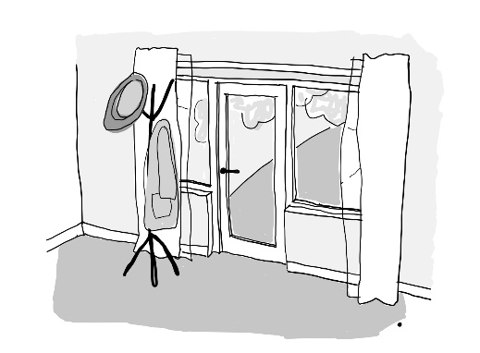

Guideline
Support staff training, addressing safety concerns and working towards ensuring doors to the garden or balcony are operable. Ideally locate these adjacent to main living rooms. Maximise visibility, ensuring curtains are drawn back, and other barriers are removed. Doors to the outside must be visible, identifiable, and easily operated by residents. Remove level and tonal changes between the resident areas and outdoors.

Scenario
Complex environments can make it difficult for people to get to the garden. Some staff have concerns about their ability to supervise safety in a garden. These two factors hinder residents getting outdoors.
Bianca can see the garden from her bedroom window and likes the look of it, but she’s not sure how to get there by herself. Bianca often asks Eleesha about going outside.
Eleesha tries to take Bianca for a walk through the gardens regularly, because she knows how much Bianca loves it, but there are so many other things to do that often it just isn’t possible. Eleesha is worried that Bianca will fall without her knowing, because she is living with dementia with Lewy Bodies. The exit door is locked. It’s easier for Eleesha to be able to see where Bianca is most of the time.

Rationale
Why is this important? As previously outlined, access to the outdoors is essential. Staff are the most important factor determining usage of outdoor areas,281 but often perceive risk as overriding all other considerations282,283 The ability of staff to see an outdoor area increases the likelihood of them removing barriers to access.284 If residents cannot see a garden, recognise a door, or see an easy route to get there, they are unlikely to be able to independently use the garden, particularly if they have dementia.285,286
What makes a difference? Physical factors promoting resident use of outdoors are visibility of gardens, the ability to find or use access doors,287 the attractive appearance of gardens,288 good door threshold design,289 short distance to a garden, and high prevalence of doors being unlocked.

Outcomes

Francine organised for the garden fencing to be made safer. The door is now often latched open. Curtains and sheers are opened in the morning. The exit door has a reed switch alerting staff silently if the door is opened. Bianca can see the garden and the exit door now from the living area and is able to go out herself. She has been watering the plants and sitting in the sunshine near the door, where there is often a neighbourhood cat lounging. She is sleeping better, and is calmer during the day. Eleesha can now easily see the extent of the garden from the lounge area and the boundary is secure, so she feels more comfortable about Bianca going out alone. She is alerted on her pager if the door gets opened when she’s not in the room.

Checklist
- Implement a policy to ensure doors to the outdoors are unlocked each day, promote staff education about the benefits of outdoor access, and address safety concerns (relates to “Environmental sustainability”)
- Provide fixings to hold back window coverings
- Install a main swing door to each outdoor area that is easy to see and operate, can be latched open and has no raised threshold or level change (relates to “Environmental sustainability”)
- Consider installing additional large sliding, bi-fold or big outward opening doors which expand a room to the outdoors
- Maximise good visibility of the garden from the main living areas (relates to “Supporting workforce”)
- Consider creating small private gardens off bedrooms for less mobile people
- Install a system on exit doors to silently alert staff when doors are opened (relates to “Enabling technology” and “Supporting workforce”)
- Consider enlarging the end of a corridor or dead-end into a sitting area for 2–3 people that links to the main household garden

Guideline 3.3 Garden Verandahs
Shaded, sheltered areas are located just outside resident living areas
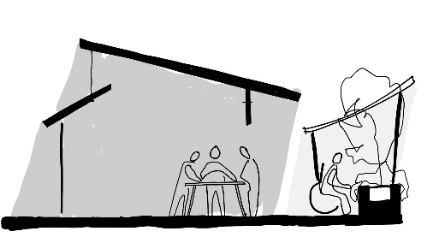

Guideline
Create sheltered areas immediately outside the doors to the garden. They should be large enough to support at least a small group sitting together around a table.

Scenario
Older people find it easier to move outside if there is a shaded transition area which protects them from the elements.
Bianca is nervous about falling, having fallen a couple of times before. She will ‘freeze’ at times or not be able to control the speed of her walk or her balance. The wind can catch her off guard. She feels particularly concerned when she goes outside and is keen to always be with someone.
Eleesha is also worried about Bianca falling in the garden. There is not much seating in the garden. The weather can be unpredictable. She is concerned about it being too hot, cold, rainy or windy for Bianca.

Rationale
Why is this important? One of the barriers which may limit someone comfortably accessing the outside is the glare or blindness experienced when entering or exiting the outdoors. This can be due to the ageing eye’s reduced ability to adjust to changes in light levels, and other common eye conditions.290
Concern about unfavourable weather conditions can also be a barrier, making shade and shelter important.291 The areas just outside building exits often encourage outdoor activity, but concerns over weather may result in staff preventing access.292
What makes a difference? Providing shaded areas immediately outside the exit door moderate bright sunshine, making it easier to transition. A sheltered area outside the door helps people venture outside to test the weather, stay longer if they would like, and come back in easily if conditions become less favourable. Areas that are close to the exit are easiest to use for someone with lower mobility who may find the distance to a garden destination is a barrier in itself.

Outcomes
Some comfortable seats were put next to the door to the garden, and blankets and cushions in a box. A trellis screen and shade sail were put up close to the door to improve the shelter without disrupting the view. Sitting by the door gives Bianca a chance to rest and get used to the outside conditions before walking a little more. The seating makes it easier for her to see the way back inside. Eleesha is now more confident that Bianca can manage and encourages her to go outside more often.

Checklist
- Place outdoor furniture close to the door out to the garden from living rooms to support activity (relates to “Infection prevention and control”)
- Provide outdoor furniture that is familiar, robust, comfortable, and stable (relates to “Cultural diversity”)
- Set up for familiar activities (eg morning teas, potting, birdwatching) in these sheltered areas (relates to “Cultural diversity”)
- Construct shade and rain shelter outside the main living rooms to outdoor areas that is at least 1.8m deep
- Integrate visible storage at the exits to the garden for hats, sunscreen, umbrellas, and blankets

Guideline 3.4 Garden Destinations
A variety of outdoor places support different and meaningful activities
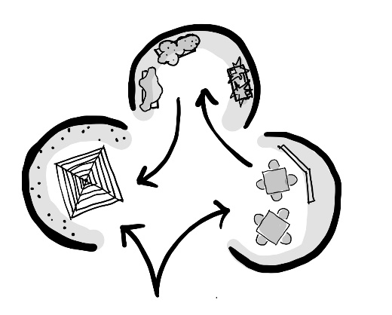

Guideline
Different residents will engage with different outdoor activities. Plan and set up outdoor places that match residents' interests. These might include morning tea, gardening, animal tending, or sport. Create areas that support these activities in the garden, ensuring a good path to each space, setting it up with furniture and familiar items, and keeping it clean and well maintained.

Scenario
If there isn’t much to do outdoors it is unlikely that someone will want to spend much time there.
In Bianca's garden at home, there was a lot of activity - neighbours to chat to, lots of birds to watch, and jobs to do. The garden in the care home is by contrast very neat and tidy. She doesn't feel like there is anything for her to do and often feels restless.
It’s difficult for Eleesha to know what to suggest for Bianca to do in the garden, even though it looks nice and is well maintained.

Rationale
Why is this important? Studies show that activities are the equivalent of treatment for people living with dementia and are an essential part of dementia care for that reason.293 Engaging in purposeful outdoor activities is motivating for people living with dementia,294 with noted positive effects including improvements in mood, reduced depression, reduced agitation, and higher social interaction.295,296 Outdoor activities provide positive sensory stimulation, 297,298 facilitate activities, and extend the range of options available to residents.299
What makes a difference? Providing different spaces for different uses helps residents find their way and engage in a variety of activities.300 Variations in the size of areas for different activities can help orientate residents. This is also helped if the areas are understandable, differentiated, and if they provide good lines of sight between doors and destinations.301,302,303 Simple paths should connect points of interest.304,305 Each destination in the garden should be familiar, legible, distinctive, accessible, comfortable, and safe.306

Outcomes
Three areas were set up in the garden: a raised kitchen garden with Bianca’s favourite herb (rosemary); a clothesline which has a line of sight to the domestic laundry; and a bird watching area with a bird bath and feeders.
Mid-morning Bianca can hang up the dishtowels and likes to watch the birds feeding or bathing. Another woman is able to identify all the birds. Bianca loves to roll the rosemary in her fingers. The scent really reminds her of her childhood. She’s been telling Eleesha all about it. Eleesha can direct Bianca to different parts of the garden depending on how Bianca feels or what the weather is like.

Checklist
- Set up at least three outdoor places for activities for people living in the household to comfortably spend an hour (relates to “Cultural diversity”)
- Involve residents in decision-making about which outdoor activities to support (relates to “Cultural diversity”)
- Prioritise domestic activities such as hanging out laundry, barbecuing, potting and dining (relates to “Cultural diversity”)
- Furnish outdoor areas in a style familiar to residents, removing unrelated clutter (relates to “Cultural diversity”)
- Provide shade and shelter in the garden to protect residents and to identify destinations
- Ensure that there is a clear pathway to each area and back into the building (relates to “Supporting workforce”)
- Provide resources for visiting children and grandchildren suited to the culture of the residents and their families

Guideline 3.5 Clear Paths
Garden paths are simple, have seating, and connect back into the building
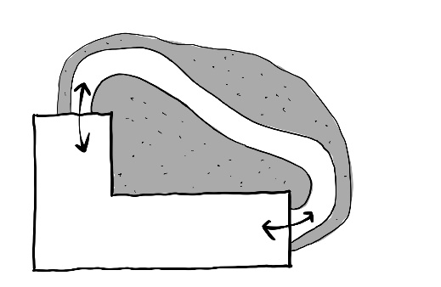

Guideline
Ensure that the paths around the outdoors are easy to see, simple in layout, and wide enough to suit different levels of mobility. Paths should be slip-resistant, even, and free from clutter and changes in tonal contrast. There should be appropriate seating at regular intervals.

Scenario
Safe and clear pathways support navigation and movement.
Anne is very limited in her mobility. To access the garden, she requires someone to wheel her in her comfort chair. She is reliant on staff or volunteers taking her out. She spends most of her time in her room. Staff are concerned that increasingly Anne's mood is low.
Eleesha believes the paths in the garden are too narrow. She worries that Anne's chair might go over the small step at the edge. It is even harder if she needs to pass someone else. The dead end at the shed also makes it hard to turn the chair around.

Rationale
Why is this important? Most residents living in aged care have some form of mobility challenge and compromised vision which contribute to an increased likelihood of falls. Falls are rightly a major concern for residents, of whom one third will not recover from a significant fall.307 Physical movement and anxiety about falls are affected by path width, safety, clarity, availability of regular seating, and mobility aids.308,309,310,311
What makes a difference? Well-designed paths for resident use are critical to the safety and accessibility of outdoor spaces. Paths must be simple in layout and wide enough for people using mobility aids, wheelchairs and comfort chairs. Eliminating clutter, trip hazards, overgrown planting, and tonal changes along the path promotes easy movement. Visible drainage channels and access panels should not be located in pathways. The edge of the path should be easy to see.312,313 Pathways leading to potentially unsafe or locked areas such as maintenance gates should be discreet, for example by tonally matching adjacent surfaces. Providing seating and access to a toilet close to the pathway supports residents in using the outdoors.

Outcomes
The path has been widened and made more even. It now connects with a door leading to a bedroom corridor which is closer to Anne’s bedroom. This makes it easier for a volunteer to take Anne directly outside without going through the main living area. There is new seating beside one of the widened areas so they can both sit together in the sunshine and relax.

Checklist
- Connect doors that lead from buildings to garden destinations with direct paths
- Remove clutter, obstructions, and overgrown planting from paths
- Ensure paths are level, non-slip, and thresholds do not present a trip hazard (relates to “Supporting workforce”)
- Ensure that the colours of adjacent indoor and outdoor floor finishes are close in tone
- Install min. 1.8m wide paths with visually clear edges, avoiding level changes
- Disguise staff-only elements like service covers and maintenance gates
- Provide seating places to sit along paths at maximum 8m intervals (relates to “Supporting workforce”)
- Configure pathways to return to living rooms or bedroom corridors
- Signpost or create visibility to the nearest WC or install an outdoor toilet if appropriate (relates to “Supporting workforce”)

Guideline 3.6 Nature Indoors
Large windows, indoor planting, fish tanks, and animals connect people to nature while they are indoors
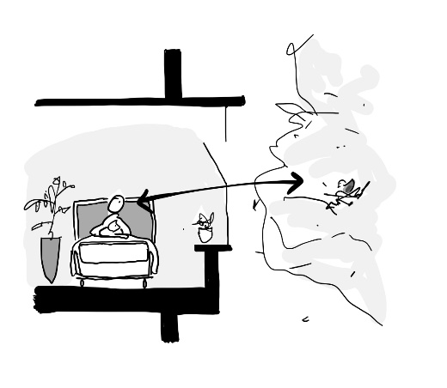

Guideline
Where possible integrate planting programs and pets into aged care homes. Promote the involvement of residents in the maintenance and care of both plants and pets. The design of windows and balconies should help residents connect with nature and the local community from within their home.

Scenario
Even in the most supportive environment, more vulnerable residents are less likely to get outdoors and risk becoming totally disconnected from nature.
Anne is in her bedroom most of the day due to her low level of mobility. Often the curtains are partially closed and she has limited access to daylight or views.
Eleesha keeps the curtains a bit closed, because she doesn’t want to disturb Anne, who looks sleepy. She feels pressure to entertain Anne.

Rationale
Why is this important? If someone is not independently mobile they are less likely to be able to access gardens and nature.314 Ensuring nature is brought indoors then becomes more critical. Access to sunshine, fresh air, views of activity and nature, and the positive stimulation of animals and plants are highly valued by residents315 and their families.316
Often concerns about perceived risk exclude pets and indoor plants from care home environments,317 however a high proportion of Australians are used to living with pets318 and indoor planting. Not having access to plants or animals is a real loss to many people and there is evidence that interaction with animals, and caring for plants supports mental health and wellbeing.319,320
What makes a difference? The areas on the edges of buildings can be opened up to create the feeling of a deck, such as the ubiquitous Australian verandah. This allows access to the outdoors without a resident needing to move.
There are also a range of programs around the world that have used extensive indoor planting to address immobility of residents or site constraints. In Australia there are various programs that involve dogs, cats, chickens and farm animals providing joy and therapeutic outcomes for residents.

Outcomes
Eleesha now opens the curtains wide for Anne every morning. Sometimes it is initially quite bright for Anne so Eleesha takes her time and does it bit by bit so that Anne’s eyes can adjust. The view of the school gives them lots to talk about as Eleesha’s little boy goes there. They can hear the kids playing handball. It reminds Anne of stories her mother would tell her of playing plainy-clappy as a child in Scotland.
A volunteer brought Anne a peace lily which is thriving in a shadier spot by Anne’s bed. Anne is able to water the plant every few days. It’s beginning to flower.

Checklist
- After consulting with residents, consider the introduction of pets within the home (relates to “Cultural diversity”)
- Provide safe houseplants to the common areas and resident bedrooms (relates to “Cultural diversity”)
- Consider providing fish tanks, bird cages and other pets in common areas (relates to “Cultural diversity”)
- Incorporate window sills that are low enough to allow a view out when seated
- Where there is an option to introduce new or enlarged windows, choose those windows or Juliet balconies that look onto natural scenes or human activities

Built examples
1. A garden set up for meaningful activity including contact with animals
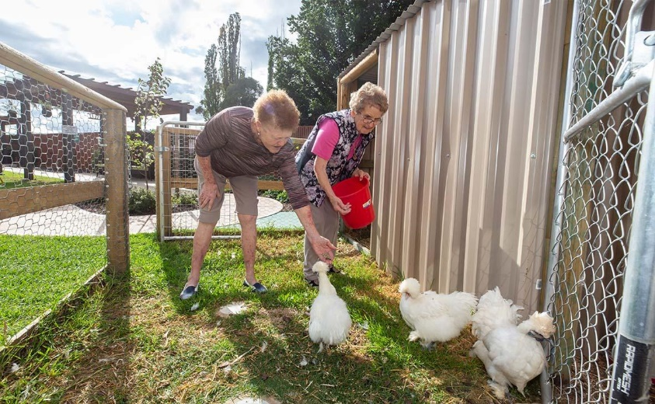
2. Covered areas providing shade, clear paths and comfortable seating
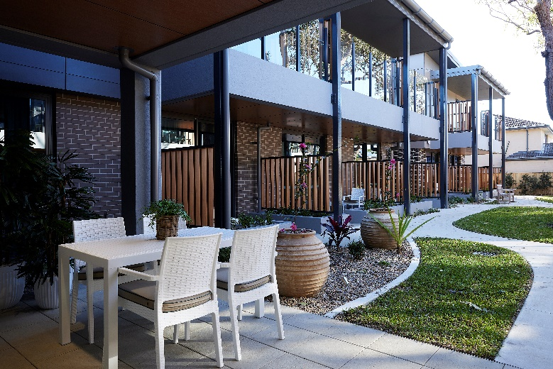
3. Shared communal gardens with maintenance and potting areas for residents from different households to enjoy together
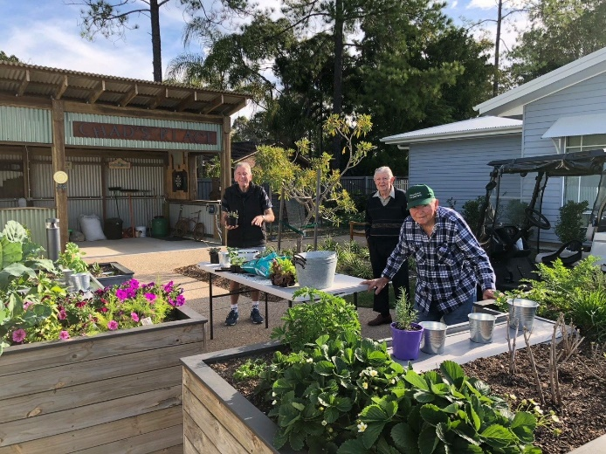
4. An attractive balcony space outside a bedroom
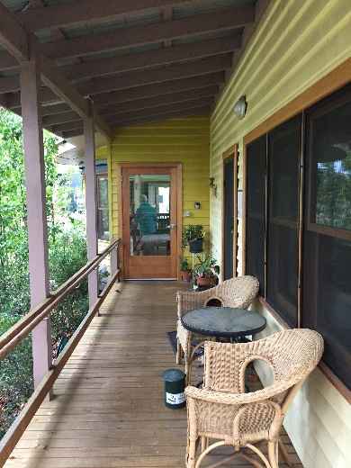
5. A lounge at the end of a corridor connects to the household back yard
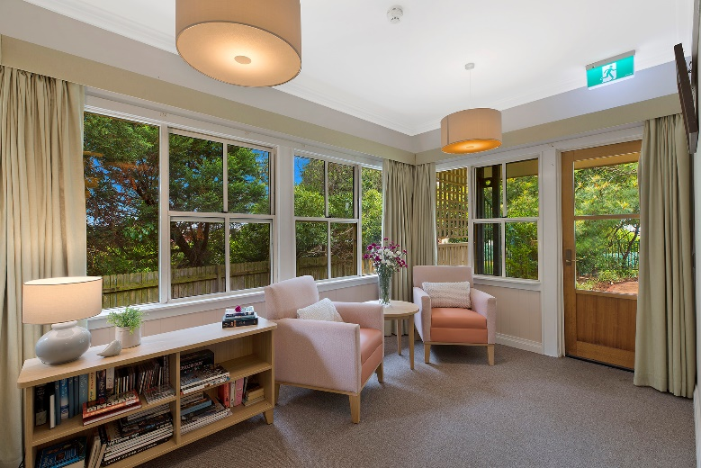
6. Apartment-style balconies to living areas on each level
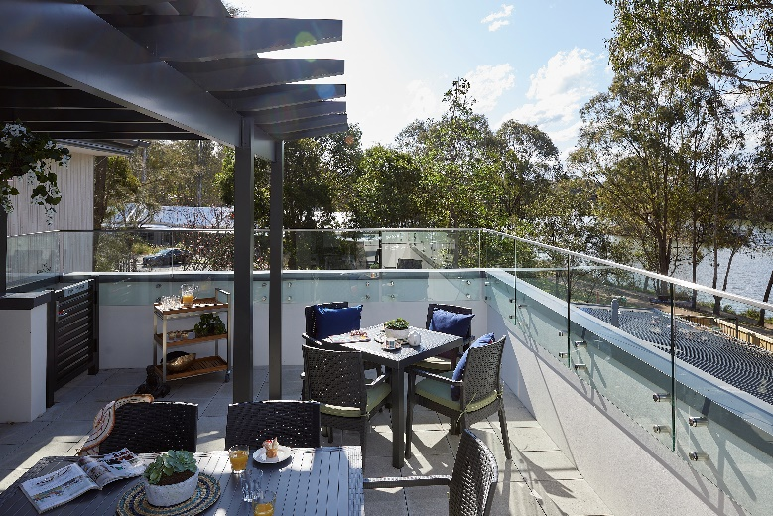

Design Principle 4 – Connect with Community

Objective
To encourage people to connect with family, friends and community, continuing to participate in meaningful activities

Guidelines
- 4.1 Neighbourhood Access
- 4.2 Community Hub
- 4.3 Easy Navigation to Households
- 4.4 Integrated Building Form

Situation
Then Minister for Aged Care, Ken Wyatt, reported that up to 40 percent of individuals in aged care homes never have visitors, presenting the real risk of isolation.321 The Hon Mark Butler MP, Minister for Health and Aged Care, and Kate Swaffer, dementia advocate, both highlight the link between isolation and negative social attitudes towards ageing and dementia.322,323
For people living with dementia, social exclusion can begin at the point of diagnosis and escalate with a move into aged care. Whilst some are active in rebuilding social networks, challenging exclusionary practices and making use of neighbourhood resources, others report that their worlds became constricted, because families and friends would avoid them.

Desired Outcomes
This Principle aims to create opportunities for residents to connect to each other socially within the larger home, to welcome and promote connection with families and friends, and to engage with social life in the local neighbourhood. It might involve site selection near a neighbourhood centre or incorporating a range of real, publicly-accessible amenities, such as a café or supermarket. For sites that are more isolated, aged care homes can create community hubs to provide a public space experience for residents of the home and as an opportunity to connect with local residents.
Site selection is a significant factor and is largely addressed by state planning strategies. However, changes to existing homes can create opportunities for a connection to local communities by developing ‘public realm’ spaces into existing buildings.
Connecting with community requires a model of care aligned with the design of the environment, such as a strategy to develop relationships with local community organisations and businesses to operate from the care home site.
Before The care home below has a professional, hotel-like appearance that is not welcoming to locals
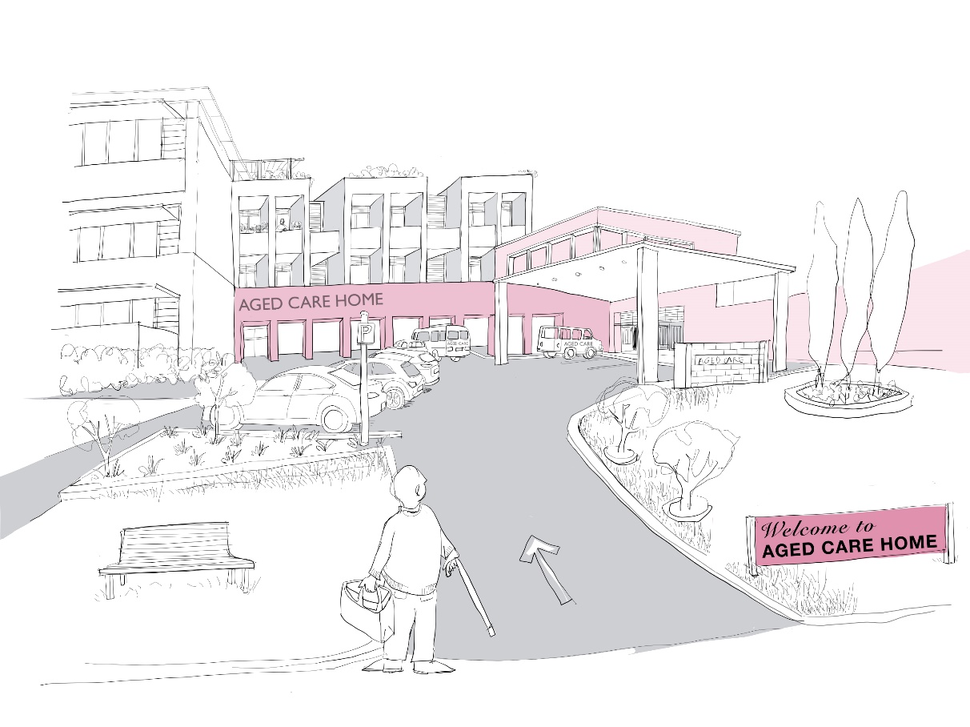
After Changes to the building in the previous image have created opportunities for the service to provide welcoming services to the wider community
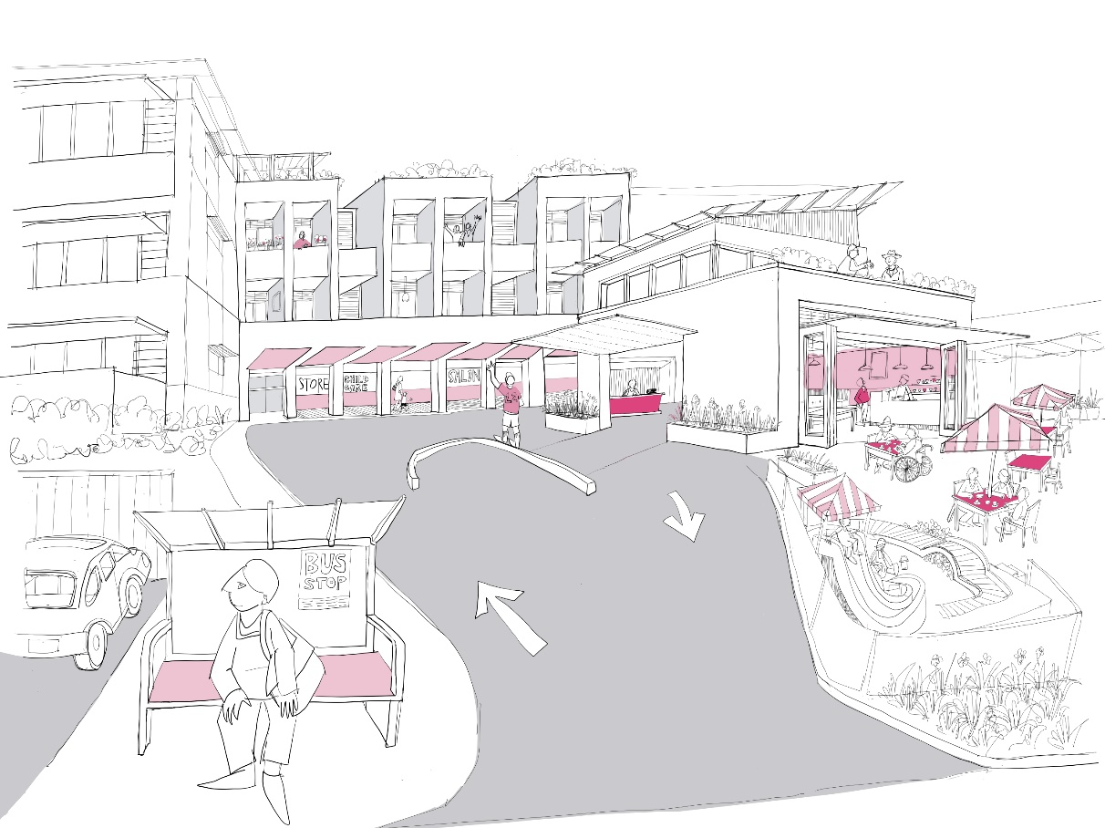

Guideline 4.1 Neighbourhood Access
Links to local cafes, shops, transport, and religious services are supported
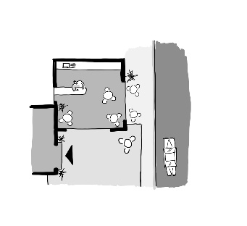

Guideline
Where possible locate aged care home near neighbourhood centres. Entering the site should be easy due to accessible configuration.

Scenario
Some aged care homes are situated in places isolated from community amenities. Links with existing local communities may not always be prioritised.
Bianca used to live in the local area. She went to the local Catholic church with her family. Occasionally they still come to take her, but it is getting harder for them to manage because the path to the carpark is long and tricky for Bianca with her walking frame. She doesn’t like to be a trouble to them so she has stopped asking about it. This is another significant loss in her life which she is grieving.
Eleesha would like to support the family to take Bianca to church as she can see how it revives her, but she doesn’t have much time to take Bianca out to the car herself, and the family are nervous about Bianca falling on the path without Eleesha’s support.

Rationale
Why is this important? Moving into residential aged care puts residents, particularly those living with dementia, at higher risk of stigma, exclusion, loneliness and boredom. One study reported324 high social exclusion after diagnosis, with many losing friends, seeing less of family, and 'frozen out' by neighbours. Moving into care can amplify exclusion or can create opportunities to connect with local neighbourhood life, in contrast with the isolation they might have felt at home.
The move can mean a disconnection from the wider community with family and friends finding it hard to visit. People living in care homes need and want to continue to participate in community life. It is essential to mental and physical well-being.
What makes a difference? The primary factor supporting a resident to remain connected to a community is location, with most aged care homes beyond walking distance from town centres.325 Ideally, a site should be near a neighbourhood centre or within a retirement or mixed community big enough to support shops and other life beyond an immediate household.
The proximity of shops within an easy walk can support independence.326,327 Location near good transport routes is helpful to visits from family and friends and to support outings that contribute to a sense of independence.328,329
Information technology can help maintain connections. During the pandemic, video conferencing supported maintaining connections with family and the community.

Outcomes
Manager Francine organised an additional drop-off space to be created out of part of the front garden that people were not really using. The paving in this area has been fixed up and the lighting is good. Bianca is able to go out fortnightly with her daughter. In addition, Francine liaised with Bianca’s church and now in the training room they have set up a live stream of Mass for Bianca and others in the home. Now on the weeks that Bianca’s daughter doesn’t come or other holy days, they can celebrate Mass online with support of pastoral care staff.
Bianca loves going to church, meeting with friends and being part of her community again and she comes back singing.

Checklist
- Provide cover, seating and lighting at entrances (relates to “Information technology” and “Cultural diversity”)
- Connect with local neighbourhood groups to develop aligned services
- Ensure the door entry system is easy to use for returning residents (relates to “Environmental sustainability”)
- Provide sufficient car, bike and motorcycle parking (relates to “Supporting workforce”)
- Make end-of-trip facilities available for staff and visitors (relates to “Information technology”)
- Consider ways that IT can be used to support social connections (relates to “Supporting workforce”)
- In planning new buildings, ensure the home is close to public transport
- Locate new homes within easy walking distance and in view of places of interest

Guideline 4.2 Community Hub
Public spaces are available to residents and ideally also used by people living nearby
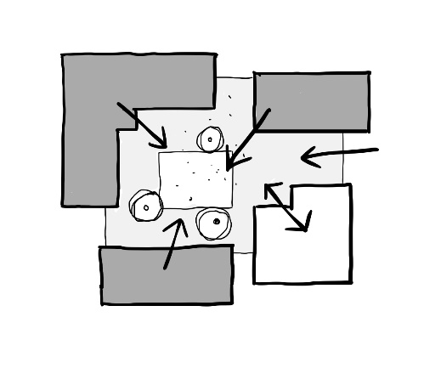

Guideline
Create public amenities inside or adjacent to the care home. Make these easily visible from the both the street and the resident area. Co-develop such amenities with local institutions, such as places of worship, grocery stores, cafes, social clubs, and childcare facilities.

Scenario
A good way to increase social interaction and reduce stigma is to provide places that are useful to both residents and people from the wider neighbourhood, bringing them together and enriching life for both groups.
Anne is becoming more withdrawn. She now rarely goes into the main part of the home. As her ability to communicate diminishes she is less able to say what she wants to do. She is beginning to not want to do anything.
Eleesha finds it hard to know what to offer Anne. Beyond taking her around the garden and sitting in the lounge, it is hard to think of ideas.

Rationale
Why is this important? Older people have a right to participate in public life but this is often challenged by building design, stigma and increasing physical and cognitive challenges.330,331 Infection control protocols established through the COVID-19 pandemic have further increased the disconnect. This often results in residents lacking access to routine outings essential to their lives, such as church, a walk to a café, or buying a paper.
What makes a difference? The decision to maintain or create a community connection needs to come from an operator’s model of care, rather than research-validated reasoning.332 A key strategy to supporting stronger engagement with family, friends and the community is the inclusion of shared community facilities on an aged care home’s site. Examples of this might include cafés, supermarkets, a bistro, a church, childcare, a supermarket, a wellness centre, or clinical services that bring in people from the neighbourhood. This can be further enhanced by playgrounds, gardens and horticultural programs that encourage visitors of all generations.333 The presence of children and animals has been identified as important for residents in care homes.334 To be attractive, it needs to be accessible to locals without them having to sign into the home as visitor.

Outcomes
There is no café in the area, so Francine organised a coffee cart to visit the home for half an hour on Tuesday afternoons. It is a real event in the week now. It coincides with school opposite finishing so some of the parents and the kids linger around. Elsie bought a seesaw and is working on a slide so that the kids can play on the front lawn too. They’ve set up some tables and chairs there.
Last week Eleesha brought Anne and Bianca down and several other residents came along independently. Anne was completely absorbed in watching the kids running around and one little girl brought her a flower unprompted.

Checklist
- Determine whether existing spaces in the home could be shared with the public (relates to “Cultural diversity”)
- Provide a community hub of relevant public facilities (eg, a shop, café, club meeting rooms, gym equipment, salon, or pub) (relates to “Cultural diversity”)
- Locate the community hub near the home entry, considering possible access to the public
- Provide baby change facilities and play equipment near the main entrance
- Provide a place for a family gathering or religious service outside the household (relates to “Cultural diversity”)
- Provide wheelchair and mobility scooter storage and charging points (relates to “Supporting workforce”)
- Provide charge points and wi-fi for resident, visitor and staff use throughout the building
- Provide an additional room, or sufficient space within bedrooms, for family to stay with a loved one overnight if needed

Guideline 4.3 Easy Navigation to Households
Routes between street entry, community hubs and households are easy to follow
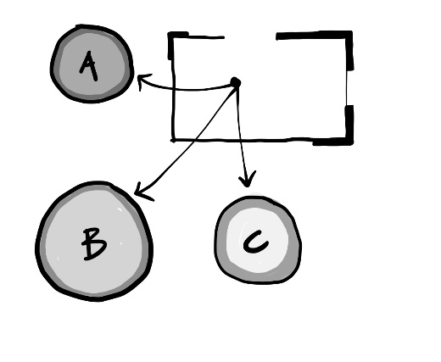

Guideline
Create easy-to-follow routes between households and those places in the home that residents like to visit.

Scenario
Building entries are often designed to be identifiable from the street. The street entry provides the best location for a community hub. However, there is often a convoluted path to reach resident household areas.
Bianca has been enjoying going to the coffee cart with Eleesha and Anne on a Tuesday, but is reliant on Eleesha being with her. Bianca can use the lift okay herself. She knows what to do when she gets there. But it’s finding her way to and from it that is the problem.
Eleesha feels like Bianca could almost get to the coffee cart by herself. There is a small hair salon near the main entrance. Similarly, while she has always needed help to find the salon, it would be amazing if she could manage herself. That would help Bianca’s sense of independence and give Eleesha more time.

Rationale
Why is this important? Easy access, simple layouts and good pathways from the home entry to households is important for visitors and residents. Often the routes are convoluted and rely on prior knowledge or extensive signage.
Community hubs are also often located at the entry. Length of route is a key barrier to residents getting to the hub without substantial staff support and time.
What makes a difference? The Design Guidelines relating to circulation and orientation are relevant. These include minimising path length, simple configuration,335 ensuring adequate path width, providing good lines of sight along the route,336 highlighting the doorways, reducing clutter along the route,337 providing good lighting,338 and ensuring floor finishes are safe.

Outcomes
Bianca’s household entrance was made much more like a front door – a strong colour with timber beading. The name of the household ‘Banksia’ was mounted on the door in a traditional manner, and a decorative olive tree in a large cream and blue ceramic pot placed beside the door. Lighting was improved in the circulation areas and the wall with the lift doors on it were cleared of all notices to ensure they stood out. On the ground floor, a clear sign to the salon and the coffee cart were put on a wall directly opposite the lift and a luxurious-looking waiting chair placed outside the salon as a landmark. The door to the salon is open and the smells of hair product waft out.
Bianca can see the chair as she walks away from the lift. After a few times following this route with Eleesha emphasising the signage and the landmarks, this has helped Bianca find the Salon on her own. The way back is trickier, but when they arrive at Banksia together, Bianca will say ‘Here we are!’

Checklist
- Use familiar landmarks at key decision points, and clear signage where navigation is more complex (relates to “Cultural diversity”)
- Review the pathway from the home entry to the households and implement improvements
- Create easy navigation between household entrances and other destinations through good visibility and simple layout
- Provide a help point or reception desk which is visible from the main entry to the home
- Create a distinctive, domestic entrance to each household which reflects the culture of the residents who live there (relates to “Cultural diversity”)
- Avoid using hard surfaces in reception areas to reduce echo

Guideline 4.4 Integrated Building Form
Building form is consistent with the character of buildings in the neighbourhood
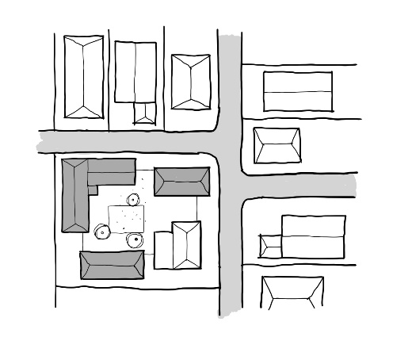

Guideline
Ensure that the form of buildings relates to other buildings in the neighbourhood through building mass, articulation of facades, surface finishes, the use of green space between a building and the street. Include other features that are common to the neighbourhood and surrounding buildings.

Scenario
When an aged care home looks out of place in the local neighbourhood, it can create negative feelings among neighbours and residents.
Charlie has one son who often visits, but his younger brother finds it difficult. The younger son has found it hard to cope with his dad living with frontotemporal dementia. The building itself stands out in the neighbourhood as a clinical facility. He finds it intimidating and depressing to visit. He came once when his dad first moved in, but hasn’t been back.
When they first came to the home, Francine tried to encourage Charlie’s sons to visit frequently, but she appreciates that it’s not for everyone. Aged care homes can be confronting.

Rationale
Why is this important? While a lack of community contact reinforces the institutional nature of care homes,339 building style can emphasise stigma and unfamiliarity of the home.
What makes a difference? Residential entries and elements, discreet fences, and a residential building morphology all reinforce an aged care home being part of the surrounding community. This reinforces the message that residents are valid and valued citizens.

Outcomes
Francine organised for more residential-style signage for the entrance and for some planting to be put in front of the security fencing to soften the entrance and match the surrounding nature strips. This makes the building look more like a block of apartments rather than an aged care home.
The home tidied up the entrance area, removing many of the notices from the glazed doors and put some comfortable seats and a piece of artwork next to the reception desk. The nurse call system is now silent, linked to pagers that staff carry.
Charlie’s son encouraged his brother to visit again, and this time he found it easier overall to come to terms about his dad living there.

Checklist
- The entry has clearly visible, legible signage, but is not heavily branded
- The building frontage fits into the local neighbourhood both in terms of scale and style
- The building setback is consistent with other buildings in the street
- Where the building is a contrasting scale or style to the neighbourhood, create welcoming spaces at the entry (refer to Community Hub Guideline)
- Reduce visibility of delivery entrances, carparks, security fencing and other institutional features from the street

Built examples
1. An active central communal garden and pond
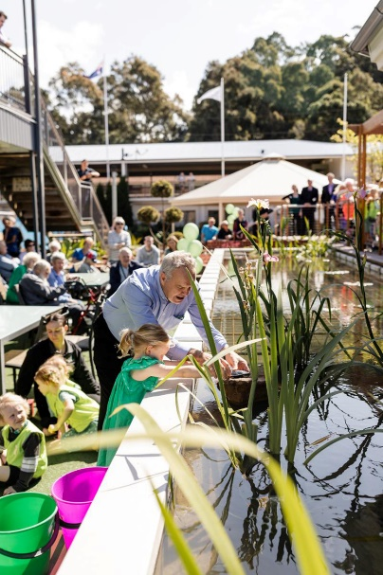
2. A resident workshed available for general use
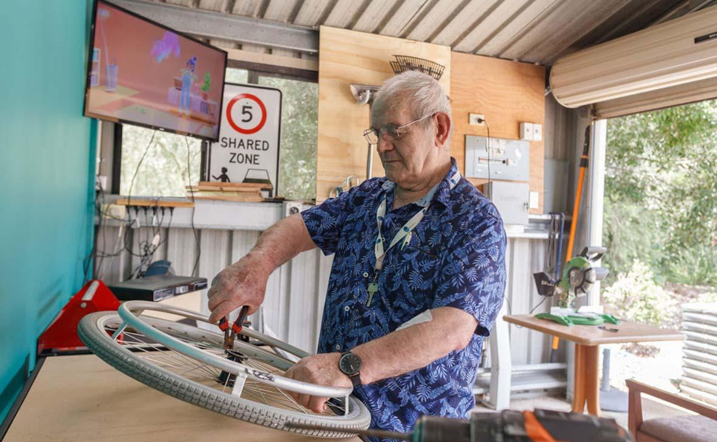
3. A generous plaza designed to resonate with the Italian heritage of many of the residents
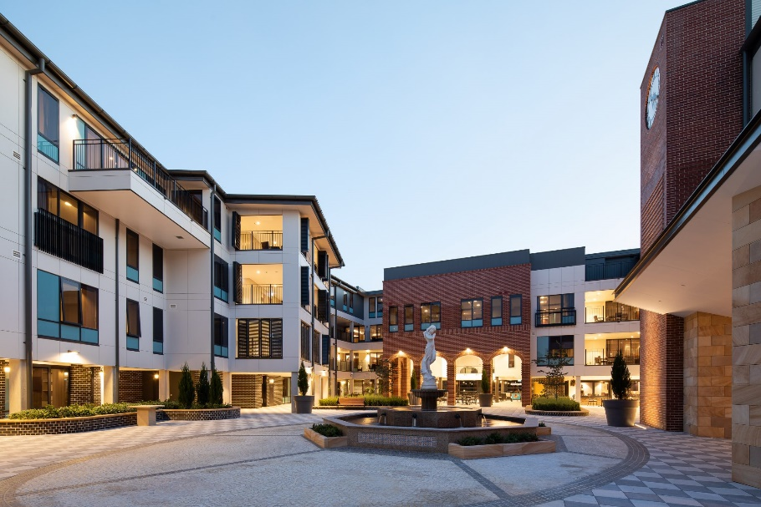
4. A welcoming café hub provides an easy place to socialise
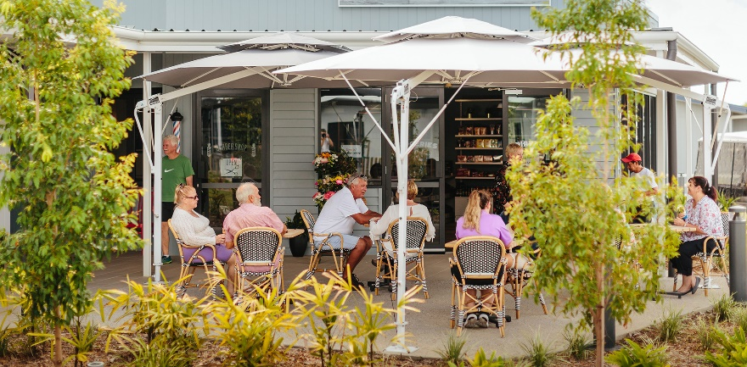
5. A café located close to the entrance is open seven days a week to residents and visitors
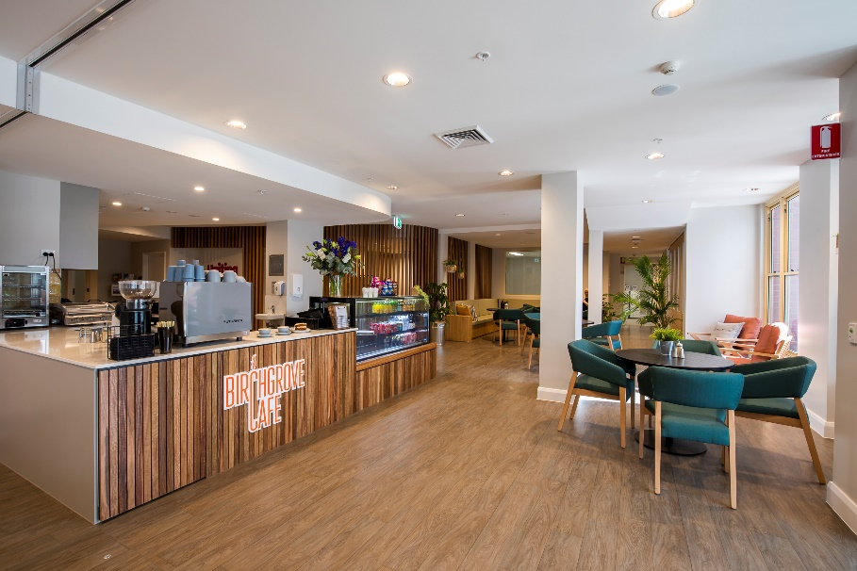
6. A beautiful Greek Orthodox chapel close to the entrance allows residents to take part in Mass in a dignified way
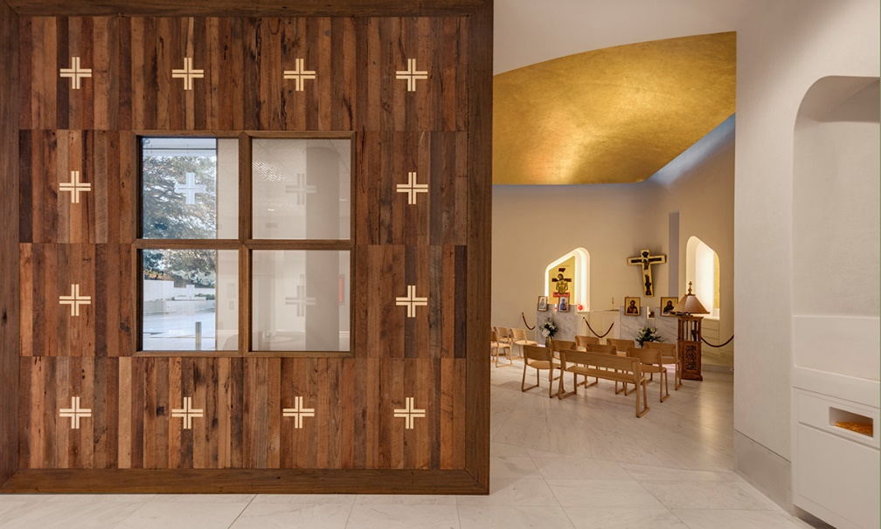

Glossary
This glossary only covers terms with a general meaning, that are given a specific meaning in this document. Terms are listed in order of frequency, rather than alphabetically.

Spatial terms
- Home: A place where someone feels they belong and which in some sense belongs to them, a place where they have agency and a sense that all is well.
- Household: Part of the resident area configured as a home for up to 15 residents.
- Resident area: Those parts of the aged care home in which residents usually live, including lounge, dining areas, plus any domestic amenities such as kitchens or laundries, bedrooms and associated circulation spaces.
- Aged care home: An organisation, together with its facility, that is a permanent home to older people, once they cannot be cared for at home.
- Community hub: Where present, an area such as a café used by both residents and people outside.
- Tonal contrast: The difference in tone (or light reflectance value) between two surfaces. Tonal values range is measured on a scale between 0 and 100, with 0 being notional pure black and 100 being notional pure white.

People terms
- Resident: A person living in an aged care home.
- Visitor or family member: People from outside the aged care home who come to visit a resident.
- Staff: The people who work at the aged care home.
- Care worker: Those staff devoted to the in-person care of residents.

Photo Credits
Principle 1
- 1 HammondCare Darlinghurst
- 2 Australian Unity Campbell Place Aged Care
- 3 Goodwin George Sautelle House
- 4 Anglicare Goodwin Gardens
- 5 Australian Unity Campbell Place Aged Care
- 6 Australian Unity Racecourse Grange
- 7 HammondCare Sinclair Cottage
- 8 Opal Glenmore Park
Principle 2
- 1 Harbison Burradoo
- 2 Benetas Heidelberg
- 3 Australian Unity
- 4 Anglicare Oran Park
- 5 VMCH Lady Lourdes
- 6 Harbison Burradoo
- 7 HammondCare Wahroonga
- 8 Harbison Burradoo
Principle 3
- 1 Opal Bathurst Riverview
- 2 Opal Narrabeen Glades
- 3 New Directions Care Bellmere Gardens
- 4 Uniting Aldersgate Haberfield
- 5 HammondCare The Pines
- 6 Opal Glenmore Park
Principle 4
- 1 Peninsula Villages Woy Woy
- 2 Opal Bathurst Riverview
- 3 Scalabrini The Village
- 4 New Directions Care Bellmere Gardens
- 5 Uniting Aldersgate Haberfield
- 6 St Basil's Randwick

References
- Dementia Australia (2021) Dementia Language Guidelines, July 2021.
- Cunningham C, Macfarlane S and Brodaty H (2019) Language paradigms when behaviour changes with dementia: #BanBPSD. International Journal of Geriatric Psychiatry, Vol.34, No.8, pp.1109-13.
- Royal Commission into Aged Care Quality and Safety (2021) Final Report - Volume 1: Summary and Recommendations. Commonwealth of Australia.
- Australian Government Aged Care Quality and Safety Commission (2021) Standard 5. Organisation’s service environment. Available from: https://www.agedcarequality.gov.au/providers/standards/standard-5 [accessed 1 Feb 2023].
- United Nations (1991) United Nations Principles for Older Persons. Available from: https://www.ohchr.org/en/instruments-mechanisms/instruments/unitednations-principles-older-persons [accessed 1 Feb 2023].
- Fleming R and Bowless J (1987) Units for the confused and disturbed elderly: Development, design, programming and evaluation. Australian Journal on Ageing, Vol.6, No.4, pp.25-8.
- Fleming R and Bennett KA (2018) Environmental Design Resources. Wollongong: Dementia Training Australia, University of Wollongong.
- Fleming R and Bennett KA (2014) Key principles for improving healthcare environments for people with dementia. Chatswood, NSW: Aged Health Network, Agency for Clinical Innovation.
- Judd S, Marshall M and Phippen P (Eds.) (1998) Design for Dementia. London: Journal of Dementia Care.
- Pollock A and Marshall M (Eds.) (2012) Designing outdoor spaces for people with dementia. Stirling, Scotland: Hammond Press.
- Calkins M, Briller SH, Proffitt MA, Perez K, Marsden JP (2001) Creating successful dementia care settings (Vols. 1-4) Baltimore: Health Professions Press, Inc.
- Australian Institute of Health and Welfare (2022) Dementia in Australia. Available from: https://www.aihw.gov.au/reports/dementia/dementia-in-aus/contents/aged-care-and-support-services-used-bypeople-with-dementia/residential-aged-care [accessed 1 Feb 2023].
- Eagar K, McNamee J, Kobel C, et al. (2019) Modelling the impact of the AN-ACC in Australia. The Resource Utilisation and Classification Study: Report 4. Wollongong, NSW: Australian Health Services Research Institute, University of Wollongong.
- Morris D, Grootemaat P, Loggie C, et al. (2023a) Final report on the development of the draft National Aged Care Design Principles and Guidelines: Evidence Review. Wollongong, NSW: Centre for Health Service Development, Australian Health Services Research Institute, University of Wollongong.
- Australian Government Department of Health and Aged Care (2022) Aged Care Design Standards consultation outcomes. Available from: https://agedcareengagement.health.gov.au/blog/aged-caredesign-standards-consultation-outcomes/ [accessed 1 Feb 2023].
- Morris D, Thompson C, Westera A, et al. (2023b) Final report on the development of the draft National Aged Care Design Principles and Guidelines: Stakeholder Consultation Report. Wollongong, NSW: Centre for Health Service Development, Australian Health Services Research Institute, University of Wollongong.
- United Nations (2006) Convention on the Rights of Persons with Disabilities. Treaty Series, Vol.2515, p.3.
- Steele L, Carr R, Swaffer K, et al. (2020) Human rights and the confinement of people living with dementia in care homes. Health and Human Rights, Vol.22, No.1, pp.7-19.
- Orthia L, McCallum J, Hosking D, Maccora J and Krasovitsky M (2021) Co-designing aged care: Views of 4,562 older Australians. Australia: National Seniors Australia and EveryAGE Counts.
- Australian Government Department of Health and Aged Care (2022) Multi-Purpose Services (MPS) Program. Available from: https://www.health.gov.au/our-work/multi-purpose-services-mps-program [accessed 1 Feb 2023].
- Australian Government Department of Health and Aged Care (2023) National Aboriginal and Torres Strait Islander Flexible Aged Care Program. Available from: https://www.health.gov.au/our-work/nationalaboriginal-and-torres-strait-islander-flexible-agedcare-program [accessed 1 Feb 2023].
- Cooper C (1974) The house as a symbol of self. In: Lang J, Burnette C, Moleski W, Vachon D (Eds.) Designing for Human Behaviour. Stroudsberg, PA: Dowden, Hutchinson and Ross.
- Csikszentmihalyi M and Halton E (1981) The Meaning of Things: Domestic Symbols and the Self. Cambridge: Cambridge University Press.
- Morris, et al. (2023b), op. cit.
- Fleming R, Goodenough B, Low L-F, et al. (2016) The relationship between the quality of the built environment and the quality of life of people with dementia in residential care. Dementia, Vol.15, No.4, pp.663-80.
- Edvardsson D, Petersson L, Sjogren K, et al. (2014) Everyday activities for people with dementia in residential aged care: associations with person-centredness and quality of life. International Journal of Older People Nursing, Vol.9, No.4, pp.269-76.
- van Hoof J, Verhagen MM, Wouters EJ, et al. (2015) Picture your nursing home: exploring the sense of home of older residents through photography. Journal of Aging Research, pp.312931.
- Eijkelenboom A, Verbeek H, Felix E, et al. (2017) Architectural factors influencing the sense of home in nursing homes: An operationalization for practice. Frontiers of Architectural Research, Vol.6, No.2, pp.111-22.
- Hung L, Chaudhury H and Rust T (2016) The effect of dining room physical environmental renovations on person-centered care practice and residents’ dining experiences in long-term care facilities. Journal of Applied Gerontology, Vol.35, No.12, pp.1279-301.
- Namazi KH, Rosner TT and Rechlin L (1991) Long-term memory cuing to reduce visuo-spatial disorientation in Alzheimer’s disease patients in a special care unit. American Journal of Alzheimer’s Disease and Other Dementias, Vol.6, No.6, pp.10-5.
- Nolan BA, Mathews RM and Harrison M (2001) Using external memory aids to increase room finding by older adults with dementia. American Journal of Alzheimer’s Disease and Other Dementias, Vol.16, No.4, pp.251-4.
- Eijkelenboom, et al. (2017), op. cit.
- Orthia L, Hosking D and McCallum J (2022) “As close to home as possible”: Older Australians’ hopes and fears for aged care. Canberra: National Seniors Australia.
- Cleary TA, Clamon C, Price M, et al. (1988) A reduced stimulation unit: effects on patients with Alzheimer’s disease and related disorders. Gerontologist, Vol.28, No.4, pp.511-4.
- Day K, Carreon D and Stump C (2000) The therapeutic design of environments for people with dementia: a review of the empirical research. Gerontologist, Vol.40, No.4, pp.397-416.
- Kearney AR and Winterbottom D (2006) Nearby nature and long-term care facility residents. Journal of Housing For the Elderly, Vol.19, No.3-4, pp.7-28.
- van Hoof J, Kort HS, van Waarde H, et al. (2010) Environmental interventions and the design of homes for older adults with dementia: an overview. American Journal of Alzheimer's Disease and Other Dementias, Vol.25, No.3, pp.202-32.
- Passini R, Pigot H, Rainville C, et al. (2000) Wayfinding in a nursing home for advanced dementia of the Alzheimer’s type. Environment and Behavior, Vol.32, No.5, pp.684-710.
- Pittet D, Allegranzi B, Sax H, et al. (2006) Evidence based model for hand transmission during patient care and the role of improved practices. The Lancet Infectious Diseases, Vol.6, No.10, pp.641-52.
- Boyce J and Pittet D (2002) Guideline for hand hygiene in health-care settings: Recommendations of the Healthcare Infection Control Practices Advisory Committee and the HICPAC/SHEA/APIC/IDSA Hand Hygiene Task Force. Infection Control and Hospital Epidemiology, Vol.23, No.S12, pp.S3-S40.
- Pollock R (2021) Acoustics in Aged Care: Optimising environments for older people and people with dementia. Sydney, NSW: HammondCare.
- Ibid.
- Cleary, et al. (1988), op. cit.
- Lawton MP, Fulcomer M and Kleban MH (1984) Architecture for the mentally impaired elderly. Environment and Behavior, Vol.16, No.6, pp.730-57.
- Edvardsson D and Nay R (2009) Acute care and older people: Challenges and ways forward. Australian Journal of Advanced Nursing, Vol.27, No.2, pp.63-9.
- Chaudhury H, Cooke HA, Cowie H, et al. (2018) The influence of the physical environment on residents with dementia in long-term care settings: A review of the empirical literature. Gerontologist, Vol.58, No.5, pp.e325-e337.
- Cohen-Mansfield J and Werner P (1995) Environmental influences on agitation: An integrative summary of an observational study. American Journal of Alzheimer's Care & Related Disorders & Research, Vol.10, No.1, pp.32-9.
- Marquardt G, Bueter K and Motzek T (2014) Impact of the design of the built environment on people with dementia: an evidence-based review. HERD, Vol.8, No.1, pp.127-57.
- Garre-Olmo J, López -Pousa S, Turon-Estrada A, et al. (2012) Environmental determinants of quality of life in nursing home residents with severe dementia. Journal of the American Geriatrics Society, Vol.60, No.7, pp.1230-6.
- Joosse LL (2012) Do sound levels and space contribute to agitation in nursing home residents with dementia? Research in Gerontological Nursing, Vol.5, No.3, pp.174-84.
- Cohen-Mansfield and Werner (1995), op. cit.
- Pollock (2021), op. cit.
- Garre-Olmo, et al. (2012), op. cit.
- Nelson J (1995) The influence of environmental factors in incidents of disruptive behaviour. Journal of Gerontological Nursing, Vol.21, No.5, pp.19-24.
- OzSAGE (2021) Safe Indoor Air (Ventilation): Recommendations, Version 1.02.
- Pollock A (2021) A Breath of Fresh Air. Sydney, NSW: HammondCare.
- Bentayeb M, Norback D, Bednarek M, et al. (2015) Indoor air quality, ventilation and respiratory health in elderly residents living in nursing homes in Europe. European Respiratory Journal, Vol.45, No.5, pp.1228-38.
- Standards Australia (1991) The use of mechanical ventilation and air-conditioning in buildings: Part 2 - Mechanical ventilation for acceptable indoor-air quality. Homebush, NSW: Standards Australia.
- National Construction Code (2022) Building Code of Australia: Volume One – Class 2 to 9 buildings Part F6, Light and Ventilation. Canberra: Australian Building Codes Board.
- Atkinson J, Chartier Y, Pessoa-Silva CL, et al. (Eds.) (2009) Natural ventilation for infection control in health care settings. Geneva: World Health Organization.
- Ulrich RS, Zimring C, Zhu X, et al. (2008) A review of the research literature on evidence-based healthcare design. HERD, Vol.1, No.3, pp.61-125.
- Morris, et al. (2023b), op. cit.
- Brush JA, Meehan RA and Calkins MP (2002) Using the environment to improve intake for people with dementia. Alzheimer’s Care Today, Vol.3, No.4, pp.330-8.
- Moore KJ, Hill KD, Robinson AL, et al. (2011) The state of physical environments in Australian residential aged care facilities. Australian Health Review, Vol.35, No.4, pp.412-7.
- Benbow W (2013) Lighting and noise design in dementia care facilities: An evidence-based checklist. Canadian Nursing Home, Vol.24, No.3, pp.4-10.
- Houston A and Houston D (2016) In their own words. Australian Ageing Agenda, No.Jul/Aug 2016, pp.46.
- McNair D, Pollock R and Cunningham C (2018) Enlighten: Lighting for older people and people with dementia. Sydney, NSW: HammondCare Media.
- Victorian Department of Health (2016) Light levels. Available from: https://www.health.vic.gov.au/dementia-friendly-environments/light-levels [accessed 2 Feb 2023].
- Black A and Wood J (2005) Vision and falls. Clinical and Experimental Optometry, Vol.88, No.4, pp.212-22.
- Allan LM, Ballard CG, Rowan EN, et al. (2009) Incidence and prediction of falls in dementia: a prospective study in older people. PLoS One, Vol.4, No.5, pp.e5521.
- Ancoli-Israel S, Gehrman P, Martin JL, et al. (2003) Increased light exposure consolidates sleep and strengthens circadian rhythms in severe Alzheimer's disease patients. Behavioral Sleep Medicine, Vol.1, No.1, pp.22-36.
- Konis K (2018) Field evaluation of the circadian stimulus potential of daylit and non-daylit spaces in dementia care facilities. Building and Environment, Vol.135, pp.112-23.
- McNair, et al. (2018), op. cit.
- Blume C, Garbazza C and Spitschan M (2019) Effects of light on human circadian rhythms, sleep and mood. Somnologie, Vol.23, No.3, pp.147-56.
- Garre-Olmo, et al. (2012), op. cit.
- Beauchemin KM and Hays P (1996) Sunny hospital rooms expedite recovery from severe and refractory depressions. Journal of Affective Disorders, Vol.40, No.1-2, pp.49-51.
- Carrick AL, Sloane PD, Williams CS, et al. (2010) Impact of ambient bright light on agitation in dementia. International Journal of Geriatric Psychiatry, Vol.25, No.10, pp.1013-21.
- Benbow (2013), op. cit.
- Netten A (1989) The effect of design of residential homes in creating dependency among confused elderly residents: A study of elderly demented residents and their ability to find their way around homes for the elderly. International Journal of Geriatric Psychiatry, Vol.4, No.3, pp.143-53.
- McNair, et al. (2018), op. cit.
- Westland S (2017) Does colour really affect our mind and body? A professor of colour science explains. The Conversation, 26 September 2017.
- Koss E and Gillmore G (1998) Environmental interventions and functional ability of AD patients. In Vellas B, Fitten F, G F, (eds). Research and practice in Alzheimer’s disease. New YorK: Springer. p 185-93.
- Hadjri K, Faith V and McManus M (2012) Designing Dementia Nursing and Residential Care Homes. Journal of Integrated Care, Vol.20, No.5, pp.322-40.
- Westera A, Snoek M, Duncan C, et al. (2019) The AN-ACC assessment model. The Resource Utilisation and Classification Study: Report 2. Wollongong, NSW: Australian Health Services Research Institute, University of Wollongong.
- Caspi E (2014) Wayfinding difficulties among elders with dementia in an assisted living residence. Dementia, Vol.13, No.4, pp.429-50.
- Morris, et al. (2023b), op. cit.
- Marquardt G and Schmieg P (2009) Dementia-friendly architecture: Environments that facilitate wayfinding in nursing homes. American Journal of Alzheimer’s Disease and Other Dementias, Vol.24, No.4, pp.333-40.
- Caspi (2014), op. cit.
- Ibid.
- Passini, et al. (2000), op. cit.
- Chaudhury, et al. (2018), op. cit.
- Caspi (2014), op. cit.
- Fleming and Bowless (1987), op. cit.
- Marquardt G (2011) Wayfinding for people with dementia: A review of the role of architectural design. HERD, Vol.4, No.2, pp.75-90.
- Morgan DG and Stewart NJ (1999) The physical environment of special care units: Needs of residents with dementia from the perspective of staff and family caregivers. Qualitative Health Research, Vol.9, No.1, pp.105-18.
- Marquardt and Schmieg (2009), op. cit.
- Marquardt (2011), op. cit.
- Australian Institute of Health and Welfare (2022) Falls in older Australians 2019–20: hospitalisations and deaths among people aged 65 and over. Available from: https://www.aihw.gov.au/reports/injury/falls-in-olderaustralians-2019-20-hospitalisation/ [accessed 2 Feb 2023].
- Rudolph JL, Zanin NM, Jones RN, et al. (2010) Hospitalization in community-dwelling persons with Alzheimer’s disease: frequency and causes. Journal of the American Geriatrics Society, Vol.58, No.8, pp.1542-8.
- Allan, et al. (2009), op. cit.
- Simpson AH, Lamb S, Roberts PJ, et al. (2004) Does the type of flooring affect the risk of hip fracture? Age and Ageing, Vol.33, No.3, pp.242-6.
- Jonsson O, Östlund B, Warell A, et al. (2014) Furniture in Swedish nursing homes: A design perspective on perceived meanings within the physical environment. Journal of Interior Design, Vol.39, No.2, pp.17-35.
- Kwok T, Bai X, Chui MY, et al. (2012) Effect of physical restraint reduction on older patients' hospital length of stay. Journal of the American Medical Directors Association, Vol.13, No.7, pp.645-50.
- Capezuti E (2004) Minimizing the use of restrictive devices in dementia patients at risk for falling. Nursing Clinics of North America, Vol.39, No.3, pp.625-47.
- Lu Z (2010) Investigating walking environments in and around assisted living facilities: A facility visit study. HERD, Vol.3, No.4, pp.58-74.
- Poulos C, Kelly J, Chapman R, et al. (2012) Review of current seating practices in supporting people living with dementia in residential aged care – a pilot study. Brisbane, Queensland: Dementia Collaborative Research Centres.
- Wagland and Peachment (1997) Chairs: guidelines for the purchase of lounge, dining and occasional chairs for elderly long term residents.
- Blackler A, Brophy C, O’Reilly M, et al. (2018) Seating in aged care: Physical fit, independence and comfort. SAGE Open Medicine, Vol. 6, pp.2050312117744925.
- Ibid.
- Morris, et al. (2023b), op. cit.
- Marshall M (2019) Toilet Talk: Accessible Design for People with Dementia. Hammond Care, editor.
- Hadjri, et al. (2012), op. cit.
- Namazi KH and Johnson BD (1991) Environmental effects on incontinence problems in Alzheimer’s disease patients. American Journal of Alzheimer’s Care and Related Disorders & Research, Vol.6, No.6, pp.16-21.
- van Hoof, et al. (2010), op. cit.
- Morris, et al. (2023b), op. cit.
- Cohen-Mansfield and Werner (1995), op. cit.
- Leung M, Wang C and Famakin IO (2021) Integrated model for indoor built environment and cognitive functional ability of older residents with dementia in care and attention homes. Building and Environment, Vol.195, pp.107734.
- Coates L, van Leeuwen J, Browning S, et al. (2022) Heatwave fatalities in Australia, 2001–2018: An analysis of coronial records. International Journal of Disaster Risk Reduction, Vol.67, pp.102671.
- Tartarini F, Cooper P, Fleming R, et al. (2007) Indoor air temperature and agitation of nursing home residents with dementia. American Journal of Alzheimer’s Disease and Other Dementias, Vol.32, No.5, pp.272-81.
- Hrybyk G, Rubinstein R, Eckert K, et al. (2012) The Dark Side: Stigma in purpose-built senior environments. Journal of Housing for the Elderly, Vol.1, No.26 (1-3), pp.275-289.
- Chaudhury, et al. (2018), op. cit.
- Lee S, Chaudhury H and Lee S (2014) Effect of physical environment on the behaviors of residents with dementia: A comparison between a small-group unit and a traditional care unit. Journal of Civil Engineering and Architecture, Vol.8, No.11, pp.1353-63.
- Verbeek H, van Rossum E, Zwakhalen SM, et al. (2009) Small, homelike care environments for older people with dementia: a literature review. International Psychogeriatrics, Vol.21, No.2, pp.252-64.
- Goring S and Loshak H (2021) Homelike models of long-term care: A 2021 update. Canadian Journal of Health Technologies, Vol.1, No.11.
- Cohen-Mansfield J and Werner P (1998) The effects of an enhanced environment on nursing home residents who pace. Gerontologist, Vol.38, No.2, pp.199-208.
- Melin L and Götestam KG (1981) The effects of rearranging ward routines on communication and eating behaviors of psychogeriatric patients. Journal of Applied Behavior Analysis, Vol.14, No.1, pp.47-51.
- Dyer SM, Liu E, Gnanamanickam ES, et al. (2018) Clustered domestic residential aged care in Australia: fewer hospitalisations and better quality of life. Medical Journal of Australia, Vol.208, No.10, pp.433-8.
- Cutler LJ and Kane RA (2009) Post-occupancy evaluation of a transformed nursing home: The first four Green House® settings. Journal of Housing for the Elderly, Vol.23, No.4, pp.304-34.
- Southward J (2022) Getting involved. Company Director, Vol.38, No.1, pp.62-4.
- Rota-Bartelink A (2006) Guardianship and administration services: The view from an aged care homeless service provider – Wintringham. Parity, Vol.19, No.3, pp.15-6.
- Edwards NE and Beck AM (2002) Animal-assisted therapy and nutrition in Alzheimer's disease. Western Journal of Nursing Research, Vol.24, No.6, pp.697-712.
- The Green House Project (2021) The Green House Project. Available from: https://thegreenhouseproject.org/ [accessed 2 Feb 2023].
- Dyer, et al. (2018), op. cit.
- Dyer, et al. (2018), op. cit.
- Zeisel J, Silverstein NM, Hyde J, et al. (2003) Environmental Correlates to Behavioral Health Outcomes in Alzheimer’s Special Care Units. The Gerontologist, Vol. 43, No.5, pp.697-711.
- Carnemolla P, Debono D, Hourihan F, et al. (2021) The influence of the built environment in enacting a household model of residential aged care for people living with a mental health condition: A qualitative post-occupancy evaluation. Health and Place, Vol.71, pp.102624.
- Ahmed A, Ormandy P and Seekles M (2019) An examination of how the ‘household model’ of care can contribute to positive ageing for residents in the ‘Fourth Age’. OBM Geriatrics, Vol.3, No.1, pp.24.
- Marquardt, et al. (2014), op. cit.
- Sloane PD, Mitchell CM, Preisser JS, et al. (1998) Environmental correlates of resident agitation in Alzheimer's disease special care units. Journal of American Geriatrics Society, Vol.46, No.7, pp.862-9.
- Caspi (2014), op. cit.
- Marquardt and Schmieg (2009), op. cit.
- Danes S (2012) Design for dementia care: A retrospective look at the Woodside Place model. Journal of Housing for the Elderly, Vol.26, No.1-3, pp.221-50.
- Reimer MA, Slaughter S, Donaldson C, et al. (2004) Special care facility compared with traditional environments for dementia care: a longitudinal study of quality of life. Journal of the American Geriatrics Society, Vol.52, No.7, pp.1085-92.
- Annerstedt L (1993) Development and consequences of group living in Sweden. A new mode of care for the demented elderly. Social Science and Medicine, Vol.37, No.12, pp.1529-38.
- Harrison SL, Bradley C, Milte R, et al. (2018) Psychotropic medications in older people in residential care facilities and associations with quality of life: a cross-sectional study. BMC Geriatrics, Vol.18, No.1, pp.60.
- Chaudhury, et al. (2018), op. cit.
- Zuidema SU, de Jonghe JF, Verhey FR, et al. (2010) Environmental correlates of neuropsychiatric symptoms in nursing home patients with dementia. International Journal of Geriatric Psychiatry, Vol.25, No.1, pp.14-22.
- Kunasekaran M, Quigley A, Rahman B, et al. (2022) Factors associated with SARS-CoV-2 attack rates in aged care: A meta-analysis. Open Forum Infectious Diseases, Vol.9, No.3, pp.ofac033.
- Morris, et al. (2023b), op. cit.
- Keefe J, Dill D, Ogilvie R, et al. (2017) Examining a “Household” model of residential long-term care in Nova Scotia. Health Reform Observer, Vol.5, No.1, pp.1-10.
- Carnemolla, et al. (2021), op. cit.
- Dyer SM, van den Berg MEL, Barnett K, et al. (2019) Review of innovative models of aged care. Adelaide, South Australia: Flinders University.
- Lawton MP (2001) The physical environment of the person with Alzheimer’s disease. Aging and Mental Health, Vol.5 Sup1, pp.S56-64.
- Zimmerman S, Bowers BJ, Cohen LW, et al. (2016) New evidence on the Green House model of nursing home care: Synthesis of findings and implications for policy, practice, and research. Health Services Research, Vol.51, pp.475-96.
- Fleming R and Purandare N (2010) Long-term care for people with dementia: Environmental design guidelines. International Psychogeriatrics, Vol.22, No.7, pp.1084-96.
- Molony SL, Evans LK, Jeon S, et al. (2011) Trajectories of at-homeness and health in usual care and small house nursing homes. Gerontologist, Vol.51, No.4, pp.504-15.
- Ausserhofer D, Deschodt M, De Geest S, et al. (2016) “There’s No Place Like Home”: A scoping review on the impact of homelike residential care models on resident-, family-, and staff-related outcomes. Journal of the American Medical Directors Association, Vol.17, No.8, pp.685-93.
- Sharkey SS, Hudak S, Horn SD, et al. (2011) Frontline caregiver daily practices: A comparison study of traditional nursing homes and the Green House project sites. Journal of the American Geriatrics Society, Vol.59, No.1, pp.126-31.
- Zeisel J, Silverstein NM, Hyde J, et al. (2003) Environmental correlates to behavioral health outcomes in Alzheimer’s special care units. The Gerontologist, Vol. 43, No.5, pp.697-711.
- Zeisel, et al. (2003), op. cit.
- Namazi KH, Rosner TT and Calkins MP (1989) Visual barriers to prevent ambulatory Alzheimer’s patients from exiting through an emergency door. Gerontologist, Vol.29, No.5, pp.699-702.
- Wilson NL, Dickinson JI, McLain-Kark J, et al. (1995) The effects of visual barriers on exiting behavior in a dementia care unit. Gerontologist, Vol.35, No.1, pp.127-31.
- Zeisel, et al. (2003), op. cit.
- Hauge S and Kristin H (2008) The nursing home as a home: a field study of residents’ daily life in the common living rooms. Journal of Clinical Nursing, Vol.17, No.4, pp.460-7.
- Zieschang T, Dutzi I, Muller E, et al. (2010) Improving care for patients with dementia hospitalized for acute somatic illness in a specialized care unit: a feasibility study. International Psychogeriatrics, Vol.22, No.1, pp.139-46.
- Low L-F, Draper B and Brodaty H (2004) The relationship between self-destructive behaviour and nursing home environment. Aging and Mental Health, Vol.8, No.1, pp.29-33.
- Torrington J (2006) What has architecture got to do with dementia care? Explorations of the relationship between quality of life and building design in two EQUAL projects. Quality in Ageing, Vol.7, No.1, pp.34-48.
- Danes (2012), op. cit.
- Dyer, et al. (2018), op. cit.
- Lowndes R, Armstrong P and Daly T (2015) The meaning of ‘dining’: The social organization of food in long-term care. Food Studies, Vol.4, No.1, pp.19-34.
- Fleming, et al. (2016), op. cit.
- Marquardt and Schmieg (2009), op. cit.
- Nijs KA, de Graaf C, Siebelink E, et al. (2006) Effect of family-style meals on energy intake and risk of malnutrition in Dutch nursing home residents: A randomized controlled trial. Journals of Gerontology, Series A: Biological Sciences and Medical Sciences, Vol.61, No.9, pp.935-42.
- Hung, et al. (2016), op. cit.
- Philpin S, Merrell J, Warring J, et al. (2014) Memories, identity and homeliness: The social construction of mealtimes in residential care homes in South Wales. Ageing and Society, Vol.34, No.5, pp.753-89.
- Danes (2012), op. cit.
- Chaudhury H, Hung L, Rust T, et al. (2017) Do physical environmental changes make a difference? Supporting person-centered care at mealtimes in nursing homes. Dementia, Vol.16, No.7, pp.878-96.
- Lowndes, et al. (2015), op. cit.
- Marsden JP, Meehan RA and Calkins MP (2001) Therapeutic kitchens for residents with dementia. American Journal of Alzheimer's Disease & Other Dementias, Vol.16, No.5, pp.303-11.
- Hung, et al. (2016), op. cit.
- Ibid.
- Danes (2012), op. cit.
- Lowndes, et al. (2015), op. cit.
- Hung, et al. (2016), op. cit.
- Philpin, et al. (2014), op. cit.
- Burke RL and Veliz-Reyes A (2021) Socio-spatial relationships in design of residential care homes for people living with dementia diagnoses: A grounded theory approach. Architectural Science Review, doi:10.1080/00038628.2021.1941749.
- Danes (2012), op. cit.
- Fleming, et al. (2016), op. cit.
- Morgan-Brown M, Newton R and Ormerod M (2013) Engaging life in two Irish nursing home units for people with dementia: Quantitative comparisons before and after implementing household environments. Aging and Mental Health, Vol.17, No.1, pp.57-65.
- Hermer L, Bryant NS, Pucciarello M, et al. (2017) Does comprehensive culture change adoption via the household model enhance nursing home residents’ psychosocial well-being? Innovation in Aging, Vol.1, No.2, pp.igx033.
- Richards K, D’Cruz R, Harman S, et al. (2015) Comparison of a traditional and non-traditional residential care facility for persons living with dementia and the impact of the environment on occupational engagement. Australian Occupational Therapy Journal, Vol.62, No.6, pp.438-48.
- Marquardt and Schmieg (2009), op. cit.
- Passini, et al. (2000), op. cit.
- Lee, et al. (2014), op. cit.
- Zeisel, et al. (2003), op. cit.
- Lowndes, et al. (2015), op. cit.
- Molony, et al. (2011), op. cit.
- Lee, et al. (2014), op. cit.
- Schwarz B, Chaudhury H and Tofle RB (2004) Effect of design interventions on a dementia care setting. American Journal of Alzheimer's Disease & Other Dementias, Vol.19, No.3, pp.172-6.
- Edvardsson, et al. (2014), op. cit.
- Westera, et al. (2019), op. cit.
- Caspi (2014), op. cit.
- Isaksson U, Astrom S, Sandman PO, et al. (2009) Factors associated with the prevalence of violent behaviour among residents living in nursing homes. Journal of Clinical Nursing, Vol.18, No.7, pp.972-80.
- Morgan DG, Stewart NJ, D’Arcy KC, et al. (2004) Evaluating rural nursing home environments: dementia special care units versus integrated facilities. Aging and Mental Health, Vol.8, No.3, pp.256-65.
- Pinet C (1999) Distance and the use of social space by nursing home residents. Journal of Interior Design, Vol.25, No.1, pp.1-15.
- Regnier V (2002) Design for Assisted Living: Guidelines for Housing the Physically and Mentally Frail. New York: Wiley.
- Marquardt and Schmieg (2009), op. cit.
- Fleming R, Kelly F and Stillfried G (2015) ‘I want to feel at home’: Establishing what aspects of environmental design are important to people with dementia nearing the end of life. BMC Palliative Care, Vol.14, pp.26.
- Elmstahl S, Annerstedt L and Ahlund O (1997) How should a group living unit for demented elderly be designed to decrease psychiatric symptoms? Alzheimer Disease and Associated Disorders, Vol.11, No.1, pp.47-52.
- Caspi (2014), op. cit.
- Benbow (2013), op. cit.
- National Construction Code (2022) Building Code of Australia: Volume One – Amendment 1, Part D3 Access for people with a disability. Canberra: Australian Building Codes Board.
- Standards Australia (2021) Australian Standard AS1428.1. Design for access and mobility, Part 1: General requirements for access - New building work. Clayton, VIC: Equal Access Group Pty Ltd.
- Nelson GG (2008) Household models for nursing home environments. Architecture and Design for Ageing Household (Symposium-Paper), Nelson-Tremain Partnership.
- Swan N, Watchorn V and Grant C (2021) What are the perceptions of staff who work in, and professionals who advise on the design of, Australian aged care facilities on the value and use of handrails in corridors? Australasian Journal on Ageing, Vol.40, No.1, pp.e62–e69.
- Nelson (2008), op. cit.
- Kane RA (2001) Long-Term Care and a Good Quality of Life: Bringing Them Closer Together, The Gerontologist, Vol. 41, No.3, pp.293–304.
- Orthia, et al. (2022), op. cit.
- Sheppard LA (2008) Privacy within aged care facilities. Internet Journal of Advanced Nursing Practice, Vol.10, No.2, pp.1-8.
- Kane RL, Bershadsky B, Kane RA, et al. (2004) Using resident reports of quality of life to distinguish among nursing homes. Gerontologist, Vol.44, No.5, pp.624-32.
- Sheppard (2008), op. cit.
- Calkins M and Cassella C (2007) Exploring the cost and value of private versus shared bedrooms in nursing homes. Gerontologist, Vol.47, No.2, pp.169-83.
- De Veer AJE and Kerkstra A (2001) Feeling at home in nursing homes. Journal of Advanced Nursing, Vol.35, No.3, pp.427-34.
- Morgan DG and Stewart NJ (1998) Multiple occupancy versus private rooms on dementia care units. Environment and Behavior, Vol.30, No.4, pp.487-503.
- Ittelson WH, Proshansky HM and Rivlin LG (1970) Bedroom size and social interaction of the psychiatric ward. Environment and Behavior, Vol.2, No.3, pp.255-70.
- Drinka PJ, Krause P, Nest L, et al. (2003) Risk of acquiring influenza A in a nursing home from a culture-positive roommate. Infection Control & Hospital Epidemiology, Vol.24, No.11, pp.872-4.
- Calkins and Cassella (2007), op. cit.
- Ibid.
- Danes (2012), op. cit.
- Yang ACH, Lau N and Ho JCF (2020) The role of bedroom privacy in social interaction among elderly residents in nursing homes: An exploratory case study of Hong Kong. Sensors, Vol.20, No.15, pp.4101.
- Cleeve H (2020) Mundane mattering: how materialities come to matter in everyday life in dementia care units and in end of life care. Sweden: Karolinska Institutet.
- Sheppard (2008), op. cit.
- Burke and Veliz-Reyes (2021), op. cit.
- Sheppard (2008), op. cit.
- Molony, et al. (2011), op. cit.
- Hadjri, et al. (2012), op. cit.
- Anderson, et al. (2020), op. cit.
- Ibid.
- Morgan and Stewart (1998), op. cit.
- Morris, et al. (2023b), op. cit.
- Chaudhury, et al. (2017), op. cit.
- Jonsson, et al. (2014), op. cit.
- Scandura DA (1995) Freedom and safety: A Colorado centre cares for Alzheimer’s patients. Health Progress, Vol.76, No.3, pp.44-6.
- Kwok, et al. (2012), op. cit.
- Capezuti (2004), op. cit.
- Eijkelenboom, et al. (2017), op. cit.
- Morris, et al. (2023b), op. cit.
- Bright K and Cook G (2010) The Colour, Light and Contrast Manual: Designing and Managing Inclusive Built Environments. Wily-Blackwell, Chichester, UK.
- Passini, et al. (2000), op. cit.
- National Health and Medical Research Council (2019) Australian Guidelines for the Prevention and Control of Infection in Healthcare. Canberra: Commonwealth of Australia.
- Cleary, et al. (1988), op. cit.
- Passini, et al. (2000), op. cit.
- Ma N, Chau H-w, Zhou J, et al. (2017) Structuring the environmental experience design research framework through selected aged care facility data analyses in Victoria. Sustainability, Vol.9, No.12, pp.2172.
- Bonomo RA (2000) Multiple antibiotic-resistant bacteria in long-term-care facilities: An emerging problem in the practice of infectious diseases. Clinical Infectious Diseases, Vol.31, No.6, pp.1414-22.
- Boyce and Pittet (2002), op. cit.
- Pittet, et al. (2006), op. cit.
- NSW Health (2021) Hospital in the Home (HITH). Available from: https://www.health.nsw.gov.au/Performance/Pages/hith.aspx [accessed 2 Feb 2023].
- Lawton, et al. (1984), op. cit.
- Morris, et al. (2023b), op. cit.
- Ibid.
- Joosse (2012), op. cit.
- Ma, et al. (2017), op. cit.
- Cutler and Kane (2009), op. cit.
- Naccarella L, Newton C, Pert A, et al. (2018) Workplace design for the Australian residential aged care workforce. Australasian Journal on Ageing, Vol.37, No.3, pp.194-201.
- Etnier JL, Nowell PM, Landers DM, et al. (2006) A meta-regression to examine the relationship between aerobic fitness and cognitive performance. Brain Research Reviews, Vol.52, No.1, pp.119-30.
- Ancoli-Israel, et al (2003), op. cit.
- Konis (2018), op. cit.
- Lao M-L, Ou S-J, Heng Hsieh C, et al. (2020) Effects of garden visits on people with dementia: A pilot study. Dementia, Vol.19, No.4, pp.1009-28.
- Walker P, Kifley A, Kurrle S, et al. (2019) Process outcomes of a multifaceted, interdisciplinary knowledge translation intervention in aged care: results from the vitamin D implementation (ViDAus) study. BMC Geriatrics, Vol.19, No.177.
- Wright F and Weller RB (2015) Risks and benefits of UV radiation in older people: More of a friend than a foe? Maturitas, Vol.81, No.4, pp.425-31.
- Zeisel, et al. (2003), op. cit.
- Namazi KH and Johnson BD (1992) Pertinent autonomy for residents with dementias: Modification of the physical environment to enhance independence. American Journal of Alzheimer’s Care and Related Disorders & Research, Vol.7, No.1, pp.16-21.
- Chalfont G (2006) Connection to nature at the building edge: Towards a therapeutic architecture for dementia care Environments. University of Sheffield.
- de Boer B, Beerens HC, Katterbach MA, et al. (2018) The physical environment of nursing homes for people with dementia: Traditional nursing homes, small-scale living facilities, and Green Care Farms. Healthcare, Vol.6, pp.137.
- Judd S (2012) Being outside ‘down under’. In: Marshall M and Pollock A (Eds.) Designing outdoor spaces for people with dementia. Stirling, Scotland: Hammond Press.
- Chalfont (2006), op. cit.
- Eijkelenboom, et al. (2017), op. cit.
- Marquardt and Schmieg (2009), op. cit.
- Marshall M (2011) Designing balconies, roof terraces, and roof gardens for people with dementia. Journal of Care Services Management, Vol.5, No.3, pp.156-9.
- Heath Y (2004) Evaluating the effect of therapeutic gardens. American Journal of Alzheimer’s Disease and Other Dementias, Vol.19, No.4, pp.239-42.
- Ibid.
- Chalfont (2006), op. cit.
- Zeisel, et al. (2003), op. cit.
- Liao M-L, Ou S-J, Heng Hsieh C, et al. (2020) Effects of garden visits on people with dementia: A pilot study. Dementia, Vol.19, No.4, pp.1009-28.
- Kearney and Winterbottom (2006), op. cit.
- de Boer, et al. (2018), op. cit.
- van den Berg MEL, Winsall M, Dyer SM, et al. (2020) Understanding the barriers and enablers to using outdoor spaces in nursing homes: A systematic review. Gerontologist, Vol.60, No.4, pp.e254-e69.
- Heath (2004), op. cit.
- Ibid.
- McNair, et al. (2018), op. cit.
- van den Berg, et al. (2020), op. cit.
- Chalfont (2006), op. cit.
- Gitlin LN, Winter L, Burke J, et al. (2008) Tailored activities to manage neuropsychiatric behaviours in persons with dementia and reduce caregiver burden: A randomised pilot study. American Journal of Geriatric Psychiatry, Vol.16, No.3, pp.229-39.
- Mapes N, Milton S, Nicholls V, et al. (2016) Is it nice outside? - Consulting people living with dementia and carers about engaging with the natural environment. Natural England Commissioned Reports, No.211.
- Liao, et al. (2020), op. cit.
- Cox H, Burns I and Savage S (2004) Multisensory environments for leisure: promoting well-being in nursing home residents with dementia. Journal of Gerontological Nursing, Vol.30, No.2, pp.37-45.
- Eijkelenboom, et al. (2017), op. cit.
- Chalfont (2006), op. cit.
- Marshall (2011), op. cit.
- Caspi (2014), op. cit.
- Ibid.
- Passini, et al. (2000), op. cit.
- Marquardt and Schmieg (2009), op. cit.
- Cohen-Mansfield J and Werner P (1999) Outdoor wandering parks for persons with dementia: A survey of characteristics and use. Alzheimer Disease and Associated Disorders, Vol.13, No.2, pp.109-17.
- Wood W, Harris S, Snider M, et al. (2005) Activity situations on an Alzheimer’s disease special care unit and resident environmental interaction, time use, and affect. American Journal of Alzheimer’s Disease and Other Dementias, Vol.20, No.2, pp.105-18.
- Mitchell L and Burton E (2006) Neighbourhoods for life: Designing dementia friendly outdoor environments. Quality in Ageing, Vol.7, No.1, pp.26-33.
- Australian Institute of Health and Welfare (2022), op. cit.
- Guo J, Yanai S and Kodama T (2022) Factors influencing the use of and attitude toward community gardens in aged care facilities: The managers’ perspective. Urban Forestry and Urban Greening, Vol.70, pp.127524.
- Heath (2004), op. cit.
- van den Berg, et al. (2020), op. cit.
- Namazi and Johnson (1992), op. cit.
- Benbow (2013), op. cit.
- Moore, et al. (2011), op. cit.
- Taylor J, Sims J and Haines TP (2014) Quality mobility care in nursing homes: A model of moderating and mediating factors to guide intervention development. Research in Gerontological Nursing, Vol.7, No.6, pp.284-91.
- Kearney and Winterbottom (2006), op. cit.
- Charras K, Bebin C, Laulier V, et al. (2020) Designing dementia-friendly gardens: A workshop for landscape architects: Innovative Practice. Dementia, Vol.19, No.7, pp.2504-12.
- Stull JW, Hoffman CC and Landers T (2018) Health Benefits and Risks of Pets in Nursing Homes: A Survey of Facilities in Ohio. Journal of Gerontological Nursing, Vol.44, No.5, pp.39-45.
- Hannink N (2020) Pets and Australians: Who has what? Available from: https://pursuit.unimelb.edu.au/articles/hilda-pets-and-australians-who-has-what [accessed 2 Feb 2023].
- Charras, et al. (2020), op. cit.
- Igarashi M, Song C, Ikei H, et al. (2015) Effect of stimulation by foliage plant display images on prefrontal cortex activity: a comparison with stimulation using actual foliage plants. Journal of Neuroimaging, Vol.25, pp.127-30.
- HelloCare (2017) 40 per cent of aged care residents have no visitors: Aged Care Minister. Available from: https://hellocare.com.au/40-per-cent-aged-careresidents-no-visitors-aged-care-minister/ [accessed 2 Feb 2023].
- Butler M (2015) Advanced Australia: The politics of ageing. Carlton, Victoria: Melbourne University Publishing.
- Low L-F, McGrath M, Swaffer K, et al. (2018) Communicating a diagnosis of dementia: A systematic mixed studies review of attitudes and practices of health practitioners. Dementia, Vol. 18, No.7-8, pp.2856-905.
- Ward R, Rummery K, Odzakovic E, et al. (2022) Beyond the shrinking world: Dementia, localisation and neighbourhood. Ageing and Society, Vol.42, No.12, pp.2892-913.
- Amini-Behbahani P, Meng L and Gu N (2020) Walking distances from services and destinations for residential aged-care centres in Australian cities. Journal of Transport Geography, Vol.85, pp.102707.
- Matsumoto H, Igarashi A, Suzuki M, et al. (2019) Association between neighbourhood convenience stores and independent living in older people in Japan. Australasian Journal on Ageing, Vol.38, No.2, pp.116-23.
- Ward R, Rummery K, Odzakovic E, et al. (2022) Beyond the shrinking world: Dementia, localisation and neighbourhood. Ageing and Society, Vol.42, No.12, pp.2892-913.
- Clark A, Campbell S, Keady J, et al. (2020) Neighbourhoods as relational places for people living with dementia. Social Science and Medicine, Vol.252, pp.112927.
- Innes A, Page SJ and Cutler C (2016) Barriers to leisure participation for people with dementia and their carers: An exploratory analysis of carer and people with dementia’s experiences. Dementia, Vol.15, No.6, pp.1643-65.
- United Nations (2022) Convention on the Rights of Persons with Disabilities (CRPD). Available from: https://www.un.org/development/desa/disabilities/convention-on-the-rights-of-persons-with-disabilities.html [accessed 2 Feb 2023].
- Batsch N, Mittler P and Kingston D (2017) Brief for Alzheimer Associations: Access to the United Nations Convention on the Rights of Persons with Disabilities by People Living with Dementia. Ankeny: Dementia Alliance International and Alzheimer’s Disease International.
- Keady J, Campbell S, Barnes H, et al. (2012) Neighbourhoods and dementia in the health and social care context: a realist review of the literature and implications for UK policy development. Reviews in Clinical Gerontology, Vol.22, No.2, pp.150-63.
- Mmako NJ, Courtney-Pratt H and Marsh P (2020) Green spaces, dementia and a meaningful life in the community: a mixed studies review. Health and Place, Vol.63, pp.102344.
- Innes A, Kelly F and Dincarslan O (2011) Care home design for people with dementia: What do people with dementia and their family carers value? Aging and Mental Health, Vol.15, No.5, pp.548-56.
- Marquardt (2011), op. cit.
- Fleming, et al. (2015), op. cit.
- Cleary, et al. (1988), op. cit.
- McNair, et al. (2018), op. cit.
- Innes, et al. (2011), op. cit.

Appendices

- 1 Environmental Sustainability
- 2 Enabling Technology
- 3 Infection Prevention and Control

Appendix 1 Environmental Sustainability
Sustainable design principles need to be incorporated into all buildings, including aged care homes. They have not been addressed in detail in the Guidelines as there are other design resources available to support these measures. Both new aged care homes and refurbishments should incorporate passive solar design, active renewable energy generation, and water conservation.

Why is this important? Climate change is already resulting in hotter temperatures and more extreme weather events in Australia.1 The IPPC report is clear that reductions in greenhouse gas emissions must reach net zero by 2050,2 requiring action across society. The aged care industry has been quick to embrace stormwater recycling and solar power, but other interventions have been less successful. Aged care is predominantly operated out of existing property with very little expected stock replacement over the coming years. It would also take many years to ‘repay’ the embodied carbon of new construction through higher insulation and more efficient systems.
What makes a difference? Passive systems work for new buildings, including locating windows to maximise sunlight into resident areas, using shading devices to control heat build-up and glare in rooms, incorporating thermal mass, and boosting natural ventilation. Each of these measures reduces heating and cooling loads on buildings.
Aged care homes are often designed to maximise resident population size to increase financial viability, resulting in bedrooms dominating façade locations, limiting sunlight to resident living areas. However, the locations of window openings can allow living rooms to access direct sunlight to significantly improve resident experiences. Transforming buildings into household models can re-purpose bedrooms to increase sunlight into living areas.
Options for reducing energy consumption in existing stock also include replacing glass with higher insulating products, installing shade devices around windows, upgrading building equipment and lighting, and installing higher performance insulation. These systems can be complemented by rooftop photovoltaic systems and other forms of site-based electricity generation.
Water conservation is now a standard part of design. However it is worth ensuring that all buildings incorporate rainwater harvesting and reuse to gardens and other available applications.

1 Mackey B, Chiew F, Pecl G, et al. (2022) New IPCC report shows Australia is at real risk from climate change, with impacts worsening, future risks high, and wide-ranging adaptation needed. The Conversation, 28 February 2022.
2 Intergovernmental Panel on Climate Change (2022) Climate Change 2022: Impacts, Adaptation and Vulnerability. Contribution of Working Group II to the Sixth Assessment Report of the Intergovernmental Panel on Climate Change. Cambridge, UK: Cambridge University Press.

Appendix 2 Enabling Technology
Technology can improve residents' lives through facilitating communication, providing better access to services, reducing WHS risk, and enabling more efficient work practices for staff.

Technological supports have been highlighted throughout this document. In Guideline Checklists, items relating to technology have been tagged with the QR code icon. However, a conclusive review of enabling technology in aged care homes is beyond the scope set for these Guidelines.
The Dyer report on innovative models of care prepared for the Royal Commission,1 outlined a range of applications for technology. The report outlines four main categories in which technology can support residents and the provision of care:
- assistive and supportive technologies
- monitoring devices and systems
- communications and connection technologies
- intelligent health information systems

Between them, the above categories cover lifting supports, robotics, remote health devices, sensors, automated record keeping systems, education tools, and a range of individualised communication supports that enable people to stay connected with family, friends, and the wider community.
Some of items covered by Dyer's four categories have immediate benefits to an individual's quality of life. Most support safe staff practices and save time for care staff so that they are more able to focus on individual resident social and care needs.
Especially in the current context of workforce shortages and WHS challenges, there is a need for separate materials to outline the options available to complement the content covered in this report.

1 Dyer SM, van den Berg MEL, Barnett K, et al. (2019) Review of innovative models of aged care. Adelaide, South Australia: Flinders University.

Appendix 3 Infection Prevention and Control (IPC)
This appendix outlines design strategies that support good infection control and associated management practices. It does not address ‘active measures’ for infection control, such as clinical governance, planning, and outbreak control procedures.

The table below describes how environmental features can contribute to effective infection control, drawing on lessons learned throughout the COVID-19 pandemic.

Key environmental strategies that have helped reduce the likelihood and severity of COVID-19 outbreaks include:
- cohorting of residents and staff in smaller groups
- providing private amenities
- controlling access to homes
- supporting testing visitors and staff
- supporting physical distancing
- increasing airflow
- increasing cleaning of high touch surfaces
- supporting frequent handwashing
- providing dedicated PPE donning/doffing stations

The household model of care has been shown to reduce the spread of COVID-19 and improve the quality of life for residents as well as staff compared to traditional larger-scale homes.1 For example, a Scottish study found that the risk of an outbreak increased by 335% for each additional 20 people living within a building.2
The cohorting of residents and staff in small household models was also found to reduce the likelihood of staff infections.
The impact on resident well-being during periods of isolation caused by lockdowns has been well-documented.3 Building design features that support residents during such times include ready access to wi-fi and equipment to maintain links with family, ready access to gardens, and areas that offer meaningful activity.
The following table outlines environmental design features that mitigate the impact of COVID-19, respiratory infections (including influenza) and gastroenteritis. Other design ideas included in the Guidelines address non-infectious disease, such as urinary tract infections.
For further reading, The Australasian Health Facility Guidelines (AusHFG), Part D – Infection Prevention and Control4 have been prepared and are maintained by the Australasian Health Infrastructure Alliance. They focus on healthcare facilities and therefore some of the advice is not feasible in aged care homes.
Residential aged care homes need to develop a plan for managing an infectious disease outbreak, including options for zoning.
Table Schedule of infection control measures against specific Guidelines
Guideline and relevance | Connection to IPC
1.4 Clean Air  Lack of ventilation or low ventilation rates are associated with increased infection rates or outbreaks of airborne disease.5,6,25,26 | This Guideline recommends:  • Spot checking the quality of the air in the building regularly  • As C02 levels act as a good proxy for air quality, keeping levels to < 880ppm  • Utilise windows, doors and fans to create cross ventilation providing rooms with access to fresh air. Air from bathrooms and bedrooms to flow outdoors and not into shared areas  • Encouraging use of outdoor areas to maximise fresh air exposure  • Fitting air purifying devices with an appropriate HEPA filter
2.1 Small Households  Small settings with dedicated staff minimise entry/re-entry of staff and residents,7,8 allow sections of resident rooms to be easily cohorted, and limit movement of staff and residents within an aged care home.9 A household environment, with a dedicated outdoor space is more supportive during lockdown situations.10 | This Guideline recommends:  • Setting up areas to promote a range of small group domestic activities  • Establishing households of 15 people or less living together  • Creating a defined boundary around each household
2.2 Private Entries  Being able to segregate a group of people and controlling entry to their living areas reduces the spread of an infection.  Avoiding unnecessary movement of staff, residents and visitors through an aged care home reduces infection risk.11 | This Guideline recommends:  • Creating an identifiable entry to each household with a defined, closed door  • Providing a vestibule at the entry to each household as a buffer
2.4 Room Clusters  Singular high traffic communal areas such as dining rooms or living spaces make aged care homes more prone to infection.12,13 | This Guideline recommends:  • Designing homes for small group activities  • Establishing small group dining  • Providing at least one living space which can be segregated
2.5 Enabling Corridors  Limiting surfaces that many people touch reduces risk of infection. | This Guideline recommends:  • Ensuring door and corridor widths are appropriate to the manoeuvring of equipment.  • Limiting use of handrails in corridors  • Ensuring clutter in corridors is minimised
2.6 Private bedrooms  Private rooms with bathrooms are linked to quality of life in aged care homes14 and improved infection control. They can also be used to isolate confirmed or suspected cases of COVID-1915 and make socially distanced visits easier. | This Guideline recommends:  • Where shared rooms exist, ensuring privacy can be maintained between bed areas  • Providing lockable single rooms with an external window  • Providing discreet lockable storage for clinical supplies
2.7 Ensuite Bathrooms  Private bathrooms are linked to quality of life in aged care homes16 and improved infection control. | This Guideline recommends:  • Providing ensuite shower rooms to all bedrooms  • Providing discreet storage in the ensuite for clinical supplies
2.8 Appropriate Furniture  Personal items are an important part of deinstitutionalising care homes, but provide a potential challenge to infection control. | This Guideline recommends:  • Ensuring high touch point areas are easy to clean
2.9 Clinical supports  Readily available handwashing supports infection control.17 Reducing clutter in corridor areas increases the ability for people to socially distance.18 | This Guideline recommends:  • Locating sufficient storage close to where it is needed  • Provide a discreet donning/doffing station ideally outside the household  • Adding rooms outside households for clinical procedures to suit allied health needs
2.10 Private Staffroom  Staff must be provided with adequate changing and hygiene facilities, with the flexibility to segregate these areas further in the context of pandemic preparedness.19  Areas to accommodate staff testing and respite need access to daylight and nature to address mental health challenges posed by COVID-19.20,21 | This Guideline recommends:  • Providing at least one dedicated staff room of a reasonable size located away from the resident area  • Ensuring the space is not accessed via a resident area  • Providing a dedicated private outdoor space connected to the main staff room
3.1 Dedicated Outdoors  Outdoor space provides an environment which is inhospitable to pathogens through reduced moisture, UV light, and the diluting effects of fresh air and air movement.22 Easy access to outdoor areas supports residents to have exercise even when isolating as recommended by the Australian Government’s Infection Control Expert Group (ICEG June 2021).23 | This Guideline recommends:  • Providing a private outdoor areas for each household  • Providing a discreet, secure boundary fence disguising staff access gates  • Ensuring there is at least 15m2 pp of accessible area, but that it is not so large that someone could be in distress without others being aware
3.2 Garden Connections  An easy to access, outdoor area makes it easier to facilitate activities for residents outdoors where infection is less likely.24 | This Guideline recommends:  • Place outdoor furniture close to the door out to the garden from living rooms to support activity

1 Zimmerman S, Dumond-Stryker C, Tandan M, et al. (2021) Nontraditional small house nursing homes have fewer COVID-19 cases and deaths. Journal of the American Medical Directors Association, Vol.22, No.3, pp.489-93.
2 Burton JK, Bayne G, Evans C, et al. (2020) Evolution and effects of COVID-19 outbreaks in care homes: a population analysis in 189 care homes in one geographical region of the UK. The Lancet Healthy Longevity, Vol.1, No.1, pp.e21-e31.
3 Christie J (2020) Promoting Resilience in Dementia Care: A Person-Centred Framework for Assessment and Support Planning. Jessica Kingsley Publishers.
4 Australasian Health Infrastructure Alliance (2016) Australasian Health Facility Guidelines, Part D: Infection Prevention and Control. Available from: https://healthfacilityguidelines.com.au/part/part-d-infectionprevention-and-control-0 [accessed 1 Feb 2023].
5 Atkinson, et al. (2009), op. cit.
6 Ulrich, et al. (2008), op. cit.
7 Zhu X, Lee H, Sang H, et al. (2022) Nursing home design and COVID-19: Implications for guidelines and regulation. Journal of the American Medical Directors Association, Vol.23, No.2, pp.272-9.
8 Abrams H, Loomer L, Gandhi A, et al. (2020) Characteristics of U.S. nursing homes with COVID-19 cases. Journal of the American Geriatrics Society, Vol.68, pp.1653-6.
9 Australian Government (2021) Infection Control Expert Group: Guidance on infection prevention and control for residential care facilities in the context of COVID-19.
10 British Geriatrics Society (2020) COVID-19: Managing the COVID-19 pandemic in care homes for older people (Version 4). Good Practice Guide.
11 Australian Government Infection Control Expert Group (2021), op. cit.
12 Barnett ML and Grabowski DC (2020) Nursing homes are ground zero for COVID-19 pandemic. JAMA Health Forum, Vol.1, No.3, pp.e200369
13 Dosa D, Jump RL, LaPlante K, et al. (2020) Long-term care facilities and the coronavirus epidemic: practical guidelines for a population at highest risk. Journal of the American Medical Directors Association, Vol.21, No.5, pp.569-71.
14 Bergland A and Kirkevold M (2006) Thriving in nursing homes in Norway: contributing aspects described by residents. International Journal of Nursing Studies, Vol.43, No.6, pp.681-91.
15 European Centre for Disease Prevention and Control (2021) Infection prevention and control and preparedness for COVID-19 in health care settings – Sixth update. Stockholm: ECDC.
16 Bergland and Kirkevold (2006), op. cit.
17 Boyce and Pittet (2002), op. cit.
18 The American Institute of Architects (2020) Re-occupancy Assessment Tool V3.0. Washington, DC: AIA.
19 Anderson, et al. (2020), op. cit.
20 Chen Q, Liang M, Li Y, et al. (2020) Mental health care for medical staff in China during the COVID-19 outbreak. Lancet Psychiatry, Vol.7, No.4, pp.e15-e16.
21 McGilton KS, Escrig-Pinol A, Gordon A, et al. (2020) Uncovering the devaluation of nursing home staff during COVID-19: are we fuelling the next health care crisis? Journal of the American Medical Directors Association, Vol.21, No.7, pp.962-5.
22 Anderson, et al. (2020), op. cit.
23 Australian Government Infection Control Expert Group (2021), op. cit.
24 Centers for Disease Control and Prevention (2023) COVID-19: How to protect yourself and others. Available from: https://www.cdc.gov/coronavirus/2019-ncov/prevent-getting-sick/prevention.html [accessed 1 Feb 2023].
25 Australian Health Protection Principal Committee (AHPPC) statement on the role of ventilation in reducing the risk of transmission of COVID-19. (2021) Available from: https://www.health.gov.au [accessed 9 June 2023].
26 Safe Work Australia (2020) National Guide for Safe Workplaces - COVID-19. Available from: https://covid19.swa.gov.au [accessed 9 June 2023].

