COVID-19 outbreaks in Australian residential aged care facilities

# National snapshot

As at 8:00 am 14 September 2023 there are 603 active COVID-19 cases in 107 active outbreaks in residential aged care facilities across Australia. There have been 63 new outbreaks, 5 new resident deaths and 533 combined new resident and staff cases reported since 7 September 2023.

Table 1: Aged Care COVID-19 data as at 8.00am 14 September 2023[1]

| Category | Active*[2]* | Previous  7 days | Cumulative  Total | Previous 7 days |
| --- | --- | --- | --- | --- |
| Outbreaks[3] | 107 | 22 | 16,206 | 63 |
| Residential Aged Care Facilities affected | 107 | 22 | 2,841 | 2 |
| Resident Cases[4] | 465 | 85 | 158,083 | 401 |
| Resident Deaths | N/A | N/A | 5,864 | 5 |
| Staff Cases | 138 | 2 | 91,796 | 132 |

Residential aged care homes with active outbreaks are included in Appendix 1.

**Table 2: Overview of Active Outbreaks in Australia**

|  |  |  |  |  |  |  |  |  |  |
| --- | --- | --- | --- | --- | --- | --- | --- | --- | --- |
|  | ACT | NSW | NT | QLD | SA | TAS | VIC | WA | Total |
| Total Facilities with outbreaks | 3 | 28 | 1 | 13 | 15 | 3 | 38 | 6 | 107 |
| *Total number of active resident cases* | 11 | 120 | 9 | 45 | 47 | 15 | 191 | 27 | 465 |
| *Total number of active staff cases* | 2 | 42 | 5 | 7 | 9 | 8 | 55 | 10 | 138 |
| Total Outbreaks Opened in Previous 7 Days | 1 | 16 | 0 | 6 | 10 | 1 | 24 | 5 | 63 |
| Total Outbreaks Closed in Previous 7 Days | 1 | 14 | 0 | 8 | 2 | 2 | 11 | 3 | 41 |

**Figure 1: National Outbreak Trends in Aged Care**

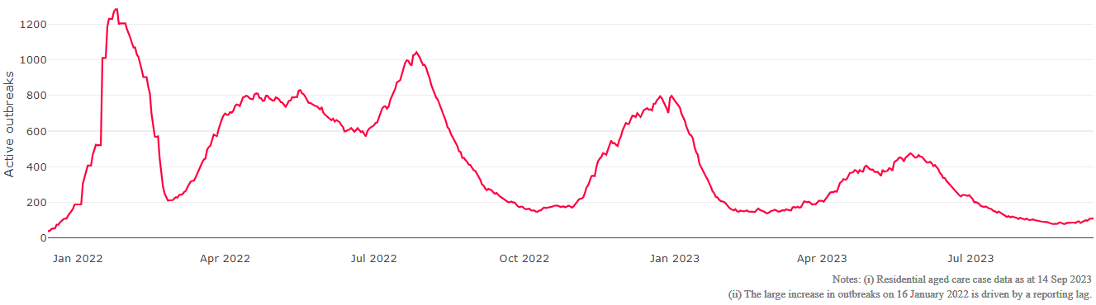

**Figure 2: Trends in Aged Care Cases – December 2021 to Present**

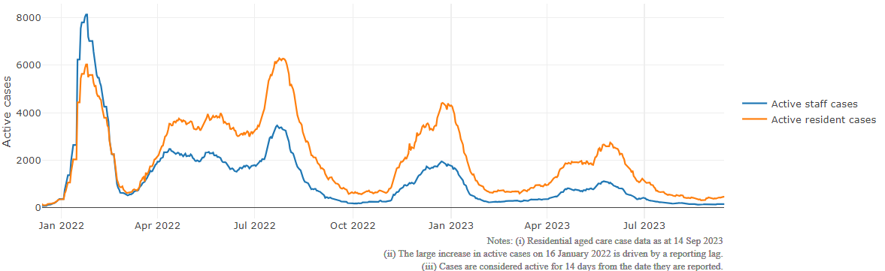

## Mortality

For the period of 1 January 2023 to 8 September 2023, COVID-19 is recorded as the cause of death in 2.8 percent of all deaths in permanent residents in aged care facilities.

Since the beginning of the Omicron outbreak in mid December[5] 2021, there have been 105,423 deaths in residential aged care from all causes (report period from 15 December 2021 to 25 August 2023)[6]. COVID-19 deaths account for 4.7 percent of this figure.

Over the course of the pandemic, all-cause excess mortality in Residential Aged Care was below expected numbers in 2020, and within expected range in 2021.

Figure 3: COVID-19 Deaths in Residential Aged Care Facilities overlaid with Community deaths

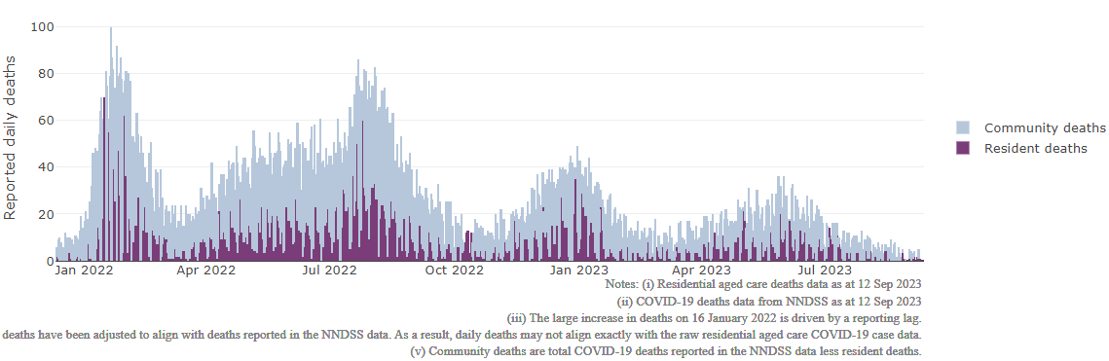

## Workforce in active residential aged care outbreaks

As at 8 September 2023, workforce surge staff have filled a total of 178,709 shifts in aged care services impacted by COVID-19, including 502 in the past 7 days. In the past 7 days (to 15 September) surge workforce providers have assisted 22 residential aged care homes. These shifts include roles for GPs, nurses, care workers, allied health workers, executive and ancillary staff. This includes:

Table 3: Workforce resources supplied to residential aged care facilities

| Workforce provider | Total Shifts | | Previous 7 days | |
| --- | --- | --- | --- | --- |
| Recruitment, Consulting and Staffing Association | 103,852 | 0 | |
| Healthcare Australia (Workforce Surge) | 14,870 | 0 | |
| Healthcare Australia (NACER) | 2,295 | N/A | |
| Mable | 2,711 | N/A | |
| Aspen Medical | 25,373 | 246 | |
| HealthX | 25,552 | 256 | |
| Torrens | 4,056 | N/A | |

The Australian Defence Force provided support to a total of 542 residential aged care homes between February and September 2022. The ADF deployment ceased on 30 September 2022.

## Oral antiviral treatments

Distribution of the oral anti-viral Lagevrio (Molnupiravir) commenced on 6 February 2022 to all RACFs with outbreak sites prioritised for delivery. The National Medical Stockpile has deployed 48,269 treatment courses of Lagevrio (Molnupiravir) to aged care facilities.

77,154 prescriptions for Lagevrio (Molnupiravir) have been issued to residents in residential aged care facilities, with a further 6,367 prescriptions for Paxlovid (nirmatrelvir + ritonavir) also issued since 28 February 2022 and up to 10 September 2023.

## Vaccination in Residential Aged Care Facilities

People living in residential aged care are a high priority for the Government’s COVID-19 vaccination program.

On 1 September 2023, the Australian Government accepted advice from the Australian Technical Advisory Group on Immunisation (ATAGI) on an additional dose for highest risk people in 2023.

ATAGI **recommends** that all adults aged 75+ should receive an additional 2023 COVID-19 vaccine dose if 6 months have passed since their last dose.

ATAGI advised that the following groups should **consider** an additional 2023 COVID-19 vaccine dose if 6 months have passed since their last dose, after discussion with their healthcare provider:

* all adults aged 65 to 74 years and
* adults aged 18 to 64 years with [severe immunocompromise](https://www.health.gov.au/news/atagi-statement-on-the-use-of-a-3rd-primary-dose-of-covid-19-vaccine-in-individuals-who-are-severely-immunocompromised?language=en).

Additionally, all aged care residents who have not already received a booster dose in 2023 are advised to do so.

Older age remains the biggest risk factor for severe COVID-19 disease. Vaccination offers added protection to help reduce the risk of severe illness or hospitalisation of aged care residents.

The department is working with both the aged care and primary care sectors to ensure everyone has access to the COVID-19 vaccine. It continues to support residential aged care facilities to arrange COVID-19 vaccination in-reach support with local primary care providers such as GPs, community pharmacists and Aboriginal Community Controlled Health Services.

As at 13 September 2023:

* 98,153 (57.5%) aged care residents received a booster dose in the last 6 months.
* 863 aged care residents received a booster dose in the last week.

In September 2023, eligibility for a 2023 COVID-19 booster for aged care residents expanded to include residents who may have had a COVID-19 infection in the last six months. As a result of this change, there may be a reduction in the reported % of residents with a 2023 booster, as eligibility for the 2023 booster will no longer exclude residents that have had a recent COVID-19 infection.

While there is minimal benefit from having a COVID-19 vaccine dose too soon after infection, current COVID-19 testing rates have dropped significantly. From a practical perspective it is challenging for many individuals to know if or when they last had an infection.

From September 2023, ATAGI have advised that where previous infection details are unknown, it is appropriate to provide a vaccine to eligible people. This change will make it easier for providers and eligible patients who may be unsure if they have had a recent infection to consider receiving a recommended COVID-19 dose.

**Table 4: Aged care COVID-19 2023 Booster Doses (data as at 13 September 2023)**

| Jurisdiction | Received booster in last 6 months | |
| --- | --- | --- |
| Residents vaccinated | % of residents vaccinated |
| **National** | **98.2k** | **57.5%** |
| ACT | 1.4k | 62.5% |
| NSW | 31.5k | 57.3% |
| NT | <200 | 39.9% |
| QLD | 18.9k | 54.8% |
| SA | 8.7k | 57.9% |
| TAS | 2.7k | 65.8% |
| VIC | 26.6k | 60.3% |
| WA | 8.2k | 53.0% |

Source: Matched Australian Immunisation Register (AIR) data of residents in permanent residential aged care.

Note: The reporting metric was adapted in September 2023 to align with ATAGI’s updated advice.

For reporting accuracy, the total aged care resident population only includes residents who have been linked with their vaccination records. As residential aged care populations are fluid, the total population for vaccination are an estimate only and there is an administrative lag with the aged care recipient data which is linked to AIR data. Counts may fluctuate due to enhancements to data over time.

Key: k= thousand

## Infection control and audit

People living in residential aged care homes remain a high priority for the Government’s COVID-19 vaccination program. The Department is continuing to communicate with both the aged care and primary care sectors, reinforcing the importance of uptake and promoting the 2023 booster dose via regular newsletters, bulletins, social media videos and webinars.

All aged care residents who have not had a COVID-19 vaccination, or a COVID-19 infection within the last 6 months, continue to be offered a 2023 booster dose. The added protection from vaccination is especially important for aged care residents and will help reduce the risk of severe illness or hospitalisation.

The Department continues to work with Primary Health Networks to support residential aged care homes across Australia to arrange COVID-19 vaccination in-reach clinics with local primary care providers such as GPs, pharmacists, and Aboriginal Community Controlled Health Services.

As at 14 September 2023, the Commission had conducted 5,563 ICM spot checks to observe infection control practices and PPE protocols in residential aged care facilities.

Table 5: Total Quality Assessment and Monitoring Activities with residential services (including IPC), by type and month 1 March 2020 to 14 September 2023

|  |  |  |  |  |  |  |
| --- | --- | --- | --- | --- | --- | --- |
| Regulatory Activities | 2019-20 (1 Mar - 30 Jun 2020) | 2020-21 | 2021-22 | 2022-23 | 2023-24  (to 14 Sep) | Total |
| ****Site visits**** | 318 | 3,452 | 1,732 | 3,815 | 830 | 10,147 |
| ****Non-site activities**** | 3,709 | 8,382 | 6,665 | 1,411 | 90 | 20,257 |
| Total activities | **4,027** | **11,834** | **8,397** | **5,226** | **920** | **30,404** |

# Appendix 1: National residential aged care services with Active outbreaks COVID-19

Please note, information reported in this table has been directly reported to the Department of Health and Aged Care by residential aged care facilities. Total cases refers to all staff and resident cases associated with the active outbreak and may not reflect the count of currently active cases. Where numbers have been incorrectly reported, facilities are able to correct these in the COVID-19 Support Portal through My Aged Care. Where a facility is reporting less than six resident or staff cases or less than six deaths, data has been suppressed to protect the privacy of affected individuals (note that “n/p” indicates data is not provided to protect privacy).

| Service Name | State | Resident Deaths | Resident Cases | Staff Cases | Total Incidents |
| --- | --- | --- | --- | --- | --- |
| Goodwin Monash | Australian Capital Territory | 0 | 17 | 6 | 23 |
| Jindalee Aged Care Residence | Australian Capital Territory | 0 | 11 | <6 | n/p |
| Pines Living | Australian Capital Territory | 0 | <6 | 0 | <6 |
| Anthem | New South Wales | 0 | 6 | <6 | n/p |
| Archbold House Aged Care Facility | New South Wales | 0 | 9 | <6 | n/p |
| Australian Vietnamese Aged Care Services | New South Wales | 0 | 12 | <6 | n/p |
| Berkeley Vale Care Community | New South Wales | 0 | <6 | <6 | <6 |
| Bernard Chan Nursing Home | New South Wales | 0 | <6 | <6 | <6 |
| Buckland | New South Wales | 0 | 60 | 29 | 89 |
| Bupa Armidale | New South Wales | 0 | <6 | 0 | <6 |
| Calvary Henley Manor | New South Wales | 0 | <6 | <6 | 6 |
| Casa Mia Aged Care Centre | New South Wales | 0 | 9 | 0 | 9 |
| CASS Residential Aged Care Facility | New South Wales | 0 | 0 | <6 | <6 |
| Catholic Healthcare Percy Miles Villa | New South Wales | <6 | 10 | <6 | n/p |
| Catholic Healthcare St Francis Aged Care | New South Wales | 0 | <6 | 0 | <6 |
| Constitution Hill Aged Care | New South Wales | 0 | <6 | 0 | <6 |
| Cooinda | New South Wales | 0 | <6 | <6 | 7 |
| Dubbo Homestead Care Community | New South Wales | 0 | <6 | 0 | <6 |
| Estia Health Camden | New South Wales | 0 | 14 | 10 | 24 |
| Estia Health Manly Vale | New South Wales | 0 | <6 | <6 | <6 |
| Hunters Hill Montefiore Home | New South Wales | 0 | 0 | <6 | <6 |
| Mary Potter Nursing Home | New South Wales | 0 | <6 | <6 | 6 |
| Moran Stockton | New South Wales | 0 | 13 | 7 | 20 |
| Randwick Montefiore Home | New South Wales | 0 | 15 | <6 | n/p |
| RFBI Moonbi Masonic Village - Jim Holm | New South Wales | 0 | <6 | <6 | <6 |
| St Basil's Nursing Home | New South Wales | 0 | <6 | <6 | <6 |
| St Vincent's Care Services Edgecliff | New South Wales | 0 | <6 | 0 | <6 |
| The Manor Fairfield East | New South Wales | <6 | 53 | 23 | 76 |
| Uniting Arrunga Ermington | New South Wales | 0 | 8 | <6 | n/p |
| Uniting Narla Belmont North | New South Wales | 0 | <6 | 0 | <6 |
| Wahroonga House | New South Wales | 0 | 6 | 0 | 6 |
| Hetti Perkins | Northern Territory | 0 | 17 | 14 | 31 |
| BallyCara Aged Care | Queensland | 0 | <6 | 0 | <6 |
| Benevolent Living | Queensland | 0 | <6 | <6 | <6 |
| Bolton Clarke Carrington | Queensland | 0 | <6 | 0 | <6 |
| Brookfield Green | Queensland | 0 | 7 | 0 | 7 |
| Infinite Care Mount Lofty | Queensland | 0 | 0 | <6 | <6 |
| Jimboomba Community Aged Care | Queensland | 0 | <6 | 0 | <6 |
| Lutheran Services - Trinder Park | Queensland | <6 | 48 | 7 | 55 |
| Portofino Hamilton | Queensland | 0 | <6 | 0 | <6 |
| Pyramid Residential Care Centre | Queensland | 0 | <6 | 0 | <6 |
| Sandbrook Assisted Aged Care | Queensland | 0 | <6 | <6 | <6 |
| The Good Shepherd Nursing Home | Queensland | 0 | 0 | <6 | <6 |
| TriCare Bayview Place Aged Care Residence | Queensland | 0 | 6 | <6 | n/p |
| Woodford Manor Aged Care | Queensland | 0 | <6 | 0 | <6 |
| Barossa Valley Nursing Home | South Australia | 0 | 8 | 12 | 20 |
| Boandik Kessal | South Australia | 0 | 6 | <6 | n/p |
| Eldercare Allambi | South Australia | 0 | 6 | <6 | n/p |
| Estia Health Golden Grove | South Australia | 0 | <6 | 0 | <6 |
| Estia Health Kensington Gardens | South Australia | 0 | <6 | 0 | <6 |
| Estia Health Lockleys | South Australia | 0 | 26 | <6 | n/p |
| Estia Health Parkside | South Australia | 0 | <6 | 0 | <6 |
| Helping Hand Aged Care - Mawson Lakes Facility | South Australia | 0 | <6 | <6 | 6 |
| Oakfield Lodge Residential Care | South Australia | 0 | <6 | 0 | <6 |
| Port Pirie Regional Health Service - Hammill House | South Australia | 0 | <6 | 0 | <6 |
| Resthaven Marion | South Australia | 0 | <6 | 0 | <6 |
| Resthaven Westbourne Park | South Australia | 0 | <6 | 0 | <6 |
| St Basil's at St Peters | South Australia | 0 | <6 | 0 | <6 |
| The Philip Kennedy Centre Residential Care | South Australia | 0 | <6 | 0 | <6 |
| The Pines Lodge Residential Care | South Australia | 0 | <6 | <6 | <6 |
| Barossa Park Lodge | Tasmania | 0 | 12 | 6 | 18 |
| Glenview Community Services Inc. | Tasmania | 0 | 20 | <6 | n/p |
| The Queen Victoria Home | Tasmania | 0 | <6 | 0 | <6 |
| Arcare Maidstone | Victoria | 0 | 7 | <6 | n/p |
| Baptcare - Strathalan Community | Victoria | 0 | <6 | 0 | <6 |
| BlueCross Grossard Court | Victoria | 0 | 7 | <6 | n/p |
| Bupa Echuca | Victoria | 0 | 9 | 9 | 18 |
| Calvary Barongarook Gardens | Victoria | 0 | <6 | 0 | <6 |
| Calvary Huntly Suites | Victoria | 0 | <6 | <6 | <6 |
| Carinya Nursing Home (Frankston Extended Care) | Victoria | 0 | 7 | <6 | n/p |
| Chirnside Views | Victoria | 0 | <6 | 0 | <6 |
| Cooinda Village Inc | Victoria | 0 | 9 | <6 | n/p |
| Craigcare Moonee Ponds | Victoria | 0 | <6 | 0 | <6 |
| Dianella Hostel | Victoria | 0 | 7 | <6 | n/p |
| Drysdale Grove | Victoria | 0 | 46 | 20 | 66 |
| Embracia Moonee Valley | Victoria | 0 | <6 | 0 | <6 |
| Estia Health Bannockburn | Victoria | 0 | <6 | 0 | <6 |
| Eva Tilley Memorial Hostel | Victoria | 0 | 7 | 0 | 7 |
| Glendale Aged Care | Victoria | 0 | <6 | <6 | 7 |
| Golden Oaks Nursing Home | Victoria | 0 | <6 | 0 | <6 |
| Heritage Northcote | Victoria | 0 | 18 | <6 | n/p |
| Hope Aged Care Brunswick | Victoria | <6 | 28 | <6 | n/p |
| John Curtin Aged Care | Victoria | 0 | <6 | 0 | <6 |
| Kara Court Nursing Home | Victoria | 0 | <6 | <6 | <6 |
| Kirkbrae Kilsyth Nursing Home | Victoria | 0 | <6 | <6 | <6 |
| Lorne Nursing Home | Victoria | <6 | 13 | <6 | n/p |
| Lynden Aged Care | Victoria | 0 | <6 | 0 | <6 |
| Mercy Place Rice Village | Victoria | 0 | 26 | 8 | 34 |
| Mount Martha Valley | Victoria | 0 | 14 | <6 | n/p |
| Nellie Melba Retirement Village | Victoria | 0 | 18 | 8 | 26 |
| Regis Inala Lodge | Victoria | 0 | <6 | <6 | <6 |
| Sea Views Manor | Victoria | 0 | <6 | 0 | <6 |
| Somerville Gardens Care Community | Victoria | 0 | <6 | 0 | <6 |
| Templestowe Grove Care Community | Victoria | 0 | <6 | <6 | 9 |
| The Bays Aged Care Facility | Victoria | 0 | <6 | 0 | <6 |
| The Oaks Nursing Home-Gisborne | Victoria | 0 | 7 | <6 | n/p |
| Uniting AgeWell Strath-Haven | Victoria | 0 | <6 | <6 | <6 |
| Villa Maria Catholic Homes St Bernadette's Aged Care Residence | Victoria | 0 | 18 | <6 | n/p |
| Villa Maria Catholic Homes St Catherine's Aged Care Residence | Victoria | 0 | <6 | 0 | <6 |
| Villa Maria Catholic Homes Wantirna Aged Care Residence | Victoria | <6 | 36 | 10 | 46 |
| Wintringham Eunice Seddon Home | Victoria | 0 | 6 | <6 | n/p |
| Aegis Amherst | Western Australia | 0 | 9 | 0 | 9 |
| Geegeelup Aged Care Facility | Western Australia | 0 | 0 | <6 | <6 |
| Little Sisters of the Poor Glendalough Home | Western Australia | 0 | 0 | <6 | <6 |
| Melville Parkside Care Community | Western Australia | 0 | 27 | <6 | n/p |
| Merredin MPS | Western Australia | 0 | 0 | <6 | <6 |
| Wearne Home | Western Australia | 0 | 16 | <6 | n/p |

1. Outbreak opening and closure includes changes in the status of exposure sites to outbreaks (and vice versa), which are applied retrospectively to facility records. New case information can also change the status of a recovered site back to an active outbreak site. As a result, changes in active outbreak status may not align with day on day variations to active totals. These adjustments will also affect the number of cases in staff and residents reported each week.
2. Active residents and staff cases are the total currently positive cases in active outbreaks
3. An outbreak is considered to be active pending advice from the relevant Public Health Unit. An outbreak is defined as at least 1 positive case in a resident or 2+ cases in staff.
4. Case numbers and numbers of deaths are dependent upon reporting from facilities and validation of deaths from state and territory governments. This is subject to change as further information is provided.
5. The Omicron outbreak start date has been redefined from late November 2021 to mid December 2021. Changes have been made to align reporting with the start date of Omicron published in the Department’s external facing Epidemiology report.
6. The Department is now accessing aged care deaths data from the SIEBEL dataset. Figures are live and subject to change. Source: Department of Health and Aged Care unpublished data / SIEBEL dataset.