COVID-19 outbreaks in Australian residential aged care facilities

# National snapshot

As at 8:00 am 31 August 2023 there are 586 active COVID-19 cases in 88 active outbreaks in residential aged care facilities across Australia. There have been 45 new outbreaks, 4 new resident deaths and 562 combined new resident and staff cases reported since 24 August 2023.

Table : Aged Care COVID-19 data as at 8.00am 31 August 2023[1]

| Category | Active*[2]* | Previous  7 days | Cumulative  Total | Previous 7 days |
| --- | --- | --- | --- | --- |
| Outbreaks[3] | 88 | 9 | 16,096 | 45 |
| Residential Aged Care Facilities affected | 88 | 9 | 2,837 | 2 |
| Resident Cases[4] | 434 | 120 | 157,384 | 419 |
| Resident Deaths | N/A | N/A | 5,856 | 4 |
| Staff Cases | 152 | 18 | 91,549 | 143 |

Residential aged care homes with active outbreaks are included in Appendix 1.

**Table 2: Overview of Active Outbreaks in Australia**

|  |  |  |  |  |  |  |  |  |  |
| --- | --- | --- | --- | --- | --- | --- | --- | --- | --- |
|  | ACT | NSW | NT | QLD | SA | TAS | VIC | WA | Total |
| Total Facilities with outbreaks | 3 | 30 | 0 | 18 | 7 | 4 | 22 | 4 | 88 |
| *Total number of active resident cases* | 13 | 140 | 0 | 60 | 31 | 17 | 152 | 21 | 434 |
| *Total number of active staff cases* | 1 | 63 | 0 | 28 | 15 | 9 | 33 | 3 | 152 |
| Total Outbreaks Opened in Previous 7 Days | 2 | 15 | 0 | 6 | 4 | 3 | 12 | 3 | 45 |
| Total Outbreaks Closed in Previous 7 Days | 0 | 10 | 0 | 8 | 1 | 1 | 12 | 4 | 36 |

**Figure 1: National Outbreak Trends in Aged Care**

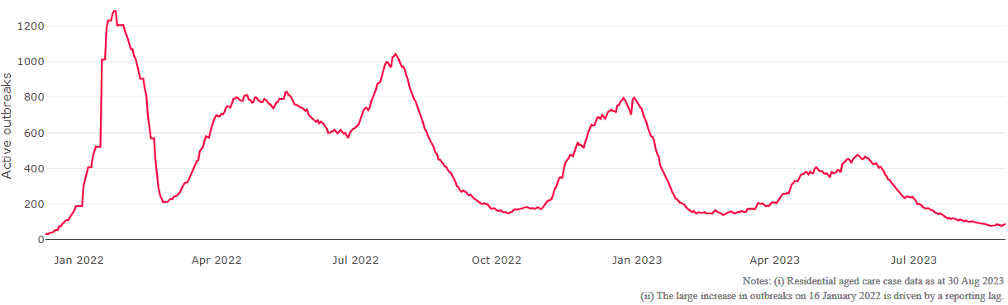

**Figure 2: Trends in Aged Care Cases – December 2021 to Present**

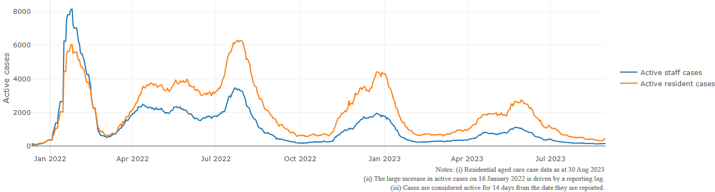

## Mortality

For the period of 1 January 2023 to 25 August 2023, COVID-19 is recorded as the cause of death in 2.9 percent of all deaths in permanent residents in aged care facilities.

Since the beginning of the Omicron outbreak in mid December[5] 2021, there have been 103,198 deaths in residential aged care from all causes (report period from 15 December 2021 to 25 August 2023)[6]. COVID-19 deaths account for 4.8 percent of this figure.

Over the course of the pandemic, all-cause excess mortality in Residential Aged Care was below expected numbers in 2020, and within expected range in 2021.

Figure 3: COVID-19 Deaths in Residential Aged Care Facilities overlaid with Community deaths

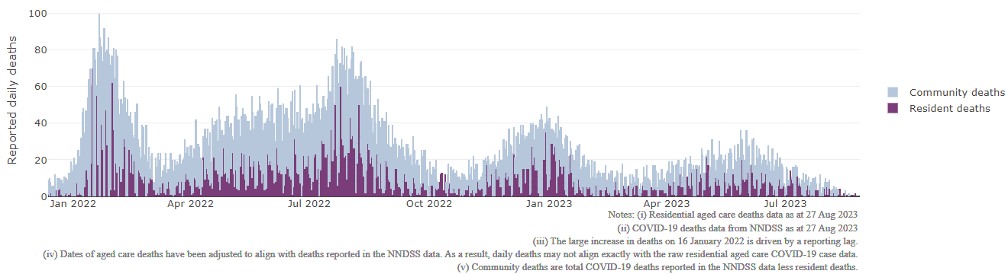

## Workforce in active residential aged care outbreaks

As at 1 September 2023, workforce surge staff have filled a total of 177,834 shifts in aged care services impacted by COVID-19, including 263 in the past 7 days. In the past 7 days (to 1 September) surge workforce providers have assisted 14 residential aged care homes. These shifts include roles for GPs, nurses, care workers, allied health workers, executive and ancillary staff. This includes:

Table 3: Workforce resources supplied to residential aged care facilities

| Workforce provider | Total Shifts | | Previous 7 days | |
| --- | --- | --- | --- | --- |
| Recruitment, Consulting and Staffing Association | 103,852 | 2 | |
| Healthcare Australia (Workforce Surge) | 14,870 | 14 | |
| Healthcare Australia (NACER) | 2,295 | N/A | |
| Mable | 2,711 | N/A | |
| Aspen Medical | 24,994 | 49 | |
| HealthX | 25,056 | 214 | |
| Torrens | 4,056 | N/A | |

The Australian Defence Force provided support to a total of 542 residential aged care homes between February and September 2022. The ADF deployment ceased on 30 September 2022.

## Oral antiviral treatments

Distribution of the oral anti-viral Lagevrio (Molnupiravir) commenced on 6 February 2022 to all RACFs with outbreak sites prioritised for delivery. The National Medical Stockpile has deployed 48,269 treatment courses of Lagevrio (Molnupiravir) to aged care facilities.

76,378 prescriptions for Lagevrio (Molnupiravir) have been issued to residents in residential aged care facilities, with a further 6,268 prescriptions for Paxlovid (nirmatrelvir + ritonavir) also issued since 28 February 2022 and up to 27 August 2023.

## Vaccination in Residential Aged Care Facilities

People living in residential aged care homes remain a high priority for the Government’s COVID-19 vaccination program. The Department is continuing to communicate with both the aged care and primary care sectors, reinforcing the importance of uptake and promoting the 2023 booster dose via regular newsletters, bulletins, social media videos and webinars.

All aged care residents who have not had a COVID-19 vaccination, or a COVID-19 infection within the last 6 months, continue to be offered a 2023 booster dose. The added protection from vaccination is especially important for aged care residents and will help reduce the risk of severe illness or hospitalisation.

The Department continues to work with Primary Health Networks to support residential aged care homes across Australia to arrange COVID-19 vaccination in-reach clinics with local primary care providers such as GPs, community pharmacists, and Aboriginal Community Controlled Health Services.

As at 30 August 2023:

* of those aged care residents who have been eligible for a booster dose since January 2023, 101,703 (67.6%)eligible residents have received a 2023 booster dose. This is an additional 1,273 residents since last week.
  + Eligibility for the vaccine under current settings is fluid, with people becoming eligible as they reach 6 months after a COVID-19 infection. This means that aged care residents who are now eligible may have only recently become eligible.
* 99% of residential aged care homes are recording residents vaccinated with the 2023 booster.
* 115,598 (62.6%) residents are estimated to have had a recent immunising event of a vaccine dose (including the 2023 booster), or COVID-19 infection in the last 6 months and are therefore not currently eligible for a 2023 booster dose.

The estimated eligible population is made up of residents who have completed their COVID-19 primary course and had their last COVID-19 vaccine dose or infection more than 6 months ago. As residential aged care populations are fluid, and case overlay is not exact, eligible populations for vaccination are an estimate only.

**Table 4: Aged Care COVID-19 2023 Booster Doses (data as at 30 August 2023)**

| Jurisdiction | % of estimated eligible residents vaccinated | Residents vaccinated |
| --- | --- | --- |
| National | 67.6% | 101,703 |
| ACT | 76.1% | 1,503 |
| NSW | 67.9% | 32,622 |
| NT | 49.1% | <200 |
| QLD | 63.9% | 19,345 |
| SA | 68.0 % | 8,985 |
| TAS | 77.3% | 2,836 |
| VIC | 70.7% | 27,966 |
| WA | 62.0% | 8,257 |

Source: Matched AIR data of residents in permanent residential aged care facilities.

## Infection control and audit

People living in residential aged care homes remain a high priority for the Government’s COVID-19 vaccination program. The Department is continuing to communicate with both the aged care and primary care sectors, reinforcing the importance of uptake and promoting the 2023 booster dose via regular newsletters, bulletins, social media videos and webinars.

All aged care residents who have not had a COVID-19 vaccination, or a COVID-19 infection within the last 6 months, continue to be offered a 2023 booster dose. The added protection from vaccination is especially important for aged care residents and will help reduce the risk of severe illness or hospitalisation.

The Department continues to work with Primary Health Networks to support residential aged care homes across Australia to arrange COVID-19 vaccination in-reach clinics with local primary care providers such as GPs, pharmacists, and Aboriginal Community Controlled Health Services.

As at 31 August 2023, the Commission had conducted 5,278 ICM spot checks to observe infection control practices and PPE protocols in residential aged care facilities.

Table 5: Total Quality Assessment and Monitoring Activities with residential services (including IPC), by type and month 1 March 2020 to 31 August 2023

|  |  |  |  |  |  |  |
| --- | --- | --- | --- | --- | --- | --- |
| Regulatory Activities | 2019-20 (1 Mar - 30 Jun 2020) | 2020-21 | 2021-22 | 2022-23 | 2023-24  (to 31 Aug) | Total |
| ****Site visits**** | 318 | 3,452 | 1,732 | 3,687 | 540 | 9,729 |
| ****Non-site activities**** | 3,709 | 8,382 | 6,665 | 1,412 | 72 | 20,240 |
| Total activities | **4,027** | **11,834** | **8,397** | **5,099** | **612** | **29,969** |

# Appendix 1: National residential aged care services with Active outbreaks COVID-19

Please note, information reported in this table has been directly reported to the Department of Health and Aged Care by residential aged care facilities. Total cases refers to all staff and resident cases associated with the active outbreak and may not reflect the count of currently active cases. Where numbers have been incorrectly reported, facilities are able to correct these in the COVID-19 Support Portal through My Aged Care. Where a facility is reporting less than six resident or staff cases or less than six deaths, data has been suppressed to protect the privacy of affected individuals (note that “n/p” indicates data is not provided to protect privacy).

| Service Name | State | Resident Deaths | Resident Cases | Staff Cases | Total Incidents |
| --- | --- | --- | --- | --- | --- |
| Bill McKenzie Gardens | Australian Capital Territory | 0 | <6 | 0 | <6 |
| Goodwin Monash | Australian Capital Territory | 0 | <6 | <6 | <6 |
| Jindalee Aged Care Residence | Australian Capital Territory | 0 | 8 | <6 | n/p |
| Ainslie House | New South Wales | <6 | 9 | 11 | 20 |
| Aurrum Erina | New South Wales | 0 | <6 | <6 | <6 |
| Buckland | New South Wales | 0 | 41 | 23 | 64 |
| Bupa Kempsey | New South Wales | 0 | <6 | <6 | <6 |
| Calvary St Francis Retirement Community | New South Wales | 0 | 10 | <6 | n/p |
| Catholic Healthcare Holy Spirit Casula | New South Wales | 0 | 8 | <6 | n/p |
| Catholic Healthcare Percy Miles Villa | New South Wales | 0 | 8 | <6 | n/p |
| Emmaville Multi-Purpose Service | New South Wales | 0 | <6 | 0 | <6 |
| Estia Health Albury | New South Wales | 0 | <6 | <6 | <6 |
| Estia Health Bexley Park | New South Wales | 0 | <6 | 0 | <6 |
| Estia Health Merrylands | New South Wales | 0 | <6 | 0 | <6 |
| Estia Health Tuncurry | New South Wales | 0 | <6 | <6 | <6 |
| Gillawarna Village | New South Wales | 0 | 18 | <6 | n/p |
| HammondCare Mason | New South Wales | 0 | <6 | 0 | <6 |
| Heritage Pennant Hills | New South Wales | 0 | 14 | <6 | n/p |
| Mark Moran at Little Bay | New South Wales | 0 | <6 | 0 | <6 |
| Murrayvale Aged Care | New South Wales | 0 | 16 | <6 | n/p |
| Quakers Hillside Care Community | New South Wales | 0 | <6 | 0 | <6 |
| Randwick Montefiore Home | New South Wales | 0 | <6 | 0 | <6 |
| Regis Port Stephens | New South Wales | 0 | 0 | <6 | <6 |
| Rose Mumbler Village | New South Wales | 0 | <6 | 0 | <6 |
| Tallwoods Corner Aged Care Service | New South Wales | 0 | 30 | <6 | n/p |
| Terrey Hills Nursing Home | New South Wales | 0 | <6 | 0 | <6 |
| The Manor Fairfield East | New South Wales | 0 | 30 | 11 | 41 |
| Uniting Abrina Ashfield | New South Wales | 0 | <6 | <6 | 6 |
| Uniting Elanora Shellharbour | New South Wales | <6 | 24 | <6 | n/p |
| Uniting Kari Court St Ives | New South Wales | 0 | <6 | 0 | <6 |
| Uniting Wesley Heights Manly | New South Wales | 0 | <6 | <6 | <6 |
| Wallsend Aged Care Facility | New South Wales | 0 | <6 | 8 | n/p |
| Warrigal Care Mt Warrigal | New South Wales | 0 | <6 | 0 | <6 |
| Arcare Helensvale St James | Queensland | 0 | 9 | <6 | n/p |
| Arcare Logan Reserve | Queensland | 0 | <6 | <6 | <6 |
| Arcare North Lakes | Queensland | 0 | 20 | <6 | n/p |
| Arcare North Shore | Queensland | 0 | <6 | <6 | <6 |
| Ashmore Gardens Care Community | Queensland | 0 | 27 | 7 | 34 |
| Berrinba Greens Care Community | Queensland | 0 | 7 | <6 | n/p |
| Bribie Cove | Queensland | 0 | 6 | <6 | n/p |
| Calvary Noosa | Queensland | 0 | <6 | 0 | <6 |
| Churches of Christ Golden Age Aged Care Service | Queensland | 0 | <6 | <6 | <6 |
| Estia Health Gold Coast | Queensland | 0 | <6 | <6 | <6 |
| Estia Health Pacific Paradise | Queensland | 0 | <6 | <6 | <6 |
| Jeta Gardens Aged Care Facility | Queensland | 0 | 13 | <6 | n/p |
| Lutheran Services - Trinder Park | Queensland | 0 | 29 | 7 | 36 |
| Nambour Gardens Care Community | Queensland | 0 | 21 | 9 | 30 |
| Regis Bulimba | Queensland | 0 | 0 | <6 | <6 |
| Regis Greenbank | Queensland | 0 | 7 | 0 | 7 |
| Torbay | Queensland | 0 | <6 | <6 | 6 |
| Villa Maria Centre | Queensland | 0 | <6 | 0 | <6 |
| Barossa Valley Nursing Home | South Australia | 0 | <6 | 8 | n/p |
| Eldercare Seaford | South Australia | 0 | <6 | 0 | <6 |
| Eldercare The Village | South Australia | 0 | 12 | 8 | 20 |
| Estia Health Flagstaff Hill | South Australia | 0 | <6 | 0 | <6 |
| Estia Health Lockleys | South Australia | 0 | 23 | <6 | n/p |
| Fullarton Lutheran Homes | South Australia | 0 | <6 | 0 | <6 |
| St Basil's at Croydon Park | South Australia | 0 | <6 | 0 | <6 |
| Barossa Park Lodge | Tasmania | 0 | 10 | <6 | n/p |
| Hawthorn Village | Tasmania | 0 | 10 | 9 | 19 |
| Regis Tasmania - Eastern Shore | Tasmania | 0 | <6 | <6 | <6 |
| Toosey Aged and Community Care | Tasmania | 0 | <6 | 0 | <6 |
| Arpad Aged Care | Victoria | 0 | <6 | 0 | <6 |
| Bethel Aged Care | Victoria | 0 | 35 | 7 | 42 |
| Calvary Elouera | Victoria | 0 | <6 | 0 | <6 |
| Casey Aged Care | Victoria | 0 | 13 | <6 | n/p |
| Dianella Hostel | Victoria | 0 | 7 | <6 | n/p |
| Drysdale Grove | Victoria | 0 | 38 | 12 | 50 |
| Hope Aged Care Brunswick | Victoria | 0 | 14 | <6 | n/p |
| Iona Digby Harris Home | Victoria | 0 | <6 | <6 | <6 |
| James Barker House | Victoria | 0 | <6 | 0 | <6 |
| Keilor East Manor Care Community | Victoria | 0 | <6 | 0 | <6 |
| Luson Bloom | Victoria | 0 | <6 | <6 | <6 |
| Mercy Place Nixon | Victoria | 0 | <6 | 0 | <6 |
| Mercy Place Rice Village | Victoria | 0 | 12 | <6 | n/p |
| Monash Gardens | Victoria | 0 | 14 | 0 | 14 |
| Nellie Melba Retirement Village | Victoria | 0 | 17 | 8 | 25 |
| Otway Health Multi-Purpose Service | Victoria | 0 | <6 | <6 | <6 |
| Parkdale Aged Care | Victoria | 0 | <6 | <6 | 7 |
| Swan Hill District (Nyah Campus) | Victoria | 0 | <6 | <6 | <6 |
| Swan Hill District Nursing Home | Victoria | 0 | <6 | <6 | <6 |
| Twin Parks Aged Care Centre | Victoria | <6 | 17 | <6 | n/p |
| Villa Maria Catholic Homes Wantirna Aged Care Residence | Victoria | 0 | 17 | <6 | n/p |
| Weary Dunlop Retirement Village | Victoria | 0 | <6 | 0 | <6 |
| Bethanie Fields | Western Australia | 0 | 9 | <6 | n/p |
| Fairhaven | Western Australia | 0 | <6 | 0 | <6 |
| Nazareth House Geraldton | Western Australia | 0 | 6 | <6 | n/p |
| Wearne Home | Western Australia | 0 | 8 | <6 | n/p |

1. Outbreak opening and closure includes changes in the status of exposure sites to outbreaks (and vice versa), which are applied retrospectively to facility records. New case information can also change the status of a recovered site back to an active outbreak site. As a result, changes in active outbreak status may not align with day on day variations to active totals. These adjustments will also affect the number of cases in staff and residents reported each week.
2. Active residents and staff cases are the total currently positive cases in active outbreaks
3. An outbreak is considered to be active pending advice from the relevant Public Health Unit. An outbreak is defined as at least 1 positive case in a resident or 2+ cases in staff.
4. Case numbers and numbers of deaths are dependent upon reporting from facilities and validation of deaths from state and territory governments. This is subject to change as further information is provided.
5. The Omicron outbreak start date has been redefined from late November 2021 to mid December 2021. Changes have been made to align reporting with the start date of Omicron published in the Department’s external facing Epidemiology report.
6. The Department is now accessing aged care deaths data from the SIEBEL dataset. Figures are live and subject to change. Source: Department of Health and Aged Care unpublished data / SIEBEL dataset.