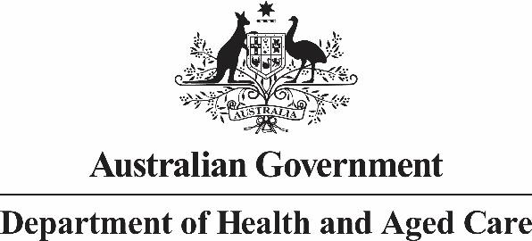

Allied Health Industry Reference Group

Meeting Seven: 26 July 2023 Summary of Outcomes

The Australian Government Chief Allied Health Officer (CAHO) convened the seventh Allied Health Industry Reference Group (AHIRG) meeting on 26 July 2023. This meeting was convened out of session to enable members to complete discussions on agenda items from the previous meeting on 7 June 2023.

Topics discussed:

* Allied health work-based learning placements
  + Associate Professor Gillian Nisbet presented a study on the positive impacts of allied health student clinical placements on quality of care in hospital settings.
  + Members discussed opportunities to expand work-based learning placements to settings outside of the hospital sector and the potential benefits of national guiding principles.
* A Better Culture Project
  + Dr Jillian Farmer outlined the Australian Government funded project, which is investigating workplace culture and ways of improving workplace experiences for medical professions.
* Guidance for allied health professionals on delegating to and supervision of Allied Health Assistants.
* Launch of Jobs and Skills Councils
  + The department advised members that HumanAbility is the new Jobs and Skills Council created for the health and community services sector.
  + HumanAbility will develop qualifications and training packages, including for AHAs.

Next Steps:

1. The department will support further liaison between the university sector and members on expanding work-based learning placements to settings outside the hospital sector.
2. Members will send any relevant data or information on allied health workplace culture to Dr Farmer.
3. The department will continue to discuss the use of AHAs with the National Allied Health Advisors and Chief Officers (NAHAC) and look to holding a joint meeting between NAHAC and the AHIRG in the future.
4. The department will seek input from members to inform a future meeting with HumanAbility.
5. The department will seek agenda nominations for the next AHIRG meeting, which will be held in September 2023.