# 

# Information kit

# National Women’s Health Advisory Council

# #EndGenderBias survey

# July 2023

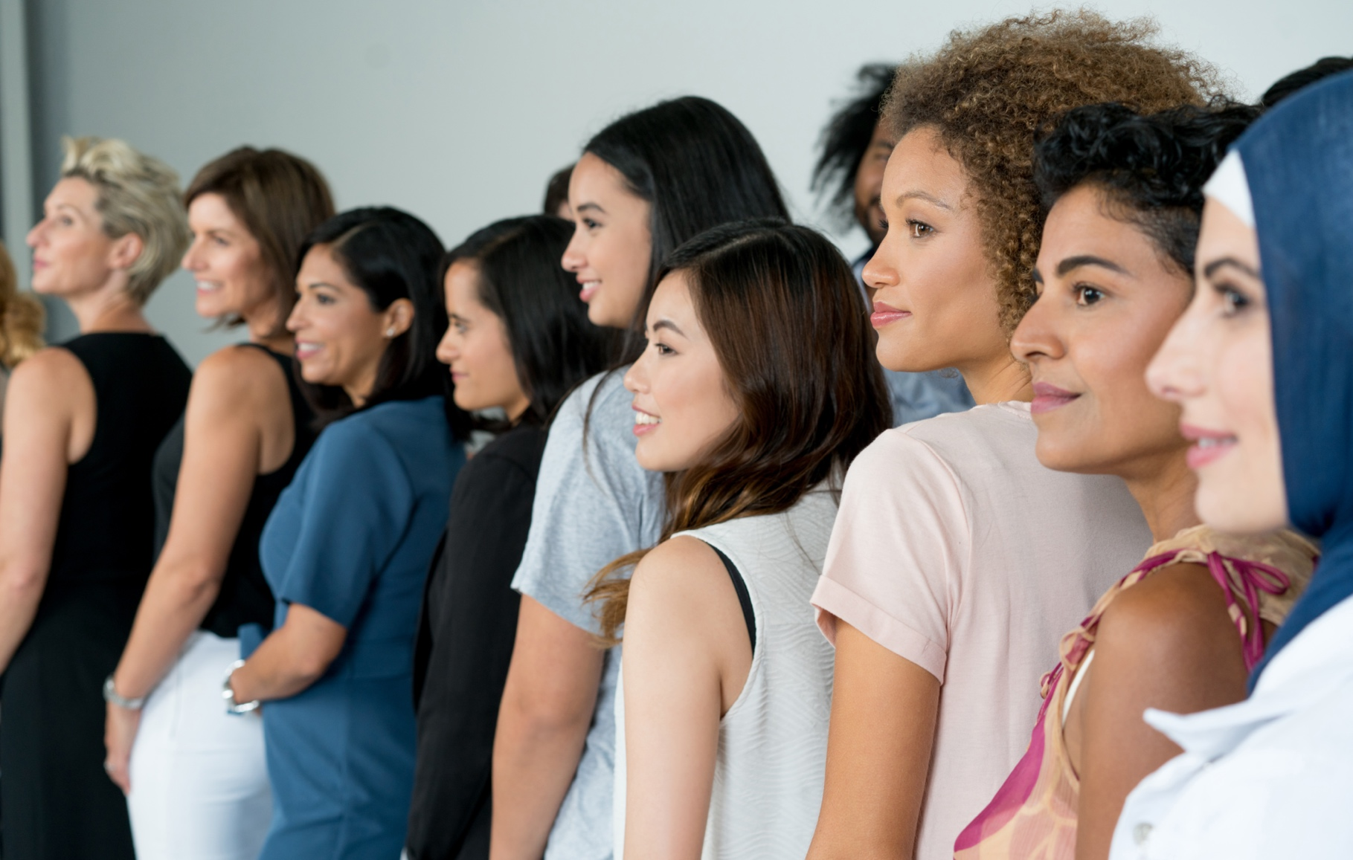

# Information kit

#### Introduction

The National Women’s Health Advisory Council provides the Australian Government with advice and recommendations to improve health outcomes for women and girls in Australia.

Through the Department of Health and Aged Care, the Council has launched the #EndGenderBias survey to better understand the barriers and bias that women face in Australia’s health system. The online survey is open to:

* adult women and caregivers of women and girls with personal experience of gender bias in Australia’s healthcare system
* experts such as academics and health professionals who can share their perspective on barriers and bias that women and girls experience in Australia’s healthcare system.

The views of the following priority populations are specifically sought:

* First Nations women
* lesbian, bisexual, transgender, intersex and queer people
* culturally and linguistically diverse people
* people from lower socio-economic households
* people from regional and remote communities
* people with a lived experience of disability.

Responses can remain anonymous and are submitted online via text, video or audio recordings.

It is anticipated that the survey will be open from 19 July until 13 October 2023 and can be accessed here.

#### How to use this kit

Council members, stakeholder organisations, consumer groups, academia, and medical and professional bodies are invited to share information and encourage survey participation by actively:

* publishing social media posts (see example content below)
* including an article in newsletters and/or on websites (see example content below)
* displaying resources such as a poster (see example below)
* directing stakeholders to the [health.gov.au/womens-health-advisory-council](http://www.health.gov.au/womens-health-advisory-council#_blank) to learn more.

#### Further information

For queries about the resources in this kit please contact [campaigns@health.gov.au](mailto:campaigns@health.gov.au).

# Newsletter article

The article below can be adapted and published on your website and/or newsletter.

***Have your say on #EndGenderBias in Australia’s healthcare system***

The National Women’s Health Advisory Council was stood-up earlier this year to provide advice to the Australian Government on ways to improve health outcomes for women and girls. They are now calling on women, girls and people assigned female at birth to share their experiences in a #EndGenderBias survey. Expertise and feedback from healthcare professionals and experts is also sought.

Chaired by the Assistant Minister for Health and Aged Care, the Hon Ged Kearney MP, the Council brings together some of the nation’s most eminent women’s health experts along with representatives from a mix of peak stakeholder organisations, consumer groups, and medical and professional bodies - including the voice of women with lived experience.

There are unique challenges that women and girls face in Australia’s healthcare system, which lead to poorer health outcomes - from delayed diagnosis, overprescribing, dismissal of pain and more.

*“In Australia no one should fall through the cracks when it comes to safe, high quality and affordable healthcare,”* says Assistant Minister Kearney.

*“It is completely unacceptable that a young girl suffers ADHD symptoms without diagnosis for potentially years longer than a boy her age. Or a woman has her crippling pelvic pain repeatedly dismissed, only to find severe endometriosis.”*

The Council is especially interested in hearing the views of priority populations, including First Nations women, culturally and linguistically diverse communities, lesbian, bisexual, transgender, intersex and queer people, people from regional and remote communities, and people with a lived experience of disability.

**Complete (or share) the survey today:**

If you (or someone you care for) have experienced access barriers or gender bias as a woman in Australia’s healthcare system, you are invited to share your experiences and complete the survey by 13 October 2023 to help #EndGenderBias.

Visit [health.gov.au/womens-health-advisory-council](http://www.health.gov.au/womens-health-advisory-council#_blank) to access the survey and learn more about the National Women’s Health Advisory Council.

# Social posts

The posts and image tiles below can be published on your preferred social channels.

|  |  |
| --- | --- |
| Post | Image |
| **For community:**  Have you had issues with the quality of your healthcare because of your gender? The National Women’s Health Advisory Council wants to hear from you.  Share your experiences by completing this survey today: [health.gov.au/womens-health-advisory-council](http://www.health.gov.au/womens-health-advisory-council#_blank)  #WomensHealthMatters #EndGenderBias #GenderHealthEquity #EmpowerHerHealth #WithWomenForWomen |  |
| Have you or someone you care for been unfairly treated as a woman in Australia’s healthcare system?  Be part of the solution and complete the #EndGenderBias survey from the National Women’s Health Advisory Council. Learn more: [health.gov.au/womens-health-advisory-council](http://www.health.gov.au/womens-health-advisory-council#_blank)  #WomensHealthMatters #EndGenderBias #GenderHealthEquity #EmpowerHerHealth #WithWomenForWomen |  |
| **For industry:**  The National Women’s Health Advisory Council wants to hear from academics and health professionals who can share their perspective on barriers and bias that women and girls experience in Australia’s healthcare system.  Share your experiences by completing the #EndGenderBias survey today: [health.gov.au/womens-health-advisory-council](http://www.health.gov.au/womens-health-advisory-council#_blank)  #WomensHealthMatters #EndGenderBias #GenderHealthEquity #EmpowerHerHealth #WithWomenForWomen |  |
| Have you or someone you care for been unfairly treated as a woman in Australia’s healthcare system?  Be part of the solution and complete the #EndGenderBias survey from the National Women’s Health Advisory Council. Learn more: [health.gov.au/womens-health-advisory-council](http://www.health.gov.au/womens-health-advisory-council#_blank)  #WomensHealthMatters #EndGenderBias #GenderHealthEquity #EmpowerHerHealth #WithWomenForWomen |  |
| As a young woman in Australia, do you feel your gender has led to difficulties accessing healthcare?  Be part of the solution and complete the #EndGenderBias survey from the National Women’s Health Advisory Council. Learn more: [health.gov.au/womens-health-advisory-council](http://www.health.gov.au/womens-health-advisory-council#_blank)  #WomensHealthMatters #EndGenderBias #GenderHealthEquity #EmpowerHerHealth #WithWomenForWomen |  |

# Poster

[Download](https://www.health.gov.au/resources/publications/national-womens-health-advisory-council-information-kit), print and display this poster on noticeboards, in foyers or in areas where adult women and caregivers of women and girls with lived experience of gender bias in Australia’s healthcare system will see it.

Poster for the National Women’s Health Advisory Council - 'Have you or someone
you care for been
unfairly treated as a
woman in Australia’s
healthcare system?'