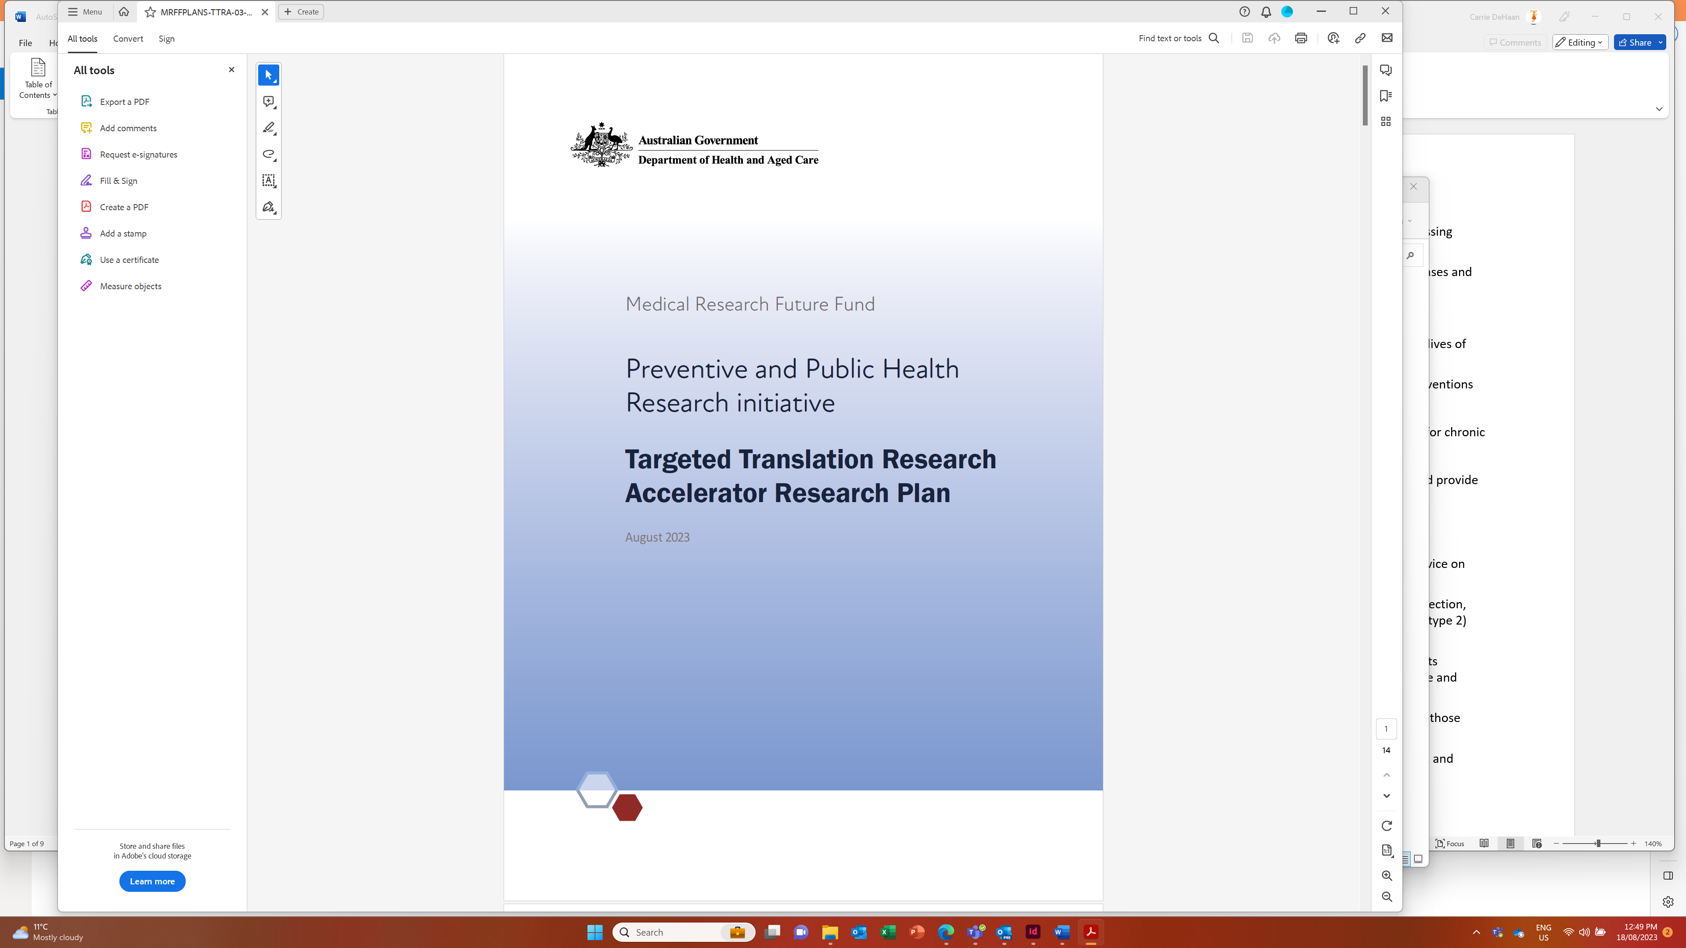

Background
Diabetes and cardiovascular disease are two of the most prominent health conditions that affect millions of Australians. An estimated 1.2 million Australian adults had one or more heart, stroke or vascular conditions, with cardiovascular disease responsible for approximately 25% of deaths in Australia. Of the approximately 1.3 million people living with types 1 or 2 diabetes, 22% report heart, stroke or vascular disease as a comorbidity.1 There is an unmet need to develop and accelerate new models of care and novel therapeutic approaches and devices for complications of cardiovascular disease and diabetes.
The previous government announced $124.5 million for the Targeted Translation Research Accelerator for health and medical research focused on diabetes (type 1 and type 2) and cardiovascular disease.
Following an open and competitive grant opportunity in 2020, MTPConnect was awarded $47.0 million to deliver the ‘Targeted Translation Research Accelerator for Diabetes and Cardiovascular Disease’ as a coordinated and collaborative program of translational research on diabetes (type 1 and type 2) and cardiovascular disease to transform health outcomes.
The initial investment was to support early-stage research discoveries to reach proof of concept and progress to human clinical trials.
The research landscape for diabetes and cardiovascular disease has changed since that time, including through the changes being generated by the Medical Research Future Fund (MRFF) project being managed by MTPConnect. As a result, a new approach is recommended for the remaining Accelerator funds, which leverages the outcomes of research funded through the initial Targeted Translation Research Accelerator investment and the MRFF Cardiovascular Health Mission.
This Research Plan has been developed to encourage collaboration and partnership between researchers, clinicians and industry, both nationally and internationally, and to promote consumer involvement in all stages of research.
A total of $77.5 million of the original $124.5 million is still available for allocation.
This Research Plan has been developed by an independent Expert Advisory Panel to advise the Minister for Health and Aged Care on the strategic priorities for research investment.
$77.5 million over 5 years from 2023–24 has been allocated for this Research Plan from the MRFF Preventive and Public Health Research initiative (PPHRI).
This initiative will support projects that:
identify and prioritise research that will most benefit patients and their families
assess the effectiveness of drugs and interventions
support the development and implementation of strategies and approaches for improving the health of pregnant women, mothers, and young children, particularly those focused on vulnerable populations
support the development and implementation of strategies and approaches for addressing modifiable risk factors at key life stages
improve the quality of care received by Australians living with chronic respiratory diseases and conditions
In addition, the initiative will support:
ongoing investments in the Targeted Translation Research Accelerator to improve the lives of patients with chronic conditions
research on the safety, quality and effectiveness of medicines use and medicines interventions by pharmacists
The objective of this initiative is to support research into new ways to address risk factors for chronic and complex diseases in Australia.
This Research Plan is intended to make the research purpose and direction transparent and provide certainty to stakeholders.

Objectives of the Research Plan
As requested by the Minister for Health and Aged Care, this Research Plan is to provide advice on research investments required to meet the following objectives:
accelerate promising therapeutic approaches and devices for the prevention, early detection, management and treatment of disease-related complications for diabetes (type 1 and type 2) and cardiovascular disease
support implementation of effective novel interventions and models of care for patients experiencing multimorbidity across diabetes (type 1 and type 2), cardiovascular disease and their risk factors
address inequities in treatment, management, access to care and health outcomes for those experiencing diabetes (type 1 and type 2) and cardiovascular disease
inform implementation of current and future policies and programs in diabetes (type 1 and type 2) and cardiovascular disease
This Research Plan must also:
align with the objectives of the PPHRI
consider what learnings and opportunities for either new or follow-on investment may arise as a result of the current funding allocated under the first phase of the ‘Targeted Translation Research Accelerator for Diabetes and Cardiovascular Disease’ program
consider priority populations, including, but not limited to, people living in rural, regional and remote communities, First Nations, and Culturally and Linguistically Diverse People and people experiencing socio-economic disadvantage
complement existing Australian Government investments in diabetes and cardiovascular diseases, including through the MRFF Cardiovascular Health Mission
- align with
- the Australian National Diabetes Strategy 2021–2030
- the National Strategic Action Plan for Heart Disease and Stroke
- the National Strategic Action Plan for Childhood Heart Disease
national (including state and territory based) and international knowledge and experiences

Research activities
Priority areas for investment are allocated across short and medium-term timeframes. These priority areas will be used by Government in the design of competitive grant opportunities under this Research Plan.
Research activities will be, or contribute to, programs of work of national strategic importance that are informed by the key priority areas outlined in this Research Plan. Research activities will be both small and large scale, with the aim to concentrate research efforts into areas of critical importance and areas not already targeted through existing MRFF initiatives.
The objectives of this Research Plan have been developed to prioritise cardiovascular disease, type 1 diabetes and type 2 diabetes, and to support investment across these three areas.
While not a focus of this Research Plan, gestational diabetes can be included and supported in research activities if proposed as part of grant applications that address type 1 or type 2 diabetes.

Monitoring and evaluation
To support this plan, the MRFF Monitoring, Evaluation and Learning Strategy (the Strategy) provides an overarching framework for assessing the performance of the MRFF, focused on individual grants, grant opportunities, initiatives (for example, the PPHRI) and the entire MRFF program.
The Strategy sets out the principles and approach used to monitor and evaluate the MRFF. It outlines the need for evaluations to be independent and impartial. The Strategy aims to be transparent in process and outcomes, and agile to the needs of the MRFF, its consumers and stakeholders (such as the health and medical research industry). This Research Plan and grants funded under it will be evaluated against the Strategy.

Our goal
To accelerate into practice new models of care, therapeutics and devices for type 1 and type 2 diabetes and cardiovascular disease to improve care, systems and outcomes.

Overview
The following aims and priority areas for research investment have been identified to achieve the objectives under this 5-year Research Plan.
Aim | Priority areas for investment
1. Improve care by building knowledge of the mechanisms underpinning cardiovascular disease and diabetes outcomes and/or prognosis | 1.1 Improving understanding of the common mechanisms and interactions between cardiovascular disease and diabetes
 | 1.2 Improving risk prediction of the co-incidence of cardiovascular disease and diabetes
2. Technology and data augmented models of care to improve accessibility, quality and cost-effectiveness | 2.1 Integrating technologies into care to improve outcomes for people living with cardiovascular disease and/or diabetes
 | 2.2 Improving access to, and integration of, data to inform health care
3. New treatment options for cardiovascular disease and/or diabetes | 3.1 Accelerating promising patient-centred therapeutic approaches and devices to improve health outcomes

Aim 1: Improve care by building knowledge of the mechanisms underpinning cardiovascular disease and diabetes outcomes and/or prognosis

Priority area 1.1
Improving understanding of the common mechanisms and interactions between cardiovascular disease and diabetes

Priority area 1.2
Improving risk prediction of the co-incidence of cardiovascular disease and diabetes
Research to begin in ... | Priorities for investment (objective, outcome and funding)
2024 | Objective: (Incubator) Conduct small-scale developmental projects that investigate the common pathophysiological mechanisms and pathways of disease or disease-related complications, focused on patients at higher risk of poor outcomes with:  - Topic A: any type of diabetes, including atypical or mixed phenotypes  - Topic B: cardiovascular disease and type 1 diabetes  - Topic C: cardiovascular disease and type 2 diabetes  Outcome: Generating knowledge to support new diagnostics, devices and therapies for people living with cardiovascular disease and diabetes.  Funding: Up to $1 million per project. Twelve projects are anticipated to be funded, commencing in 2024. The two top-ranked applications and the next two highest-ranked applications led by early- to mid-career researchers (EMCRs) for each Topic (Topic A, B, C) will be funded.  Duration: Grant duration of up to 2 years.
2026 | Objective: (Incubator) Conduct small-scale projects that identify predictive markers (including, but not restricted to, biomarkers) of disease or complications in:  - Topic A: any type of diabetes, including atypical or mixed phenotypes  - Topic B: cardiovascular disease in patients with type 1 diabetes  - Topic C: cardiovascular disease in patients with type 2 diabetes  Outcome: Identifying predictive markers to improve risk stratification.  Funding: Up to $1 million per project. Twelve projects are anticipated to be funded, commencing in 2026. The two top-ranked applications and the next two highest-ranked applications led by EMCRs⁴ for each Topic (Topic A, B, C) will be funded.  Duration: Grant duration of up to 2 years.

Aim 2: Technology and data augmented models of care to improve accessibility, quality and cost-effectiveness

Priority area 2.1
Integrating technologies into care to improve outcomes for people living with cardiovascular disease and/or diabetes

Priority area 2.2
Improving access to, and integration of, data to inform health care
Research to begin in ... | Priorities for investment (objective, outcome and funding)
2026 | Objective: (Targeted Call for Research) Conduct large-scale multidisciplinary projects to develop, implement and validate technology-augmented patient-centred models of care for people with cardiovascular disease or diabetes (types 1 or 2), through co-design with consumers and health services that:  - augment face-to-face care with remote patient monitoring, digital therapeutics or devices  - focus on an identified geographic area or priority population  - embed co-design with consumers and health services in all aspects of research design and implementation  - include a cost-effectiveness analysis and appropriate key health outcomes in the proposed methodology to inform progression of the research  - may include approaches for early diagnosis, secondary and/or tertiary prevention  Four topics of funding are available based on the geographic location of the organisation undertaking the majority of the research or on the priority population identified:  - Topic A: The organisation undertaking the majority of the research is based in any area according to the Modified Monash Model locator (MM 1–7)  - Topic B: The organisation undertaking the majority of the research must be located in, and the Chief Investigator A and 50% or more of all Chief Investigators and all research participants must be primarily resident in, a regional, rural or remote area according to the 2019 Modified Monash Model locator (MM 2–7)  - Topic C: The proposed research focuses on the health of First Nations peoples and demonstrates leadership by First Nations researchers and communities  - Topic D: The proposed research focuses on the health of people from Culturally and Linguistically Diverse backgrounds and demonstrates co-leadership by individuals from Culturally and Linguistically Diverse backgrounds in the design and implementation of the research.  Outcome: Generating new technology-enabled patient-centred models of care that improve health care delivery and drive equitable health outcomes for people with cardiovascular disease or diabetes (type 1 or 2).  Funding: Up to $2.5 million per project. Four projects are anticipated to be funded (one per Topic), with all four to commence in 2026.  Duration: Grant duration of up to 5 years.  Additional eligibility requirements: 50% or more of the Chief Investigator team must be EMCRs.  Notes: The highest-ranked application in each of Topics A, B, C and D will be funded.
2026 | Objective: (Targeted Call for Research) Conduct large-scale multidisciplinary projects to develop, implement and validate technology-augmented patient-centred models of care for people with both cardiovascular disease and diabetes (type 1 or type 2), through co-design with consumers and health services that:  - augment face-to-face care with remote patient monitoring, digital therapeutics or devices  - focus on an identified geographic area or priority population  - embed co-design with consumers and health services in all aspects of research design and implementation  - include a cost-effectiveness analysis and appropriate key health outcomes in the proposed methodology to inform progression of the research  - may include approaches for early diagnosis, secondary and/or tertiary prevention  Four topics of funding are available based on the geographic location of the organisation undertaking the majority of the research or on the priority population identified:  - Topic A: The organisation undertaking the majority of the research is based in any area according to the Modified Monash Model locator (MM 1–7)  - Topic B: The organisation undertaking the majority of the research must be located in, and the Chief Investigator and 50% or more of all Chief Investigators and all research participants must be primarily resident in, a regional, rural or remote area according to the 2019 Modified Monash Model locator (MM 2–7)  - Topic C: The proposed research focuses on the health of First Nations peoples and demonstrates leadership by First Nations researchers and communities  - Topic D: The proposed research focuses on the health of people from Culturally and Linguistically Diverse backgrounds and demonstrates co-leadership by individuals from Culturally and Linguistically Diverse backgrounds in the design and implementation of the research  Outcome: Generating new technology-enabled patient-centred models of care that improve health care delivery and drive equitable health outcomes for people with both cardiovascular disease and diabetes (type 1 or type 2).  Funding: Up to $2.5 million per project. Four projects are anticipated to be funded (1 per Topic), with all four to commence in 2026.  Duration: Grant duration of up to 5 years.  Additional eligibility requirements: 50% or more of the Chief Investigator team must be EMCRs.  Notes: The highest-ranked application in each of Topics A, B, C and D will be funded.
2026 | Objective: (Targeted Call for Research) Conduct multidisciplinary projects that use novel methods to harness multiple existing data infrastructure types in developing and implementing new approaches for the prevention and/or treatment of cardiovascular disease, diabetes (types 1 and/or 2) and/or complications of these diseases.  Two topics of funding are available, based on the disease foci:  - Topic A: Focused on, but not limited to, cardiovascular disease  - Topic B: Focused on, but not limited to, diabetes (type 1 or 2)  For the purposes of all Topics in this objective, ‘research data infrastructure’ includes clinical quality registries, biobanks, data collections, linkage platforms, data collection from wearables, integrated electronic medical records, use of artificial intelligence and informatics.  Outcome: Generating new approaches to improve health care and health outcomes for people living with cardiovascular disease, diabetes and their complications.  Funding: Up to $2.5 million per project. Two projects are anticipated to be funded, both commencing in 2026.  Duration: Grant duration of up to 5 years.  Additional eligibility requirements: The organisation undertaking the majority of the research must be located in, and the Chief Investigator A and 50% or more of all Chief Investigators and all research participants must be primarily resident in, a regional, rural or remote area according to the 2019 Modified Monash Model locator (MM 2–7).

New treatment options for cardiovascular disease and/or diabetes

Priority area 3.1
Accelerating promising patient-centred therapeutic approaches and devices to improve health outcomes
Research to begin in ... | Priorities for investment (objective, outcome and funding)
2024 | Objective: (Targeted Call for Research) Through competitively selected national organisation/s partnering with small to medium enterprises, accelerate into practice promising drugs and devices focused on cardiovascular disease and the complications of diabetes (types 1 and 2).  - Topic A: drugs (preclinical and clinical development)  - Topic B: devices (including, but not restricted to, diagnostics)  The successful independent organisation/s will be responsible for ensuring that the funding by each organisation:  - targets investment and related support through partnership projects to accelerate promising drug (Topic A) or device (Topic B) development projects  - promotes commercialisation of novel drugs and devices for cardiovascular disease and for complications of diabetes (types 1 and 2)  - provides a maximum of $1.5 million for each promising drug/device project  - leverages support (including co-funding) from partner organisations such as industry  - provides a minimum investment of $3 million into each of the following: cardiovascular disease; the disease-related complications in people with type 1 diabetes; and the disease-related complications in people with type 2 diabetes  Outcome: Accelerating into practice promising drugs and devices that reduce the burden of cardiovascular disease and complications of diabetes for patients, carers, families and community.  Funding: $28.5 million, comprising $15 million for the organisation awarded under Topic A and $13.5 million for the organisation awarded under Topic B, with two grants funded, commencing in 2024.  Duration: Grant duration of up to 5 years.

Australian Institute of Health and Welfare (2023). Heart, stroke and vascular disease: Australian facts.
Australian Bureau of Statistics (2020). Causes of death, Australia.
Australian Institute of Health and Welfare (2023). Diabetes: Australian facts.
For this Research Plan, an EMCR-led application includes the Chief Investigator A being an EMCR and 50% or more of the Chief Investigator team being EMCRs.

