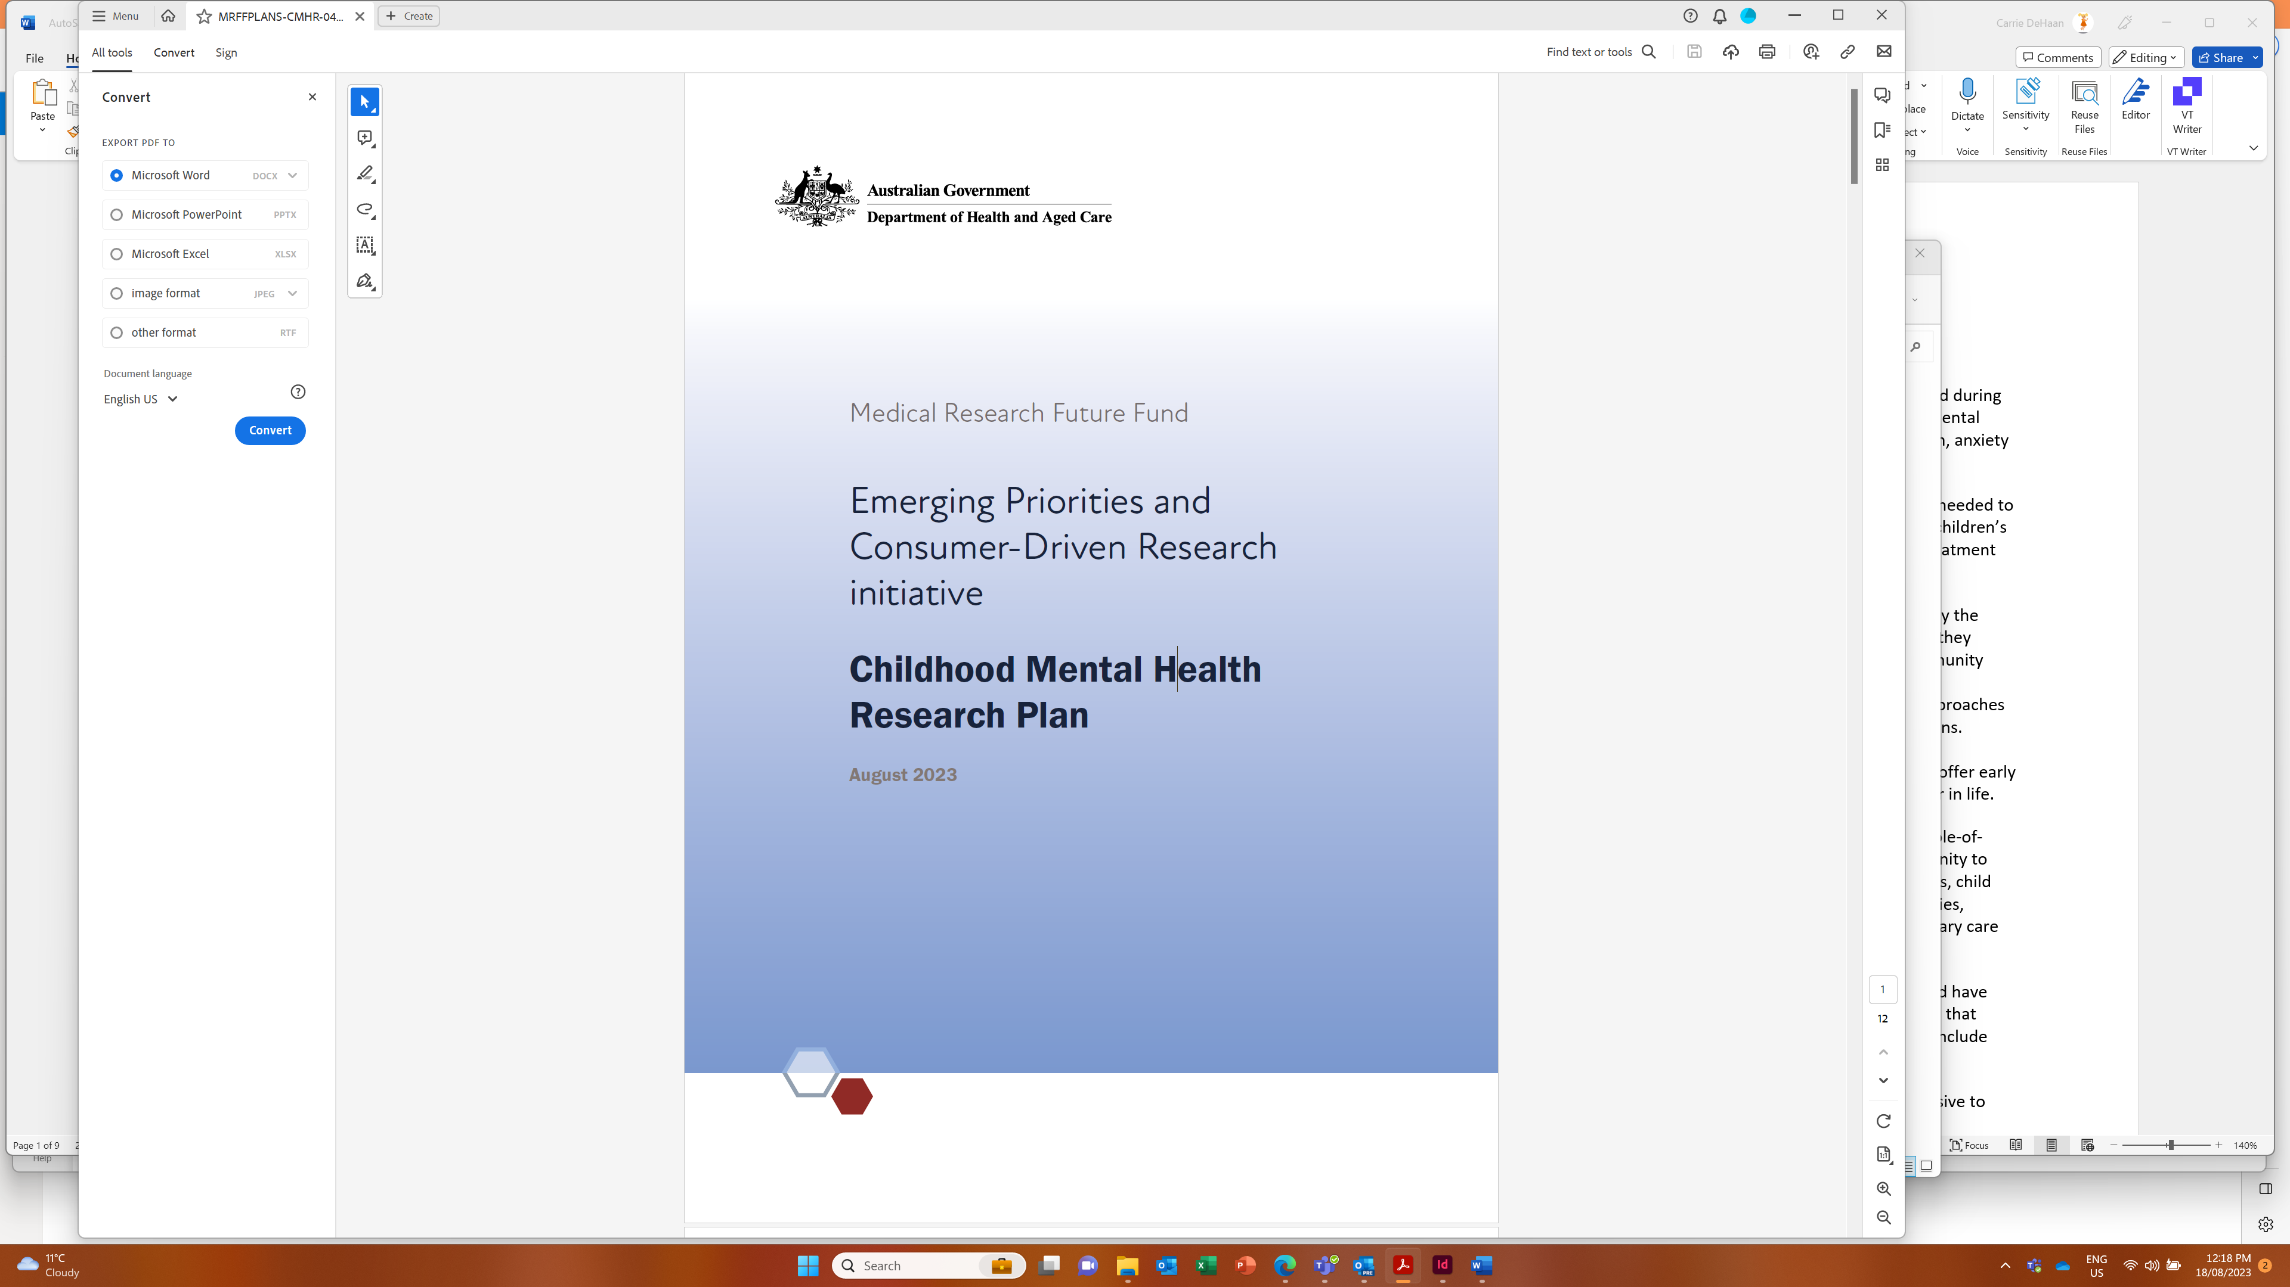

Background
There has been evidence of substantial deterioration in children’s mental health before and during the COVID-19 pandemic, particularly for priority populations and those with pre-existing mental health conditions. In particular, there has been an increase in the presentation of self-harm, anxiety and depressive symptoms, and eating disorders in children.
Although the immediate impacts of the pandemic have eased over time, more research is needed to understand the causes of poor mental health and develop interventions likely to improve children’s mental health and wellbeing. There is also evidence that many remain unable to access treatment and/or support.
The wellbeing of children is primarily affected by the society in which they live, as well as by the people with whom they interact. In addition to a clinical focus on an individual child, once they develop a diagnosis, there are significant benefits to focusing on the families, carers, community (especially schools) and broader environment to determine ways to reduce adversity and psychological distress, and build children’s mental health and wellbeing. This is true for approaches to understanding why children’s mental health has deteriorated and improving interventions. Universal prevention in children can help set them up for a lifetime of good mental health. Addressing mental health concerns in childhood through more targeted interventions can offer early intervention and/or treatment that prevents the individual from developing problems later in life.
One of the ways to support children’s mental health is through the implementation of whole-of-community approaches. These approaches aim to empower and engage the wider community to make a change. They require collaboration across sectors, including education practitioners, child protection, legal, housing, financial services, social workers, families and carers, communities, community elders, peak Aboriginal and Torres Strait Islander health related agencies, primary care providers, and mental health providers.
Children from priority populations may experience high levels of psychosocial adversity and have difficulty accessing mental health services/resources, and may require tailored approaches that promote safety; emotional, social, and cultural wellbeing; and healing. These approaches include harnessing First Nations Ways of Knowing, Being, and Doing.
Children are more likely to develop and thrive when supported by nurturing adults responsive to their needs. This includes families and carers at home, in out-of-home care, in learning environments, and in the community. Children struggling with their mental health also need evidence-based interventions that acknowledge the child’s biological, developmental, social, and cultural context. Interventions for children struggling with mental ill health may directly target the child, be inclusive of the child, or indirectly target the child. Expanding the knowledge base for diagnosis, treatment, and models of service delivery for children with mental health problems is needed to improve outcomes for the individual child, their family, and their community.
This Childhood Mental Health Research Plan (the Research Plan) outlines priority areas for investment into research on childhood mental health. The Research Plan aims to prioritise projects that improve the understanding of mental ill health, investigate ways to prevent and treat mental illness and psychological distress in children, and promote and improve children’s wellbeing. For this Research Plan, children are defined as being 0–15 years of age (that is, under 16 years of age).
An independent Expert Advisory Panel has developed this Research Plan to advise the Minister for Health and Aged Care on the strategic priorities for research investment.
Many strategies and plans already exist around the health of children, including the National Children’s Mental Health and Wellbeing Strategy. These were considered during the production of this Research Plan.
$50 million over four years from 2024–25 has been allocated for this Research Plan from the Medical Research Future Fund’s (MRFF’s) Emerging Priorities and Consumer-Driven Research (EPCDR) initiative.
The EPCDR initiative will support research on addressing emerging priority health needs and areas of unmet need. It will:
improve patient care
translate new discoveries into clinical practice
encourage researchers to work together with consumers
The objectives of the EPCDR initiative are to support research that improves patient care and translation of new discoveries, and encourage collaboration between consumers and researchers.
This Research Plan is intended to make the research purpose and direction transparent and provide certainty to stakeholders.
Objectives of the Research Plan
As requested by the Minister for Health and Aged Care, this Research Plan is to provide advice on research investments required to meet the following objectives:
generate knowledge on the determinants of, and protective factors for, optimal mental health and wellbeing in children
generate knowledge to improve access to, and delivery of, evidence-based treatments, and to reduce mental illness and psychological distress in children
address inequities in childhood mental health and psychological distress outcomes
inform implementation of current and future policies and programs in child mental health
This Research Plan must also:
align with the objectives of the EPCDR initiative
complement existing mental health research initiatives, including the MRFF’s Million Minds Mental Health Research Mission
- align with the
- National Mental Health Research Strategy
- National Mental Health and Suicide Prevention Agreement
- National Children’s Mental Health and Wellbeing Strategy
Australian Eating Disorders Research and Translation Strategy 2021–2031

Research activities
Priority areas for investment are allocated across short- and medium-term timeframes. These priority areas will be used by Government in the design of competitive grant opportunities under this Research Plan.
Research activities will contribute to programs of work of national strategic importance that are informed by the key priority areas outlined in this Research Plan. Research activities will be both small and large scale, with the aim to concentrate research efforts into areas of critical importance and areas not already targeted through existing MRFF initiatives. These activities will improve the nation’s capacity for meaningful data collection and measurement-based care in children’s mental health and wellbeing.

Small-scale activities
The small-scale activities in this Research Plan will be supported through MRFF Incubator Grants. These activities will use novel strategies to generate new approaches — and potentially contribute to substantial breakthroughs — to address areas of unmet need. These activities will involve children, their families and carers, and childhood mental health service providers, and will work across sectors (for example, education, health, and social services) and disciplines (for example, public health, social, clinical, policy, health economics, engineering, statistics, and artificial intelligence), in all aspects of the research process.
The findings generated from these activities will allow for a greater ability to attract further funding to develop or implement solutions in health care or practice.
These activities will also contribute to capacity building, as targeted funding will be provided for Early- and Mid-Career Researcher (EMCR)-led research.

Large-scale activities
The large-scale activities in this Research Plan will be significant collaborative efforts to drive the implementation of sustainable, systematic and substantial improvements to health care and health system effectiveness.
These collaborations will:
be multi-institutional and intersectoral
encompass multiple geographies and demographics
consist of multidisciplinary and interdisciplinary teams
partner with population groups and service providers
include co-production and/or co-design with children, their families and carers, and childhood mental health service providers, and will work across sectors (for example, education, health, and social services) and disciplines (for example, public health, social, clinical, policy, health economics, engineering, statistics, and artificial intelligence) in all aspects of research design and implementation
consider partnerships with governments (Commonwealth and/or state)
be community-based by joining with the community as partners in all phases of the research process
mobilise resources across states and institutions, at both the national and local level, with at least three different institutions with a strong reputation and track record in working in mental health (such as in clinical translation, workforce development, or policy impact)
These collaborative efforts must:
be bold, inspirational, and widely relevant to society
be clearly framed (targeted, measurable and time-bound)
be impact-driven but with realistic goals
be culturally responsive
consider different childhood developmental stages, including neurodevelopment
work with existing and upcoming datasets, such as the upcoming National Survey of Childhood Mental Health, the Multi-Agency Data Integration Project, and the Australian Early Development Census
operate under a strong governance structure
link activities across different disciplines and different types of research and innovation
make it easier for people to understand the value of investments in research and innovation (such as through communication activities)

Monitoring and evaluation
To support this Research Plan, the MRFF Monitoring, Evaluation and Learning Strategy (the Strategy) provides an overarching framework for assessing the performance of the MRFF, focused on individual grants, grant opportunities, initiatives (for example, the EPCDR) and the entire MRFF program.
The Strategy sets out the principles and approach used to monitor and evaluate the MRFF. It outlines the need for evaluations to be independent and impartial. The Strategy aims to be transparent in process and outcomes, and agile to the needs of the MRFF, its consumers (including their families and carers), community and stakeholders (such as the health and medical research industry). This Research Plan and grants funded under it will be evaluated against the Strategy.

Our goal
Setting up the current and future generations of Australian children for the best possible lifetime of mental health through effective prevention and intervention, with a focus on reducing inequities.

Overview
The following aims and priority areas for research investment have been identified to achieve the objectives under this 4-year Research Plan.
Aim | Priority areas for investment
1. Better understanding of the contributing factors of childhood mental illness, psychological distress and wellbeing | 1.1 Understanding the factors impacting childhood mental illness and psychological distress
 | 1.2 Understanding the protective factors that enhance the social and emotional wellbeing of children
2. Timely access to evidence-based treatment and prevention for childhood mental illness | 2.1 Creating and implementing innovative treatments and preventions to improve outcomes
 | 2.2 Creating and implementing community-based service models

Aim 1: Better understanding of the contributing factors of childhood mental illness, psychological distress and wellbeing

Priority area 1.1
Understanding the factors impacting childhood mental illness and psychological distress

Priority area 1.2
Understanding the protective factors that enhance the social and emotional wellbeing of children
Research to begin in ... | Priorities for investment (objective, outcome and funding)
2024 | Objective: (Targeted Call for Research) Conduct large-scale multidisciplinary projects to build knowledge of the biological, environmental, social, cultural, structural, economic, and individual factors that:  - contribute to mental illness in children and  - keep children mentally healthy  Projects should be culturally responsive, co-designed, and co-produced with children (where appropriate), their families, carers, the community, providers in settings (for example, child care or schools), and childhood mental health service providers.  Outcome: Building evidence to support the development of effective strategies, interventions, policies and programs for promoting social and emotional wellbeing in children.  Funding: Up to $5 million per project. Two projects are anticipated to be funded. 50% or more of the Chief Investigator team must be Early- and Mid-Career Researchers (EMCRs) and/or peer researchers.  Duration: Grant duration of up to 5 years. Up to 15 Chief Investigators.

Aim 2: Timely access to evidence-based treatment and prevention for childhood mental illness

Priority area 2.1
Creating and implementing innovative treatments and preventions to improve outcomes

Priority area 2.2
Creating and implementing community-based service models
Research to begin in ... | Priorities for investment (objective, outcome and funding)
2024 | Objective: (Incubator) Conduct small-scale developmental projects to create assessments, treatments, preventions, and/or improve our understanding of the mechanisms of therapeutic change for childhood mental illness and psychological distress:  - Topic A: for children aged 0 to 5 years  - Topic B: in settings where children are cared for and/or whom they are cared by (for example, at home, in out-of-home care, in learning environments, in the community)  - Topic C: among First Nations children by accessing the unique knowledges, strengths, and endurance of First Nations communities  - Topic D: among children with a disability (including psychosocial disability or neurodisability) and/or long-term chronic disease  - Topic E: among children who have experienced trauma  - Topic F: among children experiencing emotionally based school avoidance/non-attendance  - Topic G: for eating disorders (and their prodromes)  - Topic H: for anxiety disorders (and their prodromes)  - Topic I: for depression and/or self-harm and/or suicidality (and their prodromes)  - Topic J: for disruptive behaviour disorders (for example, conduct disorder and oppositional defiant disorder)  Projects should be culturally responsive, co-designed, and co-produced with children (where appropriate), their families, carers, the community, providers in settings (for example, child care or schools), and childhood mental health service providers.  Outcome: Generating new assessments, treatments, preventions, and knowledge of the therapeutic mechanisms of change that improve the mental health, education, wellbeing, and quality of life for children.  Funding: Up to $1 million per project. Twenty projects are anticipated to be funded (two in each Topic: the top-ranked project and the next top-ranked EMCR-led project). Applications will then be pooled in rank order and funded until funding has been expended.  Duration: Grant duration of up to 2 years. Up to 15 Chief Investigators.
2026 | Objective: (Targeted Call for Research) Conduct large-scale implementation research projects to bring evidence-based preventions and treatments, including those that are technologically enabled, into practice that:  - are in partnership with local health and community service providers  - are co-produced and/or co-designed with children and their families, carers, and the community  - support the integration of mental health services for children and their families and carers  - build clinical research workforce capacity  - address mental health issues that are a priority for the community  - measure the impact of the interventions  - address barriers and build upon enablers to support and scale implementation  Three streams of funding are available based on the primary focus of the research or the geographic location of the organisation undertaking the majority of the research.  - Topic A: improving the mental health of First Nations children through research led by First Nations researchers that includes meaningful involvement of First Nations communities  - Topic B: the organisation undertaking the majority of the research is based in any area according to the Modified Monash Model locator (MM 1–7)  - Topic C: the organisation undertaking the majority of the research, the Chief Investigator A and 50% or more of all Chief Investigators, and all research participants are primarily based in a regional, rural or remote area according to the Modified Monash Model locator (MM 2–7)  Outcomes: Implementation of ‘evidence-based’ models that improve children’s mental health and wellbeing or prevent mental illness.  Funding: Up to $5 million per project. One project for Topics A and C, and two projects for Topic B, are anticipated to be funded. 50% or more of the Chief Investigator team must be Early- and Mid-Career Researchers (EMCRs) and/or peer researchers.  Duration: Grant duration of up to 5 years. Up to 15 Chief Investigators.

An Early to Mid-career Researcher is defined as an individual who is within ten years post PhD (that is, within ten years of their PhD award date), excluding career disruptions.
Peer researchers (also referred to as ‘community researchers’) use their lived experience and understanding of a social or geographical community to help generate information about their peers for research purposes. They may be involved in research design, developing research tools, collecting and analysing data, or writing up and disseminating findings.

