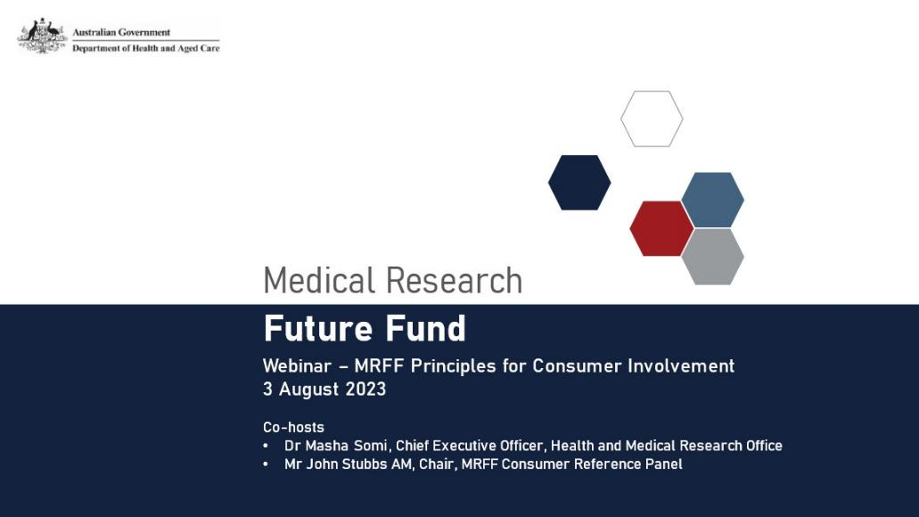
Agenda
- Introduction and background
- Masha Somi (Chief Executive Officer, Health and Medical Research Office (HMRO))
- John Stubbs (Chair, MRFF Consumer Reference Panel (CRP))
- Caroline Homer (Deputy Chair, Australian Medical Research Advisory Board (AMRAB))
- Consumer involvement in health and medical research – how and why:





Bernadette Brady Yvonne Cadet-James Merryn Carter Tom Snelling
- Questions and Answers

Consumer Involvement in the MRFF

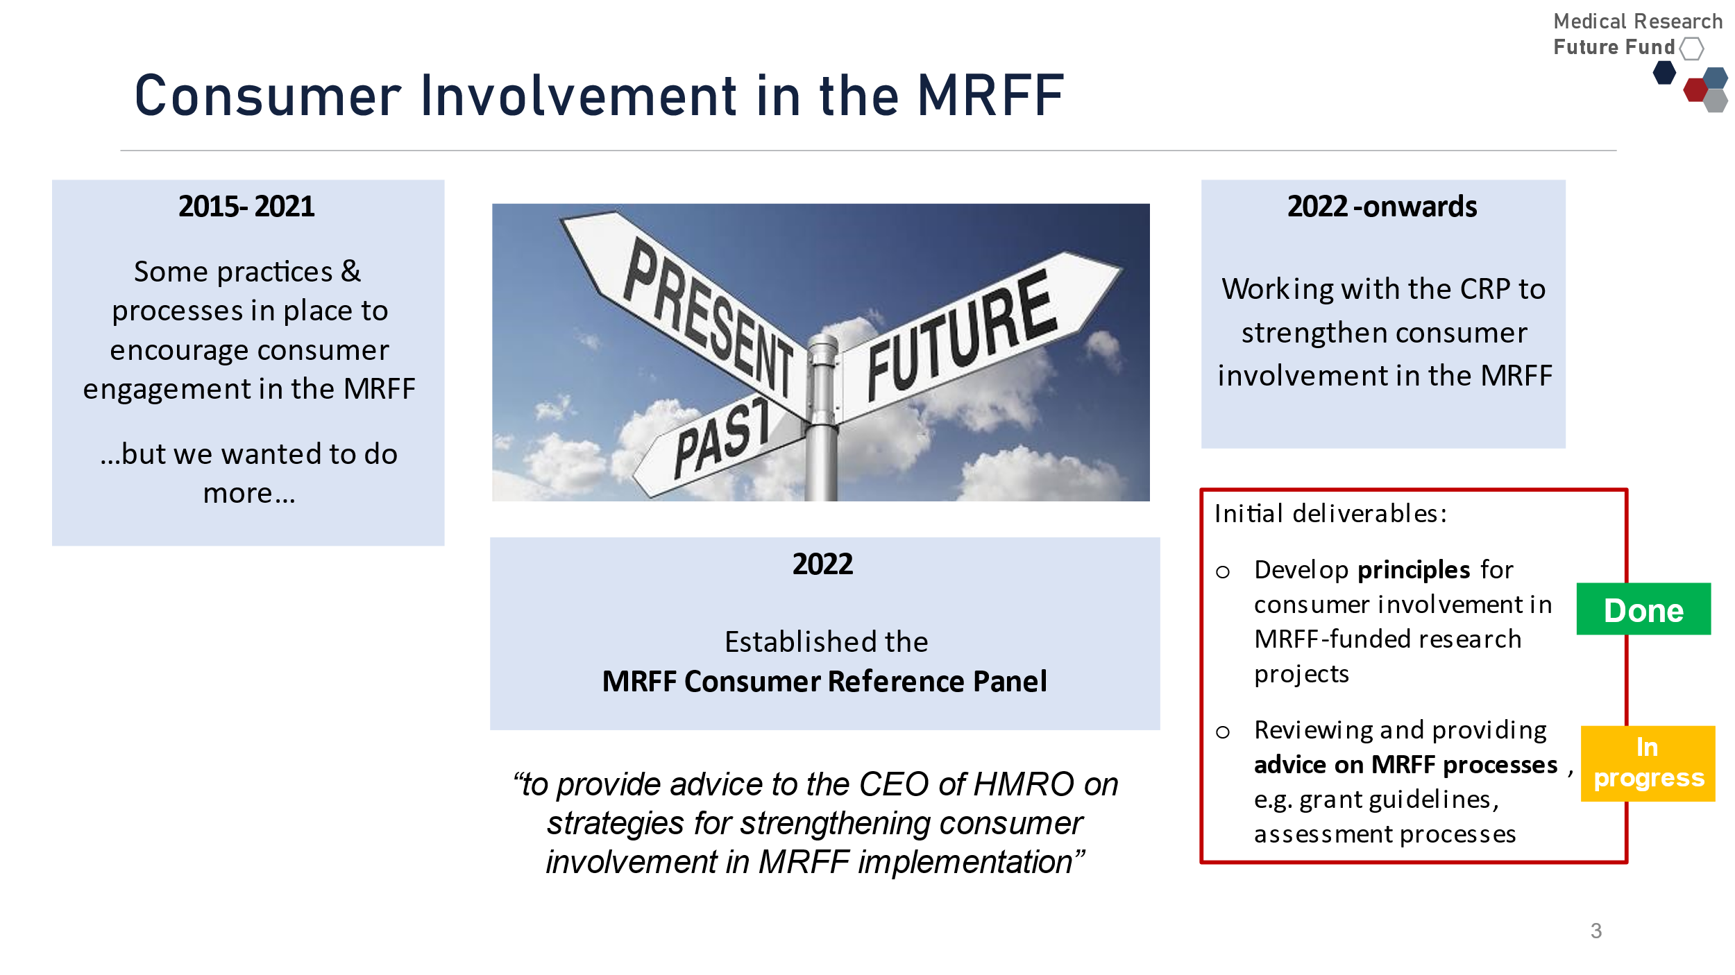

Refresh of the MRFF assessment criteria
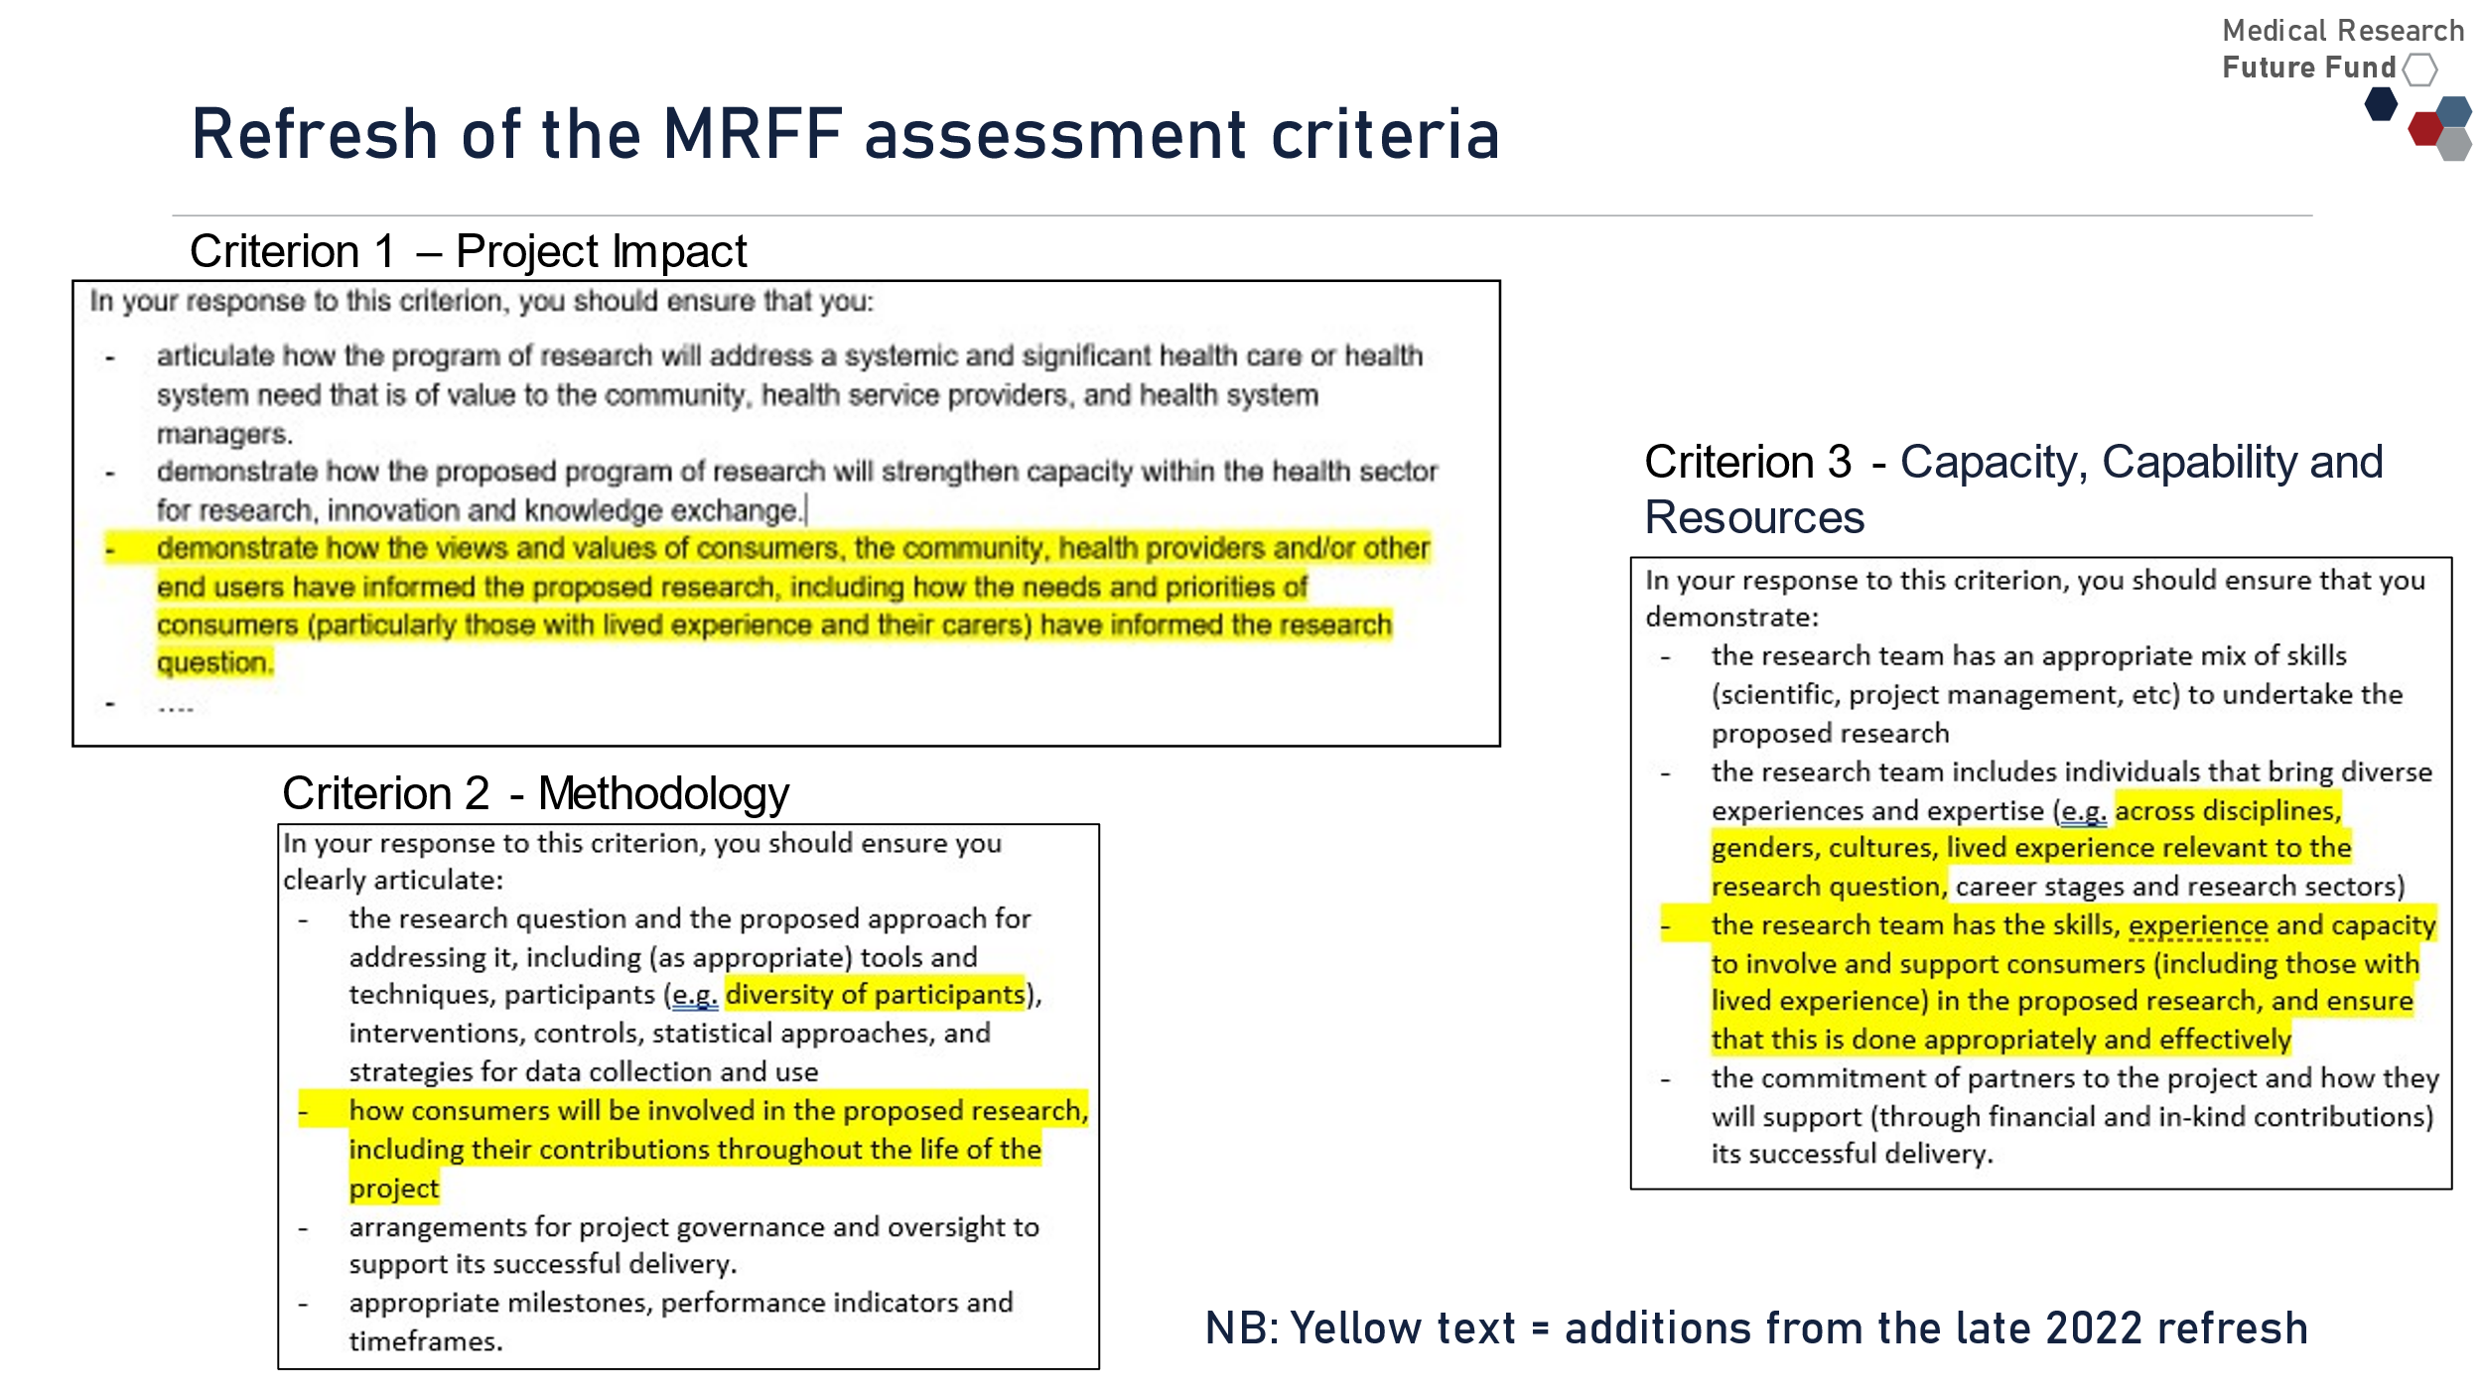

Providing advice on MRFF processes
- Light-touch review of assessment criteria descriptors
- Pilots in the 2023 MRFF Consumer-Led Research Grant Opportunity:
  - Consumer Involvement Statement – 2 pages in grant application
  - Greater consumer involvement in assessment – multiple consumers as full, scoring panel members
- Review of the draft NHMRC/MRFF Statement on Sex, Gender, Variations of Sex Characteristics and Sexual Orientation in Health and Medical Research
- Reviewing grant opportunity guideline templates
- Inputting into research topics/prioritisation
  - Future Consumer-Led Research Grant Opportunities
- MRFF Preventive and Public Health Research Initiative - $100 million over 10 years from 2022-23 allocated to a Consumer-Led Research stream
- Further implementation of the CRP principles, e.g.
  - Guidance for researchers, e.g. costs associated with consumer involvement can be included in MRFF applications
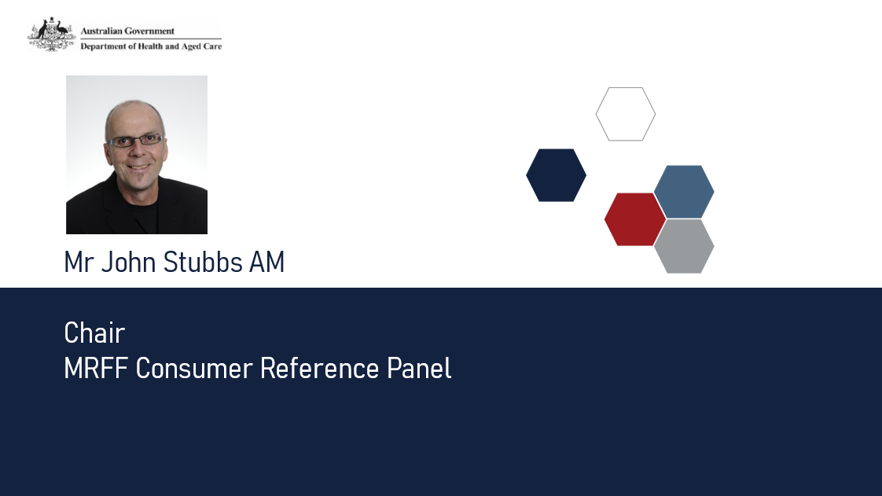

Principles for Consumer Involvement in Research Funded by MRFF
~ WHY? ~
The inclusion and strengthening of the consumer voice will improve the quality, relevance and impact of MRFF-funded research, through:
- More, safe, diverse and effective consumer involvement
- Recognising the valuable perspectives that Australians with lived experience as patients, clients, service users and carers bring to research
- Recognising the diversity of our Australian population and the importance of including these varied life experiences, values and cultures in our research
- Helping researchers, research organisations, consumers and other relevant stakeholders by providing guidance on what ‘good’ consumer involvement looks like

Principles for Consumer Involvement in Research Funded by MRFF

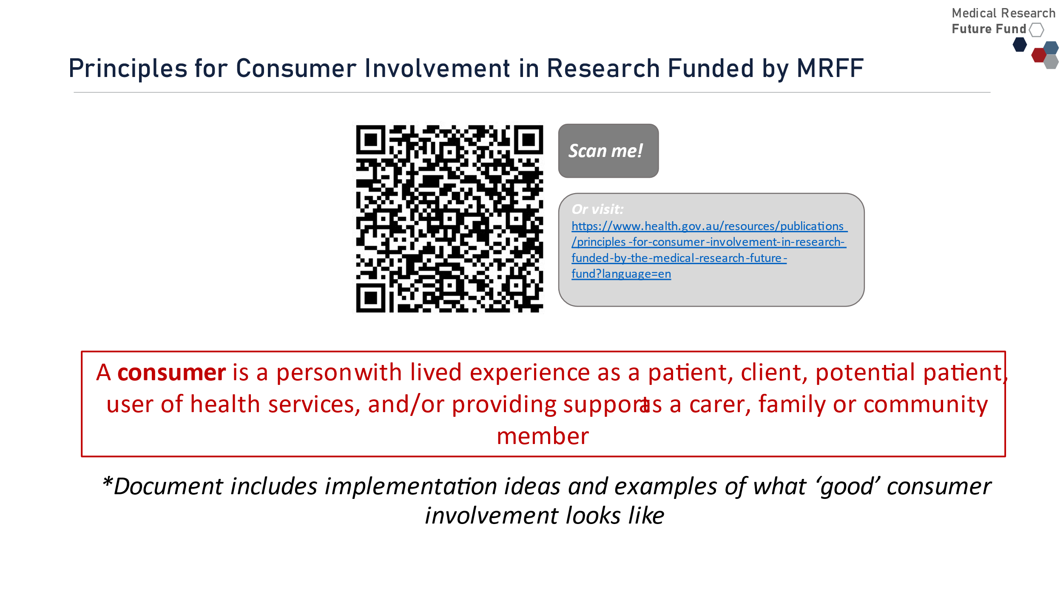
A consumer is a person with lived experience as a patient, client, potential patient, user of health services, and/or providing support as a carer, family or community member
*Document includes implementation ideas and examples of what ‘good’ consumer involvement looks like

Principles for Consumer Involvement in Research Funded by MRFF (cont.)
- In every type of research, including basic science, public health, preventive health, translation and clinical research.
- At all stages of research, from defining the need/priority of a research question, refining the research question and research design through to conduct of the research and sharing and translation of results.
- In partnership with researchers, with consumers respected and recognised for the valuable and complementary knowledge, expertise and perspectives they bring to the research.
- Effectively, with sufficient time, resources and depth of relationships to enable consumers to understand and actively engage with and contribute to the research.
- Sensitively and safely, through research teams with strong and broad capacity and capabilities in consumer involvement, appropriate training and a supportive environment for consumers, and clearly defined and agreed roles.
- With broad diversity and equity, with the goal of increasing involvement of priority populations through culturally safe and appropriate engagement.
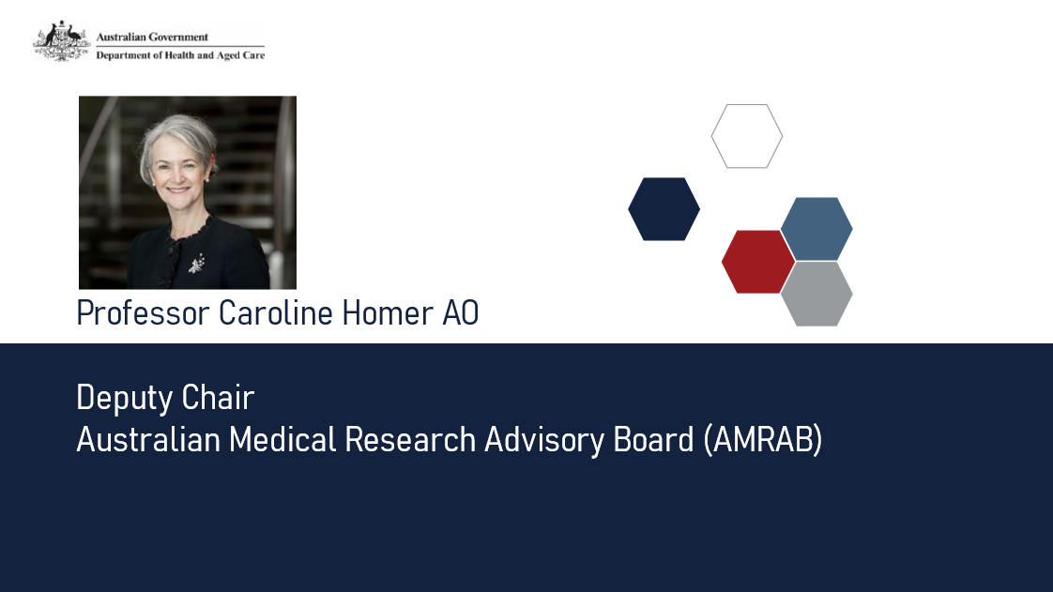

Message from the Australian Medical Research Advisory Board (AMRAB)
- AMRAB advises the Minister for Health and Aged Care on prioritising spending from the MRFF
- Responsible for developing the Australian Medical Research and Innovation Strategy and the Australian Medical Research and Innovation Priorities via a public consultation process

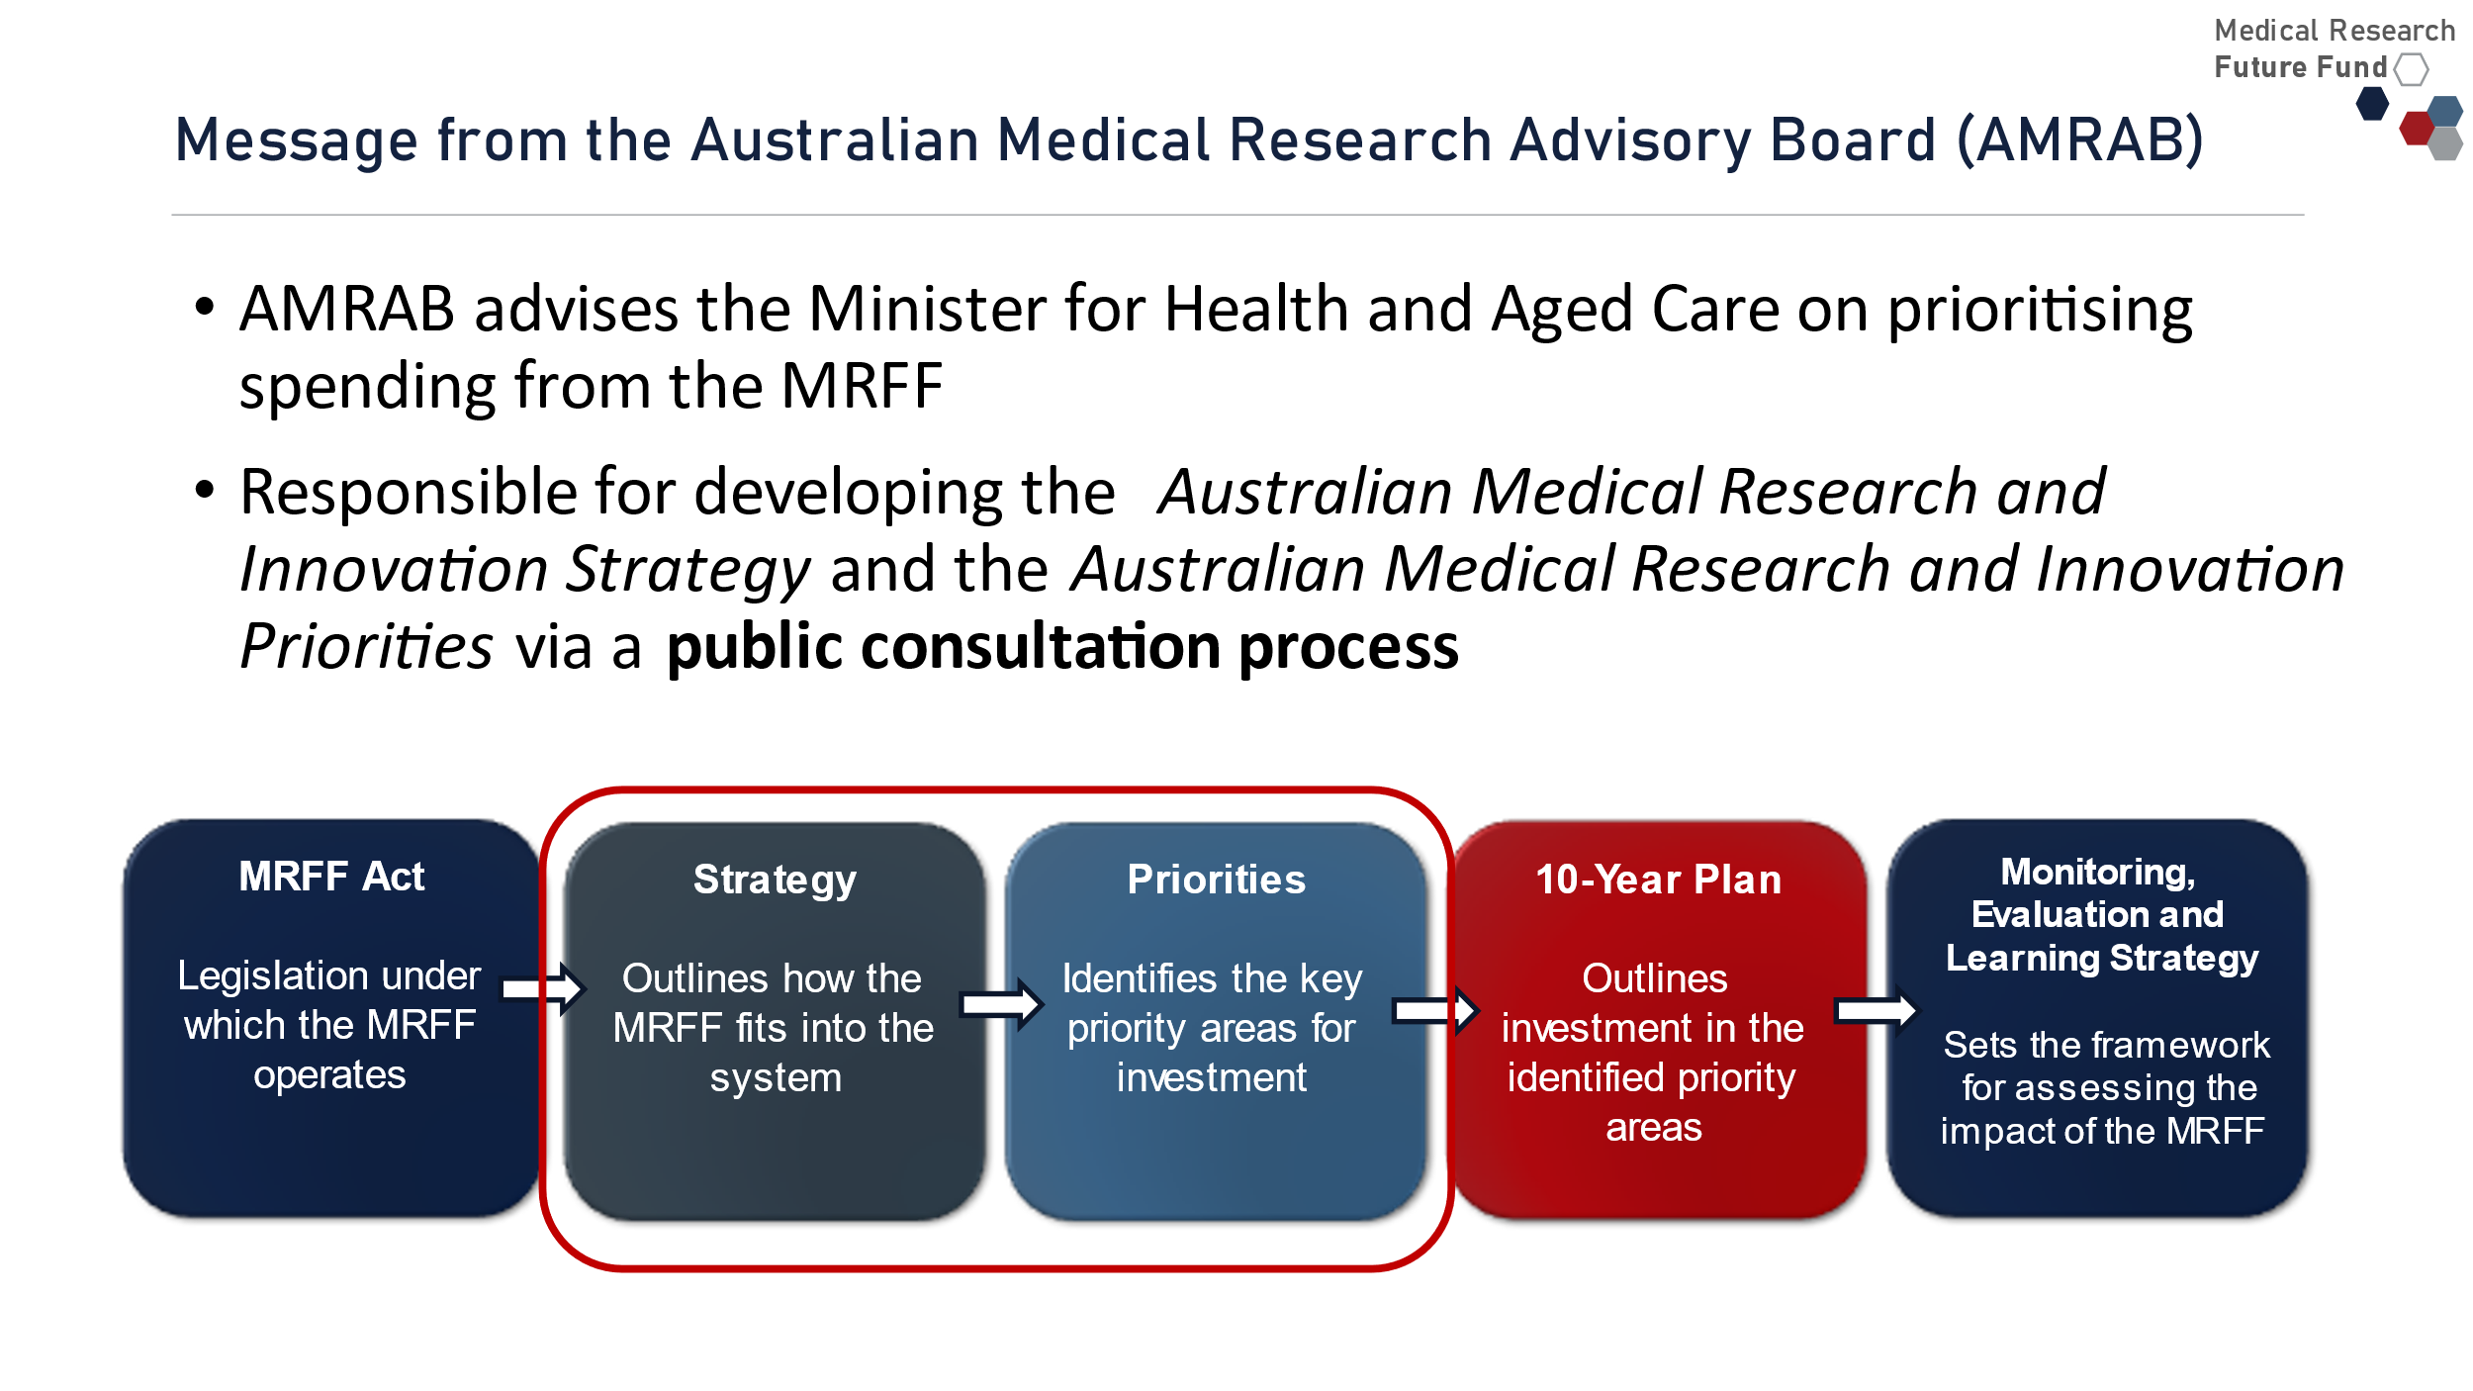

AMRAB support for the MRFF Consumer Involvement Principles
- AMRAB strongly supports the Principles for Consumer Involvement in Research Funded by MRFF
  - Consumer involvement is critical to get the greatest impact from our tax payer-funded research
  - Statement of what best practice looks like
  - It’s not ‘mandatory’, but a statement of future intent and an excellent guide
  - Start doing what you can now
  - It’s a learning process and takes time and resources
    - Don’t let perfect be the enemy of good
    - It’s not just on researchers, but requires support from their organisations and all aspects of the system, including funders
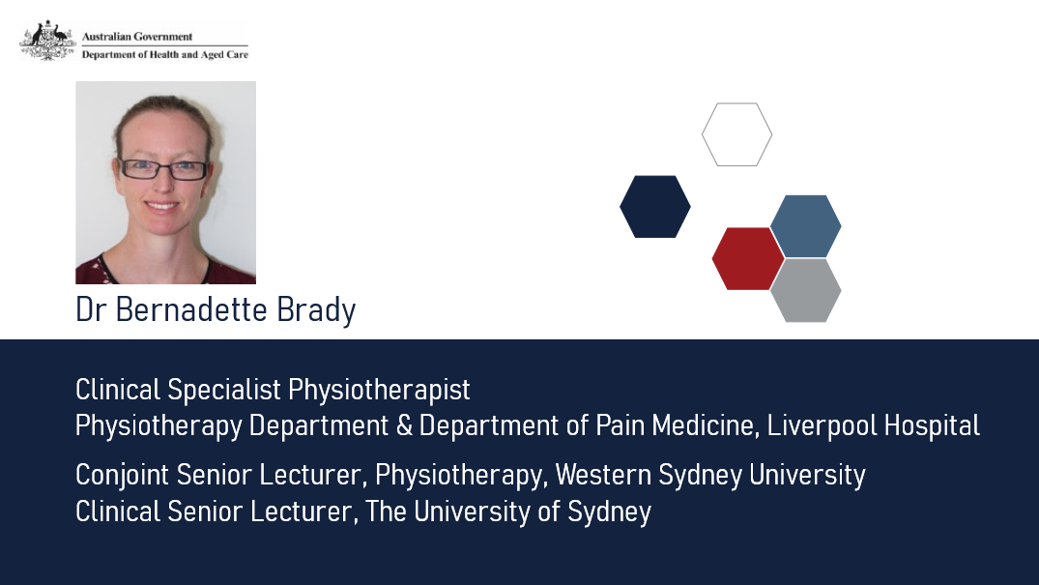
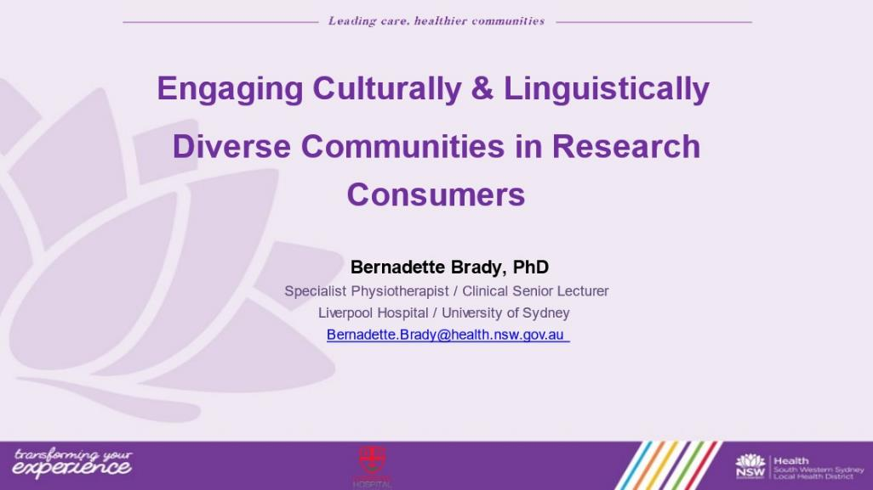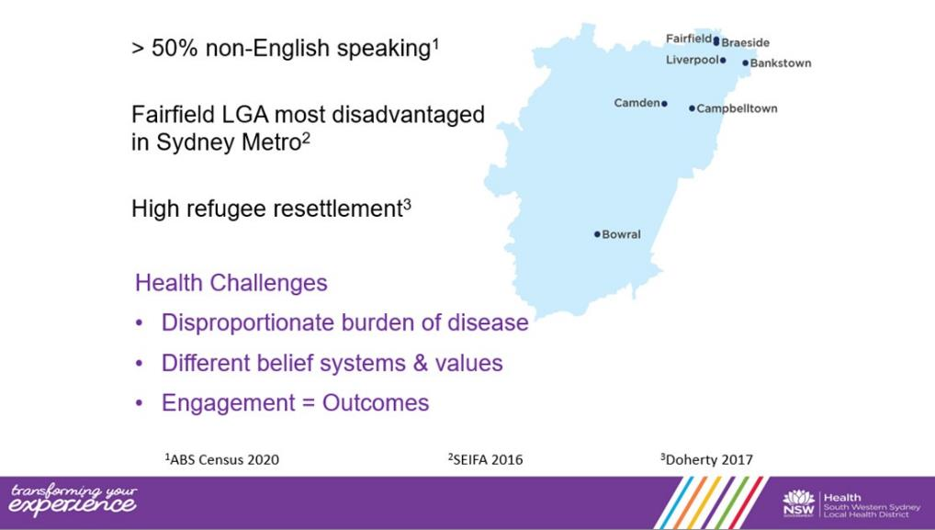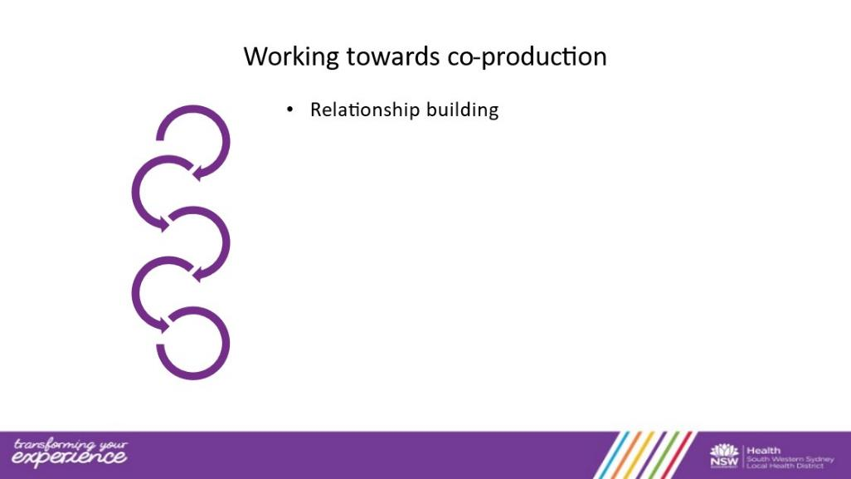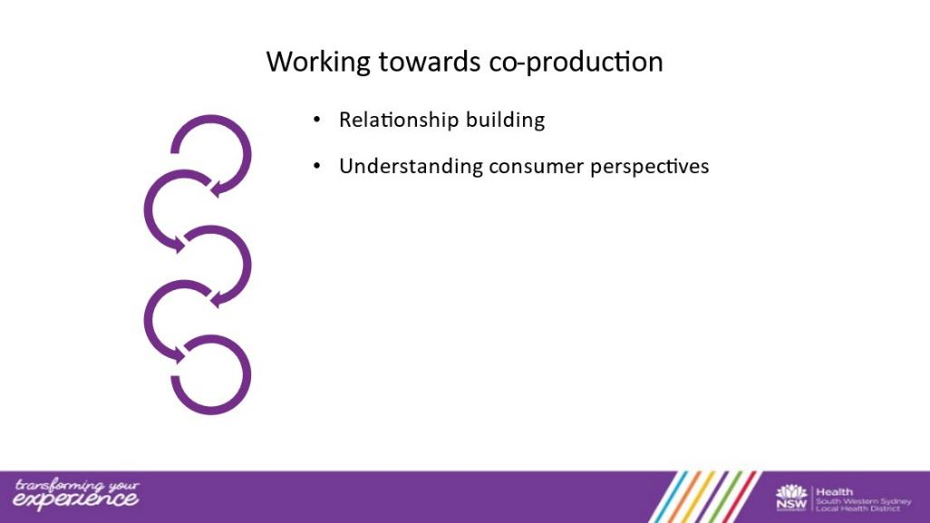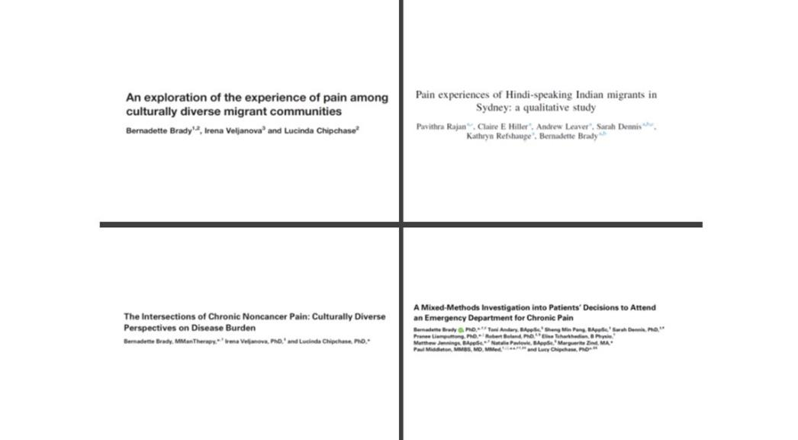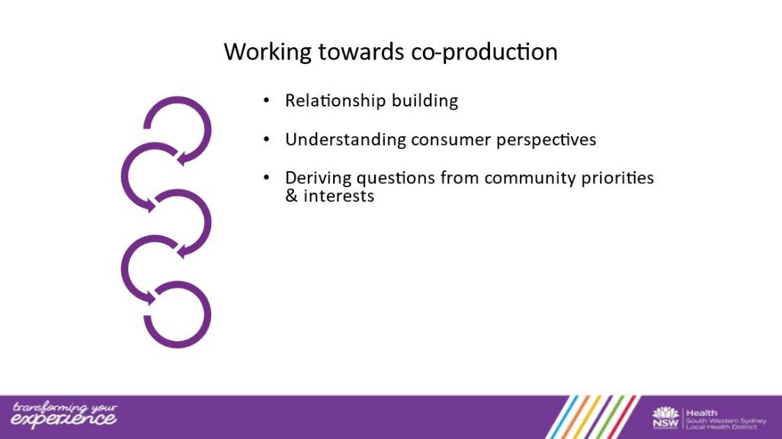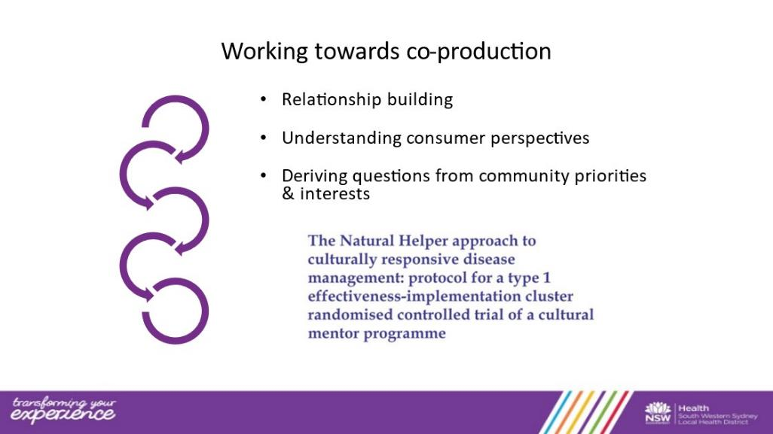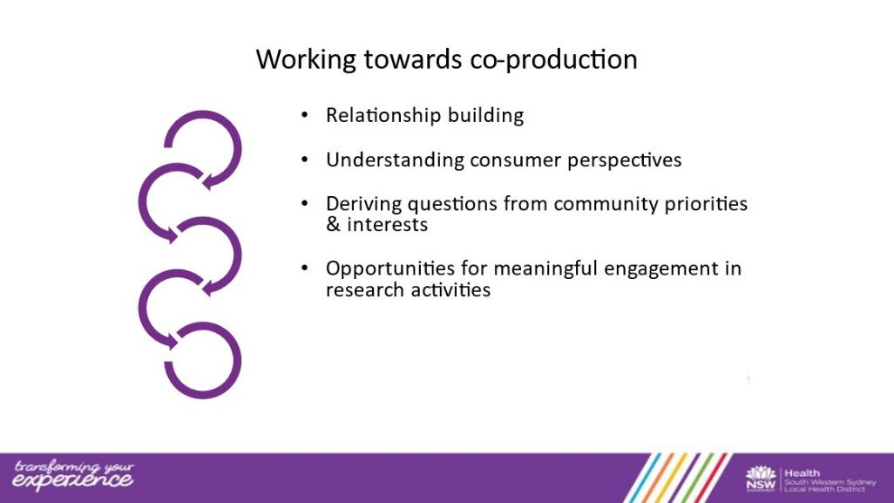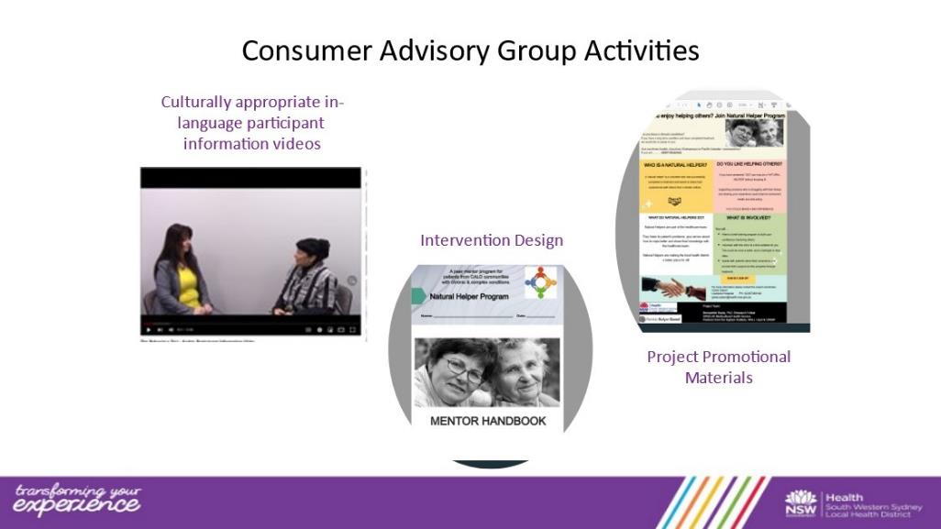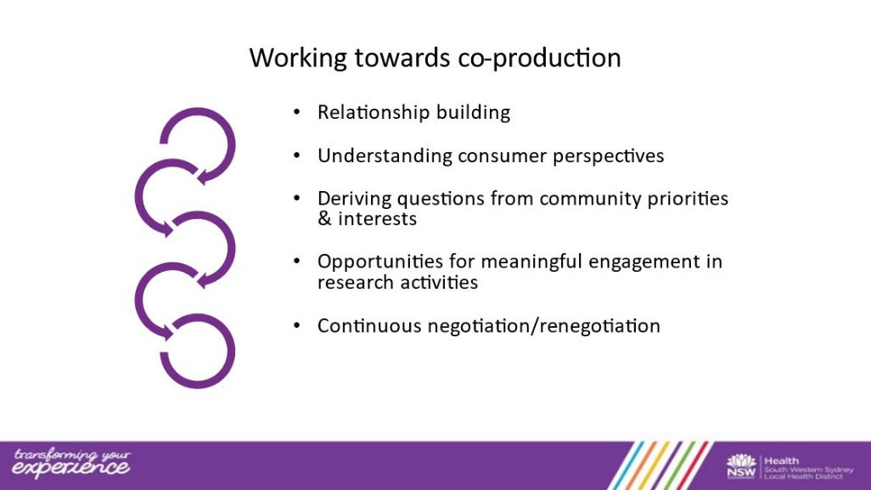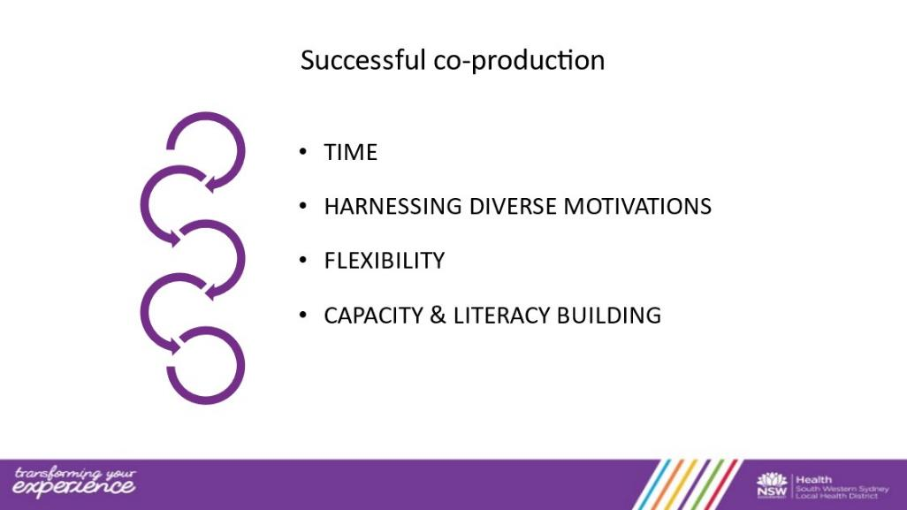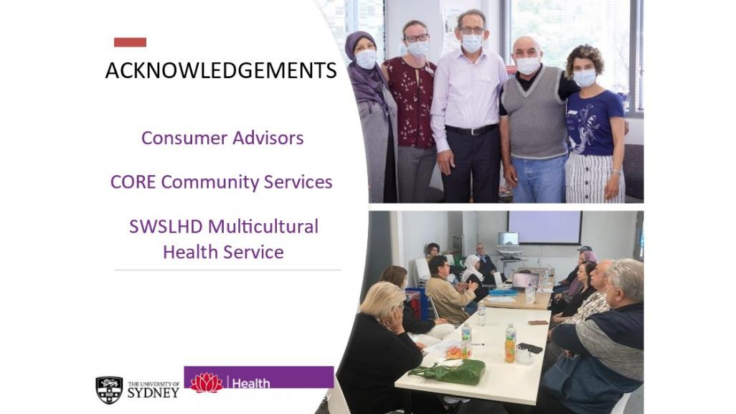

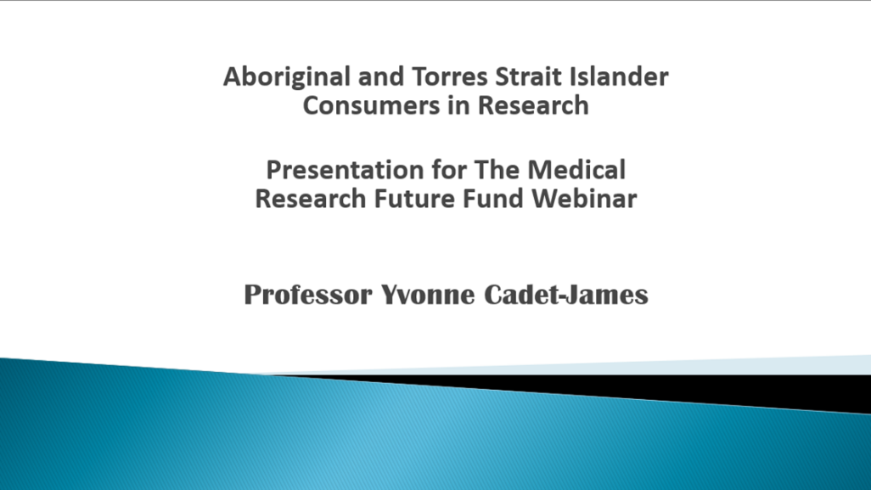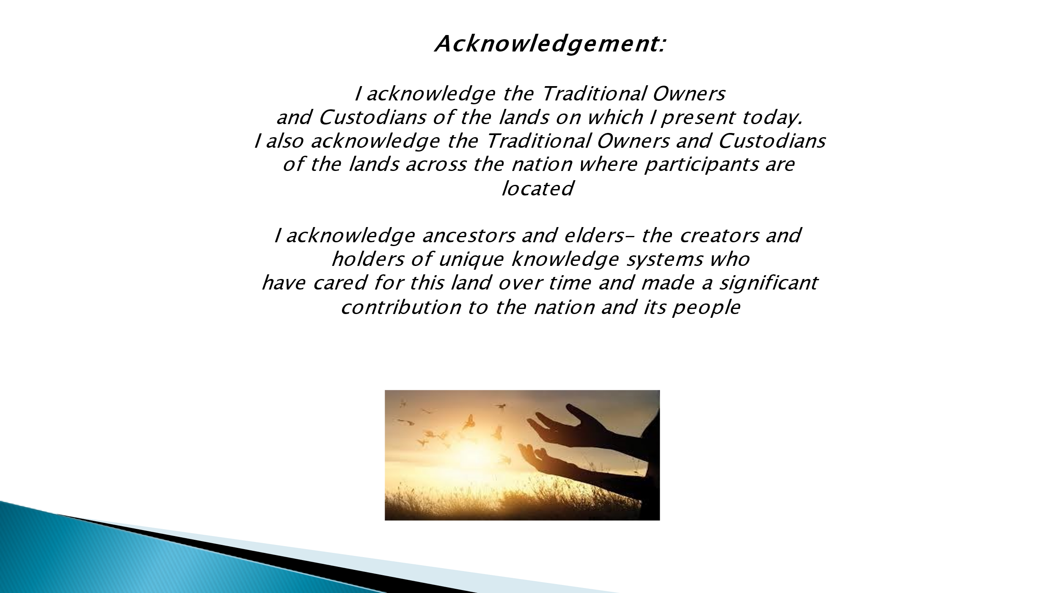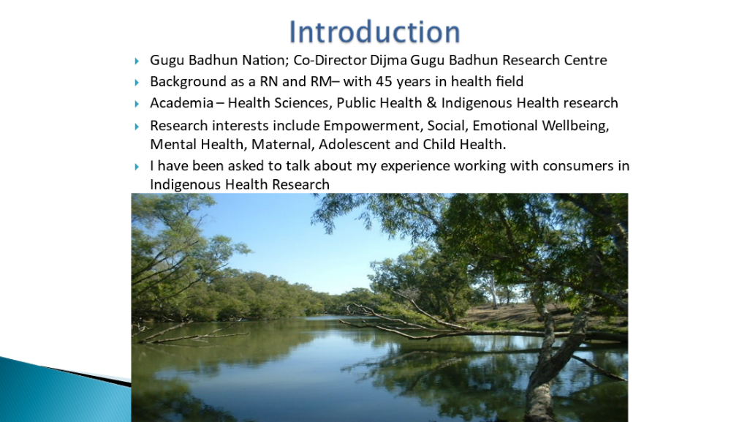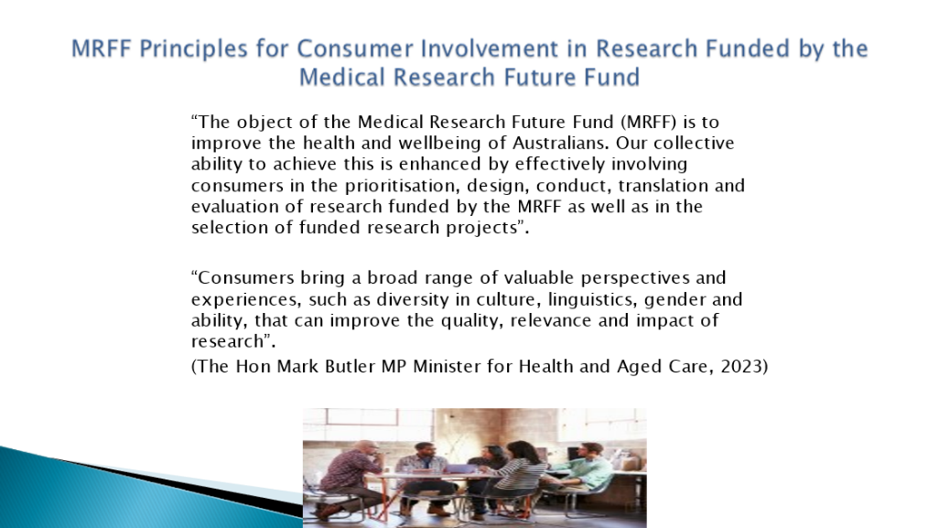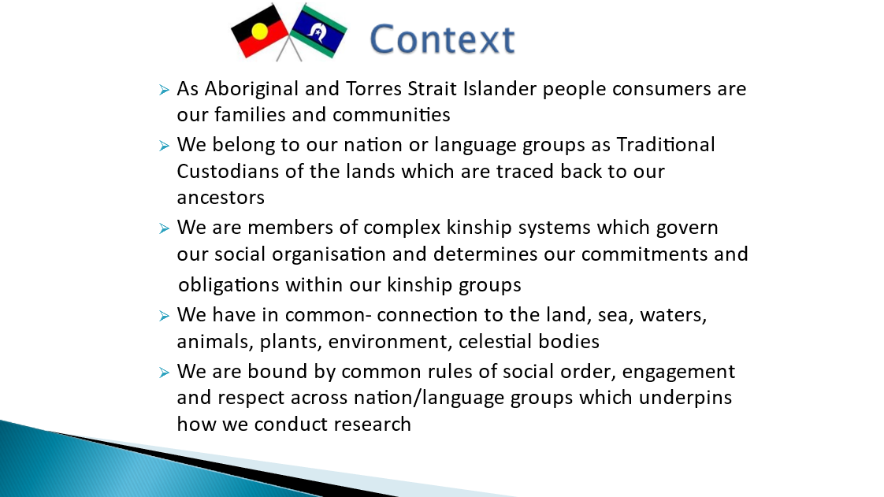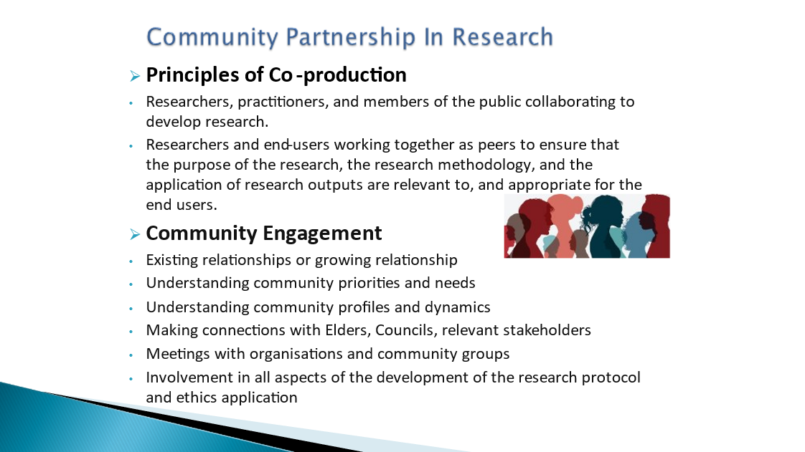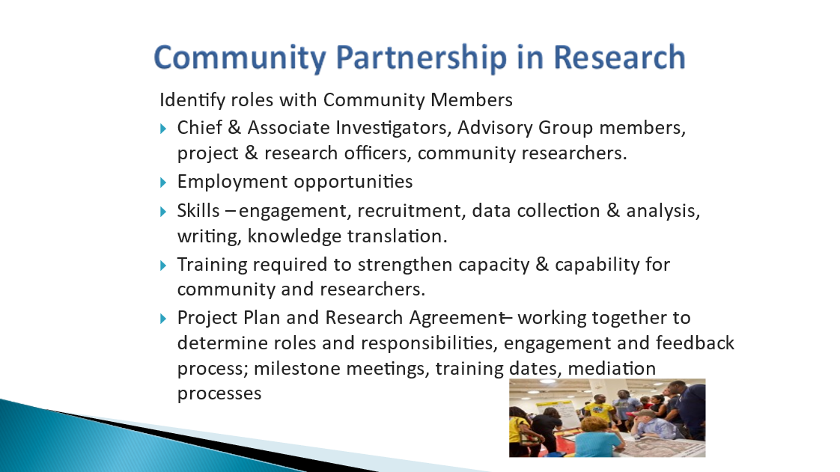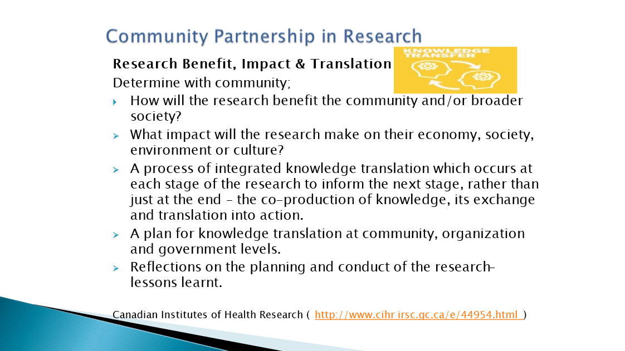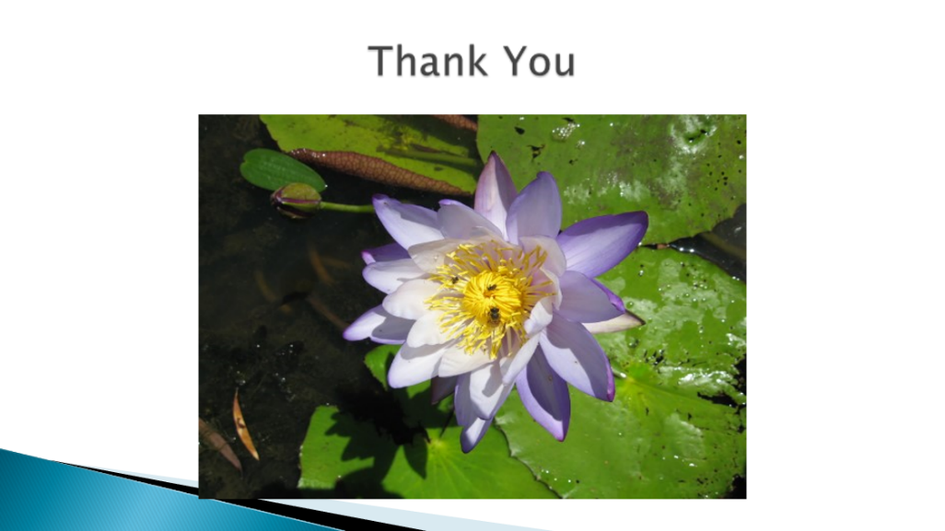
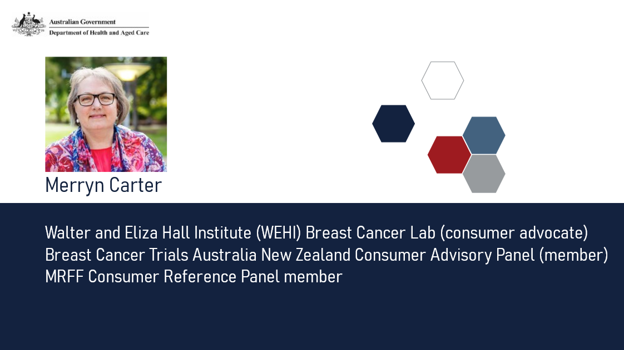
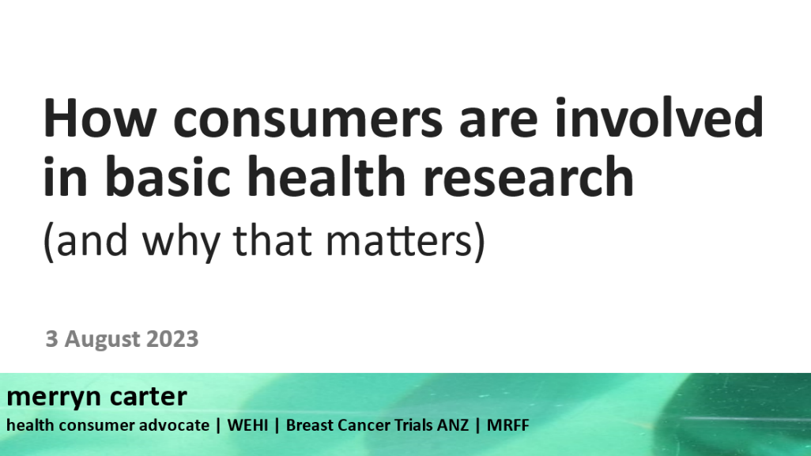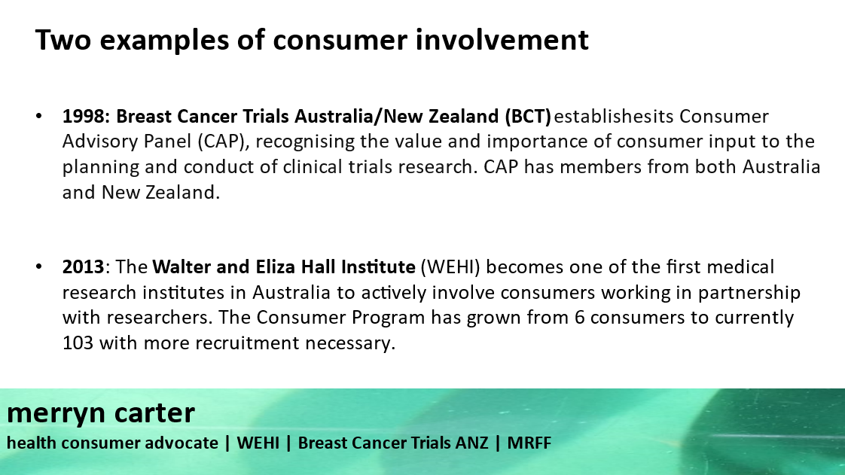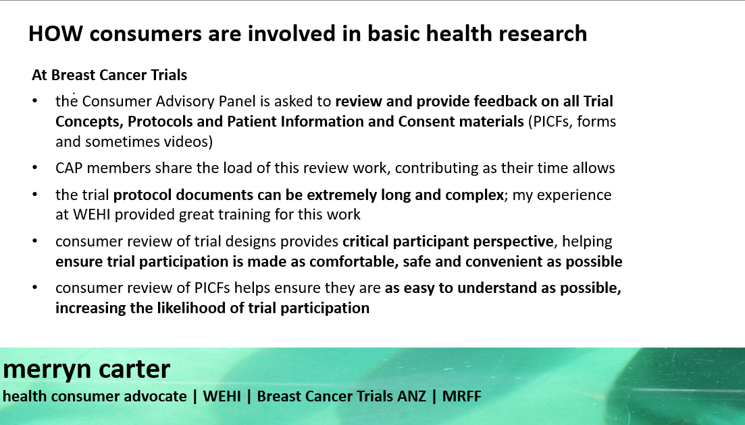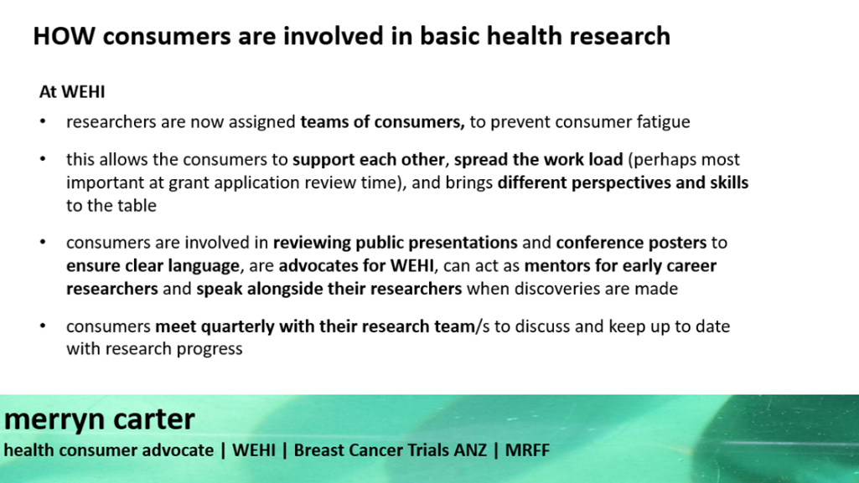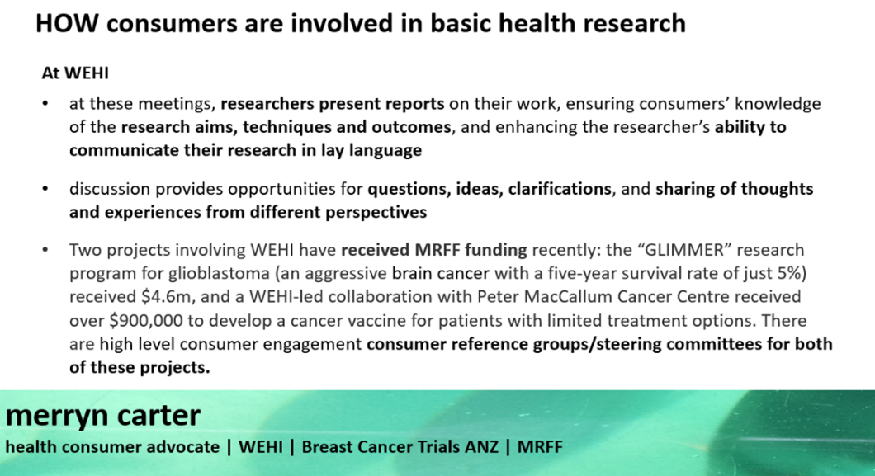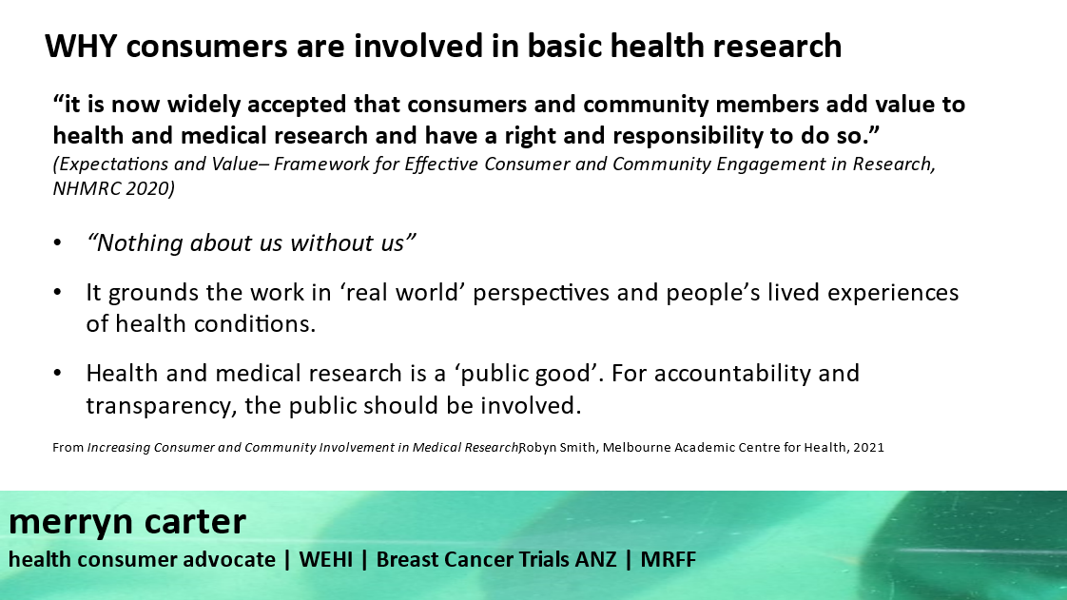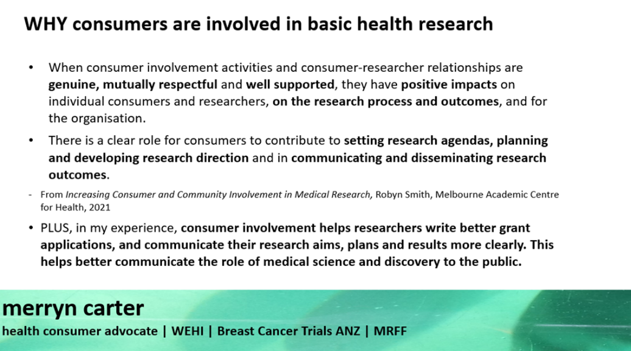

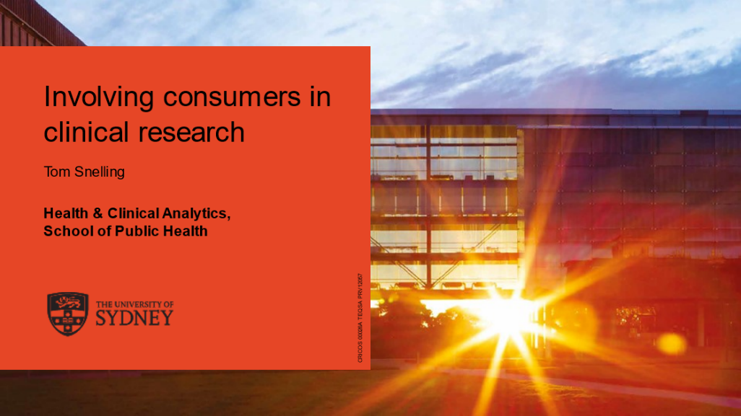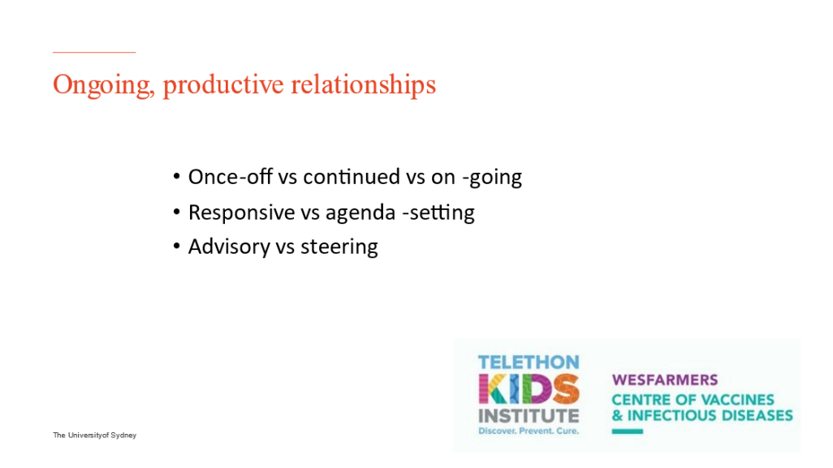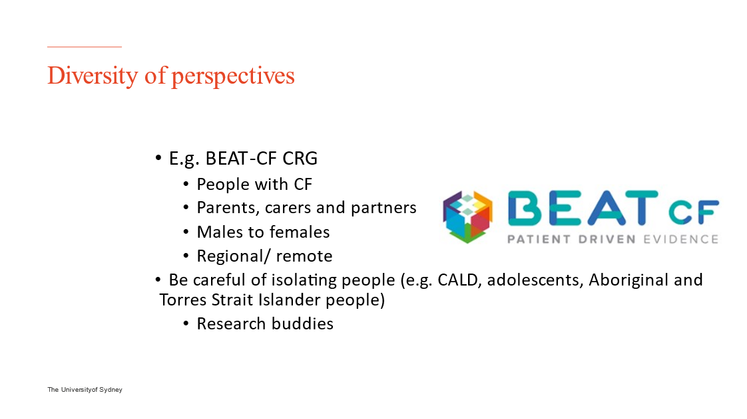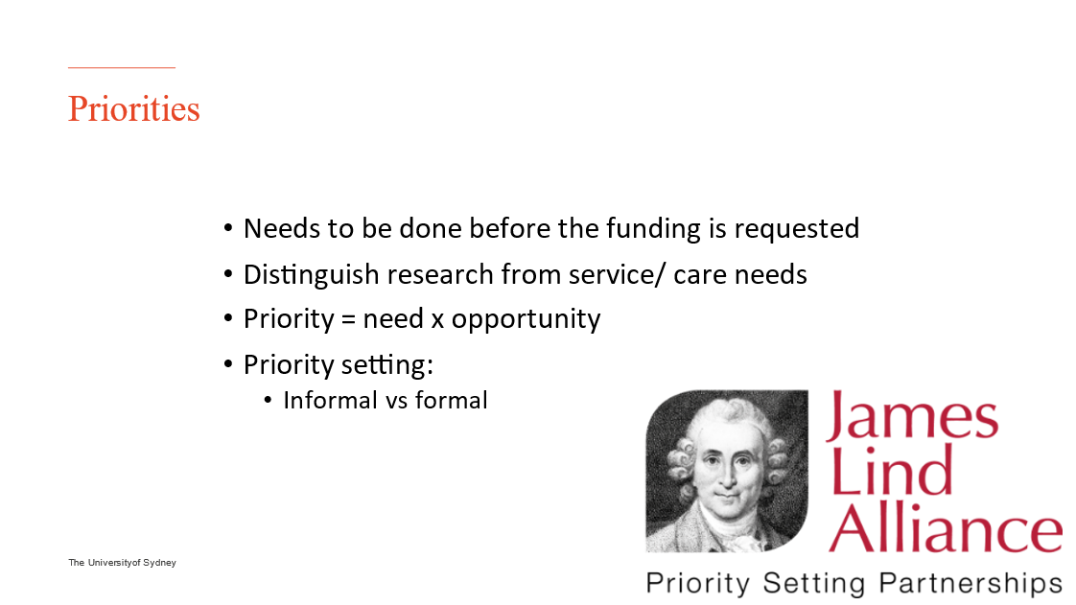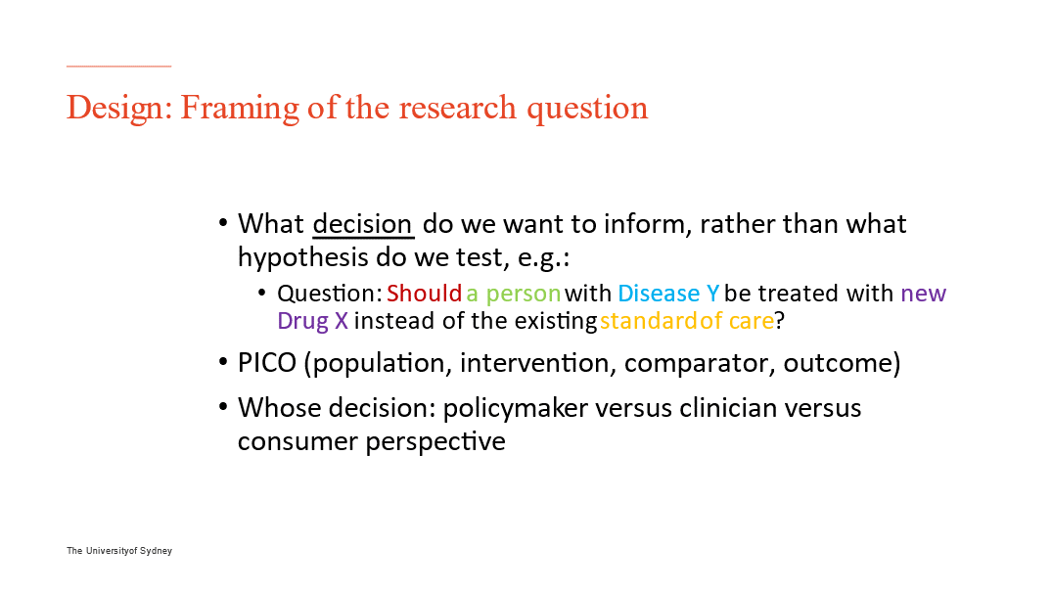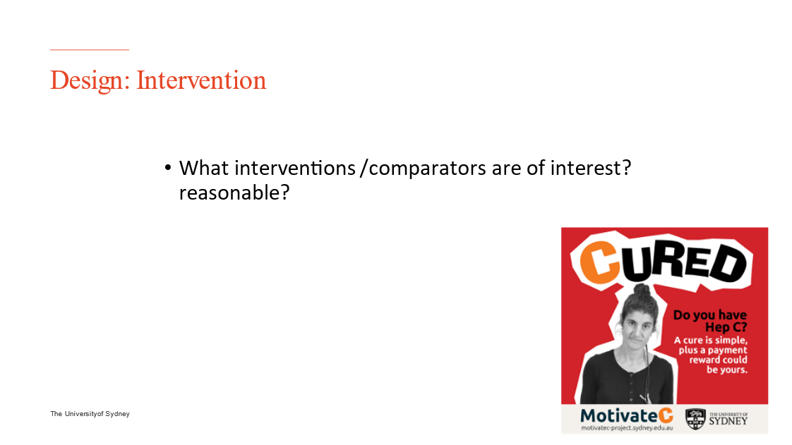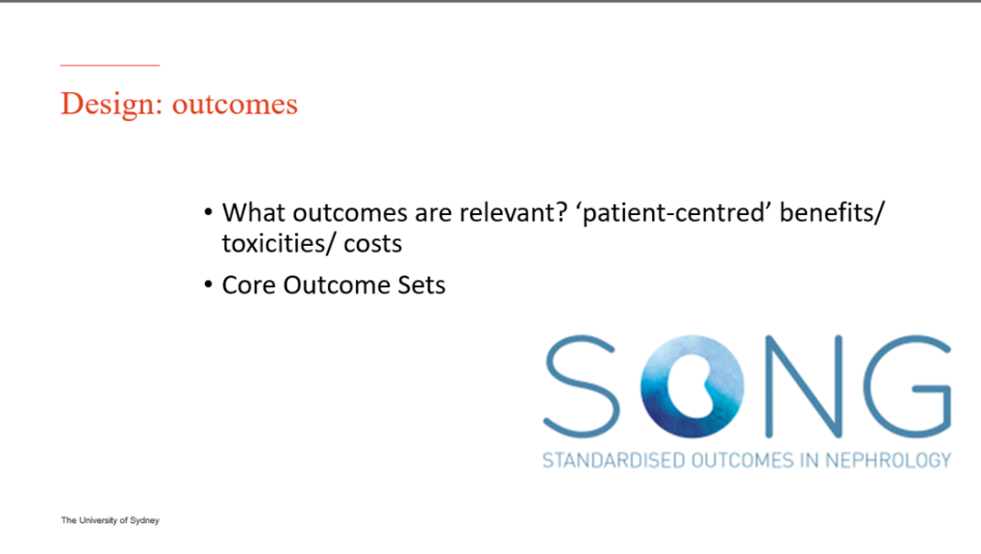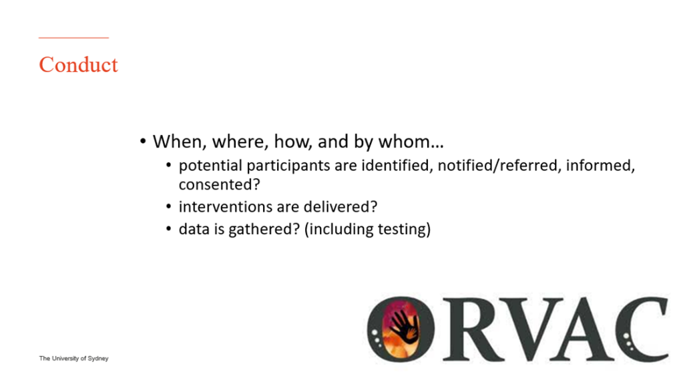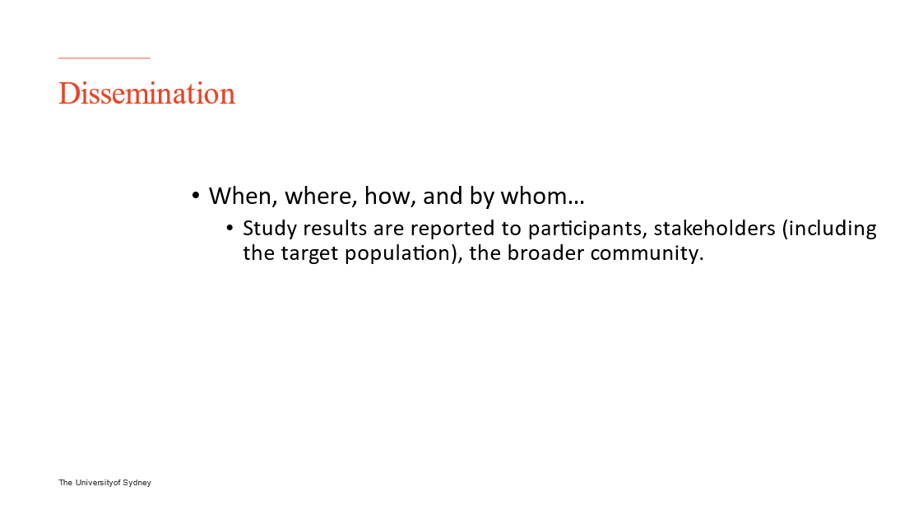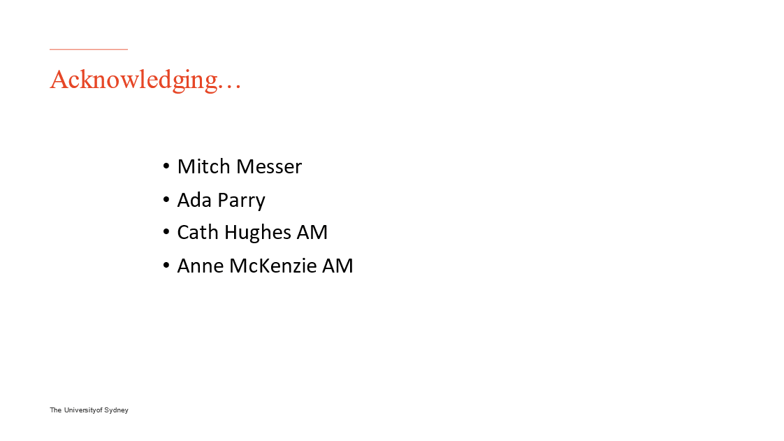
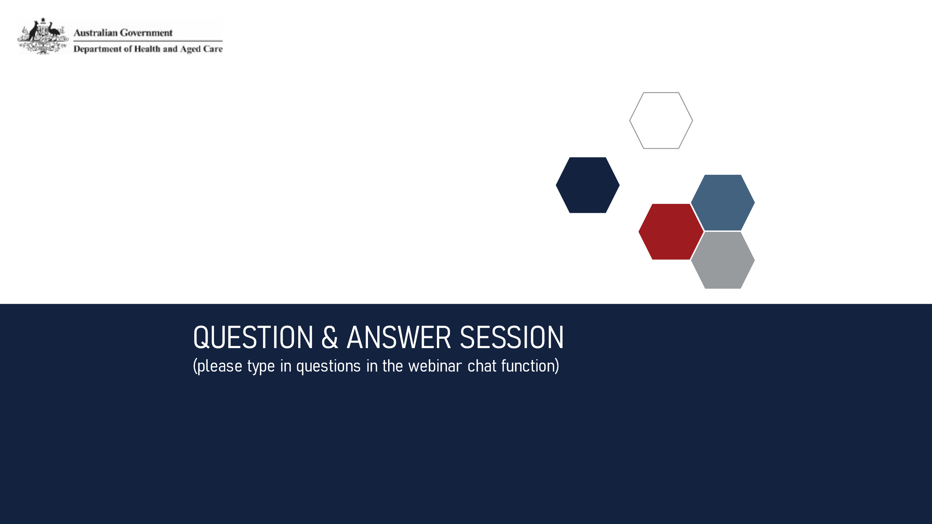

Thank you for your time

