Information sheet for people with disability: COVID-19 oral medicines
July 2023
Some people are at higher risk of serious illness from COVID-19 and should talk to their doctor about eligibility for COVID-19 oral antiviral treatments.​
There are two COVID-19 oral antiviral medicines approved for use in Australia, and available on the Pharmaceutical Benefits Scheme (PBS). They are called molnupiravir (Lagevrio®) and nirmatrelvir and ritonavir (Paxlovid®).
You may be eligible for treatment with one of these medicines if you are over 18 years old with a COVID-19 infection and are at higher risk of becoming very sick.
Oral treatments work best when taken as soon as you test positive for COVID-19, so it’s important to plan ahead:
- Speak with your doctor in advance, to discuss if the COVID-19 medicines will be right for you if you get COVID-19.
- Plan what you will do if you get COVID-19.
- If you get COVID-19, you will need to ask your doctor for a script and to find out where you get the medicines from, for example: your local pharmacy or hospital.
- Take those actions to get your COVID-19 medicine as soon as possible.
- The medicine course needs to be started within 5 days of testing positive to COVID-19 and symptoms starting (or, for people who are 70 years of age or older who do not have symptoms, as soon as possible after a positive COVID-19 test).
The advantages of these medicines are:
- They can be taken as tablets or capsules.
- You can take these medicines at home.
- They can prevent you needing to go to hospital or stay in hospital (unless you get very sick) while you have COVID-19.
The medicines will help some people, but they are not suitable for everyone. Your doctor can help you work out what treatment is right for you.
If you are at high risk of becoming very sick, get tested quickly if you get symptoms.
An online symptom checker is available here: www.healthdirect.gov.au/symptom-checker/tool.
This can help you to identify if you have COVID-19, and what type of support you may need for your symptoms.
Talk to your doctor to see if you are eligible to receive the antiviral treatments. For additional information you can also access the PBS factsheets.

State and territory pathways for COVID-19 oral medicines
You can call the National Coronavirus Helpline and they can help you understand if you’re eligible for COVID-19 medicines. In NSW, QLD, SA and VIC , they can help you to make an appointment with a doctor. You can ask the person if they can help you with this when you call.
This service can be accessed by selecting Option 1 on the National Coronavirus Helpline on
1800 020 080.
If you call this Helpline, you should have details of your preferred GP practice ready to give them.
Find more information about the Healthdirect pathways

For people with swallowing difficulties
If you have difficulty swallowing tablets, you should speak to your doctor about what treatment is right for you.
The Society of Hospital Pharmacists of Australia has published information explaining how Lagevrio can be modified for people with swallowing difficulties and enteral feeding tubes: Don’t Rush to Crush. Discussion between prescribers and patients about this approach may also be informed by the Therapeutic Goods Administration (TGA) approved Product Information (PI), however the Lagevrio PI does not reference opening capsules or dispersing capsule contents before administration.
The TGA approved PI for Paxlovid outlines that the tablets must be swallowed whole and cannot be chewed, broken or crushed. There is no information about the safety or efficacy of Paxlovid when the tablets are crushed or dispersed and given by enteral feeding tube, or crushed for patients with swallowing difficulties.
You can also discuss this with your pharmacist when collecting your prescription.

Vaccination
Vaccination is still very important. Australia’s COVID-19 vaccines are safe, and they help reduce your chance of getting very sick from COVID-19.
The best way to protect yourself from COVID-19 is to get your booster when you’re due. This is recommended to be six months after your last confirmed COVID-19 infection or booster vaccine.
If you need help or support, you can call the Disability Gateway Helpline on 1800 643 787. They can make a booking for your booster. If you don’t know if you are eligible for a booster, ask your doctor. Your doctor can help you get any vaccinations you may need.
Find out more information on COVID-19 vaccines here: www.health.gov.au/our-work/covid-19-vaccines/disability-sector/people-with-disability.

How to access COVID-19 medication

Before you get COVID-19
Make a plan for what you will do if you or someone who supports you gets COVID-19.
The following resources can help you to plan:
- Person-centred Emergency Preparedness COVID-19 Guide
- Department of Health and Aged Care COVID-19 treatments and winter preparedness webinar
Speak to your GP to see if COVID-19 treatments are right for you.

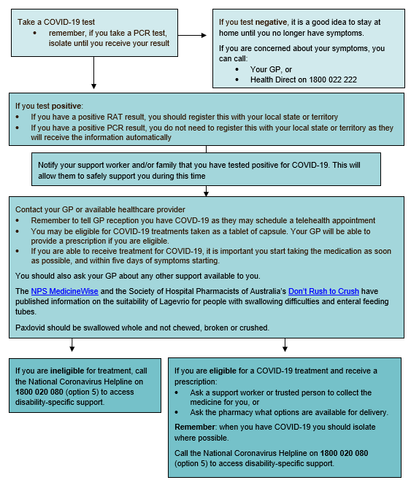
Steps to access COVID-19 medication
Contact your GP or available healthcare provider
- Remember to tell GP reception you have COVID-19 as they may schedule a telehealth appointment
- You may be eligible for COVID-19 treatments taken as a tablet or capsule. Your GP will be able to provide a prescription if you are eligible.
- If you are eligible for COVID-19 oral antivirals treatment, it is important you start taking the medication as soon as possible, and within five days of symptoms starting.
You should also ask your GP about other support available to you.

