# How to voluntarily acknowledge additional services using the Online Compliance Platform (OCP)

August 2023

You can use the OCP to voluntarily acknowledge additional services that are not on the schedule of claims applicable to the compliance activity.

## Acknowledging additional incorrect claims

Once you voluntarily acknowledge items from your schedule of claims, you can also voluntarily acknowledge up to 50 additional services using the OCP.

To voluntarily acknowledge more than 50 additional services, you can use the [Voluntary acknowledgement of incorrect payments form](https://www.health.gov.au/resources/publications/voluntary-acknowledgement-of-incorrect-payments). You can also use this form to acknowledge services outside the period applicable to the compliance activity.

If you have not identified other services to voluntarily acknowledge, click No. Then click the Next button to continue.



To voluntarily acknowledge additional services, click Yes. This will display a schedule to tell us about the other services. You can also choose to write a brief comment to explain why you claimed the other services incorrectly.

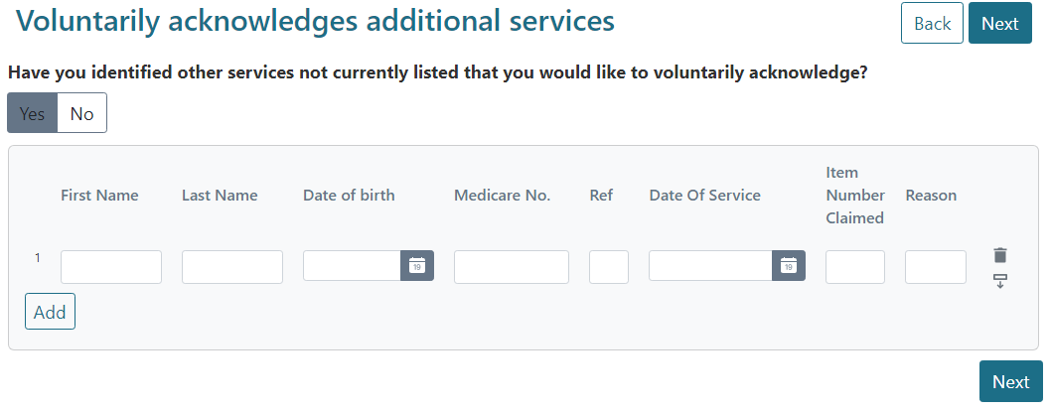

Enter information about the patient and service in the form. To add a new row, click the Add button. You can also delete or duplicate an existing row by clicking the buttons on the right-hand side of the relevant row.

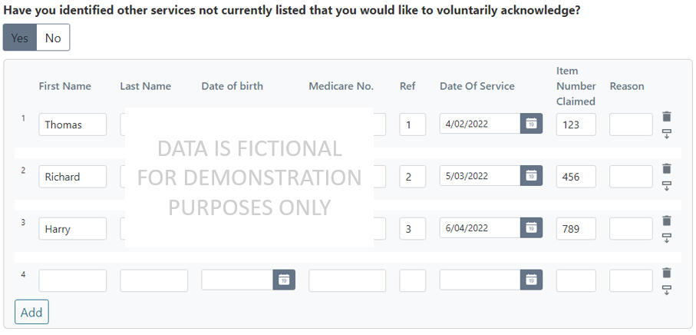

You must complete all fields on the form except the Reason field. You can choose to use the Reason field to write a brief comment explaining why you claimed the service incorrectly.

If you do not complete a required field, or make errors in a required field, the OCP will show you a warning highlighted in red. You must delete any blank rows or correct any errors before you can proceed.

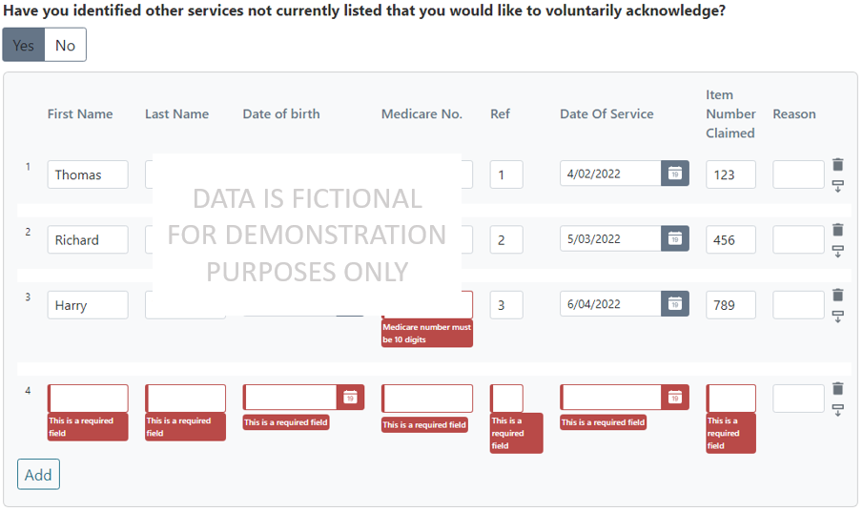

Once you have voluntarily acknowledged any additional services, click the Next button.

## Saving your progress and logging out

The OCP will save your changes automatically. To log out of the OCP, close your browser, including all open tabs and windows. For your security, the OCP will automatically log you out if you are inactive for 30 minutes.

If you have not submitted a response, you can log back into the OCP using the link we sent you via email. You will also need the access code we sent you via SMS. When you log back into the portal, you will resume from the screen you were using when you logged out.

## How to get more help

You can use our [self-help resources](https://www.health.gov.au/resources/collections/online-compliance-platform-resources) at any time.

You can also [contact us](https://www.health.gov.au/contacts/online-compliance-platform-support-contact) by email if you need more help.

You can find out more about how we protect your privacy in our [privacy notice](https://www.health.gov.au/resources/publications/online-compliance-platform-privacy-notice).

You can also refer to our [terms of use](https://www.health.gov.au/resources/publications/online-compliance-platform-terms-of-use) for more information about using the OCP.