# How to upload supporting information using the Online Compliance Platform (OCP)

August 2023

You can use the OCP to upload a PDF file to include with your response. You can also choose to write a comment to support your submission.

## Uploading supporting information

Before you complete your response, you can upload a PDF file no larger than 10MB. You can also choose to write a brief comment to include with your submission.

If you would not like to upload any supporting information, click No. Then click the Next button to continue.

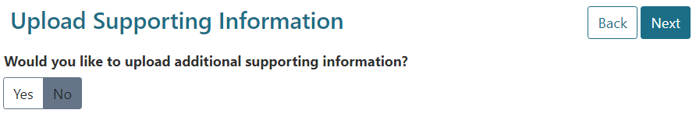

If you would like to upload any supporting information, click Yes. This will open a statement that you must acknowledge before you can continue.

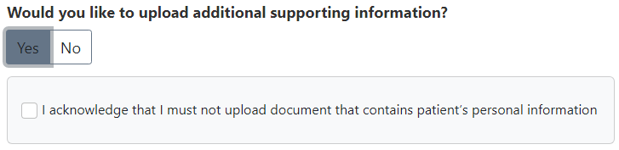

Before you can upload any supporting information, you must click the checkbox to acknowledge you will not upload any patient personal information. This will display an Upload button and comment field.

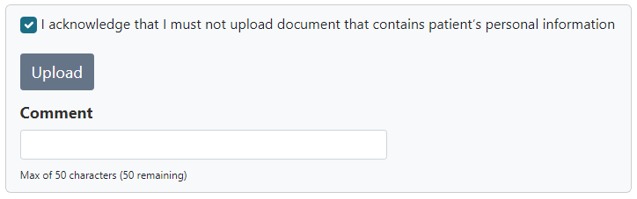

To upload a PDF document, click the Upload button. This will open a pop-up box so that you can choose a document from your computer.

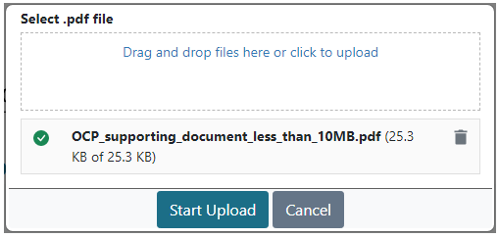

You can drag and drop files into the upload box. You can also click the link to open your computer’s file explorer dialogue and choose a file to upload. Once you have chosen a file, click the Start Upload button to upload the file.

Once you have uploaded a file, the OCP will show the file name in place of the Upload button. To delete the file, click the delete icon. To download the file, click the download icon.

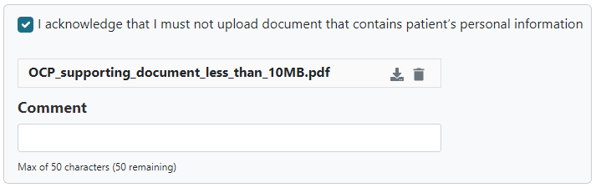

You can also choose to add a brief comment to include with your submission.

When you have uploaded a file and written a comment, click the Next button to continue.

## Saving your progress and logging out

The OCP will save your changes automatically. To log out of the OCP, close your browser, including all open tabs and windows. For your security, the OCP will automatically log you out if you are inactive for 30 minutes.

If you have not submitted a response, you can log back into the OCP using the link we sent you via email. You will also need the access code we sent you via SMS. When you log back into the portal, you will resume from the screen you were using when you logged out.

## How to get more help

You can use our [self-help resources](https://www.health.gov.au/resources/collections/online-compliance-platform-resources) at any time.

You can also [contact us](https://www.health.gov.au/contacts/online-compliance-platform-support-contact) by email if you need more help.

You can find out more about how we protect your privacy in our [privacy notice](https://www.health.gov.au/resources/publications/online-compliance-platform-privacy-notice).

You can also refer to our [terms of use](https://www.health.gov.au/resources/publications/online-compliance-platform-terms-of-use) for more information about using the OCP.