# How to tell us about compliant and incorrect claims using the Online Compliance Platform (OCP)

August 2023

You can use the OCP to tell us about services you claimed correctly and incorrectly. You can choose services individually or in bulk. You can also choose to write a brief comment to explain why you claimed the services correctly or incorrectly.

## Reporting services as either Compliant or Incorrect

Your list of claimed items includes information about your patients. It includes the date and item number of the service and the amount of the benefit paid. The first time you review your schedule of claims, all items will show a default response of Unanswered.

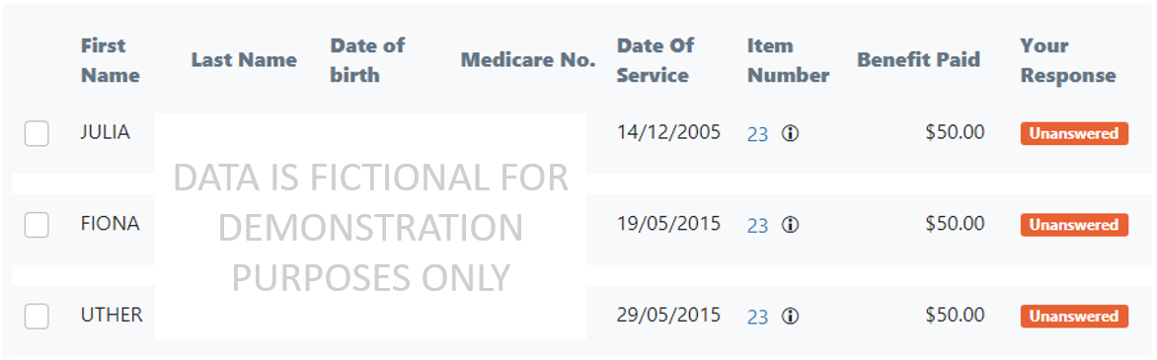

### Choosing responses for single items on the schedule

You can use the OCP to respond to a single item on the schedule. To respond to a single item, click the checkbox on the left-hand side of the relevant row.

Once you have selected a single row, the OCP will show a message below the schedule. The message will indicate ‘1 Line Item(s) selected’.

Use the tool below the schedule to choose Compliant or Incorrect using the Response drop-down list. You can also choose to write a brief comment to explain why you claimed the service correctly or incorrectly. If you would not like to write a comment, leave the Comment box blank. Then click the Save my responses button.

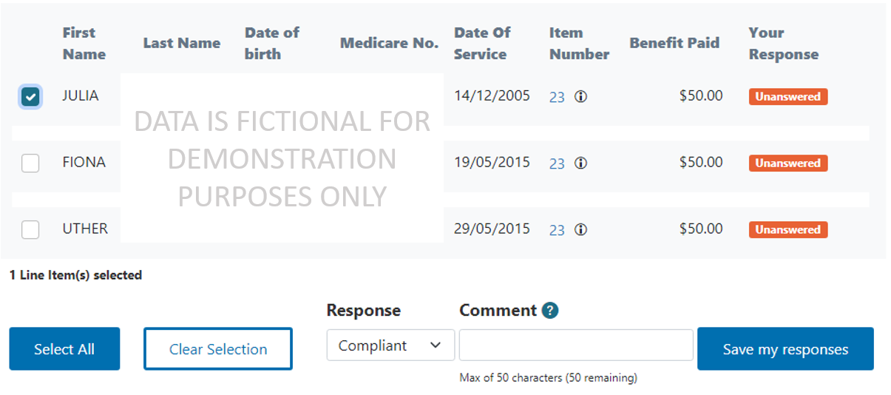

Once you have saved your response, the OCP will update the Your Response column for the relevant line item.

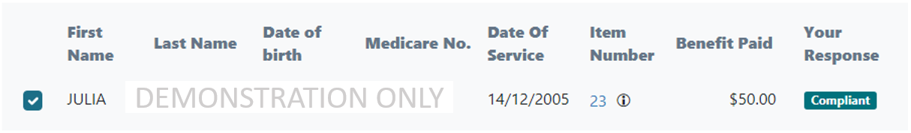

If you wrote a comment, there will also be a comment icon next to your response.

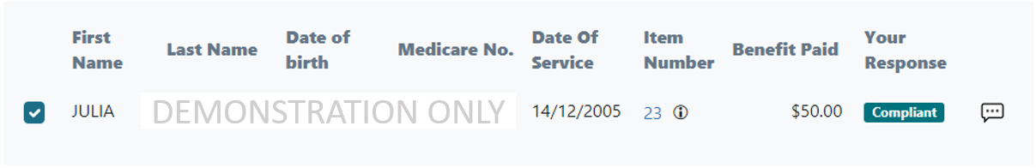

Once you update your response, click the Clear Selection button to clear the checkbox.

### Choosing responses for multiple items on the schedule

You can also use the OCP to respond to multiple items on the schedule. You respond to multiple items by choosing items individually or choosing all items from a filtered list.

#### Choosing multiple items individually

To choose multiple items individually, click the checkboxes on the left-hand side of the rows you would like to choose.

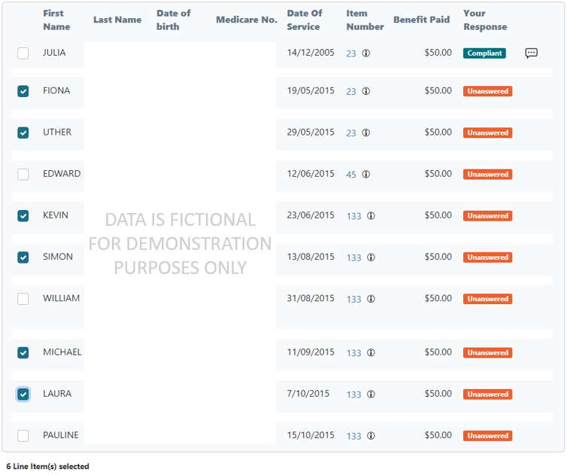

Once you choose the rows you want to respond to, the OCP will show a message below the schedule. The message will indicate the number of line items selected.

Use the tool below the schedule to choose either Compliant or Incorrect using the Response drop-down list. You can also choose to write a brief comment to explain why you claimed the services correctly or incorrectly. If you would not like to write a comment, leave the Comment box blank. Then click the Save my responses button.

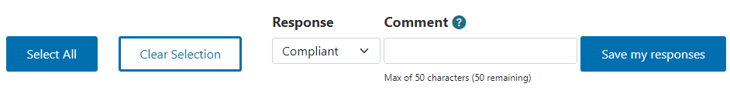

Once you have saved your responses, the OCP will update the Your Response column for the relevant line items.

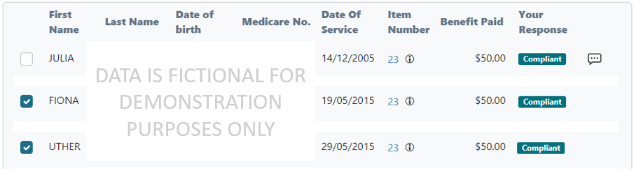

If you wrote a comment, there will also be a comment icon next to your responses.

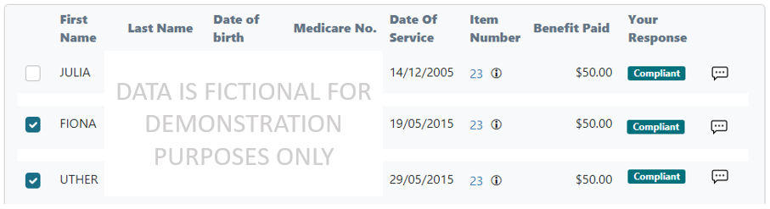

Once you update your responses, click the Clear Selection button to clear the checkboxes.

#### Choosing all items from a filtered list

To choose all items from a filtered list, use the Filter and Search options. For example, you can filter the schedule to show all remaining unanswered items by selecting Unanswered from the Response drop-down menu.

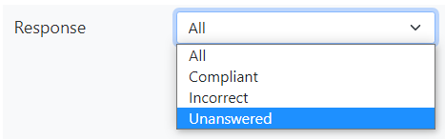

Once you have chosen a filter, click the Update result button to filter the schedule.

Choose all items on your filtered list by clicking the Select All button below the schedule. In this case, the OCP will choose all items in the filtered list instead of all items in the schedule.

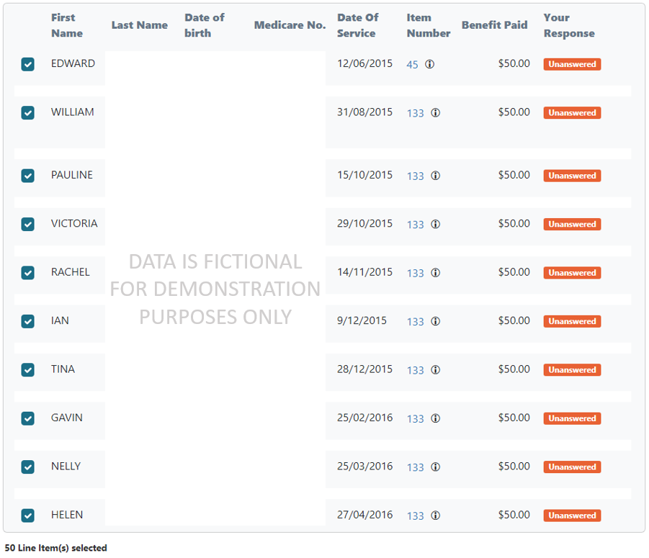

Once you have chosen all rows from your filtered list, the OCP will show a message below the schedule. The message will indicate the number of line items selected.

Use the tool below the schedule to choose either Compliant or Incorrect using the Response drop-down list. You can also choose to write a brief comment to explain why you claimed the services correctly or incorrectly. If you would not like to write a comment, leave the Comment box blank. Then click the Save my responses button.



Once you have saved your responses, the OCP will update the Your Response column.

If you chose all items in a filtered list and change all responses to Compliant or Incorrect, the OCP will not display any items in the schedule.

### Resetting all filters and searches

If you have applied any filters to your schedule, you can reset the filters you have applied. To reset all filters, choose All in each filter drop-down list. If you have entered keywords, then delete all text in the Keyword Search box. Then click the Update result button.

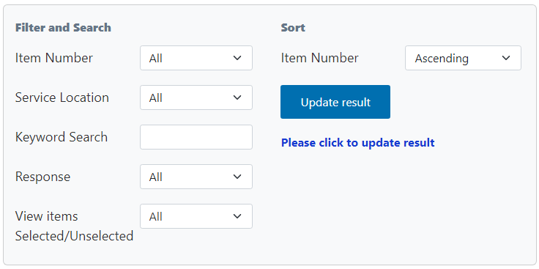

Once you have reset all filters, click the Clear Selection button to clear the checkboxes.

## Reviewing your progress

There is a progress bar at the top of the page. It keeps track of how many Unanswered responses you must edit before you can submit a voluntary acknowledgement.

The first time you use the OCP to review your schedule of claims, all items on your schedule will show a default response of Unanswered.

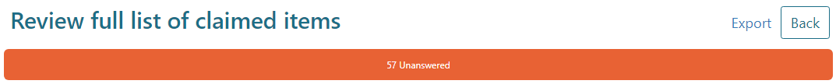

As you update your responses, the number of Compliant, Incorrect and Unanswered responses will change. Once you choose Compliant or Incorrect for each item, the progress bar will not display any Unanswered items.

Image of the progress bar on the OCP website, showing 50 Compliant and 7 Incorrect responses.

You must choose a response of either Compliant or Incorrect for every item in the schedule before you can submit your voluntary acknowledgement.

## Exporting your schedule of claims

You can export your schedule to review the items offline. To export the schedule, click the Export link in the top right corner of the page, above the progress bar.



When you export your schedule, you can save it as a Microsoft Excel spreadsheet. This spreadsheet will display the schedule in columns with the same headings as the online display. The spreadsheet will also show any comments you have chosen to write.

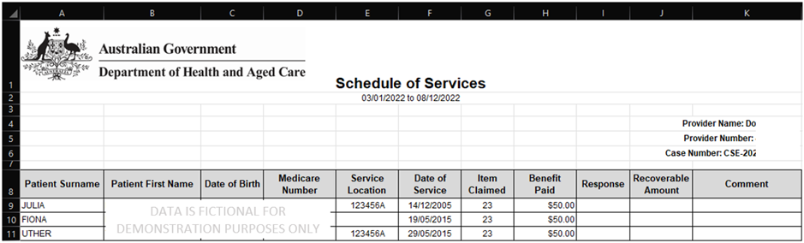

If you export the schedule as a Microsoft Excel spreadsheet, you cannot import this spreadsheet back into the OCP. You must use the OCP to record your responses to the items on the schedule and complete your compliance activity.

## Saving your progress and logging out

The OCP will save your changes automatically. To log out of the OCP, close your browser, including all open tabs and windows. For your security, the OCP will automatically log you out if you are inactive for 30 minutes.

If you have not submitted a response you can log back into the OCP using the link we sent you via email. You will also need the access code we sent you via SMS. When you log back into the portal, you will resume from the screen you were using when you logged out.

## How to get more help

Y You can use our [self-help resources](https://www.health.gov.au/resources/collections/online-compliance-platform-resources) at any time.

You can also [contact us](https://www.health.gov.au/contacts/online-compliance-platform-support-contact) by email if you need more help.

You can find out more about how we protect your privacy in our [privacy notice](https://www.health.gov.au/resources/publications/online-compliance-platform-privacy-notice).

You can also refer to our [terms of use](https://www.health.gov.au/resources/publications/online-compliance-platform-terms-of-use) for more information about using the OCP.