# How to submit your response using the Online Compliance Platform (OCP)

August 2023

You can use the OCP to submit your response to the compliance activity. You can download a copy of your submission and also choose to give feedback about your experience using the OCP.

## Submitting your response

You will not be able to log back in to the OCP after you submit your response. If you would like to download your submission, you must do it before you close your browser.

You must complete a declaration before you submit your response to the compliance activity. To complete the declaration, click the checkbox in the declaration section.

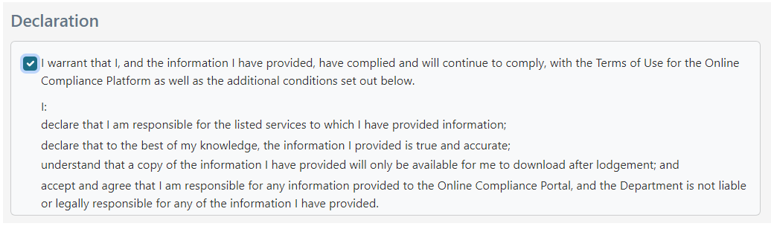

### Giving feedback about using the OCP

When you submit your response, you can choose to write feedback about your experience using the OCP. You can type your feedback in the textbox provided.

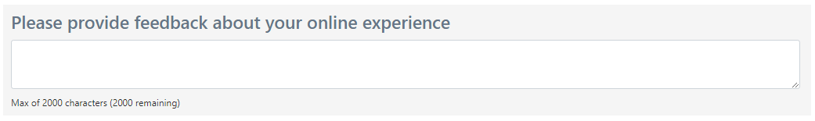

## Downloading a copy of your submission

Once you submit your response, the OCP will redirect you to a page where you can download a copy of your submission. If you are acknowledging additional services, you can also download a schedule of these other items.

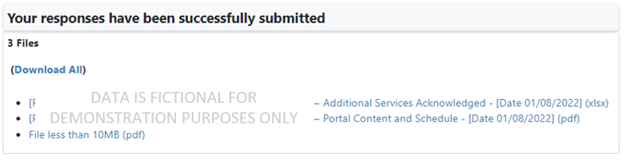

If you would like to download a copy of your submission, you must do it from this page before you close your browser. If you would like to change your responses or get a copy of your submission after leaving the OCP, please [contact us](https://www.health.gov.au/contacts/online-compliance-platform-support-contact).

## Saving your progress and logging out

The OCP will save your changes automatically. To log out of the OCP, close your browser, including all open tabs and windows. For your security, the OCP will automatically log you out if you are inactive for 30 minutes.

If you have not submitted a response, you can log back into the OCP using the link we sent you via email. You will also need the access code we sent you via SMS. When you log back into the portal, you will resume from the screen you were using when you logged out.

## How to get more help

You can use our [self-help resources](https://www.health.gov.au/resources/collections/online-compliance-platform-resources) at any time.

You can also [contact us](https://www.health.gov.au/contacts/online-compliance-platform-support-contact) by email if you need more help.

You can find out more about how we protect your privacy in our [privacy notice](https://www.health.gov.au/resources/publications/online-compliance-platform-privacy-notice).

You can also refer to our [terms of use](https://www.health.gov.au/resources/publications/online-compliance-platform-terms-of-use) for more information about using the OCP.