# How to review your submission and contact details using the Online Compliance Platform (OCP)

August 2023

You can use the OCP to review a summary of the services you are voluntarily acknowledging. You can also update the contact details we will use to communicate with you about the compliance activity.

## Reviewing your submission

You can review a summary of your voluntary acknowledgement before you submit it. The summary will include the total number of services and total recoverable amount. It also shows the amount of bulk bill incentive items for the services.

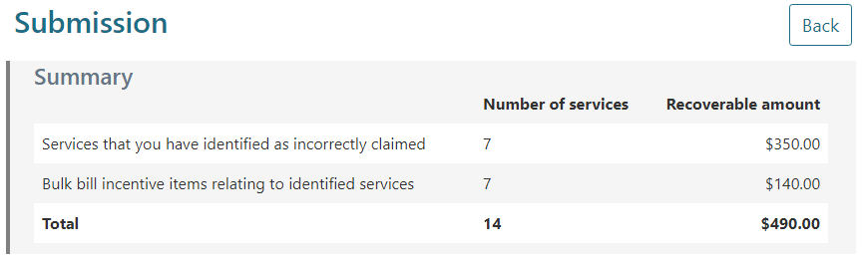

Once you submit a voluntary acknowledgement, we will confirm the recoverable amount of the services you have claimed incorrectly. We will then send you an email with a debt notification. We will also send you a tax invoice to tell you the repayment amount and payment options. After submit your response, you will not be able to access the OCP.

## Updating your contact details

Before you submit your response, you can update your contact details. We will use this information to communicate with you about the compliance activity and send you a debt notification if you voluntarily acknowledge any services.

If you do not update your contact information, we will continue to use the existing information for the compliance activity and debt notices.

To update your contact details, click the Update My Contact Details button. This will open a pop-up form showing your Address Details and Contact Details.

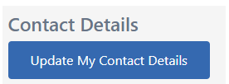

To update your postal address, click the Address Details link. The OCP will show the existing address we have for you. To update your postal address, click the relevant text field and type your updated address.

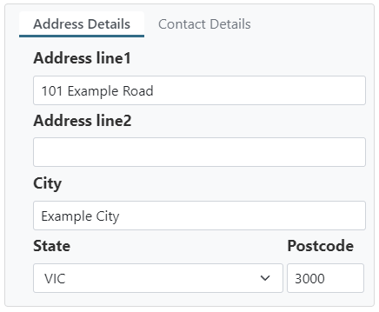

To update your contact details, click the Contact Details link. The OCP will show the existing email address and mobile phone number we have for you. To update your email address or phone number, click the relevant field and type your updated contact details.

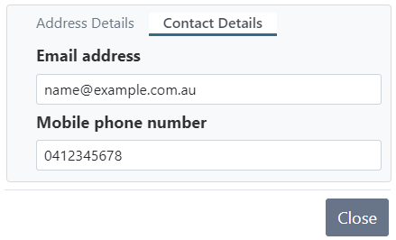

When you have reviewed and updated your address and contact details click the Close button to save the information.

Updating your contact details using the OCP will only apply to communications we send you about the compliance activity, including any applicable debt notifications. If you would like to update your preferred mailing address for all Medicare activities you must do this by contacting Services Australia.

## Saving your progress and logging out

The OCP will save your changes automatically. To log out of the OCP, close your browser, including all open tabs and windows. For your security, the OCP will automatically log you out if you are inactive for 30 minutes.

If you have not submitted a response, you can log back into the OCP using the link we sent you via email. You will also need the access code we sent you via SMS. When you log back into the portal, you will resume from the screen you were using when you logged out.

## How to get more help

You can use our [self-help resources](https://www.health.gov.au/resources/collections/online-compliance-platform-resources) at any time.

You can also [contact us](https://www.health.gov.au/contacts/online-compliance-platform-support-contact) by email if you need more help.

You can find out more about how we protect your privacy in our [privacy notice](https://www.health.gov.au/resources/publications/online-compliance-platform-privacy-notice).

You can also refer to our [terms of use](https://www.health.gov.au/resources/publications/online-compliance-platform-terms-of-use) for more information about using the OCP.