# How to review your claims using the Online Compliance Platform (OCP)

August 2023

You can use the OCP to review a schedule of your Medicare claims applicable to the compliance activity. You can sort and filter the schedule and search for a keyword to help you identify any incorrect claims.

## Reviewing your schedule of claims

To review your schedule of claims, choose Review full list of claimed items in Step 2. Then click the Next button to continue.

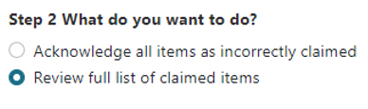

Your list of claimed items includes information about your patients. It includes the date and item number of the service and the amount of the benefit paid. The first time you review your schedule of claims, all items will show a default response of Unanswered.

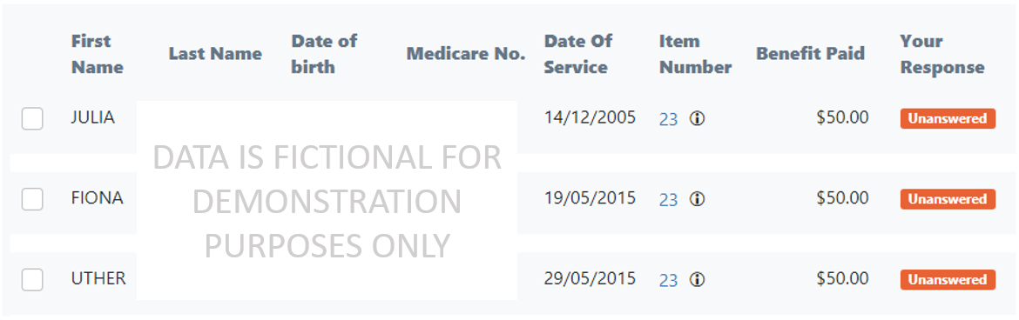

You must choose a response of either Compliant or Incorrect for every item in the schedule before you can submit your voluntary acknowledgement.

## Filtering, searching and sorting the schedule

You can filter, search and sort the schedule using the Filter and Search menu. This menu is above the items on the schedule.

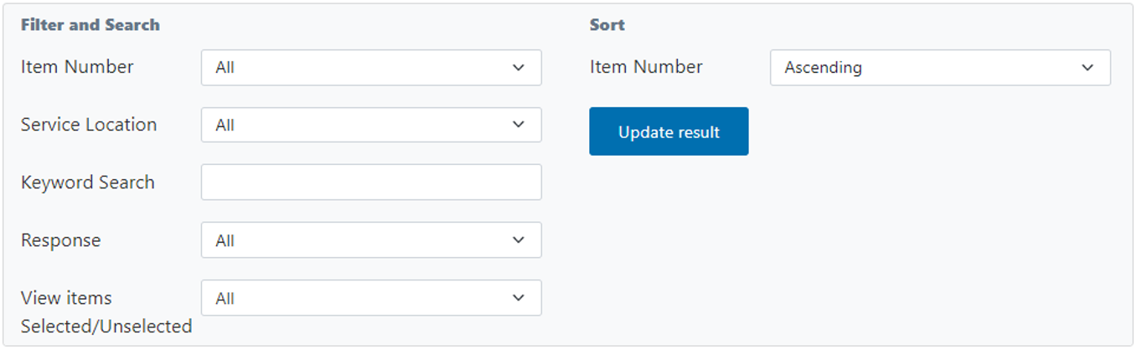

Use the Item Number filter to show services with a specific Medicare item number.

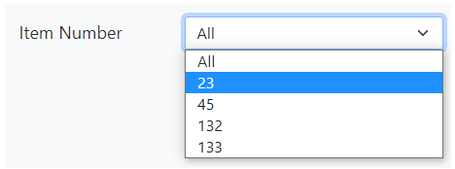

Use the Service Location filter to show services provided at a specific location.

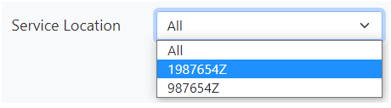

Use the Response filter to show services with a response of Compliant, Incorrect or Unanswered.

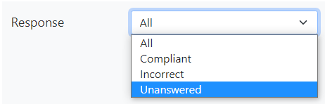

Use the Keyword Search filter to search your list of services for a specific keyword. For example, you could search for a patient’s family name to find all services provided to an individual patient.

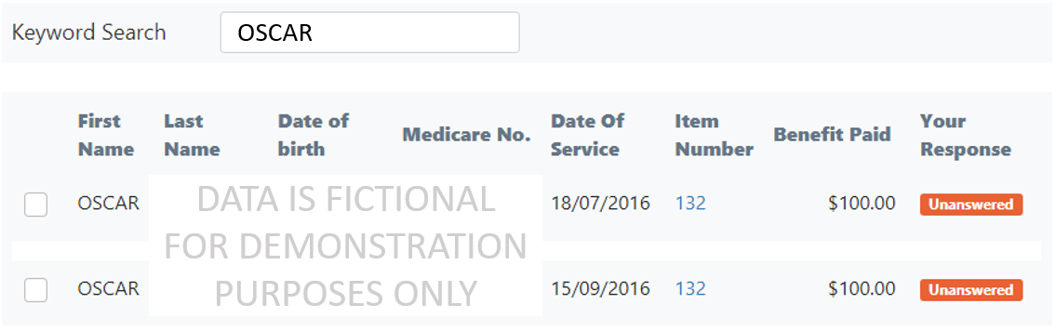

You can also use the Sort filter to sort the full schedule or sort a filtered list by Item Number. You can sort the schedule in ascending or descending order.

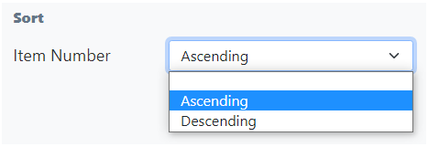

### Resetting all filters and searches

If you have applied any filters to your schedule, you can reset the filters you have applied. To reset all filters, choose All in each filter drop-down list. If you have entered keywords, delete all text in the Keyword Search box. Then click the Update result button.

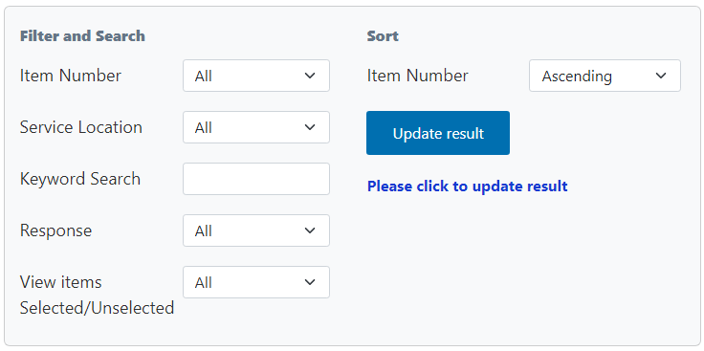

## Exporting your schedule of claims

You can export your schedule to review the items offline. To export the schedule, click the Export link in the top right corner of the page, above the progress bar.



When you export your schedule, you can save it as a Microsoft Excel spreadsheet. This spreadsheet will display the schedule in columns with the same headings as the online display. The spreadsheet will also show any comments you have chosen to write.

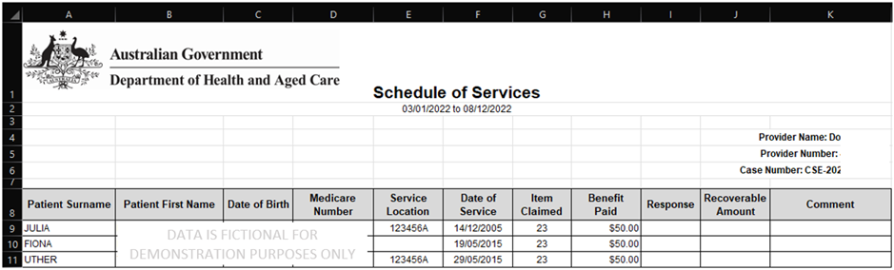

If you export the schedule as a Microsoft Excel spreadsheet, you cannot import this spreadsheet back into the OCP. You must use the OCP to record your responses to the items on the schedule and complete your compliance activity.

## Saving your progress and logging out

The OCP will save your changes automatically. To log out of the OCP, close your browser, including all open tabs and windows. For your security, the OCP will automatically log you out if you are inactive for 30 minutes.

If you have not submitted a response, you can log back into the OCP using the link we sent you via email. You will also need the access code we sent you via SMS. When you log back into the portal, you will resume from the screen you were using when you logged out.

## How to get more help

You can use our [self-help resources](https://www.health.gov.au/resources/collections/online-compliance-platform-resources) at any time.

You can also [contact us](https://www.health.gov.au/contacts/online-compliance-platform-support-contact) by email if you need more help.

You can find out more about how we protect your privacy in our [privacy notice](https://www.health.gov.au/resources/publications/online-compliance-platform-privacy-notice).

You can also refer to our [terms of use](https://www.health.gov.au/resources/publications/online-compliance-platform-terms-of-use) for more information about using the OCP.