# How to review your claim summary using the Online Compliance Platform (OCP)

August 2023

You can use the OCP to review a summary of your Medicare claims. Your claim summary shows the total number and amount of your claims applicable to the compliance activity.

## Reviewing your claim summary

Once you log into the OCP, you can review your claim summary. Your claim summary is a schedule of your Medicare claims applicable to the compliance activity. The summary shows the total number and amount of your claims for a period.

The total amount shown in this summary does not include any associated bulk bill incentive amounts. The OCP will give you details of bulk bill incentive items you voluntarily acknowledge the associated services as incorrect claims.

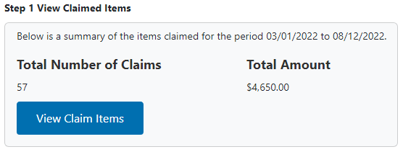

To view the item numbers for your claims, click the View Claim Items button.

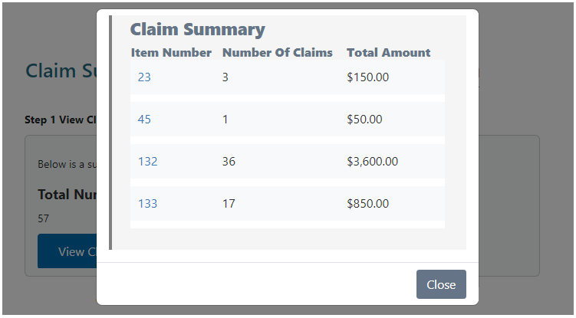

The item numbers shown in this window link to the MBS Online description of the item. Click the Item Number to open the MBS Online in a new browser tab.

The MBS Online description may have changed since you provided the services and lodged a Medicare claim.

## Saving your progress and logging out

The OCP will save your changes automatically. To log out of the OCP, close your browser, including all open tabs and windows. For your security, the OCP will automatically log you out if you are inactive for 30 minutes.

If you have not submitted a response, you can log back into the OCP using the link we sent you via email. You will also need the access code we sent you via SMS. When you log back into the portal, you will resume from the screen you were using when you logged out.

## How to get more help

You can use our [self-help resources](https://www.health.gov.au/resources/collections/online-compliance-platform-resources) at any time.

You can also [contact us](https://www.health.gov.au/contacts/online-compliance-platform-support-contact) by email if you need more help.

You can find out more about how we protect your privacy in our [privacy notice](https://www.health.gov.au/resources/publications/online-compliance-platform-privacy-notice).

You can also refer to our [terms of use](https://www.health.gov.au/resources/publications/online-compliance-platform-terms-of-use) for more information about using the OCP.