# How to activate and log in to the Online Compliance Platform (OCP)

August 2023

You can access and log in to the OCP using a unique link and private access code. We will send you an email with instructions.

## Activating the OCP

If you would like to use the OCP, we must confirm your email address and mobile phone number. This is to make sure your login and access code are private and secure. To confirm your contact information, we will call you by telephone.

Once we confirm your contact details, we will send you an email with a link to the OCP activation page. We will usually send this email one week after we call you.

On the activation page, you must agree to the OCP terms of use.

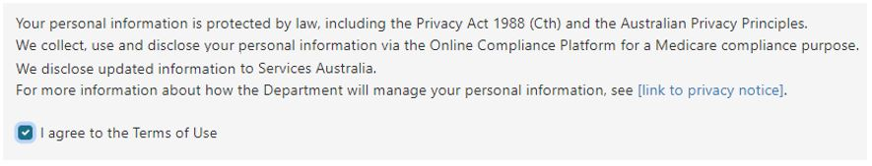

It is important to read the OCP [terms of use](https://www.health.gov.au/resources/publications/online-compliance-platform-terms-of-use) before you agree to them. To read the OCP terms of use, click the link in the Using our website section in the footer of the OCP website.

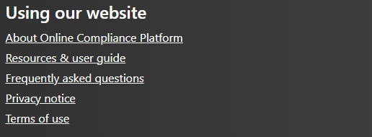

If you agree to the terms of use, click the Acknowledge button to continue.

If you do not agree to the OCP terms of use, you can [contact us](https://www.health.gov.au/contacts/online-compliance-platform-support-contact) to arrange an alternative way to complete your compliance activity.

## Logging in to the OCP

You should use the OCP on a desktop or a laptop computer. Not all functions will work on other types of devices, such as a mobile phone or tablet.

You will need a private access code to log in to the OCP.

Once you agree to the terms of use, we will send you:

* an email with a link to the OCP login page
* an SMS with an access code to log in to the OCP.

Click the link in your email to go to the OCP login page.

On the OCP login page, you can log in to the portal by entering your access code and clicking the Login button.

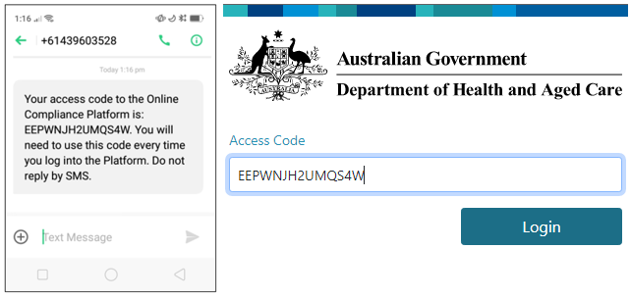

Your access code is a unique combination of 14 numbers and upper-case letters. You must enter the access code correctly, which includes using upper-case letters. If you enter it incorrectly 5 times, you must wait 5 minutes before you can try again.

You can continue to use your access code to log in to the OCP until the due date for completing your compliance activity. We will give you this date in the email we send you.

Please contact us if you need more time to complete your compliance activity. You should also contact us if you are unable to login to the OCP with your access code.

## Saving your progress and logging out

The OCP will save your changes automatically. To log out of the OCP, close your browser, including all open tabs and windows. For your security, the OCP will automatically log you out if you are inactive for 30 minutes.

If you have not submitted a response, you can log back into the OCP using the link we sent you via email. You will also need the access code we sent you via SMS. When you log back into the portal, you will resume from the screen you were using when you logged out.

## How to get more help

You can use our [self-help resources](https://www.health.gov.au/resources/collections/online-compliance-platform-resources) at any time.

You can also [contact us](https://www.health.gov.au/contacts/online-compliance-platform-support-contact) by email if you need more help.

You can find out more about how we protect your privacy in our [privacy notice](https://www.health.gov.au/resources/publications/online-compliance-platform-privacy-notice).

You can also refer to our [terms of use](https://www.health.gov.au/resources/publications/online-compliance-platform-terms-of-use) for more information about using the OCP.