# How to acknowledge all items as incorrectly claimed using the Online Compliance Platform (OCP)

August 2023

If you have incorrectly claimed every item on your claim schedule, you can use the OCP to voluntarily acknowledge all items. You can also choose to explain why you claimed the services incorrectly.

## Acknowledge all items as incorrectly claimed

### Using the claim summary screen

You can voluntarily acknowledge all items on the schedule from the Claim Summary screen. To acknowledge all items, choose Acknowledge all items as incorrectly claimed at Step 2.

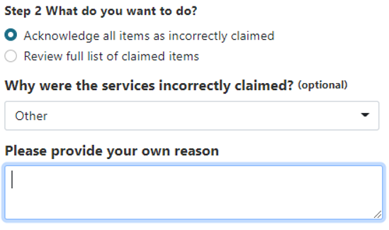

Before deciding to voluntarily acknowledge all items as incorrectly claimed from the claim summary screen, you should review your schedule of claims.

Once you choose Acknowledge all items as incorrectly claimed, click on the downward arrow to choose a reason why you claimed the items incorrectly.

If you choose ‘Other’, you can choose to write a brief comment to explain why you claimed the services incorrectly. If you would like to write a longer explanation, you can upload a supporting document in PDF file format before completing your submission. The file must be no larger than 10MB.

### Using the schedule of claims

Your list of claimed items includes information about your patients. It includes the date and item number of the service and the amount of the benefit paid. The first time you review your schedule of claims, all items will show a default response of Unanswered.

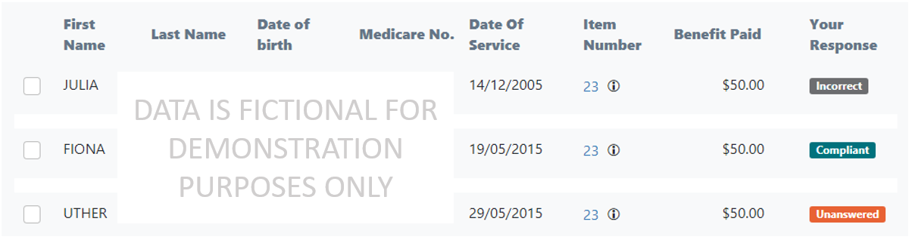

To tell us that you claimed all your services incorrectly, you must change the default response for all items from Unanswered to Incorrect.

To choose all items on the schedule, first reset any filters you have applied. To reset all filters, choose All in each filter drop-down list. If you have entered keywords, delete all text in the Keyword Search box. Then click the Update result button.

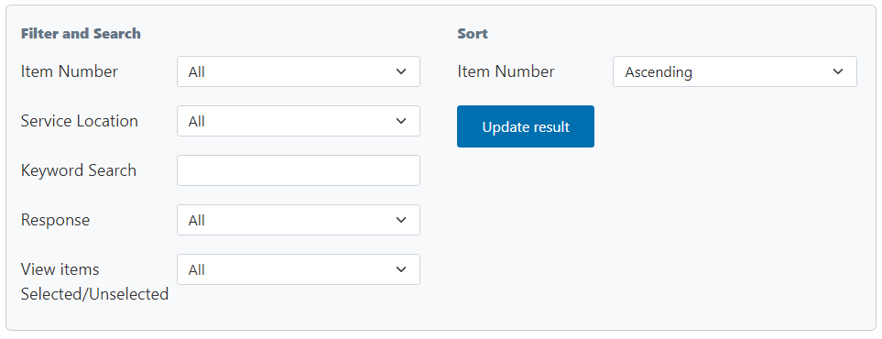

Once you have reset all filters, click the Select All button below the schedule. Then use the response drop-down list to choose Incorrect.

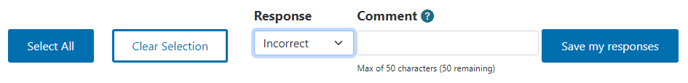

You can also choose to write a brief comment to explain why you claimed the services incorrectly. If you would not like to write a comment, leave the Comment box blank.

When you have chosen Incorrect as a response, click the Save my responses button.

All items on the schedule will now show a response of Incorrect.

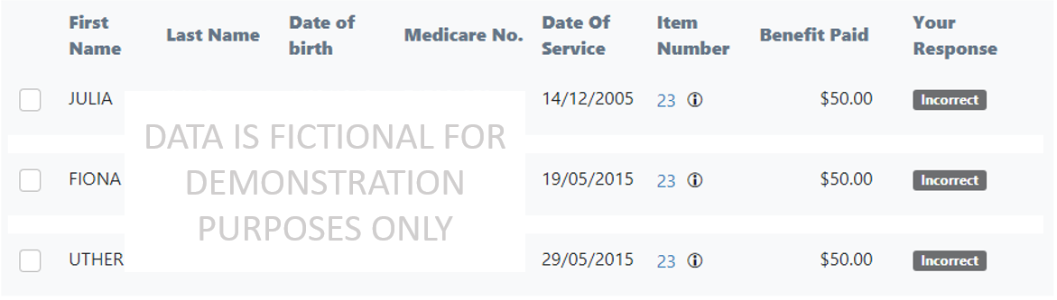

## Reviewing your progress

There is a progress bar at the top of the page. It keeps track of how many Unanswered responses you must edit before you can submit a voluntary acknowledgment.

The first time you use the OCP to review your schedule of claims, all items on your schedule will show a default response of Unanswered.

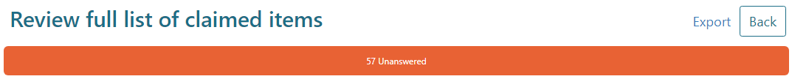

As you update your responses, the number of Compliant, Incorrect and Unanswered responses will change. Once you choose Incorrect for all items on the schedule, the progress bar will not display any remaining Unanswered items.

Image of the progress bar on the OCP website, showing all items as Incorrect.

You must choose a response of either Compliant or Incorrect for every item in the schedule before you can submit your voluntary acknowledgement.

## Exporting your schedule of claims

You can export your schedule to review the items offline. To export the schedule, click the Export link in the top right corner of the page, above the progress bar.



When you export your schedule, you can save it as a Microsoft Excel spreadsheet. This spreadsheet will display the schedule in columns with the same headings as the online display. The spreadsheet will also show any comments you have chosen to write.

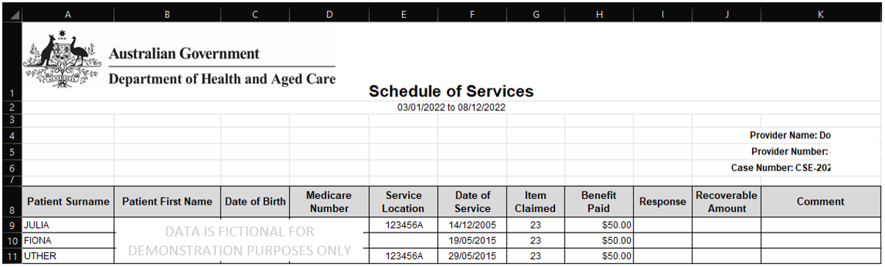

If you export the schedule as a Microsoft Excel spreadsheet, you cannot import this spreadsheet back into the OCP. You must use the OCP to record your responses to the items on the schedule and complete your compliance activity.

## Saving your progress and logging out

The OCP will save your changes automatically. To log out of the OCP, close your browser, including all open tabs and windows. For your security, the OCP will automatically log you out if you are inactive for 30 minutes.

If you have not submitted a response you can log back into the OCP using the link we sent you via email. You will also need the access code we sent you via SMS. When you log back into the portal, you will resume from the screen you were using when you logged out.

## How to get more help

You can use our [self-help resources](https://www.health.gov.au/resources/collections/online-compliance-platform-resources) at any time.

You can also [contact us](https://www.health.gov.au/contacts/online-compliance-platform-support-contact) by email if you need more help.

You can find out more about how we protect your privacy in our [privacy notice](https://www.health.gov.au/resources/publications/online-compliance-platform-privacy-notice).

You can also refer to our [terms of use](https://www.health.gov.au/resources/publications/online-compliance-platform-terms-of-use) for more information about using the OCP.